Introduction
Magna Carta has had an enduring legacy that has shaped the human rights and freedoms that all Australians enjoy today. In particular, Magna Carta advanced ideas of freedom, justice and the rule of law, principles which have become enshrined in our democracy.
To mark the 800th anniversary of Magna Carta, the Australian Human Rights Commission has created a series of online educational resources which explore the evolution of human rights since 1215 and the impact that Magna Carta has had on our human rights and freedoms in Australia.
The two digital resources - an interactive infographic and a short animated video - have been mapped to the Australian Curriculum for History and Civics and Citizenship for Years 5 and 6.

Australian Curriculum links
Australian Curriculum Content Description | Elaborations
Year 5 Civics and Citizenship (Government and Democracy)
The key values that underpin Australia’s democratic system of government (ACHCK022) | - discussing the meaning of democracy  - discussing the meaning and importance of the key values of Australian democracy such as freedom, equality, fairness and justice
Year 6 Civics and Citizenship (Government and Democracy)
The key institutions of Australia’s democratic system of government based on the Westminster system, including the monarchy, parliaments, and courts (ACHCK035) | - recognising the importance of the Westminster system and the Magna Carta in influencing Australia’s parliamentary government
Year 6 History (Australia as a nation)
Key figures and events that led to Australia’s Federation, including British and American influences on Australia’s system of law and government (ACHHK113) | - comparing the model of Australian federalism with the original model of the United States of America to identify the US influence on Australia’s system of government  - identifying key elements of Australia’s system of law and government and their origins (for example the Magna Carta; federalism; constitutional monarchy; the Westminster system and the separation of powers - legislature, executive, judiciary; the houses of parliament; how laws are made)
Experiences of Australian democracy and citizenship, including the status and rights of Aboriginal and Torres Strait Islander Peoples, migrants, women, and children (ACHHK114) | - the lack of citizenship rights for Aboriginal Peoples and Torres Strait Islander Peoples in Australia  - investigating the stories of individuals or groups who advocated or fought for rights in twentieth-century Australia  - investigating the experiences of democracy and citizenship of women (for example the suffragette movement)  - investigating the experiences of democracy and citizenship of migrant groups

The evolution of democracy
The activities in this teaching resource explore the evolution of democratic ideas and principals stemming from Magna Carta, and how these ideas have shaped key features of Australian democracy, such as the values of freedom, equality, fairness and justice.

Introductory activity – Class brainstorm
As a class, begin the lesson by creating a mind map on the board about the concept of “democracy” and what it means.
You may wish to prompt class discussion with the following questions:
- What makes a democracy?
- Why is having a democracy important?
- How does democracy have an impact on people’s lives?
Explain to students that the word “democracy” means “rule by the people”. The idea of democracy comes from Ancient Greece and the word combines the Ancient Greek words – “demos” meaning the people, and “kratia” meaning rule or authority.

Medieval England and the Magna Carta
Australian Curriculum content codes: History Year 6 ACHHK113 and Civics and Citizenship Year 6 ACHCK035
Background information: The Middle Ages was a period of European history from the fall of the Roman Empire (476 AD) until the fall of Constantinople in 1453 AD. It is also known as the Dark Ages, because it is historically regarded as a period when Western civilisation went “backwards” in cultural and economic terms.
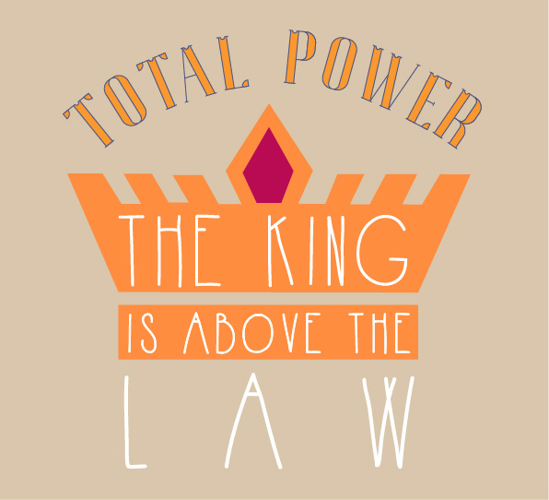
At this time in England, the political system that existed was known as feudalism or the feudal system. The feudal system was a rigid hierarchy where peasants served wealthy land owning lords, in exchange for their protection. At the top of this hierarchy was the monarch, who held absolute power.
Absolute monarchy is the term used to explain when a ruler holds total power, and can make any laws or decisions without having to consult the people or a representative assembly (such as a parliament).
Explain to students that in this time and place, the common people did not have any say in decision making processes. Only the wealthy nobility could do this. And the King had the power to overrule everyone.

Role play activity: Absolute monarchy
This activity is designed to explore the concept of absolute monarchy. In this activity the teacher plays a “despotic monarch” who introduces a series of arbitrary rules to the class. A printable worksheet of these new rules is available on the next page.
Discussion questions:
- Do you agree with the new rules?
- Are the new rules unfair? Why/ why not?
- How could you ensure that these new rules are not introduced into the class? (e.g. go to the school principal or Student Representative Council)
- What would fair rules be like? Should students be free to do whatever they want?

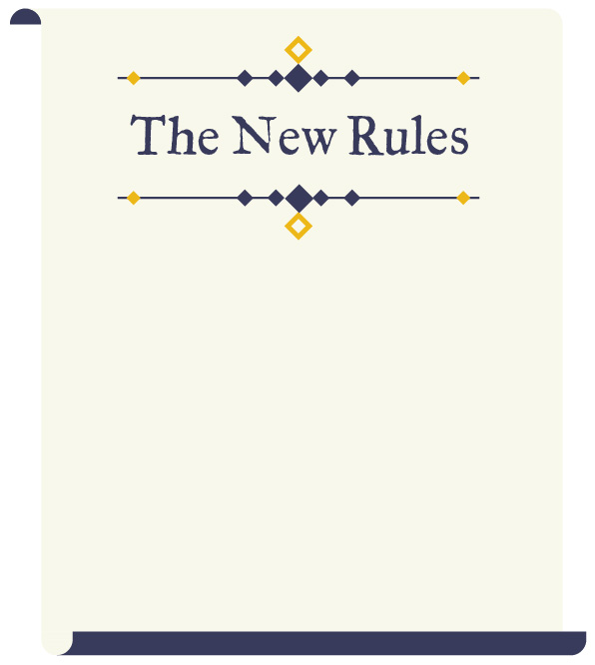

New rule 1: Teachers may hit students at any time
New rule 2: Students must convert to their teacher’s religion
New rule 3: Teachers can go through students’ bags at any time and examine their property
New rule 4: Anyone who criticises the new rules will be punished
New rule 5: Students cannot talk to each other or stand in groups of more than two during school hours
New rule 6: Students can be given a detention at any time without reason. They are not allowed to argue with this decision
New rule 7: Teachers can take any mobiles from students and keep them for their own use
New rule 8: Students whose names start with the letter R cannot come to school ever again and will instead clean public toilets eight hours a day

Acknowledgment: This activity has been adapted from activities in the following resources:
Right Here, Rights Now, Teaching Citizenship through Human Rights, UK Ministry of Justice and British Institute of Human Rights, p.25; and Magna Carta for Schools - Key stage 2, The Magna Carta Project, p.5.

Viewing activity: “The Story of Our Freedom” video
As a class, watch the “The Story of Our Freedom” video.
Having viewed the video and discussed the key facts of the story, ask the class to share why they think Magna Carta was so important at the time and why it is still significant today. Draw out the following:
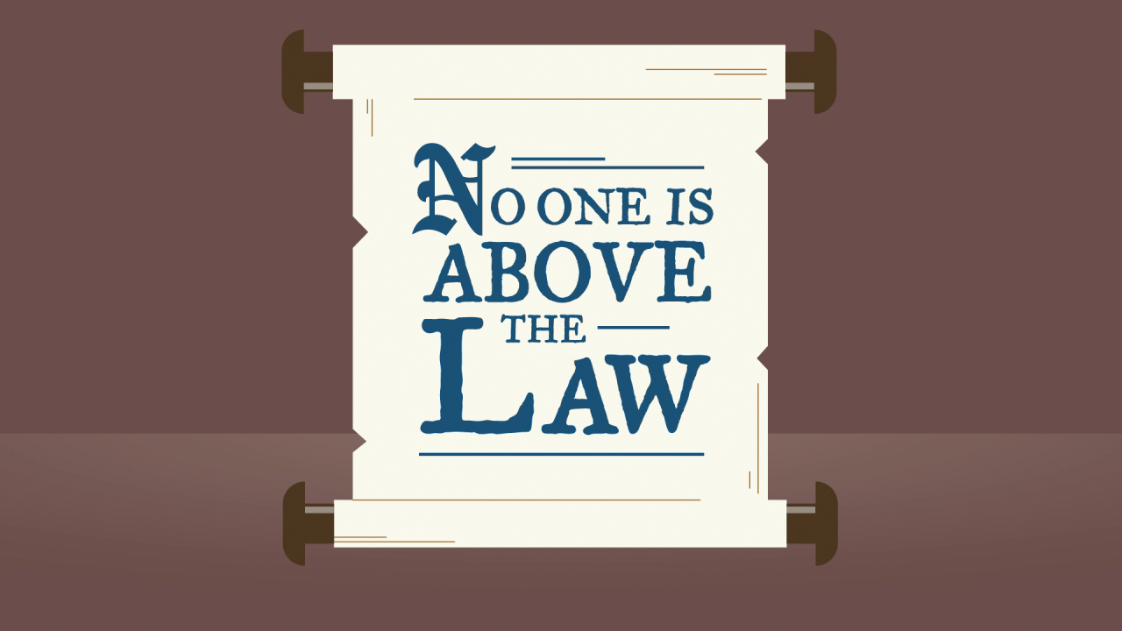 | 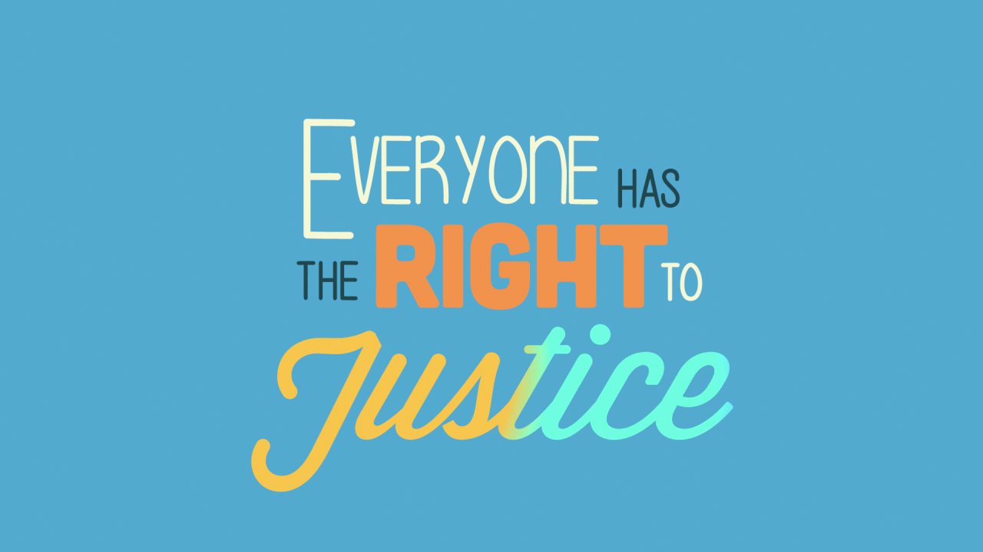 | 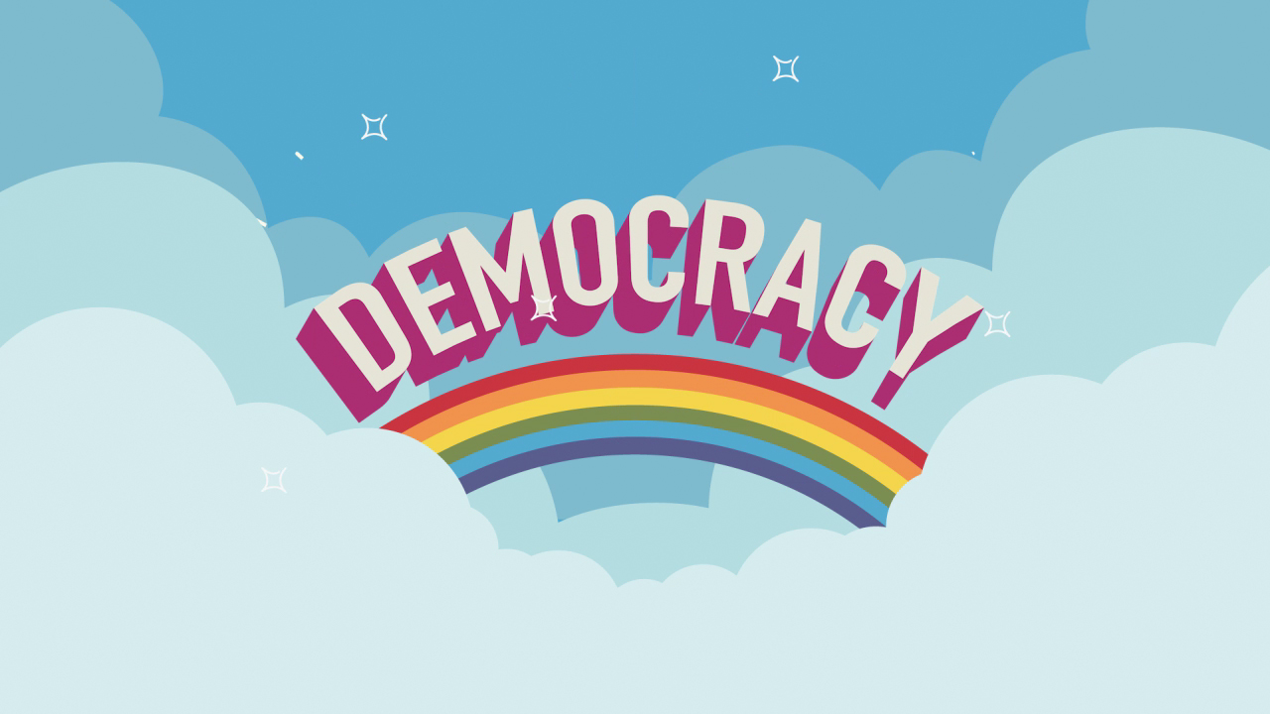
It established for the first time that the king is not above the law | It gave rights to (a select group of) people, including the right to a fair trial | It was the start of a process that eventually led to democracy as we know it today

Extension activity: design a shield
Allow children to design their own shields. Explain that the knights in medieval times often wore a coat of arms, which was an artistic design that illustrating which noble family a knight came from. This was often displayed on the knight’s shield.
Instruct students to incorporate visual elements into their shields design that represent:
- their family
- their likes and interests
- include a motto that reflects their values (e.g. showing kindness to all, always respecting others)

Bright ideas in the Age of Enlightenment
Background information: Significant development in thinking about equality and rights took place in the seventeenth and eighteenth centuries. This found expression in the American Declaration of Independence (1776) and the subsequent Bill of Rights written into the American Constitution (1791), and the French Declaration of the Rights of Man and the Citizen (1789).
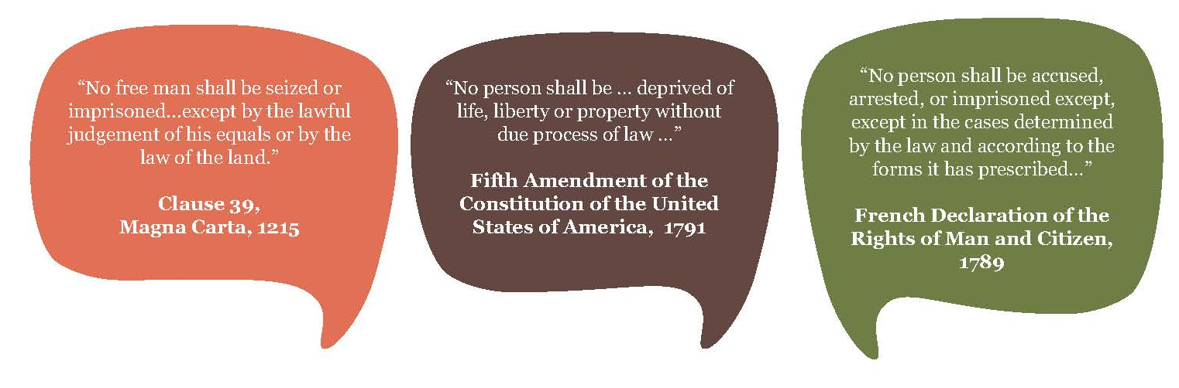
You may wish to point out to students that there are clear echoes of Magna Carta in some of the important documents the emerged in this time period, for example, the American Bill of Rights and the French Declaration of the Rights of Man and Citizen. For example:

Class discussion: Emerging ideas of equality
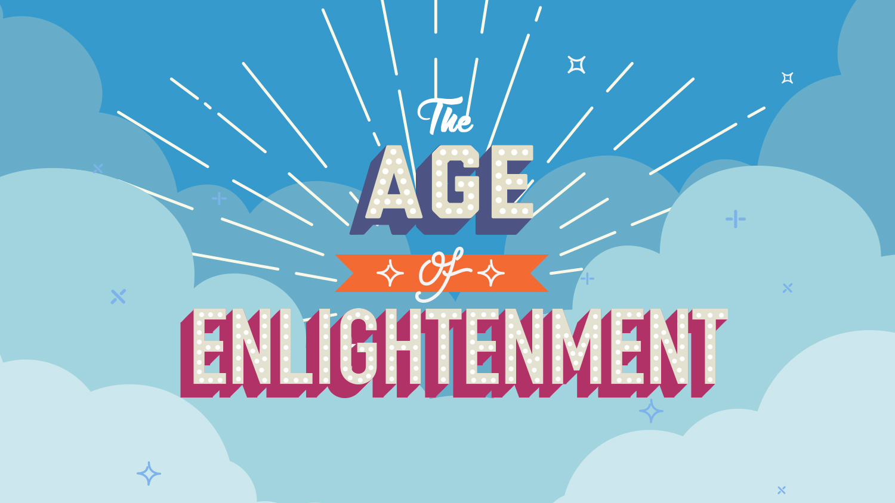
Ask students to explore the Magna Carta interactive infographic, focussing specifically on the sections relating to the Age of Enlightenment through to the United States revolution. Remind students to click on the red diamonds for additional information!
Ask students to identify the significant ideas about rights and freedoms that emerged in this period.
An important idea that emerged during the Age of Enlightenment was the idea that there is a ‘natural law’ that stands above the law of rulers. In previous times, the focus had been on the absolute and unquestionable power of rulers. Now the emphasis starts to shift to the rights of the individual in relation to the State. This means that individuals have certain fundamental rights and freedoms simply because they are human beings.
Make sure to point out to students that despite this shift there were still large groups of people, such as women, who were not seen as having these rights and freedoms.

Origins of Australia’s parliamentary system
Australian Curriculum content code: History Year 6 ACHHK113
Ask students to describe what kind of government system Australia has. (You may prompt students by asking: are we a republic like the US? Do we have a monarch, i.e. king or queen? Are they an absolute monarch like King John?)
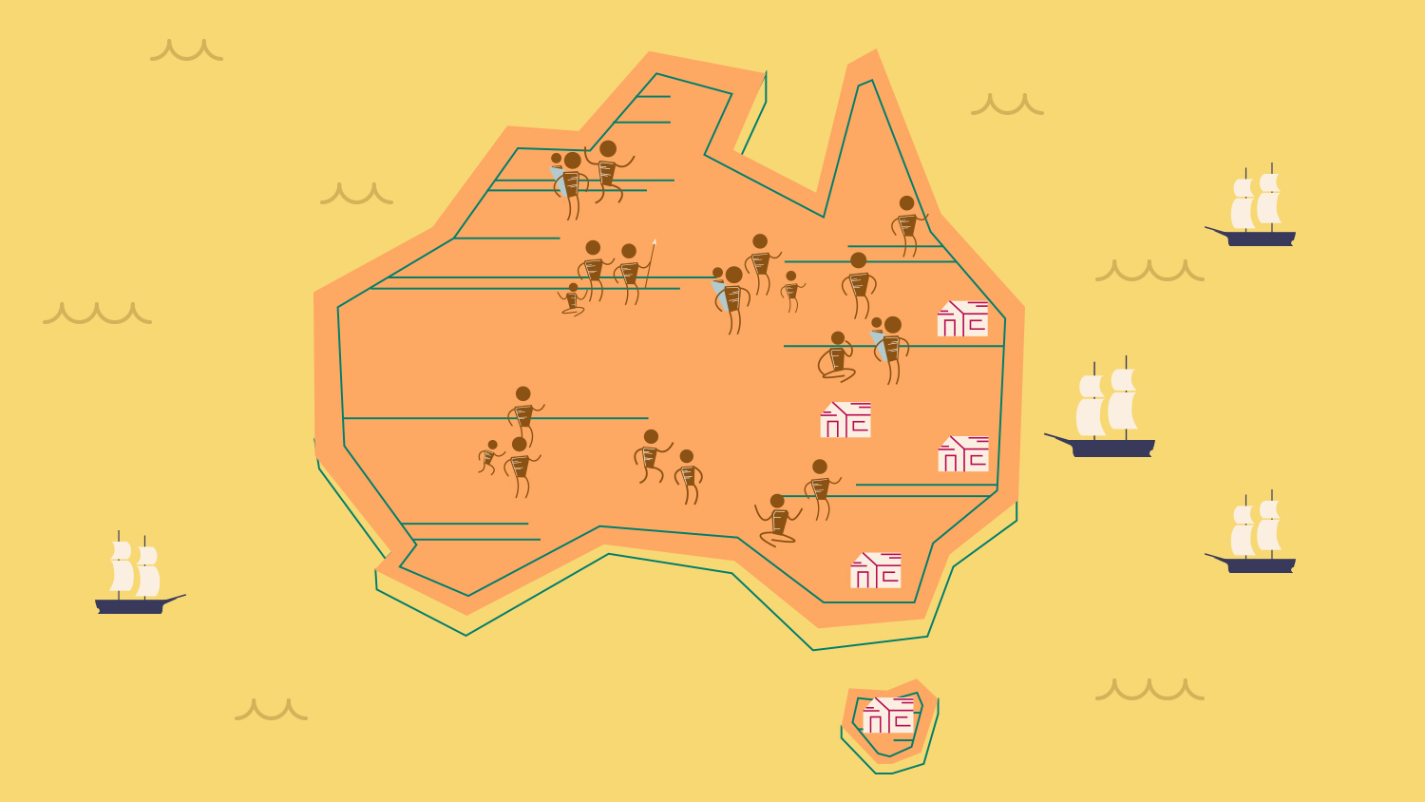
Direct students to explore the sections of the infographic relating to Australia’s establishment as a nation, starting from Captain Cook’s arrival up to Federation.
Ask students to identify how the American and British models of government influenced Australia’s democratic system of government.
You may also instruct students to do some additional online research on US Federalism and the UK Westminster System in order to answer this question.
For a detailed teacher overview of how the Australian Constitution borrowed from the American and British models of government refer to the Discovering Democracy webpage: “The Australian Nation: Constitution Making”.

Research activity: Experiences of Australian democracy and citizenship
Australian Curriculum content code: History Year 6 ACHHK114
Refer students to the section of the infographic that depicts three groups in Australia who historically have struggled to receive recognition of their rights: women, migrants and Aboriginal and Torres Strait Islander Peoples.
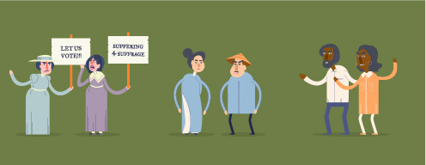
Using this as a starting point for an online investigation, ask students to select one group and research their experiences of Australian democracy and citizenship. Then assign specific topics for investigation.
In summarising their research findings, ask students to provide information on the following points:

- What rights and freedoms did your chosen group have to fight for?
- List some of the reasons why your chosen group was historically denied these rights and freedoms.
- Explain how your chosen group achieved recognition of their rights, with reference to one key historical event.
- Are there any rights that your chosen groups are still fighting for?
Women | Migrants | Aboriginal and Torres  Strait Islander Peoples
 |  | 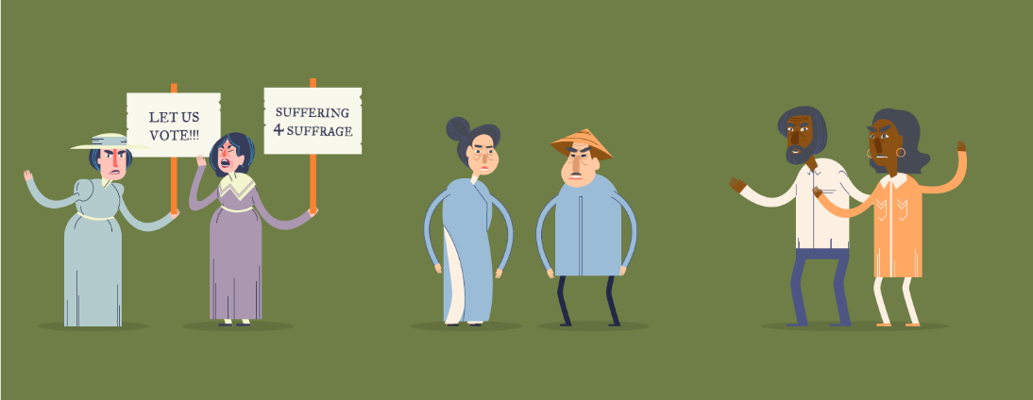
Topics for investigation:  - the suffragette movement  - the bar on married women working  - the equal pay movement  - the Sex Discrimination Act 1984 | Topics for investigation:  - assimilation policies  - anti-discrimination legislation  - mandatory detention  - poor pay and working conditions | Topics for investigation:  - controls on movement and residence  - the forcible removal of children from their families leading to the Stolen Generations  - the 1962 right to vote federally  - the 1967 referendum

Discussion activity: Australian democratic values
Beyond the political system and governance structure of a parliamentary democracy, there are other elements to living in a democracy, such as respecting certain values and ideas.
Pose the following question to the class: We say that Australia is a democratic society, what does this mean?
Discuss with the class what values might come out of living in a democracy. You may wish to write the four following headings on the board to prompt student discussion: freedom, equality, fairness and justice.

Rights and freedoms in Australia today
In Australia today, we are fortunate to hold many rights and freedoms, some of which have been passed down from as far back as Magna Carta, 800 years ago!
The interactive infographic illustrates some of the rights and freedoms that we enjoy today: such as freedom of speech, the right to vote, freedom of religion (the right to worship) and the right to a fair trial.
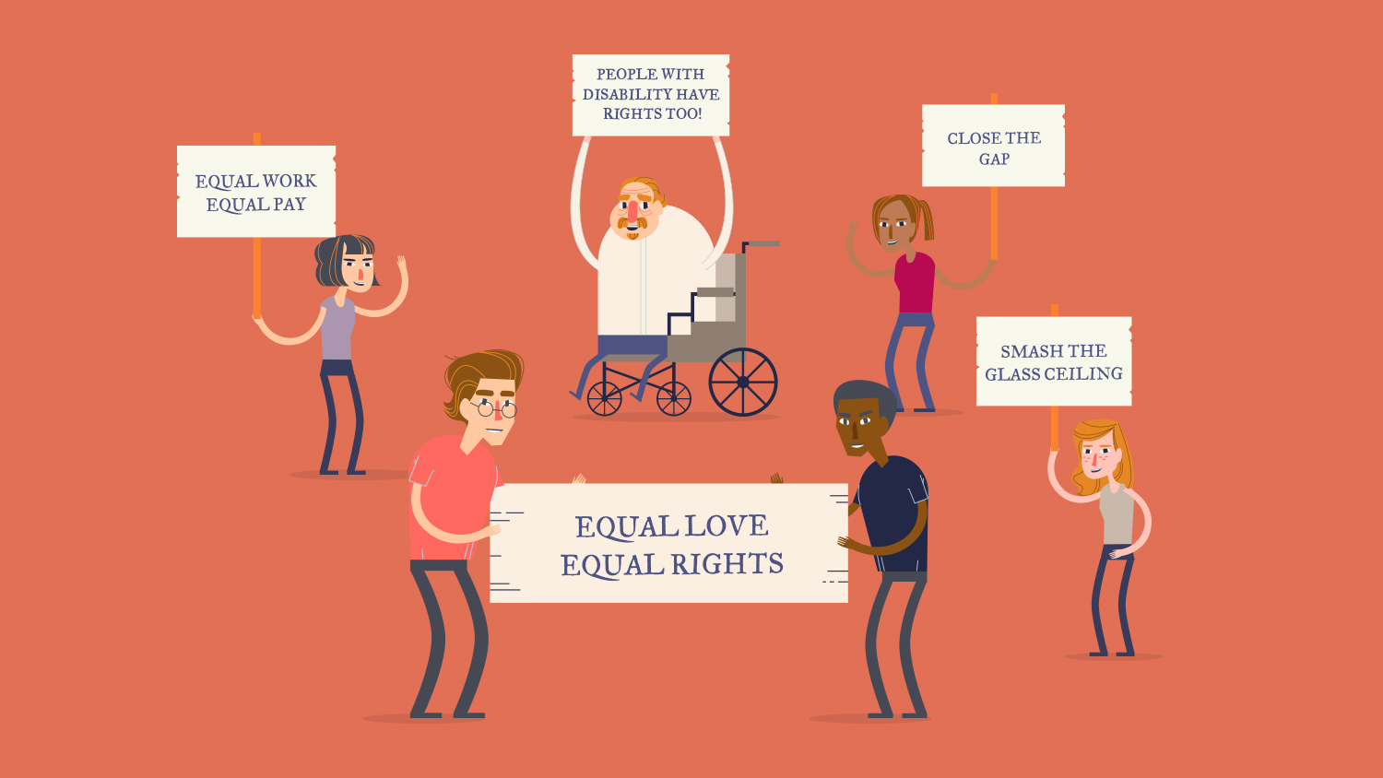
Ask students if they can think of any other rights and freedoms that they are entitled to. (Some suggestions include: freedom of association, equality before the law, the right to non-discrimination).
Point out that many of these rights overlap with the democratic values of freedom, equality, fairness and justice explored in the previous discussion.
Emphasise to students that just because we have certain rights and freedoms, doesn’t mean that they are always protected and upheld. Refer students to the image showing the group of people advocating for a range of human rights issues.
Pose the following questions:
- Have you heard of any of the slogans shown on the signs before? What rights and freedoms are the people advocating for? (If students are not able to identify a particular human rights issue, ask them do some research and find out what it is about)
- Do any of these placards have any relationship to the struggles experienced by women, migrants and Aboriginal and Torres Strait Islander Peoples, which were explored earlier? (for example, the Close the Gap campaign shows that Aboriginal and Torres Strait Islander people still experience forms of inequality)
- What other important human rights issues in Australia can you think of, that aren’t shown here? (for example, efforts to tackle racism, issues surrounding asylum seekers and refugees, homelessness)

Summative activity: A “Great Charter” for your classroom
Remind students, that as individuals everyone has the power to stand up and demand rights for themselves and others. They can do this at home, in the community, in the playground, and even in the classroom!
Ask students to consider: if you had to make a Magna Carta for your classroom, what rights and freedoms would you include?
As a class, brainstorm ideas for a Classroom Charter of Rights and Responsibilities.
To do this, ask students to think about things they think they have a “right” to expect as members of the class (e.g. the right to be treated fairly, the right to express their opinion). Write these down in a list labelled “Our Classroom Rights”.
After students have created their list of classroom rights, ask them to rephrase each right in terms of a responsibility and write these down in a separate list labelled “Our Classroom Responsibilities” (e.g. “Everyone has the right to express their opinion” might be rewritten as “Everyone has the responsibility not to say things that hurt the feelings of someone else”).
Ask students if there are any ideas or principles from Magna Carta that they would include in their new charter. Remind the group of just how different our world is today, compared to 1215. Ask students if they would want to include rights that relate to the modern world, such as a right to internet access?
To inspire the students, you may want to show them the rights and freedoms contained in the Universal Declaration of Human Rights, depicted in this poster from Zen Pencils.
After finishing their Classroom Charter of Rights and Responsibilities, the class may choose to put the poster of their new Charter on display or make a presentation about the Charter at a school assembly, in order to begin a wider discussion about rights and freedoms in the school.

© Australian Human Rights Commission 2015, CC BY 3.0 AU

The Australian Human Rights Commission encourages the dissemination and exchange of information provided in this publication.
All material presented in this publication is provided under a Creative Commons Attribution licence, with the exception of the Australian Human Rights Commission Logo
The details of the relevant licence conditions are available on the Australian Human Rights Commission Copyright Statement webpage.
Attribution: Material obtained from this publication is to be attributed to the Australian Human Rights Commission with the following copyright notice: © Australian Human Rights Commission 2015.
Contact details: For further information about the Australian Human Rights Commission, please visit www.humanrights.gov.au or email mailto:communications@humanrights.gov.au
You can also write to: Human Rights Education Team Australian Human Rights Commission GPO Box 5218 Sydney NSW 2001

