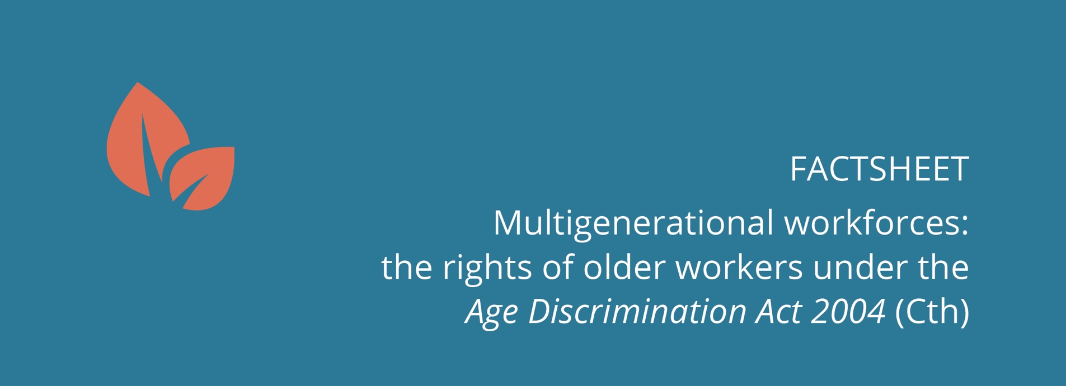

FACTSHEET
Multigenerational workforces: the rights of older workers under the Age Discrimination Act 2004 (Cth)
Australians are increasingly working to older ages, with five generations now working side by side.
While older workers bring valuable skills and knowledge to the workplace, age discrimination still presents a significant barrier to meaningful participation in the workforce.
This factsheet provides information on the core provisions of the Age Discrimination Act 2004 (Cth) (the Act) as they relate to discrimination against older workers.

Work relationships
The Act covers a broad range of ‘work relationships’, and prospective work relationships (for example, when a person has applied for a role and is moving through the recruitment process).
Work relationships may, for example, be employee and employer; partner and partners; commission agent and principal; contract worker and principal; or an employment agency, employer and employee/worker.
Work
‘Work’ is not defined in the Act. It is used in this factsheet to refer to activities undertaken in the context of the relationships outlined above. Examples of work include the activities of a partner in an accounting firm or a barista employed in a café.
Work provider
The term ‘work provider’ is not used in the Act. It is a collective term used in this factsheet to refer to all parties who engage another person to do work or partner with them in a partnership, whether as an employer, fellow partner, principal (in the context of a commission agent or contract worker) or employment agency.
Workplace
‘Workplace’ is not defined in the Act but is used in this factsheet as a collective term to refer to all of the places and contexts in which work is conducted. Examples of workplaces include an office, factory, or shop.

What is age discrimination?
Age discrimination can be direct or indirect.
Direct discrimination occurs when a person is treated less favourably than another person because of their age, or a characteristic generally associated with a person of that age, in circumstances that are the same or not materially different.
For example, if a person is selected for a redundancy simply because they are aged over 55 this is likely to amount to direct discrimination on the basis of age.
Indirect discrimination can be less obvious. It occurs when a condition, requirement or practice that applies to everyone, disadvantages people of a particular age, and the condition, requirement or practice is not reasonable in the circumstances.
In a work context the employer or work provider is required to prove that the condition, requirement or practice is reasonable.
For example, it could be indirect discrimination if an employer requires an older person to meet a physical fitness test, which more young people are able to meet, if that fitness standard is not necessary for the job in question.

When is it unlawful to discriminate in a work context?
The Act makes it unlawful to discriminate on the basis of age in relation to, amongst other things:
- recruitment arrangements
- decisions about who should be offered a role
- access to the benefits of a role
- access to promotion, transfer or training opportunities
- the terms and conditions of a role
- termination
- any other detriment.
A broad range of work providers, and work relationships, are covered under the Act, including the Commonwealth government, state government, private sector, partners, contract workers and commission agents.
The Act also applies to recruitment processes performed by employment agencies on behalf of employers.
Age discrimination against older workers may include not inviting a person aged over 50 to join a partnership because they won’t ‘fit in’ with the ‘young vibe’ of the team.

The Act also creates offences in relation to discrimination based on age in the context of:
- job advertisements
- victimisation as the result of a complaint or other action under the Act.

It is also unlawful for other bodies that are not work providers to discriminate against a person in relation to activities connected to work.
For example, it is unlawful for a body that issues qualifications (such as a TAFE or university) or an organisation or association registered or recognised under the Fair Work (Registered Organisations) Act 2009 (Cth) (such as a union) to discriminate against a person based on their age in particular circumstances.
It is also important to note that requesting information about a person’s age for the purpose of discriminating against them is also unlawful.

When is discrimination allowed?
Discrimination on the basis of age is allowed where:
- it constitutes ‘positive discrimination’
- a specific exemption applies
- a general exemption applies
- a temporary exemption exists.

3.1 Positive discrimination
Under the Act it is permissible to positively discriminate in favour of a person by providing them with a genuine benefit, or doing something that helps meet an identified need for people of their age group.
For example, a recruitment campaign targeted at unemployed or underemployed older workers (an act intended to reduce disadvantage) is likely to be a form of positive discrimination.

3.2 Specific exemptions
There are two forms of specific exemption under the Act:
- domestic duties—where the job is based in the employer’s home
- inherent requirements—where the age of the person means that they are unable to carry out the ‘inherent requirements’ of a role.
Neither ‘domestic duties’ nor ‘inherent requirements’ are defined in the Act. ‘Inherent requirements’ can be understood as something essential to the position.
These exemptions are work relationship specific—for example, their operation will depend on whether the relationship is one of employment, partnership, engagement as a contract worker or commission agent, or through an employment agency.

3.3 General exemptions
There are a number of general exemptions to the core anti-discrimination provisions of the Act. Depending on the circumstances these may be relevant in a workplace context.
The general exemptions relate to:
- charities, religious and voluntary bodies
- superannuation, insurance and credit
- health
- direct compliance with the law, a court order, or taxation and social security legislation
- targeted Commonwealth employment programs
- administration of migration and citizenship laws
- youth wages.
For example, an employer could facilitate the provision of free flu vaccinations for employees over a certain age only, where the vaccination is part of an ‘exempted health program’, without unlawfully discriminating against younger employees.

3.4 Temporary exemptions
An organisation may also apply to the Australian Human Rights Commission (the Commission) for a temporary exemption for up to five years. Given the other general exemptions that already exist in the Act, the Commission grants temporary exemptions sparingly.
The Commission has published guidelines about how it assesses applications for temporary exemptions under the Act.

Who is responsible for unlawful discrimination?
Legal responsibility—or liability—determines who has to pay compensation or take other actions because of a finding of unlawful discrimination.
Both an individual, or organisation, that discriminates against an individual, and a person who ‘causes, instructs, induces, aids or permits’ another person to unlawfully discriminate can be held liable under the Act.
An employer or other work provider can also be vicariously liable for the actions of employees or agents where these amount to unlawful discrimination, or an unlawful request for information, unless they have taken reasonable precautions or conducted due diligence to prevent discrimination on the basis of age.

Further information
For more detailed information on the Act, definitions of the terms referred to in this factsheet, and how to promote the inclusion of older workers in a multigenerational workplace see Multigenerational workforces: a guide to the rights of older workers under the Age Discrimination Act 2004 (Cth) or visit the Commission’s Age Discrimination page.

www.humanrights.gov.au

