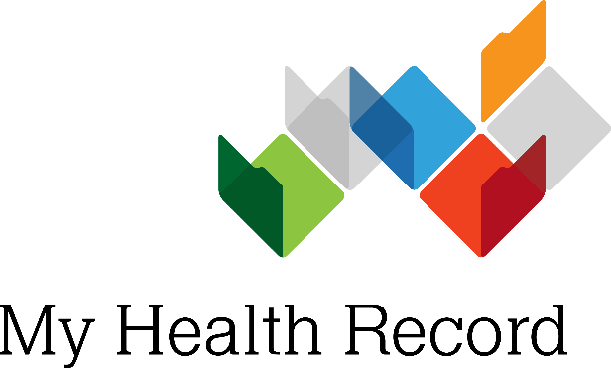
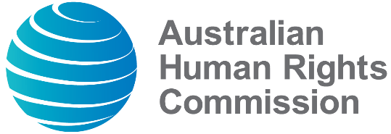
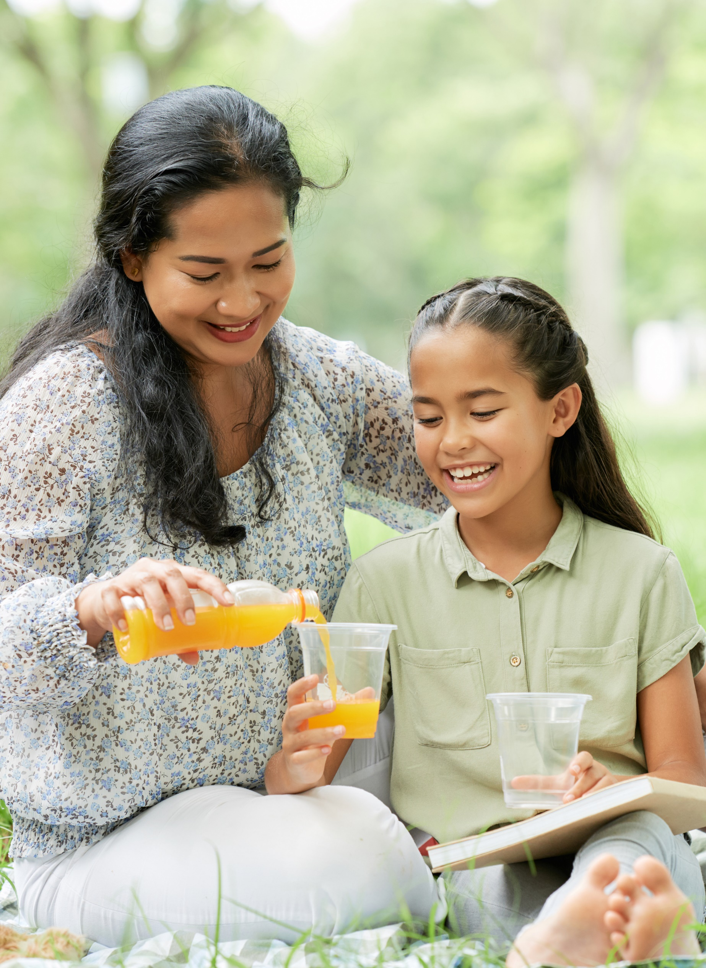

Stage 3 lesson plan

Lesson Overview
In this lesson, students will be introduced to the concept of children’s rights and how the United Nations Convention on the Rights of the Child (1989) both defines and protects these rights. Students will explore specific rights; such as the right to health (article 24), the right to privacy (article 16), the right to participate in decisions that affect them (article 12) and the right to get accurate information (article 13) by using My Health Record as a case study.

My Health Record is a secure online summary of your health information. Young people can manage their own My Health Record from the age of 14. My Health Record allows children and young people to participate in decision-making about their health data and get accurate information about their own health. It also protects their right to privacy and to high-quality health care.

Throughout this lesson, students will be encouraged to find and locate relevant information about My Health Record, and explore ways in which they can discuss My Health Record with their parents/carers, medical professionals and other significant adults in their lives. This learning will be linked to relevant articles of the United Nations Convention on the Rights of the Child (1989) to assist students in developing an understanding of children’s rights both in Australia and globally. Students will apply this knowledge in a range of age-appropriate ways; and complete a summative assessment quiz following completion of the teaching and learning activities.

Additional resources relating to My Health Record and the United Nations Convention on the Rights of the Child (1989) can be found on the final page of this lesson plan in the ‘Further Reading’ section.

Learning Intentions
Students will understand:
- Their rights as children/young people in Australia
- What My Health Record is
- Their rights as children/young people in relation to My Health Record
- That children can manage their own My Health Record from age 14
- Safe behaviours in relation to accessing and recording personal information on My Health Record

Assessment
There are a range of opportunities for assessment in this lesson, including:
- Student participation in class and group discussions
- KWL Chart to reflect development of student understanding
- Review students’ role play improvisations to assess for understanding
- Summative True/False Quiz

Australian Curriculum Links – Stage 3

Health and Physical Education
Personal, social and community health | Being healthy, safe and active
Investigate community resources and ways to seek help about health, safety and wellbeing (ACPPS053)

Humanities and Social Sciences
Inquiry and skills | Questioning
Develop appropriate questions to guide an inquiry about people, events, developments, places, systems and challenges (Year 5 - ACHASSI094 | Year 6 - ACHASSI122)
Inquiry and skills | Analysing
Examine different viewpoints on actions, events, issues and phenomena in the past and present (Year 5 - ACHASSI099 | Year 6 - ACHASSI127)
Inquiry and skills | Evaluating and reflecting
Work in groups to generate responses to issues and challenges (Year 5 - ACHASSI102 |Year 6 - ACHASSI130)
Knowledge and understanding | Civics and citizenship
The key values that underpin Australia’s democracy (ACHASSK115)

Digital Technologies
Digital technologies processes and production skills
Explain how student solutions and existing information systems are sustainable and meet current and future local community needs (ACTDIP021)

The Arts
Drama
Develop skills and techniques of voice and movement to create character, mood and atmosphere and focus dramatic action (ACADRM036)

General Capabilities
- Literacy
- Personal and Social Capability
- ICT Capability

Resources
- Whiteboard or Flipchart
- Internet
- Video recording devices (optional)

Lesson Introduction (10 minutes)
- To begin the lesson and activate prior knowledge, ask students to consider what they already know about children’s rights and record any questions they may have. Students will complete the first two columns of a KWL Chart (what I already know, what I want to know, what I have learned) to structure their thinking.

K  What do you already know about children’s rights? | W  What do you want to learn about children’s rights? | L  What have you learned about children’s rights?  (to be completed at the conclusion of the lesson)

- Upon completion of the first two columns of the KWL Chart, ask students to share some of the ideas they have recorded. Discuss as a class.

- Introduce students to the United Nations Convention on the Rights of the Child (1989). Discuss key features including some of their rights under the Convention. Share the following information with students to further support understanding. Additional information can be found in the ‘Further Reading’ section of this lesson plan.
- The United Nations Convention on the Rights of the Child (1989) was adopted by the United Nations General Assembly on November 20, 1989.
- Australia ratified the Convention on December 17, 1990.
- The United Nations Convention on the Rights of the Child (1989) applies to all children and young people under the age of 18, regardless of their race, religion, abilities, whatever they think or say, or whatever type of family they come from.
- The Convention explains which rights children have and what governments must do to protect these rights.

- Watch this video (https://www.youtube.com/ watch?v=caYPHvufYgQ) as a class to introduce students to My Health Record. Discuss how My Health Record protects their rights as children/young people as stated in articles 24, 16, 13 and 12 of the United Nations Convention on the Rights of the Child (1989). Please see the supporting resources in the ‘Further Reading’ section of this lesson plan for additional information.

- As a class, discuss the importance of online safety when using My Health Record. Encourage students to consider strategies for keeping their online accounts secure, including the use of strong passwords and the potential risks when using public WiFi. Please see the ‘Further Reading’ section of this lesson plan for additional resources relating to online privacy and security.

Body of Lesson – Activity 1 – My Health Record Scenario (15 minutes)

- Introduce students to the following four scenarios that relate to My Health Record:

- Mohammad is 16. He doesn’t know if he has a My Health Record. He would like to find out some more information about what My Health Record is and how to use it.
- Jumana is 12 and has a My Health record. She sees the benefits of My Health Record but knows that her mum is worried about privacy. She also overheard her mother tell her step-dad that they should both cancel their My Health Record because of online security concerns.
- Sung-Ae has a severe allergy to peanuts. If she comes into contact with peanuts, she can experience anaphylaxis – which is a life-threatening, whole body response to an allergen. She has been rushed to hospital by ambulance three times because of her allergy.
- Jacob is 15. For the past few months he has been feeling sad and miserable, and has stopped going out with his friends. He told his parents how he was feeling and they suggested that he should talk to the family doctor. The doctor has prescribed some medication for Jacob. Jacob has also started seeing a counsellor.
- Explain to students that they will participate in a brainstorming activity to further explore each of the above scenarios. Students will work in small groups and rotate around the classroom, stopping at various stations for a designated period of time (ideally 2-3 minutes) to discuss each scenario and brainstorm responses to the following reflection questions:

- Who could the young person in this scenario talk to about My Health Record?
- What advice would you give to the young person in this scenario?
- What online safety advice would you give to the young person in this scenario?

- Students will use the following table to record their ideas about My Health Record as it relates to each scenario. Upon completion, share and discuss responses as a class.

Scenario:
Who could the young person in this scenario talk to about My Health Record? | What advice would you give to the young person in this scenario? | What online safety advice would you give to the young person in this scenario?

Body of Lesson – Activity 2 – Improvised Role Play Scenario
(25 minutes)

- Explain to students that they will be working in small groups to role play a scenario that explores the impact of either My Health Record or the United Nations Convention on the Rights of the Child (1989) on themselves, their peers, and the wider school community. Role plays should be based on one of the following scenarios:

- You and your family have recently moved to Australia. Your parents/carers have never heard of My Health Record. Act out a conversation between you and your parents/carers. What would you tell them about My Health Record and how it works? What questions might they ask you about My Health Record? How would you explain what happens to your record when you turn 14? Where could your family find out more information about My Health Record? Who could help your family understand the My Health Record and what information might they share with you?
- The year is 1990 and the Convention on the Rights of the Child has just been ratified by Australia. Your school’s Principal has invited students in Years 5 and 6 to share ways in which you want your rights to be supported and upheld by the school. Role play a conversation with your Principal. Consider what questions your Principal might ask about the Convention on the Rights of the Child. What information and ideas could you share with your Principal? What role do you think your school could play in ensuring that children’s right to good health is protected? Who else might need to be involved in the conversation? Where could you find more information about the Convention?

- Each group should prepare and rehearse their role play.

- Invite students to perform role play scenarios to the class and offer constructive teacher and peer feedback. Teachers may also choose to ask students to use a recording device to film their performance (optional).

Lesson Conclusion (10 minutes)

Revisit the KWL Chart and ask students to complete the final ‘what I learned’ column. Share and discuss as a class.

Explain to students that they will participate in a True/False quiz. Following completion of the quiz discuss each answer as a class. Statements and answers are as follows:

Statement | True/False
My parent/guardian will have access to my My Health Record until I turn 18. | FALSE. When you turn 14, you can manage your own record and your parent/guardian will no longer have access. If you want them to have access you can invite them.
I must sign up to My Health Record by law. | FALSE. You can choose to have or cancel a My Health Record at any time. If you are under 14, your parent/guardian can cancel your My Health Record.
I can see who has accessed my My Health Record. | TRUE. My Health Record shows you who has accessed your record.
The United Nations Convention on the Rights of the Child (1989) protects the rights of all children. | TRUE. The Convention protects the rights of everyone under 18, regardless of their race, religion, beliefs, or family background.
I have a right to privacy under the United Nations Convention on the Rights of the Child (1989). My Health Record promotes this right. | TRUE. The Convention protects your right to privacy. My Health Record helps you to enjoy this right.
Australia ratified the Convention in 1990. This means the Australian Government agreed to uphold the rights of children and young people outlined in the Convention. | TRUE. In December 1990 Australia agreed to uphold and protect the rights of its children and young people. The Convention on the Rights of the Child is the most widely ratified human rights treaty in the world.

Going Further

To further consolidate and extend student learning about My Health Record, the following activities can be completed:
- Ask students to work in small groups and select one of the ‘My HealthRecord scenarios’ from Activity 1 to explore further. Invite students to create a short improvisation that elaborates on the scenario and explains how My Health Record could support the young person. Encourage students to perform their improvisation for a group of peers.
- As a class, brainstorm conversation starters that may assist students in opening a discussion about My Health Record with their parent/carer, or another trusted adult in their life.

Further Reading

Australian Digital Health Agency. (2019). Are You 14 or Over? You can manage your own health information. Retrieved from https://www.myhealthrecord.gov.au/for-you-your-family/howtos/manage-your-record-from-age-14

Australian Digital Health Agency. (2019). For You and Your Family. Retrieved from https://www.myhealthrecord.gov.au/for-you-your-family

Australian Digital Health Agency. (2019). Frequently Asked Questions. Retrieved from https://www.myhealthrecord.gov.au/for-you-your-family/howtos/frequently-asked-questions

Australian Human Rights Commission. (2019). About Children’s rights. Retrieved from https://www.humanrights.gov.au/our-work/childrens-rights/about-childrens-rights.

Australian Human Rights Commission. (2019). What Are Children’s Rights? Retreived from https://www.youtube.com/watch?v=HHNfaPuoZHM
Australian Human Rights Commission. (2020). Child-Friendly Version of the Children’s Rights Report 2019. Retrieved from https://www.humanrights.gov.au/our-work/childrens-rights/publications/child-friendly-version-childrens-rights-report-2019

My Health Record Youtube Channel. (2019). Accessible at https://www.youtube.com/channel/UC2FLSV2THQY5bqc2uh2cEUQ

Office of the eSafety Commissioner. (2019). Keeping Your Online Accounts Secure. Accessible at https://www.esafety.gov.au/young-people/keeping-your-online-accounts-secure

UNICEF. (1996). Convention on the Rights of the Child: The Child-Friendly Version. Retrieved from https://www.unicef.org/sop/convention-rights-child-child-friendly-version

United Nations Human Rights Office of the High Commissioner. (2019). Convention on the Rights of the Child. Retrieved from https://www.ohchr.org/en/professionalinterest/pages/crc.aspx
© Australian Digital Health Agency 2020 (with the exception of all photographs and the Australian Human Rights Commission logo).

Information on this topic is available from the Australian Digital Health Agency at www.myhealthrecord.gov.au.

The first version of this resource was created in 2020 for the Australian Digital Health Agency by the Australian Human Rights Commission.

Acknowledgments
The Australian Human Rights Commission would like to thank the school students in Brisbane, Hobart and Sydney who participated in the co-design of these resources. The Commission would also like to thank Kimberlin Education.

This publication can be found in electronic format on the Australian Human Rights Commission’s website at https://www.humanrights.gov.au/education/teachers.

