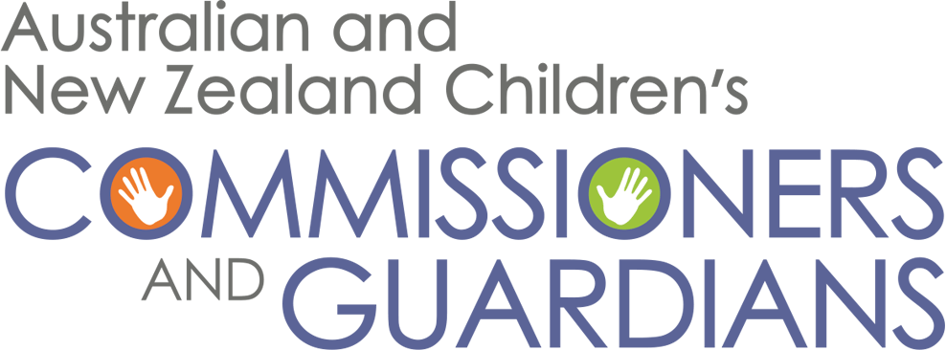

8 March 2022
The Hon Michael Gunner MLA
Chief Minister of the Northern Territory
Parliament House 5
DARWIN NT 0800
By email: Chief.Minister@nt.gov.au
Cc: Minister.Uibo@nt.gov.au
Minister.Worden@nt.gov.au
Minister.Manison@nt.gov.au

Dear Chief Minister

RE: BANNING THE USE OF SPIT HOODS AND MECHANICAL RESTRAINT CHAIRS (MRC) ON CHILDREN

Members of the Australian and New Zealand Children’s Commissioners and Guardians (ANZCCG) write to share our grave concerns about recent announcements by the Northern Territory Police that they continue to use spit hoods and mechanical restraint chairs (MRC) on children despite overwhelming evidence of the harm these restraints cause. There are alternative measures available which should be utilised to ensure the safety of staff and children.

ANZCCG members support calls for the Northern Territory government to legislate protections prohibiting the use of spit hoods and MRC on children and young people in the Northern Territory.

The ANZCCG comprises National, State and Territory children and young people’s commissioners, guardians and advocates. The aim of the ANZCCG is to promote and protect the safety, well-being and rights of children and young people in Australia and New Zealand, and ensure that the best interests of children and young people are considered in public policy and program development across Australia and New Zealand.

Whilst we are aware not all jurisdictions or professions are actively employing the use of spit hoods or MRC on children, to date South Australia is the only jurisdiction within the remit of ANZCCG that have legally banned the use of spit hoods. This matter is too critical to leave under the guidance of policy. State and Territory laws need to be consistent with the aim of the Optional Protocol to the Convention Against Torture (OPCAT), to which Australia is a signatory. This requires a commitment to uphold children’s rights and prevent inhumane treatment. Of greatest concern is the potential for the use of spit hoods to be fatal, exemplified through numerous cases of deaths in custody involving circumstances where spit hoods, or similar devices, have been used.

Children who come to the attention of our justice systems are often some of the most vulnerable and disadvantaged members of our society. Research indicates these children are more likely to have a disability, have experienced trauma and/or been exposed to child protection intervention. Further, a disproportionate number of the children charged with criminal offences each year are Aboriginal and Torres Strait Islander in Australia.

We recognise that police and others working with children have the right to work in a safe environment. It must also be acknowledged that the level of distress experienced by a child as they come into contact with the police can be extreme. The subsequent use of spit hoods or MRC is detrimental and causes significant additional trauma and/or re-traumatisation for these children.

There are less dangerous and more appropriate and effective measures for protecting both children and workers when children in their care become heightened or distressed. These are being widely used across many sectors.

To effectively protect children and young people the use of these alternative measures must be mandated through clearly articulated legislative provisions banning the use of spit hoods and MRC.

Members of the ANZCCG urgently request that every jurisdiction across Australia act to prevent the use of spit hoods and MRC on children by any profession, including but not limited to security officers, departmental staff (including youth detention/training centre), correctional officers, police officers and employees under relevant mental health legislation.

Yours sincerely,

The terms ‘child’ and ‘children’ are used in accordance with the legislative definition of a vulnerable child as per the Children’s Commissioner Act (NT) 2013. However, the ANZCCG acknowledges that there are Aboriginal young people that, in accordance with Aboriginal customary lore, are adults.
Commonwealth, Royal Commission and Board of Inquiry into the Protection and Detention of Children in the Northern Territory Final Report (2017); Ombudsman SA, Investigation concerning the use of spit hoods in the Adelaide Youth Training Centre (2019) <https://www.ombudsman.sa.gov.au/publication-documents/investigation-reports/2019/>
A Hookey, ANU College of Law, Australian State bans use of spit hoods on detainees following death of Indigenous man in custody (2021) <https://www.jurist.org/news/2021/11/australia-state-bans-use-of-spit-hoods-on-detainees-following-death-of-indigenous-man-in-custody/>; E Buddge, Budge and Heipt PLLC Attorneys, Improper use of spit hoods: a recipe for disaster (2015) <https://budgeandheipt.com/blog/improper-use-of-spit-hoods-a-recipe-for-disaster/>; R Felton, The Guardian Detroit, Lawsuit over Michigan man’s death in jail focuses on officers use of spit hood (2016) <https://www.theguardian.com/us-news/2016/jan/11/michigan-death-jail-jack-marden-spit-hood>; J Garrison, USA Today Tennessee, ‘Death of inmate placed in spit hood to cost Metro $150k’ (2015) <https://www.tennessean.com/story/news/2015/10/01/death-inmate-3-hours-after-arrest-cost-metro-150k/73140798/>; M Carter, Seattle Times, Fathers lawsuit blames Seattle police for sons injuries (2011) https://www.seattletimes.com/seattle-news/fathers-lawsuit-blames-seattle-police-for-sons-injuries/; A Watkins, New York Times, What are spit hoods and why do police use them? (2020) <https://www.nytimes.com/2020/09/03/nyregion/spit-hoods-police.html>

