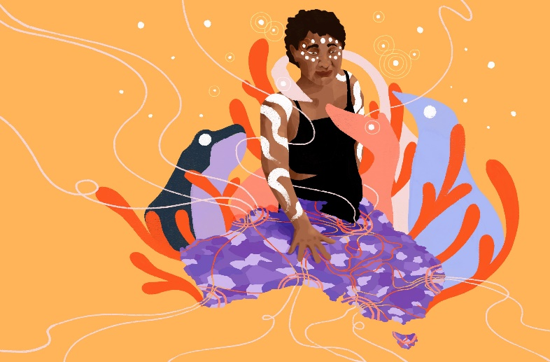
Call for Submissions from Aboriginal and
Torres Strait Islander women and girls

The Australian Human Rights Commission (AHRC) is inviting submissions to contribute to the design of the Wiyi Yani U Thangani Framework for Action for First Nations Gender Justice and Equality (working title) and the establishment of a First Nations Gender Justice Institute.
The Institute and Framework for Action are independent of government, designed by and for First Nations women and girls, to translate the significant evidence of the Wiyi Yani U Thangani project into action to achieve First Nations gender justice and equality.
In designing the Framework and Institute, we are seeking your input to ensure we are working towards the right priorities, and that we are collecting data, taking action and measuring progress against outcomes self-determined by First Nations women and girls. As we progress this work far into the future, we need to ensure that the Framework and Institute deliver the changes women and girls want to see across Australia.
Drawing on your insights, experiences and ideas, we welcome submissions to respond to the following themes:
- Measuring change outcomes
- Ensuring a strong accountability and evaluation approach
- Protecting and strengthening data sovereignty and governance
Below are a series of questions associated with each area to help guide your response. We welcome submissions that respond more generally to the themes, as well as those that answer all, or specific, questions.

How to make a submission
In order to receive as many perspectives as possible from Aboriginal and Torres Strait Islander women and girls, we welcome submissions online or posted as:
- Written text
- Video
- Creative expression (artwork, poetry, song or any other expression you wish to use)
Get excited!
Be in the running to win a Yaye gift box as a thank you for your submission.
- Yarn with the team
Submissions are also open to Indigenous and non-Indigenous individuals, groups and organisations who work with Aboriginal and Torres Strait Islander women and girls, and/or have developed measurement and evaluation approaches related to gender equality and intersectional movements. We encourage young people to contribute, however submissions by anyone below 18 years of age will need to be in contact the team directly via phone or email.
Further information on providing a submission, including contact consent, use and privacy is provided below.
The closing date for providing submissions is 22 December 2023.

What is the Framework and Institute?
Stage Three of the Wiyi Yani U Thangani project involves the development of the Framework for Action for First Nations Gender Justice and Equality and the establishment of a First Nations Gender Justice Institute at the Australian National University, to be launched in March 2024.

The Framework and Institute build on the success of the Wiyi Yan U Thangani Project in making the lives, rights and needs of First Nations women and girls visible. They will also build on and respond to the themes and priorities set out in the Wiyi Yani U Thangani (Women’s Voices): Securing our Rights, Securing our Future Report (2020) and Implementation Framework (2021).
The Framework will be an overarching generational tool highlighting the actions and responses that can enable change to occur from the ground to the international level, and across different parts of the system from laws and policies to shifting public attitudes and behaviours. It will also be an advocacy tool for women and girls everywhere, a change-making guide for all stakeholders, and will support governments and stakeholders to take a First Nations gender responsive approach to policy and decision-making.
The Institute and Framework are co-related—the Institute will drive the implementation and monitoring of the Framework, as well as developing and creating pathways for research, stakeholder engagement and projects, supporting community practices, knowledge translation, and advocacy.

Focusing on measurement and evaluation
Our approach to measurement and evaluation will bring together and respond to existing Wiyi Yani U Thangani ways of working and principles, and address the four key thematic areas, priorities and actions set out in the Implementation Framework. Additional actions and outcomes will also continue to be developed throughout the design of the Framework and Institute and may change over time based on feedback.
This submission process will help construct what these approaches look like and how we can best work towards achieving our priorities, goals and outcomes.

Why now?
The ongoing work of the Framework and Institute will be a part of the mosaic of Indigenous-led initiatives that will continue the journey of peaceful and healing dialogues and nation-building. A First Nations gender justice and equality approach to systems change has the potential to unite Australians of all backgrounds with First Nations people’s lived realities and immense and diverse knowledges, to form a more inclusive and equitable society for all.

Feedback received through the Wiyi Yani U Thangani National Summit
Feedback was initially sought from delegates attending the Wiyi Yani U Thangani National Summit: We are the Change held in May 2023 through a post-summit survey and gathered through discussions during summit presentations and sessions. This feedback has provided useful insight guiding the design phases of this exciting work.
Read this feedback on our website: https://wiyiyaniuthangani.humanrights.gov.au/framework-for-action

Guiding questions
We encourage you to respond to the following questions and themes, drawing on your lived experience and knowledge. Respondents do not have to answer all questions. If you prefer, you are also welcome to respond more generally to the themes.
Measuring change outcomes: We are interested in learning from your experience about what effective practices (data collection, measurement, and evaluation) look like in order to understand how to measure change outcomes across community, regional, state, national and global settings. We also recognise that there are approaches and methodologies grounded in First Nations women’s knowledges and cultures that should be used when setting outcomes and measuring change, and we are keen to understand what these look like from your experience.
- What change do you want to see for First Nations women and girls, in all their diversity, with their families and communities, to live their lives in the way they want? What would you feel, see, hear, sense or collectively understand if this change was happening?
- In your experience, what practices and approaches are most effective in collecting data, measuring and evaluating change?
- How do you want to see local change practices and data collection inform national priorities and achieve systemic outcomes, and how could this relate to the Wiyi Yani U Thangani Framework for Action for First Nations Gender Justice and Equality?
- Do you have any additional thoughts, views or experiences about gender-specific data and outcomes that could be included in the Wiyi Yani U Thangani Framework for Action for First Nations Gender Justice and Equality and the First Nations Gender Justice Institute’s work?
Ensuring a strong accountability and evaluation approach: An accountability and evaluation approach is necessary to ensure that the Wiyi Yani U Thangani Framework for Action for First Nations Gender Justice and Equality and First Nations Gender Justice Institute can be responsive to the changes that First Nations women and girls, in all their diversity, want to see in their lives and communities. As both the Framework and Institute are independent of government, owned and designed by First Nations women and girls, this approach may be used to hold stakeholders to account if they have a role in realising outcomes.
- Should government (and other stakeholders) be accountable to community determined outcomes? How can this be included in the Wiyi Yani U Thangani Framework for Action for First Nations Gender Justice and Equality?
- What does the Wiyi Yani U Thangani Framework for Action for First Nations Gender Justice and Equality and First Nations Gender Justice Institute need to do to incorporate diverse lived experiences and to ensure that no one misses out on opportunities to contribute to and hear this work?
- We recognise that the process to implement change is just as important as achieving outcomes. How would you want to see implementation processes evaluated over time?
- Do you have any additional thoughts, views or experiences about accountability practices that could be included in the Wiyi Yani U Thangani Framework for Action for First Nations Gender Justice and Equality and the Institute’s work?
Protecting and strengthening data sovereignty and governance: The First Nations Gender Justice Institute will continue the engagement, storytelling and sharing of women's and girls’ voices that has been a core practice of Wiyi Yani U Thangani. These experiences, strengths, issues and aspirations that women and girls share will be used to form part of a living database to help us understand what’s working, what needs to change, and what success looks like.
- What are your hopes and aspirations for what the First Nations Gender Justice Institute’s database on First Nations women’s and girl’s lived experience and voices could look like? How can we ensure safe and considered access and use of the database?
- How do we ensure that this living database is used and owned by First Nations women and girls?
- How can the First Nations Gender Justice Institute support First Nations women and girls to access, contribute to and use the database? How can this help women and girls to make decisions about their own local priorities to measure what works on the ground?
- Do you have any additional thoughts, views or experiences about strengthening data sovereignty and government that could be included in the Wiyi Yani U Thangani Framework for Action for First Nations Gender Justice and Equality and First Nations Gender Justice Institute’s work?

Let us know your views and opinions:
Ensuring that everyone has the opportunity to share their views, experiences and opinions in ways that best suit their needs, we invite submissions as written, video or creative expression (artwork, poetry, song or any other expression you wish to use).
Upload your submission on our website: https://wiyiyaniuthangani.humanrights.gov.au/framework-for-action or scan the QR code:
The online submission form collects some personal information and includes a consent declaration which will only be viewed by the Australian Human Rights Commission (unless there is a legal or regulatory requirement to disclose it).
Please refer to the Australian Human Rights Commission’s Submission Policy and the Participant Information Sheet for more information on use, publication, access, privacy and copyright of submissions received. If consent is provided, submissions will be shared on the Wiyi Yani U Thangani website after the deadline for submissions has closed.
Individuals or groups are also welcome to have a yarn with a member of the Aboriginal and Torres Strait Islander Social Justice team at the Australian Human Rights Commission. Select the yarn option on the links form above and a member of the team will get back to you. Enabling a team member to call you ensures that we don’t miss your call and have time to take notes and listen carefully.
If you would like to mail your submission, please post to:
Social Justice Team, Australian Human Rights Commission
GPO Box 5218 Sydney NSW 2001
If posting, please also complete the online form to provide your consent to being a part of the submissions process.
If you have any further questions or need assistance in providing your submission, please contact the Social Justice Team via phone or email:
- Telephone: (02) 9284 9600
- Email: wiyiyaniuthangani@humanrights.gov.au
- If you are under 18, please email niamh.kealy@humanright.gov.au

Be into the running to win a Yaye bath and body gift box!
The AHRC is offering Yaye gift boxes as a thank you to randomly selected respondents. To enter the running to win a gift box, respondents will be required to opt-in via the online submissions form. Winners will be contacted shortly after the closing date for submissions via their contact number to collect the prize or have it posted. The gift box contains body and bath products by Yaye produced with Indigenous bush medicine ingredients.

