factsheet

Responsible business conduct and the apparel and footwear industry in Viet Nam
Globally, there is increasing expectation on businesses to operate responsibly and sustainably – and at the heart of this is respect for human rights. Following the unanimous endorsement of the UN Guiding Principles on Business and Human Rights (Guiding Principles) in 2011 by the UN Human Rights Council, there is growing focus on responsible business conduct amongst governments, business, investors and civil society.

The apparel and footwear industry is one of Viet Nam’s most important industries, accounting for nearly 20% of all exports and employment for approximately 2.5 million people. As Viet Nam capitalises on its promising economic growth and development, businesses are increasingly expected to take action to respect human rights within the apparel and footwear industry, especially in the context of COVID-19 pandemic.
The impacts of COVID-19 have, and will continue to have, devastating repercussions on the apparel and footwear industry, leaving many unemployed and ultimately in poverty. While many businesses may look to deprioritise their commitment to human rights, the importance of embedding respect for human rights into business operations has never been more critical.

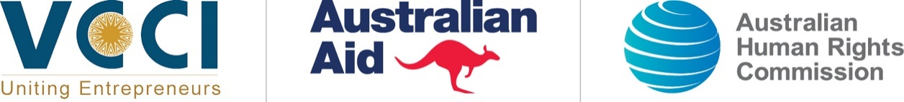
What do human rights have to do with business?
Businesses in Viet Nam are increasingly recognising that respecting human rights is not only the right thing to do, but also good for business. There is growing evidence of social and economic value for a business that embeds human rights considerations into its core business practices, and significant costs when human rights are ignored. Respecting human rights is not just about risk management, it can also create new business opportunities, including access to markets, capital, suppliers and consumers.

Rights at risk: Key challenges for the apparel and footwear industry
Almost all human rights are relevant to business. A company’s operations can have an impact – both positive and negative – on many people, including employees, customers, suppliers and their employees, and communities in which a company operates. However, for business in the apparel and footwear industry in Viet Nam, there are a number of key human rights risks that may exist in their operations or business relationships. Women, children and migrant workers are at particular risk of being exploited.

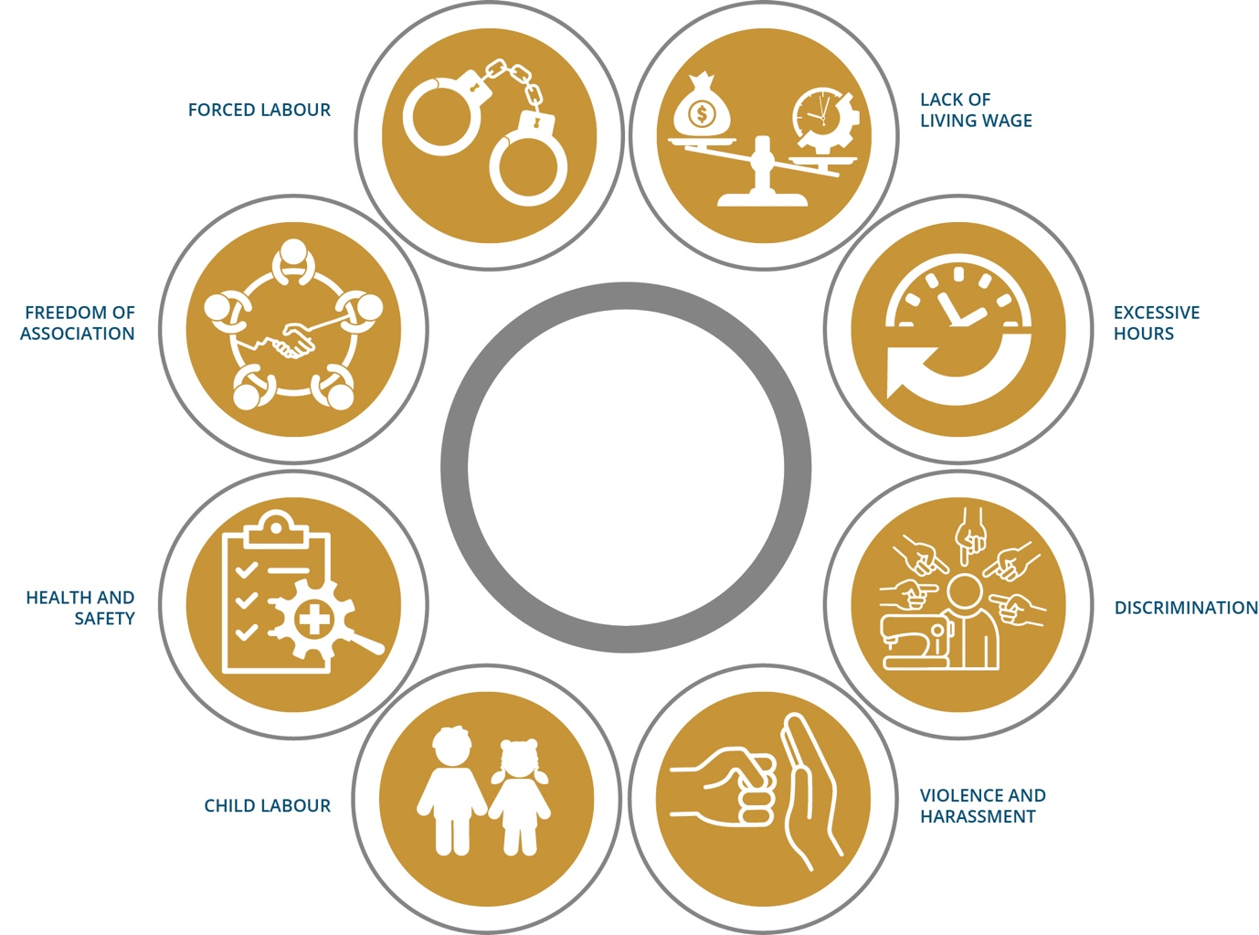

Approximately 80% of the workers in the apparel and footwear industry are women, many of whom have migrated from regional areas and have received no vocational training.

How should business respond?
Being a responsible business means avoiding and addressing the adverse impacts of your activities and operations, while contributing to sustainable development of the countries in which you operate. This expectation applies to all businesses, regardless of size, sector, structure, location, ownership or legal status. At the heart of responsible business conduct and practice is respect for human rights.
The Guiding Principles outline a number of steps that businesses should take to respect human rights in their operations, supply chains and business relationships. The process will vary for each company depending on the type of business and where it operates.

UN Guiding Principles on Business and Human Rights
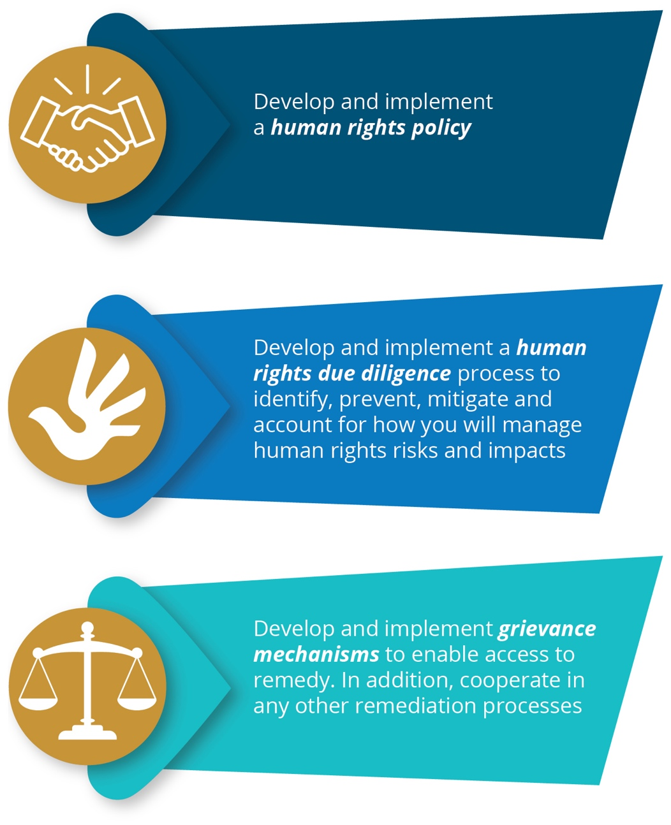

Looking to get started?
Starting the process of identifying and addressing human rights risks and impacts can be challenging. There are a number of things that a business can do to apply responsible business practices or strengthen existing approaches and strategies.

Focus on risks to people
Being a responsible business means embracing a different understanding of risk, which centres on ‘risks to people’ rather than ‘risks to business’. Taking a people-centred approach requires your business to ask: who will be impacted by our decisions, operations, relationships and strategies and what do we need to do to address these risks and impacts?

Embed human rights into operations, strategies and culture
To ensure a people-centred approach, human rights should not be seen as an ‘add-on’ but as central to business strategy, operations, culture and risk management. A rights-respecting culture seeks to embed respect and responsibility for the realisation of human rights through all levels of an organisation. It is also important to build human rights actions into your business’ policies, reporting processes and strategies including ensuring appropriate responsibility and accountability.

Engage and listen to rights-holders and other stakeholders
Engaging with key stakeholders (such as employees, customers, communities and workers in your supply chains), is critical to effective human rights due diligence. Meaningful engagement and consultation will enable your business to get a holistic picture of its human rights risks and impacts. Businesses that embrace meaningful engagement, see rights-holders as their eyes and ears on the ground, enabling a deeper understanding of risks and impacts and early risk identification and mitigation.

Build relationships for collective action
Many of the challenges that arise in the apparel and footwear industry are systemic and cannot be solved by one business alone; they require sector-wide collaboration. To generate transformational change and real social impact, genuine commitment to collaborative action with business peers and other stakeholders and endeavours is required. Engaging in multi-stakeholder dialogue and collaboration can take time, it may also take your business out of its comfort zone, however this is necessary to shift the industry and generate change.

Want to learn more?
Read the Vietnam Chamber of Commerce and Industry and Australian Human Rights Commission’s full guidance – Responsible Busines Conduct and the Apparel and Footwear Industry: Guidance for Companies in Vietnam (2021).

This factsheet was developed under the ‘Advancing Responsible Business Conduct’ Project, a collaboration between the Vietnam Chamber of Commerce and Industry and the Australian Human Rights Commission. The program is supported by the Australian Government’s Department of Foreign Affairs and Trade (DFAT). The views expressed in this fact sheet are the author's alone and are not necessarily the views of the Australian or Vietnamese Government.

