Face the facts:
LESBIAN, GAY, BISEXUAL, TRANS AND INTERSEX PEOPLE • 2014

UP TO

Australians may have a diverse sexual orientation, sex or gender identity.

The Australian Human Rights Commission encourages the dissemination and exchange of information provided in this publication. All material presented in this publication is provided under Creative Commons Attribution 3.0 Australia, with the exception of:
- the Australian Human Rights Commission Logo
- photographs and images
- any content or material provided by third parties.
The details of the relevant licence conditions are available on the Creative Commons website, as is the full legal code for the CC BY 3.0 AU licence.
Attribution
Material obtained from this publication is to be attributed to the
Australian Human Rights Commission with the following copyright notice:
© Australian Human Rights Commission 2014.
Face the Facts: Lesbian, gay, bisexual, trans and intersex people • 2014 ISBN 978-1-921449-67-3
Design and layout Dancingirl Designs
Infographic Design Firefly Interactive
Content James Iliffe, Black and White Media Australia
Electronic format
This publication can be found in electronic format on the website of the Australian Human Rights Commission:
http://www.humanrights.gov.au/publications
Contact details
For further information about the Australian Human Rights Commission, please visit
www.humanrights.gov.au or email communications@humanrights.gov.au. You can also write to:
Communications Team
Australian Human Rights Commission GPO Box 5218
Sydney NSW 2001

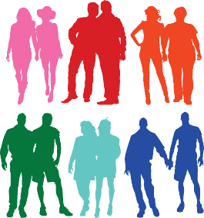
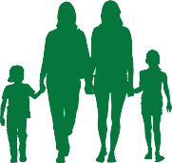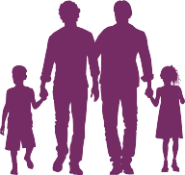UP TO

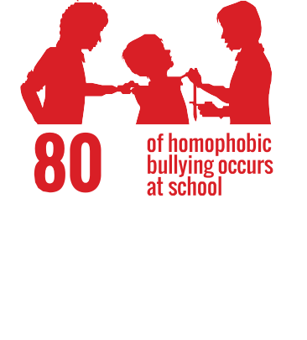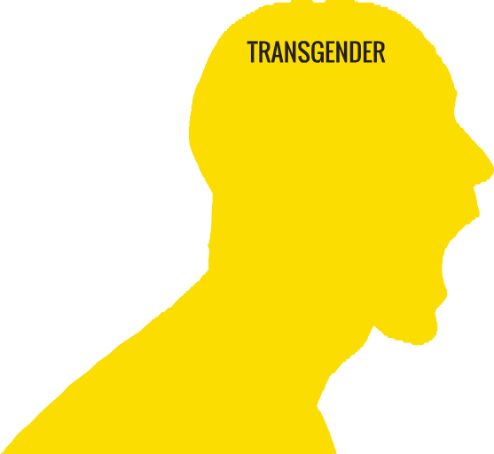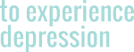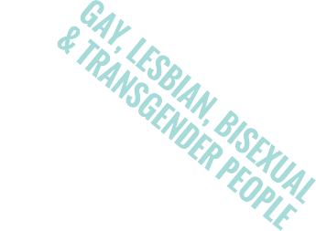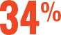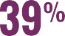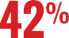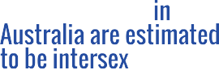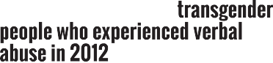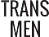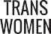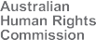Australians may have a diverse sexual orientation, sex or gender identity.
www.humanrights.gov.au/face-facts

For source information, please refer to the complete Fact the Facts: Lesbian, Gay, Bisexual, Transgender and Intersex People publication.

Lesbian, gay, bisexual, trans and intersex people

Equality and freedom from discrimination are fundamental human rights that belong to all people, regardless of sexual orientation, gender identity or because they are intersex.
On 1 August 2013, the Sex Discrimination Act 1984 was amended to make discrimination on the basis of a person’s sexual orientation, gender identity and intersex status against the law.
Despite this important step forward, lesbian, gay, bisexual, trans and intersex (LGBTI) people in Australia still experience discrimination, harassment and hostility in many parts of everyday life; in public, at work and study, accessing health and other services and securing proper recognition of their sex in official documents.

About
  - Due to a lack of comprehensive, publicly available data, it is difficult to estimate the total LGBTI population in Australia. Australians of diverse sexual orientation, sex or gender identity may account for up to 11 per cent of the Australian population.1
  - Same-sex couples make up about one per cent of all couples in Australia. In 2011, there were around
33,700 same-sex couples in Australia, including 17,600 male same-sex couples and 16,100 female same-sex couples.2 The number of same-sex couples more than tripled between 1996 and 2011.3
  - In 2011, there were 6,300 children living in same-sex couple families, up from 3,400 in 2001. Most of these children (89 per cent) are in female same-sex couple families.4
  - There are no firm figures for Australia’s intersex population. Estimates range from one in 2,000 births to four per cent of the population.5

Key issues for LGBTI people
- A large number of LGBTI people hide their sexuality or gender identity when accessing services (34 per cent), at social and community events (42 per cent) and
at work (39 per cent).6 Young people aged 16 to 24 years are most likely to hide their sexuality or gender identity.7
- LGBTI young people report experiencing verbal homophobic abuse (61 per cent), physical homophobic abuse (18 per cent) and other types of homophobia (nine per cent), including cyberbullying, graffiti, social exclusion and humiliation.8
- Eighty per cent of homophobic bullying involving LGBTI young people occurs at school and has a profound impact on their well-being and education.9
- Transgender males and females experience significantly higher rates of non-physical and physical abuse compared with lesbians and gay men.10
- Gay, lesbian, bisexual and transgender people are three times more likely to experience depression compared to the broader population.11
- Around 60 per cent of same-sex attracted and gender- questioning young people said they experienced verbal abuse because of their sexuality, while 18 per cent reported experiencing physical abuse. Young men (70 per cent) and gender-questioning young people (66 per cent) were more likely than young women (53 per cent) to experience verbal abuse.12

Positive developments
  - LGBTI young people at schools where protective policies are in place are more likely to feel safe compared with those in schools without similar policies (75 per cent compared with 45 per cent). They are almost half less likely to be physically abused at school, less likely to suffer other forms of homophobic abuse, less likely to self-harm and less likely to attempt suicide.13
  - People in same-sex couples tend to be more highly educated,14 more likely to work in highly skilled occupations (53 per cent compared with 43 per cent)15 and more likely to have higher incomes.16
  - On measures of general health and family cohesion, children aged 5 to 17 years with same-sex attracted parents had significantly better scores when compared to Australian children from all other backgrounds and family contexts. For all other health measures, there were no statistically significant differences.17

Did you know?
- Almost half of all gay, lesbian, bisexual and transgender people hide their sexual orientation or gender identity in public for fear of violence or discrimination.18

Find out more
- Australian Human Rights Commission, Addressing sexual orientation and sex and/or gender identity discrimination: Consultation Report (2011)
- Australian Human Rights Commission, Sex Files: the legal recognition of sex in documents and government records (2009)
- Australian Human Rights Commission, Same-Sex: Same Entitlements, Report of the National Inquiry into discrimination against people in same-sex relationships in the area of financial and work related entitlements (2007)
- Australian Research Centre in Sex, Health and Society, La Trobe University, Private Lives 2: The second national survey of the health and wellbeing of GLBT Australians (2012)
- Beyond Blue, In my shoes: Experiences of discrimination, depression and anxiety among gay, lesbian, bisexual, trans and intersex people (2012)

Our role
The Commission can investigate complaints of discrimination on the basis of sexual orientation, gender identity and intersex status under the Sex Discrimination Act, which was amended in August 2013.
The amended Act also protects same-sex couples from discrimination under the definition of “marital or relationship status”.
We have conducted a number of major projects in recent years to identify and build community awareness around the human rights issues faced by LGBTI people.
Find out more about our work in this area.

Endnotes

- Department of Health, Australian Government, National Lesbian, Gay, Bisexual, Transgender and Intersex (LGBTI) Ageing and Aged Care Strategy (2012).
- Australian Bureau of Statistics, 4102.0 – Australian Social Trends, July 2013, Same-Sex Couples (July 2013).
- Australian Bureau of Statistics, above.
- Australian Bureau of Statistics, note 2.
- See the website of the Organisation Intersex International Australia (OII). OII recommends a mid-range figure of 1.7 per cent of all births.
- Australian Research Centre in Sex, Health and Society, La Trobe University, Private Lives 2: The second national survey of the health and wellbeing of GLBT Australians (2012).
- Australian Research Centre in Sex, Health and Society, La Trobe University, above.
- Australian Research Centre in Sex, Health and Society, La Trobe University, Writing Themselves in 3: The third national study on the sexual health and wellbeing of same sex attracted and gender questioning young people (2010).
- Australian Research Centre in Sex, Health and Society, La Trobe University, above.
- For example, while 26 per cent of males and 23 per cent of females reported verbal abuse in the past 12 months, the percentages jump to 47 per cent and 37 per cent for trans males and trans females
respectively. See Australian Research Centre in Sex, Health and Society, La Trobe University, note 6.
- Beyond Blue, In my shoes: Experiences of discrimination, depression and anxiety among gay, lesbian, bisexual, trans and intersex people (2012).
- Australian Research Centre in Sex, Health and Society, La Trobe University, note 8.
- T Jones and Western Australian Equal Opportunity Commission, A report about discrimination and bullying on the grounds of sexual orientation and gender identity in Western Australian education (2012).
- Australian Bureau of Statistics, note 2.
- Australian Bureau of Statistics, note 2.
- Australian Bureau of Statistics, note 2.
- University of Melbourne, Australian Study of Child Health In Same-Sex Families (ACHESS): Interim report (2013).
- Australian Research Centre in Sex, Health and Society, La Trobe University, note 6.

