Human Rights and  Equal Opportunity Commission  28 May 1991  Our Ref: 58913081 |  | Human Rights Commissioner  U RGENT  BY COURIER

The Hon. N. Bolkus
Minister for Administrative Services
Parliament House
CANBERRA ACT 2600
c.c.: The Hon. Michael Duffy Attorney General Parliament House CANBERRA ACT 2600

Dear Minister
Thank you for your letter of 23 May.
It appears from your letter that when you approved the text for signature from overseas you had not seen the further advice contained in my letter which was hand-delivered to your office on 20 May. It is clear that we simply continue to
disagree on a number of important issues. I will not therefore, repeat the details already set out in my letters of 9 and 20 May. However, I think I should make several further points.
Radio for “print handicapped" persons
Your letter refers to radio programme standards providing for the reading on radio of newspaper advertisements for the benefit of "print handicapped" persons. However, I can find no reflection of, or effective protection for, this concept in the Bill before the House. On my understanding the exceptions provided for under the heading of "exempt matter" would not cover such broadcasts. The only possibly relevant exception is that for "any notice or announcement required to be broadcast by or under any law...". On my understanding of the Act such readings of advertisements would not fall within that exception. First, the readings are permitted, rather than required. Second, they are broadcast according to radio program standards and not "by or under any law". Third, it is unclear whether, in any event, such a reading would constitute a "prescribed notice or announcement" (of which, as noted in my letter of 20 May, I can find no definition in the Bill) and thus fall outside the exception for this reason. The proposed statutory ban would therefore (if I have understood it correctly) prevail over such inconsistent non-statutory programme standards and would proscribe the reading of these advertisements for the benefit of "print handicapped" persons.

Moreover, even if there were some exception from the ban in the terms of these programme standards, that would not prevent the ban from seriously restricting the clearly recognised right of "print handicapped persons", together with other Australians, to receive and impart information and ideas in the media and form of their choice.
Free speech and bought speech
I note that your letter maintains the distinction asserted between "free speech" and "bought speech". Having carefully considered the points you make I remain of the view that this distinction is neither helpful nor sustainable in terms of honouring our human rights obligations - for the reasons indicated in my letter of 9 May. You state, "The one cogent and obvious distinction between print and other campaigning and broadcast advertising is cost" (page 1). As I have already indicated, however, this distinction in degree does not embody a principle which could be consistently and coherently applied without permitting restrictions on other media or forms of expression.
Nor, with respect, is your general proposition in accordance with the facts. Some radio advertising (both "community radio" and "mainstream" stations) is relatively inexpensive compared to some newspaper advertising. A number of points I have made previously are also relevant (for example, that some charities or community organisations may prefer radio, to impart information, and many individuals may prefer to exercise their richt, to receive information through that medium).
The Government has stated its intention that the proposed ban should encompass advertising by broadcasters in their own behalf. I remain of the view that, if this is accepted, there is no relevant distinction in principle which would prevent extension of the ban to newspaper editorial comment, for example, to prevent major newspaper proprietors exercising undue influence on government in decisions affecting their interests (such as foreign ownership or "cross media ownership") or in matters of public concern more generally (on the basis of the same considerations of "equity" advanced in relation to broadcasting).
Political rights
I note your statement that "In my view and on the advice available to me your interpretation of Article 25 of the Covenant goes beyond the extent of that Article" (page 6). I can only reiterate that I strongly disagree with the advice you are getting.
Article 25 is not, with respect, exclusively "...directed at guaranteeing that elections (emphasis added] are genuine, are held periodically and are protected from abuses by such procedural means as secret ballot, which is explicitly mentioned in the Article" (page 6).

Article 25, as clearly indicated in my earlier written advice, is not confined in its scope to elections. It expressly recognises a general right. to take part in public _affairs, of which the electoral rights recognised form are a particular (though highly important) part. Many of the problems relating to the Bill’s inconsistency with our international treaty obligations (in particular in relation to Article 25 and to Article 19 of the ICCPR), and many of the reasons why, as drafted, it exceeds what can legitimately be justified by reference to potential electoral corruption, arise from the fact that its application is not confined to electoral advertising - but will restrict the imparting..and receipt of information about ideas in ..relation to public affairs in general.

Even to the extent to which it may be permissible to restrict electoral advertising, the electoral process does not, with respect, exhaust the ambit of "public affairs" in a democratic society. Your letter states, "I am not aware of any authority for the proposition that Article 25 requires Party States [sic] to guarantee that its (sic] citizens make informed decisions when they vote" (page 6). With respect, neither my written advice nor any comment I have subsequently made depended on any such proposition.
The question of what positive measures States Parties to the ICCPR might be required to undertake to guarantee that citizens may make informed electoral choices is clearly distinct from the presently relevant question of the extent to which they may actively restrict the imparting and receipt of information and ideas directed to this end. Clearly, secret ballots and the prevention of abuses in the electoral process itself do not exhaust the abuses and restrictions which may interfere with the free expression of the will of the electors. A prohibition on opposition candidates publicising their policy or party affiliation could be an equally effective means of preventing such expression. (I note this point not to suggest any comparison in intention or effect, but to indicate the inadequacy of any view which would restrict the scope of Article 25 to the electoral process itself.)
I continue to regard this issue as one of fundamental importance to the protection of human rights in Australia. If there is any further advice the government requires to clarify the points I have made I am anxious to provide it.
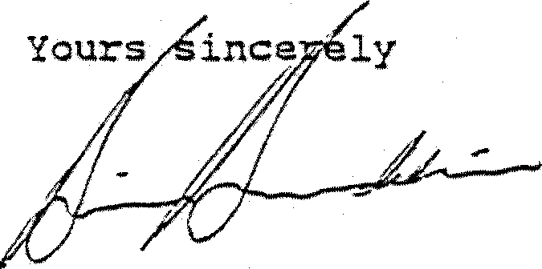
BRIAN EURDEKIN
Federal Human Rights Commissioner

