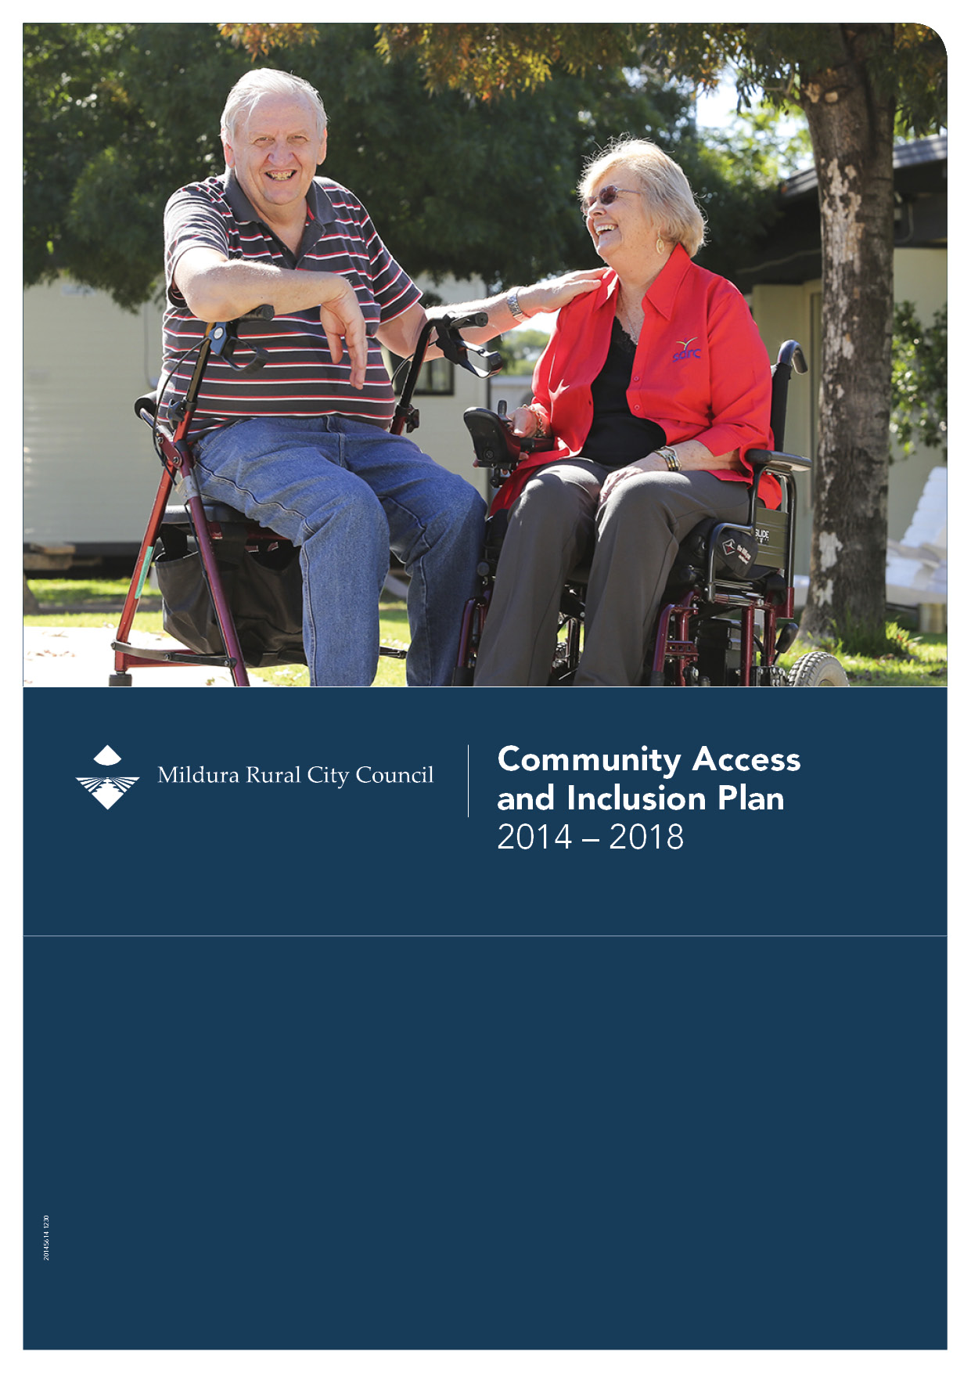

Community Access and Inclusion Plan 2014 - 2018

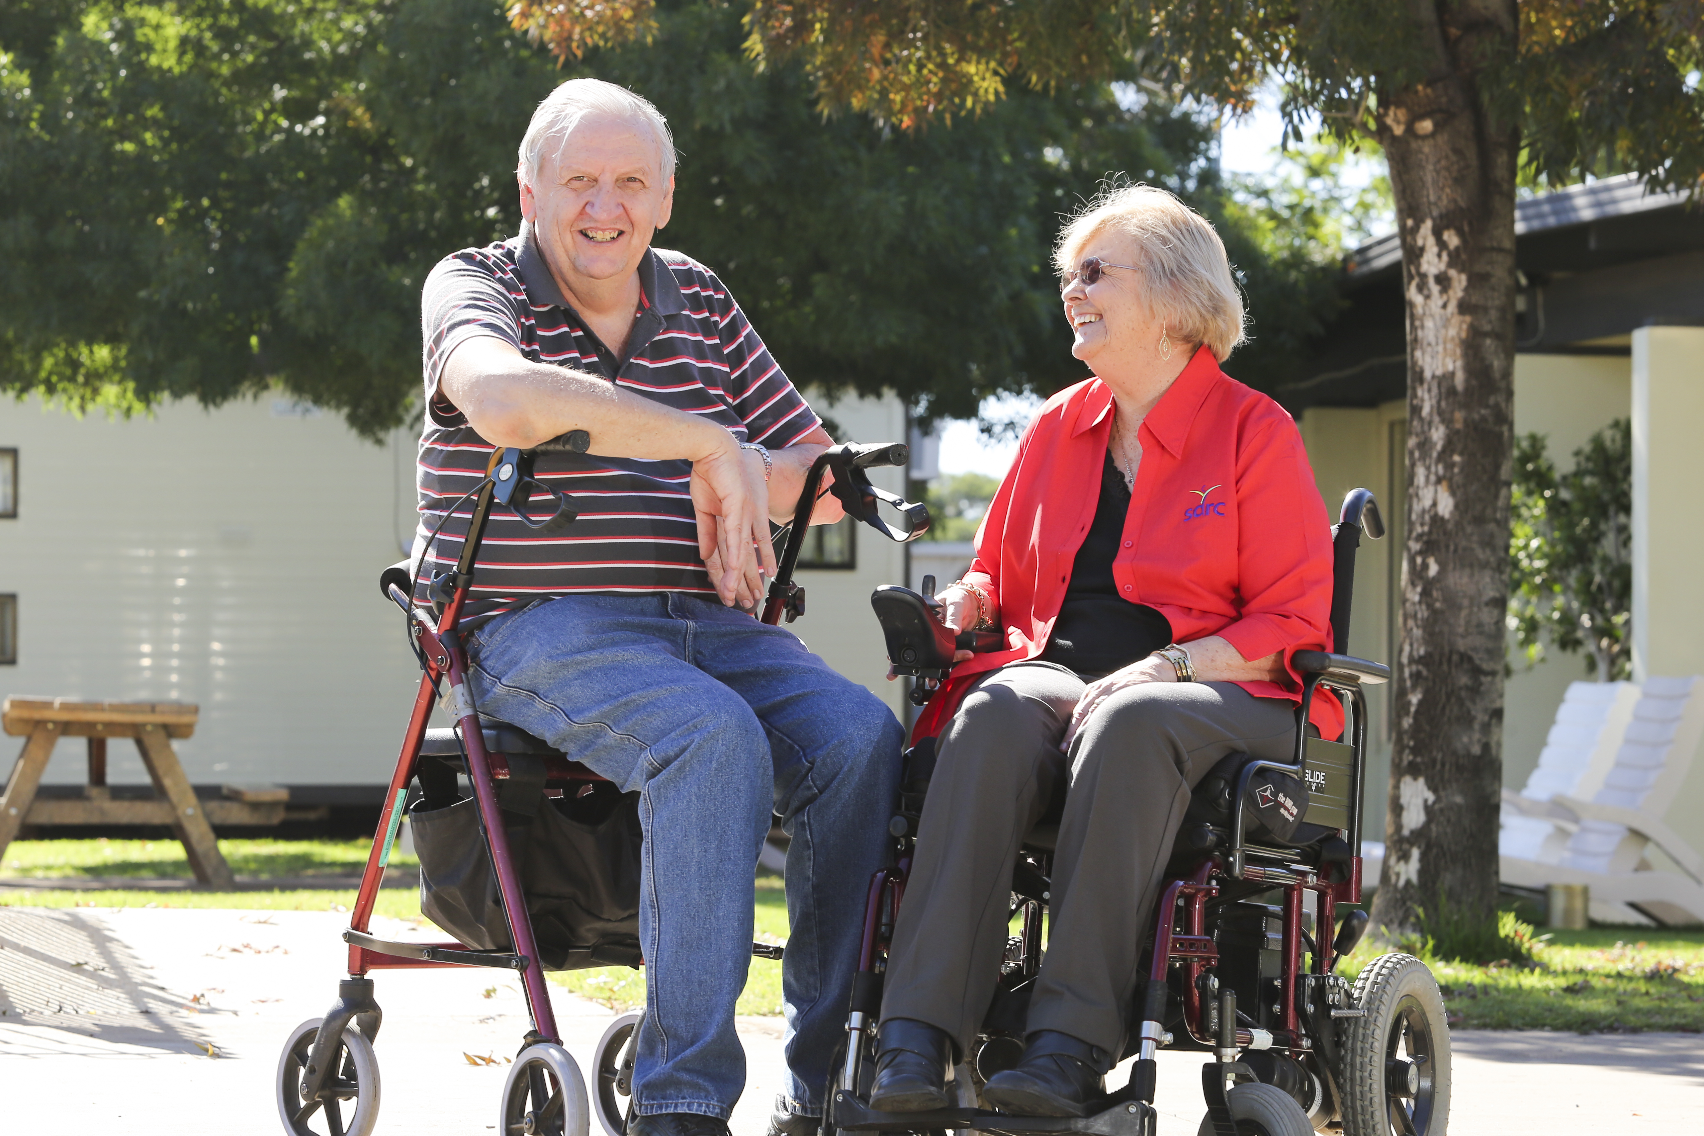

Contents

Executive Summary 3
Our Vision 3
Key Strategic Directions and Action Plan 3
Aims and Objectives 4
Monitoring and Evaluation 4
Key Achievements of 2009 – 2013 Plan 5
Our Community 6
Strategy Context 8
Purpose of the Community Access and Inclusion Plan 9
Methodology 9
Community Engagement 9
Disability Access Advisory Committee 9
Community Consultations 10
Council Staff 13
Development of Action Plan 14
Key Strategic Directions and Action Plan 14
Budget 14
Key Strategic Directions 2014 - 2018 15
Appendix 1: Strategy Context 27

Executive Summary

Mildura Rural City Council’s vision is to be the most liveable, people-friendly community in Australia.

The development of Council’s Community Access and Inclusion Plan (CAIP) aligns with this vision. The plan demonstrates Council’s commitment to being pro-active in meeting the needs of people with a disability and their families. The plan commits to ensure there is no discrimination based on disability in Council’s policies, planning or service provision.

The plan was developed through consultation with key stakeholders within the community and included input from a cross section of Council staff and disability service providers.

The consultations identified key gaps and also identified priorities from the community. The action plan will address those gaps utilising the insight from the community consultation process to address these issues.

This is Council’s third Community Access and Inclusion Plan, the aim is not to reproduce or update the previous plans, but to develop a new version based on increased knowledge and understanding of the requirements of people with a disability.

Our Vision

Council’s vision is to be the most liveable, people-friendly community in Australia. One way to achieve this vision is to ensure that our strategies, systems and processes are aligned to support the achievement of our vision.

Our commitment is that all people with a disability have the right to enjoy and have access to any opportunity that our community has to offer.

Through consultation Council will identify and understand the barriers to access and inclusion, we are committed to removing these barriers by implementing effective strategies and monitoring and evaluating the actions undertaken.

Key Strategic Directions and Action Plan

There are three key themes that will frame the future actions of Council in promoting and implementing inclusive practices within Council and the community. The action plan will identify activities under each of the three key themes to be undertaken during 2014 - 2018.
The three key themes are:

- Infrastructure and Access
- Awareness – Positive Attitudes and Inclusion
- Advocacy.

Aims and Objectives

The Community Access and Inclusion Plan (CAIP) will provide a framework to provide direction and address specific issues for our community in the future by:

- Providing strategic guidance
- Improve accessibility to services and facilities for people with a disability
- Facilitate active participation in our community
- Adopting a proactive approach to identifying and removing barriers.

Tourism Ambassador’s Project which was supported by the
Community Access and Inclusion Plan 2009 - 2013.

Monitoring and Evaluation

The Community Access and Inclusion Plan will be monitored on a quarterly basis and progress reported annually through the Council Plan. The plan will include a two year review and an end of plan evaluation.

Key Achievements of 2009 – 2013 Plan

The Community Access and Inclusion Plan 2009 – 2013 resulted in 82 per cent of actions being completed.

A review was undertaken of a range of processes and policies which resulted in the development of checklists to support the inclusion of people with a disability.

New documents / checklists developed include:

- Meeting checklist
- Park and Gardens checklist
- Accessible Accommodation Guide
- Disability Awareness Training undertaken with Council staff
- People from the Disability Community invited to participate in major projects like the Riverfront.

Over the last four years Council has spent $679,182 on disability access improvements.

Provided advocacy at a state and national level by engaging all levels of government to advocate on behalf of people with a disability.

Education for Council Employees

- Access Auditing Buildings training
- Access in Open Spaces training
- Access Awareness training as part of Council’s induction process.

Amenities at Council owned or leased reserves and facilities:

- Etiwanda Wetlands pathway to accessible toilet
- Lake Cullulleraine accessible toilet and pathway
- Mildura Motorcycles –accessible toilet
- Auto Door Opener – Ninth Street accessible toilet
- Auto Door Opening – Deakin Avenue service centre
- Hearing Loops – three at Mildura Library
- Hearing Loops - three at Merbein Library and Hub
- Hearing Loops – two at Mildura Arts Centre
- Purchase of a portable hearing loop
- Mildura Airport has a counter loop
- Signage at Mildura Library
- Signage at Nowingi Place.

Guidelines

- Accessible Accommodation guide developed
- Access Guide for the Mildura Arts Centre
- Mobility Map for the Central Business District (CBD)
- Access Guide for the Mildura Airport.

Access in the Community
Various community groups have received Council funding through grants schemes to fund access.

Project | Organisation
Gaming X Box | Sunraysia Autism Spectrum Support Group
Tracking System | Sunraysia Residential Services
Surface Tablet and Scanner/Reader | Vision Australia Mildura
Concrete pathway | Sunraysia Men’s Shed Inc
Widening doorways and passage | Sunraysia Disability Resource Centre
Hearing loop | Holy Trinity Lutheran Church
Automatic swing door | Oasis Aged Care Inc
Access ramp to respite house | Christie Centre Inc
First night out | Interchange Loddon Mallee
Be an inclusive club | Mallee Sports Assembly Inc
Family fishing fun and stuff happens | Sunraysia ADHD Support Group
Accessible toilet | St Vincent de Paul Society

Our Community

There are 54,666 people residing in the Mildura Rural City Council local government area and according to the Australian Bureau of Statistics approximately 20 per cent of the population in Victoria have some form of disability. This means that approximately 10,933 people within the community have a disability. With the population of the Mildura Rural City Council region projected to increase from 54,666 in 2011 to 64,288 by 2031, (an increase of 9,622 people, or 18 per cent) the demand for disability services will increase.

The figures show 2,882 people receiving Disability Support pensions
 | Total Population |  | Indigenous
Location | No | % of total est. 2006 population | No. | % of indigenous est. 2006 population
Mildura RC | 2882 | 5.8% | 187 | 13.0%
Victoria* | 186,951 | 3.8%
Commissioned data from Centrelink 2010 *as at Sept 2010

Disability Support Pension
The purpose of the Disability Support Pension is to provide income support for people who have a permanent physical, intellectual or psychiatric impairment. In September 2010, Mildura Rural City Council had a much higher proportion of population receiving the disability support pension, compared to the Victorian average. Also, Mildura Rural City Council had a significantly higher proportion of Indigenous population receiving the disability support pension compared to the total Mildura Rural City Council population.

Strategy Context

Mildura Rural City Council Plan 2014 - 2018
The Community Access and Inclusion Plan aligns with Council Plan 2013 to 2017 and the development of this plan was identified as a priority action within Key Result Area 1.2 Community.

Key Result Area 1.2 Community
We will create a safe and supportive place to live, where diversity and lifestyle opportunities are encouraged; and participating in arts, culture, sport and recreation enhances wellbeing.

- Facilities, services and activities are accessible to everyone;
- Everyone feels part of the community and can participate in community life;
- Everyone has opportunities to help shape their community; and
- Everyone has access to education opportunities.

The Community Access and Inclusion Plan fits within the existing Council Plan and has actions that affect various plans and strategies and also relevant legislation and policies.

Disability Discrimination Act
Victorian Disability Act
State Disability Plan
Building Code of Australia

Council Plan 2013 to 2017

Community Access & Inclusion Plan

MRCC Social Inclusion Policy

Human Rights Policy

Municipal Early Years Plan

Youth Agenda
Healthy Ageing Strategy

Community Health & Wellbeing Plan
Cultural Diversity and Inclusion Strategy

Building Asset
Management Plan

Roads & Footpath Asset Management Plan
Community Engagement Framework
Public Open Space Strategy
Library Service Strategic Plan

Purpose of the Community Access and Inclusion Plan

The Community Access and Inclusion Plan has been prepared to demonstrate Council’s commitment to the principles of the Disability Discrimination Act 1992 and the Disability Act 2006 in the provision of equitable, dignified access to all its services, facilities, programs and processes.

The 2014 – 2018 plan seeks to understand and address the range of needs of people with disabilities and address issues raised by the community.

Methodology

The plan was developed following Council’s Strategic Planning Process and the following steps:

- Review of previous Community Access and Inclusion Plan 2009 - 2013
- Development of a consultation plan
- Development of workshop questions
- Measuring results from workshops
- Inclusive, accessible engagement
- Development of strategic direction and actions
- Communication of plan results.

Council has undertaken a significant range of activities to engage with community as part of the development of the plan. As part of the process, key stakeholders were identified both internally and externally and the consultation process commenced with an internal stakeholder workshop to test the questions and the workshop process.

Community Engagement

Disability Access Advisory Committee
The aim of the Disability Access Advisory Committee (DAAC) is to establish a consultative framework to enable input from the community to Council and advise on the priority accessibility needs of people with disabilities.

The DAAC was established in 2001 and has evolved over the years from being an advisory committee to also being an expert resource to Council in addressing barriers to access and inclusion for people with a disability.

As part of the terms of reference, group members of the committee must have a commitment to working to improve access and inclusion for people in the community with a disability and those people who support them.

Community Consultations

DAAC committee members contributed to the formal consultation with the community in developing the key questions and being involved in the public consultation in Mildura. Overall these sessions were structured and involved discussion around three questions asking the community their views.

The three questions workshopped were:

- What are the key issues for people with a disability that Mildura Rural City Council should consider for access and inclusion?

- What are some of the opportunities in this municipality to improve accessibility and inclusion?

- What can Council do to promote awareness within the community for people with disabilities?

130 community members and service providers participated in the formal and informal consultations (via survey) and provided a wide range of ideas and suggestions for Council with relation to disability access and inclusion.

Of the 130 participants 49.4 per cent of the attendees were either a person with a disability or a carer of a person with a disability.

As part of the community consultations information was provided in Easy English (pictorially) and Braille. Vision Australia provided equipment and a representative to help any person attending with vision difficulties.

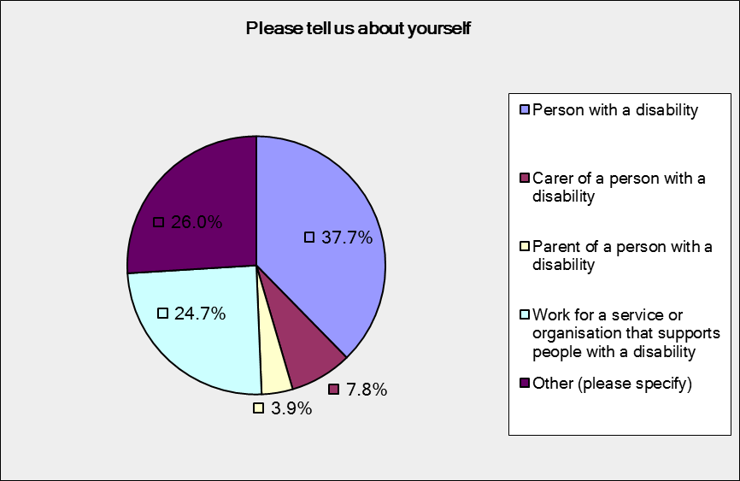
Pie Chart of people attending
37% Person with a disability
7.8% Carer of a person with a disability
3.9% Parent of a person with a disability
24.7% Work for a service or organisation that supports people with a disability
3.9% Other

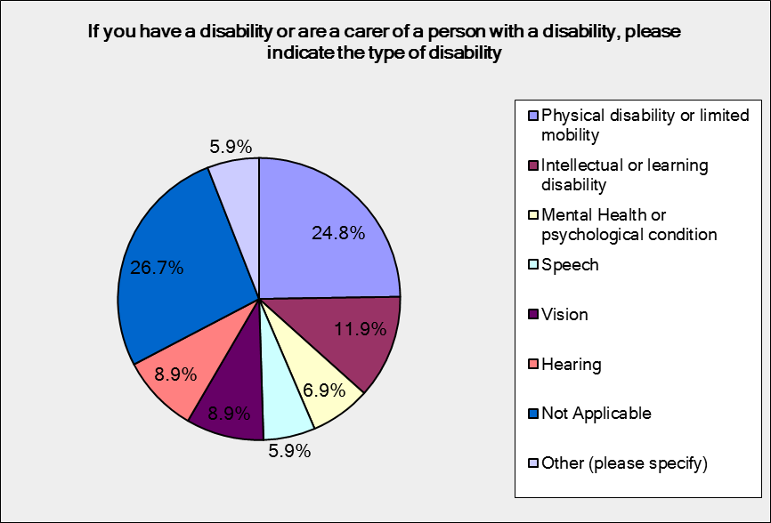
Pie Chart of Type of Disability
24.8% Physical disability or limited mobility
11.9% Intellectual or learning disability
6.9% Mental Health or psychological condition
5.9% Speech
8.9% Vision
8.9% Hearing
26.7 Not applicable

Council Staff
182 Council staff representing different branches and departments were involved in workshops using the same three questions to provide suggestions for the development of the plan.

The consultations provided an opportunity for staff to suggest possible actions to address some of the issues and also highlighted existing work that Council is committed to continuing.

Development of Action Plan

Key themes were identified from the workshop material and Council staff developed the actions to address the issues raised and suggestions shared through the consultation.

Key Strategic Directions and Action Plan

The action plan has been developed based on the three key themes identified through the consultation process. The three key themes provide the strategic direction for Council to support people with a disability within our community.

The three key themes are:

- Infrastructure and Access
- Awareness - positive community attitudes and practices promote inclusion and participation
- Advocacy.

The action plan outlines specific actions and key strategic direction for the next five years. The action plan will be reviewed by Council’s Rural Access Worker midway through its tenure.

Actions which are identified by the symbol below are actions that will be completed with involvement of the community.
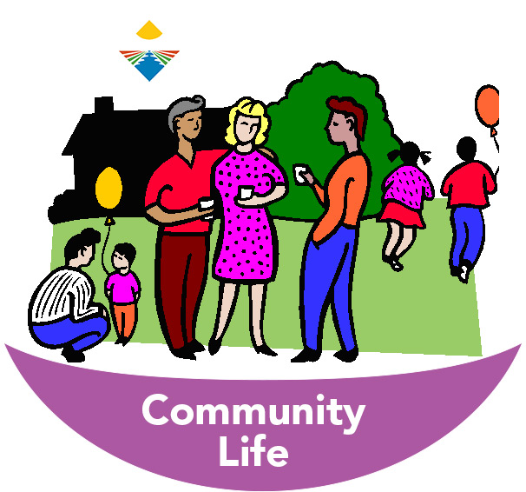

Picture developed to represent community life

Budget

The majority of the actions outlined and committed to in this plan will be undertaken using existing resources within the identified branches. It is expected that these actions will not be resource intensive, rather looking at the best possible outcome for community members using existing resources.

Some actions however may require some financial resources and will be considered through Council’s annual budgetary processes. Any opportunities for grant funding through State or Federal Government or other funding providers will be explored in preparation for the action implementation.

Key Strategic Directions 2014 - 2018

- Infrastructure and Access
Our community will have accessible facilities, services and activities.

- Awareness
Promote positive community attitudes and practices towards people with a disability.

Promote inclusion and participation in the community for people with a disability to participate in events, recreation and sporting clubs.

Advocacy
On behalf of the community to improve services and employment opportunities and quality of life for all people with a disability.

Infrastructure & Access
Services – Our Community will have accessible facilities, services and activities

Council Plan  2013 - 2017 | Action | Strategy/  Plan | Measure | Budget | Action  Owner | Officer | Community | Financial Year Ending
 |  |  |  |  |  |  |  | 2014/15 | 2015/16 | 2016/17 | 2017/18 | 2018/19
1.1  Community Safety | Review emergency planning documentation to ensure they include requirements for people with a disability | Emergency Management Strategy | %  Review  Completed | Within current budget | MCA | REMC |  |  |  | X
2.4  Infrastructure, Assets and Facilities | Review Council’s footpath maintenance program and implement to rectify barriers to access for people with a disability | Capital Works Program | % Program  Completed | $100,000  Per year  (CWP) | GMD | STO |  | X | X | X | X | X
2.4  Infrastructure, Assets and Facilities | Identify and prioritise Council buildings to be audited and develop listing | Council Plan | %  List  Developed | Within current budget | GMD | STO |  | X | X
2.4  Infrastructure, Assets and Facilities | Undertake an Access Audit on Council buildings to identify priorities and staged implementation of works to be included for funding in the capital works program | Council Plan | %  Audit Completed | $10,000  Per year  $2600  RA | GMD | STO |  |  | X | X

Infrastructure & Access
Services – Our Community will have accessible facilities, services and activities

Council Plan  2013 - 2017 | Action | Strategy/  Plan | Measure | Budget | Action  Owner | Officer | Community | Financial Year Ending
 |  |  |  |  |  |  |  | 2014/15 | 2015/16 | 2016/17 | 2017/18 | 2018/19
2.4  Infrastructure, Assets and Facilities | Continue to implement works from Access Audit of Council buildings and include in Capital works program to DDA standards | Capital Works Program | %  Audit Implemented | Within current budget | GMD | STO |  |  |  |  | X | X
2.4  Infrastructure, Assets and Facilities | The ability to approve access provisions in significant refurbishments to all relevant buildings in accordance with the building code of Australia, Vol 1 and AS 1428 Part 1, 2 & 4 | Vic State Disability Plan 2013-  2016 | % building Inspections are implemented | Within current budget | MDS | MBS |  | X | X | X | X | X
2.4  Infrastructure, Assets and Facilities | Audit of disabled parking and investigate high use areas to ensure availability requirements | Council Plan | %  Audit  Completed | Within current budget | GMD | STO |  |  |  |  | X

Awareness
Promote positive community attitudes and practices towards people with a disability

Council Plan  2013 - 2017 | Action | Strategy/  Plan | Measure | Budget | Action  Owner | Officer | Community | Financial Year Ending
 |  |  |  |  |  |  |  | 2014/15 | 2015/16 | 2016/17 | 2017/18 | 2018/19
1.2  Community Development | To promote, provide advice, information and awareness to businesses, clubs, schools and community groups. | Vic State Disability Plan 2013-2016 | 2 Sessions Completed | Within current budget | MCF | RAW | Community | X | X | X | X | X
1.2  Community  Development | To work with and build the skills of MRCC staff by providing disability awareness training  *Annual Training Plan for induction of staff | Council Induction  Program | No of Staff  Trained | Within current budget | MCF | RAW |  | X | X | X | X | X

Awareness
Promote positive community attitudes and practices towards people with a disability

Council Plan  2013 - 2017 | Action | Strategy/  Plan | Measure | Budget | Action  Owner | Officer | Community | Financial Year Ending
 |  |  |  |  |  |  |  | 2014/15 | 2015/16 | 2016/17 | 2017/18 | 2018/19
1.5  Arts & Cultural Heritage | Seek opportunities for people with a disability to participate in arts and cultural opportunities | Arts, Cultural and Heritage  Strategy | 1 Session Per year completed | Within current budget | MCF | A&CM | Community | X | X | X | X | X
1.6  Recreation & Sport | Encourage and facilitate recreation and sports associations to provide increased opportunities for people with a disability to participate | Youth Agenda  Vic State Disability Plan 2013-2016 | No of  Articles in Newsletters | Within current budget | MLCS | CRO | Community | X | X | X | X | X

Awareness
Promote inclusion and participation in the community for people with a disability with events, recreation and sporting clubs

Council Plan  2013 - 2017 | Action | Strategy/  Plan | Measure | Budget | Action  Owner | Officer | Community | Financial Year Ending
 |  |  |  |  |  |  |  | 2014/15 | 2015/16 | 2016/17 | 2017/18 | 2018/19
1.2  Community  Development | Facilitate greater participation in community activities by people with a disability | Community Engagement Strategy  Vic State Disability Plan 2013-2016 | Access addressed in all Engagement Plan | Within  Current  budget | MCF | CDC | Community | X | X | X | X | X
1.2  Community Development | Work with community groups to provide opportunities to up-skill and change attitudes and practices which discriminate against people with a disability | Municipal Health & Wellbeing Plan | 4 Sessions per year | Within current budget | MCF | RAW | Community | X | X | X | X | X

Awareness
Promote inclusion and participation in the community for people with a disability with events, recreation and sporting clubs

Council Plan  2013 - 2017 | Action | Strategy/  Plan | Measure | Budget | Action  Owner | Officer | Community | Financial Year Ending
 |  |  |  |  |  |  |  | 2014/15 | 2015/16 | 2016/17 | 2017/18 | 2018/19
1.6  Recreation & Sport | Ensure any redevelopment of recreation facilities are DDA compliant to facilitate greater participation in community activities by people with a disability | Municipal Health & Wellbeing Plan  Vic State Disability Plan 2013-2016 | %Recreation Facilities Compliant per audit | Within  Current  budget | MLCS | RDO | Community | X | X | X | X | X
4.2  Communication & Engagement | Raise awareness of diversity, access and inclusion through Community Matters and Council communication channels | Integrated Marketing & Communications Plan | % of Communication Plan Completed | Within current budget | MCA  MCF | CRC  RAW |  | X | X | X | X | X
4.3  Customer  Service | Raise awareness of the customer service request system to log all access and inclusion issues  *5% increase | Customer Service  Strategy 2012-2015 | % of Issues Logged | Within current budget | MCA | CRC |  | X | X | X | X | X

Advocacy
Advocate on behalf of the community to improve services and employment opportunities and quality of life for all people with a disability

Council Plan  2013 - 2017 | Action | Strategy/  Plan | Measure | Budget | Action  Owner | Officer | Community | Financial Year Ending
 |  |  |  |  |  |  |  | 2014/15 | 2015/16 | 2016/17 | 2017/18 | 2018/19
1.2  Community  Development | Review CAIP 2014 - 2018 to determine progress and identify the way forward for development of 2018 – 2022 CAIP | Council Plan | %  Review  Completed | Within Current Budget | MCF | RAW |  |  |  | X
1.2  Community  Development | Development of 2018 – 2022 Community Access and Inclusion Plan |  | % Development of Plan  Completed | TBA | MCF | RAW |  |  |  |  | X | X

Advocacy
Advocate on behalf of the community to improve services and employment opportunities and quality of life for all people with a disability

Council Plan  2013 - 2017 | Action | Strategy/  Plan | Measure | Budget | Action  Owner | Officer | Community | Financial Year Ending
 |  |  |  |  |  |  |  | 2014/15 | 2015/16 | 2016/17 | 2017/18 | 2018/19
1.2  Community  Development | Raise public awareness by providing information to the community about issues associated with disability document this  *Document Events/Media | Community Access & Inclusion Plan | % media Plan Completed | Within current Budget | MCF | RAW |  | X | X | X | X | X
1.2  Community  Development | Council actively advocates in the wider community to address access and inclusion issues  *Activities/Advocacy register | Community Access and Inclusion Plan | Benchmark Results | Within current Budget | MCF | RAW |  |  | X |  | X
1.2  Community  Development | Supporting DAAC to contribute to decision making of behalf of people with a disability  *Actions/Issues Raised | Community Access & Inclusion Plan | No of Actions  /Issues  Resolved | Within Current Budget | MCF | RAW |  | X | X | X | X | X

Advocacy
Advocate on behalf of the community to improve services and employment opportunities and quality of life for all people with a disability

Council Plan  2013 - 2017 | Action | Strategy/  Plan | Measure | Budget | Action  Owner | Officer | Community | Financial Year Ending
 |  |  |  |  |  |  |  | 2014/15 | 2015/16 | 2016/17 | 2017/18 | 2018/19
2.6  Transport | Review of public transport options to determine if services are meeting the needs of people with a disability | Community Access & Inclusion Plan | %  Review  Completed | Within Current Budget | MCF | RAW |  |  | X
3.2  Tourism and  Events | Council actively advocates in the wider community to address access and inclusion issues  *Event documentation/support/grant applications | Events Strategy 2014-2019 | No of Documents / Supports / Grant Applications | Within Current Budget | MLCS | EDO |  |  | X | X | X | X
4.5  Organisational Management | Review applicable HR policies to ensure access and inclusion principles are reflected | Human Resources Strategy 2013 - 2017 | % of Policies  Reviewed | Within Current Budget | MOD |  |  | X | X | X | X | X

Advocacy
Advocate on behalf of the community to improve services and employment opportunities and quality of life for all people with a disability

Council Plan  2013 - 2017 | Action | Strategy/  Plan | Measure | Budget | Action  Owner | Officer | Community | Financial Year Ending
 |  |  |  |  |  |  |  | 2014/15 | 2015/16 | 2016/17 | 2017/18 | 2018/19
4.2  Communication & Engagement | Strategies and Plans developed by the Mildura Rural City Council include access and inclusion principles where appropriate  *Develop and implementation of improvement plan to ensure compliance | All | Implementation Plan Completed | Within Current Budget | All | MCF | CDC | X |  |  | X
4.2  Communication & Engagement | The voice of the disability community will be provided with the opportunity to participate in all community engagement activities | Community Engagement Strategy | % Engagement Plan Implemented | Within Current Budget | All | MCF | CDC | X | X | X | X | X

Appendix 1: Strategy Context

Council Strategies, Action Plans and Agendas
The Community Access and Inclusion Plan also has close links to the following key agendas, plans and strategies:

Community Health and Wellbeing Plan 2013 - 2017
Developed in 2013, the Community Health and Wellbeing Plan represents the Mildura Rural City Council’s priorities with respect to the development of community health and wellbeing over the next four years. The Plan provides a framework that guides an integrated approach across Council with respect to supporting health and wellbeing in the local municipality. The key areas within the plan that align to the Community Access and Inclusion plan are:

- Our Goal is that people feel connected to each other within their own neighbourhood and the broader community
- Our Goal is that people living with mental and emotional ill health feel supported and feel connectivity to community.
- Our Goal is for all people to have the opportunity for community participation and to live with a sense of belonging and feeling valued
- Our Goal is that everyone across the life span has opportunities to reach
- their full potential and live well
- Our Goal is that people are informed and that everyone has access to
- health services and facilities
- Our Goal is to create a community where equitable opportunities for employment are created
- Our Goal is that everyone has access to quality education and opportunities for learning
- Our Goal is to support vulnerable people in our community in times of stress

Strategy
- Include the community in the development and planning of community and neighbourhood events and activities
- Increase opportunities for people to participate in community activities and feel for connected
- Implement relevant activities during Mental Health Week. For example, free movie night at Nowingi Place; R U Ok Day and Check on your Neighbour
- Increase understanding of mental health and wellbeing in our community
- Involve Culturally and Linguistically Diverse (CALD) and Indigenous Australians in the planning and development of community initiatives
- Provide an environment where all community members can reach their full potential
- Inform community members about local services and events
- Support people in ways that help them cope with modern life
- Improve opportunities to develop skills, access life long learning and continuing personal development
- Decrease barriers to job pathways and work readiness
- Support people in ways that help them cope with modern life

Municipal Early Years Plan
Many of the key areas in the Municipal Early Years Plan align with the Community Access and Inclusion Plan and in particular:

The Mildura Rural City community will be one where families and their early years children:
- have equitable access to facilities, services and activities
- can be active participants in community life
- are actively involved in shaping the community to meet their family’s needs

Mildura Rural City Council Youth Agenda 2008- 2012
Developed in 2008, the Youth Agenda is a framework that guides the ‘whole of council’ youth development and strategic planning for the four year period. One of the key areas within the Youth Agenda that links to the Community Access and Inclusion Plan is ‘Inclusion and Connection to Community’ and the specific actions related to this under the Key Strategic Action 2: Actively value and strengthen young peoples’ inclusion and engagement in community.

The Mildura Rural City Council Library Service Strategic Plan 2013 - 2018
The plan sets out a framework for library services provided by Council. It has been developed to help achieve the organisational vision of ‘Making this the most liveable, people-friendly community in Australia’.
This Strategic Plan identifies the Library Service’s key customers and stakeholders along with its strategic objectives and goals, and outlines actions that will be undertaken to achieve them.
It also seeks to set the direction of the Library Service for the next five years, taking into account the changing trends in provision of public library services.

The Northern Mallee Positive Ageing Strategy (Strategy for Older People)
The Positive Ageing Strategy identifies social inclusion of older people being an issue now and on that will increase as the population of older people continues to grow. It also discusses the importance of information channels and portals that are relevant and accessible for all older people, including a projected increased need for information in languages other than English for members of our CALD communities to continue to have opportunities to participate and have access to services.

Mildura Rural City Council Community Care Services Access and Equity
Report 2010
The purpose of the report is to document the access and inclusion principles of Community Care Services. The Access and Equity report lists services and commitments to inclusive practices, lists current approaches and practices, which are guided by the following principles which are well aligned to the intentions and commitments of the Cultural Diversity and Inclusion Strategy:
Cultural Diversity and Inclusion Strategy
Mildura Rural City Council is very proud of its cultural diversity. The development of the Cultural Diversity and Inclusion Strategy is a reflection of the commitment of Council to support and celebrate diversity in our community through inclusive policies and actions.

Community Engagement Strategy
Community engagement encourages ownership and a sense of community. Councils have a responsibility as well as a legal requirement to engage with the community and provide opportunities for residents to participate in decision making. While there may be residents who do not wish to participate or engage, it is vital that they are given an opportunity to do so.

‘Engagement is about involving the community in a decision making process.’

The Mildura Rural City Building Services Asset Management Plan 2013 (B-AMP)
The Building and Facilities asset group includes a variety of municipal building types and categories to meet the service needs and functional expectations of the Council, the community and the various facility users.

Public Open Spaces Strategy
Creates a diverse and integrated network of public open space for recreation and conservation of natural and cultural environments, and to meet the needs of Council residents and visitors.

Roads Asset Management Plan 2013
The Mildura Rural City Road Asset Management Plan covers the road network asset group that includes road pavements, footpaths, kerb and channel, bridges, laneways and car parks. It is generally referred to as the Road Asset Management Plan (R-AMP). It sets out how the road asset group will be managed by Council.

Social Inclusion Policy
The purpose of this policy is to provide a framework and set of guiding principles for Mildura Rural City Council to address issues that impact on a well functioning community in order to achieve Council’s vision of becoming the most livable, people friendly city in Australia. Council recognises its responsibility and role in promoting community wellbeing and assisting the development of a community that is supportive, inclusive, tolerant and welcoming.

Human Rights Policy
Council is committed to ensuring compliance with human rights legislation and principles. It considers human rights to be the foundation for freedom, justice, peace and respect, and an essential part of a democratic and inclusive society that respects the rule of law, human dignity and equality.

State

Victorian State Disability Plan 2013-2016
This document articulates the government’s view for the future and set a clear direction for the next four years. At the centre of the plan is the framework, which outlines the vision and principles of the plan, the long-term goals, shorter term outcomes and four year strategies that the two-yearly implementation plans.

The plan described how we will monitor our progress and the results of our actions, allowing us to make adjustments if needed and enabling greater transparency and accountability.

A Fairer Victoria 2008
A Fairer Victoria is the Victorian state government’s long term commitment to reduce disadvantage and ensure more Victorians have the opportunity, capability and support to lead active, fulfilling lives and promote inclusion and participation.

Multicultural Victorian Act 2011
Victorian Parliament recognises and values the cultural, religious, racial and linguistic diversity of the people of Victoria, recognises that the principles of multiculturalism are based on citizenship, and wishes to promote Victoria as a united community with shared laws, values, aspirations and responsibilities within which people from diverse backgrounds can participate.

The Charter of Human Rights and Responsibilities Act 2006
The purpose of the charter is to protect and promote human rights by recognising that all people are born free and equal in dignity and rights. The charter protects basic civil and political rights in law, and requires public authorities, including local governments to comply with the charter and to consider human rights when making decisions and delivering services.

Equal Opportunity Act 2010
The act makes it against the law to discriminate on specific attributes. The act states the responsibilities for government, business and community to identify and eliminate discrimination.

Federal Disability Discrimination Act 1992
The Federal Disability Discrimination Act 1992 (DDA) provides protection for everyone in Australia against discrimination based on disability. It encourages everyone to be involved in implementing the Act and to share in the overall benefits to the community and the economy that flow from participation by the widest range of people.
Disability discrimination happens when people with a disability are treated less fairly than people without a disability. Disability discrimination also occurs when people are treated less fairly because they are relatives, friends, carers, co-workers or associates of a person with a disability.
The objects of this Act are:
(a) to eliminate, as far as possible, discrimination against persons on the ground of disability in the areas of:
- (i)work, accommodation, education, access to premises, clubs and sport; and
- (ii) the provision of goods, facilities, services and land; and
- (iIi) existing laws;
- (iv)and the administration of Commonwealth laws and programs; and
(b) to ensure, as far as practicable, that persons with disabilities have the same rights to equality before the law as the rest of the community; and
(c) to promote recognition and acceptance within the community of the principle that persons with disabilities have the same fundamental rights as the rest of the community.
Building Code of Australia - The BCA Goal
The goal of the BCA is to enable the achievement of nationally consistent, minimum necessary standards of relevant safety (including structural safety and safety from fire), health, amenity and sustainability objectives efficiently.

What does the BCA cover?
The BCA contains technical provisions for the design and construction of buildings and other structures, covering such matters as structure, fire resistance, access and egress, services and equipment, and energy efficiency as well as certain aspects of health and amenity.

The Universal Declaration of Human Rights - How Does International Law Protect Human Rights?
International human rights law lays down obligations which states are bound to respect. By becoming parties to international treaties, states assume obligations and duties under international law to respect, to protect and to fulfil human rights. The obligation to respect means that states must refrain from interfering with or curtailing the enjoyment of human rights. The obligation to protect requires states to protect individuals and groups against human rights abuses. The obligation to fulfil means that states must take positive action to facilitate the enjoyment of basic human rights.

The People of Australia – Australia’s Multicultural Policy 2010
This policy is the Australian Federal Government’s commitment to a multicultural Australia. The policy recognises the benefits and potential that cultural diversity brings. It allows those who call Australia home the right to practice their culture, traditions and language within the law and free from discrimination.

A Stronger, Fairer Australia – Social Inclusion Agenda
The Australian government’s Social Inclusion agenda aims to make sure that every Australian has the capability, opportunity and resources to participate in the economy and their community while taking responsibility for shaping their own lives.

Acknowledgements
Disability Access Advisory Committee (DAAC)
This DAAC has been in operation since 2001 and meets 11 times a year. The committee consists of residents of the community with a disability, two disability service providers, internal Council staff and a Councillor. The committee advise on issues relating to access and inclusion for people with a disability.

This committee are community advocates, who are well respected and motivated to bring about positive change for the community they are a part of.

Department of Human Services
The Rural Access initiative is funded by the Victorian Government, Department of Human Services and is based on a Community Capacity Building framework. This initiative supports local communities to be more accessible and inclusive of people with disabilities. The project involves governments at all levels and community agencies working together on a broad range of projects the increase community awareness of disabilities and access.

