**REQUEST TO JOIN EXEMPTION APPLICATION LODGED BY THE DEPARTMENT OF   
FAMILIES, HOUSING, COMMUNITY SERVICES AND INDIGENOUS AFFAIRS (FaHCSIA)   
UNDER S55 OF *THE DISABILITY DISCRIMINATION ACT* (1992) (CTH)**

INVe seek to join/support the exemption application submitted by FaHCSIA as follows:

* I/VVe seek an exemption for all existing ADEs from sections 15 and 24 of the DDA, and the Commonwealth (and officers of the Commonwealth) from section 29 for a period of three years.
* This exemption would apply to use of the BSWAT to:

1. assess wages for employees; and
2. pay wages to ADE employees based on assessments conducted under the BSWAT.

* The proposed exemption would apply while alternative wage setting arrangements are being considered, devised and/or established and implemented by FaHCSIA.

**NAME**

Anne Thorn

**ORGANISATION:**

Macarthur Disability Services (MDS)

**POSITION:**

**SIGNATURE:**

By signing this document I certify that I have authority to sign on behalf of the organisation named above

Chief Executive Officer

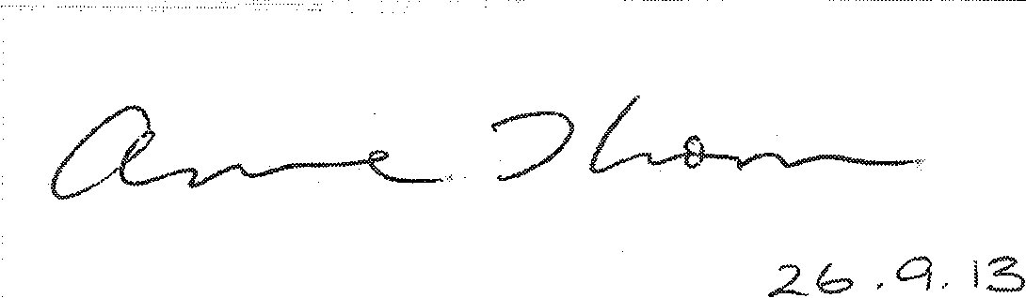

**COMMENTS**

MDS Complete Property Services (CPS) is an Australian Disability Enterprise that is funded through the Department of Families, Housing, Community Services and Indigenous Affairs (FaHCSIA) and provides 26 supported employees with meaningful work involving lawn mowing and property maintenance.

Approval for MDS to join FaHCSIA's exemption application has been granted by the Board of Directors following extensive discussion with its Senior Executive. MDS is committed to ensuring that its supported employees are paid at an appropriate level and in the absence of BSWAT, it feels somewhat hamstrung in determining pay rates.

MDS supports the action taken by FaHCSIA and looks forward to the development of a new wage assessment tool that will replace the BSWAT.