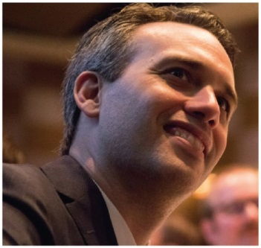 | Edward Santow  Human Rights Commissioner  FOURTH YEAR OF TERM | ‘The touchstone of human rights is dignity. The human rights framework provides practical tools to protect the dignity of all members of our community.’

TERM GOALS
Improved human rights protections for people including:  - refugees and asylum seekers  - lesbian, gay, bisexual, transgender and intersex people  - people in all forms of detention  - people of faith | Improved Australia’s protection of human rights in difficult contexts including:  - design and regulation of new technologies  - serious harms experienced by religious communities  - implementation of anti-terrorism and national security law and policy

STRATEGIES  - Developing partnerships and collaborations to address common goals.  - Public advocacy supported by research and evidence.  - Fostering public debate on human rights via strategic public engagement.  - Engaging stakeholders and ensuring inclusive consultation with diverse groups.  - Providing policy and law reform advice to improve human rights protection for vulnerable groups.  - Developing innovative solutions to protect and promote rights and freedoms. | 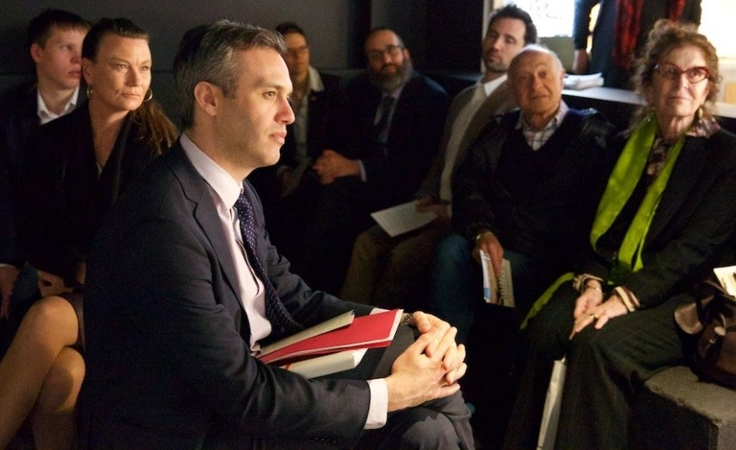  Commissioner Santow at the Sydney Jewish Museum Education Program launch, February 2018 (Photograph by Giselle Haber).

2019–20 PROGRAMS/PROJECTS
Human rights and technology project | - This project was prompted by unprecedented technological development, and especially the increasing use of artificial intelligence in ways that can engage our human rights. The aim is to identify the challenges and opportunities that new technologies bring to the protection and promotion of human rights in Australia, and to address the risks of harm.  - The first of a two-phase public consultation with experts and affected individuals from all sectors of our community is complete. In 2019, release of a discussion paper setting out a draft template for reform will be the basis of the second phase of public consultation. In early 2020, the project’s final report will be published and work with public and private sector stakeholders to implement the recommendations will follow.
Asylum seeker and immigration detention program | - This work aims to improve human rights protection in Australia’s immigration system. Projects include inspections of Australia’s immigration detention facilities to identify human rights problems and best practices; and research and reporting on the human rights implications of policies affecting asylum seekers, refugees and other migrants, including those in the Australian community.
Freedom of religion program | - This ongoing program is establishing a sustainable mechanism to communicate and work constructively with religious organisations, and the broader faith community, on how to protect freedom of religion in Australia. Through a combination of better data, community dialogue and education, it aims to increase understanding of the threats to religious freedom and to focus on combatting serious harms faced by religious communities in Australia.
Implementation of the Optional Protocol to the Convention against Torture (OPCAT) program | - Following the publication of a final report on our OPCAT project in late 2019, this work will continue to pursue opportunities to advocate and educate in relation to the implementation of OPCAT in Australia.
Medical interventions for people born with variations in sex characteristics: consultation project | - Following the publication of a final report by the end of 2019, this work will continue to pursue opportunities to advocate and educate in relation to the protection of human rights of people born with variations in sex characteristics in the context of medical interventions in Australia.

