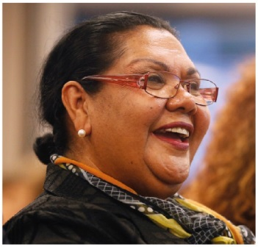 | June Oscar AO  Aboriginal and Torres Strait Islander Social Justice Commissioner  THIRD YEAR OF TERM | ‘We have a right to our voice and I am committed to making what you say count. To achieve equality and be free from discrimination we need to be making the decisions that determine our futures.’

TERM GOALS
Elevated the voices of Aboriginal and Torres Strait Islander women and girls | Reduced Aboriginal and Torres Strait Islander health inequality | Reduced numbers and rates of Aboriginal and Torres Strait Islander incarceration and children in the out of home care system | Progressed constitutional reform | Progressed the UN Declaration on the Rights of Indigenous Peoples to full effect through a national level coordinated action plan | Progressed native title reform

STRATEGIES  - Applying a human rights-based approach to working with Aboriginal and Torres Strait Islander communities that respects self-determination; participation in decision-making and free, prior and informed consent; non-discrimination and equality; and respect for and protection of culture.  - Empowering communities through participation and strengths-based engagement—gathering, and communicating community voice, content and discussion on key issues.  - Engaging with key organisations and campaigns supporting and advocating for families and enabling children to stay safe and connected to kin and culture and promoting justice sector reform including justice reinvestment initiatives.  - Engaging internationally to highlight Aboriginal and Torres Strait Islander issues, forge links with other Indigenous representatives, and hold our government to account on Indigenous rights.  - Promoting human rights-based, strengths-based and trauma-informed approaches to supporting Aboriginal and Torres Strait Islander people to lead change for their communities.  - Co-ordination, leadership and liaison with key bodies to drive constitutional and native title reform. | 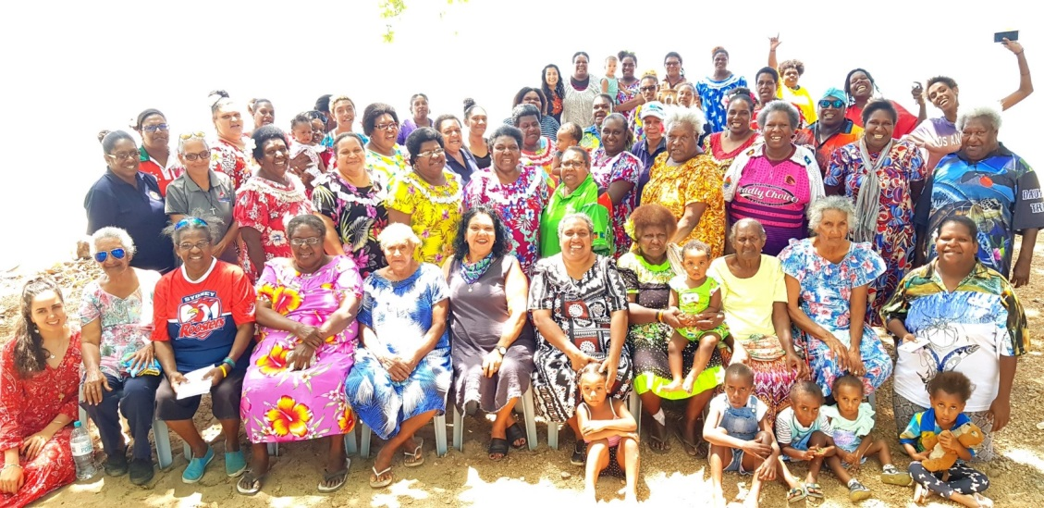  Commissioner Oscar (centre) with the Wiyi Yani U Thangani participants of the Murray Island women’s session, October 2018 (Photograph by Wayne Quilliam).

2019–20 PROGRAMS/PROJECTS
Wiyi Yani U Thangani (Women’s Voices) Project | This year’s work builds on last year’s national conversation with women and girls, which involved face-to-face engagement with 2,294 women and girls in 50 locations across Australia. The Wiyi Yani U Thangani Report will elevate the voices of Aboriginal and Torres Strait Islander women and girls with respect to their strengths, challenges, aspirations and solutions.  Stage 2 of the Project will focus on meaningful access to the report and its findings, additional consultations with senior Elders, and knowledge-sharing resources aimed at building capacity for governments, service providers and community to partner on genuinely co-designed initiatives.
Native Title Project | As Australia enters the post-determination era, many Indigenous people are deeply disappointed about what Native Title has failed to deliver. There is a need to assess the challenges and opportunities that lie ahead from a human rights-based perspective. The project will provide a report on the current state of Native Title across Australia and investigate what changes and initiatives are required if Native Title is to enable Indigenous Peoples to achieve self-defined development goals.
The Close the Gap Campaign | This multi-year collaboration is working with Australia’s peak Indigenous and non-Indigenous health bodies, NGOs and human rights organisations to achieve health and life expectation equality for Australia’s Aboriginal and Torres Strait Islander peoples.

