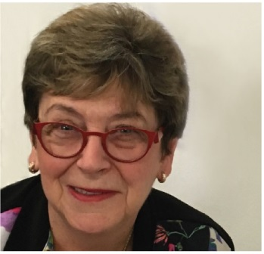 | The Hon  Dr Kay Patterson AO  Age Discrimination Commissioner  FOURTH YEAR OF TERM | ‘I have an absolute aversion to good solid reports ending up in the graveyard of good intentions. Therefore, I have made it my goal to advance, as far as possible, the implementation of sensible recommendations and practical solutions in relation to three main issues.’

TERM GOALS
Increased employment opportunities for older workers | Improved recognition and responses to elder abuse | Increased housing security for older women at risk of homelessness | Promoted positive ageing

STRATEGIES  - Creating relationships and establishing allies, partners and collaborations to identify common interests and goals.  - Encouraging resource sharing and collaboration to develop new initiatives.  - Developing innovative solutions to further term goals.  - Promoting and strategically advocating with stakeholders and decision makers to understand, engage with and implement key policy, process and legislative recommendations.  - Developing specific initiatives to reach regional, rural and remote stakeholders. | 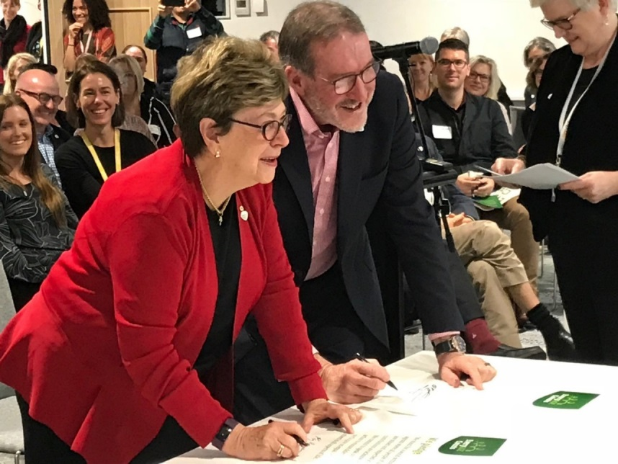  Commissioner Patterson and Robert Tickner AO signing the pledge to end ageism at the EveryAGE Counts Launch (Benevolent Society) October 2018.

2019–20 PROGRAMS/PROJECTS
Older Australians and employment program | - Fostering implementation of key recommendations from the 2016 Willing to Work report.  - Human Resources Professionals and Older Workers—a collaboration with the Australian Human Resources Institute. Investigating more deeply the attitudes revealed in the 2018 member attitudinal survey and explore initiatives to address employment barriers for older Australians.  - Rights of Older Workers training package is being delivered with support from FACS NSW.
Elder abuse awareness program | - Fostering implementation of selected recommendations from the 2017 Australian Law Reform Commission’s Elder Abuse report.  - Elder abuse awareness project in collaboration with peak professional bodies—this initiative will develop educational materials on elder abuse for members who are in position to identify older people at risk of elder abuse in the community. The initial project is with health professional peak bodies.  - Community elder abuse awareness project—this work has an outreach focus on regional, rural and remote stakeholders and will create of elder abuse awareness materials and undertake local educational events as well as harnessing radio to reach people, raise awareness of elder abuse and promote tools and resources for local communities.
Older women at risk of homelessness program | - Encouraging initiatives that increase housing security for older women.  - This program emphasises advocacy with community groups and the private sector to encourage innovative housing solutions for older women at risk of homelessness. It will be informed by an examination of the state of research in this area and a review of the current initiatives and programs being undertaken in Australia.
Supporting and promoting positive ageing | - To raise awareness among older people of their rights in a number of life arenas. The Your Rights at Retirement resource has been updated and is to be followed by a new series of resources.  - Participating annually in the 100: The Centenarian Portrait Project by Teenagers to help this campaign build cross-generational awareness of positive ageing.

