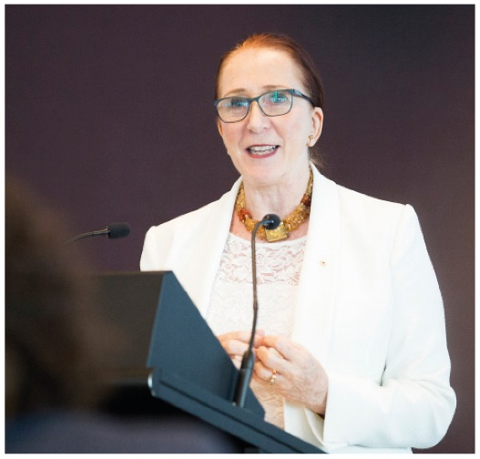 | Emeritus Professor  Rosalind Croucher AM  President  THIRD YEAR OF TERM | ‘Good relationships and open doors are absolutely crucial for us to be able to play the role of trusted adviser to its fullest–to be the devil’s advocate and at times to be the “devil’s blowtorch”, you need to have a respected seat at the table.’

TERM GOALS
Progressed the role and leadership of the Commission as an independent statutory agency and as Australia’s National Human Rights Institution | Advanced the Commission’s relationship with key stakeholders including Commonwealth Government and Parliament | Enhanced community understanding of human rights and an Australian culture of rights-mindedness | Led and managed the internal and external governance of the Commission effectively | Fostered and led a positive and collegiate Commission and organisational culture

STRATEGIES  - Working inclusively to lift the consideration of human rights across law, policy and practice above and ahead of politics.  - Opening the conversation and generating forward momentum in discussing human rights challenges and solutions.  - Leading the united development of a national reform agenda for human rights.  - Ensuring and promoting the Commission’s reputation for human rights expertise, evidence and independence.  - Building understanding through thematically-linked speeches and articles.  - Celebrating human rights achievements across the community. | 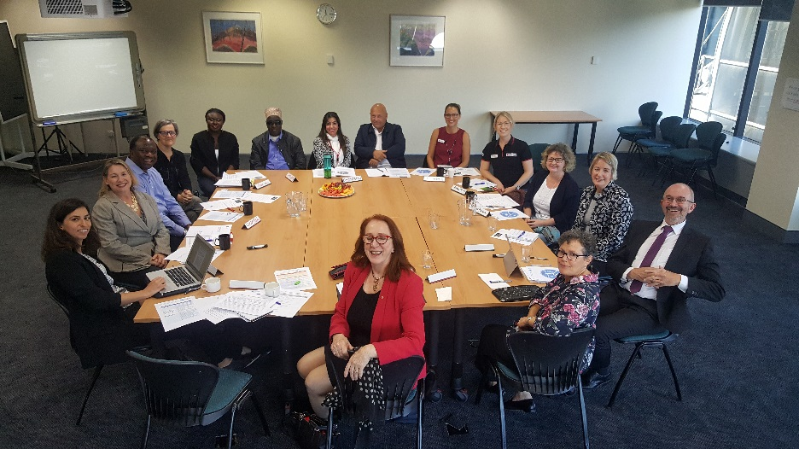  National conversation consultation meeting with Perth stakeholders, May 2019.

2019–20 PROGRAMS/PROJECTS
In addition to the governance, statutory and leadership functions of the Commission, President Croucher leads these programs and projects.
Free and equal in dignity and rights: An Australian conversation on human rights | - This strategic multiyear initiative aims to spearhead a system of human rights protection for 21st century Australia where the promotion of human rights is a shared endeavour—by government, business, the NGO sector, educators, service providers and the community at large. The initiative draws on the expertise and unites the work of all the Commission.  - This year's project includes a national engagement process with consultations, submissions, stakeholder workshops and national human rights conference—culminating in a reform agenda report for government.
Investigation and Conciliation and National Information Services | - These services ensure all Australians can access free and accessible information, and investigation and conciliation services. They provide best practice alternative dispute resolution for complainants and respondents and focus on systemic outcomes that have far-reaching positive benefits for the Australian Community.
Human rights education and training | - This program strategically targets audiences and sectors in its aim to ‘build a universal culture of human rights’. This year’s program includes: teaching resources mapped to The Early Years Learning Framework and the Australian Curriculum; resources for the vocational education sector; adult training programs for public servants and private sector employers on age and disability rights in the workplace, and the development of guidelines and policies to support organisations to comply with their legal anti-discrimination obligations and to promote a best practice human rights-based approach.
Human rights technical co‑operation | - Through funding from Australia’s Aid Program, this year’s programs with other countries include: collaborating with partners to advance human rights reform in China; advancing human rights education throughout schools and universities in Vietnam; strengthening the capacity of the Government of Lao People's Democratic Republic to engage with UN treaty bodies and the Universal Periodic Review process; supporting the Association of Southeast Asian Nations Intergovernmental Commission on Human Rights.
International engagement | - As an ‘A status’ National Human Rights Institution (NHRI) we have a formal role in the United Nations system. This year involves preparation for Australia’s third United Nations Universal Periodic Review (UPR) appearance and participating in scheduled Human Rights Treaty body reporting.  - In partnership with other NHRIs we work to advance human rights in our region and globally. This year the President has a pivotal role as a bureau (board) member of the Global Alliance for National Human Rights Institutions and as Chairperson of the Asia Pacific Forum of National Human Rights Institutions.
Business and human rights strategy | - This program builds upon the momentum created by recent legislative action in Australia and internationally to begin operationalising the United Nations Guiding Principles on Business and Human Rights and other frameworks.  - A strategic focus is to work with government, business and civil society in the implementation of the Australia Modern Slavery Act 2018 (Cth) and Modern Slavery Act 2018 (NSW). This includes a project to develop sector-based guidance on using a human rights approach to identify and respond to modern slavery risks.
Human rights scrutiny | - This program aims to improve human rights protections in current and proposed legislation and includes an ongoing relationship with the Parliamentary Joint Committee on Human Rights. The work involves the monitoring of federal legislative and inquiry processes, identifying strategic opportunities for engagement by the Commission, including evidenced based submissions to inquiries.

