Headshot photo - Commissioner Oscar

June Oscar AO

Aboriginal and Torres Strait Islander Social Justice Commissioner

SIXTH YEAR OF TERM

‘The Wiyi Yani U Thangani report puts in the hands of all Australians the lives and truths of our women and girls. Read and listen to them. In responding we will unleash their determination, power and potential to improve their lives and those of all Australians.’

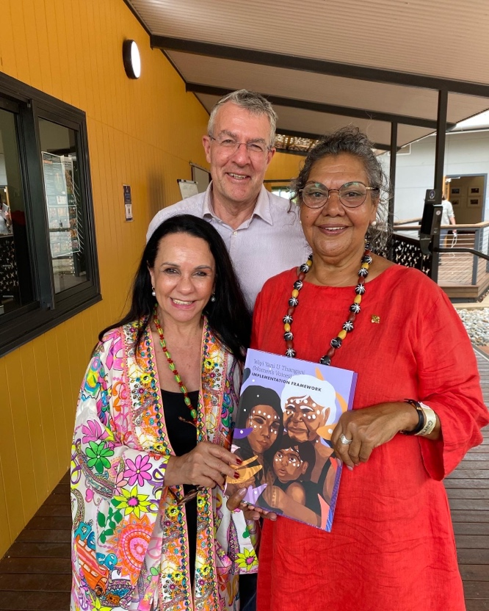

Commissioner Oscar (right) presenting the Wiyi Yani U Thangani (Women’s Voices) implementation framework to the Hon Linda Burney, Minister for Indigenous Australians and Attorney-General, the Hon Mark Dreyfus QC in June 2022

# TERM GOALS

* Elevate the voices of Aboriginal and Torres Strait Islander women and girls.
* Reduce Aboriginal and Torres Strait Islander health inequality.
* Progress Constitutional reform.
* Progress native title reform.
* Reduce numbers and rates of Aboriginal and Torres Strait Islander incarceration and children in the out of home care system.
* Progress the realisation of the UN Declaration on the Rights of Indigenous Peoples.

# PRINCIPLES / APPROACH

* Applying a human rights-based approach to working with Aboriginal and Torres Strait Islander communities that respects self-determination; participation in decision-making and free, prior and informed consent; non-discrimination and equality; and respect for and protection of culture.
* Empowering communities through participation and strengths-based engagement—gathering, and communicating community voice, content and discussion on key issues.
* Engaging with key organisations and campaigns supporting and advocating for families and enabling children to stay safe and connected to kin and culture and promoting justice sector reform including justice reinvestment initiatives.
* Engaging internationally to highlight Aboriginal and Torres Strait Islander issues, forge links with other Indigenous representatives, and hold our government to account on Indigenous rights.
* Promoting human rights-based, strengths-based and trauma-informed approaches to supporting Aboriginal and Torres Strait Islander people to lead change for their communities. Co-ordination, leadership and liaison with key bodies to drive constitutional and native title reform.

# KEY ACTIVITES: 2022–23 WORKPLAN

|  |  |
| --- | --- |
| Wiyi Yani U Thangani (Women’s Voices) project stage three | * Currently, Australia does not have the national architecture to define the many dimensions of gender equality and progress determined change, nor does it have a nationally consistent approach to respond holistically to the needs of First Nations women and girls. This must change. * This year’s work is focused on the final stage of implementation of the Commissioner’s Wiyi Yani U Thangani (Women’s Voices) report (2020) which sets out First Nations women and girls’ aspirations for structural reform. Stage Three of Wiyi Yani U Thangani will continue the co-design approach through the Virtual Policy Forum on women’s safety and protection in September 2022 and the First Nations Women’s and Girls National Leadership Summit in May 2023. The project will also conduct research into effective strengths-based programs and approaches and deliver a National Framework for Action by end of 2023. |
| Native title project | * As Australia enters the post-determination era, many Aboriginal and Torres Strait Islander people are deeply disappointed about what native title has failed to deliver. There is a need to assess the challenges and opportunities that lie ahead from a human rights-based perspective. * Building on the work of the Wiyi Yani U Thangani (Women’s Voices) project, the native title Project will provide a stories-based picture of the current state of native title across Australia, specifically from the perspective of Aboriginal and Torres Strait Islander women involved in native title. * The Project will identify and explore the challenges experienced by women in the native title system and their perspectives about what reforms are required to ensure Aboriginal and Torres Strait Islander peoples’ full enjoyment of human rights in relation to their traditional lands and waters. This will include the provision of a statutory report containing key reform recommendations in FY22–23. |
| The Close the Gap campaign | * This multi-year collaboration is working with Australia’s peak Indigenous and non-Indigenous health bodies, NGOs and human rights organisations to achieve health and life expectation equality for Australia’s Aboriginal and Torres Strait Islander peoples. |