Headshot photo - Commissioner Patterson

The Hon Dr Kay Patterson AO

Age Discrimination Commissioner

SEVENTH YEAR OF TERM

‘I have an absolute aversion to good solid reports ending up in the graveyard of good intentions. Therefore I have made it my goal to advance, as far as possible, the implementation of sensible recommendations and practical solutions in relation to three main issues.’

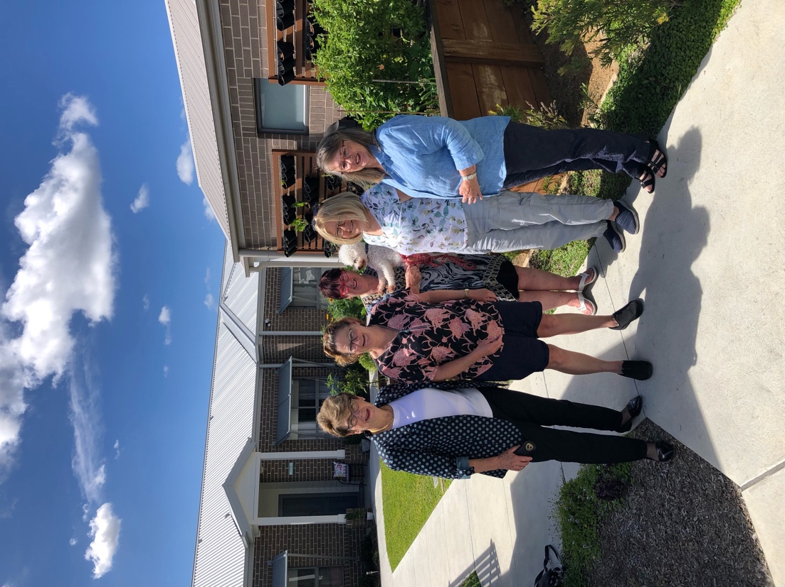

Commissioner Patterson with (left to right) Narelle Neilson, Dianne Shiels, Maree Gardner and Robyn Oliver, residents of IRT Jasmine Grove at Kanahooka. Jasmine Grove enables a small group of single women aged over 55 to live together in a supportive environment within an IRT retirement village

# TERM GOALS

* Increase employment opportunities for older workers.
* Improve recognition and responses to elder abuse.
* Increase housing security for older women at risk of homelessness.
* Promote positive aging.

# PRINCIPLES / APPROACH

* Increasing awareness of the National Elder Abuse phone line (1800 ELDERHelp / 1800 353 374).
* Increasing capacity and confidence of the community to identify signs and respond to elder abuse appropriately.
* Promoting and strategically advocating with stakeholders and decision makers to understand, engage with and implement key policy, process, and legislative recommendations.
* Developing specific initiatives to reach culturally and linguistically diverse communities and other minority groups.

# KEY ACTIVITIES: 2022–23 WORKPLAN

|  |  |
| --- | --- |
| Older Australians and employment program | * Increase awareness and understanding of the issues and barriers affecting the employment of older workers. Projects in 2022–23 include the Older Workers Survey Report in collaboration with the Australian Human Resource Institute and supporting activities, including stakeholder and media engagement, to encourage the employment of older people and promote the benefits of multigenerational workforces. * Rights of Older Workers training package and awareness materials, developed with support from Department of Communities and Justice NSW. * Chairing the Collaborative Partnership on Mature Age Employment. |
| Elder abuse awareness program | * Fostering implementation of selected recommendations from the 2017 Australian Law Reform Commission’s Elder Abuse report. * Ongoing distribution of elder abuse awareness bookmarks and posters in English and core community languages. * Increased understanding in the general community about causes and responses to elder abuse and continued promotion of resources, supports and best practices. Projects in 2022–23 include the development of a new elder abuse awareness video and associated campaign activities. |
| Older women at risk of homelessness | * Encouraging initiatives that increase housing security for older women. * This program emphasises advocacy with community groups and the private sector to encourage innovative housing solutions for older women at risk of homelessness. It will be informed by an examination of the state of research in this area and a review of the current initiatives and programs being undertaken in Australia. * In 2022–23 the focus will be to continue to increase understanding of the issues among community and national stakeholders and engaging in community outreach and awareness raising events. |
| Supporting and promoting positive ageing | * Increasing understanding of Australian community perceptions and beliefs regarding ageing and older people, with a particular focus on those who have high contact with older people through their work. This project will contribute a more detailed understanding of fostering positive beliefs and perceptions about older people and ageing. * Participating in the 100: The Centenarian Portrait Project by Teenagers to help this campaign build cross-generational awareness of positive ageing and continue to support and promote the exhibition across state and territories in 2022–23. * Appointed as a member of the Council of Elders, at the end of 2021, for two years. The Council has been asked to advise Government on aged care and ageing in general. |