Human Rights and Equal Opportunity Commission

Annual Report 2004-2005

Chapter 4: Complaint handling section

Overview of the work of the Complaint Handling Section
The President of the Human Rights and Equal Opportunity Commission is responsible for the Commission’s complaint handling function. The President is assisted in investigating and conciliating complaints lodged under federal anti-discrimination and human rights law by staff of the Complaint Handling Section (CHS).

There are three investigation/conciliation teams, headed by a Principal Investigation/Conciliation Officer, who handle complaints on behalf of the President. The teams are divided with reference to specific pieces of federal legislation to enable staff to develop specialised knowledge of the law and an understanding of issues raised under this law.

CHS staff undertake in-house training in the investigation and conciliation of complaints and are offered on-going professional development through other programs conducted by the CHS Principal Training and Policy Officer.

Once a complaint has been formally accepted by the Commission, the aim of the CHS is to manage the complaint in a timely and unbiased manner and to be responsive to the legitimate needs of parties to the complaint. Complaints are generally allocated to an officer for action within six weeks of receipt. While allocation to an officer may take a little longer than this at times, cases that need priority handling are dealt with straight away.

The investigation of a complaint may include such tasks as statement taking, site inspections, viewing video/TV/CCTV footage or reviewing employment and medical records.

After investigation, if a complaint is considered appropriate for conciliation, a conciliation conference is arranged. Conciliation conferences usually take the form of a face-to-face meeting of the parties to the complaint and conferences are held in various locations throughout Australia including regional and remote areas. An Investigation/Conciliation Officer presides over the conference and assists parties to try to resolve the complaint. If a complaint can be resolved through conciliation, the matter is closed. Many complaints are dealt with in this way as parties recognise the benefits of a process where they have direct input into how the matter is resolved without having to resort to more formal court proceedings.

Where a complaint of unlawful race, sex, disability or age discrimination is unable to be resolved through a conciliation process or where the President is of the view that the complaint is, for example, lacking in substance or better dealt with by another organisation, the complaint will be terminated. Both parties to a complaint are advised in writing of the President’s decision regarding a complaint. After a complaint is terminated, the complainant may decide to pursue the matter before the Federal Court of Australia or the Federal Magistrates Court.

Complaints that allege a breach of human rights or discrimination under the Human Rights and Equal Opportunity Commission Act 1986 cannot be taken to court for determination. Complaints under this Act which have not been declined and are unable to be resolved through conciliation may be subject to a report to the Attorney-General and subsequent tabling of the report in Parliament. Decisions under this Act may, however, be subject to review under the Administrative Decisions (Judicial Review) Act 1977 (Cth).

In 2004-05:
✣ 1 241 complaints were received;
✣ 1 233 complaints were finalised;
✣ 38 percent of finalised complaints were conciliated; and
✣ 91 percent of complaints were finalised within 12 months of lodgement.

A diagram of the complaint handling process is provided at Appendix 4.

The CHS also manages the Complaint Information Service. Each year around 10 000 people from all over Australia contact the Commission’s Complaint Information Service either by telephone, TTY, post, e-mail or in person to obtain information about the law the Commission administers and the complaint process. As many enquirers are unsure which organisation can best assist them, the work of Complaint Information Service staff frequently involves providing contact details for organisations that can more appropriately deal with the enquirer’s concerns. If the enquirer’s concern is one that the Commission can deal with, the enquirer is provided with information on how to lodge a complaint and is either provided with the necessary forms or directed to the Commission’s website and ‘on-line’ complaint lodgement facility.

✣ 9 936 telephone/post/e-mail/TTY/in person enquiries were received in 2004-05.

Key performance indicators and goals
✣ Timeliness – the section’s stated performance measure is for 80 percent of complaints to be finalised within 12 months of date of receipt. In 2004-05, the CHS finalised 91 percent of matters within 12 months and the average time from receipt to finalisation of a complaint was six and a half months. A detailed breakdown of timeliness statistics by jurisdiction is provided in Table 11. There has been continual improvement in the timeliness of the complaint process over the past three years.
✣ Conciliation rate – the section’s stated performance measure is for 30 percent of finalised complaints to be conciliated. In 2004-05, the section achieved this goal with a 38 percent conciliation rate.
✣ Customer satisfaction – the section’s stated performance measure is for 80 percent of parties to be satisfied with the complaint handling process. Data for the past year indicates that 92 percent of parties were satisfied with the service they received and 57 percent rated the service they received as ‘very good’ or ‘excellent’. Further details of survey results for this reporting year are provided below.

Customer satisfaction survey
Since 1997, the CHS has sought feedback on the complaint process from people lodging complaints (complainants) and people responding to complaints (respondents). This feedback is obtained by means of a Customer Satisfaction Survey which is predominately undertaken by telephone interview. Survey results for the period 1 July 2004 to 30 June 2005 indicate that:

✣ Eighty eight (88) percent of complainants and 97 percent of respondents felt that staff explained things in a way that was easy for them to understand;
✣ Ninety three (93) percent of complainants and 96 percent of respondents felt that forms and correspondence from the Commission were easy to understand;
✣ Seventy eight (78) percent of complainants and 81 percent of respondents felt that the Commission dealt with the complaint in a timely manner; and
✣ Eighty nine (89) percent of complainants and 87 percent of respondents did not consider staff to be biased.

In comparison with the last reporting year, there has been improved satisfaction across almost all of the reporting categories. In particular, in 2004-05 there has been significant improvement in complainant satisfaction with the timeliness of the complaint process.

Service Charter
The CHS’s Service Charter provides a clear and accountable commitment to service. It also provides an avenue through which users can understand the nature and standard of service they can expect and contribute to service improvement. All complainants are provided with a copy of the Service Charter and respondents receive a copy when they are notified of a complaint against them.
In the 2004-05 reporting year the Commission did not receive any complaints about its services through this mechanism. It is noted that where parties have concerns about the complaint handling process, they are generally able to resolve their concerns through discussions with the officer handling the complaint.

Access to complaint services
The CHS aims to facilitate broad community access to its information and services. In meeting this challenge the CHS provides the services outlined below:

✣ The Complaint Infoline. 1300 656 419 (local call charge) is open Monday - Friday between 9.00 am and 5.00 pm. This service offers enquirers the opportunity to call and discuss allegations of discrimination with a Complaint Information Officer. Enquirers can also e-mail: complaintsinfo@humanrights.gov.au

✣ CHS webpage. www.humanrights.gov.au/complaints_information/ This webpage provides the general public and potential users of the service with information about the Commission’s complaint handling role and the complaint process. The webpage includes information on how to lodge a complaint, a complaint form, frequently asked questions about complaints and a conciliation register. The conciliation register contains de-identified information about the outcomes of conciliated complaints. The CHS webpage received 114 008 page views during this reporting year.

✣ On-line complaint form. This service, which allows complaints to be lodged electronically, continues to be well utilised.

✣ Concise complaint guide. This document, which provides an overview of the complaint process, can be accessed on the CHS webpage and downloaded in 14 community languages.

✣ Interpreter and translation services. In the past reporting year the section utilised a range of interpretation and translation services. The main language groups assisted in 2004-05 were Cantonese, Arabic, Persian and Vietnamese.

✣ Arrangements with State and Territory agencies. The Commission has formal arrangements with the Victorian Equal Opportunity Commission, the Queensland Anti-Discrimination Commission, the South Australian Equal Opportunity Commission, the Northern Territory Anti-Discrimination Commission and the Western Australia Equal Opportunity Commission, whereby CHS staff utilise facilities at these agencies for conciliation conferences, community education or training and display of CHS publications. The Commission has informal arrangements with the Tasmanian Anti-Discrimination Commission and the Australian Capital Territory Human Rights Office.

✣ Election of jurisdiction information. In the majority of cases complainants have a choice to lodge complaints either under state or territory anti-discrimination law or under federal law. The Commission has developed an information sheet to assist complainants understand this election of jurisdiction. The information sheet can be downloaded from the Commission’s website at: www.humanrights.gov.au/complaints_information/guides/jurisdiction.html

✣ Video/DVD on the conciliation process. This audio-visual resource entitled ‘Pathways to Resolution’ is available to the general public and complainants, respondents and advocates who may be involved in the complaint process. The video/DVD provides parties with an overview of a conciliation conference, outlines steps to take in preparation for conciliation and demonstrates positive approaches to discussing issues and negotiating resolution outcomes. Captioned and uncaptioned versions of the video/DVD are available from the Commission and the video/DVD is provided on loan to complainants, respondents and advocates who are currently involved in complaints before the Commission. Sections of the video/DVD can also be viewed on the Commission’s webpage at: www.humanrights.gov.au/pathways_to_resolution/index.html

✣ Conciliation circuits. Conciliation officers travel throughout Australia to conduct face-to-face conciliation conferences. Along with conferences conducted in the greater Sydney area, CHS officers conducted 27 conferences in regional NSW (including Coffs Harbour, Wagga Wagga, Newcastle, Wollongong, Coonamble, Orange, Gosford, Lismore, Albury, Tamworth, Taree and Morisset); 75 in Victoria (including Melbourne and Bendigo; 53 in Adelaide; 33 in Queensland (including Brisbane, Cairns, Hervey Bay, Mackay, Gold Coast and Townsville); 22 in Western Australia (Perth and Kalgoorlie); eight in the Australian Capital Territory; eight in Darwin and 13 in Tasmania (including Hobart, Launceston and Devonport).

✣ Access working group. During this reporting year the CHS access working group updated the section’s community education presentation to include information about the Age Discrimination Act 2004 which came into effect on 23 June 2004. The group also continued to develop strategies to ensure broad dissemination of information about federal anti-discrimination law and the Commission’s complaint handling process.

Community education
The CHS contributes to the Commission’s function of promoting an understanding and acceptance of human rights through its community education activities.

In this reporting year around 90 organisations throughout all states and territories attended information sessions on the law and the complaint handling process run by CHS staff. The CHS Indigenous Information/Liaison Officer, on her own or with other officers, undertook around 30 meetings with Indigenous organisations.

The organisations visited by CHS staff included community legal centres, Aboriginal legal centres, multicultural organisations, universities, disability groups, professional associations and unions. The regions covered included: Dandenong and Geelong in Victoria; Wagga Wagga, Orange and Glen Innes in NSW; Kalgoorlie in Western Australia and Rockhampton and Mackay in Queensland.

Training
The Commission has two specialised training programs which provide knowledge and skills in statutory investigation and conciliation. All complaint handling staff are required to undertake these courses. The CHS also provides training in investigation and conciliation for other organisations.

Two investigation training courses and two conciliation training courses were held for Commission staff during 2004-05. The courses held in May 2005 were also attended by staff from anti-discrimination agencies in New South Wales, South Australia, the Australian Capital Territory and Tasmania.

In February 2005, investigation and conciliation training was also provided to staff of the Office of the Federal Privacy Commissioner.

For the fourth year, the Commission has worked in partnership with the Australian Public Service Commission to provide a two-day investigation training course for federal public servants. This course, which is a variation of the Commission’s standard statutory investigation training program, provides theory and skills that can be applied to the investigation of internal complaints and breaches of the Australian Public Service Code of Conduct. In the past year, eight courses were delivered in various locations around Australia including Canberra, Adelaide, Perth, Brisbane and Sydney.

In the second half of 2004 a Principal Investigation/Conciliation Officer acted as a mentor for the Willing and Able Mentoring Program which is run by Employers Making a Difference. This program assists tertiary students with disabilities develop strategies to enable transition into paid employment. Through the mentoring placement students gain an understanding of a workplace culture and acquire skills in networking and professional presentation.

Staff of the CHS also attended various seminars and training courses relating to their work. These included ‘Industrial Relations and the Law’ seminars conducted by the University of Sydney; Australian Government Solicitor Law Group seminars; the Community Legal Centres’ National Conference; the Administrative Law Conference; the NSW Commonwealth Agencies Government Business Conference; the National Alternative Dispute Resolution Advisory Council’s Research Forum; and the Mawul Rom Cross Cultural Mediation Training Seminar. In this reporting year two CHS officers continued study towards Certificate IV accreditation in Assessment and Workplace Training.

Research and policy
In recent years the CHS has undertaken research with a view to better understand and improve the Commission’s complaint handling work. During 2004-05, the CHS obtained current and detailed information about conciliation with the aim of improving its practice and increasing practitioner and public understanding of the Commission’s Alternative Dispute Resolution process.

This particular research project involved CHS officers completing a survey at the conclusion of each conciliation process which occurred during the period 1July 2004 – 31 December 2004. One hundred and thirteen surveys were completed. The information gathered by the survey included information on party representation in conciliation and the form of the conciliation process. A summary of the information obtained from this survey will be placed on the Complaint Page of the Commission’s website in the near future. This will supplement research findings and papers regarding the Commission’s conciliation process which are currently available on the Commission’s website at: www.humanrights.gov.au/complaints_information/papers.html

International training and consultation
In recognition of the Commission’s role as a leader in the field of human rights and anti-discrimination complaint practice, the CHS is often requested to provide investigation and conciliation skill training for human rights institutions in other counties. This includes the provision of specifically designed training programs for staff from institutions in developing countries and more advanced skill workshops for staff from established institutions. The Commission’s CHS undertook three major overseas training projects in 2004-05.

In 2004, the Commission’s CHS was awarded a tender by the Asia Pacific Forum of National Human Rights Institutions to provide training for staff of the National Human Rights Commission of Thailand. This project involved the development and presentation of a five-day training course in human rights investigation. The training program took place in Bangkok from 22 – 26 October 2004. Thirty officers from the National Human Rights Commission of Thailand, the Department of Rights and Liberties Protection and the Ministry of Justice attended the program which was conducted in English with simultaneous translation into Thai.

In the period 20 November – 3 December 2004, two principal officers from the Commission's CHS section provided basic investigation and conciliation training for new staff of the Hong Kong Equal Opportunities Commission and advanced training workshops for more experienced staff. This is the third time the CHS has been invited to provide training for staff of the Hong Kong Equal Opportunities Commission.

In 2005, the CHS once again as a consultant to the Asia Pacific Forum of National Human Rights Institutions, developed and conducted a five-day training course in human rights investigation for staff of the Commission on Human Rights of the Philippines. Twenty-six staff from the Commission’s central and regional offices attended the training which was held in Tagaytay City in the Philippines from 18 – 22 April 2005.

The CHS is often called upon to provide placements for staff from overseas human rights institutions and to provide information about the Commission’s complaint handling work to visiting delegations. In January 2005, the CHS hosted a placement for two officers from the South Korean Human Rights Commission. During this reporting year CHS staff also provided information to visiting delegations from China, Iraq, the United Kingdom, Papua New Guinea and Malta. These delegations included ministerial, diplomatic and government representatives from human rights, gender equity and public service organisations.

In 2004-05, a CHS staff member participated in a training course entitled ‘The Role of National Human Rights Institutions in Human Rights Protection’. This course was held in Bangkok, Thailand from 1-10 December 2004.

Conciliation case studies ¹ Racial Discrimination Act

Under the Racial Discrimination Act 1975 it is unlawful to do any act involving a distinction, exclusion, restriction or preference based on race, colour, descent, or national or ethnic origin which has the purpose or effect of nullifying or impairing the recognition, enjoyment or exercise, on equal footing, of any human right or fundamental freedom in the political, economic, social, cultural or any other field of public life. The Act also prohibits offensive behaviour based on racial hatred.

In this reporting year the Commission received 167 complaints under the Racial Discrimination Act. The majority of these complaints related to employment (43%), the provision of goods and services (24%) and racial hatred (20%). The CHS finalised 157 complaints under this Act and 26 percent of these finalised complaints were conciliated. Detailed statistics regarding complaints under the Racial Discrimination Act are provided later in this chapter.

1. Complaint of race discrimination in the provision of goods and services
Four Aboriginal men complained that when they went to get a drink at a local club with a non-Aboriginal friend, the barman told them that the club does not serve beer to Aboriginal people.

In response to the complaint, the owner advised that the barman who was on duty at the time of the alleged incident was a casual employee and was no longer employed with the club. The owner said that no incident report had been lodged and he was unaware of the alleged incident. The owner claimed that if the matter had been reported to him and the alleged conduct confirmed, he would have dismissed the employee immediately.

The parties agreed to try and resolve the complaint by conciliation. The matter was resolved with the complainants agreeing to accept a verbal apology from the club owner and an offer to attend the club and have a drink with him.

2. Alleged race discrimination in employment
The complainant, who is of Ethiopian origin, claimed that he was discriminated against because of his race during his employment with the respondent manufacturing company. The complainant’s allegations included that he was called ‘black b…’, referred to as ‘monkey’ and asked “Where is there a well developed black country?”. The complainant claimed that he was over scrutinized compared to other employees and that he was rarely acknowledged by co-workers and managers. The complainant said that he eventually resigned because of pressure put on him.

In reply, the company denied that the complainant had been discriminated against because of his race. The company advised that while one employee agreed that he said “How are you, you black b…” to the complainant, this employee claimed that he intended no offence by the words and had apologised to the complainant.

The parties agreed to participate in a conciliation process which was successful. The complaint was resolved with an agreement that the company would pay the complainant $10 000 compensation and provide a verbal reference to prospective employees. The company also agreed to provide anti-discrimination training for its staff.

3. Alleged race discrimination in accessing facilities at a leisure centre
The complainant, who is of Jordanian origin, stated that in keeping with her customs she wears long sleeve clothing and a head scarf. She claimed that when attending a regular hydrotherapy session at a local leisure centre, a staff member approached her and told her that she was not allowed to enter the pool wearing a long sleeved shirt and scarf. The complainant said that when she told the staff member that she had been swimming in that manner at the centre for three months, the staff member told her that she would be allowed to swim but must shower first. The complainant said that she was embarrassed and humiliated by the action of the staff member.

In response to the complaint the leisure centre stated that it has no policy prohibiting people from wearing long sleeved shirts or head scarfs in wet areas. The centre noted that all members of the public are required to shower before entering the pool.

The parties agreed to participate in a conciliation process. The matter resolved with an agreement that the leisure centre would pay the complainant $8 500 compensation and provide her with a written apology.

4. Complaint of race discrimination in voluntary employment
The complainant, who is of Dutch origin, claimed that he applied to work as a volunteer tourist guide with a non-profit community based organisation. He alleged that his application was delayed and then ultimately rejected because of his race and accent.

In response to the complaint the respondent organisation said that the complainant’s application was unsuccessful because he did not have the suitable level of written and oral English language skills required for the job.

The complaint was resolved through conciliation with the organisation agreeing to provide the complainant with a verbal apology and offering the complainant a volunteer position in another section of the organisation. The organisation also agreed to implement procedures whereby prospective volunteers will be provided with information regarding the requirements for the positions they apply for and where the position requires English communication skills, they will be provided with detailed information on the level of skill required.

Sex Discrimination Act

Under The Sex Discrimination Act 1984 it is unlawful to discriminate against a person on the ground of their sex, marital status, pregnancy or potential pregnancy in many areas of public life including employment, education, provision of goods services and facilities, accommodation, clubs and in the administration of Commonwealth laws and programs. It is also unlawful to dismiss a person from their employment on the ground of their family responsibilities. Further, sexual harassment is unlawful in a variety of areas of public life including employment, educational institutions, the provision of goods, services and facilities, registered organisations, the provision of accommodation, clubs and in dealings concerning land.

In this reporting year the Commission received 348 complaints under the Sex Discrimination Act. The large majority of complaints related to employment (85%). Twenty-eight percent of the complaints alleged sexual harassment and a further 26 percent alleged discrimination on the ground of pregnancy. The Commission finalised 375 complaints under this Act and 47 percent of these finalised complaints were conciliated. Detailed statistics regarding complaints under the Sex Discrimination Act are provided later in this chapter.

1. Alleged pregnancy discrimination in casual employment
The complainant stated that she was employed by the respondent company as a casual pharmacy assistant and had worked regular shifts over a nine-month period. She claimed that in April 2004 she notified her supervisor that she was pregnant and three days later the company advised her that she could no longer be offered permanent regular employment but rather, would be offered on-call work.

In response to the complaint the company claimed that the complainant’s hours were reduced because of dissatisfaction with her work performance and as a result of having to train a new full-time employee to replace the complainant. The company disputed the complainant’s claim that she suffered detriment because of the reduction in her hours as the company was of the view that the complainant had found work elsewhere.

The parties agreed to try and resolve the complaint by conciliation. The complaint was resolved with an agreement that the company would pay the complainant $3 000 in general damages and provide her with a statement of service and a letter of apology. The company also agreed to ensure that relevant staff attend equal employment opportunity training.

2. Complaint of discrimination in employment on the ground of family responsibilities
The complainant advised that she had been employed as a full-time sales assistant with the respondent retail store for approximately 6 years. She claimed that when a new store manager commenced, her hours were changed from 8.30am - 4.30pm to 10.30am - 6.30pm. The complainant said that she advised the manager that she could not work the new hours as the day care centre her daughter attends closes at 6pm. The complainant claimed she spoke with the Area Manager about a possible transfer to another store but was told that even if she transferred, she would be required to do the later shift two days per week. The complainant subsequently resigned from her employment.

In response to the complaint the company stated that changing business needs and trading patterns had required changes to all employee shifts. The company claimed that various options were discussed with the complainant and that she was offered a transfer to another store where she could work two days on a later shift and three days on her usual shift but she refused this offer.

The parties agreed to resolve the complaint on the basis that the company would re-employ the complainant full-time at a particular store on the 8am - 5pm shift. The parties agreed that the complainant may be rostered to work at other agreed stores providing the company gives the complainant at least two days notice. The parties also agreed that no break in the complainant’s employment would be recorded.

3. Allegations of race discrimination and sexual harassment in employment
The complainant, who is of Asian background, stated that she was the only female contract administrator employed with the respondent building company. The complainant alleged that she was sexually harassed by a co-worker who was employed as a construction worker. Her allegations included that the co-worker made numerous comments about her Asian background, told her she would look cute if she wore a short skirt with black boots like those “Asian school girls” and showed her pornographic pictures of Asian women. The complainant stated that she raised concerns about the co-worker’s behaviour with the General Manager who said he would deal with the matter. The complainant claimed that she was issued with two written warnings about her performance and approximately one month after complaining about the co-worker’s behaviour, her employment was terminated.

In response to the complaint the company said that the complainant had been subject to performance counselling sessions before her dismissal for unsatisfactory performance. The company advised that during performance counselling the complainant told her immediate manager that she had been subjected to harassment. The company claimed that the General Manager advised her of the procedure for making a complaint but she did not make a formal complaint. The co-worker vigorously denied the complainant’s allegations and in reply claimed that the complainant often used sexual innuendo, showed him pornographic pictures and had exposed her breasts to him at a work party.

The parties agreed to participate in a conciliation process. Following a conciliation conference, the parties resolved the matter with an agreement that the company would pay the complainant $7 000 in general damages.

4. Complaint of pregnancy discrimination in employment
The complainant had been employed as a Regional Human Resources Manager with a large national retail company for three years. She claimed that while on maternity leave she was informed that her position had become redundant. She stated that four of her colleagues who held similar positions were advised about the restructure and successfully redeployed within three weeks. She claimed that the person who occupied her position while she was on maternity leave was also offered a similar position. The complainant alleged that on return from maternity leave she was placed in a project role, was not offered a comparable permanent position and was advised to look for positions online. She claimed that while she had been offered other positions within the human resources section, they were interstate or in other parts of the state in which she lives. She claimed that the computer she was provided with on her return from maternity leave was not linked to the company’s intranet until a month after her return and that at least two senior appointments had been made in the period after her return to work but she had not been given the opportunity to apply.

In reply, the company stated that numerous attempts were made to advise the complainant of the restructure while she was on parental leave. The company claimed that at the time of the restructure, the complainant was offered four positions but advised that she wished to remain on parental leave. The company said that on her return to work the complainant was provided with project work for a three-month period while she applied for alternative internal positions.

The parties agreed to try and resolve the complaint. As an outcome of conciliation the complainant was offered a permanent role in another department and paid $19 000 to cover her economic loss during the relevant period.
Disability Discrimination Act

Under the Disability Discrimination Act 1992 it is unlawful to discriminate against a person on the ground of their disability in many areas of public life including employment, education, provision of goods services and facilities, access to premises, accommodation, clubs and incorporated associations, dealing with land, sport and in the administration of Commonwealth laws and programs. It is also unlawful to discriminate against a person on the ground they are an associate of a person with a disability and it is unlawful to harass a person because of their disability.

In this reporting year the Commission received 523 complaints under the Disability Discrimination Act. The majority of these complaints concerned employment (49%) and the provision of goods, services and facilities (30%). The Commission finalised 530 complaints under this Act and 41 percent of these finalised complaints were conciliated. Detailed statistics regarding complaints under the Disability Discrimination Act are provided later in this chapter.

1. Complaint regarding access to library premises and services for the vision impaired
The complainant, who has a significant vision impairment, claimed that when she visited the new local library she could not read the signs and could not travel around the building safely because accessible signage and wayfinding assistance had not been provided.

In reply, the respondent council stated that it had engaged a disability consultant to provide disability management services in relation to the library development. The council advised that in response to the complaint to the Commission, it had arranged for the disability consultant to meet with the complainant to formulate an action plan to address the issues she had raised. The action plan provided that the required signage would be completed within two months and other works completed within four months.

The complainant advised the Commission that she was satisfied with the action taken by the council.

2. Alleged discrimination in the provision of accident and sickness insurance
The complainant advised that she had personal accident and sickness insurance, subject to an exclusion for circulatory system complaints, with the respondent company. The complainant claimed that the company had recently refused to renew the policy. The complainant advised that she had a melanoma removed 13 years ago but had provided a medical report indicating that there was no evidence of recurrent problems. The complainant also advised that she had an angioplasty six years ago but had provided a medical report indicating that there was only a one percent chance of a further occurrence of acute coronary syndrome.

In reply, the company stated that the decision not to renew the policy was not based on an assessment of the complainant's individual risk profile but rather, the policy was not renewed because the complainant had a pre-existing condition that became subject to an automatic decline following a review of its participation in the provision of sickness and accident products. The respondent claimed that the decision was reasonable given industry practice, the change in its underwriting guidelines and the non-availability of in-house underwriting expertise for the product.

The parties agreed to participate in a conciliation process. The complaint was settled on the basis of an agreement that the insurance company would reinstate the complainant's insurance without the previous exclusion and waive the premium for the remainder of the term of the policy for the current year. The company also agreed to pay the complainant $3 000 to compensate for any inconvenience and distress and provide a letter confirming that in the future, it would not decline to renew the complainant's insurance policy on the basis of facts already known.

3. Complaint of disability discrimination in on-going employment
The complainant advised that he had been employed for many years as a driver with a large transport company and had sustained a work-related injury which resulted in him being permanently restricted to a 30kg lifting capacity. He claimed that he was able to carry out his pre-injury duties with minor adjustments but was being denied the option of returning to work because of his work-related injury and his age.

In response to the complaint the company stated that the complainant was provided with suitable duties for nine months until he provided a medical certificate of permanent incapacity. The respondent company claimed that the level of permanent restrictions precluded the complainant from fulfilling the inherent requirements of his job.

The parties agreed to participate in conciliation and the matter was resolved with an agreement that the complainant would return to work in a training position and the company would pay the complainant $35 000 in general damages and legal costs.

4. Alleged disability discrimination in private education
The complainant lodged the complaint on behalf of her son, who has dyslexia. The complainant advised that her son has been enrolled in the respondent school since kindergarten and was now in Year 11. The complainant claimed that while the school was aware of her son’s difficulty with reading and writing and his need for adjustments, the school failed to make textbooks, classroom handouts and teacher notes available in an accessible format and in a timely manner. The complainant alleged that the failure to provide these adjustments adversely affected her son's performance and this, in turn, prevented him from being selected as a school prefect.

In response to the complaint the school claimed that efforts had been made to have the student’s needs assessed by independent experts but the student’s parents had not cooperated with that process and agreement could not be reached over the best way to provide adjustment for the student’s disability. The school claimed that processes put in place to provide adjustments were not adhered to by the student and that the student’s parents preferred that individual teachers did not speak to the student about his disability or adjustments, making it difficult to assess the need for adjustments in particular classes and activities. The school also referred to difficulties with the number and manner of the requests for adjustments which made it difficult to coordinate responses in a timely manner.

The parties agreed to try and resolve the complaint. The complaint was settled on the basis of an agreement that the school would implement a plan to provide reasonable adjustments for the student and support for his teachers. The school also agreed to provide information to the school community about its anti-discrimination policy and associated complaint process and about how students with disabilities can seek reasonable adjustments. Additionally, the school agreed to allow the student to undertake his final year of schooling over a two-year period with fees for that year apportioned over two-years, to provide disability awareness training for staff, to allow the student to be made a prefect after following the usual school procedures and to refund educational expenses of $15 000.

Age Discrimination Act

The Age Discrimination Act 2004 came into effect on 23 June 2004. Under this Act it is unlawful to discriminate against a person on the ground of their age or age group in many areas of public life including employment, provision of goods services and facilities, education, accommodation, access to premises and the administration of Commonwealth laws and programs. The procedures for handling complaints lodged under this Act are the same as the procedures for handling complaints of unlawful racial, sex and disability discrimination.

In this reporting year the Commission received 78 complaints under the Age Discrimination Act. The majority of these complaints concerned employment (73%). The Commission finalised 49 complaints under this Act and 47 percent of these finalised complaints were conciliated. Detailed statistics regarding complaints under the Age Discrimination Act are provided later in this chapter.

1. Complaint of age discrimination in the provision of insurance
The complainant advised that he is 61 years of age and working as a sub contractor. He claimed that he has had commercial business insurance with the respondent company for 10 years and has never made a claim. The complainant provided a copy of correspondence from the insurance company in which the company advised that it was unable to continue to provide personal illness cover for the complainant under the personal accident and illness section of his business insurance policy. The complainant alleged that the refusal to renew illness cover under the policy constituted age discrimination as illness cover had been provided when he was under 60 years of age.

In reply to the complaint the company said that they have always had an age cut off for the provision of such insurance cover and the 60 year age limit is consistent with standard industry practice. The company advised that as they only underwrite a small volume of personal accident and illness cover, they rely on available industry data for statistical information relating to this type of risk. The company claimed that statistics for the complainant’s relevant occupation category indicates that there is a large jump in claims for those in the 60-65 year age group and the cost of claims for policy holders over 60 years is much higher and uncertain. The company claimed that this uncertainty and volatility makes it difficult to identify and obtain an appropriate premium pool for these risks and therefore they do not offer illness cover for people over 60 years of age.

The complaint was resolved with the insurance company agreeing to reinstate personal illness cover for the complainant until he reaches 65 years of age.

2. Complaint of age discrimination by apprentice
The complainant is 19 years of age and was employed as an apprentice with the respondent engineering company. The complainant claimed that because of his age he was continually subjected to workplace bullying, harassment and verbal abuse. He claimed that the company director continually made comments to him such as “Your father should have done the smart thing and put your head in a warm bucket of water when you were born” and “you are nothing but a useless c***”.

In response to the complaint the company confirmed that the apprentice had made an internal complaint about the actions of the director and a subsequent investigation had confirmed the allegations. The company advised that the director is no longer employed with the company.

The complaint was resolved with the company agreeing to pay the complainant $3 800 in general damages.

3. Alleged age discrimination by employment service
The complainant stated that he is 60 years of age and had applied for a position as a cleaner through the respondent employment service. He claimed that a staff member of the employment service told him that he was too old for the position.

In response to the complaint the employment service said that the staff member in question could not recall the conversation and that they had other applicants for the position who were close to the complainant’s age. The employment service claimed that they were not responsible for filling the position as this had been done by the employer directly.

The parties agreed to participate in a conciliation process. The complaint was resolved with the employment service agreeing to provide the complainant with a formal written apology and arrange for the complainant to meet with management to discuss possible employment options. The complainant advised that he was satisfied with this action by the employment service.

4. Complaint of age discrimination in advertising
The complainant advised that she is a 48 year old job seeker and that she had received notification, via an electronic job match service, of a position with a real estate company. The complainant provided a copy of the advertisement for the position which stated “…seeks a well presented younger applicant …for the position of Receptionist/Personal Assistant”. The complainant claimed that if it had not been for the word ‘younger’ she would have applied for the position as she felt she had relevant skills and experience.

In response to the complaint the company confirmed the wording of the advertisement and advised that there was no reason for this age identification. The company stated that the person who placed the advertisement was in his mid 50’s and new to the organisation and that his interpretation of ‘younger’ was someone his age or younger.

The complaint was resolved with provision of a written apology to the complainant.

Human Rights and Equal Opportunity Commission Act

Complaints under the Human Rights and Equal Opportunity Commission Act 1986 are not subject to the same process as complaints under the Racial, Sex and Disability Discrimination Acts.

Under this Act the President can inquire into and attempt to conciliate complaints that concern alleged breaches of human rights by, or on behalf, of the Commonwealth. Human rights are defined in the Act as rights and freedoms contained in any relevant international instrument which is scheduled to or declared under the Act. They are the:
✣ International Covenant on Civil and Political Rights;
✣ Declaration on the Rights of the Child;
✣ Declaration on the Rights of Mentally Retarded Persons;
✣ Declaration on the Rights of Disabled Persons;
✣ Convention on the Rights of the Child; and
✣ Declaration on the Elimination of all Forms of Intolerance and of Discrimination Based on Religion or Belief.

Under the Act the President can also inquire into and endeavour to conciliate complaints of discrimination in employment on specific grounds. These grounds include religion, sexual preference, trade union activity and criminal record.

If a complaint of alleged discrimination or alleged breach of a human right is neither conciliated nor declined, the President can undertake further inquiry. If the President is satisfied that the subject matter of the complaint constitutes discrimination in employment or is a breach of a human right, the President must report the findings to the Attorney-General for tabling in Parliament. The Commission's Legal Services assists the President in this part of the process.

In this reporting year the Commission received 125 complaints under the Human Rights and Equal Opportunity Commission Act. The majority of these complaints concerned alleged breaches of the International Covenant on Civil and Political Rights (20%) and discrimination in employment based on criminal record (19%) and trade union activity (19%). The Commission finalised 122 complaints under this Act. Thirteen percent of these finalised complaints were conciliated and four percent were referred for reporting. Detailed statistics regarding complaints under the Human Rights and Equal Opportunity Commission Act are provided later in this chapter.

1. Complaint of religious discrimination in relation to an employment-related examination
The complainant claimed that to complete her registration as a medical practitioner she was required to undertake a clinical examination on a Saturday. The complainant stated that she is a Seventh Day Adventist and her religion requires that work-related activities are not conducted on Saturdays. The complainant claimed that the registration body would not allow her to change the day of the examination and she alleged that this constituted discrimination on the ground of religious belief.

In reply, the registration body denied discriminating against the complainant because of her religion. The body stated that it did not have clinical facilities of its own where testing can be conducted and has to rely on clinical facilities in teaching hospitals in capital cities. The registration body claimed that clinical facilities in hospitals in the city where the complainant lived were not available on weekdays.

The complaint was resolved through a conciliation process with agreement that the complainant could undertake the examination on a weekday in a clinical hospital in another city.

2. Complaint from detainee regarding visitation with his children
The complainant advised that he is currently in immigration detention but his family have been released on bridging visas. The complainant claimed that he had not been able to visit his children for eight months and does not have a telephone number where he can reach them. The complainant stated that he had raised his concerns with staff of the detention centre but no action was taken.

The respondent department confirmed that the complainant had made requests to see his children but stated that in its view, this was a matter between the complainant and the mother of the children. However, after lodgement of the complaint with the Commission the department was able to facilitate both telephone and face-to-face contact between the complainant and his children.

The complainant subsequently advised the Commission that he was satisfied with the steps taken by the department to address his concerns.

3. Alleged discrimination on the ground of sexual preference in employment
The complainant was employed as a machine operator for a large manufacturing company. The complainant alleged that on one occasion during his employment a female co-worker approached him screaming and yelling, put on a “so called gay voice”, said “vulgar” things relating to sexual activities, moved her head in a ‘gay way’ and posed her arms and hands in an exaggerated ‘gay movement’. The complainant said that he reported this behaviour to his supervisor and following this he was put on a 12-month behavioural contract and given a final written warning in relation to his conduct and behaviour. The complainant said that various other issues about his work performance were raised and he was subsequently advised that could either resign or be sacked. The complainant claimed that his employment was terminated and he alleged discrimination on the basis of his sexual preference.

In response to the complaint the company stated that there was an altercation between the complainant and a female employee and that the complainant complained to his supervisor that this employee had sexually harassed him by making a ‘gay gesture’ and speaking to him in a ‘gay voice’. The company claimed that the incident was investigated but the complainant's specific allegations were not supported by witnesses. The internal investigation concluded that the conduct of both employees was unacceptable and both were given warnings and provided with behavioural contracts. The company claimed that the complainant had an excessive amount of absenteeism during his time with the company and after another incident of unacceptable conduct he was counselled and his employment was terminated.

The parties agreed to try and resolve the complaint. The complaint was resolved through a conciliation conference with an agreement that the company would pay the complainant $1 000 in general damages and provide him with a written apology and a statement of service.

4. Complaint regarding access to medical services
The complainant stated that he is currently in immigration detention and that during his time in detention he has developed a ‘mental problem’. The complainant claimed that he requested to see a psychologist at the detention centre but his request was not acted on.

The respondent department stated that medical staff at the detention centre had not previously received a request from the complainant in regard to seeing a psychologist. The department advised that since notification of the complaint, an appointment with a psychologist had been arranged and a treatment plan for the complainant initiated.

The complainant advised the Commission that he was satisfied with the steps taken by the department to address his concerns.

5. Alleged discrimination in employment on the ground of criminal record
The complainant stated that he applied for a position as a security liaison manager with a bank and was offered employment. The complainant claimed that the bank withdrew the offer of employment and paid him four weeks salary in lieu of notice because he had a criminal record relating to deceptive conduct. The complainant said that his criminal record was more than 10 years old and information about his record was obtained from another bank employee and not as the result of a criminal record check.

In response to the complaint the bank confirmed that an offer of employment had been made to the complainant and then withdrawn after they received information about the complainant’s criminal record. The bank claimed that an inherent requirement of the position involved liaising with police services and the complainant’s criminal record rendered him unable to fulfil this requirement.

The parties agreed to participate in a conciliation process and the complaint was resolved on the basis of an agreement that the bank would provide the complainant with an apology and pay the complainant $8 759 compensation for lost wages.

Complaint handling statistics

Preliminary comments
The following statistical data provides information on enquiries handled by the Commission this reporting year, an overview of complaints received and finalised and specific details on complaints received and finalised under each of the Acts administered by the Commission.

As noted in previous reports, it is important when comparing complaint data between different agencies and across reporting years, to consider that there may be variations in the way the data is counted and collected. Some additional information explaining the Commission’s approach to statistical reporting is footnoted. Further clarification about complaint statistics can be obtained by contacting the CHS.

Summary
(i) Complaints received and finalised
The number of complaints received and finalised in 2004-05 is slightly higher than the number received and finalised in the previous reporting year. This increase in complaints received can be attributed to the introduction of the federal Age Discrimination Act which came into effect on 23 June 2004.

In 2004-05, 42 percent of complaints were lodged under the Disability Discrimination Act, 28 percent under the Sex Discrimination Act, 14 percent under the Racial Discrimination Act, 10 percent under the Human Rights and Equal Opportunity Commission Act and 6 percent under the Age Discrimination Act.

While the numbers of complaints received in 2004-05 under the various pieces of legislation are generally similar to the numbers received in the previous reported year, there has been a slight increase in complaints received under the Racial Discrimination Act (5%) the Human Rights and Equal Opportunity Commission Act (6%) and the Disability Discrimination Act (8%).

As in previous reporting years, employment was the main area of complaint under all federal anti-discrimination legislation. In this reporting year complaints regarding employment constituted 43 percent of complaints under the Racial Discrimination Act, 85 percent of complaints under the Sex Discrimination Act, 49 percent of complaints under the Disability Discrimination Act and 73 percent of complaints under the Age Discrimination Act. Data on complaints under the Age Discrimination Act also indicate that the majority of complaints (48%) were lodged by complainants in the 45 - 54 years and 55 - 64 years age groups.

In relation to the Human Rights and Equal Opportunity Commission Act, the majority of complaints received related to alleged breaches of the International Covenant on Civil and Political Rights and alleged discrimination in employment on the grounds of trade union activity and criminal record. This is generally consistent with the type of complaints received over the past two reporting years. Whereas in previous years many complaints under this Act related to age discrimination in employment, such complaints are now lodged under the new Age Discrimination Act.

(ii) Conciliation of complaints
Of the complaints finalised in 2004-05, 38 percent were conciliated. This is the same conciliation rate as the last reporting year. Of those matters where conciliation was attempted, 67 percent were able to be resolved. This is an increase of two percent in the conciliation success rate from the previous year.

Complaints under the Age Discrimination Act shared the highest conciliation rate (47%) and had the highest conciliation success rate (95%). This may be attributed to the newness of this legislation and the high level of public debate about Australia’s aging population. Complaints under the Sex Discrimination Act had a conciliation rate of 47 percent and a conciliation success rate of 65 percent. Complaints under the Disability Discrimination Act had a conciliation rate of 41 percent and a conciliation success rate of 69 percent. Complaints under the Racial Discrimination Act had a conciliation rate of 26 percent and a conciliation success rate of 54 percent. In this reporting year, 13 percent of finalised complaints under the Human Rights and Equal Opportunity Commission Act (HREOCA) were successfully resolved and the conciliation success rate for these matters was 76 percent. As noted in previous reports, HREOCA complaints that relate to alleged breaches of human rights by the Commonwealth generally have a low conciliation rate (6% in this reporting year) as they often concern broad policy issues which are difficult to resolve at the individual complainant level. However, HREOCA complaints regarding employment under the International Labour Organisations Convention (ILO111) have a much higher conciliation rate (15% in this reporting year).

(iii) Demographic data
Information on the geographical location and ethnicity of complainants is provided in Tables 7, 9 and 10 below. Demographic data provided at the commencement of the complaint process provides additional information on complainants.

The data indicates that 50 percent of complaints were lodged by individual males, 48 percent by individual females and two percent by other categories, for example, multiple complainants.

Forty-two percent of complainants reported that they knew about the Commission prior to lodging their complaint. The main sources of information for others were legal centres and lawyers (13%).
The majority of complainants (67%) indicated that their main source of income at the time of the alleged act was from full, part-time or casual employment.

Approximately 44 percent of complainants advised at the beginning of the complaint process that they were represented². Of this group, 38 percent indicated that that were represented by privately funded solicitors. Other forms of representation were community legal centres such as an Indigenous or disability legal services (18%), other advocate groups such as working women’s centres or disability advocacy services (18%), family members or friends (15%) and trade unions or professional associations (11%). Further data on representation in the complaint process is provided in articles on the Commission’s webpage: http://www.humanrights.gov.au/complaints_information/papers.html.

Data collected on respondent organisation categories indicates that in the last reporting year approximately 46 percent of complaints were against private enterprise, 13 percent against Commonwealth departments/statutory authorities and 10 percent against state departments/statutory authorities. These have been the main respondent organisation categories for the last three reporting years.

Complaint Information Service
Table 1: Website enquiries

Table 2: Telephone, TTY, E-mail, in person and written enquiries received

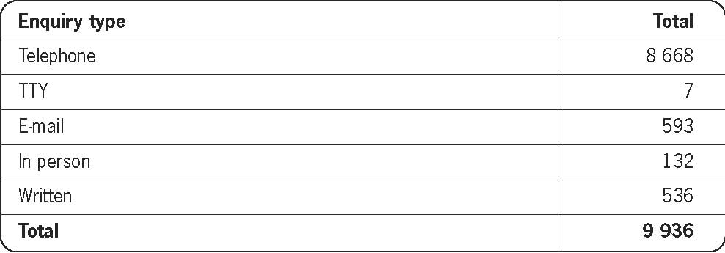

Table 3: Enquiries received by issue

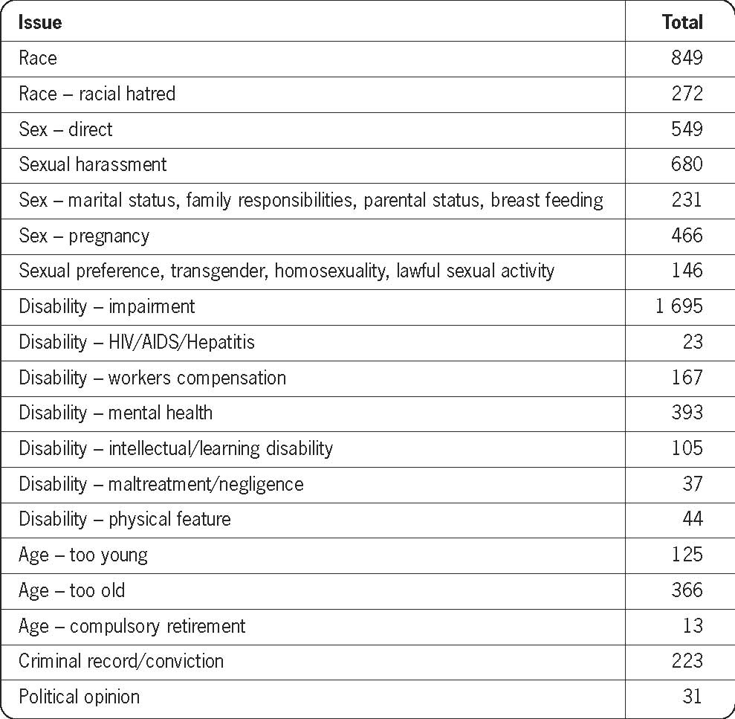

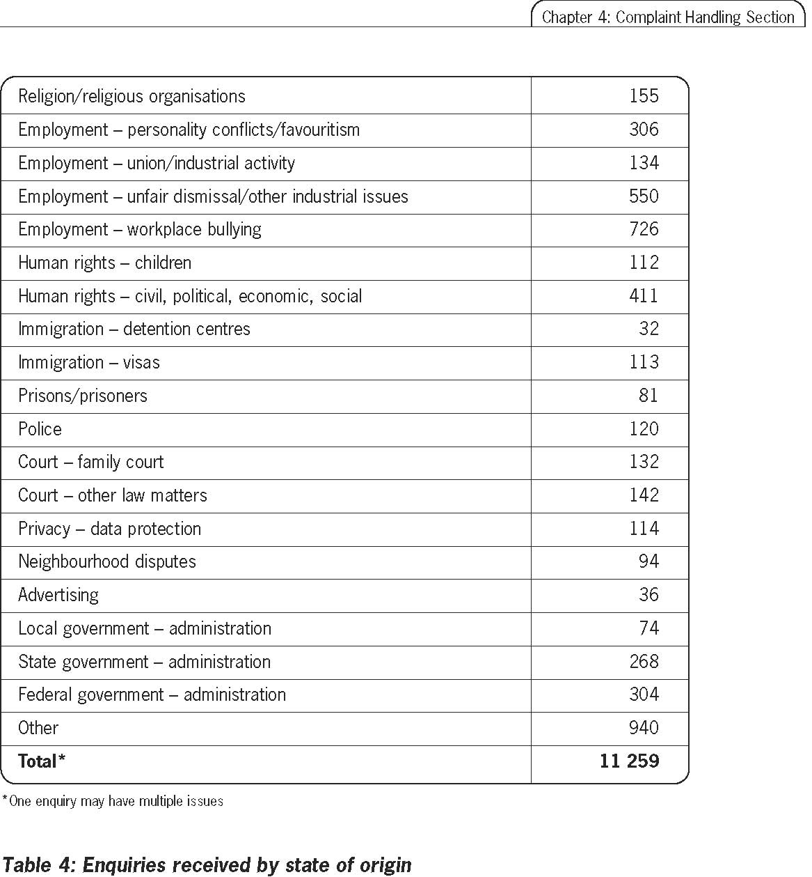
State of origin | Total | Percentage
New South Wales | 4 301 | 43
Victoria | 1 924 | 19
South Australia | 591 | 6
Western Australia | 469 | 5
Queensland | 1 662 | 17
Australian Capital Territory | 184 | 2
Tasmania | 150 | 2
Northern Territory | 137 | 1
Unknown/overseas | 518 | 5
Total | 9 936 | 100

Complaints Overview
Table 5: National complaints received and finalised over the past three years
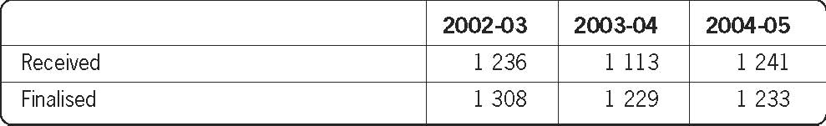
Table 6: Outcomes of national complaints finalised over the past three years
 | 2002-03 (percent) | 2003-04 (percent) | 2004-05 (percent)
Terminated/declined | 56 | 51 | 46
Conciliated | 32 | 38 | 38
Withdrawn | 11 | 10 | 16
Reported (HREOCA only) | 1 | 1 | -

Table 7: State of origin of complainant at time of lodgement
State of origin | Total | Percentage (%)
New South Wales | 522 | 42
Victoria | 202 | 16
South Australia | 160 | 13
Western Australia | 85 | 7
Queensland | 195 | 16
Australian Capital Territory | 34 | 3
Tasmania | 18 | 1
Northern Territory | 15 | 1
Unknown/overseas | 10 | 1
Total | 1 241 | 100

Table 8: Complaints received and finalised by Act
Act | Received | Finalised
Racial Discrimination Act (RDA) | 167 | 157
Sex Discrimination Act (SDA) | 348 | 375
Disability Discrimination Act (DDA) | 523 | 530
Age Discrimination Act (ADA) | 78 | 49
Human Rights and Equal Opportunity Commission Act (HREOCA) | 125 | 122
Total | 1 241 | 1 233

Chart 1
Complaints received by Act
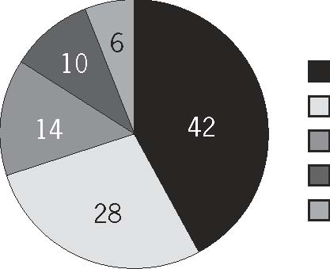
Disability Discrimination Act | 42%
Sex Discrimination Act | 28%
Racial Discrimination Act | 14%
Human Rights and Equal Opportunity Commission Act | 10%
Age Discrimination Act | 6%

Table 9: Country of birth – complainants
 | RDA (%) | SDA (%) | DDA (%) | ADA (%) | HREOCA (%) | Total (%)
Born in Australia | 41 | 74 | 64 | 75 | 60 | 61
Born outside of Australia | 52 | 13 | 15 | 17 | 30 | 24
Unknown | 7 | 13 | 21 | 8 | 10 | 15

Table 10: Indigenous status – complainants
 | RDA (%) | SDA (%) | DDA (%) | ADA (%) | HREOCA (%) | Total (%)
Aboriginal | 27 | 3 | 4 | 8 | 2 | 7
Torres Strait Islander | 1 | - | - | - | - | -
None of the above | 72 | 97 | 96 | 92 | 98 | 93

Table 11: Time from receipt to finalisation for finalised complaints
 | RDA (%) | SDA (%) | DDA (%) | ADA (%) | HREOCA (%) | Cumulative Total (%)
0 - 3 months | 21 | 23 | 17 | 29 | 33 | 21
3 – 6 months | 35 | 34 | 32 | 55 | 27 | 55
6 – 9 months | 25 | 22 | 25 | 16 | 17 | 78
9 – 12 months | 10 | 13 | 16 | - | 9 | 91
More than 12 months | 6 | 5 | 7 | - | 7 | 97
More than 18 months | 3 | 2 | 2 | - | 3 | 99
More than 24 months | - | 1 | 1 | - | 4 | 100

Racial Discrimination Act
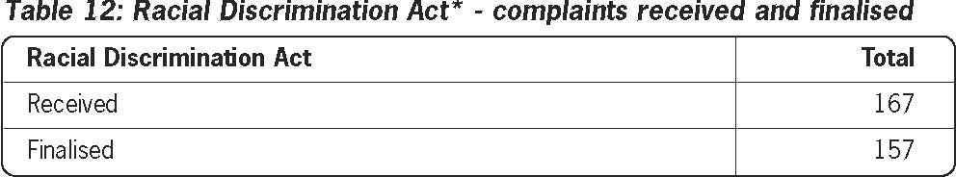
*Includes complaints lodged under the racial hatred provisions.
Table 13: Racial Discrimination Act - complaints received by ground
Racial Discrimination Act | Total | Percentage (%)
Colour | 37 | 10
National origin/extraction | 64 | 18
Ethnic origin | 113 | 31
Descent | 2 | 1
Race | 88 | 24
Victimisation | 1 | -
Racial hatred | 57 | 16
Aids, permits or instructs | - | -
Association | - | -
Total* | 362 | 100
* One complaint may have multiple grounds
Table 14: Racial Discrimination Act - complaints received by area
Racial Discrimination Act | Total | Percentage (%)
Rights to equality before the law | - | -
Access to places and facilities | 8 | 2
Land, housing, other accommodation | 3 | 1
Provision of goods and services | 88 | 24
Right to join trade unions | - | -
Employment | 155 | 43
Advertisements | - | -
Education | 6 | 2
Incitement to unlawful acts | 2 | 1
Other – section 9 | 27 | 7
Racial hatred | 73 | 20
Total* | 362 | 100

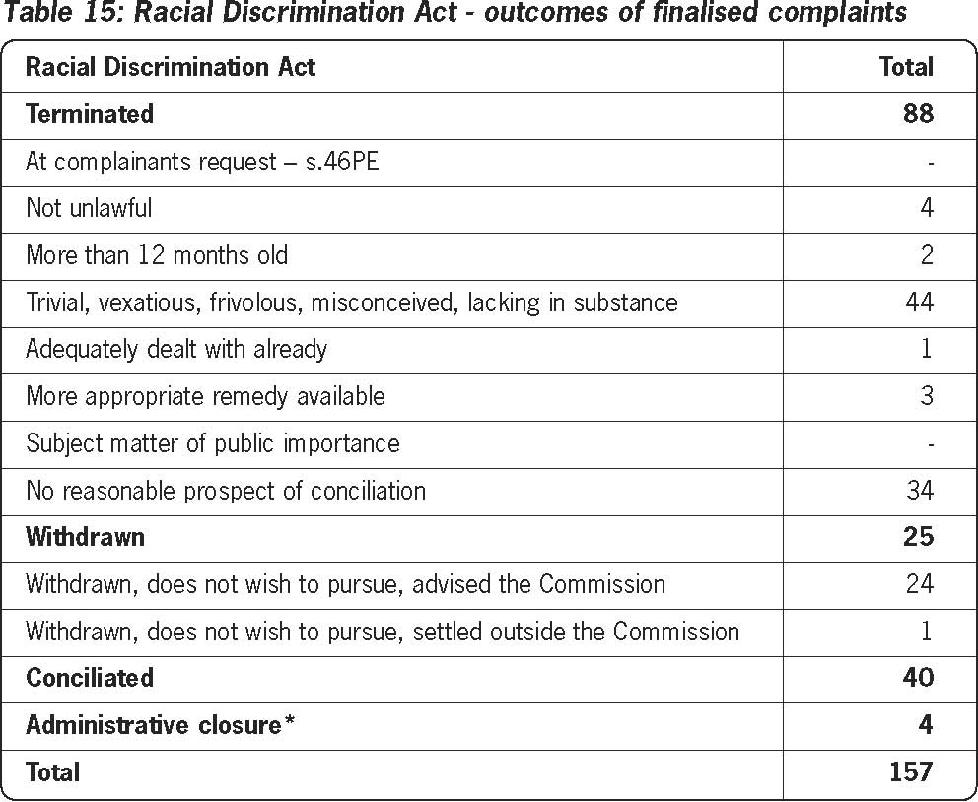
*Not an aggrieved party, state complaint previously lodged.
Chart 2
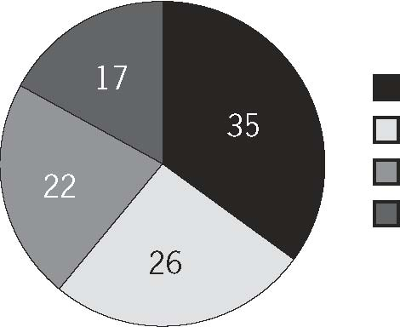
Racial Discrimination Act - outcomes of finalised complaints

Terminated – other reason | 35%
Conciliated | 26%
Terminated – no reasonable prospect of conciliation | 22%
Withdrawn | 17%
Sex Discrimination Act
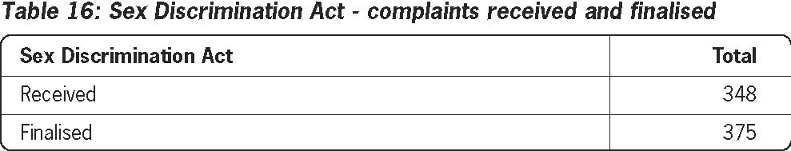

Table 17: Sex Discrimination Act - complaints received by ground
Sex Discrimination Act | Total | Percentage (%)
Sex discrimination | 218 | 36
Marital status | 22 | 4
Pregnancy | 158 | 26
Sexual harassment | 167 | 28
Parental status/ family responsibility | 20 | 3
Victimisation | 17 | 3
Aids, permits, instructs discrimination (sestion 105) | 2 | -
Total* | 604 | 100
*One complaint may have multiple grounds
Table 18: Sex Discrimination Act - complaints received by area
Sex Discrimination Act | Total | Percentage (%)
Employment | 516 | 85
Goods, services and facilities | 40 | 7
Land | - | -
Accommodation | 1 | -
Superannuation, insurance | 3 | 1
Education | 12 | 2
Clubs | 2 | -
Administration of Commonwealth laws and programs | 24 | 4
Application forms etc | 2 | -
Trade unions, accrediting bodies | 4 | 1
Total* | 604 | 100

* An area is recorded for each ground, so one complaint may have multiple and different areas.

Chart 3
Sex Discrimination Act - outcomes of finalised complaints

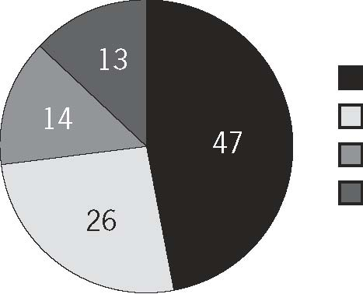

Conciliated 47%
Terminated - no reasonable prospect of conciliation 26%
Terminated - other reason 14%
Withdrawn 13%

Disability Discrimination Act
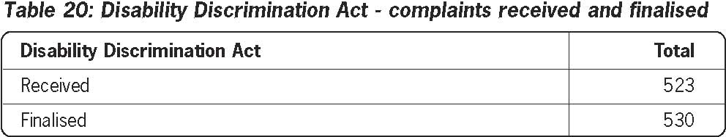
Table 21: Nature of complainant’s disability
Disability Discrimination Act | Total | Percentage (%)
Physical disability | 211 | 22
A mobility aid is used (e.g. walking frame or wheelchair) | 88 | 9
Physical disfigurement | 16 | 2
Presence in the body of organisms causing disease (HIV/AIDS) | 9 | 1
Presence in the body of organisms causing disease (other) | 12 | 1
Psychiatric disability | 175 | 18
Neurological disability (e.g. epilepsy) | 53 | 5
Intellectual disability | 29 | 3
Learning disability | 48 | 5
Sensory disability (hearing impaired) | 22 | 2
Sensory disability (deaf) | 21 | 2
Sensory disability (vision impaired) | 45 | 5
Sensory disability (blind) | 23 | 2
Work related injury | 102 | 10
Medical condition (e.g. diabetes) | 81 | 8
Other | 50 | 5
Total* | 985 | 100
* One complainant may have multiple disabilities

Table 22: Disability Discrimination Act - complaints received by ground
Disability Discrimination Act | Total | Percentage (%)
Disability of person(s) aggrieved | 924 | 92
Associate | 17 | 2
Disability – person assisted by trained animal | 26 | 3
Disability – accompanied by assistant | 2 | -
Disability – use of appliance | 1 | -
Harassment | 21 | 2
Victimisation | 3 | -
Aids, permits or instructs | 8 | 1
Total* | 1 002 | 100
* One complaint may have multiple grounds.
Table 23: Disability Discrimination Act - complaints received by area
Disability Discrimination Act | Total | Percentage (%)
Employment | 485 | 49
Goods, services and facilities | 304 | 30
Access to premises | 33 | 3
Land | - | -
Accommodation | 24 | 2.5
Incitement to unlawful acts or offences | - | -
Advertisements | - | -
Superannuation, insurance | 10 | 1
Education | 102 | 10
Clubs, incorporated associations | 24 | 2.5
Administration of Commonwealth laws and programs | 18 | 2
Sport | - | -
Application forms, requests for information | - | -
Trade unions, registered organisations | - | -
Unlawful to contravene Disability Standard | 2 | -
Total* | 1 002 | 100
* An area is recorded for each ground, so one complaint may have multiple and different areas.
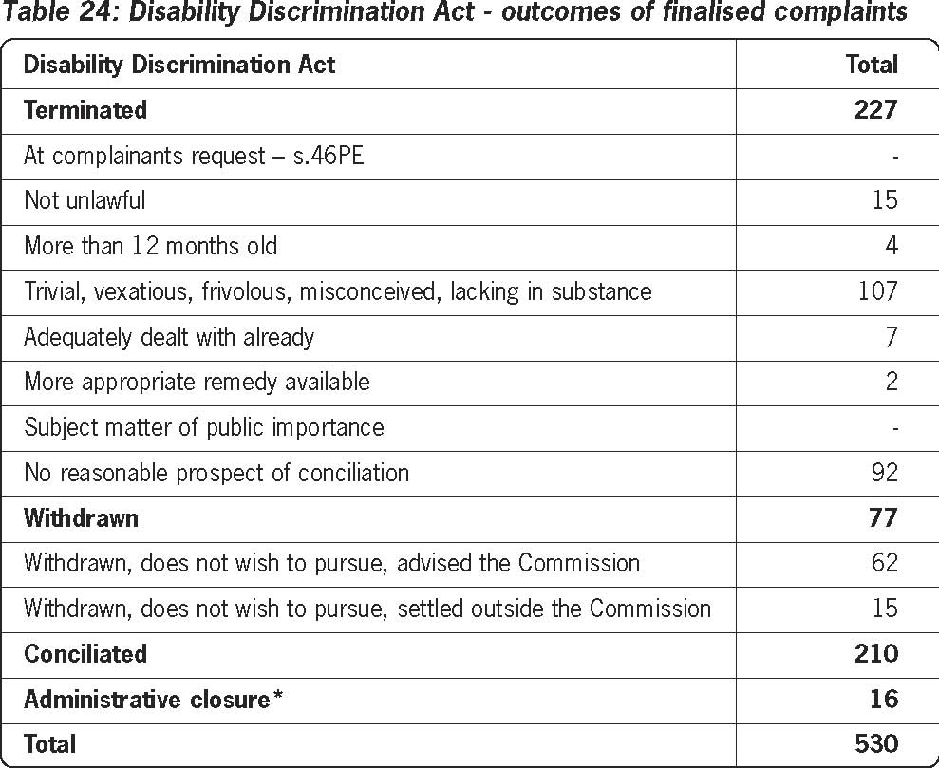
*Not an aggrieved party, state complaint previously lodged.
Chart 4
Disability Discrimination Act - outcomes of finalised complaints

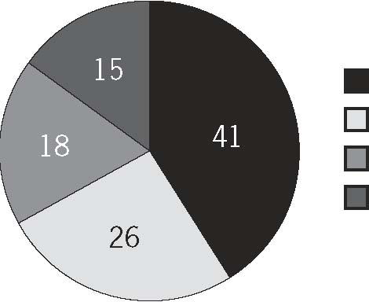
Conciliated 41%
Terminated - other reason 26%
Terminated - no reasonable prospect of conciliation 18%
Withdrawn 15%

Age Discrimination Act
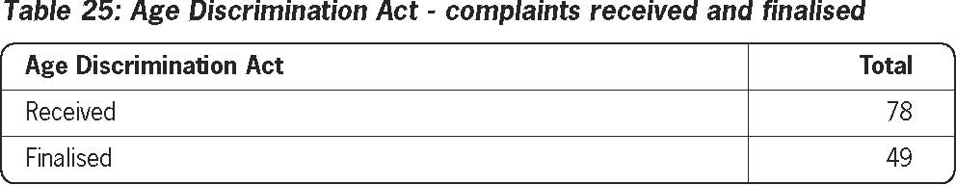

Table 26: Age Discrimination Act - complaints received by age group of complainant
Age Discrimination Act | Total | Percentage (%)
15 – 24 years | 10 | 13
25 – 34 years | 3 | 4
35 – 44 years | 4 | 5
45 – 54 years | 18 | 23
55 – 64 years | 20 | 25
> 65 years | 10 | 13
Unknown | 13 | 17
Total | 78 | 100

Table 27: Age Discrimination Act - complaints received by area
Age Discrimination Act | Total | Percentage (%)
Employment | 99 | 73
Goods, services and facilities | 24 | 18
Access to premises | 1 | 1
Land | - | -
Accommodation | 1 | 1
Incitement to unlawful acts or offences | - | -
Advertisements | - | -
Superannuation, insurance | 4 | 3
Education | 2 | 1
Clubs, incorporated associations | - | -
Administration of Commonwealth laws and programs | 4 | 3
Sport | - | -
Application forms, requests for information | - | -
Trade unions, registered organisations | - | -
Total* | 135 | 100

* One complaint may have multiple and different areas.

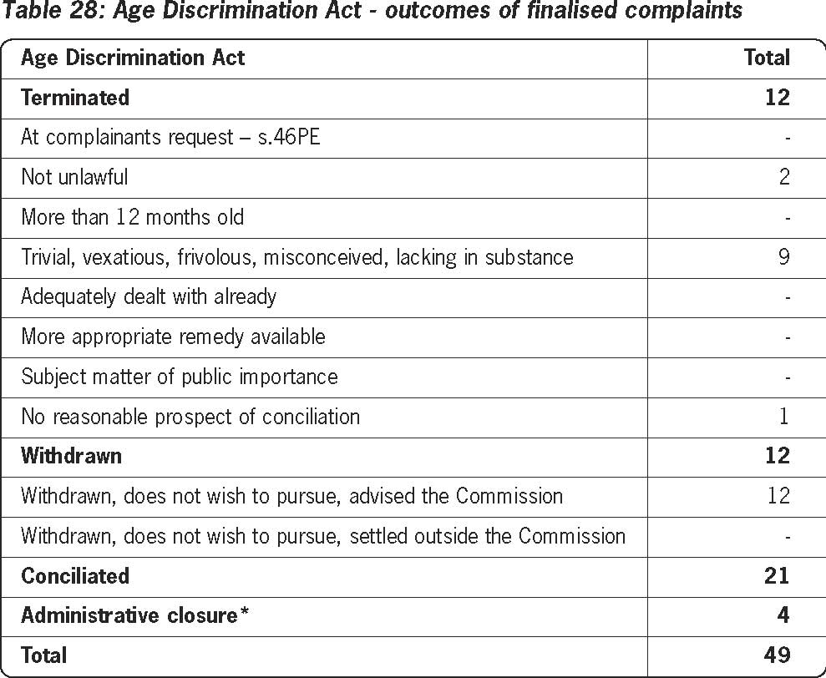
*Not an aggrieved party, state complaint previously lodged.

Chart 5
Age Discrimination Act - outcomes of finalised complaints

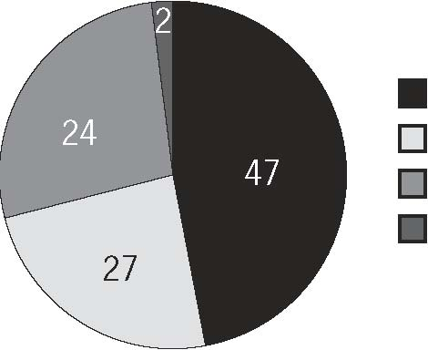
Conciliated | 47%
Withdrawn | 27%
Terminated - other reason | 24%
Terminated - no reasonable prospect of conciliation | 2%

Human Rights and Equal Opportunity Commission Act
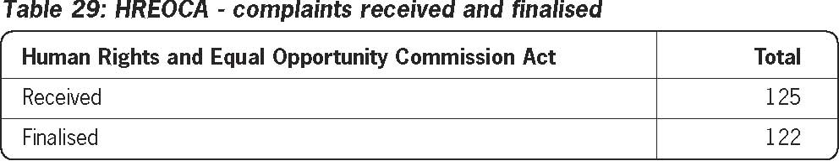
Table 30: HREOCA - complaints received by ground
Human Rights and Equal Opportunity Commission Act Race (ILO 111) | Total - | Percentage (%) -
Colour (ILO 111) | - | -
Sex (ILO 111) | - | -
Religion (ILO 111) | 16 | 12
Political opinion (ILO 111) | 2 | 1
National extraction (ILO 111) | - | -
Social origin (ILO 111) | - | -
Age (ILO 111) | 12 | 9
Medical record (ILO 111) | - | -
Criminal record (ILO 111) | 26 | 19
Impairment (including HIV/AIDS status) (ILO 111) | - | -
Marital status (ILO 111) | - | -
Disability (ILO 111) | - | -
Nationality (ILO 111) | - | -
Sexual preference (ILO 111) | 16 | 12
Trade union activity (ILO 111) | 26 | 19
International Covenant on Civil and Political Rights | 28 | 20
Declaration on the Rights of the Child | - | -
Declaration on the Rights of Mentally Retarded Persons | - | -
Declaration on the Rights of Disabled Persons | 1 | 1
Convention on the Rights of the Child | 5 | 3
Declaration on the Elimination of All Forms of Intolerance and of Discrimination Based on Religion or Belief | 1 | 1
Not a ground within jurisdiction | - | -
Not a human right as defined by the Act | 4 | 3
Total* | 137 | 100

*One complaint may have multiple grounds.

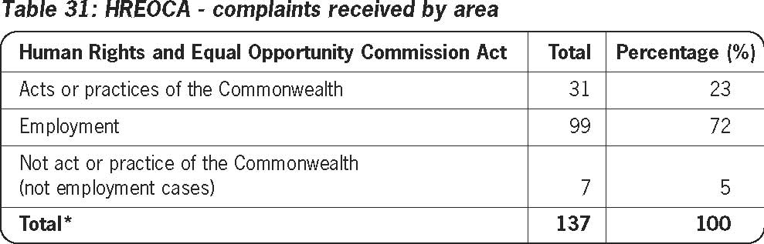
* An area is recorded for each ground, so one complaint may have multiple and different areas.

Table 32: HREOCA - non-employment complaints received by sub-area
Human Rights and Equal Opportunity Commission Act Prisons, prisoner | Total 5 | Percentage (%) 13
Religious institutions | - | -
Family court matters | 1 | 3
Other law court matters | 2 | 5
Immigration | 21 | 55
Law enforcement agency | 1 | 3
State agency | - | -
Other service provider (private sector) | - | -
Local government | - | -
Education systems | - | -
Welfare systems | - | -
Personal or neighbourhood conflict | - | -
Health system | 1 | 3
Other | 7 | 18
Total | 38 | 100

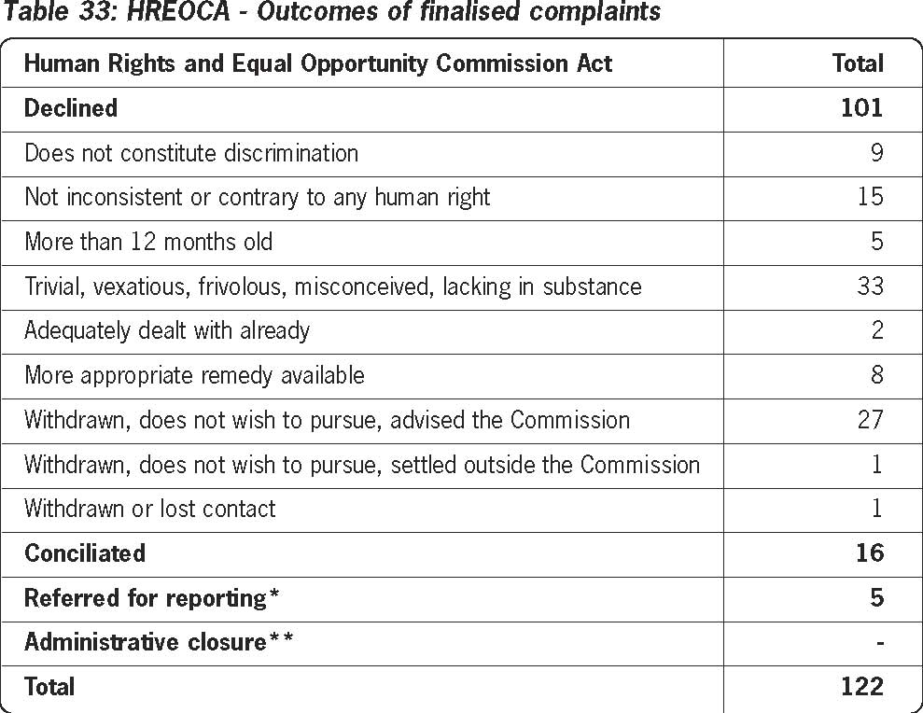
* Complaints in this category were not conciliable and therefore transferred from the Commission’s Complaint Handling Section
to Legal Services for further inquiry and possible report. **Not an aggrieved party, state complaint previously lodged.

Chart 6
Human Rights and Equal Opportunity Commission Act - outcomes of finalised complaints
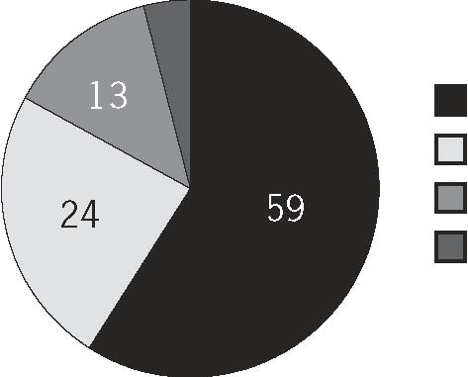
Declined | 59%
Withdrawn | 24%
Conciliated | 13%
Referred for reporting | 4%

Appendix 4
The complaint handling process

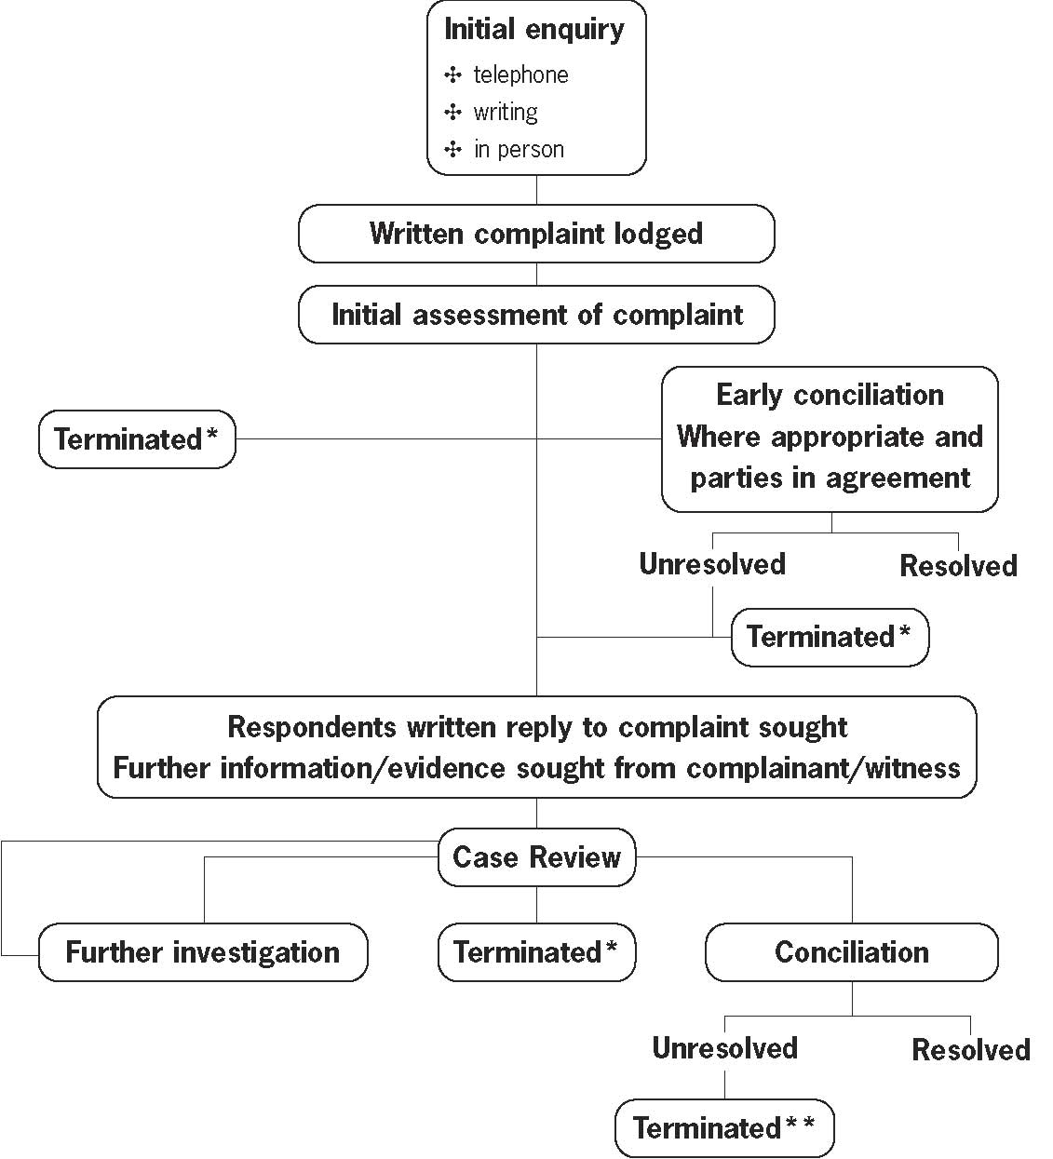
*When complaints under the Age, Racial, Sex and Disability Discrimination Acts are terminated, the complainant may apply to have the allegations heard and determined by the Federal Court of Australia or the Federal Magistrates Court.

**Complaints under the Human Rights and Equal Opportunity Commission Act concerning discrimination in employment or a breach of human rights, which cannot be conciliated, cannot be taken to court. If the President is satisfied that the subject matter of the complaint constitutes discrimination or a breach of human rights these findings are reported to the Attorney-General for tabling in Parliament.

