Human Rights and Equal Opportunity Commission

Annual Report 2004-2005

© Human Rights and Equal Opportunity Commission 2005
ISSN 1031-5098
This work is copyright. Apart from any use as permitted under the Copyright Act 1968, no part may be reproduced by any process without prior written permission from the Human Rights and Equal Opportunity Commission.

Requests and enquiries concerning reproduction, rights and content should be addressed to:
Public Affairs Unit
Human Rights and Equal Opportunity Commission
Level 8, Piccadilly Tower 133 Castlereagh Street Sydney NSW 2000
GPO Box 5218 Sydney NSW, 2001

Telephone: (02) 9284 9600
General enquiries and publications: 1300 369 711
Complaints Infoline: 1300 656 419
TTY: 1800 620 241
Facsimile: (02) 9284 9611
Website: www.humanrights.gov.au
E-mail: paffairs@humanrights.gov.au

The 2004-05 Annual Report is available on the Commission's website at: www.humanrights.gov.au/annrep04_05/

9 September 2005
The Hon. Philip Ruddock MP Attorney-General Parliament House Canberra ACT 2600
I have the pleasure in presenting the Annual Report of the Human Rights and Equal Opportunity Commission for the period ending 30 June 2005, pursuant to section 45 of the Human Rights and Equal Opportunity Commission Act 1986. The report has been prepared in accordance with the requirements of section 70 of the Public Service Act 1999.
Yours sincerely,
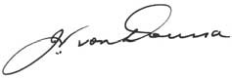

The Hon. John von Doussa QC
President Human Rights and Equal Opportunity Commission

Contents
Significant achievements
Statement from the President
Chapter 1: The Commission
Chapter 2: Human rights Education and Promotion
Chapter 3: Monitoring Human Rights
Chapter 4: Complaint Handling Section
Chapter 5: Legal Services
Chapter 6: Aboriginal and Torres Strait Islander Social Justice
Chapter 7: Disability Rights
Chapter 8: Human Rights
Chapter 9: Race Discrimination
Chapter 10: Sex and Age Discrimination
Chapter 11: International Activities
Appendix 1
International Instruments observed under legislation administered
by the Human Rights and Equal Opportunity Commission
Appendix 2
Commission publications released during 2003–04
Appendix 3
Freedom of Information
Appendix 4
The complaint handling process
Appendix 5
Human resources and administrative services
Commonwealth Disability Strategy
Index

Significant achievements

- In August 2005, the federal Government released all children from immigration detention. ‘A last resort?’ , the report of the National Inquiry into Children in Immigration Detention released in 2004 by the Human Rights Commissioner recommended this action, and together with NGO’s, community groups and individuals, played a major role in achieving this outcome.
- A Discussion Paper titled ‘Striking the Balance: Women, men, work and family’ was released by the Sex Discrimination Commissioner in June 2005 and has engendered a wide ranging media debate on the subject.
- Preliminary evaluations following the 2004 report Isma – Listen: National consultations on eliminating prejudice against Arab and Muslim Australians show significant education and awareness programs have been run by the Arab and Muslim communities as well as governments, police and others as a direct and indirect result of the report’s recommendations.
- National consultations were held in association with the Mental Health Council of Australia on mental health services in Australia - a report will be issued in 2005.
- An eight-page Community Guide summarising both the Social Justice Report and the Native Title Report was distributed in national Indigenous newspapers to make the reports more accessible to communities.
- Publication of ‘Federal Discrimination Law 2005’.
- The Complaint Handling Section finalised 91% of its complaints within 12 months. 38% were finalised by conciliation. This exceeded key performance indicators.
- The Commission finalised its work in two significant intervention matters regarding the detention of asylum seekers under Australia’s migration laws.
- The Commission has continued to seek to play a part in the legislative process by making submissions to Inquiries held by Parliamentary Committees, in particular submissions regarding state and federal anti-terrorism legislation.
- An increase of 15,000 subscribers to the 10 electronic mailing lists of the Commission in the last 12 months has provided the community with increased access to the Commission resources. Total subscribers 36 332.
- Usage of the website has increased from 4,392,429 page views in 2003-04 to 5,515,999 pageviews in 2004-05. This equates to 56,971,558 hits on the site.
- The Young People and Human Rights Dialogue was launched in April 2005, which aims to discover young peoples’ knowledge of, and attitudes towards, various human rights issues in local, national and international contexts.
- The 20th Anniversary of the Sex Discrimination Act was marked by the Commission in 2004 by a series of events and activities.
- A resource for business ‘Good Practice, Good Business – eliminating discrimination and harassment from your Workplace’ was released in December 2004.

Statement from the President

The Hon. John von Doussa QC

This Annual Report is a testament to the determination and commitment of the Commissioners and staff at the Human Rights and Equal Opportunity Commission (HREOC) to improve the enjoyment of human rights. Over the past year, their successes have included the publication of several groundbreaking reports and discussion papers on topics ranging from the balance between work and family, the experiences of Arab and Muslim Australians in the era of terrorism to the suffering of the mentally ill. The Social Justice Unit has distributed a community guide to the Social Justice Report to facilitate public awareness of the work of the Commission. The Legal Section has intervened, or appeared as an amicus curiae, in several cases and has launched Federal Discrimination Law 2005, a handbook which gives a comprehensive, practical overview of Federal Court decisions concerning unlawful discrimination. The Complaint Handling Section exceeded its expected performance indicators by finalising 91% of complaints within 12 months and conciliating outcomes in 38% of them.

It has been my pleasure to welcome Tom Calma to the Commission, whose appointment as Aboriginal and Torres Strait Islander Social Justice Commissioner and Acting Race Discrimination Commissioner commenced on 12 July 2004. Commissioner Calma is an Aboriginal elder from the Kungarakan and Iwaidja tribes of the Northern Territory. His appointment coincided with the implementation of a new government policy for the delivery of services to Indigenous Australians. Part of this policy involved the abolition of the Aboriginal and Torres Strait Islander Commission. As Commissioner Calma notes in this Report, HREOC is one of the few national mechanisms now able to independently and objectively monitor the activities of governments.

In addition to monitoring the new federal administrative arrangements for the provision of services to Indigenous Australians, Commissioner Calma has signalled his intention to focus on four issues: healthcare; Indigenous mental health; international recognition of the rights of indigenous peoples, and; changing the focus of native title so that it is utilised to improve the economic and social conditions of Indigenous people. These are big tasks, and very important ones.

Since my appointment as President, it has also been my pleasure to work alongside Dr Sev Ozdowski, the Human Rights Commissioner and Acting Disability Discrimination Commissioner. Dr Ozdowski’s term is due to expire in December 2005. I wish to acknowledge the significant and lasting impact he has had on human rights in Australia and, in particular, on the rights of children in immigration detention centres. After conducting a three-year Inquiry on the issue, Commissioner Ozdowski published the report of his findings entitled ‘A Last resort?’, which catalogued a litany of human rights violations against child asylum seekers and recommended that all children be immediately released from immigration detention. The Commissioner and his staff are entitled to share in the credit for the government’s decision to release all children from immigration detention centres in August 2005.

As Acting Disability Discrimination Commissioner, Dr Ozdowski oversaw the development of rigorous and comprehensive standards for enabling access to education, transport and public premises for people with disabilities. In conjunction with the Mental Health Council of Australia (MHCA) and the Brain and Mind Research Institute, he has engaged in nation-wide consultations on mental health and human rights issues. These consultations are informing the preparation of a comprehensive report by MHCA entitled ‘Not for Service’, which will be launched before his term expires. Its impact is likely to be considerable and I am confident that mental health will receive greater attention, and the mentally ill greater compassion, in the future.

I would also like to pay tribute to Commissioner Pru Goward. Her statement in this Report, and the chapter accompanying it, indicate the immense range and number of activities she and her unit have undertaken in the past year. The discussion paper Striking the Balance: Women, men, work and family and the public debate that followed its release has at last created widespread awareness of the fundamental equality issues that confront most Australian families every day.

Commissioner Goward’s role has also been extended to age discrimination. She has conducted a range of seminars and conferences to raise public awareness of the new Age Discrimination Act to all Australians, particularly to employers.

The work of the Commission is not, however, limited to domestic matters. As President, I have attended meetings of the United Nations Commission on Human Rights, the Asia Pacific Forum of National Human Rights Institutions and the International Coordinating Committee of National Human Rights Institutions. I have spoken at international conferences on human rights and the rule of law. I have also been part of delegations to China to plan the technical cooperation program between China and Australia, which the Commission administers. Each Commissioner has also participated in international conferences and workshops relating to their field. Periodically, the Legal Section and Complaint Handling Section conduct regional training sessions on the development of human rights law and policy, and the investigation and conciliation of human rights complaints.

While the Commission devotes most of its resources to domestic matters, its international work should not be underrated. Political leaders in Australia, the United States and the United Kingdom now consider that peace in their own countries depends upon the success of liberty and democracy in other lands. The international work of the Commission helps to facilitate this process because the partnerships we create help to open channels of communication through which we can share the knowledge and expertise we have gained over many years. International contacts also help to keep the Commission abreast of human rights developments, which we use in our work on domestic issues.

The importance of national human rights institutions has been recognised by both the Secretary-General of the United Nations and the UN High Commissioner for Human Rights. As a result of a Resolution promoted by Australia at the 61st session of the Commission on Human Rights, there will be greater recognition of accredited national institutions by the Commission and their right to participate in its deliberations will be progressively increased.

The Secretary-General’s proposal to reform the United Nations also recommends that greater emphasis be given by Member States and UN agencies to the promotion and protection of human rights. Pursuant to this goal, countries without independent national human rights institutions are being encouraged to establish them. Particular attention is being directed to the Pacific Region which, for obvious geographical reasons, falls within Australia’s sphere of influence. At present, both the Office of the High Commissioner for Human Rights and the Pacific Islands Forum are advocating the establishment of a national human rights institution, or its equivalent, in each country that does not have one.

The establishment of an effective human rights mechanism is an integral element of good governance, but for some emerging island States it is not an easy task to accomplish. I think it is in our national interest to help facilitate this process, and the Commission has the knowledge and expertise necessary to make a meaningful contribution.

The Commission’s work stretches its budget to the limits. We have accomplished much, but there is still a great deal to be done and few resources with which to do it. We have worked hard to ensure we remain within our strict budget limits and actively review our expenditure.

In some respects, this Annual Report spans two remarkable years. In 2004-05, Australia celebrated not only the introduction of the Age Discrimination Act, but the 20th anniversary of the Sex Discrimination Act and the 30th anniversary of the Race Discrimination Act. These Acts have substantially contributed to the progress that we, as a nation, have made in realising the inalienable right to dignity, respect and equality of treatment.

It is clear, however, that gaping holes still exist. The entrenched deprivations suffered by Indigenous Australians are unacceptable and embarrassing given our status as a first world country. Our responsibility to alleviate their suffering only intensifies as the years pass. The threat of terrorism has led to a marked increase in the level of prejudice experienced by Arab and Muslim Australians. It has also had a negative impact on the treatment of refugees and newly-arrived immigrants. The mistreatment and neglect of the mentally ill, whether they are asylum seekers, Indigenous Australians or ordinary members of the public, is chronic and requires immediate attention. These are some of the challenges in the future and they are problems that the Commission will continue to address until solutions are found.

Australia is a stable and peaceful nation. Its success is premised upon its commitment to parliamentary democracy, multiculturalism, human rights and the rule of law. It concerns me greatly that, in the name of national security, multiculturalism and the enjoyment of fundamental human rights are coming under challenge.

In my view, multiculturalism is not the cause, nor even the catalyst, of the present security threat, just as commitment to human rights will not hamper our ability to protect ourselves. Human rights and multiculturalism are, in many ways, technical terms for very simple concepts: dignity, humanity, tolerance and respect. If fully realised, these values are likely to promote security, not undermine it, as they will encourage citizens to be loyal to the State and to each other. National security may require us to balance competing rights and interests but it should never require us to abrogate rights and freedoms that we have always considered to be fundamental. If we do so, we will abandon the very things that make this country great.

I commend this report to you.

John von Doussa QC
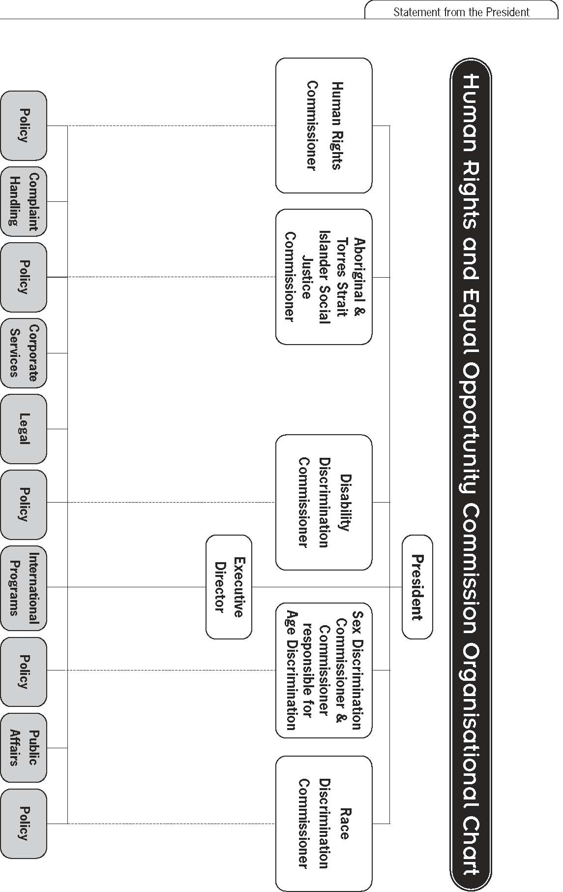

Chapter 1: The Commission
Vision
An Australian society in which the human rights of all are respected, protected and promoted.
Mission
To provide leadership on human rights through:
- ✣ building partnerships with others
- ✣ having a constructive relationship with government
- ✣ being responsive to the community
- ✣ promoting community ownership of human rights.

To ensure that Australians:
- ✣ have access to independent human rights complaint handling and public inquiries processes
- ✣ benefit from human rights education, promotion and monitoring and compliance activities.

As an effective organisation, we are committed to:
- ✣ unity of purpose
- ✣ valuing our diversity and creativity
- ✣ the pursuit of best practice.

Structure
The Commission is a national independent statutory body established under the Human Rights and Equal Opportunity Commission Act 1986. It has a President and five Commissioners. The five positions are currently held by three persons. Please refer to the organisational chart on page 12 for further information.
President – The Hon. John von Doussa, QC
The Hon. John von Doussa was appointed President of the Human Rights and Equal Opportunity Commission on 1 May 2003 for a five year term.
At the time of his appointment he was a Judge of the Federal Court of Australia, an appointment he had held since 1988. He was also the President of the Australia Competition Tribunal, a Presidential Member of the Administrative Appeals Tribunal, an Additional Judge of the Supreme Court of the Australian Capital Territory, and a Judge of the Industrial Relations Court of Australia. From 1992 until shortly before his appointment he was also a part-time Commissioner of the Australian Law Reform Commission. From 1986 to 1988 he was a Judge of the Supreme Court of South Australia.
Before his appointment as a Judge he was a Queens Counsel practicing mainly in South Australia, and had served terms as the President of the Law Society of South Australia, and Vice-President of the Law Council of Australia.
In South Australia he had a close interest in the organisation and provision of practical legal training for newly qualified graduates in law. At different times he was the chair of advisory committees for the graduate diploma courses in legal practice conducted by the University of South Australia and by the Law Society of South Australia. In 1996 he was awarded an Honorary Doctorate of the University of South Australia in recognition of that involvement. He received a Centenary Medal in 2003.
In 1993 he sat as an Acting Judge in the Supreme Court of Vanuatu. In 1997 he became a member of the Court of Appeal of Vanuatu. In 2003 he was appointed a non-resident member of the Supreme Court of Fiji. He continues to hold these appointments.
He was appointed Chancellor of the University of Adelaide in July 2004.
Aboriginal and Torres Strait Islander Social Justice Commissioner and acting Race Discrimination Commissioner – Mr Tom Calma
Mr Tom Calma succeeded Dr William Jonas as the Aboriginal and Torres Strait Islander Social Justice Commissioner and Acting Race Discrimination Commissioner and commenced on 12 July 2004.
Mr Calma is an Aboriginal elder from the Kungarakan tribal group and the Iwaidja tribal group whose traditional lands are south west of Darwin and on the Coburg Peninsula in Northern Territory, respectively. He has been involved in Indigenous affairs at a local, community, state, national and international level and worked in the public sector for over 30 years.
Mr Calma has broad experience in public administration, particularly in Indigenous education programs and in developing employment and training programs for Indigenous people from both a national policy and program perspective.
He served three terms as a Director of Aboriginal Hostels Ltd and as a Company Director for a private tourism and hospitality venture in the Northern Territory.
Until his appointment as Commissioner, on 12 July 2004 for five years, Mr Calma managed the Community Development and Education Branch at Aboriginal and Torres Strait Islander Services (ATSIS) where he worked with remote Indigenous communities to implement community-based and driven empowerment and participation programs. In 2003, he was Senior Adviser Indigenous Affairs to the Minister of Immigration, Multicultural and Indigenous Affairs.
From 1995-2002, he worked as a senior Australian diplomat in India and Vietnam representing Australia’s interests in education and training. During his time in India, he also oversaw the management of the Australian international education offices in Pakistan, Nepal and Sri Lanka.
He moved to Canberra in 1992 and undertook various assignments, including Executive Director to the Secretary and Senior Executive of the Department of Employment, Education, Training and Youth Affairs (DEETYA).
In the early 1980s, Mr Calma and Indigenous colleagues established the Aboriginal Task Force (ATF) at the Darwin Community College (which later became the Darwin Institute of Technology ), which provided second chance education programs for Indigenous people. He became a senior lecturer and head of the ATF for six years.

Human Rights Commissioner and acting Disability Discrimination Commissioner – Dr Sev Ozdowski, OAM
Dr Sev Ozdowski took up his appointment as Human Rights Commissioner in December 2000 for a five year term. Previously, Dr Ozdowski was Chief Executive of South Australia’s Office of Multicultural and International Affairs. Dr Ozdowski has a long term commitment to human rights and his relationship with the Human Rights Commission dates back to the original Commission of the early 1980s. He is the author of many papers on sociology of law, human rights, immigration and multiculturalism. Born in Poland in 1949, Dr Ozdowski migrated to Australia in 1975. He has held senior positions in the Federal portfolios of the Prime Minister and Cabinet, Attorney-General’s and Foreign Affairs and Trade. He has also worked as Secretary of the Human Rights Commission Inquiry into the Migration Act 1958 and for the Joint Parliamentary Committee on Foreign Affairs, Defence and Trade.
Dr Ozdowski has a Master of Laws and Master of Arts in Sociology from Poznan University, Poland, and a PhD in Sociology of Law from the University of New England, Armidale, New South Wales. He was awarded a Harkness Fellowship in 1984 for post-doctoral work on race relations, international human rights and immigration law and public administration – studies that took him from Harvard University (Cambridge, MA) to Georgetown University (Washington DC) and the University of California (Berkeley, California).
Dr Ozdowski has been acting Disability Discrimination Commissioner since December 2000.
Sex Discrimination Commissioner and Commissioner responsible for Age Discrimination – Ms Pru Goward
Journalist, broadcaster and commentator Pru Goward was appointed Federal Sex Discrimination Commissioner for a five year term from 30 July 2001.
Ms Goward has worked closely on issues of women's rights for several years, heading the Federal women's policy advisory unit, the Office of the Status of Women, from 1997 to 1999. She was appointed First Assistant Secretary of the Office, which reports directly to the Office of Prime Minister and Cabinet, after working as a national affairs journalist and political commentator for 19 years.
At the Office of the Status of Women, Ms Goward presided over the introduction of the first national program for the prevention of domestic violence – the largest program run by OSW with a budget of $50 million. She also oversaw the introduction of reform to superannuation laws for divorced couples.
Ms Goward completed an Economics degree with Honours from the University of Adelaide while teaching high school in Adelaide during the 1970s. She later tutored at the University while conducting Masters research. Over the past 10 years she has also run her own media management company, was a freelance newspaper and magazine columnist and a part-time lecturer in Broadcast Journalism at the University of Canberra.
Just prior to taking up the role of Sex Discrimination Commissioner, she was National Director of the Australian Property Institute. Ms Goward is also on the board of the John Curtin School of Medical Research and the Neuroscience Institute for Schizophrenia and Allied Disorders. She is Official Patron of the ANU Australian Rules Football Club.
Ms Goward has been nominated by the Commission as the Commissioner responsible for Age Discrimination.

Legislation
The Commission is responsible for administering the following Acts:
- ✣ Human Rights and Equal Opportunity Commission Act 1986
- ✣ Racial Discrimination Act 1975
- ✣ Sex Discrimination Act 1984
- ✣ Disability Discrimination Act 1992
- ✣ Age Discrimination Act 2004.

Functions performed under these Acts are vested in the Commission as a collegiate body, in the President or individual members of the Commission or in the federal Attorney-General.
Other legislation administered through the Commission includes functions under the Native Title Act 1993 performed by the Aboriginal and Torres Strait Islander Social Justice Commissioner. The Sex Discrimination Commissioner has functions in relation to federal awards and equal pay under the Workplace Relations Act 1996.
Human Rights and Equal Opportunity Commission Act
The Human Rights and Equal Opportunity Commission Act 1986 established the Commission and outlines the Commission powers and functions. Human rights are strictly defined, and only relate to the international instruments scheduled to, or declared under, the Act. They are the:
- ✣ International Covenant on Civil and Political Rights
- ✣ Convention on the Rights of the Child
- ✣ Declaration on the Rights of the Child
- ✣ Declaration on the Rights of Disabled Persons
- ✣ Declaration on the Rights of Mentally Retarded Persons
  - ✣ Declaration on the Elimination of All Forms of Intolerance and of Discrimination Based on Religion or Belief
- ✣ Convention Concerning Discrimination in Respect of Employment and Occupation.

Racial Discrimination Act
The Racial Discrimination Act 1975 gives effect to Australia’s obligations under the International Convention on the Elimination of All Forms of Racial Discrimination.
Its main aims are to:
- ✣ promote equality before the law for all persons, regardless of their race, colour or national or ethnic origin
- ✣ make discrimination on the basis of race, colour, descent or national or ethnic origin, unlawful
- ✣ provide protection against racial hatred.

Sex Discrimination Act
The Sex Discrimination Act 1984 gives effect to Australia’s obligations under the Convention on the Elimination of All Forms of Discrimination against Women and certain aspects of the International Labour Organisation (ILO) Convention 156.
Its main aims are to:
- ✣ promote equality between men and women
- ✣ eliminate discrimination on the basis of sex, marital status or pregnancy, and family responsibilities
- ✣ eliminate sexual harassment at work, in educational institutions, in the provision of goods and services, accommodation and in the delivery of Commonwealth programs.

Disability Discrimination Act
The objectives of the Disability Discrimination Act 1992 are to:
- ✣ eliminate discrimination against people with disabilities as far as is possible
- ✣ promote community acceptance of the principle that people with disabilities have the same fundamental rights as all members of the community
- ✣ ensure as far as practicable that people with disabilities have the same rights to equality before the law as other people in the community.

Age Discrimination Act
The objectives of the Age Discrimination Act 2004 are to:
- ✣ promote equality before the law for all persons regardless of their age
- ✣ eliminate discrimination against persons on the ground of age in many areas of public life such as employment, education and the provision of services or facilities
- ✣ change negative stereotypes about older people.

Functions and powers
The Commission’s responsibilities fall within four main areas:
- human rights education and promotion.

- Inquiring into discrimination and human rights complaints.

- Human rights monitoring.

- Policy development and legislative reform.

- In order to fulfil its obligations, the Commission:
- Fosters public discussion, and undertakes and coordinates research and educational programs to promote human rights and eliminate discrimination in relation to all Acts.

- Investigates complaints of alleged unlawful discrimination pursuant to the Racial Discrimination Act, the Sex Discrimination Act, Disability Discrimination Act and the Age Discrimination Act, and attempts to resolve these matters through conciliation where appropriate. The President may terminate a complaint of alleged unlawful race, sex, age or disability discrimination if, for example there is no reasonable prospect of settling the complaint by conciliation or the complaint is lacking in substance. If a complainant, whose complaint has been terminated, wants the complaint heard and determined by the Courts they must lodge an application to the Federal Court of Australia or the Federal Magistrates Court within 28 days of a Notice of Termination issued by the President.

- Investigates acts or practices that may be contrary to a human right or that may be discriminatory pursuant to the Human Rights and Equal Opportunity Commission Act. If the complaint is unable to be resolved through conciliation and is not discontinued for other reasons the President may report on the case and make particular recommendations. The Report is tabled in Parliament.

- May advise on legislation relating to human rights and monitor its implementation; may review existing and proposed legislation for any inconsistency with human rights or for any discriminatory provision which impairs equality of opportunity or treatment in employment or occupation; may examine any new international instruments relevant to human rights and advise the federal Government on their consistency with other international treaties or existing Australian law; and may propose laws or suggest actions the government may take on matters relating to human rights and discrimination.

In order to carry out these functions the Commission is empowered under all Acts (unless otherwise specified) to:
- Refer individual complaints to the President for investigation and conciliation.
- Report to the government on any matters arising in the course of its functions.
- Establish advisory committees.
- Formulate guidelines to assist in the compliance by organisations and individuals of the requirements of human rights and anti-discrimination legislation and conventions.
- Intervene in court proceedings involving human rights matters with the permission of the Court.
- Act as amicus curiae (friend of the court) in alleged unlawful discrimination cases that are before the Courts
- Grant exemptions under certain conditions (Age, Sex and Disability Discrimination Acts).
- Conduct inquiries into issues of major importance, either on its own initiative, or at the request of the Attorney-General.
- Examine enactments.

Specific functions of the President and Commissioners
In addition to the broad functions outlined above, the President, the Aboriginal and Torres Strait Islander Social Justice Commissioner and the Sex Discrimination Commissioner have specific responsibilities.

President
The President is the Chief Executive Officer of the Commission, responsible for its financial and administrative affairs.
The President is also responsible for the complaint handling function of the Commission.
Aboriginal and Torres Strait Islander Social Justice Commissioner
The Aboriginal and Torres Strait Islander Social Justice Commissioner, under the Human Rights and Equal Opportunity Commission Act 1986, prepares an annual report on the exercise and enjoyment of human rights of Indigenous people, and undertakes social justice education and promotional activities.
The Commissioner also performs separate reporting functions under the Native Title Act 1993. This includes preparing an annual report on the operation of the Act and its effect on the exercise and enjoyment of human rights of Indigenous people. The Commissioner also reports, when requested by the Minister, on any other matter relating to the rights of Indigenous people under this Act.

Sex Discrimination Commissioner
The Workplace Relations Act 1996 gives the Sex Discrimination Commissioner the power to initiate and refer equal pay cases to the Australian Industrial Relations Commission.

The Minister
The Attorney-General, the Honourable Philip Ruddock MP, is the Minister responsible in Parliament for the Commission. He has a number of powers under the Human Rights and Equal Opportunity Commission Act 1986.
The most significant are:
- to make, vary or revoke an arrangement with states or territories for the performance of functions relating to human rights or to discrimination in employment or occupation.

- to declare, after consultation with the states, an international instrument to be one relating to human rights and freedoms for the purposes of the Act.

- to establish an advisory committee (or committees) to advise the Commission in relation to the performance of its functions. The Commission will, at his request, report to him on Australia’s compliance with International Labour Organisation Convention 111 and advise him on national policies relating to equality of opportunity and treatment in employment and occupation.

Outcomes structure
The Commission has one outcome:
An Australian society in which the human rights of all are respected, protected and promoted.
There is one output for the Commission’s outcome:
Australians have access to independent human rights complaint handling and public inquiries processes and benefit from human rights education, promotion and monitoring and compliance activities.
Resources for outcomes
Outcome 1: An Australian society in which the human rights of all are respected, protected and promoted
Total Administered Expenses | Budget 2004-05 $'000 - | Actual Expenses 2004-05 $'000 - | Budget 2005-06 $'000 -
Price of Department Outputs | 14,635 | 15,324 | 13,843
Output Group 1.1 - Australians have access to independent human rights complaint handling and public inquiry processes and benefit from human rights education, promotion and monitoring and compliance activities. | 14,635 | 15,324 | 13,843
Subtotal Output Group 1.1 | 14,635 | 15,324 | 13,843
Revenue from Government (Appropriation) for Departmental Outputs | 11,973 | 11,931 | 12,131
Revenue from other sources | 1,712 | 3,095 | 1,712
Cash reserves applied to a revenue deficiency | 950 | 298
Total Price of Outputs | 14,635 | 15,324 | 13,843
Total for Outcome 1 (Total Price of Outputs and Administered Expenses) | 14,635 | 15,324 | 13,843

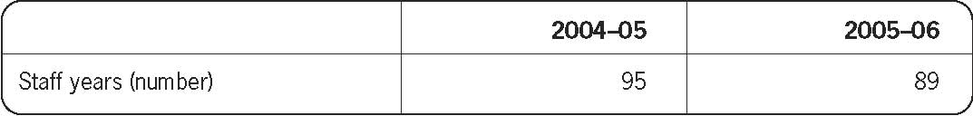
Chapter 2: Human rights education and promotion
A central function of the Human Rights and Equal Opportunity Commission is to undertake education programs that increase public awareness and generate discussion of human rights and anti-discrimination issues within Australia.
The Commission’s legislative responsibilities are:
1. To promote an understanding and acceptance of, and compliance with, the relevant Act:
Human Rights and Equal Opportunity Commission Act section 11(1)(g) Racial Discrimination Act section 20(1)(b) Sex Discrimination Act section 48(1)(d) Disability Discrimination Act section 67(1) (g) Age Discrimination Act section 53(aa).
2. To undertake research and education programs for the purpose of promoting the objects of the relevant Act:
Human Rights and Equal Opportunity Commission Act section 11(1)(h) Racial Discrimination Act section 20(1)(c) Sex Discrimination Act section 48(1)(e) Disability Discrimination Act section 67(1)(h) Age Discrimination Act section 53(ac).
Human rights education is also an international obligation which Australia has consistently supported. In the earliest international articulation of universal human rights, the Universal Declaration of Human Rights, the General Assembly proclaimed:

every individual and every organ of society, keeping this Declaration constantly in mind,
shall strive by teaching and education to promote respect of these rights and freedoms
and by progressive measures, national and international, to secure their universal and
effective recognition and observance.
All work undertaken by the Commission has a human rights educative base, from the handling of individual complaints of discrimination or harassment to the conduct of National Inquiries which involve important human right issues, such as the detention of children in immigration detention.

Education and communications strategy
The Commission uses a range of strategies to communicate its key human rights messages to the community including:
✣ Regular media engagement by the President and Commissioners with metropolitan, regional and specialist press, radio and television outlets.
✣ The Commissioners and staff holding consultations with a range of peak bodies, community groups, NGOs, parliamentarians, business and industry groups, academics and government officers.

✣ The development of an extensive and accessible website which provides human rights education materials for individuals, students, teachers, employers, government and community groups.
✣ Curriculum-linked human rights education materials for teachers and students.
✣ Preparation and distribution of plain English publications on human rights and discrimination.
✣ Organisation of promotional events such as the annual Human Rights Awards.

Specific human rights educational and promotional programs conducted by individual Commissioners are detailed later in this Report.
Media engagement
The Commission’s communication strategies are based on the necessity to target all Australians wherever they live and whatever their background age, or gender. The Commission uses the mainstream and specialist media to disseminate human rights messages, and works with peak business and community groups in the development and delivery of messages. The Commission also provides human rights related materials for the media direct to editors and journalists via electronic mailing lists.
Engagement with the media is a crucial aspect of the Commission’s public education function. Wherever possible the Commission engages in public debate via the print and electronic media to provide substantial information to the public, and directly to journalists and editors.
The Commission also uses community announcements and niche or specialist media such as ethnic and Indigenous radio and press, as well as country and regional media outlets to provide general information on the work of the Commission and of the Commissioners.
In the past year, the Commission has issued 87 media releases and alerts, and the President and Commissioners have had 15 opinion pieces published in major metropolitan newspapers throughout Australia and have conducted approx. 500 media interviews resulting in a significant range of press, radio and television coverage.
Commissioners have contributed to public debate on human rights, equality and discrimination issues, including: age discrimination, refugees and asylum seekers, racial vilification and discrimination, Indigenous social justice, native title, sex discrimination and sexual harassment in the workplace, paid maternity leave, work and family balance, disability discrimination and advances in accessibility for people with a disability and on changes to legislation that may affect people’s human rights.
The Commission also promotes the Human Rights Medal and Awards, which include a category to recognise an outstanding contribution to human rights through the print media, radio or television.
In 2004, Commissioner Goward and Commissioner Ozdowski both presented speeches at the National Press Club in Canberra, which were telecast nationally.
The Sex Discrimination Commissioner, Pru Goward, was again the focus of significant media interest throughout the year, particularly on the work and family balance, pay equity, child custody and paid maternity leave.
Commissioner Goward briefed editors from major publishing houses to provide information on discrimination, harassment and work and family issues. As a result, a range of articles have appeared in family and women’s magazines.
The Commissioner also did a range of media interviews on the launch of the discussion paper Striking the Balance: Women, men, work and family, events to celebrate the 20th anniversary of the Sex Discrimination Act, a seminar on people trafficking, a Work, Work and Equity forum, a seminar on age discrimination in the workplace and the launch of Good practice, good business: resources for employers.
Human Rights Commissioner, Dr Ozdowski, continued to do a range of media interviews on children in immigration detention following the release of ‘A Last resort?’ the Report of the National Inquiry into Children in Immigration Detention and subsequent public forums. Other issues covered related to the findings of the Palmer Inquiry and the release of children from immigration detention.
There was also a range of articles and interviews relating to the Young People and Human Rights Dialogue project.
Aboriginal and Torres Strait Islander Social Justice Commissioner, Tom Calma, launched his 2004 Social Justice and Native Title Reports at public events throughout Australia. There was national media coverage of most of the launches by print media, radio and television. An 8-page Community Guide about the reports was also distributed via National Indigenous publications.
Commissioner Calma also spoke to the media on a range of Indigenous issues, including: changes to ATSIC, the needs of Indigenous women exiting prison, new arrangements for Indigenous affairs, reconciliation, Indigenous land use, native title agreements and the Palm Island Inquest.
The report of Isma – Listen: National consultations on eliminating prejudice against Arab and Muslim Australians was launched in Adelaide, Canberra, Alice Springs, Hobart and WA and attracted considerable interest from mainstream and ethnic press. Commissioner Calma also continued to do a range of interviews in relation to discrimination and vilification of various groups in society.
Acting Disability Discrimination Commissioner, Dr Sev Ozdowski, made statements to the media on a range of disability issues, including: the mental health consultations in all states and territories held in conjunction with the Mental Health Council of Australia, and the disability and employment Inquiry being conducted by the Commissioner.
Media comments were also made about education for people with disabilities, new welfare reforms and a range of mental health issues.
Public Affairs distributed a series of four articles in a joint project with the Complaints section to promote the Commission’s complaint handling function. Memo from HREOC: What have Australians got to complain about? was distributed to a range of regional and work/employer publications resulting in a range of articles on the issue.
Public Affairs continued to develop promotional material for educational writers, education editors and specialist teaching publications for a range of Commission educational resources including: Face the Facts, Bringing the home, Isma and the Children in Immigration Detention Report.
Community consultations
Community consultations are an important part of the Commission’s human rights education program and provide a valuable two-way exchange of information. The President, Commissioners and their staff met with a very wide range of peak bodies, community groups, NGOs, parliamentarians, business and industry groups, academics and government officers during the year.
A range of these consultations are detailed below:
- The Sex Discrimination Commissioner and staff were involved in approximately 75meetings and made over 100 speeches during 2004-05. These consultations have been with the community, community organisations and activists, academics, employers and employer groups, unions and Commonwealth Government officers.

- The Human Rights Commissioner and staff conducted over 130 meetings and made approx. 30 speeches during 2004-05. These included community information and feedback consultations, especially in relation to the Young People and Human Rights Dialogue and Discrimination in Employment on the Basis of Criminal Record projects.

- The Acting Disability Discrimination Commissioner, Deputy Commissioner and staff conducted over 120 meetings and made approx. 25 speeches. These included community information and feedback consultations, especially in relation to the Inquiry into Employment and Disability as well as continuing contact with a range of industry bodies, including the financial services industry, TV and cinema organisations, local government and educational institutions. The unit has also continued regular meetings with representatives from peak and state/territory disability advocacy groups.

- The Acting Race Discrimination Commissioner and staff have held ongoing consultations with representatives from the Arab and Muslim communities, in relation to the Isma project. In addition, they have consulted with state and federal Government agencies, State Equal Opportunity Commissions, media organisations, non-government organisations and advocacy groups, multicultural and Indigenous organisations, and individuals on a number of race-related issues.

- The Aboriginal and Torres Strait Islander Social Justice Commissioner and staff consulted with Indigenous peoples and communities, ATSIC Regional Councils, Indigenous community organisations and service deliverers, academics and government officers regarding the implementation of the new arrangements for the administration of Indigenous affairs at the federal level. These consultations informed the 2004 Social Justice Report. Further consultations have been held in the first half of 2005 relating to the new arrangements and the follow up actions identified in the report. These consultations will inform the 2005 Social Justice Report. Consultations were also held relating to the needs of Indigenous young people with cognitive disabilities in the juvenile justice system and international processes for advancing Indigenous human rights, including the United Nations Draft Declaration on the Rights of Indigenous Peoples.

- The Social Justice Commissioner and staff consulted with Native Title Representative Bodies, staff of the National Native Title Tribunal and some state and territory government departments, academics and native title practitioners, and industry bodies to develop principles for agreement making that is directed towards social and economic outcomes for native title holders and traditional owners. These consultations formed the basis of the 2004 Native Title Report.

- The Social Justice Commissioner and staff also consulted broadly with the federal Attorney-General's Department, Native Title Representative Bodies, state and territory government department, academics, the Federal Court and the National Native Title Tribunal on the operation of the Native Title Act 1993, as well as with native title holders and claimants.

Commission website – www.humanrights.gov.au
The Human Rights and Equal Opportunity Commission's website is a major educative tool and is used widely by government, legal, community and employer organisations, the media, schools and individuals to obtain information about human rights and responsibilities, and anti-discrimination law and practice.
The Commission's website is maintained to ensure that the most up-to-date information is posted daily, and all reports, submissions, media releases and other Commission publications are available online.
Web resources include an online complaints form and information for complainants and respondents, a range of curriculum-linked human rights education resources for schools, information resources for employers, a legal section which provides full details of legislation and other legal issues, and information on the work of the President and Commissioners.
Major additions and improvements in 2004–05
✣ Online information sheets published including: All About Age Discrimination.
✣ Human Rights Medal and Awards website published to promote the Commission’s annual Human Rights Awards competition.
✣ Updates and additions to curriculum-linked human rights education resources published
online including:
✧ Information for Teachers Web Portal
✧ Bringing them home: Learning about the Separation of Aboriginal and Torres Strait Islander Children from their Families
✧ Youth Challenge – Teaching Human Rights and Responsibilities.
✣ Development of a new resource for employers titled Information for Employers which includes ‘Good Practice, Good Business’ - eliminating discrimination and harassment from your workplace resource kit.
✣ Online publication of Commission reports and publications including:
✧ Striking the Balance Report - which explores men's and women's choices for balancing their competing work and family responsibilities
✧ ‘Missed Business’ - which provides practical advice on how small businesses can make their premises or services more accessible and user-friendly for mature-aged Australians and people with disabilities and their families
✧ Women, Work and Equity – a collection of speeches to mark the 20th Anniversary of the Sex Discrimination Act
✧ Voices of Australia website – designed to support the Voices of Australia project which celebrates 30 years of the Race Discrimination Act
✧ Social Justice Report 2004
✧ Native Title Report 2004
✧ Federal Discrimination Law 2005 – which provides a comprehensive overview of case law in the federal unlawful discrimination jurisdiction.
✣ Publication of speeches and other presentations by the President and Commissioners.
✣ Publication of a range of legal submissions made to the Parliament and other bodies by the
Commission.
✣ Updates and improvement to the structure and navigation of the site have been made in response to feedback received from users via the Commission’s 2003 Website Users Survey, which received approximately 500 responses.

Electronic mailing lists and feedback facility
The Commission's email-based electronic mailing list service provides for regular communications to all constituency groups, including community and government. There are 36,332
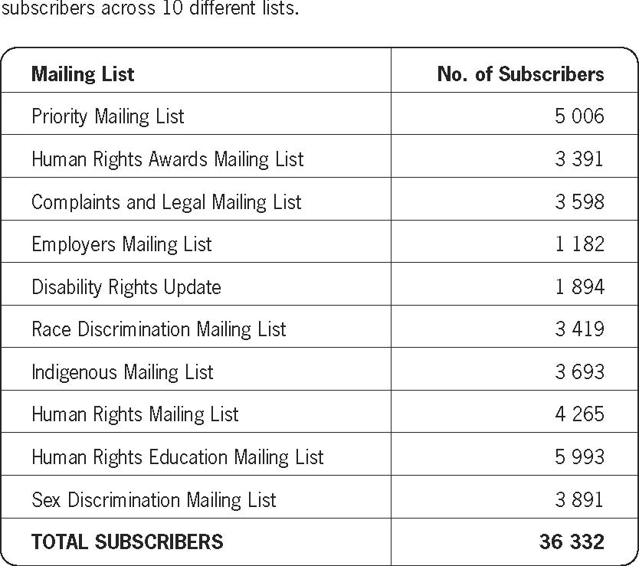
Further information about the Commission’s electronic mailing list service is available at: www.humanrights.gov.au/mailing_lists.
Statistics
The Commission uses a web statistics system which tracks the number of visitors the site has and how visitors are using the site. This allows the Commission to identify materials that are particularly successful or popular and where we have room for improvement.
Usage of the site has increased significantly over the year with approximately 5,515,999 page views on the server during 2004–05. This equates to approximately 56,971,558 hits on the site in total. This is an increase of 25% on website usage since the previous financial year.

A summary of statistical information is provided below:
Section | Home/Index page views | Section page views
HREOC Homepage www.humanrights.gov.au | 424 246 | n/a
Aboriginal and Torres Strait Islander Social Justice www.humanrights.gov.au/social_justice | 47 721 | 414 544
Complaints Information www.humanrights.gov.au/complaints_information | 13 119 | 114 008
Disability Rights Homepage www.humanrights.gov.au/disability_rights | 65 272 | 597 935
Human Rights Homepage www.humanrights.gov.au/human_rights | 51 040 | 525 075
Legal Information Homepage www.humanrights.gov.au/legal | 21 618 | 114 707
Racial Discrimination Homepage www.humanrights.gov.au/racial_discrimination | 59 282 | 321 649
Sex Discrimination Homepage www.humanrights.gov.au/sex_discrimination | 143 577 | 515 297
Information for Employers Homepage www.humanrights.gov.au/info_for_employers | 56 154 | 112 629
Publications Homepage www.humanrights.gov.au/publications | 21 333 | n/a
Media Releases Index www.humanrights.gov.au/media_releases | 26 937 | 335 335
Job Vacancies Homepage www.humanrights.gov.au/jobs | 31 289 | 41 903
Human Rights Education Resources | n/a | 688 752

Website feedback
The Commission's feedback facility allows users to request help with research and provide constructive feedback on the Commission's online resources and site accessibility. Thousands of messages have been received from legal, government, community and employer organisations, the media, schools and individuals during the year and are responded to by Commission staff within five working days.
Human rights education for teachers and students
In response to the high demand from teachers and students, the Commission has developed a range of human rights education modules specifically for use in upper primary and secondary schools. These modules are all linked to the curriculum of each state and territory education system.
They have been developed in consultation with education experts to ensure that they are relevant to young people and to the contemporary pedagogy of the Australian classroom.
Philosophy
The philosophy that guides the Commission’s approach to human rights education is based on a critical methodology which balances the learning needs of students with the curriculum requirements of relevant subject areas.
The modules that make up the human rights education program draw students into real-life situations relevant to their own experiences, which can then be explored in the context of Australian and international law.
Such programs have the capacity to develop values of respect and tolerance and encourage young people to consider ways in which they can take an active role to address intolerance and discrimination in the communities in which they live.
Human rights education is promoted through three dimensions of educational components:
(a) Knowledge: provision of information about human rights and mechanisms for their protection;
(b) Values, beliefs and attitudes: development of values, beliefs and attitudes, which uphold human rights; and
(c) Action: encouragement to take action to defend human rights and prevent human rights abuses.

Outcomes
The broad goal of the Commission’s human rights education program is to develop in students an awareness of their human rights and responsibilities as members of the community in which they live.
In so doing, a central aim is to assist young people in their development as informed, active citizens and to encourage values of tolerance, respect and empathy.
Content
Each human rights education module developed by the Commission is explicitly linked to the curriculum framework that exists in each state and territory.
These curriculum links are clearly outlined in the supporting documentation of each module, providing teachers with the required language to describe the learning outcomes of the Commission’s human rights education resources in their own programming.
Links have been established to subjects across a range of Key Learning Areas, including:
✣ Studies of Society and Environment (especially subjects such as History, Aboriginal Studies, Australian Studies, Civics and Citizenship);
✣ English;
✣ The Arts.

The education modules also include detailed teaching notes and resources to help teachers deliver an effective teaching and learning program on human rights.
They also provide significant flexibility in how they are delivered – teachers can incorporate individual activities into an existing program or teach the module as a whole.
Resources
The Commission has developed a range of human rights education resources, which focus on issues included in the Commission’s area of statutory responsibility. These include:
✥ Youth Challenge: Teaching Human Rights and Responsibilities
The Youth Challenge program comprises four units of study:
✧ Human Rights in the Classroom provides an accessible overview of human rights: what they are, how they have developed and where they apply.
✧ Disability Discrimination - but what about Doug’s rights? explores the issue of how competing rights can be resolved in a school community environment.
✧ Young People in the Workforce examines issues of race and sex discrimination, as well as the legal rights and responsibilities of employees and employers in Australia.
✧ Tackling Sexual Harassment addresses the issue of sexual harassment and how students can identify and address the issue, regardless of whether it happens to them or another student.

✥ Bringing Them Home
This education module introduces students and teachers to some of the key issues in the Commission’s Report of the National Inquiry into the Separation of Aboriginal and Torres Strait Islander Children from Their Families. It gives students the opportunity to research issues and engage in debate in an informed way.

✥ Face the Facts: Questions and Answers about Refugees, Migrants and Indigenous People
This education module provides teaching notes, student activities and worksheets, plus a range of recommended online resources and further reading, to research, analyse and debate the issues facing different groups in Australian society.

✥ Paid Maternity Leave: Activities on Gender Equality in the Workplace.
This education module draws on comprehension and oral/written composition skills to develop an understanding of gender and the workforce. It includes a fact sheet, a case study, teaching notes, structured activities and a student interview with the Commissioner.
In addition, the Commission’s website features links to a comprehensive collection of national and international human rights education resources.
Electronic mailing lists
The Commission maintains on-going communication with teachers and education bodies through an electronic mailing list. There are currently more than 5 900 individuals that subscribe to this mailing list. The Commission provides regular updates which:
✣ link to the most recent set of human rights education activities;
✣ reviews and links to human rights education resources;
✣ review of particular section of the Commission’s website which are useful for educators;
✣ list of upcoming human rights education events.

Delivery
The modules are delivered direct to teachers via the Commission website at www.humanrights.gov.au/info_for_teachers

The Commission also advertises in teacher magazines and other education press to let teachers know about the resources. The Commission sends CD Rom’s and other hard copy education materials to all schools together with order forms. All of these resources are provided free of charge.
In addition, the Commission has experience in co-ordinating and presenting human rights education programmes for secondary school students. The most recent Youth Challenge programme on ‘Tackling Sexual Harassment in Your School’ (2003/04) was presented to a total of 739 teachers and students in nine day-long sessions. Over 90% of all participants rated the program as either ‘very good’ or ‘excellent’. This program was converted into the online education resource and now forms part of the Youth Challenge module.

Information for Students webpage
This page has been redeveloped and was launched in 2005.
It provides students with ‘plain English’ information about international and domestic human rights issues. It has a Q&A Section and links to a wide range of resources to assist students to research and find answers to questions they may have in relation to their rights and responsibilities. It can be found at www.humanrights.gov.au /info_for_students

Human Rights Explained
This is an online resource for tertiary students. It was first published in 1998 and remains one of the Commission’s most accessed sections.

Usage of Online Education Resources
The Commission’s online human rights education resources are widely used by educators, both nationally and internationally. During 2004-05 the resources received 688,752 pageviews.
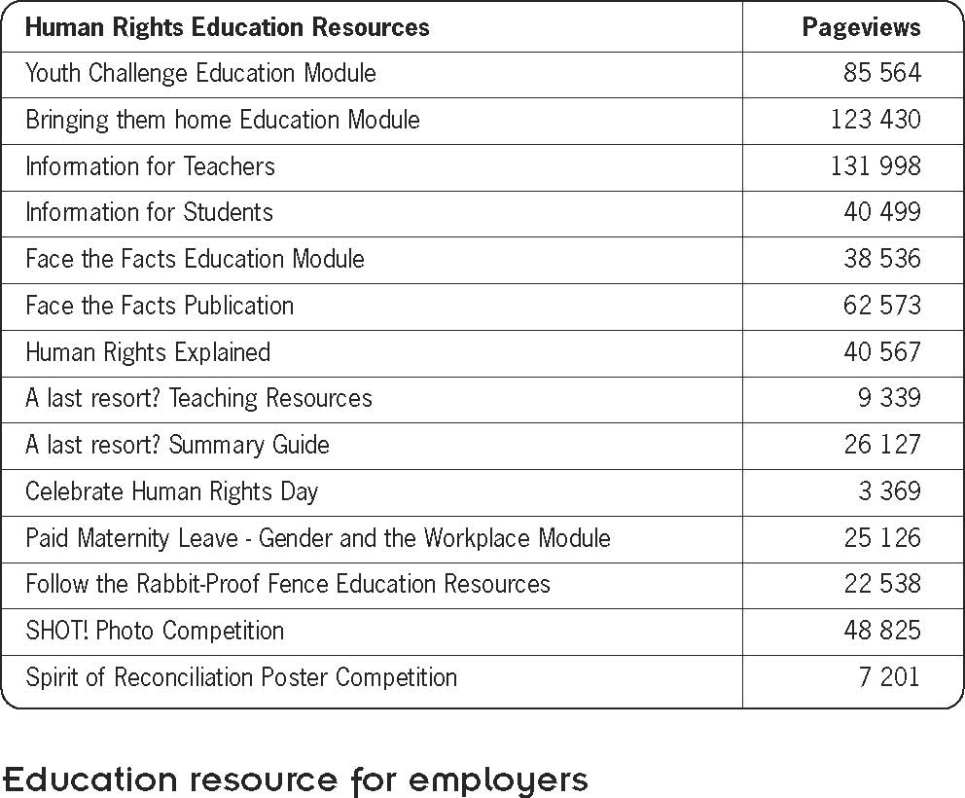
‘Good practice, good business’: a step-by-step guide to a discrimination free workplace

Federal Sex Discrimination Commissioner and Commissioner responsible for Age Discrimination, Pru Goward, launched a new employers’ pack titled Good practice, good business – eliminating discrimination and harassment in your workplace on 1 December 2004.

The new resources were launched at the Australian Stock Exchange in Sydney along with the Managing Director and CEO of the Australian Stock Exchange, Mr Tony D’Aloisio.

Good practice, good business includes a CD-Rom, brochures, posters and a new Information for Employers website at www.humanrights.gov.au/info_for_employers/. The pack contains resources for employers working in large and small business, as well as information about age, race and disability discrimination, sexual harassment and pregnancy, paid maternity leave and workplace bullying.

The resources have been designed for use in the workplace and the package is being distributed widely through business and employer organisations, recruitment agencies, government departments and unions.

The Attorney-General, Mr. Philip Ruddock MP issued a media statement welcoming the release of the employers pack. Mr Ruddock commended the Commission’s inclusive approach to working with all parties who have an interest in eliminating discrimination. The launch attracted a lot of publicity and the resources have been linked to other government websites. This resource has been extremely popular with both large and small employers from all over Australia.

Orders
Since the release of the employers resource the Commission had received over 12 000 orders for Good practice, good business.

Electronic mailing list
There are now 1,182 subscribers to the Commission’s new Employer’s Electronic Mailing List since the material was launched on 1 December.

Subscribers receive up-to-date alerts about new or updated material on the Information for Employers website and discrimination and harassment issues in the workplace.

Information for Employers website usage
The new Information for Employers website has received 86 655 page views for the period 1 December 2004 to 30 June 2005.

Requests to add to intranet
Employers are being encouraged to download the CD-Rom onto their intranet for their employees to access and to make training on these issues an essential part of induction for new employees.

Ongoing promotion
Public Affairs has promoted the Good practice; good business pack widely though businesses and employers’ organisations, the general media and specialist business publications, through recruitment agencies, government departments and unions.

Distribution of resource
✣ packs to all federal MPs;
✣ packs to other employers’/industry groups/human resources and personnel organisations;
✣ packs to local councils;
✣ continuation of promotion in specialist media (employment/workplace relations journalists/specialist publications);
✣ packs to Public Service Departments – staff news contacts.

Media Coverage
✣ Commissioner Goward has been interviewed by employment/workplace relations journalists/specialist publications;
✣ by seniors/youth publications regarding age discrimination;
✣ packs to web publications and magazines to promote the Information for Employers website.

Opinion pieces on age discrimination which promoted Good Practice Good Business were published in International Federation on Ageing and Australian Seniors magazines.

Another 10,000 copies of the CD Rom have been produced which include an update of ‘Hot Issues’ and form part of the resources on the CD. This resource is provided free of charge to those who request it.

Commission publications
In addition to all Commission publications being made available on the Commission’s website, around 95 000 publications were dispatched in hard copy format during 2004–05.
The most popular publications were: Sexual harassment and Disability posters, Good practice, good business’ brochure, Federal Discrimination Law 2005, Face the Facts: Some Questions and Answers about Immigration, Refugees and Indigenous Affairs.
A list of publications released during 2004–05 can be found at Appendix 2 of this Report.

2004 Human Rights Medal and Awards
The Human Rights Medal and Awards were established in 1987 to recognise individuals and organisations that have made a significant contribution to the promotion and protection of human rights and equal opportunity in Australia.

The 2004 Human Rights Medal and Awards presentation ceremony was held on 10 December 2004 at a luncheon at the Sheraton on the Park hotel in Sydney. The Human Rights Day address was delivered by Commission President, the Hon. John von Doussa QC and Julie McCrossin was the MC. The Commission is very grateful for the services of the judging panels who give their time and expertise on an honorary basis. The 2004 judges were: Jonathan Biggins, Justice Catherine Branson, David Cooper, Maurice Corcoran, Nicholas Cowdery QC, Eva Cox, Morag Fraser, Jackie Huggins, Ian Kiernan, Justice Ruth McColl, Sandy McCutcheon, David Marr, Kathryn Millard, Andy Nehl, Natalie O'Brien, Cleonie Quayle, Paul Sheehan, Laura Tingle and Andrew Urban.

Information on the 2004 winners can be found below and on the Commission’s website at: www.humanrights.gov.au/hr_awards/2004.html#medal

Human Rights Medal
The Human Rights Medal is awarded to an individual who has made an outstanding contribution to the advancement of human rights in Australia.

Joint winner: Deborah Kilroy
Deborah Kilroy is the founder and Director of Sisters Inside, a thriving community organisation providing services to women in and from prison throughout Queensland. After emerging from prison herself in1992, Ms Kilroy established Sisters Inside for women who were marginalised, stigmatised or imprisoned. The management team is made up mainly of women who are in or have been in prison –augmented by a few former politicians, lawyers, academics and other professionals. About 25% of the staff and steering committee are Indigenous women.

Its programs include a personal support and women’s transition program, kids of mums in gaol project and youth crime prevention program. The organisation also produces journals and newsletters and takes part in national and international advocacy.

The judges praised Ms Kilroy for her strong leadership and advocacy on behalf of women and girls in prison. Under Ms Kilroy’s leadership, Sisters Inside is addressing the rising number of Indigenous women in prison and the criminalisation and imprisonment of women with mental illness and physical disabilities.

Joint winner: Dick Estens
Dick Estens is the founder of the Aboriginal Employment Strategy, a model for Indigenous employment which helped turn around the future of NSW country town Moree. The strategy which was set up in Moree in 1997, now places 450 Aboriginal people into employment every year and has expanded into Tamworth and Dubbo.

All staff are Aboriginal. They visit businesses to seek a commitment to work with the Employment Strategy not only to provide employment to Aboriginal people, but to build partnerships and acts as mentors to ensure success for the employer and the employees.

The success of the Aboriginal Employment Strategy relies on building self-esteem and pride, and also peer pressure to succeed, from within the Aboriginal community. The judges said Dick Estens’ success in Moree was a great example of what can be done and how it can be used as a blueprint for other Indigenous communities. A racial hotspot ten years ago, Moree now displays great self-esteem and initiative. Aboriginal people are delivering for their community and in charge of their own destiny. Similar strategies will be rolled out into six regional sites by the end of 2004.

Law Award – sponsored by the Law Council of Australia
The entrant should be an individual or an organisation with a proven track record in the promotion and advancement of human rights in Australia through the practice of law.

Winner: Julian Burnside QC
Melbourne barrister Julian Burnside QC has been extensively and consistently involved in pro-bono legal work for asylum seekers (including the well-known Tampa case) – not least through Spare Lawyers for Refugees, which he established in order to encourage other lawyers (now over 250 nationwide) to volunteer their time and professional expertise to help refugees and asylum seekers. He and his wife also established Spare Rooms for Refugees to provide material support and accommodation for refugees in the general community.

He teaches and trains young lawyers internationally and is outspoken about human rights and freedoms in the legal profession, in the media and in the community. In 2004, with Malcolm Fraser, Robert Manne and Young Australian of the Year Hugh Evans, he started The Justice Project – a group that supports basic human rights for all in the community and provides humanitarian assistance in many ways.

Community Award (Organisation)
The entrant must be an individual or a non-government or community-based organisation with a proven track record in the promotion and advancement of human rights in the Australian community.

Winner: PEN International
The judges credited PEN (the international association of Poets, Playwrights, Essayists and Novelists) with an effective campaign of raising asylum seeker issues within the Australian conscience and said it was able to bring national and international pressure to bear in seeking the release of asylum seekers in detention.

PEN Sydney created a Writers in Detention Committee in 2001 and, through members Tom Keneally and Rosie Scott, organised the International PEN’s Day of the Imprisoned Writers which focused on the plight of asylum seekers in detention in Australia. The work of writers recently released from detention was featured at the Sydney and Melbourne Writers Festivals. PEN also edited Another Country – an anthology of writing from asylum seekers.

Community Award (Individual)
Joint winner: Merinda Epstein
Merinda Epstein has been actively involved in mental health politics for 15 years. She is recognised as one of Australia’s leading mental health consumer advocates and internationally recognised for her contribution to mental health service development. Ms Epstein was recognised by the judges for her determination, bravery, moral integrity and insight in ensuring that the rights of people with psychiatric disabilities are defended.

The judges particularly admired the fact that Merinda, as quoted by one of her nominators, “can sniff out injustice much as a beagle find contraband at the airport” and the fact that “Merinda is notoriously bad with money, as she gives away to those in needs and forgets to budget to keep any
money for herself”.

Joint winner: John Murray
John Murray, coordinator of the Positive Justice Centre (a volunteer community organisation) has campaigned tirelessly to overcome discrimination against and social exclusion of people who were in the care of the State or Church as children. He has authored and co-authored many books and made many important submissions to government committees on the subject.

Mr Murray was recognised by the judges for the outstanding role he has played in promoting human rights for young people in institutionalised care. His groundbreaking findings in the 2001 Inmate Health Survey found that almost 40% of prisoners had been in the care of the State/Church as children, which led to the first comprehensive assessment of the State ward/care leavers over-representation in the criminal justice system.

John has lobbied and argued that identification of young people previously in State/Church care permits rehabilitation and effective crime prevention programs and enables preventative models to be undertaken.

Arts Non-Fiction Award
The entrant must have written a non-fiction work (including social history, social commentary, biography or documentary).

Winner: Refuge Australia, Klaus Neumann
Refuge Australia, by Klaus Neumann documents the history of Australia’s response to refugees and provides fresh insights that illuminate the social and political forces that have shaped Australia’s refugee policy.

The judges described Refuge Australia as a highly readable account of Australia’s long history of debate about refugees and asylum seekers. Drawing together thousands of personal stories of refugees seeking refuge in Australia between 1930 and 1970 and original government documents, the book describes Australia’s ambivalent attitude to refugees in a cool, clear tone.

“In so doing, Klaus Neumann doesn’t prejudge the issues. Rather, he allows readers to arrive at their own conclusions. Refuge Australia does, however, leave the reader with a sense of optimism and the idea that change is possible.

In the midst of widespread community debate about Australia’s current treatment of refugees and asylum seekers, Refuge Australia provides an important historical context in which to examine these issues. It’s also a great read.”

Television Award
The entrant must have written or produced a TV drama, news or current affairs program or documentary, broadcast in Australia.

Winner: The Road to Tooleybuc, Australian Story, ABC Television – Helen Grasswill, Quentin Davis, Mara Blazic, Ross Byrne and Roger Carter.

The Road to Tooleybuc focussed on a seemingly unlikely friendship between Ian Skiller, a farmer from the town of Tooleybuc, population 250, and a young Afghan refugee, Dr Abdul Nasiry, a medical graduate from Kabul University.

The judges described The Road to Tooleybuc as an open and honest story about the relationships that develop between Afghan TPV holders and members of small rural communities. They said the image of a group of Afghan refugees in traditional garb eating their food next to the Murray River farmer and his mother does more to promote what these human rights awards are about than any words.

The story showed that those who assume people from outback Australia are intolerant or inflexible are very wrong. It moved beyond the negative images and portrayals of refugees – here are Afghan people on TPVs integrating into the community – and showed how ‘normal’ people with no idea of refugee issues could become activists.

Radio Award
The entrant must have written or produced a news or current affairs program or documentary, up to a maximum of one hour duration (either one program or a compilation of highlights), broadcast in Australia.

Winner: Beyond the Bars: Out and Blak, Radio 3CR – Lisa Bellear, Kutcha Edwards, Juliet Fox, Lester Green, Eleisha Jones, Gilla McGuiness, Johnny McGuiness and Ross Morgan.

Beyond the Bars: Out and Blak is a unique radio program that presented the stories, songs, messages and concerns of Indigenous prisoners – a six hour broadcast from within the Port Phillip prison in Laverton and the Dame Phyllis Frost Centre in Deer Park, Victoria.

The judges said it was “simply a great program and a standout winner” and an excellent example of a community telling its own story. They said the program demonstrated that great radio does not have to rely on a big budget – the key ingredient is talking to people who have something honest and important to say.

Print Media Award
The entrant must have had work published in Australian magazines or metropolitan or regional newspapers.

Winner: Stolen Wages Payback Shame, National Indigenous Times

Stolen Wages Payback Shameis a special report on “stolen” wages and payments owed to Aborigines from the turn of the century in NSW. The series documents the story of the wages and savings, pensions and other payments to Aborigines withheld by New South Wales Governments for 70 years until 1969. It detailed the “unwritten policies” pursued by successive Governments of denying liability, misleading Aboriginal people about the fate of the funds and resisting efforts by the rightful owners of the money from claiming it back.

The judges were impressed by the effort undertaken by the small newspaper and the direct impact it had in prompting action by the NSW Government, other State Governments and Indigenous organisations. They said the power of the piece came not just from the revelations of past injustices, but also the illustration that Indigenous people’s lives are still being frustrated by government failure.

Chapter 3: Monitoring human rights
Along with its human rights education and promotion function, the Commission undertakes a monitoring role in relation to human rights standards. This monitoring role ranges across the work of the individual Commissioners who examine and report issues of race, age, sex and disability discrimination and human rights, to the assessment of legislative proposals and presentation of submissions through the Parliamentary Committee process.
These submissions are also used by lawyers as resource material; politicians and advocacy groups who can use them in the political process and in public debate; and students and other individuals who have an interest in human rights issues. The Commission’s Legal Section generally assists the Commission in preparing those submissions, in consultation with the Commission’s policy units and Complaint Handling Section.
A range of submissions made by the Commission during 2004–05 are summarised below:
Submission on statutory review of Terrorism (Police Powers) Act 2002 (NSW)
The Commission was invited to make submissions to the New South Wales Attorney-General’s review of the Terrorism (Police Powers) Act 2002 (NSW). The Act provides, amongst other things, for a wide range of powers of search in response to an apprehended terrorist threat, including powers to stop and search people in the company of a ‘target person’ and anyone in a ‘target area’.
The Commission made a submission in February 2005, raising concerns that the Act contained broad powers that, if misused, had the potential to contravene human rights. In this context, the Commission expressed particular concern with the lack of judicial oversight of the exercise of powers contained in the Act.
The Commission’s submission acknowledged that the legislation was structured to allow rapid action in situations of emergency and that judicial oversight of decisions in advance may not be possible in all cases. However, the Commission submitted that where urgency does not dictate to the contrary, it should provide that the authorisation of the exercise of special powers should be approved in advance by a judicial officer.
In cases where urgency does not allow for this to occur, the Commission submitted that the Terrorism (Police Powers) Act 2002 (NSW) should allow for people to seek judicial review after the event, with the prospect of remedial orders (for example, relating to the return of property improperly seized) being available. The Commission submitted that the prospect of such review would provide a potent check on the risk of the improper or excessive exercise of power under the legislation.
The Commission’s submission available at: www.humanrights.gov.au/legal/submissions/nsw_terrorism.htm

Submission on Criminal Code Amendment
(Trafficking in Persons Offences) Bill 2004
In February 2005, the Commission made a written submission to the Senate Legal and Constitutional Legislation Committee in relation to the provisions of the Criminal Code Amendment (Trafficking in Persons) Bill 2004. The Commission also appeared before the Committee at a public hearing in Sydney. The Bill sought to implement certain obligations Australia has under the Protocol To Prevent, Suppress And Punish Trafficking In Persons, Especially Women And Children, Supplementing The United Nations Convention Against Transnational Organized Crime (‘the Trafficking Protocol’) which Australia signed on 11 December 2002.

The Commission generally welcomed the Bill, but made drafting suggestions which fell into two general categories:
✣ A number of suggestions which reflected recommendations made by an earlier Parliamentary Committee considering similar issues (the Parliamentary Joint Committee on the Australian Crime Commission).
✣ A second category of drafting suggestions including recommendations designed to ensure that the provisions fully meet the obligations Australia would assume if it were to ratify the Trafficking Protocol. Several issues arose, including:
✧ the Bill did not cover all the ‘means’ of trafficking referred to in the Trafficking Protocol;
✧ the proposed offences of trafficking by force or threat included a requirement that the prosecution prove the force or threats of the accused resulted in consent on the part of the victim. The Trafficking Protocol specifically states that the consent of a victim should be irrelevant in such cases; and
✧ some of the proposed offences did not include an element of ‘exploitative purpose’. This element is an essential component of the definition of ‘trafficking’ in the Trafficking Protocol. Its omission meant that those proposed offences had an uncertain scope, extending to circumstances outside the internationally accepted definition of trafficking.

The committee accepted many of the Commission’s recommendations. The Bill was later amended in a manner which largely reflected the Committee’s recommendations.

The Commission’s submission to the committee is available at:www.humanrights.gov.au/legal/submissions/criminal_code_trafficking_bill.html

Submission on Division 3 of Part III ASIO Act

The Commission made submissions to the Parliamentary Joint Committee on ASIO, ASIS and DSD, which is currently reviewing Division 3 of Part III of the ASIO Act 1979 (Cth). Those provisions create a regime of detention and questioning warrants for the purpose of gaining information in relation to terrorism offences.

In summary, the Commission made the following submissions:
✣ The Commission considers that Division 3 of Part III of the ASIO Act 1979 (Cth) raises specific and more general concerns regarding arbitrary detention, which is proscribed by article 9(1) of the International Covenant on Civil and Political Rights. The Commission makes a number of recommendations directed at avoiding arbitrary detention by ensuring that detention is proportional to the purpose of obtaining intelligence to avoid terrorist attacks.

✣ The Commission considers that the protections against self incrimination conferred by Division 3 of Part III do not protect against ‘derivative use’ of material obtained through the warrant procedures (as required by article 14(3) of the International Covenant on Civil and Political Rights). The Commission has recommended amendments to extend those protections.

✣ In its terms and operation, Division 3 of Part III limits the legal advice or representation available to the subjects of the warrant procedures. In the Commission’s view, some of those limitations leave people without an ‘effective remedy’ for violations of their human rights. Australia is required to provide such remedies under article 2(3) of the International Covenant on Civil and Political Rights.

✣ Division 3 of Part III operates on children aged between 16 and 18 years. The Commission is concerned that the protections provided to such children may be insufficient to avoid violations of various articles of the Convention on the Rights of the Child. The Commission has made recommendations designed to avoid such violations.

The Commission’s submission to the committee is available at www.humanrights.gov.au/human_rights/terrorism_sub/asio_asis_dsd.html

The Commission also gave oral evidence to the Committee in May 2005. The Committee is required to complete its review by 22 January 2006.

Submission on Migration Litigation Reform Bill 2005

In April 2005, the Commission made a written submission to the Senate Legal and Constitutional Legislation Committee in relation to the provisions of the Migration Litigation Reform Bill 2005. The Commission also appeared before the committee at a public hearing in Canberra.

The stated intention of the Bill was to ‘improve the overall efficiency of migration litigation’. The main proposals in relation to which the Commission made submissions were:
✣ Changes aimed at imposing uniform time limits for the commencement of migration litigation.
✣ The extension of the power of summary dismissal in all types of litigation.
✣ Provisions said to be designed to deter unmeritorious litigation, particularly by exposing any person ‘encouraging’ unmeritorious migration litigation to the prospect of a personal costs order against them.

The Commission raised concerns that the Bill potentially undermines the rights of litigants in migration and other proceedings. While acknowledging the legitimacy of the objective of improving the efficiency of migration litigation, the Commission expressed the view that a number of the proposed changes were potentially unjust and unlikely to work.

In summary, the Commission submitted that:
✣ The imposition of strict time limits (in the present case allowing no discretion to extend time beyond 84 days) raises a clear potential for injustice, and in cases where a person fears persecution, their ‘refoulement’ (returned to a place where they will be persecuted). There is no sufficient reason to deny an extension of time where the interests of justice require it.
✣ The current approach of courts to summary dismissal requires that great care be taken in dismissing a case at an early stage so as to avoid prejudice to people’s rights. This approach is appropriate and should not be altered.
✣ The provisions aimed at deterring unmeritorious litigation are poorly defined, potentially very broad, and are likely to have the effect of cutting off access to advice, assistance and representation for people in migration matters who may already be significantly disadvantaged in their ability to advocate on their own behalf.

The Commission’s submission to the committee is available at www.humanrights.gov.au/legal/submissions/migration.html.

The Committee’s recommendations responded, in part, to the concerns raised by the Commission and others by recommending the inclusion of a ‘sunset clause’ in relation to the proposed expanded powers of summary dismissal. This clause provides that those provisions would be repealed at the conclusion of 18 months to ensure review of their operations by Parliament. The Committee further recommended that the Bill include a requirement that the Minister must report to both Houses of Parliament on the operation of the provisions of the Bill at the end of 12 months.

Submission on National Security Legislation Amendment Bill 2005

In April 2005, the Commission made a written submission to the Senate Legal and Constitutional Committee in relation to the National Security Legislation Amendment Bill 2005. The Bill sought to extend the operation of the National Security Information (Criminal Proceedings) Act 2004 (Cth) (the Act) to civil proceedings (state and federal proceedings). Like the Act, the Bill aimed to prevent the disclosure of information in court where the disclosure is likely to prejudice ‘national security’. The process by which the Bill sought to do this substantially mirrored the method currently used for criminal proceedings.

In its written submission, the Commission raised concerns in relation to provisions of the bill, including:
✣ provisions which restricted the court’s discretion in making orders for dealing with national security information;
✣ provisions which imposed a requirement to hold closed hearings when considering such orders;
✣ provisions allowing for the exclusion of parties and their legal representatives from closed hearings in certain circumstances;
✣ provisions dealing with the power of the court to issue a stay, which potentially prevent litigants in civil proceedings accessing an effective remedy for violations of their human rights; and
✣ provisions restricting the disclosure of information to parties and legal representatives.

The Commission argued that those concerns related to key human rights enshrined under the International Covenant on Civil and Political Rights.

The Commission’s submission is available at: www.humanrights.gov.au/legal/submissions/national_security.html

Making extensive reference to the submissions made by the Commission, the committee recommended several amendments be made to the Bill, however none of the recommendations of the Committee were adopted by the Senate.

The Act was later amended by the Senate to provide factors to which a court must have regard when determining whether to exercise the stay provision. Those factors include whether a party has reasonable prospects of obtaining a remedy in the proceedings, the extent of any financial loss that a party would suffer as a result of the proceedings being stayed and any other relevant factors.
The Act passed through the House of Representatives on 21 June 2005, as amended by the Senate.

Submissions to the Senate Select Committee on the Administration of Indigenous Affairs Inquiry into the ATSIC Bill

In July 2004, Dr William Jonas, the then Social Justice Commissioner, made a submission to the Senate Select Committee on the Administration of Indigenous Affairs for their Inquiry into the ATSIC Bill, the mainstreaming of government service delivery to Indigenous peoples and related matters.
The submission includes a number of recommendations relating to ATSIC, the Senate Committee, and mainstreaming of service delivery. It is available online at: www.humanrights.gov.au/social_justice/submissions/atsic_review.html

In February 2005, the current Social Justice Commissioner, Mr Tom Calma, made an opening statement to the Senate Select Committee on the Administration of Indigenous Affairs Public Hearing for their Inquiry into the ATSIC Bill and the administration of Indigenous programs and services by mainstream departments. The statement can be found at:
www.humanrights.gov.au/speeches/social_justice/senate_select.html
Commonwealth Parliamentary Inquiry into Balancing Work and Family

In June 2005, the Sex Discrimination Commissioner, Ms Pru Goward, on behalf of the Commission, lodged Striking the Balance: Women, men, work and family Discussion Paper 2005, as a submission to the Commonwealth Parliamentary Inquiry into Balancing Work and Family.

Optional Protocol to the Convention on the Rights of the Child

In August 2004, the Commission made a submission to the Joint Standing Committee on Treaties on the Optional Protocol to the Convention on the Rights of the Child on the Involvement of Children in Armed Conflict (Optional Protocol). The Commission also gave oral evidence at a hearing before the Committee.

The Optional Protocol strengthens the protections contained in the Convention on the Rights of the Child, to which Australia is a party. In addition, the Optional Protocol establishes the age of 18 as the minimum for direct participation in hostilities, for compulsory recruitment by state parties, and for recruitment into armed groups. Amongst other things, it requires that state parties increase the minimum age for voluntary recruitment beyond the current minimum of 15.

The Commission sought to provide the committee with an overview of the obligations contained in the Optional Protocol and the extent to which they have already been adopted in Australian law. The submission noted that broadly speaking, Australian law already complies with the requirements of the Optional Protocol. However, the submission pointed to some possible drafting issues which, in the Commission’s view, required further consideration, including amendments to the Criminal Code Act 1995 (Cth). The Commission also suggested that the protections contained in the Optional Protocol regarding minimum age of recruits to Australia’s armed forces should be implemented in the Defence Act 1903 (Cth), rather than in the relevant defence instruction (Defence Instruction (General) PERS 33-4), so as to provide a greater level of protection.

The Commission’s submission also urged the government to go beyond the minimum standards contained in the Optional Protocol and provide leadership by ensuring members of the Defence Force under the age of 18 years are not directly or indirectly involved in hostilities.

The committee accepted the Commission’s recommendations regarding amendment of the Criminal Code Act 1995 (Cth). Those recommendations were reflected in the Inquiry into the provisions of the Law and Justice Legislation Amendment (Serious Drug Offences and Other Measures) Bill 2005.

While the Committee did not consider that protections contained in the Optional Protocol regarding minimum age of recruits to Australia’s armed forces should be implemented in the Defence Act 1903 (Cth), it did accept that there was a need to make the contents of the relevant defence instruction publicly available. That document has since been placed on the website of the Defence Department.

The Commission’s submission is available at: www.humanrights.gov.au/legal/submissions/jscot_submission_croc_optional_protocol.html
Chapter 4: Complaint handling section

Overview of the work of the Complaint Handling Section
The President of the Human Rights and Equal Opportunity Commission is responsible for the Commission’s complaint handling function. The President is assisted in investigating and conciliating complaints lodged under federal anti-discrimination and human rights law by staff of the Complaint Handling Section (CHS).

There are three investigation/conciliation teams, headed by a Principal Investigation/Conciliation Officer, who handle complaints on behalf of the President. The teams are divided with reference to specific pieces of federal legislation to enable staff to develop specialised knowledge of the law and an understanding of issues raised under this law.

CHS staff undertake in-house training in the investigation and conciliation of complaints and are offered on-going professional development through other programs conducted by the CHS Principal Training and Policy Officer.

Once a complaint has been formally accepted by the Commission, the aim of the CHS is to manage the complaint in a timely and unbiased manner and to be responsive to the legitimate needs of parties to the complaint. Complaints are generally allocated to an officer for action within six weeks of receipt. While allocation to an officer may take a little longer than this at times, cases that need priority handling are dealt with straight away.

The investigation of a complaint may include such tasks as statement taking, site inspections, viewing video/TV/CCTV footage or reviewing employment and medical records.

After investigation, if a complaint is considered appropriate for conciliation, a conciliation conference is arranged. Conciliation conferences usually take the form of a face-to-face meeting of the parties to the complaint and conferences are held in various locations throughout Australia including regional and remote areas. An Investigation/Conciliation Officer presides over the conference and assists parties to try to resolve the complaint. If a complaint can be resolved through conciliation, the matter is closed. Many complaints are dealt with in this way as parties recognise the benefits of a process where they have direct input into how the matter is resolved without having to resort to more formal court proceedings.

Where a complaint of unlawful race, sex, disability or age discrimination is unable to be resolved through a conciliation process or where the President is of the view that the complaint is, for example, lacking in substance or better dealt with by another organisation, the complaint will be terminated. Both parties to a complaint are advised in writing of the President’s decision regarding a complaint. After a complaint is terminated, the complainant may decide to pursue the matter before the Federal Court of Australia or the Federal Magistrates Court.

Complaints that allege a breach of human rights or discrimination under the Human Rights and Equal Opportunity Commission Act 1986 cannot be taken to court for determination. Complaints under this Act which have not been declined and are unable to be resolved through conciliation may be subject to a report to the Attorney-General and subsequent tabling of the report in Parliament. Decisions under this Act may, however, be subject to review under the Administrative Decisions (Judicial Review) Act 1977 (Cth).

In 2004-05:
✣ 1 241 complaints were received;
✣ 1 233 complaints were finalised;
✣ 38 percent of finalised complaints were conciliated; and
✣ 91 percent of complaints were finalised within 12 months of lodgement.

A diagram of the complaint handling process is provided at Appendix 4.

The CHS also manages the Complaint Information Service. Each year around 10 000 people from all over Australia contact the Commission’s Complaint Information Service either by telephone, TTY, post, e-mail or in person to obtain information about the law the Commission administers and the complaint process. As many enquirers are unsure which organisation can best assist them, the work of Complaint Information Service staff frequently involves providing contact details for organisations that can more appropriately deal with the enquirer’s concerns. If the enquirer’s concern is one that the Commission can deal with, the enquirer is provided with information on how to lodge a complaint and is either provided with the necessary forms or directed to the Commission’s website and ‘on-line’ complaint lodgement facility.

✣ 9 936 telephone/post/e-mail/TTY/in person enquiries were received in 2004-05.

Key performance indicators and goals
✣ Timeliness – the section’s stated performance measure is for 80 percent of complaints to be finalised within 12 months of date of receipt. In 2004-05, the CHS finalised 91 percent of matters within 12 months and the average time from receipt to finalisation of a complaint was six and a half months. A detailed breakdown of timeliness statistics by jurisdiction is provided in Table 11. There has been continual improvement in the timeliness of the complaint process over the past three years.
✣ Conciliation rate – the section’s stated performance measure is for 30 percent of finalised complaints to be conciliated. In 2004-05, the section achieved this goal with a 38 percent conciliation rate.
✣ Customer satisfaction – the section’s stated performance measure is for 80 percent of parties to be satisfied with the complaint handling process. Data for the past year indicates that 92 percent of parties were satisfied with the service they received and 57 percent rated the service they received as ‘very good’ or ‘excellent’. Further details of survey results for this reporting year are provided below.

Customer satisfaction survey
Since 1997, the CHS has sought feedback on the complaint process from people lodging complaints (complainants) and people responding to complaints (respondents). This feedback is obtained by means of a Customer Satisfaction Survey which is predominately undertaken by telephone interview. Survey results for the period 1 July 2004 to 30 June 2005 indicate that:

✣ Eighty eight (88) percent of complainants and 97 percent of respondents felt that staff explained things in a way that was easy for them to understand;
✣ Ninety three (93) percent of complainants and 96 percent of respondents felt that forms and correspondence from the Commission were easy to understand;
✣ Seventy eight (78) percent of complainants and 81 percent of respondents felt that the Commission dealt with the complaint in a timely manner; and
✣ Eighty nine (89) percent of complainants and 87 percent of respondents did not consider staff to be biased.

In comparison with the last reporting year, there has been improved satisfaction across almost all of the reporting categories. In particular, in 2004-05 there has been significant improvement in complainant satisfaction with the timeliness of the complaint process.

Service Charter
The CHS’s Service Charter provides a clear and accountable commitment to service. It also provides an avenue through which users can understand the nature and standard of service they can expect and contribute to service improvement. All complainants are provided with a copy of the Service Charter and respondents receive a copy when they are notified of a complaint against them.
In the 2004-05 reporting year the Commission did not receive any complaints about its services through this mechanism. It is noted that where parties have concerns about the complaint handling process, they are generally able to resolve their concerns through discussions with the officer handling the complaint.

Access to complaint services
The CHS aims to facilitate broad community access to its information and services. In meeting this challenge the CHS provides the services outlined below:

✣ The Complaint Infoline. 1300 656 419 (local call charge) is open Monday - Friday between 9.00 am and 5.00 pm. This service offers enquirers the opportunity to call and discuss allegations of discrimination with a Complaint Information Officer. Enquirers can also e-mail: complaintsinfo@humanrights.gov.au

✣ CHS webpage. www.humanrights.gov.au/complaints_information/ This webpage provides the general public and potential users of the service with information about the Commission’s complaint handling role and the complaint process. The webpage includes information on how to lodge a complaint, a complaint form, frequently asked questions about complaints and a conciliation register. The conciliation register contains de-identified information about the outcomes of conciliated complaints. The CHS webpage received 114 008 page views during this reporting year.

✣ On-line complaint form. This service, which allows complaints to be lodged electronically, continues to be well utilised.

✣ Concise complaint guide. This document, which provides an overview of the complaint process, can be accessed on the CHS webpage and downloaded in 14 community languages.

✣ Interpreter and translation services. In the past reporting year the section utilised a range of interpretation and translation services. The main language groups assisted in 2004-05 were Cantonese, Arabic, Persian and Vietnamese.

✣ Arrangements with State and Territory agencies. The Commission has formal arrangements with the Victorian Equal Opportunity Commission, the Queensland Anti-Discrimination Commission, the South Australian Equal Opportunity Commission, the Northern Territory Anti-Discrimination Commission and the Western Australia Equal Opportunity Commission, whereby CHS staff utilise facilities at these agencies for conciliation conferences, community education or training and display of CHS publications. The Commission has informal arrangements with the Tasmanian Anti-Discrimination Commission and the Australian Capital Territory Human Rights Office.

✣ Election of jurisdiction information. In the majority of cases complainants have a choice to lodge complaints either under state or territory anti-discrimination law or under federal law. The Commission has developed an information sheet to assist complainants understand this election of jurisdiction. The information sheet can be downloaded from the Commission’s website at: www.humanrights.gov.au/complaints_information/guides/jurisdiction.html

✣ Video/DVD on the conciliation process. This audio-visual resource entitled ‘Pathways to Resolution’ is available to the general public and complainants, respondents and advocates who may be involved in the complaint process. The video/DVD provides parties with an overview of a conciliation conference, outlines steps to take in preparation for conciliation and demonstrates positive approaches to discussing issues and negotiating resolution outcomes. Captioned and uncaptioned versions of the video/DVD are available from the Commission and the video/DVD is provided on loan to complainants, respondents and advocates who are currently involved in complaints before the Commission. Sections of the video/DVD can also be viewed on the Commission’s webpage at: www.humanrights.gov.au/pathways_to_resolution/index.html

✣ Conciliation circuits. Conciliation officers travel throughout Australia to conduct face-to-face conciliation conferences. Along with conferences conducted in the greater Sydney area, CHS officers conducted 27 conferences in regional NSW (including Coffs Harbour, Wagga Wagga, Newcastle, Wollongong, Coonamble, Orange, Gosford, Lismore, Albury, Tamworth, Taree and Morisset); 75 in Victoria (including Melbourne and Bendigo; 53 in Adelaide; 33 in Queensland (including Brisbane, Cairns, Hervey Bay, Mackay, Gold Coast and Townsville); 22 in Western Australia (Perth and Kalgoorlie); eight in the Australian Capital Territory; eight in Darwin and 13 in Tasmania (including Hobart, Launceston and Devonport).

✣ Access working group. During this reporting year the CHS access working group updated the section’s community education presentation to include information about the Age Discrimination Act 2004 which came into effect on 23 June 2004. The group also continued to develop strategies to ensure broad dissemination of information about federal anti-discrimination law and the Commission’s complaint handling process.

Community education
The CHS contributes to the Commission’s function of promoting an understanding and acceptance of human rights through its community education activities.

In this reporting year around 90 organisations throughout all states and territories attended information sessions on the law and the complaint handling process run by CHS staff. The CHS Indigenous Information/Liaison Officer, on her own or with other officers, undertook around 30 meetings with Indigenous organisations.

The organisations visited by CHS staff included community legal centres, Aboriginal legal centres, multicultural organisations, universities, disability groups, professional associations and unions. The regions covered included: Dandenong and Geelong in Victoria; Wagga Wagga, Orange and Glen Innes in NSW; Kalgoorlie in Western Australia and Rockhampton and Mackay in Queensland.

Training
The Commission has two specialised training programs which provide knowledge and skills in statutory investigation and conciliation. All complaint handling staff are required to undertake these courses. The CHS also provides training in investigation and conciliation for other organisations.

Two investigation training courses and two conciliation training courses were held for Commission staff during 2004-05. The courses held in May 2005 were also attended by staff from anti-discrimination agencies in New South Wales, South Australia, the Australian Capital Territory and Tasmania.

In February 2005, investigation and conciliation training was also provided to staff of the Office of the Federal Privacy Commissioner.

For the fourth year, the Commission has worked in partnership with the Australian Public Service Commission to provide a two-day investigation training course for federal public servants. This course, which is a variation of the Commission’s standard statutory investigation training program, provides theory and skills that can be applied to the investigation of internal complaints and breaches of the Australian Public Service Code of Conduct. In the past year, eight courses were delivered in various locations around Australia including Canberra, Adelaide, Perth, Brisbane and Sydney.

In the second half of 2004 a Principal Investigation/Conciliation Officer acted as a mentor for the Willing and Able Mentoring Program which is run by Employers Making a Difference. This program assists tertiary students with disabilities develop strategies to enable transition into paid employment. Through the mentoring placement students gain an understanding of a workplace culture and acquire skills in networking and professional presentation.

Staff of the CHS also attended various seminars and training courses relating to their work. These included ‘Industrial Relations and the Law’ seminars conducted by the University of Sydney; Australian Government Solicitor Law Group seminars; the Community Legal Centres’ National Conference; the Administrative Law Conference; the NSW Commonwealth Agencies Government Business Conference; the National Alternative Dispute Resolution Advisory Council’s Research Forum; and the Mawul Rom Cross Cultural Mediation Training Seminar. In this reporting year two CHS officers continued study towards Certificate IV accreditation in Assessment and Workplace Training.

Research and policy
In recent years the CHS has undertaken research with a view to better understand and improve the Commission’s complaint handling work. During 2004-05, the CHS obtained current and detailed information about conciliation with the aim of improving its practice and increasing practitioner and public understanding of the Commission’s Alternative Dispute Resolution process.

This particular research project involved CHS officers completing a survey at the conclusion of each conciliation process which occurred during the period 1July 2004 – 31 December 2004. One hundred and thirteen surveys were completed. The information gathered by the survey included information on party representation in conciliation and the form of the conciliation process. A summary of the information obtained from this survey will be placed on the Complaint Page of the Commission’s website in the near future. This will supplement research findings and papers regarding the Commission’s conciliation process which are currently available on the Commission’s website at: www.humanrights.gov.au/complaints_information/papers.html

International training and consultation
In recognition of the Commission’s role as a leader in the field of human rights and anti-discrimination complaint practice, the CHS is often requested to provide investigation and conciliation skill training for human rights institutions in other counties. This includes the provision of specifically designed training programs for staff from institutions in developing countries and more advanced skill workshops for staff from established institutions. The Commission’s CHS undertook three major overseas training projects in 2004-05.

In 2004, the Commission’s CHS was awarded a tender by the Asia Pacific Forum of National Human Rights Institutions to provide training for staff of the National Human Rights Commission of Thailand. This project involved the development and presentation of a five-day training course in human rights investigation. The training program took place in Bangkok from 22 – 26 October 2004. Thirty officers from the National Human Rights Commission of Thailand, the Department of Rights and Liberties Protection and the Ministry of Justice attended the program which was conducted in English with simultaneous translation into Thai.

In the period 20 November – 3 December 2004, two principal officers from the Commission's CHS section provided basic investigation and conciliation training for new staff of the Hong Kong Equal Opportunities Commission and advanced training workshops for more experienced staff. This is the third time the CHS has been invited to provide training for staff of the Hong Kong Equal Opportunities Commission.

In 2005, the CHS once again as a consultant to the Asia Pacific Forum of National Human Rights Institutions, developed and conducted a five-day training course in human rights investigation for staff of the Commission on Human Rights of the Philippines. Twenty-six staff from the Commission’s central and regional offices attended the training which was held in Tagaytay City in the Philippines from 18 – 22 April 2005.

The CHS is often called upon to provide placements for staff from overseas human rights institutions and to provide information about the Commission’s complaint handling work to visiting delegations. In January 2005, the CHS hosted a placement for two officers from the South Korean Human Rights Commission. During this reporting year CHS staff also provided information to visiting delegations from China, Iraq, the United Kingdom, Papua New Guinea and Malta. These delegations included ministerial, diplomatic and government representatives from human rights, gender equity and public service organisations.

In 2004-05, a CHS staff member participated in a training course entitled ‘The Role of National Human Rights Institutions in Human Rights Protection’. This course was held in Bangkok, Thailand from 1-10 December 2004.

Conciliation case studies ¹ Racial Discrimination Act

Under the Racial Discrimination Act 1975 it is unlawful to do any act involving a distinction, exclusion, restriction or preference based on race, colour, descent, or national or ethnic origin which has the purpose or effect of nullifying or impairing the recognition, enjoyment or exercise, on equal footing, of any human right or fundamental freedom in the political, economic, social, cultural or any other field of public life. The Act also prohibits offensive behaviour based on racial hatred.

In this reporting year the Commission received 167 complaints under the Racial Discrimination Act. The majority of these complaints related to employment (43%), the provision of goods and services (24%) and racial hatred (20%). The CHS finalised 157 complaints under this Act and 26 percent of these finalised complaints were conciliated. Detailed statistics regarding complaints under the Racial Discrimination Act are provided later in this chapter.

1. Complaint of race discrimination in the provision of goods and services
Four Aboriginal men complained that when they went to get a drink at a local club with a non-Aboriginal friend, the barman told them that the club does not serve beer to Aboriginal people.

In response to the complaint, the owner advised that the barman who was on duty at the time of the alleged incident was a casual employee and was no longer employed with the club. The owner said that no incident report had been lodged and he was unaware of the alleged incident. The owner claimed that if the matter had been reported to him and the alleged conduct confirmed, he would have dismissed the employee immediately.

The parties agreed to try and resolve the complaint by conciliation. The matter was resolved with the complainants agreeing to accept a verbal apology from the club owner and an offer to attend the club and have a drink with him.

2. Alleged race discrimination in employment
The complainant, who is of Ethiopian origin, claimed that he was discriminated against because of his race during his employment with the respondent manufacturing company. The complainant’s allegations included that he was called ‘black b…’, referred to as ‘monkey’ and asked “Where is there a well developed black country?”. The complainant claimed that he was over scrutinized compared to other employees and that he was rarely acknowledged by co-workers and managers. The complainant said that he eventually resigned because of pressure put on him.

In reply, the company denied that the complainant had been discriminated against because of his race. The company advised that while one employee agreed that he said “How are you, you black b…” to the complainant, this employee claimed that he intended no offence by the words and had apologised to the complainant.

The parties agreed to participate in a conciliation process which was successful. The complaint was resolved with an agreement that the company would pay the complainant $10 000 compensation and provide a verbal reference to prospective employees. The company also agreed to provide anti-discrimination training for its staff.

3. Alleged race discrimination in accessing facilities at a leisure centre
The complainant, who is of Jordanian origin, stated that in keeping with her customs she wears long sleeve clothing and a head scarf. She claimed that when attending a regular hydrotherapy session at a local leisure centre, a staff member approached her and told her that she was not allowed to enter the pool wearing a long sleeved shirt and scarf. The complainant said that when she told the staff member that she had been swimming in that manner at the centre for three months, the staff member told her that she would be allowed to swim but must shower first. The complainant said that she was embarrassed and humiliated by the action of the staff member.

In response to the complaint the leisure centre stated that it has no policy prohibiting people from wearing long sleeved shirts or head scarfs in wet areas. The centre noted that all members of the public are required to shower before entering the pool.

The parties agreed to participate in a conciliation process. The matter resolved with an agreement that the leisure centre would pay the complainant $8 500 compensation and provide her with a written apology.

4. Complaint of race discrimination in voluntary employment
The complainant, who is of Dutch origin, claimed that he applied to work as a volunteer tourist guide with a non-profit community based organisation. He alleged that his application was delayed and then ultimately rejected because of his race and accent.

In response to the complaint the respondent organisation said that the complainant’s application was unsuccessful because he did not have the suitable level of written and oral English language skills required for the job.

The complaint was resolved through conciliation with the organisation agreeing to provide the complainant with a verbal apology and offering the complainant a volunteer position in another section of the organisation. The organisation also agreed to implement procedures whereby prospective volunteers will be provided with information regarding the requirements for the positions they apply for and where the position requires English communication skills, they will be provided with detailed information on the level of skill required.

Sex Discrimination Act

Under The Sex Discrimination Act 1984 it is unlawful to discriminate against a person on the ground of their sex, marital status, pregnancy or potential pregnancy in many areas of public life including employment, education, provision of goods services and facilities, accommodation, clubs and in the administration of Commonwealth laws and programs. It is also unlawful to dismiss a person from their employment on the ground of their family responsibilities. Further, sexual harassment is unlawful in a variety of areas of public life including employment, educational institutions, the provision of goods, services and facilities, registered organisations, the provision of accommodation, clubs and in dealings concerning land.

In this reporting year the Commission received 348 complaints under the Sex Discrimination Act. The large majority of complaints related to employment (85%). Twenty-eight percent of the complaints alleged sexual harassment and a further 26 percent alleged discrimination on the ground of pregnancy. The Commission finalised 375 complaints under this Act and 47 percent of these finalised complaints were conciliated. Detailed statistics regarding complaints under the Sex Discrimination Act are provided later in this chapter.

1. Alleged pregnancy discrimination in casual employment
The complainant stated that she was employed by the respondent company as a casual pharmacy assistant and had worked regular shifts over a nine-month period. She claimed that in April 2004 she notified her supervisor that she was pregnant and three days later the company advised her that she could no longer be offered permanent regular employment but rather, would be offered on-call work.

In response to the complaint the company claimed that the complainant’s hours were reduced because of dissatisfaction with her work performance and as a result of having to train a new full-time employee to replace the complainant. The company disputed the complainant’s claim that she suffered detriment because of the reduction in her hours as the company was of the view that the complainant had found work elsewhere.

The parties agreed to try and resolve the complaint by conciliation. The complaint was resolved with an agreement that the company would pay the complainant $3 000 in general damages and provide her with a statement of service and a letter of apology. The company also agreed to ensure that relevant staff attend equal employment opportunity training.

2. Complaint of discrimination in employment on the ground of family responsibilities
The complainant advised that she had been employed as a full-time sales assistant with the respondent retail store for approximately 6 years. She claimed that when a new store manager commenced, her hours were changed from 8.30am - 4.30pm to 10.30am - 6.30pm. The complainant said that she advised the manager that she could not work the new hours as the day care centre her daughter attends closes at 6pm. The complainant claimed she spoke with the Area Manager about a possible transfer to another store but was told that even if she transferred, she would be required to do the later shift two days per week. The complainant subsequently resigned from her employment.

In response to the complaint the company stated that changing business needs and trading patterns had required changes to all employee shifts. The company claimed that various options were discussed with the complainant and that she was offered a transfer to another store where she could work two days on a later shift and three days on her usual shift but she refused this offer.

The parties agreed to resolve the complaint on the basis that the company would re-employ the complainant full-time at a particular store on the 8am - 5pm shift. The parties agreed that the complainant may be rostered to work at other agreed stores providing the company gives the complainant at least two days notice. The parties also agreed that no break in the complainant’s employment would be recorded.

3. Allegations of race discrimination and sexual harassment in employment
The complainant, who is of Asian background, stated that she was the only female contract administrator employed with the respondent building company. The complainant alleged that she was sexually harassed by a co-worker who was employed as a construction worker. Her allegations included that the co-worker made numerous comments about her Asian background, told her she would look cute if she wore a short skirt with black boots like those “Asian school girls” and showed her pornographic pictures of Asian women. The complainant stated that she raised concerns about the co-worker’s behaviour with the General Manager who said he would deal with the matter. The complainant claimed that she was issued with two written warnings about her performance and approximately one month after complaining about the co-worker’s behaviour, her employment was terminated.

In response to the complaint the company said that the complainant had been subject to performance counselling sessions before her dismissal for unsatisfactory performance. The company advised that during performance counselling the complainant told her immediate manager that she had been subjected to harassment. The company claimed that the General Manager advised her of the procedure for making a complaint but she did not make a formal complaint. The co-worker vigorously denied the complainant’s allegations and in reply claimed that the complainant often used sexual innuendo, showed him pornographic pictures and had exposed her breasts to him at a work party.

The parties agreed to participate in a conciliation process. Following a conciliation conference, the parties resolved the matter with an agreement that the company would pay the complainant $7 000 in general damages.

4. Complaint of pregnancy discrimination in employment
The complainant had been employed as a Regional Human Resources Manager with a large national retail company for three years. She claimed that while on maternity leave she was informed that her position had become redundant. She stated that four of her colleagues who held similar positions were advised about the restructure and successfully redeployed within three weeks. She claimed that the person who occupied her position while she was on maternity leave was also offered a similar position. The complainant alleged that on return from maternity leave she was placed in a project role, was not offered a comparable permanent position and was advised to look for positions online. She claimed that while she had been offered other positions within the human resources section, they were interstate or in other parts of the state in which she lives. She claimed that the computer she was provided with on her return from maternity leave was not linked to the company’s intranet until a month after her return and that at least two senior appointments had been made in the period after her return to work but she had not been given the opportunity to apply.

In reply, the company stated that numerous attempts were made to advise the complainant of the restructure while she was on parental leave. The company claimed that at the time of the restructure, the complainant was offered four positions but advised that she wished to remain on parental leave. The company said that on her return to work the complainant was provided with project work for a three-month period while she applied for alternative internal positions.

The parties agreed to try and resolve the complaint. As an outcome of conciliation the complainant was offered a permanent role in another department and paid $19 000 to cover her economic loss during the relevant period.
Disability Discrimination Act

Under the Disability Discrimination Act 1992 it is unlawful to discriminate against a person on the ground of their disability in many areas of public life including employment, education, provision of goods services and facilities, access to premises, accommodation, clubs and incorporated associations, dealing with land, sport and in the administration of Commonwealth laws and programs. It is also unlawful to discriminate against a person on the ground they are an associate of a person with a disability and it is unlawful to harass a person because of their disability.

In this reporting year the Commission received 523 complaints under the Disability Discrimination Act. The majority of these complaints concerned employment (49%) and the provision of goods, services and facilities (30%). The Commission finalised 530 complaints under this Act and 41 percent of these finalised complaints were conciliated. Detailed statistics regarding complaints under the Disability Discrimination Act are provided later in this chapter.

1. Complaint regarding access to library premises and services for the vision impaired
The complainant, who has a significant vision impairment, claimed that when she visited the new local library she could not read the signs and could not travel around the building safely because accessible signage and wayfinding assistance had not been provided.

In reply, the respondent council stated that it had engaged a disability consultant to provide disability management services in relation to the library development. The council advised that in response to the complaint to the Commission, it had arranged for the disability consultant to meet with the complainant to formulate an action plan to address the issues she had raised. The action plan provided that the required signage would be completed within two months and other works completed within four months.

The complainant advised the Commission that she was satisfied with the action taken by the council.

2. Alleged discrimination in the provision of accident and sickness insurance
The complainant advised that she had personal accident and sickness insurance, subject to an exclusion for circulatory system complaints, with the respondent company. The complainant claimed that the company had recently refused to renew the policy. The complainant advised that she had a melanoma removed 13 years ago but had provided a medical report indicating that there was no evidence of recurrent problems. The complainant also advised that she had an angioplasty six years ago but had provided a medical report indicating that there was only a one percent chance of a further occurrence of acute coronary syndrome.

In reply, the company stated that the decision not to renew the policy was not based on an assessment of the complainant's individual risk profile but rather, the policy was not renewed because the complainant had a pre-existing condition that became subject to an automatic decline following a review of its participation in the provision of sickness and accident products. The respondent claimed that the decision was reasonable given industry practice, the change in its underwriting guidelines and the non-availability of in-house underwriting expertise for the product.

The parties agreed to participate in a conciliation process. The complaint was settled on the basis of an agreement that the insurance company would reinstate the complainant's insurance without the previous exclusion and waive the premium for the remainder of the term of the policy for the current year. The company also agreed to pay the complainant $3 000 to compensate for any inconvenience and distress and provide a letter confirming that in the future, it would not decline to renew the complainant's insurance policy on the basis of facts already known.

3. Complaint of disability discrimination in on-going employment
The complainant advised that he had been employed for many years as a driver with a large transport company and had sustained a work-related injury which resulted in him being permanently restricted to a 30kg lifting capacity. He claimed that he was able to carry out his pre-injury duties with minor adjustments but was being denied the option of returning to work because of his work-related injury and his age.

In response to the complaint the company stated that the complainant was provided with suitable duties for nine months until he provided a medical certificate of permanent incapacity. The respondent company claimed that the level of permanent restrictions precluded the complainant from fulfilling the inherent requirements of his job.

The parties agreed to participate in conciliation and the matter was resolved with an agreement that the complainant would return to work in a training position and the company would pay the complainant $35 000 in general damages and legal costs.

4. Alleged disability discrimination in private education
The complainant lodged the complaint on behalf of her son, who has dyslexia. The complainant advised that her son has been enrolled in the respondent school since kindergarten and was now in Year 11. The complainant claimed that while the school was aware of her son’s difficulty with reading and writing and his need for adjustments, the school failed to make textbooks, classroom handouts and teacher notes available in an accessible format and in a timely manner. The complainant alleged that the failure to provide these adjustments adversely affected her son's performance and this, in turn, prevented him from being selected as a school prefect.

In response to the complaint the school claimed that efforts had been made to have the student’s needs assessed by independent experts but the student’s parents had not cooperated with that process and agreement could not be reached over the best way to provide adjustment for the student’s disability. The school claimed that processes put in place to provide adjustments were not adhered to by the student and that the student’s parents preferred that individual teachers did not speak to the student about his disability or adjustments, making it difficult to assess the need for adjustments in particular classes and activities. The school also referred to difficulties with the number and manner of the requests for adjustments which made it difficult to coordinate responses in a timely manner.

The parties agreed to try and resolve the complaint. The complaint was settled on the basis of an agreement that the school would implement a plan to provide reasonable adjustments for the student and support for his teachers. The school also agreed to provide information to the school community about its anti-discrimination policy and associated complaint process and about how students with disabilities can seek reasonable adjustments. Additionally, the school agreed to allow the student to undertake his final year of schooling over a two-year period with fees for that year apportioned over two-years, to provide disability awareness training for staff, to allow the student to be made a prefect after following the usual school procedures and to refund educational expenses of $15 000.

Age Discrimination Act

The Age Discrimination Act 2004 came into effect on 23 June 2004. Under this Act it is unlawful to discriminate against a person on the ground of their age or age group in many areas of public life including employment, provision of goods services and facilities, education, accommodation, access to premises and the administration of Commonwealth laws and programs. The procedures for handling complaints lodged under this Act are the same as the procedures for handling complaints of unlawful racial, sex and disability discrimination.

In this reporting year the Commission received 78 complaints under the Age Discrimination Act. The majority of these complaints concerned employment (73%). The Commission finalised 49 complaints under this Act and 47 percent of these finalised complaints were conciliated. Detailed statistics regarding complaints under the Age Discrimination Act are provided later in this chapter.

1. Complaint of age discrimination in the provision of insurance
The complainant advised that he is 61 years of age and working as a sub contractor. He claimed that he has had commercial business insurance with the respondent company for 10 years and has never made a claim. The complainant provided a copy of correspondence from the insurance company in which the company advised that it was unable to continue to provide personal illness cover for the complainant under the personal accident and illness section of his business insurance policy. The complainant alleged that the refusal to renew illness cover under the policy constituted age discrimination as illness cover had been provided when he was under 60 years of age.

In reply to the complaint the company said that they have always had an age cut off for the provision of such insurance cover and the 60 year age limit is consistent with standard industry practice. The company advised that as they only underwrite a small volume of personal accident and illness cover, they rely on available industry data for statistical information relating to this type of risk. The company claimed that statistics for the complainant’s relevant occupation category indicates that there is a large jump in claims for those in the 60-65 year age group and the cost of claims for policy holders over 60 years is much higher and uncertain. The company claimed that this uncertainty and volatility makes it difficult to identify and obtain an appropriate premium pool for these risks and therefore they do not offer illness cover for people over 60 years of age.

The complaint was resolved with the insurance company agreeing to reinstate personal illness cover for the complainant until he reaches 65 years of age.

2. Complaint of age discrimination by apprentice
The complainant is 19 years of age and was employed as an apprentice with the respondent engineering company. The complainant claimed that because of his age he was continually subjected to workplace bullying, harassment and verbal abuse. He claimed that the company director continually made comments to him such as “Your father should have done the smart thing and put your head in a warm bucket of water when you were born” and “you are nothing but a useless c***”.

In response to the complaint the company confirmed that the apprentice had made an internal complaint about the actions of the director and a subsequent investigation had confirmed the allegations. The company advised that the director is no longer employed with the company.

The complaint was resolved with the company agreeing to pay the complainant $3 800 in general damages.

3. Alleged age discrimination by employment service
The complainant stated that he is 60 years of age and had applied for a position as a cleaner through the respondent employment service. He claimed that a staff member of the employment service told him that he was too old for the position.

In response to the complaint the employment service said that the staff member in question could not recall the conversation and that they had other applicants for the position who were close to the complainant’s age. The employment service claimed that they were not responsible for filling the position as this had been done by the employer directly.

The parties agreed to participate in a conciliation process. The complaint was resolved with the employment service agreeing to provide the complainant with a formal written apology and arrange for the complainant to meet with management to discuss possible employment options. The complainant advised that he was satisfied with this action by the employment service.

4. Complaint of age discrimination in advertising
The complainant advised that she is a 48 year old job seeker and that she had received notification, via an electronic job match service, of a position with a real estate company. The complainant provided a copy of the advertisement for the position which stated “…seeks a well presented younger applicant …for the position of Receptionist/Personal Assistant”. The complainant claimed that if it had not been for the word ‘younger’ she would have applied for the position as she felt she had relevant skills and experience.

In response to the complaint the company confirmed the wording of the advertisement and advised that there was no reason for this age identification. The company stated that the person who placed the advertisement was in his mid 50’s and new to the organisation and that his interpretation of ‘younger’ was someone his age or younger.

The complaint was resolved with provision of a written apology to the complainant.

Human Rights and Equal Opportunity Commission Act

Complaints under the Human Rights and Equal Opportunity Commission Act 1986 are not subject to the same process as complaints under the Racial, Sex and Disability Discrimination Acts.

Under this Act the President can inquire into and attempt to conciliate complaints that concern alleged breaches of human rights by, or on behalf, of the Commonwealth. Human rights are defined in the Act as rights and freedoms contained in any relevant international instrument which is scheduled to or declared under the Act. They are the:
✣ International Covenant on Civil and Political Rights;
✣ Declaration on the Rights of the Child;
✣ Declaration on the Rights of Mentally Retarded Persons;
✣ Declaration on the Rights of Disabled Persons;
✣ Convention on the Rights of the Child; and
✣ Declaration on the Elimination of all Forms of Intolerance and of Discrimination Based on Religion or Belief.

Under the Act the President can also inquire into and endeavour to conciliate complaints of discrimination in employment on specific grounds. These grounds include religion, sexual preference, trade union activity and criminal record.

If a complaint of alleged discrimination or alleged breach of a human right is neither conciliated nor declined, the President can undertake further inquiry. If the President is satisfied that the subject matter of the complaint constitutes discrimination in employment or is a breach of a human right, the President must report the findings to the Attorney-General for tabling in Parliament. The Commission's Legal Services assists the President in this part of the process.

In this reporting year the Commission received 125 complaints under the Human Rights and Equal Opportunity Commission Act. The majority of these complaints concerned alleged breaches of the International Covenant on Civil and Political Rights (20%) and discrimination in employment based on criminal record (19%) and trade union activity (19%). The Commission finalised 122 complaints under this Act. Thirteen percent of these finalised complaints were conciliated and four percent were referred for reporting. Detailed statistics regarding complaints under the Human Rights and Equal Opportunity Commission Act are provided later in this chapter.

1. Complaint of religious discrimination in relation to an employment-related examination
The complainant claimed that to complete her registration as a medical practitioner she was required to undertake a clinical examination on a Saturday. The complainant stated that she is a Seventh Day Adventist and her religion requires that work-related activities are not conducted on Saturdays. The complainant claimed that the registration body would not allow her to change the day of the examination and she alleged that this constituted discrimination on the ground of religious belief.

In reply, the registration body denied discriminating against the complainant because of her religion. The body stated that it did not have clinical facilities of its own where testing can be conducted and has to rely on clinical facilities in teaching hospitals in capital cities. The registration body claimed that clinical facilities in hospitals in the city where the complainant lived were not available on weekdays.

The complaint was resolved through a conciliation process with agreement that the complainant could undertake the examination on a weekday in a clinical hospital in another city.

2. Complaint from detainee regarding visitation with his children
The complainant advised that he is currently in immigration detention but his family have been released on bridging visas. The complainant claimed that he had not been able to visit his children for eight months and does not have a telephone number where he can reach them. The complainant stated that he had raised his concerns with staff of the detention centre but no action was taken.

The respondent department confirmed that the complainant had made requests to see his children but stated that in its view, this was a matter between the complainant and the mother of the children. However, after lodgement of the complaint with the Commission the department was able to facilitate both telephone and face-to-face contact between the complainant and his children.

The complainant subsequently advised the Commission that he was satisfied with the steps taken by the department to address his concerns.

3. Alleged discrimination on the ground of sexual preference in employment
The complainant was employed as a machine operator for a large manufacturing company. The complainant alleged that on one occasion during his employment a female co-worker approached him screaming and yelling, put on a “so called gay voice”, said “vulgar” things relating to sexual activities, moved her head in a ‘gay way’ and posed her arms and hands in an exaggerated ‘gay movement’. The complainant said that he reported this behaviour to his supervisor and following this he was put on a 12-month behavioural contract and given a final written warning in relation to his conduct and behaviour. The complainant said that various other issues about his work performance were raised and he was subsequently advised that could either resign or be sacked. The complainant claimed that his employment was terminated and he alleged discrimination on the basis of his sexual preference.

In response to the complaint the company stated that there was an altercation between the complainant and a female employee and that the complainant complained to his supervisor that this employee had sexually harassed him by making a ‘gay gesture’ and speaking to him in a ‘gay voice’. The company claimed that the incident was investigated but the complainant's specific allegations were not supported by witnesses. The internal investigation concluded that the conduct of both employees was unacceptable and both were given warnings and provided with behavioural contracts. The company claimed that the complainant had an excessive amount of absenteeism during his time with the company and after another incident of unacceptable conduct he was counselled and his employment was terminated.

The parties agreed to try and resolve the complaint. The complaint was resolved through a conciliation conference with an agreement that the company would pay the complainant $1 000 in general damages and provide him with a written apology and a statement of service.

4. Complaint regarding access to medical services
The complainant stated that he is currently in immigration detention and that during his time in detention he has developed a ‘mental problem’. The complainant claimed that he requested to see a psychologist at the detention centre but his request was not acted on.

The respondent department stated that medical staff at the detention centre had not previously received a request from the complainant in regard to seeing a psychologist. The department advised that since notification of the complaint, an appointment with a psychologist had been arranged and a treatment plan for the complainant initiated.

The complainant advised the Commission that he was satisfied with the steps taken by the department to address his concerns.

5. Alleged discrimination in employment on the ground of criminal record
The complainant stated that he applied for a position as a security liaison manager with a bank and was offered employment. The complainant claimed that the bank withdrew the offer of employment and paid him four weeks salary in lieu of notice because he had a criminal record relating to deceptive conduct. The complainant said that his criminal record was more than 10 years old and information about his record was obtained from another bank employee and not as the result of a criminal record check.

In response to the complaint the bank confirmed that an offer of employment had been made to the complainant and then withdrawn after they received information about the complainant’s criminal record. The bank claimed that an inherent requirement of the position involved liaising with police services and the complainant’s criminal record rendered him unable to fulfil this requirement.

The parties agreed to participate in a conciliation process and the complaint was resolved on the basis of an agreement that the bank would provide the complainant with an apology and pay the complainant $8 759 compensation for lost wages.

Complaint handling statistics

Preliminary comments
The following statistical data provides information on enquiries handled by the Commission this reporting year, an overview of complaints received and finalised and specific details on complaints received and finalised under each of the Acts administered by the Commission.

As noted in previous reports, it is important when comparing complaint data between different agencies and across reporting years, to consider that there may be variations in the way the data is counted and collected. Some additional information explaining the Commission’s approach to statistical reporting is footnoted. Further clarification about complaint statistics can be obtained by contacting the CHS.

Summary
(i) Complaints received and finalised
The number of complaints received and finalised in 2004-05 is slightly higher than the number received and finalised in the previous reporting year. This increase in complaints received can be attributed to the introduction of the federal Age Discrimination Act which came into effect on 23 June 2004.

In 2004-05, 42 percent of complaints were lodged under the Disability Discrimination Act, 28 percent under the Sex Discrimination Act, 14 percent under the Racial Discrimination Act, 10 percent under the Human Rights and Equal Opportunity Commission Act and 6 percent under the Age Discrimination Act.

While the numbers of complaints received in 2004-05 under the various pieces of legislation are generally similar to the numbers received in the previous reported year, there has been a slight increase in complaints received under the Racial Discrimination Act (5%) the Human Rights and Equal Opportunity Commission Act (6%) and the Disability Discrimination Act (8%).

As in previous reporting years, employment was the main area of complaint under all federal anti-discrimination legislation. In this reporting year complaints regarding employment constituted 43 percent of complaints under the Racial Discrimination Act, 85 percent of complaints under the Sex Discrimination Act, 49 percent of complaints under the Disability Discrimination Act and 73 percent of complaints under the Age Discrimination Act. Data on complaints under the Age Discrimination Act also indicate that the majority of complaints (48%) were lodged by complainants in the 45 - 54 years and 55 - 64 years age groups.

In relation to the Human Rights and Equal Opportunity Commission Act, the majority of complaints received related to alleged breaches of the International Covenant on Civil and Political Rights and alleged discrimination in employment on the grounds of trade union activity and criminal record. This is generally consistent with the type of complaints received over the past two reporting years. Whereas in previous years many complaints under this Act related to age discrimination in employment, such complaints are now lodged under the new Age Discrimination Act.

(ii) Conciliation of complaints
Of the complaints finalised in 2004-05, 38 percent were conciliated. This is the same conciliation rate as the last reporting year. Of those matters where conciliation was attempted, 67 percent were able to be resolved. This is an increase of two percent in the conciliation success rate from the previous year.

Complaints under the Age Discrimination Act shared the highest conciliation rate (47%) and had the highest conciliation success rate (95%). This may be attributed to the newness of this legislation and the high level of public debate about Australia’s aging population. Complaints under the Sex Discrimination Act had a conciliation rate of 47 percent and a conciliation success rate of 65 percent. Complaints under the Disability Discrimination Act had a conciliation rate of 41 percent and a conciliation success rate of 69 percent. Complaints under the Racial Discrimination Act had a conciliation rate of 26 percent and a conciliation success rate of 54 percent. In this reporting year, 13 percent of finalised complaints under the Human Rights and Equal Opportunity Commission Act (HREOCA) were successfully resolved and the conciliation success rate for these matters was 76 percent. As noted in previous reports, HREOCA complaints that relate to alleged breaches of human rights by the Commonwealth generally have a low conciliation rate (6% in this reporting year) as they often concern broad policy issues which are difficult to resolve at the individual complainant level. However, HREOCA complaints regarding employment under the International Labour Organisations Convention (ILO111) have a much higher conciliation rate (15% in this reporting year).

(iii) Demographic data
Information on the geographical location and ethnicity of complainants is provided in Tables 7, 9 and 10 below. Demographic data provided at the commencement of the complaint process provides additional information on complainants.

The data indicates that 50 percent of complaints were lodged by individual males, 48 percent by individual females and two percent by other categories, for example, multiple complainants.

Forty-two percent of complainants reported that they knew about the Commission prior to lodging their complaint. The main sources of information for others were legal centres and lawyers (13%).
The majority of complainants (67%) indicated that their main source of income at the time of the alleged act was from full, part-time or casual employment.

Approximately 44 percent of complainants advised at the beginning of the complaint process that they were represented². Of this group, 38 percent indicated that that were represented by privately funded solicitors. Other forms of representation were community legal centres such as an Indigenous or disability legal services (18%), other advocate groups such as working women’s centres or disability advocacy services (18%), family members or friends (15%) and trade unions or professional associations (11%). Further data on representation in the complaint process is provided in articles on the Commission’s webpage: http://www.humanrights.gov.au/complaints_information/papers.html.

Data collected on respondent organisation categories indicates that in the last reporting year approximately 46 percent of complaints were against private enterprise, 13 percent against Commonwealth departments/statutory authorities and 10 percent against state departments/statutory authorities. These have been the main respondent organisation categories for the last three reporting years.

Complaint Information Service
Table 1: Website enquiries

Table 2: Telephone, TTY, E-mail, in person and written enquiries received

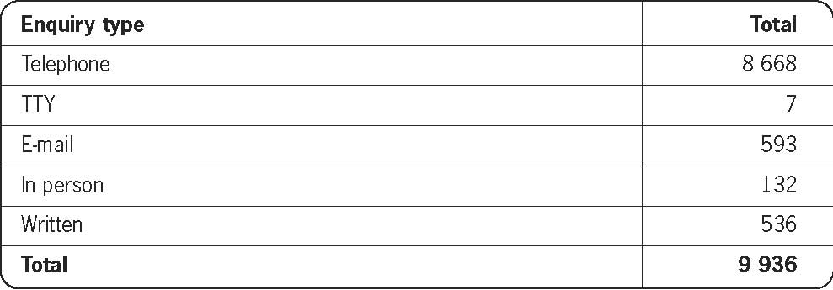

Table 3: Enquiries received by issue

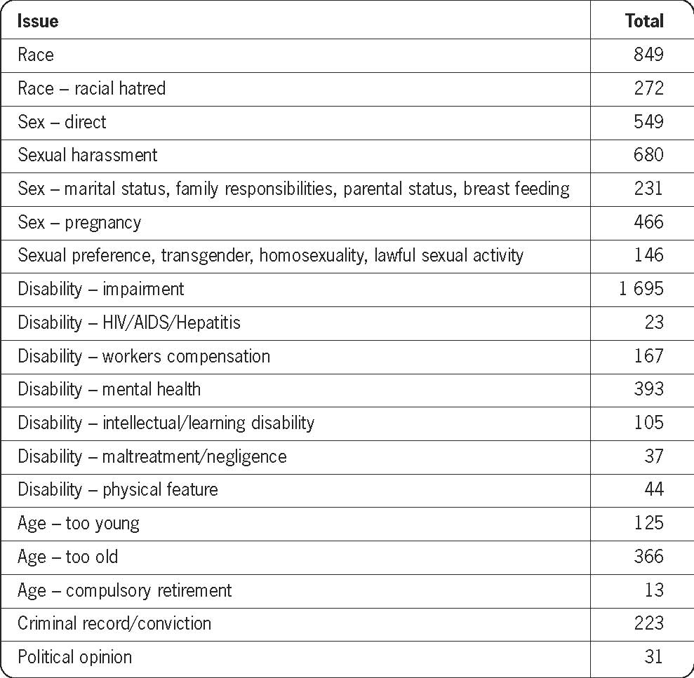

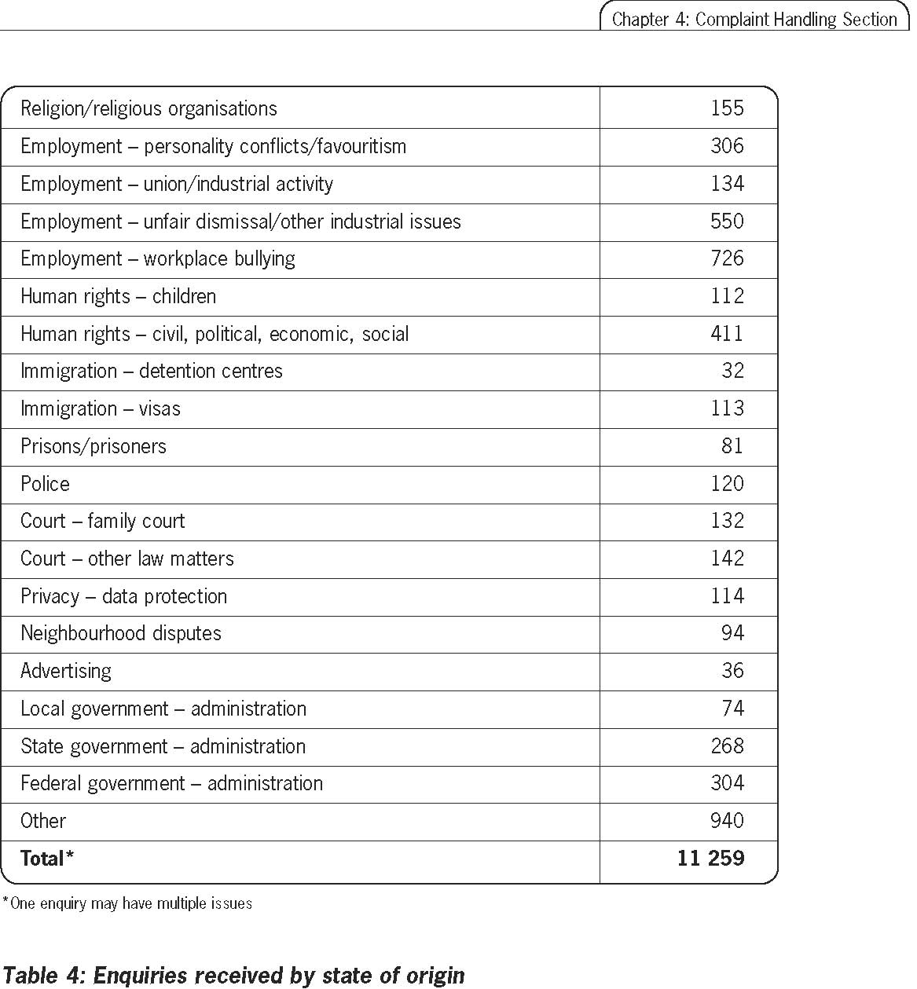
State of origin | Total | Percentage
New South Wales | 4 301 | 43
Victoria | 1 924 | 19
South Australia | 591 | 6
Western Australia | 469 | 5
Queensland | 1 662 | 17
Australian Capital Territory | 184 | 2
Tasmania | 150 | 2
Northern Territory | 137 | 1
Unknown/overseas | 518 | 5
Total | 9 936 | 100

Complaints Overview
Table 5: National complaints received and finalised over the past three years
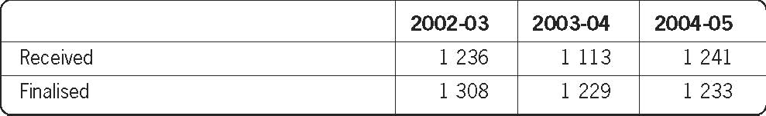
Table 6: Outcomes of national complaints finalised over the past three years
 | 2002-03 (percent) | 2003-04 (percent) | 2004-05 (percent)
Terminated/declined | 56 | 51 | 46
Conciliated | 32 | 38 | 38
Withdrawn | 11 | 10 | 16
Reported (HREOCA only) | 1 | 1 | -

Table 7: State of origin of complainant at time of lodgement
State of origin | Total | Percentage (%)
New South Wales | 522 | 42
Victoria | 202 | 16
South Australia | 160 | 13
Western Australia | 85 | 7
Queensland | 195 | 16
Australian Capital Territory | 34 | 3
Tasmania | 18 | 1
Northern Territory | 15 | 1
Unknown/overseas | 10 | 1
Total | 1 241 | 100

Table 8: Complaints received and finalised by Act
Act | Received | Finalised
Racial Discrimination Act (RDA) | 167 | 157
Sex Discrimination Act (SDA) | 348 | 375
Disability Discrimination Act (DDA) | 523 | 530
Age Discrimination Act (ADA) | 78 | 49
Human Rights and Equal Opportunity Commission Act (HREOCA) | 125 | 122
Total | 1 241 | 1 233

Chart 1
Complaints received by Act
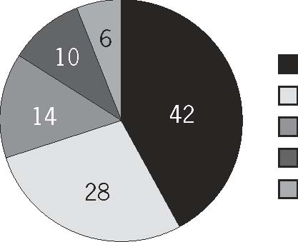
Disability Discrimination Act | 42%
Sex Discrimination Act | 28%
Racial Discrimination Act | 14%
Human Rights and Equal Opportunity Commission Act | 10%
Age Discrimination Act | 6%

Table 9: Country of birth – complainants
 | RDA (%) | SDA (%) | DDA (%) | ADA (%) | HREOCA (%) | Total (%)
Born in Australia | 41 | 74 | 64 | 75 | 60 | 61
Born outside of Australia | 52 | 13 | 15 | 17 | 30 | 24
Unknown | 7 | 13 | 21 | 8 | 10 | 15

Table 10: Indigenous status – complainants
 | RDA (%) | SDA (%) | DDA (%) | ADA (%) | HREOCA (%) | Total (%)
Aboriginal | 27 | 3 | 4 | 8 | 2 | 7
Torres Strait Islander | 1 | - | - | - | - | -
None of the above | 72 | 97 | 96 | 92 | 98 | 93

Table 11: Time from receipt to finalisation for finalised complaints
 | RDA (%) | SDA (%) | DDA (%) | ADA (%) | HREOCA (%) | Cumulative Total (%)
0 - 3 months | 21 | 23 | 17 | 29 | 33 | 21
3 – 6 months | 35 | 34 | 32 | 55 | 27 | 55
6 – 9 months | 25 | 22 | 25 | 16 | 17 | 78
9 – 12 months | 10 | 13 | 16 | - | 9 | 91
More than 12 months | 6 | 5 | 7 | - | 7 | 97
More than 18 months | 3 | 2 | 2 | - | 3 | 99
More than 24 months | - | 1 | 1 | - | 4 | 100

Racial Discrimination Act
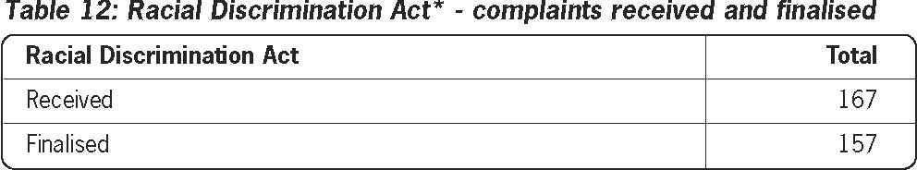
*Includes complaints lodged under the racial hatred provisions.
Table 13: Racial Discrimination Act - complaints received by ground
Racial Discrimination Act | Total | Percentage (%)
Colour | 37 | 10
National origin/extraction | 64 | 18
Ethnic origin | 113 | 31
Descent | 2 | 1
Race | 88 | 24
Victimisation | 1 | -
Racial hatred | 57 | 16
Aids, permits or instructs | - | -
Association | - | -
Total* | 362 | 100
* One complaint may have multiple grounds
Table 14: Racial Discrimination Act - complaints received by area
Racial Discrimination Act | Total | Percentage (%)
Rights to equality before the law | - | -
Access to places and facilities | 8 | 2
Land, housing, other accommodation | 3 | 1
Provision of goods and services | 88 | 24
Right to join trade unions | - | -
Employment | 155 | 43
Advertisements | - | -
Education | 6 | 2
Incitement to unlawful acts | 2 | 1
Other – section 9 | 27 | 7
Racial hatred | 73 | 20
Total* | 362 | 100

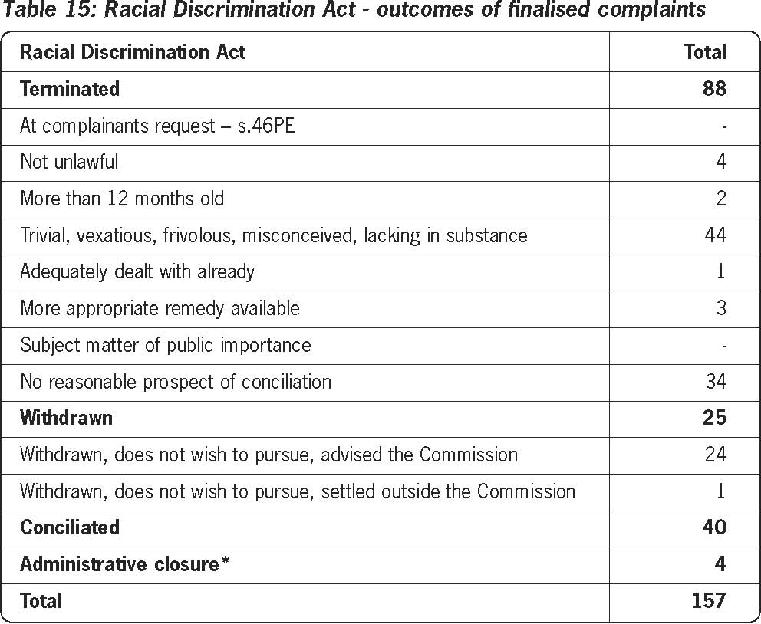
*Not an aggrieved party, state complaint previously lodged.
Chart 2
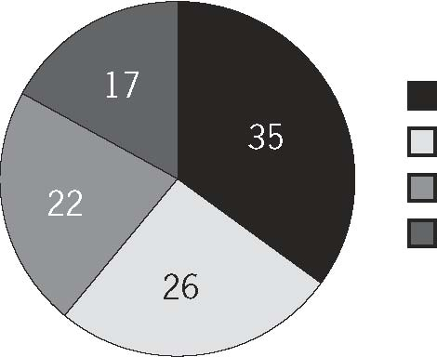
Racial Discrimination Act - outcomes of finalised complaints

Terminated – other reason | 35%
Conciliated | 26%
Terminated – no reasonable prospect of conciliation | 22%
Withdrawn | 17%
Sex Discrimination Act
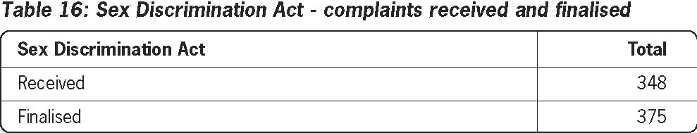

Table 17: Sex Discrimination Act - complaints received by ground
Sex Discrimination Act | Total | Percentage (%)
Sex discrimination | 218 | 36
Marital status | 22 | 4
Pregnancy | 158 | 26
Sexual harassment | 167 | 28
Parental status/ family responsibility | 20 | 3
Victimisation | 17 | 3
Aids, permits, instructs discrimination (sestion 105) | 2 | -
Total* | 604 | 100
*One complaint may have multiple grounds
Table 18: Sex Discrimination Act - complaints received by area
Sex Discrimination Act | Total | Percentage (%)
Employment | 516 | 85
Goods, services and facilities | 40 | 7
Land | - | -
Accommodation | 1 | -
Superannuation, insurance | 3 | 1
Education | 12 | 2
Clubs | 2 | -
Administration of Commonwealth laws and programs | 24 | 4
Application forms etc | 2 | -
Trade unions, accrediting bodies | 4 | 1
Total* | 604 | 100

* An area is recorded for each ground, so one complaint may have multiple and different areas.

Chart 3
Sex Discrimination Act - outcomes of finalised complaints

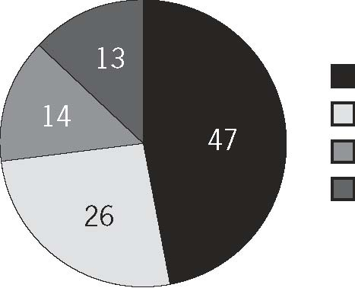

Conciliated 47%
Terminated - no reasonable prospect of conciliation 26%
Terminated - other reason 14%
Withdrawn 13%

Disability Discrimination Act
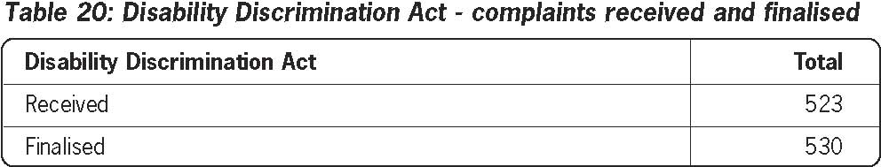
Table 21: Nature of complainant’s disability
Disability Discrimination Act | Total | Percentage (%)
Physical disability | 211 | 22
A mobility aid is used (e.g. walking frame or wheelchair) | 88 | 9
Physical disfigurement | 16 | 2
Presence in the body of organisms causing disease (HIV/AIDS) | 9 | 1
Presence in the body of organisms causing disease (other) | 12 | 1
Psychiatric disability | 175 | 18
Neurological disability (e.g. epilepsy) | 53 | 5
Intellectual disability | 29 | 3
Learning disability | 48 | 5
Sensory disability (hearing impaired) | 22 | 2
Sensory disability (deaf) | 21 | 2
Sensory disability (vision impaired) | 45 | 5
Sensory disability (blind) | 23 | 2
Work related injury | 102 | 10
Medical condition (e.g. diabetes) | 81 | 8
Other | 50 | 5
Total* | 985 | 100
* One complainant may have multiple disabilities

Table 22: Disability Discrimination Act - complaints received by ground
Disability Discrimination Act | Total | Percentage (%)
Disability of person(s) aggrieved | 924 | 92
Associate | 17 | 2
Disability – person assisted by trained animal | 26 | 3
Disability – accompanied by assistant | 2 | -
Disability – use of appliance | 1 | -
Harassment | 21 | 2
Victimisation | 3 | -
Aids, permits or instructs | 8 | 1
Total* | 1 002 | 100
* One complaint may have multiple grounds.
Table 23: Disability Discrimination Act - complaints received by area
Disability Discrimination Act | Total | Percentage (%)
Employment | 485 | 49
Goods, services and facilities | 304 | 30
Access to premises | 33 | 3
Land | - | -
Accommodation | 24 | 2.5
Incitement to unlawful acts or offences | - | -
Advertisements | - | -
Superannuation, insurance | 10 | 1
Education | 102 | 10
Clubs, incorporated associations | 24 | 2.5
Administration of Commonwealth laws and programs | 18 | 2
Sport | - | -
Application forms, requests for information | - | -
Trade unions, registered organisations | - | -
Unlawful to contravene Disability Standard | 2 | -
Total* | 1 002 | 100
* An area is recorded for each ground, so one complaint may have multiple and different areas.
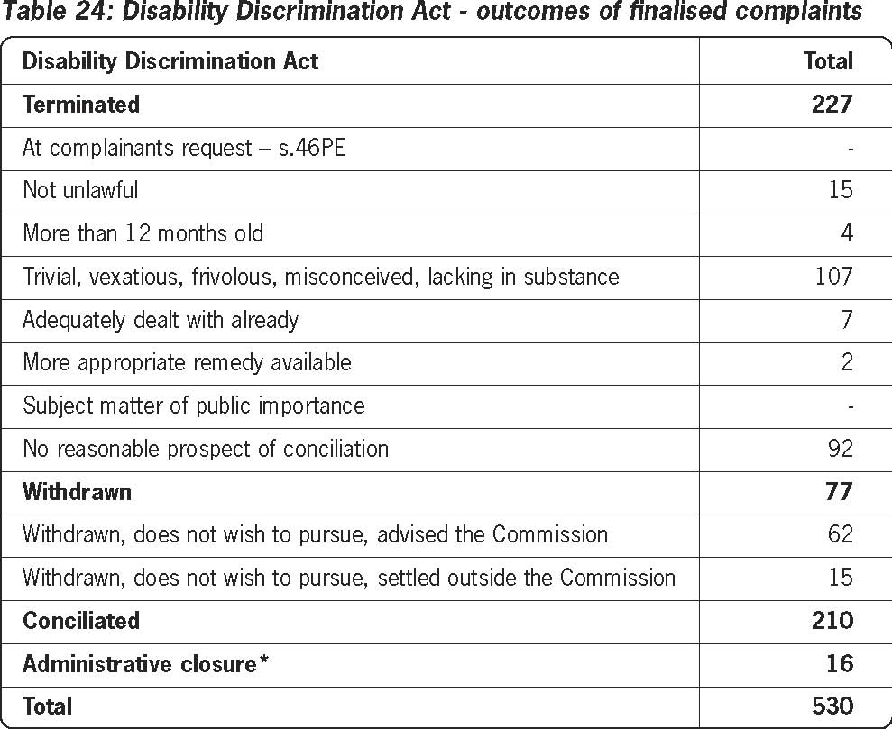
*Not an aggrieved party, state complaint previously lodged.
Chart 4
Disability Discrimination Act - outcomes of finalised complaints

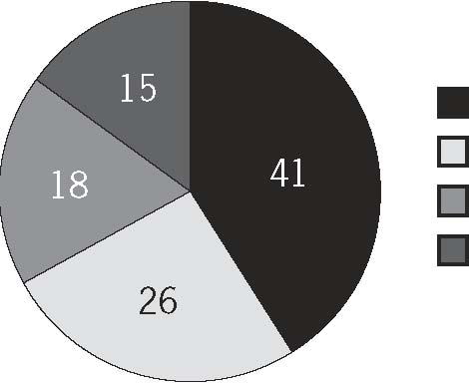
Conciliated 41%
Terminated - other reason 26%
Terminated - no reasonable prospect of conciliation 18%
Withdrawn 15%

Age Discrimination Act
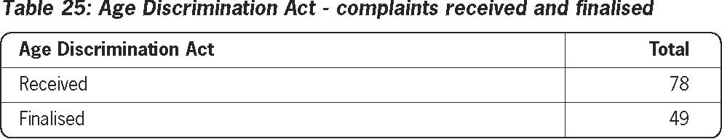

Table 26: Age Discrimination Act - complaints received by age group of complainant
Age Discrimination Act | Total | Percentage (%)
15 – 24 years | 10 | 13
25 – 34 years | 3 | 4
35 – 44 years | 4 | 5
45 – 54 years | 18 | 23
55 – 64 years | 20 | 25
> 65 years | 10 | 13
Unknown | 13 | 17
Total | 78 | 100

Table 27: Age Discrimination Act - complaints received by area
Age Discrimination Act | Total | Percentage (%)
Employment | 99 | 73
Goods, services and facilities | 24 | 18
Access to premises | 1 | 1
Land | - | -
Accommodation | 1 | 1
Incitement to unlawful acts or offences | - | -
Advertisements | - | -
Superannuation, insurance | 4 | 3
Education | 2 | 1
Clubs, incorporated associations | - | -
Administration of Commonwealth laws and programs | 4 | 3
Sport | - | -
Application forms, requests for information | - | -
Trade unions, registered organisations | - | -
Total* | 135 | 100

* One complaint may have multiple and different areas.

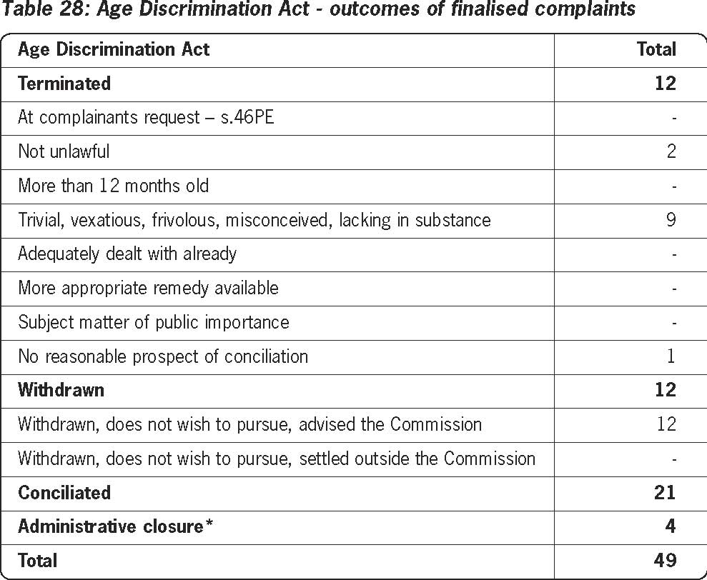
*Not an aggrieved party, state complaint previously lodged.

Chart 5
Age Discrimination Act - outcomes of finalised complaints

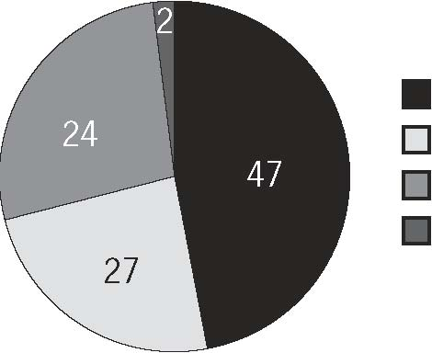
Conciliated | 47%
Withdrawn | 27%
Terminated - other reason | 24%
Terminated - no reasonable prospect of conciliation | 2%

Human Rights and Equal Opportunity Commission Act
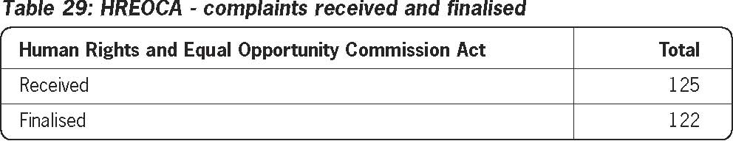
Table 30: HREOCA - complaints received by ground
Human Rights and Equal Opportunity Commission Act Race (ILO 111) | Total - | Percentage (%) -
Colour (ILO 111) | - | -
Sex (ILO 111) | - | -
Religion (ILO 111) | 16 | 12
Political opinion (ILO 111) | 2 | 1
National extraction (ILO 111) | - | -
Social origin (ILO 111) | - | -
Age (ILO 111) | 12 | 9
Medical record (ILO 111) | - | -
Criminal record (ILO 111) | 26 | 19
Impairment (including HIV/AIDS status) (ILO 111) | - | -
Marital status (ILO 111) | - | -
Disability (ILO 111) | - | -
Nationality (ILO 111) | - | -
Sexual preference (ILO 111) | 16 | 12
Trade union activity (ILO 111) | 26 | 19
International Covenant on Civil and Political Rights | 28 | 20
Declaration on the Rights of the Child | - | -
Declaration on the Rights of Mentally Retarded Persons | - | -
Declaration on the Rights of Disabled Persons | 1 | 1
Convention on the Rights of the Child | 5 | 3
Declaration on the Elimination of All Forms of Intolerance and of Discrimination Based on Religion or Belief | 1 | 1
Not a ground within jurisdiction | - | -
Not a human right as defined by the Act | 4 | 3
Total* | 137 | 100

*One complaint may have multiple grounds.

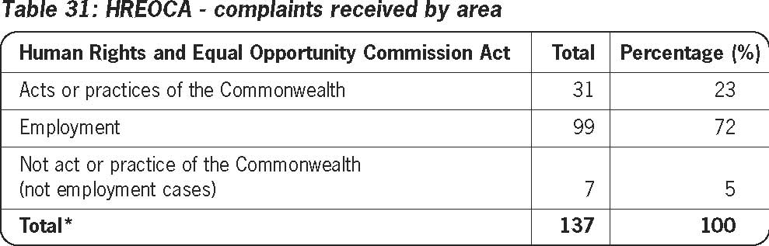
* An area is recorded for each ground, so one complaint may have multiple and different areas.

Table 32: HREOCA - non-employment complaints received by sub-area
Human Rights and Equal Opportunity Commission Act Prisons, prisoner | Total 5 | Percentage (%) 13
Religious institutions | - | -
Family court matters | 1 | 3
Other law court matters | 2 | 5
Immigration | 21 | 55
Law enforcement agency | 1 | 3
State agency | - | -
Other service provider (private sector) | - | -
Local government | - | -
Education systems | - | -
Welfare systems | - | -
Personal or neighbourhood conflict | - | -
Health system | 1 | 3
Other | 7 | 18
Total | 38 | 100

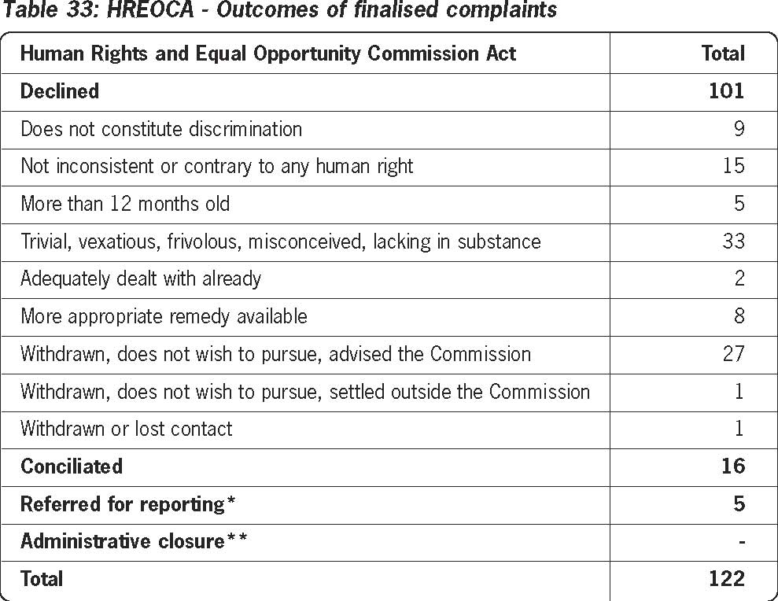
* Complaints in this category were not conciliable and therefore transferred from the Commission’s Complaint Handling Section
to Legal Services for further inquiry and possible report. **Not an aggrieved party, state complaint previously lodged.

Chart 6
Human Rights and Equal Opportunity Commission Act - outcomes of finalised complaints
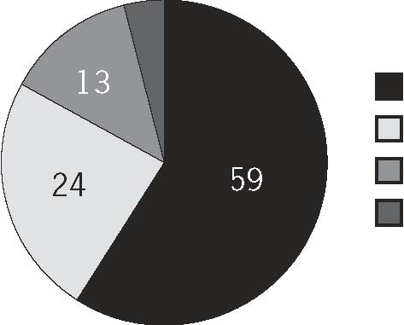
Declined | 59%
Withdrawn | 24%
Conciliated | 13%
Referred for reporting | 4%

Chapter 5: Legal services

The Legal Section supports the Commission, President and Commissioners in relation to a broad range of legal services. This includes: the preparation of notices and reports under the Human Rights and Equal Opportunity Commission Act 1986 (Cth) (HREOC Act); provision of internal legal advice on discrimination and human rights and other relevant laws; acting as counsel or instructing solicitor in external litigation, such as applications under the Administrative Decisions (Judicial Review) Act 1977 (Cth); assists the Commission to consider applications for exemptions under The Sex Discrimination Act 1984 (Cth), the Disability Discrimination Act 1992 (Cth) and the Age Discrimination Act 2004 (Cth); and processing applications under the Freedom of Information Act 1982 (Cth).

The section also represents the Commission externally, through providing information and education on human rights matters and assists in work arising from legislation or bills raising human rights issues. It also monitors and promotes awareness of developments in international and domestic human rights law, including discrimination jurisprudence in the Federal Court and Federal Magistrates Court.

Complaints relating to breaches of human rights or discrimination in employment made under the HREOC Act

Where a complaint under the HREOC Act alleging breaches of human rights or discrimination in employment is received, the Commission attempts to resolve the complaint through the process of conciliation. If the complaint is unable to be resolved and the President is satisfied after enquiry that discrimination or a breach has occurred, the matter is reported to the federal Attorney-General. This report can make recommendations to address any damage suffered by the complainant, however these are not enforceable.

For 2004-05, the following Commission reports were tabled in parliament by the Attorney-General.

HREOC Report No. 28
Report of an Inquiry into complaint by immigration detainees concerning their detention at the Curtin Immigration Reception Processing Centre

In August and September 2001, a number of detainees at the Curtin Immigration Reception and Processing Centre complained to the Commission about the circumstances of their detention. The complaint concerned the practice of the Department of Immigration and Multicultural and Indigenous Affairs (DIMIA) of keeping new arrivals in separation detention for ‘entry screening, health checking and establishment of identity’. DIMIA advised that new arrivals are kept in separate accommodation from the general detainee population until it is established who they are, their purpose and intention in coming to Australia, whether they have claims to remain and whether they pose a risk.

The complainants alleged they were held in separation detention for an unjustifiably long time (in some cases up to nine months) and were not allowed to have contact with the outside world (including members of their family or other detainees in the main compound). Complaints were also made of various other breaches of their human rights.

After considering the material provided by the parties, the President found that the practice of separation detention when it extended beyond three or four weeks was inconsistent with article 10(1) of the International Covenant on Civil and Political Rights. He made recommendations relating to communication with family and friends, access to news and the duration of separation detention.

In September 2004, the President and Commission staff met with representatives of DIMIA to conduct a ’workshop’ to discuss the President’s findings and recommendations. This somewhat innovative approach was a useful way of discussing how the findings might be addressed. DIMIA subsequently provided a written response to the findings and recommendations, in which it undertook to take certain steps to address those matters.

The President’s report was transmitted to the Attorney-General and tabled in the Parliament on 24 May 2005. A copy of the report is available at www.humanrights.gov.au/human_rights/human_rights_reports/hrc_report_28.htm

HREOC Report No. 29
Report of an Inquiry into complaints by Ms Susan Campbell that the human rights of her daughter were breached by the Commonwealth of Australia under the Convention on the Rights of the Child

Ms Campbell alleged that her daughter, Eleanore Tibble’s human rights were breached by the Commonwealth of Australia when she was a cadet in the Tasmanian Air Training Corps (AIRTC).

The allegations related to the treatment of Ms Tibble by certain officers of the AIRTC. On 5 October 2000, on the instruction of the AIRTC Wing Commander, Ms Tibble (who was 15 years old) was formally interviewed in relation to an allegation that she had inappropriately fraternised with an adult instructor in the AIRTC. Although a female adult aircraftwoman was present to record the interview, Ms Campbell was not informed of the intention to interview her daughter.

On 30 October 2000, and again on 1 November 2000, Ms Tibble was instructed to either resign, or face discharge, from the AIRTC. On 1 November 2000, Ms Tibble informed AIRTC personnel that she had not been given natural justice and would take the matter further. On 2 November 2000, Ms Tibble delivered a letter to AIRTC personnel seeking written confirmation of the two verbal communications. The AIRTC Wing Commander was instructed by his superior to advise Ms Tibble that she was not to be discharged. She was not advised of this, nor did the AIRTC respond to Ms Tibble’s letter of 2 November. Ms Tibble committed suicide on 27 November 2000.

Ms Campbell alleged that the treatment that her daughter received was inappropriate for someone of her age and directly contributed to her mental anguish and consequently to her death.

After considering the extensive material provided by the parties, the President found that the manner in which AIRTC personnel dealt with Ms Tibble was inconsistent with, or contrary to, her human rights under articles 3(1) and 19(1) of the Convention on the Rights of the Child. No positive finding was made about the extent, if any, that the actions of the AIRTC officers led to Ms Tibble’s suicide. The President made recommendations that changes recently put in place to the relevant policy manual and training program be augmented to address the situation where inappropriate behaviour by a cadet may be the result of influence or pressure from a superior to which the cadet has succumbed. The Defence Department has advised that it is revisiting the changes in view of the President’s recommendations.

The President’s report was transmitted to the Attorney-General and tabled in Parliament on 10 May 2005. A copy of the report is available at: www.humanrights.gov.au/human_rights/human_rights_reports/hrc_report_29.htm

HREOC Report No. 30
Report of an Inquiry into a complaint by Mr William Mayne of age discrimination in the Australian Defence Force

Mr Mayne made a complaint to the Commission against the Commonwealth of Australia, Australian Defence Force – Royal Australian Air Force (RAAF), alleging discrimination in employment on the basis of his age.

Mr Mayne enlisted in the RAAF in January 1966 and was promoted to the rank of Group Captain in January 1991. In early 2002, Mr Mayne learnt that he had not received a posting to the position of Command at the Joint Ammunition Logistics Unit for which he possessed the necessary qualifications and experience. He was 53 years of age at the time. Mr Mayne alleged that he was eliminated from consideration for the Command position in the course of the selection process because of his proximity to the compulsory retirement age without any separate consideration of the merits of his qualifications and experience against the qualifications and experience of other candidates. The Air Force Regulations provided that, in the absence of an extension, the compulsory retirement age for Mr Mayne was 55 years. Mr Mayne also claimed that no consideration was given to him getting an extension of service beyond 55 years.

Following a review of the submissions made by Mr Mayne and the Department of Defence, the President found that the complaint constituted discrimination in employment on the basis of age. The Commission recommended that the Chief of Air Force provide a written apology to Mr Mayne. On 4 February 2005, the Commission issued a notice of the President’s findings and recommendations in relation to this complaint. On 28 February 2005, the Chief of the Defence Force informed the Commission that the Chief of Air Force declined to provide an apology to Mr Mayne, and that the Department of Defence does not intend to take any other action as a result of the findings.

The President’s report was transmitted to the Attorney-General and tabled in Parliament on 15 June 2005. A copy of the report is available at: www.humanrights.gov.au/human_rights/human_rights_reports/hrc_report_30.html

Interventions

The Commission has a statutory function of intervening, with the leave of the Court, in proceedings that involve issues of age, race, sex, marital status, pregnancy and disability discrimination, human rights issues and equal opportunity in employment.

The Commission’s intervention functions are contained in:
✣ section 53(1)(g) of the Age Discrimination Act 2004 (Cth);
✣ section 67(1)(l) of the Disability Discrimination Act 1992 (Cth);
✣ sections 11(1)(o) and 31(j) of theHuman Rights and Equal Opportunity Commission Act 1986 (Cth);
✣ section 20(1)(e) of the Racial Discrimination Act 1975 (Cth); and
✣ section 48(1)(gb) of The Sex Discrimination Act 1984 (Cth).

The Commission will consider seeking leave to intervene in cases where the human rights or discrimination issues are significant and central to the proceedings, and where these issues are not being addressed by the parties to the proceedings. The guidelines that the Commission uses to determine if it will seek leave to intervene in a matter are publicly available on the Commission’s website at: www.humanrights.gov.au/legal/intervention_info.html

In exercising those functions, the Commission is seeking to develop Australian law (generally over the long term) so that it is more consistent with human rights standards. The intervention functions also serve an important educative purpose, which the Commission seeks to further enhance by placing all its submissions on its website.

Leave granted to intervene in 2004-05

During 2004-05, the Commission considered 13 potential intervention matters: eight of these matters came before the Commission at the request of a party to proceedings or a third party; and five were considered by the Commission’s own motion. The Commission resolved to intervene in three matters and was granted leave to intervene in two matters (the third matter discontinuing before the Commission sought leave to intervene).

Australian Competition and Consumer Commission ('ACCC') v Radio Rentals Limited and Anor (No S844 of 2003)

In November 2004, the Commission was granted leave to intervene in proceedings commenced by the Australian Competition and Consumer Commission (‘ACCC’) against Radio Rentals Limited in the Federal Court of Australia in Adelaide for alleged breaches of the Trade Practices Act 1974 (Cth).

Between 1996 and 2002, Radio Rentals entered into approximately 40 agreements with Mr Groth, including certain loan agreements. During this time, Mr Groth was the recipient of a disability pension as his sole source of income.

The ACCC allege that Radio Rentals entered into the loan agreements with Mr Groth when it knew or ought to have known from Mr Groth's presentation and verbal skills that Mr Groth: was a person with an intellectual disability; could not read the loan agreements; was unable to understand all the rights and options he had under the loan agreements; and was unable to make a worthwhile judgment about whether entering into the loan agreements was in his best interests. The ACCC further allege that Radio Rentals entered into the loan agreements with Mr Groth when it knew or ought to have known from its records that Mr Groth: was the recipient of a disability pension as his sole source of income; that the credit applications contained information that was incorrect; and that Mr Groth's monthly liability to Radio Rentals ranged between $270 and $365 (representing 30-40% of his income). In the alternative, the ACCC allege that Radio Rentals were recklessly indifferent to these matters. The ACCC allege that in entering into and enforcing the agreements, Radio Rentals engaged in unconscionable conduct within the meaning of sections 51AA and 51AB of the Trade Practices Act 1974 (Cth). The ACCC also allege that Radio Rentals used undue harassment in connection with the payment for goods and in the conduct of its settlement negotiations with Mr Groth in contravention of section 60 of that Act. Radio Rentals deny all these allegations.

The Commission’s involvement was limited to making submissions in relation to certain orders sought by the ACCC in the event that breaches of the Trade Practices Act 1974 (Cth) were established. The Commission’s principal concern was with the terms of an injunction sought by the ACCC - that Radio Rentals be required to develop guidelines setting out procedures to be followed for dealing with persons known or suspected to have an intellectual disability.

The Commission considered that the injunction sought by the ACCC may raise issues regarding discrimination on the ground of disability. Further, the Commission was concerned that any guidelines developed in accordance with the terms of the proposed injunction, if so ordered, may operate in a directly or indirectly discriminatory manner in breach of the Disability Discrimination Act 1992 (Cth).

The proceedings were heard by Justice Finn in the Federal Court in Adelaide for two weeks commencing 11 April 2005. The Commission was excused from attending the hearing. His Honour indicated that he would publish his reasons on the issue of liability, and then seek submissions from the parties and the Commission as to remedies and the appropriate form of any orders.

Justice Finn handed down judgment in this matter on 17 August 2005. His Honour ordered that the ACCC’s application be dismissed and that the ACCC pay the respondents costs of the application. As the Commission’s role was limited to making submissions in relation to certain orders sought by the ACCC, Justice Finn’s judgment (dismissing the ACCC’s application) concluded the Commission’s involvement in the proceedings.

Inquest into the Death of Mulrunji
The Commission has been granted leave to appear in the Inquest being conducted by the Queensland Deputy State Coroner into the death in custody on Palm Island in November 2004 of Mulrunji. That matter is ongoing at the time of publication.

The Commission’s role in the proceedings is to raise human rights concerns relating to the policing, arrest and detention of Indigenous people. The Commission will particularly focus on the implementation of the recommendations of the Royal Commission into Aboriginal Deaths in Custody and will encourage the making of recommendations that may assist to prevent further deaths.

Ongoing matters in which the Commission intervened in prior years

Family Provisions Test Case
On 26 September 2003, the Commission was granted leave to intervene in the Family Provisions Test Case in the Australian Industrial Relations Commission (AIRC). Those proceedings consist of a number of applications to vary federal awards to provide workers with more flexibility to balance their work and family responsibilities. The case was heard by the Full Bench in September and December 2004.

As noted in last year’s Annual Report, this case continues the Commission’s earlier work as an intervener in the AIRC, which has included the 1990 Parental Leave Test Case (establishing the standard clause for maternity, paternity and adoption leave for awards), and Gunn and Taylor (Aust) Pty Ltd v AMWU [PR918573] 4 June 2002 (regarding equal work for equal value and the adequacy of alternative remedies).

In its submissions in the Family Provisions Test Case, the Commission supported the introduction of award provisions to assist men and women to balance their paid work and family and caring responsibilities, which did not reduce existing employment conditions or result in the diminution of employment conditions for employees with family and caring responsibilities, as compared with other employees. However, the Commission did not make any submissions as to the precise form of appropriate award variations.

A copy of the Commission’s submissions is available on the AIRC’s website at: www.e-airc.gov.au/familyprovisions/stories/storyReader$12

The Full Bench handed down its decision on 8 August 2005. The Full Bench introduced a new award provision which gives an employee a right to request that his or her employer extend the period of simultaneous unpaid parental leave to eight weeks; extend the period of unpaid parental leave from 12 months to 24 months; and permit an employee to return from parental leave on a part-time basis until the child reaches school age. The Commission will report on the decision in more detail in the 2005-06 Annual Report.

Matters in which the Commission intervened in prior years and which were finalised in 2004-05

As of July 2004, there were three intervention matters which were yet to be finalised. Those matters have now been finalised in the manner discussed below.

Al Kateb v Godwin [2004] HCA 37; MIMIA v Al Khafaji [2004] HCA 38; Behrooz v DIMIA [2004] HCA 36
In November 2003, the Commission was granted leave to intervene in these three matters, which were heard together by the High Court. All three related to the limits on the powers to detain people under the Migration Act 1958 (Cth).

Two of these matters, Al Khafaji and Al Kateb, involved: non-citizens who were refused protection visas by delegates of the Minister for Immigration and Multicultural and Indigenous Affairs; unsuccessfully sought review of those decisions before the Refugee Review Tribunal; and then wrote to the Minister asking to be removed from Australia. It was found, in each case by the relevant trial judge, that their removal was not “reasonably practicable”, in the sense that there was at that time no real prospect of them being removed from Australia in the reasonably foreseeable future. The issue before the High Court was the lawfulness of ongoing detention in those circumstances.

The majority of the High Court (McHugh, Hayne, Callinan and Heydon JJ) rejected arguments that, in the circumstances, the detention of Mr Al Khafaji and Mr Al Kateb exceeded limitations derived from principles of statutory construction, Chapter III of the Constitution and international human rights law. Their Honours held that the Migration Act 1958 (Cth) permitted ongoing detention, even where there was no real prospect of non-citizen being removed from Australia in the reasonably foreseeable future. In separate judgements, Chief Justice Gleeson and Justices Gummow and Kirby dissented.

The third matter, Behrooz, was an appeal relating to a procedural matter (the setting aside of a summons requiring the production of documents). Mr Behrooz was one of a number of people who escaped from Woomera Immigration Reception and Processing Centre and was then charged with certain criminal offences under the Migration Act 1958 (Cth). The summons to produce documents was issued in those proceedings. In considering whether the summons should have been set aside, the Court was required to consider whether the conditions of immigration detention can render it unlawful.

The majority of the High Court dismissed Mr Behrooz’s appeal. They held that Mr Behrooz had no right to escape from Woomera, even if he could show the conditions of detention were harsh. Rather, he was entitled to seek legal redress for any civil wrong or criminal offence committed against him. In his dissenting judgment, Kirby J would have allowed the appeal holding that immigration detention under the Migration Act 1958 (Cth) ceases to be such when the conditions of detention are inhuman or intolerable.

A copy of the Commission’s submission and supplementary submission in these cases are available at: www.humanrights.gov.au/legal/intervention/khafaji.htm and www.humanrights.gov.au/legal/intervention/khafaji_supp.htm

A copy of the High Court’s decisions in these cases is available at: www.austlii.edu.au/au/cases/cth/HCA/2004

Re Woolley; Ex parte Applicants M276/2003 by their next friend GS [2004] HCA 49
In February 2004, the High Court granted the Commission leave to intervene in proceedings brought by four children of the Sakhi family, seeking a writ of habeas corpus and prohibition to secure their release from immigration detention, where they had been held for nearly three years. The children, originally from Afghanistan, were detained with their parents at the Baxter Immigration Detention Centre, pursuant to section 196 of the Migration Act 1958 (Cth). The applicants argued that section 196 is inconsistent with Chapter III of the Constitution as it was ‘punitive’ in character so far as it applied to children - children lacking the capacity to request removal (and thereby end their detention), and having a special status and vulnerability.

On 7 October 2004, the Court unanimously dismissed the appeal (in separate judgements). Their Honours held: that any special status that may be attributed to children did not transform non-punitive detention into punitive detention (so as to amount to an invalid exercise of judicial power by the executive contrary to Chapter III of the Constitution); nor did the fact that some children may lack the capacity to request removal. In that regard, their Honours stated that while some children in detention would lack the capacity to request removal, their parents or guardian could request removal and therefore end their detention.

Three members of the Court (McHugh, Gummow and Kirby JJ) made obiter comments to the effect that if an applicant were able to establish that they were being detained in ‘harsh, inhuman and degrading’ conditions (Gummow and Kirby JJ), for an ‘inordinately prolonged duration’ (Kirby J), or that the Minister had not complied with his (or her) implied duty in the Act to ‘carry out each step involved in processing a visa application in a reasonable time’ (McHugh J), they may be able to establish that their detention was contrary to Chapter III of the Constitution. A copy of the High Court’s decision is available at: www.austlii.edu.au/au/cases/cth/HCA/2004/49.html

Catholic Education Office v Clarke [2004] FCAFC 197
In May 2004, the Commission was granted leave by the Full Federal Court to intervene in this matter; an appeal against a decision regarding the Disability Discrimination Act 1992 (Cth) (DDA). The appeal was from a decision of Madgwick J (Clarke v Catholic Education Office (2003) 202 ALR 340) who found that Mackillop College and the Catholic Education Office had indirectly discriminated against a deaf student, Jacob Clarke, in the terms and conditions upon which it was prepared to enroll him in the College. While the offer of enrolment included a ‘model of support’ which acknowledged Jacob’s special needs, it did not include provision of an Auslan (Australian Sign Language) interpreter which, Madgwick J held, Jacob required to receive an education.

For the purposes of the definition of ‘indirect discrimination’ under section 6 of the DDA, Madgwick J had found that it was a ‘requirement or condition’ imposed by the College that Jacob ‘participate in and receive classroom instruction without the assistance of an Auslan interpreter’. This was a requirement or condition with which Jacob could not comply and which a ‘substantially higher proportion’ of people without the disability were able to comply (appropriate ‘base groups’ for this comparison were ‘students admitted to Year 7 at the College in 2000’ or alternatively ‘all students enrolled in the College in 2000’). His Honour found the requirement or condition wasn’t reasonable in all the circumstances of the case.

The Full Court upheld Madgwick J’s finding that the terms or conditions upon which the College was prepared to admit Jacob constituted a ‘requirement or condition’ for the purposes of section 6 of the DDA.

The Court also upheld the approach of Madgwick J to the ‘base group’ in assessing whether or not a ‘substantially higher proportion’ of people without the disability could comply with the requirement or condition.

The Court upheld the findings of Madgwick J in relation to unreasonableness and further rejected an argument by the appellant in relation to the ‘special measures’ provision in section 45 of the DDA.
The Full Court held that the ‘act’ rendered unlawful by the DDA was not the offer of a ‘model of support’ which provided benefits to Jacob, but the appellants’ offer of a place subject to a term or condition that Jacob participate in an receive classroom instruction without an interpreter. This could not be said to be ‘reasonably intended’ to meet Jacob’s special needs for the purposes of section 45.

In any event, the Full Court held that the test of whether or not something is ‘reasonably intended’ to achieve the objectives set out in section 45 is an objective one. Madgwick J had found that ‘any adult should have known that the withdrawal of Auslan support would cause Jacob distress, confusion and frustration and that in the absence of an Auslan interpreter, Jacob would not have received an effective education’.

The Full Court also upheld the damages awarded by Madgwick J ($20 000 for general damages, plus $6 000 interest), described by Sackville and Stone JJ as “relatively modest”. The Full Court’s decision is available at: www.austlii.edu.au/au/cases/cth/FCAFC/2004/197.html

Amicus curiae

Section 46PV of Human Rights and Equal Opportunity Commission Act 1986 (Cth) provides that the Aboriginal and Torres Strait Islander Social Justice Commissioner, the Disability Discrimination Commissioner, the Human Rights Commissioner, the Race Discrimination Commissioner and the Sex Discrimination Commissioner, may with permission of the Federal Court or Federal Magistrates Court, seek to appear as amicus curiae (or friend of the Court) in the hearings of complaints that have been terminated by the President.

Guidelines for the exercise of this function are publicly available on the Commission’s website at: www.humanrights.gov.au/legal/amicus_info.html

As with the Commission’s intervention functions, the Commissioners attempt to enhance the educative role of their amicus functions by placing all submissions on the website.

Leave granted to appear as amicus in 2004-05

During 2004-05, Commissioners were granted leave to appear as amicus curiae in one matter, which is summarised below.

Che Forest v Tranter Pty Ltd t/as Kuranda Hotel & Barry Smith
The applicant has a psychiatric disorder and claims that his dog is an ‘assistance animal’ for the purposes of section 9(1)(f) of the DDA on the basis that the dog alleviates the effects of his disability by providing him with physical comfort and reducing his social anxiety.

The applicant commenced proceedings in the Federal Magistrates Court (Townsville Registry) claiming that he was discriminated against by the respondent hotel in breach of section 9(1) of the DDA because he was not permitted to enter the hotel with his dog. The respondent contends that it only declined to allow the applicant into the hotel with his dog because the applicant could not produce any documentary evidence that his dog was an ‘assistance animal’.

On 30 November 2004, Coker FM granted the Acting Disability Discrimination Commissioner leave to appear as amicus curiae in this matter.

The issue of whether an animal is an assistance animal for the purposes of section 9(1)(f) of the DDA was considered in Sheehan v Tin Can Bay Country Club [2002] FMCA 95, a decision of the Federal Magistrates Court. In that case, Driver FM construed section 9(1)(f) widely.

The Commissioner has questioned whether the breadth with which Driver FM construed section 9(1)(f) creates an “unsustainable position for service providers and other members of the public, while not giving surety of access rights to users of appropriate assistance animals”. This case provides the Commissioner with an opportunity to make submissions in relation to the interpretation and construction of section 9(1)(f) of the DDA.

The matter was ongoing at the time of publication.

Matters in which the Commissioners were granted leave in prior years which were finalised in 2004-05

As at July 2004, there were three amicus matters which were yet to be finalised. Those matters have now been finalised in the manner discussed below.

Howe v Qantas Airways Limited [2004] FMCA 242
Ms Howe commenced proceedings in the Federal Magistrates Court of Australia in Sydney, alleging that she had been unlawfully discriminated against on the basis of her sex, pregnancy and family responsibilities in the course of her employment with Qantas Airways Limited. Ms Howe was employed by Qantas in the position of Customer Service Manager (CSM) Long Haul.

The discrimination was said to have arisen by reason of: the refusal to pay Ms Howe her base salary as a CSM during the periods in which she was required to cease flying duties by reason of her pregnancy; the refusal to allow Ms Howe to access her sick leave entitlements during the periods in which she was required to cease flying duties by reason of her pregnancy; and the requirement to work full-time and without flexibility in order to maintain her position as CSM upon her return from maternity leave.

Qantas denied the allegations of discrimination and submitted, inter alia, that any act done was in compliance with the relevant award or enterprise agreement and section 40(1)(f) of the SDA operated as a complete defence.

The Sex Discrimination Commissioner limited her role as amicus curiae to issues that arose concerning: the proper construction of section 40 of the SDA, particularly in the context of awards and certified agreements; and the indirect sex discrimination claim brought by Ms Howe in respect of the requirement to work full-time and without flexibility in order to maintain her position as CSM upon her return from maternity leave (sections 5(2) and 7B of the SDA).

The Commissioner filed detailed written submissions in relation to these issues and Counsel appeared on behalf of the Commissioner at the hearing, making brief oral submissions.

Judgment was handed down on 15 October 2004. Driver FM found that Qantas unlawfully discriminated against Ms Howe by refusing her access to her accumulated sick leave contrary to sections 7(1) and 14(2)(b) of the SDA. Qantas was ordered to pay Ms Howe special damages to be calculated in accordance with the applicant's salary and general damages in the sum of $3 000. Driver FM found against the applicant on her claims for direct family responsibilities discrimination and indirect sex discrimination.

Driver FM adopted the submissions of the Commissioner in relation to the construction and interpretation of sections 40, 5(2) and 7B of the SDA) in their entirety.

Ms Howe filed an appeal from the judgment of Driver FM. Ms Howe subsequently discontinued the appeal. See the Commission’s submission at: www.humanrights.gov.au/legal/amicus/howe_submissions_fifth.html

A copy of the Federal Magistrates Court decision is available at:www.austlii.edu.au/au/cases/cth/FMCA/2004/242.html

Jacomb v The Australian Municipal Administrative Clerical and Services Union
[2004] FCA 1250
This is an important matter, as it is the first time the special measures provision in section 7D of the SDA has directly arisen for consideration by a Court. Section 7D provides that a person does not discriminate against another person by taking ‘special measures’ for the purpose of achieving substantive equality between certain classes of people including men and women.

Mr Jacomb alleged that he had been unlawfully discriminated against on the basis of his sex by the Australian Municipal Administrative Clerical and Services Union. The discrimination was said to have arisen by reason of the recently certified Union rules which provided that particular elected positions in the Branch Executive were available only to women. Mr Jacomb claimed that there was no substantive inequality in the Union that needed to be addressed by way of affirmative action policies, and the relevant provisions in the rules meant that a disproportionate number of women (compared to numbers of women members of the Union) were on the Branch Executive. The Union defended the proceedings on the basis that those parts of the rules referred to by Mr Jacomb were ‘special measures’ within the meaning of section 7D of the SDA and as such, were not discriminatory.

The matter was listed for hearing before Crennan J in the Federal Court of Australia in Victoria on 8 April 2004. The Sex Discrimination Commissioner was granted leave to appear as amicus curiae in the proceedings. The Commissioner filed detailed written submissions in relation to the interpretation of section 7D and the test that should be applied in determining whether a measure was a ‘special measure’ within the meaning of that section. Counsel appeared on behalf of the Commissioner at the hearing, making brief oral submissions. The Commissioner’s submissions are available at: www.humanrights.gov.au/legal/amicus/jacomb.html

Judgment was handed down on 24 September 2004. The application was dismissed. Crennan J found that the rules of the Union in respect of which the proceedings were brought were special measures within the meaning of section 7D of the SDA. Crennan J adopted the test set out in the submissions of the Commissioner in relation to the construction and application of section 7D.

Crennan J was satisfied on the evidence that the subjective purpose of the quotas imposed by the Union’s rules was to achieve substantive equality between male and female members of the Union. Crennan J was also satisfied on the evidence that the rules were a reasonable special measure when tested objectively. In reaching this conclusion, Crennan J appeared to accept the submission of the Commissioner that section 7D requires the court to assess whether it was reasonable for the person taking the measure to conclude that the measure would further the purpose of achieving substantive equality. Having regard to the inflexibility of the quotas imposed by the rules, Crennan J stated that monitoring of this special measure was important. In this regard, Crennan J noted that there was evidence of Union rules which enabled the discontinuance of the two rules in question, if they were no longer needed.

A copy of the Federal Court decision is available at:www.austlii.edu.au/au/cases/cth/federal_ct/2004/1250.html

Access for All Alliance (Hervey Bay) Inc v Hervey Bay City Council [2004] FMCA 915
The applicant organisation in this matter alleged indirect disability discrimination in the provision of services and access to premises by the respondent Council, contrary to section 23 of the Disability Discrimination Act 1992 (Cth).

In particular, the complaint related to: an outside entertainment area at a local community centre which was said to be inaccessible to people with mobility disabilities; round concrete picnic tables in a foreshore park which were alleged to fail to allow access for people with mobility disabilities; and toilets in a number of locations which provided hand basins placed on the outside of the facility and therefore could not be used with dignity by persons with disabilities who have particular toileting regimes or needs.

The Acting Disability Discrimination Commissioner was granted leave to appear in the matter and make submissions as amicus curiae on issues surrounding the correct interpretation and application of the DDA. A copy of the Commission’s submissions is available at: www.humanrights.gov.au/legal/amicus/hervey.html

Baumann FM dismissed the first two aspects of the claim. His Honour concluded, upon a balancing of the evidence, that the ‘requirements or conditions’ imposed in relation to community centre and the picnic tables were not unreasonable and accordingly did not constitute indirect discrimination as defined by section 6 of the DDA.

Baumann FM upheld the application in relation to the toilet hand basins. His Honour found the requirement or condition was unreasonable and persons were unable to comply with it.

Notably, Baumann FM found that justifications for the placement of the basins outside the toilets (relating to attempts to reduce vandalism and soliciting) were “offset by the community expectation that persons with a disability should be entitled to complete a toileting regime in private”.

On the defence of unjustifiable hardship raised by the respondent, Baumann FM found that the benefits of the alteration/rectification required to prevent the discrimination were “real and important”. His Honour noted that the benefits extended not only to local residents, but also visitors to the area. His Honour also took into account the embarrassment and lack of dignity potentially caused by having to use the facilities in their current state following an “accident”.

Baumann FM accepted that the Council has “many priorities”, but that it could make necessary adjustments to its budget to meet the estimated cost ($75 250 the highest quote in evidence). The Court ordered the respondent, within nine months, to construct and install internal hand basins in the various toilets the subject of the complaint. A copy of the Federal Magistrates Court decision is available at www.austlii.edu.au/au/cases/cth/FMCA/2004/915.html

Education and Promotion

As noted above, the Commission considers the intervention and amicus functions contribute to the Commission’s human rights education work by demonstrating how human rights principles may be applied to resolve factual and legal issues before domestic courts.

The Legal Section is also involved in other aspects of the Commission’s human rights education and promotion work, particularly those projects involving a focus upon domestic and international law. Two of the Legal Section’s more significant human rights education projects for 2004-05 are described below.

Federal Discrimination Law 2005
On 12 May 2005, the Commission launched its publication ‘Federal Discrimination Law 2005’. The publication was produced by the Legal Section and provides a comprehensive overview of the case law that has been decided in the field of federal unlawful discrimination law. In addition to detailed analysis of discrimination law jurisprudence, the publication also covers issues of practical concern for litigants and practitioners, with chapters on procedural issues, damages and remedies, and costs.

The publication significantly revised, expanded and updated the contents of the 2004 edition. It is an invaluable resource for anyone with an interest in this very challenging area of the law. The publication is accessible online via the Commission’s website and can be downloaded for free. Printed copies of the publication are also available for sale. For details, see www.humanrights.gov.au/legal/fed_discrimination_law_05/index.html.

Legal Bulletin and associated seminars

The Legal Section continues to publish a quarterly Legal Bulletin, providing an update on domestic and international human rights law. The Legal Bulletin is published on the Commission’s website and links sent on the legal section’s email list (see www.humanrights.gov.au/legal/mailing.html to subscribe).

In connection with each new edition of the Legal Bulletin, the Legal Section has organised a seminar on a topic of current interest in domestic or international human rights law. The seminars and speakers for 2004-05 were as follows:
✣ Mr Jeremy Kirk of the New South Wales Bar, discussing the High Court's decisions in
Al Kateb, Al Khafaji and Behrooz.
✣ A Senior Legal Officer of the Commission, speaking on the decisions of Howe v Qantas and Jacomb v Australian Municipal Administrative Clerical and Services Union.
✣ A panel comprised of Mr Dennis Richardson AO (Director-General of ASIO) Ms Devika Hovell (Director, International Law Project, Gilbert & Tobin Centre of Public Law) and Mr Simeon Beckett (New South Wales Bar), speaking on the topic ‘Are human rights principles relevant to the war on terror?’

Review of administrative decisions made by the Commission

The Commission is at times a party to proceedings in courts or tribunals involving judicial review or merits review of the Commission’s administrative decisions. Commission staff are also sometimes party to such proceedings.

Judicial review
Judicial review of Commission decisions generally involves an application to the Federal Court or the Federal Magistrates Court pursuant to the Administrative Decisions (Judicial Review) Act 1977 (Cth).

In accordance with established legal principle, the Commission (as decision maker) usually submits to the jurisdiction of the Court in these matters, leaving the substantive parties (usually the complainant and respondent to the complaint that was before the Commission) to present the matter to the Court. In a very small number of matters, the Commission even limits its role to assisting the Court rather than adopting a contentious or adversarial approach.

The Commission was a party to four applications under the Administrative Decisions (Judicial Review) Act 1977 (Cth) in 2004-05.

Merits review
Some decisions of the Commission or Commission staff (acting under instruments of delegation) are subject to merits review by the Administrative Appeals Tribunal. These include decisions made under the Freedom of Information Act 1982 (Cth), and decisions on applications for temporary exemptions under section 44 of the SDA and section 55 of DDA.

During the reporting period, there was only one active merits review matter - a review of the decision of the Commission under the Freedom of Information Act 1982 (Cth). Those proceedings are currently adjourned while the applicant conducts an appeal to the Federal Court in relation to a procedural decision of the Administrative Appeals Tribunal.

International technical assistance work
In April 2005, legal staff presented human rights training titled ‘Human Rights Standards for Legislative Drafting and Analysis and the Provision of Policy Advice’ in Suva, Fiji. The training was developed by the Legal Section, in consultation with the Fiji Human Rights Commission and funded by AusAID.

The training was directed at providing participants with: a detailed understanding of the human rights monitoring and reporting mechanisms of the United Nations, including the roles played in those processes by states, national human rights institutions and non-governmental organisations; and the knowledge and skills to develop and analyse policy and existing and proposed legislation within a human rights paradigm, with regard to Fiji’s international human rights obligations and the Fijian Bill of Rights.

The broad content of the training attracted participants from a wide variety of organisations within Fiji including: government civil servants, representatives from peak Fiji non-governmental organisations, and officers from the Fiji Human Rights Commission. The training was very well received by all participants, many of whom expressed the hope that it would assist them to create a lasting and constructive human rights dialogue in Fiji.

Chapter 6: Aboriginal and Torres Strait Islander Social Justice

Statement from the Commissioner
Mr Tom Calma - Aboriginal and Torres Strait Islander Social Justice Commissioner

I commenced my five-year term as the Aboriginal and Torres Strait Islander Social Justice Commissioner on 12 July 2004.

I am a Kungarakan and Iwaidja man and a traditional owner of lands in the Top End of the Northern Territory. For over three decades I have worked in numerous Indigenous specific, Australian Government and academic roles in the Northern Territory, Canberra, India and Vietnam. Most recently, I worked in Aboriginal and Torres Strait Islander Services on community development, capacity building and Indigenous education policy and programs.

I have taken up the position of Social Justice Commissioner at a time of great uncertainty for Indigenous peoples. As my first Social Justice Report documents, there are significant changes underway in the federal Government’s approach to Indigenous affairs. These range from the abolition of the Aboriginal and Torres Strait Islander Commission (ATSIC), through to the movement to new arrangements for the administration of Indigenous programs and services and the development of Indigenous policy.

The changes will leave the Human Rights and Equal Opportunity Commission, and specifically my position, as one of the very few mechanisms remaining that are able to independently monitor the activities of governments from a national perspective.

In light of current events, the need for a Social Justice Commissioner has never been stronger. The new arrangements have the potential to impact significantly on the enjoyment of human rights by Indigenous peoples, by either leading to improved performance and outcomes by government, or by undermining the enjoyment of human rights by Indigenous peoples.

My activities as Commissioner will be a mix of reactive and proactive measures. Where significant human rights issues are raised by an event in the community or action or decision by government, I will respond to it. This will be the case in situations that may involve significant or systemic breaches of Indigenous peoples' human rights. I will respond through engagement with the relevant government department, the media, the making of submissions to parliament or governments, appearing in court cases, or providing appropriate support (such as education and training) to Indigenous communities or groups.

I will also seek to proactively engage in emerging debates and issues to promote best practice and celebrate success, as well as set out a forward-looking agenda to address potential breaches of Indigenous peoples' human rights before they happen.

My annual Social Justice Report and Native Title Report will be vital tools in achieving this aim. Given the very different audiences that I will need to engage with, I also intend to produce the Social Justice Report and Native Title Report in several formats. This is to ensure that the issues raised are in an acceptable language and style, and are accessible to Indigenous people and communities.
I will also focus debate on key human rights issues, as appropriate and within my resources, through the release of discussion or issues papers, the convening of regional forums and national roundtables, and through building partnerships with community and government agencies.

There are two further ways in which I intend to fulfil my role as Social Justice Commissioner.

First, I have already indicated to government that I intend to engage with them fully and maintain an ongoing dialogue about issues of mutual interest and concern. I will raise concerns with government when they come to my attention and seek to resolve them. The findings of a Social Justice Report, for example, will not be a surprise to the government as significant concerns will have already been raised with them. The report will provide acknowledgement where concerns have been raised with the government and subsequently addressed and will identify good practice.

Second, I will also seek to consult widely with Indigenous peoples and communities. Indigenous peoples are the experts on the needs and priorities in Indigenous communities. I consider that it is only through processes of community engagement and education that the findings of a specialist, national human rights office such as HREOC can have true meaning at the grass roots level. Not only are Indigenous people the intended beneficiaries of the findings and proposals for reform identified in processes such as my reports to Parliament, but they are also the best advocates for seeking these changes to be put into place.

Some of the issues that I propose to address over my term as Commissioner include:
✣ Indigenous health. My unit has already undertaken extensive research into issues relating to Indigenous health status. I will be looking to engage with governments, communities and organisations about how to address this situation. The thrust of this work will be a campaign for health equality within our lifetime: for governments to commit to meet the outstanding primary health care and health infrastructure needs of Indigenous communities within a reasonable time period (5-10 years) and with the goal of achieving equality of health status and life expectation within the next generation.

✣ Indigenous mental health. There is very little infrastructure or expertise in addressing mental health issues facing Indigenous peoples. It is a forgotten issue. I will consider the adequacy of current approaches in addressing these issues.

✣ International processes for the recognition of the rights of Indigenous peoples. 2004 signified an uncertain time in the recognition of Indigenous rights in the international system. The First International Decade for the World's Indigenous People ended in December and the Working Group on the Draft Declaration on the Rights of Indigenous Peoples concluded its 10th session without consensus on a Draft Declaration on the Rights of Indigenous Peoples (DDRIP). It was encouraging that in December 2004 the United Nations General Assembly proclaimed the Second International Decade of the World's Indigenous People, commencing 1 January 2005. The Commission on Human Rights also authorised further negotiations on the text of the DDRIP, subject to review of progress annually. In relation to these developments, I am committed to engage with government and Indigenous peoples about the process and to consider domestic programs of action for the second international decade.

✣ How native title can be utilised to improve the economic and social conditions of Indigenous peoples' lives. Prior to my taking office, the work of the Native Title Unit focused on the legal issues around native title. The shift towards focusing on the improvement of economic and social conditions is one that I endorse: recognising that the real injustice of denying Indigenous people their traditional land for so long lies in the economic and social degradation that this causes. It is my hope that the government will see native title as just such a tool, available to contribute to what is undeniably the most pressing problem facing Indigenous people - poverty. In changing the focus of native title in this way, a shift must occur in how Australian society sees the relationship between Indigenous and non-Indigenous values and world views. Obviously, within the field of native title, the laws and customs through which entitlement to land is transmitted represents a point of divergence between Indigenous and non-Indigenous systems and practices. While this is important, it should not, and in reality does not, divide our worlds in two. For Indigenous people, respecting traditional law does not render us unable to participate in the modern Australian economy. In order to increase the opportunities for traditional owners and their communities to generate wealth and break the poverty cycle, differences of this kind should not become a basis for exclusion of Indigenous people from the broader economy.

Monitoring and Reporting
Social Justice Report 2004

Under section 46C(1)(a) of the Human Rights and Equal Opportunity Commission Act 1986 (Cth), the Commissioner is required to annually submit a report to the Attorney-General on the exercise and enjoyment of human rights by Aboriginal persons and Torres Strait Islanders (the Social Justice Report).

The Social Justice Report 2004 was transmitted to the Attorney-General on 7 February 2005, and tabled out of session of Parliament on 8 April 2005.

The Commissioner used the introductory chapter of the Social Justice Report to introduce himself and indicate to Indigenous peoples and communities, governments and federal Parliament, how he intends to fulfil the duties of the role of Commissioner, as set out in the Commissioner’s statement above.

The report examines programs that address the needs of Indigenous women upon exiting prison. This builds on work reported on in the Social Justice Report 2002 which identified the rapidly growing numbers (and over-representation) of Indigenous women in prison, and lack of services tailored to their needs during and after prison as a growing concern. Over 2003 and 2004, in addition to further research, information was requested from all governments about services and programs for pre and post-release of Indigenous women. Forums were also held with Indigenous women and service providers across Australia.

The chapter provides an overview of what is available and highlights where things could be better. The main findings are the importance of housing and emergency accommodation options for Indigenous women when released from prison; the importance of being able to access a broad range of programs upon release, including healing; and the lack of coordination of existing government and community services, which has the result of limiting the accessibility of services to Indigenous women.

The main focus of the report was the new arrangements for the administration of Indigenous affairs at the federal level, which began to be implemented from 1 July 2004. That is:
✣ the abolition of the Aboriginal and Torres Strait Islander Commission and its service delivery arm (Aboriginal and Torres Strait Islander Services);
✣ the transfer of responsibility for the delivery of all Indigenous specific programs to mainstream government departments.
✣ the coordination of government department activity through the adoption of whole of government approaches, with a greater emphasis on regional service delivery.
✣ a process of negotiating Shared Responsibility Agreements (SRAs) with Indigenous families and communities at the local level, and setting priorities at the regional level. Central to this negotiation process is the concept of mutual obligation or reciprocity for service delivery.

The chapter sets out the intended approach to the new arrangements, including the principle of mutual obligation that underpins them. Given that these arrangements were still being announced and implemented at the time, only preliminary concerns are expressed. Only where there is a clear need for guidance for the process did the Commissioner make recommendations. He also identified how he would follow up and monitor the new arrangements over the next 12 months.

The chapter is supported by an Appendix that provides a timeline of events leading up to the announcement of the new arrangements as well as events in introducing them. Appendix two of the report provides information relating to one of the most important emerging issues for Indigenous peoples - the protections provided by race discrimination laws in negotiating Shared Responsibility Agreements with the government. It sets out the relevant factors to identify where a particular situation may amount to discriminatory treatment by the Racial Discrimination Act 1975.

The report, an executive summary and media pack can be accessed from the Commission’s website at www.humanrights.gov.au/social_justice/sjreport04/index.html.

Native Title Report 2004
Under section 209 of the Native Title Act 1993 (Cth), the Commissioner is required to annually submit a report to the Attorney-General on the operation of the Native Title Act and the effect of the Act on the exercise and enjoyment of human rights of Aboriginal peoples and Torres Strait Islanders.

The Native Title Report 2004 is the first by Commissioner Calma, and was transmitted to the Attorney-General on 17 February 2005 and tabled in federal Parliament on 8 April 2005.

The first chapter of the report builds on principles developed in the Native Title Report 2003 which focus on native title as a framework for economic and social development for traditional owner groups. The principles are designed to redirect the native title system towards the economic and social development goals of traditional owners, through the negotiation of agreements that:

✣ respond to the traditional owner group's goals for economic and social development;
✣ provide for the group's capacity to set, implement and achieve the group's development goals;
✣ utilise the existing assets and capacity of the group;
✣ build relationships between stakeholders; and
✣ integrate the activities of native title institutions to achieve the development goals of the group.

To further develop the principles, from August to October 2004, the Commissioner and his staff met with Native Title Representative Bodies (NTRBs) throughout the country, as well as a number of peak bodies, government representatives and academic researchers. The principles and results of the consultations are given consideration in the first chapter of the Native Title Report 2004. It identifies the need for additional research and further consultation with NTRBs, government and industry. There was a clear message from NTRBs that economic and social development is a goal of traditional owner groups and that the principles were a useful guide to how this should be achieved through native title. However, the report highlighted a number of issues affecting how the principles might operate in practice. These included:

✣ The importance of identifying the appropriate traditional owner group for negotiating an agreement. Both traditional owners and governments or companies want to ensure that the ‘right people’ are negotiating an agreement. However, the process of identifying the traditional group can be difficult and time consuming - the native title system itself can impose inappropriate and restrictive definitions. As a result, other mechanisms for identifying the traditional owner group need to be considered.

✣ Good governance and capacity building. Within traditional owner groups good governance can emerge from: unified and visionary leadership; strong links between traditional law and governance structures; internal dispute resolution and effective group decision making mechanisms; and options for governance structures beyond the Prescribed Bodies Corporate (PBCs) required by the Native Title Act. Capacity building involves developing the natural, financial, political, social and human resources of traditional owner groups to achieve their own goals. Governments and companies also require capacity building so they are better able to: negotiate agreements directed to broader outcomes; coordinate a whole of government approach; and help build the capacity of traditional owner groups.

✣ That sufficient resources are needed to enable capacity building within traditional owner groups and those parts of the native title system on which these groups depend (particularly NTRBs and PBCs). Funding to non-Indigenous third party respondents in native title claims needs to be reassessed so that economic and social development initiatives, beyond the claims process, are supported.

During consultations, many respondents recognised that a wide range of options for economic development need to be made available to traditional owners to reflect the diversity of their circumstances and goals. These include: supporting the commercial exercise of native title rights; natural resource management services; commercial customary harvesting; joint ventures with developers; directing a proportion of catch or mining profits to traditional owners; regional economic and social development strategies; and developing eco and cultural tourism.

To support social and economic development, governments must retain and satisfy their responsibilities to provide basic citizenship rights such as health, housing, education, roads and infrastructure. Consideration also needs to be given to how economic development through native title can also work in a beneficial way for the broader Indigenous community.

Chapter 2 of the report applies the ideas and concerns raised in the consultations to each of the five principles, proposes strategies for addressing the issues identified by stakeholders and contains ideas on how each principle might be put into practice.

The consultations revealed that for native title to be oriented to achieve social and economic development outcomes, the principles should apply not just to agreements, but also to other aspects of the native title system.

Flowing from this analysis, Chapter 3 of the report identifies the need for a policy approach to native title aimed at economic and social development. This chapter closely examines the policy framework underpinning the Australian Government’s new arrangements for the administration of Indigenous affairs and the COAG trials, and identifies links between the principles and the new policy context.

This chapter suggests that engagement between native title policy and agreements and the new arrangements, and Shared Responsibility Agreements/ Regional Participation Agreements would improve the sustainability of both.

The full report, an executive summary and a media pack can be accessed from the Commission’s website at www.humanrights.gov.au/social_justice/nt_reports.html#2004.

Community Guide and CD-ROM
In April 2005, an eight-page Community Guide summarising both the Social Justice Report and the Native Title Report was distributed in national Indigenous newspapers to make the reports more accessible to communities. 12,000 copies were included as supplements to the National Indigenous Times, and 14,000 copies with the Koori Mail.

A CD-ROM containing both reports, the community guide and a media pack was also released. The reports were launched with public events in Sydney, Canberra, Melbourne (hosted by Reconciliation Australia) and Darwin.

Promoting awareness and discussion of human rights issues

The Commissioner is required under section 46C(1)(b) of the Human Rights and Equal Opportunity Commission Act to promote discussion and awareness of human rights in relation to Aboriginal persons and Torres Strait Islanders.

Advice regarding alcohol restrictions in Aboriginal communities
In August 2004, Commission staff addressed a Queensland Government forum regarding the compliance of the Queensland legislated alcohol restrictions in Aboriginal communities with the Racial Discrimination Act1975 (Cth). On 28 October 2004, Commissioner Calma addressed the 34th Australasian Liquor Licensing Authorities Conference in Hobart on the same issues. Find the speech at:www.humanrights.gov.au/speeches/race/LiquorLicensingAuthoritiesConference.html

Indigenous juveniles with cognitive disabilities in the criminal justice system
In 2005, the federal Attorney-General’s Department provided funding to conduct a research project on the needs of Indigenous young people with cognitive disabilities in the criminal justice system. The project involved conducting research, inviting contributions from each government on their relevant programs and services, and the convening of a national roundtable.

The national roundtable was held in Sydney on 15 June 2005. Participating in the roundtable were representatives from a range of agencies including: Telethon Institute for Child Health Research (WA); Menzies School of Health Research (NT); Department of Communities (QLD); Tasmanian Aboriginal Centre, Department of Justice (Vic); Regional Aboriginal Justice Advisory Committee (Vic); and the Department of Families and Communities (SA).

The outcomes of the roundtable and research have been compiled into a report to the Attorney-General’s Department. The report emphasises further research needs and proposes ways to obtain greater understanding of the impact of mental health and cognitive disabilities on the incarceration of Indigenous juveniles.

Mining Certification Evaluation Project
The Commissioner is a member of a multi-stakeholder working group convened by the World Wildlife Fund Australia and CSIRO to research the feasibility of developing criteria for the independent auditing of mining sites based on sustainable development principles.

The working group, also comprising representatives of mining companies, consumer organisations, the Minerals Council of Australia, environmental and shareholder interests, finalised a draft of the evaluation criteria in December 2003. The criteria address the three pillars of sustainable development economic responsibility, environmental responsibility and social responsibility.

The working group has retained an auditor to conduct a series of pilot projects on particular mine sites to test whether the criteria can be applied in the field. The draft criteria can be found at: www.minerals.csiro.au/sd/SD_MCEP.htm

International activities
Section 46C(3) of the Human Rights and Equal Opportunity Commission Act 1986 states that in the performance of his functions, the Social Justice Commissioner may consult with international organisations and agencies, particularly international Indigenous organisations.

Draft Declaration on the Rights of Indigenous Peoples
The Commissioner attended the first and second meetings of the 10th session of the Working Group on the Draft Declaration on the Rights of Indigenous Peoples (DDRIP) in September and November-December 2004 in Geneva.

Although the working group was unable to reach consensus on the Declaration, there was a continued movement towards agreement on key issues. The Chairman of the Working Group recommended to the Commission on Human Rights (CHR) that the process be extended. This was approved by CHR in April 2005, with meetings due to reconvene in November and December 2005.

It is anticipated that the working group will continue on a year by year basis, and that ongoing approval for the working group beyond one year will depend on the progress made in the previous session.

Human Rights Dialogue – China
The Commissioner led the Australian delegation to the meeting of the China-Australia Human Rights Technical Cooperation Program, ‘Economic Development and the Rights of Ethnic Minorities and Indigenous Peoples’ at the Honghe Prefecture, Yunnan Province, China, on 15-16 December 2004.

The program was hosted by the Chinese Ministry of Foreign Affairs. The activity contributed to the goal of Human Rights Technical Cooperation by providing officials and representatives of Chinese ethnic minorities with information and knowledge of relevant human rights standards, and Australian experience in programs and practical measures to achieve economic development consistent with the expression and protection of indigenous cultures.

Submission to the Convention on the Elimination of all forms of Racial Discrimination (CERD) Committee
The Commission provided a written submission in relation to the Australian Government’s combined 13th and 14th periodic report under the International Convention on the Elimination of All Forms of Racial Discriminationn (ICERD). The submission contains information about the many issues of relevance to the human rights of Indigenous peoples in Australia. Further details are provided in the chapter of this report relating to Race Discrimination. The submission and information about the Committee on the Elimination of Racial Discrimination is available online at: www.humanrights.gov.au/cerd/index.html

Research and educational programs
Under section 46C(1)(c) of the Human Rights and Equal Opportunity Commission Act, the Commissioner is required to undertake research and educational programs for the purposes of promoting respect for, and enjoyment and exercise of, human rights by Aboriginal persons and Torres Strait Islanders.

Seminar with International Law Association: ‘Indigenous sovereignty – does it mean secession?’
The question ‘Indigenous Peoples and Sovereignty – does sovereignty mean secession?’ provided the theme for the third in a series of seminars on Indigenous rights and international law, jointly hosted by the Australian Branch of the International Law Association and the Commission, held at Sydney on 10 November 2004.

The Commissioner presented a paper in which he discussed Indigenous peoples and the right to self-determination, especially in the context of recent developments in Geneva in negotiations over the text of the draft Declaration on the Rights of Indigenous Peoples.

Find the paper at: www.hreoc.gov.au/speeches/social_justice/sovereignty_seminar.html

Indigenous internship
Social Justice Unit staff, in partnership with the University of New South Wales (UNSW), has developed an Indigenous internship program for Indigenous university students studying law at UNSW. Under the program (to commence in July 2005) up to four students per year will be selected to undertake a research project in the Commission’s Social Justice Unit. The project will be recognized as a subject towards the award of the student’s law studies. The Commission has agreed to sponsor an annual prize for the highest performing students as part of the internship program.

Speeches

Attached is a selection of speeches, seminars and presentations made by, or on behalf of, the Commissioner during 2004-05. Selected papers are available on the Commission’s website at: www.humanrights.gov.au/speeches/social_justice/.

All of the following speeches were presented by Commissioner Calma.

❁ Australian Public Service (APS) Indigenous Development Network Steering Committee and the APS Commission luncheon function, Melbourne, 26 October 2004.
❁ 34th Australasian Liquor Licensing Authorities Conference, Hobart, 28 October 2004.
❁ Panellist on Indigenous Health and Human Rights at the International Symposium on Human Rights in Public Health, Melbourne, 4 November 2004.
❁ HREOC/International Law Association seminar on Indigenous Sovereignty – does it mean secession? Sydney, 10 November 2004.
❁ China-Australia Human Rights Technical Cooperation Program, Economic Development and the Rights of Ethnic Minorities and Indigenous Peoples, Honghe Prefecture, Yunnan Province, China, on 15-16 December 2004.
❁ Redfern Community Centre, Sydney, 1 April 2005.
❁ OIPC Branch Planning Workshop, ACT Indigenous Culture Centre, Yarramundi Reach, 11 April 2005.
❁ Opening Plenary of Native Title Representative Body Conference, Coffs Harbour, 2-3 June 2005.
Chapter 7: Disability Rights

Statement from the Commissioner
Dr Sev Ozdowski OAM – Acting Disability Discrimination Commissioner

This report covers my fifth year acting as Disability Discrimination Commissioner and the 13th year of the Disability Discrimination Act (DDA).

Last year, I welcomed confirmation by the Productivity Commission of the important and continuing role of the DDA in providing a fairer go for Australians with disabilities, in its review of the Act. This year, we have welcomed commitments by the federal Government to implement most of the recommendations of that review, in part or in full.

The position of Australians with disabilities remains far from equal in many areas. This may be explained by saying that the DDA is still relatively new and that 13 years is not a long time in achieving major social changes, in attitudes, behaviour, systems and infrastructure.

However, I am proud of the substantial range of work the Commission has undertaken in the past year to advance human rights and equality for people with disabilities. This work, including progress in the demanding processes of developing and implementing Disability Standards is detailed in the body of this report. In this statement, I would like to highlight work in two important areas: mental health and employment.

A major area of work in 2004-05 has been national consultations on mental health and human rights which I conducted in conjunction with the Mental Health Council of Australia and the Brain and Mind Research Institute. These consultations follow from the Commission’s landmark report in the 1990s on human rights and mental illness (‘The Burdekin Report’).

When I commenced as Human Rights Commissioner in 2000, I saw many reports indicating a situation of ongoing crisis in access to effective mental health services. While I was reluctant to simply add to this pile of reports, community members continued to voice their ever increasing concerns to me. As a result, I became convinced that the Commission needed to be involved in a major project in this area again, to refocus debate on the issue as it involved matters of human rights, and to draw public and political attention as a means of promoting accountability and remedies where abuses or neglect of human rights were found.

The consultations included 20 open community forums in each state and territory, meetings with community, professional and non-government groups, and received around 360 submissions. A detailed report should be ready for release in September 2005. The time taken to produce this report reflects the fact that the number of people who wanted to participate in the consultations and provide submissions by far exceeded what my partners in this process and I had anticipated. I appeared before the Senate Inquiry on Mental Health in May 2005 together with our partners in the consultations to give evidence on what we had heard.

In the last report I noted a particularly concerning lack of progress in employment outcomes for people with disabilities, and referred to the possibility of a public Inquiry in this area. It is clear that Australians with disabilities are missing out on opportunities to develop and use their skills and capabilities, and to earn a decent living for themselves and their families. Only 53% of people with disabilities who are of a working age are in the workforce, compared to 80% for other Australians. They also have a higher unemployment rate than other Australian workers and lower incomes.

After extensive consultation with interested parties, the Commission publicly announced an Inquiry on disability and equal opportunity and participation in employment on 4 March 2005. The Inquiry will report before the end of this year. It will focus on barriers that face people with disabilities, but also investigate how to reduce barriers and difficulties that face employers in recruiting, retaining or fully utilising employees with disabilities.

I intend for this Inquiry to work constructively with employers, government, the disability community and other relevant sections of society to identify and gain consensus on measures that will make a practical difference to employment outcomes for people with disabilities. It is pleasing to note that one issue highlighted by the Inquiry - the need for easier access to information and advice for employers and other interested parties on making adjustments in workplace facilities and practices to accommodate employees with disabilities – has already been addressed by the federal Government in the recent Budget. I look forward to similar progress on other aspects of employment issues through the course of the Inquiry.

Finally, it is important to note that these and other priority areas of our work have resulted from, and been shaped by, input from thousands of individuals and organisations around Australia in the disability community, as well as people in industry and government.

Consultation with such a wide range of people is in my view an essential part of our human rights work and an important role for a statutory officer in a human rights commission. I thank everyone who has shared their insights over the last five years and contributed to the Commission’s work in pursuing a more inclusive society.

Deputy Disability Discrimination Commissioner

Mr Graeme Innes AM continued to serve on a part time basis throughout 2004-05 as Deputy Disability Discrimination Commissioner.

Promotion of awareness, understanding and compliance

Most of the Commission’s awareness and compliance promotion work in the disability area is connected to policy work and legislative development and is reported on under those headings accordingly.

Public use of the disability rights area of the website continues to be strong; with 597 935 page views recorded on the disability rights web pages in this period. Publications are also distributed in print and other formats on request.

In November 2004, the Disability Discrimination Commissioner launched ‘Missed Business’, a guide for small business on ways to be more accessible to customers with disabilities. The guide was developed jointly with Marrickville Council in NSW. Other local governments have been invited to use the material to produce guides for their own local businesses and a number have already done so.

Work has commenced on a similar guide to assist people who organise events such as conferences, festivals and AGM's, to make these accessible for people with a range of disabilities. This work is being done in partnership with the peak body Meetings and Events Australia.

Action Plans under the Disability Discrimination Act

Action Plans under the Disability Discrimination Act provide an important mechanism for organisations to structure their own compliance efforts.

As at 30 June 2005, 337 plans were registered with the Commission (increased from 320 in June 2004), comprising 40 business enterprises, 40 non-government organisations, 35 federal Government, 45 State and Territory Government, 135 local government organisations and 44 education providers. The register of Action Plans, and those plans provided electronically to the Commission (295 of the total), are available on the website. This register assists other organisations interested in developing their own plans and individuals interested in assessing the effectiveness and implementation of an organisation’s Action Plan. A number of organisations have also submitted revised plans or implementation reports.

Research and policy

Mental health and human rights
Community consultations on mental health and human rights issues are referred to in the Commissioner’s statement.

Employment and Disability Inquiry
As noted in the Commissioner’s statement, the Commission commenced an Inquiry on employment opportunity and participation for people with disabilities in March 2005. As at June 2005 over 120 submissions had been received and a number of forums conducted involving employer and disability sector organisations, as well as relevant federal Government departments and agencies. An interim report is to be issued in August 2005.

Discussion of possible international convention
A working group of the United Nations General Assembly is considering a possible international convention on human rights and disability. In sessions in July 2004 and January 2005, support for the development of a convention continued to strengthen. While there remain diverse views (among governments and non-government participants) on the appropriate approach to a number of important issues, there has been substantial progress in negotiating a draft text. The role of the Australian delegation (which the Commission is part of) has been widely recognised as important and positive. Also important has been the contribution of Australian non-government representatives from the disability sector, facilitated by funding from the Attorney-General’s Department. The Commission intends to continue participation in this process to the maximum extent permitted by available resources.

Access to electronic commerce
During 2004-05, the Commission, in conjunction with disability organisations and the Australian Bankers Association, conducted a review of the implementation of Voluntary Industry Standards on Banking Accessibility. The report of this review is due for release later this year.

Access to education materials
The Commission has continued to promote progress in removing barriers to information access caused by copyright regimes and practices, and for developments in technology to be used to enable the production of information in accessible formats. The Copyright and Publishing Roundtable, which the Commission established in 2003, produced a useful consolidation of information relating to copyright and print disability. This work has stimulated a further research project to develop guidelines for publishers, producers of accessible-format material and consumers, covering all aspects of the interface between copyright and print disability. The project is being funded by the Copyright Agency Limited and the Commission has had significant input into the information being gathered. At the time of writing, draft guidelines on copyright and print disability were under discussion between copyright administrators, producers of accessible-format materials and consumers.

Health access
Following the national forum on access to health services for people with disabilities convened by the Commission in May 2004, the Commission, in conjunction with the Royal Australian College of General Practitioners (RACGP), convened a meeting of representatives from national disability peak organisations and national general practice representative organisations in June 2005 for further discussion of health access issues. This included relevant aspects of the RACGP's Standards for General Practices. Work in this area will continue in 2005-06.

Insurance
In March 2005, a revised edition of the Commission’s guidelines on insurance under the DDA was issued, to take into account developments since first issuing guidelines in this area in 1999 (this includes the important Federal Court decision in QBE v Bassanelli).

Telecommunications
In June 2005, the Commission released a report on progress in improving access to telecommunications for people with a disability since the forum which the Commissioner convened in November 2003. Encouraging progress has been made in some areas and useful mechanisms for ongoing discussion have been established.

Issues that require further attention include:
✣ all but the most basic features of mobile phones remain largely inaccessible to blind users other than by purchasing much more expensive equipment;
✣ access for deaf people and people who have a hearing or speech impairment is falling behind that available to other members of the community as traditional TTY equipment is becoming difficult or impossible to interface with mobile phones and internet telephony networks;
✣ customer information on accessibility features;
✣ access to video communications for Auslan users (Auslan being a visual language); and
✣ further regulatory or quasi-regulatory development, to ensure that as far as possible, new telecommunications products and services are accessible, rather than people with disabilities always having to play catch up.

Web access
Website accessibility continues to be a significant concern for various groups of people with disabilities. The Commission receives frequent requests for guidance from government and business organisations on requirements, methods and policies for achieving accessible web pages. The World Wide Web Disability Discrimination Act Advisory Note is one of the most frequently used documents on the website. The Commission also continues to contribute to selected conferences in this area.

Exemptions
Under section 55 of the DDA, the Commission has power to grant temporary exemption from provisions of the Act which make discrimination unlawful. The exemption applications policy is available on the Commission’s website or on request.

The Commission sees the temporary exemption mechanism as an important means for managing the process of transition over time, from discriminatory and inaccessible systems and environments, to inclusive, accessible non-discriminatory systems and environments.

Exemption processes are open to public participation through online publication of the Commission’s notice of inquiry and details or text of applications, and also publication of submissions from interested parties.

La La Land Byron Bay
An exemption was granted on 5 May 2005 for a period of 12 months concerning disability access to the upper floor premises occupied by La La Land Pty Ltd, on condition that work to provide such access be commenced and substantially completed within that period.

In previous decisions the Commission had indicated that it is not appropriate to grant exemptions purely to certify the existence of unjustifiable hardship on financial or other grounds, nor is it appropriate use of the Commission’s power under section 55 of the DDA to override local government’s power to approve or decline buildings for use. However, the Commission has been prepared to grant exemptions on condition that the applicant makes and meets commitments to provide access within a reasonable period, as was the case in this instance.

Oxford Hotel, Casino
On 6 April 2005, an exemption was refused regarding access to the Oxford Hotel, Casino. The Commission noted that while the applicant’s contentions that it would involve unjustifiable hardship to provide access to the first floor (given site constraints and financial factors) might be correct, these factors may be used to argue a possible unjustifiable hardship defence in the event of complaints and it was not appropriate to use the exemption power purely to certify unjustifiable hardship.

Bendigo Trams
On 28 January 2005, an exemption was granted to the Bendigo Trust for tram services in Bendigo from relevant provisions of the Disability Standards for Accessible Public Transport, and from sections 23 and 24 of the DDA, in so far as those provisions would prevent installation of one tram stop using kerb side boarding, for a period of three years. The exemption was granted on condition that during the exemption period the applicants install four tram stops compliant with the Disability Standards for Accessible Public Transport, as proposed in their application. Also, that the applicants report to the Commission within 12 months on options for providing access where kerbside boarding is used, including through modification of tram vehicles to provide lifts or hoists.

The Commission noted that the application did not simply seek permission to do nothing, based on unjustifiable hardship. The proposed project involved moving from a position where one out of four stops provide access for people using wheelchairs and other passengers with similar mobility requirements, to a position where access would be provided at three out of four new stops, and five stops out of eight overall.

Coffs Harbour Travel And Tours Service
On 21 September 2004, an exemption was granted to Mr G. Kinny from relevant provisions of the Disability Standards for Accessible Public Transport and from sections 23 and 24 of the DDA, insofar as they would prohibit operation of a public transport and tour service with a new vehicle lacking wheelchair access, until 1 December 2007. The exemption was granted on condition that on or before this date, wheelchair access is provided by replacement or refitting of the vehicle. The Commission accepted arguments that while it would not be appropriate to automatically grant exemptions to permit introduction of new inaccessible vehicles in exchange for an accelerated program of phased compliance (compared to the targets set in the Standards), an exemption was justified in this instance having regard to specific evidence of potential hardship which would otherwise be incurred, commitments to upgrade access within three years and the single vehicle fleet involved.

Murranumbla Bed and Breakfast
On 21 September 2004, an exemption was granted from sections 23 and 24 of the DDA, for a period of 18 months, regarding disability access to bathroom facilities at a proposed bed and breakfast facility. The exemption was granted on condition that within 12 months of the date of this decision the operators commence work to provide accessible bathroom facilities, and complete that work within 18 months of the date of the exemption. The Commission considered that it was regrettable that such a small scale development found it necessary to approach the national human rights commission for approval through the exemption process rather than issues of this kind being able to be resolved through local approval processes, but that pending greater harmonisation of discrimination law and building and development approval processes (including through finalisation of Disability Standards in this area), the Commission is required to determine exemption applications of this kind on their merits when such applications are made.

Legislative development

Disability Standards
The DDA provides for ‘Disability Standards’ to be made by the Attorney-General in specified areas. These currently include: accommodation, administration of Commonwealth laws and programs, education, employment; and public transport. Contravention of a Disability Standard is unlawful under the Act.

The Commission supports adoption of Disability Standards as offering potential to increase certainty and clarity of rights and responsibilities for relevant parties, and thereby advance the objects of the Act. The Commission has a function under the DDA to advise the Attorney-General regarding the making of Standards. To date, it has performed this function by practical participation in Standards development processes, rather than by way of formal reporting.

Access to premises
The Commission has continued to work intensively with the Australian Building Codes Board and industry, community and government members of the Building Access Policy Committee established by the Board, towards the development of Disability Standards on Access to Premises. This would permit adoption under the DDA of content developed by the mainstream building regulatory regime and would provide industry, local government and other parties with a clearer and more coherent set of rights and responsibilities.

The Building Access Policy Committee completed its discussions in April 2005 and its final report was considered by the Australian Building Codes Board in May. The Committee was not able to find consensus on a number of issues, including access to small low-rise buildings, location of accessible toilets and certain aspects of circulation spaces. The final meeting of the Committee also included discussion about the inclusion of Class 2 (flats and apartments) and Class 1b (B and holiday homes) buildings in the proposed Premises Standard. The Commissioner wrote to the Board expressing views on those issues where consensus could not be achieved. This letter was followed up by a number of meetings with Board members to clarify the issues raised. The Attorney-General and colleagues in state and territory anti-discrimination agencies were also provided with an update of progress.

As at June 2005, the Board was still finalising its report, including recommendations and options, to the Attorney-General. Once these recommendations are available, the Commission will have a formal role in providing advice to the Attorney on the appropriateness of adopting particular Standards, including their consistency with the objects of the DDA.

Education
Amendments to the DDA associated with the draft Disability Standards for Education were passed on 9 February 2005. The amendments addressed a drafting error in the original legislation, by making clear that issues of unjustifiable hardship in providing equal access in particular cases can be considered at all stages, rather than only at enrolment and admission. The amendments also confirmed that Standards under the Act can provide for positive measures to provide equal opportunity for students with disabilities and to prevent harassment.

Following this, Disability Standards for Education were tabled for approval on 17 March 2005. The Commission is aware of some remaining community concerns about aspects of the Standards, but has publicly supported them entering into force as soon as possible in view of the lengthy process to date. It is the Commission’s view that on balance the Standards will contribute positively to equality in educational opportunities and that concerns can be addressed through appropriate guidance material, and if necessary through subsequent fine tuning amendments (as done with the Disability Standards for Accessible Public Transport).

These amendments and standards came into effect in August 2005.

Public transport
Discussions have commenced through the Accessible Public Transport National Advisory Committee of processes and issues for the five-year review of the Disability Standards for Accessible Public Transport. The Commission has stated its view that the aim should be to have this review complete, or at least well under way, by the five-year point in 2007.

Productivity Commission review
The review of the DDA by the Productivity Commission was released in July 2004. The government issued a response in January 2005 which accepted the majority of the recommendations in whole or part. The Commission publicly welcomed the response, in particular the commitment to legislate, to confirm obligations, to make reasonable adjustments in employment and other areas, and have begun work towards assisting in implementing the government’s response.

Speeches

Attached is a selection of speeches made by the Commissioner during 2004-05. Selected speeches and papers are available on the Commission’s website at: www.humanrights.gov.au/disability_rights/speeches/speeches.html

Speeches listed were presented by Commissioner Ozdowski except where otherwise noted.

❁ Presentation to the DEWR Employer Roundtable, Melbourne, 13 July 2005.
❁ ‘Mental Health and Human Rights in Regional Australia in 2005’, Small Towns Conference, Centre for Sustainable Regional Communities, La Trobe University, Bendigo, 11 July 2005.
❁ ‘People with Disabilities and Productive Diversity in the Australian Public Service’, Australian Public Service Commission one-day diversity conference, Brisbane, 8 June 2005.
❁ ‘Mental Health and Human Rights: the state of play in 2005’, Comprehensive Area Psychiatrists Special Interest Group, Rozelle Hospital, 17 May 2005.
❁ ‘Healthy Solutions for Children: Making the Right Choice’, Association for the Welfare of Child Health (AWCH) 2005 Conference, Parramatta Carlton Hotel, 28-29 April 2005.
❁ ‘Software Accessibility: It's Everybody's Business’, Presentation to Australian Taxation Office Software Development Group, Sydney, April 7 2005 (Bruce Maguire).
❁ Presentation to Accessible Arts Workshop, Sydney Opera House, 10 December 2004 (Bruce Maguire).
❁ ‘Missed Business’, Launch of HREOC/Marrickville Council Guide, Marrickville, 29 October 2004.
❁ ‘The draft United Nations Convention on Human Rights and Disability’, Annual General Meeting of People with Disability Australia, Sydney, 27 November 2004.
❁ Workshop on Employment Issues, ACROD National Convention, Brighton (Sydney), 24 November 2004.
❁ ‘Risky Business? Occupational Health and Safety and the Disability Discrimination Act’, Employers Making a Difference Seminar, Sydney, 27 October 2004.
❁ ‘Disability Discrimination Developments’, Australian Industry Group National PIR (Personnel and Industrial Relations) Conference, Canberra, 26 October 2004.
❁ ‘Mental Health Reform in South Australia’, Press Conference convened by Australian Nurses Federation, 19 October 2004.
❁ ‘Pokemons in the Amazon Jungle: Web Accessibility, Disability Discrimination, and the WOW Factor’, Presentation to Web Essentials 2004 Conference, September 30, 2004 (Bruce Maguire).
❁ Launch of Western Australian Government Accessing Abilities Strategy, Perth, 15 September 2004.
❁ Disability Enterprises Annual Meeting, Leura, NSW, 30 July 2004.
Chapter 8: Human rights

Statement from the Commissioner
Dr Sev Ozdowski OAM – Human Rights Commissioner

As my five-year term as Human Rights Commissioner draws to a close it is fitting that one of my final projects involves Australia’s young people. It is of course a truism to say that the future of human rights in this country depends on our next generation, but that doesn’t mean it is not worth repeating.

Major incidents which have coincided with my time as Commissioner, such as 9/11, the ‘War on Terror’, ‘Tampa’ and the focus on mandatory immigration detention, amply demonstrate that the world which our new generation will live will be very challenging from a human rights perspective.

The Young People and Human Rights Dialogue has taken me to many different locations around Australia. I talked to small groups of young people about their knowledge of human rights and their commitment to civic values. I am pleased to report, that contrary to media-driven, stereotypical views of youth as self-absorbed and selfish, the reality is quite different. In the groups I listened to, I found people who were eager to share their observations on contemporary topics such as discrimination, equality, tolerance and vilification.

I considered what this project tells me about young people in Australia, then compared it with my first task as Human Rights Commissioner (another Australia-wide dialogue with children in preparation for my New York attendance at the UN Special Session on Children) and I find similarity in the outcomes. Both groups demonstrated an optimism and sensitivity about the individual rights of others no matter what their background or orientation. Accordingly, I find myself increasingly optimistic about the kind of world young people will be striving to mould, in human rights terms, when they find themselves in control of the levers of power and influence.

Turning to other major themes running throughout my term at the Commission, I see four issues which have dominated the human rights arena:
✣ the suite of anti-terror laws introduced in reaction to 9/11, the Bali bombings etc;
✣ long-term mandatory immigration detention;
✣ the need for Australia to legislate for a charter that provides individual protection of civil and political rights; and
✣ the quantum increase in the global movement of children, voluntary and involuntary, accompanied and unaccompanied.

In dealing with these themes, I have tried to engage and communicate with as many Australians as possible, rather than rely solely on criticising or lobbying our politicians. I think that by changing community attitudes, we can produce policy shifts from government; public Inquiries have enabled me to receive vital community feedback to further this aim. My trust in this strategy has been reaffirmed by my belief that Australian ‘civil society’ is one of the most effective in the world. At all times commonsense, consensus and balance were my watchwords.

Balancing anti-terror laws and human rights
Firstly, it needs to be acknowledged that terrorist activities which result in the death or injury of civilians represent the total nullification of human rights. Nothing ever justifies the use of deadly force solely directed at causing indiscriminate loss of life and injury amongst non-military personnel. Accordingly, it is entirely appropriate that governments charged with that most basic human rights obligation – ensuring the physical safety of people present within their nation’s borders – must take the necessary steps to ensure this.

It is also self evident that in the 21st century, where terrorist attacks may come in any number of forms, that governments must carefully re-evaluate the sufficiency of our laws to adequately deal with these threats - even though such a process may involve a degree of personal restriction for us all.
But we must not let human rights become the other ‘casualty’ of the war against terror. New or amended laws must, after careful evaluation, clearly fulfil the human rights criteria of necessity and proportionality. This is not an easy task. Nor is it a task which will necessarily engage the broader community. Invariably it will fall on the shoulders of the constituents who comprise ‘civil society’, which enables the government of the day to characterise criticisms of proposed legislation as ‘out of touch with majority views’.

Suffice to say, continued scrutiny of proposed anti-terror legislation by civil society is critical. That is if we wish to avoid inflicting greater long-term damage to our human rights than is currently being done to them by the actions of terrorists.

Mandatory immigration detention
Since 1992, the policy of mandatory detention has been embraced and enlarged by both Labor and Coalition governments. It has also been the subject of four major reports to parliament by this Commission, which all found that this policy and its application effectively breached international Conventions to which Australia was a party.

The most recent report, initiated by myself, titled ‘A last resort?’: findings of the National Inquiry into Children in Immigration Detention, was tabled in May 2004. This exhaustive Inquiry consumed two and a half years of my five-year term and found serious breaches of the human rights of children in immigration detention, as measured against the standards of the Convention on the Rights of the Child. The most serious finding related to the effects of long-term immigration detention on the mental health of children.

Since tabling of the report of the Inquiry in May 2004, we have witnessed some softening of the policy in relation to the detention of children and their families, as evidenced by amendments to the Migration Act which received parliamentary approval in late June 2005. These changes represent the first ‘pro refugee’ amendments since 1992 and are an important first step. The report of the Palmer Inquiry has also prompted the government to announce substantial senior management changes to the Immigration Department in an effort to effect cultural changes within. It is hoped that these changes will ensure the department’s compliance section implements government policy in a manner that also acknowledges the human dignity of its clients. I commend the government for these changes; however, I still believe that the enactment of a Detention Centre Act (recommendation four of my report) would do much to improve how the department interacts with detainees.

Notwithstanding all of these changes, the Migration Act still requires mandatory detention of unlawful non-citizens without the need for ‘bail-style’ judicial review. I readily acknowledge the government’s obligation to secure our borders in maintenance of our sovereignty, but the history of mandatory detention teaches us that it often leads to a substantial number of cases of long-term detention. Thus, it lacks proportionality. Proponents of the policy argue that the policy is primarily responsible for the hiatus in illegal boat arrivals evident over the last 18 months. I believe this to be a simplistic response to the complex web of causes and effects that underpin the periodic nature of boat arrivals and international migration.

But even if I am wrong about deterrence, the policy still lacks proportionality. Many refugees who have endured long-term detention suffer from significant mental health problems, either caused or exacerbated by the detention. Such an outcome is disproportionate to the nominated policy goals of the mandatory detention regime. In addition, as many of those refugees are ultimately released into the Australian community, it is Australians who will bear the long term task of restoring their mental health.

The Commission’s reports and civil society have gradually shifted community opinion on mandatory immigration detention. Following Tampa, community polling showed overwhelming support for the government’s tough line on immigration. Recent polling, especially in respect of children, has shown a substantial shift away from this hard-line approach. However, as long as this policy remains embedded in the Migration Act the job of civil society remains unfinished.

Bill of rights
When I started at the Commission, I was relatively neutral about the need for an Australian Bill of Rights. My attitude was initially coloured by the fact that compared with many other countries, Australia had a healthy robust democracy at work which provided its inhabitants with all the protections they needed. However, I came to re-evaluate my stance.

Using mandatory immigration detention and anti-terrorism legislation introduced post 9/11 as my yardstick; I came to appreciate just how vulnerable Australian residents were, if and when the state overreached itself. I now believe a legislated Bill of Rights is necessary to reduce that level of vulnerability. The success of the British Human Rights Act is also instructive in this regard.

My belief was also reinforced another more conceptually challenging notion: that a Bill of Rights could also have a long-term economic benefit. Put simply, this theory suggests that in the wake of economic deregulation and globalisation, which places much greater emphasis on individual responsibility for financial security, the missing link which is potentially capable of unleashing a positive tide of entrepreneurship, is the lack of enforceable civil and political rights.

However, even if this economic argument lacks sufficient empirical proofs to support a Bill of Rights, recent High Court outcomes in connection with the Migration Act certainly provide proof of the need for such a Bill. In the majority High Court decision of Al-Kateb, Justice McHugh stated (for the majority) that pursuant to the Migration Act, the government was permitted to continue the immigration detention of Mr Al-Kateb indefinitely, so long as it remained committed to finding a deportation solution - even if there was no realistic prospect of ever deporting him. In Mr Al-Kateb’s case, this could mean that legally he is reduced to a life-time in detention. In acknowledging this prospect, Justice Mc Hugh observed that the only way out of this legal cul de sac was the enactment of a Bill of Rights.

A close reading of the Palmer Report also leads one to the conclusion that the ability of others to bring a court challenge for unlawful detention, implicit in any Bill of Rights, may well have bought Cornelia Rau’s unlawful detention to an end earlier than was otherwise the case.

Increase in the global movement of children
My work with children in Australia, specifically in regard to my Inquiry into children in immigration detention, focussed on the scale of child migration around the world. While this issue is not new, state-sponsored forced migration was formerly a policy that many ‘enlightened nations’ once embraced. It is fair to say now that one outcome of globalisation is undoubtedly an explosion in ‘at risk’ children on the move around the globe.

The status of these children may vary: from trafficking for prostitution or body parts; to parents who want a better economic life for the family. In this later case the parents will entrust one child to a people smuggler, so that the child can establish a ‘beachhead’ in an economically advantageous country. Notwithstanding the motive, the scale of this juvenile ‘tsunami’ sweeping around the world is colossal. Accurate figures are difficult to estimate but in all categories of movement it is possible that as many as one million children are on the move at any one time. These numbers dwarf individual mainstream industrial countries’ capacity to cope. Australia has certainly found unaccompanied minors who apply for refugee status to be a particularly difficult migration problem – and we are only seeing a fraction of the numbers compared to other parts of the world. There is an urgent need in the senior councils of the worlds’ mainstream industrial nations to introduce co-ordinated policies aimed at bringing some semblance of order to this issue.

But whatever mechanism is established to address global child movements, it must act sooner rather than later. If it is true to say that the future of human rights in Australia rests lightly on the shoulders of our young people, it is equally true that this situation must be replicated in as many of the nations of the world as possible. Otherwise, the global future of human rights remains parlous indeed.

Research and Policy
Discrimination in employment on the grounds of criminal record

In recent years, the Commission has received a significant number of complaints from people with a criminal record who believe that they have experienced discrimination in their employment because of this record. During 2001-03, the Commission received 103 complaints of discrimination on the basis of criminal record, the majority alleging discrimination at the recruitment stage.
A review of these complaints indicated that there is some misunderstanding by both employers and employees as to what amounts to discrimination on the basis of criminal record. As a result, in 2004 the Commissioner commenced a research project on discrimination in employment and occupation on the basis of criminal record. The project aims to examine:
✣ the extent and nature of discrimination in employment on the basis of criminal record;
✣ the rights and responsibilities of employers and employees in relation to employment and criminal records;
✣ the adequacy and effectiveness of anti-discrimination and other laws to protect against discrimination in employment on the basis of criminal record;
✣ measures which may be taken to protect people against discrimination in employment on the basis of criminal record.

On 13 December 2004, a Discussion Paper on Discrimination in Employment on the basis of Criminal Record was launched on the Commission’s website, calling for comment from interested parties. The Paper was distributed widely to employers, government, licensing and registration boards, community groups, legal organisations, unions and state equal opportunity commissions among others. Over 90 submissions were received, most of which have been posted on the website. The Commissioner also conducted a number of targeted consultations with groups with a primary interest in criminal record discrimination (including people with a criminal record and employers) to discuss some of the main issues presented in the Paper.

Through these submissions, consultations and secondary research, the project has been able to identify some of the key issues relating to discrimination in this area. A number of submissions highlighted the lack of understanding among employers and people with a criminal record of anti-discrimination law, and other related laws such as spent conviction. They recommended the Commission produce information resources for employers and people with a criminal record to better inform and guide them. These resources will be completed later this year.

Following this, the Commissioner will consider other measures to protect people against discrimination on the basis of criminal record, as suggested in submissions to the Discussion Paper.

Young People and Human Rights Dialogue

The Young People and Human Rights Dialogue was launched in April 2005. The dialogue aims to discover young peoples’ knowledge of, and attitudes towards, various human rights issues in local, national and international contexts. It also aims to assess the level of participation by young people in various civic and political activities to see how this correlates to human rights knowledge, attitudes and participation rates with regard to human rights education policy and implementation.

The dialogue consisted of four phases:
Survey: over 1 000 printed surveys were distributed to 23 high schools, youth clubs and other centres across the country. The survey was designed to identify general trends in knowledge regarding rights and discrimination as they affect young people, workers and people in the general community.

Focus groups: these took place in 16 schools and youth centres across three states (NSW, SA, and QLD) and the ACT, with participants 11-18 years of age. The same questions were asked of all groups following the line of questioning used in the survey questionnaire.

A review of the relevant academic literature.

Essay and art competitions: targeting young people nationally, these competitions sought to include the attitudes of young people with artistic leanings in the dialogue.

The most discussed contemporary human rights issue by respondents in relation to the school environment was bullying. At the national level, a majority of participants believed the ‘refugee issue’ was the most important human rights concern, with many expressing a diverse range of complex views on the subject. With regards to the international environment, participants frequently mentioned poverty and inequality.

Many of the young people consulted expressed a feeling of being disempowered and believed that they were incapable of making a difference or instigating change. Despite this, most participants believed that they would become active voters once they reached an eligible age.
At the time of writing, the feedback from the dialogue was still being assessed and the national essay and art competitions were still open to entrants. Feedback from all phases of the research is due to be published in November 2005.

Education and promotion of human rights

Criminal record and employment
One of the key recommendations of submissions to the Discussion Paper on Discrimination in Employment on the basis of Criminal Record was the production of guidelines for employers on eliminating discrimination on the basis of criminal record. The submissions also identified a need for more information and guidance in the areas of anti-discrimination law, disclosure of criminal record, spent convictions and privacy of criminal record information.

As a result, the Commission is drafting non-binding guidelines for employers using information gathered by the project, which will be completed and distributed later this year. The Commission will also produce some information resources specifically for people with a criminal record and their advocates.

Young People and Human Rights Dialogue
The Commission sees the Young People and Human Rights Dialogue as providing a number of public education opportunities. Feedback from the dialogue and research is expected to be used to continue research into attitudes of young people in a way that will encourage their active participation in future Commission projects. The best entries from the ‘Human Writes’ essay competition and ‘Rights in Perspective’ art competition will be published on CD-Rom and online in a document aimed specifically at young people. It is anticipated that the promotion and dissemination of this document will raise young peoples’ awareness of other Commission publications and human rights concepts and bodies.

‘A last resort?’
In July 2004, the final state-based launch of ‘A last resort?’: the findings of the National Inquiry into Children in Immigration Detention, took place in Hobart. On 25 August 2004, the Commissioner gave a nationally televised address at the National Press Club in Canberra on the report. These two events completed the Australia-wide education and promotion campaign accompanying the tabling of the report in parliament in May 2004.

International Activities
The Commissioner attended the 4th World Congress on Family Law and Children’s Rights from 20-23 March 2005 in Cape Town, South Africa, delivering a major address on ‘Child Migrants and Human Rights in our Time’. The address drew on the Commissioner’s work for the Inquiry into Children in Immigration Detention.

Speeches

A selection of public addresses made by the Human Rights Commissioner during 2004-2005 is listed below. Some speeches can be accessed on the Commission’s website at: www.humanrights.gov.au/speeches/human_rights/index.html

❁ ‘Human Rights in Australia; Their Protection and Resolution Through the Law’, Address to Chartered Institute of Arbitrators and Victorian Bar, Melbourne, 20 July 2005.
❁ ‘10th Commemoration of Genocide in Bosnia Herzegovina - Srebrenica 11 July’, Victoria University Lecture Theatre, Footscray, 1 July 2005.
❁ Response to Dr Alison Broinowski oration ‘Adolescent or geriatric? The future of the United Nations?’, Sydney Peace Foundation and AIIA, Sydney University, 19 May 2005.
❁ 11th Anniversary of Rwandan Genocide Memorial, Sydney, 30 April 2005.
❁ Young People and Human Rights Dialogue pre-dinner Conference Address, Youth Affairs Network Queensland (YANQ) Biennial State Youth Affairs Conference, Brisbane, 21 April 2005.
❁ ‘Values of Contemporary Australian Society and their Impact on the Preservation and Defence of Human Rights and Social Justice’ address at the Dialogue Aust/Asia Network National Conference: Values Education – Relevance and Rigour, Newington College, Sydney, 13-15 April 2005.
❁ ‘Child Migrants and Human Rights in our Time’ address at the 4th World Congress on Family Law and Children’s Rights, Cape Town, South Africa, 20-23 March 2005.
❁ ‘Reflections on Mental Health Post Parliamentary Tabling Of ‘A last resort?’’, Health and Wellbeing of Refugees and Asylum Seekers Conference, University Of Melbourne, 15 November 2004.
❁ ‘Human Rights: A Report Card for Australia and Tasmania’ address to the United Nations Human Rights Conference University of Tasmania, Hobart, 21-23 October 2004.
❁ ‘Australian Human Rights - Inside And Outside The Wire’ address to the National Press Club, Canberra, 25 August 2004.
❁ Long-term Immigration Detention and Children's Mental Health Paper to the XXIV World Congress of OMEP, Melbourne, 24 July 2004.

Chapter 9: Race Discrimination Commissioner

Statement from the Commissioner
Tom Calma – Acting Race Discrimination Commissioner

I have been acting in the position of Race Discrimination Commissioner since July 2004, in addition to my position as Aboriginal and Torres Strait Islander Social Justice Commissioner.
In both of these roles, I face the challenging task of confronting diverse and complex manifestations of racism. In recent years, this task has been made even more challenging as we witness an upsurge in the level of racism arising in the context of national security concerns. Fear and prejudice are a potent mix and something all sectors of the community need to address.

Since September 11 and the Bali bombings, the government and the Muslim community have been quick to respond to the public’s national security concerns. They have worked hard to inform people that there is no necessary link between terrorism and the Muslim religion.

Measures have also been taken by the government as part of a counter-terrorist offensive. While it is important to strengthen our security arrangements and allay the public’s fear of terrorism, it is also important to understand the relationship between fear and racial prejudice, and ensure that both are being addressed. If racism is not dealt with at an early stage, it can quickly fester into racial hatred, which in turn can set off a further cycle of fear and violence. So what can be done to address the issue of racism in this contemporary setting?

To help answer this I am fortunate to have the benefit of work which was done by the previous Race Discrimination Commissioner on a project titled ‘Isma’. This project was initiated in 2003 to find out whether Arab and Muslim Australians had become targets of increased hostility since the 9/11 attack. Much of my work in the past year has been focussed on following up the findings and recommendations of the Isma report, which provide a blueprint for addressing the upsurge in racial and religious intolerance occurring today. The report will continue to shape my work in the coming year.

The key areas for improvement and future action identified in the report include: promoting positive public awareness through education; addressing stereotypes and misinformation in public debate; encouraging effective community action; ensuring community safety through law enforcement; and improving legal protections. In summary, the report advocates both a bottom-up approach (emphasising community education and action), as well as a top-down approach (addressing the inadequacy of institutional and legal frameworks to deal with religious and racial intolerance).

In relation to community education and action, I will continue to work with a range of groups to reduce the demonisation of Australian Arabs and Muslims by increasing positive public awareness about their cultures and religions. Also, through my participation in conferences, parliamentary processes and engagement with the media, I will advocate the positive benefits of cultural diversity. I will also encourage the community to uphold the principles of multiculturalism, including all Australians being able to express their own culture and beliefs.

In addition, I will continue to disseminate factual, accessible and easy-to-understand information about human rights and racism. One of the most successful educational projects that the Commission has undertaken in recent years is a booklet aimed largely at the media, school students and the community titled ‘Face the Facts’. This booklet, currently in its third edition, takes a number of common misconceptions relating to Indigenous people, migrants and refugees and provides factual information which shows how often the public’s perception or understanding is quite different from the actual situation. In view of its popularity, the publication has been updated and the 2005 edition of Face the Facts will be launched later this year as part of the 30th anniversary of the Racial Discrimination Act (RDA).

In relation to institutional and legal frameworks for addressing contemporary manifestations of racism, it is important that all ethnic and religious communities in Australia, including Islamic communities, can rely on strong anti-discrimination laws, which are based on principles of equality and mutual respect.

This year, Australia is celebrating the 30th Anniversary of the RDA and its tremendous contribution to building a society where racial tolerance and respect for difference have become part of our national identity. However, at present there is no federal law which makes discrimination or vilification on the basis of religion unlawful. This means that in many places Muslim people, as well as people from other religious backgrounds, are exposed to the threat of vilification and discrimination without legal recourse. A federal law would ensure there is a national ‘safety net’ protecting everyone around the country from religious intolerance and vilification.

These are some of the issues that need to be addressed in responding to racism in the present climate. Following up on the Commission’s work on the Isma Report, I will continue to use this two-pronged approach to deal with the complexity of racial prejudice as it arises in contemporary society through the upcoming year.

Research and Policy
Isma – Listen: National consultations on eliminating prejudice against Arab and Muslim Australians

As noted in last year’s Annual Report, the former Race Discrimination Commissioner, Dr William Jonas launched the report of the Isma project in Sydney on 16 June 2004. The report was subsequently launched in Melbourne (22 June), Shepparton (22 June), Perth (25 June), Brisbane (30 June), Adelaide (5 July) and Canberra (9 July), Alice Springs (31 July) and Hobart (5 August).
The Isma project was undertaken in response to increasing concerns expressed by Arab and Muslim organisations about the rise in anti-Arab and anti-Muslim prejudice in Australia. It aimed to explore whether Arab and Muslim Australians were experiencing discrimination and vilification post-September 11, and if so: what was the nature of these experiences; what were their impacts; how were Arab and Muslim Australians responding to such experiences; and why weren't they reporting them through official complaint channels?

All of the information relating to the Isma project, including the report and the audio CD is available on the Commission’s website at www.humanrights.gov.au/racial_discrimination/isma/index.html

Since the launches, the report and audio CD have been widely distributed (a total of 5,500 reports and 6,500 audio CD’s have been distributed across Australia). Due to high demand for these publications, additional copies of both the report and CD have been ordered.

The project has also attracted media attention across the country from ethnic and religious media, regional, local and commercial media. It has also featured in conferences, workshops, meetings and various forums that the Commission has been invited to address or attend.

A major goal of the Isma project was to engage members of Arab and Muslim communities, government and non-government organisations in constructive discussion about future strategies to eliminate anti-Arab and anti-Muslim prejudice and discrimination. The Commission developed specific recommendations following investigation of the various initiatives which were already in place at local, state and federal level across Australia. In response to these recommendations, the Australian Broadcasting Authority (ABA) has contacted the majority of Arab and Muslim organisations consulted in the Isma report, as well as other peak bodies representing ethnic communities across Australia, to provide information on the complaints handling procedures under the industry codes of practice and broadcasting legislation and draw attention to their translator services.

In addition, the ABA has advised of its intention to undertake information campaigns in a variety of community languages and formats to inform Arab and Muslim organisations and community members about their standards and complaint processes.

As part of the follow-up to the report, the Race Discrimination Unit has met with a number of key stakeholders to whom recommendations were directed. Representatives of the Australasian Multicultural Police Advisory Bureau (APMAB) have notified the Commission that they are interested in considering consider research outcomes and recommendations of the project relating to the development of a uniform method of collecting ethnicity-based data and racially motivated crime or hate crime. APMAB and HREOC have met on several occasions to address issues of mutual concern.

A number of collaborative initiatives and projects have been undertaken following the Isma project. Mosque open days, interfaith initiatives and cross-cultural awareness training continues to take place around Australia. The Commission has also been involved in work to address anti-Arab and anti-Muslim prejudice following the Isma project, and continues to receive requests for advice on matters relating to this issue.

In October 2004, the Commission provided a written submission in response to the West Australian Government’s consultation paper on the proposal to introduce racial and religious vilification laws in WA and any appropriate models for such laws. Also in October 2004, the Commission advised the National Health and Medical Research Council (NHMRC) of the difficulties that many of the participants in the Isma consultations face in relation to accessing and improving health and medical service provision. This information contributed to the development of a framework for communicating health messages to culturally and linguistically diverse communities.

The Commission has also advised the Australian Bureau of Statistics (ABS) that participants in the Isma consultations expressed concerns about how certain ethnic groups (especially Palestinian and Turkish people) were classified in the 2001 Census data. This information contributed to the ABS’s review of the Australian Standard Classification of Cultural and Ethnic Groups (ASCCEG) in preparation for the 2006 Census.

Education and Promotion
Voices of Australia

The ‘Voices of Australia’ project was launched via media release on 27 April 2005. The project forms part of the celebrations for the 30th Anniversary of the RDA.

There are several components to this project. The first is the production of a magazine-style publication and audio CD recording the stories of people from a variety of racial backgrounds and exploring their experiences of life in Australia over the last 30 years. The stories will be personal perspectives on different aspects of Australian life, culture and attitudes over the past three decades.

The published stories will relate to one of the following themes: Australia: our home; Unexpected friendships; Breaking down barriers; Racism: not in my backyard; or From tolerance to respect.

The publications (magazine and CD) will also provide a brief overview of the role that the RDA has played in Australian public life over the past 30 years; a time-line of important dates in Australia’s history of race relations and a plain English guide to the RDA. They will be launched later this year.

The main goal of this part of the project is to encourage greater understanding, tolerance and friendship between people of different backgrounds.

The second component of this project is the production of a curriculum-linked educational resource for Australian secondary schools. The educational resource will be built around the personal stories in the Voices of Australia publication. It will encourage students to establish their own oral history projects, and collect the stories of migrants, refugees, Indigenous Australians and Anglo-Australians in their own communities.

Included in the educational resource will be teaching and learning materials that explore: the history of the RDA, and the events leading to its enactment; how the RDA works; important legal cases involving the RDA; a timeline of important events in Australia’s history of race relations; and stories and experiences of a broad range of people living in Australia.

The aim of this educational component is to develop students’ awareness of their rights and responsibilities as members of the community in which they live. It hopes to assist young people in their development as informed, active citizens and to encourage values of tolerance, respect and equality.

To facilitate the support and participation of various community groups in this project, a steering committee, made up of representatives from government, non-government organisations and community groups, has been established. The steering committee has refined the project’s aims and promoted the project to community groups and people with stories to tell.

Face the Facts
Face the Facts remains the Commission’s most requested publication. It was first published in 1997 and was seen as an effective way of addressing public debates on race-related issues by answering some of the most common questions on migrants, refugees and Indigenous peoples. The project aims to provide factual, unbiased, easy-to-read and up-to-date information on these issues.

Face the Facts was updated in 2001 and again in 2003. Based on the feedback forms received from people using the publication, most felt that Face the Facts was “easy to understand”, “factual and unbiased” and “useful”. For these reasons, and as part of the celebrations of the 30th Anniversary of the RDA, the Commission is currently updating both the printed and the on-line version to take account of new research and the latest available statistics. The 2005 edition of Face the Facts will be launched by the end of 2005.

The on-line version of Face the Facts is designed specifically for use by teachers and students to enable access to more detailed statistical information and further reading sources. There is a teaching resource module which suggests ways teachers can use Face the Facts to help achieve key learning outcomes in the classroom. The activities link with a range of key learning areas for junior and senior high school students across all states and territories. This resource is also currently being updated.

Sport and Racism
The Commissioner has commenced preliminary research on a project focusing on sport and racism. Discussions have taken place with the Department of Immigration and Multicultural and Indigenous Affairs to establish a co-ordinated approach to the project between the government, sporting codes and the Commission.

Like many of the projects undertaken by the Commission, an integral component of this project will be the production of educational resources.

International activities
Information provided to the Committee on the Elimination of Racial Discrimination

Australia’s 13th and 14th periodic report under the International Convention on the Elimination of All Forms of Racial Discriminationn was considered at the session of the Committee on the Elimination of Racial Discrimination (CERD) on 1-2 March 2005.

On 10 January 2005, the Commission provided a written submission to the Secretariat of the CERD, the Attorney-General and the Minister for Foreign Affairs, in relation to Australia’s combined 13th and 14th periodic report. The submission contains information about the role of the Commission as it relates to: the Convention; the Racial Discrimination Act and its operation in the reporting period; racial vilification; education on human rights and combating prejudice; the proposed restructuring of the Commission; the consultations on eliminating prejudice against Arab and Muslim Australians; and government services for migrant and refugee settlement. It also contains information on issues relevant to the role of the Social Justice Commissioner, such as native title and social justice towards Indigenous peoples of Australia. These are outlined in the Aboriginal and Torres Strait Islander Social Justice Section of this report.

On 2 February 2005, the Commission held a meeting with a number of representatives of non-government organisations to discuss the issues dealt within our respective submissions to CERD.

HREOC’s submission can be found at: www.humanrights.gov.au/cerd/index.html

Speeches

A selection of public addresses made by the acting Race Discrimination Commissioner during 2004–05 is listed below. Speeches can also be accessed on the Commission’s websites at: www.humanrights.gov.au/speeches/race-discrim/index.html

❁ ‘Australian South Sea Islanders: their history, their value and their recognition’, keynote address for the Commemoration Dinner for the federal Government’s recognition of Australian South Sea Islanders, Mackay, Queensland, 25 August 2004.
❁ ‘Race discrimination with reference to Indigenous issues and State licensing legislation’, Keynote address to 34th Australasian Liquor Licensing Authorities’ Conference, Hobart, 28 October 2004.
❁ ‘Who’s Afraid in the War on Terror’, NSW Civil Rights Network and Research Initiative on International Activism and Social Inquiry, University of Technology, Sydney, 13 November 2004.
❁ ‘Human Rights: Recognising and Protecting Diversity’, Transformations Conference, Canberra, 7 Feb 2005.
Chapter 10: Sex and Age Discrimination

Statement from the Commissioner
Ms Pru Goward – Sex Discrimination Commissioner and Commissioner responsible for Age Discrimination

In addition to my role as Sex Discrimination Commissioner, the Commission assigned me responsibility for age discrimination following the Age Discrimination Act’s proclamation in June 2004.

Engagement in public debate and my continuing busy public speaking schedule (this year I gave over 100 speeches) ensures that the Commission contributes to public awareness of the importance and nature of sex discrimination and gender equality. Increasingly, albeit with limited resources, this public awareness has also been extended to age discrimination and the relevance of the new Age Discrimination_{r} Act to all Australians, particularly to employers.

I chaired a seminar in Sydney on the new Act nine months after its introduction and a summary of the complaints we had received to date. The seminar was opened by the federal Attorney-General and was extremely well attended by legal and business representatives. Speakers were drawn from government, academia, business and the union movement. See speeches at www.humanrights.gov.au/sex_discrimination/workingage/index.html

Since the Age Discrimination Act is scarcely a year old, there is considerable scope for further promotion of this very necessary piece of legislation. The growing number of requests I receive to speak about age discrimination suggests that slowly Australians are becoming aware of the legislation’s existence and its importance. While resource limitations preclude any national research or formal promotional activity on the Commission’s part, the ageing of Australia and its social and economic consequences give the issue of age discrimination a natural topicality and broad public interest.

The last 12 months have been largely devoted to a new national project exploring the relationships between unpaid work and family responsibilities and gender equality. Despite this focus, there has still been time for the staff to contribute to a number of other issues of national concern, such as trafficking in women.

2004 also saw a range of activities to mark the 20th anniversary of the Sex Discrimination Act. In particular, a forum held in partnership with the Work and Organisational Studies at the School of Business at the University of Sydney in August. The ‘Women, Work and Equity’ forum provided a retrospective and prospective examination of the Sex Discrimination Act’s impact on Women, Work and Equity. See papers at www.humanrights.gov.au/sex_discrimination/20thanniversary/women_work_equity/index.html

The Sex Discrimination Unit has devoted considerable resources and effort to consulting, scoping, refining and drafting the first national discussion paper, Striking the Balance: Women, men, work and family. The paper was publicly released in Sydney at the offices of Blake Waldron and Dawson on 22 June 2005 and continues to generate great public interest and debate. The disadvantage and discrimination experienced by women in the public world of paid work requires us to examine the relationship of paid to unpaid work to family time, its rewards and responsibilities. Inevitably, this requires some examination of the role of men in the home and the implications for both men and women of the present allocation of responsibilities between them. Traditionally, it has been accepted that it is women who suffer primarily from gender inequality, but this project is also examining the disadvantages experienced by men. In so doing, the project has become engaged with the concerns of a number of men’s groups and is attempting to constructively address these concerns.

The Commission has since embarked on a series of national consultations and focus groups around Australia which will contribute to a final discussion paper that will be released in early 2006.

In recognition of the importance of human rights education, my Unit and I hosted a people trafficking seminar in 2004 at Parliament House, Canberra. Sharon Cohn, Vice President of Interventions at the International Justice Mission (IJM), was guest speaker. Other panellists were Federal Minister for Justice and Customs, Senator Chris Ellison, Kathleen Maltzahn of Project Respect and Maria McMahon from the New South Wales Sex Workers Outreach Project.

This financial year, the Sex Discrimination Unit has also partnered with two Australian Research Council linkage projects: one involving the utilisation of parental leave in Australia; and a second on the impact of parents’ employment on children’s well being. Both of these projects, engaging highly reputable academic researchers such as Associate Professor Gillian Whitehouse and Dr Lyndall Strazdins, will provide public policy analysts (such as ourselves) with useful and rigorous data about issues of key concern to gender equality. Strategic partnerships such as these are vitally important if the Commission’s output is to continue to be high quality and evidence-driven.

My Unit has also continued its work on domestic violence and anti-trafficking activities as part of the Australia-China Human Rights Technical Cooperation Program, an AusAID funded program. In August, the Unit’s director and I attended the third of these workshops, in HohHot, Inner Mongolia. The workshop was enthusiastically received by the Chinese participants who report that the effect of these workshops is reflected in domestic violence policy development throughout the provinces. Domestic violence policy in China now has a distinctly Australian hue.

In November, I was invited to attend a roundtable meeting in Morocco organised by the UN Division for the Advancement of Women and the Office of the High Commissioner for Human Rights, hosted by the Moroccan Human Rights Commission. The roundtable focused on strengthening the linkages between national women’s machineries and human rights institutions and was a commendable beginning by the United Nations.

In March 2005, I attended the 49th session of the United Nations Commission on the Status of Women in New York as part of the Australian Government delegation. The special purpose of the meeting was to review the Beijing Platform for Action, agreed on in Beijing in 1995.

My Unit has also made submissions to a number of parliamentary Inquiries; most notably to the Legal and Constitutional Committee’s Inquiry into the Criminal Code (Trafficking in Persons Offences) Bill 2004 and the Commonwealth Inquiry into Balancing Work and Family. In addition, we made a submission to the Family Provisions Test Case before the Industrial Relations Commission on behalf of the Commission.

2004-05 certainly had its challenges, but it also had many achievements. As usual, my staff has worked to the high standard expected of national institutions such as ours. A culture of equality requires strong legislative backing, but also widespread public awareness and respect for the meaning and purpose of equality. My work, strongly supported by the efforts of my staff and the work of the Commission more generally, is vital in promoting such a culture. I am grateful for the support of the Australian community and for their continuing interest in gender issues.

Education and Promotion

20th Anniversary of the Sex Discrimination Act
2004 marked the 20th anniversary of The Sex Discrimination Act 1984 (Cth). The date of assent was 21 March 1984 and the date of commencement 1 August 1984. The Commission, in partnership with the Work and Organisational Studies at the School of Business at the University of Sydney marked the anniversary with a forum on 3 August 2004.

The ‘Women, Work and Equity’ forum provided a retrospective and prospective examination of the Sex Discrimination Act’s impact on Women, Work and Equity. The Commissioner made an opening address at the forum and was followed by Marian Sawer (ANU), Beth Gaze (Monash), Gillian Whitehouse (UQ), Marian Baird (USyd), Diana Olsberg (UNSW) and Sara Charlesworth (RMIT).

Magazine briefings
The Sex Discrimination Unit (SDU) worked with Public Affairs to develop a strategy to engage women’s magazines in gender issues central to the SDU’s work. Briefings were conducted by the Commissioner and held with each of the major publication houses in Australia.

Seminar series
Seminar with Professor Angela Davis and Dr Gina Dent
On 3 September 2004, the Commissioner and the Acting Race Discrimination Commissioner and Aboriginal and Torres Strait Islander Social Justice Commissioner, co-hosted a seminar presented by Professor Angela Davis and Dr Gina Dent of the United States, who were in Australia as guests of the National Association of Community Legal Centres.

Professor Davis is well known internationally for her ongoing work to combat all forms of oppression in the United States and abroad and addressed the seminar on issues of intersectionality involving race, gender and class.

Dr Dent, an Assistant Professor of Women’s Studies at the University of California, informed the seminar of her work on social justice, women and prisons.

Seminar with Sharon Cohn, International Justice Mission
On 7 September 2004, the Commissioner and SDU hosted a seminar on ‘People Trafficking’ at Parliament House, Canberra. Sharon Cohn, Vice President of Interventions at the International Justice Mission (IJM), was invited as guest speaker. IJM is an international human rights agency that provides a hands-on, operational field response to individual cases of human rights abuse. Many cases referred to IJM involve the abduction of women and children for sex trafficking and commercial sexual exploitation.

Fellow panellists at the seminar included: Federal Minister for Justice and Customs, Senator Chris Ellison; Kathleen Maltzahn, Project Respect; and Maria McMahon, New South Wales Sex Workers Outreach Project.

Of Working Age: A seminar on age discrimination in the workplace
On 16 May 2005, the Commissioner hosted ‘Of Working Age: A seminar on age discrimination in the workplace’ to highlight some of the barriers faced by mature age and younger people in Australian workplaces. The federal Attorney-General made an opening statement, followed by an address by Commissioner Goward.

Presentations were made by representatives of academia, business, unions and government, including: Diane McEwan, Department of Employment and Workplace Relations; Melinda Cilento, Business Council of Australia; Dr Robert Ranzijn, University of South Australia; Chris Kossen, University of Southern Queensland; and Dean Mighell, Electrical Trades Union.

Research and Policy

Paid work and family responsibilities
Striking the Balance: Women, men, work and family
On 9 February 2005, the Commissioner announced the SDU’s project on paid work and family responsibilities at the National Press Club in Canberra. The primary objective of the project is to ensure a systemic approach to preventing discrimination against men and women on the basis of their family responsibilities. The project aims to examine the ways in which men and women manage to balance their paid work with unpaid family responsibilities and builds on the Commission’s previous work on paid maternity leave and the Pregnancy and Work Inquiry conducted in 1999.

Roundtable consultations with project advisory panel members from relevant academic, industry and community fields were conducted between November 2004 and January 2005. The Commissioner and SDU conducted focus groups with parents in the Sydney areas of Bankstown and Penrith in February 2005 and provided an opportunity to canvass a range of community attitudes towards paid work and unpaid caring responsibilities.

On 22 June 2005, the Commissioner launched Striking the Balance: Women, men, work and family Discussion Paper 2005. Written submissions to issues raised in the paper have been invited and the Commissioner will be conducting consultations and further focus groups around the country in 2005-06.

Indigenous women, pregnancy and work
Following recommendations in the 1999 HREOC report, Pregnant and Productive: It’s a right not a privilege to work while pregnant, the SDU has been requested by the federal Attorney General’s Department to produce culturally specific education materials on pregnancy, potential pregnancy and breastfeeding discrimination in the workplace for Indigenous women. This will include information on parental leave and information on returning to the workplace with young children.

The project is being carried out in partnership with the National Network of Indigenous Women’s Legal Services, and consultations are being conducted with Indigenous women and Indigenous organisations across a number of metropolitan and regional locations. The project has received funding from the federal Attorney-General's Department, the Office of Indigenous Policy Coordination and the Office for Women to produce and distribute materials nationally.

ARC linkage project ‘Parental Leave in Australia: Access, utilization and efficacy’
The SDU, on behalf of the Commission, is an industry partner to the Australian Research Council (ARC) linkage project ‘Parental Leave in Australia: Access, utilization and efficacy’. The project aims to provide benchmark information on access to, and utilisation of, parental leave in Australia; identify parents’ preferences and unmet needs for parental leave; and assess broader implications for gender equality.

On 16 February 2005, a roundtable reporting on the initial results of the survey was held at the Commission. Papers were presented by the Commissioner and academics engaged in the project.

ARC linkage project ‘Impact of Parents’ Employment on Children’s Well-being: The influence of employment quality, time and activities with children, and parenting practices’
The SDU, on behalf of the Commission, is an industry partner to the ARC linkage project ‘Impact of Parents’ Employment on Children’s Well-being: The influence of employment quality, time and activities with children, and parenting practices’.

Lead investigators are Dr MP Bittman (UNE), Dr JM Nicholson (QUT), Dr L Strazdins (ANU) and A/Prof AV Sanson (AIFS). Other industry partners are the Queensland Commission for Children and Young People, the Queensland Office for Women, the NSW Commission for Children and Young People.

International Activities

Human Rights Technical Cooperation Program
Inner Mongolia Domestic Violence Workshop
The SDU is working with the International Programs Unit on domestic violence activities of the Australia-China Human Rights Technical Cooperation Program. From 23-25 August 2004, the Commissioner and the SDU Director attended and presented at a workshop on domestic violence in Inner Mongolia.

All-China Women’s Federation and Hong Kong Equal Opportunity Commission
The Commissioner and SDU Director met with the All-China Women’s Federation in Beijing to discuss a range of issues of mutual interest, particularly workplace issues for women in the two countries. Visits were also made to local women’s federation projects in and around Beijing.

Following the visit to Beijing, they also met with the Chair, members and staff of the Hong Kong Equal Opportunity Commission and the Hong Kong Women’s Commission. Australia’s work on domestic violence was a particular focus of the meeting.

Country level training in anti-trafficking
The SDU is working with the International Programs Unit on trafficking activities of the Australia-China Human Rights Technical Cooperation Program. On 23-26 April 2005, the SDU Director attended and presented at a country level training activity in anti-trafficking in Chongqing, China.

UN Division for the Advancement of Women and OHCHR Roundtable, Morocco
The Commissioner and the SDU Director attended a roundtable in Morocco on 15-19 November 2004, organised by the United Nations Division for the Advancement of Women and the Office of the High Commissioner for Human Rights, hosted by the Moroccan Human Rights Commission. The roundtable aimed to strengthen the capacity of national machineries for the advancement of women and national human rights institutions to promote and protect the human rights of women through the development of institutional links and joint strategies.

Commission on the Status of Women
The Commissioner attended the 49th session of the United Nations’ Commission on the Status of Women (CSW) as part of the Australian Government delegation. The meeting was held in New York from 28 February – 11 March 2005. The special purpose of the meeting was to review progress on the Beijing Platform for Action, a declaration of equality measures negotiated and agreed on in Beijing in 1995, 10 years earlier.

Exemptions under the Sex Discrimination Act

Lourdes Hill College
Lourdes Hill College is an all girls' secondary Catholic boarding school. An exemption under the Sex Discrimination Act was sought to advertise employment for females only for the positions of Boarding Dean, Assistant Dean or Boarding Supervisor.

The application stated that the persons in the above roles have duties that require them to enter the living quarters of the girls, including their individual rooms. The persons in these positions may also have to attend to the physical needs of a sick child and are required to enter the shower and toilet blocks. The application noted that the girls frequently go from their rooms to the bathroom in only a towel and are allowed at times to be in the dining hall in only their pyjamas, so as to promote a comfortable atmosphere for the girls. The persons holding these positions also have living quarters within the confines of the girls' living area.

The Commission declined to grant the exemption on the basis that the application did not demonstrate an arguable case that the proposed activity constituted sex discrimination. The Commission formed the view that existing exemptions under the Sex Discrimination Act applied to allow for the proposed activity, namely: the exemption allowing for discrimination in positions that involve the residential care of children (section 35); and the exemption allowing discrimination where it is a genuine occupational requirement that a person be of a particular sex (section 30).

Annetco Inc
Annetco Inc (formerly WiN Support Services) in a not for profit organisation that provides services to people with a disability, the aged and their families/carers in Victoria. An exemption under the Sex Discrimination Act was sought to advertise employment and allocate work according to gender.

The application stated that persons in the role of support worker were required to be of a particular gender to preserve the privacy and decency of Annetco’s clients in the provision of personal care, including: assistance with the fitting of clothing, showering/bathing, toileting, lifting, grooming, administration of medications and other services.

The Commission declined to grant the exemption on the basis that the application did not demonstrate an arguable case that the proposed activity constituted sex discrimination. The Commission formed the view that an existing exemption under the Sex Discrimination Act applied to allow for the proposed activity, namely: the exemption allowing discrimination where it is a genuine occupational requirement that a person be of a particular sex (section 30).

Speeches
Commissioner Goward and the SDU were involved in approximately 75 meetings and made over 100 speeches during 2004-05. A selection of these, listed below, can be accessed on the Commission’s website at www.humanrights.gov.au/speeches/sex_discrim/index.html
All of the following speeches were presented by Commissioner Goward.

❁ ‘Sea Change and the Workplace: How Age is Changing Australia’, Ron Haggar Memorial Address 2004 Australian Institute of Management, Employee Relations Management Group and the Industrial Relations Society of Victoria, Melbourne, 22 July 2004.
❁ ‘Why Gender Matters in Public Policy’, SES Officers Lunch, Australian Federal Police College, Barton, ACT, 29 October 2004.
❁ ‘Woman and Savings’, ASFA 2004 National Conference and Super Expo, Adelaide, 11 November 2004.
❁ Launch of ‘Good Practice, Good Business’, Exchange Centre, Australian Stock Exchange, Sydney, 1 December 2004.
❁ ‘Coming of Age: the Sex Discrimination Act, Women, Men, Work and Family’, Address to the National Press Club in Canberra, 9 February 2005.
❁ ‘After the Barbeque: Women, men, work and family’, ‘Families Matter’ Australian Institute of Family Studies Conference, Melbourne, 10 February 2005.
❁ ‘The Work/Family Debate: Working for or against Gender Equality?’, Fabian Society, New International Bookshop, Carlton Melbourne, 30 March 2005.
❁ ‘Launch of ‘Medical responses to adults who have experienced sexual assault: An interactive educational module for Doctors’, RANZCOG College House, East Melbourne, 31 March 2005.
❁ ‘The Age Discrimination Act: Liability & Beyond…’, Marcus Evans: Managing the Ageing Workforce Conference, Sydney Harbour Marriott Hotel, 7 April 2005.
❁ ‘Women in Finance - The Challenges Ahead’, Australian Institute of Banking and Finance, Sydney, 8 April 2005.
❁ ‘Eliminating Discrimination and Harassment from your workplace’, Employee Assistance Professionals Association of Australia (EAPA), Sydney, 3 May 2005.
❁ ‘Firing up Women’, National Women in Fire Fighting Forum, Sydney, 13 May 2005.
❁ ‘Striking the Balance: Women, men, work and family’, launch speech, Blake Waldron and Dawson offices, Sydney, 22 June 2005.
❁ ‘It’s Over to You’, Lone Fathers Conference, Main Committee Room Parliament House, Canberra, 23 June 2005.
Chapter 11: International training, consultations and assistance

While the role and functions of the Commission are, as set out in legislation, primarily directed towards human rights issues within Australia, the Commission undertakes an international education and training role, with a specific focus on agencies in the Asia Pacific region.

In 2004-05, as in past years, most of this has taken the form of technical cooperation programs with the national human rights institutions of other countries, or related agencies. These training programs, which are based around sharing knowledge and expertise, are generally delivered through the framework of the Australian Government's development cooperation program, which is administered by the Australian Agency for International Development (AusAID). This international technical cooperation work is externally funded (not from the Commission's core budget, which is devoted to fulfilling its domestic mandate).

These programs, along with the Commission’s participation in other international fora, such as the Asia Pacific Forum of National Human Rights Institutions, also provide a valuable way to keep abreast of international developments in human rights and models of best practice for national human rights institutions.

The Commission’s international role has evolved from the way that it has pursued its domestic responsibilities. It also reflects the Commission’s belief that helping to strengthen human rights protection in other countries has flow-on benefits for everyone, including Australia. The international work also provides staff development and gives wider international perspectives which enhance our domestic work.

In undertaking these activities, the Commission engages a variety of institutions and professionals relevant to the protection and promotion of human rights. For example, government agencies and civil society groups in other countries that are involved in the protection and promotion of human rights, and interested in how the Australian experience could be relevant to their country. The activities seek to strengthen the capacity of those institutions to protect human rights through the increased ‘professionalism’ of agencies involved in enforcing or implementing laws and the rule of law.

Many of the Commission’s international training activities involve a staged process of implementation, from initial scoping to design through to full implementation. This reflects the strong emphasis the Commission gives to detailed planning to ensure that the Australian input accords with the needs and priorities of overseas partner agencies.

It also reflects the fact that success in this area requires a gradualist approach, with substantive training often preceded by a lengthy process of establishing relationships and building confidence in the program. Concerted efforts are also made to ensure that partner agencies feel a sense of ownership of the program, which is essential to its success and long-term sustainability.

Most of the international training activities undertaken by the Commission centre on practical issues that affect the lives of individuals, such as domestic violence, police conduct, prison management, investigation techniques, human trafficking and so on. Notwithstanding this practical focus, efforts are made to ensure that the activities are firmly grounded in human rights principles set out in international law.

China-Australia Human Rights Technical Cooperation Program
The Commission’s most substantial international program involvement is with the China-Australia Human Rights Technical Cooperation Program (HRTC), which is an integral part of Australia’s annual inter-governmental Dialogue on Human Rights with China. The Commission participated in dialogue meetings held in China in June 2005.

This program encompasses three principal themes: protection of the rights of women and children; protection of ethnic minority rights; and reform of the legal system.

The program aims to provide an important information base of human rights principles, ideas and strategies which can be drawn upon in the development of Chinese policies and practices.
In 2004-05, the program included providing scholarships for Chinese officials to study human rights in Australia, and community level workshops on subjects such as prevention of domestic violence against women and protection of language rights for minorities. Other HRTC activities conducted in China included a human rights public education initiative and a Model United Nations Commission on Human Rights.

Under the HRTC program, the Commission has hosted visits to Australia by Chinese officials working in areas relevant to human rights protection to exchange information and experience with their Australian counterparts.

In 2004-05, these visits included Chinese judges studying the development of a human rights curriculum for judicial training, prosecutors studying protection of the rights of juveniles in the criminal justice system and correctional officials studying non-custodial sentencing options and community-based correction programs for minor offenders. The Commission also hosted a visit by Chinese family planning officials to study protection of human rights in the delivery of family planning and reproductive health services.

Australia-Vietnam Dialogue
The Commission also participates in the annual Australia-Vietnam Dialogue on International Organisations and Legal Issues, including human rights. During the third session, held in Vietnam in June 2004, the two governments agreed that it would be desirable to establish a formal program of technical cooperation in the field of human rights.

In January 2005, the Commission participated in a Program Identification Mission to Vietnam, for consultations between Australian and Vietnamese authorities to discuss priority areas for longer term cooperation in human rights. The mission involved meetings with the Ministry of Foreign Affairs and a number of other Vietnamese organisations relevant to the protection and promotion of human rights.

International visitors
In addition to formal programs of bilateral technical cooperation, the Commission frequently receives international visitors and participates in meetings with representatives of organisations concerned with human rights.

In October 2004, the Commission hosted a two-day visit by officials of the Iraqi Ministry of Human Rights. Other international visitors during 2004-05 included: senior officials from China’s Central Party School; Malta’s National Commission for Promotion of Equality for Men and Women; the Indonesian National Commission on Violence Against Women; and a training group of senior officials from key Indonesian agencies relevant to human rights, including the Office of the Attorney-General and the Ministry of Justice and Human Rights.

International conferences and meetings
The Commission has also maintained involvement in a number of multilateral bodies concerned with the protection and promotion of human rights. International conferences and meetings the Commission participated in during 2004-05 included:

✣ Asia-Pacific Forum of National Human Rights Institutions, 9th Annual Meeting, Seoul, South Korea, September 2004.
✣ United Nations Office of the High Commissioner for Human Rights, Roundtable on Good Governance, Suva, Fiji, December 2004.
✣ United Nations Commission on Human Rights Ad-Hoc Open-Ended Working Group on the Draft Declaration on the Rights of Indigenous Peoples, Geneva, Switzerland, September and December 2004.
✣ International Coordinating Committee of National Human Rights Institutions, Geneva, Switzerland, April 2005.

Before attending the first of these conferences, the President and the Executive Director of the Commission visited the National Human Rights Commission of Mongolia and conducted a training program for its Commissioners and staff on the conduct of national inquiries.

For information on the international activities undertaken by Commissioners and other units refer to relevant policy chapters.
Appendix 1
International Instruments observed under legislation administered by the Human Rights and Equal Opportunity Commission

Human Rights and Equal Opportunity Commission Act
The International Covenant on Civil and Political Rights deals with many human rights and includes the right without discrimination to:
✣ freedom from torture or cruel and inhumane punishment
✣ equality before the law
✣ humane treatment if deprived of liberty
✣ freedom of thought, conscience and religion
✣ peaceful assembly
✣ a vote and election by equal suffrage
✣ marriage and family.

The Declaration of the Rights of the Child provides that every child has the right to:
✣ a name and nationality
✣ adequate nutrition, housing and medical services
✣ education
✣ special treatment, education and care if the child has a disability
✣ adequate care, affection and security
✣ protection from neglect, cruelty and exploitation.

The Declaration on the Rights of Disabled Persons provides that people with disabilities have the right to:
✣ respect and dignity
✣ assistance to enable them to become as self reliant as possible
✣ education, training and work
✣ family and social life
✣ protection from discriminatory treatment.

The Declaration on the Rights of Mentally Retarded Persons provides that people with a mental disability have the right to:
✣ proper medical care and therapy
✣ protection from exploitation, abuse and degrading treatment
✣ a decent standard of living
✣ education, training and work
✣ due process of law
✣ review of procedures which may deny them these rights.

The International Labour Organisation Convention 111 deals with discrimination in employment and occupation. Australian adherence to this Convention provides that all people have the right to equal treatment in employment and occupation without discrimination on the basis of:
✣ race
✣ colour
✣ sex
✣ religion
✣ political opinion
✣ national extraction
✣ social origin
✣ age
✣ medical record
✣ criminal record
✣ sexual preference
✣ trade union activity
✣ marital status
✣ nationality
✣ disability (whether physical, intellectual, psychiatric or mental)
✣ impairment (including HIV/AIDS status).

The Convention on the Rights of the Child confirms that children are entitled to the full range of human rights recognised in international law (subject to limitations relating to their capacity to exercise these rights and to the responsibilities of families). The Convention also recognises a range of rights relating to the special needs of children. It seeks to ensure that the protection of these rights in law and practice is improved.

The Declaration on the Elimination of All Forms of Intolerance and of Discrimination Based on Religion or Belief became part of the definition of human rights for the purposes of the Human Rights and Equal Opportunity Act on 24 February 1994. The Declaration recognises the right to freedom of religion. The only limitations to this right are those prescribed by law and which are necessary to protect public safety, order, health, morals or the fundamental rights and freedoms of others.

Age Discrimination Act
Australia has assumed obligations to eliminate and address age discrimination under the International Labour Organisation Convention 111, the International Covenant on Civil and Political Rights, the International Covenant on Economic, Social and Cultural Rights and the Convention on the Rights of the Child.

Racial Discrimination Act
The International Convention on the Elimination of All Forms of Racial Discrimination aims at the elimination of all forms of racial discrimination in order to promote understanding between races and provide freedom from racial segregation. It is entered into force for Australia by the Commonwealth Racial Discrimination Act 1975 in which it is scheduled.

Sex Discrimination Act
The Convention on the Elimination of All Forms of Discrimination against Women and certain aspects of the International Labour (ILO) Convention 156 are multilateral agreements adopted under the auspices of the General Assembly of the United Nations in 1979. The Conventions recognise the civil, political, economic, social and cultural rights of women. The Commonwealth Sex Discrimination Act 1984 implemented the Convention into Australian law.
Appendix 2

Commission publications released during 2004–05

General
❁ Human Rights and Equal Opportunity Commission Annual Report 2003–04 (tabled report)

❁ HREOC Report No. 28 - Report of an inquiry into complaints by immigration detainees concerning their detention at the Curtin Immigration Reception and Processing Centre (2005)

❁ HREOC Report No. 29 - Report of an inquiry into complaints by Ms Susan Campbell that the human rights of her daughter were breached by the Commonwealth of Australia under the Convention on the Rights of the Child (2005)

❁ HREOC Report No. 30 - Report of an inquiry into a complaint by Mr William Mayne of age discrimination in the Australian Defence Force (2005)

❁ ‘Good practice, good business' brochure and CD Rom

❁ Federal Discrimination Law 2005

❁ Quarterly Legal Bulletin: providing an update on domestic and international human rights law

❁ 2004 Human Rights Award and Medals brochure

❁ The Complaints Guide (revised 2004)

Aboriginal and Torres Strait Islander Social Justice
❁ Social Justice Report 2004 (tabled report)

❁ Native Title Report 2004 (tabled report)

❁ Social Justice Report 2004 and Native Title Report 2004 community guide and CD Rom

Human Rights
❁ Discrimination in Employment on the basis of Criminal Record discussion paper

Disability Rights
❁ ‘Missed Business’ publication

Sex Discrimination
❁ Striking the Balance: Women, men, work and family Discussion Paper

Age Discrimination
❁ All about age discrimination brochure

Appendix 3
Freedom of Information
The Freedom of Information Act gives the general public legal access to government documents.

Freedom of Information statistics
During 2004–05, the Commission received 11 requests for access to documents under the Freedom of Information Act:
✣ 7 requested access to documents relating to complaint files.
✣ 3 requested access to documents relating to inquiries.
✣ 1 request related to research

A total of 13 applications were processed.

Categories of documents
Documents held by the Commission relate to:
✣ administration matters, including personnel, recruitment, accounts, purchasing, registers, registry, library records and indices;
✣ complaint handling matters, including the investigation, clarification and resolution of complaints;
✣ legal matters, including legal documents, opinion, advice and representations;
✣ research matters, including research papers in relation to complaints, existing or proposed legislative practices, public education, national inquiries and other relevant issues;
✣ policy matters, including minutes of Commission meetings, administrative and operational
  - guidelines;
✣ operational matters, including files on formal inquiries; and
✣ reference materials, including press clippings, survey and research materials, documents relating to conferences, seminars and those contained in the library.

Freedom of Information procedures
Initial inquiries about access to Commission documents should be directed to the Freedom of Information Officer by either telephoning (02) 9284 9600 or by writing to:

Freedom of Information Officer Human Rights and Equal Opportunity Commission GPO Box 5218 Sydney, NSW 2001

Procedures for dealing with Freedom of Information requests are detailed in section 15 of the Freedom of Information Act. A valid request must:
✣ Be in writing,
✣ Be accompanied by a payment of $30 application fee,
✣ Include the name and address of the person requesting the information, and
✣ Specify the documents to be accessed.

Appendix 4
The complaint handling process

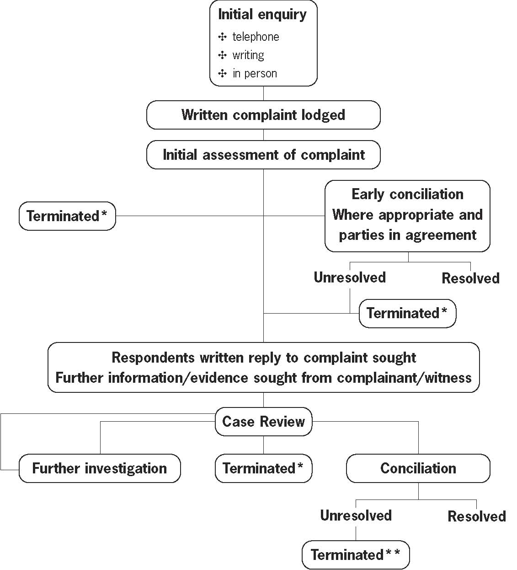
*When complaints under the Age, Racial, Sex and Disability Discrimination Acts are terminated, the complainant may apply to have the allegations heard and determined by the Federal Court of Australia or the Federal Magistrates Court.

**Complaints under the Human Rights and Equal Opportunity Commission Act concerning discrimination in employment or a breach of human rights, which cannot be conciliated, cannot be taken to court. If the President is satisfied that the subject matter of the complaint constitutes discrimination or a breach of human rights these findings are reported to the Attorney-General for tabling in Parliament.

Appendix 5
Human resources and administrative services

Performance management and staff development
The Commission's Performance Management Scheme provides a framework to manage and develop our staff to achieve our corporate objectives. The scheme provides regular and formal assessment of an employee's work performance and allows for access to training and skill development. The scheme was reviewed through the year and minor changes were made.

The Commission's Certified Agreement recognises the need to provide adequate training for staff to support workplace changes. This is especially relevant with changes in the information technology area where staff are provided with relevant and ongoing computer training. During the year, the Commission implemented a new telephone/communication system with an interface to the computer network and staff were provided with training.

Training is identified through an individual’s training and development plan in conjunction with the Performance Management Scheme. Training encompasses a range of development activities including: professional development courses, on the job training, mentoring and the opportunity to represent the organisation at seminars/fora. These may broaden the skills and experience of staff, and where overseas/interstate travel is involved, may also provide an opportunity to reward staff for their performance. As part of the Commission's staff development strategy, staff are also provided with support under our Studies Assistance policy. The policy provides for access to study leave where study is relevant to the work of the Commission, an individual's work responsibilities and where it assists with career development.

Workplace diversity and equal employment opportunity
The Commission recognises that diversity in our staff is one of our greatest strengths and assets and is committed to valuing and promoting the principles of workplace diversity through our work practices. During the year, the Committee implemented a revised Diversity Plan.

Projects through the year included supporting two placements under the Willing and Able Mentoring Program (WAM). This program recognises the disadvantages faced by students with disabilities and aims to equip them with the skills and experience they need in order to gain employment that is relevant to their academic training and abilities. This program provides students who have a disability with a one-on-one relationship with a mentor who has experience of working within an organisation in the student’s chosen future professional area.

Throughout the year, the Commission also continued to promote and support diversity events, including International Women's Day, NAIDOC Week and Harmony Day.

Under the Commission's Indigenous employment strategy, a staff member completed the inaugural Indigenous Leadership Course at the end of 2004. The diploma level course is run by the Australian Indigenous Leadership Centre and examines models and styles of leadership, and leadership in various contexts, including personal, organisational, political and international. The Commission also supported a staff member to attend a training program on human rights funded by the Raoul Wallenberg Institute of Human Rights and Humanitarian Law (RWI).

Other strategies under the plan focus on supporting staff with family responsibilities, including part-time work, with 16 staff currently working part-time. The Commission has supported staff returning from maternity leave to work part time.

Occupational health and safety
It is the policy of the Commission to promote and maintain the highest degree of health, safety and well being of all staff. The Commission monitors health and safety though its OH Committee, which includes a staff health and safety representative and four corporate support staff who met regularly through the year. Minutes of the committee are placed on the Commission's intranet and any issues that require action are brought to the attention of management. The Commission’s policy was reviewed through the year.

A hazards survey is conducted annually and the committee monitor any OH issues that arise. Personnel staff have been trained as case managers and regularly attend COMCARE forums and training as required. Ongoing assistance and support on OH and ergonomic issues is provided to new and existing staff. A software program called 'Workplace' assists staff in taking regular ergonomic breaks through the day. The Commission also offers support to staff through the promotion of QUIT smoking programs and flu vaccinations. There have been no dangerous accidents or occurrences reported and the Commission has a very low claim frequency rate.

The Commission continues to provide staff with access to counselling services through its Employee Assistance Program. This is a free and confidential service for staff and their families to provide counselling on personal and work-related problems if required.

Workplace relations and employment
Staff in the Commission are employed under section 22 of the Public Service Act 1999. The Commission's current agreement was certified by the Australian Industrial Relations Commission on 19 December 2002 and is in operation until 15 July 2005. The agreement is comprehensive and was certified under section 170LJ of the Workplace Relations Act 1976. The number of Commission employees covered by the agreement as at 30 June 2005 was 82, including both ongoing and non-ongoing staff. Productivity savings funded a 12% salary increase to staff, delivered in three instalments over the life of the Agreement, with the final 4% increase in January 2005.

The agreement maintains core employment conditions and supports family friendly policies. Staff are able to purchase additional leave and access further benefits such as salary packaging and cashing out five days recreation leave subject to conditions. Salary progression within classification levels is subject to performance assessment. Salary ranges are reflected in the table below. The Commission has five staff covered by Australian Workplace Agreements, including one senior executive level staff member.

Staffing
In order to reduce expenditure in the current and subsequent years a range of measures were undertaken, including internal restructuring. The equivalent of eight positions were cut from the Commission permanent structure in the latter part of the year.

The Commission's average staffing level for the year was 95.27 staff, with a turnover of 17% for ongoing staff. This was higher than usual as a result of the internal restructuring. An overview of the Commission's staffing profile as at 30 June 2004 is summarised in the table below.

Classification | Male | Female | Full time | Part time | Total Ongoing | Total Non-ongoing
Statutory Office Holder | 3 | 1 | 3 | 1 | - | 4
SES Band 2 | - | 1 | - | 1 | 1 | -
SES Band 1 | - | - | - | - | - | -
EL2 above the barrier ($94,126) | 1 | 2 | 2 | 1 | 3 | -
EL 2 ($78,335-$90,218) | 10 | 10 | 16 | 4 | 17 | 3
EL 1 ($67,920-$74,482) | 3 | 4 | 5 | 2 | 7 | -
APS 6 ($54,299-$60,859) | 5 | 23 | 24 | 4 | 20 | 8
APS 5 ($49,053-$52,981) | 3 | 1 | 4 | - | 3 | 1
APS 4 ($43,979-$47,752) | 2 | 6 | 7 | 1 | 7 | 1
APS 3 ($39,460-$42,589) | 1 | 13 | 13 | 1 | 13 | 1
APS 2 ($35,598-$38,418) | - | 1 | 1 | - | 1 | -
APS 1 ($30,612-$33,833) | 1 | - | - | 1 | 1 | -
Total | 29 | 62 | 75 | 16 | 73 | 18

Office of the Federal Privacy Commissioner
The Commission provides corporate support to the Office of the Federal Privacy Commissioner (OFPC) under the terms of a three-year MOU concluding on 31 May 2007. The Commission provides financial, procurement and contract services, personnel management, legal advice, library facilities, registry and reception, records management, information technology and property management services to the OFPC. The OFPC pays an agreed fee to the Commission of 10% of gross revenue for corporate support services.

The OFPC and the Commission are co-located and the OFPC occupies space under the Commission's lease. OFPC and the Commission have a separate MOU covering the provision of office space which is referenced to the Commission's lease with Stockland Trust Management Ltd. The rate at which the lettable area is charged to OFPC is the same as that which is paid by the Commission.

Consultancy services
During 2004-05 the Commission engaged one IRAP approved consultant to undertake a Threat and Risk Assessment in relation to its Telecommunication services. The contract cost and payments totalled $23,760. No other consultants were engaged and there were no on-going consultancies.

Consultancy services let during 2004-05, of $10,000 or more

Consultant | Description of services | Contract Price (Inc. GST) | Selection Process | Justification
Volante Systems Pty Ltd | Telecommunications Threat and Risk Assessment Services | $ 23,760.00 | Direct Sourcing | Need for specialist telecommunication security skills
Total F/Y | Description of services | $ 23,760.00

Purchasing
The Commission's purchasing procedures are consistent with the Commonwealth Procurement Guidelines issued by the Department of Finance and Administration and updated to incorporate policy changes effective 1 January 2005. The procedures address a wide range of procurement situations, allowing managers to be flexible when making procurement decisions, while complying with the Commonwealth's core principle of value for money. There were no contracts exempt from publishing through the gazette.

There was no competitive tendering and contracting during 2004-05 that resulted in a transfer of providers of goods and services from a Commonwealth organisation to a non Government body.

Ecologically sustainable development and environmental performance
The Commission uses energy saving methods in its operations and endeavours to make the best use of resources. Purchase and/or leasing of ‘Energy Star’ rated office machines and equipment with 'power save' features is encouraged, and preference is given to environmentally sound products when purchasing office supplies.

The Commission has implemented a number of environmental initiatives to ensure issues of environmental impact are addressed. Waste paper, cardboard, printer cartridges and other recyclable materials are recycled subject to the availability of appropriate recycling schemes. During June 2005, the Commission installed throughout its premises new generation triphosphor fluorescent tubes that deliver 70% less mercury into each tube than environmentally unfriendly halophosphor tubes. The contract required recycling of the replaced halophosphor tube components.

Fraud control
The Commission has prepared a Fraud Risk Assessment and Fraud Control Plan and has procedures and processes in place to assist in the process of fraud prevention, detection, investigation and reporting in line with the Commonwealth Fraud Control Guidelines. The Fraud Control Plan is made available electronically to all Commission staff.
Commonwealth Disability Strategy (CDS)
The Commission, along with all other Commonwealth agencies, reports against the CDS performance framework annually. Full details on the CDS can be found on the Department of Family and Community Services website at: www.facs.gov.au/disability/cds.

Through the CDS, the government seeks to ensure its policies, programs and services are as accessible to people with disabilities as they are to all other Australians. This, of course, is integral to the work of the Commission and evident in the work we do. The CDS identifies five core roles that may be relevant to the agency. The Commission’s primary roles are that of policy adviser, service provider and employer. Full details on the policies and services highlighted in the Appendices can be found within the relevant section of the Annual Report.

The Commission is committed to implementing best practices in providing and improving access to its services for people with disabilities. In particular, our Complaint Handling processes, online access to our services, website and education material, and consultation with disability groups provide examples of what we are doing to achieve this. In March 2005, the Commission launched a National Inquiry on Employment and Disability (further details can be found within the Disability Rights section of the Annual Report).

Commonwealth Disability Strategy Performance
reporting June 2005
Further details on programs and policies outlined against the performance indicators can be found in the relevant section of the Annual Report.

POLICY ADVISOR ROLE
Performance indicator 1
New or revised policy/program assesses impact on the lives of people with disabilities prior to decision

Performance measure
Percentage of new or revised policy/program proposals that document that the impact of the proposal was considered prior to the decision-making stage.

Current level of performance 2004-2005
✣ Commission public Inquiries and exemption applications include people with disabilities to seek views on the issue before finalisation.
✣ National peak disability groups and selected regional groups are consulted on new projects in development phase to seek their views on impact. In the Disability Rights Unit (DRU) compliance is 100%.
✣ All submissions to Inquiries are taken in a range of formats, including verbal/audio (transcribed by the Commission), e-mail and handwritten letters.
✣ All new initiatives are made publicly available through the Commission’s webpage and key disability organisations are informed of developments through the Commission’s listserve.
✣ Through the use of the Commission’s website and e-based networks the DRU provides extensive information on new and revised policies and programs and seeks feedback at any stage on their effect.

Performance indicator 2
People with disabilities are included in consultation about new or revised policy/program proposals

Performance measure
Percentage of consultations about new or revised policy/program proposals that are developed in consultation with people with disabilities.

Current level of performance 2004-2005
✣ In the DRU, consultation with people with disabilities and their representative organisations occurs at a number of levels:
✧ direct contact with representative organisations at a national and state/territory level.
✧ through invitation to respond to new and revised policy/programs through the Commission’s website, e-based networks, in writing or by phone.
✧ through public forums, conferences and public meetings.
✣ New initiatives are made publicly available through the Commission’s webpage and disability organisations and individuals are informed of developments through the Commission’s listserve.
✣ Public consultation events all occur in accessible venues with hearing augmentation and sign language interpreters available.
✣ Before undertaking a National Inquiry on Employment and Disability in March 2005 the Commission sought comments on issues from individuals and disabilities groups in 2004. Further details are available in the Disability Rights section of the Annual Report.

Performance indicator 3
Public announcements of new, revised or proposed policy/program initiatives are available in accessible formats for people with disabilities in a timely manner

Performance measure
✣ Percentage of new, revised or proposed policy/program announcements available in a range of accessible formats.
✣ Time taken in providing announcements in accessible formats.

Current level of performance 2004-2005
✣ All information about new Commission initiatives is available on a W3C/WAI compliant website, simultaneous with public release.
✣ 100% of announcements and information material available in accessible electronic format.
✣ 100% of material produced is also available in standard print, large print, audio and Braille on request.
✣ Time taken to produce in other than electronic format varies according to the size of the document, but generally within seven days.

PROVIDER ROLE
Further details on the Commission’s complaint handling function, with a full description of its services and relevant statistics can be found in the Complaint Handling Section of the Annual Report.

Performance indicator 1
Complaints information service provides information about complaint handling service to people with disabilities

Performance measure
✣ Complaints information service accessible to people with disabilities.
✣ Number of calls/e-mails/visits to complaints information service related to disability issues.
✣ Number of groups that attended complaint handling information session, or were visited by the Complaint Handling Section (CHS) during regional and interstate visits, included disability advocacy and disability legal services.

Current level of performance 2004-2005
✣ Commission complaints information is available in electronic and alternative formats. E-mail facility and accessible online complaint form for the lodgement of complaints is available. Telephone and TTY facilities are available with a national 1300 number at local call cost.
✣ All complaint handling brochures and publications are available on the Commission’s website in accessible electronic format and are available in alternative formats on request. Information about the complaints process and legislation is available in plain English format on the Commission’s website. The website is updated regularly.
✣ 22% of phone/e-mail/written enquiries to the CHS are related to disability issues.
✣ 90 groups attended a CHS session or were visited by CHS staff.
✣ A complaints information referral list is updated regularly to ensure callers with disabilities can be referred to appropriate advocacy groups and other appropriate services.

Goals 2005-2006
✣ Increase targeted community education and liaison with disability groups and advocacy organisations in all states, in particular regional areas.
✣ Targeted community education and liaison with Indigenous and multicultural disability networks in each state.

Performance indicator 2
Complaint handling service accessible to people with disabilities

Performance measure
✣ Number of complaints received under the DDA.
✣ Number of complaints lodged by people with disabilities under all legislation administered by the Commission.
✣ Number of complainants who identify the need for specific assistance on intake form.
✣ Complaints received about accessibility of service.

Current level of performance 2004-2005
✣ 523 complaints were received under Disability Discrimination Act (DDA) legislation for 2004-2005. Refer to the Complaint Handling Section of the Annual Report for further details.
✣ Complaints were received from people identifying as having a disability under all Acts administered by the Commission. 58% of responses to a survey question on demographics indicated the complainant had a disability.
✣ 118 requests for assistance were recorded, including assistance with language interpreters and sign language interpreters, TTY and assistance with writing.
✣ There were no formal complaints received regarding accessibility of the Commission complaint handling service or premises. Performance measure = 100%.
✣ The Commission’s premises are accessible. Premises used for remote conciliation conferences are accessible. Performance measure = 100%.
✣ The Complaint Handling Section Access Committee reviews access to the CHS service by the community, including specific focus on people with disabilities. Further details are available in the Annual Report.

Performance indicator 3
Staff training and development, includes training related to people with disabilities

Performance measure
Percentage of training programs that include information regarding people with disabilities and relevance to complaint handling processes.

Current level of performance 2004-2005
✣ CHS investigation and conciliation training courses include specific training on accommodating people with disabilities in the complaint handling investigation and conciliation processes. Performance measure = 100%.
✣ Ad hoc CHS training sessions specifically address relevance to people with disabilities who use complaint handling services. Performance measure = 100%.
✣ CHS Complaint Handling Manual advises staff to consider reasonable accommodation for people with disabilities is provided during the investigation and conciliation process such as provision of Auslan interpreters, use of TTY, use of alternative formats for information. Performance measure = 100%.

Performance indicator 4
Complaint mechanism in place to address concerns raised about service and addresses requirements of people with disabilities

Performance measure
Established complaint/grievance mechanism in operation. Detailed in Charter of Service which is provided to all parties to a complaint and available on website. Provided in alternative format on request.

Current level of performance 2004-2005
✣ Charter of Service addresses roles and responsibilities of the Commission and parties.
✣ No complaints about accessibility of service or disability-related issues were received under the Charter in the year.
✣ Performance measure = 100%.

EMPLOYER ROLE
Performance indicator 1
Employment policies, procedures and practices comply with the requirements of the Disability Discrimination Act 1992

Performance measure
Number of employment policies, procedures and practices that meet the requirements of the Disability Discrimination Act 1992.

Current level of performance 2004-2005
✣ The Corporate Plan includes reference to APS values and social justice principles to ensure access to the Commission’s services.
✣ The Commission’s Certified Agreement 2002–2005 contains reference to Workplace Diversity principles. Most of the Commission’s policies on employment are contained within the Certified Agreement.
✣ The Workplace Diversity Plan outlines strategies to maximise employment and developmental opportunities for people with disabilities. On induction, all new staff are provided with a copy of the Plan.
✣ The e-mail/internet policy is reviewed annually. It specifically refers to the inappropriate use of e-mails that may demean people with disabilities.
✣ No formal complaints/grievances made by staff with disabilities with regard to current work practices.
✣ Reasonable adjustment principles are adhered to in the modification of employee’s duties in the workplace. Two employees have been provided with voice-activated software to enable them to undertake their duties and another staff member with CCTV equipment.

Performance indicator 2
Recruitment information for potential job applicants is available in accessible formats on request

Performance measure
✣ Percentage of recruitment information requested and provided in alternate electronic formats and accessible formats other than electronic.
✣ Average time taken to provide accessible information in electronic formats and formats other than electronic.

Current level of performance 2004-2005
✣ Performance in providing accessible formats for recruitment material = 100%.
✣ Applicants are advised on the Commission’s website that recruitment information is able to be provided in any format. All recruitment material is on the Commission’s website and available by download at the same time it is advertised in the press. Advertisements in the press advise that information is available by contact phone, by TTY phone and on the Commission’s website. The Commission website meets the criteria for accessibility as outlined in the Government Online Strategy. The Jobs Page (www.humanrights.gov.au/jobs/index.html) received 41 903 page views during the last financial year.
✣ There were no requests for Braille during 2004/5. The Commission is able to supply any requests within 3-7 days.

Performance indicator 3
Agency recruiters and managers apply the principle of reasonable adjustment

Performance measure
Percentage of recruiters and managers provided with information on reasonable adjustment.

Current level of performance 2004-2005
✣ Selection guidelines include information on reasonable adjustment and guidelines for interviewing staff with disabilities.
✣ Recruitment action is managed internally and not outsourced and all committees are provided with selection information on reasonable adjustment.

Performance indicator 4
Training and development programs consider the needs of staff with disabilities

Performance measure
Percentage of training and development programs that consider the needs of staff with disabilities.

Current level of performance 2004-2005
✣ Due to the small number of staff in the agency, training is co-ordinated by each of the unit managers under the Commission’s Performance Management Scheme. The majority of training is provided off-site with external providers. Any in-house training programs recognise the needs of people with disabilities.

✣ Training nomination forms include specific requirements that may be needed such as:
✧ wheelchair access
✧ accessible toilets/parking
✧ a hearing device
✧ sign language interpreter
✧ an attendant
✧ a support person
✧ information in Braille, audio cassette, large print, ASCII format.

Performance indicator 5
Training and development programs include information on disability issues as they relate to the content of the program

Performance measure
Percentage of training and development programs that include information on disability issues as they relate to the program.

Current level of performance 2004-2005
✣ The Commission conducted an in house training session on ‘Deaf Awareness’ for staff in July 2004. The session called ‘It's a Deaf Deaf World’ was presented by the Deaf Education Network (DEN) and provided staff with an increased awareness of the deaf community, in particular modes of communication.
✣ As noted above, training is co-ordinated by each individual section.
✣ Induction includes information on workplace diversity and relevant legislation that the Commission administers, including the Disability Discrimination Act.
✣ The Complaint Handling Section conducts training and information on disability issues for staff.

Performance indicator 6
Complaint/grievance mechanism, including access to external mechanisms, in place to address issues and concerns by staff

Performance measure
Established complaints/grievance mechanisms, including access to external mechanisms in operation.

Current level of performance 2004-2005
✣ There is an established process in the Commission’s Certified Agreement 2002–2005 for complaints/grievances, which includes access to external review through the Australian Public Service Commission.
✣ All staff are advised of access to the Commission’s Employee Assistance Program and encouraged to use this service when needed. This free service provides counselling and support for staff and their families.
✣ Provision of access to complaints/grievance mechanisms = 100%.

Note: Accessible electronic formats include ASCII (or .txt) files and html for the web. Non-electronic accessible formats include Braille, audio cassette, large print and easy English. Other ways of making information available include video captioning and Auslan interpreters.

Index
A
ABC Television, Australian Story, 34
Aboriginal and Torres Strait Islander Commission
(ATSIC)
abolition, 95
Regional Councils, 22
Aboriginal and Torres Strait Islander Services
(ATSIS), 95
Aboriginal and Torres Strait Islander Social Justice, 93-100
Bringing them home, 21, 27
case study, 49
Commissioner statement, 93-5
community consultations, 22
Community Guide, 5
criminal justice issues, 98
federal arrangements, delivery of administrative services, 6, 22
health, 94
Indigenous internship, UNSW, 100
international activities, 94
juveniles with cognitive disabilities in the criminal justice system, 98
major issues, 6, 94-5
mental health, 94
mining certification evaluation project, 99
monitoring and reporting, 95-8
native title, 22, 94-5
Native Title Report, 21, 93, 96-8
promoting awareness and discussion, 98-9
publications, 139
research and educational programs, 98, 100
Shared Responsibility Agreements (SRAs), 96
Social Justice Report, 21, 22, 93
speeches, 98, 100
Aboriginal Employment Strategy, 32
Access for All Alliance (Hervey Bay) v Hervey Bay City Council [2004] FMCA 915, 89
Accessible Public Transport National Advisory Committee, 107
address, contact, 3
Administrative Appeals Tribunal, 91
Administrative Decisions (Judicial Review) Act 1977 (Cth), 43, 91
Age Discrimination Act 2004 (Cth), 7, 46, 55, 123-9, 138
access to insurance, 55
advertising, 56
apprentice, 55
Australian Defence Force, 81
case studies, 55-6
employment, 55, 56, 60, 126
introduction of Act, 8
objectives, 15
provision of services, 55
publications, 139
seminar, 126
statistics, 55, 73-4
workplace, 21
Al Kateb v Godwin [2004] HCA 37, 84, 90, 111
Al Khafaji case, 90
All-China Women’s Federation, 127
amicus curiae, 86-9
Anneto Inc, 129
Arab communities, 8, 22, 117
Arts Non-Fiction Award, 34
Asia-Pacific Forum of National Human Rights Institutions (APF), 7, 131
training for Commission on Human Rights of the Philippines, 48
training for Hong Kong Equal Opportunities Commission, 48
training for National Human Rights Commission of Thailand, 47-8
ASIO Act 1979 (Cth), 38-9
asylum seekers, 33, 34
anthology of writing, 33
education module, 27
pro-bono legal work, 32
Refuge Australia, 34
see also A last resort?; immigration detention; immigration detention centres
Attorney-General, 17, 29
reports to, 57, 107
AusAID, 91, 124, 131
Australasian Multicultural Police Advisory Bureau (APMAB), 119
Australia-China Human Rights Technical Cooperation Program, 124, 127, 132
Australian Bankers’ Association, 103
Australian Broadcasting Authority, 119
Australian Building Codes Board, 107
Australian Bureau of Statistics, 119
Australian Competition and Consumer Commission (‘ACCC’) v Radio Rentals Limited and Anor (No S844 of 2003), 82-3
Australian Defence Force, 81
Australian Industrial Relations Commission, 17, 143
Family Provisions Test Case, 83
Australian Municipal Administrative Clerical and Services Union, 88
Australian Research Council (ARC), 124, 127
Australian Standard Classification of Cultural and Ethnic Groups (ASCCEG), 119
Australian Stock Exchange, 29
Australian Workplace Agreements, 143
Australia-Vietnam Dialogue on International Organisations and Legal Issues, 132
awards, Human Rights, 20, 31-5

B
Baird, Marian, 125
Bali bombings, 109, 117
Behrooz v DIMIA [2004] HCA 36, 84, 90
Bendigo Trams, 105
Beyond the Bars: Out and Blak, 35
Bill of Rights, Australian, 111
Blake Waldron and Dawson, 123
Brain and Mind Research Institute, 101
Bringing them home, 21, 27
budget, 8, 18
see also financial statements Building Access Policy Committee, 107
bullying, 113
The Burdekin Report, 101
Burnside, Julian, 32

C
Calma, Tom, 6, 12, 21, 93, 117-18
Campbell, Ms Susan, 80
case studies, 49-59
Aboriginal and Torres Strait Islander peoples, 49
age discrimination, 55-6
disability discrimination, 53-4
human rights and equal opportunity, 57-9
race discrimination, 49-50
sex discrimination, 51-2
Catholic Education Office v Clarke [2004] FCAFC 197, 85-6
Charlesworth, Sara, 125
Che Forest v Tranter Pty Ltd t/as Kuranda Hotel & Barry Smith, 86-7
child(ren) Bringing them home, 21, 27
Convention on the Rights of the Child, 14, 39, 80, 110
Declaration on the Rights of the Child, 14, 137
global movement, increase, 111-12
immigration detention centres, 85
A last resort? (National Inquiry into Children in Immigration Detention), 5, 6, 110, 114
parents’ employment, impact on children’s wellbeing, 124, 127
release of from immigration detention, 5, 6, 110
rights in immigration detention centres, 6
State or Church care, previously in, 33
see also education, students; Youth Challenge
China, 7, 48, 99, 124, 133
All-China Women’s Federation, 127
Australia-China Human Rights Technical Cooperation Program, 124, 127, 132
Coffs Harbour Travel And Tours Service, 106
Cohn, Sharon, 124
COMCARE, 143
Commission on Human Rights of the Philippines, 48
Commissioners
Aboriginal and Torres Strait Islander Social Justice, 6, 12, 14, 93-5
Age Discrimination, 7, 123
Disability Discrimination (acting), 6, 7, 101-2
Human Rights, 6, 13, 109-12, 115
Race Discrimination (acting), 6, 12, 117-18
Sex Discrimination, 5, 7, 13, 14, 123-4 specific functions, 17
see also President
Commonwealth Disability Strategy, 146
performance reporting
employer role, 150-3
policy advisory role, 146-7
provider role, 147-9
Commonwealth Parliamentary Inquiry into Balancing
Work and Family, 41, 124
communications strategy, 19-20
Community Award
Business, 33
Individual, 33
community consultations, 21-2
complainant(s)
country of birth, 64, 65
demographic data, 61
detainee, 58, 79-80
Indigenous status, 65
state of origin, 64
complaint handling, 43-77
access to services, 45-6
access working group, 46
conciliation, 43, 47, 61
conciliation case studies, 49-59
conciliation circuits, 46
conciliation process (video/DVD), 46
conciliation rate, 44
concise complaint guide, 45
customer satisfaction survey, 44-5
education and promotion, 21, 46
election of jurisdiction, 45
enquiries, 62
Infoline, 45
international activities, 47-8
interpreter services, 45
key performance indicators, 44
online complaint form, 45
overview, 43-5
process, 43
process, chart, 141
research and policy, 47
Service Charter, 45
statistics, 44, 60-1
timeliness, 44
training, 46
translation services, 45
website, 45
see also statistics
Complaint Information Service, 44
statistics, 62-3
complaints guide, concise, 45
conferences, workshops and seminars
‘Are human rights principles relevant to the war on terror’ seminar, 90
Indigenous sovereignty - does it mean secession?, 100
Inner Mongolia Domestic Violence Workshop, 127
international, 115, 127, 133
International Coordinating Committee of National Human Rights Institutions, 7
Legal Bulletin, 90
‘Of Working Age: A seminar on age discrimination in the workplace’, 126
sex discrimination, seminar series, 125
see also community consultations
Constitution, 85
consultancy services, 145
Convention Concerning Discrimination in Respect of Employment and Occupation, 14
Convention on the Elimination of All Forms of Discrimination Against Women (CEDAW), 15, 138
Convention on the Rights of the Child (CRC), 14, 39, 80, 110, 138
Optional Protocol, 41-2
Copyright Agency Limited, 104
Copyright and Publishing Roundtable, 103-4
Criminal Code (Trafficking in Persons Offences) Bill 2004, 38, 124
Criminal Code Act 1995 (Cth), 41, 42
criminal record discrimination, 22, 57, 59, 60, 112-13, 114
CSIRO, 99
Curtin Immigration Reception Processing Centre, 79-80

D
Davis, Professor Angela, 125
Declaration on the Elimination of All Forms of Intolerance and of Discrimination Based on Religion or Belief, 14, 138
Declaration on the Rights of Disabled Persons, 14, 137
Declaration on the Rights of Indigenous Peoples, Draft, 94, 99
Declaration on the Rights of Mentally Retarded Persons, 14, 137
Declaration on the Rights of the Child, 14, 137
Defence Act 1903 (Cth), 41, 42
Dent, Dr Gina, 125
Department of Defence, 80
Department of Immigration and Multicultural and Indigenous Affairs (DIMIA), 79, 121 Detention Centre Act, proposed, 110
detention centres
see immigration detention centres
Disability Discrimination Act 1992, 15, 53-4, 82, 85, 86-7, 89, 101-8
access to premises, 7, 53, 89, 105, 107
accident and sickness insurance, 53
action plans, 103
assistance animals, 86-7
Auslan interpreter, 85-6
awareness promotion, 102
bathroom facilities, 89, 106
case studies, 53-4
Commissioner
Deputy, 102
statement, 101-2
community consultations, 22
complaints, number, 70
conciliations, 72
education, 7, 54, 85-6, 103-4, 107
electronic commerce, 103
employment, 47, 54, 60, 101
public inquiry, 102, 103, 146
entertainment, 89
exemptions, 105-6
health access, 104
indirect discrimination, 89
insurance industry, 104
intellectual disability, 82
international convention, 103
legislative development, 106-7
mental health review, 8, 101, 103
objectives, 15
Productivity Commission review, 101, 108
provision of services, 53
psychiatric illness, 33, 86
research and policy, 103-4
small business guide, 102
speeches, 22, 108
Standards, 106, 107
statistics, 53, 70-2
telecommunications access, 104-5
transport, 7, 105, 106, 107
visually impaired, 53
website accessibility, 104
website use, 102
Disability Standards for Accessible Public Transport, 105, 106, 107
Disability Standards for Education, 107
‘Discrimination in Employment on the Basis of Criminal Record project, 22
domestic violence, 124
Draft Declaration on the Rights of Indigenous Peoples, 94, 99

E
ecologically sustainable development, 99, 145
education and promotion
Aboriginal and Social Justice, 98-9
amicus curiae, 89
Bringing them home education module, 27
community consultations, 21-2
complaint services, 46
disability rights, 102
education modules, 26-8
education resources, 27-8, 29
education resources for employers, 29-30,
114
electronic mailing lists, 24, 28
electronic mailing list, educators, 28
electronic mailing list, employers, 30
Face the Facts education modules, 27-8
feedback, 24
human rights, 19-36, 114
information sheets, 23
interventions, 89
Legal Section, 89-90
legislative responsibilities, 19
medals and awards, 23
media engagement, 19, 20-1
outcomes, 26
plain English publications, 20, 28
pregnancy materials, 126
publications, 23, 139
resources, 27
race discrimination, 117, 120-1
sex discrimination, 125-6
sexual harassment, 27, 28
strategies, 19-20
students, 20, 26-8, 120, 121
students, tertiary, 28
teachers, 20, 26-8, 121
webpage, Information for Students, 28
website, resources on, 23
website use, 29
Youth Challenge, 27
election of jurisdiction, 45
electronic mailing lists, 24, 28, 30
Ellison, Senator Chris, 124, 125
Employee Assistance Program, 143
employer role, 150-3
Employer’s Electronic Mailing List, 30
Employers Making a Difference, 47
employment
age discrimination, 7, 55, 56, 60, 126
complaint statistics, 60
criminal record discrimination, 57
disability discrimination, 47, 54, 60, 101
Discussion paper on Discrimination in Employment, 113
HREOC Act, 57, 58, 59, 60, 112-13, 114
race discrimination, 49, 52, 60
sex discrimination, 51-2, 52, 87-8, 128, 129
sexual harassment, 52
trade union activity discrimination, 57
environmental performance, 99, 145
Epstein, Merinda, 33
equal employment opportunity, 142
Equal Opportunity Commissions, state, 22
Estens, Dick, 32 Evans, Hugh, 32

F
Face the Facts, 21, 27-8, 31, 118, 120-1
Family Provisions Test Case, 83, 124
Federal Court of Australia, 16, 43, 85, 86, 88, 104, 141
Federal Discrimination Law 2005, 5, 31, 90
Federal Magistrates Court, 16, 43, 86, 87, 89, 141
Fiji Human Rights Commission, 91
financial statements, 153-82
Fraser, Malcolm, 32
fraud control, 145
Freedom of Information Act 1982 (Cth), 91, 140
freedom of information
categories of documents, 140
procedures, 140
statistics, 140
functions and powers, HREOC, 15-16
Commissioners and President, specific functions, 17
Minister (Attorney-General), 17
responsibilities, 15

G
Gaze, Beth, 125
‘Good Practice, Good Business - eliminating discrimination and harassment from your Workplace’, 5, 21, 29, 30, 31
CD-Rom, 29, 30
Goward, Ms Pru, 13, 20, 41, 123-4, 126
see also Commissioner, Sex Discrimination
Gunn and Taylor (Aust) Pty Ltd v AMWU [PR18573] 4 June 2002, 83

H
Harmony Day, 142
High Court, 84, 85, 90, 111
homosexuality
see HREOC Act, sexual preference
Hong Kong Equal Opportunities Commission, 48, 127
Howe v Qantas Airways Limited [2004], FMCA 242, 87-8, 90
human resources and administrative services,
Human Rights Act (UK), 111
Human Rights and Equal Opportunity Commission Act 1986, 14, 17, 43, 79, 86, 95, 100, 109-15 access to medical services, 58
case studies, 57-9
Commissioner statement, 109-12
complaints, number, 57, 75
community consultations, 22
conciliations, 57
criminal record, 57, 59, 60, 112-13, 114
definition, human rights, 14, 57
detainee and access to medical services, 58
detainee and visitation with children, 58
education and promotion, 19-36, 114
employment, 57, 58, 59, 60, 112-13, 114
international activities, 115
international instruments, 137-8
legislative responsibilities, 19
powers, Minister, 17
powers, HREOC, 15-16
publications, 139
religion, 57
Reports to Attorney-General, 79-81
research and policy, 112-13
sexual preference, 58
speeches, 22, 31, 115
statistics, 75-7
structure of HREOC, 11
submissions to Inquiries, 37-42
trade union activity, 57, 60
Human Rights Day, 31
Human Rights Medal and Awards, 20, 31-5
Arts Non-Fiction Award, 34
Community Award (Individual), 33
Community Award (Organisation), 33
Human Rights Medal, 31
Law Award, 32
Print Media Award, 35
Radio Award, 35
Television Award, 34
human rights, definition, 14, 57

I
immigration detention detainee and access to medical services, 58
detainee and visitation with children, 58
mandatory, 110-11
Palmer Inquiry, 21, 110, 111
see also asylum seekers; A last resort?
immigration detention centres
Curtin, 79-80
Woomera, 84
Impact of Parents’ Employment on Children’s Wellbeing: The influence of employment quality, time and activities with children, and parenting practices, 127
Indigenous Australians, 8
delivery of services to, new federal arrangements, 6, 22, 41, 95-6
Stolen Wages Payback Shame, 35
see also Aboriginal and Torres Strait Islander Social Justice
Indonesia, 133
Infoline, 45
Inmate Health Survey, 33
Inner Mongolia Domestic Violence Workshop, 127
Innes, Mr Graeme, 102
Inquiry into Employment and Disability, 22
international activities, 7, 91
Australia-China Human Rights Technical Cooperation Program, 124, 127, 132
Australia-Vietnam Dialogue, 132
conferences and meetings, 115, 133
promotion of national institutions of human rights, 7-8
race discrimination, 121
scholarships, 132
sex discrimination, 127-8
South Korean Human Rights Commission, placements from, 48
social justice, 99-100
training, 7, 47-8, 91, 131-3
visiting delegations, 48, 132
visitors, 133
see also Asia-Pacific Forum
international convention on human rights and disability draft, 103
International Convention on the Elimination of All Forms of Racial Discrimination, 14 combined 13th and 14th periodic report, 121
submission to, 99, 121
International Covenant on Civil and Political Rights (ICCPR), 14, 38, 39, 40, 57, 60, 80, 137, 138
International Covenant on Economic, Social and Cultural Rights, 138
International Decade of the World’s Indigenous People, 94
International Justice Mission, 124
International Labour Organisation (ILO) Convention, 15, 17, 138
International Law Association, 100
international law
Draft Declaration on the Rights of Indigenous Peoples (DDRIP), 94, 99
international visitors, 133
International Women’s Day, 142
interpreter and translation services, 45
interventions, court proceedings, 81-6
legislative base, 81 statistics, 82
Iraq, 48, 133
Isma Listen: National consultations on eliminating prejudice against Arab and Muslim Australians (Isma Project), 21, 117, 118-19
aim of project, 117, 119
CD-Rom, 119
consultations, 22
launch of report, 21
preliminary evaluations, 5
recommendations, 117

J
Jacomb v The Australian Municipal Administrative Clerical and Services Union [2004] FCA 1250, 88, 90
Joint Standing Committee on Treaties, 41
jurisdiction, election, 45
Justice Project, The, 32

K
Keneally, Tom, 33
Kilroy, Deborah, 31-2

L
La La Land Byron Bay, 105
A last resort?, 5, 6, 110, 114
Law Award, 32
Law Council of Australia, 32
Legal Bulletin, 90
seminars, 90
Legal Section, responsibilities, 79
legal services, 79-91
complaints under the HREOC Act, 79
discrimination law, review, 5, 31, 90
interventions, 81-6
judicial review of HREOC decisions under the Administrative Decisions (Judicial Review) Act 1977 (Cth), 91
merits review by Administrative Appeals Tribunal of HREOC decisions, 91
Reports to Attorney-General, 79-81
role of Legal Section, 79
legislation, HREOC responsibility, 14
legislative development
disability discrimination, 106-7
letter of transmittal, 3
Lourdes Hill College, 128

M
mailing lists, electronic, 5, 28, 30
number of subscribers, 5
Malta, 48, 133
Maltzahn, Kathleen, 124, 125
Manne, Robert, 32
Marrickville Council, 102
maternity leave, paid, 28, 126
Mayne, Mr William, 81
McCrossin, Julie, 31
McMahon, Maria, 124, 125
medals and awards, 20, 31-5
media
interviews, 20, 30
magazine briefings, 125
media engagement, 19, 20-1
opinion pieces, 20, 30
releases, 20
statistics, 20
see also education and promotion
Meetings and Events Australia, 102
Memo from HREOC: What have Australians got to complain about?, 21
Mental Health Council of Australia, 5, 6, 21, 101
merits review, Commission decisions, 91
Migration Act 1958 (Cth), 84
and children, 110-11
Migration Litigation Reform Bill 2005, 39-40
MIMIA v Al Khafaji [2004] HCA 38, 84
Minerals Council of Australia, 99
mining certification evaluation project, 99
Minister responsible, 17
‘Missed Business’, 23, 102
mission statement, 11
Mongolia, 124, 127, 133
monitoring human rights, 37-42
Moree, 32
Morocco, 124, 127
Mulrinji, 83
multiculturalism, 8, 117
Murranumbla Bed and Breakfast, 105
Murray, John, 33
Muslim communities, 21, 117, 118-19

N
NAIDOC week, 142
National Association of Legal Centres, 125
National Health and Medical Research Council (NHMRC), 119
National Human Rights Commission of Thailand, 47-8
National Indigenous Times, 35
National Inquiry into Children in Immigration Detention
see A last resort?
National Inquiry on Employment and Disability, 102, 103, 146
National Network of Indigenous Women’s Legal Services, 126
National Press Club, 20, 114
National Security Legislation Amendment Bill 2005, 40
see also terrorism
Native Title Act 1993, 14, 17
consultations on operation of, 22
Native Title Report, 21, 22, 96-8
Community Guide, 5, 98
Native Title Representative Bodies, 96-7
Neumann, Klaus, 34
Northern Territory Anti-Discrimination Commission, 45
NSW Commission for Children and Young People, 127

O
occupational health and safety, 143
‘Of Working Age: A seminar on age discrimination in the workplace’, 126
Office for Women, 126
Office of Indigenous Policy Coordination, 126
Office of the Federal Privacy Commissioner (OFPC), 144
corporate support, 144
investigation and conciliation training, 46
Olsberg, Diana, 125
Optional Protocol to the Convention on the Rights of the Child on the Involvement of Children in Armed Conflict (Optional Protocol), 41-2
organisation chart, 9
outcomes structure, 18
output, 18
resources, 18
Oxford Hotel, Casino, 105
Ozdowski, Dr Sev, 6, 13, 21
see also Commissioners: Human Rights; Disability Discrimination (acting)

P
Pacific Islands Forum, 7
Palmer Inquiry, 21, 110, 111
Parental leave in Australia: Access, utilization and efficacy, 127
parental leave research project, 124, 127
Parental Leave Test Case, 83
Parliamentary Joint Committee on the Australian Crime Commission (ACC), 38
PEN International, 33
people trafficking, 21, 38, 112, 124, 125, 127
performance indicators, complaint handling, 44
Performance Management Scheme, 142
performance reporting, Commonwealth Disability Strategy, 146-53
employer role, 150-3
policy advisory role, 146-7
provider role, 147-9
policy advisor role, 146-7
Positive Justice Centre, 33
powers, HREOC, 15-16
Pregnant and Productive: It’s a right not a privilege to work while pregnant, 126
President, 11-12, 57
international work, 7
specific functions, 17
statement, 6-8
see also von Doussa, the Hon. John
Print Media Award, 35
prisoners
female, 31-2, 95
Indigenous, 35, 95
Inmate Health, 33
Sisters Inside, 31-2
see also asylum seekers; immigration detention; immigration detention centres
Productivity Commission, Review of Disability Discrimination Act, 101, 108
Project Respect, 124, 125
Protocol to Prevent, Suppress And Punish Trafficking In Persons, Especially Women And Children, Supplementing The United Nations Convention Against Transnational Organized Crime, 38
provider role, 148-9
Public Affairs, 21, 30
see also education and promotion; media public consultations
see community consultations
Public Service Act 1999, 143
publications, 139
distribution statistics, 31
Legal Section, 90
online, 23
plain English, 20
purchasing, 145

Q
Qantas Airways Limited, 87-8
QBE v Bassanelli, 104
Queensland Anti-Discrimination Commission, 45
Queensland Commission for Children and Young People, 127
Queensland Office for Women, 127

R
Racial Discrimination Act 1975 (RDA), 14-15, 49, 96, 117-22, 138
Aboriginal and Torres Strait Islander peoples, 49
accessing facilities, 50
aims, 14
alcohol restrictions, 98
Arab and Muslim Australians, 8, 22, 117
case studies, 49-50
Commissioner statement, 117-18
community consultations, 22
complaints, number, 66
conciliations, 49-50
education and promotion, 117, 120-1
employment, 49, 52, 60
international activities, 121
provision of goods and services, 49
research and policy, 118-19
speeches, 122
sport, 121
statistics, 49, 66-7
30th anniversary, 8, 118, 120, 121
voluntary employment, 50
Radio Award, 35
Rau, Cornelia, 111
Re Woolley; Ex parte Applicants M276/2003 by their next friend GS [2004] HCA 49, 85 Refuge Australia, 34
Refugee Review Tribunal, 84
refugees
see asylum seekers
Road to Tooleybuc, The, 34
Royal Australian Air Force (RAAF), 81
Royal Australian College of General Practitioners, 104
Royal Commission into Aboriginal Deaths in Custody, 83
Ruddock, the Hon. Philip, 17, 29

S
Sakhi family, 85
Sanson, A/Prof A.V., 127
Sawer, Marian, 125
Scott, Rosie, 33
Senate Inquiry on Mental Health, 101
Senate Legal and Constitutional Legislation Committee, 38, 39, 124
Senate Select Committee on the Administration of Indigenous Affairs Inquiry into the ATSIC Bill, 42
September 11
see terrorism
Service Charter, 45
Sex Discrimination Act 1984, 15, 51, 123-9, 138
aims, 14
case studies, 51-2
Commissioner statement, 123-6
community consultations, 21
complaints, number, 51, 68
education and promotion, 125-6
employment, 51-2, 52, 87-8, 128, 129
exemptions, 128-9
family responsibilities, 51-2, 87-8
indigenous women, 126
international activities, 127-8
paid maternity leave, 28, 126
pregnancy, 51, 52, 87-8
publications, 139
research and policy, 126-7
seminar series, 125
sexual harassment, 27, 28, 51, 52
sexual harassment, workplace, 5, 52
special measures provision, 88
speeches, 21, 129-30
statistics, 51, 68-9
submissions, 124
20th anniversary, 5, 7, 20-1, 123, 125
work-life balance, 5, 7, 20, 41, 123-4, 126
Sex Discrimination Commissioner
see Commissioners, Sex Discrimination;
see also Sex Discrimination Act
Sex Workers Outreach Project (NSW), 124, 125
Sheehan v Tin Can Bay Country Club [2002] FMCA 95, 87
significant achievements, 5
Sisters Inside, 31-2
small business guide, people with disabilities, 102
Social Justice Report 2004, 21, 22, 95-6
Community Guide, 5
South Australia Equal Opportunity Commission, 4
South Korean Human Rights Commission, 48
Spare Lawyers for Refugees, 32
speeches, 21, 22, 98, 100, 108, 115, 129-30
staff(ing)
development, 142
level, 143
restructure, 143
Studies Assistance, 142
training, 46-7, 143
statistics
Age Discrimination Act, 55, 61, 73
complaints received by area, 73
complaints received and finalised, 73
complaints received by age group of
complainant, 73
conciliations, 61
outcomes of finalised complaints, 74
community consultations, 21-2
complainants, 65
complaint handling, 44, 60-1
complaints by state of origin, 64
complaints received and finalised, 60
complaints received and finalised by Act, 64, 65
conciliation rate, 5, 44, 61
customer satisfaction, 44
overview, 64-5
state of origin of complainant at time of lodgement, 64
time from receipt to finalisation, 5, 44, 65
Complaint Information Service, 62-3
conciliation circuits, 46
Disability Discrimination Act, 53
action plans, 103
complaints by nature of disability, 70
complaints received and finalised, 70
complaints received by area, 71
complaints received by ground, 71
conciliations, 61
outcomes of finalised complaints, 72
education program delivery, 28
electronic mailing lists, 30
enquiries, 62-3
by issue, 62-3
by state of origin, 63-4, 64
freedom of information, 140
media engagement interviews, 20
opinion pieces, 20
releases and alerts, 20
Human Rights and Equal Opportunity Commission Act, 75-7
complaints received and finalised, 75
complaints received by area, 76
complaints received by ground, 75
conciliations, 61
non-employment complaints received by sub-area, 76
outcomes of finalised complaints, 76
publications distribution, 31
Racial Discrimination Act, 49, 66-7
complaints received and finalised, 66
complaints received by area, 66
complaints received by ground, 66
conciliations, 61
outcomes of finalised complaints, 67
Sex Discrimination Act, 68-9
complaints received and finalised, 68
complaints received by area, 68
complaints received by ground, 68
conciliations, 61
outcomes of finalised complaints, 69
staff, 143-4
website, HREOC, 5, 24-5
Stolen Wages Payback Shame, 35
Strazdins, Dr Lyndall, 124, 127
Striking the Balance: Women, men, work and family, 5, 7, 20, 41, 123-4, 126
structure of HREOC, 11

T
Tackling Sexual Harassment in Your School, 28
Tampa case, 32, 109
Tasmanian Air Training Corps (AIRTC), 80
Television Award, 34
terrorism, 8
anti-terror laws and human rights, 110
‘Are human rights principles relevant to the war on terror’ seminar, 90
Bali bombings, 109, 117
September 11 (9/11), 109, 117, 118
Terrorism (Police Powers) Act 2002 (NSW), 37
Terrorism (Police Powers) Act 2002 (NSW), 37
Thailand, 47-8
Tibble, Ms Eleanore, 80
Trade Practices Act 1974 (Cth), 82
trade unions, 57, 60
training, 46-7
international, 47-8
investigation and conciliation, 46-7
The Role of National Human Rights Institutions in Human Rights Protection, 48
staff, 46

U
United Kingdom, 7, 48
United Nations, 91
Commissioner on Human Rights, 7
Division for the Advancement of Women, 124, 128
Draft Declaration on the Rights of Indigenous Peoples, 94, 99
draft international convention on human rights and disability, 103
49th Session, UN Commission on the Status of Women, 124, 127, 128
High Commissioner for Human Rights, 7, 124, 127
reform, 7
Secretary-General, 7
61st Session, Commission on Human Rights, 7
Special Session on Children, 109
United States of America, 7, 125
terrorist attacks, 109, 117, 118
Universal Declaration of Human Rights, 19
University of New South Wales, 100

V
Victoria Equal Opportunity Commission, 45
video/DVD, conciliation process, 46
Vietnam, 132
vision statement, 11
‘Voices of Australia’ project, 120
Voluntary Industry Standards on Banking Accessibility, 103
von Doussa, the Hon. John, 6-8, 11-12, 31
see also President

W
website addresses
alcohol restrictions in Aboriginal communities, speech, 98
amicus curiae guidelines, 86
Commonwealth Disability Strategy, 146
Complaint Handling Service, 45
complaint process, representation, 61
conciliation process, research papers, 47
conciliation process survey, 47
Convention on the Elimination of all forms of Racial Discrimination (CERD) Committee, submission, 99
education modules, 28
election of jurisdiction, 45
electronic mailing lists, 24
e-mail address, 45
Family Provisions Test Case, 83
Federal Discrimination Law 2005, 90
Indigenous peoples and self-determination, speech, 100
Information for Employers, 29
Information for Teachers, 28
Information for Students, 28
international submissions, 99
interventions, 81, 84, 85, 86, 88, 89
Isma project, 118
Jobs page, HREOC, 151
Joint Standing Committee on Treaties, submission on the Optional Protocol to the Convention on the Rights of the Child, 42
legal intervention submissions, 83, 84
legal intervention guidelines, 81
Legal Bulletin, 90
Legal Reports to Attorney-General, 80, 81
medal and award winners, 31
mining certification evaluation project, 99
Native Title Report 2004, 98
online education resources, usage of, 29
Parliamentary Joint committee on ASIO, ASIS and DSD, submission, 39
Pathways to Resolution (video/DVD), 46
Reports to Attorney-General, 80, 81
Senate Legal and Constitutional Committee, submission on Criminal Code Amendment (Trafficking in Persons) Bill 2004, 38
Senate Legal and Constitutional Committee, submission on National Security Legislation Amendment Bill 2005, 40
Senate Legal and Constitutional Legislation Committee, submission on Migration Litigation Reform Bill 2005, 40
Senate Select Committee on the Administration of Indigenous Affairs Inquiry into the ATSIC Bill, submission, 41
sex discrimination 20th anniversary papers, 123
Social Justice Report 2004, 22, 96
speeches, 100, 108, 115, 122, 123, 129
submissions to inquiries, 37, 38, 39, 40, 41, 42
submission to CERD, 121
Terrorism (Police Powers) Act 2002 (NSW), submission, 37
video/DVD, complaint handling process, 46
Women, Work and Equity, 123
website, HREOC, 20, 23-5
additions and improvements, 23
addresses, major, 25
electronic mailing lists, 24
feedback facility, 24, 25
resources available on, 23, 29, 30
statistics on usage, 5, 24-5, 29, 30, 45, 62
Western Australia
consultation paper on racial and religious vilification laws, 119
Equal Opportunity Commission, 45
Whitehouse, Associate Professor Gillian, 124, 125
Willing and Able Mentoring Program, 47, 142
Women, Work and Equity, 123, 125
Woomera Immigration Reception and Processing Centre, 84
Work, Work and Equity forum, 21
workplace diversity, 142
workplace harassment, 5
see also ‘Good Practice, Good Business -elimination discrimination and harassment from your workplace’
workplace relations, 143
Workplace Relations Act 1996, 14, 17, 143
World Wide Web Disability Discrimination Act Advisory Note, 104
World Wildlife Fund Australia, 99
Writers in Detention Committee, 33

Y
Young People and Human Rights Dialogue, 5, 22, 109, 113, 114
Youth Challenge, 27
Disability Discrimination, 27
Human Rights in the Classroom, 27
Tackling Sexual Harassment, 28
units of study, 24
Young People in the Workforce, 27
youth
see children; education, students; Youth Challenge

