Contents

Acknowledgements | 2
1 Introduction to “A Place to Call Home” | 3
2 Organisations | 4
2.1 St Vincent de Paul Society NSW
2.2 Catholic Education Office, Sydney
3 Community Forums | 7
3.1 Aims and Objectives of the African Community Forums
3.2 Community Forums: Auburn, Sydney
3.3 Community Forum: Coffs Harbour
3.4 Summary of the Key Issues Raised
4 Housing | 13
4.1 Housing Needs
4.2 Access to Housing
4.3 Housing Rights and Discrimination
4.4 Housing Recommendations
5 Education | 21
5.1 Access to Education
5.2 Education Recommendations
5.3 Educational Needs for African Australian Students
6 Conclusion and Summary of Recommendations | 34
Reference List | 35

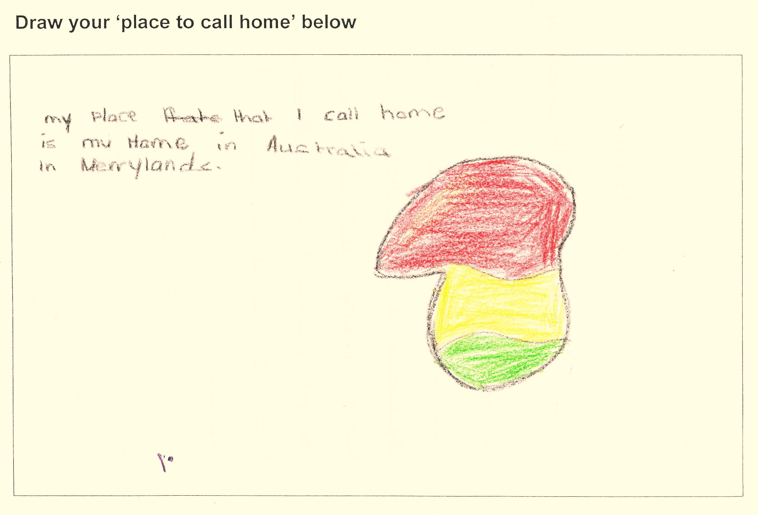

SPARK participant, 12 years old
Acknowledgements

Researched and Submitted by:

Clare Thompson (SPARK Coordinator, St Vincent de Paul Society NSW)
Virginia Francis (Refugee Liaison Officer, Catholic Education Office, Sydney)

Housing Section:

Cassie Douglas (Research Officer, St Vincent de Paul Society NSW)

Thanks to:

Madam Anna Dimo, Sudanese Community Leader; Salwa Alhag, African Community Settlement - Team Leader, Beatrice Sesay, African Women Caseworker and Edward Abu Bayor, Sierra Leonean Caseworker, Auburn Migrant Resource Centre; Suzie Stollznow, Migrant and Refugee Coordinator, and Cheryl Nolan, CHRSS Coordinator, St Vincent de Paul Society NSW; Mark Rix, Head of Communications, Catholic Education Office, Sydney; St Vincent de Paul Society NSW SPARK volunteers including Lynne Peterson, Tamara Malcolm, Gemma Peters and Janet Ho; Sr Johanna Conway rsm; Sally Macfarlane and David Hardie, Classroom Connect Project Co-ordinators, Mercy Works Inc.; Cameron Thompson, NAP Project Manager, Auburn Youth Centre; St Joseph’s Hospital, Auburn; the families and teachers from St John’s Primary School, Auburn and special thanks to the African community members who have been involved in our programs and forums, and entrusted us with their stories.

For further information please contact:

Clare Thompson, SPARK Coordinator, St Vincent de Paul Society NSW, spark@vinnies.org.au

Virginia Francis, Refugee Liaison Officer, Catholic Education Office, Sydney, virginia.francis@ceosyd.catholic.edu.au

“A place to call home is Australia and Africa. I came from Africa to Australia. A place to call home is home. I feel safe at home with my family.” SPARK participant, 8 years old.

Privacy Statement: The names of any students or participants featured in this report have been changed.
1. Introduction to “A Place to Call Home”

The Catholic Education Office, Sydney and the St Vincent de Paul Society NSW have pooled first hand knowledge and expertise to produce this submission in response to the Australian Human Rights Commission’s “African Australians: A Report on Human Rights and Social Inclusion Issues” discussion paper released in March 2009.

The objective of this submission is to share the voice of the students, families and individuals of African refugee backgrounds that access the specialised programs and services that the two organisations run.

The stories, quotes and information gathered for this submission come from participants in the services run by the St Vincent de Paul Society in Central Western Sydney and Coffs Harbour; and in the Sydney Archdiocese for the Catholic Education Office, Sydney.

The information for the submission was gathered through consultations and three community forums held for people of African backgrounds. Two of these forums were held in the Auburn area of Sydney and one in Coffs Harbour. The forums gave the community members who participated an opportunity to tell their stories, give their opinions and voice their concerns over the issues of housing and education. Individual interviews gave a more detailed account of the stories from some individuals and these are featured throughout the submission.

In 2008, the Refugee Council of Australia’s theme for Refugee Week was “A Place to Call Home” and this has become the title of this submission. Finding ‘a place to call home’ and settling into Australia can be difficult and distressing, especially for newly-arrived refugees and humanitarian entrants.

The St Vincent de Paul Society NSW’s SPARK program collected stories and drawings from 100 primary school children of refugee background illustrating in words and pictures what “A Place to Call Home” meant to them. Some of the children’s quotes and images are displayed intermittently throughout the submission.

Structure

The submission begins with an explanation of the two organisations involved in the preparation of this document. This is followed by summaries of the community forums that have been held in Sydney and Coffs Harbour which have informed our findings in the housing and education sections of the submission. Recommendations have been included with practical suggestions. The education section concludes the submission with examples of three successful programs that are currently working with schools to assist children and youth of refugee background.
“I live in Sudan, I live in Sydney, I love my chickens, I love my dog, I love god, I love my sister, I love my dad, I love my cat, I love my dog” SPARK participant, 6 years old

2. Organisations

2.1 St Vincent de Paul Society NSW

The St Vincent de Paul Society, a lay Catholic organisation, is one of the largest charitable providers in Australia with over 40,000 members and volunteers carrying out the good works of the Society. In NSW alone, 20,000 members and volunteers and 1000 employees work tirelessly to help people in every area of human need.
The aims and objectives of the St Vincent de Paul Society are to seek out and assist people in need, victims of exclusion or those dealing with adversity. The St Vincent de Paul Society serves everyone regardless of creed, ethnic or social background, health, gender, or political opinions. In addition to its core activity of giving material and financial assistance through home visitation, the St Vincent de Paul Society has a range of 'Special Works' or professional specialised services that are tailored to meet very specific needs, including: Matthew Talbot Homeless Services, Mental Health Services, Disaster Recovery and Crisis Relief, Disability Vocational Support, Domestic Violence, Supported Employment. In NSW there are 93 Special Works including the Society’s Migrant & Refugee Team.
The Migrant and Refugee Team aims to work within the Society’s overarching mission of 'a hand up'. Programs are designed to promote self reliance and empower people. This may be through the provision of material assistance or through helping people to build confidence, establish relationships and gain important information. Examples of such programs currently include the St Vincent de Paul Society Assisting Refugee Kids (SPARK) program and the Coffs Harbour Refugee Support Service (CHRSS).

2.2 Catholic Education Office, Sydney
The Catholic Education Office (CEO), Sydney is responsible for the leadership, operation and management of 147 parish primary and regional secondary schools in the Archdiocese of Sydney which educate almost 63,000 students. The CEO, Sydney employs almost 8,000 teaching and clerical staff with a central office located in Leichhardt and three satellite offices in the eastern region, southern region and the inner western region of Sydney.
Consistent with the goals of “Catholic Schools at a Crossroads - Pastoral Letter of the Bishops of NSW and the ACT”, the CEO, Sydney engages in outreach to students and families within its school communities and also to the marginalised and vulnerable in the wider community.
Students and staff in the Archdiocesan Catholic schools are vigorously engaged in a variety of charitable works. Schools support many charities including Caritas, the Charitable Works Fund Appeal and the St Vincent de Paul Society.
The CEO, Sydney has a long-standing commitment to programs that support the language development of English as a Second Language (ESL) learners. In addition to the provision of these programs, schools
have created structures to guide, inform and assist new arrival families through the process of settlement. In 2007 CEO, Sydney appointed a Refugee Liaison Officer to support schools in meeting the broader educational, pastoral and settlement needs of refugee students and families in consultation with a Refugee Advisory Committee. This committee includes students and elders from the Sudanese community.
As a partner in a joint venture with the Australian Catholic University, the CEO, Sydney continues to support three cohorts of Sudanese refugees undertaking studies in education, social work, nursing and business studies.

Jane’s story – Sydney

Jane was living in Newcastle with her husband and two sons until she was widowed in 2008. With no support available to her in Newcastle, she was encouraged to move to Auburn to be close to the Liberian community. She began to look for accommodation before moving to Sydney but has still been unable to find any accommodation. At present, her two sons live at separate locations, while she resides in accommodation elsewhere. It is this splintering of the family, especially in the wake of Jane’s husband’s death, which is most distressing. “I just want all of us in a house together, to be together again.”

Jane says she has faced considerable intolerance and bureaucratic loopholes from a number of public and private organisations. She had considerable difficulty communicating with real estate agencies due to language difficulties. She relays that a big problem is that real estate agents refuse to use interpreters.

Real estate agents ask for multiple forms of identification which makes it difficult for people newly arrived in Australia. Jane has also been asked to provide a passport photograph of herself to pass onto the landlord. Jane states that “I didn’t get anything because they knew I was African”. She strongly feels that there is racial discrimination from the real estate industry against them, and there are no protections for them.

The separation of the family has impacted on her children’s education. Because she takes the children to school, the boys are often late to class. This can be frustrating for everyone.

Jane wants accommodation as soon as possible so she can be close to the Liberian community to get the support she needs to come to terms with her husband’s death. While it is easier to access accommodation in Newcastle, that essential community support is absent.

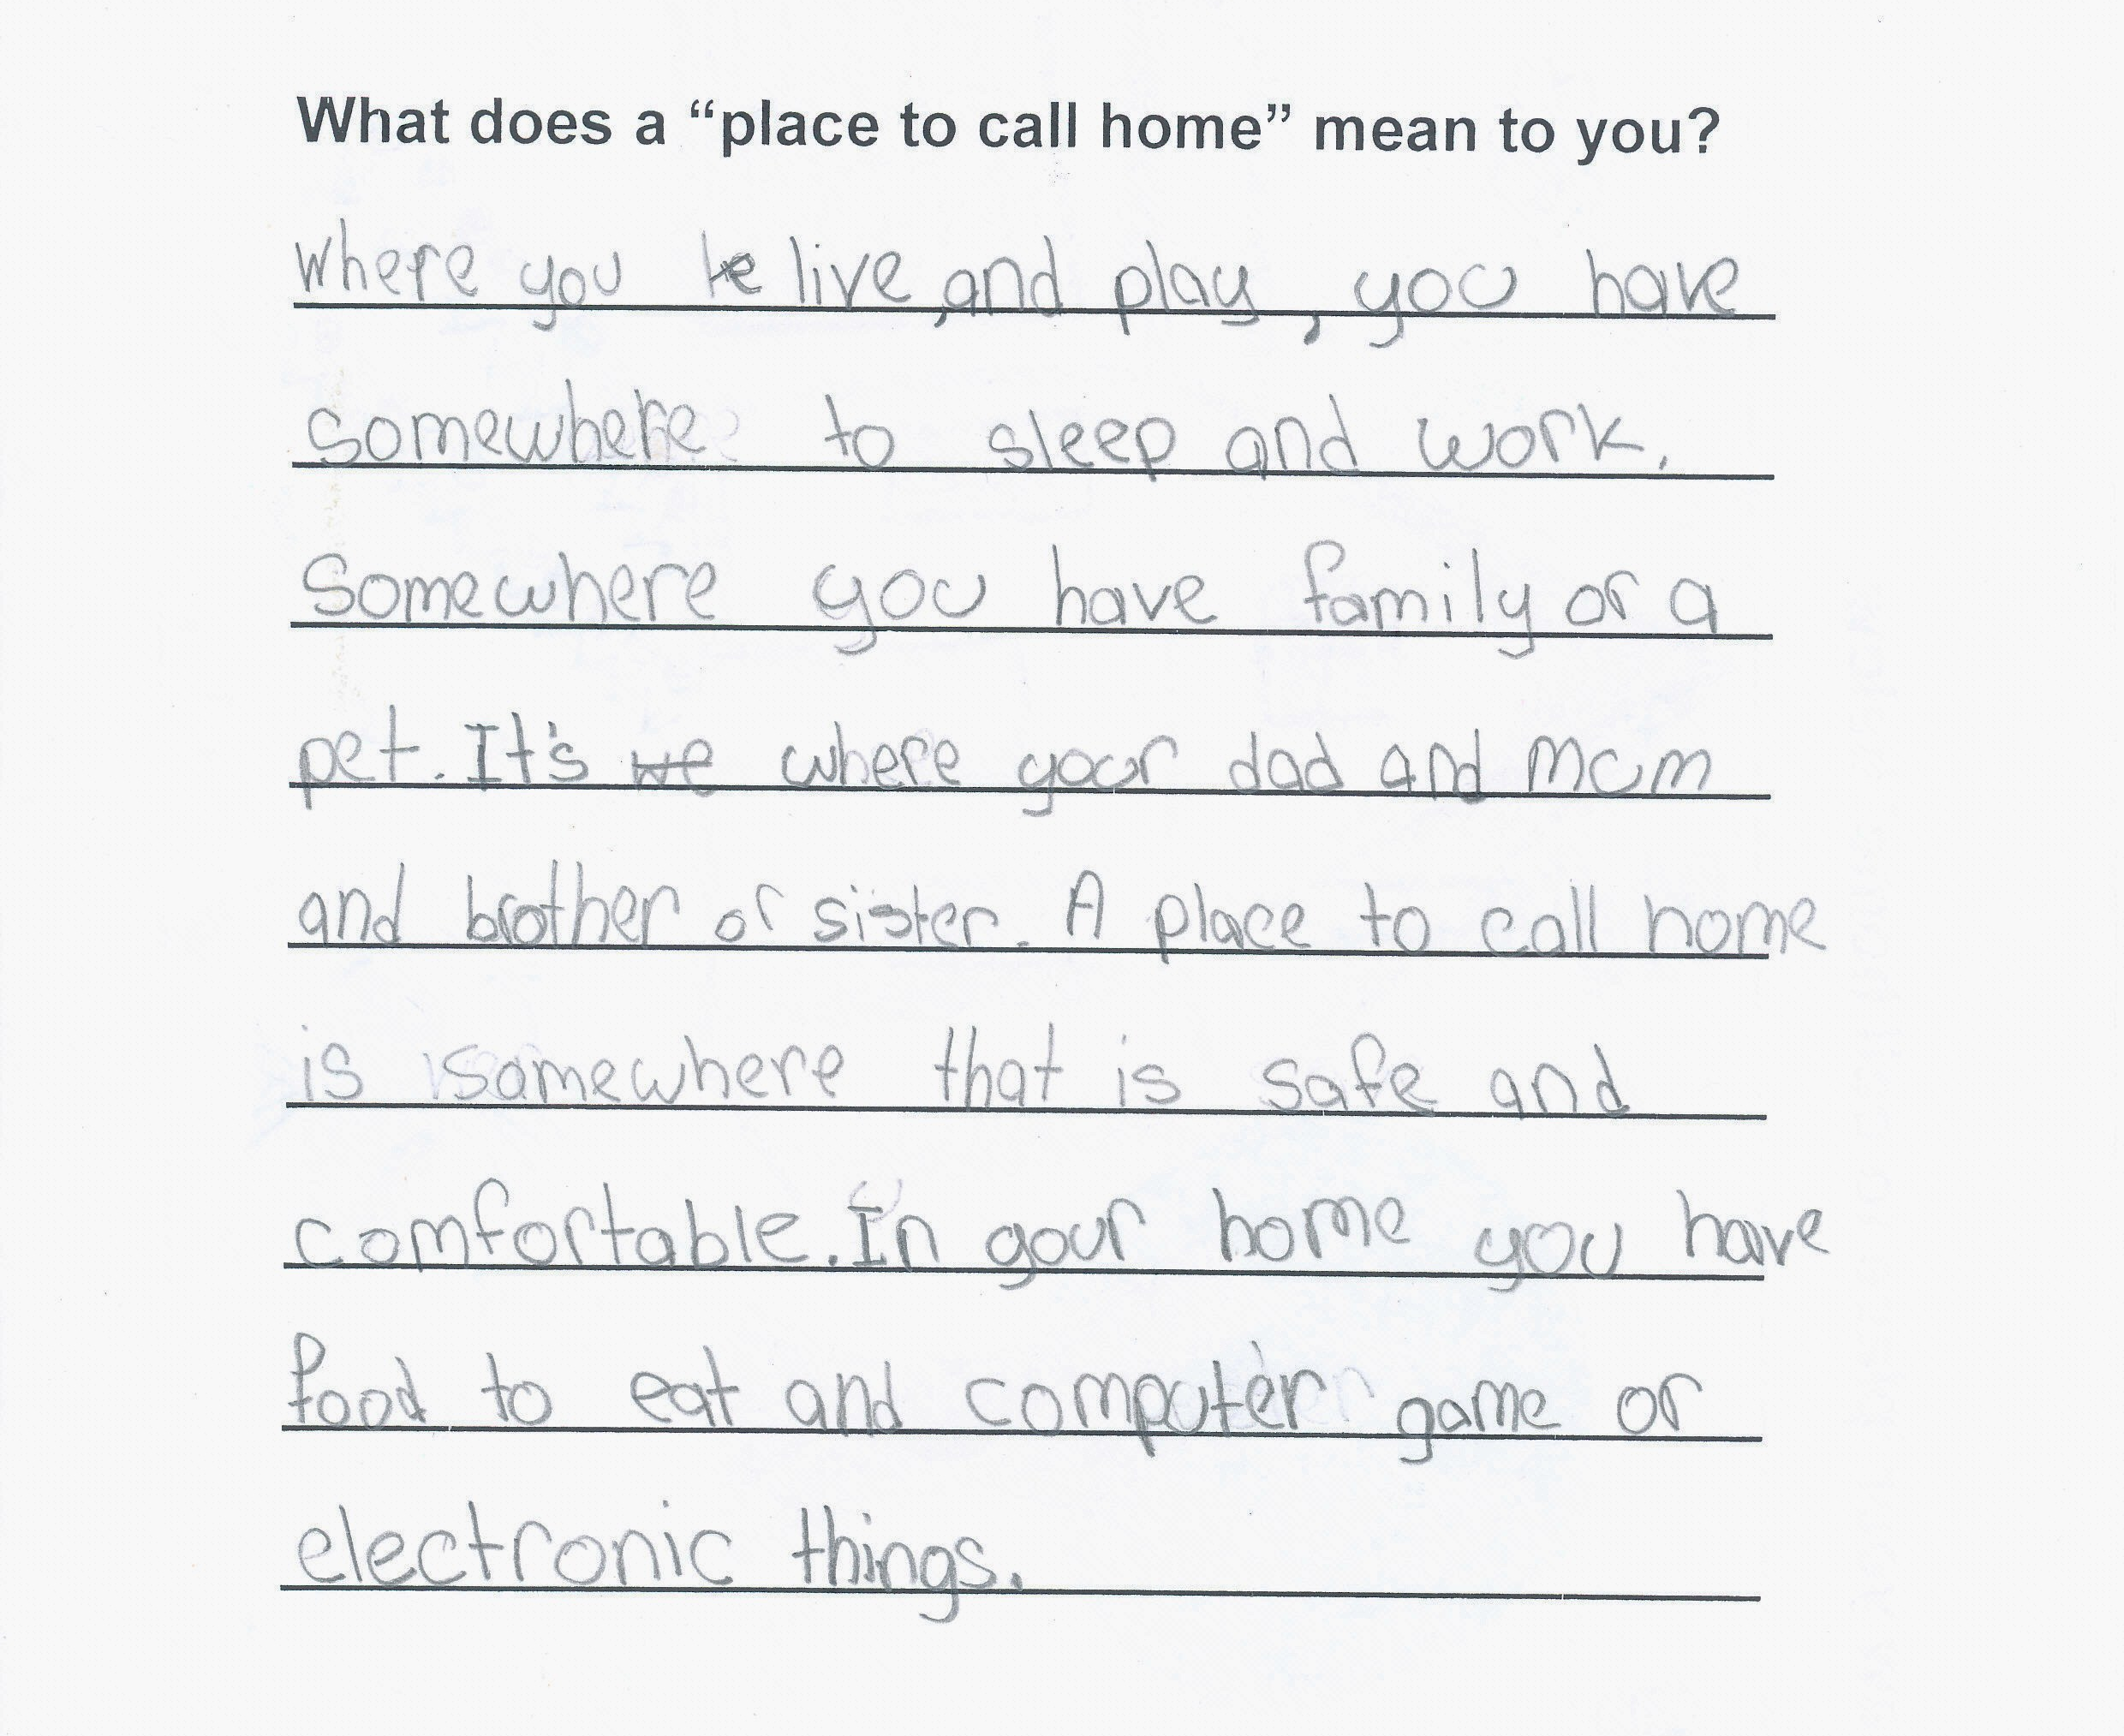
SPARK participant, 11 years old

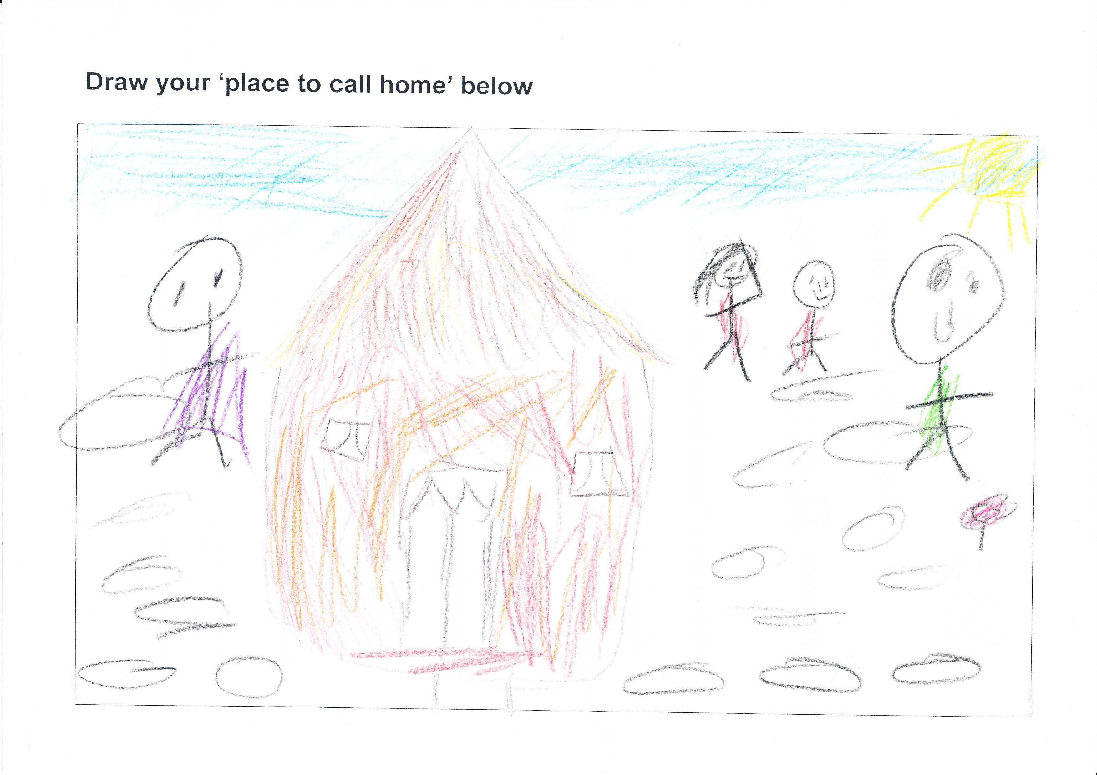

SPARK participant, 10 years old
3. Community Forums

3.1 Aims and Objectives of the African Community Forums

- To provide an opportunity for African community members in the Auburn and Coffs Harbour areas to participate in a forum on topics that were of significant interest to their communities, namely Education and Housing

- To encourage African community members to organise and lead community forums

- To raise awareness of the issues faced by the African communities within the mainstream community and service providers

- To assist service providers to recognise the areas of interest or concern to the African communities, and to address these issues by providing further support, services and information sessions, as required

- To provide important information that could be used in a report to government departments, the Human Rights Commission and service providers

Victoria’s story – Sydney

Victoria from Sierra Leone, arrived in Australia with her family through a sponsor. Not long after arrival, Victoria needed to find accommodation for herself and her son. She has found it very difficult to find housing, even for just two people. At present, her son lives in Mount Druitt with a cousin to be near his school, while Victoria lives in Bankstown, close to her work. Because of the travel needed to be in contact with her son, she has had to reduce her work hours to two days a week, which barely covers living expenses.

She strongly feels that she is discriminated against due to her gender and ethnicity. Although she has work and has only one child to care for, she still has housing applications rejected. At present, she shares accommodation under another name. However, Victoria is facing the risk of eviction, meaning that she will need to find accommodation again. She is tired of moving all the time and being separated from her son. She wants to be near her community and to feel at home.

3.2 Community Forums: Auburn, Sydney

3.2.1 Forum 1: Sharing Experiences I Sudanese Community Forum on Housing Issues

On Saturday 15 November 2008, the SPARK program of the St Vincent de Paul Society NSW and the Catholic Education Office, Sydney held a forum on the issue of housing for the Sudanese community in Auburn. 35 adults and 27 children attended the forum held at St Joseph’s Hospital, Auburn. It was the initiative of the CEO, Sydney and was organised in response to the considerable number of reports of Sudanese families in Auburn having difficulties with rising rents and tenancy issues and having to move further from schools and community. Of great concern was the number of families needing to relocate to new areas and therefore new schools. This was creating another layer of disadvantage for children in terms of their educational progress and opportunities to develop effective relationships.

The forum enabled the Sudanese community to voice their concerns and share their experiences about housing and the effect that the housing crisis was having on their families’ settlement in Australia.

The strongest theme emanating from the discussion was the impact of housing issues on the education of their children. Other key issues included feeling displaced, financial strain and changing family dynamics, public and community housing, dealing with real estate agencies, discrimination and having a place to feel safe.

3.2.2 Forum 2: Sharing Experiences I African Communities Forum on Housing Issues

The first community forum generated requests for a follow up to be held, involving the other African communities living in the Auburn area.

On the 1 April 2009 the CEO, Sydney and the SPARK program of the St Vincent de Paul Society NSW worked in collaboration with the Auburn Migrant Resource Centre to deliver a community forum focused on housing and education issues for the African communities in Auburn.

Guest speakers were invited from NSW Department of Housing and Macquarie Legal Centre. They provided information on rights and responsibilities in housing-related issues.

Over 40 participants from countries including Sudan, Liberia, Somalia, Sierra Leone, Democratic Republic of the Congo attended this forum, which was held at St Joseph’s Hospital, Auburn.

“A place to call home is where people stay. And where people feel comfortable to stay in”. SPARK participant, 10 years old

3.3 Community Forum: Coffs Harbour

A forum was held for the Sudanese community in Coffs Harbour on 12 May 2009. The forum was initiated by the St Vincent de Paul Society NSW’s Coffs Harbour Refugee Support Service to discuss housing issues and develop community led solutions. 50 members of the Sudanese community attended.

Rebecca’s story – Coffs Harbour

Rebecca is a single mother with 6 children. She originally arrived in Australia from Sudan.

Rebecca’s house in Coffs Harbour was badly damaged by floods. Rebecca was a good tenant and the real estate agent said they would accept her back into the house after the repairs were completed, however this was expected to take 6 months. She was assisted by Housing NSW who provided a room in a motel for her and her children, for 5 nights.

Rebecca and her children were subsequently required to move 3 more times, to different motels. Each time they were provided with one room. After agreeing that this situation was unacceptable, Housing NSW moved her to another motel, where Rebecca and her children were provided with 2 rooms. However this was an unsuitable solution, as the rooms were not near each other, which effectively separated her from her children.

Staying in motels presented a further problem, in that there were no cooking facilities, and Rebecca’s income was not sufficient for her and her children to eat out.

Housing NSW moved Rebecca to a three bedroom house with a kitchen, where she lived for more than 4 weeks.

Rebecca, with the help of the Coffs Harbour Refugee Support Service continues to view houses and so far has received sixteen rejected applications.

3.4 Summary of the Key Issues Raised

3.4.1 Community Forums - Auburn

- Rent increases – multiple increases and short notification periods

- Local schools such as St John’s Primary School in Auburn are the hubs of support of the community and provide much needed assistance to families

- A reluctance to move from Auburn area as families are settled and the children are settled at school

- Many families are forced to move numerous times due to issues such as rent increases

- Children having to change schools resulting in continued disruption to their schooling

- It is especially difficult for single mothers and unemployed parents to find housing

- The state of housing is often very poor – no running water, broken window panes, limited space for large families

- Health issues resulting from poor conditions in housing affecting children’s health and well-being

- The frequent rejection of housing applications by the Department of Housing and Community Housing applications being rejected

- Real estate agents and landlords not making repairs to the houses

A constant sentiment expressed throughout this forum was the desire to remain living in the Auburn district. Because families have established connections and developed meaningful relationships, Auburn has become, for them, a “Place to Call Home”.

3.4.2 Community Forums – Coffs Harbour

- Lack of interpreter services

- Difficult relations between real estate agencies and people of African refugee backgrounds

- High risk of homelessness

- Inadequate housing services for people of refugee background places pressure on other settlement services

- Low literacy levels impede housing applications

- African families are traditionally larger than the capacity of available dwellings

- Lack of African cultural awareness in the broader community

A place to call home: “village – house – family – church – life – God, live, sudan. Place, egypt, Australia, country born”.
SPARK participant, 8 years old

Warrah’s story - Sydney
After arriving in Australia from Sierra Leone, Warrah lived with around eight people, family and non family members, in a “big, expensive flat” with rent of $425 a week. The rent was divided between residents until some of the tenants moved out, leaving Warrah to carry the $425 a week rent on her own, and as caretaker to her four children. Warrah’s only income comes from a Centrelink benefit and she has been told that there is no prospect of her being employed because of language difficulties. The Centrelink benefit barely covers the cost of rent and basic needs, “We would go without food just to pay the rent. But I always pay the rent every week.” This has created great psychological, physical and emotional distress for Warrah, who has been hospitalised three times for a heart attack and for great mental distress.

Warrah has tried to look for alternative accommodation that is affordable and can house herself and her children. This has been the source of much anguish: “I put four applications in with real estate, they reject all of them.” One real estate agent expressed that landlords want people who have steady employment.

Warrah has also applied to the NSW Department of Housing, but has been placed on the ‘non priority’ waiting list. She has been waiting for three years, and nothing has eventuated. Support letters have been written for her but nothing has been resolved.

With these rejections, Warrah struggles to make the rent on her current place. All of her children want to leave the flat, so they do not continue to forgo basic needs such as food.

The greatest dilemma is the struggle to stay in Auburn. “Auburn is my community, my children go to school here, I want to stay here.” By staying put, Warrah is struggling to avoid any further relocation and distress for her family. That there are other members of her community in the Auburn area is a further incentive to stay. Warrah needs support from community workers who are able to communicate with her; she does not want to lose that: “Who else can I talk to?”

Warrah expressed that “I feel so alone and helpless. I have been in hospital three times. My children are not well.” At the end of it all, “I just want help to get cheaper accommodation that is close to my community as soon as possible.”

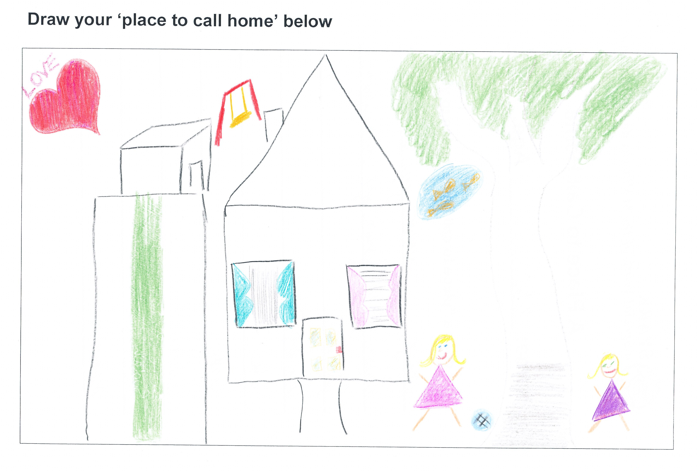

SPARK Participant, 11 years old
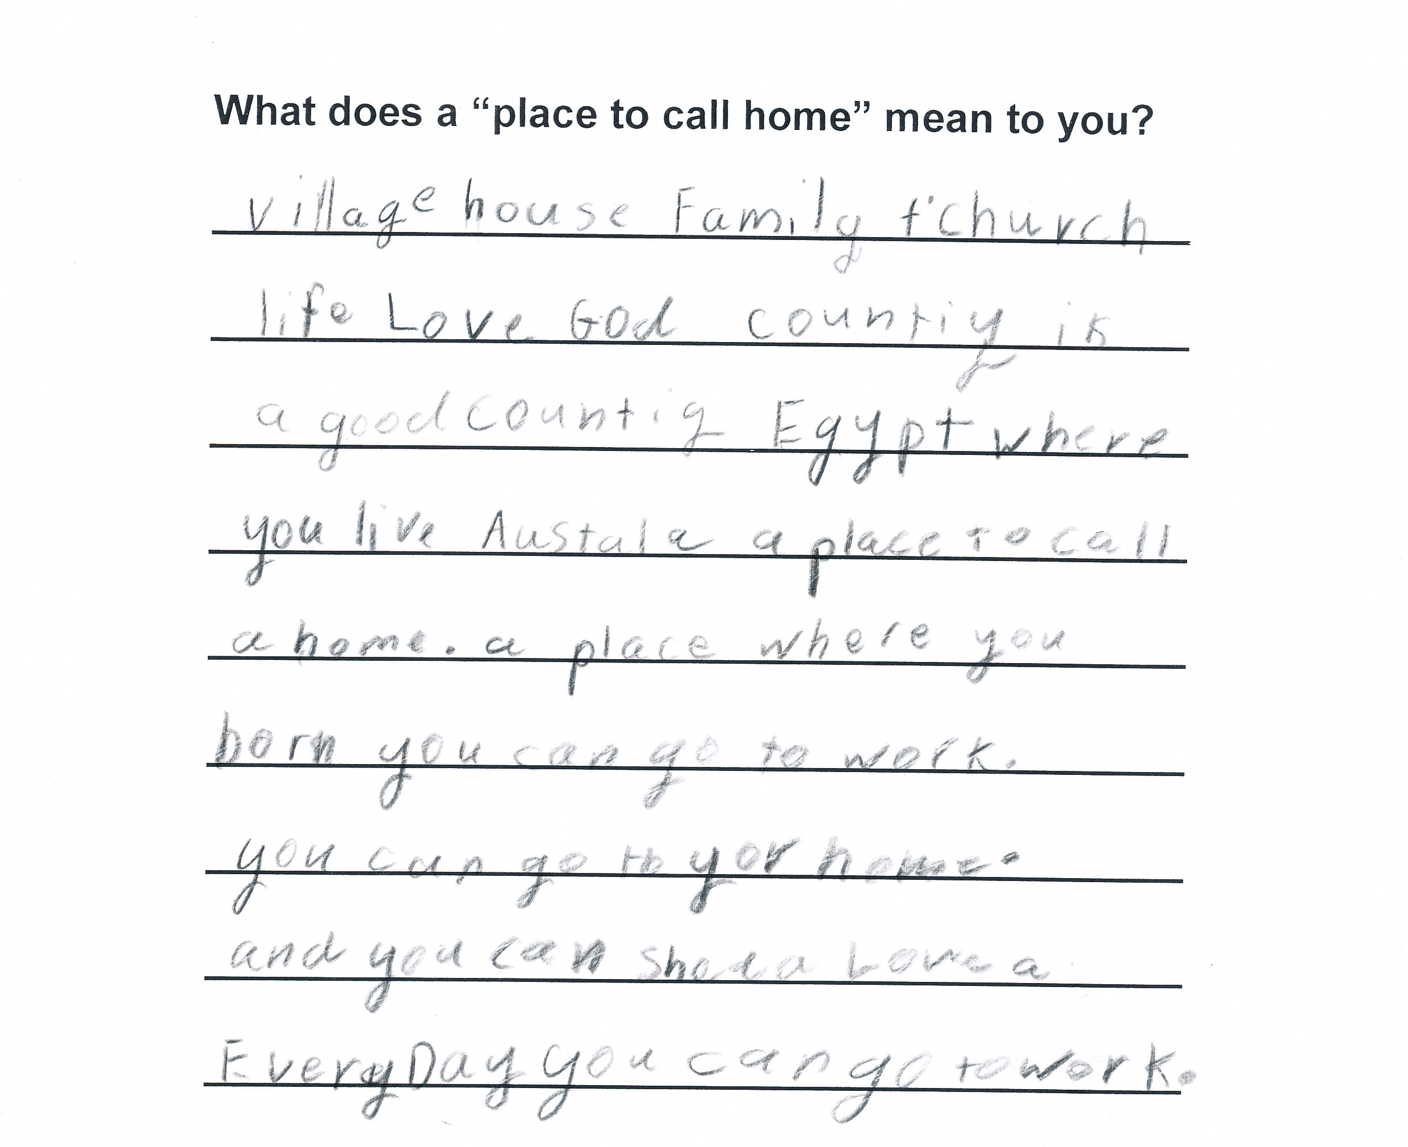

SPARK Participant, 10 years old
4. Housing

4.1 Housing Needs

4.1.1 Family Composition

Families of African backgrounds experience housing stress due to their larger family size. The African fertility rate is more than double that of Australia, which results in significantly larger families. It appears that families of African backgrounds experience difficulties on this basis, reporting that real estate agents are unwilling to house larger families.

4.1.2 Occupancy

The average occupancy rate in New South Wales is 2.7 persons per dwelling. Auburn’s occupancy rate is unusually high, at 3.1 persons per dwelling. This still fails to provide for families of African backgrounds, who display an average of 4.5 children per family. This is highlighted by an attendee of the Coffs Harbour Refugee Support Services (CHRSS) forum who asked,

“If I can not afford a house with enough rooms then how can I not break my tenancy?”

4.1.3 Services

Information regarding support services is not made readily available to people of African refugee backgrounds. This often has a detrimental impact on the part of the individual, as they feel lost in a highly complicated system. They often find themselves telling their story repeatedly, which both reinforces trauma, and acts as a disincentive to pursue service providers.

“We have no knowledge of where the agents or houses are.”
- Community forum attendee

Many of the issues raised by the attendees at the community forum in Auburn were of a practical nature, highlighting the lack of information available. The forums also revealed that the problem is further perpetuated by a lack of interpretation services for African languages.

“We need to know the law. We need to know that the real estate can’t increase the rent.”

- Community forum attendee
The Coffs Harbour Refugee Support Service (CHRSS) has documented similar barriers to access. Reports from clients of this service reported that at times Housing NSW seemed to be reluctant to employ interpreting services which created an additional disadvantage, for example completion of forms. Recently there has been an improvement in this area although access limitations have been placed on clients when this Translating and Interpreting Service is engaged. Clients reported that access to this service was a one-off opportunity resulting in a limited time to address complex and varied issues.

“We would be so grateful to know more about housing, we learn about school, and English and things like that, so if we learn more about the landlord’s rights and our rights, then we will be about to say “oh, okay, then this would be okay to do.”
- Community forum attendee

The CHRSS forum revealed that people of Sudanese refugee background in Coffs Harbour often reach the end of the Federal Government’s Integrated Humanitarian Settlement Strategy programme and still have little knowledge of the basics of sustaining tenancy. This indicates a need for services aimed at providing the skills necessary to navigate the private rental market.

4.1.4 Stereotypes

In order to combat negative stereotypes of African people there is a need to raise awareness amongst real estate agents about the experiences of people of African backgrounds. As highlighted at a community forum,

“Private real estate should be invited to learn about the issues of the Africans. I know when we arrive we get a lot of meetings, Public and Community Housing people go and meet the African people. Private real estates don’t know us.”

The CHRSS forum revealed increasing levels of frustration with African tenants breaking tenancy agreements, which is generally due to overcrowding, rental arrears or a failure to maintain houses to an adequate standard. Unfortunately the mistakes of a few have resulted in discriminatory behaviour towards all African clients.

“All black people are lumped in together – if one person does something wrong in a house, all blacks are blamed”
- Community forum attendee

CHRSS has reported the experience of a particular client, who has applied for and been denied 45 properties. Extremely high levels of rejection such as this are common both in Western Sydney and Coffs Harbour.

“A place to call home is where people sleep and eat and also have fun with your family if your house is small you still have to live in it.” SPARK participant, 10 years old
4.2 Access to Housing
4.2.1 The Right to Housing

Housing is a fundamental right, codified in the Universal Declaration of Human Rights.
"Everyone has the right to a standard of living adequate for the health and well-being of himself and his family, including food, clothing, housing and medical care and necessary social services, and the right to security in the event of unemployment, sickness, disability, widowhood, old age or other lack of livelihood in circumstances beyond his control".
Housing must be considered as a human right. It is commonly recognised as a right, and therefore must be acknowledged as a fundamental element of any society. The right to housing underpins many others, including education, due to its intrinsic provision of shelter, safety and stability.
4.2.2 Access

Waiting lists for public housing are unrealistically long. Some families who presented at the community forums reported that they are expected to wait up to twelve years for housing. Housing NSW confirms that “the private rental market in Auburn is not catering adequately to the needs of lower income households,” with 45% of those receiving Commonwealth Rent Assistance to be in housing stress, which places them at risk of homelessness. (Housing Stress indicates that households are committing 30% or more of their income to rent). As demonstrated by the chart below, Auburn displays a much higher increase in cost of rent than neighbouring Parramatta or Holroyd, further compromising rental affordability.
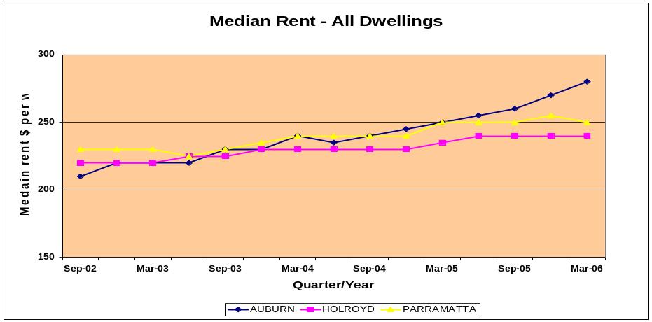
Median rents increased by 88% between September 2006 and September 2007 alone. A comparison with the 1.9% increase in Consumer Price Index for the same period illustrates the enormous stress that is placed on tenants in the area.

At the CHRSS forum, attendees expressed confusion and despair that the government was willing to assist their travel to Australia, but stopped short at providing secure housing. As illustrated by an attendee of the CHRSS forum,

“When they let us come – why don’t they have a plan for
settlement?”

4.2.3 Literacy

A common issue raised by people of Sudanese refugee background who have presented at CHRSS is a lack of literacy, and therefore an inability to complete forms required to secure both public and private housing.

“We can not read or write English so how can we fill in the forms? Real estate agents require a lot of paper – too many documents – how can we read them?”

- Community forum attendee

4.2.4 Impacts of Poor Access

Limited access to stable affordable housing impacts on children. The experience of many families of African refugee background is such that children are forced to move from school to school, as their families are compelled to move from dwelling to dwelling. This greatly undermines social inclusion for refugee families, hindering the child’s self-esteem and development. In the experience of people from African refugee backgrounds, children have in some instances been removed from parents as a result of insufficient housing. Families who are forced to separate lose their stability and sense of identity. When discussing this issue, a mother who attended one of the community forums in Auburn asked,

“Where do our kids go when they don’t know what help they can get? Where can Sudanese kids go and be kept safe?”

CHRSS (Coffs Harbour Refugee Support Service) has 128 active clients, of these, 13 have been homeless or at risk of homelessness over the past six months. Those who are homeless are often left with no choice but to stay with friends and family. This living arrangement routinely places pressure on the tenants, who risk eviction in order to support the homeless.

“Many youth are homeless at the moment”

- Community forum attendee

At the time of the forum, three clients of CHRSS were living in Housing NSW temporary accommodation. Housing NSW has indicated that will be unable to assist these tenants beyond a period of 28 days, and have not offered any options for alternative accommodation. They will therefore be homeless when this tenure expires.

“We don’t feel supported. How can we work without a house?”
- Community forum attendee

    - Community Awareness

Participants in the community forums expressed that the broader community has a limited understanding of their situation. They find that they are particularly confronted with this when dealing with real estate agents.

Experiences outlined at the forums indicated that real estate agencies are reluctant to rent to those without steady employment, demonstrating a lack of understanding as to the benefits that people of African refugee backgrounds receive from Centrelink. As described by one forum attendee,

“Real estate agents aren’t aware of automatic deductions of rent from Centrelink payments.”

A place to call home is: “…friend, family, house, countries (Sudan), comfort, Australia, family, car, food, water, trees, dad, mum, brothers, sisters. HOME”.
SPARK participant, 12 years old.

4.3 Housing Rights and Discrimination

4.3.1 Acts of Discrimination

African families of refugee backgrounds, find that their rent is increased at a far greater rate than that of the broader community. They have little choice but to accept the rental increases, due to the difficulty in finding adequate housing. Experiences shared at the forum reveal particularly discriminative acts on the part of the real estate agents and landlords.

“Real estate agents are singling out Sudanese – what
can we do?
- Community forum attendee

These acts include requests for interpreters being refused, and the requirement of a photograph of the applicant being submitted to the landlord. The success rate for rental applications for African families is very low, which has a terrible impact on the self-esteem of the applicant. Such feelings of uncertainty are illustrated by an attendee of one of the Auburn community forums,

“While they claim not to discriminate based on ethnicity, it is very different in practice.”

CHRSS has documented the experience of people of Sudanese refugee backgrounds when applying for tenancy in the private market; real estate agents in Coffs Harbour will accept African applications, however they often urge Africans to look elsewhere.

“The house I had, the owner said it was okay, but the real estate agent rejected it”
- Community forum attendee

    - Effects of Discrimination

Feedback from the forums indicates that families of African refugee background are reluctant to take legal action against landlords, for fear of compromising future rental applications. As reported by an attendee of one of the community forums held in Auburn,

“Most people have problems with real estate agents but we’re scared to take it further.”

They are therefore compelled to accept sub-standard housing conditions in the private market. This reportedly impacts both physical and mental health, particularly for children. When this occurs, parents are often left with no choice but to forgo work in order to stay and home and care for their children. Margaret is originally from Sudan, she attended one of the Auburn community forums and commented,

“I have lots of problems. I have an old house, and a very old carpet. The agent said they’d clean the carpet before we moved in, and they didn’t. The kids cough and wheeze.”

  - Housing Recommendations

- Cultural awareness training for real estate agents

- Increase awareness-raising campaigns on refugee settlement within the wider community

- The implementation of a dedicated housing support service

- Access to a Translating Interpreter Service (TIS) code for real estate agents to assist clients

- Incorporate “Multicultural Tenancy Project” training into the DIAC funded SGP/IHSS services’ delivery work plan

- Training and forums delivered on tenancy rights and responsibilities
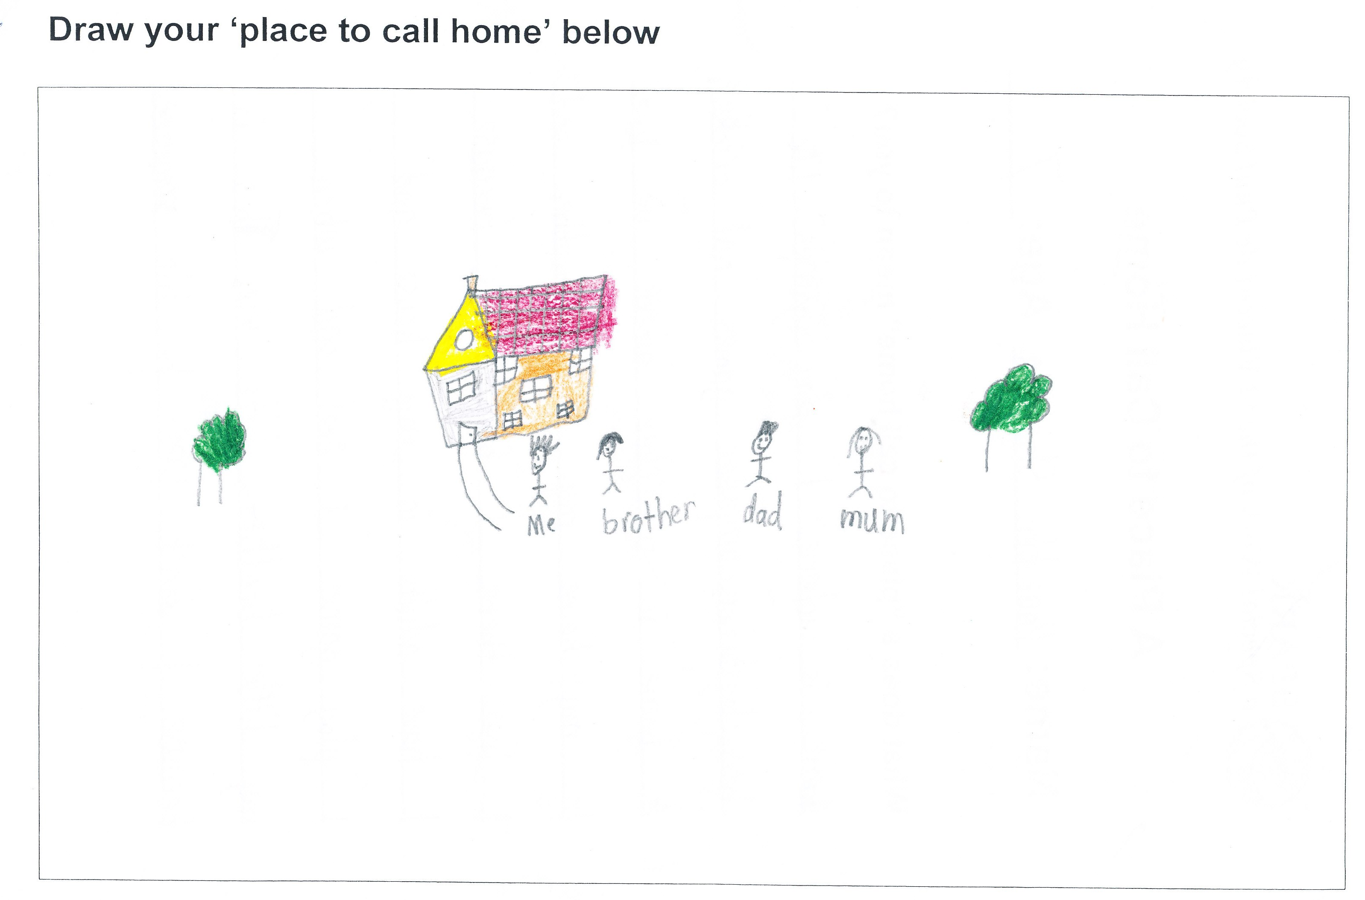
“A home is somewhere I feel safe. I came to Australia because my country was fighting. I came here because no one was fighting here. They all feel happy”. SPARK participant, 6 years old.

Claudine’s story – Coffs Harbour

Claudine is originally from Burundi; she speaks very little English, and is illiterate both in English and Burundi. There is only a small Burundian community in Coffs Harbour.

Claudine received notice to vacate her property by the 6th April 2009. She has had a poor history with this tenancy, however she had no problems with her sole previous rental property.

Claudine began searching for properties with the assistance of the Coffs Harbour Refugee Support Service (CHRSS) as soon as she received her notice in February. As of the 30th March Claudine had already been denied 16 rental applications. CHRSS contacted Housing NSW on her behalf, but Housing NSW were reportedly unable to assist until Claudine until she was actually homeless. CHRSS then contacted Coffs Harbour Accommodation Brokerage and Housing Support Service. They too were unable to assist, claiming that she must first approach Housing NSW.

Unfortunately for Claudine, severe flooding prevented real estate agencies from showing any properties or processing any applications between the 31st of March and the 6th of April.

On the 6th April Claudine’s furniture was removed from her house, and stored in her sister’s garage. Claudine then presented herself to the CHRSS office, as she and her 5 children had nowhere to stay that night.

Claudine and a CHRSS representative presented at Housing NSW that afternoon. The CHRSS representative relayed that Claudine and her children were now homeless, and urgently requested assistance in locating both short and long-term accommodation. The CHRSS representative explained that Claudine would need an interpreter, as provided by the Translating and Interpreting Service.

Claudine was given an appointment and the representative left her with the necessary documentation, including a RentStart application, a list of real estate applications and her Centrelink statement. However an interpreter was not provided. Claudine was given additional forms to fill out, with no assistance.

Accommodation was provided that night at a local motel, and another appointment with Housing NSW the following day. Again, CHRSS requested an interpreter on her behalf, however Claudine was unable to understand the interpreter, and once again, had nowhere to stay for that night.

Housing NSW closed for the day, and Claudine was left waiting outside the Housing NSW office. CHRSS accessed the After Hours Temporary Accommodation Line on her behalf in hopes of locating suitable accommodation for her and her children that night.

Since the eviction notice was issued in February, Claudine had applied for 45 properties. As of the 19th May she has been unsuccessful on each occasion. At this time Housing NSW was accommodating her and her children in emergency accommodation, which consisted of a two bedroom apartment.

It is becoming increasingly difficult for Claudine to apply for tenancy, as she has already had applications rejected for most of the properties on the market. The staff at the hotel where Claudine was residing during this time are reportedly very impressed with Claudine, and have offered to provide her with a reference.

At the time of writing, Claudine had another appointment pending with Housing NSW. They have indicated that they have exhausted all of their accommodation avenues with her, and that they are unsure if they are able to offer her further assistance.

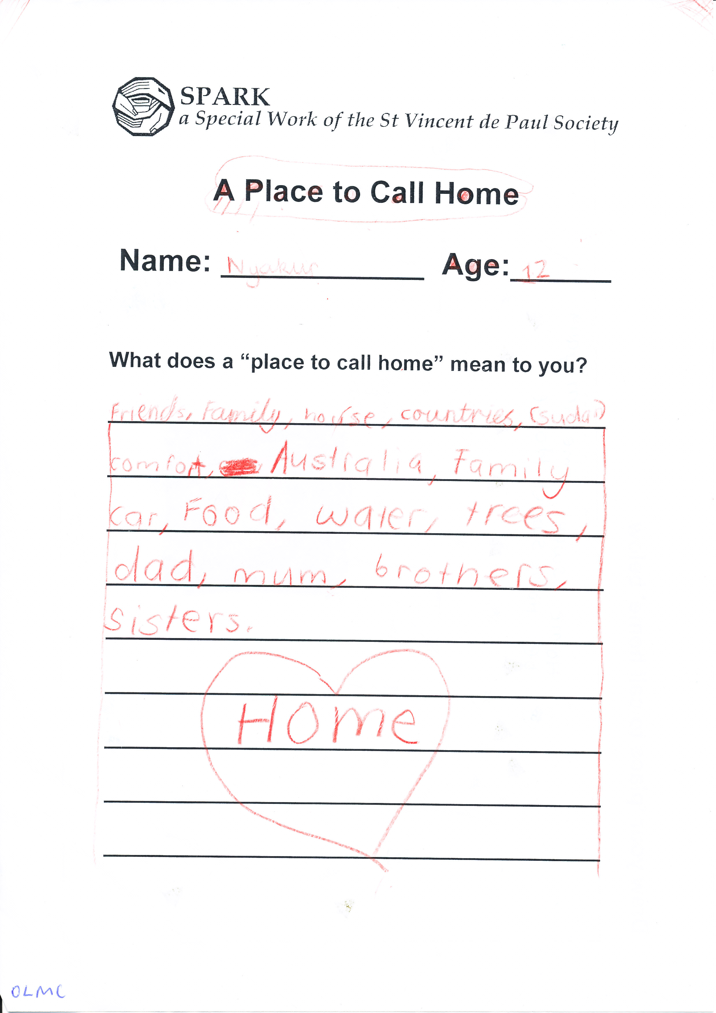
SPARK Participant, 10 years old
5. Education

5.1 Access to Education

5.1.1 The Right to Education

Education is a right that has been enshrined in numerous international and national instruments.

“Everyone has the right to education. Education shall be free, at least in the elementary and fundamental stages. Elementary education shall be compulsory. Technical and professional education shall be made generally available and higher education shall be equally accessible to all on the basis of merit.”

Taking a rights-based approach to the provision of education emphasises the entitlement to education rather than the need. Education complements and links to other fundamental rights; it aids protection and overall well-being. The provision of education must be regarded as a ‘human right’ rather than a service, a privilege or an option.

    - Education as a Priority

Education is a priority for people of African refugee backgrounds arriving in Australia. Many adults, particularly girls and women, have been denied a formal education both in their countries and in countries of asylum. The priority for refugee families is that the children have access to education. Accessing education is not only about being placed in a school or classroom but also about being able to participate. Challenges remain in the provision of education to refugee children and youth at primary and secondary levels. In order to ensure that refugee children and youth access education in Australia at the same level, additional educational support is required.

5.1.3 Barriers to Inclusion

Adjusting to the formal education system and learning environment in Australia can create challenges for some African Australian students. The challenges are now well documented in professional journals and research papers. However, the complex and ever-changing needs relating to bridging literacy gaps and overcoming social disadvantage often continue to present as barriers to an effective and equitable education or vocational pathway for many refugee students. On 11 May 2009 at a school community consultation held in Ashfield, Sydney, NSW, parents, carers and students identified the following as issues of concern:

Pathways/ Future Directions

- Vocational and educational options

- Skills in effective decision-making when selecting subjects

- Apprenticeship placements - what are the options?

- Age / year-level issues

Partnership with Schools

- Language barriers

- Homework help - parents feel they do not have the capacity to provide support

- Internet safety - hard to control what students are looking at on the net

- Assessment - parents may not be aware that an assessment is due or how to help

- Changing family dynamics

- Misunderstandings misinterpreted as racism

- Students not informing parents about activities or seeking permission

The consultation also provided an opportunity for students to acknowledge factors that were having a positive impact on their academic progress and general well-being, including:

- (ESL) English as a Second Language support and caring teachers

- Pastoral care structures

- Access to and support from the principals and their executive staff

- Volunteers and tutors

- Homework clubs and access to computers

“A place to call home is our family, friends, our homes, animals, our community and our school. A place to call home means loving and respecting everyone”. SPARK participant, 10 years old.

5.1.4 Importance of Stability

Another barrier to education for children and youth of refugee background is a lack of consistency and stability due to repeatedly changing schools. At the community forums, people talked about the cyclical feeling of instability. They described the “…constant anguish, not being settled, not settled in Sudan, same here in Australia” and the feeling of “… being chased away (from Auburn), like in Sudan”.

The shortage of accommodation, employment and the high cost of living in Sydney have resulted in many families of refugee background moving to regional areas or interstate. This instability has a detrimental effect on the children as they struggle to resettle into new schools and new areas, and to make friends and connections again. At the community forums, there were reports of some families having to move every six months, resulting in their children shifting from school to school.

African families of refugee background also find there are often limited services in the new areas. Families with children attending St John’s Primary School in Auburn have found that the school offers additional services for the African communities, including mother’s groups, play groups, community liaison officers and after school programs (including SPARK). However, when families have had to move to areas such as Orange or Wagga Wagga, they find these services to be lacking or non-existent. One participant at the Auburn community forum shared:

“Not happy in house, scared. Am not safe. Can’t find a house. Went to Brisbane. No properties. Want to stay in Auburn. Might have to move to Orange now. My wife is sick. Mental illness. My children are sick. No housing”.

The stress and pressure on parents and carers to provide for their families, and keep them safe, impacts on the children. The families emphasise the importance of community in Auburn and that schools such as St John’s Primary School, Auburn provide vital links and support.

5.1.5 Beyond the Classroom

It is widely acknowledged that education encompasses more than cognitive academic learning.

“The States Parties to the present Covenant recognize the right of everyone to education. They agree that education shall be directed to the full development of the human personality and the sense of its dignity, and shall strengthen the respect for human rights and fundamental freedoms”.
International Covenant on Economic, Social and Cultural Rights 1966, Article 13 (1).

Exploring alternative ways of delivering educational assistance to children, youth and adults of refugee background is essential. Education for social well-being goes beyond literacy and academic skills. The 2007 UNHCR ExCom ‘Conclusion on Children at Risk’ highlighted access to education ‘at all stages of the displacement cycle’ for refugee children. The document also recognised the importance of additional educational activities that are essential for refugee children and youth including ‘life skills, vocational training, recreational activities, sports, play and cultural activities’.

Providing additional educational assistance at the primary and secondary levels can be done through informal yet structured and supportive environments that not only focus on the academic outcomes but also build self-esteem, create stability and increase confidence.

  - Education Recommendations

- The establishment of long-term educational assistance programs for newly arrived children and youth of refugee background in government and non-government schools

- An increase in awareness-raising campaigns on refugee settlement within the wider community

- Increase in the number of Refugee Community Liaison Officers in schools

- Additional training for teachers, Boards of Education and others involved in the education of people of refugee background

- The formation of a collaborative, national, education-focused network for government and non government agencies involved in the provision of education to people of refugee background

- Ensure that people of African Australian backgrounds have access to positions on decision-making bodies

- Encourage further family involvement in schools

- Increased educational assistance in regional areas

- Training of more teachers of African background

- The implementation of additional educational assistance programs such as SPARK, Classroom Connect and NAP in schools that have significant numbers of newly arrived children and youth of refugee background

“My place is called home because I have shelta and food, and we have some were to sleep and it’s the best to have a place to call home.”
SPARK participant, 12 years old
  - Educational Needs for African Australian Students

Examples of programs providing additional support to African
Australians during their education:

- SPARK, St Vincent de Paul Society NSW –
for primary school students and their families
- Classroom Connect, Mercy Works Inc –
for secondary students
- NAP (Newly Arrived Pathways Project), Auburn Youth Centre Inc. – for secondary students

5.3.1 SPARK - St Vincent de Paul Society Assisting Refugee Kids,
St Vincent de Paul Society NSW

In 2006, the Migrant and Refugee Committee of the St Vincent de Paul Society NSW established SPARK to aid in facilitating the settlement of refugee families and their children, through educational, social and cultural programs.

A variety of settlement services exist that provide support to youth, parents and families as a whole. However, there are only a few services targeting primary school-aged children of refugee background. SPARK is focused on providing support at an early phase in the refugee child’s life in Australia and through that support maximising the capacity of the refugee child to engage fully in Australian society.

Settlement services generally have tenuous links to the education system. SPARK bridges that gap, promoting understanding and collaboration between services, families and communities. The program is also unique as SPARK operates within the NSW Department of Education and Training, as well as in the Catholic School system in two dioceses. SPARK has the potential to be implemented in every school with groups of newly arrived refugee students.

SPARK has been implemented in six Central Western Sydney primary schools with significant numbers of refugee students. There are currently 160 children aged five to twelve participating on a weekly basis. The majority of the children on the SPARK program are from African refugee backgrounds from Sudan, Sierra Leone, Zimbabwe, Liberia, Ethiopia and Uganda.

The project aids in refugee/humanitarian entrant settlement, raises mainstream community awareness about refugees, and provides opportunities for social contact and mutual appreciation between refugee and mainstream communities. SPARK is informed by an ecological approach to child development and well-being, with programs that empower the child, as well as their family, school and wider community.
SPARK harnesses the power of schools to act as hubs of community engagement and support. The programs involve over 200 community members as volunteers and draws on community resources to find local solutions to common issues, thereby enhancing existing networks and building new networks of exchange, trust and reciprocity. SPARK aims to enhance community strengths and build relationships that are self sustaining, developing refugee and mainstream communities’ capacity to support and celebrate each other long term.

Encouraging the involvement of parents/ carers in schools and the education of their children is important. Schools are symbols of hope for the future, for children, their families and the community. SPARK is adaptable and mobile. The project responds to schools’ needs and is comprised of several programs which take a holistic approach in supporting the settlement of refugee children. The SPARK program includes an after school and activities club run in partnership with the primary schools, family support groups which include life skills and settlement support, community forums and mainstream community awareness programs.

SPARK is a Special Work of the St Vincent de Paul Society NSW and has funding from the Australian Government Department of Immigration and Citizenship under the Settlement Grants Program. In June 2009 SPARK was awarded a Refugee Humanitarian Award for “Best Local Project Supporting Refugees” by the Refugee Council of Australia and STARTTS.

SPARK Program:

Bright Sparks

Bright Sparks is an after school homework and activities club for refugee children in Kindergarten to Year Six. It is run by teachers and local community volunteers. Children develop confidence in themselves as they are supported to understand and complete school work, enjoy creative and recreational activities and interact and develop relationships.

Little Sparks

Little Sparks is a child-minding group for pre-school refugee children who have siblings attending Bright Sparks. Professional child care is provided so the parents/ guardians are able to attend the Family Group. Little Sparks is aimed at introducing the children to the school environment and developing their early learning skills through games and activities.

Family Group

The Family Group is run concurrently with Bright Sparks and Little Sparks, so parents/ guardians can practise English, gain support from each other and volunteers, and establish relationships with teachers, other parents/ guardians and community members.

Community Forums

Community forums link community members from the schools involved in SPARK to join together to discuss topics such as housing, parenting, education and nutrition. Presenters from service providers deliver information on settlement issues.

Mainstream Community Awareness

An important element of this program is raising mainstream community awareness about refugees and especially the new members of the school community. This increases knowledge and understanding, promotes acceptance and stimulates interaction and mutual appreciation within the local community.

Comments on SPARK

The schools:

“Our students received individual support and individual contact with an adult which has been enormously beneficial for them. The children were given assistance and support with their homework that they (for the majority) would be unable to get at home. The children formed friendships with each other and the volunteers and this is important for their overall well-being. It also provides the children with opportunities to ask questions which they would normally feel too shy to ask in class.”

“The children loved the interaction, interest and friendship of the volunteers...We are truly appreciative of all you do for our school.”

“SPARK has supported our children’s learning and growth in a big way. This program has been an invaluable resource in our school.”

The volunteers:

“It was a wonderful and engaging experience.”

“It’s a fantastic program and I’m so glad I discovered it”.

“I feel very strongly committed to the aims of the program and am very supportive of its extension to other schools. The children are superb.”

The students:

“It is fun. We learn lots of things. Our helpers can help us. It’s fair that they don’t tell answers. Everyone is kind and helpful. They always say ‘good try’ and nice things.”

“I think that it’s really helpful for my work. It’s fun, enjoyable and sometimes hard but it’s OK when me and my partner get through it. I like it because my helper helps me when I don’t understand some things”.

“I think the Bright Sparks homework club was the bestest place to have fun and games. My teacher taught me all sorts of things like my times table and what synonyms mean. It was the best fun in my life”.
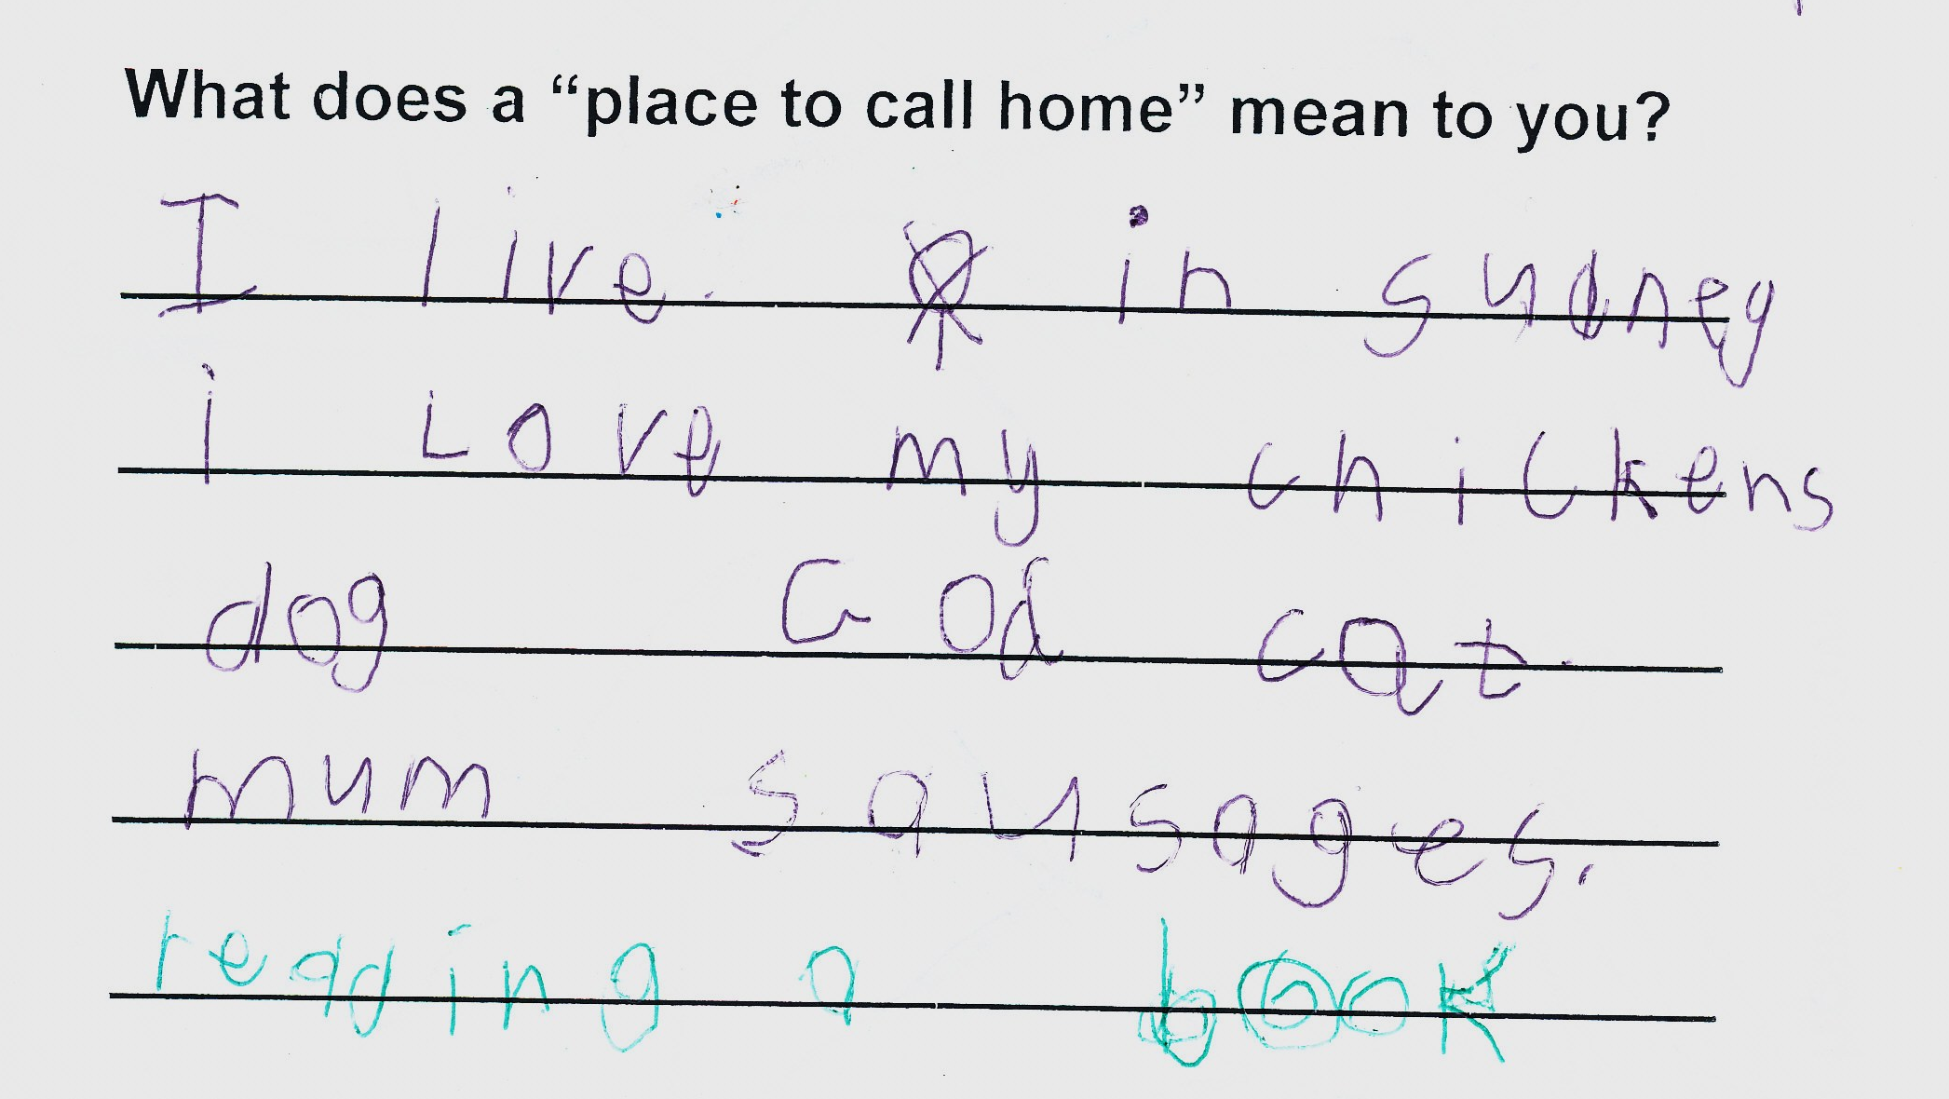

SPARK participant, 8 years old
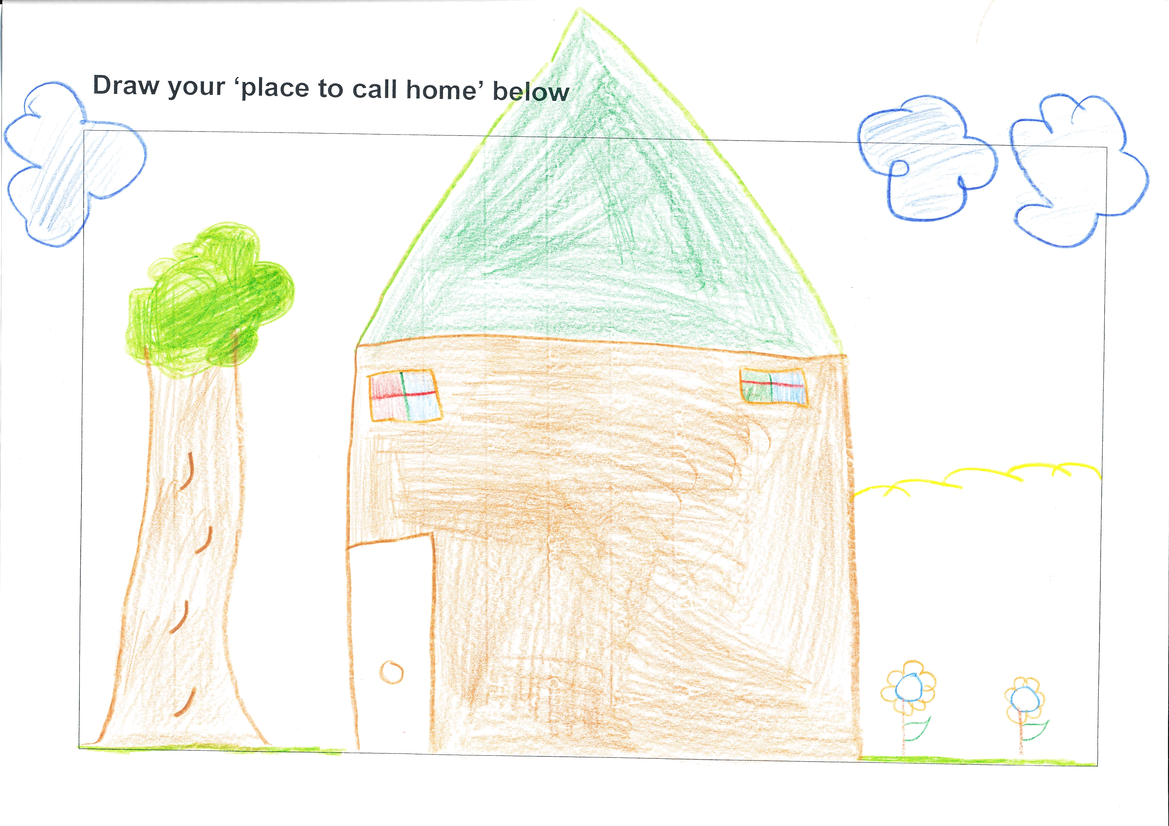
SPARK participant, 9 years old
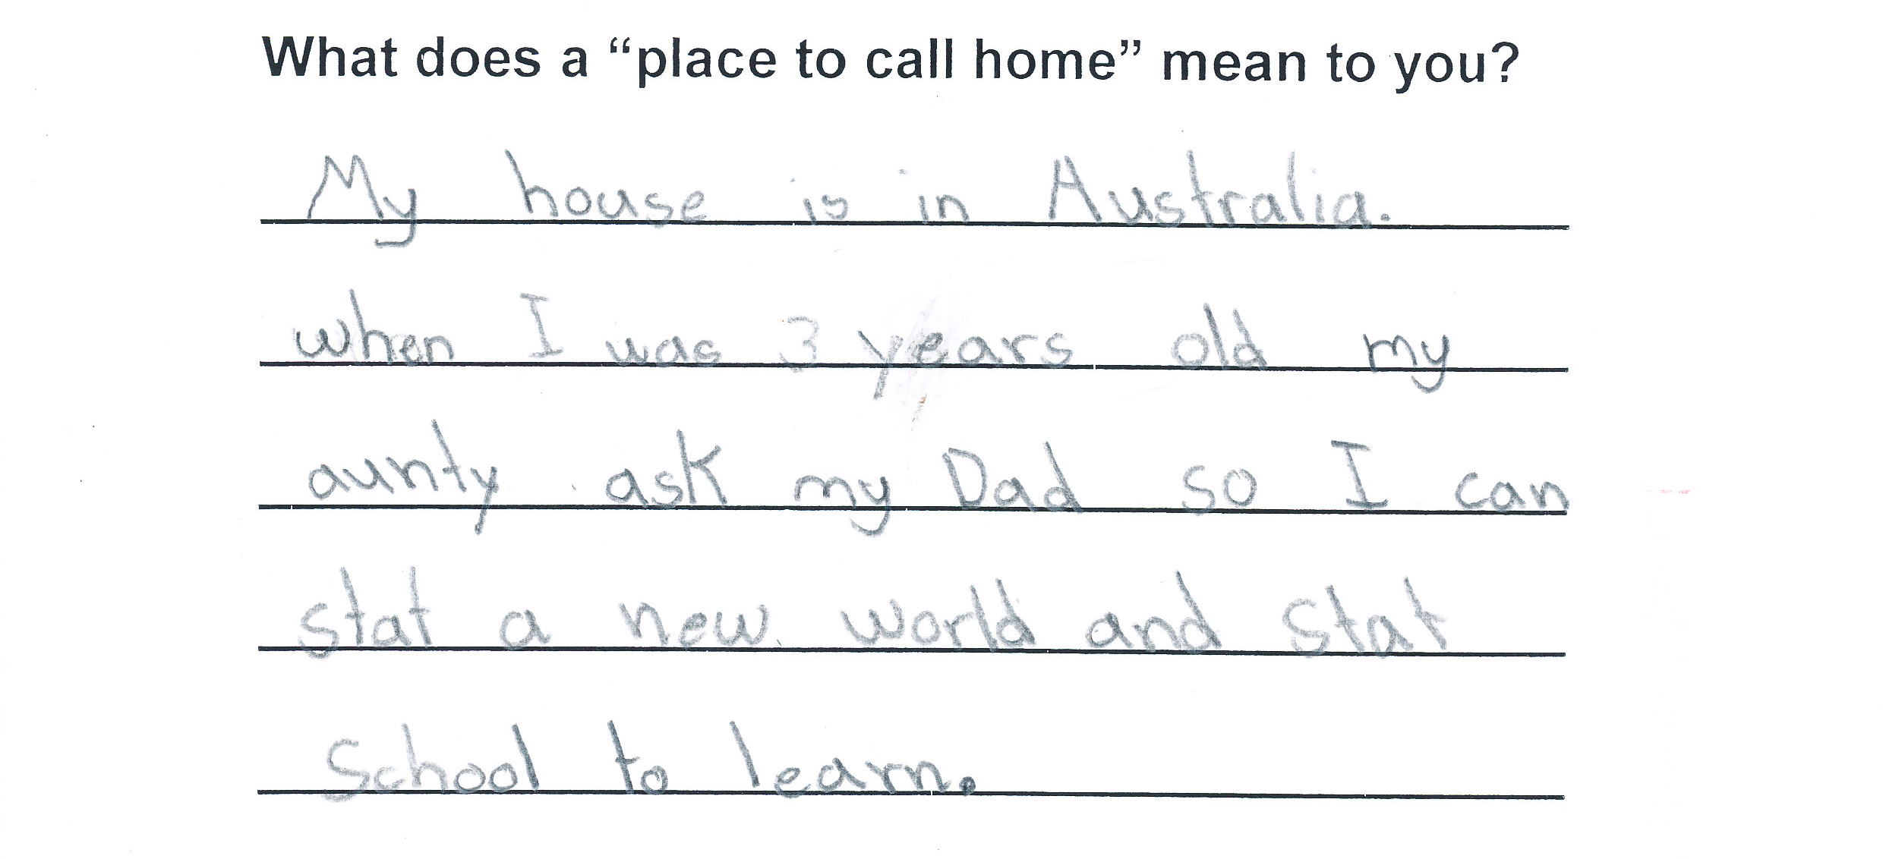 SPARK participant, 8 years old
5.3.2 Classroom Connect Project, Mercy Works Inc

Mercy Works Inc.

Mercy Works Inc. is an Incorporated Association that supports the local and overseas relief and development activities that are part of the vision and mission of the Institute of the Sisters of Mercy of Australia. Mercy Works programs engage in partnerships with communities to promote justice, self reliance and to support displaced people and communities who are denied access to basic resources such as education, health care and social welfare. In Australia, Mercy Works offers community education in world development concerns, provides assistance with refugees and works in partnership with Indigenous peoples.

Classroom Connect Project

A project of Mercy Works Inc. in partnership with the Catholic Education Office, Sydney, the Classroom Connect Project is a targeted educational intervention that uses the extensive educational experience of trained volunteers to provide additional in-school support to refugee students at a critical time in their settlement in Australia.

The project provides support to refugee students in Years 7-12 in CEO, Sydney schools. It currently operates in 7 schools with 25 volunteers supporting approximately 100 refugee students.

The project has been developed from a strong research base. In summary, the research identifies a number of learning barriers faced by refugee students, including:

- Interrupted schooling and acquisition of literacy

- Unfamiliarity with subject specific language

- Limited cultural knowledge

- Lack of familiarity with approaches to teaching and learning

- Anxiety and isolation

Students have to quickly adapt to academic learning as well as the expectations, rules and procedures of schools and classrooms. These challenges occur at the same time as they are learning a new language and adapting to different socio-cultural expectations and living environments.

The educational challenges facing refugee students are significant and the use of skilled and trained volunteers (in this case retired school teachers) is a creative way of accessing significant and relevant experience for schools. Targeting this group to a student cohort with major educational challenges helps to supplement the existing, often stretched resources within schools. It enables the educational system to retain access to a valuable resource who have recently left formal employment. It also provides the volunteers with the opportunity to continue to use their skills in a flexible way that complements the other activities in their lives. The project thereby has benefits for the schools, the volunteers and the refugee students.

Volunteers work with refugee students for approximately three hours per week for one school year, focusing on assisting the educational transitions of students. The key responsibilities of the volunteer are to assist newly arrived refugee students in their learning by providing support that nurtures student well-being and self-esteem. Volunteers provide literacy and numeracy support and assist students in understanding classroom instructions, assessment tasks and in organising their school work.

Underpinning the work of the volunteers is a comprehensive project structure, including:

- Processes for recruiting (formal application, interview and
referee checks) , training (2.5 days) and ongoing support
(quarterly information sesions) to volunteers.
- Partnerships with participating schools including the integration
of the volunteer role with other school support service and in-
school coordination by a dedicated member of staff.

The Desired Outcomes of the Classroom Connect Project are:

- Refugee students receive targeted classroom assistance during
periods of transition through the education system
- Refugee students form an effective relationship with an adult
mentor to build self-esteem and social skills
- Refugee students receive literacy and assignment support
- Refugee students become more confident learners
- Schools receive additional targeted educational support
- Volunteers receive training and ongoing assistance to build their
understanding of the needs of refugee students.

Words from our students…

“You feel good when they help you”

“She helps me with everything. I like her so much and she is very good and kind”

“She is like my sister and she is nice. We get along very well. She jokes and I joke. She talks and I talk”

“I want her to keep coming so she can help me more and I can understand more”

“When we get an assignment we do half and wait for the tutors to come and help”

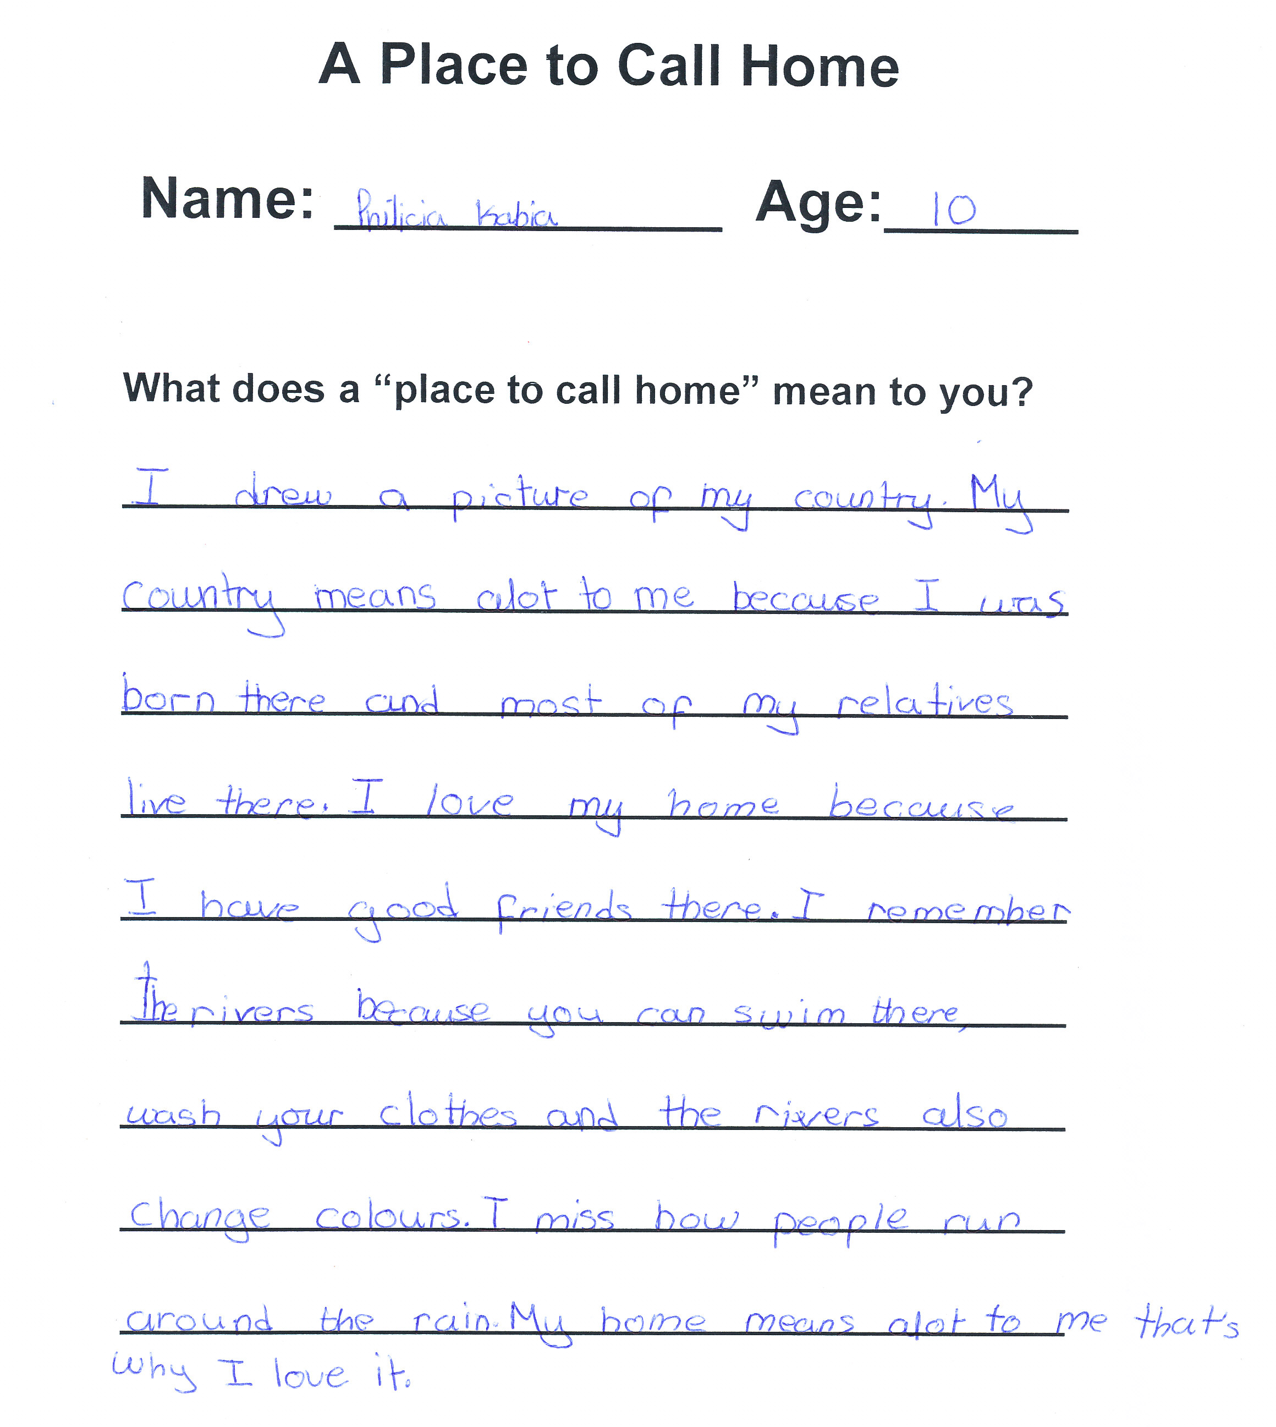

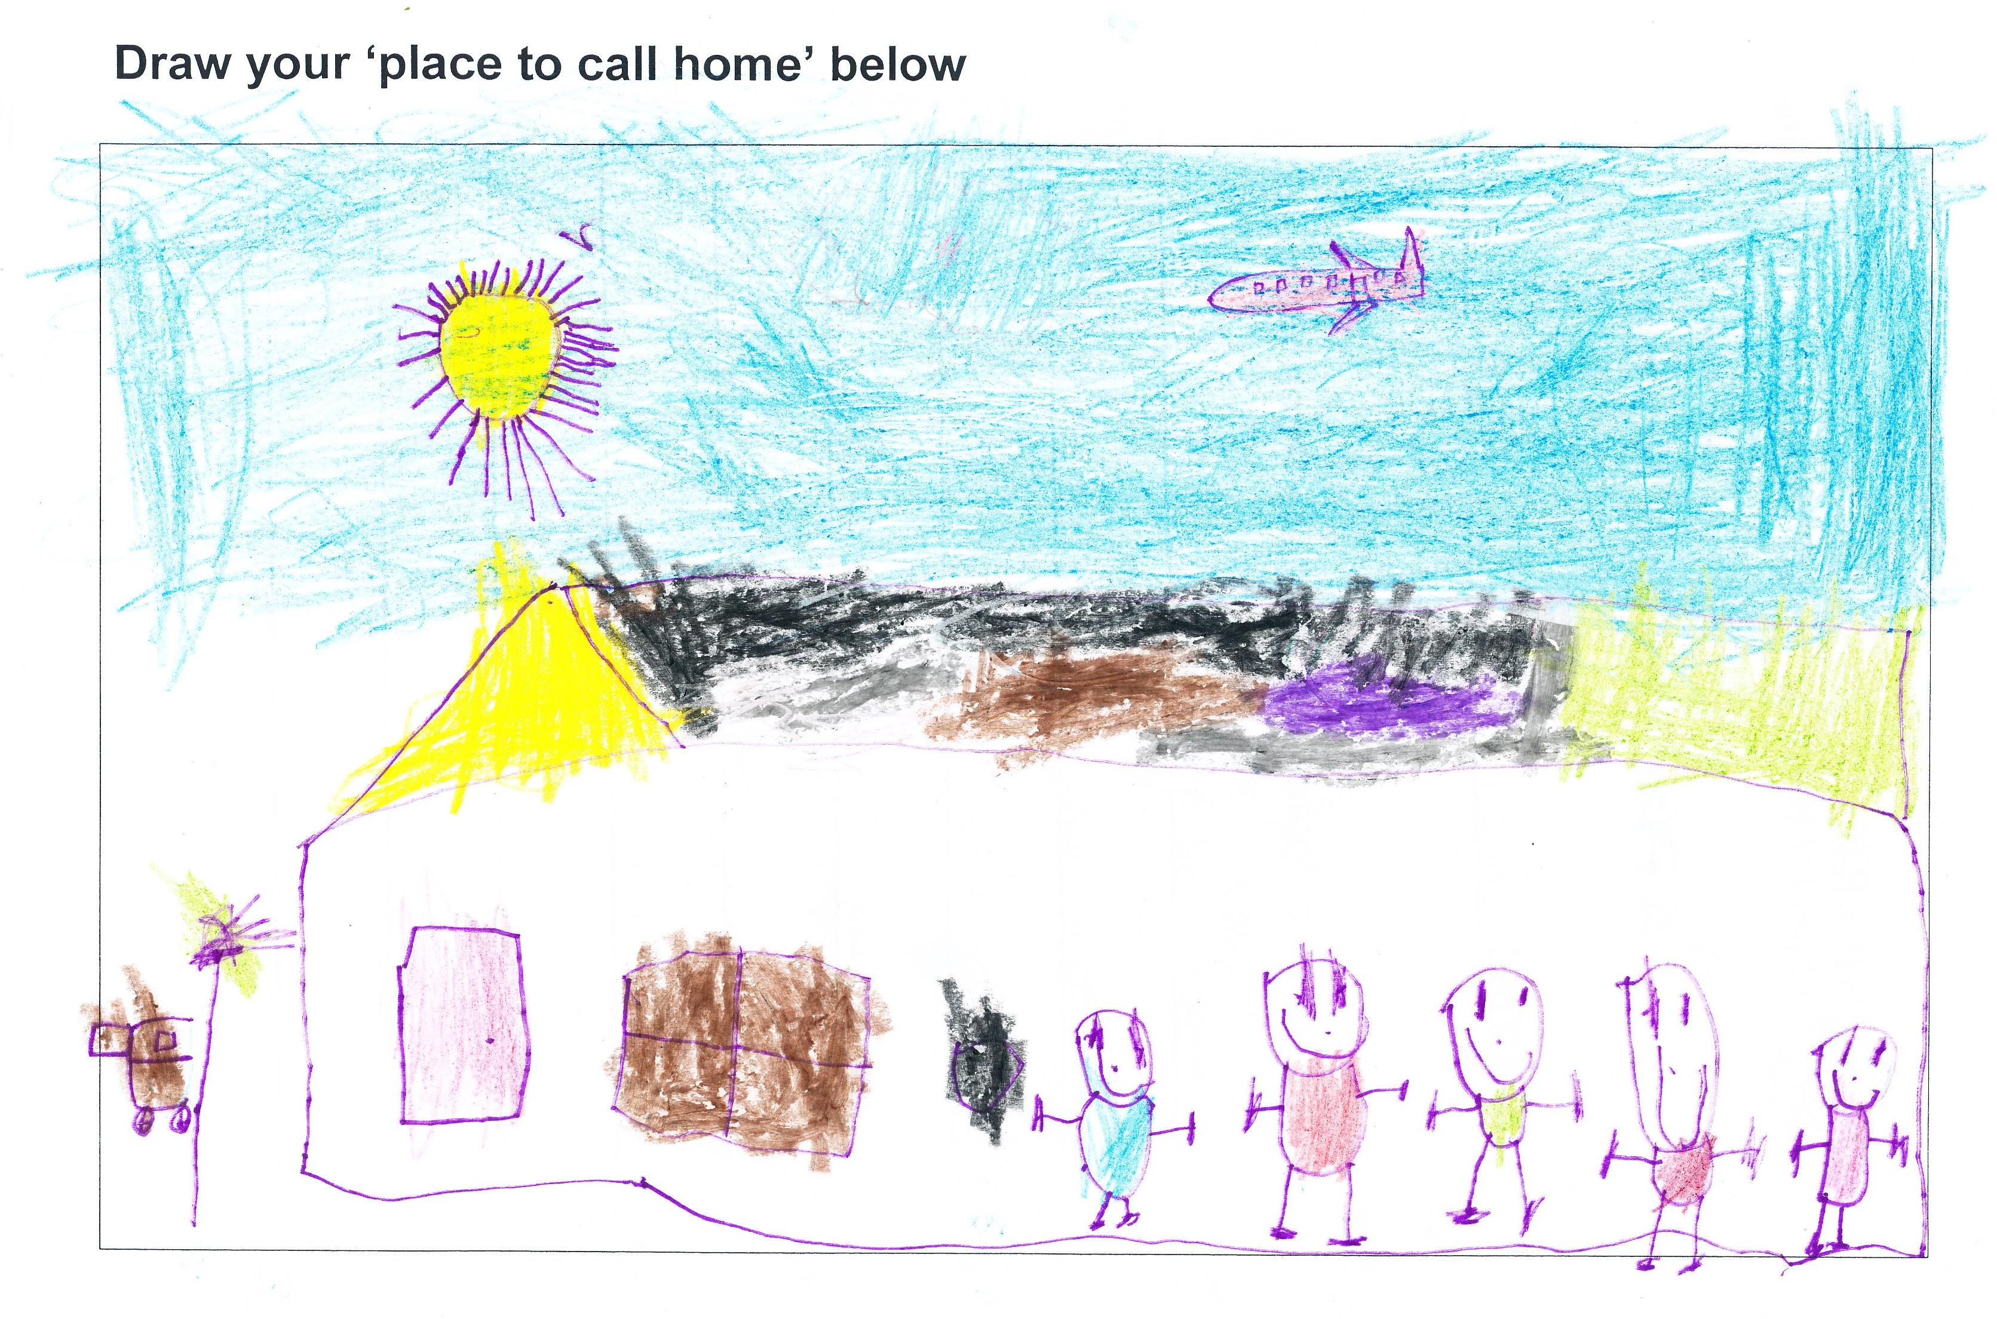 SPARK participant, 6 years old
5.3.3 Newly Arrived Pathways Program (NAP), Auburn Youth Centre

Auburn Youth Centre Inc.

Auburn Youth Centre Inc. is an independent charitable organisation governed by a Board of Directors who are elected by AYC members. AYC was established in 1986. AYC provides counselling, social, educational and recreational services for young people aged 12 to 24 who have a connection with Auburn and surrounding suburbs. Through these programs, AYC aims to remove the barriers confronting young people. Particularly barriers associated with culture, language, education, economic disadvantage, established stereotypes and racism. AYC's major projects are funded by: Department of Immigration and Citizenship; Department of Family and Housing, Community Services, and Indigenous Affairs; and NSW Department of Community Services.

Newly Arrived Pathways Program (NAP)

NAP has delivered casework to around 45 clients, and delivered workshops in six schools in Auburn, Holroyd and Parramatta LGAs.

- Education and employment pathways orientation for newly arrived young people
- NAP aims to build the capacity of newly arrived young people to realize the possibilities of their career pathways

Why NAP?
The issues facing newly arrived young people are well known:
- Homework support
- Support in transition from Intensive English Centres to High School
- Information and understanding about alternative pathways for students and their parents

Who is eligible for NAP?
- Young people aged 14 – 24
- Arrived in Australia less than 5 years ago
- Entered Australia on a humanitarian visa, or family stream visa with low English proficiency

How does NAP help?
The NAP program delivers:
- Casework
- Career workshops
- Referrals
- Parent information sessions
In conjunction with schools, government and community organisations, NAP delivers workshops for newly-arrived young people and their parents on the topics of education and employment pathways, job seeking and application skills, interview skills and resume writing.
Why the need for such programs?

Two of the key reported settlement needs in the Central Western Sydney are education/training and employment.

- Identified Needs:

- The Settlement Needs Report identifies limited employment and
education experience, limited English proficiency and pre- literacy in first languages as key participation barriers.

- Parents lack of education and lack of familiarity with the Australian Education system are also cited as limiting parental capacity to participate in their children's education

- Information on accessing employment programs and creating effective links with mainstream service providers is also cited, along with a need for information on Australian work place culture.

- Expected Outcomes

- Increase awareness of the target group and their parents about education and employment pathways suitable for students with low English proficiency

- It is hoped that this will be achieved by gaining skills in accessing suitable programs, aligning parents’ expectations for their children with pathways that the target group can realistically aspire to, and informing parents about the range of opportunities they can participate in within the school community. This will be achieved through delivering information sessions for students with their parents, casework with selected students and referrals to community services and main-stream service providers.

- Increase the target group's capacity to engage in suitable education and employment pathways.

- This will be achieved through referrals to homework support services, employment services, and other relevant services, such as counselling that can support students to remain engaged with school.

NAP is funded by the Department of Immigration and Citizenship under the Settlement Grants Program.

6. Conclusion and Summary of Recommendations

This joint submission represents the stories and experiences of African Australian children, families and individuals who have a connection with CEO Sydney and St Vincent de Paul Society’s programs and services.

The community forums were structured to meet the aims of this inaugural national project through the exploring of issues and seeking possible solutions. We trust that the process provided a meaningful opportunity for participants to voice their concerns in light of African Australians: a report on human rights and social inclusion issues.

The authentic case studies captured in this submission are a powerful reminder that not all are experiencing “a fair go” in Australia. The children’s illustrations and reflections may well provide a significant starting point for the measurement of successful outcomes. The reported statement from an 11 year old SPARK participant [p6] that “…a place to call home is where you live and play, [where] you have somewhere to sleep and work. Somewhere [where] you have a family. A place to call home is somewhere that is safe and comfortable” seems to capture a very clear understanding about human rights and social inclusion. It is our strong hope that this submission embodies the spirit of the forums and honours the resilience exemplified in each and every story.

In light of the stories, experiences and collective knowledge shared at the forums, we submit this report and following recommendations:

Housing Recommendations

- Cultural awareness training for real estate agents
- Increase awareness-raising campaigns on refugee settlement within the wider community
- The implementation of a dedicated housing support service
- Access to a Translating Interpreter Service (TIS) code for real estate agents to assist clients
- Incorporate “Multicultural Tenancy Project” training into the DIAC funded SGP/IHSS services’ delivery work plan
- Training and forums delivered on tenancy rights and responsibilities

Education Recommendations
- The establishment of long-term educational assistance programs for newly arrived children and youth of refugee background in government and non-government schools
- An increase in awareness-raising campaigns on refugee settlement within the wider community
- Increase in the number of Refugee Community Liaison Officers
- Additional training for teachers, Boards of Education and others involved in the education of people of refugee background
- The formation of a collaborative, national, education-focused network for government and non government agencies involved in the provision of education to people of refugee background
- Ensure that people of African Australian backgrounds have access to positions on decision-making bodies
- Encourage further family involvement in schools
- Increased educational assistance in regional areas
- Training of more teachers of African background
Reference List

Australian Bureau of Statistics, ‘6401.1 Consumer Price Index, Australia, Sept 2007’, October 24, 2007, viewed on 2 June 2009, <http://www.abs.gov.au/AUSSTATS/abs@.nsf/allprimarymainfeatures/BBDC7C862ABE310BCA2573D800138C55?opendocument>.

NSW Department of Housing, ‘Information on the Auburn Housing Market’, viewed on 2 June 2009,<www.housing.nsw.gov.au/NR/rdonlyres/2AEA5A36-47DD-4C14-BDE71E0D3694999D/0/InformationonAuburnHousingMarket.doc>.

OHCHR, Universal Declaration of Human Rights, December 10 1948, viewed on 2 June 2009, <http://www2.ohchr.org>.
Refugee Council of Australia 2008, Australia’s Refugee and Humanitarian Program. Community views on current challenges and future direction, Unpublished, viewed 11 May 2008, <http://www.refugeecouncil.org.au/docs/resources/submissions/2008-09_intakesub.pdf>.
Refugee Council of Australia, viewed on 2 June 2009, <http://www.refugeecouncil.org.au/newsevents/refugeeweek08.html>.
Tenant NSW, ‘Affordable Housing’, Tenants Union NSW 2008, viewed on 2 June 2009, <http://www.tenants.org.au/publish/affordable-housing/index.php>
UNHCR 2007, Conclusion on children at risk, 5 October 2007. No. 107 (LVIII) (8), UNHCR Geneva.
United Nations Population, Resources, Environment and Development, ‘The 2005 Revision’, viewed on 2 June 2009, Victorian Foundation for Survivors of Torture 2005, Education and Refugee Students from Southern Sudan. Foundation House, Melbourne. <http://www.un.org/esa/desa/>
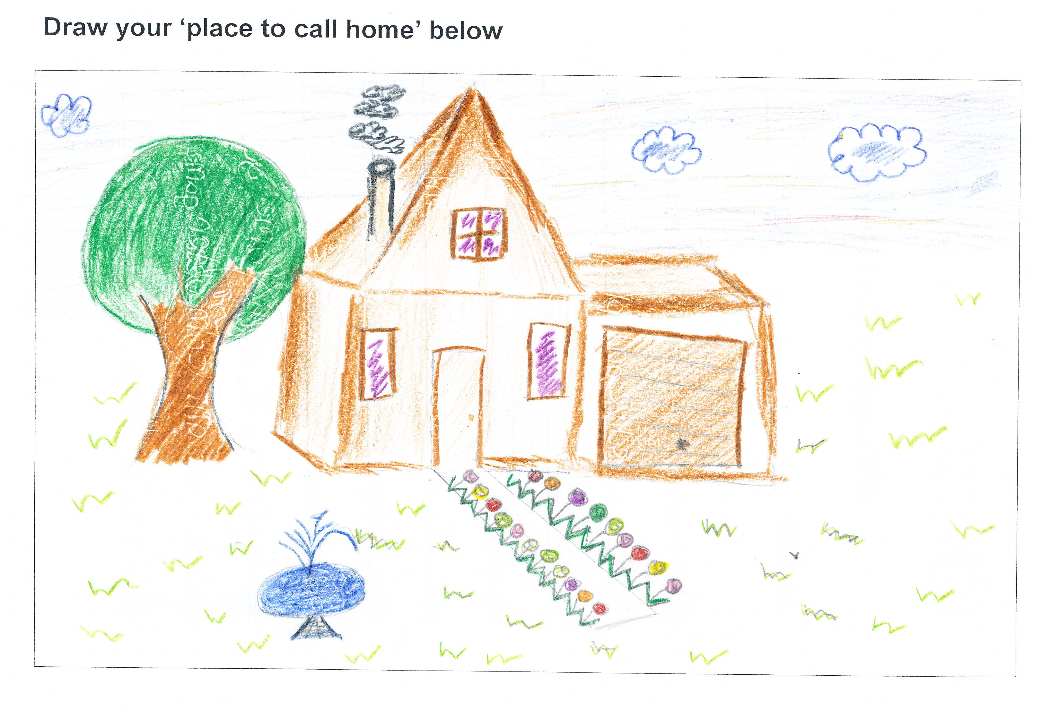
SPARK Participant, 11 years old

United Nations Population, Resources, Environment and Development, ‘The 2005 Revision’, viewed on 2 June 2009, <http://www.un.org/esa/desa/>
NSW Department of Housing, ‘Information on the Auburn Housing Market’, viewed on 2 June 2009, <www.housing.nsw.gov.au/NR/rdonlyres/2AEA5A36-47DD-4C14-BDE7-1E0D3694999D/0/InformationonAuburnHousingMarket.doc>
United Nations Population, Resources, Environment and Development, ‘The 2005 Revision’, viewed on 2 June 2009, <http://www.un.org/esa/desa/>
OHCHR, ‘Article 25 (1)’ Universal Declaration of Human Rights, December 10 1948, viewed on 2 June 2009, <http://www2.ohchr.org>.
NSW Department of Housing, ‘Information on the Auburn Housing Market’, viewed on 2 June 2009, <www.housing.nsw.gov.au/NR/rdonlyres/2AEA5A36-47DD-4C14-BDE7-1E0D3694999D/0/InformationonAuburnHousingMarket.doc>
Tenant NSW, ‘Affordable Housing’, Tenants Union NSW 2008, viewed on 2 June 2009, <http://www.tenants.org.au/publish/affordable-housing/index.php>
NSW Department of Housing, ‘Information on the Auburn Housing Market’, viewed on 2 June 2009, <www.housing.nsw.gov.au/NR/rdonlyres/2AEA5A36-47DD-4C14-BDE7-1E0D3694999D/0/InformationonAuburnHousingMarket.doc>
Australian Bureau of Statistics, ‘6401.1 Consumer Price Index, Australia, Sept 2007’, October 24, 2007, viewed on 2 June 2009, <http://www.abs.gov.au/AUSSTATS/abs@.nsf/allprimarymainfeatures/BBDC7C862ABE310BCA2573D800138C55?opendocument>.
OHCHR, ‘Article 26(1)’, Universal Declaration of Human Rights, December 10, 1948, viewed on 2 June 2009, <http://www2.ohchr.org>.
Such as those documented in the reference section.
OHCHR ‘Article 13(1)’, Universal Declaration of Human Rights, December 10, 1948, viewed on 2 June 2009, <http://www2.ohchr.org>.
UNHCR 2007, Conclusion on children at risk, 5 October 2007. No. 107 (LVIII) (8), UNHCR Geneva.

