A BAD BUSINESS

Review of sexual harassment in employment complaints
2002

© Human Rights and Equal Opportunity Commission 2003

ISBN 0 642 26987 4

This paper is to be cited as:
Human Rights and Equal Opportunity Commission A Bad Business: Review of sexual harassment in employment complaints 2002 HREOC Sydney 2003.

This work is copyright. Apart from any use permitted under the Copyright Act 1968, no part may be reproduced by any process without prior written permission from the Human Rights and Equal Opportunity Commission. Requests and enquiries concerning reproduction, rights and content should be addressed to the:

Sex Discrimination Unit
Human Rights and Equal Opportunity Commission
GPO Box 5218
Sydney NSW 2001

Cover design
Jan-maree O'Sullivan, LHD Visual.Communications, Sydney.

Nineteen-year-old Jodie worked as a casual receptionist and office administrator for a mid-sized courier company. Two months after she started working for this company, her manager, Alec, allegedly started to send sexual SMS messages and pictures to Jodie’s mobile phone. Jodie also claimed that Alec offered Jodie $1500 to spend a night with him at a hotel. Over a two year period, Alec allegedly threatened to squeeze Jodie’s nipples, pinched Jodie’s upper thighs, massaged her neck and shoulders while she was on the computer, rubbed up against Jodie, tried to hold her hands and promised Jodie full-time employment if she gave him a kiss and cuddle. After having been formally warned twice for her work performance and attendance, Jodie felt that she was forced to resign.

Jodie lodged a complaint with the Human Rights and Equal Opportunity Commission (HREOC) against Alec for sexual harassment and against her former employer company, for vicarious liability. The matter was conciliated with the company agreeing to pay Jodie $10,000 and Alec agreeing to pay Jodie $5,000 in general damages.

Nina was employed as a casual shop assistant in a fruit shop. Within two months of commencing employment, Adam, the owner and manager of the shop, allegedly started making comments of a sexual nature to Nina, such as “you have nice coconuts”, “I want to see how far you can stick that bottle in your mouth” and “you’re making me cum in my pants.” Adam also allegedly asked Nina how her sex life was. When it was Nina’s turn to be paid Nina claimed that Adam often said to her “are you ready to be laid – oops – I mean paid yet.” Nina claimed that Adam threatened to cut Nina’s hours of work if she did not let him touch her. She refused his requests. Adam allegedly pinned Nina’s arms down and rubbed himself up against Nina’s back on four occasions.

Nina lodged a complaint alleging sexual harassment against Adam and the fruit shop. A conciliation conference was held and the matter settled with Adam agreeing to pay Nina compensation in the amount of $4,500, to provide a written apology to Nina and to attend a training course for employers on sexual harassment and bullying.

Kate was employed as a security alarm monitor by a security company. Kate claimed that one of her co-workers, Matt, was attracted to her and asked her several times to go out. He allegedly grabbed her arm and pulled her away from others at the company’s Christmas party; he allegedly sent her numerous text messages on her mobile phone, emailed her and rang her on her mobile phone.

Kate made a formal complaint to the Human Resources Manager. After accepting Kate’s written complaint, the Manager allegedly said to Kate “how can you prove that this is not all fabricated?” To Kate’s knowledge, Matt was not spoken to by management nor were Matt’s rosters changed so that they did not overlap with Kate’s roster as requested.

Kate lodged a complaint with HREOC alleging sexual harassment against Matt and the security company. The matter settled at a conciliation conference with the company agreeing to pay general damages in the amount of $9,500 and to implement a sexual harassment policy and undertake training of staff. The complaint against Matt was terminated on the ground of there being no reasonable prospect of conciliation.
TABLE OF CONTENTS

Foreword………………………………………………………………….
Key findings………………………………………………………………………..

PART A: BACKGROUND………………………………………………………
1. Introduction……………………………………………………………
1.1 Purpose of the review
1.2 The research project: design, methodology and analysis
1.3 Limitations of the research
1.4 About this paper

PART B: THE COMPLAINTS PROCESS………………………………………..
2. The legal definition of sexual harassment………………………………..
3. Overview of HREOC’s complaint handling function……………………

PART C: FINDINGS……………………………………………………………..
4. The nature of harassment………………………………………………..
4.1 Gendered nature of harassment
4.2 Type of harassment complained about
4.3 Duration of harassment
5. Characteristics of complainants and individual respondents …………….
5.1 Sex of complainants and individual respondents
5.2 Age of complainants and individual respondents
5.3 Ethnicity of complainants
6. Complainants’ employment……………………………………………...
6.1 Employment status of complainants at time of harassment
6.2 Length of complainants’ employment at first incidence of harassment
6.3 Employment status of complainants at time complaint made to HREOC
6.4 Complainants’ occupation
6.5 Employment relationship of individual respondents to complainants
7. Characteristics of workplaces………………………………………………
7.1 Employer size
7.2 Gender balance of workplaces
7.3 Industry classification
7.4 Location of workplaces
8. Workplace responses to harassment………………………………………
8.1 Reporting harassment in the workplace
8.2 Sexual harassment policies
8.3 How harassment was dealt with in the workplace
9. Outcomes of complaints………………………………………………….
9.1 Remedies sought by complainants
9.2 Outcome of complaints
9.3 Termination of complaints
9.4 Financial compensation arising from settlement
9.5 Who paid the compensation
9.6 Relationship between financial compensation and age of complainant
9.7 Time taken to finalise complaints
9.8 Litigation

PART D: CONCLUSION…………………………………………………………
10. Conclusion……………………………………………………………….

Acknowledgements……………………………………………………………..
Foreword

In a modern workforce where men and women work side by side it is important that employers protect their employees from unwanted behaviour that is not only harmful to the employee involved but also unprofessional and unproductive for the workplace. Sexual harassment is one form of unwanted behaviour that attempts to exclude individuals from the workplace by focusing on the sex of the person involved. Sexual harassment can happen in many different situations but overwhelmingly the complaints we receive involve the workplace. Harassment, bullying and exclusion may also be motivated by and focused on other characteristics of a person such as race, culture or disability. It can also just be personal.

Ninety-five per cent of the complaints of sexual harassment in employment that we finalised in 2002 were made by women. This indicates a significant barrier to women’s full participation in the workforce. Identifying and addressing such systemic discrimination against women is essential to achieving equality between men and women.

Although Australian legislation outlawing sexual harassment was enacted almost twenty years ago and many organisations have well developed policies for dealing with it, there is still confusion about what sexual harassment is and how it should be managed by employers. Naturally all behaviour exists on a continuum of acceptability and sexual harassment may sometimes be confused with friendship, flirtation or consensual relations. However the importance of ensuring that people are treated respectfully, are able to go about their daily lives with dignity and work in a professional environment are clearly minimum standards employers and all service providers need to be able to ensure.

This review of sexual harassment complaints finalised by the Human Rights and Equal Opportunity Commission (HREOC) in 2002 was sparked by the annual complaints figures, which demonstrate that, year after year, sexual harassment remains a significant percentage of complaints. What is more, the number of complaints on this ground has increased by just over 20 per cent in the last four years.

HREOC’s complaints information is not kept for the purpose of policy research and for this reason the review has sometimes struggled with the limited data available. In addition to this, HREOC’s complaints process does not seek to find a party liable for sexual harassment, but only to conciliate between the parties. This means all information regarding the conduct must be treated as allegations rather than as proven facts. However the review’s major findings have certainly been sufficiently unambiguous to warrant drawing a number of conclusions, including the need for a national survey. HREOC has already commissioned this survey and the results will be published early in 2004.

For employers and policy makers, it is particularly worth noting that although 60 per cent of the alleged harassers were senior to the alleged victims, 40 per cent were not. In other words they were co-workers, or less often, clients or service providers. The development of sexual harassment policies and their implementation needs to take this into account; employers are liable if their policies are either inadequate or not implemented fully. In those 22 per cent of cases where the harassment continued for more than 12 months, clearly the workplace policy, or its implementation, had failed to empower its employees to seek the effective protection of the employer. The fact that most complainants (78 per cent) report the harassment within their workplace first suggests that employees expect their employers to meet a duty of care. Failure to adequately deal with a complaint contributes to the ultimate liability of an employer.

In almost all cases resolved at HREOC, the employer agreed to compensate the complainant either as well as or instead of the alleged harasser, a further price paid by employers who had failed to prevent or satisfactorily resolve the complaints themselves.

The compensation paid by employers is in addition to the organisational cost of losing the employee who has claimed harassment. Perhaps the most significant finding of the paper is that at least 77 per cent of all complainants had either left the organisation where the alleged harassment occurred or taken leave. This represents a considerable cost in recruitment, training and development, in addition to the indirect cost associated with loss of staff morale inevitably arising from unresolved disputes within workplaces. Of course, it also gives an indication of the significance of these experiences to complainants and the disruption that it is likely to have caused in their lives. The data do not allow us to conclude whether the disruption is caused by the experience of harassment or by the fact of taking action on it. I hope that the national survey to be published next year will shed light on this. Nevertheless, it is clear that those who experience sexual harassment have suffered a breach of their workplace rights.

It is also significant that sexual harassment remains an issue for business of any size; small business is so often singled out for criticism but the complaints review demonstrates that sexual harassment occurs across business. That almost a quarter (23 per cent) of reported cases involved sexual physical behaviour indicates a degree of seriousness that requires employers to act immediately.

The review should prove a useful guide for policy makers and anyone involved in people management. I commend it to leaders of business, large or small. The review also makes the case for employers to conscientiously review their sexual harassment policies and policy implementation, as well as their workplace culture. Increasingly victims of harassment will make complaints; employers who condone, ignore or fail to act against this conduct bear considerable risk.

This first publication will be built upon by a suite of materials to be produced in 2004. Together, I hope they will make a contribution towards the important work of eliminating sexual harassment in Australian workplaces. However, the real responsibility for that work lies with each of us.

Pru Goward
Sex Discrimination Commissioner
Human Rights and Equal Opportunity Commission
12 November 2003

Key findings
HREOC has reviewed 152 complaints of sexual harassment in the workplace that were finalised in 2002. These are the key findings from the review.

The information available in relation to each of the 152 complaints varied. As such, it was not always possible to determine each finding in relation to all of the complaints. For each of the findings below, the number of complaints for which the particular information was available is noted in brackets.

The reported harassment was by men against women
- 86 per cent of complaints involved a man sexually harassing a woman (of 152 complaints). The remaining 14 per cent of complaints included harassment of men and harassment by women.

- 95 per cent of the complainants were female (of 152 complaints). 88 per cent of individual respondents were male, five per cent were female and seven per cent involved both male and female respondents (of 152 complaints).

The nature of the reported harassment
- Most complaints involved multiple forms of harassing behaviours. 71 per cent of complaints involved verbal harassment, 37 per cent involved physical intimacy and 23 per cent involved sexual physical behaviour (of 152 complaints).

- 18 per cent of cases involved an isolated incident of sexual harassment (of 136 complaints). In 22 per cent of cases the harassment had continued for more than 12 months.

- 72 per cent of complainants reported that the harassment began in the first 12 months of the complainant’s employment (of 121 complaints). 51 per cent reported harassment as beginning within the first four months of employment.

- 60 per cent of individual respondents were in a more senior position in the workplace than the complainant (of 161 individual respondents).

Harassment is an issue for all forms of business
- 44 per cent of complainants were employed in small businesses, 19 per cent in medium sized businesses and 36 per cent were employed in large businesses (of 135 complaints).

- 51 per cent of complainants were employed in the occupational groups of clerical, hospitality, shop assistant and labourer (of 146 complaints).

- 67 per cent of reported harassment occurred in workplaces located in cities, 31 per cent occurred in rural areas and three per cent was in remote rural areas (of 150 complaints).

- 78 per cent of complainants had reported the harassment within their workplace (of 130 complaints).

Harassment has a cost for employers
- At the time the complaint was made to HREOC, only seven per cent of complainants were known still to be actively working for the organisation where the alleged harassment occurred. 67 per cent had left the organisation and 10 per cent were on leave (of 152 complaints).

- Financial compensation received by complainants varied from $500 to $200,000 and was most often paid by employers rather than the individual harasser.

PART A: BACKGROUND

1. Introduction

Sexual harassment has been unlawful across Australia for almost twenty years with 2004 marking the twentieth anniversary of the Sex Discrimination Act 1984 (Cth) (Sex Discrimination Act). Over that period, community awareness of the existence of sexual harassment, particularly in the area of employment, has grown considerably.

The Sex Discrimination Act makes it unlawful for a person to sexually harass another person in employment, education and other areas of public life.

The proportion of sexual harassment in employment complaints received by the Human Rights and Equal Opportunity Commission (HREOC) under the Sex Discrimination Act has been decreasing over the past eight financial years, while the proportions of complaints on the grounds of sex and pregnancy discrimination have been increasing. However, for the period July 1999 to June 2002 the actual number of complaints received by HREOC alleging sexual harassment increased, suggesting that sexual harassment is an on-going problem despite 20 years of legislation. In addition, complaints of sexual harassment are still significant, at 27 per cent of the complaints to HREOC under the Sex Discrimination Act. As such, it is timely to review these complaints.

1.1 Purpose of the review

The purpose of this review is to investigate the nature of sexual harassment in employment that is being reported to HREOC by analysing complaints made to HREOC. The review has analysed the data according to a number of characteristics such as type of harassment, nature of employment and employer consequences. The data also provide evidence of the consequences for employers in failing to effectively implement preventative strategies in their workplaces.

The analysis is limited to complaints that have been made to HREOC. Sexual harassment that has been reported to State and Territory organisations under State and Territory legislation has not been included. As such, the review represents only a particular segment of nationally reported sexual harassment.

It is important to note that the outcomes of the conciliated complaints are agreements between the parties to the complaint and that HREOC does not determine whether the alleged harassment actually occurred. Any compensation paid by employers or individuals may not be taken as an admission that harassment occurred and conciliation agreements usually include a statement to this effect. This should be borne in mind when considering the data presented in this paper.

This paper forms part of a broader package of work on sexual harassment being undertaken by HREOC. HREOC is also:
- conducting a series of one-day Youth Challenge programs in schools aimed at raising awareness of sexual harassment in 2003-04;
- commissioning a telephone survey on the general incidence of sexual harassment in Australia that will be released early in 2004;
- updating HREOC’s publication, Sexual Harassment: A Code of Practice; and
- preparing public education material.

1.2 The research project: design, methodology and analysis

The research project involved the collection of quantitative and qualitative information on sexual harassment complaints through detailed examination of the complaint files for each relevant complaint. This information was then classified to allow comparison between complaints and the identification of general trends in the nature of reported sexual harassment.

Overall 370 complaints made under the Sex Discrimination Act were finalised by HREOC in 2002. Of these, 162 complaints were identified as involving allegations of sexual harassment.

One complaint may be made on multiple grounds under the Sex Discrimination Act, and each of these grounds will relate to an area of public life in which the harassment occurred. In this review, the 162 complaints were classified as follows:
- 155 complaints involved allegations of sexual harassment in employment;
- four complaints involved allegations of sexual harassment in the provision of goods and services;
- one complaint involved allegations of sexual harassment in education; and
- two complaints involved allegations of victimisation.

Given the prevalence of sexual harassment in employment amongst the complaints, it was decided to focus the review on this issue. In addition, the smaller number of complaints in other areas would not have been statistically significant in the results. Three of the 155 complaint files on sexual harassment in employment were not available and so have not been included in the review.

This paper therefore presents the statistics and qualitative data from a review of 152 complaints alleging sexual harassment in the area of employment finalised in 2002 by HREOC.

All 152 complaints were included regardless of the outcome of the complaint or whether a conciliation conference was held. This includes cases which were terminated by HREOC. Only one of these complaints was terminated on the ground that it lacked substance.

1.3 Limitations of the research

While the analysis of complaints has been an effective method for gathering statistical data on the nature and frequency of reported sexual harassment and gaining insight into the complaints process, it has been unable to provide insight into the nature and frequency of the incidence of sexual harassment in the community. In short, this paper provides information about who reports harassment, but does not provide a full picture of who is harassed. It is widely accepted that reported sexual harassment represents only the “tip of the iceberg” in relation to the incidence of sexual harassment in the community. It is not possible to extrapolate the full picture from the complaints data.

The analysis is also limited by the available data on complaints. Complaints varied in their level of complexity and in the degree of investigation required. As a result, complaints files varied in the amount of information that was collected, particularly in relation to demographics of complainants and individual respondents, information about the employer, and the effect of the harassment. In addition, completion of a survey by complainants about their personal characteristics and background is voluntary and as such was not available for all complaints. This means that, at times, the calculated statistics are based on a relatively small number of complaints and should be used with caution.

1.4 About this paper

The paper is divided into four sections.

Part A includes an introduction to the paper and an overview of the project design and limitations.

Part B provides an overview of HREOC’s complaint handling process and the legal definition of sexual harassment under the Sex Discrimination Act.

Part C contains the findings of the research. This includes information on:
- the nature of the harassment;
- demographics about the complainant and individual respondent;
- the complainants’ employment;
- characteristics of the workplaces where reported harassment occurs;
- workplace responses to reported harassment; and
- the outcomes of complaints.

Part D considers the implications of the research findings.

PART B: THE COMPLAINTS PROCESS

2. The legal definition of sexual harassment

Sexual harassment is an unwelcome sexual advance, unwelcome request for sexual favours or other unwelcome conduct of a sexual nature which makes a person feel offended, humiliated or intimidated, where a reasonable person would anticipate that reaction in the circumstances. The Sex Discrimination Act defines the nature and circumstances in which sexual harassment is unlawful.

The legal test for sexual harassment in the Sex Discrimination Act has three essential elements:
- the behaviour must be unwelcome;
- it must be of a sexual nature; and
- it must be such that a reasonable person would anticipate in the circumstances that the person who was harassed would be offended, humiliated or intimidated.

In Aldridge v Booth, Justice Spender of the Federal Court said that “unwelcome” means

… that the advance, request or conduct was not solicited or invited by the employee, and the employee regarded the conduct as undesirable or offensive.

The intention or motive of an alleged harasser is not relevant when determining whether the behaviour was unwelcome. Sexual harassment focuses on how the conduct in question was perceived and experienced by the recipient rather than the intention behind it. It is irrelevant that the behaviour may not offend others or has been an accepted feature of the work environment in the past.

A complaint of sexual harassment will not be dismissed just because the person subjected to the behaviour did not directly inform the harasser that it was unwelcome. However, there does need to be some indication from the person’s conduct or surrounding circumstances that the behaviour was in fact unwelcome. The case law takes into account the reasons why someone may feel unable to confront a harasser directly.

Sexual interaction or flirtation which is based on mutual attraction or friendship is not sexual harassment because it is not unwelcome. If the behaviour is consensual and reciprocated it will not be unlawful. However, consent or participation which is obtained by fear, intimidation, threats or coercion does not mitigate a complaint of sexual harassment.

Examples of sexually harassing behaviour include:
- unwelcome touching;
- staring or leering;
- suggestive comments or jokes;
- sexually explicit pictures or posters;
- unwanted invitations to go out on dates;
- requests for sex;
- intrusive questions about a person’s private life or body;
- unnecessary familiarity, such as deliberately brushing up against a person;
- insults or taunts based on sex; and
- sexually explicit emails or SMS text messages.

A working environment or workplace culture that is sexually permeated or hostile will also amount to unlawful sexual harassment. Some of the factors which may indicate a potentially hostile environment include the display of obscene or pornographic materials, general sexual banter, crude conversation or innuendo and offensive jokes.

The Sex Discrimination Act makes such conduct unlawful in the following areas of public life:
- employment situations;
- bodies or authorities responsible for occupational qualifications;
- registered organisations such as unions;
- employment agencies;
- educational institutions;
- the provision of goods, services and accommodation;
- the disposal or acquisition of land;
- club membership; and
- the administration of Commonwealth laws or programs.

It is also unlawful, under section 94 of the Sex Discrimination Act, for a person to be victimised for making, or proposing to make, a complaint of sexual harassment to HREOC. This section also protects people giving information relating to a complaint.

Section 106 of the Sex Discrimination Act makes an employer vicariously liable for acts of sexual harassment committed by employees or agents in connection with their duties unless the employer can demonstrate that “all reasonable steps” were taken to prevent sexual harassment occurring. This requires employers to implement precautions to minimise the risk of unlawful behaviour occurring in the workplace. The case law suggests that:
- “reasonable steps” must be active, preventative measures;
- the obligation to prove that “all reasonable steps” were taken rests with the employer; and
- lack of awareness that the harassment was occurring is not a defence for employers.

Individuals and employers can also be held personally liable under section 105 of the Sex Discrimination Act if they “caused, instructed, induced, aided or permitted” an individual to commit an unlawful act. There is no defence available for this type of liability.

An organisation can be held liable under section 105 even if there was no legal relationship between the parties, such as that of employer/employee or principal/agent. However, an organisation must at least have been aware of the situation in order to be liable. In effect, a person can be held liable under section 105 if they were aware that sexual harassment was occurring but permitted (or actively assisted) it to continue.

3. Overview of HREOC’s complaint handling function

HREOC is empowered under the Human Rights and Equal Opportunity Commission Act 1986 (Cth) to investigate complaints under federal human rights and anti-discrimination legislation, including the Sex Discrimination Act, and to attempt to resolve complaints by conciliation where this is considered appropriate. HREOC has the power to compel the production of information and documents and to convene compulsory conciliation conferences. HREOC does not determine whether or not there has been sexual harassment under the Sex Discrimination Act. This is a matter for the Courts, on application by the complainant, if the complaint is terminated.

There are two types of parties to a complaint: the complainant and the respondent. The complainant is the person who lodges the complaint with HREOC, and must generally be a person who has been personally affected by the alleged discrimination. In the case of sexual harassment, this will be the person who is claiming to have been harassed or victimised. The respondent is the party against whom the complaint has been lodged. There may be more than one respondent to a complaint. In the case of sexual harassment, the respondent is generally the individual or individuals whom it is alleged committed the harassment and/or the complainant’s employer who may be vicariously liable for individuals’ harassing behaviour.

Complaints are handled by HREOC according to the circumstances and evidence available taking care to meet the requirements of natural justice and procedural fairness. The following diagram sets out the complaint handling process.

The complaint handling process

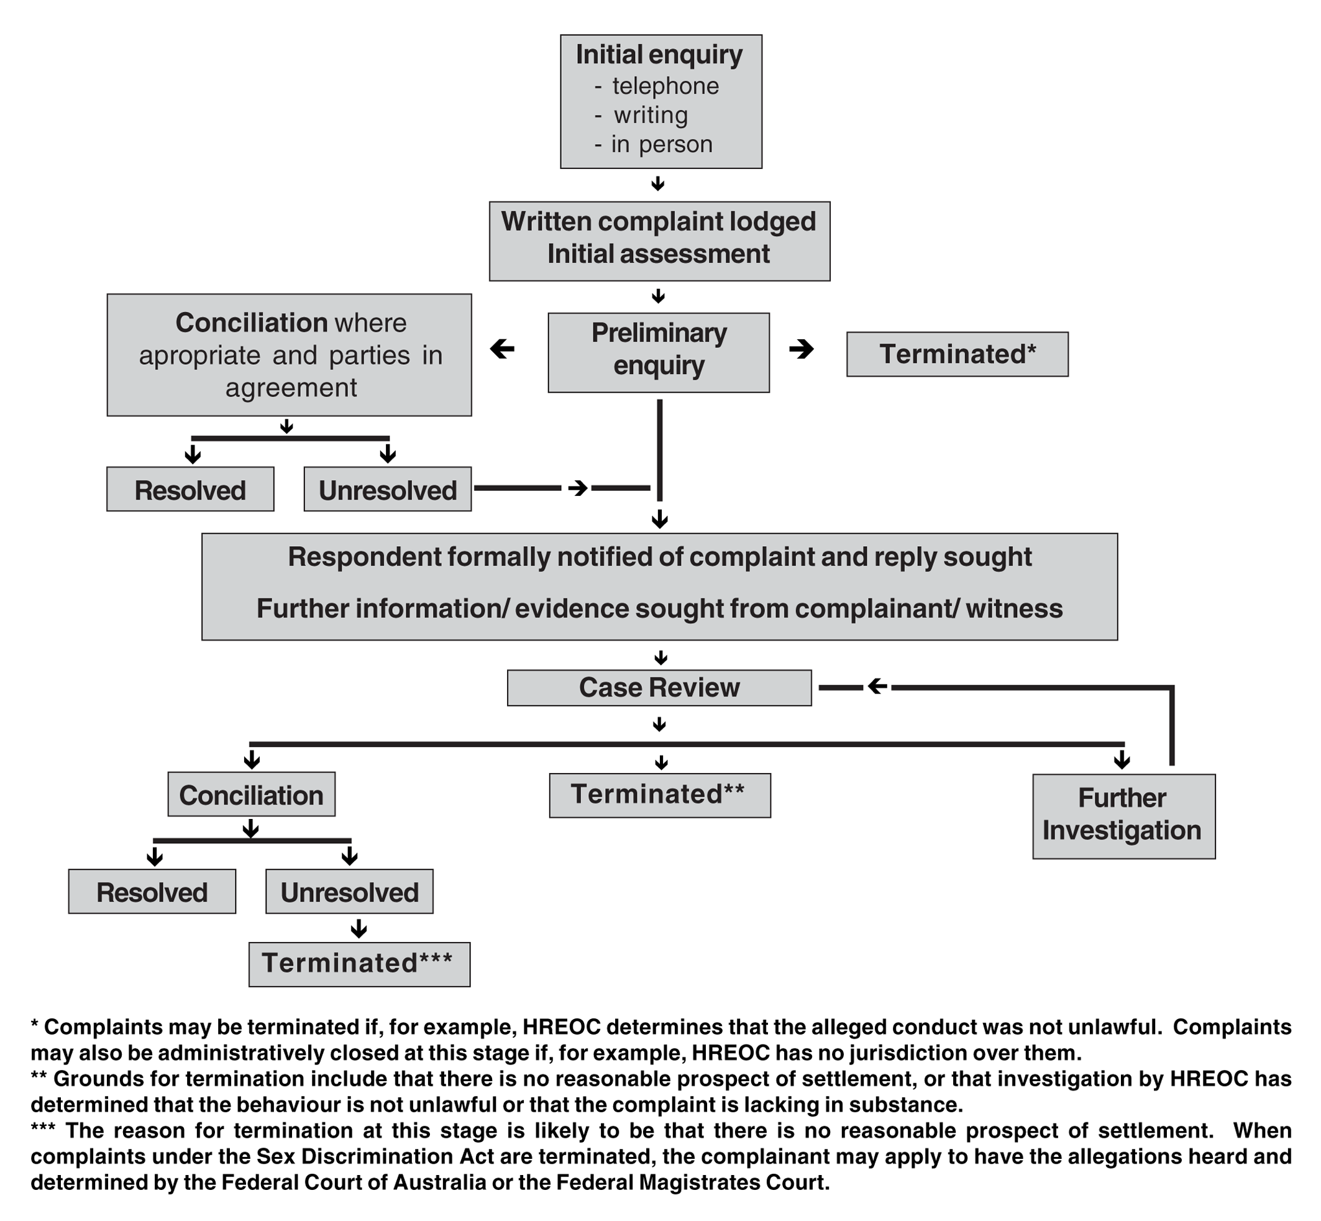

Complaints made under the Sex Discrimination Act which have substance and are within jurisdiction are investigated, with most progressing to a conciliation conference. Conciliation can also occur through holding a tele-conference or negotiating through a conciliator.

The conciliation conference is a meeting that gives the parties the opportunity to hold a frank discussion about the complaint, in an attempt to resolve the matter through negotiation. The conference gives the parties the chance to settle a matter on their terms. The conciliation conference is not a public hearing, a court of law or a tribunal. As such, the parties attending do not have to prove or disprove the complaint.

The conciliator’s role is a neutral one, conducting the conference in a fair and impartial manner, giving each party an opportunity to present their point of view and assisting them in resolving the complaint. The conciliator may make suggestions for terms of settlement, give expert advice on likely settlement terms, and may actively encourage the parties to reach an agreement. The conciliator is not an advocate for either party. His or her role is to keep the parties in the conference focused on the issues raised under the law and to help resolve the matter.

The settlements that have been agreed upon by parties in conferences conducted by HREOC are wide and varied. Outcomes depend on how the complainant is seeking to resolve the complaint and what the respondent is prepared to offer.

Complaints of unlawful discrimination that cannot be resolved by conciliation or are considered inappropriate for conciliation are terminated by the President of HREOC. Grounds for termination include that there is no reasonable prospect of settlement, that the behaviour is not unlawful or that the complaint was lacking in substance. Complaints may also be finalised as an “administrative closure” which means that either the complainant was not an aggrieved party to the harassment; that the complaint was against a State Government instrumentality over which HREOC has no jurisdiction or that the complaint had been actioned by a State or Territory anti-discrimination agency and therefore could not be considered by HREOC. As noted in the diagram above, the grounds for termination are likely to vary depending on the stage at which the complaint has been terminated. For example, early finalisation of a complaint is likely to be due to a determination by HREOC that HREOC does not have jurisdiction or that the alleged conduct was not unlawful. Termination after conciliation has been attempted is more likely to be on the ground of there being no reasonable prospect of settlement.

When a complaint under the Sex Discrimination Act has been terminated, the complainant may then make an application to the Federal Court of Australia or Federal Magistrates Court to hear and determine the allegations.

PART C: FINDINGS

4. The nature of harassment

The majority of reported sexual harassment was targeted at women, involved multiple forms of harassing behaviour and occurred on more than one occasion. In over one in five cases, the harassment continued for more than 12 months. Verbal harassment was often a precursor to physical forms of harassment.

4.1 Gendered nature of harassment

The sexual harassment that is reported to HREOC is gendered. The majority (86 per cent) of complaints involved a man sexually harassing a woman (131 complaints). Women harassing men was a rare occurrence (three per cent, or five complaints), while same sex harassment was also infrequent (one per cent for males, or two complaints and two per cent for females, or three complaints). Seven per cent of complaints (10 complaints) involved men and women harassing women, while one per cent of complaints (one complaint) involved men and women harassing a man.

4.2 Type of harassment complained about

While some complainants detailed only one type of harassing behaviour, most complaints involved a number of categories of harassing behaviours. Verbal harassment is most prevalent, however this form of harassment was often a precursor to physical harassment. As such, verbal harassment may be an early warning of other forms of harassment.

Verbal harassment represented 36 per cent of all harassment and occurred in 71 per cent of complaints. Physical intimacy was the next most frequently complained of form of harassment and occurred in more than one in three complaints. Sexual physical behaviour represented 12 per cent of the harassment complained about and occurred in 23 per cent of complaints. Some of the general bullying behaviour reported was in response to complainants reporting the harassment within the workplace.

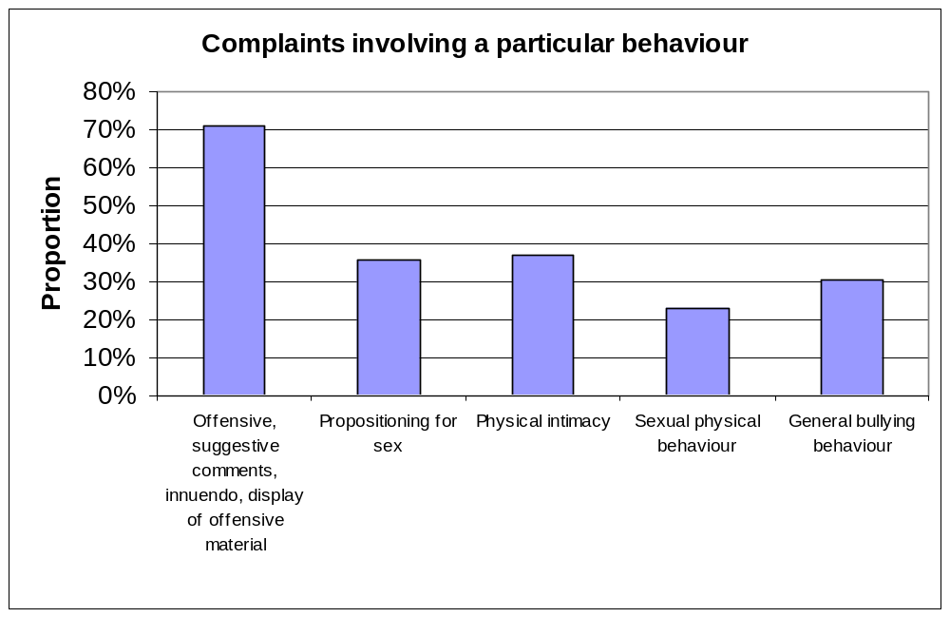

4.3 Duration of harassment

Sexual harassment does not have to be repeated or continuous to be unlawful. The legislation is drafted in the singular (for example, “an unwelcome sexual advance” and “an unwelcome request for sexual favours”). This is supported by the case law.

Of the 136 complaints from which the duration of the sexual harassment could be discerned, 24 cases or 18 per cent reported sexual harassment constituted by a single incident. Harassment that continued over a significant period was the most prevalent, with 22 per cent of harassment continuing for more than 12 months. Twenty-one per cent of harassment occurred over one to three months. The longest period of harassment recorded was 156 months (13 years), however the complainant first complained about the behaviour 140 months after it had commenced.

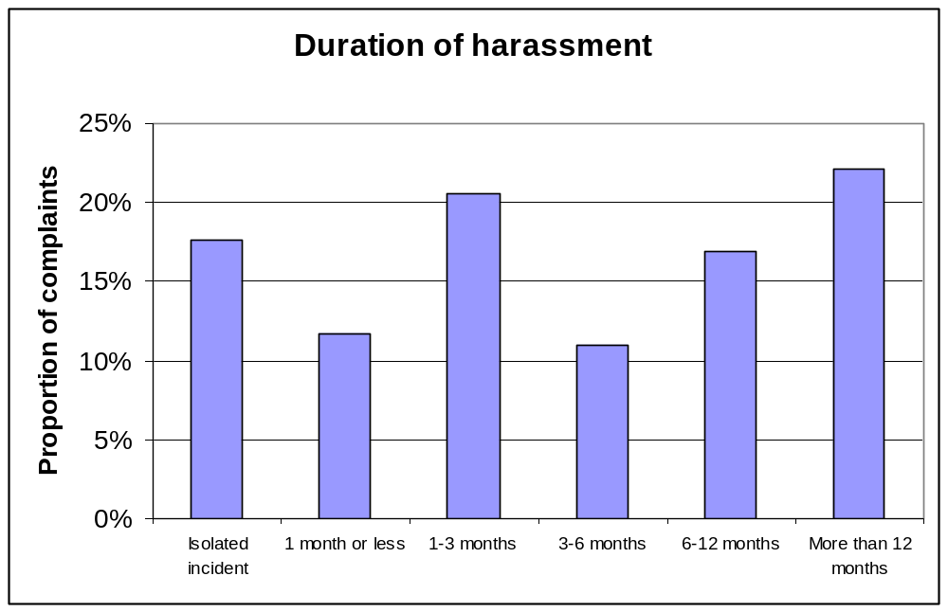

5. Characteristics of complainants and individual respondents

The data show that the overwhelming majority of those who reported sexual harassment were women, and that they were reporting harassment by men. Complainants were on average 12 years younger than individual respondents. Three quarters of individual respondents were aged over 30 years while over half of complainants were 30 years or less. However, the data on age of complainants and respondents should be used with caution given the small number of complaints where this information was available. Individuals who reported sexual harassment were more likely to be Australian born, to have Australian born parents and to speak English at home compared to the general population.

5.1 Sex of complainants and individual respondents

Complainants

Of the 152 complaints of sexual harassment in employment, 95 per cent of the complainants were female.

Individual respondents

Of the 152 complaints of sexual harassment in employment, 88 per cent of the individual respondents were male, five per cent were female and seven per cent involved both male and female respondents.

5.2 Age of complainants and individual respondents

Complainants

Of the 152 complaints analysed, 66 contained information about the complainant’s age. The following data are based on those 66 complaints.

The youngest complainant was aged 15 years at the time that the harassment occurred and the oldest complainant was aged 58 years at the time the harassment occurred. The average age (mean), median age (the middle value of the range) and the mode (most common age) for complainants were all similar at 30 years, 29 and 29 respectively. Fifty-eight per cent of complainants were aged 15-30 years.

Younger people are overrepresented in the complaints data compared to the Australian labour force. For example, eight per cent of the labour force are aged 15-19 years, while 26 per cent of complainants are aged 15-20 years. Similarly 43 per cent of the labour force was aged 15-34 years old, while 58 per cent of complainants were aged 15-30 years.

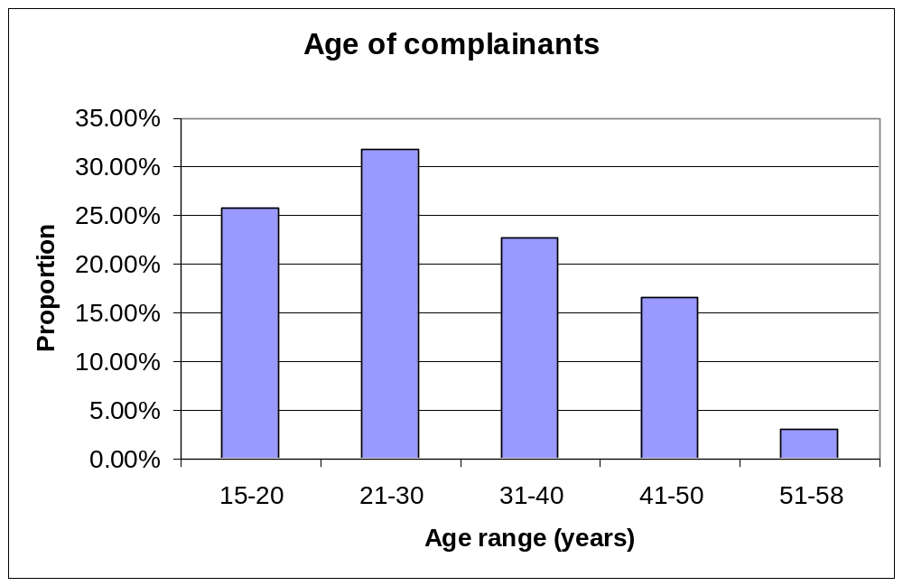

Individual respondents

The individual respondent’s age was contained in the complaint file in 21 cases. In an additional 19 cases, while the age of the respondent was not provided, it was possible to infer from the information contained in the file whether the respondent was older or younger than the complainant.

The youngest respondent was aged 20 years and the oldest respondent aged 69 years. The average age (mean) and median age (the middle value of the range) of respondents were similar at 42 years and 41 years respectively. The modes (most common age) were 30, 42, 48, 56 and 69 years. This reflects the relatively even spread of respondents’ ages across the range 20 to 69 years. Seventy-five per cent of respondents whose age was known were over 30 years.

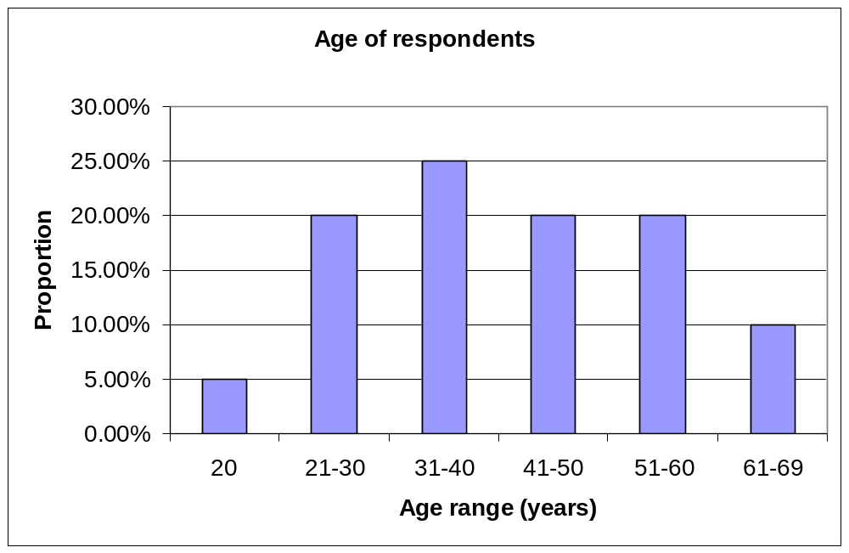

Comparison

The average age of respondents was 12 years older than that of complainants.

 | Complainants | Individual respondents
Number of cases where age recorded | 66 | 21
Average age | 30.08 | 42.15 years
Median | 29 | 41 years
Mode | 29 | 30, 42, 48, 56 and 69 years
Standard deviation | 10.60 | 14.69

More limited data were available that directly compared the ages for the individual respondent and complainant within a complaint.

There were only 13 complaints where the ages of both parties were explicitly provided. Of these 13, there were two cases of the respondent being younger than the complainant, one by seven years and the other by 18 years. In both cases the complainant was female and the respondent male. Of the 11 cases where the respondent was older than the complainant, the age difference ranged from two years to 54 years. In 10 of these 11 cases, the complainant was female and the respondent male while in one case the complainant was male and the respondent was female. It should be noted, however, that in complaints of sexual harassment where the complainant is relatively young, and/or the age difference between the complainant and respondent is significant, the ages of both are more likely to be provided. This may be due to the fact that a significant age gap between the complainant and respondent increases the severity of the alleged harassment. As such, caution is needed in extrapolating from these data.

Of the additional 19 complaints where a difference in the ages between complainants and respondents could be discerned, the respondents were older than the complainants in 16 cases. Of these 16 cases, in all but one the respondent was male and the complainant female. In the other case, the complainant was male and the respondent was female. Of the three cases where the respondent was younger than the complainant, all three respondents were male and all three complainants were female.

5.3 Ethnicity of complainants

Country of birth

Australian-born complainants are overrepresented in the complaints data. Of the two-thirds of complaints (100 complaints) where country of birth was provided 83 per cent of complainants were Australian born. Two complainants (two per cent) identified themselves as Aboriginal. In June 2000, 76 per cent of the Australian population was Australian born.

Parents’ country of birth

Complainants with at least one parent born overseas are underrepresented in the complaints data. Of the 70 complaints where parents’ country of birth was provided, 45 complainants (64 per cent) stated that their mother was Australian born, and 47 complainants (67 per cent) stated that their father was Australian born. Fifteen (18 per cent) of Australian-born complainants had at least one parent born overseas. In contrast, in 1996 27 per cent of persons born in Australia had at least one overseas-born parent.

Language spoken at home

Individuals from a non-English speaking background are underrepresented in the complaints population. Of the 70 complaints where this information was provided, there were only seven complaints (10 per cent) where a language other than English was spoken at the complainant’s home. The languages other than English were French, Italian, Hindi, Pidgin, Spanish, Arabic and Greek. In 2001, 16 per cent of the Australian population spoke a language other than English at home.

6. Complainants’ employment

Reported harassment tended to occur in the first few months of a complainant’s employment, involved harassment by a more senior person in the workplace and was targeted at particular occupations. Most complainants had resigned or been dismissed at the time the complaint was made to HREOC.

6.1 Employment status of complainants at time of harassment

Of the 143 complaints where employment status was able to be determined, the majority of complainants were employed full-time (58 per cent). Of the remainder, 27 per cent were classified as casuals, nine per cent were part-time and six per cent were on a fixed term contract. It is difficult to draw conclusions on the basis of these data. In particular, a comparison cannot be made with Australian Bureau of Statistics (ABS) data as the complainants have not been classified consistently with ABS recorded data.

6.2 Length of complainants’ employment at first incidence of harassment

Reported harassment is far more likely to occur early on in a complainant’s employment. Amongst the 121 cases where this could be determined, 72 per cent of complainants reported that the harassment occurred in the first 12 months of the complainant’s employment, with 11 per cent reporting that it occurred in the second year and 17 per cent reporting that it occurred in the third year or later. In just over half of the complaints, the first incidence of reported harassment occurred within the first four months of the complainant’s employment.

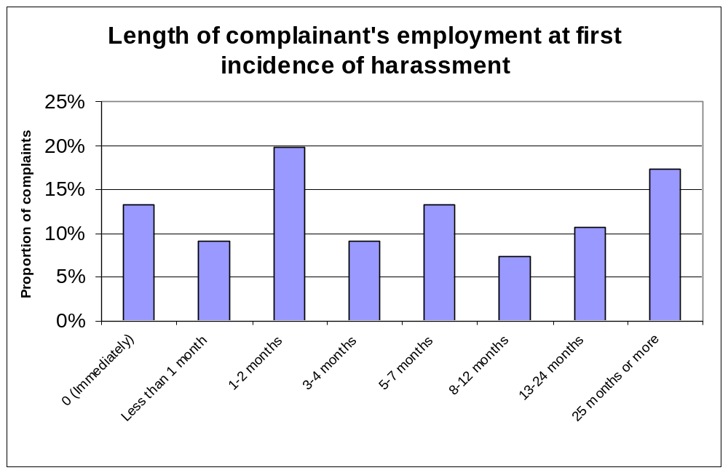

6.3 Employment status of complainants at time complaint made to HREOC

The data on complainants’ employment status provide an indication of the disruption to the workforce caused by incidences of sexual harassment and of the inherent costs for the employer such as employee absenteeism and employee turnover.

Seventy-seven per cent of all complainants were no longer actively working for the organisation where the alleged harassment occurred, having either left their employer, or taken leave.

Almost half (45 per cent) of the complainants had resigned from their employment at the time of making a complaint to HREOC. Nineteen per cent of complainants had been dismissed from their employment. The high percentage (67 per cent) of complainants who left their position in connection with the reported sexual harassment suggest staff turnover is one direct cost that is borne by employers.

Even amongst the small proportion of complainants who were still with the same employer, the reported sexual harassment affected staff productivity. For example, of the 17 per cent of complainants (26 complainants) who were still with the same employer at the time of making a complaint to HREOC, 14 (54 per cent) were absent from work receiving workers’ compensation, one (four per cent) was absent from work on leave without pay and sick leave, two (eight per cent) had transferred to another area with the same employer and one (four per cent) had changed shifts.

It should be noted that information about the employment status of individual respondents was generally not available on the face of the complaint file. See also Section 8.3 for disciplinary outcomes for individual respondents.

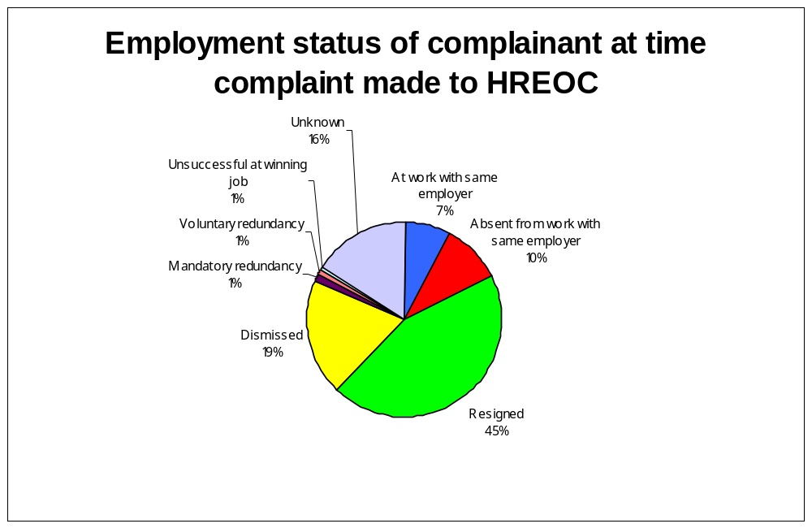

6.4 Complainants’ occupation

Of the 146 complainants whose occupation was known, approximately half (51 per cent) were employed in four occupational groups: clerical, hospitality, shop assistant and labourer.

Almost one in four complainants were employed in clerical work, including as secretaries, administrative assistants, office administrators, clerks, clerical administrators, personal assistants and receptionists. Twelve per cent of complainants were employed in the hospitality area, in positions such as bartenders, waitresses, kitchen hands, restaurant managers and chefs. The next most common grouping was shop assistant or sales assistant which accounted for nine per cent of complainants. Seven per cent of complainants were labourers, packers and stockpersons.

The occupational categories of clerical, sales and service workers are overrepresented in the complaints data. These occupations accounted for 31 per cent of the Australian workforce compared to 45 per cent of complainants. However, given that the majority (95 per cent) of complainants were women, the complaints figures are likely to reflect the gender segregated nature of the Australian workforce and the concentration of women in these occupations. Fifty-one per cent of all women employees were employed as clerical, sales and service workers in their main job. The greater proportion of women who work as clerical, sales and service workers equates to greater incidence of harassment being reported in these occupations given that women are far more likely to report sexual harassment than men.

6.5 Employment relationship of individual respondents to complainants

The data reflect an imbalance in power relations between the individual respondent and complainant, with 60 per cent of 161 respondents in a more senior position in the workplace relative to the complainant. Just over one third (34 per cent) of respondents were co-workers of the complainant.

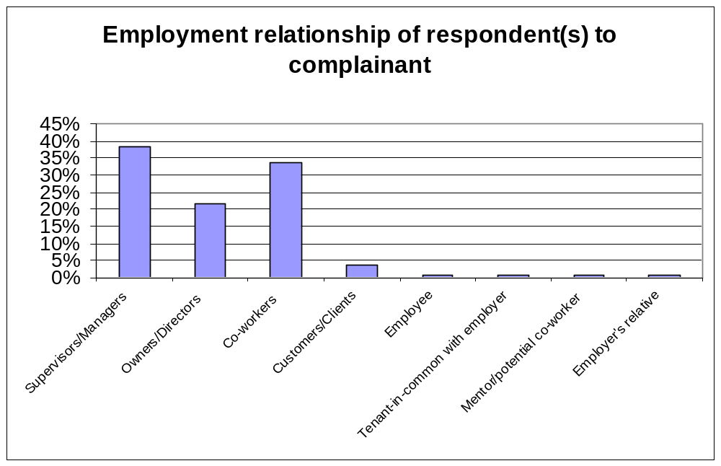

7. Characteristics of workplaces

The data show that sexual harassment remains a problem across employer types, regardless of employer size, industry and location.

7.1 Employer size

The size of the employer or workplace where the sexual harassment occurred could be discerned from 135 of the 152 complaints analysed. Complaints of sexual harassment were more likely to emanate from small businesses according to HREOC’s sample of complaints.

In addition, in comparison to the proportion of the Australian population employed in small, medium and large businesses, complaints from employees working in small businesses appear slightly overrepresented and complaints from employees in large businesses are slightly underrepresented. However, it should be noted that the ABS classifies small business as employers with 1-19 employees, while for the purposes of this review a small employer was defined as one with 1-24 employees. This difference in classification may explain the slight overrepresentation of small business in this review.

Size of employer | Proportion of employees in Australian  labour force  2000-01 | Proportion of complaints  2002
Small | 38% (1-19 employees) | 44% (1-24 employees)
Medium | 23% (20-99 employees) | 19% (25-99 employees)
Large | 38% (100+ employees) | 36% (100+ employees)
Total | 5,912,200 | 135

7.2 Gender balance of workplaces

For 55 complaints it was possible to establish that the complainant’s workplace was dominated by one sex. Ninety-one per cent of these workplaces were male dominated. These sexual harassment complaints may reflect male exclusion of women from their traditional employment domain. However, it is not possible to draw conclusions with any confidence from such a small sample. Ninety-seven complaints were not classified.

7.3 Industry classification

Complaints were analysed and the industry of the employer classified according to the Australian and New Zealand Standard Industrial Classification (ANZIC). As the employer was identified and the type of business generally described in each complaint, it was possible to extrapolate the main industry in which the employer was based from the material in the complaint file. The industry could not be determined in four complaints due to the limited material in the file about the employer.

The most frequently occurring industry was the Property and Business Services industry (14 per cent), followed by Retail Trade (13 per cent), Accommodation, Cafes and Restaurants (12 per cent), Manufacturing (11 per cent), Wholesale Trade (seven per cent), and Transport and Storage (seven per cent).

Communication Services and Accommodation, Cafes and Restaurants were both significantly overrepresented amongst complaints, with the level of complaints being 2.9 and 2.4 times respectively greater a proportion of complaints compared to their contribution to total employment. The workforces in these industries are dominated by women. Other industries that were overrepresented included Wholesale Trade, Transport and Storage, Property and Business Services, Government Administration and Defence, and Cultural and Recreational Services. Education, Health and Community Services and Agriculture, Forestry and Fishing were amongst those industries that were underrepresented amongst complaints. It should be remembered that these figures do not reflect the level of sexual harassment occurring in each of these industries, but rather the level of harassment that has been reported to HREOC.

7.4 Location of workplaces

The location of the workplace where the harassment occurred could be determined for 150 of the complaint files.

Nearly half of the sexual harassment complaints occurred in NSW workplaces. However, the fact that complaints of sexual harassment may also be made to State and Territory organisations under State and Territory legislation means that the data are not very informative on the distribution of reported harassment across Australia.

Two-thirds of the reported harassment occurred in workplaces located in cities including capital cities and major regional cities, 31 per cent occurred in rural areas and three per cent was in remote rural areas.

8. Workplace responses to harassment

The majority of harassment complaints had been reported within workplaces, to people in a management or supervisory role, shortly after the harassment had occurred. Most small businesses did not have a sexual harassment policy. While a significant number of large and medium-sized businesses did have a sexual harassment policy, this was not always implemented.

8.1 Reporting harassment in the workplace

Reporting of harassment via internal mechanisms

In 130 complaints it was clear whether or not the harassment had been reported via internal mechanisms. Amongst these complaints, 78 per cent of complainants (102 complainants) had reported the harassment internally.

Time between harassment and reporting

Of the 102 complainants who reported the harassment internally, the period of time elapsing between the first incidence of harassment and the reporting of it could only be discerned from 86 complaint files. Almost three quarters of these complainants reported the harassment within three months. Forty per cent of complainants (34 complainants) reported the harassment immediately.

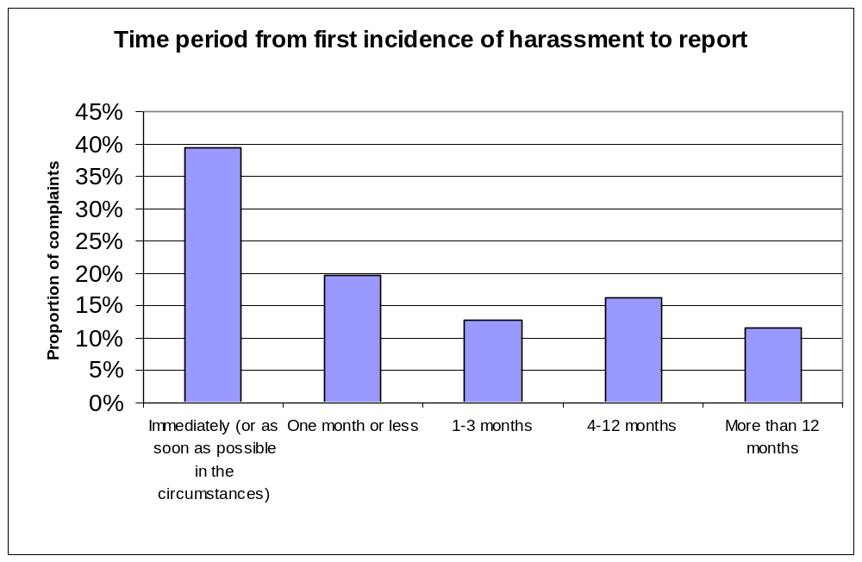

Person to whom harassment was reported

The complaints data reveal that complainants took their concerns to a variety of officers or agencies.
- Thirty-five per cent of complainants reported to a supervisor, manager or team leader.
- Fourteen per cent of complainants reported to a human resources manager or personnel manager.
- Twenty-eight per cent of complainants reported to a Director, CEO, General Manager, Management, Board of Directors, Board of Management or the owner of the business.
- Four per cent of complainants reported to a harassment officer, equity officer or complaints hotline.
- Eight per cent of complainants reported to the alleged harasser.
- Three per cent of complainants reported to another internal person including in-house legal counsel, security and co-workers.
- Eight per cent of complainants reported directly to an external person or organisation (including police, union representative, employer representative, employment agency, apprenticeship co-ordinator, teacher and lifestyle co-ordinator).

Seventy-seven per cent of reporting of harassment was to people in a management or supervisory role. This indicates an expectation by complainants that senior people within an organisation would address complaints of sexual harassment. However since complaints were subsequently made to HREOC in these cases, this also indicates that these managers and supervisors were unable to resolve the complaints in these cases. This has significant implications for business – indicating a need for managers and supervisors to be prepared and able to handle complaints of sexual harassment.

The level of reporting to harassment officers is surprisingly low (four per cent). There are a range of possible explanations for this, including that most organisations do not have a harassment officer; that harassment officers were better able to resolve complaints and thus these complaints did not come to HREOC; or that employees were not making full use of harassment officers. It is not possible to determine which of these reasons apply from the available data.

8.2 Sexual harassment policies

Existence of a sexual harassment policy

Of the 152 complaints analysed, 125 (82 per cent) indicated whether there was a policy on harassment in existence within the workplace or not. Of these respondent employers, 62 per cent indicated that they had a sexual harassment policy in existence.

Implementation of a sexual harassment policy

Implementation of a sexual harassment policy may include training of staff and management; display or publication of the policy on billboards, websites or other prominent positions; induction training and reference to sexual harassment policies in performance management systems. While 62 per cent of respondent employers for whom this information was available had a policy in place, just over one in four (27 per cent) of those respondent employers had not fully implemented their policies. This included not promoting the policy, not including the policy in induction training and/or no recent training of managers about the policy.

The majority of complaints involved employers who had not implemented sexual harassment policies fully or at all. Amongst all 152 complaints analysed, only 36 per cent (54 of 152 complaints) involved an employer who had a sexual harassment policy that had been fully implemented. Half of the employers either did not have a policy or had not implemented the policy. This suggests there is significant scope for employers to improve their preventative measures in relation to sexual harassment.

Relationship between size of employer and existence and implementation of a sexual harassment policy

The existence and implementation of a sexual harassment policy was more common amongst larger business. Eighty-six per cent of large employers, 69 per cent of medium-sized employers and 10 per cent of small employers had a sexual harassment policy. Amongst those organisations that had a sexual harassment policy, 88 per cent of large employers, 50 per cent of medium-sized employers and 33 per cent of small employers had implemented the policy.

At first glance these figures suggest that the existence of a sexual harassment policy has not helped larger organisations to reduce the level of sexual harassment complaints in their workplaces given that the proportion of complaints that HREOC received from large businesses is similar to the proportion of the workforce that is employed by large businesses. However, this does not take account of the fact that the existence of a policy may increase awareness of the option of lodging a complaint with HREOC. In addition, since conciliated complaints are agreements between the parties to a complaint and not a determination that harassment has actually occurred, this paper is not able to conclusively consider the extent to which employers were vicariously liable for the harassment. The existence of a sexual harassment policy may be used in litigation by larger employers to establish that they had met their duty to their employees and taken all reasonable steps to prevent the harassment from occurring.

HREOC has recommended that small businesses have a written policy on sexual harassment in its publication Sexual Harassment: A Code of Practice, and that either the owner of the small business or a responsible senior employee be nominated as a sexual harassment complaints officer. This person should be provided with any training or resources offered by employer organisations, small business associations, industry associations, HREOC or State or Territory anti-discrimination agencies. The facts that in the complaints to HREOC, only one in 10 small employers had a sexual harassment policy and of these only one in three had implemented the policy suggest that small businesses, in particular, need to focus on implementing preventative strategies in order to avoid vicarious liability.

8.3 How harassment was dealt with in the workplace

Informal or formal internal complaint process

The existence of a formal or informal internal complaints process could be determined in 116 of the 152 complaints. Of this 116, a formal or informal internal complaints process existed in 76 per cent of cases. There was no internal complaints process in 23 per cent of cases.

It is surprising that the proportion of complaints from organisations with an internal complaints process is so high. Insufficient information is available on organisations’ complaints processes to be able to determine the reasons for these results. In addition, it is difficult to draw conclusions from these data without knowing the proportion of all workplaces which have an internal complaints process.

Possible explanations for complaints proceeding to HREOC despite the existence of an internal complaints process include that the complaint handling processes, where they exist, are not well implemented or that the existence of a complaints process raises employees’ awareness of the HREOC complaint functions and expectations of satisfactory outcomes.

Workplace response

Complaints of sexual harassment were investigated by the employer in 62 per cent of the 111 cases where this information could be determined.

Disciplinary proceedings took place in 34 per cent of those 111 cases (that is, in 38 cases). In 65 per cent of cases (72 cases), disciplinary proceedings did not occur. There was one case (one per cent) where the occurrence of disciplinary proceedings was disputed between the parties to the complaint.

The most common disciplinary proceedings were transferring the individual respondent (18 per cent), counselling the individual respondent (15 per cent), giving an oral warning to the respondent (12 per cent), giving a written warning to the respondent (12 per cent), and resignation of the respondent (12 per cent). The individual respondent was dismissed in two cases (six per cent) and had to undertake training in one case (three per cent). These figures do not indicate the effectiveness of the disciplinary proceedings in changing the individual respondent’s behaviour or acting as a disincentive for others.

Given that there was only one case where an alleged harasser was required to undertake training as a result of disciplinary proceedings, it would appear that there is scope for increased use of training in response to complaints of sexual harassment, particularly as a means of preventing reoccurrences of this behaviour. However, warnings and counselling may serve as a sufficient indicator that the particular behaviour is not acceptable in the workplace.

One in four complaints were alleged to have been ignored within workplaces amongst the 67 complaints where this could be determined.

Satisfaction with the workplace process

Ninety-nine per cent of complainants were not satisfied with the workplace process for handling sexual harassment complaints amongst the 70 complaints where this could be determined. Obviously, this is consistent with the expectation that only those complainants who were not satisfied with how the complaint was handled within the workplace would proceed to lodge a complaint with HREOC. It underlines the importance of not just having an internal complaints process, but also ensuring that the process is operating well and meeting the expectations of staff.

9. Outcomes of complaints

Almost all complainants sought financial compensation for the harassment they had experienced and more than one in two sought an apology. A conciliation conference was held in over half the complaints, with just over two out of three of these cases settling as a result.

The most common ground for HREOC terminating a complaint was that there was no reasonable prospect of settlement. Very few complaints proceeded to litigation.

9.1 Remedies sought by complainants

Amongst the 123 complaints where the remedies sought by the complainant were specified, 93 per cent sought financial compensation, 59 per cent sought an apology, 38 per cent sought the introduction or enforcement of preventative strategies, 11 per cent sought the provision of a reference or work statement and six per cent sought the dismissal or demotion of the harasser. The average amount of financial compensation sought by complainants was approximately $45,000.

9.2 Outcome of complaints

Conciliation conferences were held in 87 cases to attempt settlement of the complaints. Sixty-one complaints (70 per cent) settled as a consequence of those 87 conciliation conferences.

Of the 152 complaints reviewed, 61 complaints (40 per cent) settled via a conciliation conference, 49 complaints (32 per cent) were terminated, four complaints (three per cent) were administratively closed, 12 complaints (eight per cent) were withdrawn and 26 complaints (17 per cent) settled privately.

9.3 Termination of complaints

Of the 49 complaints that were terminated by HREOC, 92 per cent were terminated on the ground that there was no reasonable prospect of settlement. This means that just under one in three of all complaints made (152 complaints) were terminated because the parties could not reach agreement.

Complaints were also terminated because HREOC considered that the behaviour was not unlawful (six per cent); or the complaint was lacking in substance (two per cent)

Amongst the 49 terminated complaints, 26 were terminated after a conciliation conference was held and 23 were terminated without a conciliation conference taking place.

9.4 Financial compensation arising from settlement

The amount of financial compensation received by complainants varied widely, from a minimum of $500 to a maximum of $200,000. The median financial payment obtained by sexual harassment in employment complainants in 2002 was $6,250. This amount is slightly above the median financial payment obtained at conciliation of all complaints under the Sex Discrimination Act in 2001, which was $5,000. Sixty-four per cent of sexual harassment in employment complainants received less than $10,000 compensation at settlement.

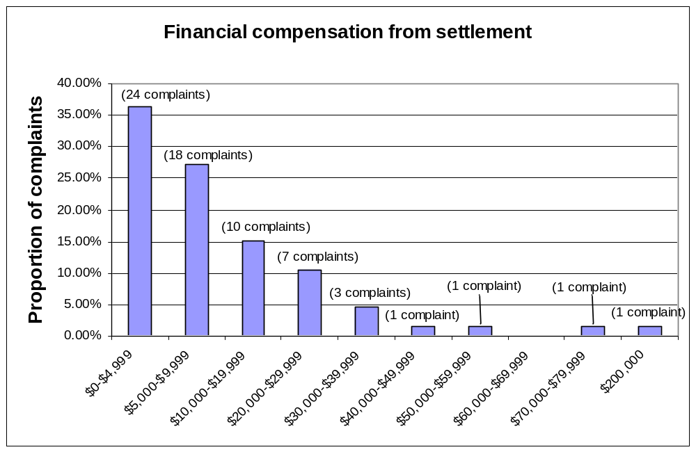

9.5 Who paid the compensation

As noted above at Section 2, employers have a legal responsibility to take “all reasonable steps” to prevent sexual harassment occurring in their workplace.
A detailed breakdown of compensation paid by employers versus individuals is not available. In most cases, however, compensation was paid by the employer rather than the individual alleged harasser.

In those cases where both the employer and the alleged harasser agreed to pay compensation, the employer generally paid a greater amount of compensation than the individual. For example, amounts paid included $500 by the alleged harasser and $9,500 by the employer; $5,000 by the alleged harasser and $10,000 by the employer; and $3,000 by the alleged harasser and $2,216 by the employer.

It is important to note that compensation by the employer arising from conciliation does not necessarily represent an admission that harassment has occurred. There are many reasons why an employer may choose to pay compensation including a desire to avoid litigation and publicity of the case, to settle the dispute more quickly or to minimise workplace disruption.

9.6 Relationship between financial compensation and age of complainant

There was significant variation in the median financial compensation received by complainants of different ages. In particular, the median amount received by complainants aged 31-40 years was significantly higher than for other age groups.

Age of complainants | Average financial compensation | Median financial compensation
15 – 20 years | $6,356 | $3,750
21 – 30 years | $10,149 | $6,419
31 – 40 years | $48,393 | $25,000
41 – 58 years | $11,278 | $8,250

It is not possible from the available data to explain the difference between the levels of financial compensation received by age. However, the most likely explanation is that the settlement was calculated by reference to the wage or salary of the complainant and thus reflects differences in seniority within the workplace and salary levels of different aged complainants. On a similar line, some of the difference may also relate to whether the person paying the compensation was an individual or an employer.

9.7 Time taken to finalise complaints

The average time taken from receipt of the complaint by HREOC to finalisation (whether settled through a conciliation conference or privately, terminated or withdrawn) was 7.6 months. For individual complaints, this ranged from less than one week to 29 months. The median time taken to finalise the 152 complaints was seven months, while the mode (most common time) was nine months. Forty-three per cent of complaints were finalised in six months or less from the date of receipt, while 12 per cent of complaints took more than 12 months to be finalised.

9.8 Litigation

Of the 152 complaint files analysed, 17 complainants (11 per cent) pursued their terminated complaints by making an application to either the Federal Magistrates Court or the Federal Court of Australia claiming unlawful discrimination.

Twelve of these cases did not proceed to hearing: six were settled, five were discontinued by the complainant and one was vacated. Of the remainder, one is yet to be heard, three were dismissed, and one complaint was substantiated. In the three applications dismissed, two were dismissed with no orders made for costs. The other application was dismissed with the applicant ordered to pay the respondent’s costs. In the substantiated complaint, the applicant was awarded damages in the sum of $10,000 plus interest from the date of filing the application to the date of judgment and exemplary damages in the sum of $7,500. Payment of these damages was to be shared between the employer and the individual harasser.
PART D: CONCLUSION

10. Conclusion

Complaints of sexual harassment are a significant issue for women in the workplace, with the overwhelming majority of complaints of sexual harassment coming from women. In addition to the personal impact of such harassment, there is also a significant impact on these women’s employment, with at least three out of four complainants no longer actively working for the organisation where the alleged harassment occurred by the time they report the harassment to HREOC. These women have been dismissed, made redundant, resigned, or are off work on unpaid leave, sick leave or workers’ compensation.

Sexual harassment reported to HREOC is significantly gendered; the complaints that HREOC receives indicate that sexual harassment by men of women is occurring throughout Australian workplaces. This harassment typically involves significant power differentials, with harassment committed by individuals who are older and hold more senior positions within an organisation. The harassment begins relatively soon after employment commences, involves multiple forms of harassing behaviour, and typically occurs on multiple occasions. The harassment often starts as verbal harassment and then proceeds to physical harassment.

Those who reported sexual harassment worked across the range of occupations but were concentrated in a small number of occupations, reflecting the gender segregation in the Australian workforce.

The data show that harassment remains an issue for small, medium and large business in city, rural and remote rural areas. Many workplaces either do not have a sexual harassment policy or have not implemented their policy, leaving themselves open to vicarious liability for the harassment. In addition, it is evident that businesses bear significant costs due to staff turnover in the event of harassment. This is despite the fact that the majority of sexual harassment complaints had been reported to a senior person within the workplace. Reasons for proceeding with a complaint to HREOC included dissatisfaction with the internal process for handling the complaint, or that the workplace had ignored the complaint.

These findings have clear implications for workplaces. They imply significant staff turnover costs for employers as a result of sexual harassment, in addition to possible negative impacts on productivity and workplace culture. The data indicate that there is more that employers could do to prevent sexual harassment and to address it where it does occur. For example, this could include:
- development and implementation of a sexual harassment policy, particularly by small business;
- review of the adequacy of internal mechanisms for handling sexual harassment complaints;
- ensuring internal complaints processes meet the expectations of staff;
- better training for managers and supervisors so that they are prepared and able to handle complaints of sexual harassment;
- greater use of training in response to complaints of sexual harassment, particularly as a means of preventing reoccurrences of this behaviour; and
- inclusion of information about harassment in orientation for new staff.

That said, it should be remembered that many of the cases reviewed in this paper are likely to be the most difficult for employers to resolve internally.

Unions and employer groups could usefully develop targeted information for those industries and occupations with a high incidence of reported harassment.

These findings reinforce the need for HREOC to continue to undertake public education and research on the issue of sexual harassment.

What the data presented in this paper do not show is who is being harassed but not reporting it to HREOC. This will include harassment that is resolved between individuals and within organisations, as well as harassment that is continuing unchecked and unreported. In order to obtain this information, HREOC has commissioned a telephone survey of the general incidence of sexual harassment in Australia. This will provide a more complete picture on the harassment that is occurring in the Australian workplaces, and the extent to which this is reflected in complaints to HREOC.

Acknowledgements

The Human Rights and Equal Opportunity Commission would like to thank the following people.

COMMISSIONER AND EDITOR
Pru Goward

DIRECTOR, SEX DISCRIMINATION UNIT
Sally Moyle

AUTHORS
Gayle Balding (Primary researcher)
Melissa Stutsel

CONTRIBUTORS

Sex Discrimination Unit
Karen O’Connell
Marissa Sandler

Complaints
Jodie Ball
Rocky Clifford
Glenda Long
Kay Russell

Legal
Catherine Hinwood
Susan Roberts

Library
Michelle Coxhead
Léonie Nagle

Public Affairs
Emma Baker
Joanna Kay
Paul Oliver
Jan Payne

The name of the complainant and respondent has been changed in each of these case studies.
Each State and Territory also has its own legislation concerning sexual harassment. In some States this legislation has been in place for longer than twenty years, for example, in Victoria it has existed since 1977: Equal Opportunity Act 1977 (repealed and replaced by the Equal Opportunity Act 1995). Such legislation has existed in the Australian Capital Territory since 1991: Anti-Discrimination Act 1991; in the Northern Territory since 1992: Anti Discrimination Act 1992; in Queensland since 1991: Anti Discrimination Act 1991; in South Australia since 1984: South Australian Equal Opportunity Act 1984; in Tasmania since 1994: Sex Discrimination Act 1994 (repealed and replaced by the Anti Discrimination Act 1998); and in Western Australia since 1984: Equal Opportunity Act 1984. In New South Wales, sexual harassment was dealt with as a form of sex discrimination under the Anti-Discrimination Act 1977 until 1997 when explicit provision for sexual harassment was made in the Act.
See Section 2 for the legal definition of sexual harassment.
Human Rights and Equal Opportunity Commission Annual Report 1995-1996 Commonwealth of Australia Canberra 1996, p90; Human Rights and Equal Opportunity Commission Annual Report 1996-1997 HREOC Sydney 1997, pp42-43; Human Rights and Equal Opportunity Commission Annual Report 1997-1998 HREOC Sydney 1998, pp47-48; Human Rights and Equal Opportunity Commission Annual Report 1998-1999 HREOC Sydney 1999, pp46-47; Human Rights and Equal Opportunity Commission Annual Report 1999-2000 HREOC Sydney 2000, p57; Human Rights and Equal Opportunity Commission Annual Report 2000-2001 HREOC Sydney 2001, p73; Human Rights and Equal Opportunity Commission Annual Report 2001-2002 HREOC Sydney 2002, p73 and Human Rights and Equal Opportunity Commission Annual Report 2002-2003 HREOC Sydney 2003, p77.
Complaints on the ground of sexual harassment increased from 142 complaints in 1999-2000 to 167 complaints in 2000-2001 to 195 complaints in 2001-2002. Human Rights and Equal Opportunity Commission Annual Report 1999-2000 HREOC Sydney 2000, p57; Human Rights and Equal Opportunity Commission Annual Report 2000-2001 HREOC Sydney 2001, p73 and Human Rights and Equal Opportunity Commission Annual Report 2001-2002 HREOC Sydney 2002, p73. Complaints decreased in 2002-2003 to 172: Human Rights and Equal Opportunity Commission Annual Report 2002-2003 HREOC Sydney 2003, p77. The next most recent increase in the number of complaints on the ground of sexual harassment was between 1993-1994 and 1994-1995. Human Rights and Equal Opportunity Commission Annual Report 1993-1994 Commonwealth of Australia Canberra 1994, p80 and Human Rights and Equal Opportunity Commission Annual Report 1994-1995 Commonwealth of Australia Canberra 1995, p151. The decrease in the number of complaints on the ground of sexual harassment between 1994-1995 and 1999-2000, and between 2001-2002 and 2002-2003 corresponds to a decrease in the total number of complaints received under the Sex Discrimination Act during these periods.
Human Rights and Equal Opportunity Commission Annual Report 2002-2003 HREOC Sydney 2003, p77.
See Section 2 on the legal definition of sexual harassment.
Complaints that cannot be resolved by conciliation or are considered inappropriate for conciliation are terminated by the President of HREOC. Grounds for termination include that there is no reasonable prospect of settlement, that the behaviour is not unlawful or that the complaint is lacking in substance. See Section 3 for an overview of HREOC’s complaint handling process.
In comparison, 14 per cent of all complaints under the Sex Discrimination Act that were finalised in 2001-2002 were terminated on the grounds of being trivial, vexatious, frivolous, misconceived or lacking in substance: Human Rights and Equal Opportunity Commission Annual Report 2001-2002 HREOC Sydney 2002, pp73-74.
HREOC invites complainants to provide a range of demographic information including their age and ethnicity for statistical purposes by returning a voluntary survey form to HREOC. For the 2001-2002 financial year, 68 per cent of complainants returned this form.
“The conduct will amount to harassment if it occurs in circumstances in which a reasonable person would have anticipated that the person harassed would be offended, humiliated or intimidated”: Font v Paspaley Pearls & Ors [2002] FMCA 142 at [134].
Section 28A of the Sex Discrimination Act defines sexual harassment. Section 28B provides the circumstances under which such behaviour is unlawful in the area of employment.
Aldridge v Booth (1988) 80 ALR 1 at 5.
In Hall & Ors v A. A. Sheiban Pty Ltd & Ors (1989) EOC 92-250 at 77, 399 Justice Lockhart stated that “In principle, advances by an employer, particularly if there is a series of them, all of which may have been tolerated by an employee out of sympathy or out of lack of choice, and each of which or all of which may have been tolerated by the majority of women, may nevertheless contravene Section 28 if they otherwise ‘vex and annoy’ so as to amount to sexual harassment.”
Section 28B-L.
In Aldridge v Booth (1988) EOC 92-222 at 77, 091 Justice Spender summed up these requirements: “It is noted that … it is for an employer or principal to establish all reasonable steps to be taken by that employer or principal to prevent the acts constituting the unlawful conduct. The discharge of this onus, of course, depends on the particular circumstances of a case, but it is seriously to be doubted that it can be discharged in circumstances of mere ignorance or inactivity.”
“In my opinion, a person can, for the purposes of s105, permit another person to do an act which is unlawful, such as discriminate against a woman on the grounds of her sex, if, before the unlawful act occurs, the permitter knowingly placed the victim of the unlawful conduct in a situation where there is a real, and something more than a remote, possibility that the unlawful conduct would occur.” Elliot v Nanda & the Commonwealth of Australia [2001] FCA 418 at [163].
Section 46PK Human Rights and Equal Opportunity Commission Act 1986 (Cth).
In certain circumstances another person can make a complaint on behalf of individuals or groups who cannot make a complaint themselves. A complaint may also be made by one affected person on behalf of a group of people, such as a group of workers or residents.
There were 299 incidences of the various types of harassment recorded for the 152 complaints.
Physical intimacy includes conduct such as giving a complainant a shoulder massage, touching a complainant’s thigh while sitting together, deliberately brushing up against a complainant’s body, hugging, touching a complainant’s face or hair and trying to hold a complainant’s hand.
Sexual physical behaviour is physical behaviour of a more sexual nature than that which has been defined as physical intimacy. It includes kissing or attempting to kiss a complainant, touching a complainant’s breasts or bottom and sexual assault.
“It is also clear that sexual harassment constituted by conduct of a sexual nature can be the result of a single act or single incident”: Johanson v Blackledge Meats [2001] FMCA 6 citing Hall & Ors v A. A. Sheiban Pty Ltd & Ors (1989) EOC 92-250 and Leslie v Graham unreported, HREOC, 21 July 2000.
Complainants are not required to give their age to HREOC. However, a voluntary survey asking demographic questions is provided to complainants when they first lodge their complaints. One of the questions on a later version of this survey asks the complainant’s age. Not all complainants in this sample returned this survey. However, the age of the complainant can sometimes be discovered in the body of the complaint file.
ABS 6203.0 Labour Force Australia: August 2002 Commonwealth of Australia Canberra 2002, p23.
ABS 6203.0 Labour Force Australia: August 2002 Commonwealth of Australia Canberra 2002, p23.
Respondents are not required to provide demographic information such as age to HREOC. However, the age of the respondent can sometimes be discovered in the information on the complaint file. In one of the 21 cases, age was provided as an age range and so has not been included in calculations of the average age.
In some of these cases, the complainant stated that the respondent was younger or older than the complainant.
See, for example, Straney v Brady (1994) EOC 92-584 "… the sense of oppressive authority that often lies at the heart of allegations of sexual harassment is more likely to be imparted in the context of a close employment relationship where there is a wide disparity in ages between the older and younger employee" and Elliot v Nanda (1999) EOC 92-989 “The conduct is made worse by: the age disparity between the parties…”
Australian Historical Population Statistics – on AusStats (3105.0.65.001) and Migration, Australia (3412.0) in ABS 1301.0 Year Book Australia 2003 Commonwealth of Australia Canberra 2003, p132.
1996 Census of Population and Housing in ABS 1301.0 Year Book Australia 2003 Commonwealth of Australia Canberra 2003, pp132-133.
2001 Census of Population and Housing in ABS 1301.0 Year Book Australia 2003 Commonwealth of Australia Canberra 2003, pp145-146.
Not all complainants stated their employment status in their complaint form, nor responded to the demographic survey. Also, where employment status was provided by the complainant, it sometimes differed from the employment status described by the respondent. In these cases, it was usually the respondent’s description that has been used in the analysis. Occasionally the complainant’s work status could be inferred from the nature of the work undertaken by the complainant, the hours worked and the industry classification. Seven complainants were on probation when the harassment occurred.
In order to compare the complaints data with ABS statistics it would be necessary to know whether the casual and fixed term contract complainants worked full-time or part-time, and whether the complainants who worked part-time and full-time were permanent employees, casuals, or worked on contract.
There were 123 complaint files containing information on the period of employment from when the complainant commenced employment to when the first incidence of reported harassment occurred. One complaint where harassment occurred during the job selection process and one complaint where the harassment occurred immediately after the new owner of the small business started have been excluded from the calculations included here. Where the harassment occurred immediately upon the complainant’s commencement of employment a value of zero was given.
Note that this calculation includes 16 per cent of complainants (24 complainants) whose employment status was not known. Of the 128 complainants whose employment status was known, 91 per cent were no longer actively working for the organisation where the harassment occurred.
These data are taken from the complainant’s and respondent’s descriptions of the position occupied by the complainant at the time of the harassment.
ABS 6203.0 Labour Force Australia: August 2002 ABS Canberra 2002, p46.
ABS 6203.0 Labour Force Australia: August 2002 ABS Canberra 2002, p46.
Note that there were occasionally more than one respondent per complaint.
Excludes persons employed by public trading and general government entities, and by businesses in the Agriculture, Fishing and Forestry industries.
Small Business in Australia 2001 (1321.0) in ABS 1301.0 Year Book Australia 2003 Commonwealth of Australia Canberra 2003, p412. Note that Small Business in Australia is a biennial publication, with the next edition featuring 2003 data due for release in 2004.
A number of complainants explicitly stated that they worked in a workplace dominated by one sex (predominantly male-dominated). It was also possible to infer the gender balance of some complainants’ workplaces in a limited number of cases. This inference is based on the complainant’s description of the workplace, the complainant’s description of co-workers and the industry the complainant worked in.
These complaints have been classified as unknown and complaints in each industry have been calculated as a proportion of all 152 complaints.
Section 13(2) of the Sex Discrimination Act provides that sexual harassment committed by an employee of a State or an instrumentality of a State is not covered by the Act. These complaints are dealt with by the relevant State or Territory organisations. Given the high levels of State provision of Education, Health and Community Services these occupations will always be underrepresented in complaints to HREOC.
Note that some complainants reported harassment to more than one reportee.
Note that this was the classification used by the complainants. It has been included in this category with other forms of senior management as it could not be classified as an individual or direct manager.
An additional two cases have not been included as question of whether the sexual harassment policy had been implemented was in dispute between the parties.
See Section 7.1.
Human Rights and Equal Opportunity Commission Sexual Harassment: A Code of Practice HREOC Sydney 1997, pp21-22. This is also supported by the case law. In the case of Gilroy v Angelov [2000] FCA 1775, Justice Wilcox said that the development of a brief document that pointed out what sexual harassment is, sanctions attached to it and what an employee can do if they are harassed would help an employer in a small business make out a defence to vicarious liability.
The obligation on small businesses to take reasonable steps to prevent sexual harassment is supported by the case law. “It may be more difficult for a small employer, with few employees, to put in place a satisfactory sexual harassment regime than for a larger employer with skilled human resources personnel and formal training procedures. But the [Sex Discrimination] Act does not distinguish between large and small employers, and the decided cases show that many sexual harassment claims concern small business, often with only a handful of employees”: Gilroy v Angelov [2000] FCA 1775 at [100].
There was one case where the existence of an internal complaints process was disputed between the parties.
This could not be determined in 41 cases.
Note that some respondents were disciplined in more than one way.
Other types of disciplinary proceedings included demotion (nine per cent), salary increment delayed (three per cent) and probation period extended (three per cent). The type of disciplinary proceedings were not known in nine cases.
The alleged harasser was dismissed by the employer in the one complaint where the complainant was satisfied with the workplace process. The complainant pursued a complaint with HREOC against the alleged harasser which went to conciliation. The outcome of the conciliation was an apology from the alleged harasser (no compensation was sought).
See Section 9.8.
The remedy sought by the complainant was unknown or not stated in 29 complaints.
A median rather than average measurement gives a clearer picture of the financial compensation that complainants received, as an average can be skewed by one or two extreme financial payments linked to specific individual circumstances.
Human Rights and Equal Opportunity Commission Review of Changes to the Administration of Federal Anti-Discrimination Law: Reflections on the initial period of operation of the Human Rights Legislation Amendment Act (No.1) 1999 (Cth) Commonwealth of Australia Sydney 2002, p11.
The complainant’s age was provided in 66 complaints.
A median rather than average measurement gives a clearer picture of the financial compensation that complainants received, as an average can be skewed by one or two extreme financial payments linked to specific individual circumstances.
Note that a payment of $200,000 was made to a 34 year old woman. As this payment is significantly higher than most other compensation payments it does skew the results for this age group. Removing this payment from the calculation results in an average payment of $23,125 for 31-40 year old complainants, which is still significantly higher than other age groups.
Excluding the payment of $200,000 from the calculation results in a median payment of $22,500 for 31-40 year old complainants.
A detailed breakdown of compensation paid by employers versus individuals is not available. See Section 9.5 for further discussion of payment by employers versus individuals.
For all complaints to HREOC in 2001-2002, 88 per cent of matters were finalised within 12 months from the date of receipt and the average time from receipt to finalisation of a complaint was seven months. Human Rights and Equal Opportunity Commission Annual Report 2001-2002 HREOC Sydney 2002, p40.
The complaint was withdrawn within six days of its receipt.
The complaint settled at a conciliation conference with the employer agreeing to pay the complainant $30,000 in full and final settlement of the complaint.
The case was listed for a directions hearing on 29 October 2003.
Maurmo v The House of the Bride & Ianotti unreported Federal Magistrates Service 4 March 2003, Fox v Gay & Boyd Hotel, unreported Federal Magistrates Service 6 August 2003 and Daley v Barrington & Wright & NSW Greyhound Breeders, Owners and Trainers Association [2003] FMCA 93.
Font v Paspaley Pearls & Ors [2002] FMCA 142.
Maurmo v The House of the Bride & Ianotti unreported Federal Magistrates Service 4 March 2003 and Fox v Gay & Boyd Hotel unreported Federal Magistrates Service 6 August 2003.
Daley v Barrington & Wright & NSW Greyhound Breeders, Owners and Trainers Association [2003] FMCA 93.
Font v Paspaley Pearls & Ors [2002] FMCA 142.
Employment status at time of reporting to HREOC could only be determined for 128 of the 152 complaints.

