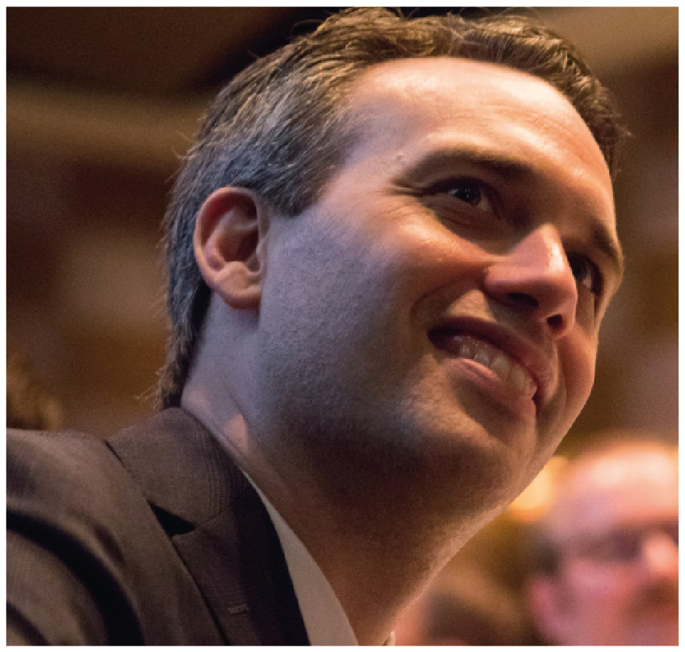 | Edward Santow  Human Rights Commissioner  THIRD YEAR OF TERM | ‘The touchstone of human rights is dignity. The human rights framework provides practical tools to protect the dignity of all members of our community.’

TERM GOALS
Improve human rights protections for vulnerable groups including:  - refugees and asylum seekers  - lesbian, gay, bisexual, trans, and/or intersex people  - people in all forms of detention | Improve Australia’s protection of human rights in difficult contexts including:  - design and regulation of new technologies  - protection and accommodation of freedom of religion and expression;  - implementation of anti-terrorism and national security law and policy

STRATEGIES
- Developing partnerships and collaborations to address common goals.
- Public advocacy supported by research and evidence.
- Fostering public debate on human rights via strategic public engagement.
- Engaging stakeholders and ensuring inclusive consultation with diverse groups.
- Providing policy and law reform advice to improve human rights protection for vulnerable groups.
- Developing innovative solutions to protect and promote rights and freedoms.

2018 –19 FEATURE PROGRAMS/PROJECTS
Human rights and technology program | In an era of unprecedented technological development, this program is a collaboration with a broad range of sectors to foster an inclusive, solution-oriented conversation about how human rights can be better protected in the development and use of new technologies. In 2018, we will deliver Australia’s first Human Rights and Technology Conference and a comprehensive stakeholder consultation and reporting process.
Implementation of the Optional Protocol to the Convention against Torture (OPCAT) project | This project continues stakeholder consultations and expert human rights analysis to report to the Australian Government on how OPCAT can be implemented in a way that reflects best practice worldwide and complies with Australia’s human rights obligations.
Medical interventions for people born with variations in sex characteristics: consultation project | This project considers how people born with variations in sex characteristics experience medical interventions. It involves broad consultation and research on how such decisions are made, with a view to improving human rights protection in this area. The project will identify changes that are needed to Australian law, medical practice protocols and in education to ensure that the rights of people born with variations in sex characteristics are protected, and to end medically unnecessary, non-consensual medical interventions in this area.
Freedom of religion program | This ongoing program is establishing a sustainable mechanism to communicate and work constructively with religious organisations, and the broader faith community, on how to protect freedom of religion in Australia. Through a combination of better data, community dialogue and education, it aims to increase understanding of serious threats to religious freedom and combat those threats.
Asylum seeker and immigration detention program | This work aims to improve human rights protection in Australia’s immigration system. Projects include: inspections of Australia’s immigration detention facilities to identify human rights problems and best practices; identifying and addressing human rights challenges for a large cohort of asylum seekers in the Australian community; research and reporting on the human rights implications of policies affecting asylum seekers, refugees and other migrants.

