Australian Human Rights Commission Inspection of Brisbane Immigration Transit Accommodation: Report

19–20 September 2017

Table of Contents
1 Introduction 5
2 Background 6
2.1 Previous monitoring visits 6
2.2 Inspection methodology 6
2.3 Relevant human rights standards 7
2.4 National context 8
(a) Number of people in detention 8
(b) Length of detention 8
(c) Reasons for detention 8
(d) Administration of the detention network 9
(e) Ratification of OPCAT 10
2.5 Brisbane Immigration Transit Accommodation 10
3 Key issues and concerns 11
3.1 Treatment of people in detention 11
(a) Safety, security and relationships with staff 11
(b) Use of force and restraints 11
(c) Other invasive and restrictive measures 12
3.2 Conditions of detention 12
(a) Accommodation and living areas 12
(b) Indoor and outdoor exercise 14
(c) Activities and excursions 15
(d) Food and personal items 16
3.3 Physical and mental health 16
(a) Health services 16
(b) Health issues 18
(c) Continuity of care 18
3.4 Communication and complaints 19
(a) Mobile phone policy 19
(b) Communication facilities 20
(c) Visits 20
(d) Complaints 22
3.5 Legislative and policy framework 22
(a) Indefinite mandatory detention 22
(b) Community alternatives to detention 24
(c) Case management and status resolution 25
4 Summary of recommendations 27
4.1 Recommendations to the Australian Government 27
4.2 Joint recommendations to the Department of Home Affairs and facility staff 27
4.3 Recommendations to the Minister and Department of Home Affairs 27
4.4 Recommendations to facility staff 30
5 Appendix 1: Photos taken during the Commission’s inspection 31
5.1 Facilities in Bedarra compound 31
5.2 Shared facilities in residential area 33
5.3 Facilities in Fraser compound 36
5.4 Facilities for visits 38
6 Appendix 2: Human rights standards relevant to immigration detention 41
6.1 Treatment of people in detention 41
6.2 Conditions of detention 41
6.3 Communication, association and complaints 42
6.4 Legal and policy framework 42
Endnotes 44

Summary of key issues
Facilities in the residential compound of the BITA are generally of an adequate standard for short periods of detention. However, the BITA is not an appropriate facility for people who are likely to be in detention for extended periods of time.
The Fraser compound at the BITA is small, crowded, offers very limited privacy and lacks adequate access to outdoor exercise. The Commission considers that the Fraser compound is not an appropriate place of immigration detention, even for short periods of time or for a smaller number of people.
Feedback on staff at the BITA was generally positive.
The use of restraints on people detained at the BITA in some cases may have been excessive.
The Commission did not identify major or systemic concerns regarding the provision of health care at the BITA. However, there is some level of concern among people detained at the BITA about health care and the impact of detention on mental health.
The Commission is particularly concerned about the circumstances of vulnerable individuals who had significant mental health issues (including people subject to third country processing) and of pregnant women detained at the BITA. These groups should be considered a priorities for release into alternative community-based arrangements.
The policy prohibiting all mobile phone use may restrict access to external communication to a greater degree than is necessary to ensure safety and security, particularly in a lower-security facility like the BITA.
The Commission welcomes the establishment of dedicated facilities for visits at the BITA.
A number of the people interviewed by the Commission reported that they had been in detention for a relatively short period of time. However, the some had been detained for prolonged periods of time, and in some cases had spent very long periods of time at the BITA.
Status Resolution Officers are not currently able to provide people in detention with adequate case management support

Introduction
This report contains an overview of key observations and concerns arising from the Australian Human Rights Commission’s inspection of the Brisbane Immigration Transit Accommodation (BITA) facility in September 2017.
The rationale for the Commission undertaking such inspections is to identify problems in the way that detainees’ human rights are being protected and to suggest ways of addressing those problems. Hence, while the report is balanced and points to some good practices, its primary focus is on issues of concern identified by the Commission. The report reflects conditions as they were at the time of the inspection.
The Commission also raised a number of additional issues with the Department of Home Affairs (Home Affairs) and facility staff during, and subsequent to, the inspection, including individual cases of concern. In the period since completing the inspection, the Commission has continued to liaise with Home Affairs regarding identified issues and concerns.
The Commission acknowledges the assistance provided by Home Affairs and the Australian Border Force (ABF) in facilitating the Commission’s inspection. The Commission is grateful to the Home Affairs and ABF officers and detention service provider staff who assisted the Commission team during the inspection. A draft of this report was shared with Home Affairs in advance of its publication, to provide an opportunity for Home Affairs to respond to the identified issues.

Background

Previous monitoring visits
The Commission has conducted inspections of immigration detention facilities in Australia since the mid-1990s. This has included periodic monitoring of detention facilities across the country and three major national inquiries into immigration detention.
The purpose of the Commission’s detention monitoring inspections is to ensure that Australia’s immigration detention system is compliant with our obligations under international human rights law. For many years, the Commission has expressed a range of concerns about aspects of the detention system that may lead to breaches of international human rights law. These include:
- the policy of mandatory immigration detention, which does not allow for adequate consideration of individual circumstances and can result in cases of arbitrary detention under international law
- the indefinite and, at times, prolonged nature of immigration detention and the lack of a legislative time limit on detention
- the detention of children, which has led to breaches of numerous obligations under the Convention on the Rights of the Child (CRC)
- the indefinite detention of people who have received adverse security or character assessments, including in circumstances where they have not been convicted of a crime under Australian law
- conditions of detention, which in some cases have not met international standards
- the impacts of immigration detention on mental health
- the need for increased use of alternatives to immigration detention.
Further information about these concerns can be found in the Commission publication, Asylum Seekers, Refugees and Human Rights: Snapshot Report.
The Commission can also investigate and, where appropriate, try to resolve through conciliation, complaints it receives from people in immigration detention regarding alleged breaches of human rights.

Inspection methodology
The Commission inspected the BITA from 19 to 20 September 2017. The inspection was conducted by three Commission staff. Dr Rachel Claydon, a general practitioner, joined the inspection team as an independent consultant.
During the inspection, the Commission team met with representatives from Home Affairs, ABF, Serco and International Health and Medical Services (IHMS); conducted an inspection of the physical conditions of detention; and held individual private interviews with nine people detained at the BITA. The Commission also held a number of informal discussions with people detained at the facility.
The Commission considered the evidence gathered during the inspection against human rights standards derived from international law that are relevant to immigration detention.
The Commission’s methodology reflects international guidelines for the conduct of detention inspections, including a core focus on prevention. This preventative approach necessitates consideration of root causes and risk factors for possible breaches of international human rights standards, both at specific facilities and at a broader level. Where relevant, the Commission draws on knowledge gained through inspections of other facilities in the detention network, to inform observations about systemic or structural issues that may lead to breaches of international law.

Relevant human rights standards
There are nine core international human rights instruments, of which seven have been ratified by Australia. These are:
- the International Convention on the Elimination of All Forms of Racial Discrimination
- the International Covenant on Civil and Political Rights (ICCPR)
- the International Covenant on Economic, Social and Cultural Rights (ICESCR)
- the Convention on the Elimination of All Forms of Discrimination against Women
- the Convention against Torture and Other Cruel, Inhuman or Degrading Treatment or Punishment (CAT)
- the Convention on the Rights of the Child (CRC)
- the Convention on the Rights of Persons with Disabilities.
Several of these treaties — particularly the ICCPR, ICESCR, CAT and CRC — contain obligations that are relevant to the situation of people in immigration detention. These include obligations relating to the treatment of people in places of detention; conditions of detention; the rights to communication and association; and the legal and policy framework underpinning detention regimes.
These obligations require Australia to ensure that people in detention are treated fairly and reasonably, and in a manner that upholds their dignity. Conditions in detention facilities should be safe and hygienic, and people in detention should have their basic needs met and access to essential services. Detention should not have a disproportionate impact on people’s ability to express themselves, communicate and associate with others, and remain in contact with their family members, friends, representatives and communities. People should only be detained in immigration detention facilities when it is reasonable and necessary in their individual circumstances, and for a limited period of time.
Further information about relevant standards can be found in Appendix 3 of this report, as well as in the Commission publication, Human rights standards for immigration detention.
At the time of the Commission’s visit, there were no children detained at the BITA. Human rights standards relating to the detention of children therefore were not applicable to this inspection.

National context
The Commission last inspected the BITA in early August 2008. Since that time, there have been a number of significant changes in the legal, policy and operational context surrounding Australia’s immigration detention system.

Number of people in detention
The number of people in closed immigration detention, and particularly the number of children in detention, has fluctuated significantly since the Commission’s last inspection. At that time, there were 326 people (including 16 children) in detention across Australia. The number of people in detention increased markedly over the subsequent years, peaking at over 10,000 in July 2013, before declining again to fewer than 2,000 in early 2015. The number of children in detention dropped from a high of almost 2,000 in July 2013 to fewer than 200 in early 2015.
As at September 2017, there were 1,257 people in immigration detention in Australia, including just four children.

Length of detention
While the overall number of people in detention has declined, the average length of detention has increased significantly. In July 2013, the average length of detention hit a low of 72 days. Since then, the average length has steadily increased, peaking at 493 days in January 2017. As at September 2017, the average stood at 440 days.
In early August 2008, 113 people had been detained for over a year, comprising around a third of people in detention. By July 2013, the number of people detained for more than a year had increased to 228 people, but they represented just two per cent of the detention population. The number of people in long-term detention has since increased, both in terms of overall numbers and as a proportion of the detention population. As at September 2017, 440 people — or more than a third of the people in detention — had been detained for over a year.
By way of comparison, the average length of immigration detention in Canada remained at less than one month between 2012–13 and 2016–17. The number of people in long-term immigration detention in Canada (defined as detention exceeding 90 days) typically comprised ten per cent or less of the detention population over the same time period. In the United Kingdom, over 90 per cent of the people leaving detention between 2012 and 2016 had been detained for a period of four months or less.

Reasons for detention
In early August 2008, the majority of people in immigration detention in Australia had been detained as a result of overstaying their visas. People who had been detained following a visa cancellation were the second-largest group in detention. Just six of the people in detention at this time were asylum seekers who had arrived by boat.
The increase in the detention population over subsequent years was primarily driven by an increase in the number of asylum seekers arriving in Australia by boat. By July 2013, this group represented over 90 per cent of the detention population. Since the beginning of 2014, most asylum seekers who arrived by boat were progressively released from detention (although they remained by far the largest group in detention until 2016).
At the same time, the number of people in detention due to having their visas cancelled has increased. This increase has been largely due to legislative amendments that broadened the scope of section 501 of the Migration Act 1958 (Cth) (the Migration Act). Section 501 allows the Minister or their delegate to refuse or to cancel a visa on the basis that a person does not pass the ‘character test’. Since this section was amended in late 2014, visa cancellations on character grounds have increased significantly, from 76 cancellations in the 2013–14 financial year to 580 in 2014–15; 983 in 2015–16; and 1,284 in 2016–17.
As at September 2017, people who had had their visas cancelled under section 501 were the largest group in detention, comprising over a third of the detention population. Asylum seekers who arrived by boat were the second-largest group in detention, at around a quarter of the population, followed by people who had overstayed their visas and people who had had their visa cancelled on non-character grounds.

Administration of the detention network
At the time of the Commission’s 2008 inspection of the BITA, Australia’s immigration detention network was administered by the Department of Immigration and Citizenship (subsequently renamed the Department of Immigration and Border Protection, and currently named the Department of Home Affairs).
On 1 July 2015, the Department of Immigration and Border Protection and the Australian Customs and Border Protection Service merged to form a single department. The ABF was established as the new frontline operational agency for this department. The ABF became responsible for administering detention operations and removals; while the Department of Immigration and Border Protection remained responsible for the overall policy framework for detention, as well as matters relating to visa processing, case management and status resolution.
On 20 December 2017, the Department of Immigration and Border Protection and the ABF became part of the newly-established Department of Home Affairs. The new Department incorporates all of the functions previously undertaken by the Department of Immigration and Border Protection, along with a range of functions relating to law enforcement, national security and emergency management.
As was the case in 2014, external contractors continue to play a central role in the management of immigration detention facilities. Serco Australia remains the contracted detention services provider, responsible for the day-to-day running of the facilities including security and provision of services and activities. IHMS remains the contracted health services provider, responsible for providing onsite physical and mental health services to people in detention.

Ratification of OPCAT
On 21 December 2017, the Australian Government ratified the Optional Protocol to the Convention Against Torture and other Cruel, Inhuman or Degrading Treatment or Punishment (OPCAT). OPCAT provides for ongoing independent monitoring of places of detention, to ensure adherence to minimum standards in conditions and treatment.
At the request of the Attorney-General, the Commission is undertaking a consultation process regarding how best to implement OPCAT. Based on the experience in jurisdictions that have ratified and implemented OPCAT, the Commission sees this as an opportunity to consider, in a more systematic way, the adequacy and appropriateness of conditions of detention. The Commission is continuing to work with the Government on the implementation of OPCAT.

Brisbane Immigration Transit Accommodation
The BITA opened in 2007. It is a low-security detention facility adjacent to Brisbane airport, with an official capacity of almost 100 people.
The BITA accommodates adult men and women across five compounds. The Bedarra compound accommodates single adult women, while the Carlisle, Daintree and Eucalyptus compounds accommodate single adult men. These four compounds share access to a range of facilities in the main complex (referred to as the ‘residential’ area). The Fraser compound is a small, higher-security compound set apart from the residential area. It is used to accommodate single adult men considered to present a high risk. The BITA is also occasionally used to detain children, although no children were present at the time of the Commission’s inspection.
At the time of the Commission’s inspection, there were 56 people detained at the BITA (37 in the residential area and 19 in the Fraser compound), the majority of whom were adult men. Most of these people had been detained after either having their visa cancelled under section 501 of the Migration Act, or due to non-compliance with visa conditions. The detention population also included a significant number of people who had arrived in Australia by boat to seek asylum, including some who were subject to third country processing and had been brought to Australia temporarily for medical treatment (a group referred to by Home Affairs as ‘transitory persons’). The most common countries of origin for people detained at the BITA were New Zealand, Iran, Vietnam and China.
The BITA was originally intended to operate as a short-term transit facility for people who were due to be removed rapidly from Australia, such as those who had not been immigration cleared on arrival at an Australian airport (referred to as ‘airport turnarounds’). However, facility staff advised that only a very small proportion of the population at the BITA (typically fewer than five people) are ‘airport turnarounds’.

Key issues and concerns

Treatment of people in detention

Safety, security and relationships with staff
The BITA is a low-security facility. Security features observed by the Commission included a high external fence with anti-climb mesh, high internal fences, security grilles (at the Fraser compound) and numerous security cameras. The Commission was advised by Home Affairs that members of Serco’s Emergency Response Team (ERT) are included in their employee pool, but are not deployed specifically to the BITA as ERT officers.
Several of the people interviewed by the Commission indicated that they felt safe in detention. A small number of people reported that they had felt intimidated while detained at the BITA, and some had witnessed incidents that they had found distressing (such as people engaging in self-harm). Some also indicated that uncertainty about their future made them feel unsafe.
Most of the people interviewed reported that they had generally had positive experiences with staff. A small number indicated that their experiences with staff had been mixed, although none made allegations of serious misconduct. Commission staff observed a number of positive interactions between staff and people in detention during the inspection. Facility staff were also consistently helpful and accommodating to the Commission during the inspection.
Overall, the Commission did not identify serious concerns relating to physical safety or relationships between staff and people detained at the BITA.

Use of force and restraints
A number of people interviewed by the Commission reported that they had been mechanically restrained when being escorted outside the facility (such as to attend court hearings or medical appointments, or when being transferred between detention facilities). A small number reported that the restraints had been left on while they were receiving medical treatment.
The Commission acknowledges that the detention population at the BITA includes people with varying risk profiles. However, the Commission notes that the BITA is a low-security facility that, with the exception of the Fraser compound, is designed to provide a less-restrictive detention environment for people who do not present serious flight or safety risks. The Commission is therefore concerned that the use of restraints on people detained at the BITA may, in some cases, have been excessive. The Commission has previously recommended a broader review of the use of restraints on people in detention.

The Department of Home Affairs and facility staff should review policies and practices relating to the use of mechanical restraints, to ensure people in detention are not subject to more restrictive measures than are necessary in their individual circumstances in the context in which they are proposed to be used. Particular consideration should be given to reducing the use of mechanical restraints during medical consultations and during transit where the risk of escape is low.

Other invasive and restrictive measures
One of the people interviewed by the Commission raised concerns about the manner in which transfers between detention facilities are conducted. His concerns arose after he witnessed a friend being transferred from the BITA in the middle of the night, without warning, by multiple security officers. Similar concerns relating to transfers have been discussed in further detail in previous inspection reports published by the Commission.
A small number of people reported that they had been body searched or that their rooms had been searched while in detention. Some raised concerns about these searches. For example, one person indicated that the ‘head checks’ conducted early in the morning disturbed his sleep, while another felt that searches were excessive.
None of the people interviewed by the Commission reported that they had been held in single separation while detained at the BITA.

Conditions of detention

Accommodation and living areas
People detained in the residential area of the BITA are accommodated according to gender in one of four single-storey compounds, connected by communal spaces. These four compounds share a similar layout and facilities.
Bedrooms accommodate up to four people and contain two sets of bunk beds and space for storage of personal items. Bedrooms are equipped with ensuite bathrooms. Shared laundry facilities are available in each compound. Each compound also contains a small common area with a television, a kitchenette, seating and some basic recreational equipment (such as games and DVD players). The common area opens onto a small outdoor patio with additional seating.
People detained in the residential area also have access to a larger common room that is shared by people from all four compounds. The common room includes a library, kitchenette, television and seating. The room opens onto a large outdoor space with a shaded seating area (containing a pool table and table tennis table) and a garden.
Some of the people interviewed by the Commission commented that their bedrooms were small or cramped, particularly when being shared with several other people. Those who had a room to themselves suggested that private arrangements were more comfortable than shared arrangements. Few people offered feedback on living areas, although one person noted that the facility ‘becomes extremely small extremely quickly’.
The Commission considers that accommodation and living areas in the four compounds within the residential area at the BITA are adequate for short periods of detention. However, the Commission considers that bedrooms in these compounds are not suitable for groups of three to four people, as they do not afford sufficient space or privacy for groups of this size. The Commission suggests that bedrooms in the residential area should be shared between a maximum of two people.
The Commission similarly considers that shared common areas in the residential area at the BITA are adequate for short periods of detention. However, the Commission notes that living areas are generally small and can become crowded and noisy (particularly the shared common room, which is used for a variety of purposes). Given these limitations, the Commission considers that the BITA is not an appropriate facility for people who are likely to be in detention for extended periods of time. This issue is discussed further in Section 3.5(a).
In the Fraser compound, bedrooms accommodate up to two people and contain one set of bunk beds, a desk and space for storage of personal items. Ensuite bathrooms are separated by partitions; however, there is no door between the bathroom and bedroom. The Fraser compound has one room used for single separation, which contains a single bed and an ensuite bathroom with stainless steel fittings (again separated from the room with a partition rather than a door).
The bedrooms in the Fraser compound open onto a large common room containing seating and recreational equipment (including a pool table, table tennis table, books, DVDs and games). The common room also includes a kitchenette and two televisions, one of which is allocated for use with console games. One end of the common room opens onto a small balcony that is fully enclosed by security grilles.
The Commission has serious concerns about the use of the Fraser compound as a place of detention. Due to the lack of bathroom doors and the absence of secluded spaces within the common room, the compound offers very limited privacy. Furthermore, the common room is used for a wide variety of purposes — in addition to the facilities listed above, the room also contains exercise and communication facilities (described in further detail in Section 3.2(b) and 3.4(b)) — and is consequently crowded and noisy. Commission staff observed that the balcony area feels cramped, harsh and restrictive due to the use of security grilles. The conditions in the Fraser compound are of particular concern given that, as discussed in Section 3.2(b) below, people remain confined to the compound for most of the day.
Facility staff explained that the Fraser compound is being used temporarily while new high-security accommodation is under construction, and is due to be demolished once these works are complete. Staff also indicated that the Fraser compound is used only for short-term accommodation of people being transferred elsewhere in the detention network, and was more crowded than usual at the time of the Commission’s inspection due to unexpected arrivals. However, the Commission considers that the Fraser compound is not an appropriate place of immigration detention, even for short periods of time or for a smaller number of people, and consequently should be closed.

The Department of Home Affairs should maintain a maximum occupancy rate of two people per bedroom in the Bedarra, Carlisle, Daintree and Eucalyptus compounds at the BITA.

The Department of Home Affairs should close the Fraser compound at the BITA.

Indoor and outdoor exercise
People detained in the residential area at the BITA have access to an indoor gym and a large outdoor basketball and tennis court. These facilities are freely accessible during the day.
The Fraser compound contains a small indoor gym at the far end of the common room. The compound opens onto a small grassed area, and is adjacent to an additional outdoor recreation area with paving and a basketball hoop. Neither of these areas contain seating, nor are they shaded.
People detained in the Fraser compound participate in structured outdoor exercise activities and have an additional two hours of outdoor exercise per day in the recreation area adjacent to the compound. For most of the day, however, people remain confined to the Fraser compound.
The Commission considers that exercise facilities in the residential area at the BITA are adequate for short periods of detention. However, the Commission has serious concerns about access to outdoor exercise in the Fraser compound. The absence of free movement between the indoor and outdoor areas means that people detained at the Fraser compound remain largely confined to the indoor common room — which, as noted above, is crowded, noisy and lacks secluded spaces that offer privacy.
The Commission can see little justification for limiting access to the outdoor areas in this manner. The compound and the adjacent outdoor recreation area are fully contained by internal and external fences with anti-climb mesh. These fences also separate the Fraser compound from the residential area. The Commission further notes that the Fraser compound has a maximum capacity of 18 people, meaning that the number of people accessing the outdoor areas at any one time would be inherently limited.
As outlined above, the Commission considers that the Fraser compound should not be used as a place of immigration detention. If the facility remains in use, however, the Commission considers that interim measures are needed to enhance access to outdoor exercise for people detained in the Fraser compound.

Until such time as Recommendation 3 is implemented, the Department of Home Affairs should:
a) Maintain an occupancy rate of one person per bedroom in the Fraser compound, in light of concerns about limited privacy
b) Permit free movement of people between the indoor and outdoor areas of the Fraser compound
c) Remove the security grilles from the balcony of the Fraser compound
d) Install shaded areas in the outdoor areas surrounding and adjacent to the Fraser compound.

Activities and excursions
Activities available in the residential area at the BITA include English classes, general studies and reintegration classes, sporting activities, gardening, arts and crafts, women’s health and beauty sessions, a coffee club, music classes and games. Religious services are also available. The complex includes a dedicated classroom, although some activities are also delivered in the shared common room.
Activities available in the Fraser compound include reintegration classes, arts and crafts, and games. Those interviewed in the Fraser compound indicated that they had not been offered an opportunity to attend religious services. In both the residential area and the Fraser compound, activities are very limited on weekends.
A number of the people interviewed by the Commission raised concerns about the activities available at the BITA, noting that they tended to be limited, repetitive or were not sufficiently meaningful or engaging. Some also noted the lack of activities on weekends.
The Commission notes that some of these comments may reflect the fact that the BITA has limited facilities available for activities. The Commission also acknowledges the proactive approach of facility staff in attempting to provide meaningful activities for people detained at the BITA. However, the Commission considers that the limited facilities for activities further highlight the unsuitability of the BITA for extended periods of detention. The Commission suggests that staff consider options for expanding the number and range of activities available to people at the facility. As a starting point, staff could explore options for providing additional activities on weekends.
Two of the people interviewed by the Commission reported that they had left the facility to attend religious services. However, none of the people interviewed indicated that they had been on excursions to locations other than places of worship.
Facility staff reported that excursions were available to people at the BITA — including bus tours and visits to a swimming pool and wildlife sanctuary — but were occasionally called off due to a lack of interest on the day. Staff indicated that efforts were being made to understand and remedy this apparent lack of interest. The Commission welcomes these efforts, noting that excursions are likely to be of significant benefit to people detained at the BITA due to its small size and limited facilities.

Facility staff should explore options for providing additional activities at the BITA on weekends.

Food and personal items
Continental breakfast supplies and snacks are available from the kitchenettes in the shared common rooms in both the residential area and the Fraser compound. In the residential area, cooked lunches and dinners are served from a kitchen in the shared common room. Facility staff noted that the lack of a dedicated dining room presented a challenge, as there is insufficient space in the common room for all people to consume their meals at the same time. For those in the Fraser compound, cooked lunches and dinners are prepared in the kitchen and delivered to the compound.
People in detention can purchase additional snacks (along with other personal items such as cigarettes, phone cards and toiletries) from a canteen in the residential area, using points. People are allocated 25 points at the beginning of each week and can earn 25 additional points through participating in activities, plus a further ten points for good behaviour.
A number of people interviewed by the Commission commented that the food available at the BITA was of a low quality, repetitive or did not adequately cater for their dietary needs. None provided feedback on the points system or items available for purchase.

Physical and mental health

Health services
Health services are provided onsite at the BITA by IHMS. Services are provided through a medical clinic from 9:00am to 5:00pm Monday to Friday. Outside of these hours, a telephone advice service may be used as needed. The clinic is staffed by two registered nurses (a primary care nurse and a mental health nurse) and a general practitioner, who is onsite 30 hours per week. Psychiatric care is available onsite for 18 hours per month.
People requiring pathology, radiology and specialist health care services (including dentistry and ophthalmology) are referred to external providers through the Royal Brisbane and Women’s Hospital. Those requiring specialist torture and trauma rehabilitation services are referred to an external provider in Brisbane.
People in detention can request medical assistance through filling in a medical request form. Request form boxes are checked every morning on weekdays. Facility staff advised that people are provided with an appointment within seven days unless it is an emergency or a priority case (in which case they will be seen within 24 hours).
A number of the people interviewed by the Commission spoke positively of the medical care they had received at the BITA. One person stated that the medical staff at the BITA ‘are probably the best thing we have’. Others, however, were dissatisfied with the health care at the BITA, claiming that medical staff had been dismissive of, or not responsive to, their health care needs. The Commission notes that these concerns appeared to relate more to the triage process than the quality of medical care. Some also highlighted long waiting times for specialist treatment, although the Commissions understands that waiting times are commensurate with those in the local community.
Several people raised specific concerns about mental health services at the BITA, reporting that they had had negative experiences with staff, or that the services available were not helpful or did not address their needs. Facility staff noted that onsite mental health services were limited at the BITA, and additional resources would assist in meeting mental health care needs. Staff also indicated that high turnover of people detained at the BITA could have an impact on services, as all new arrivals must undergo mandatory mental health screening (even if they are expected to be detained at the facility for a short period of time, as in the case of ‘airport turnarounds’).
Overall, the Commission did not identify major or systemic concerns regarding the provision of health care at the BITA. However, the issues noted above indicate that there is some level of concern about health care, particularly mental health care, among people detained at the BITA. The Commission suggests that the Department consult with facility staff regarding the additional resources required to address mental health care needs at the BITA.
The Commission further considers that the Government should revisit the Commission’s previous recommendation to establish an independent body to monitor the provision of physical and mental health services in immigration detention. The Independent Health Advice Panel, appointed by the Chief Medical Officer/Surgeon General of the Australian Border Force, currently provides expert independent advice to Home Affairs as requested on detention health issues. To ensure effective independent monitoring of health care services in detention, however, the Commission considers that a body appointed for this purpose should have the capacity to conduct regular monitoring activities and to initiate these activities independently of Home Affairs.

The Department of Home Affairs should consult with facility staff regarding the resources required to deliver adequate mental health services at the BITA.

The Australian Government should establish and resource an independent body to monitor the provision of physical and mental health services in immigration detention.

Health issues
Facility staff reported that they encountered a variety of health issues among the detention population at the BITA and did not identify any obvious trends in medical presentations.
At the time of the Commission’s inspection, there were several pregnant women at the BITA, at least one of whom was identified as having a high-risk pregnancy. While noting the efforts of facility staff to provide adequate support to these women, the Commission considers that a detention facility is not an appropriate environment for managing the care of pregnant women. This issue is discussed further in Section 3.5(b).
During the inspection, the Commission identified a number of vulnerable individuals who had significant mental health issues (often resulting from experiences of trauma). Some of the people interviewed by the Commission also expressed concerns about their mental health, particularly the negative impact of detention on their mental health. People who had been held in offshore processing facilities appeared particularly vulnerable and exhibited signs of having significant mental health issues. A small number of people reported engaging in or witnessing self-harm while detained at the BITA.
The Commission wishes to acknowledge the efforts of successive Australian Governments to strengthen the mental health services and response across the immigration detention network. However, the Commission considers that a detention facility is not an appropriate environment for managing the care of people with significant mental health issues (see Section 3.5(b) for further discussion of this issue).
Furthermore, the Commission notes that it is often the detention environment itself that causes mental health concerns. In its recent Concluding Observations on Australia, the United Nations Human Rights Committee raised concerns about ‘the high reported rates of mental health problems among migrants in detention, which allegedly correlate to the length and conditions of detention’. Given this correlation, steps that reduce the reliance on closed immigration detention, and at least reduce the time that people are held in closed immigration detention, may reduce the incidence of diagnosed mental ill health in the Australian immigration detention system.

Continuity of care
Facility staff reported that ensuring continuity of health care for people entering immigration detention from the prison system could present a challenge. It was noted that requests for medical records from Queensland Corrective Services had to be made in writing, which could result in significant delays in obtaining records (and consequent delays in providing care). Staff indicated that these delays could have a particularly significant impact on people who required regular medication, including those on opioid substitution programs.
The Commission has received similar feedback regarding continuity of care during other detention inspections in 2017. The Commission therefore considers that current arrangements for ensuring continuity of care where a person is entering or leaving detention should be reviewed.

In consultation with facility staff, the Department of Home Affairs should conduct a review of policies and procedures to ensure continuity of health care for people entering or leaving immigration detention, with a view to developing strategies to prevent gaps and delays in treatment.

Communication and complaints

Mobile phone policy
In February 2017, DIBP introduced a new policy that prohibits the possession and use of mobile phones in immigration detention facilities. According to a media release issued in November 2016, the new policy was implemented in response to concerns that some people in detention were using mobile phones ‘to organise criminal activities, threaten other detainees, create or escalate disturbances and plan escapes by enlisting outsiders to assist them’. The media release indicated that people in detention would be given increased access to landlines phones in place of mobile phones.
In mid-February, the Federal Court issued an injunction preventing the implementation of the new mobile policy. As a result, some people in detention have been able to retain their mobile phones. However, those who had already surrendered their phones to facility staff have not had them returned.
In September 2017, the Australian Government introduced the Migration Amendment (Prohibiting Items in Immigration Detention Facilities) Bill 2017. The Bill would allow the Minister to determine, by legislative instrument, things to be prohibited in immigration detention facilities. Any item may be declared prohibited if the Minister is satisfied ‘might be a risk to the health, safety or security of persons in the facility, or to the order of the facility’. The Government has indicated that, should the Bill be passed, the Minister intends to determine mobile phones and SIM cards to be prohibited.
The Bill was referred to the Senate Legal and Constitutional Affairs Committee for inquiry and report. The Commission made a submission to this inquiry, raising concerns that the broad application of restrictive measures may lead to unreasonable limitations on human rights in some circumstances.
In November 2017, the Committee recommended that the Bill be passed, subject to amendments ‘to ensure that detainees have access to communication facilities that will reasonably meet their needs, and enable timely, and where appropriate, private contact with friends, family, and legal services’. The Committee also recommended that the Department of Immigration and Border Protection establish a central information registry to record the status and location of people in immigration detention, to facilitate communication with people outside detention.
The Commission considers that prohibiting all mobile phone use in immigration detention may restrict access to external communication to a greater degree than is necessary to ensure safety and security. The Commission therefore considers that this policy should be reviewed to ensure that access to mobile phones is restricted only to the extent necessary, and on an individualised basis, rather than as a blanket policy. The Commission has also recommended further amendments to the Migration Amendment (Prohibiting Items in Immigration Detention Facilities) Bill 2017, to ensure that the possession of items that do not present inherent risks to safety and security (such as mobile phones) may only be prohibited in certain circumstances.

The Department of Home Affairs should review its policy regarding the use of mobile phones in immigration detention facilities, with a view to restricting mobile phone usage only in response to unacceptable risks determined through an individualised assessment process.

Communication facilities
Landline phones were located in all compounds in the residential area at the BITA. Eight computers with internet access were available in a small room attached to the shared common room. In the Fraser compound, three landline phones and three computers were available in the common room.
Those interviewed by the Commission generally indicated that they were able to access telephones when needed. A number of people raised concerns about internet access, noting that internet speeds were typically slow and that some websites were blocked or failed to load. One person noted that the unreliability of internet access could present a barrier to meeting important deadlines, such as when appealing a visa decision. The Commission notes that this may in turn have implications for timely status resolution.

Facility staff should investigate concerns regarding the quality of internet access at the BITA, with a view to increasing speed and reliability.

Visits
At the time of the Commission’s last inspection of the BITA, the facility lacked a dedicated space in which people could receive visits from family, friends and other members of the community. Visits took place in the shared common room within the residential area. Since the beginning of 2016, visits have instead taken place in a dedicated demountable building that can accommodate up to 14 people at a time. This facility is used by people detained in both the residential area and the Fraser compound, although visiting hours for those in the Fraser compound are more limited than for those in the residential area. The visits room contains seating areas, a television, a children’s play area and a kitchenette. The room opens onto a small shaded outdoor area with additional seating. The Commission welcomes the establishment of dedicated facilities for visits at the BITA.
Two private interview rooms are also available in the residential compound. The Fraser compound has its own private interview room that is accessed through the indoor common room. This room contains a table, chairs and a phone. Appointments with IHMS and Home Affairs Status Resolution Officers also take place in this room. The Commission notes that the private interview room in the Fraser compound offers less privacy than the interview rooms in the residential area, as staff enter and leave the Fraser compound via the interview room (as was observed during one of the Commission’s private interviews with a person in detention).
Some of the people interviewed by the Commission indicated that they had received visits from relatives or volunteers while detained at the BITA. A number of people expressed concern about the introduction of new outside food policy for visitors to detention facilities, which restricts the types of food that can be brought into detention facilities. The Commission will continue to monitor the impacts of this change in policy during future detention inspections.
A number of people also raised concerns about the impact of their detention on family members, particularly where their families lived some distance from Brisbane. One person, for example, reported that his family had been unable to visit him at the BITA because they lived interstate. He was particularly distressed that he had never had an opportunity to meet his infant child, who had been born after he was detained.
The Commission considers that people in detention should be accommodated as close as possible to any family members and friends who are living in the Australian community.
The Commission was particularly concerned about cases of family separation involving people subject to third country processing in Nauru. Some of these individuals reported that they had relatives in Nauru (including immediate family members) who had not been permitted to travel with them when they were brought to Australia for medical treatment. The Commission considers it inappropriate to separate families in this manner, particularly given that the people affected typically have significant and often complex health care needs, and may remain in Australia for an extended period of time while receiving treatment.

The Department of Home Affairs should accommodate people in immigration detention as close as possible to family members and friends living in the Australian community.

Where a person is transferred from a regional processing country to Australia for medical treatment, the Department of Home Affairs should:
a) Permit their immediate family members or next of kin to accompany them to Australia.
b) In cases where the person has already been transferred to Australia, immediately facilitate family reunification through transferring their immediate family members or next of kin to Australia.

Complaints
People in detention have the right to make complaints about conditions and treatment both internally through the Home Affairs Global Feedback Unit, and to external agencies, such as the Commission and the Commonwealth Ombudsman.
The Commission observed that facility staff had, as requested, put up posters to notify people in detention about the Commission’s inspection of the BITA. The Commission also observed signs or posters advertising external complaints processes.
A number of the people interviewed by the Commission reported that they had made a complaint internally or to an external agency. However, some considered that these complaints processes were of limited effectiveness in terms of resolving issues of concern.

Legislative and policy framework

Indefinite mandatory detention
The Commission has long expressed concern that Australia’s legislative framework for immigration detention does not contain adequate safeguards to prevent detention from becoming arbitrary under international law. People can be detained for prolonged periods of time, on an indefinite basis, and in circumstances where there is no valid justification for their continued and closed detention under international law.
In its recent Concluding Observations on Australia, the United Nations Human Rights Committee found that Australia’s system of indefinite mandatory detention ‘does not meet the legal standards under article 9 of the [ICCPR] due to the lengthy periods of migrant detention it allows’. The Committee recommended that Australia ‘bring its legislation and practices related to immigration detention into compliance with article 9’, including through reducing the initial period of mandatory detention; ensuring that ongoing detention is justified as reasonable, necessary and proportionate in light of individual circumstances; ensuring that detention is subject to periodic judicial review; expanding the use of alternatives to detention; and considering the introduction of a time limit on the overall duration of detention.
Facility staff indicated that many people are detained at the BITA for short periods of time, such as where people are detained due to non-compliance with visa conditions and are due to be rapidly removed from Australia. Such circumstances may be appropriate, and not arbitrary, under international law. A number of the people interviewed by the Commission reported that they had been in detention for a relatively short period of time.
However, staff also indicated that the facility accommodated a significant number of people in long-term detention. Of these, the majority had been detained for at least six months, and some had been in detention for more than a year. Some of these individuals had also been detained in other facilities prior to being transferred to the BITA. However, a number had been held at the BITA for very long periods of time, or even for the entirety of their detention in Australia.
As noted in Section 3.2(a), the Commission considers that the BITA — in light of its small size and the basic nature of its facilities — is not an appropriate facility for people who are likely to be in detention for extended periods of time. The Commission therefore recommends that the BITA should only be used in cases where the person is expected to be in detention for a short period of time.
The Commission also became aware of cases in which ongoing detention may not have been justifiable in the circumstances. For example, the Commission met with people who had been detained after their visas were cancelled under section 501, on the basis of charges that had subsequently been dismissed, or following a conviction that did not result in a custodial sentence. The Commission questions whether ongoing closed immigration detention is necessary in these cases, given that the criminal justice system has determined that the people in question should be permitted to live freely in the community.
The Commission also met with people who were subject to third country processing in Nauru and had been transferred to Australia temporarily for medical treatment. The Commission understands that these individuals had not been subject to detention in Nauru, and facility staff reported that all had been referred for release into alternative community-based arrangements. The Commission is concerned that the detention of these individuals in Australia appeared to be largely due to their status as ‘transitory persons’, rather than an identifiable health, flight or security risk, and therefore may be considered arbitrary under international law.

The Department of Home Affairs should ensure that the BITA is only used for short periods of detention.

The Australian Government should introduce legislation to ensure that closed immigration detention is only used as a last resort in circumstances where:
a) a person has been individually assessed as posing an unacceptable risk to the Australian community, and that risk cannot be managed in a less restrictive way
b) the necessity for continued detention has been individually assessed by a court or tribunal, with further assessments to occur periodically up to a maximum time limit.

Community alternatives to detention
The Commission welcomes the Government’s ongoing commitment to using community-based alternatives to detention where possible, especially for children and other vulnerable groups. The Commission acknowledges that most people have their immigration status resolved while living in the community, rather than in closed detention.
During the inspection, however, the Commission became particularly concerned about the circumstances of a number of vulnerable individuals who had significant mental health issues (often resulting from experiences of trauma). The Commission has similar concerns about the situation of people at the BITA who are subject to third country processing in Nauru, given the high prevalence of mental health issues amongst this group.
The Commission acknowledges the efforts of facility staff and contractors to ensure adequate care for these individuals. However, the Commission considers that a detention facility is simply not a suitable environment for managing the care of people with significant mental health issues, particularly in light of the negative impact of detention on mental health.
The Commission considers that community-based alternatives should be explored for all people in detention, and especially for those who have significant vulnerabilities and health care needs. Ongoing detention should only occur when a person presents an unacceptable risk that cannot be managed in a less restrictive way.
As noted in Section 3.3(b), the Commission was also concerned about the circumstances of pregnant women detained at the BITA. The United Nations High Commissioner for Refugees recommends that, as a general rule, pregnant women and nursing mothers should not be detained in immigration detention facilities. The Commission considers that pregnant women should be considered a priority for release into alternative community-based arrangements.

The Minister and Department of Home Affairs should routinely consider all people in immigration detention (especially those with significant vulnerabilities) for release into alternative community-based arrangements.

The Minister and Department of Home Affairs should consider the following groups as a priority for release into alternative community-based arrangements:
a) Pregnant women
b) People subject to third country processing, with appropriate mental health assessments and treatment provided where needed.

Case management and status resolution
People in immigration detention are assigned a Home Affairs Status Resolution Officer, whose role is to assist people in resolving their immigration status. Status resolution options may include applying for a substantive visa, appealing a visa cancellation or voluntarily returning to one’s country of citizenship. Status Resolution Officers also refer people for possible release from detention into alternative community arrangements. Case managers from the Department of Immigration and Border Protection previously provided welfare services to people in detention, but Status Resolution Officers no longer fulfil this role.
Most of the people interviewed by the Commission expressed concerns about the status resolution process. Some noted that they were not satisfied with the assistance provided to them by their Status Resolution Officer, or that their Officer was not able to provide them with adequate support. Several people felt that they did not have access to sufficient information about the status of their case, Australia’s migration processes and the various status resolution options available to them. A number were clearly confused about their situation — one stated that ‘I don't know what Immigration wants to do with me’, while another simply commented, ‘I feel lost’.
Some people indicated that they had received independent migration or legal advice regarding their case. Others, however, noted that they experienced difficulty sourcing independent advice. One person, for example, alleged that access to legal advice for people in immigration detention ‘seems to rely on word of mouth’, as facility staff did not provide specific assistance with sourcing independent advice.
The Commission acknowledges that some of these comments may reflect the reduction in the scope of the case manager role and its present limitations, rather than issues with the performance of individual officers. It was also evident that a number of the people interviewed by the Commission had complex cases (particularly those subject to third country processing). Nonetheless, this feedback further confirms the concerns previously raised by the Commission that Status Resolution Officers are not currently able to provide people in detention with adequate case management support.
The Commission is concerned that the limitations of the case management system may delay or complicate the status resolution process. As a result, people may be detained for longer periods than is necessary or miss opportunities for status resolution simply because they were unaware of their options or how to pursue them. The Commission therefore considers that it would be beneficial to review the case management system, to determine whether it is operating as effectively as possible to assist people in detention to resolve their status.
Given the limitations of the Status Resolution Officer role, it is particularly important that people in detention are able to access alternative forms of advice and assistance with status resolution. The Commission therefore considers that Status Resolution Officers should have the capacity to assist people in detention to access independent legal and migration advice, for example through providing information and referrals to relevant services (such as Legal Aid and specialist migration and asylum seeker advice services).

The Department of Home Affairs should review the case management system for people in immigration detention to determine:
a) the extent to which the case management system addresses the needs of people in detention
b) whether the case management system is operating as effectively as possible to facilitate status resolution, including through ensuring that people in detention have access to sufficient advice about their status and options for resolution.

Recognising the limited role of Status Resolution Officers, the Department of Home Affairs should introduce capacity for Status Resolution Officers to provide people in detention with appropriate information and referrals to independent migration and legal advice.

Summary of recommendations

Recommendations to the Australian Government
Recommendation 7 (independent health monitor)
The Australian Government should establish and resource an independent body to monitor the provision of physical and mental health services in immigration detention.

Recommendation 14 (indefinite mandatory detention)
The Australian Government should introduce legislation to ensure that closed immigration detention is only used as a last resort in circumstances where:
a) a person has been individually assessed as posing an unacceptable risk to the Australian community, and that risk cannot be managed in a less restrictive way
b) the necessity for continued detention has been individually assessed by a court or tribunal, with further assessments to occur periodically up to a maximum time limit.

Joint recommendations to the Department of Home Affairs and facility staff
Recommendation 1 (mechanical restraints)
The Department of Home Affairs and facility staff should review policies and practices relating to the use of mechanical restraints, to ensure people in detention are not subject to more restrictive measures than are necessary in their individual circumstances in the context in which they are proposed to be used. Particular consideration should be given to reducing the use of mechanical restraints during medical consultations and during transit where the risk of escape is low.

Recommendations to the Minister and Department of Home Affairs
Recommendation 2 (occupancy rate)
The Department of Home Affairs should maintain a maximum occupancy rate of two people per bedroom in the Bedarra, Carlisle, Daintree and Eucalyptus compounds at the BITA.

Recommendation 3 (closure of Fraser compound)
The Department of Home Affairs should close the Fraser compound at the BITA.

Recommendation 4 (modification of Fraser compound)
Until such time as Recommendation 3 is implemented, the Department of Home Affairs should:
a) Maintain an occupancy rate of one person per bedroom in the Fraser compound, in light of concerns about limited privacy
b) Permit free movement of people between the indoor and outdoor areas of the Fraser compound
c) Remove the security grilles from the balcony of the Fraser compound
d) Install shaded areas in the outdoor areas surrounding and adjacent to the Fraser compound.

Recommendation 6 (mental health services)
The Department of Home Affairs should consult with facility staff regarding the resources required to deliver adequate mental health services at the BITA.

Recommendation 8 (continuity of care)
In consultation with facility staff, the Department of Home Affairs should conduct a review of policies and procedures to ensure continuity of health care for people entering or leaving immigration detention, with a view to developing strategies to prevent gaps and delays in treatment.

Recommendation 9 (mobile phone policy)
The Department of Home Affairs should review its policy regarding the use of mobile phones in immigration detention facilities, with a view to restricting mobile phone usage only in response to unacceptable risks determined through an individualised assessment process.

Recommendation 11 (family unity)
The Department of Home Affairs should accommodate people in immigration detention as close as possible to family members and friends living in the Australian community.

Recommendation 12 (transfers from regional processing countries)
Where a person is transferred from a regional processing country to Australia for medical treatment, the Department of Home Affairs should:
a) Permit their immediate family members or next of kin to accompany them to Australia.
b) In cases where the person has already been transferred to Australia, immediately facilitate family reunification through transferring their immediate family members or next of kin to Australia.

Recommendation 13 (length of detention)
The Department of Home Affairs should ensure that the BITA is only used for short periods of detention.

Recommendation 15 (alternatives to detention)
The Minister and Department of Home Affairs should routinely consider all people in immigration detention (especially those with significant vulnerabilities) for release into alternative community-based arrangements.

Recommendation 16 (priorities for consideration of alternatives to detention)
The Minister and Department of Home Affairs should consider the following groups as a priority for release into alternative community-based arrangements:
a) Pregnant women
b) People subject to third country processing, with appropriate mental health assessments and treatment provided where needed.

Recommendation 17 (case management)
The Department of Home Affairs should review the case management system for people in immigration detention to determine:
a) the extent to which the case management system addresses the needs of people in detention
b) whether the case management system is operating as effectively as possible to facilitate status resolution, including through ensuring that people in detention have access to sufficient advice about their status and options for resolution.

Recommendation 18 (legal and migration advice)
Recognising the limited role of Status Resolution Officers, the Department of Home Affairs should introduce capacity for Status Resolution Officers to provide people in detention with appropriate information and referrals to independent migration and legal advice.

Recommendations to facility staff
Recommendation 5 (activities on weekends)
Facility staff should explore options for providing additional activities at the BITA on weekends.

Recommendation 10 (internet access)
Facility staff should investigate concerns regarding the quality of internet access at the BITA, with a view to increasing speed and reliability.

Appendix 1: Photos taken during the Commission’s inspection

Facilities in Bedarra compound
Typical of facilities on Carlisle, Daintree and Eucalyptus compounds.
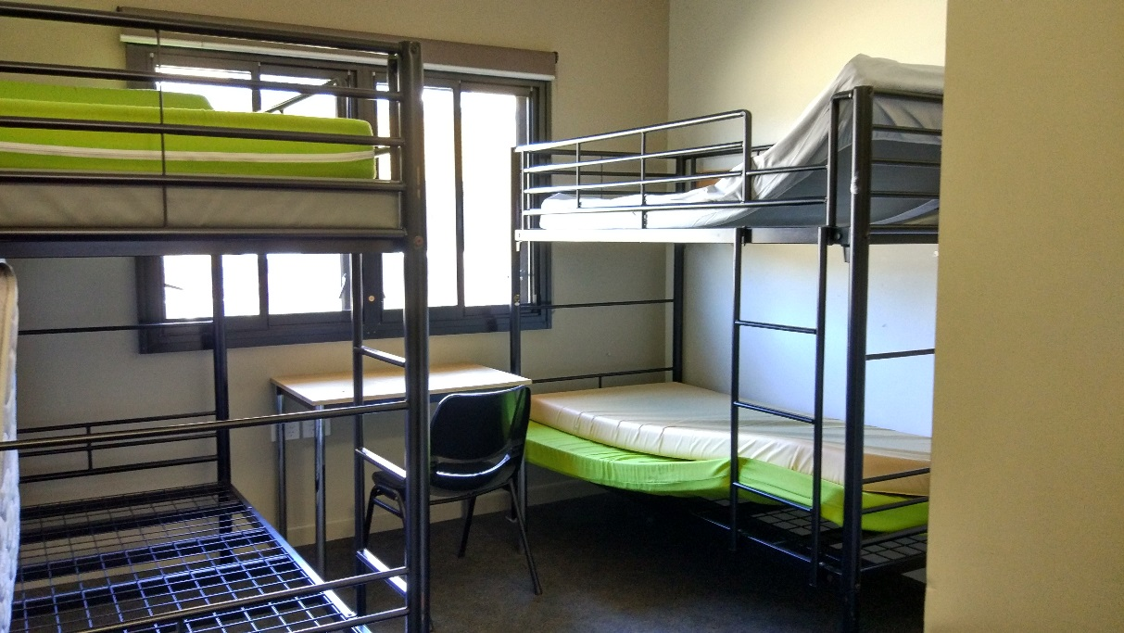
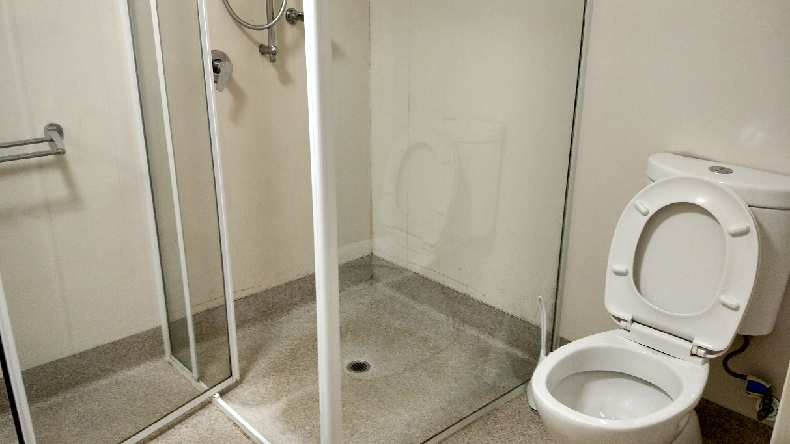

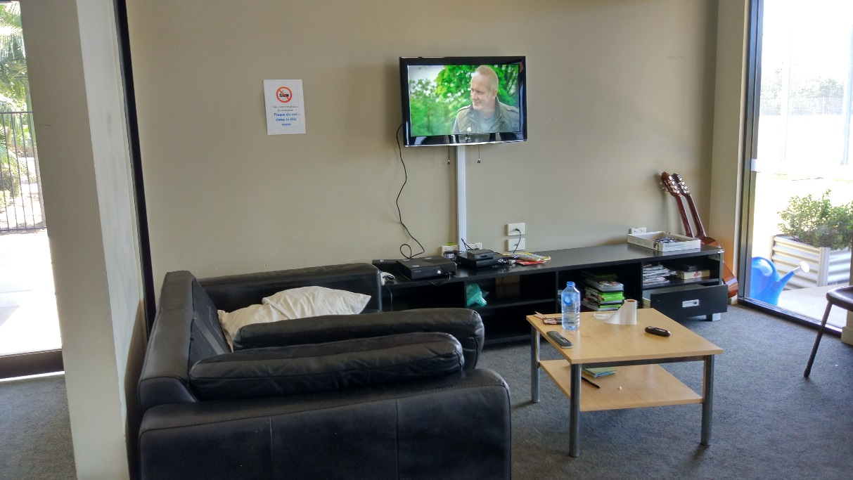
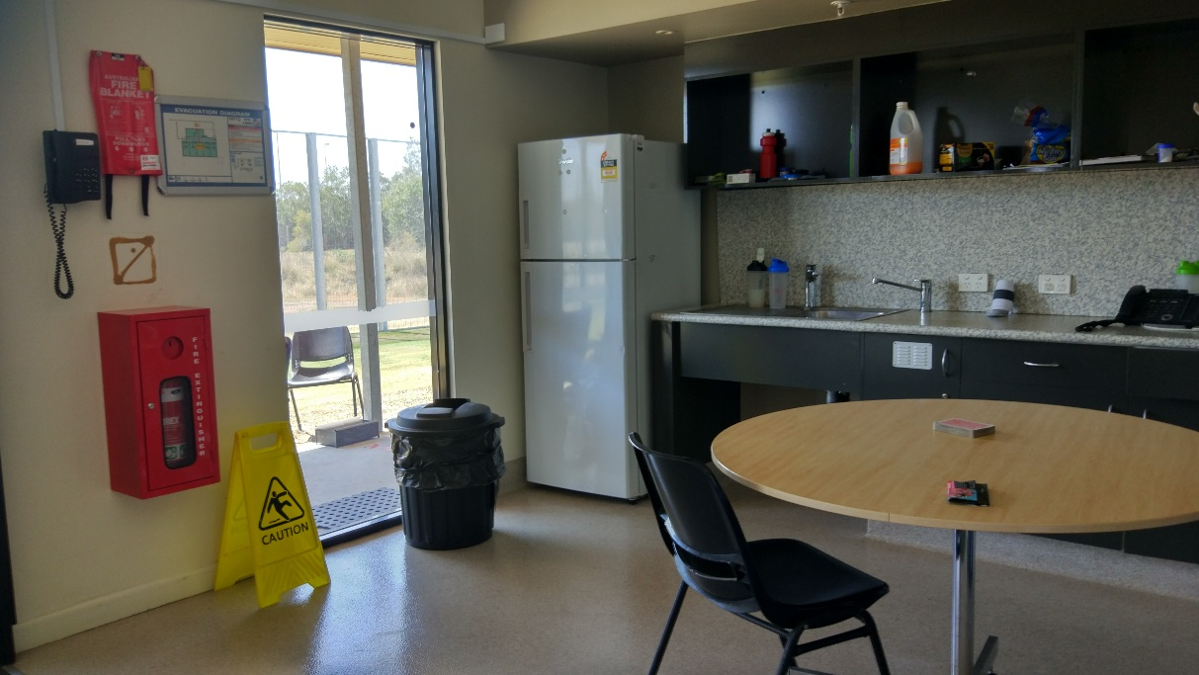
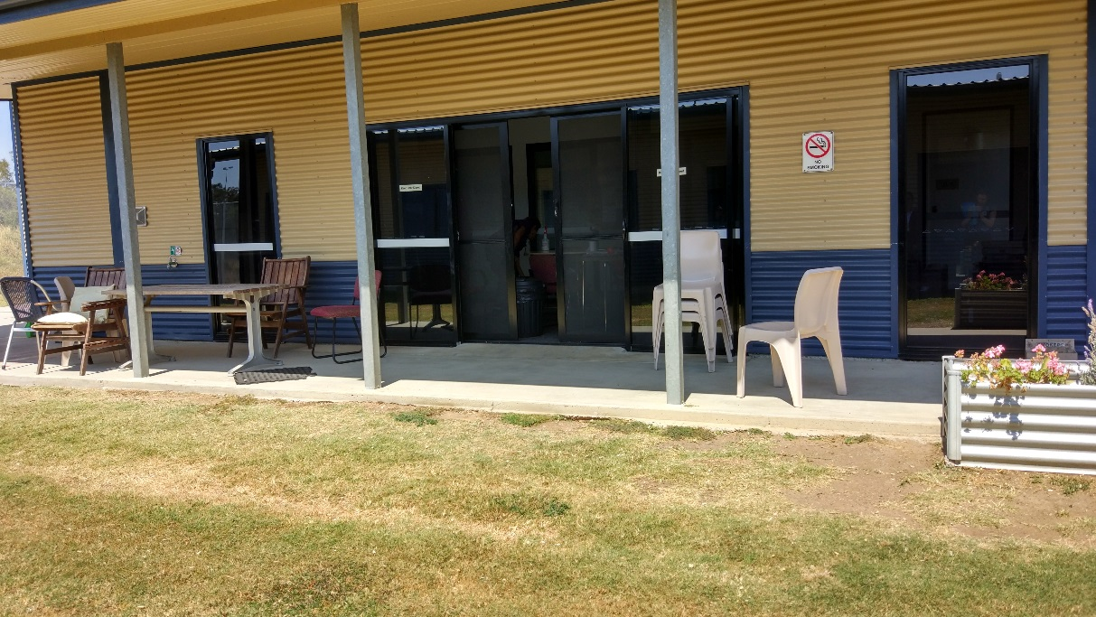
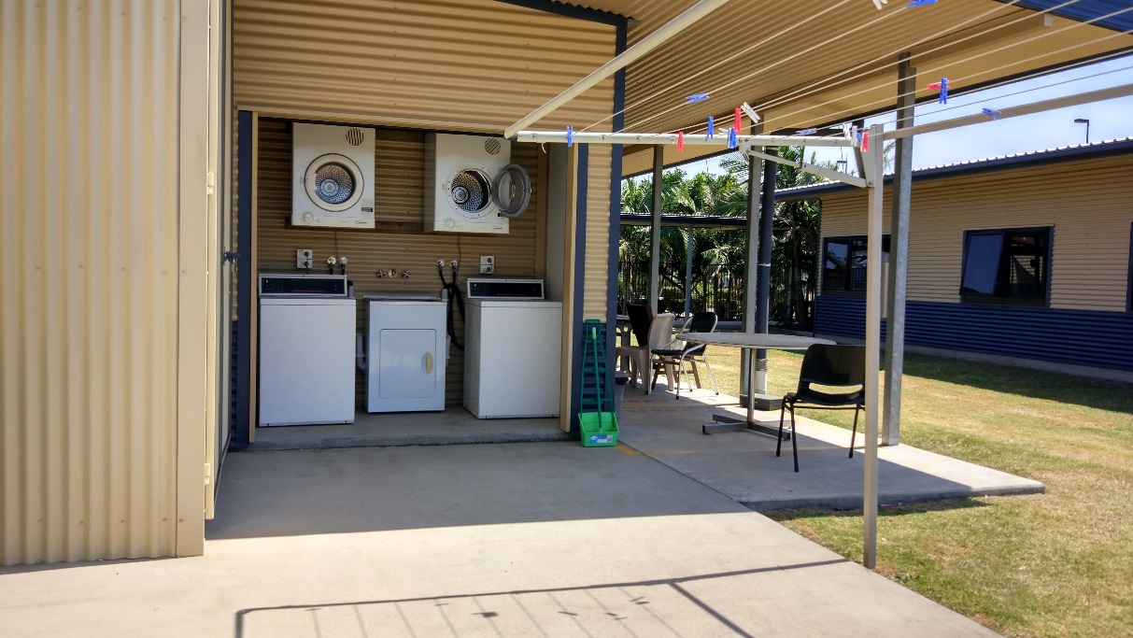

Shared facilities in residential area
Top to bottom: indoor common room (x3), outdoor common area (x2), classroom, gym, basketball and tennis court.
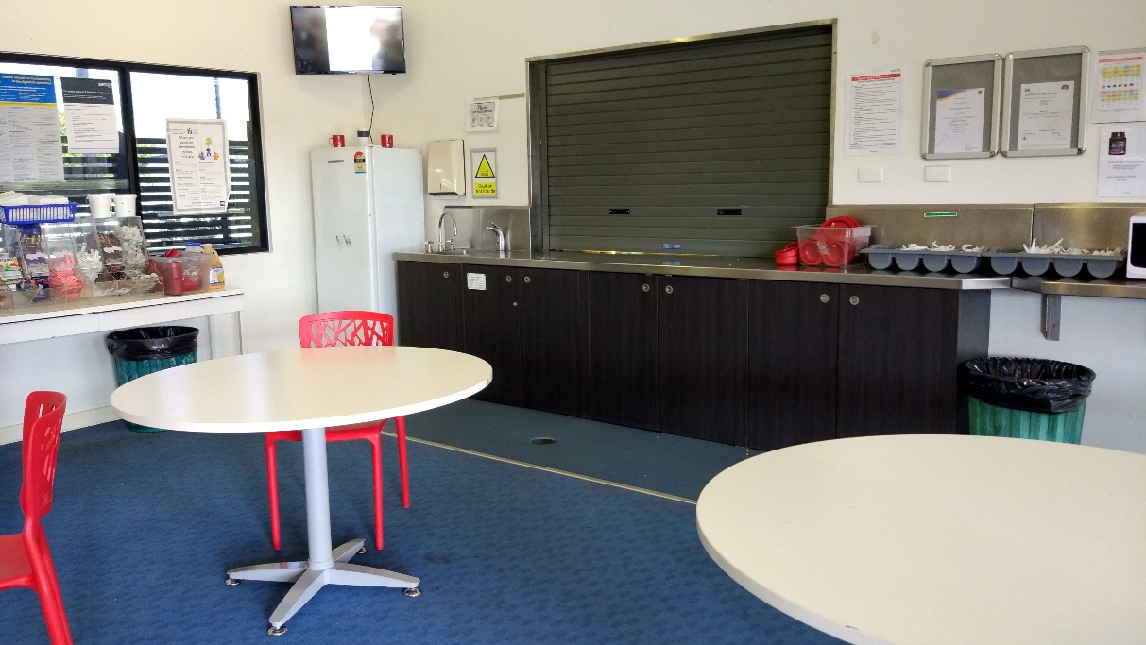
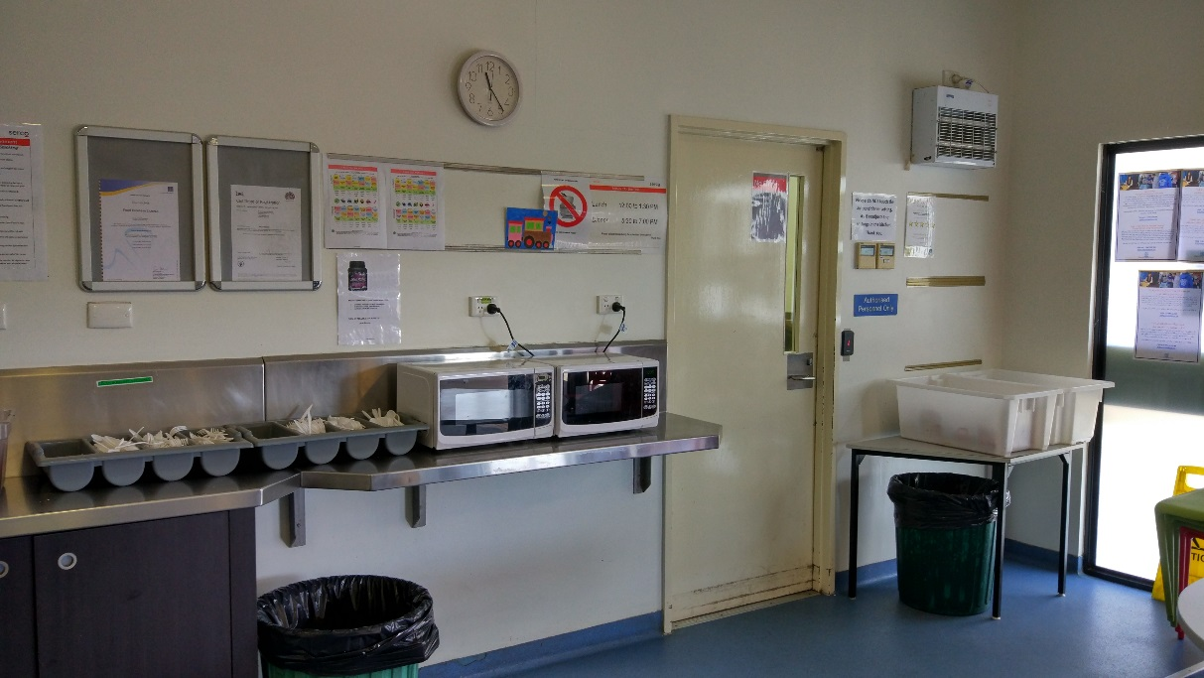
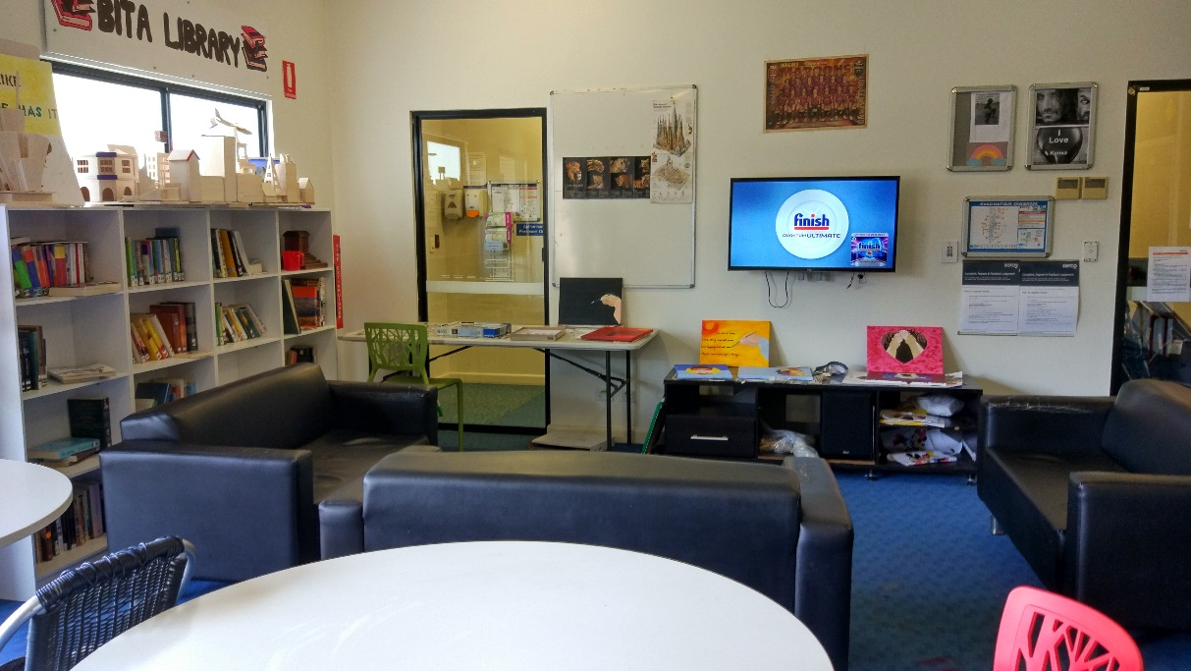
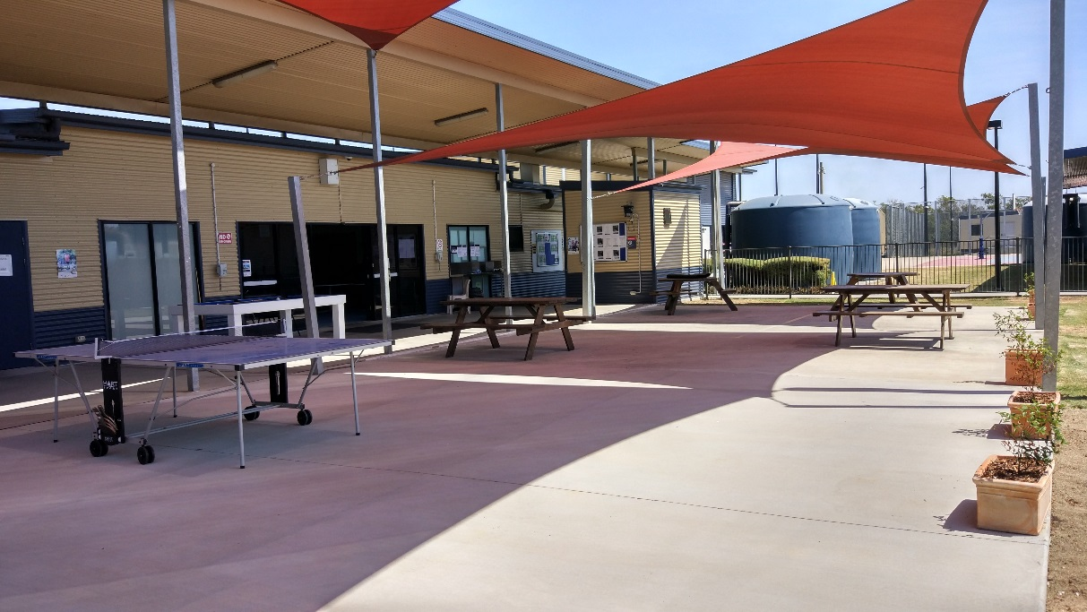
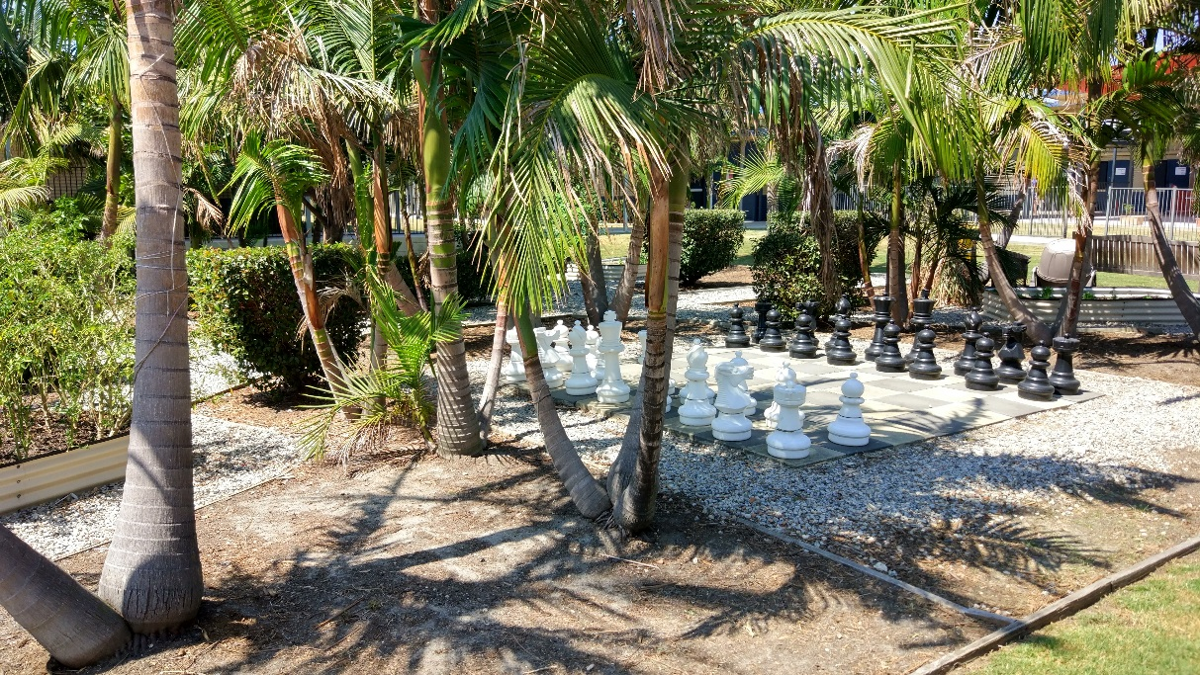
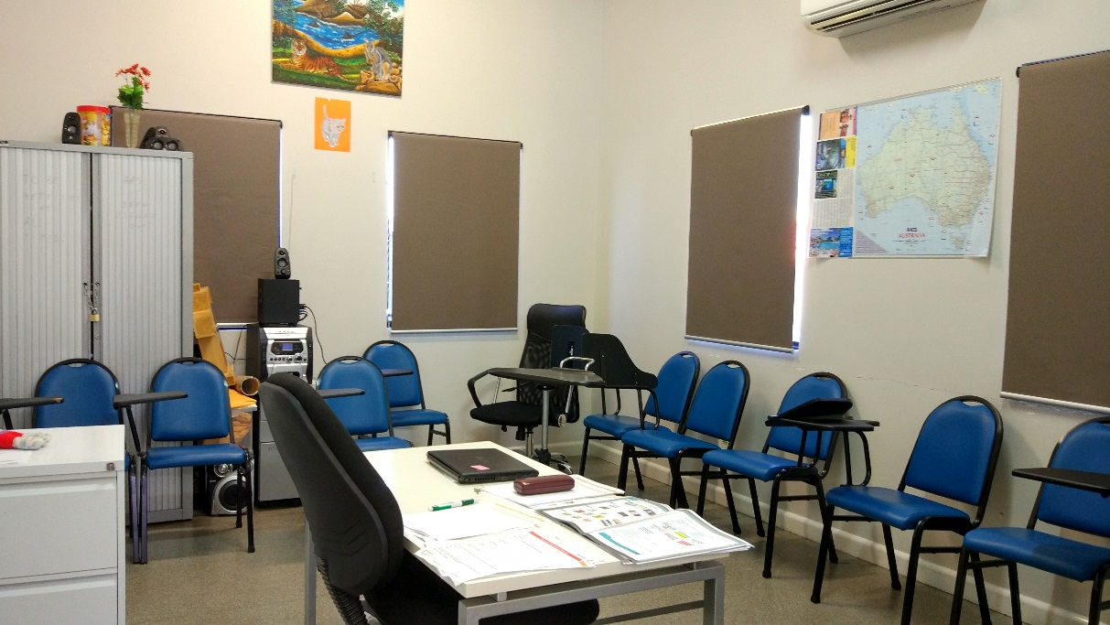
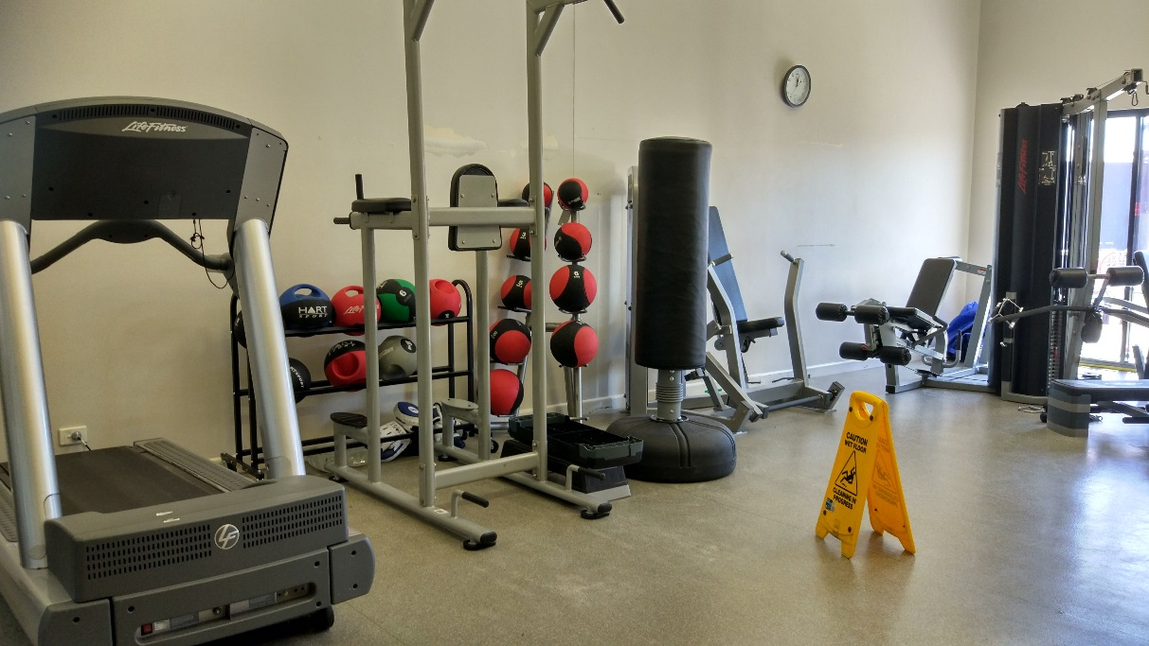
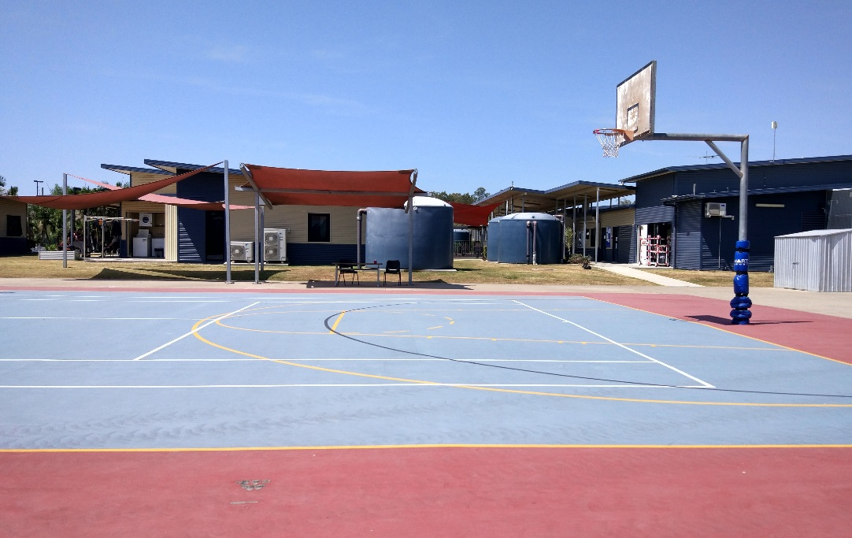

Facilities in Fraser compound
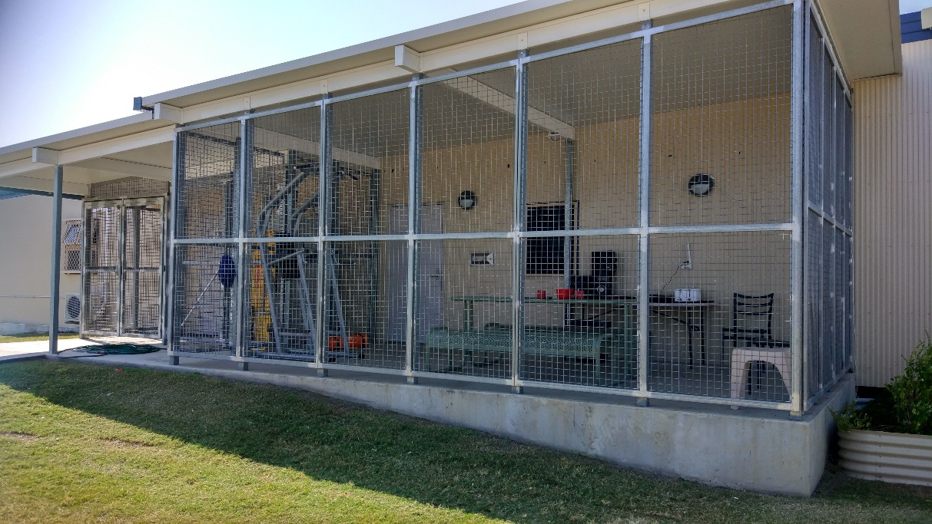
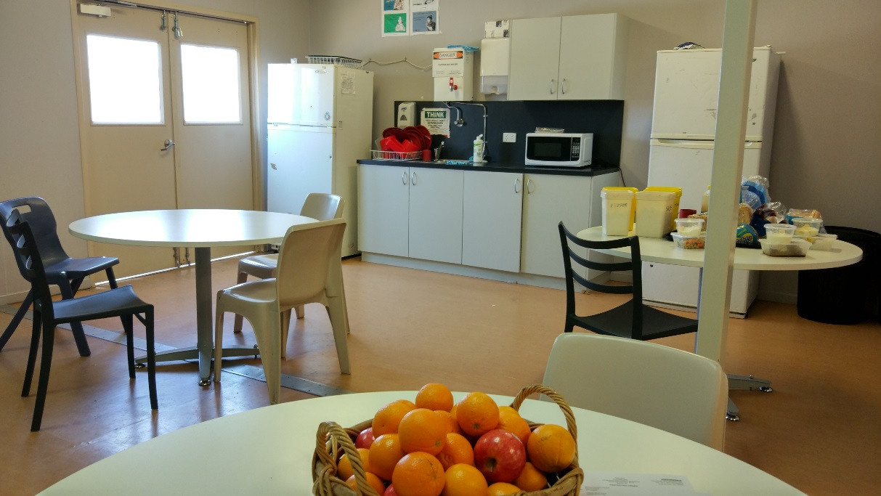
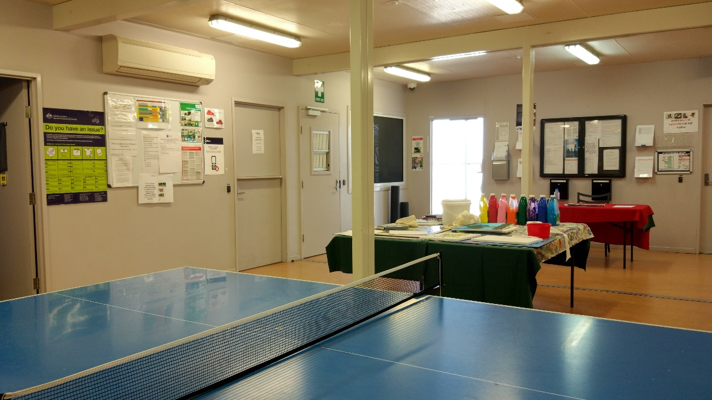
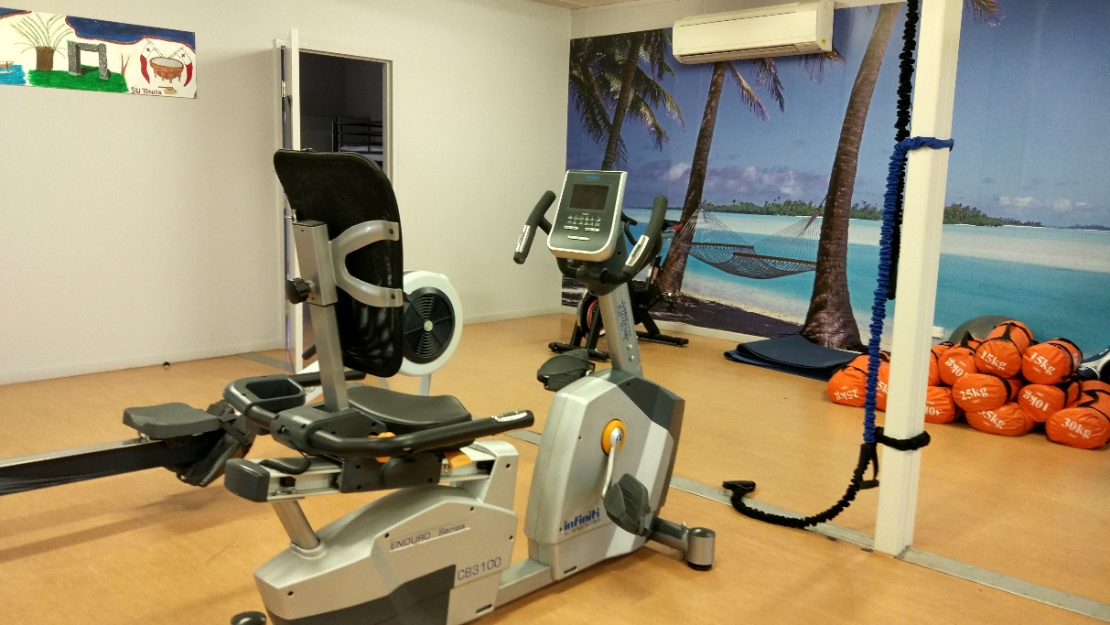
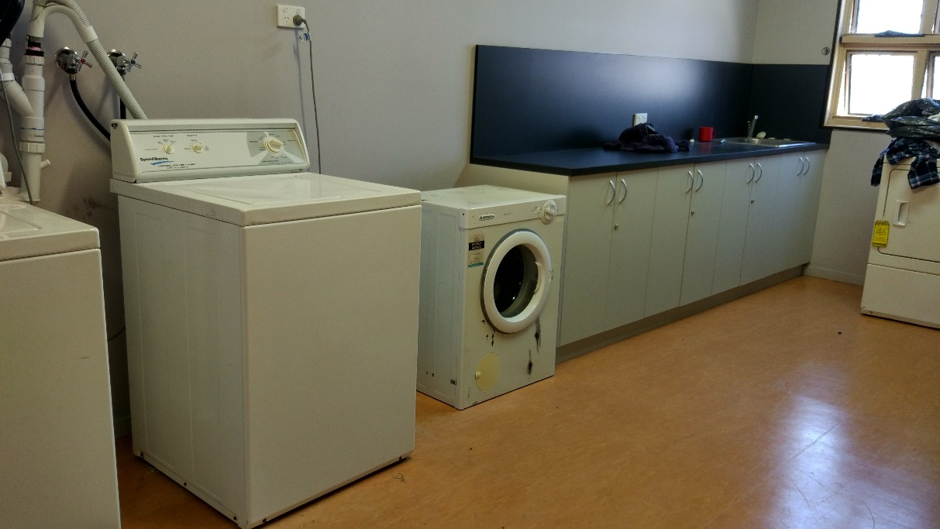
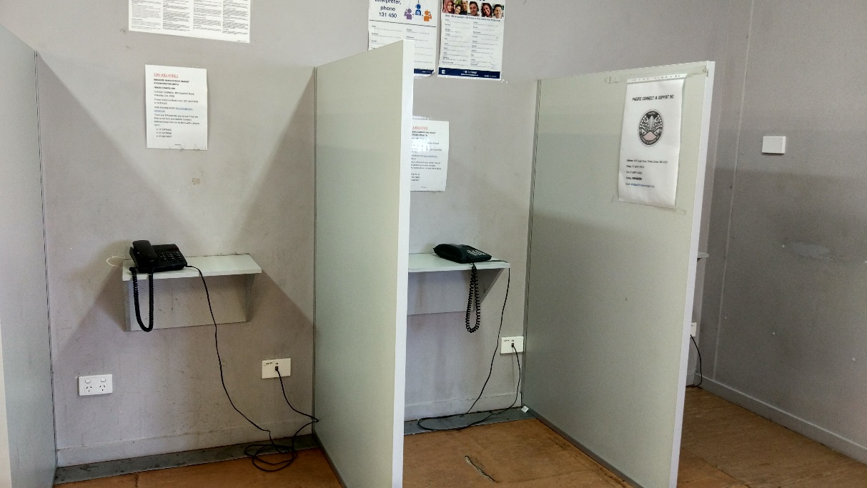

Facilities for visits
Top to bottom: visits room in residential area (x3), private interview room in residential area, visits room and private interview room in Fraser compound.
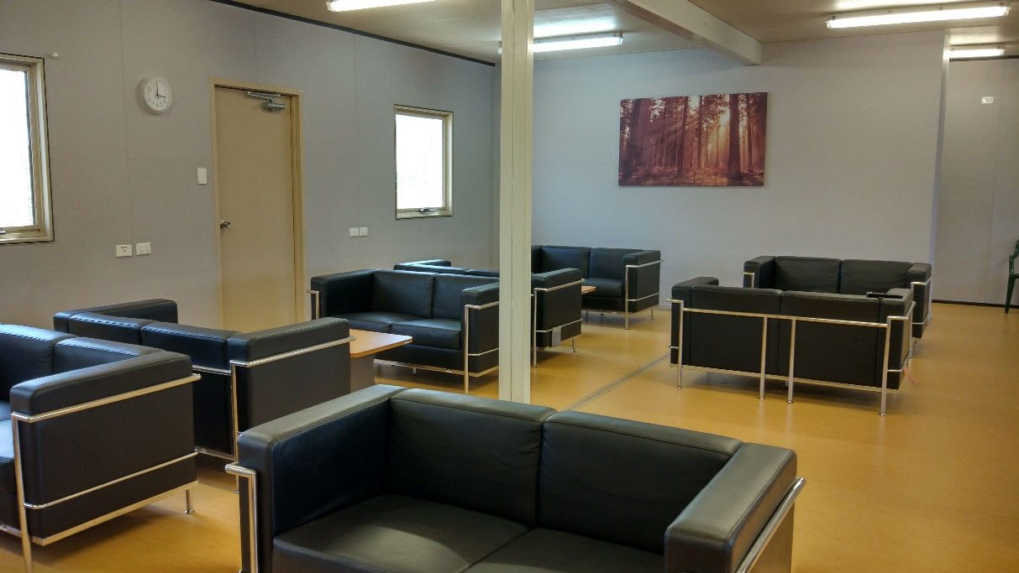
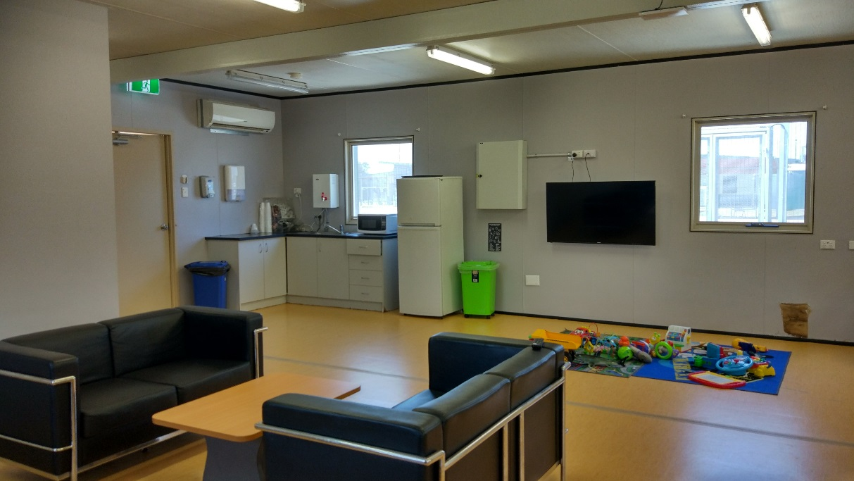
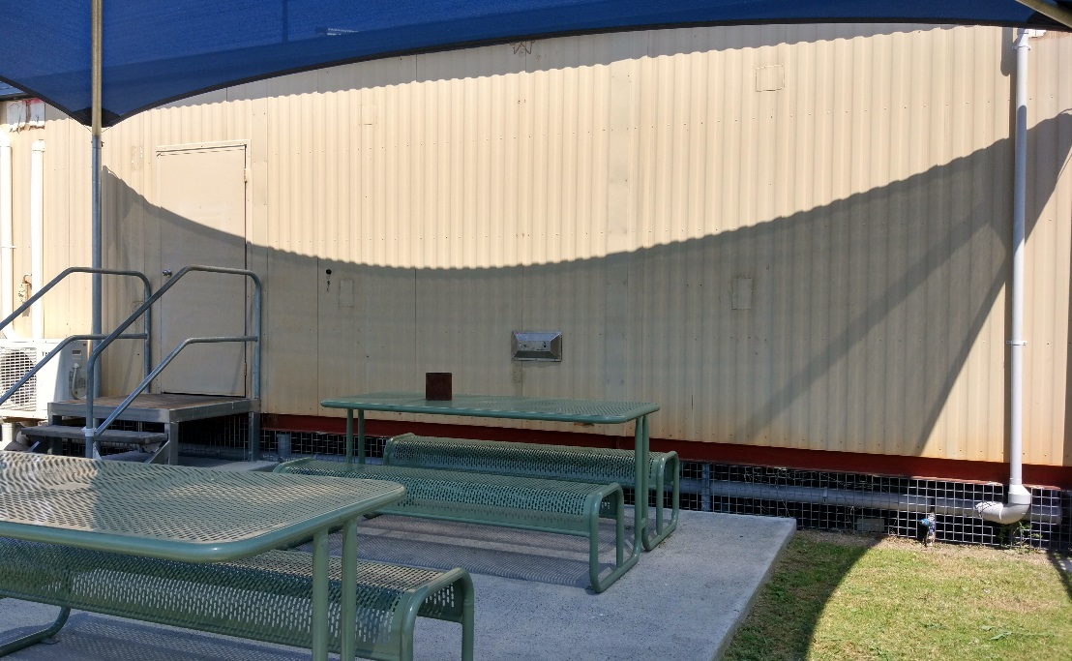
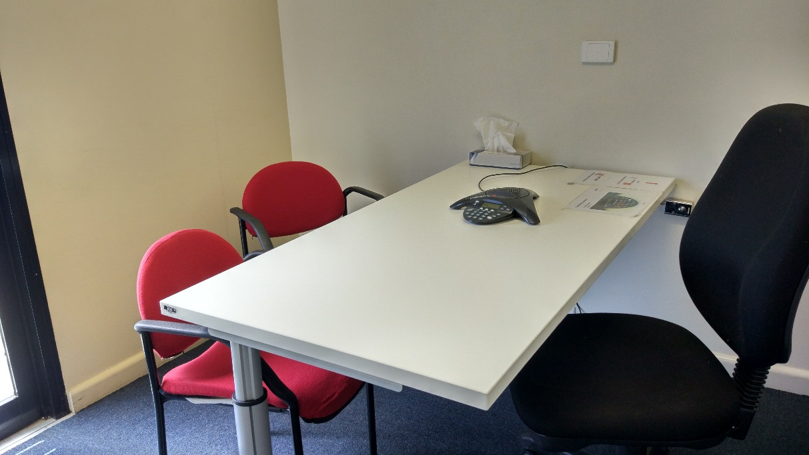
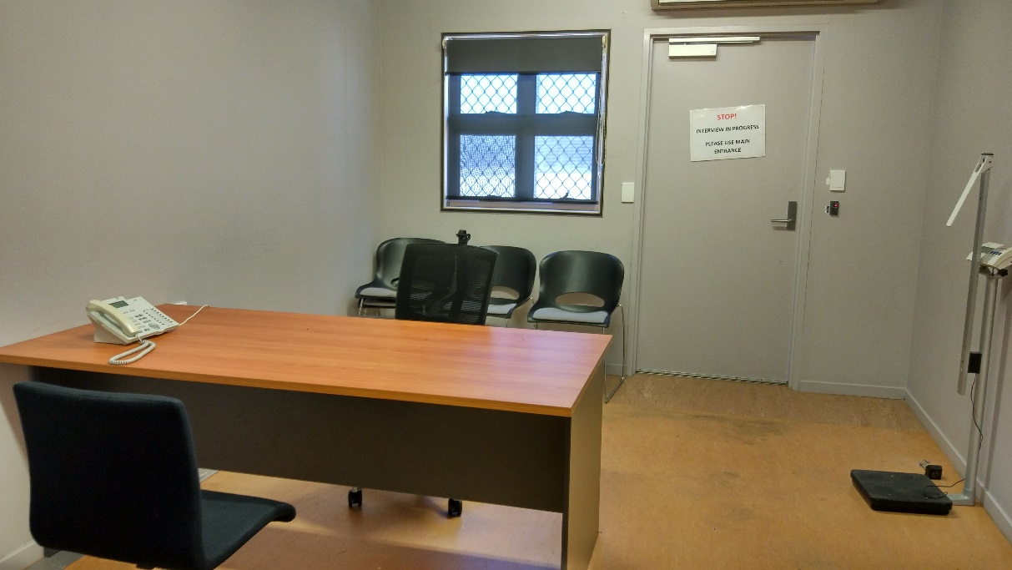

Appendix 2: Human rights standards relevant to immigration detention

Treatment of people in detention
Australia is obliged under articles 9(1) and 10(1) of the International Covenant on Civil and Political Rights (ICCPR) to, respectively, uphold the right to security of the person and ensure that people in detention are treated with humanity and respect for the inherent dignity of the human person. Australia also has obligations under article 7 of the ICCPR and articles 2(1) and 16(1) of the Convention Against Torture and other Cruel, Inhuman or Degrading Treatment or Punishment (CAT) not to subject anyone to torture or to cruel, inhuman or degrading treatment or punishment, and to take effective measures to prevent these acts from occurring.
These obligations require Australia to ensure that people in detention are treated fairly and reasonably, and in a manner that upholds their dignity. They should enjoy a safe environment free from bullying, harassment, abuse and violence. Security measures should be commensurate with identified risks, and should be the least restrictive possible in the circumstances, taking into account the particular vulnerabilities of people in detention. Measures that may constitute torture or cruel, inhuman or degrading treatment or punishment (such as collective punishment, corporal punishment, excessive use of force and holding people incommunicado) should be prohibited.

Conditions of detention
Australia has a range of obligations under the International Covenant on Economic, Social and Cultural Rights (ICESCR) relevant to the material conditions of immigration detention. These include the right to education (articles 6(2) and 13); the right to an adequate standard of living, including adequate food, clothing and housing (article 11); the right to the highest attainable standard of health (article 12); and the right to take part in cultural life (article 15(1)(a)).
Australia’s obligations under the ICCPR and CAT to treat people in detention with humanity and respect, and not to subject anyone to cruel, inhuman or degrading treatment or punishment, are also relevant to conditions of detention. In addition, Australia has an obligation under articles 17 and 18 of the ICCPR to uphold the right to privacy and freedom of religion respectively.
These obligations require Australia to ensure that detention facilities are safe, hygienic and uphold human dignity. People in detention should have their basic needs met and have access to essential services (such as health care and primary and secondary education) to a standard commensurate with those provided in the Australian community.
People in detention should have opportunities to engage in meaningful activities and excursions that provide physical and mental stimulation. People in detention should also be able to profess and practise the religion of their choice, including through being able to attend religious services, receiving pastoral visits from religious representatives and celebrating major religious holidays and festivals.
In light of the negative impacts of detention on mental health, the length of detention should be limited to the minimum period necessary to achieve a legitimate aim, and community-based alternatives to detention should be used wherever feasible.

Communication, association and complaints
Australia has a range of obligations under the ICCPR relevant to communication between people in detention and their family members, friends, representatives and communities outside detention. These include the right to freedom of expression and to seek, receive and impart information and ideas (article 19(b)); the right to freedom of association with others (article 22); and the right of ethnic, religious and linguistic minorities, in community with the other members of their group, to enjoy their own culture, to profess and practise their own religion and to use their own language (article 27). Under the ICESCR, Australia also has an obligation to uphold the right to take part in cultural life (article 15(1)(a)).
In addition, Australia has obligations under articles 23(1) of the ICCPR and 10(1) of the ICESCR to afford protection and assistance to the family as the natural and fundamental group unit of society. Australia also has obligations under article 17(1) of the ICCPR and article 16(1) of the CRC not to subject anyone to arbitrary or unlawful interference with their family.
These obligations require Australia to ensure that detention does not have a disproportionate impact on people’s ability to express themselves, communicate and associate with others, and remain in contact with their family members, friends, representatives and communities. People in detention should be able to receive regular visits, and should have access to adequate communication facilities (such as telephones and computers) as well as news and library services. People in detention should, if possible, be located in facilities within a reasonable distance from their family members, friends and communities.
External communication, in particular access to complaints processes, is also essential for the prevention of torture and other cruel, inhuman or degrading treatment or punishment. Australia has obligations under articles 13 and 16(1) of the CAT to ensure that anyone who alleges that they have been subjected to torture or to cruel, inhuman or degrading treatment or punishment, has the right to complain to and have their case examined by competent authorities.
To ensure these obligations are upheld, people in detention should have opportunities to raise concerns and issues regarding treatment and conditions in detention, and make complaints both internally and to independent monitors (including the Commission and the Commonwealth Ombudsman), without fear of repercussions.

Legal and policy framework
Australia has an obligation under article 9 of the ICCPR not to subject anyone to arbitrary detention. According to the United Nations Human Rights Committee, ‘arbitrary detention’ includes detention that, although lawful under domestic law, is unjust or disproportionate. In order for the detention of a person not to be arbitrary, it must be a reasonable and necessary measure in all the circumstances.
Australia has further obligations under article 9 of the ICCPR to ensure that anyone who is arrested has the right to be informed of the reasons for their arrest and the charges against them, and that anyone who is detained has the right to challenge the legality of their detention in court.
These obligations require Australia to ensure that people are only detained in immigration detention facilities when it is reasonable and necessary in their individual circumstances (such as where they pose an unacceptable health or security risk), and for a limited period of time. Community-based alternatives to detention should be used wherever possible. People held in immigration detention should be informed of the reasons for their detention and be able to seek judicial review of whether their detention is arbitrary.

Endnotes

Reports from previous monitoring visits to immigration detention facilities can be found on the Commission’s website at https://www.humanrights.gov.au/our-work/asylum-seekers-and-refugees/immigration-detention-reports-and-photos
Human Rights and Equal Opportunity Commission, Those who've come across the seas: Detention of unauthorised arrivals (1998). At https://www.humanrights.gov.au/our-work/asylum-seekers-and-refugees/publications/those-whove-come-across-seas-detention (viewed 11 May 2017); Human Rights and Equal Opportunity Commission, A last resort? National Inquiry into Children in Immigration Detention (2004). At https://www.humanrights.gov.au/our-work/asylum-seekers-and-refugees/projects/last-resort-report-national-inquiry-children (viewed 11 May 2017); Australian Human Rights Commission, The Forgotten Children: National Inquiry into Children in Immigration Detention (2014). At https://www.humanrights.gov.au/our-work/asylum-seekers-and-refugees/projects/national-inquiry-children-immigration-detention-index (viewed 11 May 2017).
Australian Human Rights Commission, Asylum seekers, refugees and human rights: Snapshot Report (2nd edition) (2017) 11–25. At https://www.humanrights.gov.au/our-work/asylum-seekers-and-refugees/publications/asylum-seekers-refugees-and-human-rights-snapsho-0 (viewed 11 May 2017).
See Subcommittee on Prevention of Torture and Other Cruel, Inhuman or Degrading Treatment or Punishment, Guidelines on national preventive mechanisms, 12th sess, UN Doc CAT/OP/12/5 (9 December 2010); Subcommittee on Prevention of Torture and Other Cruel, Inhuman or Degrading Treatment or Punishment, The approach of the Subcommittee on Prevention of Torture to the concept of prevention of torture and other cruel, inhuman or degrading treatment or punishment under the Optional Protocol to the Convention against Torture and Other Cruel, Inhuman or Degrading Treatment or Punishment, 12th sess, UN Doc CAT/OP/12/6 (30 December 2010); Association for the Prevention of Torture and Inter-American Institute for Human Rights, Optional Protocol to the UN Convention against Torture Implementation Manual (2010). At https://www.apt.ch/en/resources/the-optional-protocol-implementation-manual (viewed 24 May 2018); Association for the Prevention of Torture and United Nations High Commissioner for Refugees, Monitoring immigration detention practical manual (2014). At https://www.apt.ch/en/resources/monitoring-immigration-detention-practical-manual (viewed 24 May 2018). See also Australian Human Rights Commission, Human rights standards for immigration protection (2013). At https://www.humanrights.gov.au/our-work/asylum-seekers-and-refugees/publications/human-rights-standards-immigration-detention (viewed 11 May 2017).
Australia has not ratified the International Convention on the Protection of the Rights of All Migrant Workers and Members of Their Families, or the International Convention for the Protection of All Persons from Enforced Disappearance.
Australian Human Rights Commission, Human rights standards for immigration protection (2013). At https://www.humanrights.gov.au/our-work/asylum-seekers-and-refugees/publications/human-rights-standards-immigration-detention (viewed 11 May 2017).
Department of Immigration and Citizenship, Immigration Detention Statistics Summary (8 August 2008) 1. The Commission visited the BITA on 5 August 2008.
Department of Immigration and Citizenship, Immigration Detention Statistics Summary (31 July 2013) 3–4. At http://www.border.gov.au/ReportsandPublications/Documents/statistics/immigration-detention-statistics-july2013.pdf (viewed 12 May 2017); Department of Immigration and Border Protection, Immigration Detention and Community Statistics Summary (28 February 2015) 3, 5. At http://www.border.gov.au/ReportsandPublications/Documents/statistics/immigration-detention-statistics-feb2015.pdf (viewed 12 May 2017).
Department of Immigration and Citizenship, Immigration Detention Statistics Summary (31 July 2013) 3, 7. At http://www.border.gov.au/ReportsandPublications/Documents/statistics/immigration-detention-statistics-july2013.pdf (viewed 12 May 2017); Department of Immigration and Border Protection, Immigration Detention and Community Statistics Summary (28 February 2015) 3, 8. At http://www.border.gov.au/ReportsandPublications/Documents/statistics/immigration-detention-statistics-feb2015.pdf (viewed 12 May 2017).
Department of Immigration and Border Protection, Immigration Detention and Community Statistics Summary (30 September 2017) 4. At http://www.homeaffairs.gov.au/ReportsandPublications/Documents/statistics/Immigration-detention-statistics-30-september-2017.pdf (viewed 22 January 2018). Note that these figures do not include people detained in the Regional Processing Centres in Nauru and Manus Island, Papua New Guinea.
Department of Immigration and Citizenship, Immigration Detention Statistics Summary (31 July 2013) 9. At http://www.border.gov.au/ReportsandPublications/Documents/statistics/immigration-detention-statistics-july2013.pdf (viewed 12 May 2017).
Department of Immigration and Border Protection, Immigration Detention and Community Statistics Summary (31 January 2017) 11. At http://www.border.gov.au/ReportsandPublications/Documents/statistics/immigration-detention-statistics-31-jan-2017.pdf (viewed 12 May 2017).
Department of Immigration and Border Protection, Immigration Detention and Community Statistics Summary (30 September 2017) 11. At http://www.homeaffairs.gov.au/ReportsandPublications/Documents/statistics/Immigration-detention-statistics-30-september-2017.pdf (viewed 22 January 2018).
Department of Immigration and Citizenship, Immigration Detention Statistics Summary (8 August 2008) 4.
Department of Immigration and Citizenship, Immigration Detention Statistics Summary (31 July 2013) 9. At http://www.border.gov.au/ReportsandPublications/Documents/statistics/immigration-detention-statistics-july2013.pdf (viewed 12 May 2017).
Department of Immigration and Border Protection, Immigration Detention and Community Statistics Summary (30 September 2017) 11. At http://www.homeaffairs.gov.au/ReportsandPublications/Documents/statistics/Immigration-detention-statistics-30-september-2017.pdf (viewed 22 January 2018).
Canada Border Services Agency, Detention Statistics (23 May 2017). At http://www.cbsa-asfc.gc.ca/security-securite/detent-stat-eng.html (viewed 25 September 2017).
United Kingdom Home Office, National Statistics: Detention (23 February 2017). At https://www.gov.uk/government/publications/immigration-statistics-october-to-december-2016/detention (viewed 25 September 2017); United Kingdom Home Office, National Statistics: Detention (3 March 2016). At https://www.gov.uk/government/publications/immigration-statistics-october-to-december-2015/detention (viewed 25 September 2017; United Kingdom Home Office, National Statistics: Immigration statistics, October to December 2014 (26 February 2015). At https://www.gov.uk/government/publications/immigration-statistics-october-to-december-2014/immigration-statistics-october-to-december-2014 (viewed 25 September 2017); United Kingdom Home Office, National Statistics: Immigration statistics, October to December 2013 (27 February 2014). At https://www.gov.uk/government/publications/immigration-statistics-october-to-december-2013/immigration-statistics-october-to-december-2013 (viewed 25 September 2017); United Kingdom Home Office, National Statistics: Immigration statistics, October to December 2012 (28 February 2013). At https://www.gov.uk/government/publications/immigration-statistics-october-to-december-2012/immigration-statistics-october-to-december-2012 (viewed 25 September 2017).
Department of Immigration and Citizenship, Immigration Detention Statistics Summary (8 August 2008) 2.
Department of Immigration and Citizenship, Immigration Detention Statistics Summary (31 July 2013) 5. At http://www.border.gov.au/ReportsandPublications/Documents/statistics/immigration-detention-statistics-july2013.pdf (viewed 12 May 2017).
See the Department of Home Affairs’ immigration detention statistics summaries, available at http://www.border.gov.au/about/reports-publications/research-statistics/statistics/live-in-australia/immigration-detention (viewed 12 May 2017).
Migration Amendment (Character and General Visa Cancellation) Act 2014 (Cth)
Department of Immigration and Border Protection, Key visa cancellation statistics (n.d.). At http://www.border.gov.au/about/reports-publications/research-statistics/statistics/key-cancellation-statistics (viewed 29 November 2016); Department of Immigration and Border Protection, Annual Report 2016–17 (2017) 8. At http://www.border.gov.au/ReportsandPublications/Documents/annual-reports/complete-annual-report-2016-17.pdf (viewed 23 October 2017).
Department of Immigration and Border Protection, Immigration Detention and Community Statistics Summary (30 September 2017) 4. At http://www.homeaffairs.gov.au/ReportsandPublications/Documents/statistics/Immigration-detention-statistics-30-september-2017.pdf (viewed 22 January 2018).
Department of Home Affairs, ‘Update on Machinery of Government changes’ (Media Release, 20 December 2017). At https://www.homeaffairs.gov.au/News/Pages/machinery-government-changes.aspx (viewed 18 January 2018).
See Australian Human Rights Commission, Inspection of Maribyrnong Immigration Detention Centre (2017) 15. At https://www.humanrights.gov.au/our-work/asylum-seekers-and-refugees/publications/inspection-maribyrnong-immigration-detention (viewed 17 January 2018); Australian Human Rights Commission, Inspection of Melbourne Immigration Transit Accommodation (2017) 13–14. At https://www.humanrights.gov.au/our-work/asylum-seekers-and-refugees/publications/inspection-melbourne-immigration-transit (viewed 17 January 2018); Australian Human Rights Commission, Inspection of Villawood Immigration Detention Centre (2017) 15–16. At https://www.humanrights.gov.au/our-work/asylum-seekers-and-refugees/publications/inspection-villawood-immigration-detention-centre (viewed 17 January 2018).
See Australian Human Rights Commission, Inspection of Maribyrnong Immigration Detention Centre (2017) 15–16. At https://www.humanrights.gov.au/our-work/asylum-seekers-and-refugees/publications/inspection-maribyrnong-immigration-detention (viewed 17 January 2018); Australian Human Rights Commission, Inspection of Villawood Immigration Detention Centre (2017) 15. At https://www.humanrights.gov.au/our-work/asylum-seekers-and-refugees/publications/inspection-villawood-immigration-detention-centre (viewed 17 January 2018); Australian Human Rights Commission, Inspection of Yongah Hill Immigration Detention Centre (2017) 14–15. At https://www.humanrights.gov.au/our-work/asylum-seekers-and-refugees/publications/inspection-yongah-hill-immigration-detention (viewed 17 January 2018).
See, for example, Australian Human Rights Commission, Immigration detention in Villawood: Summary of observations from visit to immigration detention facility in Villawood (2011) 18, 30. At https://www.humanrights.gov.au/sites/default/files/content/human_rights/immigration/idc2011_villawood.pdf (viewed 6 June 2017).
Louise K Newman, Nicholas G Procter and Michael J Dudley, ‘Suicide and self-harm in immigration detention’ (2011) 195(6) Medical Journal of Australia 310; Melissa Bull et al, ‘Sickness in the System of Long-term Immigration Detention’ (2013) 26 Journal of Refugee Studies 47; Ilan Katz et al, The experiences of Irregular Maritime Arrivals detained in immigration detention facilities: Final report (2013). At http://www.border.gov.au/ReportsandPublications/Documents/research/IMA-experiences-IDF.pdf (viewed 7 December 2016).
United Nations Human Rights Committee, Concluding observations on the sixth periodic report of Australia, 121st sess, Agenda Item 5, UN Doc CCPR/C/AUS/CO/6 (9 November 2017) [37].
Department of Immigration and Border Protection, ‘New measures to combat illegal activity within immigration detention facilities’ (Media Release, 11 November 2016). At http://newsroom.border.gov.au/releases/new-measures-to-combat-illegal-activity-within-immigration-detention-facilities (viewed 26 May 2017).
Migration Amendment (Prohibiting Items in Immigration Detention Facilities) Bill 2017 (Cth) sch 1 item 2.
Statement of Compatibility with Human Rights, Explanatory Memorandum, Migration Amendment (Prohibiting Items in Immigration Detention Facilities) Bill 2017 (Cth).
Australian Human Rights Commission, Submission No 11 to the Senate Legal and Constitutional Affairs Legislation Committee, Parliament of Australia, Inquiry into the Migration Amendment (Prohibiting Items in Immigration Detention Facilities) Bill 2017 [Provisions], 11 October 2017.
Senate Legal and Constitutional Affairs Legislation Committee, Parliament of Australia, Inquiry into the Migration Amendment (Prohibiting Items in Immigration Detention Facilities) Bill 2017 [Provisions] (2017) 25.
Senate Legal and Constitutional Affairs Legislation Committee, Parliament of Australia, Inquiry into the Migration Amendment (Prohibiting Items in Immigration Detention Facilities) Bill 2017 [Provisions] (2017) 25.
For further information and recommendations, see Australian Human Rights Commission, Submission No 11 to the Senate Standing Committee on Legal and Constitutional Affairs, Parliament of Australia, Inquiry into the Migration Amendment (Prohibiting Items in Immigration Detention Facilities) Bill 2017 [Provisions], 11 October 2017.
Australian Human Rights Commission, Submission No 11 to the Senate Standing Committee on Legal and Constitutional Affairs, Parliament of Australia, Inquiry into the Migration Amendment (Prohibiting Items in Immigration Detention Facilities) Bill 2017 [Provisions], 11 October 2017, 8–9.
For further information, see Department of Home Affairs, Outside food policy for immigration detention facilities (n.d.). At https://www.homeaffairs.gov.au/about/immigration-detention-in-australia/detention-facilities/outside-food-policy-for-immigration-detention-facilities (viewed 23 January 2018).
See Australian Human Rights Commission, Asylum seekers, refugees and human rights: Snapshot Report (2nd edition) (2017) 11–25. At https://www.humanrights.gov.au/our-work/asylum-seekers-and-refugees/publications/asylum-seekers-refugees-and-human-rights-snapsho-0 (viewed 11 May 2017). See also Australian Human Rights Commission, Inspection of Maribyrnong Immigration Detention Centre: Report (2017) 26–29. At https://www.humanrights.gov.au/our-work/asylum-seekers-and-refugees/publications/inspection-maribyrnong-immigration-detention (viewed 17 October 2017); Australian Human Rights Commission, Inspection of Melbourne Immigration Transit Accommodation: Report (2017) 24–27. At https://www.humanrights.gov.au/our-work/asylum-seekers-and-refugees/publications/inspection-melbourne-immigration-transit (viewed 17 October 2017).
United Nations Human Rights Committee, Concluding observations on the sixth periodic report of Australia, 121st sess, Agenda Item 5, UN Doc CCPR/C/AUS/CO/6 (9 November 2017) [37].
United Nations Human Rights Committee, Concluding observations on the sixth periodic report of Australia, 121st sess, Agenda Item 5, UN Doc CCPR/C/AUS/CO/6 (9 November 2017) [38].
United Nations High Commissioner for Refugees, Submission No 43 to the Senate Legal and Constitutional Affairs References Committee, Parliament of Australia, Inquiry into serious allegations of abuse, self-harm and neglect of asylum seekers in relation to the Nauru Regional Processing Centre, and any like allegations in relation to the Manus Regional Processing Centre, 12 November 2016, 13–15 [41–50].
United Nations High Commissioner for Refugees, Guidelines on the Applicable Criteria and Standards relating to the Detention of Asylum Seekers and Alternatives to Detention (2012) 37 [58]. At http://www.refworld.org/pdfid/503489533b8.pdf (viewed 22 January 2018).
International Covenant on Civil and Political Rights, opened for signature 16 December 1966, 999 UNTS 171 (entered into force 23 March 1976) arts 9(1), 10(1)
International Covenant on Civil and Political Rights, opened for signature 16 December 1966, 999 UNTS 171 (entered into force 23 March 1976) art 7; Convention against Torture and Other Cruel, Inhuman or Degrading Treatment or Punishment, opened for signature 10 December 1984, 1465 UNTS 85 (entered into force 26 June 1987) arts 2(1), 16(1).
International Covenant on Economic, Social and Cultural Rights, opened for signature 16 December 1966, 993 UNTS 3 (entered into force 3 January 1976) arts 6(2), 11, 12, 13, 15(1a).
International Covenant on Civil and Political Rights, opened for signature 16 December 1966, 999 UNTS 171 (entered into force 23 March 1976) arts 7, 10(1); Convention against Torture and Other Cruel, Inhuman or Degrading Treatment or Punishment, opened for signature 10 December 1984, 1465 UNTS 85 (entered into force 26 June 1987) arts 2(1), 16(1).
International Covenant on Civil and Political Rights, opened for signature 16 December 1966, 999 UNTS 171 (entered into force 23 March 1976) arts 17, 18.
International Covenant on Civil and Political Rights, opened for signature 16 December 1966, 999 UNTS 171 (entered into force 23 March 1976) arts 19(b), 22, 27.
International Covenant on Economic, Social and Cultural Rights, opened for signature 16 December 1966, 993 UNTS 3 (entered into force 3 January 1976) art 15(1a).
International Covenant on Civil and Political Rights, opened for signature 16 December 1966, 999 UNTS 171 (entered into force 23 March 1976) art 23(1); International Covenant on Economic, Social and Cultural Rights, opened for signature 16 December 1966, 993 UNTS 3 (entered into force 3 January 1976) art 10(1).
International Covenant on Civil and Political Rights, opened for signature 16 December 1966, 999 UNTS 171 (entered into force 23 March 1976) art 17(1); Convention on the Rights of the Child, opened for signature 20 November 1989, 1577 UNTS 3 (entered into force 2 September 1990) art 16(1).
Convention against Torture and Other Cruel, Inhuman or Degrading Treatment or Punishment, opened for signature 10 December 1984, 1465 UNTS 85 (entered into force 26 June 1987) arts 13, 16(1).
International Covenant on Civil and Political Rights, opened for signature 16 December 1966, 999 UNTS 171 (entered into force 23 March 1976) art 9(1)
Human Rights Committee, Van Alphen v Netherlands, Communication No. 305/1988, UN Doc CCPR/C/39/D/305/1988 (23 July 1990) [5.8]. At http://www.refworld.org/docid/525414304.html (viewed 7 December 2016); Human Rights Committee, A v Australia, Communication No. 560/1993, UN Doc CCPR/C/59/D/560/1993 (3 April1997) [9.4]. At http://www.refworld.org/docid/3ae6b71a0.html (viewed 7 December 2016).
International Covenant on Civil and Political Rights, opened for signature 16 December 1966, 999 UNTS 171 (entered into force 23 March 1976) arts 9(2), 9(4)

