Australian Human Rights Commission Inspection of Christmas Island Immigration Detention Centre: Report

23–25 August 2017

Table of Contents
1 Introduction 5
2 Background 6
2.1 Previous monitoring visits 6
2.2 Inspection methodology 6
2.3 Relevant human rights standards 7
2.4 National context 8
(a) Number of people in detention 8
(b) Length of detention 8
(c) Reasons for detention 9
(d) Administration of the detention network 9
(e) Ratification of OPCAT 10
2.5 Christmas Island Immigration Detention Centre 10
3 Key issues and concerns 11
3.1 Treatment of people in detention 11
(a) Risk assessments 11
(b) Security measures 12
(c) Physical safety 13
(d) Relationships with staff 14
(e) Use of force and restraints 14
(f) Transfers between detention facilities 15
(g) Single separation 16
(h) Searches 17
3.2 Conditions of detention 17
(a) Controlled movement policy 17
(b) Accommodation and living areas 19
(c) Indoor and outdoor exercise 20
(d) Activities and excursions 21
(e) Food 23
(f) Personal items 23
3.3 Physical and mental health 23
(a) Health services 23
(b) Physical health 24
(c) Mental health 25
(d) Continuity of care 26
3.4 Communication and complaints 27
(a) Mobile phone policy 27
(b) Telephone access 28
(c) Computers and internet access 30
(d) Visits 31
(e) Complaints 32
3.5 Legislative and policy framework 33
(a) Indefinite mandatory detention 33
(b) Community alternatives to detention 35
(c) Case management and status resolution 36
4 Summary of recommendations 38
4.1 Recommendations to the Australian Government 38
4.2 Joint recommendations to the Department of Home Affairs and facility staff 38
4.3 Recommendations to the Minister and Department of Home Affairs 40
4.4 Recommendations to facility staff 42
5 Appendix 1: Photos taken during the Commission’s inspection 44
5.1 Facilities in Red (‘support’) compound 44
5.2 Facilities in accommodation compounds 46
5.3 Sanitation facilities in accommodation compounds 50
5.4 Facilities in Gold (‘incentive’) compound 52
5.5 Shared facilities 54
5.6 Facilities for exercise and activities 56
6 Appendix 2: Kessler Psychological Distress Scale 60
7 Appendix 3: Human rights standards relevant to immigration detention 61
7.1 Treatment of people in detention 61
7.2 Conditions of detention 61
7.3 Communication, association and complaints 62
7.4 Legal and policy framework 62
Endnotes 64

Summary of key issues
Due to its remoteness, the nature of its security infrastructure, and the limited access to facilities and services on Christmas Island, the CIIDC is not an appropriate facility for immigration detention, particularly for people who are vulnerable or have been detained for prolonged periods of time.
The Red compound, used for single separation, is a highly restrictive environment and is not an appropriate place of immigration detention, even for a short period of time.
A considerable number of people detained at the CIIDC were apprehensive about their physical safety and described the detention environment as unsafe and unpredictable.
Certain aspects of the transfer process are not appropriately justified, particularly in relation to the lack of prior warning of transfers and lack of adequate opportunities for people to pack their belongings and notify family members, friends and legal representatives prior to the transfer. The use of restraints for the entire duration of transfers to Christmas Island may not have been necessary or proportionate in all cases.
Concerns about accommodation arrangements at the CIIDC remain ongoing, particularly in relation to dormitory bedrooms which provide no privacy.
Facilities for exercise and activities at the CIIDC are generally of a good standard. However, the implementation of a ‘controlled movement policy’ has had significant impact on living conditions, freedom of movement and access to facilities for people detained at the CIIDC.
Excursions from the CIIDC take place infrequently and present a significant challenge for facility staff given the limited community resources and options for excursions on Christmas Island.
There significant level of concern among people detained at the CIIDC about physical health care and the impact of detention on mental health.
Many people raised concerns about limited access to communication facilities at the CIIDC. The policy prohibiting all mobile phone use may restrict access to external communication to a greater degree than is necessary to ensure safety and security. In-person visits to the facility are rare due to the logistical challenges of travelling to Christmas Island, with the result that many people detained at the CIIDC had faced lengthy separation from their families.
Many of the people interviewed by the Commission indicated that they had been in immigration detention for a prolonged period of time and in some cases had spent most of their time in detention at the CIIDC.
Status Resolution Officers are not currently able to provide people in detention with adequate case management support.

Introduction
This report contains an overview of key observations and concerns arising from the Australian Human Rights Commission’s inspection of the Christmas Island Immigration Detention Centre (CIIDC) in August 2017.
The rationale for the Commission undertaking such inspections is to identify problems in the way that detainees’ human rights are being protected and to suggest ways of addressing those problems. Hence, while the report is balanced and points to some good practices, its primary focus is on issues of concern identified by the Commission. The report reflects conditions as they were at the time of the inspection.
The Commission also raised a number of additional issues with the Department of Home Affairs (Home Affairs) and facility staff during, and subsequent to, the inspection, including individual cases of concern. In the period since completing the inspection, the Commission has continued to liaise with Home Affairs regarding identified issues and concerns.
The Commission acknowledges the assistance provided by Home Affairs and the Australian Border Force (ABF) in facilitating the Commission’s inspection. The Commission is grateful to the staff of Home Affairs, the ABF and detention service providers who assisted the Commission team during the inspection. A draft of this report was shared with Home Affairs in advance of its publication, to provide an opportunity for Home Affairs to respond to the identified issues.

Background

Previous monitoring visits
The Commission has conducted inspections of immigration detention facilities in Australia since the mid-1990s. This has included periodic monitoring of detention facilities across the country and three major national inquiries into immigration detention.
The purpose of the Commission’s detention monitoring inspections is to ensure that Australia’s immigration detention system is compliant with our obligations under international human rights law. For many years, the Commission has expressed a range of concerns about aspects of the detention system that may lead to breaches of international human rights law. These include:
- the policy of mandatory immigration detention, which does not allow for adequate consideration of individual circumstances and can result in cases of arbitrary detention under international law
- the indefinite and, at times, prolonged nature of immigration detention and the lack of a legislative time limit on detention
- the detention of children, which has led to breaches of numerous obligations under the Convention on the Rights of the Child (CRC)
- the indefinite detention of people who have received adverse security or character assessments, including in circumstances where they have not been convicted of a crime under Australian law
- conditions of detention, which in some cases have not met international standards
- the impacts of immigration detention on mental health
- the need for increased use of alternatives to immigration detention.
Further information about these concerns can be found in the Commission publication, Asylum Seekers, Refugees and Human Rights: Snapshot Report.
The Commission can also investigate and, where appropriate, try to resolve through conciliation, complaints it receives from people in immigration detention regarding alleged breaches of human rights.

Inspection methodology
The Commission inspected the CIIDC from 23 to 25 August 2017. The inspection was conducted by three Commission staff. Dr Penny Abbott, an academic general practitioner, joined the inspection team as an independent consultant.
During the inspection, the Commission team met with representatives from the Department of Immigration and Border Protection (now Home Affairs), ABF, Serco and International Health and Medical Services (IHMS); conducted an inspection of the physical conditions of detention; and held individual private interviews with 50 people detained at the CIIDC. The Commission also held a number of informal group discussions with people detained at the facility.
The Commission considered the evidence gathered during the inspection against human rights standards derived from international law that are relevant to immigration detention.
The Commission’s methodology reflects international guidelines for the conduct of detention inspections, including a core focus on prevention. This preventative approach necessitates consideration of root causes and risk factors for possible breaches of international human rights standards, both at specific facilities and at a broader level. Where relevant, the Commission draws on knowledge gained through inspections of other facilities in the detention network, to inform observations about systemic or structural issues that may lead to breaches of international law.

Relevant human rights standards
There are nine core international human rights instruments, of which seven have been ratified by Australia. These are:
- the International Convention on the Elimination of All Forms of Racial Discrimination
- the International Covenant on Civil and Political Rights (ICCPR)
- the International Covenant on Economic, Social and Cultural Rights (ICESCR)
- the Convention on the Elimination of All Forms of Discrimination against Women
- the Convention against Torture and Other Cruel, Inhuman or Degrading Treatment or Punishment (CAT)
- the Convention on the Rights of the Child (CRC)
- the Convention on the Rights of Persons with Disabilities.
Several of these treaties — particularly the ICCPR, ICESCR, CAT and CRC — contain obligations that are relevant to the situation of people in immigration detention. These include obligations relating to the treatment of people in places of detention; conditions of detention; the rights to communication and association; and the legal and policy framework underpinning detention regimes.
These obligations require Australia to ensure that people in detention are treated fairly and reasonably, and in a manner that upholds their dignity. Conditions in detention facilities should be safe and hygienic, and people in detention should have their basic needs met and access to essential services. Detention should not have a disproportionate impact on people’s ability to express themselves, communicate and associate with others, and remain in contact with their family members, friends, representatives and communities. People should only be detained in immigration detention facilities when it is reasonable and necessary in their individual circumstances, and for a limited period of time.
Further information about relevant standards can be found in Appendix 3 of this report, as well as in the Commission publication, Human rights standards for immigration detention.
The CIIDC is a high-security detention facility that is not used to detain children. Human rights standards relating to the detention of children were therefore not applicable to this inspection.

National context
The Commission last inspected detention facilities on Christmas Island in July 2014, as part of the National Inquiry into Children in Immigration Detention (although this visit did not involve an inspection of the CIIDC). Since that time, there have been a number of significant changes in the legal, policy and operational context surrounding Australia’s immigration detention system.

Number of people in detention
The number of people in closed immigration detention, and particularly the number of children in detention, has reduced markedly in recent years. The total number peaked at over 10,000 in July 2013, before declining to around 3,700 at the time of the Commission’s last visit to Christmas Island in July 2014. By August 2017, this number had declined further to 1,259 people.
The number of children in detention dropped from a high of almost 2,000 in July 2013 to 712 by July 2014. In August 2017, there was just one child in immigration detention in Australia.

Length of detention
While the overall number of people in detention has declined, the average length of detention has increased significantly. In July 2013, the average length of detention was 72 days. When the Commission visited Christmas Island a year later, the average stood at 349 days and was steadily increasing. The average peaked at 493 days in January 2017, dropping to 445 days by August 2017.
The number of people in long-term detention has also increased, particularly as a proportion of the overall detention population. In July 2013, 228 people, or around two per cent of people in detention, had been in detention for over a year. By July 2014, this had increased to 1,487 people, or around 40% of the detention population. The number of people detained for more than a year had declined to 454 people by August 2017, although they comprised a similar proportion of the detention population (36%).
Significantly, however, the number of people in very long-term detention (those detained for more than two years) increased both in numerical terms and as a proportion of the detention population: from 173 in July 2014 (less than five per cent of the detention population), to 276 in August 2017 (more than 20% of the population).
By way of comparison, the average length of immigration detention in Canada remained at less than one month between 2012–13 and 2016–17. The number of people in long-term immigration detention in Canada (defined as detention exceeding 90 days) typically comprised ten per cent or less of the detention population over the same time period. In the United Kingdom, over 90 per cent of the people leaving detention between 2012 and 2016 had been detained for a period of four months or less.

Reasons for detention
Until the beginning of 2014, the vast majority of people in detention in Australia were asylum seekers who arrived by boat. Since that time, asylum seekers have progressively comprised a smaller proportion of the detention population, although they remained by far the largest group in detention until 2016.
At the same time, the number of people in detention due to having their visas cancelled has increased. This increase has been largely due to legislative amendments that broadened the scope of section 501 of the Migration Act 1958 (Cth) (the Migration Act). Section 501 allows the Minister or their delegate to refuse or to cancel a visa on the basis that a person does not pass the ‘character test’. Since this section was amended in late 2014, visa cancellations on character grounds have increased significantly, from 76 cancellations in the 2013–14 financial year to 580 in 2014–15; 983 in 2015–16; and 1,284 in 2016–17.
As at August 2017, people who had had their visas cancelled under section 501 were the largest group in detention, comprising over a third of the detention population. Asylum seekers who arrived by boat were the second-largest group in detention, at around a quarter of the population, followed by people who had overstayed their visas and people who had had their visas cancelled on non-character grounds.

Administration of the detention network
At the time of the Commission’s last visit to Christmas Island in 2014, Australia’s immigration detention network was administered by the Department of Immigration and Border Protection.
On 1 July 2015, the Department of Immigration and Border Protection and the Australian Customs and Border Protection Service merged to form a single department. The ABF was established as the new frontline operational agency for this department. The ABF became responsible for administering detention operations and removals; while the Department of Immigration and Border Protection remained responsible for the overall policy framework for detention, as well as matters relating to visa processing, case management and status resolution.
On 20 December 2017, the Department of Immigration and Border Protection and the ABF became part of the newly-established Department of Home Affairs. The new Department incorporates all of the functions previously undertaken by the Department of Immigration and Border Protection, along with a range of functions relating to law enforcement, national security and emergency management.
As was the case in 2014, external contractors continue to play a central role in the management of immigration detention facilities. Serco Australia remains the contracted detention services provider, responsible for the day-to-day running of the facilities including security and provision of services and activities. IHMS remains the contracted health services provider, responsible for providing onsite physical and mental health services to people in detention.

Ratification of OPCAT
On 21 December 2017, the Australian Government ratified the Optional Protocol to the Convention Against Torture and other Cruel, Inhuman or Degrading Treatment or Punishment (OPCAT). OPCAT provides for ongoing independent monitoring of places of detention, to ensure adherence to minimum standards in conditions and treatment.
At the request of the Attorney-General, the Commission is undertaking a consultation process regarding how best to implement OPCAT. Based on the experience in jurisdictions that have ratified and implemented OPCAT, the Commission sees this as an opportunity to consider, in a more systematic way, the adequacy and appropriateness of conditions of detention. The Commission is continuing to work with the Government on the implementation of OPCAT.

Christmas Island Immigration Detention Centre
Christmas Island is a remote territory of Australia located in the Indian Ocean, approximately 2,650 kilometres north-west of Perth. The immigration detention facilities on Christmas Island were progressively opened between 2001 and 2010, and were originally intended to accommodate people who had arrived in Australia by boat to seek asylum.
At the time of the Commission’s 2014 visit to Christmas Island, there were five detention facilities in operation. Two of these (the Aqua and Lilac Alternative Places of Detention) have been closed, and a further two (the Construction Camp and Phosphate Hill Alternative Places of Detention) have been placed into contingency. The only detention facility currently in operation on Christmas Island is the North West Point Immigration Detention Centre, referred to in this report as the CIIDC.
The CIIDC is a high-security detention facility with an official capacity of 350 people (or 500 at surge capacity). The facility currently accommodates single adult men across five compounds, each of which is divided into two accommodation blocks.
The Red, or ‘support’, compound, is used for single separation of people who are assessed as presenting a risk to themselves or others, on a short-term basis. The White compound is also used for risk management. White 1 is the ‘behaviour management unit’ and is used for people who are assessed as presenting a risk to themselves or others, or who are deemed to require ‘time out’. White 2 is used for people who are deemed to be at risk of harm from others in detention, such as people who have been convicted of certain types of offences or who have served as informants.
The Blue and Green compounds are used for general accommodation. The Gold compound is the ‘incentive’ unit, which accommodates people who have not had any incidents in detention for the past nine months. People in this compound have additional privileges, described in further detail in Section 3.
At the time of the Commission’s inspection, there were 308 people detained at the CIIDC. More than half of these people had been detained as a result of having their visas cancelled under section 501, and around a quarter were asylum seekers who had arrived in Australia by boat. The remaining people had been detained for other reasons, such as for overstaying their visas or having their visas cancelled on non-character grounds.
The detention population included people of over forty different nationalities. The most common country of origin for people detained at the CIIDC was New Zealand, with around a fifth of the population being New Zealand citizens. Other countries of origin with significant numbers included Vietnam, Iran, India and Afghanistan.

Key issues and concerns

Treatment of people in detention

Risk assessments
People in detention are assigned risk ‘ratings’, which are used to determine how they will be treated while in immigration detention. People in detention undergo two separate risk assessments: a security risk assessment, which is used to determine where people are placed, both within individual detention facilities and within the detention network; and a transport risk assessment, which is used to determine the conditions of escort when people are taken outside the facility (such as during transfers or when attending external appointments).
Risk ratings are developed using an algorithm that determines a person’s rating based on inputs from staff. The assessment process takes into account a range of factors, including behaviour in detention, criminal history, risk of self-harm, community safety, safety of staff and treating practitioners, and opportunities to escape or offend. Risk ratings are reviewed at least monthly to determine whether they are still appropriate. Ratings can also be amended by the Superintendent based on consideration of individual circumstances.
The CIIDC is considered the highest-security detention facility in Australia and is therefore used to detain people who are considered to pose significant risks. At the time of the Commission’s inspection, almost all of the people detained at the CIIDC were assessed as posing either a ‘high’ or ‘extreme’ risk.
The Commission has previously expressed concern that the risk rating system may not be sufficiently nuanced to prevent unnecessary use of restrictive measures, or ensure the safety of people in detention. This concern was reinforced during the Commission’s inspection of the CIIDC. While the Commission appreciates that it does not have access to all information relevant to a person’s risk rating, there appeared to be a significant degree of variation in the circumstances of people deemed to present a ‘high’ risk.
For example, the Commission met with people who had had visas cancelled following conviction for serious violent offences (such as assault and child sex offences), as well as people who have had their visas cancelled following conviction for less serious, non-violent crimes (such as traffic offences and non-violent drug offences). The Commission also met with people who had had their visas cancelled and been detained due to criminal charges, but who had not been convicted of a crime. In some cases, it was reported that the relevant charges had been withdrawn or the person had been acquitted, yet they were still considered to present a ‘high’ risk.
Despite these differing risk profiles, people deemed to present a ‘high’ risk would all be subject to similar restrictive measures and accommodated alongside other people with the same risk rating, possibly including individuals who present a significant risk to the safety of others. Risk assessments may therefore result in some people being subject to measures that are more restrictive than is necessary in their individual circumstances, or potentially placed in environments where they could be at risk of harm.

The Department of Home Affairs should review the current risk assessment and rating process to ensure that:
a) people in detention are not subject to more restrictive measures than are necessary in their individual circumstances
b) ratings clearly denote the type of risk that a person is deemed to pose (such as risk to others or risk of escape), with a view to ensuring that people who present a risk to the safety of others can be readily distinguished from those who do not.

Security measures
As noted above, the CIIDC is considered the highest-security detention facility in Australia. Security features observed by the Commission included: an electrified external fence topped with barbed wire; high internal fences topped with anti-climb barriers; secure internal doors and gates; walkways enclosed entirely by security grilles; and numerous security cameras. Members of Serco’s Emergency Response Team are typically equipped with body cameras and flexi-cuffs and may wear protective equipment (such as body armour, helmets and shields) when conducting an operation, but they do not carry weapons.
Following previous inspections of the CIIDC between 2008 and 2012, the Commission expressed concern about the ‘prison-like’ nature of the security infrastructure as a high-security facility. At the time of these previous inspections, the facility was used exclusively to detain people seeking asylum. However, given that the profile of the detention population has since changed significantly, including individuals who have had visas refused or cancelled due to character concerns and who pose significant risks to safety and security, certain restrictions may be appropriate.
Notwithstanding this observation, the Commission notes that all people in immigration detention — regardless of their risk profile — are being detained administratively, not as a punitive measure. Particular care should therefore be taken to ensure that any security measures applied are the least restrictive in the circumstances. Where the detention population at the CIIDC includes people who may not pose significant risks to safety and security, their continued detention in a high-security facility may not be reasonable or proportionate.
In light of these concerns, the Commission considers that the CIIDC is not an appropriate facility for immigration detention, particularly for people who are vulnerable or have been detained for prolonged periods of time. The Commission therefore commends the Government’s commitment to placing the facility into contingency by the beginning of the 2017–18 financial year. The Commission encourages the Government to permanently close the CIIDC at this time and no longer use the facility as a place of immigration detention.

The Australian Government should proceed with the planned closure of the Christmas Island Immigration Detention Centre by the end of the 2017–18 financial year.

Physical safety
A significant number of the people interviewed by the Commission reported that they did not feel safe at the CIIDC. They reported: witnessing fights, violence or other distressing incidents; or being subject to threats, intimidation or harassment. A small number of people reported more serious incidents, such as assaults.
Some commented that they regularly felt tense or worried in detention. Several people described the atmosphere of the facility as volatile — for example, two people in separate interviews described the atmosphere as one in which ‘anything can happen’. Some specifically highlighted the co-location of people seeking asylum with people whose visas had been cancelled on character grounds as a factor affecting their perceptions of safety. At the same time, a number of people indicated that they did feel safe in detention.
The Commission observes that there are inherent challenges faced by facility staff in managing a mixed detention population that includes people who have committed serious crimes. There are also considerable safety risks faced by staff in this environment.
The Commission is concerned that a considerable number of people detained at the CIIDC are apprehensive about their physical safety and perceive the detention environment as unsafe and unpredictable. Furthermore, the more serious violent incidents reported to the Commission — if substantiated — would give considerable cause for concern. Therefore, at least as a short-term measure, the Commission encourages facility staff to closely monitor the situation, with a view to implementing measures to respond to safety concerns as needed.
The Commission also notes that the level of tension described by people detained at the CIIDC is likely compounded by a range of other factors, as discussed in further detail in the remainder of this report. Implementing the Commission’s recommendations to address these issues may assist in alleviating concerns about physical safety.

As a short-term measure to respond to concerns regarding physical safety, facility staff should continue to closely monitor safety concerns and implement strategies to address these concerns as needed.

Relationships with staff
Some of the people in detention interviewed by the Commission indicated that they had generally positive views of staff. More commonly, however, people reported that their experiences with staff had been ‘mixed’ or ‘negative’. Some said that staff had been unhelpful, or had treated them rudely or in a discriminatory manner. A few people expressed concern that staff treated them ‘like criminals’, regardless of the reasons for their detention or their risk profile. In the words of one person, ‘They assume we are rapists and murderers’.
A small number of people raised specific concerns about incidents in which they considered that staff had not adequately protected their privacy. For example, some reported that they had faced reprisals from people in detention after acting as an informant, and attributed this outcome to the failure of staff to ensure confidentiality.
The Commission is unable to verify these accounts. The Commission also acknowledges its own positive interactions with facility staff, who were consistently helpful and accommodating during the inspection.
Nonetheless, feedback provided during the Commission’s inspection indicates that some relationships between staff and people detained at the CIIDC may be problematic. In consequence, the Commission considers that it would be beneficial to monitor this issue to ensure that respectful relationships between staff and people in detention are maintained.

The Department of Home Affairs and facility managers should monitor interactions between staff and people in detention to ensure that respectful relationships are maintained.

Use of force and restraints
Many of the people interviewed by the Commission reported that they had been mechanically restrained when being escorted outside the detention facility, most commonly during a transfer from a mainland facility to the CIIDC. It was reported that mechanical restraints were used for the entire duration of the transfer, which — due to the remote location of Christmas Island — had resulted in people remaining in handcuffs for many hours.
Those interviewed expressed concern that the use of restraints for such lengthy periods of time had caused pain or discomfort, and that they had experienced difficulties with eating or going to the toilet during flights as a result. Some expressed concerns that their ability to operate safety equipment (such as lifejackets and oxygen masks) in the case of an in-flight emergency would be impeded by the restraints.
The Commission is unable to verify these accounts or ascertain the circumstances that led to the use of restraints in these cases. However, the Commission is concerned that the use of restraints for the entire duration of transfers to the CIIDC may not have been necessary or proportionate in all cases, particularly given the minimal risk of escape during flights. The Commission is also concerned that the use of restraints during lengthy transfers may cause significant discomfort and distress.
The Commission understands that the use of restraints during flights is partly determined by the crew of the aircraft and therefore may not be entirely within the control of detention facility staff. However, the Commission also understands that policies and practices of Home Affairs and facility staff may influence the determinations of aircraft crew (for example, crew may instruct that a person who has been assessed by Home Affairs as being ‘high risk’ must be restrained, regardless of the reasons for this determination).
The Commission suggests that Home Affairs consult with relevant carriers to develop strategies for limiting the use of restraints during transfers where possible, particularly during lengthy transfers (such as those to and from the CIIDC).

The Department of Home Affairs and facility staff should review policies and practices relating to the use of mechanical restraints, to ensure people in detention are not subject to more restrictive measures than are necessary in their individual circumstances in the context in which they are proposed to be used.

The Department of Home Affairs should consult with relevant carriers to develop strategies for limiting the use of mechanical restraints during transfers (particularly lengthy transfers) to the extent possible.

Transfers between detention facilities
Many of the people interviewed by the Commission expressed concern about the manner in which they were transferred to the CIIDC. It was reported that people were typically transferred without warning after having been woken in the early hours of the morning by multiple security officers. Several people indicated that they were not informed that they were being transferred to the CIIDC until they arrived at the airport or were on the plane. Some claimed that they were given little time to pack their belongings or did not have an adequate opportunity to notify family members, friends or legal representatives before they were transferred.
The Commission considers that certain aspects of the transfer process are not appropriately justified, given that people are being transferred from a secure detention environment. In particular, the Commission considers that there would be few circumstances in which it would be justifiable to give people no prior warning of a transfer or deny them the opportunity to pack their belongings and notify family members, friends and legal representatives prior to the transfer.
The Commission further considers that these matters may be all the more significant in the case of transfers to remote facilities such as the CIIDC. For example, facilitating contact with family members and friends prior to a transfer may be particularly important for people being transferred the CIIDC, in light of the practical barriers to visiting the facility (see Section 3.4(d) for further information).

Where a person is being transferred between immigration detention facilities (particularly to remote facilities such as the CIIDC), the Department of Home Affairs and facility staff should ensure that the person:
a) is given adequate notice of the transfer
b) receives a clear explanation of the reasons for the transfer
c) is given an opportunity to pack their belongings and notify family members, friends and legal representatives prior to the transfer.

Single separation
The Red compound, located apart from the other accommodation compounds and used for single separation, is the most restrictive compound at the CIIDC. The bedrooms are single-occupancy and sparsely furnished, with solid metal doors. Ensuite bathrooms are separated from the bedrooms by partitions (but not doors) and bathroom fittings are stainless steel. The bedrooms are constantly monitored via CCTV. The compound also contains an indoor common area with metal tables and chairs that are bolted to the floor.
People in the Red compound are generally confined to their rooms and do not have freedom of movement throughout the compound. People can be held in the Red compound for 24 hours at a time, plus an additional 24 hours with ABF approval. In some circumstances, people can be held in the Red compound for longer periods of time under an ‘open door’ policy (under which they are not confined to their rooms), again with ABF approval.
The White 1 compound, which serves as the ‘behaviour management unit’, may also be used for single separation, without people being confined to their rooms. Facility staff informed the Commission team that people are rarely held in White 1 for more than a week, with most remaining in the compound for a few days. All new arrivals to the CIIDC also spend their first day in White 1 or in the Red compound, before being moved to other compounds.
The White compound shares a similar layout to the Blue, Green and Gold compounds (as described in further detail in Section 3.2(b)) and is significantly less restrictive than the Red compound. However, the security infrastructure in the White compound is nonetheless more restrictive than in other accommodation compounds. For example, the Commission has previously expressed concern that the security grilles on the upper floors of the accommodation blocks contribute to a ‘prison-like feel’ of the White compound.
A number of people reported that they had been held in single separation while detained at the CIIDC. This has most commonly occurred on arrival at the facility, but had also occurred after specific incidents — such as where a person was alleged to have acted aggressively. Those interviewed by the Commission generally reported that they had been held in single separation for short periods of time. A small number expressed concern about conditions in the compounds used for single separation.
The Commission recognises that there may, at times, be a need to hold people in detention in a secure environment or to separate them from the rest of the detention population, particularly if they pose a risk to the safety of others. However, the Commission considers that single separation, given the serious limitations on human rights it entails, should only be used within an immigration detention context in exceptional circumstances where a serious risk has been identified, and only for very short periods of time. The Commission is particularly concerned that, because the Red compound is a highly restrictive environment, it is not an appropriate place of immigration detention, even for a short period of time.

The Department of Home Affairs and facility staff should ensure that single separation is only used in exceptional circumstances where a serious risk has been identified, and only for very short periods of time.

The Department of Home Affairs should cease using the Red compound at the CIIDC.

Searches
A number of the people interviewed by the Commission reported that they were regularly pat searched and that their rooms were regularly searched. Several people expressed concern about the manner in which searches were conducted. For example, some alleged said that they had been unfairly targeted for room searches; and some reported that searches were conducted in a disrespectful manner (such as where officers left rooms in a mess) or at inconvenient times (such as early in the morning or late at night when people were sleeping). Overall, concerns about pat searches and room searches were not widespread, and some indicated that they had no concerns about searches.

Conditions of detention

Controlled movement policy
The CIIDC currently operates under a ‘controlled movement’ policy. Previously, people in detention could move freely between their accommodation compounds and the central outdoor recreation area, referred to as the ‘Green Heart’. Under the controlled movement policy, people in most compounds are permitted to access the Green Heart for two hours per day only, and the Education compound (containing facilities for activities) three times per week. Those in the Gold 1 compound have more than three hours of access to the Green Heart each day, while those in Gold 2, the highest incentive compound at the CIIDC, can access the Green Heart between 6:00am and 6:00pm each day. For the remainder of the day, people remain confined to their accommodation compounds.
Facility staff explained that the controlled movement policy had been implemented following a major disturbance at the CIIDC in November 2015. According to staff, subsequent reviews identified the ability of people in detention to congregate in large numbers in the Green Heart as a factor that contributed to the escalation of the disturbance, and hampered efforts to bring the facility under control. Through limiting the number of people in the Green Heart at any one time, the controlled movement policy at the CIIDC aims to prevent people in detention from being able to congregate in similarly large numbers.
The Commission acknowledges that the controlled movement policy was implemented with the aim of ensuring the safety of facility staff and people in detention. However, the Commission also notes that the policy has had a significant impact on living conditions, freedom of movement and access to facilities for people detained at the CIIDC.
In some Australian detention facilities, accommodation compounds are designed to be self-sufficient — that is, they contain a range of facilities for exercise and activities in addition to living quarters. This is not currently the case at the CIIDC. As described in further detail below, the accommodation compounds typically contain limited space for exercise and few facilities for activities. As a result, people detained in most of the compounds at the CIIDC can spend up to 22 hours per day confined to a relatively small area with little to occupy their time.
During interviews with the Commission, a significant number of people raised concerns about the controlled movement policy. It was generally felt that two hours of access to the Green Heart per day was insufficient, and that the limited opportunities for exercise and meaningful activities contributed to boredom and frustration. The Commission is also concerned that the controlled movement policy may itself be a contributor to the level of tension in the facility, with implications for safety and security.
The Commission therefore suggests that Home Affairs review the impacts of the controlled movement policy on conditions and access to facilities at the CIIDC. This review should include consideration of strategies for reducing the amount of time that people are confined to their accommodation compounds.
A possible strategy could involve allowing different groups to simultaneously access different recreational facilities. Currently, for example, people in detention can only access the Recreation compound, containing an indoor gym and basketball court, within their two-hour Green Heart timeslot. However, it would be possible for two different groups to simultaneously access this indoor area and the Green Heart without congregating in the same area. Another strategy could involve providing additional access to facilities in the Education compound (such as providing access daily, rather than the current three days per week).
The remainder of this section includes a number of additional recommendations for improving conditions and access to facilities in light of the controlled movement policy.

The Department of Home Affairs should review the impacts of the controlled movement policy on conditions and access to facilities at the CIIDC, with a particular focus on reducing the amount of time for which people are confined to accommodation compounds.

Accommodation and living areas
The White, Blue, Green and Gold compounds are located adjacent to each other in the main detention complex. These compounds share a similar layout and facilities, with some variations.
In the White 1 compound, bedrooms accommodate up to two people in bunk beds — although facility staff advised that rooms are generally occupied by one person only. The bedrooms contain ensuite bathrooms with stainless steel fittings. There are also shared bathroom facilities in the compound, but staff advised that they were not in use. The compound contains indoor and shaded outdoor common areas with metal tables and chairs that are bolted to the floor, and basic kitchen facilities (such as sinks, benches and basic kitchen appliances). Laundry facilities are also available.
The White 2, Blue and Green compounds are similar to White 1, but contain a mix of smaller bedrooms and dormitories. The dormitory bedrooms contain bunk beds and can accommodate up to 48 people — although they were not being used for accommodation at this scale at the time of the Commission’s inspection. Those accommodated in the dormitory bedrooms have access to shared bathroom facilities, rather than ensuite bathrooms. In the Gold compound, which was originally designed as family accommodation, bedrooms are accessed through an antechamber which branches onto a bedroom and a kitchenette.
During interviews with the Commission, a number of people provided positive or neutral feedback about accommodation arrangements and sanitation facilities at the CIIDC. Others — particularly those in dormitory bedrooms — raised concerns about their accommodation, noting that bedrooms were small, offered little privacy and may be shared between large numbers of people. Some also noted that the shared bathrooms were not kept sufficiently clean. For example, two people in separate interviews reported that the bathrooms were cleaned regularly but quickly became dirty due to the large number of people using them.
The Commission has previously raised concerns about accommodation arrangements at the CIIDC. The Commission team observed that bedrooms are small and dim, and the use of stainless steel bathroom fittings and security grilles around walkways contributes to the prison-like feel of the facility. The Commission has particular concerns about the use of dormitory bedrooms, which provide no privacy. In light of the controlled movement policy, and the length of time for which many people at the CIIDC have been detained, the Commission considers that shared accommodation arrangements should be avoided where possible, particularly the use of dormitory bedrooms.

The Department of Home Affairs and facility staff should minimise shared accommodation arrangements at the CIIDC, including through phasing out the use of dormitory bedrooms.

Indoor and outdoor exercise
Each accommodation compound (aside from the Red compound) opens onto a large grassed area, which in some compounds included garden beds and exercise stations. These spaces were generally large enough for people in detention to run around. However, they may not be suitable for sporting activities due to the slope of the ground and the presence of garden beds. Some compounds also contained gym equipment, although this was generally limited and in some cases was located within the dormitories rather than in a dedicated exercise space. The Red compound contains a small basketball court and an outdoor yard enclosed by security grilles.
The Green Heart is an expansive area containing playing fields, exercise stations and shaded areas. It provides ample space for a range of exercise and sporting activities. The Recreation compound adjacent to the Green Heart contains a large indoor basketball court and a well-equipped indoor gym. The Education compounds also contain several outdoor recreation areas, including a small shaded basketball court.
The Commission notes that the Red compound provides very limited access to exercise facilities: it does not contain a gym, and its outdoor areas do not provide sufficient space for people to run around. The Commission reiterates that the use of this compound should be avoided wherever possible.
Excepting the Red compound, the Commission considers that current facilities at the CIIDC provide ample space for indoor and outdoor exercise. However, the controlled movement policy has had a significant negative impact by limiting access to these facilities. In addition to the measures outlined in Section 3.2(a), the Commission considers that there is a need for additional measures to further enhance exercise facilities within accommodation compounds. This could include, for example, installing a dedicated gym space in each compound (similar to the gym in the Gold 2 compound).
At the same time, the Commission wishes to acknowledge the efforts of facility staff to create a more comfortable environment for those in the Gold compound, particularly Gold 2. While all compounds at the CIIDC are to some degree restrictive, measures such as minimising shared accommodation arrangements and providing increased access to exercise facilities certainly represent an improvement in conditions compared to other compounds.
However, the Commission notes that the Gold compound is only available to people who have been detained at the CIIDC without incident for nine months. The Commission questions whether a facility such as the CIIDC is appropriate for people in this situation. Furthermore, as discussed in further detail in Section 3.5(a), the Commission considers that the CIIDC should not be used for prolonged periods of immigration detention.
In addition, the Commission notes that the additional entitlements available to people in the Gold compound are not much more than the minimum standards required by international law for all persons in detention. The conditions of detention in the Gold compound are also of a lower standard than conditions in regular accommodation in some other Australian detention facilities. The Commission therefore considers that it may be problematic to use access to such conditions as an ‘incentive’. In the words of one person residing in the Gold compound, ‘Everyone should have equal rights to recreation and outdoor space. It shouldn't be a privilege’.

The Department of Home Affairs and facility staff should implement strategies to enhance exercise facilities within accommodation compounds at the CIIDC.

Activities and excursions
Activities available at the CIIDC include fitness classes, education programs (such as mental maths and hospitality classes), music and dance classes, games and religious services (including bible studies). The Education compound contains a range of purpose-built facilities for activities, including classrooms, libraries, art and crafts rooms, music rooms, a recreation room and a kitchen.
Many of the people interviewed by the Commission reported that they participated in activities at the CIIDC. Some said that these activities were not sufficiently engaging or meaningful. For example, a number of people commented that activities were ‘childish’, while others said that the program of activities was repetitive. Some also noted the lack of activities in the evening or on weekends. Several people expressed a desire to participate in more meaningful activities, such as work or education programs.
The most common concern raised in relation to activities, however, was that people detained at the CIIDC did not have access to sufficient activities to fill their time and prevent boredom, particularly for the hours during which they were confined to accommodation compounds. While some of the compounds contained basic facilities for activities (such as pool or table tennis tables, television rooms and prayer rooms), most did not have the space or facilities for anything other than basic activities. In some cases, even these basic facilities were not fit for purpose. For example, the television room in the White 2 compound did not contain any seating or other furniture at the time of the Commission’s inspection. The Red compound does not contain any purpose-built facilities for activities.
In a similar manner to exercise facilities, the Commission considers that the facilities for activities in the Education compound are generally of a good standard, but access to these facilities has been negatively affected by the controlled movement policy. The Commission therefore considers that comparable efforts are needed to enhance facilities for activities within accommodation compounds. Options could include upgrading existing facilities (such as through providing additional furniture) or converting rooms currently used for dormitory accommodation into facilities for activities. In addition, as noted in Section 3.2(a), the Commission suggests that Home Affairs and facility staff should work towards providing daily access to the facilities in the Education compound.
The Commission further suggests that consideration could be given to introducing a wider range of educational activities at the CIIDC. Where enrolment in formal education is not possible, alternative options could include short courses, workshops and a broader range of literacy and numeracy classes.
A number of people interviewed by the Commission reported that they had been on excursions while detained at the CIIDC. Excursions include a bus tour, swimming and visits to the national park and the recreation facilities at the (now closed) detention facilities at Phosphate Hill. Excursions to places of worship are also available. However, several people reported that excursions took place infrequently and there was often a significant waiting list for excursions. Some noted that they attended religious services at a local church or mosque, but not all were able to attend regularly. In addition, a significant number of people indicated that they had not been on excursions while detained at the CIIDC.
Facility staff nominated access to excursions as a significant challenge, given the limited community resources and options for excursions on Christmas Island. The Commission appreciates these challenges. However, the Commission also notes that access to excursions is likely to be of significant benefit to people detained at the CIIDC, given their limited access to exercise facilities and activities. The Commission therefore suggests that facility staff consider strategies for providing more regular access to excursions to people detained at the CIIDC.

The Department of Home Affairs and facility staff should implement strategies to enhance facilities for activities within accommodation compounds at the CIIDC.

The Department of Home Affairs and facility staff should:
a) develop a strategy for providing daily access to the Education compound for people detained at the CIIDC
b) implement strategies to provide greater access to educational opportunities for people detained at the CIIDC.

Facility staff should consider strategies for providing more regular access to excursions to people at the CIIDC.

Food
Continental breakfast supplies (such as bread, cereal and milk) are available in all compounds in the main facility complex. Cooked lunches and dinners are served daily from a kitchen in the White 2 compound. Weekly barbeques are held on Thursdays. There are limited opportunities at the CIIDC for people to cook their own food. People in detention can also purchase snacks using points (see Section 3.2(f) below).
Many of the people interviewed by the Commission provided negative feedback on the food, commenting that it was repetitive, of a low quality and sometimes poorly prepared. Some reported that the quantity of food available was not adequate and at times ran out before all compounds had been served, which could lead to fights among people in detention. Specific concerns were also raised about the limited availability of fresh vegetables and salad. At the same time, a small number of people indicated that they had no concerns about food at the CIIDC.
Facility staff indicated that provision of food at the CIIDC presented significant challenges, as it does on Christmas Island generally. Most fresh food is imported to Christmas Island from the Australian mainland, and as a result is often very expensive. Staff also noted that food is difficult to preserve in the tropical climate. The Commission acknowledges these challenges but notes that they highlight the inherent difficulties of ensuring adequate conditions of detention in remote locations.

Personal items
People in detention earn points which can be used to purchase personal items such as cigarettes, drinks, snacks, phone cards and toiletries. People are allocated 25 points at the beginning of each week and can earn 25 additional points through participating in activities. The canteen is located in the Green Heart and can be accessed by people in detention during their Green Heart timeslot.
A number of people interviewed by the Commission commented on the limited selection of items available at the canteen. Others did not provide feedback about personal items or indicated that they did not have concerns about the items available for purchase.

Physical and mental health

Health services
Medical services are provided onsite at the CIIDC by IHMS. The medical clinic is open Monday to Friday from 9:00am to 5:00pm. Outside of these hours, a telephone advice service may be used as needed. At the time of the Commission’s inspection, the clinic was staffed by a fulltime general practitioner and seven primary health nurses. Physiotherapy, hepatology, orthopaedic services, dental services and other specialist health services are also delivered periodically onsite through mobile clinics, or by visiting specialists.
Mental health services are also provided onsite through the clinic. Mental health staff consist of three mental health nurses, a psychologist and a counsellor. Specialist counselling for survivors of torture and trauma is also available. Staff advised that a visiting psychiatrist usually attends the facility every three months.
People in detention can request medical assistance through filling in a medical request form. Request form boxes are checked daily. Facility staff advised that urgent cases will be seen immediately, and waiting times for non-urgent cases are usually one to four days and no longer than a week.
People requiring urgent or emergency treatment will be referred to the local hospital. Otherwise, people requiring specialist treatment will either be seen by a visiting specialist or transferred to Perth for treatment.

Physical health
Common physical health issues encountered by facility staff included dermatological complaints (often related to the humid climate on Christmas Island) and musculoskeletal issues. Facility staff advised that people who are seriously ill or have complex health needs will not be placed at the CIIDC, given the limited health services available on Christmas Island and its remote location, which may hamper rapid medical evacuations in emergencies.
Facility staff advised that preventing the entry of illicit drugs and alcohol into the CIIDC is an ongoing challenge. However, staff involved in health care advised that drug and alcohol use was not seen as a major problem from a health care perspective. As there is no opioid substitution program operating on Christmas Island, people requiring such treatment will not be placed at the CIIDC.
A number of people interviewed by the Commission indicated that they were dissatisfied with the standard of medical care they had received at the CIIDC. Some said that their medical issues had not been taken seriously by medical staff. A common complaint was that staff had simply provided medication for pain relief without adequately addressing their concerns.
A number of people indicated that they had been referred for specialist treatment and had faced lengthy waiting times. Facility staff indicated that waiting times are commensurate with those for people in the general community. However, some people reported that that they were experiencing significant ongoing pain or discomfort while awaiting specialist treatment, and felt that this was not being adequately managed at the CIIDC.
The Commission appreciates the difficulties of providing adequate health care in a closed detention environment, particularly in a remote location with limited local health services like Christmas Island. However, feedback gathered by the Commission indicates that there is a significant level of concern about physical health care among people detained at the CIIDC.
The Commission has previously recommended that the Government establish an independent body to monitor the provision of physical and mental health services in immigration detention. In light of the concerns noted above, the Commission considers that the Government should revisit this recommendation. The Independent Health Advice Panel, appointed by the Chief Medical Officer/Surgeon General of the Australian Border Force, currently provides expert independent advice to Home Affairs as requested on detention health issues. To ensure effective independent monitoring of health care services in detention, however, the Commission considers that a body appointed for this purpose should have the capacity to conduct regular monitoring activities and to initiate these activities independently of Home Affairs.

The Australian Government should establish and resource an independent body to monitor the provision of physical and mental health services in immigration detention.

Mental health
Facility staff reported that ‘detention fatigue’, depression and adjustment disorders (often related to family separation) were the most common mental health issues among people detained at the CIIDC. As with physical health issues, staff advised that people with severe mental health issues are not placed at the CIIDC, but some may develop such issues after arrival.
During interviews with the Commission, a significant number of people expressed concerns about the impact of detention on their mental health. They reported experiencing depression, stress, frustration, hopelessness and difficulties sleeping. Some indicated that they had witnessed distressing or traumatic incidents (such as suicide attempts) while in detention, which had negatively affected their mental health.
Some individuals appeared to be in a particularly poor state of mental health. For example, one person stated, ‘My mind is dying, my mind is in a critical condition’. Another commented that ‘The mental pressure is horrendous … I have no ability to enjoy anything anymore’. A small number of people indicated that they had engaged in self-harm in the past.
A number of people reported that they had received mental health services while detained at the CIIDC, and some indicated that they had found these services helpful. Others stated that they had not found the services to be helpful, or had not sought mental health support because they did not consider it helpful. In some cases, this was due to the fact that the causative factors for their mental ill health could not be resolved while they remained in detention. In the words of one person, ‘You're walking [from a counselling session] straight back out into misery’. Another commented that mental health services helped at the time, but later on, ‘You are still in the same environment facing the same circumstances’.
As part of individual interviews, the Commission invited people to complete the ten-point Kessler Psychological Distress Scale (known as the K10 test), a self-administered screening tool used to measure general psychological distress. The test consists of ten questions that measure the frequency and severity of symptoms related to anxiety and depression. A copy of the test can be found in Appendix 2.
While the K10 test is not a substitute for a comprehensive psychiatric assessment by a trained medical professional, it can be expected that people who score under 25 on the K10 test are likely to be well or have a mild mental disorder. Around 95 per cent of the Australian population fall into this category. Those who score 25 to 29 are likely to have a moderate mental disorder (around three per cent of the Australian population), while those who score 30 or higher are likely to have a severe mental disorder (around two per cent of the Australian population).
People interviewed by the Commission were invited to complete the K10 test on a voluntary basis. The test was only administered in cases where the interviewer deemed it appropriate, taking into account the person’s level of distress and their ability to understand the test in the absence of onsite interpretation.
Eighteen of the people interviewed by the Commission completed a K10 test. Of these, three scored under 25, two scored between 25 and 29, and 13 scored over 30. More than half of the people in the latter category had scores in excess of 40. Those who completed the test usually gave varied answered to the ten questions, indicating that they were not automatically selecting the higher concern categories for all symptoms.
The Commission notes that some of the people who completed the K10 test may have experienced significant trauma prior to being detained or before their arrival in Australia. The Commission also acknowledges that this relatively small sample may not be representative of the general detention population. Nonetheless, these high scores suggest that a significant number of the people detained at the CIIDC are likely to be experiencing moderate to severe mental disorders, which may be caused or compounded by their experiences of detention.
The Commission acknowledges the efforts of successive Australian Governments to strengthen the mental health services and response across the immigration detention network. However, the Commission notes that it is often the detention environment itself that causes mental health concerns. In its recent Concluding Observations on Australia, the United Nations Human Rights Committee raised concerns about ‘the high reported rates of mental health problems among migrants in detention, which allegedly correlate to the length and conditions of detention’. Given this correlation, steps that reduce the reliance on closed immigration detention, and at least reduce the time that people are held in closed immigration detention, may reduce the incidence of diagnosed mental ill health in the Australian immigration detention system.

Continuity of care
Facility staff noted that once a person is granted a visa, they must be released from detention within a very short timeframe, which does not always allow adequate time to ensure continuity of care. Facility staff also indicated that transfers between detention facilities may interfere with continuity of care for people who are on waiting lists for specialist treatment, as they may lose their place on the list if they are moved to a different state.
During interviews with the Commission, very few people raised specific concerns about continuity of care. However, given the concerns about access to specialist treatment noted in Section 3.2(b), the Commission considers that it would be appropriate to consider improved strategies for ensuring continuity of care for people in detention. In particular, the Commission considers that transfers of people who are on waiting lists for specialist treatment should be avoided wherever possible, especially in the case of transfers to locations such as Christmas Island that have limited access to health services.

Wherever possible, the Department of Home Affairs should avoid transferring people who are on waiting lists for specialist treatment between immigration detention facilities in different states.

Communication and complaints

Mobile phone policy
In February 2017, the Department of Immigration and Border Protection (now Home Affairs) introduced a new policy that prohibits the possession and use of mobile phones in immigration detention facilities. According to a media release issued in November 2016, the new policy was implemented in response to concerns that some people in detention were using mobile phones ‘to organise criminal activities, threaten other detainees, create or escalate disturbances and plan escapes by enlisting outsiders to assist them’. The media release indicated that people in detention would be given increased access to landlines phones in place of mobile phones.
In mid-February, the Federal Court issued an injunction preventing the implementation of the new mobile policy. As a result, some people in detention have been able to retain their mobile phones. However, those who had already surrendered their phones to facility staff have not had them returned.
In September 2017, the Australian Government introduced the Migration Amendment (Prohibiting Items in Immigration Detention Facilities) Bill 2017. The Bill would allow the Minister to determine, by legislative instrument, things to be prohibited in immigration detention facilities. Any item may be declared prohibited if the Minister is satisfied ‘might be a risk to the health, safety or security of persons in the facility, or to the order of the facility’. The Government has indicated that, should the Bill be passed, the Minister intends to determine mobile phones and SIM cards to be prohibited.
The Bill was referred to the Senate Legal and Constitutional Affairs Committee for inquiry and report. The Commission made a submission to this inquiry, raising concerns that the broad application of restrictive measures may lead to unreasonable limitations on human rights in some circumstances.
In November, the Committee recommended that the Bill be passed, subject to amendments ‘to ensure that detainees have access to communication facilities that will reasonably meet their needs, and enable timely, and where appropriate, private contact with friends, family, and legal services’. The Committee also recommended that the Department of Immigration and Border Protection establish a central information registry to record the status and location of people in immigration detention, to facilitate communication with people outside detention.
During interviews with the Commission, many people detained at the CIIDC expressed concerns about the lack of access to mobile phones, noting that it hampered their ability to communicate with people outside detention. Several people, for example, reported that it was more expensive for them to stay in touch with family members and friends when using landline phones as opposed to mobile phones. While local calls from facility landlines are free, phone cards are required for calls to mobile phones and international numbers. The cost of calls when using these cards was reported to be significantly higher than under a mobile phone plan, and had a particular impact on people whose family members or friends lived overseas.
The Commission considers that prohibiting all mobile phone use in immigration detention may restrict access to external communication to a greater degree than is necessary to ensure safety and security. The Commission therefore considers that this policy should be reviewed to ensure that access to mobile phones is restricted only to the extent necessary, and on an individualised basis, rather than as a blanket policy. The Commission has also recommended further amendments to the Migration Amendment (Prohibiting Items in Immigration Detention Facilities) Bill 2017, to ensure that the possession of items that do not present inherent risks to safety and security (such as mobile phones) may only be prohibited in certain circumstances.
The Commission notes that the use of mobile phones at the CIIDC was already banned as a facility-specific policy prior to the introduction of the new policy in February 2017. In light of the issues outlined above, and the concerns regarding telephone access discussed in the following section, the Commission suggests that the facility-specific ban on mobile phones at the CIIDC should also be reconsidered.

The Department of Home Affairs should review its policy regarding the use of mobile phones in immigration detention facilities, with a view to restricting mobile phone usage only in response to unacceptable risks determined through an individualised assessment process.

The Department of Home Affairs should reconsider the facility-specific ban on the use of mobile phones at the CIIDC.

Telephone access
Landline phones were present in all compounds at the CIIDC, generally in the outdoor common area. Private interview rooms containing telephones and videoconferencing facilities are also available. In the Red compound, landline phones could be accessed via the officers’ stations.
A number of the people interviewed by the Commission provided positive or neutral feedback relating to telephone access at the CIIDC. Many more people, however, raised concerns about telephone access. Some noted that landline phones were located in public areas in compounds, where others could overhear their conversations and calls may be interrupted by background noise. Several people reported that they had experienced difficulty accessing a phone due to high demand, although others indicated that they had no difficulties accessing phones.
A number of people reported that their relatives or legal representatives had experienced difficulty contacting them via the landline phones. One person, for instance, provided the example of an incident where his family had tried to call the facility to notify him that a relative had been hospitalised, but had been unable to reach him as he was not in the common area of the compound at the time. Some also raised concerns that calls from landlines phones were being monitored by facility staff. The Commission understands that calls are not monitored, but notes that this perception may deter some people from using the phones.
A number of these concerns could be addressed through the reintroduction of mobile phone access, as recommended above. If this recommendation is not implemented however, the Commission considers that there is a need to improve access to private telephone facilities at the CIIDC. While private interview rooms are available, people in detention may not be able to access these facilities in a timely manner. The Commission therefore suggests that private landline telephone facilities (such as enclosed booths) be installed within accommodation compounds at the CIIDC.
At the time of the Commission’s inspection, facility staff had recently concluded a successful pilot program allowing people detained at the CIIDC to make Skype calls to family members. Calls took place in a dedicated private room, and calls were restricted to people who had demonstrated good behaviour in detention. Calls were only available to family members of people in detention, not friends. Following the pilot, facility staff planned to expand the program to all people detained at the CIIDC.
The Commission received limited feedback about the Skype program from people detained at the CIIDC, although this may be due to the fact that the broader roll-out of the program had only recently commenced at the time of the inspection. The Commission welcomes the Skype program as a positive initiative to facilitate communication with people outside detention, and commends the efforts of facility staff in successfully introducing this program. The Commission considers that similar programs should be introduced in other immigration detention facilities.

The Department of Home Affairs should install private landline telephone facilities within accommodation compounds at the CIIDC.

Based on the successful pilot program at the CIIDC, the Department of Home Affairs should:
a) Proceed with the planned expansion of the Skype program at the CIIDC
b) Introduce similar Skype programs at other immigration detention facilities.

Computers and internet access
Desktop computers were present in all compounds at the CIIDC except the Red compound, and were generally located in a small room adjacent to the common area. Additional computers were located in the Education compound. There was also a dedicated room for private legal work, containing computers, printers and a scanner.
Many people interviewed by the Commission raised concerns about access to computers and the internet. The most commonly-raised concern related to internet speeds. It was reported that the internet at the CIIDC was very slow, at times to the point of effectively being unusable. For example, some alleged that it could take 20 to 30 minutes to perform simple tasks such as sending an email or opening a Facebook profile.
Tasks requiring higher speeds, such as watching videos or making video calls, were reported to be virtually impossible. Some provided specific examples of where videoconferencing facilities for court hearings had failed. A small number of people raised concerns about certain websites being blocked or failing to load.
Several people raised concerns about the limited access to computers within accommodation compounds, where a small number of computers are shared between several dozen people. Some reported that the lack of adequate computer access could lead to conflict between people in detention. A small number of people noted that it could take two to three days to for them to be allocated a timeslot in the room for private legal work, which could make it difficult for them to address urgent legal matters.
Facility staff acknowledged the frustration caused by slow internet speeds, but noted that this challenge was largely due to the limited telecommunications infrastructure on Christmas Island — again highlighting the inherent difficulties of ensuring adequate conditions of detention in remote locations.
The Commission considers that there is a need to improve access to computers at the CIIDC, particularly in light of the controlled movement policy and consequent limited access to the computers in the Education compound. The Commission suggests that additional computers be installed within accommodation compounds at the CIIDC.

The Department of Home Affairs should install additional computers within accommodation compounds at the CIIDC.

Visits
There are several private interview rooms (some with videoconferencing facilities) at the CIIDC, which are generally used for legal appointments, court hearings, private phone calls and Skype appointments. However, in-person visits to the facility are rare due to the logistical challenges of travelling to Christmas Island.
Flights between Perth and Christmas Island take approximately three-and-a-half to four hours, depart on only two days of the week, and can cost in excess of $1,200 return. The prices of food and accommodation on Christmas Island are also generally high due to the island’s remote location. These factors can make travel to Christmas Island impractical and prohibitively expensive for relatives and friends of people detained at the CIIDC. Indeed, only one of the people interviewed by the Commission reported that they had received a visit from a family member while detained at the CIIDC.
Many people indicated that they had relatives (including partners and children) living elsewhere in Australia, and expressed serious concern that their detention at the CIIDC prevented them from having in-person contact with their families. As discussed in further detail in Section 3.5(a), many of the people interviewed by the Commission had been detained at the CIIDC for a prolonged period of time — and, consequently, had faced lengthy separation from their families.
Many spoke of the significant distress caused by separation and the negative impacts of separation on family relationships. Some had received regular visits from relatives while detained in other facilities, and were deeply frustrated that these visits could not continue at the CIIDC.
The Commission wishes to acknowledge that facility staff identified family separation as a significant challenge. A key objective of the abovementioned Skype program was to facilitate more meaningful contact between people in detention and their families, in recognition of the limited opportunities for in-person visits. However, the Commission is troubled by the high degree of concern about family separation amongst people detained at the CIIDC.
Indeed, the degree of concern about family separation and lack of visits at the CIIDC was far higher during this inspection than had been the case during previous Commission inspections of detention facilities on Christmas Island. This is likely due to the fact that, until recently, these facilities were used exclusively to accommodate people who had arrived at Christmas Island by boat to seek asylum. Some of these individuals had relatives in Australia; however, they were far less likely to have relatives (particularly immediate family members) living in Australia, as compared to people who had been Australian residents prior to being detained.
It has been the Commission’s long-standing position that the detention facilities on Christmas Island are not appropriate for detaining asylum seekers, particularly those who have experienced torture or trauma. The Commission is also concerned that the CIIDC has now entered ‘general’ usage as a place of immigration detention — that is, it accommodates people detained for a variety of reasons, including those who had previously been long-term residents of Australia — despite the fact that it was never intended to serve this function. In the Commission’s view, it is inappropriate to use this exceptionally remote facility in much the same manner as any other facility in Australia’s immigration network, particularly for people who have family connections and other social networks in Australia.

Complaints
People in detention have the right to make complaints about conditions and treatment both internally through the Home Affairs Global Feedback Unit, and to external agencies such as the Commission and the Commonwealth Ombudsman.
The Commission observed that facility staff had, as requested, put up posters to notify people in detention about the Commission’s inspection of the CIIDC. The Commission also observed that signs or posters advertising external complaints processes appeared to be consistently displayed across accommodation compounds.
Facility staff reported that they had been implementing strategies to increase engagement between staff and people in detention, with a view to resolving matters before they escalated into complaints. The Commission commends these efforts.
A number of people interviewed by the Commission reported that they had made internal complaints about conditions or treatment in detention. Most were not satisfied with the outcome of the complaints process, indicating that no action had been taken or that the complaint had not been resolved.
Some people indicated that they had chosen not to make internal complaints because they felt it would not be an effective means to resolve their issue of concern. One person, for example, referred to the complaints process as a ‘waste of time’. Others indicated that they were reluctant to make complaints due to concerns about possible victimisation. For instance, one person expressed fears that making a complaint would negatively affect his risk rating.
A smaller number of people reported that they had contacted or made complaints to external agencies. Again, however, some noted the limitations of these complaints processes in terms of resolving issues of concern.
Based on these comments and observations, the Commission considers that more could be done to promote complaints processes and foster greater confidence in these processes. For example, facility staff could provide information sessions that include information about the possible outcomes of complaints and strategies for preventing victimisation of people who have made complaints.

Facility staff should implement strategies to promote and foster greater confidence in the internal and external complaints processes available to people in immigration detention.

Legislative and policy framework

Indefinite mandatory detention
The Commission has long expressed concern that Australia’s legislative framework for immigration detention does not contain adequate safeguards to prevent detention from becoming arbitrary under international law. People can be detained for prolonged periods of time, on an indefinite basis, and in circumstances where there is no valid justification for their continued and closed detention under international law.
In its most recent Concluding Observations on Australia, the United Nations Human Rights Committee found that Australia’s system of indefinite mandatory detention ‘does not meet the legal standards under article 9 of the [ICCPR] due to the lengthy periods of migrant detention it allows’. The Committee recommended that Australia ‘bring its legislation and practices related to immigration detention into compliance with article 9’, including through reducing the initial period of mandatory detention; ensuring that ongoing detention is justified as reasonable, necessary and proportionate in light of individual circumstances; ensuring that detention is subject to periodic judicial review; expanding the use of alternatives to detention; and considering the introduction of a time limit on the overall duration of detention.
The Commission acknowledges that short periods of immigration detention may be justifiable in some circumstances where an individual presents an unacceptable risk to the community. However, the Commission became aware of several cases in which ongoing detention may not have been justifiable in the circumstances.
For example, the Commission spoke to a number of people who had been detained after having their visas cancelled under section 501, despite the fact that they had served their term of imprisonment and, in some cases, had been living in the community for a significant period of time. The Commission also met with people who had had their visas cancelled and been detained due to criminal charges but who had not been convicted of a crime. In some cases, it was reported that the relevant charges had been withdrawn or the person had been acquitted, yet they remained in detention. The Commission questions whether ongoing immigration detention is necessary in all of these cases, given that the criminal justice system has determined that the people in question should be permitted to live freely in the community.
Many of the people interviewed by the Commission indicated that they had been in immigration detention for a prolonged period of time. Most reported that they had been detained for at least six months; well over half had been detained for a year or more; and two-fifths had been detained for two years or more. Many of these individuals had been detained in other detention facilities prior to being transferred to the CIIDC. However, some had spent most of their time in detention at the CIIDC. The Commission was particularly concerned that a significant number of people reported having been detained at the CIIDC for a year or more.
As noted following previous inspections of detention facilities on Christmas Island, the Commission considers that the CIIDC — in light of its remoteness, the restrictive nature of its security infrastructure, and the limited access to facilities and services on Christmas Island — is not an appropriate facility for immigration detention, particularly for prolonged periods of detention. As recommended in Section 3.1(b), the Commission considers that the CIIDC should no longer be used as a place of immigration detention. While the facility remains in operation, however — and particularly while the controlled movement policy remains in effect — the Commission considers that people should only be held at the CIIDC for the shortest possible period of time.
The Commission has also previously raised concerns about particular groups who are at risk of prolonged indefinite detention, such as refugees who have received adverse security assessments. The Commission welcomes the progress made by the Australian Government in providing for an independent review of these adverse security assessments and in subsequently releasing almost all of these individuals from closed detention. However, the Commission remains concerned about the situation of people in similar circumstances — such as refugees who have had visas cancelled on character grounds — who may continue to face prolonged indefinite detention with little prospect of release.
The Commission considers that alternatives to closed detention should be contemplated for these individuals wherever possible. Where security or character concerns exist, conditions could be applied to mitigate any identified risks (such as a requirement to reside at a specified location, curfews, travel restrictions, reporting requirements or sureties).

The Australian Government should introduce legislation to ensure that closed immigration detention is only used as a last resort in circumstances where:
a) a person has been individually assessed as posing an unacceptable risk to the Australian community, and that risk cannot be managed in a less restrictive way
b) the necessity for continued detention has been individually assessed by a court or tribunal, with further assessments to occur periodically up to a maximum time limit.

While the CIIDC remains operational, the Department of Home Affairs should ensure that people are only held at the CIIDC for the shortest possible period of time.

The Department of Home Affairs should urgently review the cases of people who cannot be returned to their countries of origin and face indefinite detention due to adverse security or character assessments, in order to:
a) identify possible risks in granting the person a visa or placing them in community detention
b) determine how any identified risks could be mitigated; for example by a requirement to reside at a specified location, curfews, travel restrictions, reporting requirements or sureties.

Community alternatives to detention
The Commission welcomes the Government’s ongoing commitment to using community-based alternatives to detention where possible, especially for children and other vulnerable groups. The Commission acknowledges that most people have their immigration status resolved while living in the community, rather than in closed detention.
During its inspection of the CIIDC, however, the Commission continued to receive information indicating that consideration of community alternatives does not occur on a systematic basis for all people in detention. In particular, people who have had visas cancelled under section 501 of the Migration Act do not appear to be considered for release into alternative community arrangements, even if their visa cancellations were due to relatively minor, non-violent crimes.
For example, two people in separate interviews indicated that they had had their visas cancelled due to criminal convictions that had resulted in prison sentences of less than a month. In both cases, the length of their detention had exceed two years at the time of the Commission’s inspection. Given the nature of their sentences, the Commission questions whether such individuals could be automatically assumed to pose an unacceptable risk to the community that would prevent their release into alternative community-based arrangements.
Similarly, people whose visas were cancelled or refused on the basis of criminal charges do not seem to be considered for release in a timely fashion if the charges are withdrawn or they are acquitted. The Commission considers that such individuals should be considered a priority for release into community alternatives, given that the original grounds for their visa cancellation or refusal have effectively ceased to exist.
The Commission considers that eligibility for community alternatives to detention should be determined on the basis of an individualised risk assessment, rather than the decision being founded more narrowly on the initial reasons for the person’s detention. Ongoing detention should only occur when a person presents an unacceptable risk that cannot be managed in a less restrictive way. In particular, people whose visas have been cancelled under section 501 should not automatically be categorised as posing an unacceptable risk to the Australian community.

The Minister and Department of Home Affairs should routinely consider all people in immigration detention for release into alternative community-based arrangements.

When considering people for release into alternative community-based arrangements, the Minister and Department of Home Affairs should treat cases in which the grounds for a person’s visa cancellation or refusal have ceased to exist (such as where a criminal charge has been withdrawn or dismissed) as a priority.

Case management and status resolution
People in immigration detention are assigned a Status Resolution Officer, whose role is to assist people in resolving their immigration status. Status resolution options may include applying for a substantive visa, appealing a visa cancellation or voluntarily returning to one’s country of citizenship. Status Resolution Officers also refer people for possible release from detention into alternative community arrangements. Case managers from the Department of Immigration and Border Protection previously provided welfare services to people in detention, but Status Resolution Officers no longer fulfil this role. The Commission also understands that Status Resolution Officers may have limited face-to-face contact with people in detention.
Many people interviewed by the Commission expressed concerns about the status resolution process. The most commonly-raised concern was that Status Resolution Officers were not able to provide people with the support they needed to resolve their situation, with a number of people indicating that they did not find their Officer’s assistance to be helpful. Some noted that their Status Resolution Officer appeared to focus disproportionately on encouraging them to return to their country of citizenship, rather than fully exploring the various options for status resolution.
Several people expressed confusion and frustration about delays or apparent lack of process in resolving their status. Some also raised concerns about what they viewed as inconsistent outcomes in the status resolution process. For example, some provided examples of cases in which people who had committed very serious crimes were granted visas, while those who had committed more minor crimes were not; and some reported that people who had been in detention for shorter periods of time may be released more quickly than those in prolonged detention. The Commission appreciates that these apparently inconsistent outcomes may well be due to the nuances of individual cases. Where this is not apparent to people in detention, however, the status resolution process may be seen as arbitrary and unfair.
The Commission acknowledges that some of these comments may reflect the reduction in the scope of the case manager role and its present limitations, rather than issues with the performance of individual case managers. The Commission also acknowledges that many visa decisions rest solely with the Minister, and Status Resolution Officers may therefore only be able to play a limited role in facilitating status resolution. Nonetheless, this feedback further confirms the concerns previously raised by the Commission that Status Resolution Officers are not currently able to provide people in detention with adequate case management support.
Several people indicated that they had received independent legal or migration advice regarding their case. However, a significant number had not received independent advice or assistance, often due to difficulties in affording private legal fees or the limited availability of pro bono legal representation. A number of people highlighted the challenges of managing complex legal matters (such as court appeals) without specialist legal expertise.
The Commission is concerned that the limitations of the case management system may delay or complicate the status resolution process. As a result, people may be detained for longer periods than is necessary or miss opportunities for status resolution simply because they were unaware of their options or how to pursue them. The Commission therefore considers that it would be beneficial to review the case management system, to determine whether it is operating as effectively as possible to assist people in detention to resolve their status.
Given the limitations of the Status Resolution Officer role, it is particularly important that people in detention are able to access alternative forms of advice and assistance with status resolution. The Commission therefore considers that Status Resolution Officers should have the capacity to assist people in detention to access independent legal and migration advice, for example through providing information and referrals to relevant services (such as Legal Aid and specialist migration and asylum seeker advice services).

The Department of Home Affairs should review the case management system for people in immigration detention to determine:
a) the extent to which the case management system addresses the needs of people in detention
b) whether the case management system is operating as effectively as possible to facilitate status resolution, including through ensuring that people in detention have access to sufficient advice about their status and options for resolution.

Recognising the limited role of Status Resolution Officers, the Department of Home Affairs should introduce capacity for Status Resolution Officers to provide people in detention with appropriate information and referrals to independent migration and legal advice.

Summary of recommendations

Recommendations to the Australian Government
Recommendation 2 (closure of the CIIDC)
The Australian Government should proceed with the planned closure of the Christmas Island Immigration Detention Centre by the end of the 2018–19 financial year.

Recommendation 16 (independent health monitor)
The Australian Government should establish and resource an independent body to monitor the provision of physical and mental health services in immigration detention.

Recommendation 24 (indefinite mandatory detention)
The Australian Government should introduce legislation to ensure that closed immigration detention is only used as a last resort in circumstances where:
a) a person has been individually assessed as posing an unacceptable risk to the Australian community, and that risk cannot be managed in a less restrictive way
b) the necessity for continued detention has been individually assessed by a court or tribunal, with further assessments to occur periodically up to a maximum time limit.

Joint recommendations to the Department of Home Affairs and facility staff
Recommendation 4 (relationships with staff)
The Department of Home Affairs and facility managers should monitor interactions between staff and people in detention to ensure that respectful relationships are maintained.

Recommendation 5 (mechanical restraints)
The Department of Home Affairs and facility staff should review policies and practices relating to the use of mechanical restraints, to ensure people in detention are not subject to more restrictive measures than are necessary in their individual circumstances in the context in which they are proposed to be used.

Recommendation 7 (transfers)
Where a person is being transferred between immigration detention facilities (particularly to remote facilities such as the CIIDC), the Department of Home Affairs and facility staff should ensure that the person:
a) is given adequate notice of the transfer
b) receives a clear explanation of the reasons for the transfer
c) is given an opportunity to pack their belongings and notify family members, friends and legal representatives prior to the transfer.

Recommendation 8 (single separation)
The Department of Home Affairs and facility staff should ensure that single separation is only used in exceptional circumstances where a serious risk has been identified, and only for very short periods of time.

Recommendation 11 (shared accommodation)
The Department of Home Affairs and facility staff should minimise shared accommodation arrangements at the CIIDC, including through phasing out the use of dormitory bedrooms.

Recommendation 12 (exercise facilities)
The Department of Home Affairs and facility staff should implement strategies to enhance exercise facilities within accommodation compounds at the CIIDC.

Recommendation 13 (facilities for activities)
The Department of Home Affairs and facility staff should implement strategies to enhance facilities for activities within accommodation compounds at the CIIDC.

Recommendation 14 (educational opportunities)
The Department of Home Affairs and facility staff should:
a) develop a strategy for providing daily access to the Education compound for people detained at the CIIDC
b) implement strategies to provide greater access to educational opportunities for people detained at the CIIDC.

Recommendations to the Minister and Department of Home Affairs
Recommendation 1 (risk assessments)
The Department of Home Affairs should review the current risk assessment and rating process to ensure that:
a) people in detention are not subject to more restrictive measures than are necessary in their individual circumstances
b) ratings clearly denote the type of risk that a person is deemed to pose (such as risk to others or risk of escape), with a view to ensuring that people who present a risk to the safety of others can be readily distinguished from those who do not.

Recommendation 6 (use of restraints during transfers)
The Department of Home Affairs should consult with relevant carriers to develop strategies for limiting the use of mechanical restraints during transfers (particularly lengthy transfers) to the extent possible.

Recommendation 9 (closure of Red compound)
The Department of Home Affairs should cease using the Red compound at the CIIDC.

Recommendation 10 (controlled movement policy)
The Department of Home Affairs should review the impacts of the controlled movement policy on conditions and access to facilities at the CIIDC, with a particular focus on reducing the amount of time for which people are confined to accommodation compounds.

Recommendation 17 (transfers of people on waiting lists)
Wherever possible, the Department of Home Affairs should avoid transferring people who are on waiting lists for specialist treatment between immigration detention facilities in different states.

Recommendation 18 (mobile phone policy)
The Department of Home Affairs should review its policy regarding the use of mobile phones in immigration detention facilities, with a view to restricting mobile phone usage only in response to unacceptable risks determined through an individualised assessment process.

Recommendation 19 (mobile phone use at the CIIDC)
The Department of Home Affairs should reconsider the facility-specific ban on the use of mobile phones at the CIIDC.

Recommendation 20 (landline phones)
The Department of Home Affairs should install private landline telephone facilities within accommodation compounds at the CIIDC.

Recommendation 21 (Skype program)
Based on the successful pilot program at the CIIDC, the Department of Home Affairs should:
a) Proceed with the planned expansion of the Skype program at the CIIDC
b) Introduce similar Skype programs at other immigration detention facilities.

Recommendation 22 (computers)
The Department of Home Affairs should install additional computers within accommodation compounds at the CIIDC.

Recommendation 25 (length of detention)
While the CIIDC remains operational, the Department of Home Affairs should ensure that people are only held at the CIIDC for the shortest possible period of time.

Recommendation 26 (people facing indefinite detention due to security or character assessments)
The Department of Home Affairs should urgently review the cases of people who cannot be returned to their countries of origin and face indefinite detention due to adverse security or character assessments, in order to:
a) identify possible risks in granting the person a visa or placing them in community detention
b) determine how any identified risks could be mitigated; for example by a requirement to reside at a specified location, curfews, travel restrictions, reporting requirements or sureties.

Recommendation 27 (alternatives to detention)
The Minister and Department of Home Affairs should routinely consider all people in immigration detention for release into alternative community-based arrangements.

Recommendation 28 (priorities for consideration of alternatives to detention)
When considering people for release into alternative community-based arrangements, the Minister and Department of Home Affairs should treat cases in which the grounds for a person’s visa cancellation or refusal have ceased to exist (such as where a criminal charge has been withdrawn or dismissed) as a priority.

Recommendation 29 (case management)
The Department of Home Affairs should review the case management system for people in immigration detention to determine:
a) the extent to which the case management system addresses the needs of people in detention
b) whether the case management system is operating as effectively as possible to facilitate status resolution, including through ensuring that people in detention have access to sufficient advice about their status and options for resolution.

Recommendation 30 (migration and legal advice)
Recognising the limited role of Status Resolution Officers, the Department of Home Affairs should introduce capacity for Status Resolution Officers to provide people in detention with appropriate information and referrals to independent migration and legal advice.

Recommendations to facility staff
Recommendation 3 (physical safety)
As a short-term measure to respond to concerns regarding physical safety, facility staff should continue to closely monitor safety concerns and implement strategies to address these concerns as needed.

Recommendation 15 (excursions)
Facility staff should consider strategies for providing more regular access to excursions to people at the CIIDC.

Recommendation 23 (complaints processes)
Facility staff should implement strategies to promote and foster greater confidence in the internal and external complaints processes available to people in immigration detention.

Appendix 1: Photos taken during the Commission’s inspection

Facilities in Red (‘support’) compound
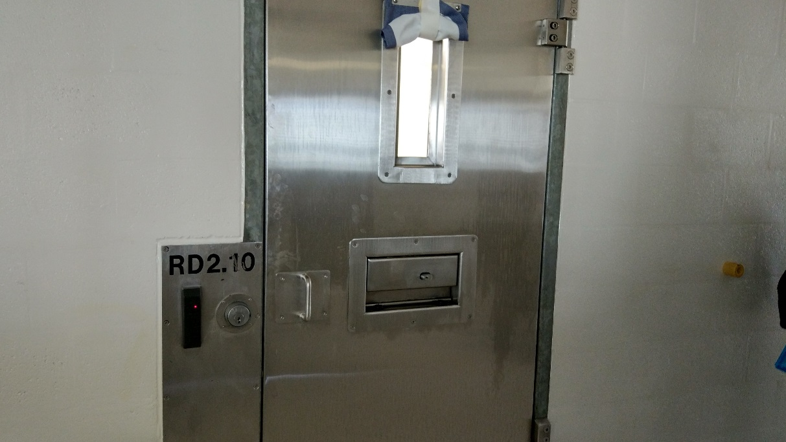
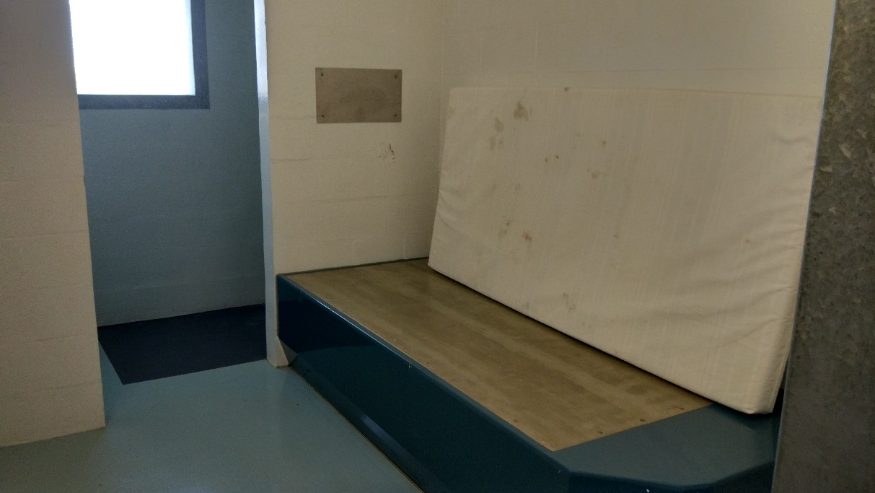
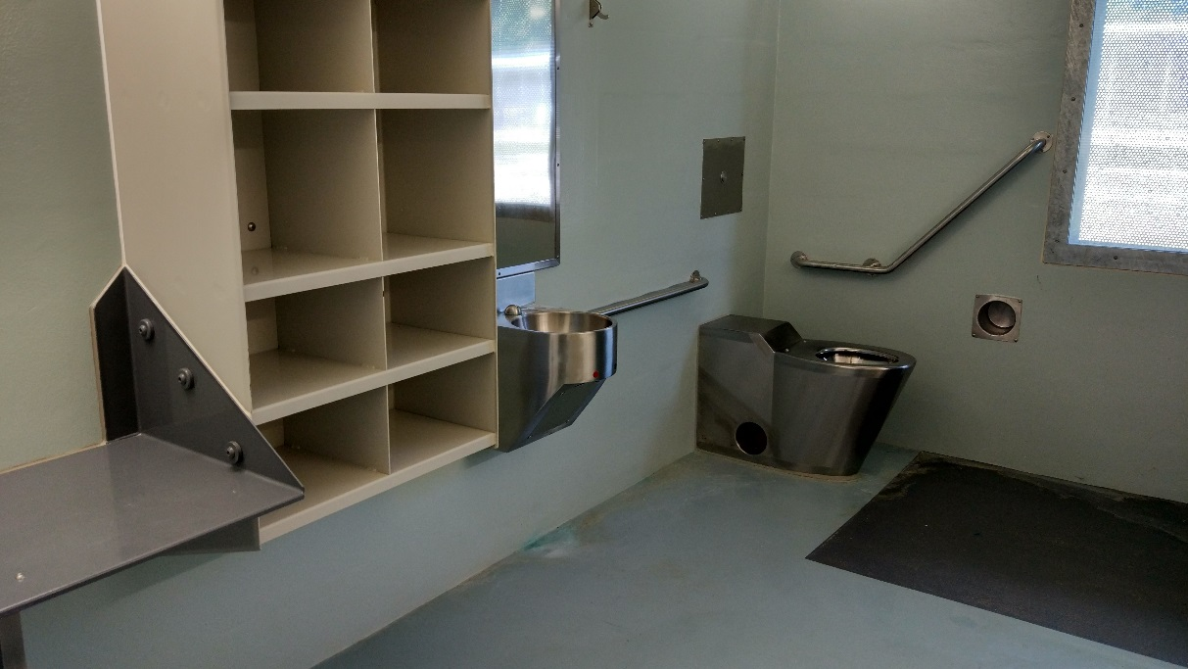
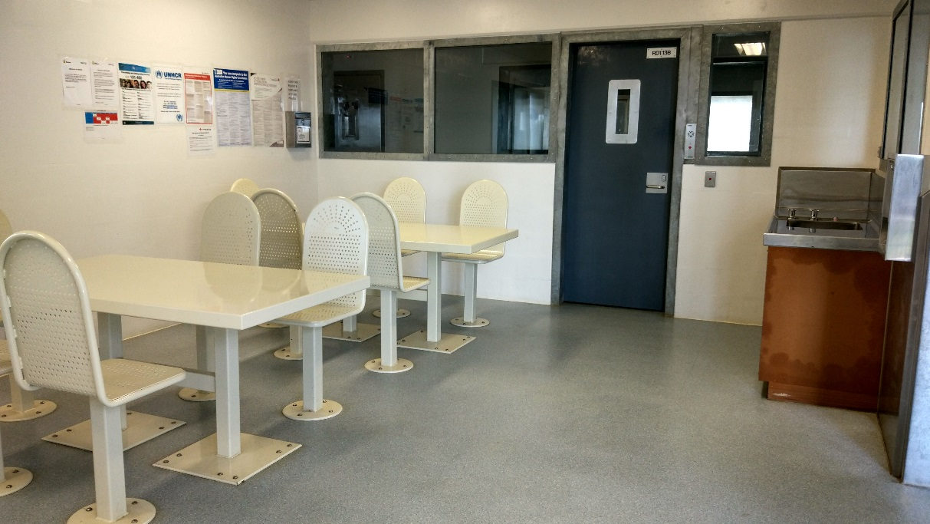
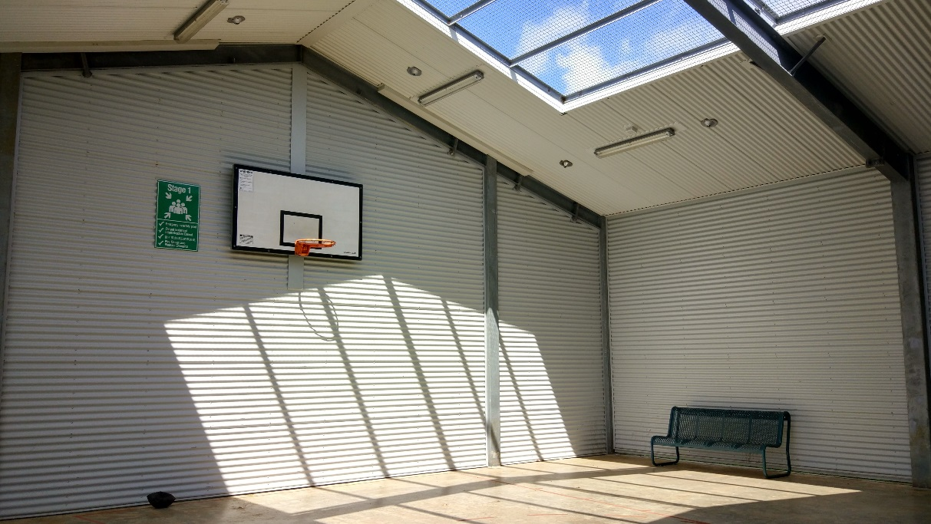
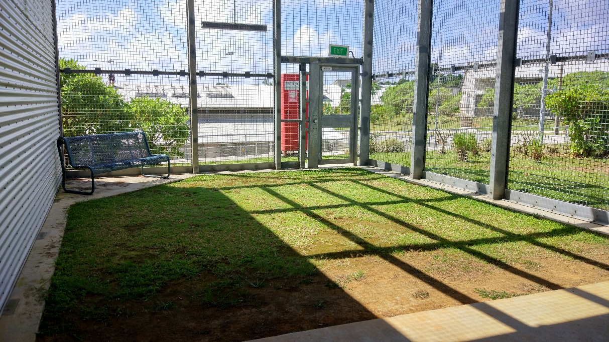

Facilities in accommodation compounds
Typical of conditions in White, Blue and Green compounds. Top to bottom: bedroom (White 1), indoor common area and entrance to bedrooms (White 1; typical of White compound only); indoor common area and entrance to bedrooms (Blue 1), kitchen facilities (Blue 1), outdoor common area (White 1), outdoor exercise area (White 1), computer room (White 1), prayer room (White 2), TV room (White 2), recreation room (Blue 1).
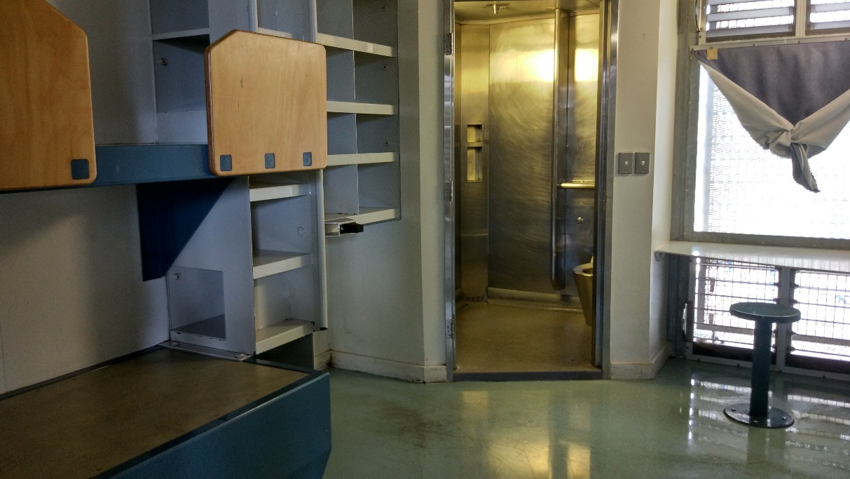
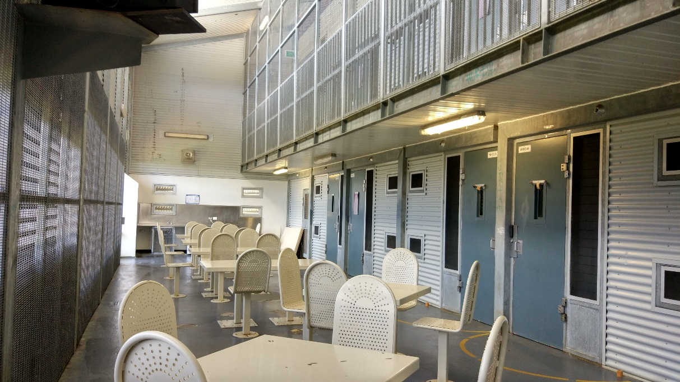
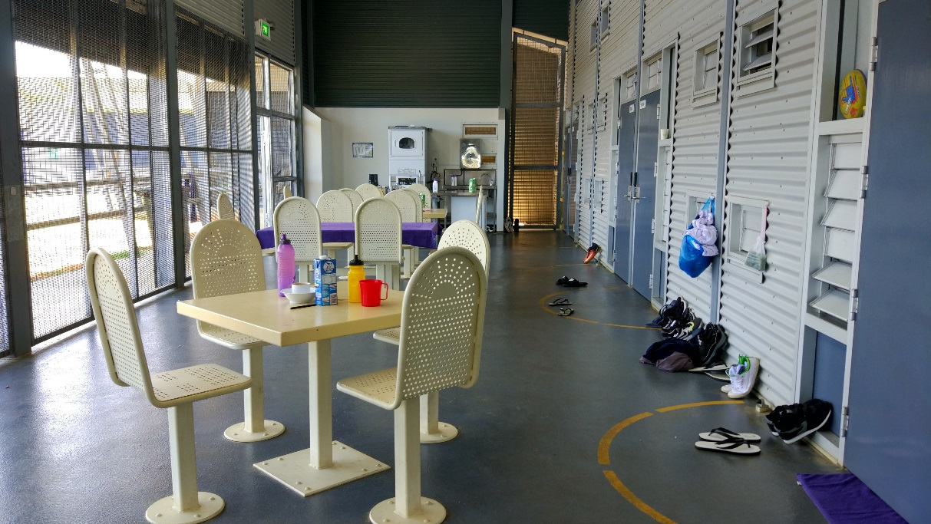
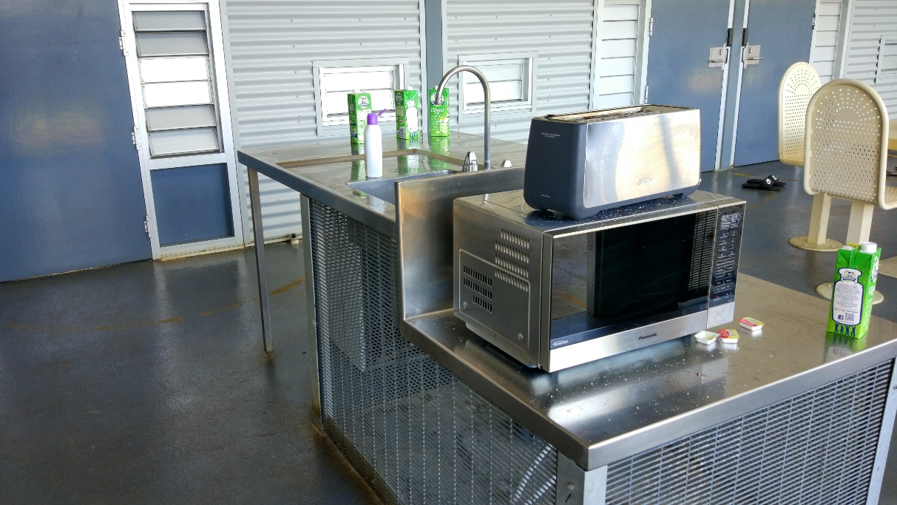
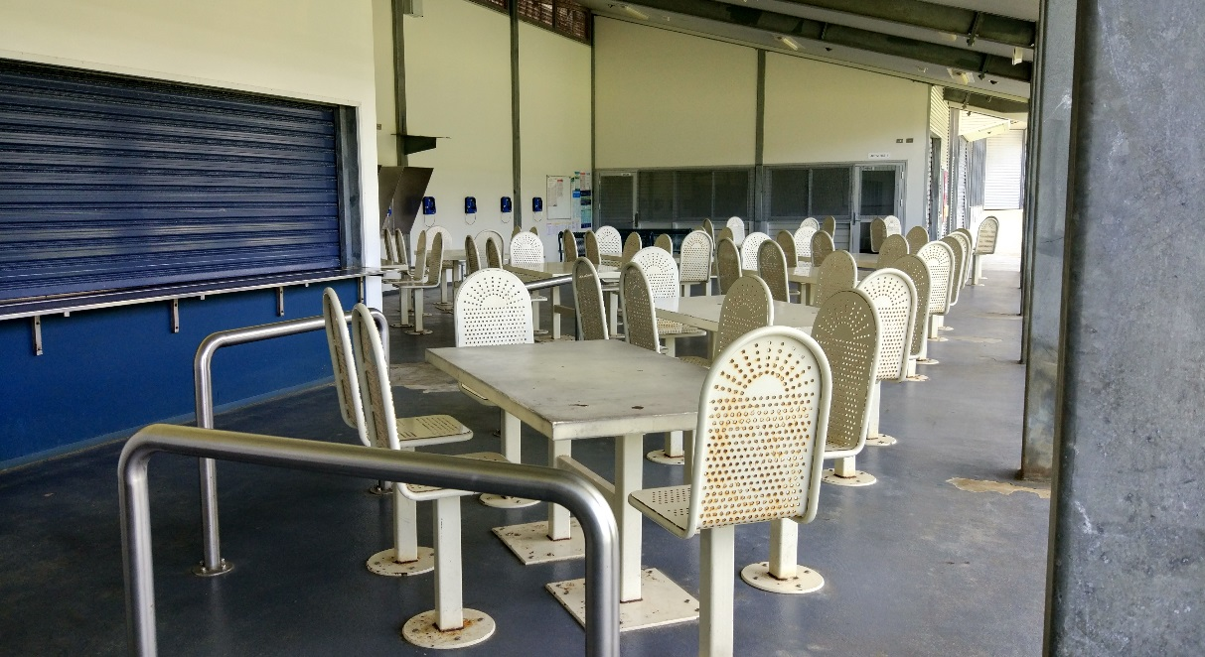
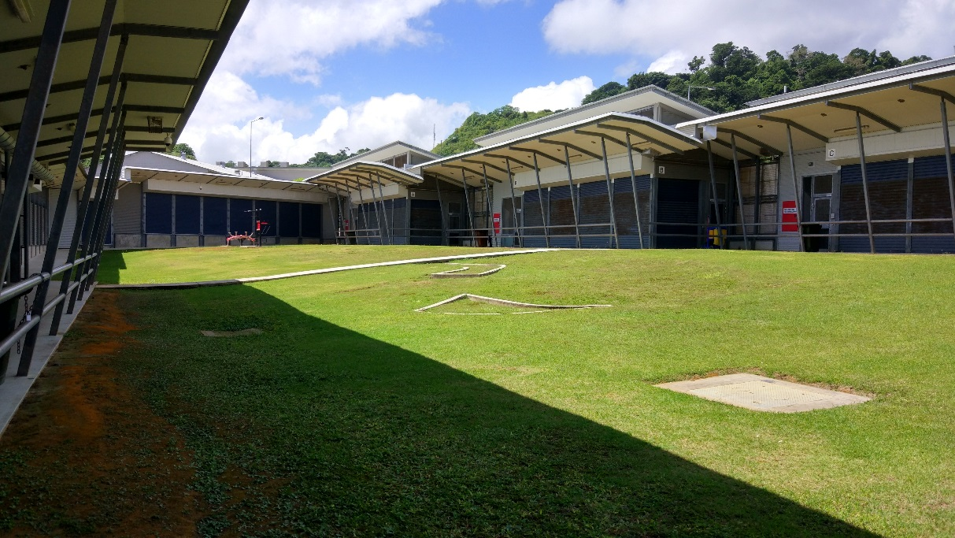
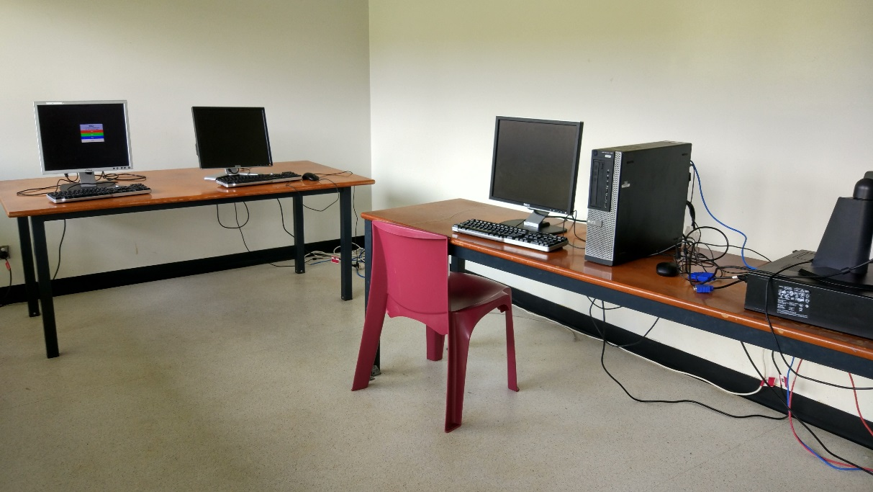
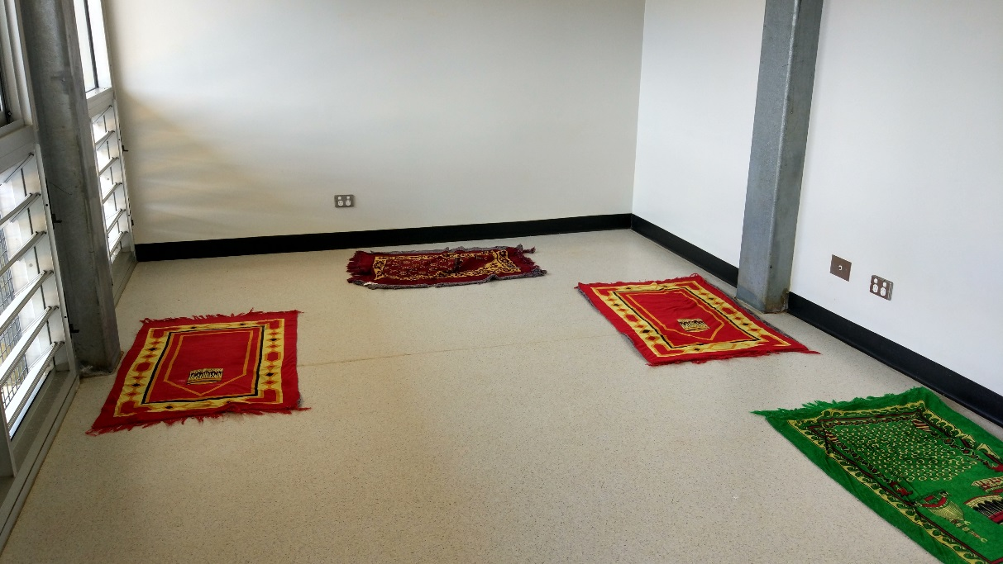
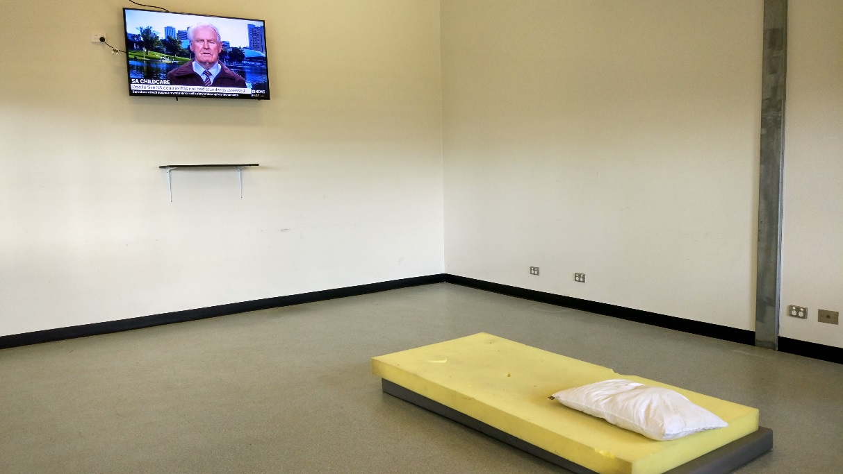
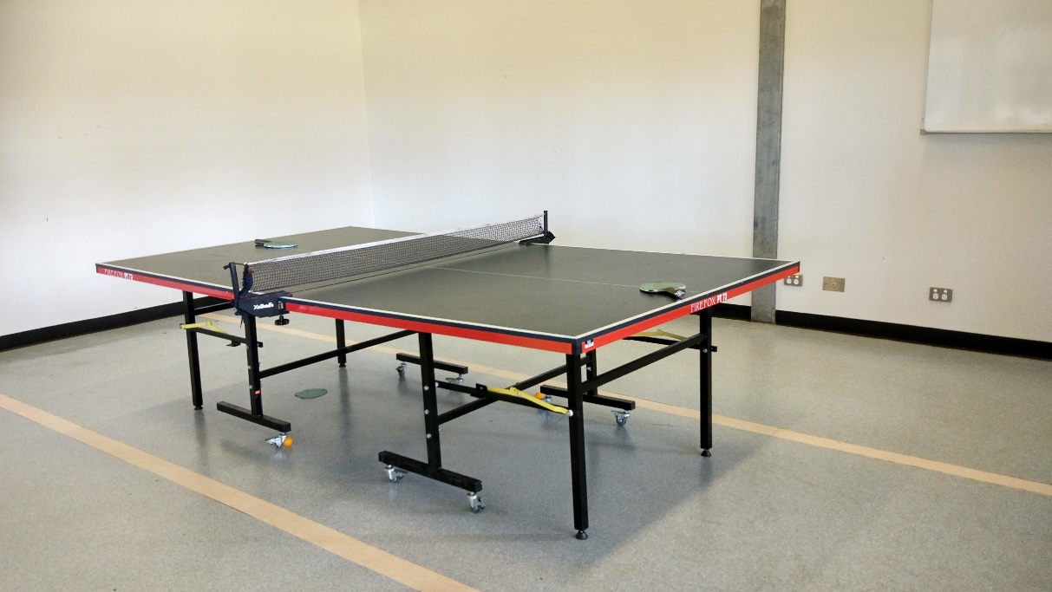

Sanitation facilities in accommodation compounds
Typical of bathroom facilities in White, Blue and Green compounds, and of laundry facilities in all compounds except Red. Top to bottom: ensuite bathroom (White 1), shared bathrooms (x3, White 2), laundry facilities (White 2).
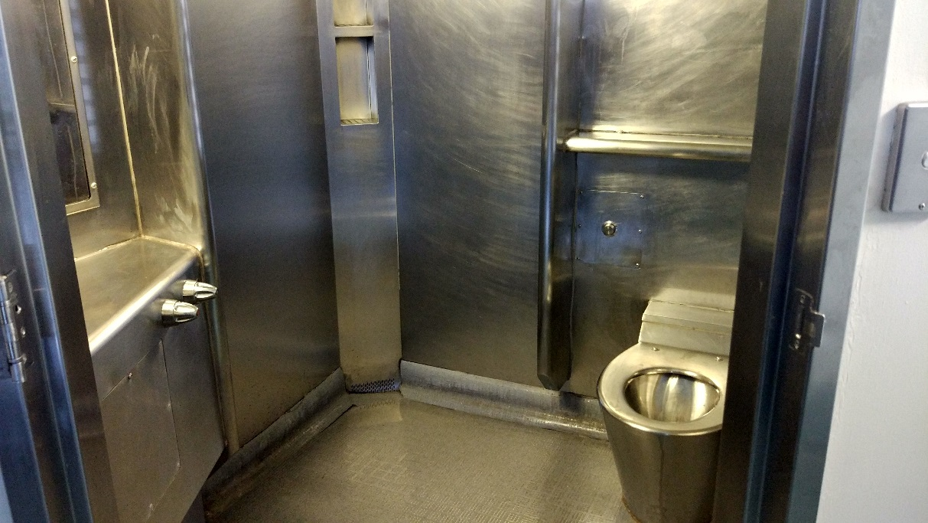
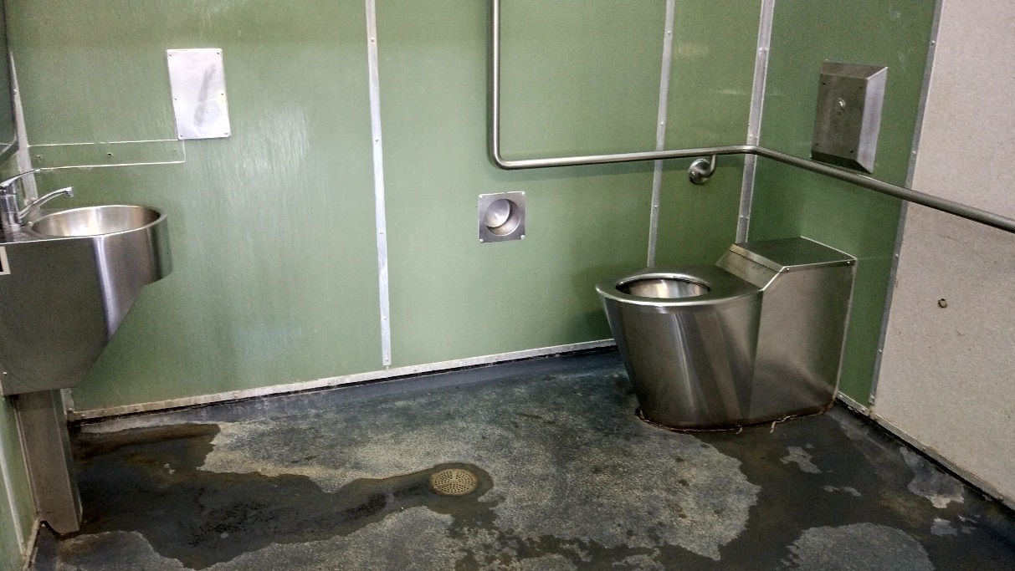
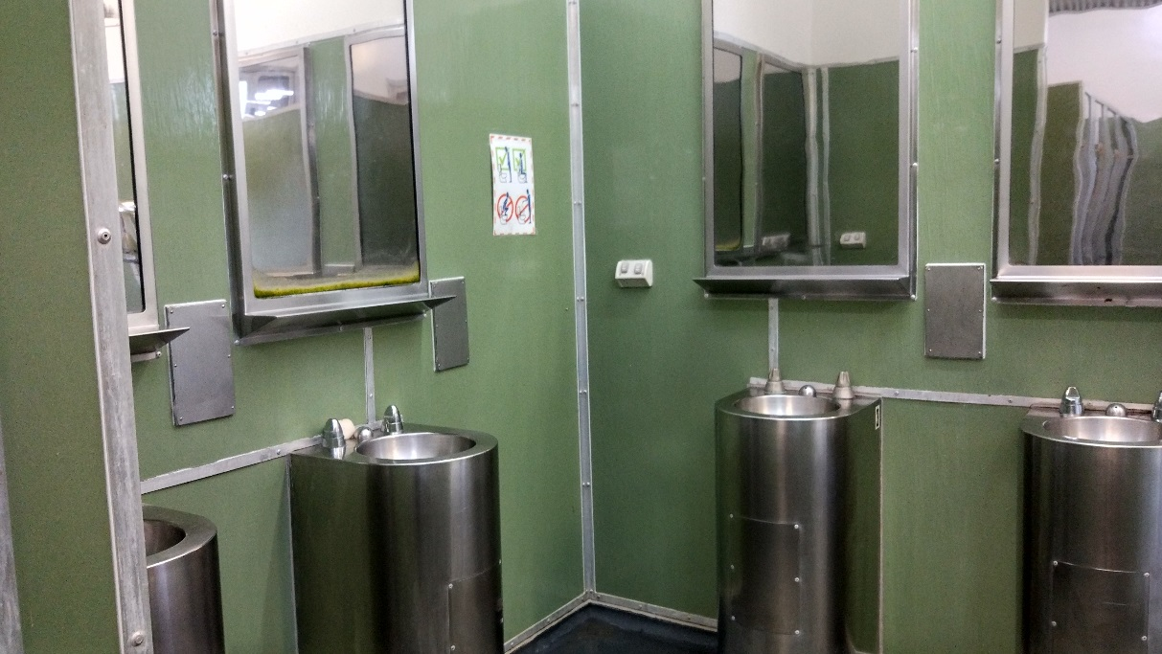
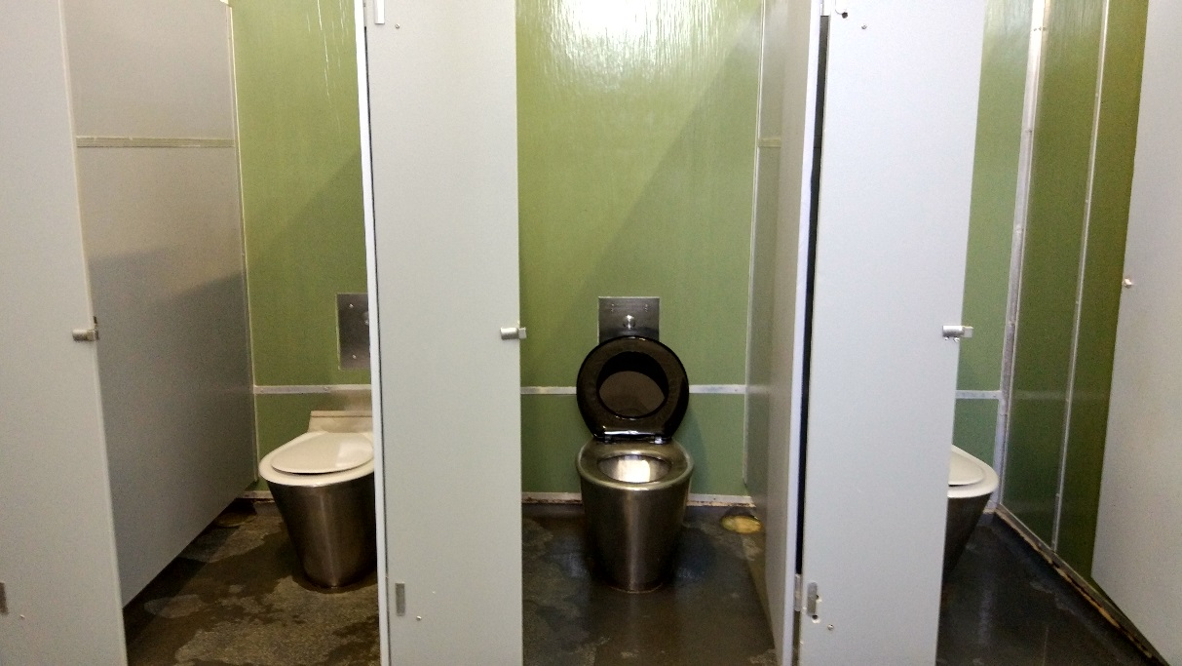
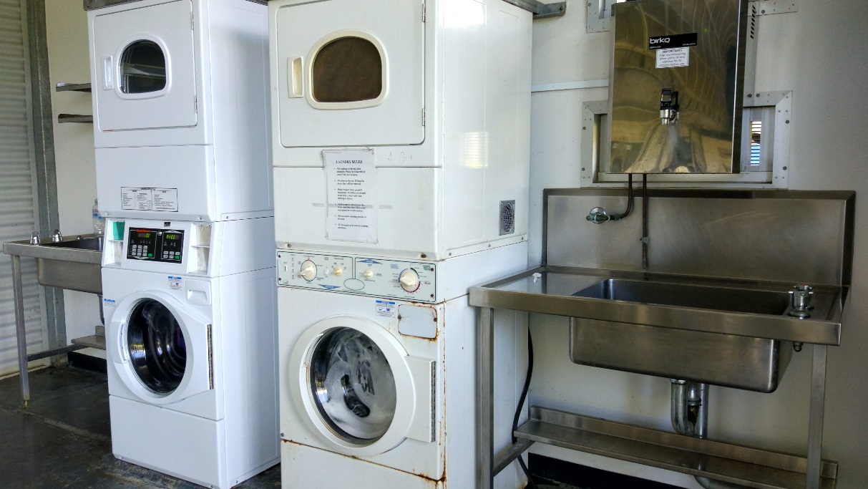

Facilities in Gold (‘incentive’) compound
All photos taken in Gold 2. Top to bottom: outdoor common area, entrance to bedrooms, TV room, recreation room, gym.
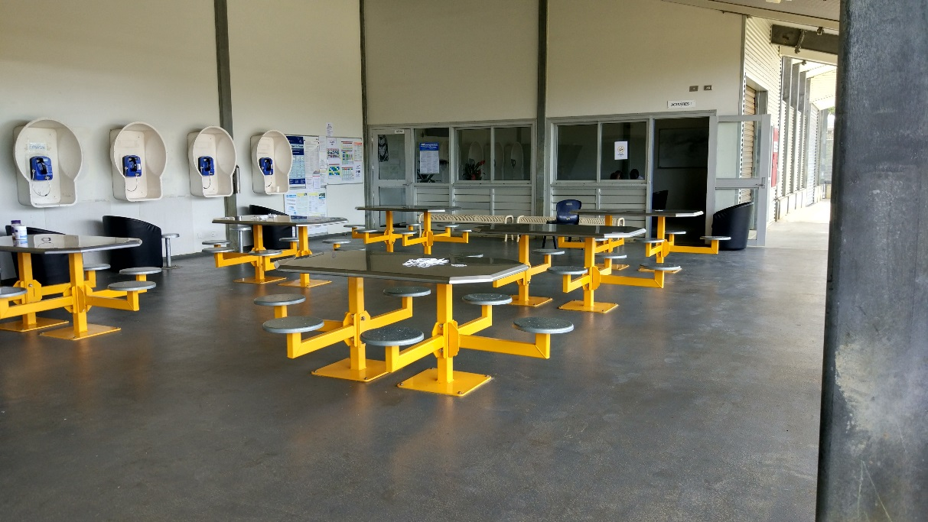
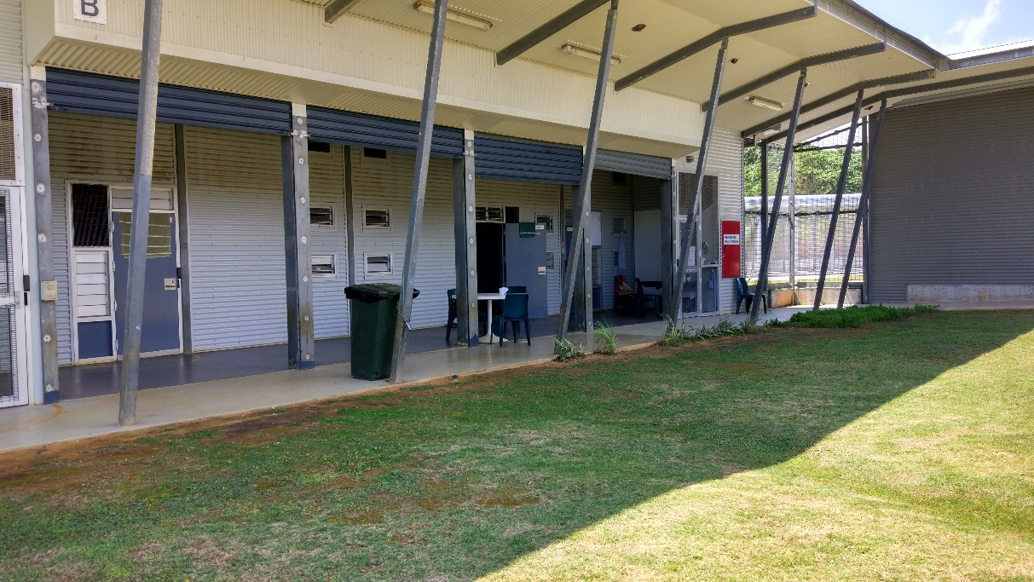

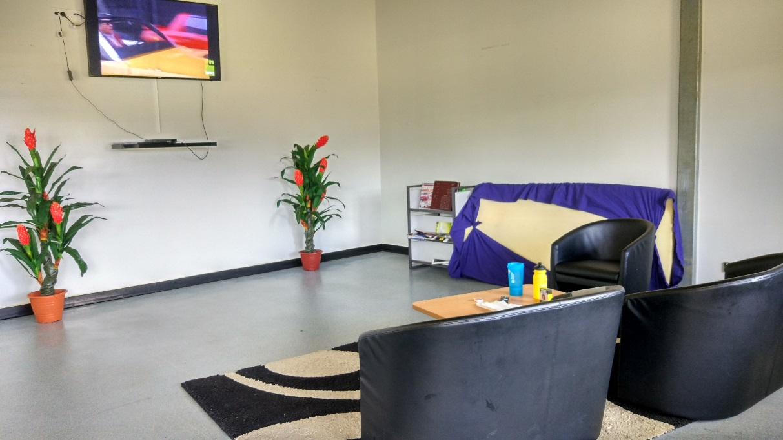
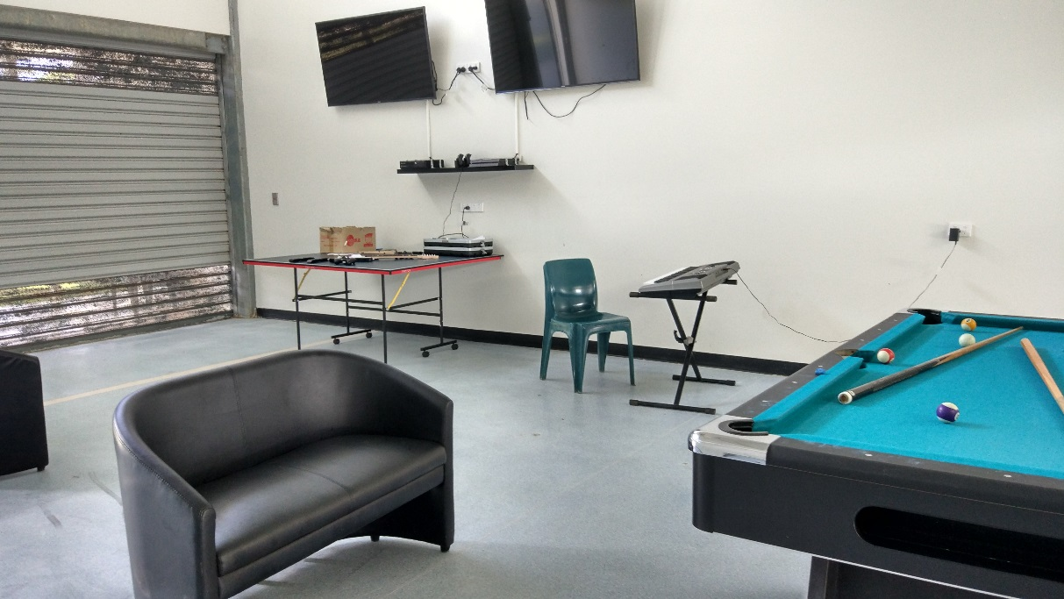
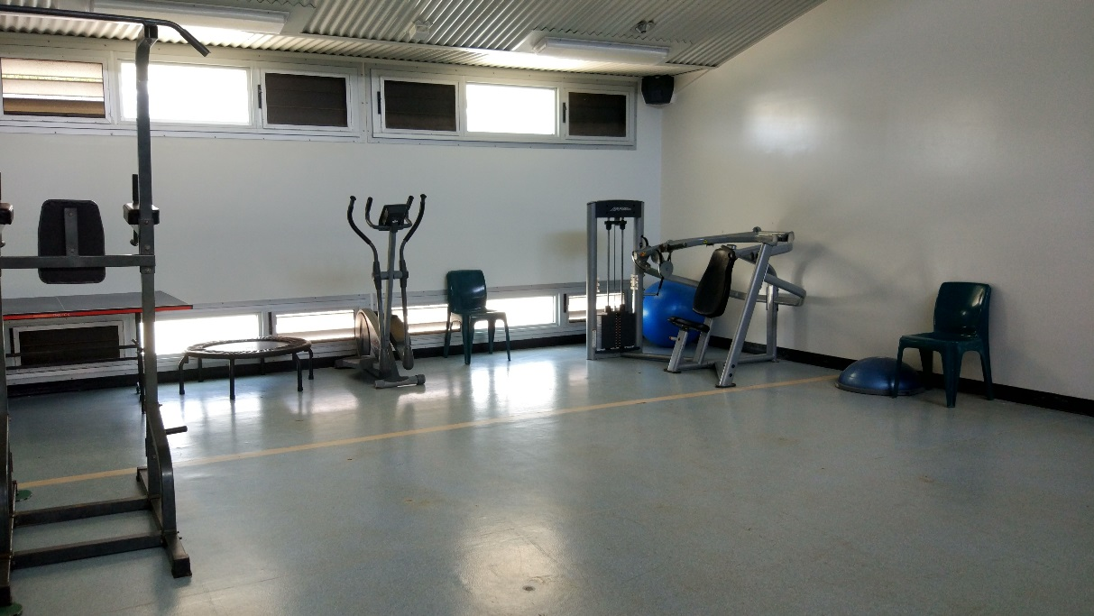

Shared facilities
From top to bottom: private interview room, room for Skype appointments, computer room for legal work, kitchen (x2; White 2), example of walkway with security grilles, canteen (Green Heart).
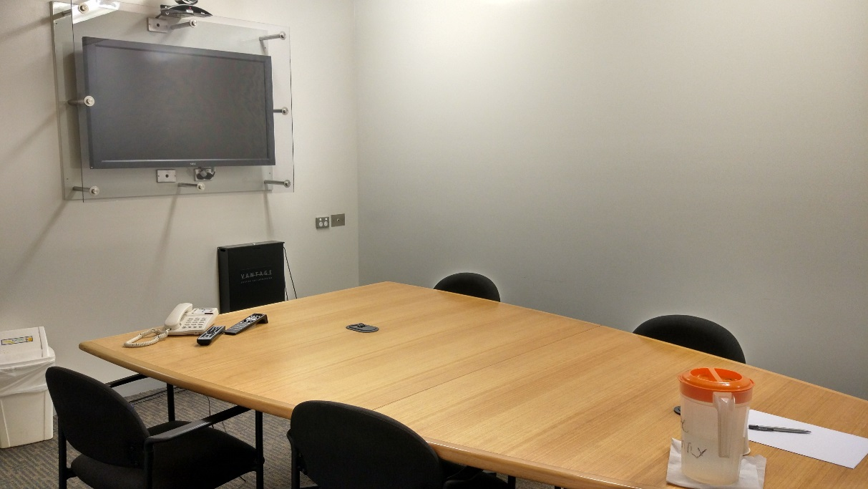
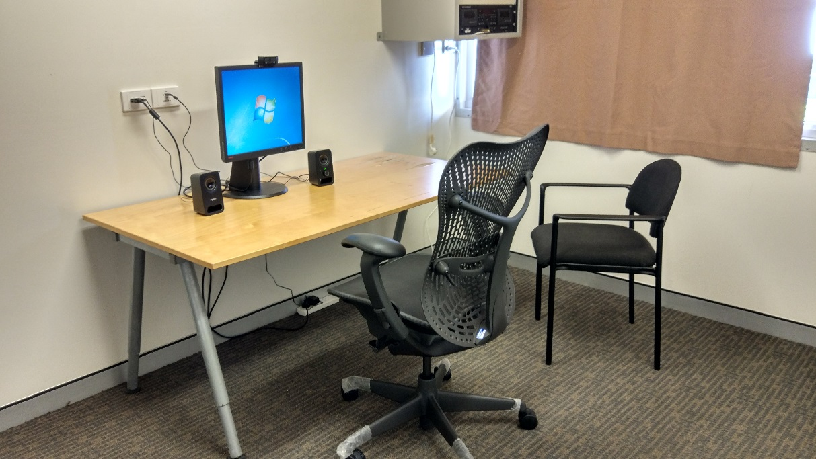
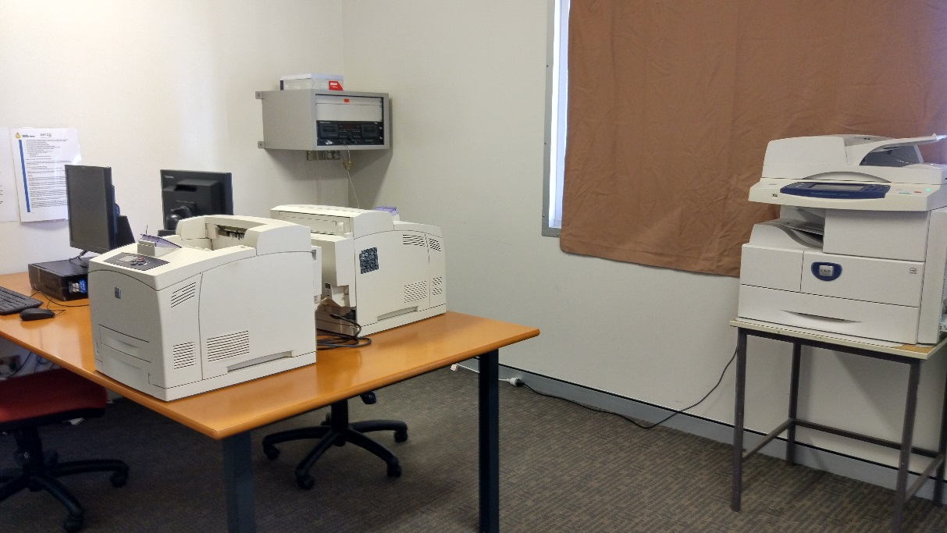
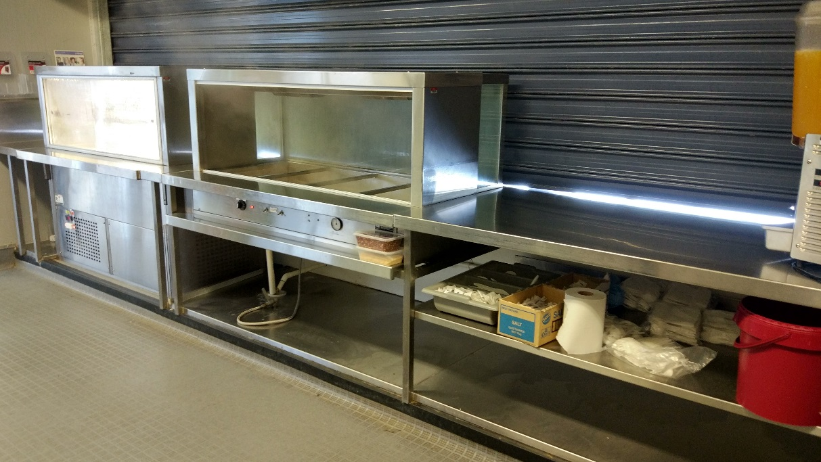
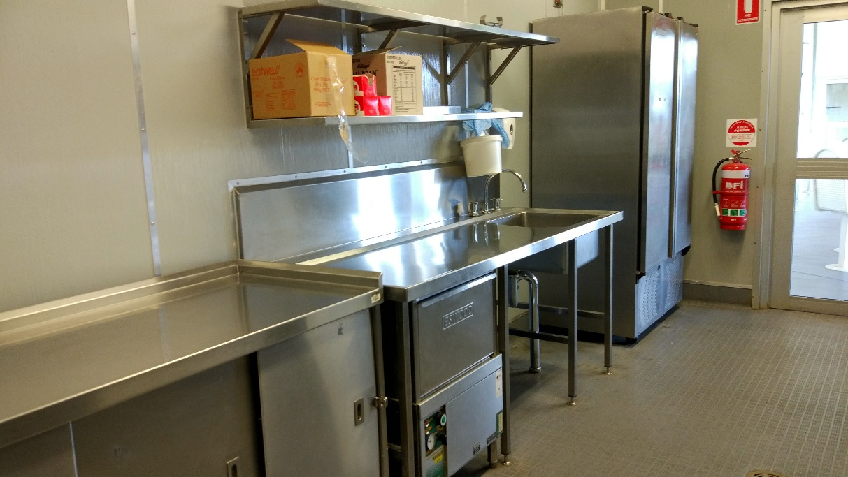
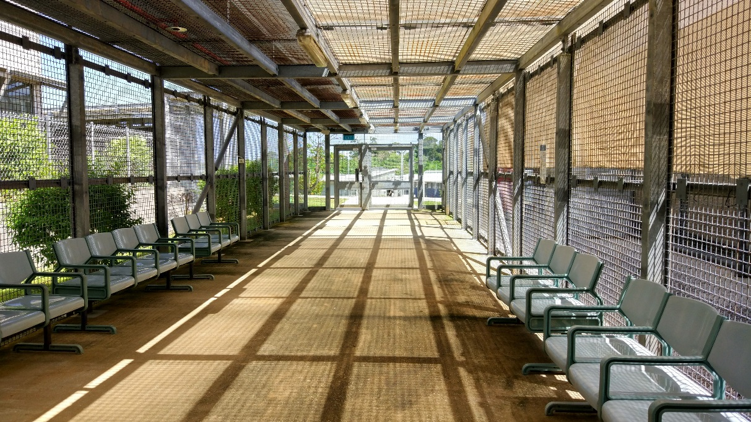
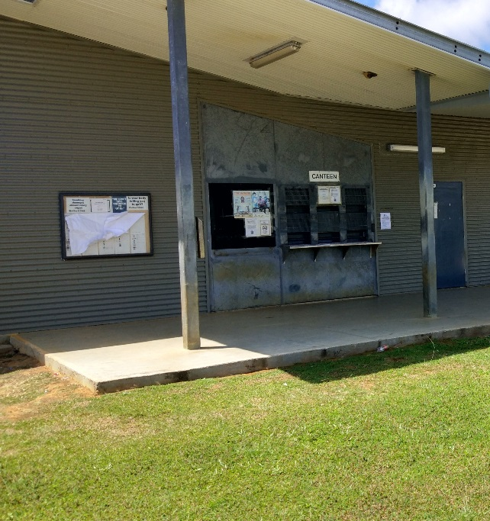

Facilities for exercise and activities
Top to bottom: Green Heart, indoor basketball court, gym, classroom, music room, art and craft room, outdoor recreation area.
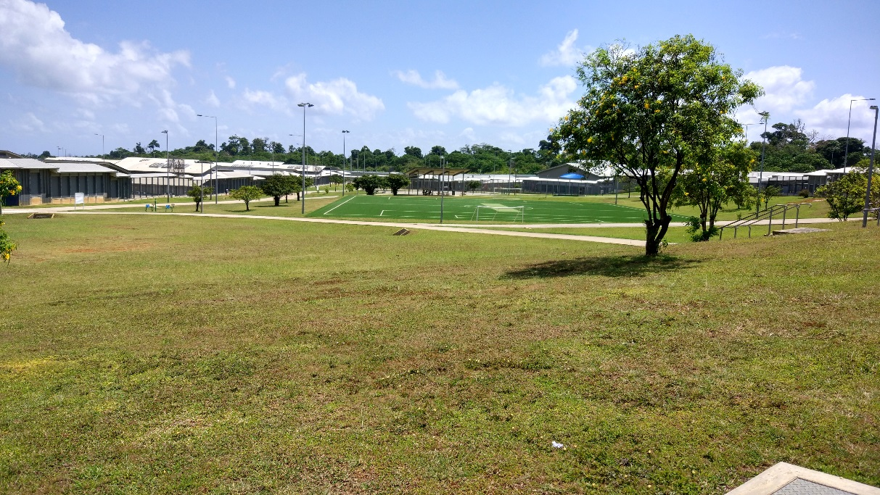
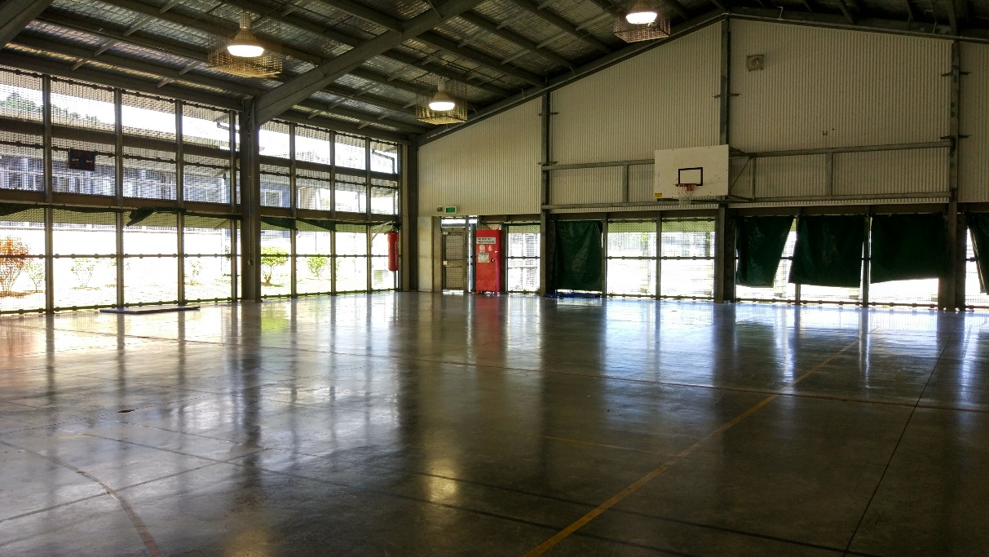
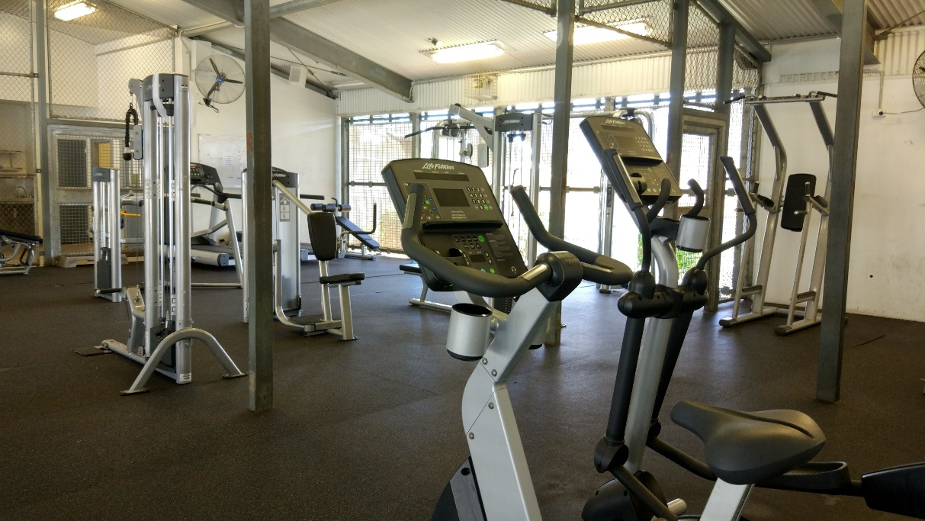
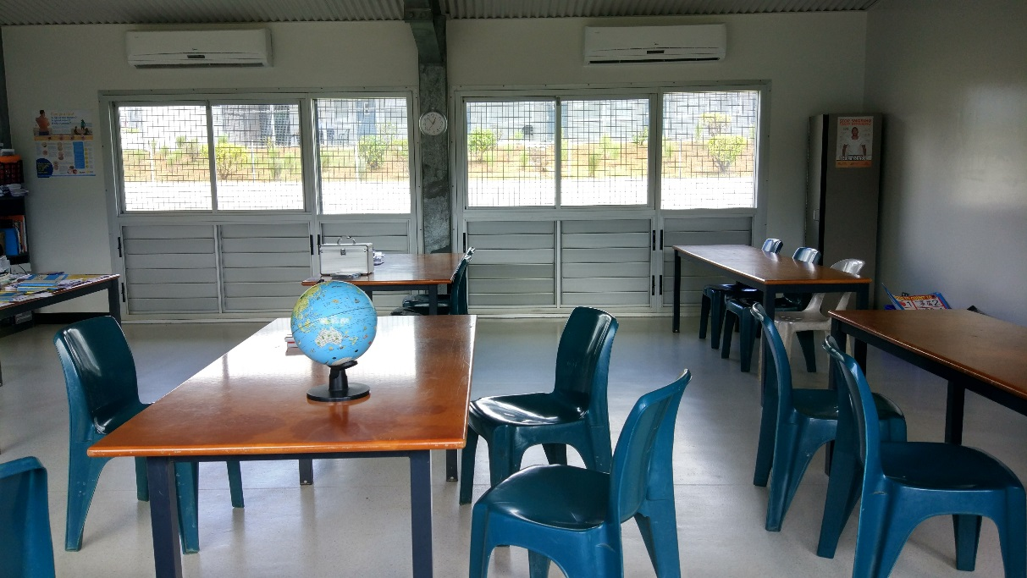
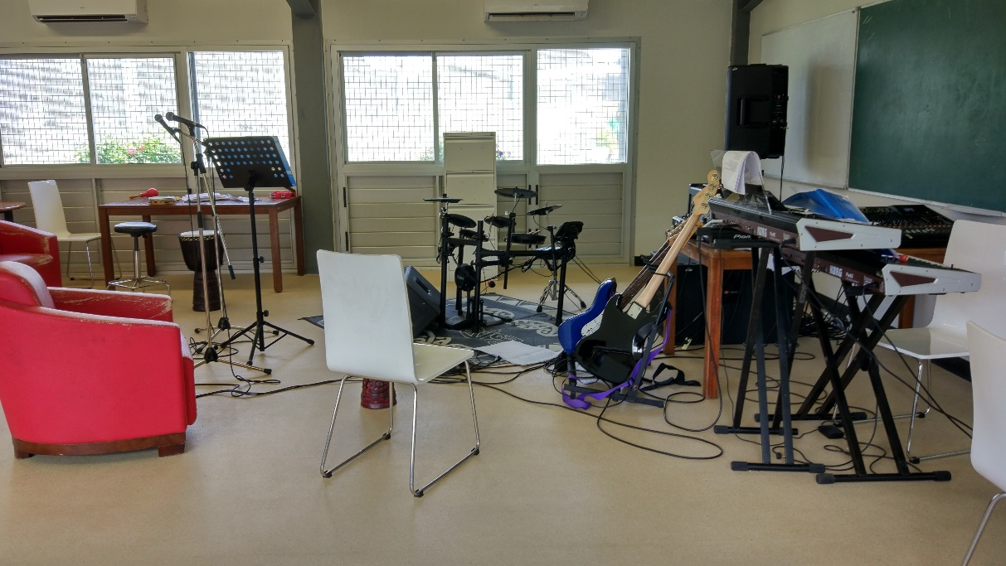
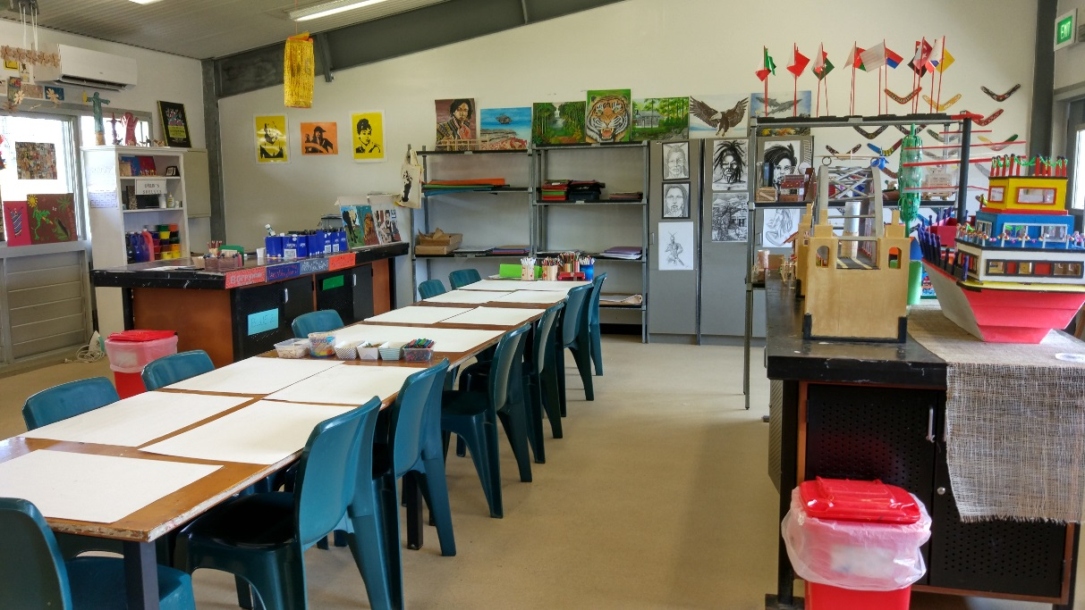
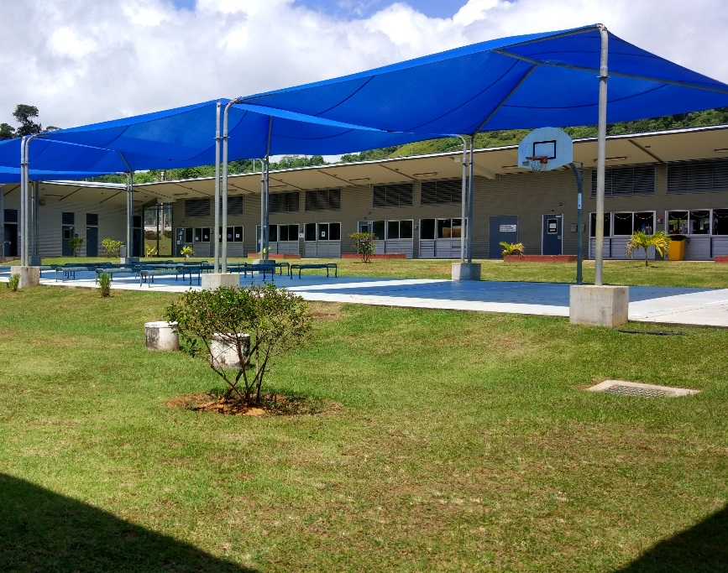

Appendix 2: Kessler Psychological Distress Scale
 | None of the time | A little of the time | Some of the time | Most of the time | All of the time
In the past four weeks, how often did you feel worn out for no good reason? | 1 | 2 | 3 | 4 | 5
In the past four weeks, how often did you feel nervous? | 1 | 2 | 3 | 4 | 5
In the past four weeks, how often did you feel so nervous that nothing could calm you down? | 1 | 2 | 3 | 4 | 5
In the past four weeks, how often did you feel hopeless? | 1 | 2 | 3 | 4 | 5
In the past four weeks, how often did you feel restless or fidgety? | 1 | 2 | 3 | 4 | 5
In the past four weeks, how often did you feel so restless you could not sit still? | 1 | 2 | 3 | 4 | 5
In the past four weeks, how often did you feel depressed? | 1 | 2 | 3 | 4 | 5
In the past four weeks, how often did you feel that everything was an effort? | 1 | 2 | 3 | 4 | 5
In the past four weeks, how often did you feel so sad that nothing could cheer you up? | 1 | 2 | 3 | 4 | 5
In the past four weeks, how often did you feel worthless? | 1 | 2 | 3 | 4 | 5

Appendix 3: Human rights standards relevant to immigration detention

Treatment of people in detention
Australia is obliged under articles 9(1) and 10(1) of the International Covenant on Civil and Political Rights (ICCPR) to, respectively, uphold the right to security of the person and ensure that people in detention are treated with humanity and respect for the inherent dignity of the human person. Australia also has obligations under article 7 of the ICCPR and articles 2(1) and 16(1) of the Convention Against Torture and other Cruel, Inhuman or Degrading Treatment or Punishment (CAT) not to subject anyone to torture or to cruel, inhuman or degrading treatment or punishment, and to take effective measures to prevent these acts from occurring.
These obligations require Australia to ensure that people in detention are treated fairly and reasonably, and in a manner that upholds their dignity. They should enjoy a safe environment free from bullying, harassment, abuse and violence. Security measures should be commensurate with identified risks, and should be the least restrictive possible in the circumstances, taking into account the particular vulnerabilities of people in detention. Measures that may constitute torture or cruel, inhuman or degrading treatment or punishment (such as collective punishment, corporal punishment, excessive use of force and holding people incommunicado) should be prohibited.

Conditions of detention
Australia has a range of obligations under the International Covenant on Economic, Social and Cultural Rights (ICESCR) relevant to the material conditions of immigration detention. These include the right to education (articles 6(2) and 13); the right to an adequate standard of living, including adequate food, clothing and housing (article 11); the right to the highest attainable standard of health (article 12); and the right to take part in cultural life (article 15(1)(a)).
Australia’s obligations under the ICCPR and CAT to treat people in detention with humanity and respect, and not to subject anyone to cruel, inhuman or degrading treatment or punishment, are also relevant to conditions of detention. In addition, Australia has an obligation under articles 17 and 18 of the ICCPR to uphold the right to privacy and freedom of religion respectively.
These obligations require Australia to ensure that detention facilities are safe, hygienic and uphold human dignity. People in detention should have their basic needs met and have access to essential services (such as health care and primary and secondary education) to a standard commensurate with those provided in the Australian community.
People in detention should have opportunities to engage in meaningful activities and excursions that provide physical and mental stimulation. People in detention should also be able to profess and practise the religion of their choice, including through being able to attend religious services, receiving pastoral visits from religious representatives and celebrating major religious holidays and festivals.
In light of the negative impacts of detention on mental health, the length of detention should be limited to the minimum period necessary to achieve a legitimate aim, and community-based alternatives to detention should be used wherever feasible.

Communication, association and complaints
Australia has a range of obligations under the ICCPR relevant to communication between people in detention and their family members, friends, representatives and communities outside detention. These include the right to freedom of expression and to seek, receive and impart information and ideas (article 19(b)); the right to freedom of association with others (article 22); and the right of ethnic, religious and linguistic minorities, in community with the other members of their group, to enjoy their own culture, to profess and practise their own religion and to use their own language (article 27). Under the ICESCR, Australia also has an obligation to uphold the right to take part in cultural life (article 15(1)(a)).
In addition, Australia has obligations under articles 23(1) of the ICCPR and 10(1) of the ICESCR to afford protection and assistance to the family as the natural and fundamental group unit of society. Australia also has obligations under article 17(1) of the ICCPR and article 16(1) of the CRC not to subject anyone to arbitrary or unlawful interference with their family.
These obligations require Australia to ensure that detention does not have a disproportionate impact on people’s ability to express themselves, communicate and associate with others, and remain in contact with their family members, friends, representatives and communities. People in detention should be able to receive regular visits, and should have access to adequate communication facilities (such as telephones and computers) as well as news and library services. People in detention should, if possible, be located in facilities within a reasonable distance from their family members, friends and communities.
External communication, in particular access to complaints processes, is also essential for the prevention of torture and other cruel, inhuman or degrading treatment or punishment. Australia has obligations under articles 13 and 16(1) of the CAT to ensure that anyone who alleges that they have been subjected to torture or to cruel, inhuman or degrading treatment or punishment, has the right to complain to and have their case examined by competent authorities.
To ensure these obligations are upheld, people in detention should have opportunities to raise concerns and issues regarding treatment and conditions in detention, and make complaints both internally and to independent monitors (including the Commission and the Commonwealth Ombudsman), without fear of repercussions.

Legal and policy framework
Australia has an obligation under article 9 of the ICCPR not to subject anyone to arbitrary detention. According to the United Nations Human Rights Committee, ‘arbitrary detention’ includes detention that, although lawful under domestic law, is unjust or disproportionate. In order for the detention of a person not to be arbitrary, it must be a reasonable and necessary measure in all the circumstances.
Australia has further obligations under article 9 of the ICCPR to ensure that anyone who is arrested has the right to be informed of the reasons for their arrest and the charges against them, and that anyone who is detained has the right to challenge the legality of their detention in court.
These obligations require Australia to ensure that people are only detained in immigration detention facilities when it is reasonable and necessary in their individual circumstances (such as where they pose an unacceptable health or security risk), and for a limited period of time. Community-based alternatives to detention should be used wherever possible. People held in immigration detention should be informed of the reasons for their detention and be able to seek judicial review of whether their detention is arbitrary.

Endnotes

Reports from previous monitoring visits to immigration detention facilities can be found on the Commission’s website at https://www.humanrights.gov.au/our-work/asylum-seekers-and-refugees/immigration-detention-reports-and-photos
Human Rights and Equal Opportunity Commission, Those who've come across the seas: Detention of unauthorised arrivals (1998). At https://www.humanrights.gov.au/our-work/asylum-seekers-and-refugees/publications/those-whove-come-across-seas-detention (viewed 11 May 2017); Human Rights and Equal Opportunity Commission, A last resort? National Inquiry into Children in Immigration Detention (2004). At https://www.humanrights.gov.au/our-work/asylum-seekers-and-refugees/projects/last-resort-report-national-inquiry-children (viewed 11 May 2017); Australian Human Rights Commission, The Forgotten Children: National Inquiry into Children in Immigration Detention (2014). At https://www.humanrights.gov.au/our-work/asylum-seekers-and-refugees/projects/national-inquiry-children-immigration-detention-index (viewed 11 May 2017).
Australian Human Rights Commission, Asylum seekers, refugees and human rights: Snapshot Report (2nd edition) (2017) 11–25. At https://www.humanrights.gov.au/our-work/asylum-seekers-and-refugees/publications/asylum-seekers-refugees-and-human-rights-snapsho-0 (viewed 11 May 2017).
See Subcommittee on Prevention of Torture and Other Cruel, Inhuman or Degrading Treatment or Punishment, Guidelines on national preventive mechanisms, 12th sess, UN Doc CAT/OP/12/5 (9 December 2010); Subcommittee on Prevention of Torture and Other Cruel, Inhuman or Degrading Treatment or Punishment, The approach of the Subcommittee on Prevention of Torture to the concept of prevention of torture and other cruel, inhuman or degrading treatment or punishment under the Optional Protocol to the Convention against Torture and Other Cruel, Inhuman or Degrading Treatment or Punishment, 12th sess, UN Doc CAT/OP/12/6 (30 December 2010); Association for the Prevention of Torture and Inter-American Institute for Human Rights, Optional Protocol to the UN Convention against Torture Implementation Manual (2010). At https://www.apt.ch/en/resources/the-optional-protocol-implementation-manual (viewed 24 May 2018); Association for the Prevention of Torture and United Nations High Commissioner for Refugees, Monitoring immigration detention practical manual (2014). At https://www.apt.ch/en/resources/monitoring-immigration-detention-practical-manual (viewed 24 May 2018). See also Australian Human Rights Commission, Human rights standards for immigration protection (2013). At https://www.humanrights.gov.au/our-work/asylum-seekers-and-refugees/publications/human-rights-standards-immigration-detention (viewed 11 May 2017).
Australia has not ratified the International Convention on the Protection of the Rights of All Migrant Workers and Members of Their Families, or the International Convention for the Protection of All Persons from Enforced Disappearance.
Australian Human Rights Commission, Human rights standards for immigration protection (2013). At https://www.humanrights.gov.au/our-work/asylum-seekers-and-refugees/publications/human-rights-standards-immigration-detention (viewed 11 May 2017).
Australian Human Rights Commission, The Forgotten Children: National Inquiry into Children in Immigration Detention (2014) 249. At https://www.humanrights.gov.au/our-work/asylum-seekers-and-refugees/projects/national-inquiry-children-immigration-detention-index (viewed 11 May 2017).
Department of Immigration and Citizenship, Immigration Detention Statistics Summary (31 July 2013) 3. At http://www.homeaffairs.gov.au/ReportsandPublications/Documents/statistics/immigration-detention-statistics-july2013.pdf (viewed 15 January 2018); Department of Immigration and Border Protection, Immigration Detention and Community Statistics Summary (31 July 2014) 3. At http://www.homeaffairs.gov.au/ReportsandPublications/Documents/statistics/immigration-detention-statistics-july2014.pdf (viewed 15 January 2018).
Department of Immigration and Border Protection, Immigration Detention and Community Statistics Summary (31 August 2017) 4. At http://www.homeaffairs.gov.au/ReportsandPublications/Documents/statistics/immigration-detention-statistics-31-august-2017.pdf (viewed 15 January 2018).
Department of Immigration and Citizenship, Immigration Detention Statistics Summary (31 July 2013) 3. At http://www.homeaffairs.gov.au/ReportsandPublications/Documents/statistics/immigration-detention-statistics-july2013.pdf (viewed 15 January 2018); Department of Immigration and Border Protection, Immigration Detention and Community Statistics Summary (31 July 2014) 3. At http://www.homeaffairs.gov.au/ReportsandPublications/Documents/statistics/immigration-detention-statistics-july2014.pdf (viewed 15 January 2018).
Department of Immigration and Border Protection, Immigration Detention and Community Statistics Summary (31 August 2017) 4. At http://www.homeaffairs.gov.au/ReportsandPublications/Documents/statistics/immigration-detention-statistics-31-august-2017.pdf (viewed 15 January 2018).
Department of Immigration and Citizenship, Immigration Detention Statistics Summary (31 July 2013) 9. At http://www.border.gov.au/ReportsandPublications/Documents/statistics/immigration-detention-statistics-july2013.pdf (viewed 15 January 2018).
Department of Immigration and Border Protection, Immigration Detention and Community Statistics Summary (31 July 2014) 10. At http://www.homeaffairs.gov.au/ReportsandPublications/Documents/statistics/immigration-detention-statistics-july2014.pdf (viewed 15 January 2018).
Department of Immigration and Border Protection, Immigration Detention and Community Statistics Summary (31 January 2017) 11. At http://www.homeaffairs.gov.au/ReportsandPublications/Documents/statistics/immigration-detention-statistics-31-jan-2017.pdf (viewed 15 January 2018); Department of Immigration and Border Protection, Immigration Detention and Community Statistics Summary (31 August 2017) 11. At http://www.homeaffairs.gov.au/ReportsandPublications/Documents/statistics/immigration-detention-statistics-31-august-2017.pdf (viewed 15 January 2018).
Department of Immigration and Citizenship, Immigration Detention Statistics Summary (31 July 2013) 9. At http://www.border.gov.au/ReportsandPublications/Documents/statistics/immigration-detention-statistics-july2013.pdf (viewed 12 May 2017).
Department of Immigration and Border Protection, Immigration Detention and Community Statistics Summary (31 July 2014) 10. At http://www.homeaffairs.gov.au/ReportsandPublications/Documents/statistics/immigration-detention-statistics-july2014.pdf (viewed 15 January 2018).
Department of Immigration and Border Protection, Immigration Detention and Community Statistics Summary (31 August 2017) 11. At http://www.homeaffairs.gov.au/ReportsandPublications/Documents/statistics/immigration-detention-statistics-31-august-2017.pdf (viewed 15 January 2018).
Department of Immigration and Border Protection, Immigration Detention and Community Statistics Summary (31 July 2014) 10. At http://www.homeaffairs.gov.au/ReportsandPublications/Documents/statistics/immigration-detention-statistics-july2014.pdf (viewed 15 January 2018); Department of Immigration and Border Protection, Immigration Detention and Community Statistics Summary (31 August 2017) 11. At http://www.homeaffairs.gov.au/ReportsandPublications/Documents/statistics/immigration-detention-statistics-31-august-2017.pdf (viewed 15 January 2018).
Canada Border Services Agency, Detention Statistics (23 May 2017). At http://www.cbsa-asfc.gc.ca/security-securite/detent-stat-eng.html (viewed 25 September 2017).
United Kingdom Home Office, National Statistics: Detention (23 February 2017). At https://www.gov.uk/government/publications/immigration-statistics-october-to-december-2016/detention (viewed 25 September 2017); United Kingdom Home Office, National Statistics: Detention (3 March 2016). At https://www.gov.uk/government/publications/immigration-statistics-october-to-december-2015/detention (viewed 25 September 2017; United Kingdom Home Office, National Statistics: Immigration statistics, October to December 2014 (26 February 2015). At https://www.gov.uk/government/publications/immigration-statistics-october-to-december-2014/immigration-statistics-october-to-december-2014 (viewed 25 September 2017); United Kingdom Home Office, National Statistics: Immigration statistics, October to December 2013 (27 February 2014). At https://www.gov.uk/government/publications/immigration-statistics-october-to-december-2013/immigration-statistics-october-to-december-2013 (viewed 25 September 2017); United Kingdom Home Office, National Statistics: Immigration statistics, October to December 2012 (28 February 2013). At https://www.gov.uk/government/publications/immigration-statistics-october-to-december-2012/immigration-statistics-october-to-december-2012 (viewed 25 September 2017).
See the Department of Immigration and Border Protection’s immigration detention statistics summaries, available at http://www.border.gov.au/about/reports-publications/research-statistics/statistics/live-in-australia/immigration-detention (viewed 12 May 2017).
Migration Amendment (Character and General Visa Cancellation) Act 2014 (Cth)
Department of Immigration and Border Protection, Key visa cancellation statistics (n.d.). At http://www.border.gov.au/about/reports-publications/research-statistics/statistics/key-cancellation-statistics (viewed 29 November 2016); Department of Immigration and Border Protection, Annual Report 2016–17 (2017) 8. At http://www.border.gov.au/ReportsandPublications/Documents/annual-reports/complete-annual-report-2016-17.pdf (viewed 23 October 2017).
Department of Immigration and Border Protection, Immigration Detention and Community Statistics Summary (31 August 2017) 4. At http://www.border.gov.au/ReportsandPublications/Documents/statistics/immigration-detention-statistics-31-august-2017.pdf (viewed 16 October 2017).
Department of Home Affairs, ‘Update on Machinery of Government changes’ (Media Release, 20 December 2017). At https://www.homeaffairs.gov.au/News/Pages/machinery-government-changes.aspx (viewed 18 January 2018).
See Australian Human Rights Commission, Inspection of Maribyrnong Immigration Detention Centre (2017) 12–14. At https://www.humanrights.gov.au/our-work/asylum-seekers-and-refugees/publications/inspection-maribyrnong-immigration-detention (viewed 17 January 2018); Australian Human Rights Commission, Inspection of Villawood Immigration Detention Centre (2017) 12–13. At https://www.humanrights.gov.au/our-work/asylum-seekers-and-refugees/publications/inspection-villawood-immigration-detention-centre (viewed 17 January 2018).
Australian Human Rights Commission, Immigration detention report: Summary of observations following visits to Australia’s immigration detention facilities (December 2008) 75. At https://www.humanrights.gov.au/publications/2008-immigration-detention-report-summary-observations-following-inspection-mainland (viewed 23 May 2018); Australian Human Rights Commission, Immigration detention and offshore processing on Christmas Island (2009) 32. At https://www.humanrights.gov.au/publications/2009-immigration-detention-and-offshore-processing-christmas-island (viewed 23 May 2018); Australian Human Rights Commission, Immigration detention on Christmas Island (2010) 31. At https://www.humanrights.gov.au/publications/2010-immigration-detention-christmas-island (viewed 23 May 2018); Australian Human Rights Commission, Immigration detention on Christmas Island: Observations from visit to Immigration detention facilities on Christmas Island (2012) 14–16. At https://www.humanrights.gov.au/our-work/asylum-seekers-and-refugees/publications/immigration-detention-christmas-island (viewed 19 January 2018).
Australian Human Rights Commission, Immigration detention on Christmas Island (2012) 15–16. At https://www.humanrights.gov.au/our-work/asylum-seekers-and-refugees/publications/immigration-detention-christmas-island (viewed 19 January 2018).
Australian Human Rights Commission, Immigration detention report: Summary of observations following visits to Australia’s immigration detention facilities (December 2008) 75. At https://www.humanrights.gov.au/publications/2008-immigration-detention-report-summary-observations-following-inspection-mainland (viewed 23 May 2018); Australian Human Rights Commission, Immigration detention and offshore processing on Christmas Island (2009) 32. At https://www.humanrights.gov.au/publications/2009-immigration-detention-and-offshore-processing-christmas-island (viewed 23 May 2018); Australian Human Rights Commission, Immigration detention on Christmas Island (2010) 32–35. At https://www.humanrights.gov.au/publications/2010-immigration-detention-christmas-island (viewed 23 May 2018); Australian Human Rights Commission, Immigration detention on Christmas Island: Observations from visit to Immigration detention facilities on Christmas Island (2012) 14–15. At https://www.humanrights.gov.au/our-work/asylum-seekers-and-refugees/publications/immigration-detention-christmas-island (viewed 19 January 2018).
See, for example, Australian Human Rights Commission, Immigration detention in Villawood: Summary of observations from visit to immigration detention facility in Villawood (2011) 18, 30. At https://www.humanrights.gov.au/sites/default/files/content/human_rights/immigration/idc2011_villawood.pdf (viewed 6 June 2017).
Australian Bureau of Statistics, Information Paper: Use of the Kessler Psychological Distress Scale in ABS Health Surveys, Australia, 2007-08 (4 April 2012) 9. At http://www.abs.gov.au/ausstats/abs@.nsf/Lookup/34333D54F054CE51CA2579D50015D786?opendocument (viewed 16 June 2017).
Gavin Andrews and Tim Slade, ‘Interpreting scores on the Kessler Psychological Distress Scale (K10)’ (2001) 25, 6 Australian and New Zealand Journal of Public Health 494, 495.
Australian Bureau of Statistics, Information Paper: Use of the Kessler Psychological Distress Scale in ABS Health Surveys, Australia, 2007-08 (4 April 2012) 9. At http://www.abs.gov.au/ausstats/abs@.nsf/Lookup/34333D54F054CE51CA2579D50015D786?opendocument (viewed 16 June 2017); Gavin Andrews and Tim Slade, ‘Interpreting scores on the Kessler Psychological Distress Scale (K10)’ (2001) 25, 6 Australian and New Zealand Journal of Public Health 494, 495.
Louise K Newman, Nicholas G Procter and Michael J Dudley, ‘Suicide and self-harm in immigration detention’ (2011) 195(6) Medical Journal of Australia 310; Melissa Bull et al, ‘Sickness in the System of Long-term Immigration Detention’ (2013) 26 Journal of Refugee Studies 47; Ilan Katz et al, The experiences of Irregular Maritime Arrivals detained in immigration detention facilities: Final report (2013). At http://www.border.gov.au/ReportsandPublications/Documents/research/IMA-experiences-IDF.pdf (viewed 7 December 2016).
United Nations Human Rights Committee, Concluding observations on the sixth periodic report of Australia, 121st sess, Agenda Item 5, UN Doc CCPR/C/AUS/CO/6 (9 November 2017) [37].
Department of Immigration and Border Protection, ‘New measures to combat illegal activity within immigration detention facilities’ (Media Release, 11 November 2016). At http://newsroom.border.gov.au/releases/new-measures-to-combat-illegal-activity-within-immigration-detention-facilities (viewed 26 May 2017).
Migration Amendment (Prohibiting Items in Immigration Detention Facilities) Bill 2017 (Cth) sch 1 item 2.
Statement of Compatibility with Human Rights, Explanatory Memorandum, Migration Amendment (Prohibiting Items in Immigration Detention Facilities) Bill 2017 (Cth).
Australian Human Rights Commission, Submission No 11 to the Senate Legal and Constitutional Affairs Legislation Committee, Parliament of Australia, Inquiry into the Migration Amendment (Prohibiting Items in Immigration Detention Facilities) Bill 2017 [Provisions], 11 October 2017.
Senate Legal and Constitutional Affairs Legislation Committee, Parliament of Australia, Inquiry into the Migration Amendment (Prohibiting Items in Immigration Detention Facilities) Bill 2017 [Provisions] (2017) 25.
Senate Legal and Constitutional Affairs Legislation Committee, Parliament of Australia, Inquiry into the Migration Amendment (Prohibiting Items in Immigration Detention Facilities) Bill 2017 [Provisions] (2017) 25.
For further information and recommendations, see Australian Human Rights Commission, Submission No 11 to the Senate Standing Committee on Legal and Constitutional Affairs, Parliament of Australia, Inquiry into the Migration Amendment (Prohibiting Items in Immigration Detention Facilities) Bill 2017 [Provisions], 11 October 2017.
Australian Human Rights Commission, Submission No 11 to the Senate Standing Committee on Legal and Constitutional Affairs, Parliament of Australia, Inquiry into the Migration Amendment (Prohibiting Items in Immigration Detention Facilities) Bill 2017 [Provisions], 11 October 2017, 8–9.
Australian Human Rights Commission, Immigration detention and offshore processing on Christmas Island (2009) 18. At https://www.humanrights.gov.au/publications/2009-immigration-detention-and-offshore-processing-christmas-island (viewed 19 January 2018); See Australian Human Rights Commission, Immigration detention on Christmas Island (2010) 5. At https://www.humanrights.gov.au/publications/2010-immigration-detention-christmas-island (viewed 19 January 2018); Australian Human Rights Commission, Immigration detention on Christmas Island (2012) 5. At https://www.humanrights.gov.au/our-work/asylum-seekers-and-refugees/publications/immigration-detention-christmas-island (viewed 19 January 2018). See also Australian Human Rights Commission, The Forgotten Children: National Inquiry into Children in Immigration Detention (2014). At https://www.humanrights.gov.au/our-work/asylum-seekers-and-refugees/projects/national-inquiry-children-immigration-detention-index (viewed 11 May 2017).
See Australian Human Rights Commission, Asylum seekers, refugees and human rights: Snapshot Report (2nd edition) (2017) 11–25. At https://www.humanrights.gov.au/our-work/asylum-seekers-and-refugees/publications/asylum-seekers-refugees-and-human-rights-snapsho-0 (viewed 11 May 2017). See also Australian Human Rights Commission, Inspection of Maribyrnong Immigration Detention Centre: Report (2017) 26–29. At https://www.humanrights.gov.au/our-work/asylum-seekers-and-refugees/publications/inspection-maribyrnong-immigration-detention (viewed 17 October 2017); Australian Human Rights Commission, Inspection of Melbourne Immigration Transit Accommodation: Report (2017) 24–27. At https://www.humanrights.gov.au/our-work/asylum-seekers-and-refugees/publications/inspection-melbourne-immigration-transit (viewed 17 October 2017).
United Nations Human Rights Committee, Concluding observations on the sixth periodic report of Australia, 121st sess, Agenda Item 5, UN Doc CCPR/C/AUS/CO/6 (9 November 2017) [37].
United Nations Human Rights Committee, Concluding observations on the sixth periodic report of Australia, 121st sess, Agenda Item 5, UN Doc CCPR/C/AUS/CO/6 (9 November 2017) [38].
Australian Human Rights Commission, Immigration detention report: Summary of observations following visits to Australia’s immigration detention facilities (December 2008) 75–76. At https://www.humanrights.gov.au/publications/2008-immigration-detention-report-summary-observations-following-inspection-mainland (viewed 23 May 2018); Australian Human Rights Commission, Immigration detention and offshore processing on Christmas Island (2009) 5. At https://www.humanrights.gov.au/publications/2009-immigration-detention-and-offshore-processing-christmas-island (viewed 23 May 2018); Australian Human Rights Commission, Immigration detention on Christmas Island (2010) 6. At https://www.humanrights.gov.au/publications/2010-immigration-detention-christmas-island (viewed 23 May 2018); Australian Human Rights Commission, Immigration detention on Christmas Island: Observations from visit to Immigration detention facilities on Christmas Island (2012) 2, 5. At https://www.humanrights.gov.au/our-work/asylum-seekers-and-refugees/publications/immigration-detention-christmas-island (viewed 19 January 2018).
See Australian Human Rights Commission, Inspection of Maribyrnong Immigration Detention Centre (2017) 29. At https://www.humanrights.gov.au/our-work/asylum-seekers-and-refugees/publications/inspection-maribyrnong-immigration-detention (viewed 17 January 2018); Australian Human Rights Commission, Inspection of Melbourne Immigration Transit Accommodation (2017) 27–28. At https://www.humanrights.gov.au/our-work/asylum-seekers-and-refugees/publications/inspection-melbourne-immigration-transit (viewed 17 January 2018); Australian Human Rights Commission, Inspection of Villawood Immigration Detention Centre (2017) 29. At https://www.humanrights.gov.au/our-work/asylum-seekers-and-refugees/publications/inspection-villawood-immigration-detention-centre (viewed 17 January 2018); Australian Human Rights Commission, Inspection of Yongah Hill Immigration Detention Centre (2017) 27–28. At https://www.humanrights.gov.au/our-work/asylum-seekers-and-refugees/publications/inspection-yongah-hill-immigration-detention (viewed 17 January 2018).
International Covenant on Civil and Political Rights, opened for signature 16 December 1966, 999 UNTS 171 (entered into force 23 March 1976) arts 9(1), 10(1)
International Covenant on Civil and Political Rights, opened for signature 16 December 1966, 999 UNTS 171 (entered into force 23 March 1976) art 7; Convention against Torture and Other Cruel, Inhuman or Degrading Treatment or Punishment, opened for signature 10 December 1984, 1465 UNTS 85 (entered into force 26 June 1987) arts 2(1), 16(1).
International Covenant on Economic, Social and Cultural Rights, opened for signature 16 December 1966, 993 UNTS 3 (entered into force 3 January 1976) arts 6(2), 11, 12, 13, 15(1a).
International Covenant on Civil and Political Rights, opened for signature 16 December 1966, 999 UNTS 171 (entered into force 23 March 1976) arts 7, 10(1); Convention against Torture and Other Cruel, Inhuman or Degrading Treatment or Punishment, opened for signature 10 December 1984, 1465 UNTS 85 (entered into force 26 June 1987) arts 2(1), 16(1).
International Covenant on Civil and Political Rights, opened for signature 16 December 1966, 999 UNTS 171 (entered into force 23 March 1976) arts 17, 18.
International Covenant on Civil and Political Rights, opened for signature 16 December 1966, 999 UNTS 171 (entered into force 23 March 1976) arts 19(b), 22, 27.
International Covenant on Economic, Social and Cultural Rights, opened for signature 16 December 1966, 993 UNTS 3 (entered into force 3 January 1976) art 15(1a).
International Covenant on Civil and Political Rights, opened for signature 16 December 1966, 999 UNTS 171 (entered into force 23 March 1976) art 23(1); International Covenant on Economic, Social and Cultural Rights, opened for signature 16 December 1966, 993 UNTS 3 (entered into force 3 January 1976) art 10(1).
International Covenant on Civil and Political Rights, opened for signature 16 December 1966, 999 UNTS 171 (entered into force 23 March 1976) art 17(1); Convention on the Rights of the Child, opened for signature 20 November 1989, 1577 UNTS 3 (entered into force 2 September 1990) art 16(1).
Convention against Torture and Other Cruel, Inhuman or Degrading Treatment or Punishment, opened for signature 10 December 1984, 1465 UNTS 85 (entered into force 26 June 1987) arts 13, 16(1).
International Covenant on Civil and Political Rights, opened for signature 16 December 1966, 999 UNTS 171 (entered into force 23 March 1976) art 9(1)
Human Rights Committee, Van Alphen v Netherlands, Communication No. 305/1988, UN Doc CCPR/C/39/D/305/1988 (23 July 1990) [5.8]. At http://www.refworld.org/docid/525414304.html (viewed 7 December 2016); Human Rights Committee, A v Australia, Communication No. 560/1993, UN Doc CCPR/C/59/D/560/1993 (3 April1997) [9.4]. At http://www.refworld.org/docid/3ae6b71a0.html (viewed 7 December 2016).
International Covenant on Civil and Political Rights, opened for signature 16 December 1966, 999 UNTS 171 (entered into force 23 March 1976) arts 9(2), 9(4)

