National prevalence
survey of age discrimination in the workplace
REPORT • 2015

The Australian Human Rights Commission encourages the dissemination and exchange of information provided in this publication. All material presented in this publication is provided under Creative Commons Attribution 3.0 Australia, with the exception of:
- the Australian Human Rights Commission Logo
- photographs and images
- any content or material provided by third parties.
The details of the relevant licence conditions are available on the Creative Commons website, as is the full legal code for the CC BY 3.0 AU licence.

Attribution
Material obtained from this publication is to be attributed to the Australian Human Rights Commission with the following copyright notice:
© Australian Human Rights Commission 2015.
National prevalence survey of age discrimination in the workplace • 2015 ISBN 978-1-921449-69-7

Acknowledgements
The Australian Human Rights Commission acknowledges the contributions of members of the Reference Panel, Professor Marian Baird, Professor Meredith Edwards AM and Professor John Piggott. The Commission also acknowledges the contributions of The Hon. Susan Ryan AO, Age Discrimination Commissioner and Disability Discrimination Commissioner, Gerry Bardsley and Katya Levina from Roy Morgan Research;
and Commission staff, Adriana Siddle, Marlene Krasovitsky, Angela Zaballa, Mala Wadhera and Camilla Gebicki.

Design and layout Dancingirl Designs
Printing Masterprint

Electronic format
This publication can be found in electronic format on the website of the Australian Human Rights Commission:
http://www.humanrights.gov.au/publications Contact details
For further information about the Australian Human Rights Commission, please visit
www.humanrights.gov.au or email communications@humanrights.gov.au. You can also write to:
Communications Team
Australian Human Rights Commission GPO Box 5218
Sydney NSW 2001

National prevalence survey of age discrimination in the workplace
The prevalence, nature and impact of workplace age discrimination amongst the Australian population aged 50 years and older

Australian Human Rights Commission 2015

Contents

  - Introduction 5
    - Objectives and background to the study 5
    - Research team 5
    - Methodology 5
    - Reading and interpreting the report 7
    - Reading the results 8
    - Calculating discrimination 8
  - The prevalence of age discrimination in the workforce 9
    - Introduction 10
    - Participation in the workforce 11
    - Reasons for not participating in the workforce 15
    - Prevalence of age discrimination in the workplace 18
    - Awareness of someone else experiencing age discrimination 23
    - Management perceptions of age discrimination 25
    - Experience of age discrimination in the workplace prior to
the reference period 29
    - Conclusion 31
  - The nature of age discrimination 33
    - Introduction 33
    - Types of age discrimination experienced in the last two years 33
    - Nature of age discrimination experienced in the last two years 35
    - Awareness of age discrimination 38
    - Most recent episode of discrimination 38
    - Context of the most recent episode of discrimination 41
    - Types of discrimination experienced prior to the reference period 43
    - Conclusion 44
  - Impact of age discrimination 45
    - Introduction 45
    - Impact of age discrimination 45
    - Impact of age discrimination by awareness of other people
aged 50 years and older experiencing discrimination 47
    - Conclusion 49

  - How different groups of people in the workforce
experience age discrimination 51
    - Introduction 51
    - Gender 51
    - Income 54
    - Household arrangement 56
    - Education 58
    - Workforce engagement (whether worked for a wage or salary,
were self-employed or looked for paid work) 60
    - Full-time/Part-time 63
    - Sector 63
    - Working arrangements 65
    - Conclusion 66
  - Response to age discrimination 67
    - Introduction 67
    - Actions taken in response to experiencing discrimination 67
    - Actions taken in response to the discrimination by age 69
    - Reasons for not taking action 70
    - Outcomes of actions taken 71
    - Conclusion 73
  - Retirement and superannuation 75
    - Introduction 75
    - Influence of superannuation on decision making about
retirement 75
Appendices
Appendix 1: Questionnaire 77
Appendix 2: Standard error tables 97
Appendix 3: Groupings of response sets for analysis 99

Table of figures

Figure 1 – Engaged in the workforce in the last two years 11
Figure 2 – Engaged in the workforce in the last two years by gender 12
Figure 3 – Engaged in the workforce in the last two years by gender and age 13
Figure 4 – Engaged in the workforce in the last two years by area 14
Figure 5 – People who did not participate in the workforce in the last two years
but would have liked to 15
Figure 6 – Reasons for not being in the workforce in the last two years 16
Figure 7 – Health reasons for not being in the workforce in the last two years
by age 17
Figure 8 – Prevalence of discrimination by age 18
Figure 9 – Prevalence of discrimination by workforce engagement 19
Figure 10 – Prevalence of discrimination by income 20
Figure 11 – Prevalence of discrimination by household arrangement 21
Figure 12 – Prevalence of discrimination by the level of education 22
Figure 13 – Frequency of age discrimination occurring to other people aged
50 years and older 23
Figure 14 – Prevalence of age discrimination among those who are aware of other people aged 50 years and older who have experienced
discrimination 24
Figure 15 – Workers in a role responsible for decision making about staff in
the last two years 25
Figure 16 – Age of an ‘older employee’ based on the perception of those in
a role responsible for decision making about staff, for selecting or recommending people for employment or promotion 26
Figure 17 – Took employee’s age into consideration when making decisions
over the last two years 27
Figure 18 – Prevalence of age discrimination among workers in a role responsible for decision making about staff, for selecting or
recommending people for employment or promotion 28
Figure 19 – Participation in the workforce prior to the reference period 29
Figure 20 – Prevalence of age discrimination in the workplace prior to the
reference period 30
Figure 21 – Types of age discrimination experienced in the workplace in the
last two years 34
Figure 22 – Types of discrimination experienced by those who were told
directly that their age was the reason for the discrimination 36
Figure 23 – Types of discrimination experienced by those who believed that their age was the reason for the discrimination but they were not
told directly 37
Figure 24 – The most recent episode of discrimination 39
Figure 25 – Occurrence of the most recent episodes of discrimination 40
Figure 26 – Situation where the most recent episode occurred 41
Figure 27 – Interviewer at the moment of the episode of discrimination 42
Figure 28 – Types of age discrimination experienced in the workplace by respondents in the period since they turned 50 years old at the
end of December 2012 43
Figure 29 – Negative impacts of discrimination 46
Figure 30 – Impact of discrimination on those who were aware of other people
aged 50 years and older experiencing discrimination 48
Figure 31 – Types of discrimination by gender 52
Figure 32 – Negative impact of discrimination by gender 53
Figure 33 – Types of discrimination by income 54
Figure 34 – Negative impact of discrimination by income 55
Figure 35 – Negative impact of discrimination by household arrangement 57
Figure 36 – Negative impact of discrimination by the level of education attained 59
Figure 37 – Types of discrimination by workforce engagement 61
Figure 38 – Impact of discrimination by workforce engagement 62
Figure 39 – Negative impact of discrimination by sector 64
Figure 40 – Types of discrimination by working arrangements 65
Figure 41 – Actions taken in response to experiencing discrimination 68
Figure 42 – Actions taken in response to the discrimination experienced by age 69
Figure 43 – Reasons for not taking action 70
Figure 44 – Issues resolved 71
Figure 45 – How the issue was resolved 72
Figure 46 – Influence of superannuation on decision making about retirement 76

Foreword
The Hon. Susan Ryan AO
Age Discrimination Commissioner

The longevity revolution is underway, inexorably.
The number of Australians aged 65 and over is projected to more than double by 2055, when there will be around 40,000 people aged 100 and over. Life expectancy continues to increase. In 2055, men can expect to live on average to 95.1 and women to 96.6.1
Awareness amongst the community, business leaders and our policy makers of these dramatically changed demographics has barely dawned. Little is in place to harness the opportunities these changes present. What is required is the removal of all those barriers that prevent older Australians from participating in the workforce for as long as they want to.
Age discrimination is a significant barrier.
I continually receive representations from older Australians who have worked all their lives, are experienced, qualified, eager and open-minded, yet who can’t get a look in when it comes to paid work. Age discrimination affects self-esteem, financial security and health. It can be devastating for individuals.
The negative effects ripple through the economy. How much do businesses lose through discarding experience and wisdom? How much does this waste cost our national economy? Research shows that an increase of 5 per cent in paid
employment of Australians over the age of 55 would result in a $48 billion impact on the national economy, every year.2
The economic as much as the human rights case for addressing age discrimination is overwhelming. To prosecute this case, we need to better understand the problem.
It was to expand and deepen this understanding that I commissioned this research
– the first ever national survey into the prevalence, nature and impact of age discrimination in the workplace. This comprehensive survey, conducted for the Australian Human Rights Commission by Roy Morgan Research, provides new extensive data on age discrimination in Australia, how it is experienced and by whom. It explores how discrimination impacts on decisions about the employment of older people.

This research will become the benchmark against which we can measure future gains in addressing age discrimination.

The results show that over a quarter of Australians aged 50 years and over report that they had experienced some form of age discrimination in the last two years.
Another headline finding is that 80 per cent of those who experienced age discrimination report negative impacts.
When managers were asked if they factored age into their decision making, a third responded that they did.
When looking at the actions people took in response to discrimination, it was found that many took no action at all. The majority of people who did not take action reported that it was because they did not expect a positive outcome, doubting they would be believed or that anything could be done.
The research confirmed anecdotal evidence that age discrimination is most commonly experienced when older people are out of a job and looking for paid work. Nearly three in five (58%) of those who looked for paid work were a target of discrimination because of their age.
Of those who did not participate in the workforce in the last two years but would have liked to, one in five (18%) reported that it was because their skills were not current. The research found that negative perceptions of skills and ability to learn were a common type of age discriminatory behaviour (44%).
Not only does this research quantify age discrimination, it informs us of the types of policy levers that could be used to empower and encourage older people to work longer.

New effective pathways to career change through retraining are fundamental. It is urgent that we act to break down workplace cultures of age
discrimination so older people are not only retained but also hired.
Average life expectancies are approaching 100 years in the foreseeable future. If people leave the workforce at age 50 due to discrimination, negative attitudes and the absence of pathways to retrain, they may have additional 50 years of life without paid work.
The financial and emotional results of discrimination impact on the human rights and fulfilment of older Australians. As every one of us is ageing, unfair age barriers can affect all of us. It is a challenge for our entire society.
In publishing this research I want to do more than raise awareness. I hope this research will be the catalyst
for business leaders and policy makers to tackle age discrimination in the workforce and liberate the economic potential of older Australians.

The Hon. Susan Ryan AO
Age Discrimination Commissioner Australian Human Rights Commission
April 2015

Executive summary

This is the first National Prevalence Survey of age discrimination in the workplace. The objectives of this survey were to quantify the prevalence of workplace age discrimination amongst those aged 50 years
and older, and identify the nature and impact of this discrimination.
A total of 2,109 telephone interviews were conducted across Australia in November and December 2014.
The National Prevalence Survey results provide clear evidence of age discrimination in Australian
workplaces. Over a quarter (27%) of Australians aged 50 years and over indicated that they had experienced some form of age discrimination on at least one occasion in the workplace in the last two years. The highest incidence of age discrimination was observed in the population aged between 55 and 64 years old.
Older workers looking for employment are more likely to experience age discrimination. A proportion of people aged 50 and older are discouraged from
entering the workforce because they anticipate, or have experienced, age discrimination. This barrier to paid work results in underemployment of older workers and has a direct impact on the Australian economy.
The results also suggest that discrimination is part of the culture of some workplaces and work practices.
It is common for Australians aged 50 years and older to witness someone else experiencing age discrimination in the workplace. Further, a substantial number of respondents who were employers and managers reported that they regularly take an employee’s age into consideration when making decisions about hiring, promoting and training staff.
The most commonly experienced forms of age discrimination were related to limiting employment, promotion or training opportunities and perceptions that older people have outdated skills, or were too slow to learn new things. Jokes and derogatory comments based on age were also amongst the most common discriminatory behaviours reported.
Age discrimination is occurring now. Nearly three quarters of all of the most recent episodes of age discrimination occurred in the last 12 months, with 12% of these occurring in the last fortnight. One third of the most recent episodes of age discrimination occurred when people were applying for a job. Given the importance of encouraging older workers to remain in, or re-enter, the workforce this is of immediate concern.
The results demonstrate that awareness of age discrimination is limited, with a significant proportion of people unaware that the behaviour they had experienced may be a form of age discrimination.
Age discrimination has significant negative impacts on most people who experience it. The most commonly reported effect was a negative impact on self-esteem or mental health, or caused stress. A negative impact on family, career and finances was the second most common effect of discrimination. The survey also found that the groups most vulnerable to experiencing age discrimination are typically people who are in a lower income bracket or in a single parent household.
It is particularly concerning that a third of people who had experienced age discrimination gave up looking for work as a result. Almost half began to think about retirement or accessing their superannuation fund.
Although most people who had been subjected to age discrimination in the workplace in the last two years were aware that they could take some form of action, a sizable proportion chose not to do so. One in four of those who chose not to take any action felt that they would not be believed, they had no proof or that nothing could be done. A significant proportion of people believed that taking action about the
discrimination would be too stressful or embarrassing, or it was just easier to keep quiet. Although only reported by a relatively small proportion of people, of those who chose not to take action, it is particularly concerning that some workers were too intimidated to take action because they believe that this would impact on their reputation, their career or job security.
For the majority of those who had experienced age discrimination and took some action in regard to the most recent event, their response in most cases was to think about leaving their job or changing career, or discuss it with family, friends or colleagues. Relatively few raised the issue within their organisation or approached an external organisation for assistance.
Consequently the issue remained unresolved for the majority of people. Where it was perceived to have been resolved, for most of these people this
involved them quitting; finding or seeking alternative employment, or simply accepting the situation.

Different people experience age discrimination in different ways. Women are more likely to be perceived as having outdated skills, slow to learning new things, or more likely to perform unsatisfactorily in their job. Women are also more likely than men to report that the most recent episode of discrimination affected their self-esteem or mental health, or caused them stress.
These results are of concern given the increasing emphasis on encouraging women to return to the workplace or to continue their participation in the workforce beyond the traditional retirement age.
Further, people on lower incomes, and/or single households are also more likely to report a negative impact of age discrimination. People looking for paid work were more likely to report that the type of discrimination they experienced was limiting
employment, promotion or training opportunities than those who were already in paid work. People looking for part-time work were more likely than those seeking full-time work to report that the discrimination they experienced made them give up looking for work.
The findings of the first National Prevalence Survey clearly indicate that age discrimination discourages older workers from remaining in, and re-entering the workforce. The survey also demonstrates the need for effective awareness and prevention strategies, examination of work practices and ensuring
appropriate and accessible redress mechanisms. There is also the need to build responsive and supportive workplace cultures to ensure that age discrimination is reported, and appropriately dealt with.
These results are a call to action for government, employers and all those who make decisions about the hiring, training and promotion of staff.

Introduction

Objectives and background to the study
The Australian Human Rights Commission (the Commission) is responsible for administration of the Age Discrimination Act 2004 (Cth) which aims to ensure that no one is treated unfavourably on the grounds of their age, particularly in the areas of employment, education, the provision of goods and services and the administration of Commonwealth laws and programs.
Research both within Australia, and overseas, has consistently identified ongoing discrimination of the older population – particularly in regard to access to, and participation in, the workplace.
In 2013, for example, the Commission’s Fact or Fiction? Stereotypes of Older Australians research provided indicative evidence of the prevalence and depths of stereotypes and negative attitudes towards older Australians. This research showed that most Australians feel that age discrimination is common, and more than a third of Australians aged 55 years and older have actually experienced age-related discrimination. The research also found that for one in ten business respondents, the average age above which they will not recruit is 50 years.
Findings from research conducted as part of the HILDA3 project, has also shown that older people are significantly more likely to experience discrimination when looking for work as well as within the workplace.
To date, there has been no national data on the prevalence of age discrimination in the workplace. In November 2014, therefore, the Commission conducted a national survey on age discrimination in the workplace to investigate the prevalence, nature and impact of age discrimination in Australian workplaces amongst the Australian population aged 50 years and older.

The overall objectives of this survey were to:
- quantify the prevalence of workplace age discrimination amongst those aged 50 years and older
- identify the nature and impact of this discrimination.

Research team
The study was developed, conducted, and the results analysed and reported by Roy Morgan Research in close consultation with the Australian Human Rights Commission.

Methodology
The survey was conducted as a Computer Assisted Telephone Survey (CATI) using a team of experienced interviewers who were given specific training on the conduct of this survey.

Sample design and size
The population of interest for this study was the Australian general population aged 50 years and over, and a total of 2,109 computer assisted telephone interviews were conducted.4
The sample was designed as a quota sample to ensure that the survey coverage was representative of the population aged 50 years or older in terms of age, gender and geographic characteristics.
Fixed-line households were recruited through random digit dialling (RDD). The sample design also considered the increasing proportion of the population that does not have a fixed-line phone by separately recruiting a sample of mobile phone only users from the Roy Morgan Single Source database.5
The sample comprised two main sub-samples:
  - respondents with a fixed-line home phone connected (n=1,798) sourced through RDD
  - respondents who had only a mobile phone – that is, had a mobile phone and no fixed-line phone connected in the home (n=311) sourced through re-contact of respondents from the Roy Morgan Single Source database.

Both samples were subject to quotas to ensure a representative coverage of the Australian population aged 50 and over by age, gender and geographical location (State and metropolitan/non-metropolitan). Furthermore both samples also had quotas applied to ensure that their demographic profile was representative of those with a household landline and those with a mobile phone only, as determined by the latest Roy Morgan Single Source database.
The final distribution of interviews for the study is shown in the Table below:

 | Total | Metropolitan | Non-Metropolitan | Women | Men | Aged 50-54  years | Aged 55-59  years | Aged 60-64  years | Aged 65+  years
Total | 2,106 | 1,263 | 843 | 1,085 | 1,021 | 432 | 387 | 343 | 944
NSW/ ACT | 711 | 421 | 290 | 373 | 338 | 149 | 123 | 109 | 330
VIC | 521 | 355 | 166 | 270 | 251 | 104 | 95 | 90 | 232
QLD | 412 | 176 | 236 | 210 | 202 | 89 | 81 | 70 | 172
NT/ SA | 194 | 134 | 60 | 97 | 97 | 37 | 38 | 32 | 87
WA | 212 | 154 | 58 | 108 | 104 | 42 | 41 | 33 | 96
TAS | 56 | 23 | 33 | 27 | 29 | 11 | 9 | 9 | 27

Weighting
The data in this report has been weighted in accordance with the current Australian Bureau of Statistics estimates for population distribution in each state and territory, and by gender and age.
The unweighted number of respondents (n) has been reported below each Figure to indicate how many respondents answered the question.

Reading and interpreting the report
- Rounded numbers
All numbers are rounded to the nearest whole number.
  - Percentages may not add up to 100% in some Figures due to this rounding of decimals.
  - In other cases numbers in the text, that are cumulated totals, may differ from the total of individual numbers shown in a Figure because of rounding of decimals.
  - Similarly, the largest single rounded numbers in pie charts may be adjusted to add to a total of 100% –
in such cases the number reported in the text may differ from the number in the pie chart because of this adjustment.

Statistical reliability of the results
The estimates derived for this study are based on information obtained from a sample survey and are therefore subject to sampling variability. That is, they may differ from results that would be obtained if all people in Australia aged 50 years or older were interviewed (i.e. a Census), or if the survey was repeated with a different sample of people.
One measure of the likelihood of any difference is the standard error (SE) which shows the extent to which an estimate might vary by chance because only a sample of people were interviewed.
An indication of the scale of the standard error can be quickly calculated from the table found in Appendix 2 of this report. This table (calculated for a 95% Confidence level) shows the range in which a survey estimate is likely to lie. For example, in this survey the results estimate that 53% of people aged 50 years or older were actively participating in the workforce at some time over the last two years. This estimate, based on a sample of 2,106 respondents has a standard error of +/- 2.1% at a 95% confidence level.
In other words, there is approximately a 95% chance (i.e. 19 chances in 20) that if the survey was repeated the estimated workforce participation rate would fall within the range of 51% and 55%.
The SE can be a useful tool in determining if there is a statistically significant difference between survey estimates for different populations. For example, further analysis of the workforce participation described in the example above shows that the participation rate for men is 59% and women is 49%. The SE for the 59% estimate is +/- 3.0% (n=1,021) therefore the minimum expected estimate for men in a repeat survey would be 56%. Similarly the SE for the 49% estimate is +/-3.0% (n=1085) and the maximum estimate in a repeat survey would be 52% for women. There is, consequently, a 95% probability that if the survey was repeated we would continue to identify
a different participation rate for men and women. Hence we can note a statistically significant difference in participation rate by gender.
The participation rates for men and women in the age group 50 to 55 years is 90% (n=209) and 81% (n=223) respectively with a SE of +/-4.1% for men and +/- 5.3% for women. Since there is a 95% chance that the estimates in a repeated survey would be a minimum of 86% for men and a maximum of 86% for a woman, the difference between the participation rates for men and women in this age group is not statistically significant.
Another measure of sampling error is the relative standard error (RSE). The RSE is the standard error expressed
as a fraction of the estimate, and is usually displayed as a percentage. Appendix 2 also includes a look up table of Relative Standard Errors. In the example above the RSE is 3.96 (i.e. 2.1/53).

Very small estimates tend to be subject to high RSEs which reduce the reliability of the result. Where the RSE is between 30% and 49% results should be regarded as moderately reliable and where the relative standard error is 50% or higher results should be regarded as indicative estimates only.

Reading the results
The values presented throughout the report have been rounded to zero decimal points (with the exception of those values between 0% and 1%).
Therefore the bars on the graphs presented throughout the report may not appear to be equal though they are reported as having the same value. Please note that this is due to rounding and is not an error. For example, two bars on the same graph may be labelled as 5% but may appear to be different visually. In this instance one may represent an actual value of 4.5% while the other may represent an actual value of 5.4% (thus both have been legitimately rounded to 5%).
Please note that for graphs in which only the significant and major results have been included, the totals may not add up to a value of 100%.
Where the number of respondents was less than 30 the reader is advised that those findings should be regarded as indicative and care taken in extrapolating the outcomes to the universal population.
All results in this report relate to the experience and views of the Australian population aged 50 years and older. Throughout the report these people are referred to as either ‘Australians’ or ‘workers’ or ‘people’.
Any reference to the ‘respondent’ in this report relates to those people who were interviewed in the survey.

Calculating discrimination
The definition of age discrimination in the workplace is open to interpretation by respondents and may vary according to people’s perceptions and expectations. Past experience in measuring discrimination incidence in surveys has shown that responses based on a legal, or formal definition alone are likely to result in a limited or restricted incidence, whereas responses based on a list of behaviours are likely to result in a higher incidence rate. Thus a combination of responses to the behavioural questions and the formal definition questions yields the most realistic incidence.
The measurement of discrimination was therefore asked in two ways:
- Respondents were initially asked if they had been treated less favourably than other people in a similar situation because of their age or because of assumptions made about older people, and if so, what was the nature of that unfair treatment,
- Respondents were then asked if they had been subject to specific examples of discriminatory behaviour.
Age discrimination can be experienced when people are told directly that they are being treated differently because of their age or when people believe that their age was the reason for the discrimination, but they are not told directly. Some people might experience both of these forms. The survey questionnaire was designed to capture both forms of age discrimination.
The incidence of age discrimination in the workplace amongst those aged 50 years or older was then calculated on the basis of the total number of individuals who had reported experiencing, on at least one occasion in the last two years, some form of unfair treatment or disadvantage in relation to their age as a proportion of the estimated number of people aged 50 years or older who had participated in the workforce in the last two years.
Since the prevalence level of workplace age discrimination in Australia, amongst those aged 50 years or older, was unknown, a two year reference period was used to ensure that a sufficient number of respondents was obtained to enable statistically reliable estimates of the prevalence, nature and impact of age discrimination.

The prevalence of age discrimination in the workforce

KEY FINDINGS
Age discrimination is ongoing and a common occurrence in the Australian workforce
  - Over a quarter (27%) of Australians aged 50 years and over indicated that they had experienced some form of age discrimination on at least one occasion in the workplace in the last two years, that is during 2013 and 2014.
  - One third (32%) of Australians aged 50 years and older were aware of other people in the same age range experiencing discrimination because of their age in the workplace, in the last two years. Of those who were aware of other people aged 50 years and older experiencing discrimination, over half (56%) believed that age discrimination occurs all the time or frequently.
The current levels of age discrimination experienced by Australians aged 50 years and older are similar to the levels experienced in the past
  - Nearly a quarter (23%) of Australians who participated in the workforce prior to the reference period (previous two years) indicated that they had experienced some form of age discrimination in the workplace.
Some Australians aged 50 years and older are discouraged from entering the workforce due to the anticipation of discrimination
  - Just over a half (53%) of Australians aged 50 years and older worked for a wage or salary, were self-employed or looked for paid work in the last two years. Of those who did not participate in the workforce in the last two years but would have liked to, one in seven (13%) anticipated experiencing some form of age discrimination and that prevented them from entering the workforce.
Older workers looking for employment are more likely to experience age discrimination
  - Australians aged 50 years and older who looked for paid work (58%) were more likely to experience discrimination because of their age when compared to those who worked for a wage or salary (28%) or those who were self- employed (26%).
  - Over two in five (44%) managers aged 50 years or older reported that they took a person’s age into consideration when making hiring decisions.
Age discrimination is more likely to be experienced by Australians aged between 55 and 64 years old
  - One in five (20%) Australians aged 65 years and older experienced discrimination as opposed to a third of those aged between 55 and 59 (32%) and three in ten of those aged between 60 and 64 (31%).
Men and women are equally likely to be subjected to age discrimination
  - Over a quarter (28%) of men and a quarter (26%) of women were subjected to age discrimination in the last two years.
The groups most vulnerable to experiencing discrimination are typically people who are in a lower income bracket or in a single parent household
  - Over two in five (45%) people in a one parent family with a child/children living in the household experienced age discrimination in the workplace in the last two years, as opposed to a quarter (23%) of those in a couple with no children.
  - Over a third (37%) of Australians aged 50 years and older who reported their total household’s annual income as
$50,000 or less experienced discrimination, as opposed to a quarter (24%) of those who reported their household’s annual income as more than $50,000.
Managers aged 50 years or older reported that they took an employee’s age into consideration on a regular basis when making decisions
  - Overall, a third (33%) of Australians aged 50 years and over, who were in a role responsible for decision making about staff took an employee’s age into consideration always, frequently or occasionally, when making those decisions.

Introduction
This chapter examines the prevalence of age discrimination in the workplace, as experienced by workplace participants aged 50 years or older and the circumstances where this age discrimination is more likely to occur.
Prevalence is examined from a number of perspectives, with the prime emphasis on the incidence levels in the last two years.
In order to determine this prevalence respondents were asked if, at any time, during the last two years they had participated in the workforce. Those who had participated were then asked if at any time during that period they had been treated less favourably than other people in a similar situation because of their age or because of assumptions made about older people.
Those who indicated that this had occurred were asked to explain all occasions when they were treated less favourably. Additionally all those who had participated in the workforce in the last two years were read a list of behaviours likely to constitute age discrimination and asked to disclose whether or not they had experienced such treatment.
They were also asked about the extent to which they had observed age discriminatory practices against other workers.
Chapter 2 also provides an overview of management perceptions of who is perceived to be an “older” worker and the extent to which the age of an employee is considered when making decisions about staff.
The final subsection 2.7 examines age discrimination in the workplace experienced at any other time prior to the two year reference period.

Participation in the workforce

(a) Participation rates
One in two (53%) people aged 50 years or older were actively participating in the workforce at some time over the last two years (2013/14).
Two in five (41%) Australians aged 50 years and older worked for a wage or salary, one in six (15%) were self-employed and nearly one in ten (8%) were looking for paid work (Figure 1).
Just under half (47%) of respondents did not participate in the workforce at any time during the last two years.

Figure 1 – Engaged in the workforce in the last two years
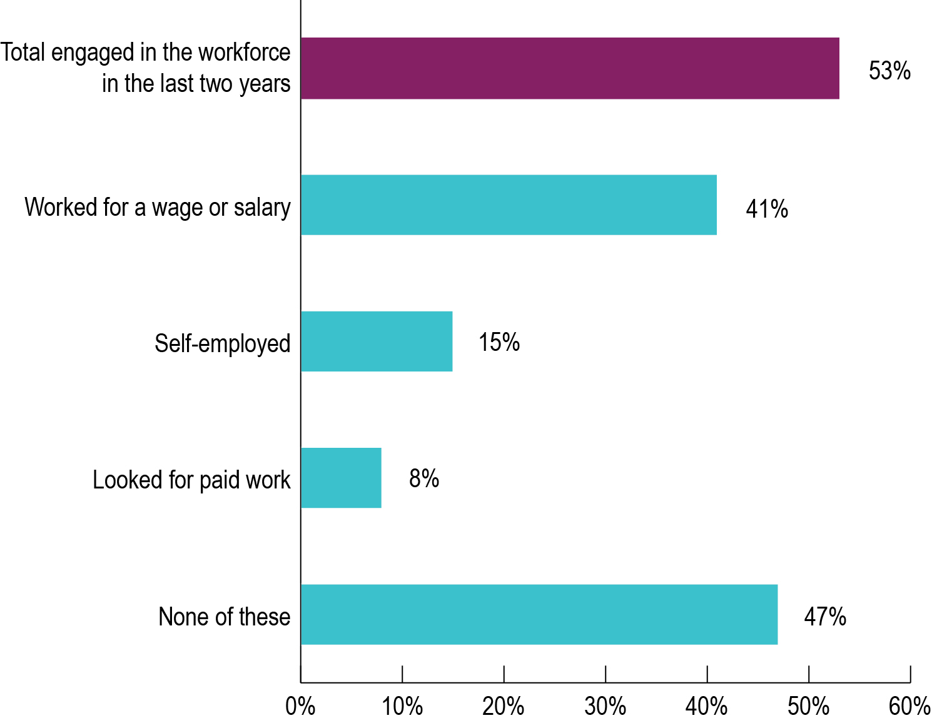

Base: Total number of respondents aged 50 years and older (N=2,106).
Percentages reporting the type of engagement in the workforce add up to more than the overall participation rate of 53% because some respondents had more than one form of participation in the two year reference period.

The data revealed that men (59%) were more likely than women (49%) to have participated in the workforce in the last two years (Figure 2).

Figure 2 – Engaged in the workforce in the last two years by gender
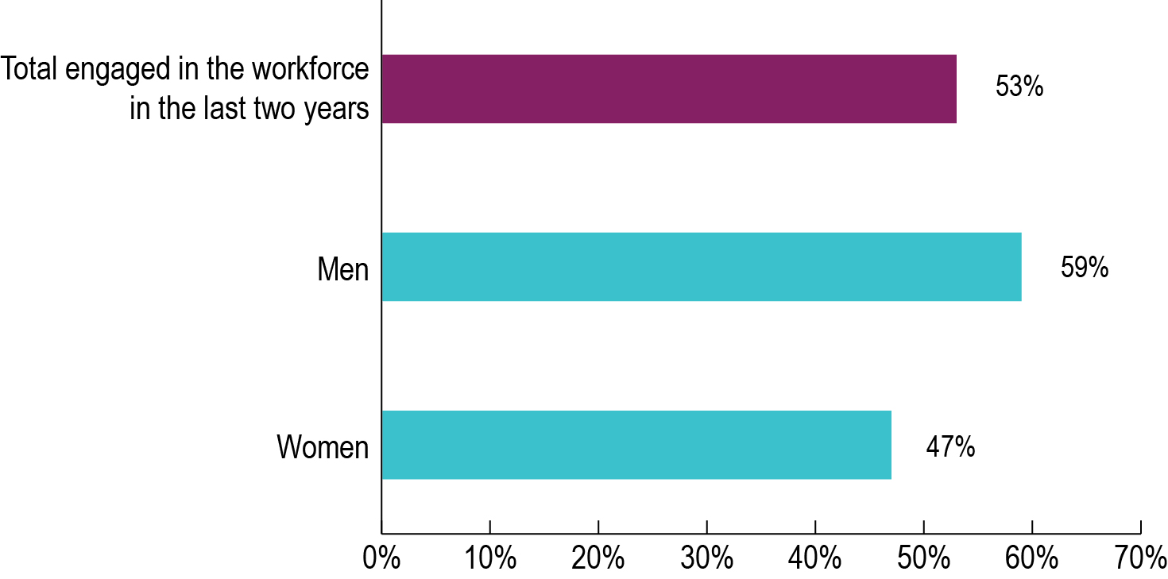

Base: Total number of respondents aged 50 years and older (N=2,106). Men (n=1,021), Women (n=1,085).

There is a marked drop in workplace participation as people get older. Only one in four (23%) Australians aged 65 years and older participated in the workforce in the last two year period, as opposed to approximately nine in
ten Australians (86%) aged between 50 and 54, eight in ten (79%) people aged between 55 and 59 and two thirds (66%) of those aged between 60 and 64.

Figure 3 – Engaged in the workforce in the last two years by gender and age
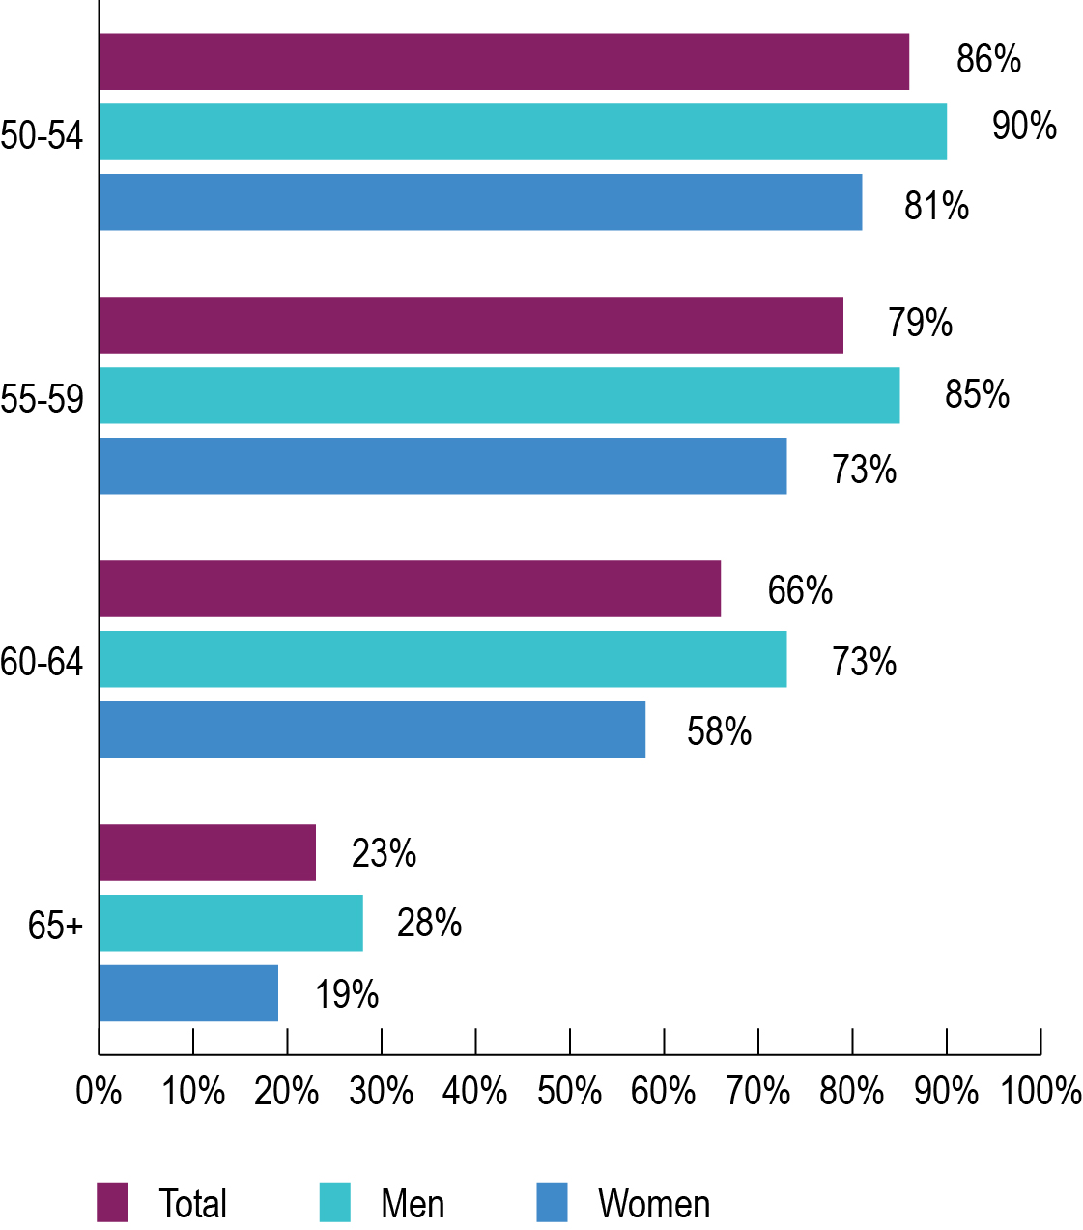

Base: Total number of respondents aged 50 years and older (N=2,106). 50-54 (n=432), 55-59 (n=387), 60-64 (n=343), 65+ (n=944). Men 50-54 (n=209), Men 55-59 (n=196), Men 60-64 (n=180), Men 65+ (n=436), Women 50-54 (n=223),
Women 55-59 (n=191), Women 60-64 (n=163), Women 65+ (n=508).

People residing in the metropolitan area (56%) were more likely than those in a non-metropolitan area (49%) to be engaged in the workforce in the last two years (Figure 4).

Figure 4 – Engaged in the workforce in the last two years by area
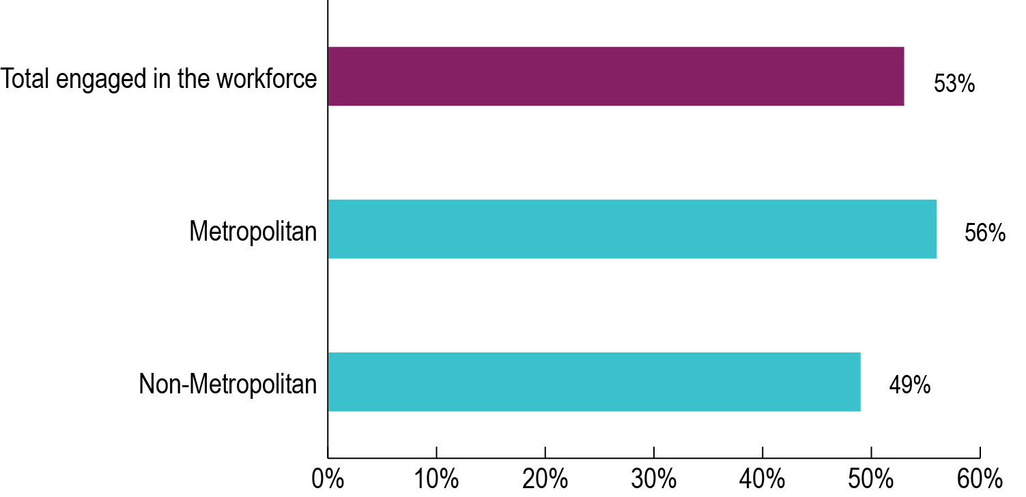

Base: Total number of respondents aged 50 years and older (N=2,106), Metropolitan (n=1,263), Non-metropolitan (n=843).

Reasons for not participating in the workforce
One in five (20%) of those who did not participate in the workforce in the last two years said that they would have liked to have worked during that time period.
Amongst all age groups, Australians aged 65 years and older who did not participate in the workforce in the last two years were least likely to report that they would have liked to work (Figure 5). Of those who were not engaged in the workforce in the last two years, only one in six (15%) people aged 65 years and older would have liked to participate in the workforce in the last two years, compared to half (49%) of Australians aged between 50 and 54, a third (35%) aged between 55 and 59 and a quarter (27%) of those aged between 60 and 64.

Figure 5 – People who did not participate in the workforce in the last two years but would have liked to
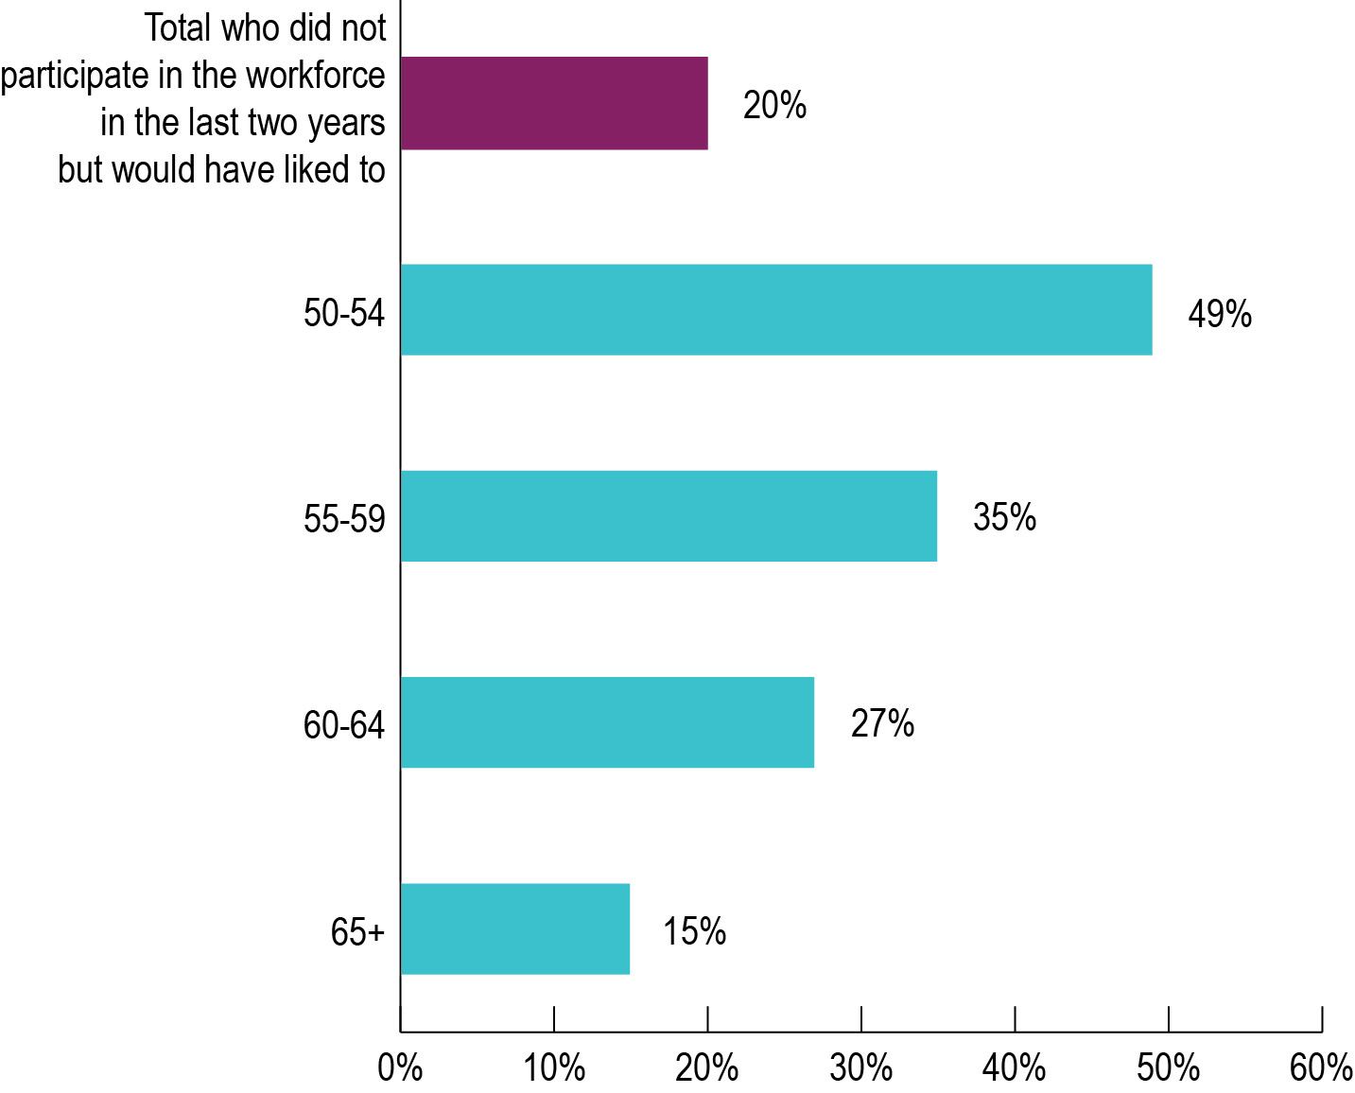

Base: Were not engaged in the workforce in the last two years (n=979); 50-54 (n=62), 55-59 (n=80), 60-64 (n=118), 65+ (n=719).

Australians aged 50 years and older who did not participate in the workforce in the last two years but would have liked to were asked to provide their reasons for not working (Figure 6).
The most common reason was related to health (44%), followed by being out of the workforce too long, or due to outdated skills (18%) and family reasons (16%).
It is notable that one in seven (13%) Australians aged 50 years and older expected to experience some form of age discrimination and that prevented them from entering the workforce in the last two years.

Figure 6 – Reasons for not being in the workforce in the last two years
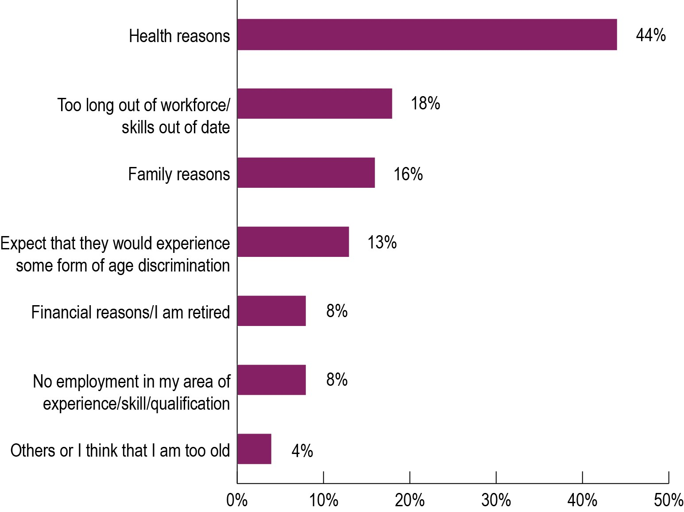

Base: Not engaged in the workforce in the last two years but would have liked to participate at any time during the last two years (n=199). The question offered multiple responses so reported percentages may not equal 100%.

There is some evidence that a barrier to workforce participation reported by younger respondents is related to their health. Two thirds (65%) of Australians aged between 50 and 54 who had not participated in the workforce in the last two years but would have liked to were unable to do so because of health reasons. However, the prevalence of health as a reason for not participating in the workforce reduces as they get older i.e. health considerations are a factor for only one in three (34%) of those aged 65 and over.

Figure 7 – Health reasons for not being in the workforce in the last two years by age6
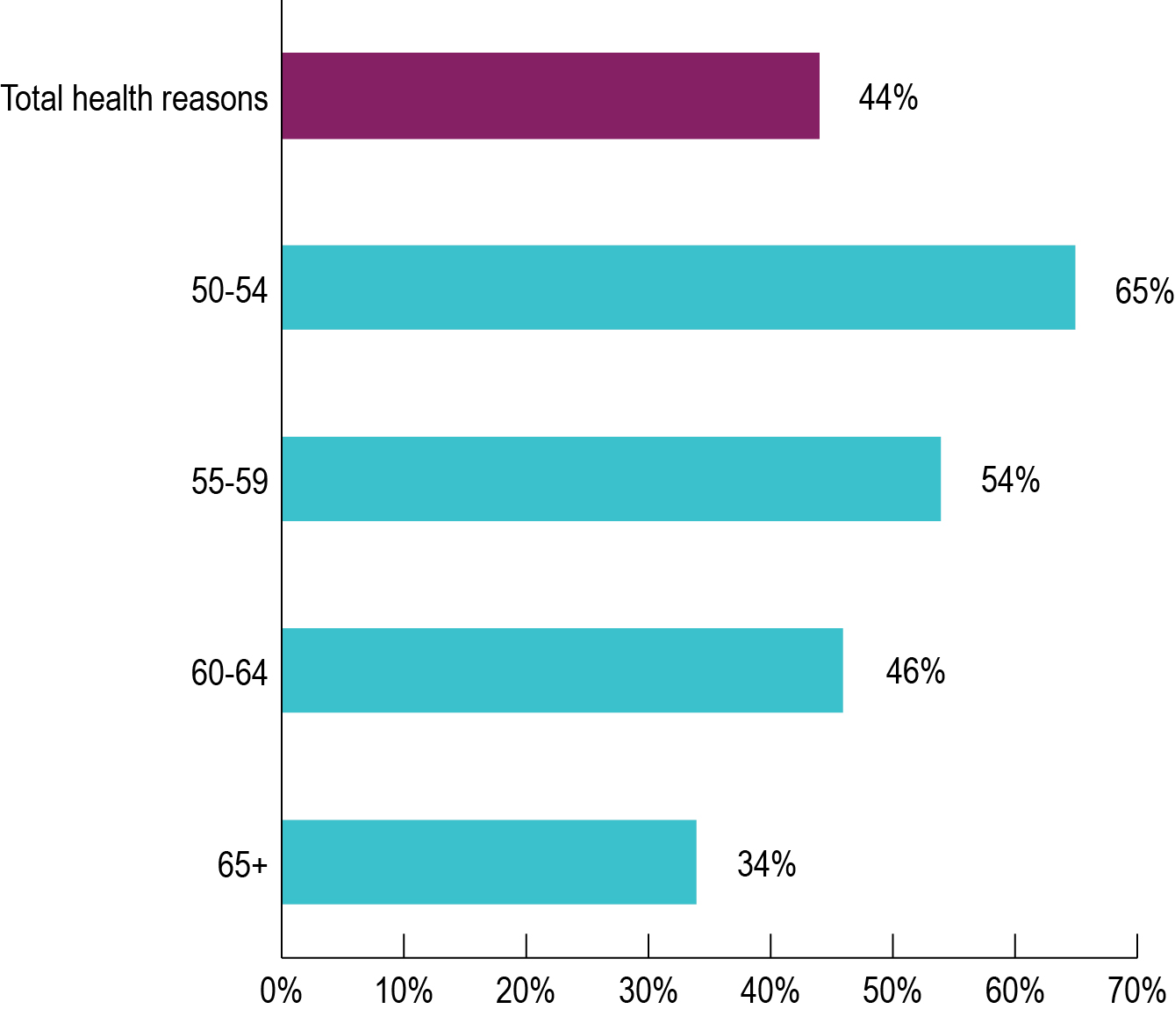

Base: Not engaged in the workforce in the last two years but would have liked to participate at any time during last two years (n=199). 50-54 (n=31), 55-59 (n=29), 60-64 (n=32), 65+ (n=107).

Prevalence of age discrimination in the workplace
More than one in four (27%) Australians aged 50 years and older who participated in the workforce at some time in the last two years experienced some form of age discrimination in the workplace at least once during that time period.
This discrimination was most likely to be experienced by those in the 55 to 64 year age group with a third of those aged between 55 and 59 (31%), and three in ten of those aged between 60 and 64 (32%) having experienced age discrimination on at least one occasion. The incidence of age discrimination was lower amongst Australians aged 65 years and older (20%). One quarter (25%) of those aged between 50 and 54 experienced age discrimination in the last two years.

Figure 8 – Prevalence of discrimination by age
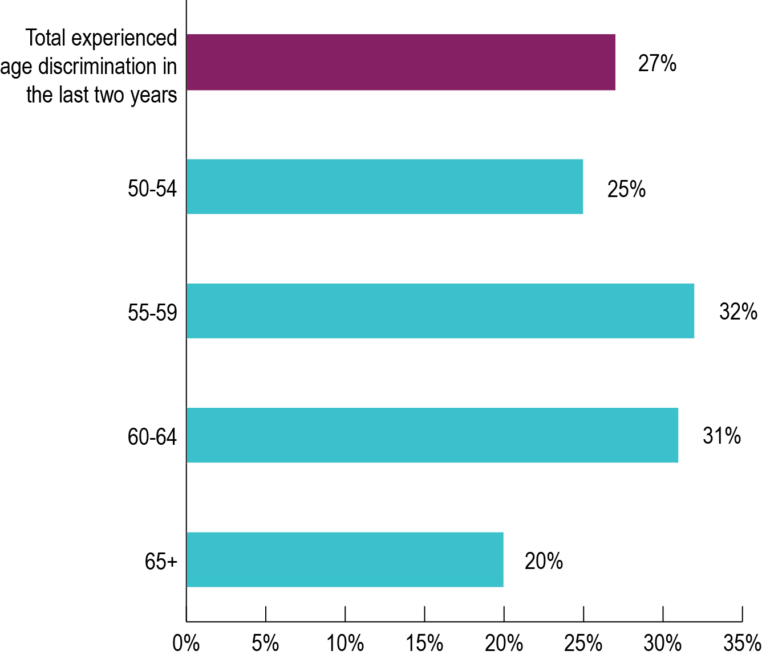

Base: Total number of respondents engaged in the workforce in the last two years: (n=1,127); 50-54 (n=370), 55-59 (n=307), 60-64 (n=225), 65+ (n=225).

While just over one in four (27%) workers aged 50 years or older had experienced some form of discrimination, the likelihood that those looking for employment will experience some form of age discrimination is significantly higher. Nearly three in five (58%) of those who looked for paid work were a target of discrimination because of their age compared to over a quarter (28%) of those who worked for a wage or salary, and a quarter (26%) of those who were self-employed.

Figure 9 – Prevalence of discrimination by workforce engagement
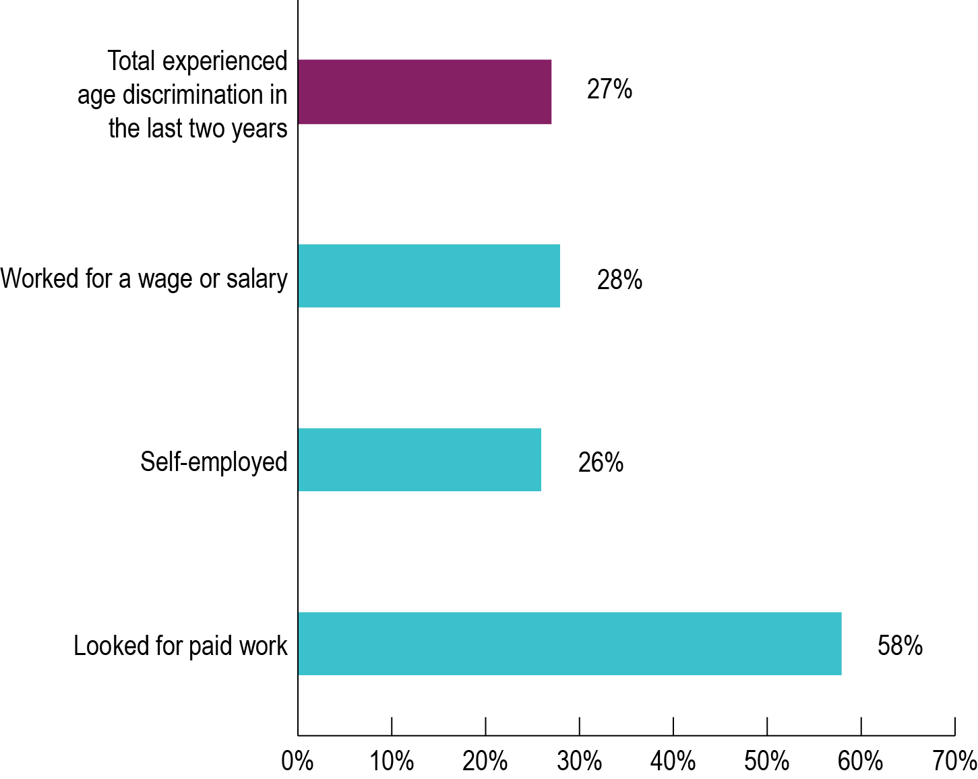

Base: Total number of respondents engaged in the workforce in the last two years: (n=1,127); Worked for a wage or salary (n=884), Self-employed (n=314), Looked for paid work (n=171).

There was no significant difference in the discrimination rates for men (28%) and women (26%).
Similarly there were no differences in discrimination levels between those living in metropolitan (27%) and non-metropolitan (27%) regions.

Those on lower incomes were more likely to report having experienced some form of age discrimination. Two in five (41%) of those on an income of $35,000 or less experienced some form of discrimination, dropping to one in five (20%) of those earning more than $150,000.

Figure 10 – Prevalence of discrimination by income
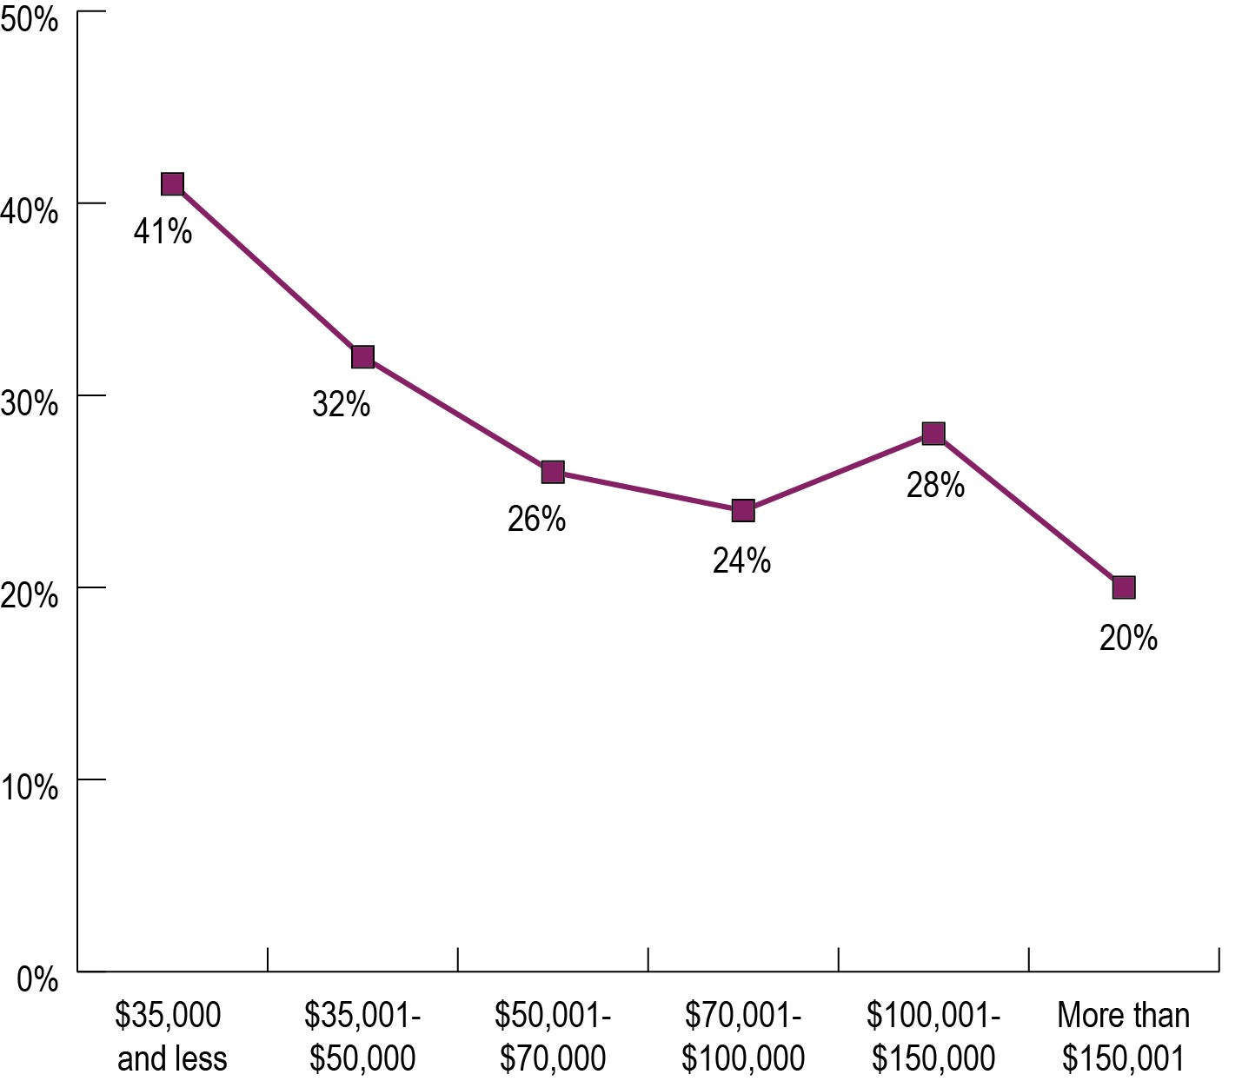

Base: Total number of respondents engaged in the workforce in the last two years: (n=1,127). $35,000 and less (n=151),
$35,001-$50,000 (n=113), $50,001 -70, 000 (n=139), $70,001-100,000 (n=178), $100,001-$150,000 (n=209), more than
$150,000 (n=197).

Australians aged 50 years and older in a one parent family with a child/children living in the household and those in a single household with no children were more likely to experience discrimination because of their age when compared to those in a couple with no children (Figure 11).
Over two in five (45%) of those in a one parent family with a child/children living in the household and a third (32%) of those in a single household with no children experienced age discrimination in the workforce in the last two years, as opposed to a quarter (23%) of those in a couple with no children.
Over a quarter (28%) of couples with a child/children living in the household experienced age discrimination in the workplace in the last two years.

Figure 11 – Prevalence of discrimination by household arrangement
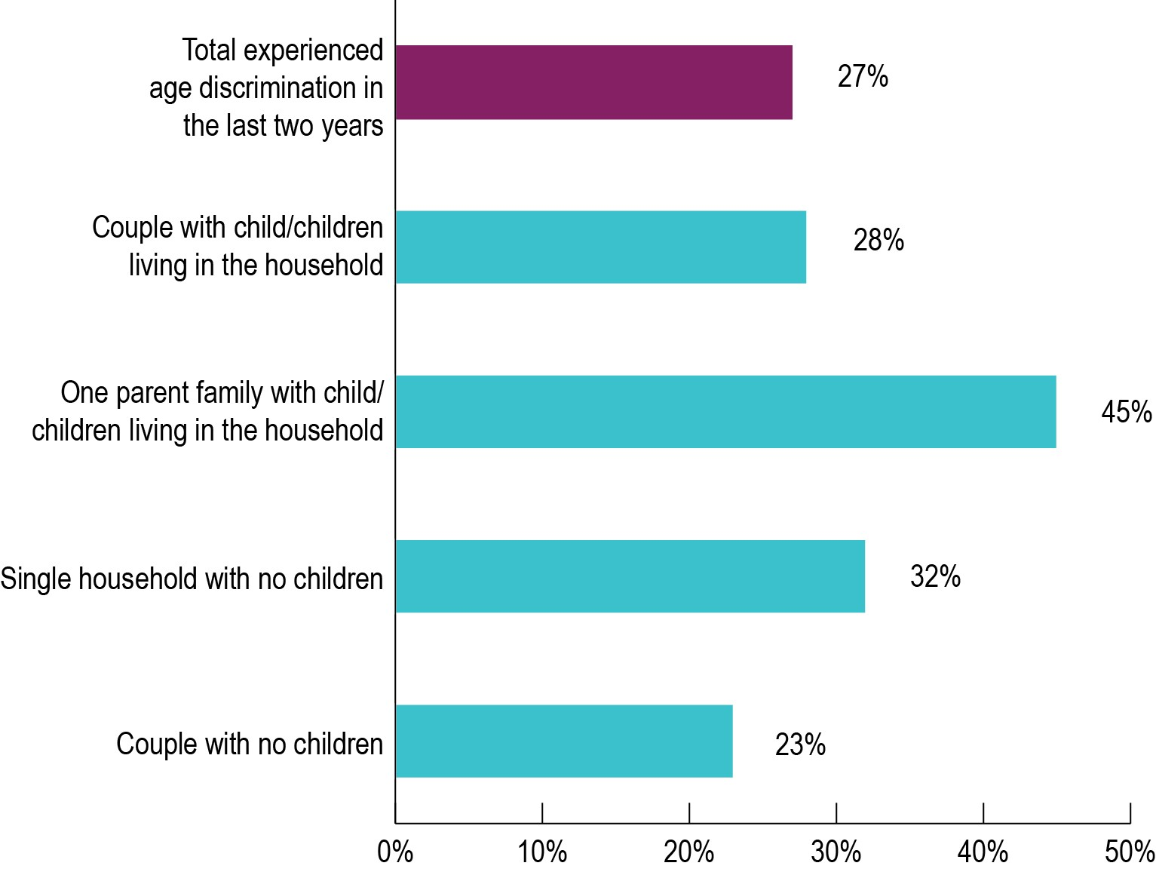

Base: Total number of respondents engaged in the workforce in the last two years: (n=1,127). Couple with child/children living in the household (n=299), One parent family with child/children living in the household (n=70), Single household with no children (n=242), Couple with no children (n=451).

The results revealed (Figure 12) that Australians across all educational levels are at risk of experiencing age discrimination in the workplace. In the last two years, over a quarter (28%) of people with a university degree and three in nine (29%) of those with a Tertiary Diploma, Technical Certificate, TAFE or some other form of non- university education experienced discrimination in the workplace because of their age. One in four (25%) of people with a school education reported experiencing age discrimination in the workplace in the last two years.

Figure 12 – Prevalence of discrimination by the level of education
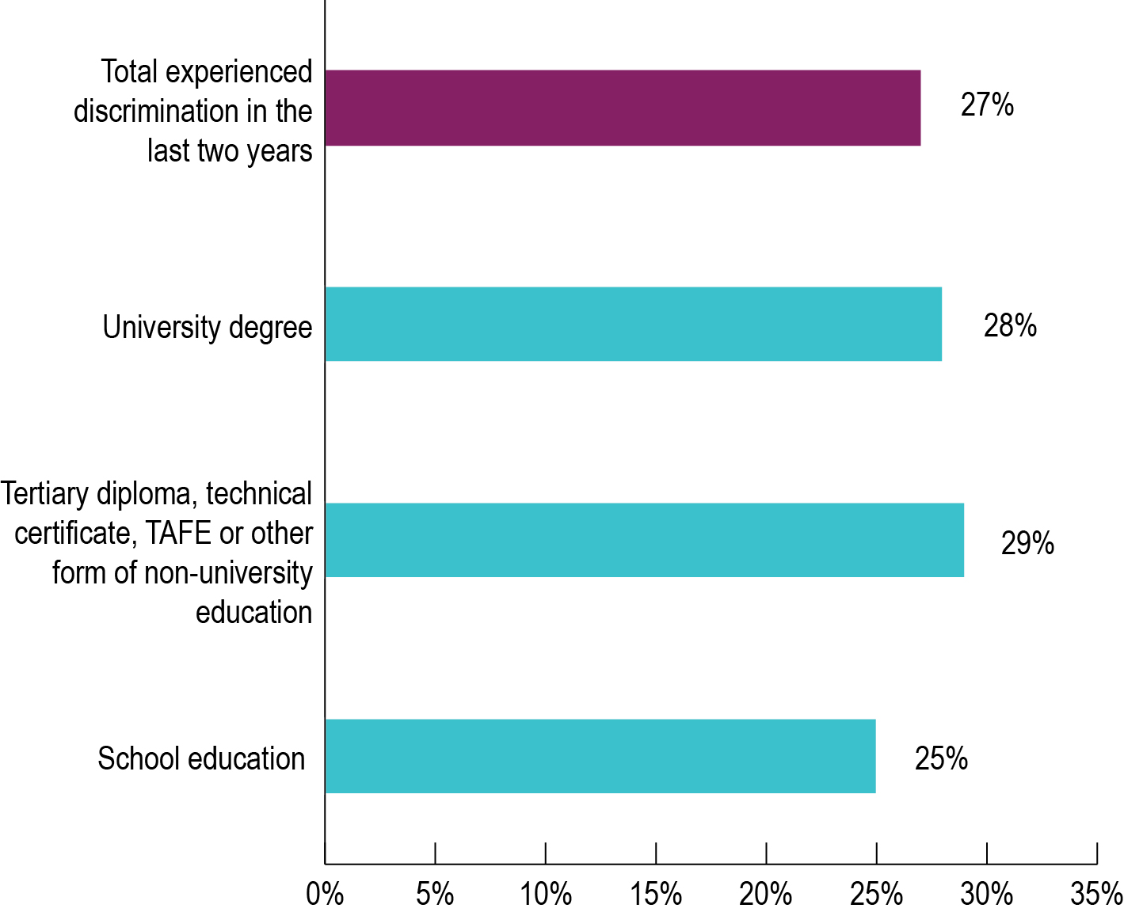

Base: Total number of respondents engaged in the workforce in the last two years (n=1,127), University degree (n=400), Tertiary Diploma, Technical Certificate, trade qualification or TAFE or commercial college certificate or other form of non- university education, (n=365), School education (n=354).

Awareness of someone else experiencing age discrimination
A third of Australians aged 50 years and older (32%), who had participated in the workforce in the last two years, were aware of other workers aged 50 years or older experiencing age discrimination.
People who were aware of someone experiencing age discrimination were asked for their opinion on how often that treatment occurred (Figure 13). Of those who were aware, one in ten (10%) believed that it occurred all the time, and nearly half (46%) said that it occurred frequently.
One third (33%) of those who were aware indicated that other people aged 50 years and older experienced age discrimination occasionally. Only one in ten (9%) of those people believed that the discriminatory treatment was a rare or one-off event.

Figure 13 – Frequency of age discrimination occurring to other people aged 50 years and older
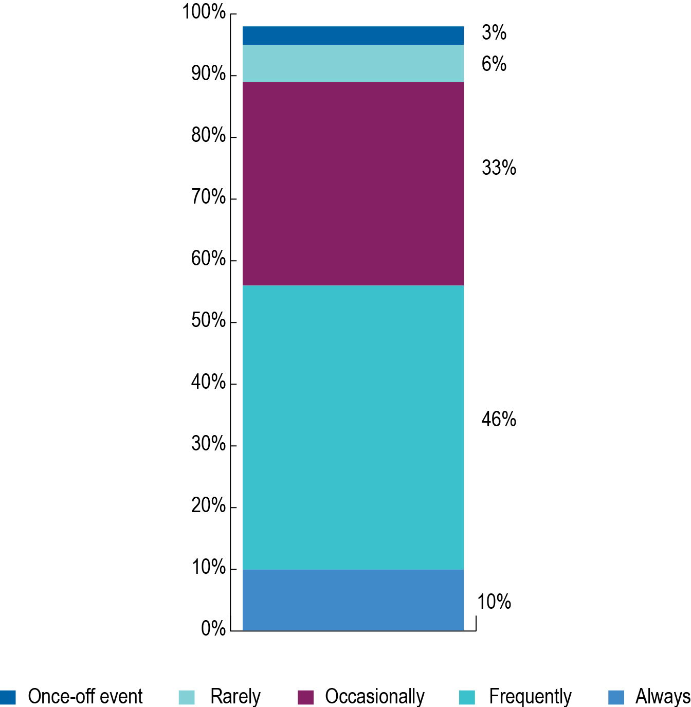

Base: Total number of respondents who were aware of other people being treated less favourably because of their age (n=364).

There is a strong indication that someone who has experienced age discrimination in the workplace is more likely to be aware of other older workers also experiencing age discrimination.
While it may be reasonable to expect that these people have been “sensitized” to age discrimination by their own experience it could also be hypothesised that they have observed discriminatory behaviour in their workplace because such behaviour is part of an embedded attitude within the culture of their workplace.

Figure 14 – Prevalence of age discrimination among those who are aware of other people aged 50 years and older who have experienced discrimination
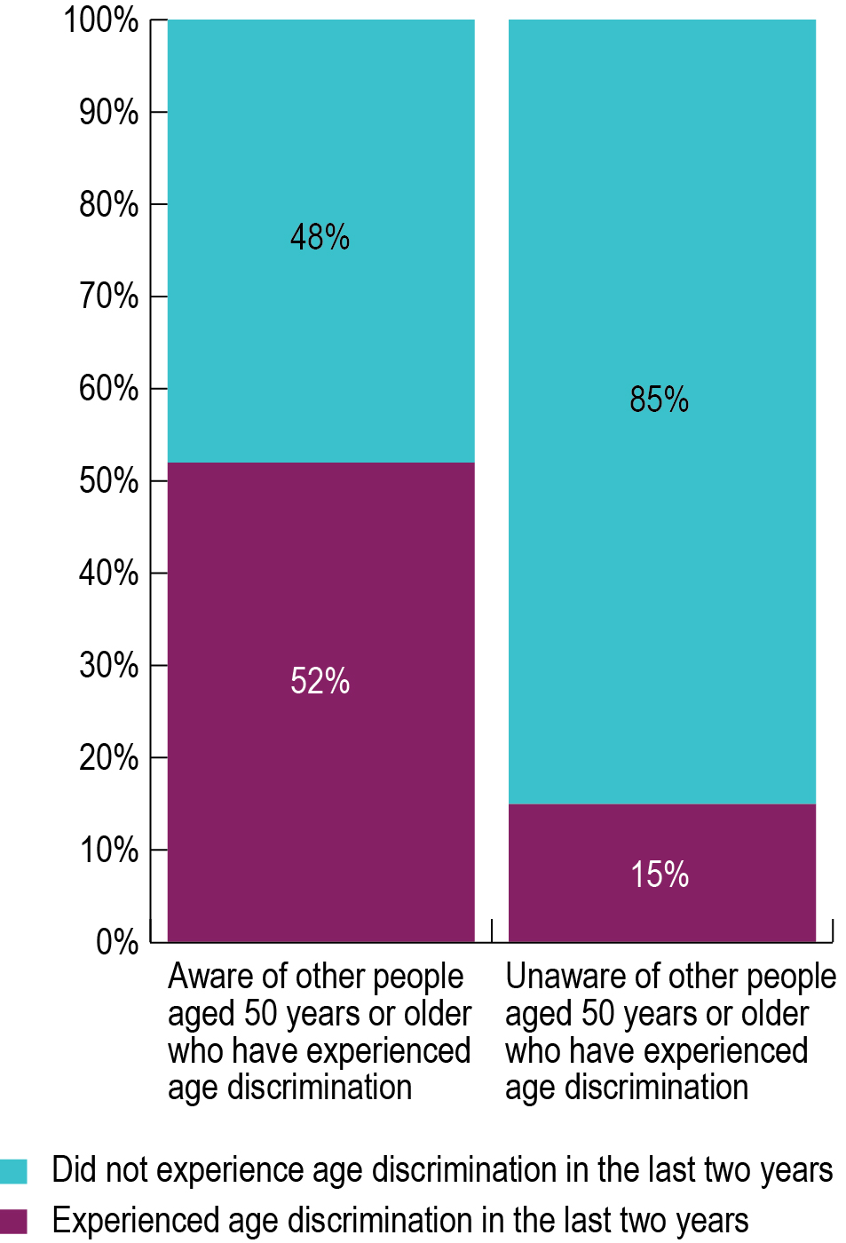

Base: Total number of respondents who were aware of other people being treated less favourably because of their age (n=364), total number of respondents who were unaware of other people being treated less favourably because of their age (n=743).

2.6 Management perceptions of age discrimination7
One third (36%) of Australians aged 50 years and older who participated in the workforce in the last two years held a role responsible for decision making about staff.
One quarter (26%) of those people were responsible for selecting or recommending people for employment or promotion, and one in five (21%) were in a senior management role responsible for decision making about staff.
One in six (17%) was a manager of a business that employs staff and a small group (7%) were Human Resource managers or equivalent.

Figure 15 – Workers in a role responsible for decision making about staff in the last two years
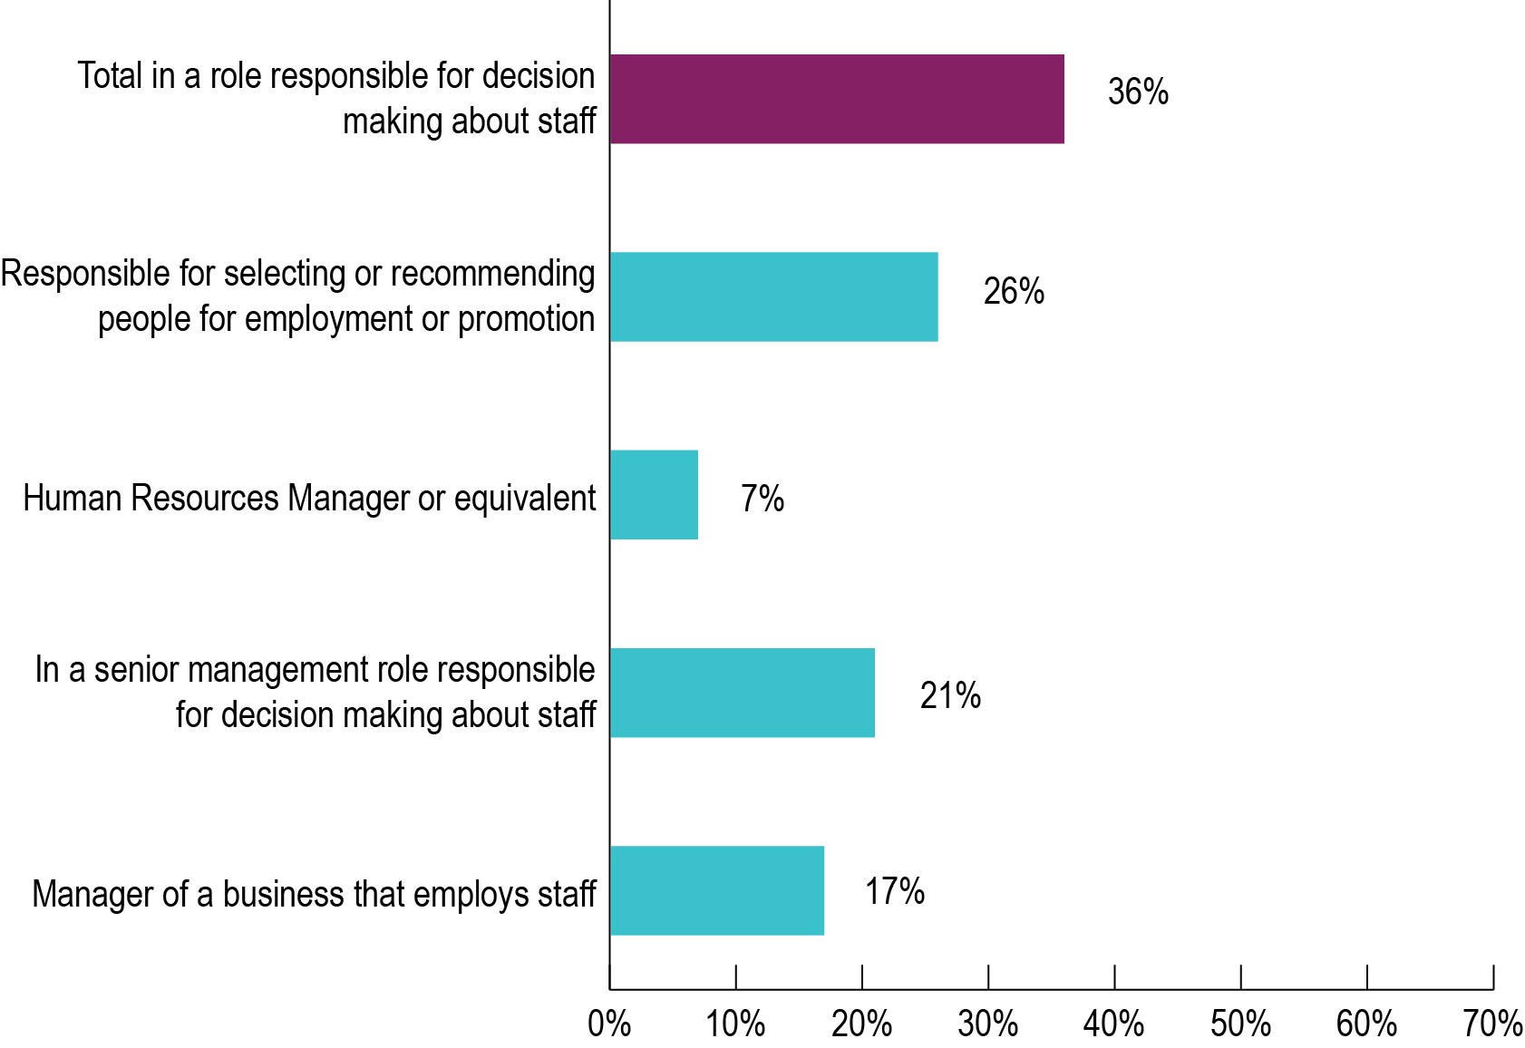

Base: Total number of respondents engaged in the workforce in the last two years: (n=1,127). The question offered multiple responses (except for ‘None of these’) so reported percentages may not equal 100%.

People aged 50 years and older, and in a role responsible for decision making about staff in the last two years (hereinafter referred to as ‘managers’) were asked a series of questions designed to understand management perceptions of age discrimination in the workplace and their perceptions of the age of an ‘older employee’.
The majority (72%) of managers believed that the ‘older employee’ was someone aged 50 years old or older.

Figure 16 – Age of an ‘older employee’ based on the perception of those in a role responsible for decision making about staff, for selecting or recommending people for employment or promotion
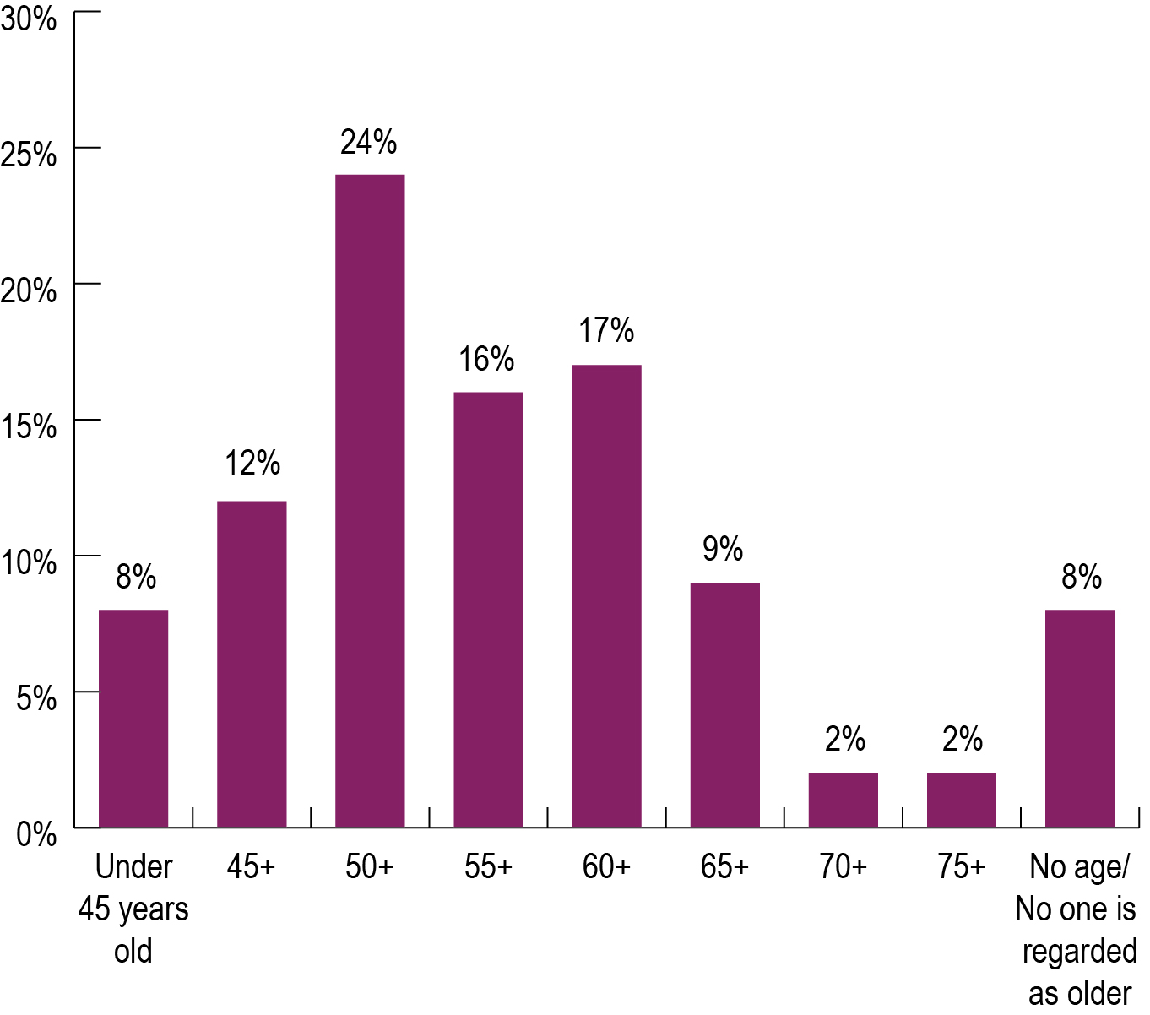

Base: Total number of respondents in a role responsible for decision making about staff, for selecting or recommending people for employment or promotion in the last two years (n=404).

Managers aged 50 years and older were asked whether they took a person’s age into account when making decisions. Overall, one third (33%) of managers took an employee’s age into consideration always, frequently or occasionally, when making decisions.
Figure 17 shows that one in seven (13%) managers took an employee’s age into consideration always or frequently when making a hiring decision, while one in six (16%) took an employee’s age into consideration occasionally.

One in seven (13%) managers took an employee’s age into consideration always, frequently or occasionally when making a decision to promote someone.
One in ten (11%) managers took an employee’s age into consideration always, frequently or occasionally when making a decision to send someone to a training course or offer them study assistance.
A small group (5%) reported that they took an employee’s age into consideration always, frequently or occasionally when making a decision to retrench or fire someone.

Figure 17 – Took employee’s age into consideration when making decisions over the last two years
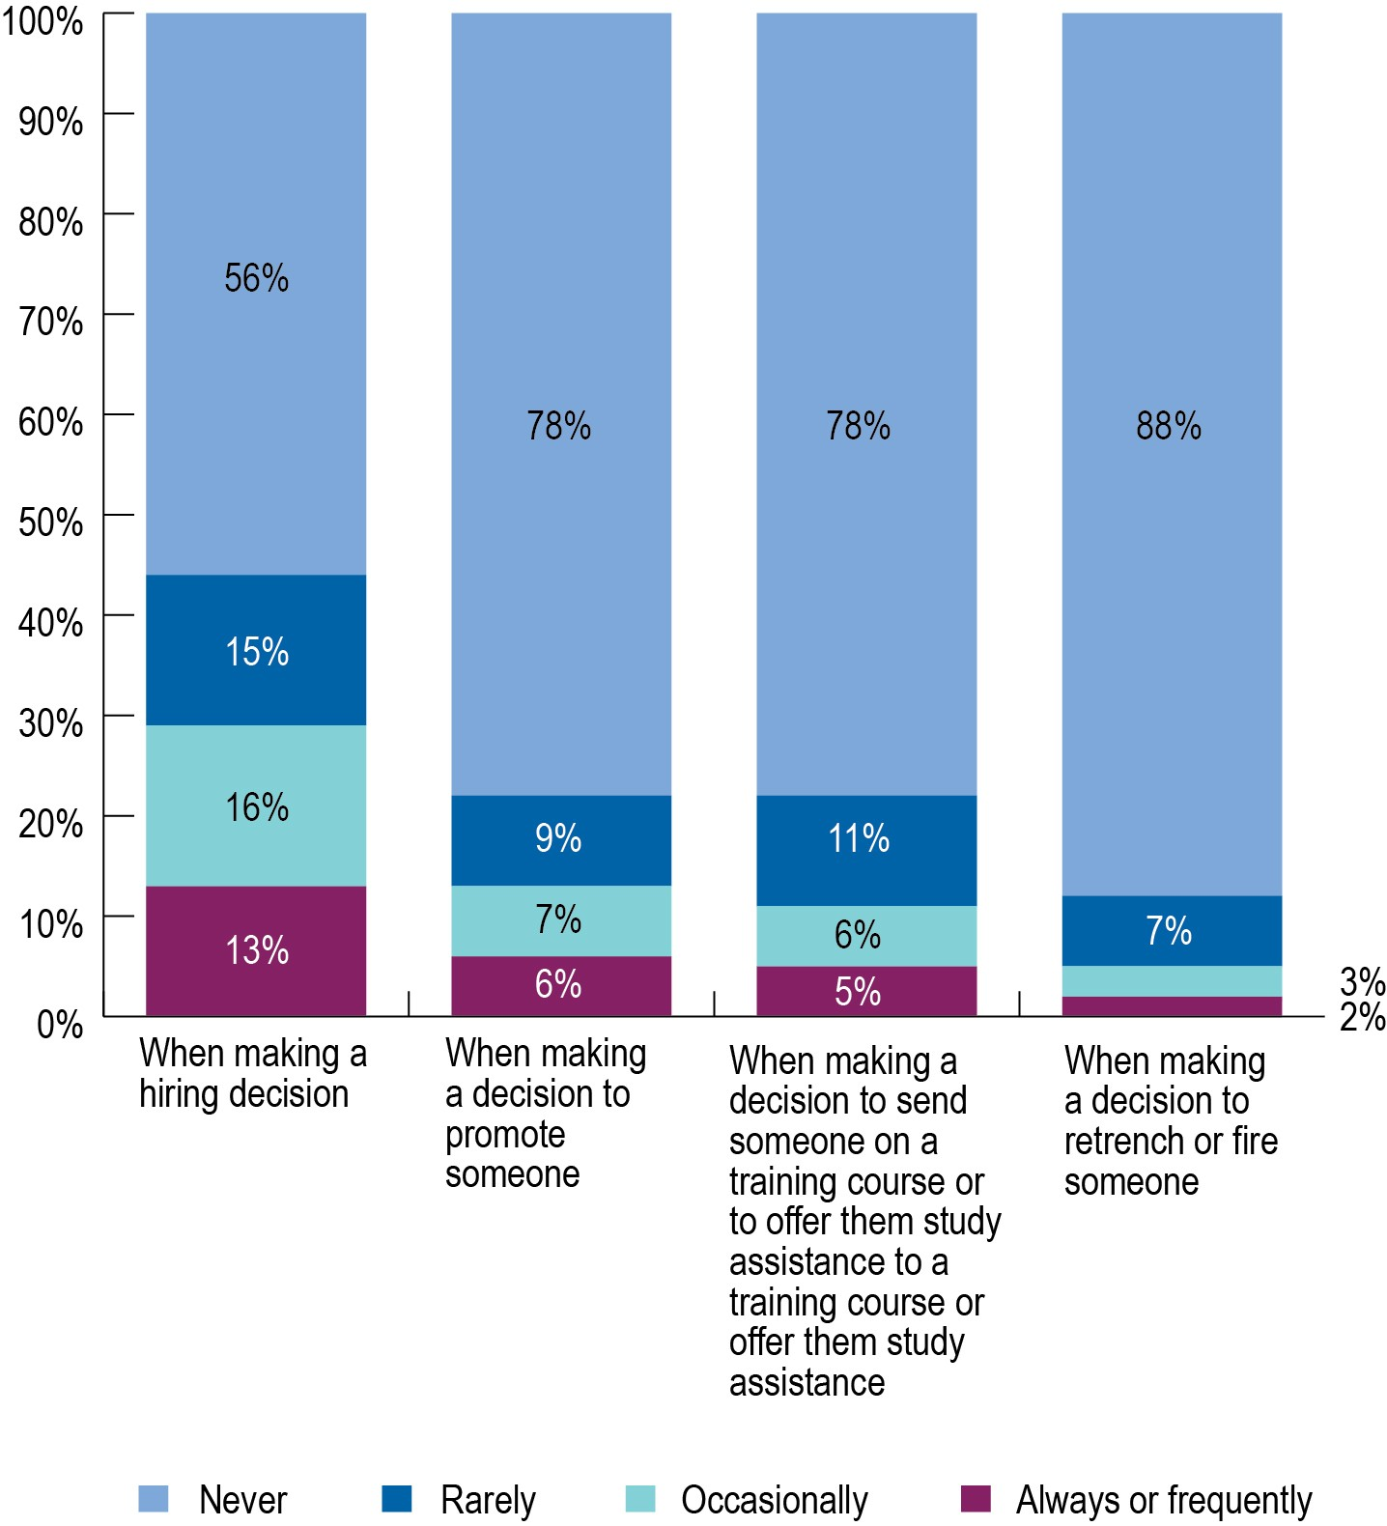

Base: Total number of respondents in a role responsible for decision making about staff, for selecting or recommending people for employment or promotion in the last two years (n=404); When making hiring decisions (n=390), When making a decision to promote someone (n=343), When making a decision to send someone to a training course or offer them study assistance (n=337), When making a decision to retrench or fire someone (n=284).

The results show that one in four (25%) of managers experienced age discrimination in the last two years.
Managers who reported taking a person’s age into consideration on a regular basis were also more likely to have experienced age discrimination themselves. Particularly, one third (34%) of managers who took an employee’s age into consideration always, frequently or occasionally experienced discrimination because of their age as opposed to only one in six (17%) managers who rarely or never took an employees’ age into consideration.

Figure 18 – Prevalence of age discrimination among workers in a role responsible for decision making about staff, for selecting or recommending people for employment or promotion
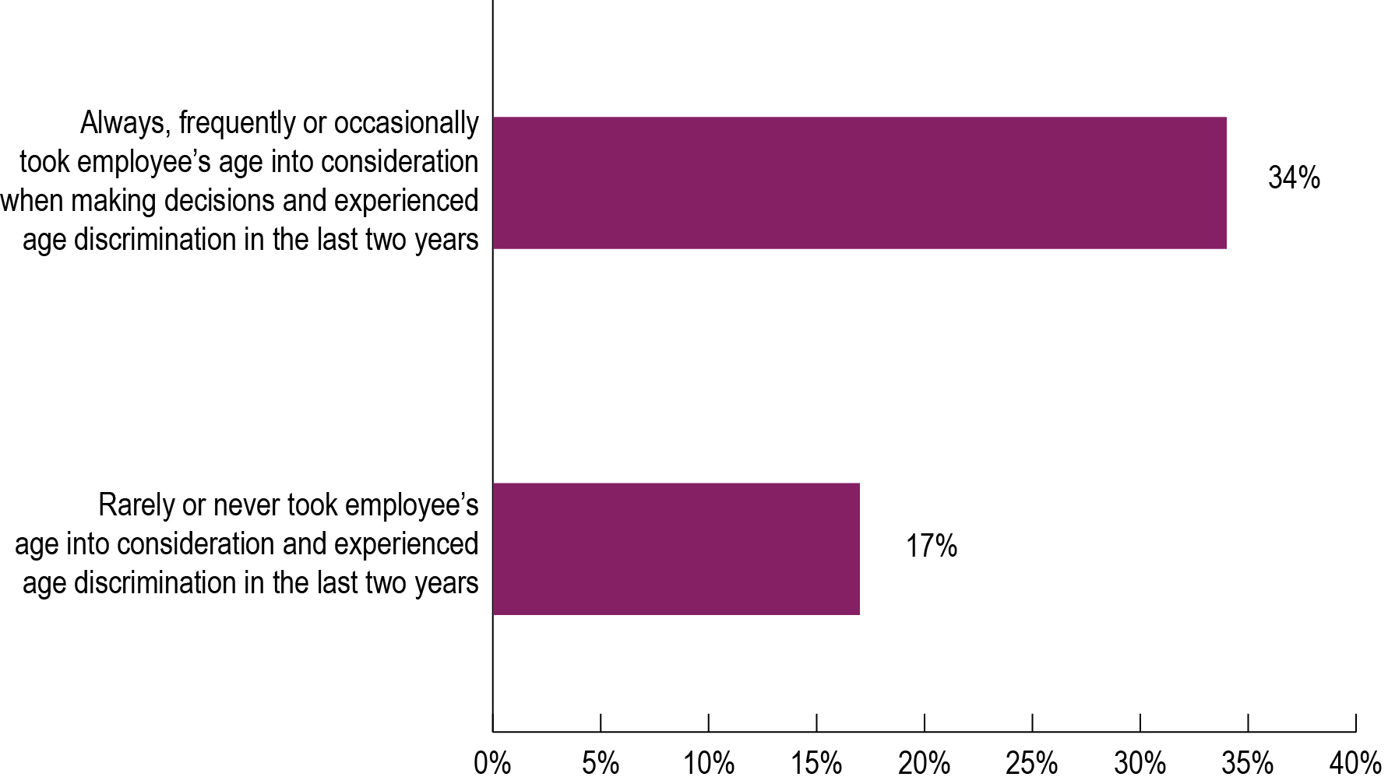

Base: Total number of respondents in a role responsible for decision making about staff, for selecting or recommending people for employment or promotion in the last two years (n=404); always, frequently or occasionally considered employee’s age when making decisions (n=132); rarely or never considered employee’s age when making decisions (n=164).

Experience of age discrimination in the workplace prior to the reference period
This subsection explores the prevalence of age discrimination beyond the past two years. People were asked about their experiences prior to the two year reference period8 (i.e. before 2013/2014), as a 50 year, or older, participant in the workforce.
Most of these Australians (81%) had participated in the workforce at some time after turning 50.
Two thirds (67%) of people had worked for a wage or salary, one in five (21%) had been self-employed and around one in ten (9%) had looked for paid work in the past.9
Figure 19 shows that women (76%) were less likely than men (86%) to participate in the workforce prior to the last two year reference period.

Figure 19 – Participation in the workforce prior to the reference period
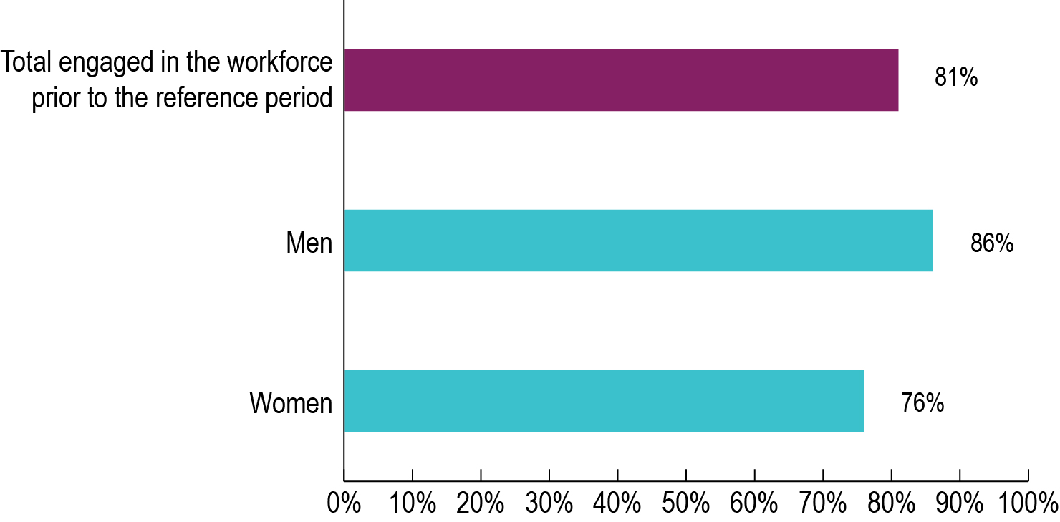

Base: Total number of respondents aged 53 years and older (n=1,884). Men (n=914), Women (n=970).

The current levels of age discrimination experienced by those aged 50 years and older are similar to the levels workers reported experiencing in the past. The results show that nearly one quarter (23%) of Australians who participated in the workforce prior to the reference period indicated that they had experienced some form of age discrimination in the workplace at least once.
There was no significant difference found in the discrimination rates for men (24%) and women (22%).
Australians aged between 55 and 64 were more likely than other age groups to report experiencing discrimination in the past.
One in six (16%) Australians aged between 53 and 54 experienced age discrimination compared to over one quarter (27%) of those aged between 55 and 59, and one quarter (26%) of those aged between 60 and 64.
One in five (21%) Australians aged 65 and over experienced discrimination because of their age prior to the reference period.

Figure 20 – Prevalence of age discrimination in the workplace prior to the reference period
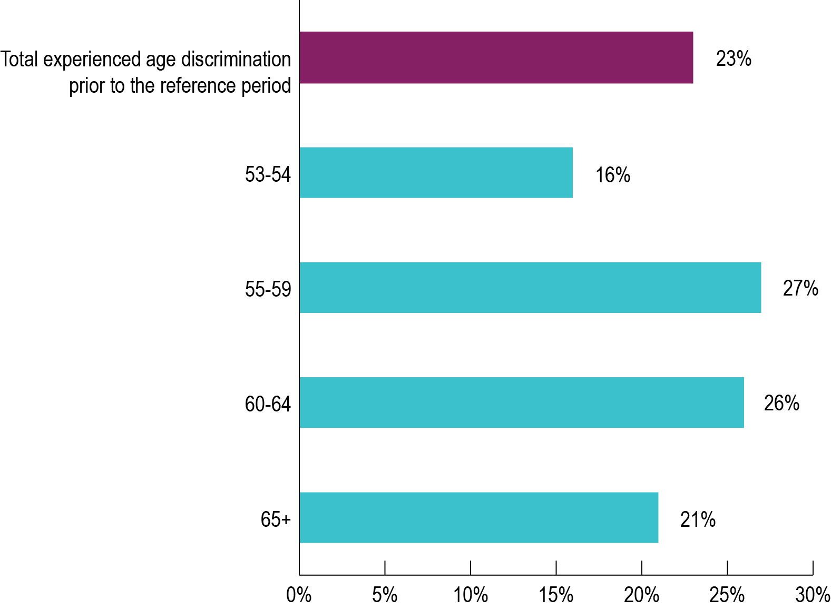

Base: Total number of respondents engaged in the workforce since they turned 50 at the end of December 2012: (n=1,532); 50-54 (n=180), 55-59 (n=332), 60-64 (n=301), 65+ (n=719).

There were no differences in discrimination levels between those living in metropolitan (23%) and non-metropolitan (23%) regions.
While one in four (23%) workers had experienced some form of age discrimination in the workplace, the likelihood that those looking for employment will experience some form of age discrimination is significantly higher. Half (50%) of those who looked for paid work reported experiencing discrimination because of their age compared to one in four (24%) of those who worked for a wage or salary and one in five (22%) of those who were self-employed.
When the prevalence of age discrimination was examined by income, the results revealed that workers in the lower income bracket of $50,000 or less (31%) were more likely to experience age discrimination after they turned 50, when compared to those in the higher income bracket of more than $50,000 (20%).
With regard to the prevalence of age discrimination by levels of education, the results show that those who had a school education (20%) were less likely to experience age discrimination than those who had a university degree (27%).

Conclusion
The 2014 National Prevalence Survey results provide clear evidence of age discrimination in Australian workplaces. The highest incidence of age discrimination was observed in the population aged between 55 and 64 years old.
The likelihood that those looking for employment will experience some form of age discrimination is significantly higher than for those in paid work. Consequently, a proportion of people aged 50 and older are discouraged from entering the workforce due to the anticipation of age discrimination. This barrier to paid work is a factor in the underemployment of older workers and has a direct impact on the Australian economy.
Age discrimination is more likely to occur amongst people who are more economically vulnerable including those in a lower income bracket or in a single parent household.
The results also suggest that discrimination is part of the culture of some workplaces and work practices. It is common for Australians aged 50 years and older to witness someone else experiencing age discrimination in the workplace. Further, a substantial number of employers and managers reported that they regularly take an employee’s age into consideration when making decisions about staff.
These findings demonstrate a clear need for effective awareness raising and prevention strategies, examination of work practices and ensuring appropriate and accessible redress mechanisms.

The nature of age discrimination

KEY FINDINGS
Age discrimination covers a broad range of treatments and behaviours. The three most commonly reported types of discrimination were:
- Limiting employment/promotion/training opportunities because of age (52%).
- A perception that mature employees have outdated skills or they are too slow to learn new things or will deliver an unsatisfactory job because of their age (44%).
- Jokes or derogatory comments from employer/manager/colleagues based on age (42%).
One third of all most recent episodes of discrimination occurs when applying for a job
- One third (32%) of most recent episodes occurred when people were applying for a job with someone they were not employed by.
Awareness of age discrimination is limited
- Out of those who experienced discrimination in the last two years, approximately one in five (18%) workers were unaware that the behaviour they had experienced was a form of age discrimination.
Jokes and derogatory comments based on age are not recognised as a form of age discrimination
- The majority (90%) of those who experienced discrimination in the form of jokes and derogatory comments based on their age only reported this when specifically asked if they had been subjected to such behaviour.

Introduction
This chapter explores the nature and types of workplace age discrimination experienced by Australians aged 50 years and older in the last two years. The types of discrimination include an extensive range of behaviours and vary from jokes and derogatory comments to dismissal. These behaviours have been summarised as seven
themes that describe the primary form of discrimination (please refer to Appendix 3 for the definitions under each classification).
Chapter 3 also examines the understanding and awareness of age discrimination.
Respondents who experienced age discrimination on more than one occasion were asked to select which episode occurred most recently. This chapter focuses on the most recent episode and investigates the timing and the context of the most recent episode of discrimination.
The last subsection analyses the types of age discrimination experienced by people who experienced discrimination prior to the two year reference period.

Types of age discrimination experienced in the last two years
Australians aged 50 years and older experienced a range of behaviours in the workplace that constitute age discrimination at some time in the last two years. There were three most commonly reported types of discrimination:
- For one in two (52%) people the experience of discrimination in the workplace related to limiting employment/promotion/training opportunities because of their age.
- Over two in five (44%) people were perceived to have outdated skills or to be too slow to learn new things or deliver an unsatisfactory job because of their age.
- Two in five (42%) workers were the subject of jokes or derogatory comments from their employer/manager/ colleagues based on age.

Figure 21 – Types of age discrimination experienced in the workplace in the last two years
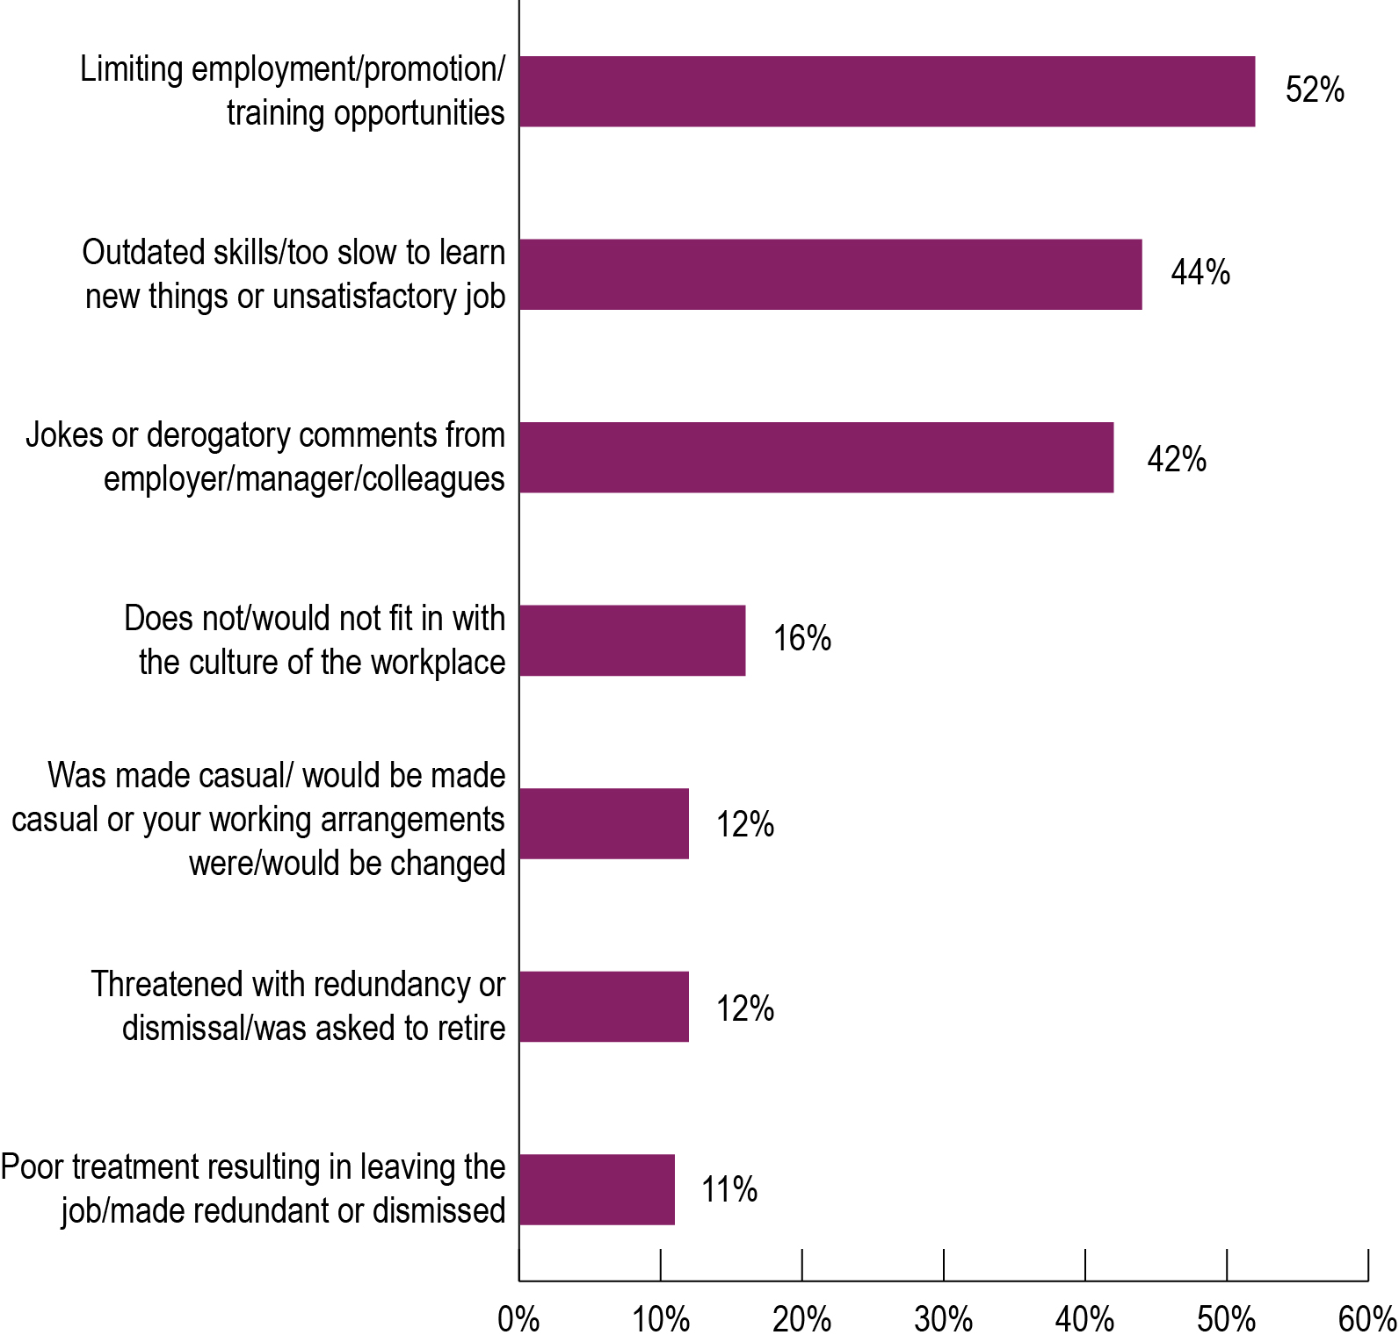

Base: Total number of respondents who experienced age discrimination in the workplace in the last two years: (n=309). The question offered multiple responses so reported percentages may not equal 100%.

Nature of age discrimination experienced in the last two years
Age discrimination can be experienced when people are told directly that they are being treated differently because of their age, or when people believe that their age was the reason for the discrimination, but they are not told directly. Some people might experience both of these forms.
The survey questionnaire was designed to capture both direct and indirect forms of age discrimination.
Of those who experienced discrimination, two thirds (65%) were told, on at least one occasion, by their current or potential employer, manager or colleagues that their age was the reason for the discrimination they experienced. Three in four (76%) believed that they had been discriminated against because of their age on at least one occasion.10
There were some notable differences in the prevalence of different forms of age discrimination where the person is directly told that their treatment is because of their age and when they believe that it was because of their age.
Figure 22 shows the types of age discrimination experienced by workers who were told directly that they were treated differently because of their age. Out of those who experienced age discrimination in the last two years, two in five people (42%) were the subject of jokes or derogatory comments based on age. Three in ten (29%) were told that because of their age they had outdated skills or were too slow to learn new things or delivered an unsatisfactory job. One in five (20%) were told that because of their age they did not get a job or would not be interviewed for a job or would not get a promotion or access to training.

Figure 22 – Types of discrimination experienced by those who were told directly that their age was the reason for the discrimination
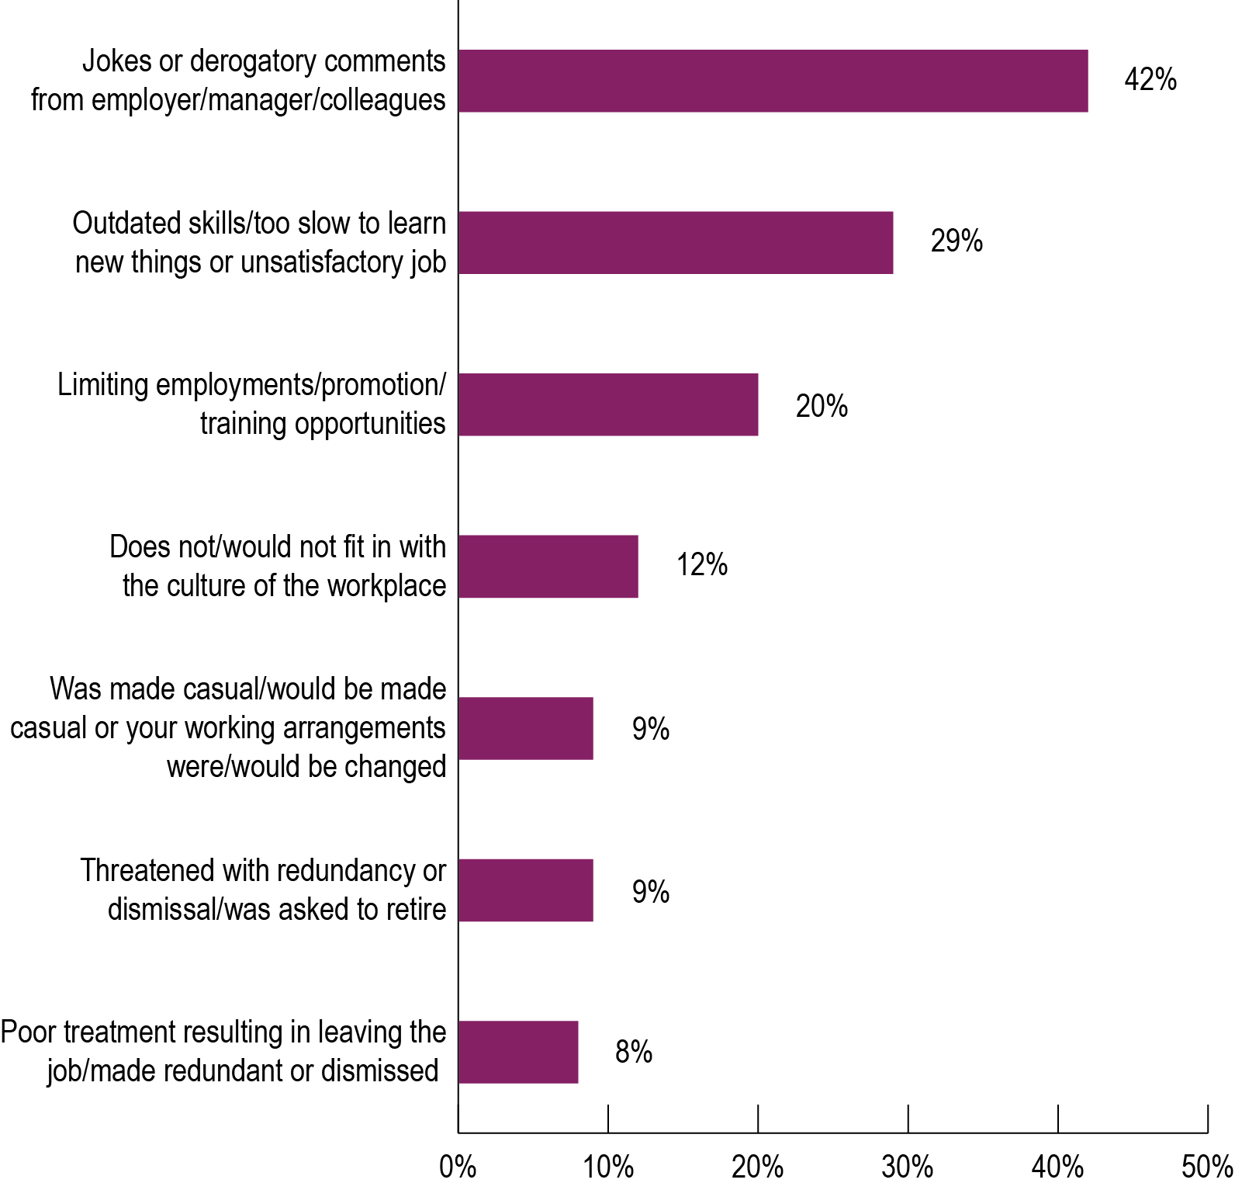

Base: Total number of respondents who experienced age discrimination in the workplace in the last two years (n=309). The question offered multiple responses (except for ‘None of these’) so reported percentages may not equal 100%.

Figure 23 shows the types of age discrimination experienced by workers who believed that their age was the reason for the discrimination but they were not told directly. Out of those who reported experiencing age
discrimination in the last two years, two in five people (42%) believed that because of their age they did not get a job or would be interviewed for a job or would not get a promotion or access to training. One quarter (24%) of those believed that their employer/potential employer or colleagues thought that, because of their age, they had outdated skills or were too slow to learn new things or delivered an unsatisfactory job.

Figure 23 – Types of discrimination experienced by those who believed that their age was the reason for the discrimination but they were not told directly
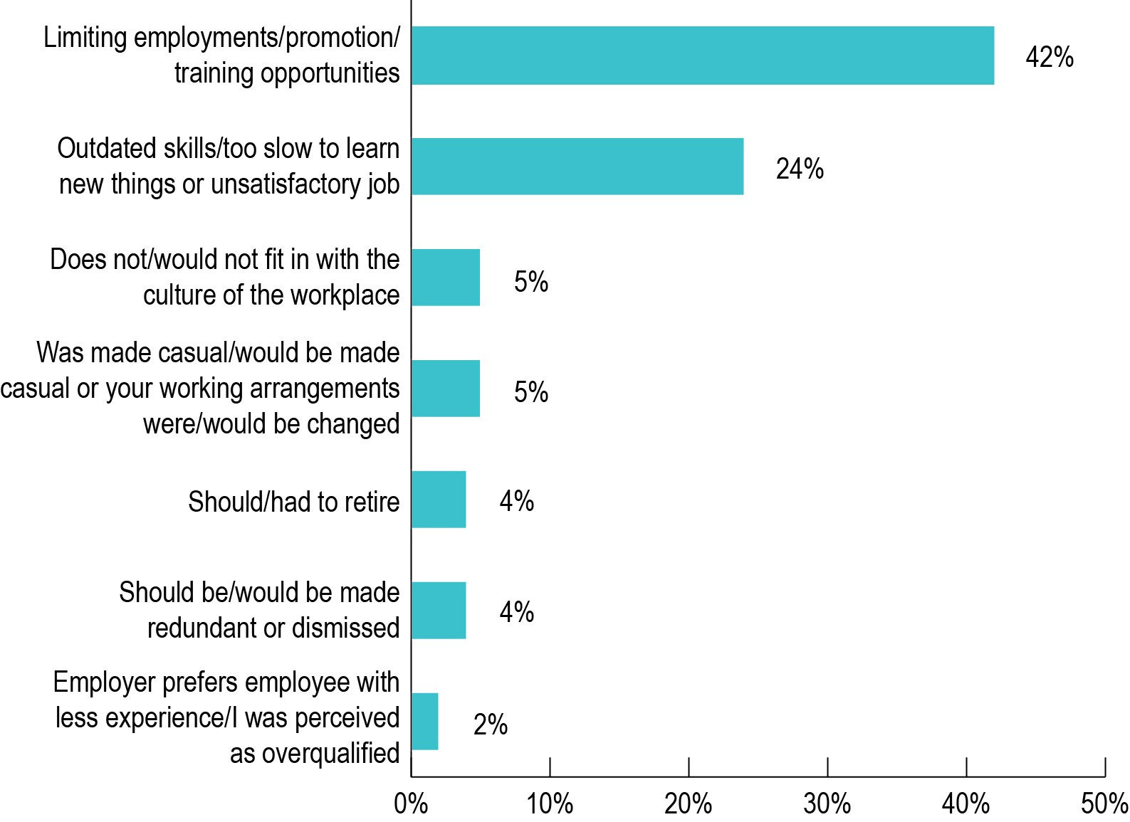

Base: Total number of respondents who experienced age discrimination in the workforce in the last two years: (n=309). The question offered multiple responses (except for ‘None of these’) so reported percentages may not equal 100%.

Awareness of age discrimination
Of those who experienced discrimination in the last two years, one in five (18%) were unaware that the behaviours they experienced constituted age discrimination. While they did not initially report that they were treated less favourably than other people because of their age, they later identified that they had in fact experienced one or more of the listed behaviours that are likely to constitute age discrimination.
The results revealed that some types of discriminatory behaviours are more likely to be associated with age discrimination than others. For instance, discrimination related to limited employment, promotion or training opportunities because of age was likely to be recognised as a discriminatory behaviour. Of those who experienced discrimination, over two in five (44%) were aware that limiting employment, promotion or training opportunities because of age constitutes age discrimination.
However, the findings suggests that jokes or derogatory comments based on age are less likely to be immediately associated with age discrimination. Of those who reported experiencing age discrimination, only a small proportion (5%) spontaneously reported that they were the subject of jokes or derogatory comments based on age as opposed to two in five (38%) people who reported experiencing this type of discrimination after they were read
a list of discriminatory behaviours.

Most recent episode of discrimination
Of those who reported experiencing age discrimination in the workplace in the last two years, just under half (46%) experienced only one type of discrimination. One in four (25%) experienced two types of discrimination. Three in ten (30%) experienced two types of age discrimination.
The most common episodes of discrimination that happened most recently were the following:
- Limiting employment/promotion/training because of age (27%);
- Jokes or derogatory comments from employer/manager/colleagues based on age (21%); and
- Perceived to have outdated skills or to be too slow to learn new things or deliver an unsatisfactory job because of their age (21%).

Figure 24 – The most recent episode of discrimination
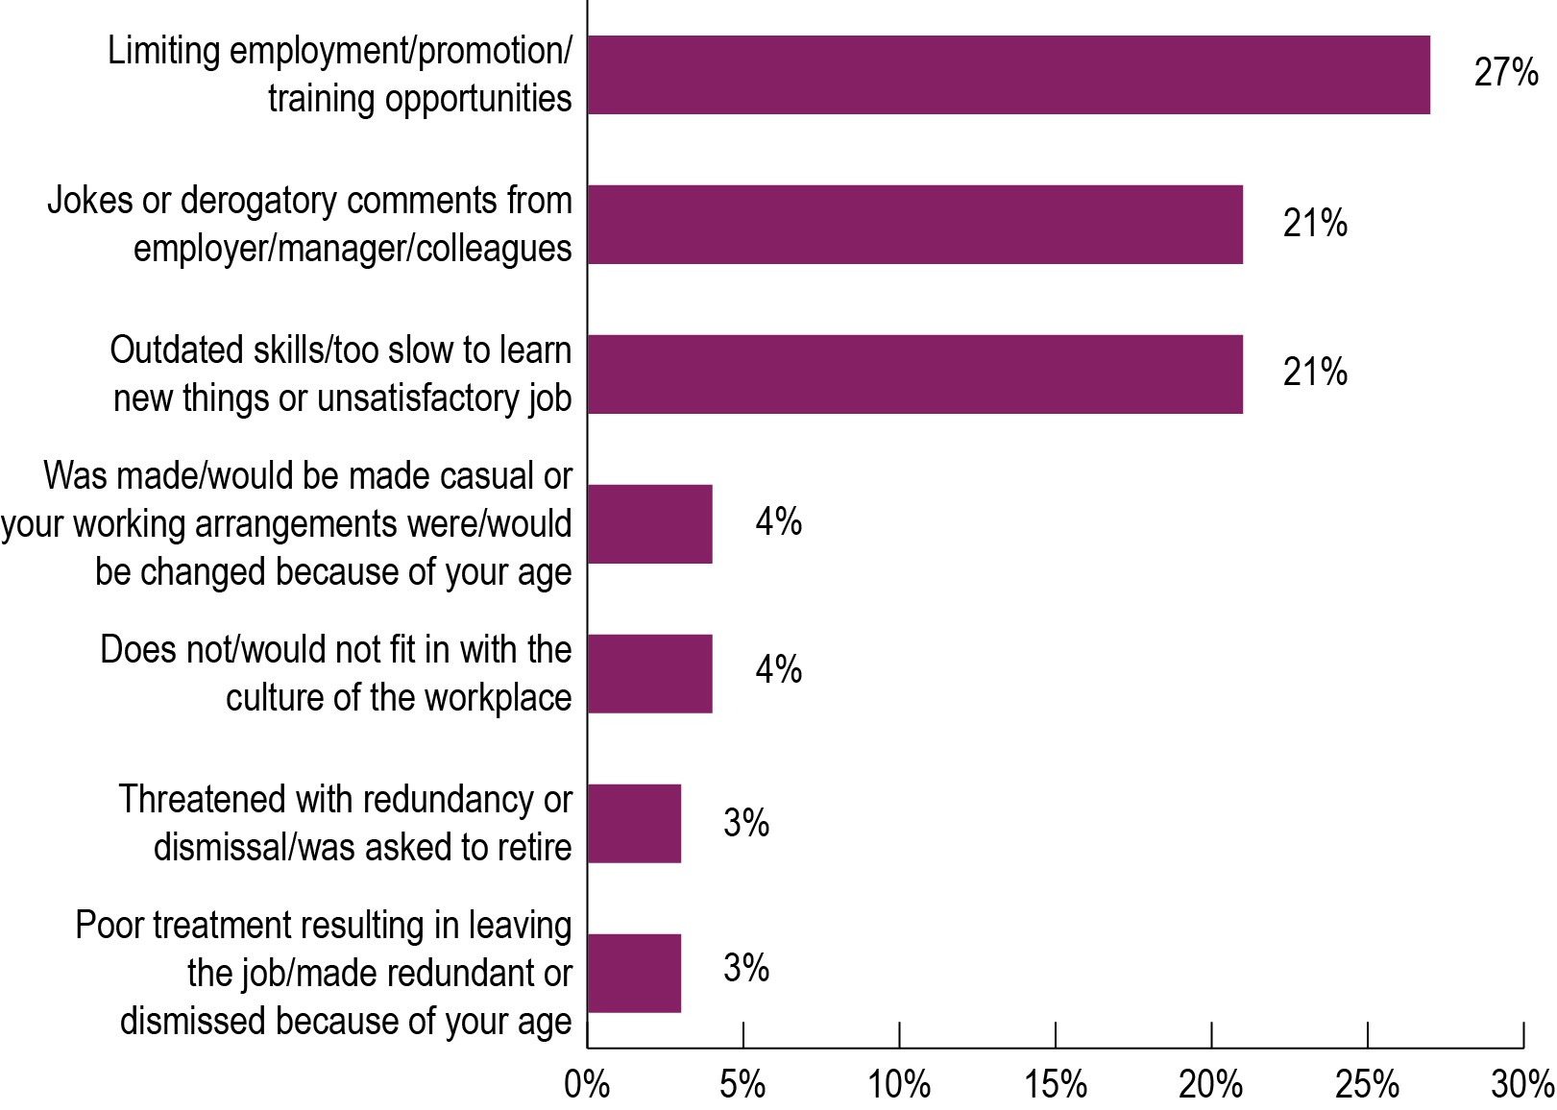

Base: Total number of respondents who experienced discrimination in the last two years (n=309).

Figure 25 shows that nearly three-quarters (72%) of all the most recent episodes of discrimination occurred in the last 12 months.

Figure 25 – Occurrence of the most recent episodes of discrimination
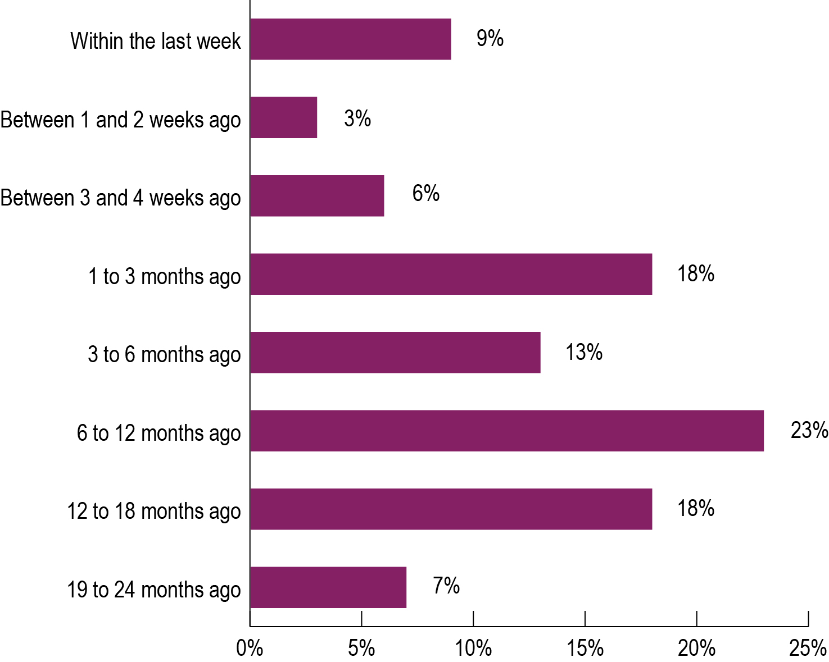

Base: Total number of respondents who experienced discrimination in the last two years (n=309).

Context of the most recent episode of discrimination
One third (32%) of the most recent episodes of discrimination occurred when people were applying for a job with someone they were not employed by. One in six (16%) episodes of discrimination occurred when applying for a job or promotion with their current employer. Of the most recent episodes of discrimination, half (52%) occurred in relation to some other aspect of their work (Figure 26).

Figure 26 – Situation where the most recent episode occurred
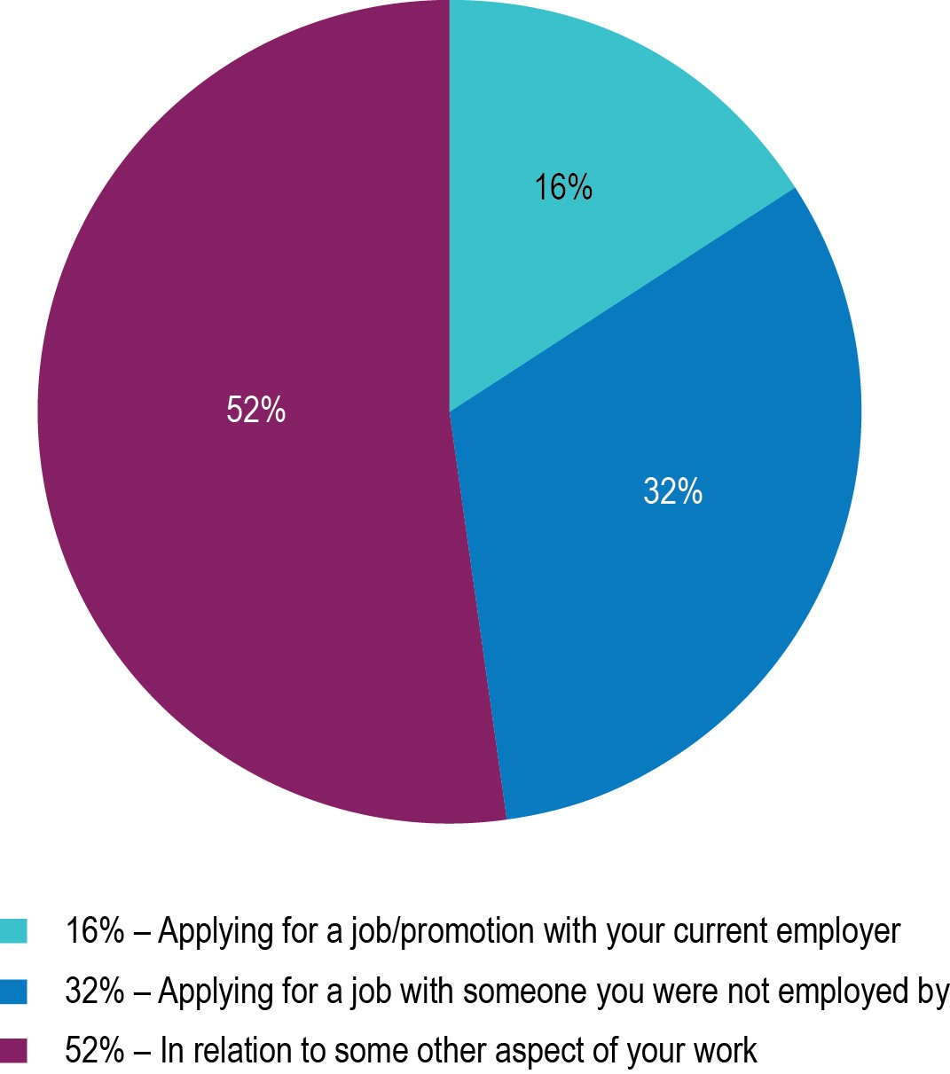

Base: Total number of respondents who experienced discrimination in the last two years (n=309).

Australians aged 50 years and older who were applying for a job or promotion either with their current employer or with someone they were not employed by were asked whether they were interviewed by a recruitment agency representing the potential employer, someone from the company offering the job, or someone at their workplace (Figure 27).
Over half (55%) of these people indicated that they were interviewed by someone from another company offering the job. Three in ten (29%) people were interviewed by someone at their current workplace, while one in five people (20%) were interviewed by a recruitment agency representing the potential employer.

Figure 27 – Interviewer at the moment of the episode of discrimination
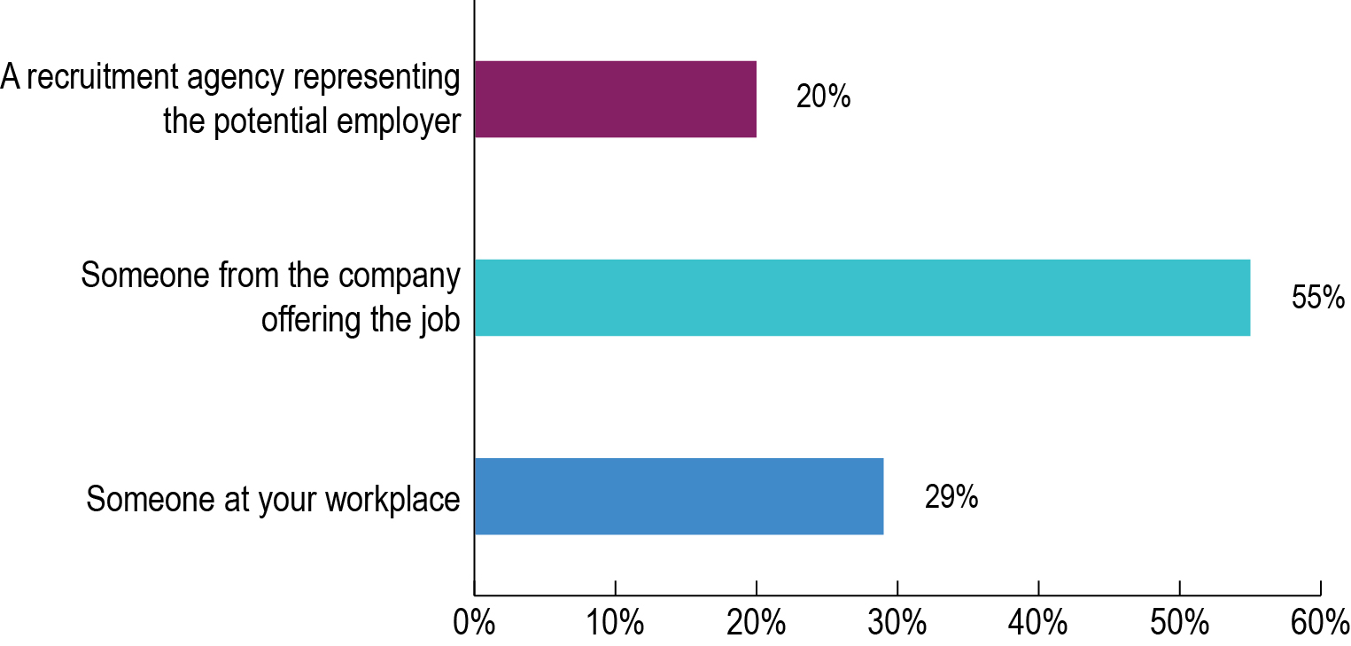

Base: Total number of respondents who were applying for a job or promotion either with their current employer or with someone they were not employed by and experienced age discrimination in the last two years (n=150). The question offered multiple responses so reported percentages may not equal 100%.

Types of discrimination experienced prior to the reference period
This subsection explores the types of age discrimination experienced in the past. Respondents were asked about their experiences prior to the two year reference period that is before 2013/2014.
Figure 28 shows the types of age discrimination experienced in the workplace in the past. The historical pattern of the types of experiences of discrimination is similar to the forms of discrimination experienced by those who had been in the workforce in the two year reference period.
The most common types of age discrimination related to limiting employment, promotion or training opportunities because of age (53%), followed by a perception that older people have outdated skills, or they are too slow to learn new things, or they delivered an unsatisfactory job because of their age (47%), and jokes or derogatory comments from employer/manager/colleagues based on age (38%).

Figure 28 – Types of age discrimination experienced in the workplace by respondents in the period since they turned 50 years old at the end of December 2012
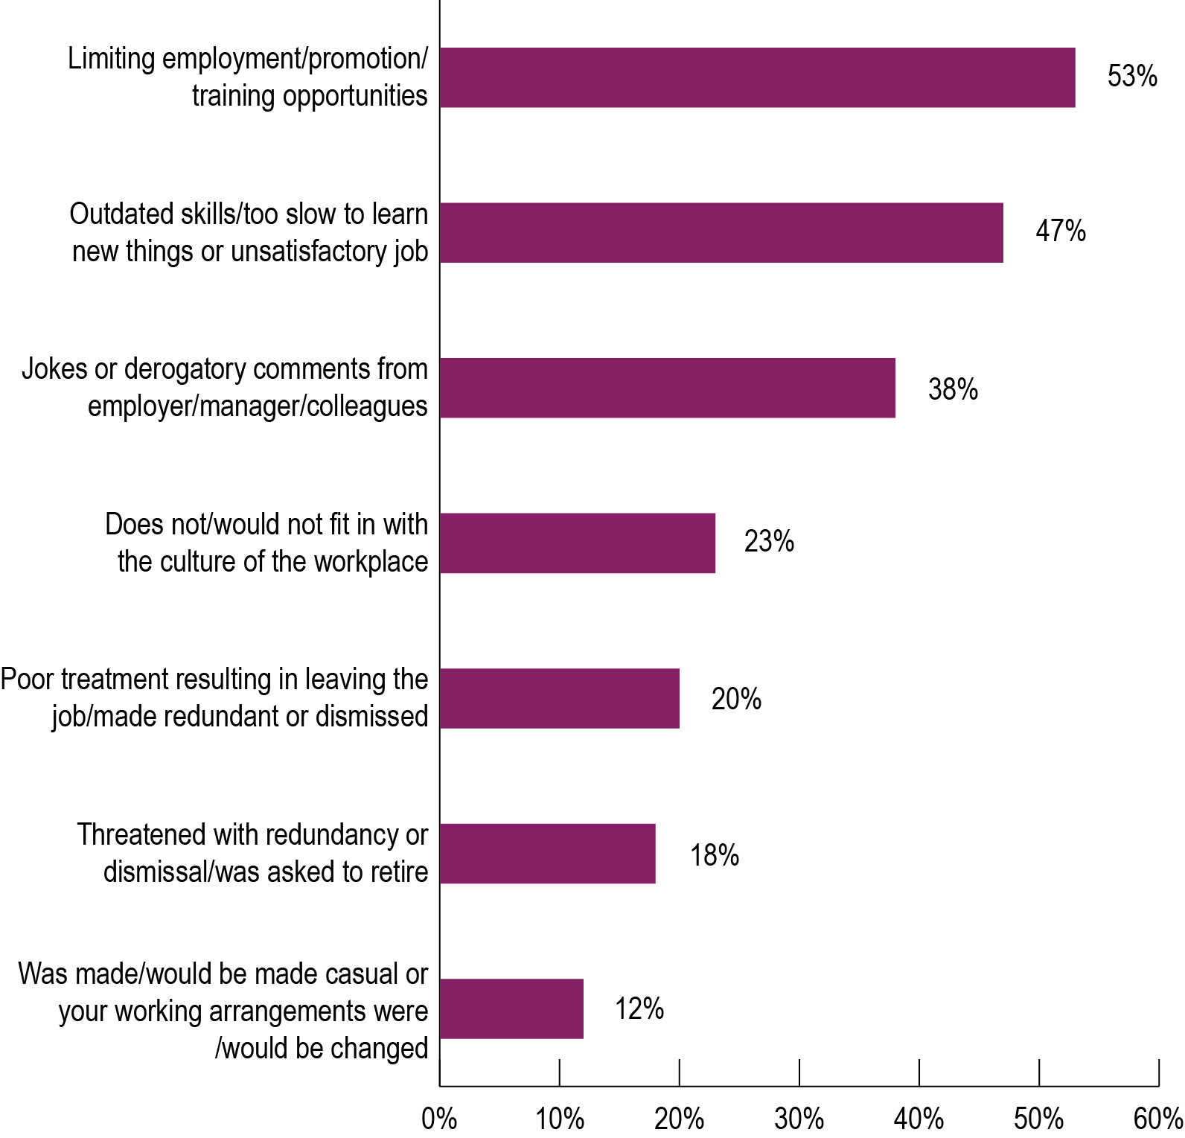

Base: Total number of respondents who experienced age discrimination in the workforce since they turned 50 and the end of December 2012: (n=355). The question offered multiple responses (except for ‘None of these’) so reported percentages may not equal 100%.

Conclusion
The 2014 National Prevalence Survey shows that age discrimination can arise at all stages of employment
i.e. during the recruitment process, access to skills enhancement, career progression and retirement.
The most commonly experienced forms of age discrimination were related to limiting employment, promotion or training opportunities and perceptions that older people have outdated skills or were too slow to learn new things. Jokes and derogatory comments based on age were also amongst the most common discriminatory behaviours reported. These attitudes and practices form significant barriers to workforce participation and constrain productivity.
Age discrimination is occurring now. Nearly three quarters of all of the most recent episodes of age discrimination occurred in the last 12 months, with 12% of these occurring in the last fortnight. One third of the most recent episodes of age discrimination occurred when people were applying for a job. Given the importance of encouraging older workers to remain in, or re-enter, the workforce this is of immediate concern.
The results demonstrate that awareness of age discrimination is limited, with a significant proportion of people being unaware that the behaviour they had experienced was a form of age discrimination. Some forms of age discrimination are difficult to recognise, while others are more obvious. For instance, being told you did not
get a job because of your age is clear, but being the subject of jokes and derogatory comments may be more ambiguous. Jokes and derogatory comments can serve to instil stereotypes. These stereotypes may reinforce assumptions about older workers’ capacities or abilities in the workplace, which can then constrain employment, training or promotion opportunities.
The results of the survey demonstrate a clear need for raising awareness of the types of behaviours which may constitute age discrimination to ensure prevention strategies are well targeted.

Impact of age discrimination

KEY FINDINGS
Age discrimination had a negative effect on the majority of those who experienced it
- Of those who reported experiencing age discrimination, four in five (80%) reported a negative impact as a result of the discrimination.
Age discrimination has a broad range of impacts on those who experience it
- Three in five (60%) people reported that the most recent episode of discrimination affected their self-esteem or mental health or caused them stress.
- Just over a half (54%) reported that the most recent episode had a negative impact on their family, career or finances.
- Half (49%) of respondents said that the most recent episode of discrimination made them consider changing their occupation or retraining themselves.
People who experience discrimination become discouraged from looking for work
- One third (33%) of people who had been discriminated against gave up looking for work as a result of experiencing age discrimination.

Introduction
Chapter 4 examines the negative effects of age discrimination in the Australian workforce. It investigates how many of those who experienced discrimination reported a negative impact as a result. It also focuses on the impacts that were more commonly reported.

Impact of age discrimination
Of those who had experienced age discrimination, four in five (80%) reported negative impacts as a result of the discrimination.
Figure 29 shows the total impact of discrimination experienced by Australians aged 50 years and older in the workforce in the last two years.
As can be seen, three in five (60%) people reported that the most recent episode of discrimination affected their self-esteem or mental health or caused them stress. Just over a half (54%) of people reported that the most recent episode had a negative impact on their family, career or finances.

Figure 29 – Negative impacts of discrimination
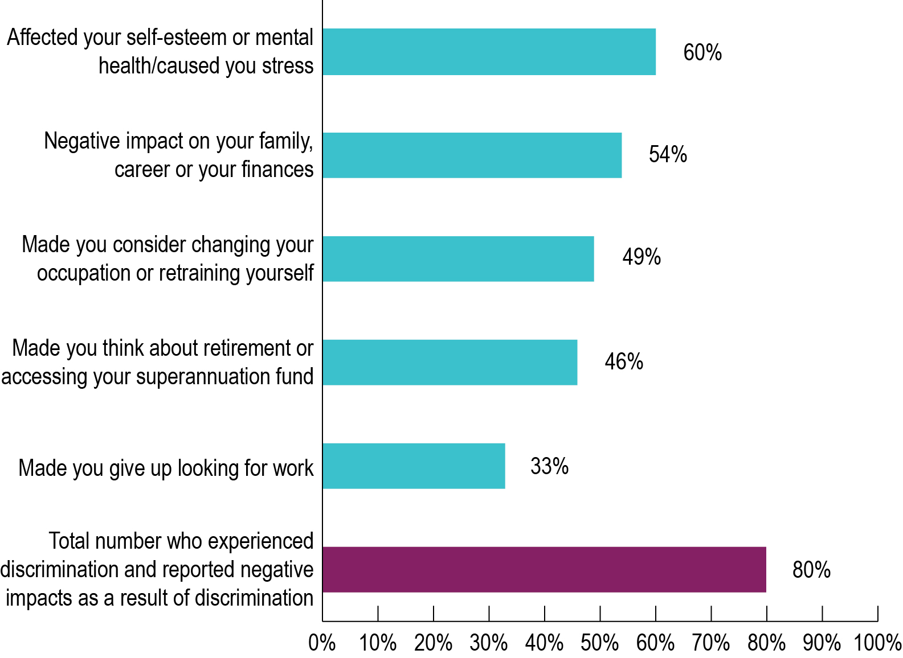

Base: Total number of respondents who experienced discrimination in the last two years (n=309). The question offered multiple responses so reported percentages may not equal 100%.

Half (49%) of respondents who experienced discrimination said that the episode made them consider changing their occupation or retraining themselves. Just under half (46%) reported that the discrimination made them think about retirement or accessing their superannuation fund. One third (33%) gave up looking for work as a result of discrimination.

Impact of age discrimination by awareness of other people aged 50 years and older experiencing discrimination
Figure 30 shows that those who were aware of someone aged 50 years and older experiencing discrimination were more likely to report a negative impact (88%) as a result, compared with those who were unaware (66%) of others who were experiencing discrimination.
In particular, those who were aware of someone aged 50 years and older experiencing discrimination were more likely than those who were unaware to report that the most recent episode of discrimination affected their self- esteem or mental health or caused them stress (69% vs. 44% respectively), negatively impacted on their family, career or their finances (62% vs. 40% respectively), made them consider changing their occupation/industry
or retraining yourself (57% vs. 33% respectively), and made them think about retirement or accessing their superannuation fund (54% vs. 33% respectively).

Figure 30 – Impact of discrimination on those who were aware of other people aged 50 years and older experiencing discrimination
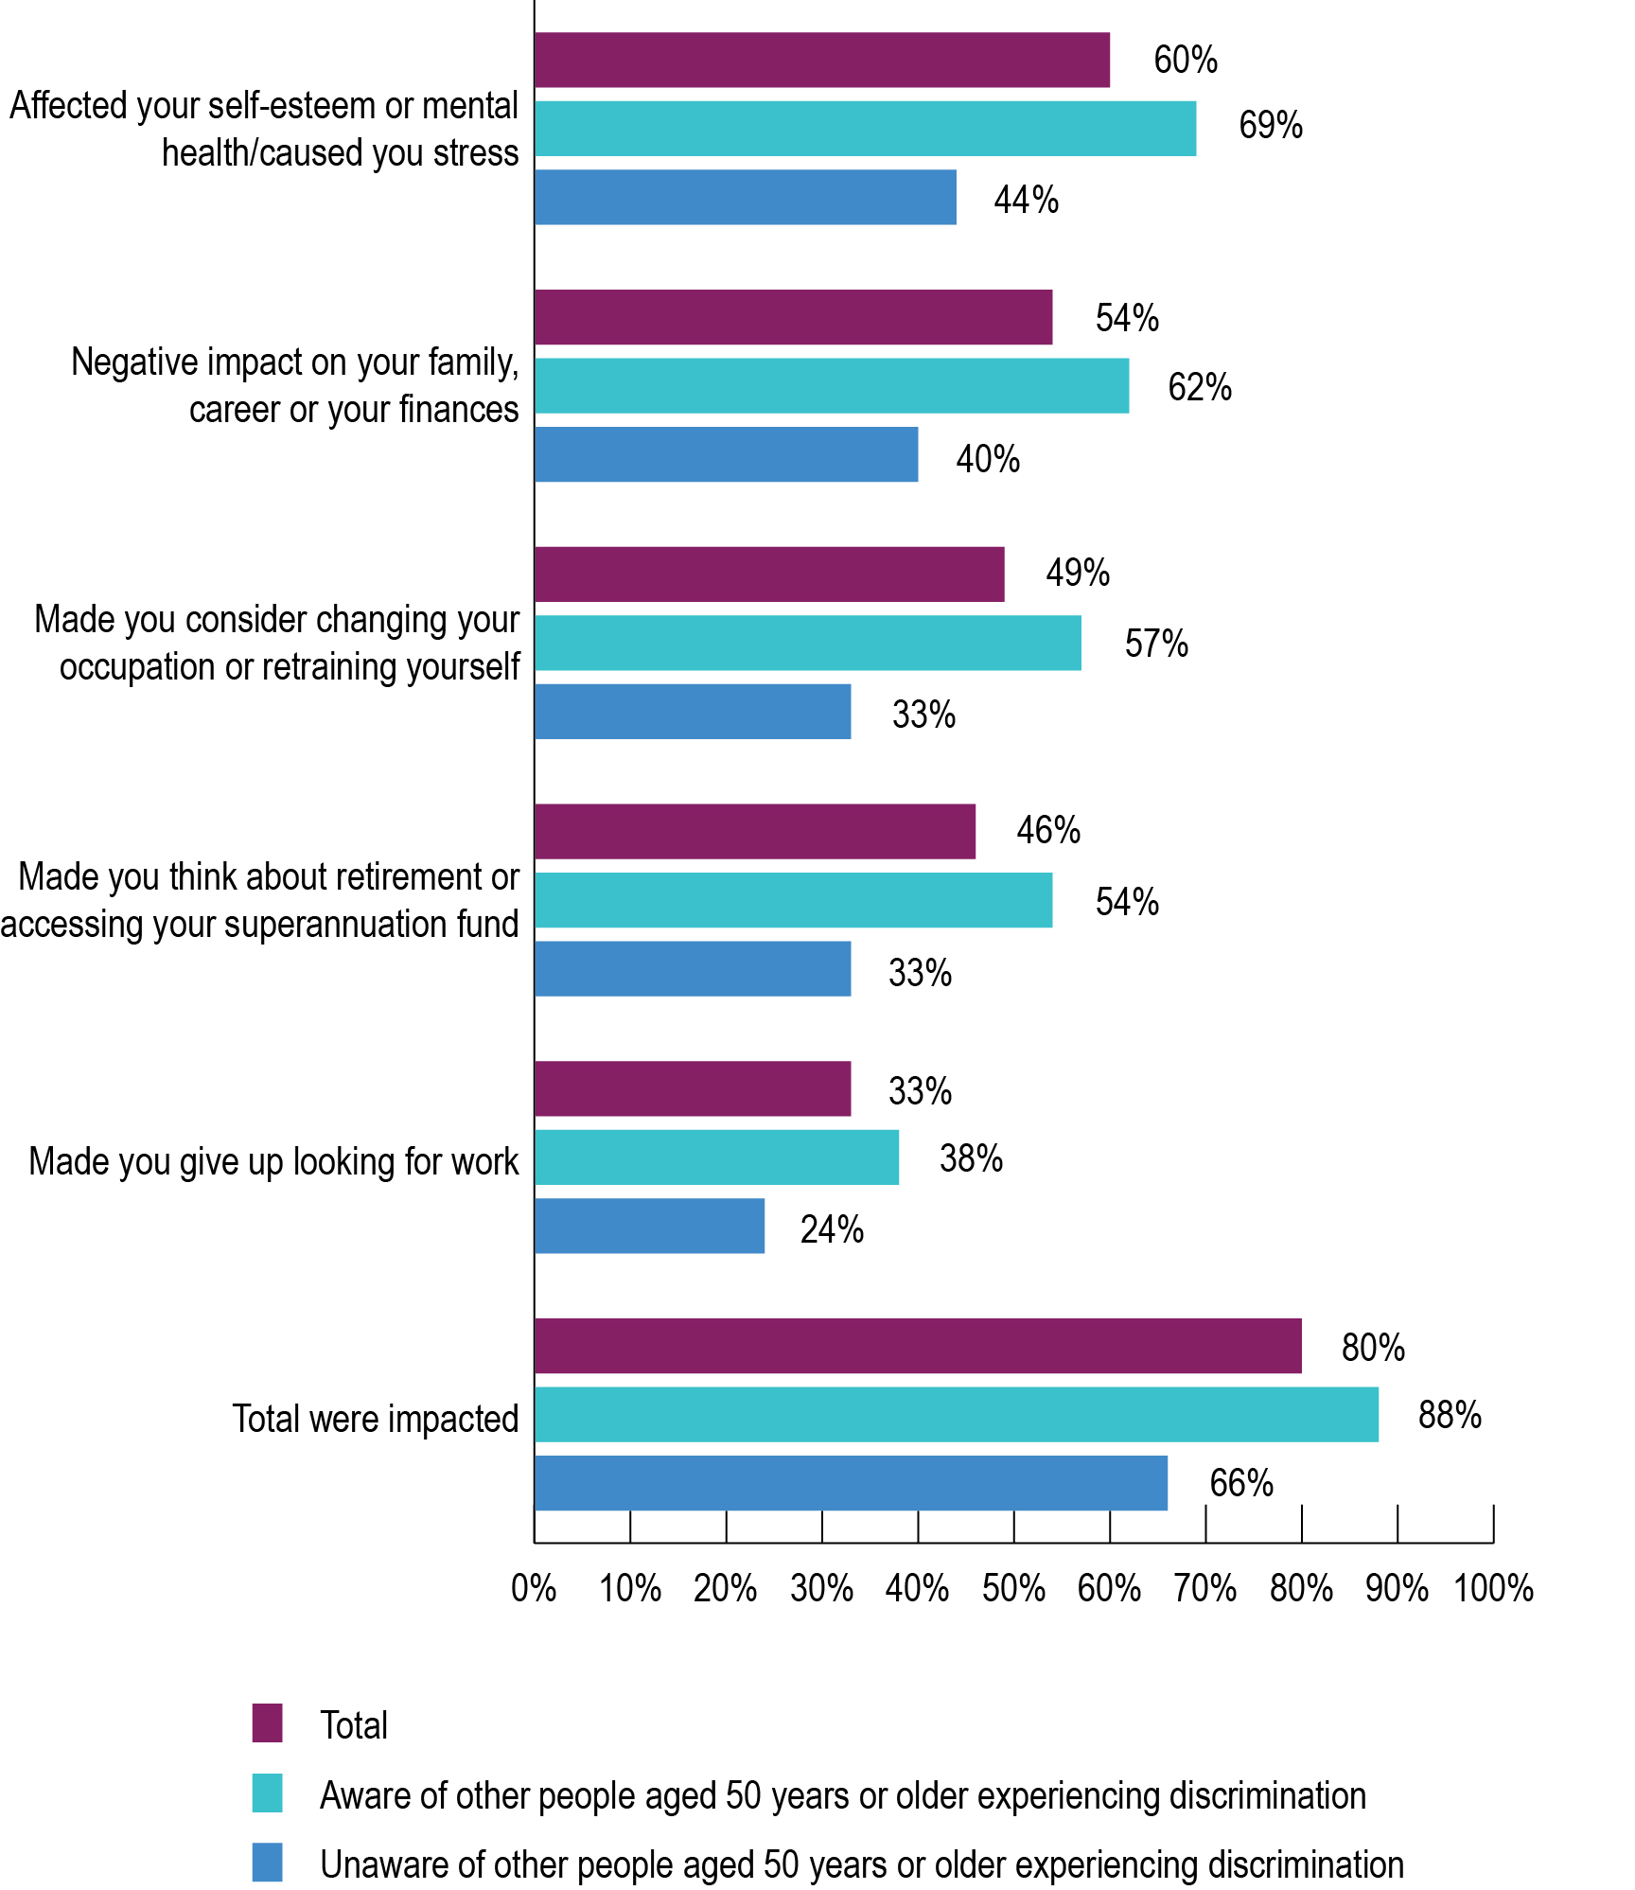
Base: Total (n=309), Aware of other people being discriminated (n=188), Unaware of other people being discriminated (n=114). The question offered multiple responses so reported percentages may not equal 100%.

Conclusion
The 2014 National Prevalence Survey demonstrates that age discrimination has a significant negative impact on most people who experience it.
The most commonly reported effect was a negative impact on self-esteem or mental health or caused stress. A negative impact on family, career and finances was the second most common effect of discrimination.
It is particularly concerning that one third (33%) of people who experienced discrimination gave up looking for work as a result of experiencing age discrimination. Almost half (46%) began to think about retirement or accessing their superannuation fund. In addition, and as reported in Chapter 2, a proportion of people who had not been engaged in the workforce in the last two years do not re-enter the workforce due to anticipated age discrimination.
The results of this survey clearly indicate that age discrimination discourages older workers from remaining in, and re-entering the workforce. This suggests that some older people have a perception, possibly based on a previous negative experience, that the workplace is not a friendly environment for older workers.

How different groups of people in the workforce experience age discrimination

KEY FINDINGS
Women are more likely to be seen as having outdated skills, being too slow to learn new things or as someone who would deliver an unsatisfactory job
  - The data indicates that of those who experienced discrimination in the last two years women were more likely than men to be perceived as having outdated skills, being too slow to learn new things or as someone who would deliver an unsatisfactory job (51% vs. 38% respectively).
Women are more likely than men to be psychologically affected by age discrimination they experienced
  - Women were more likely than men to report that the most recent episode of discrimination they had experienced affected their self-esteem or mental health or caused them stress (68% vs. 52% respectively).
People who experienced discrimination while looking for paid work were more likely to consider changing their occupation or retraining themselves (71%), as opposed to those who worked for a wage or salary (50%) or were self-employed (45%).
People in vulnerable circumstances are more likely to experience a negative impact of discrimination
  - Workers in the lower income bracket were more likely to experience a negative impact as a result of the most recent episode of discrimination (90% vs. 77% respectively). In addition, one in two (50%) people in the lower income bracket (50%) gave up looking for work as a result of experiencing discrimination, as opposed to a quarter (25%) of those in the higher income bracket.
  - People in a single household with no children (91%) were more likely to report a negative impact as a result of discrimination when compared to those in a couple with children (71%), and those in a couple with no children living in the household (80%).
  - People in a single parent household (87%)11 were more likely to be negatively impacted by the experience of discrimination when compared to those in a couple with children (71%).

Introduction
Chapter 5 examines the types and negative impact of discrimination by the characteristics of those who experienced it. It investigates whether some types of discrimination are more likely to occur amongst certain population groups. This chapter also examines if some negative impacts of age discrimination were more common amongst certain population groups.

Gender

- Types of discrimination
Looking at the types of discrimination experienced by gender, the data indicates that out of those who reported experiencing age discrimination in the last two years, women were more likely than men to be perceived as having outdated skills, being too slow to learn new things or as someone who would deliver an unsatisfactory job (51% vs. 38% respectively).

Figure 31 – Types of discrimination by gender
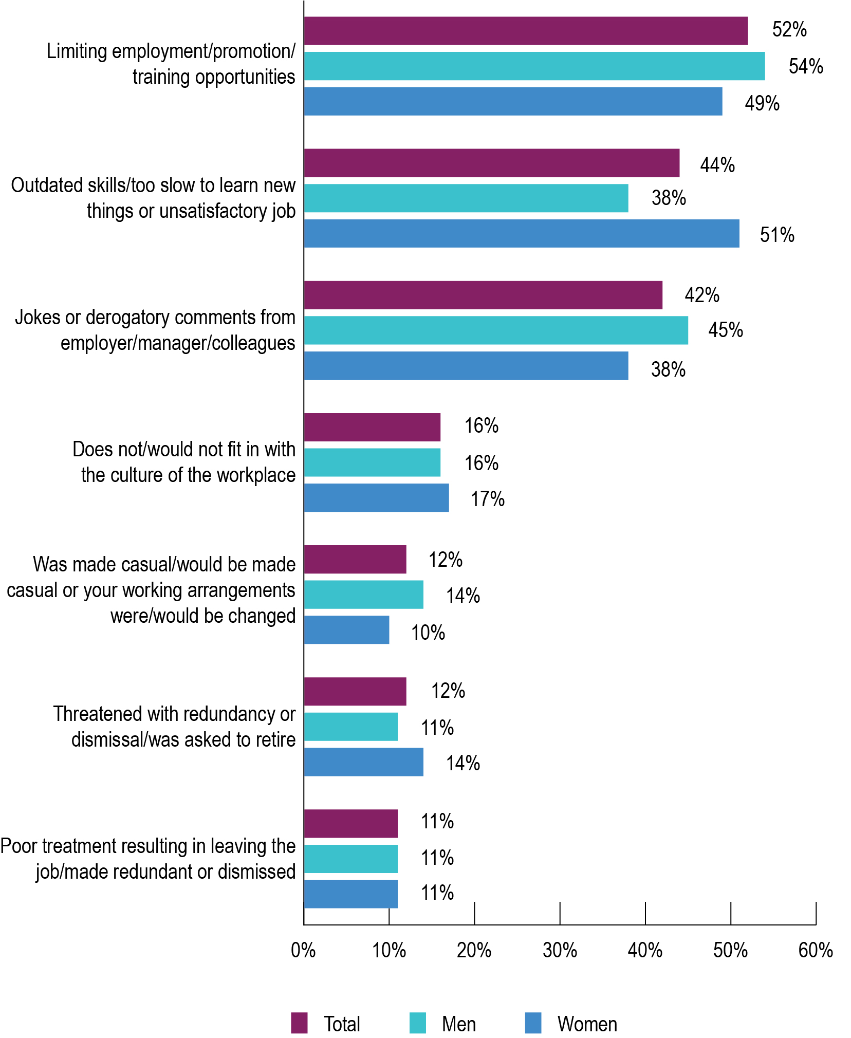
Base: Total number of respondents who experienced discrimination in the last two years (n=309); Men (n=173), Women (n=136). The question offered multiple responses so reported percentages may not equal 100%.

Impact of discrimination
The results revealed that women were more likely than men to report that the most recent episode of discrimination they experienced affected their self-esteem or mental health or caused them stress (68% vs. 52% respectively).

Figure 32 – Negative impact of discrimination by gender
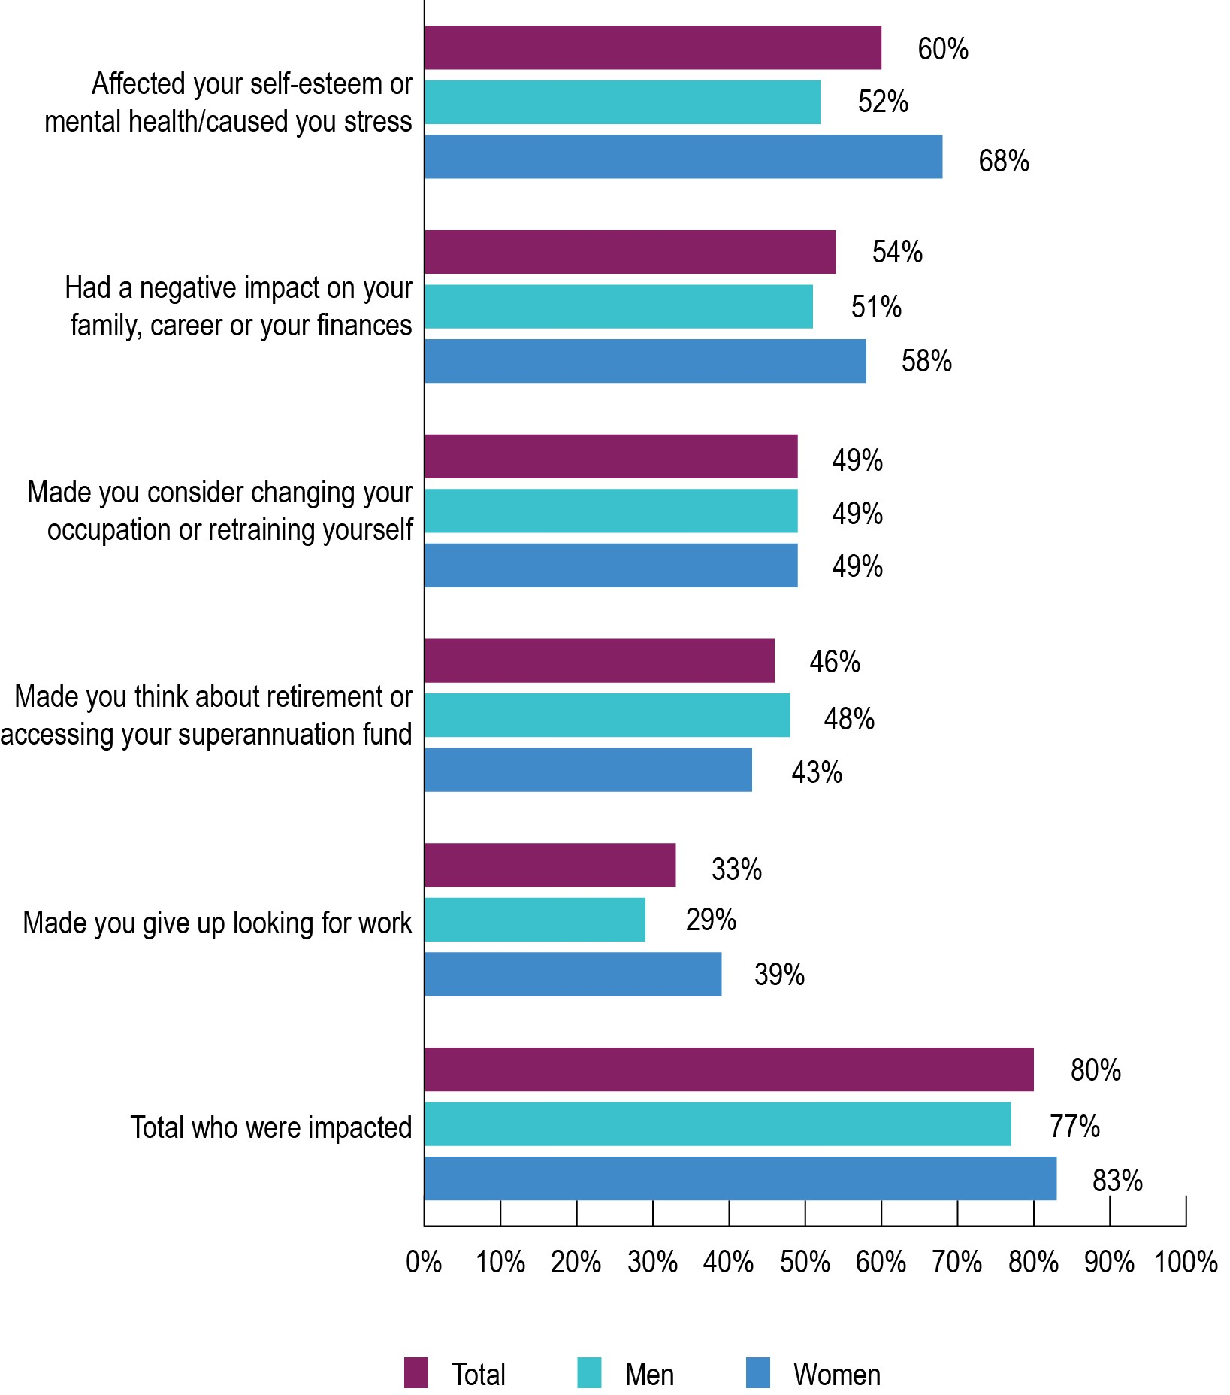

Base: Total number of respondents who experienced discrimination in the last two years (n=309); Men (n=173), Women (n=136). The question offered multiple responses so reported percentages may not equal 100%.

5.3 Income12

- Types of discrimination
The data indicates that out of those who experienced discrimination in the last two years, people in the higher income bracket of more than $50,000 were more likely to be the subject of jokes or derogatory comments from employer/manager/colleagues when compared to people in the lower income bracket of $50,000 or less (49% vs. 31% respectively).

Figure 33 – Types of discrimination by income
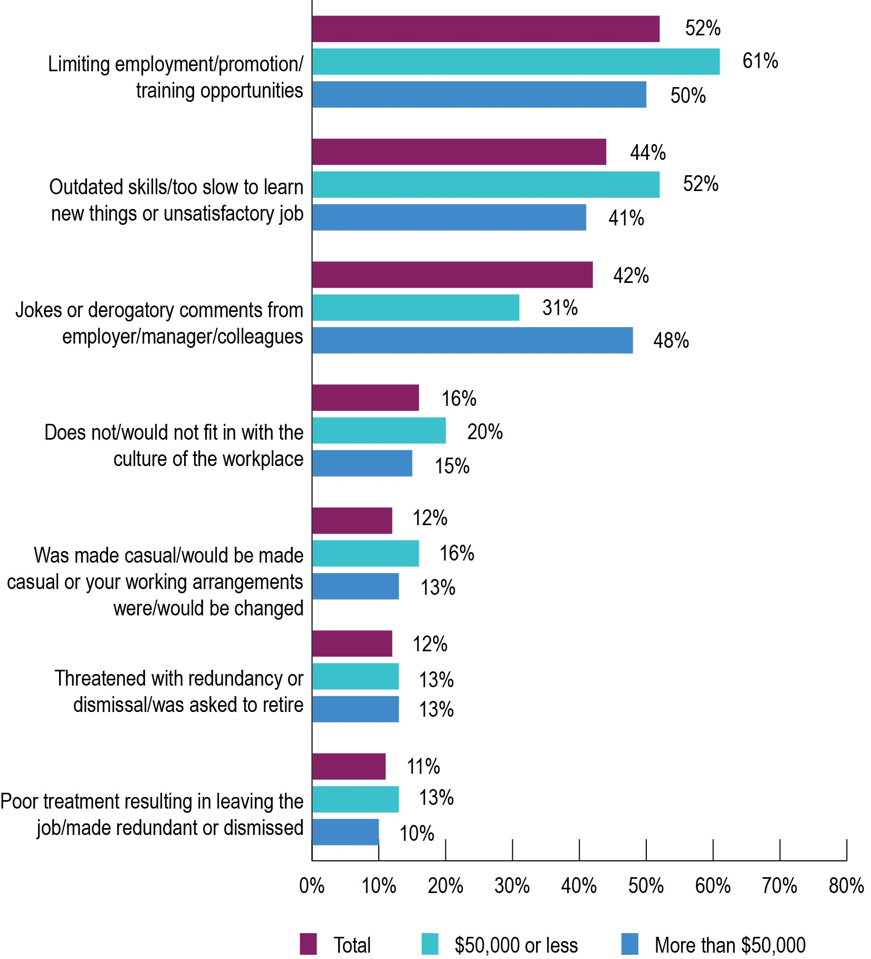

Base: Total number of respondents who experienced discrimination in the last two years (n=309); Income of
$50,000 or less (n=100), More than $50,000 (n=176). The question offered multiple responses so reported percentages may not equal 100%.

Impact of discrimination
Figure 34 shows that people in the lower income bracket were more likely than those in the higher income bracket to experience a negative impact as a result of the most recent episode of discrimination (90% vs. 77% respectively).
In particular, two thirds of people (68%) on an income of $50,000 or less reported that the most recent episode of discrimination negatively impacted their family, career or their finances when compared to half of those (49%) on an income of more than $50,000.
Over half of those (55%) with an income of $50,000 or less thought about retirement or accessing their superannuation fund, compared to two in five of those (42%) with income of more than $50,000. In addition, half of people in the lower income bracket (50%) reported that the last episode of discrimination made them give up looking for work, as opposed to a quarter (25%) of those in the higher income bracket.

Figure 34 – Negative impact of discrimination by income
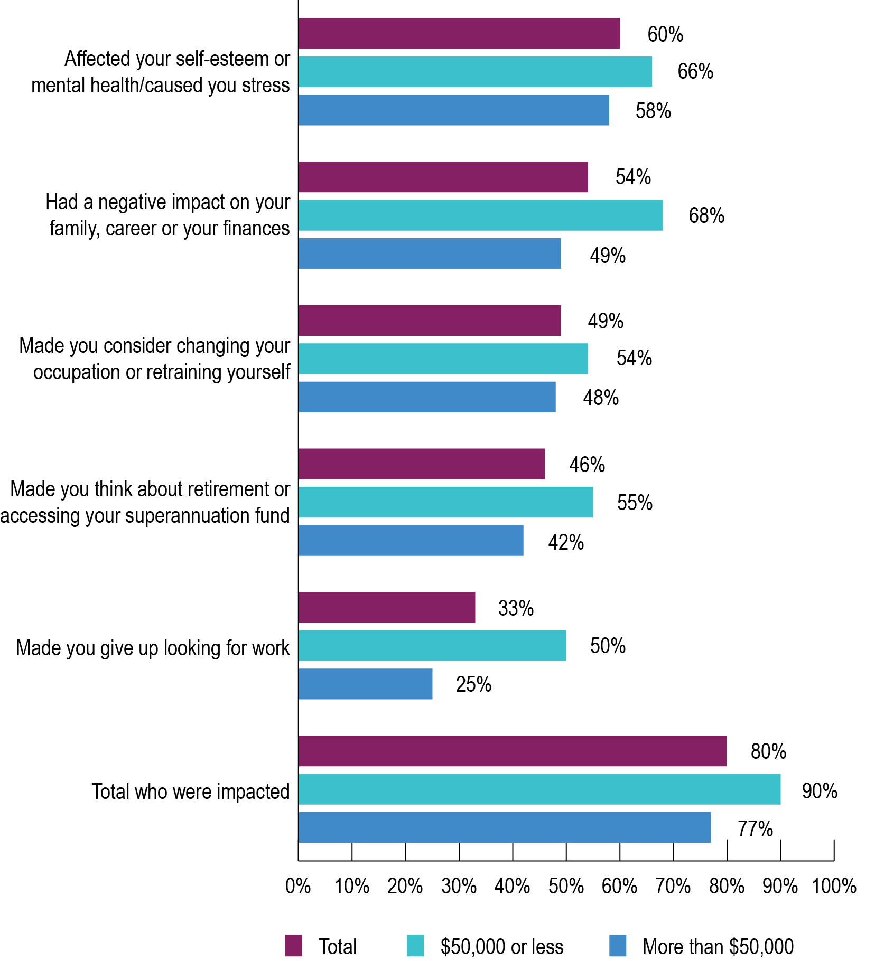

Base: Total number of respondents who experienced discrimination in the last two years (n=309); Income of $50,000 or less (n=100), more than $50,000(n=176). The question offered multiple responses (except for ‘None of these’)
so reported percentages may not equal 100%.

Household arrangement

(a) Impact of discrimination
When the impact of discrimination was examined by household arrangement, the data revealed that single households with no children (91%) were more likely to report a negative impact as a result of discrimination, compared to those in a couple with children (71%), and those in a couple with no children living in the household (80%). There are indications that people in a single parent household (87%)13 were more likely to be negatively impacted by the experience of discrimination when compared to those in a couple with children (71%).
Further analysis revealed notable differences in the types of impact experienced between those in a couple with child/children and those in a single household with no children.
For instance, over two thirds (70%) of those in a single household with no children reported that the experience of discrimination affected their self-esteem or mental health or caused them stress, as opposed to one in two (48%) people in a couple with child/children living in the household.
Three in five (62%) people in a single household with no children experienced a negative impact on their family, career or their finances compared to under half (46%) of people in a couple with child/children living in the household.
In addition, over a half (54%) of people in a single household with no children thought about retirement or accessing their superannuation fund as a result of the most recent episode of age discrimination, as opposed to a third (36%) of those in a couple with child/children living in the household.

Figure 35 – Negative impact of discrimination by household arrangement
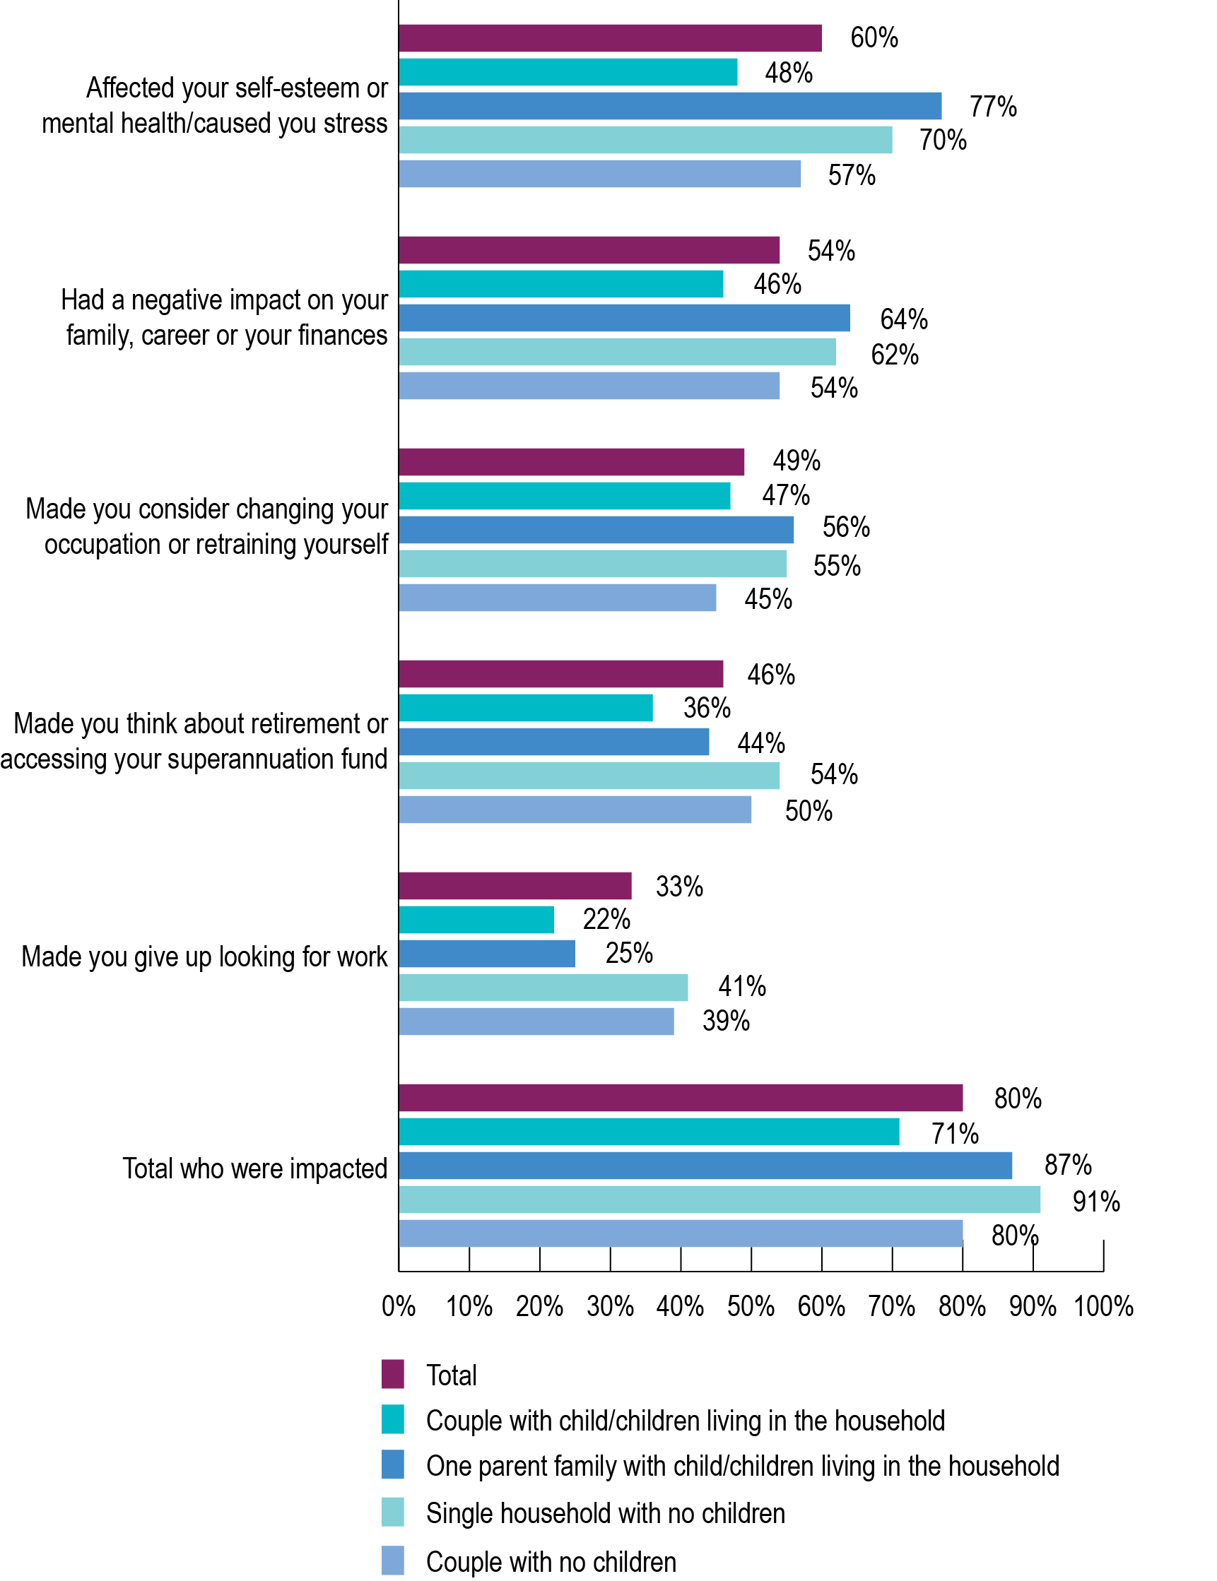
Base: Total number of respondents who experienced discrimination in the last two years (n=309). Couple with child/ children living in the household (n=84), One parent family with child/children living in the household (n=31), Single household with no children (n=77), Couple with no children (n=106). The question offered multiple responses (except for ‘None of these’) so reported percentages may not equal 100%.

Education

- Types of discrimination
The data indicates that workers with a university degree were more likely than those with school education to be perceived as having outdated skills, being too slow to learn new things or as someone who would deliver an unsatisfactory job (50% vs. 34% respectively).

Negative impact of discrimination
The results showed that workers with a university degree were more likely than those who had school education to report a negative impact as a result of experiencing discrimination (85% vs. 69% respectively). Furthermore, people with a university degree were more likely than those with school education to report that the experience of
discrimination made them consider changing their occupation or retraining themselves (57% vs. 38% respectively).

Figure 36 – Negative impact of discrimination by the level of education attained
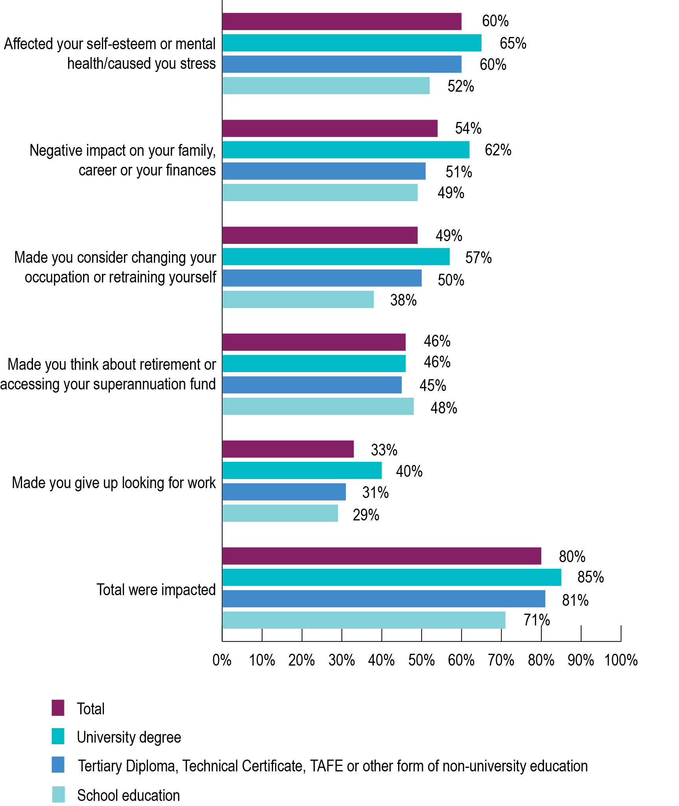

Base: Total number of respondents who experienced discrimination in the last two years (n=309); University degree (n=113), Tertiary Diploma, Technical Certificate, TAFE or other form of non-university education (n=105), School education (n=89). The question offered multiple responses so reported percentages may not equal 100%.

Workforce engagement (whether worked for a wage or salary, were self-employed or looked for paid work)
- Types of discrimination
Out of those who reported experiencing discrimination in the last two years, seven in ten (71%) people who looked for paid work experienced discrimination related to limiting employment, promotion or training opportunities, when compared to over a half (53%) of those who worked for a wage or salary, and a similar proportion (53%) of those who were self-employed.
Out of those who experienced discrimination in the last two years, three in five (58%) self-employed people were perceived as having outdated skills, being too slow to learn new things, or as someone who would deliver an unsatisfactory job compared to two in five (41%) people who worked for a wage or salary.
Nearly half (46%) of people who worked for a wage or salary were subjected to jokes or derogatory comments from their employer/manager/colleagues compared to three in ten (31%) of those who looked for paid work.

Figure 37 – Types of discrimination by workforce engagement
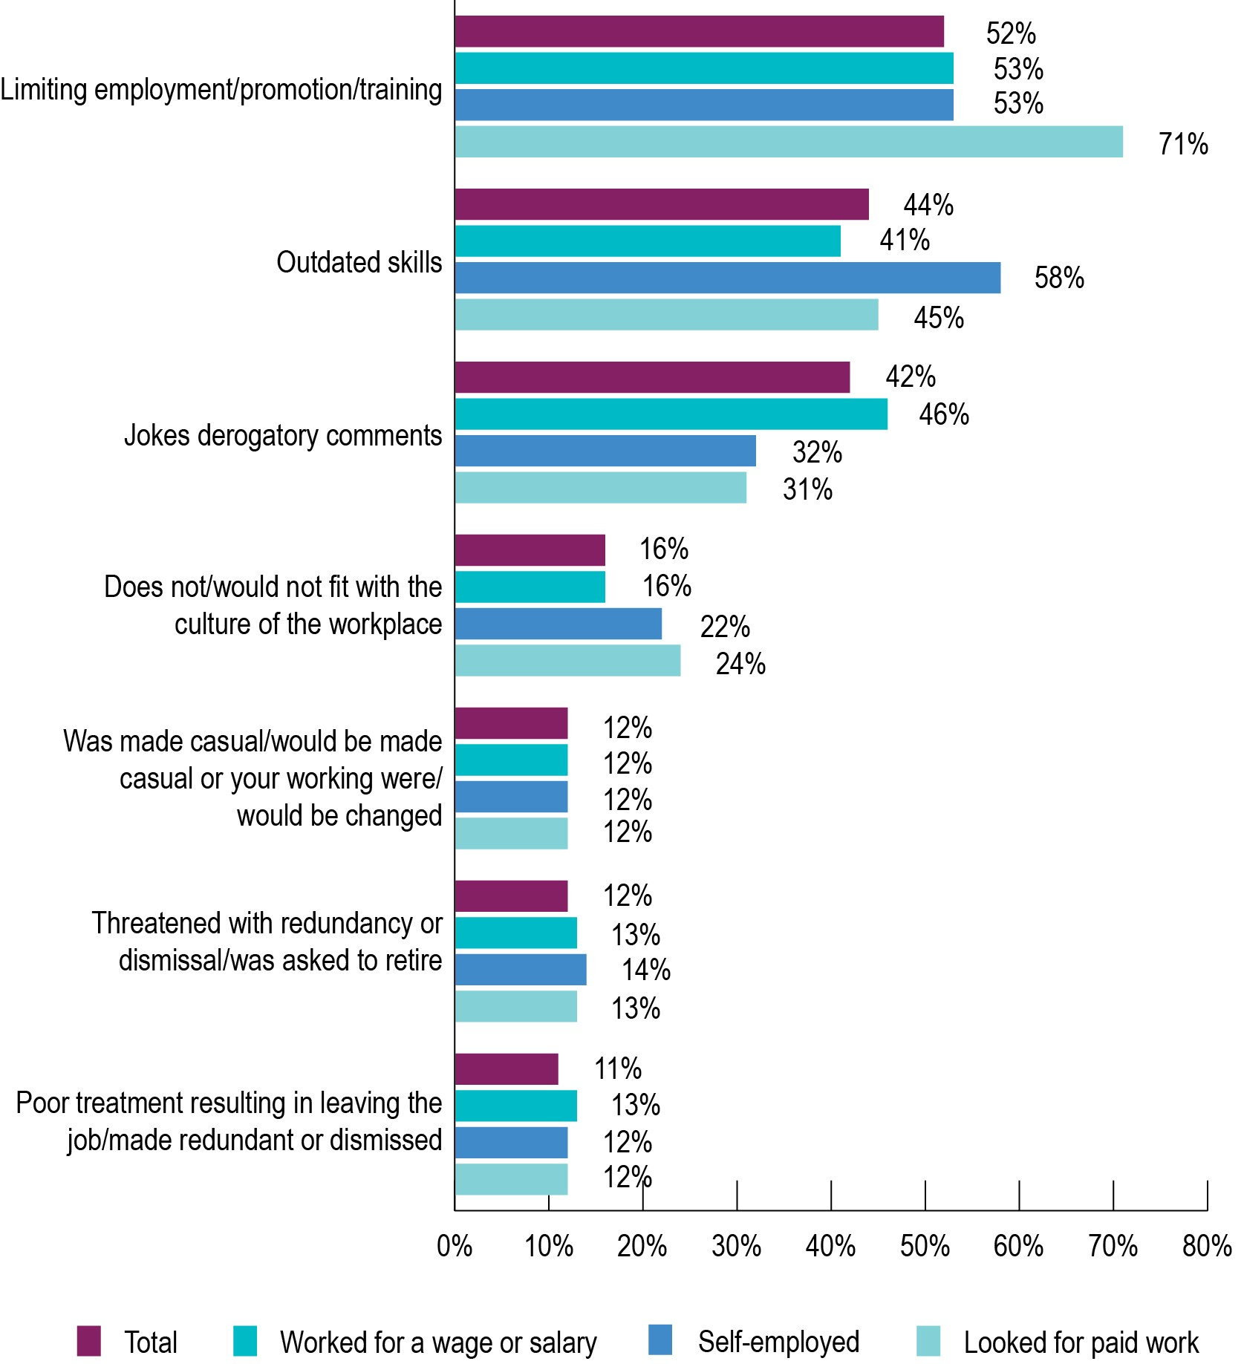

Base: Total number of respondents who experienced discrimination in the last two years (n=309); Worked for a wage or salary (n=252), Been self-employed (n=82), Looked for paid work (n=99). The question offered multiple responses so reported percentages may not equal 100%.

Impact of discrimination
The data indicates that those who looked for work were more likely to experience certain impacts as a result of discrimination. In particular, they were more likely to consider changing their occupation or retraining themselves (71%), as opposed to those who worked for a wage or salary (50%) or were self-employed (45%).
In addition, those who looked for work were more likely to report that the most recent episode of discrimination they experienced had a negative impact on their family, career or their finances (70%), compared to those who worked for a wage or salary (54%) and were self-employed (51%).

Figure 38 – Impact of discrimination by workforce engagement
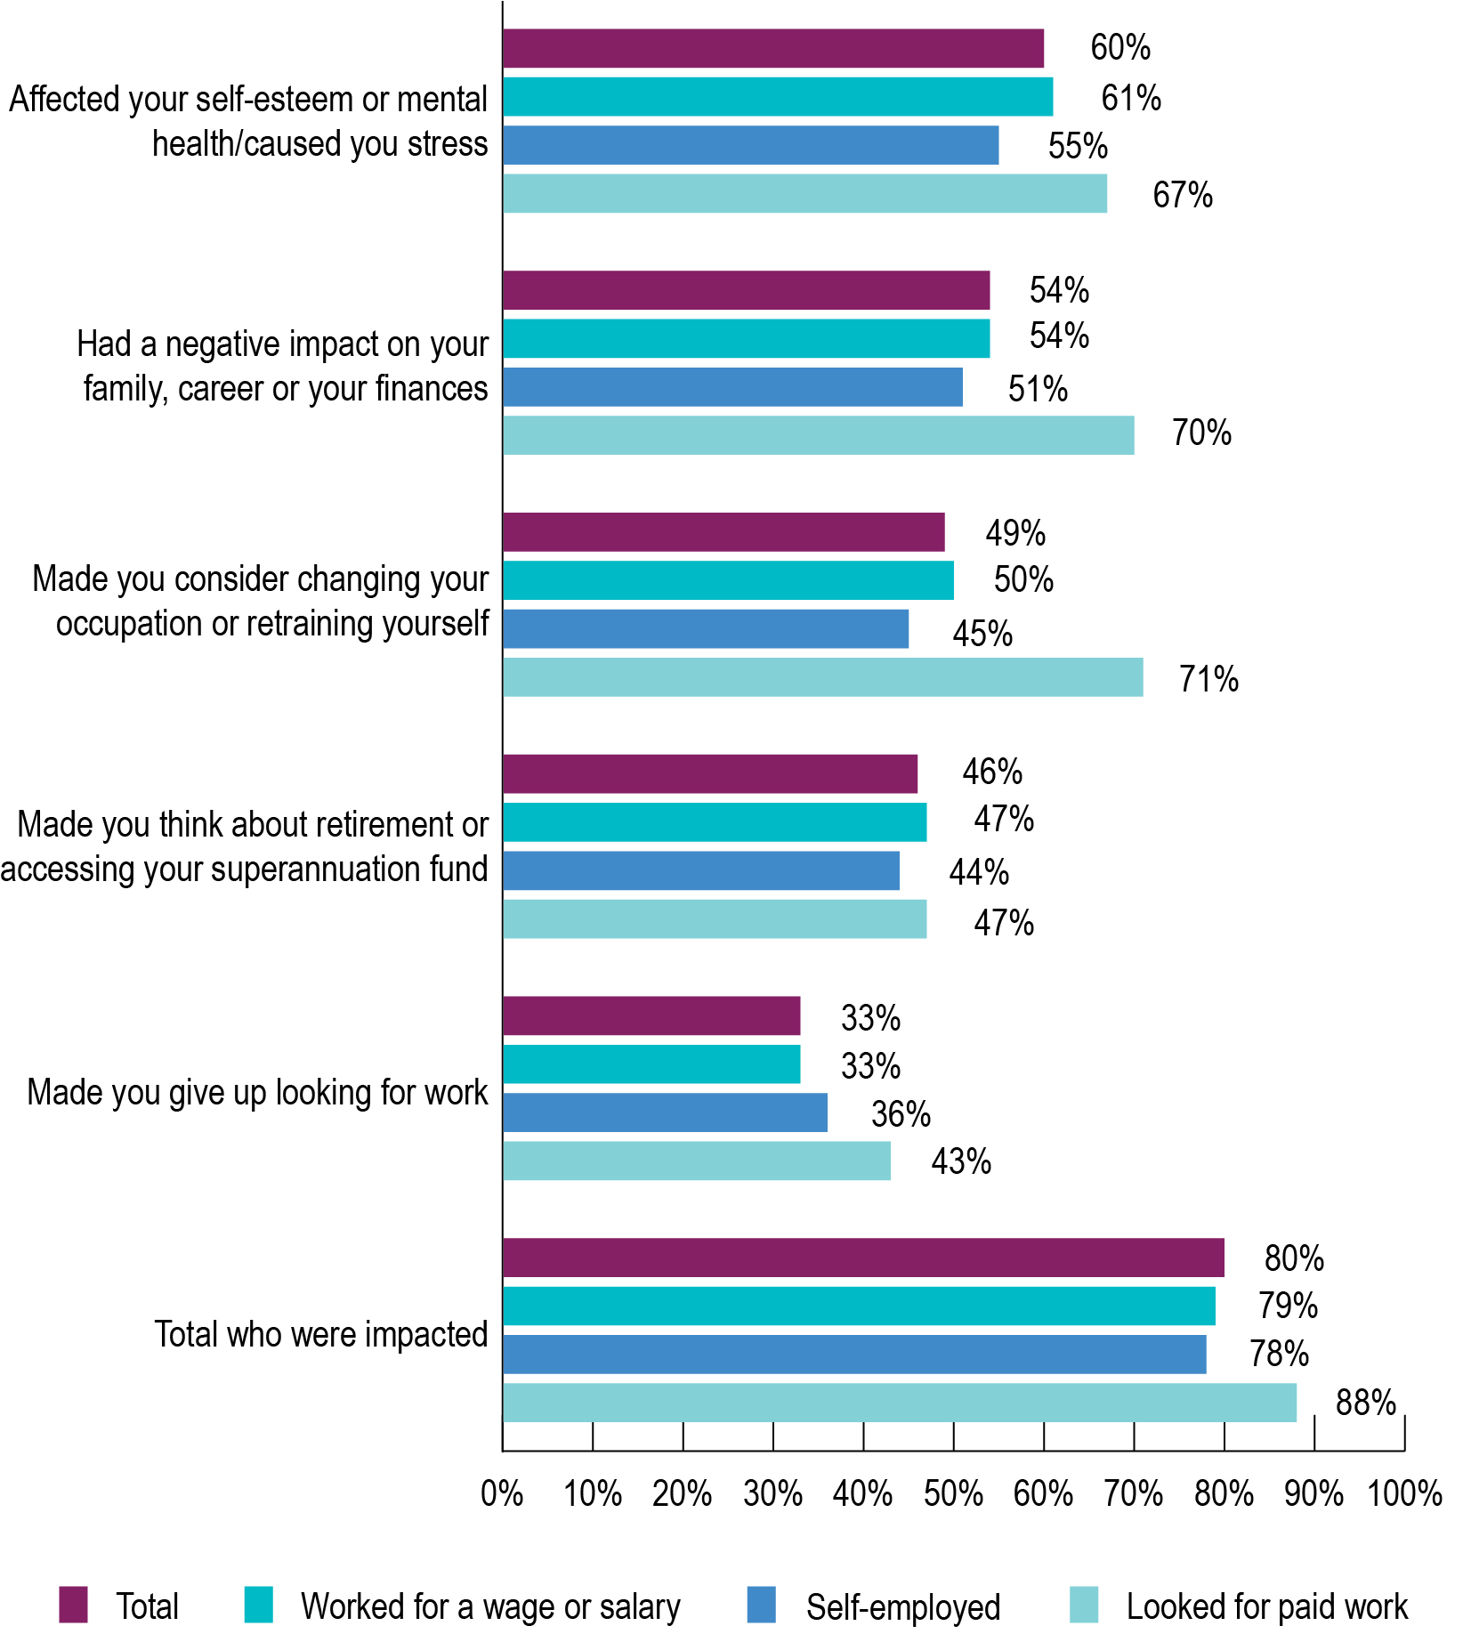
Base: Total number of respondents who experienced discrimination in the last two years (n=309); Worked for a wage or salary (n=252), Been self-employed (n=82), Looked for paid work (n=99). The question offered multiple responses (except for ‘None of these’) so reported percentages may not equal 100%.

Full-time/Part-time

(a) Impact of discrimination
A notable difference was found with regard to the impact of discrimination between full-time and part-time working arrangements. In particular, those who worked or looked for work on a part-time basis (43%) were more likely to report that the experience of discrimination made them give up looking for work, when compared to those who worked or looked for work on a full-time basis (30%).

Sector

(a) Impact of discrimination
A notable difference was found with regard to the impact of discrimination between those who experienced discrimination in the public and private sector.
In particular, people who experienced discrimination within an organisation in the public sector (54%) were
more likely to report that the episode made them think about retirement or accessing their superannuation fund, compared to those who experienced discrimination within an organisation in the private sector (42%).

Figure 39 – Negative impact of discrimination by sector
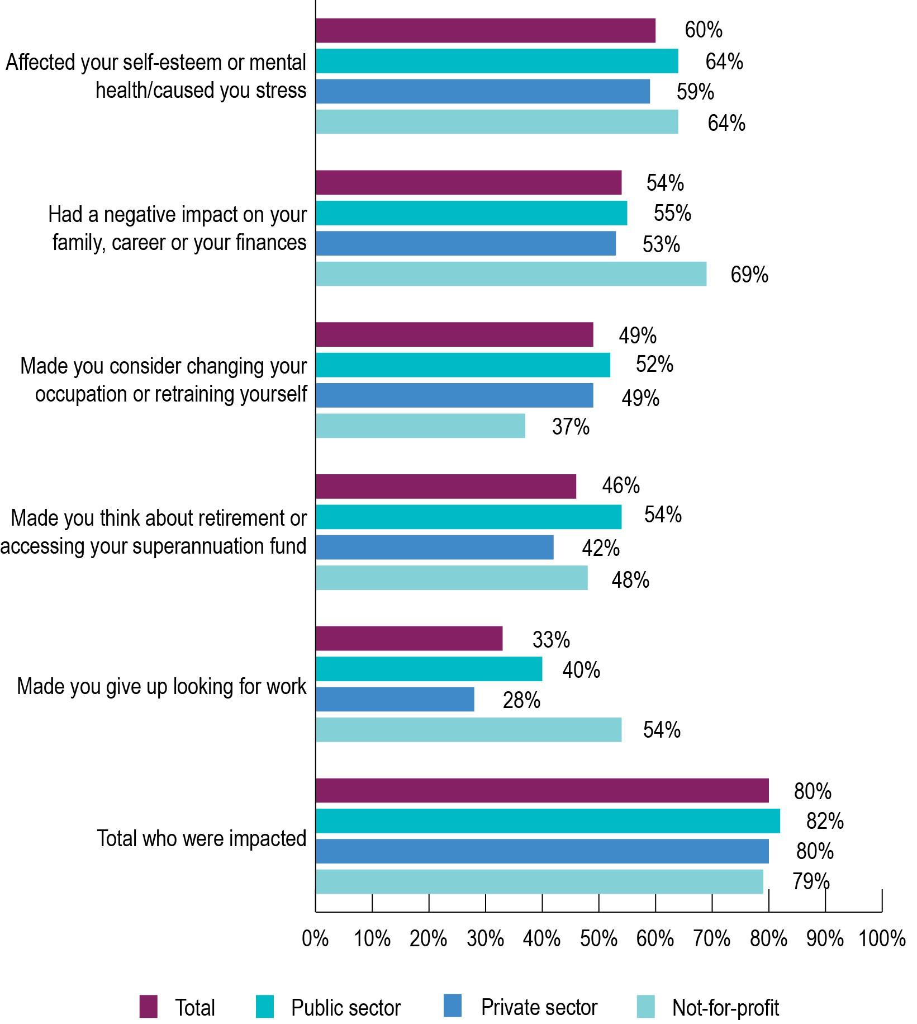

Base: Total number of respondents who experienced discrimination in the last two years (n=309). Public sector (n=103), Private sector (n=178), Not-For-Profit (n=19). The question offered multiple responses (except for ‘None of these’) so reported percentages may not equal 100%.

Working arrangements

(a) Types of discrimination
Those who experienced discrimination while working or applying for work on a casual basis (62%) were more
likely to be perceived as having outdated skills or being too slow to learn new things or delivering an unsatisfactory job because of their age as opposed to those who worked or applied for work on an on-going or permanent basis (41%).

Figure 40 – Types of discrimination by working arrangements
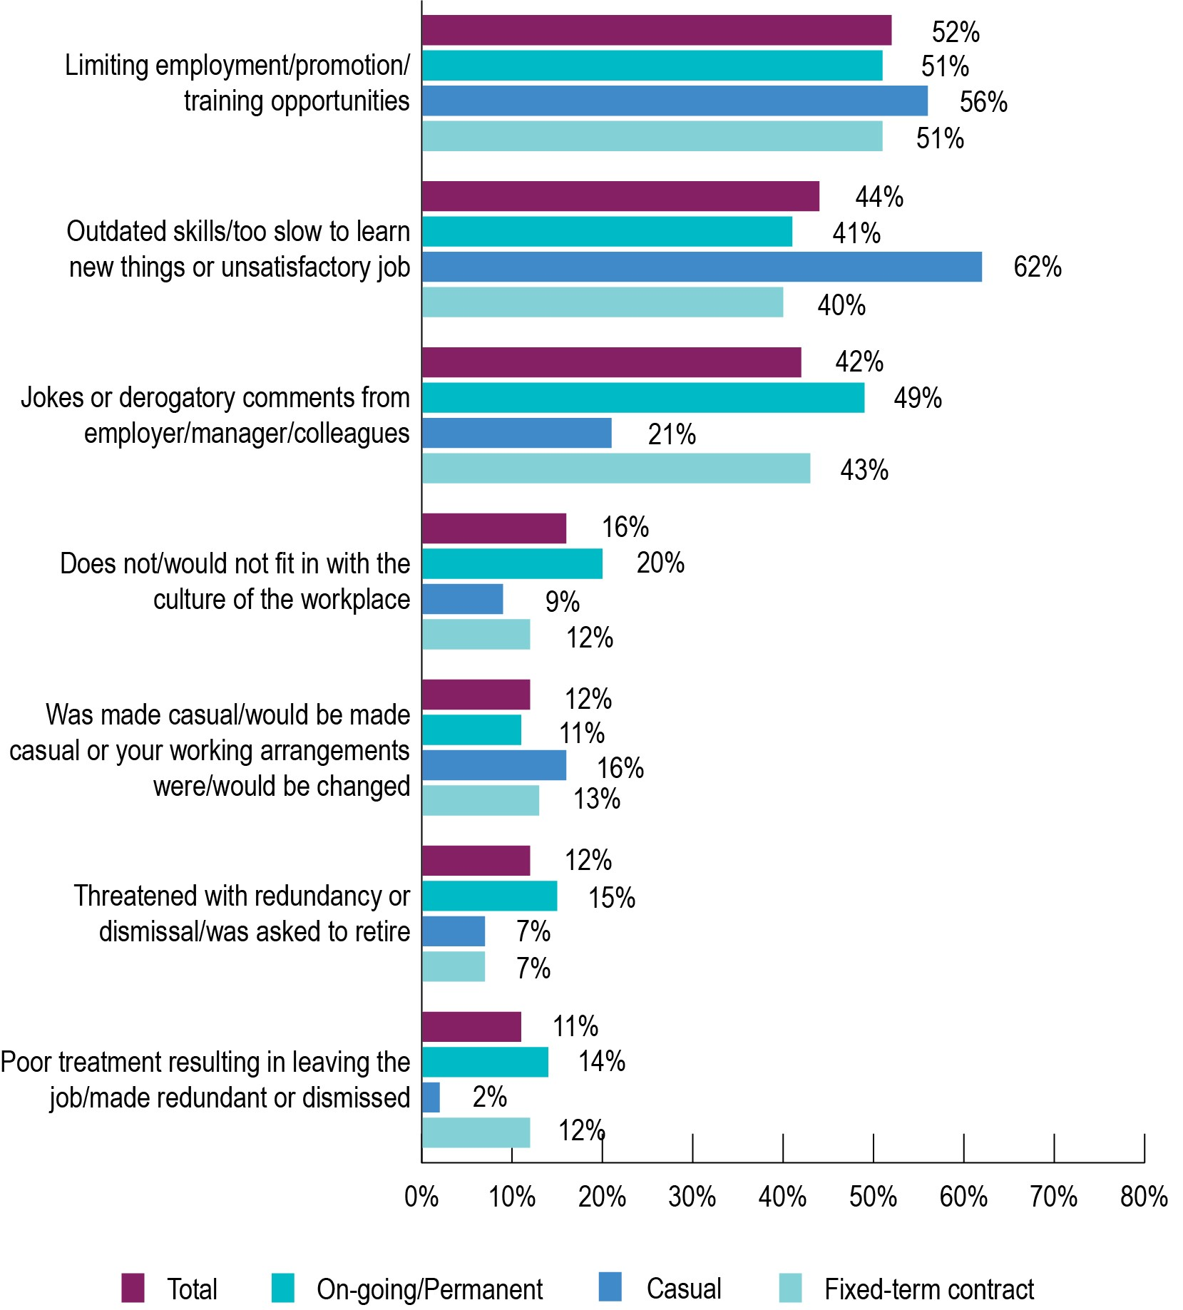
Base: Total number of respondents who experienced discrimination in the last two years (n=309); The question offered multiple responses (except for ‘None of these’) so reported percentages may not equal 100%.

Conclusion
The 2014 National Prevalence Survey results show that different groups of people in the workforce experience age discrimination in different ways.
Women are more likely to be perceived as having outdated skills, be too slow to learn new things or be more likely to perform unsatisfactorily in their job. Women are also more likely than men to report that the most recent episode of discrimination affected their self-esteem or mental health, or caused them stress.
These results are of concern given the efforts to increase women’s participation in the workforce and continue their participation beyond the traditional retirement age.
Further, those in vulnerable economic circumstances including people on lower incomes, and/or single households are also more likely to report a negative impact of age discrimination. People looking for paid work were more likely to report that the type of discrimination they experienced was limiting employment, promotion or training than those who were already in paid work.
People looking for part-time work were more likely than those seeking full time work to report that the experience of discrimination made them give up looking for work. The results indicate the range of impacts of age discrimination and the need for nuanced, targeted strategies.

Response to age discrimination

KEY FINDINGS
43% of workers did not take any action in response to experiencing age discrimination Results show that formal complaints in response to age discrimination are rare
- Although more than half (57%) of respondents who experienced discrimination reported that they took some form of action, only 5% discussed the issue with an external organisation and only 14% raised or discussed it within their organisation.
The most common steps undertaken in response to discrimination were leaving or thinking about leaving their job (23%), and discussions with friends, family or colleagues (15%)
People did not take action in response to age discrimination because they did not think it was serious enough or because they did not have proof or thought nothing could be done
- Out of those who did not take action, over a quarter (27%) were not offended because they thought it was just a joke or the discrimination did not affect them. Nearly a quarter (23%) of people did not take action because
they thought that they would not be believed or they did not have proof or evidence of the discrimination, or they thought that nothing could be done.
Of those who experienced discrimination and reported that the issue was partially or fully resolved, only for a few was it resolved in a positive way within the organisation
- Of those who experienced discrimination and reported that the issue was partially or fully resolved, one in five (18%) kept their job or were retrained, or received their flexible work arrangements, or were given an apology.

Introduction
This chapter examines actions taken in response to age discrimination and explores where people who experienced age discrimination seek advice or support. It also investigates reasons for not taking action in response to the discrimination experienced.
In addition, Chapter 6 identifies if the issues associated with discrimination were resolved and how.

Actions taken in response to experiencing discrimination
Australians aged 50 years and older who experienced discrimination were asked whether they took any actions in response to the most recent episode of discrimination.
Over half (57%) of respondents took some form of action in response to the most recent episode of discrimination and two in five (43%) took no action.
One in six (17%) people thought about leaving their job and a similar proportion (15%) discussed the issue with their family/friends/colleagues. One in seven (14%) people discussed or raised the issue with the organisation. One in ten (8%) people changed or thought about changing their career. A small group (6%) left their job, and a similar proportion (5%) discussed or raised the issue with an external organisation.

Figure 41 – Actions taken in response to experiencing discrimination
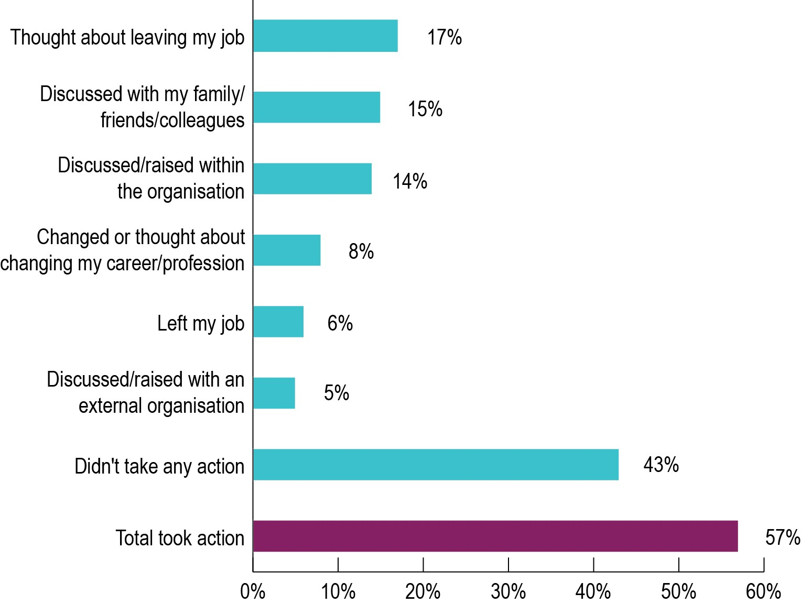

Base: Total number of respondents who experienced discrimination in the last two years (n=309).The question offered multiple responses (except for ‘None of these’) so reported percentages may not equal 100%.

Actions taken in response to the discrimination by age
When responses to discrimination were examined by age, the results revealed notable differences between the
50- 54 and 55-59 age groups.
Those aged between 50 and 54 were less likely to take action (48%) in response to the most recent episode of discrimination experienced, as opposed to those aged between 55 and 59 (66%).

Figure 42 – Actions taken in response to the discrimination experienced by age
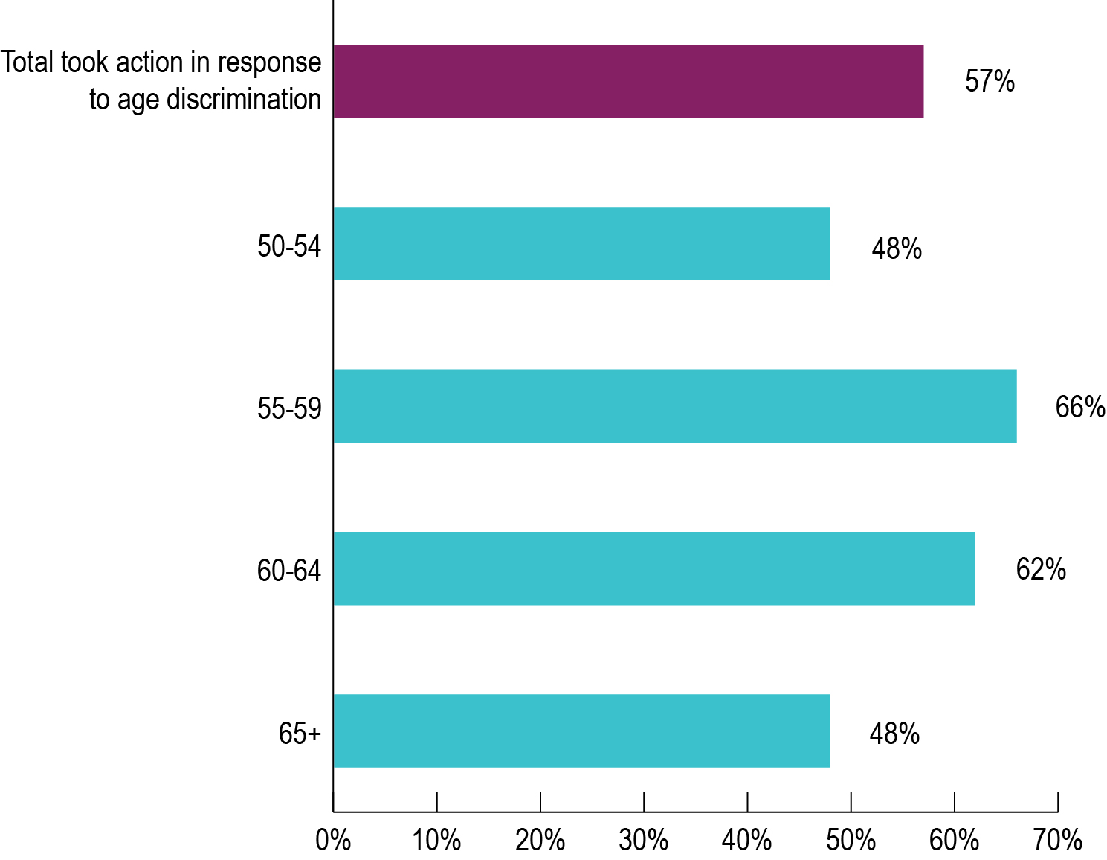

Base: Total number of respondents who experienced discrimination in the last two years (n=309). 50-54 (n=94), 55-59 (n=98), 60-64 (n=71), 65+ (n=46).

Reasons for not taking action
Over two in five (43%) Australians aged 50 years and older who experienced discrimination did not take any action in response to that discrimination.
Out of those who did not take action, over a quarter (27%) were not offended because they thought it was just
a joke or the discrimination did not affect them. Nearly one quarter (23%) of people did not take action because they thought that they would not be believed, or they did not have proof or evidence of the discrimination, or they thought that nothing could be done. One in six (16%) people reported that they did not take action because the complaint process would be stressful, difficult or embarrassing, or because it was easier to keep quiet. A small group (6%) were afraid it would affect their career or thought that they would get fired and a similar proportion (5%) did not know they could take action or did not how to take action. In addition, a small group (5%) of workers did not take action because they were concerned about their reputation.

Figure 43 – Reasons for not taking action
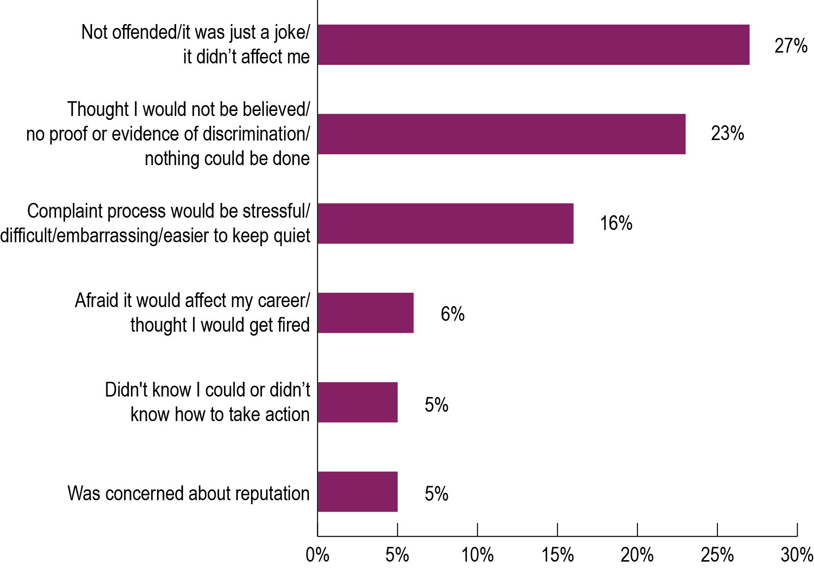

Base: Total number of respondents who did not take action in response to experiencing discrimination (n=133).
The question offered multiple responses (except for ‘None of these’) so reported percentages may not equal 100%.

Outcomes of actions taken
Three in five (58%) Australians aged 50 years and older who experienced discrimination indicated that the issue was not resolved (Figure 44). One in ten (11%) reported that the issue was resolved partially.
Only three in ten (31%) people indicated that the issue was fully resolved.

Figure 44 – Issues resolved
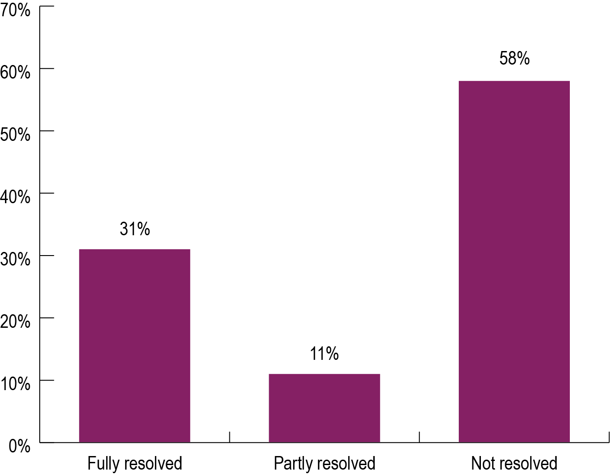

Base: Total number of respondents who experienced discrimination in the last two years (n=309).

Those who experienced discrimination and reported that the issue was fully or partially resolved were asked in what way the issue was resolved (Figure 45). One in six (17%) people reported that they quit their job. One in ten (12%) looked for another job or found another job. One in seven (14%) of those said that they moved on or ignored the issue and a similar proportion (13%) believed that there was not an issue or it was a joke. Nearly one in ten (8%) kept their job. A small group of people (5%) discussed the issue with their employer/colleagues/parties involved
and a similar (5%) proportion was retrained. In addition a small group (3%) of people received their flexible work arrangements and a similar proportion (3%) was given an apology.

Figure 45 – How the issue was resolved
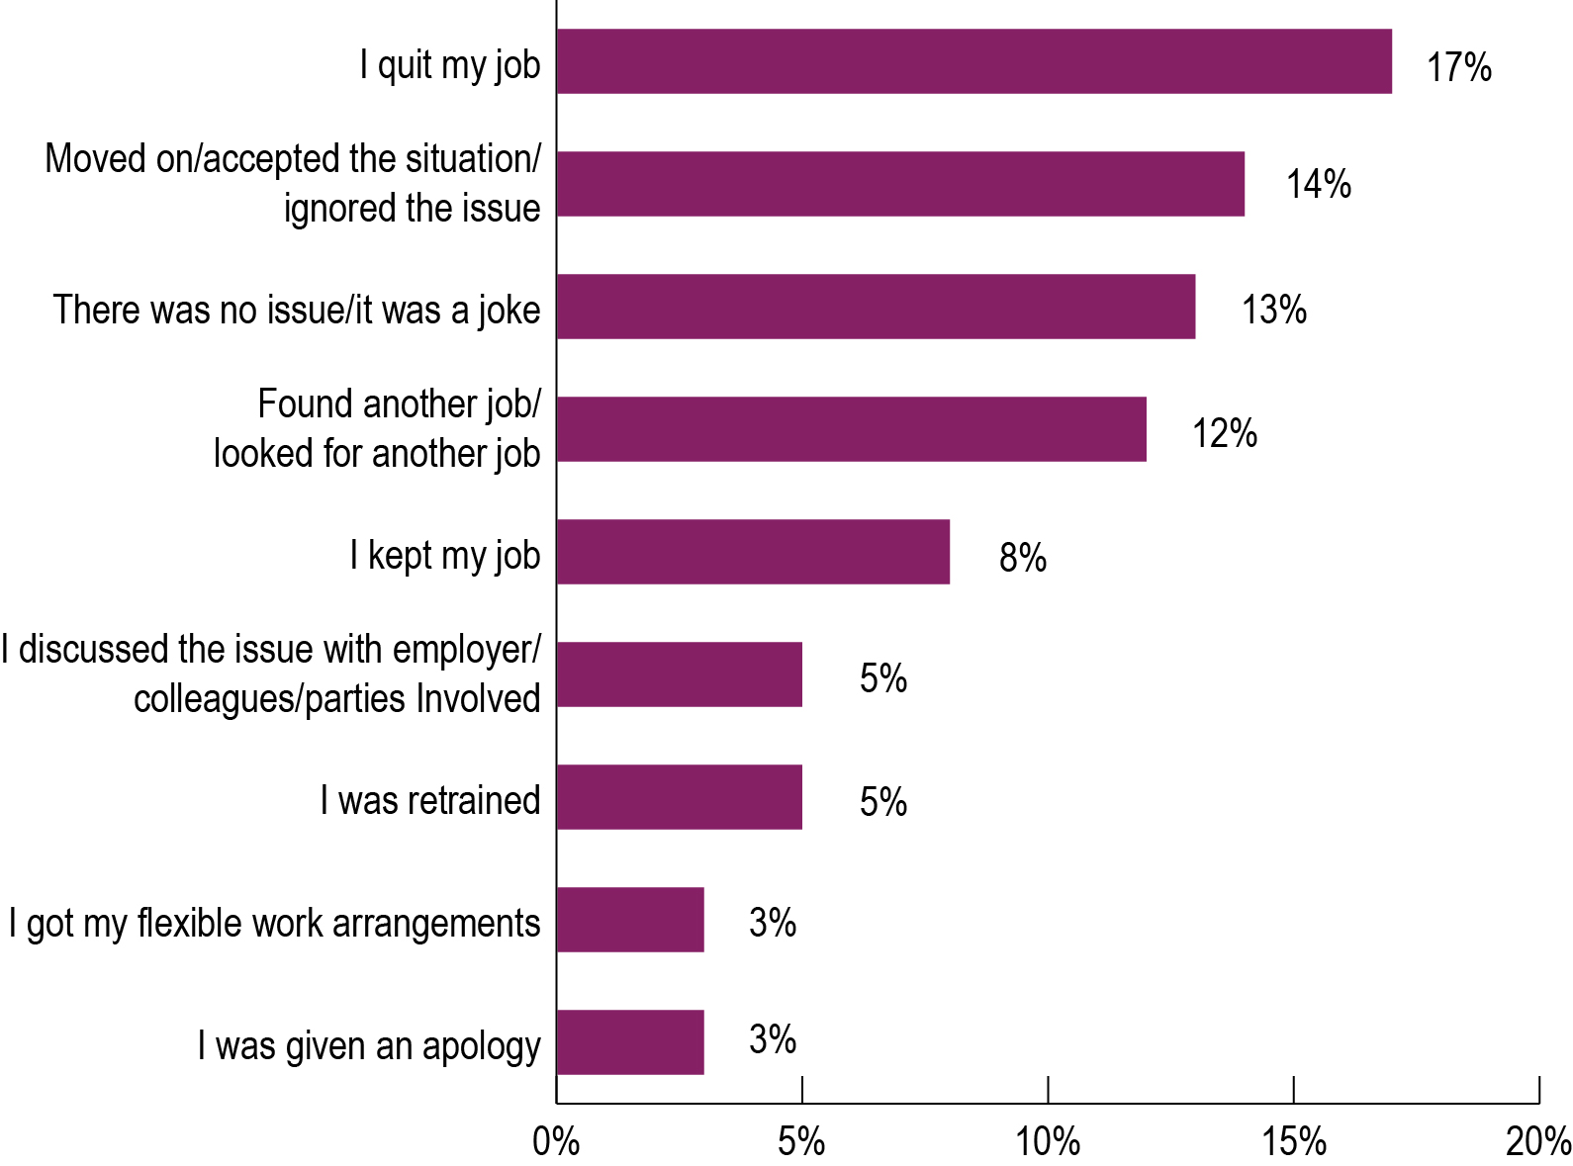

Base: Total number of respondents who experienced discrimination and reported that the issue was fully or partially resolved (n=131). The question offered multiple responses so reported percentages may not equal 100%.

Conclusion
Although most people who had been subjected to age discrimination in the workplace in the last two years were aware that they could take some form of action in regard to this treatment, a sizable proportion chose not to do so.
The reasons given for not taking any corrective action point to three specific areas which relate to workplace culture:
    - One in four (23%) of those who chose not to take any action felt that they would not be believed, they had no proof or that nothing could be done. This may suggest a lack of confidence that their employer would support them. This issue is further highlighted by the significant proportion of people who believed that taking action about the discrimination would be too stressful or embarrassing or it was just easier to keep quiet.
    - Although only reported by a relatively small proportion of those who chose not to take action it is particularly concerning that some workers are too intimidated to take action because they believe that this would impact on their reputation, their career or job security.
    - The evidence suggests that there is a lack of understanding in the workplace that jokes and derogatory comments may be a form of age discrimination.
While the majority of those who had experienced age discrimination took some action in regard to the most recent event, their response in most cases was to think about leaving their job or changing career, or discuss it with family, friends or colleagues. Relatively few raised the issue within their organisation or approached an external organisation for assistance.
Consequently the issue remained unresolved for the majority of people. Where it was perceived to have been resolved, for most of these people the resolution involved them quitting, finding or seeking alternative employment, or simply accepting the situation.
These findings clearly indicate the need for responsive and supportive workplaces to ensure that age discrimination is reported, and appropriately dealt with, in order to retain older workers and prevent them from leaving.

Retirement and superannuation

KEY FINDINGS
The data shows that superannuation provided Australians with the option to choose the timing of their retirement.
- Over two in five (44%) Australians aged 50 years and older who are currently retired would not have been able to retire or would have had to delay their retirement if they had not been a member of a superannuation scheme at the time of their retirement.
Women were more likely than men to report that they still would have retired when they did regardless of superannuation
- It is worth noting that women were more likely than men to report that they still would have retired when they did if they had not been a member of the superannuation fund (65% vs. 48% respectively).

Introduction
Superannuation can play a key role in the decision of older workers to transition from the workplace to retirement. Given that some people experiencing age discrimination at work will resolve the problem by retiring, Chapter 7 examines the importance of having access to superannuation when making a decision to leave the workplace.
Australians aged 50 years and older who are currently retired were asked whether they would have had to stay working if they had not been a member of a superannuation scheme at the time of their retirement.

Influence of superannuation on decision making about retirement
Two in five (43%) of those with superannuation when they retired would have had to remain in the workforce if they did not have this superannuation.
This consisted of 16% of retirees with superannuation who would have had to delay their retirement, and a further 28% would have not been able to retire.
It is worth noting that women are less likely than men to be influenced by superannuation when making the decision to retire. Two thirds (65%) of women would still have retired when they did even if they did not have superannuation, compared to one in two men (48%).

Figure 46 – Influence of superannuation on decision making about retirement
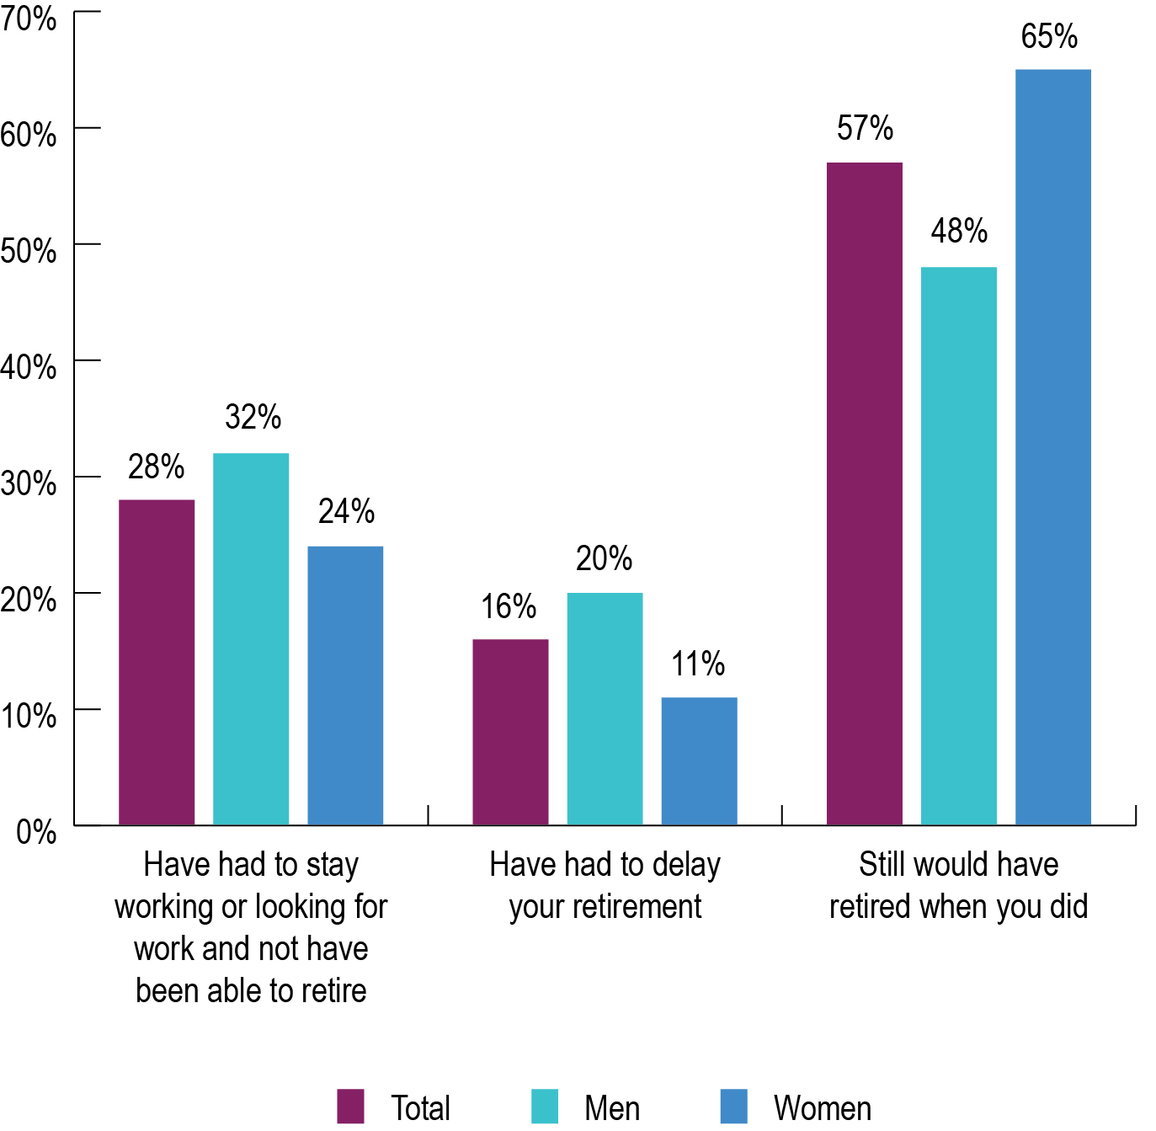

Base: Currently retired and were a member of a superannuation scheme at the time of retirement (n=705).

Appendix 1: Questionnaire

RDD SAMPLE INTRODUCTION:
Good [Morning/Afternoon/Evening]. My name is (SAY NAME) from Roy Morgan Research. We are conducting an important study of people aged 50 and over on behalf of the Australian Human Rights Commission. May I please speak to someone in the household aged 50 and over?
IF QUERIED ABOUT HOW NAME OR NUMBER WAS SOURCED:
We are contacting people from all over Australia. A computer has randomly generated numbers for us to phone.

SS SAMPLE INTRODUCTION:
Good [Morning/Afternoon/Evening]. My name is (SAY NAME) from the Roy Morgan Research. May I please speak to [SAY NAME]? We are conducting an important social study on behalf of the Australian Human Rights Commission.

BOTH RDD AND SS SAMPLE
IF NECESSARY:
The time needed for the survey depends on each person’s experience – for a lot of people it will only take around 10 minutes but in some cases it might take an additional 5-10 minutes. The information will be used for research purposes only. Your answers will remain strictly confidential. You will not be identified in any way in the results.
Your answers will be combined with the information from hundreds of other participants across Australia.
IF NECESSARY, ADD:
We really would like to include your opinion and experience in this survey to ensure a representative and diverse sample of Australians.
    - Willing to participate
    - Refused
    - No-one in household is aged 50+ Is now a good time?
IF NECESSARY, MAKE APPOINTMENT.
First I need to ask a few questions about you to see if you qualify for the survey.

[Single]
- Can you please tell me your age? (READ OUT IF NECESSARY)
  - Less than 50 years old 2. 50-52
3. 53-54
4. 55-59
5. 60-64
6. 65-69
7. 70-74
8. 75 and over
99. REFUSED

IF NECESSARY: For this study we need to know which age group you are in.
IF Q1=1 OR 99 TERMINATE- SAY: Thank you for your time, but we need this information to continue with this survey.

[Single]
  - What is your gender?
    - Female
    - Male
    - X (indeterminate, intersex, unspecified)
99. REFUSED

IF AGE/SEX QUOTA FULL, TERMINATE – SAY: Thank you for your time and assistance but we have spoken to enough people in your age group.
IF Q2=99 TERMINATE – SAY: Thank you for your time, but we need this information to continue with this survey.

[Single]
  - Can you please tell me the postcode of where you live?

98. CAN’T SAY/DON’T KNOW

IF Q3=98 TERMINATE- SAY: Thank you for your time, but we need this information to continue with this survey.
IF GEOGRAPHIC QUOTA FULL, TERMINATE – SAY: Thank you for your time and assistance but we have spoken to enough people in your area.

IF SINGLE SOURCE, ASK Q5:

[Single]
- Do you live in a home that also has a landline telephone?
  - Yes
  - No
98. CAN’T SAY/DON’T KNOW

Now we are going to ask you a few questions about your experience in Australia…
ASK ALL

[Multiple]
- At any time during 2013 and 2014 (in the last two years) have you:
  - Worked for a wage or salary
  - Been self-employed
  - Looked for paid work
  - None of these [Single]
99. REFUSED

IF Q6=99 TERMINATE – SAY: Thank you for your time, but we need this information to continue with this survey.

IF Q6=4 ASK Q36

[Single]
- Now thinking about when you <SHOW IF CODE 1 IN Q6> were working for a wage or salary /<SHOW IF CODE 2 IN Q6> were self-employed /<SHOW IF CODE 3 IN Q6> were looking for paid employment during 2013 and 2014, have you at any time during those two years, been treated less favourably than other people in a similar situation because of your age or because of assumptions made about older people?
  - Yes
  - No
98. DON’T KNOW

IF Q7=1 ASK Q8
IF Q7=2 OR 98 ASK Q9

[Multiple]
- In what way were you treated less favourably than other people in a similar situation because of your age or because of assumptions about older people? Please tell me about ALL occasions when you were treated less favourably.

DO NOT READ OUT
  - I was told that because of my age I was too slow to learn new things
  - I was told that because of my age my set of skills was outdated
  - I was treated so poorly because of my age that I left the job
  - I was threatened with redundancy or dismissal because of my age
  - I was told that my age was the reason for my redundancy or dismissal
  - I was told that people of my age could not do my job properly or as well as a younger person
  - My employer asked me to retire or my colleagues said that I had to retire because of my age
  - I was told that I did not get a job that I WAS interviewed for because of my age
  - I was told that because of my age I would not be interviewed or considered for a job or would not be offered a promotion
  - I was told that someone of my age would not fit in with the culture of the workplace
  - I was told that my duties, role or work hours were to be/had been changed because of my age
  - I was told that because of my age I was/would be made casual
  - I was told that because of my age I would not have access to training or courses or work opportunities
  - I was told that my work was unsatisfactory because of my age
  - I received inappropriate or derogatory comments from my employer/manager/colleagues based on my age
  - My age was a subject of jokes among my colleagues

Although they have not directly told me, my employer/potential employer or colleagues think/thought that, because of my age:
  - I am/was too slow to learn new things
  - My set of skills are/were outdated
  - I should be/would be made redundant/dismissed
  - I can not/could not do my job properly or as well as a younger person
  - I should/had to retire
  - I should not be interviewed or considered for a job or offered a promotion
  - I do not/would not fit in with the culture of the workplace
  - My duties, role or work hours should be/would be changed
  - I should be/would be made casual
  - I should not/would not have access to training or courses or work opportunities
  - My work is/was unsatisfactory
  - I should not/would not get a job that I was interviewed for
97. OTHER (Specify) ………………….

PROGRAMMING NOTE: IN Q9 DO NOT SHOW CODES ALREADY SELECTED IN Q8

[Multiple]
- At any time in the last two years, that is during 2013 and 2014, did you experience any of the following when you <SHOW IF CODE 1 IN Q6> were working for a wage or salary /<SHOW IF CODE 2 IN Q6> were self- employed/<SHOW IF CODE 3 IN Q6> were looking for paid employment?

READ OUT
  - You were told that because of your age you were too slow to learn new things
  - You were told that because of your age your set of skills were outdated
  - You were treated so poorly because of your age that you left the job
  - You were threatened with redundancy or dismissal because of your age
  - You were told that your age was the reason for your redundancy or dismissal
  - You were told that people of your age could not do your job properly or as well as a younger person
  - Your employer asked you to retire or your colleagues said that you had to retire because of your age
  - You were told that because of your age you did not get a job that you were interviewed for
  - You were told that because of your age you would not be interviewed or considered for a job or would not be offered a promotion
  - You were told that someone of your age would not fit in with the culture of the workplace
  - You were told that because of your age your duties, role or work hours had been/would be changed
  - You were told that because of your age you had been/would be made casual
  - You were told that because of your age you would not have access to training or courses or work opportunities
  - You were told that your work was unsatisfactory because of your age
  - You received inappropriate or derogatory comments from your employer/manager/colleagues based on your age
  - Your age was a subject of jokes among your colleagues
98. NONE OF THE ABOVE [Single]

IF Q8=17-28 DONT ASK Q10

[Single]
- At any time in the last two years, were you in a situation, at work or when looking for work, where you believed that you were treated less favourably than other people in a similar situation because of your age or because of assumptions made about older people, even though you were not told directly that your age was the reason?
  - Yes
  - No
98. DON’T KNOW

IF Q10 = 1 ASK Q11
IF Q10=2 OR 98 AND Q7=2 OR 98 AND Q9=98 ASK Q28
IF Q10=2 AND Q8=1-97 OR Q9=1–16 AND THERE IS ONLY 1 RESPONSE in Q8 AND Q9 ASK Q13
IF Q10=2 AND Q8=1-97 OR Q9=1–16 AND THERE IS MORE THAN 1 RESPONSE IN Q8 AND Q9 ASK Q12

[Multiple]
- In what way do you believe that you were treated less favorably?

DO NOT READ OUT
MY EMPLOYER/POTENTIAL EMPLOYER OR COLLEAGUES THINK/THOUGHT THAT, BECAUSE OF MY AGE,
  - I am/was too slow to learn new things
  - My set of skills are/were outdated
  - I should be/would be made redundant/dismissed
  - I can not/could not do my job properly or as well as a younger person
  - I should/had to retire
  - I should not be interviewed or considered for a job or offered a promotion
  - I do not/would not fit in with the culture of the workplace
  - My duties, role or work hours should be/would be changed
  - I should be/would be made casual
  - I should not/would not have access to training or courses or work opportunities
  - My work is/was unsatisfactory
  - I should not/would not get a job that I was interviewed for
98. OTHER (Specify) ………………….

IF Q8=1-97 OR Q9=1–16 OR Q11 = 1-98 AND THERE IS ONLY 1 RESPONSE ASK Q13
IF Q8=1-97 OR Q9=1–16 OR Q11 = 1-98 AND THERE IS MORE THAN 1 RESPONSE ASK Q12

[Single]
- In summary then, during the last two years [READ OUT CODES BELOW]. Which one happened most recently?
  - You were told that because of your age you were too slow to learn new things
  - You were told that because of your age your set of skills were outdated
  - You were treated so poorly because of your age that you left the job
  - You were threatened with redundancy or dismissal because of your age
  - You were told that your age was the reason for your redundancy or dismissal
  - You were told that people of your age could not do your job properly or as well as a younger person
  - You were your employer asked you to retire or your colleagues said that you had to retire because of you were your age
  - You were told that you did not get a job that you were interviewed for because of your age
  - You were told that because of your age you would not be interviewed or considered for a job or would not be offered a promotion
  - You were told that someone of your age would not fit in with the culture of the workplace
  - You were told their duties, role or work hours had been/would be changed because of their age
  - You were told that because of your age you had been/would be made casual
  - You were told that because of your age you would not have access to training or courses or work opportunities
  - You were told that your work was unsatisfactory because of your age
  - You received inappropriate or derogatory comments from your employer/manager/colleagues based on your age
  - Your age was a subject of jokes among your colleagues
  - Your employer/potential employer or colleagues think/thought that, because of your age you are/ were too slow to learn new things
  - Your employer/potential employer or colleagues think/thought that, because of your age your set of skills are/were outdated
  - Your employer/potential employer or colleagues think/thought that, because of your age you should be/would be made redundant/dismissed
  - Your employer/potential employer or colleagues think/thought that, because of your age you can not/could not do my job properly or as well as a younger person
  - Your employer/potential employer or colleagues think/thought that, because of your age you should/had to retire
  - Your employer/potential employer or colleagues think/thought that, because of your age you should not be interviewed or considered for a job or offered a promotion
  - Your employer/potential employer or colleagues think/thought that, because of your age you do not/would not fit in with the culture of the workplace
  - Your employer/potential employer or colleagues think/thought that, because of your age your duties, role or work hours should be/would be changed
  - Your employer/potential employer or colleagues think/thought that, because of your age you should be/would be made casual
  - Your employer/potential employer or colleagues think/thought that, because of your age you should not/would not have access to training or courses or work opportunities
  - Your employer/potential employer or colleagues think/thought that, because of your age your work is/was unsatisfactory
  - Your employer/potential employer or colleagues think/thought that, because of your age you should not/would not get a job that you was interviewed for
98. Other (as specified)

[Single]
- When did this last happen? Would it have been … READ OUT UNTIL RESPONDENT SAYS YES
  - Within the last week
  - Between 1 and 2 weeks ago
  - Between 3 and 4 weeks ago
  - 1 to 3 months ago
  - 3 to 6 months ago
  - 6 to 12 months ago
  - 12 to 18 months ago
  - 19 to 24 months ago
97. DON’T KNOW/CAN’T REMEMBER

[Single]
- Did this episode occur when you were applying for a job or promotion with your current employer, when applying for a job with someone you were not employed by or in relation to some other aspect of your work?
  - A job/promotion with your current employer
  - A job with someone you were not employed by
  - Some other aspect of your work

IF Q14=1 OR 2 ASK Q15

[Multiple]
- When this episode occurred, were you being interviewed by a recruitment agency representing the potential employer, someone from the company offering the job, or someone at your workplace?
  - A recruitment agency representing the potential employer
  - Someone from the company offering the job
  - Someone at your workplace

[Multiple]
- What impact, if any, did that <SHOW IF SELECTED MORE THAN ONE CODE IN TOTAL ACROSS Q8, Q9 AND Q11 most recent> episode have on you?

READ OUT
Affected your
  - Self-esteem and confidence
  - Your mental health
  - Caused you stress Negatively impacted on
  - Your family
  - You financially
  - Your career
  - Your capacity to seek other work

Made you

  - Think about or start planning for retirement
  - Consider changing your occupation or industry
  - Consider accessing your superannuation fund
  - Give up looking for work
  - Consider retraining or updating my skills
- NONE OF THESE [Single]
- OTHER
- DON’T KNOW

[Multiple]
- Still thinking about this <SHOW IF SELECTED MORE THAN ONE CODE IN TOTAL ACROSS Q8, Q9 AND Q11 most recent> episode, what actions, if any, did you take?
  - Discussed it with family/friends
  - Discussed it with colleagues
  - Discussed/raised it with supervisor/manager
  - Discussed/raised it with human resources/personnel department
  - Made a formal complaint within the organisation
  - Went to a union or employee advisory service
  - Went to a solicitor or legal service
  - Contacted the australian human rights commission or a state or territory discrimination agency
  - Made a complaint to the australian human rights commission or a state or territory discrimination agency
  - Contacted the fair work ombudsman/fair work commission
  - Lodged a complaint with fair work ombudsman/fair work commission
  - Went to look for another job
  - Resigned
  - Retired
  - Thought about retirement
  - Thought about changing my career/retraining myself
  - Changed my profession
  - Went on pension
  - Didn’t take any action [Single]
97. OTHER

IF Q17=19 ASK Q18
IF Q17=1-18 OR 97 ASK Q19

[Multiple]
- Why didn’t you take any action?
  - I could not afford to lose my job because I am too old to look for another job
  - Not aware of how to take action or who to report it to
  - I didn’t know I could
  - Family/friends/co-workers advised me not to
  - Easier to keep quiet
  - Thought I would not be believed
  - Complaint process would be stressful
  - Complaint process would be embarrassing

  - Complaint process would be difficult
  - Would not change things/Nothing could be done
  - Didn’t want to get a reputation for being a troublemaker
  - Afraid it would affect my career
  - Thought I would get fired
- OTHER (Specify) ………………….
- DON’T KNOW

[Single]
- Was the issue resolved?
  - Yes fully
  - Yes partly
  - No

IF Q19=1 or 2 ASK Q20

[Multiple]
- In what way was the issue resolved?
  - I was given an apology
  - I received financial compensation
  - I kept my job
  - I was retrained
  - I quit my job
  - I got my flexible work arrangements
- OTHER (Specify) ………………….
- DON’T KNOW

PROGRAMMER NOTE: SHOW Q21A IF Q14 =3, SHOW Q21B IF Q14 =1 or 2

[Single]
21A. Now thinking about your role in the organisation where this occurred, can you please tell me your occupation in that organisation at the time this episode occurred?

[Single]
21B. Now thinking about the role you were applying for when this occurred, can you please tell me your occupation you were applying for at the time this episode occurred?
- Manager
- Professional
- Technician/Trade worker
- Community and personal service
- Clerical/Admin
- Sales
- Machinery operators/Drivers
- Labourers

[Single]
- Can you please tell me the industry of that job?
  - Agriculture, forestry and fishing
  - Mining
  - Manufacturing
  - Electricity, gas, water and water services
  - Construction
  - Wholesale trade
  - Retail trade
  - Accomodation and food services
  - Transport, postal and warehousing
  - Information media and telecommunication
  - Financial and insurance services
  - Rental, hiring and real estate services
  - Professional, scientific and technical services (including legal, accounting, architectural, engineering and other professions)
  - Administrative and support services
  - Public administration and safety
  - Education and training
  - Health care and social assistance
  - Arts and recreational services
  - OTHER SERVICES
98. CAN’T SAY

[Single]
- Was this job a fixed-term contract, casual employment or an on-going/permanent job?
  - Fixed-term contract
  - Casual
  - On-going/Permanent
98. DON’T KNOW

[Single]
- And were the normal working hours 35 hours or more per week or less than 35 hours per week?
  - 35 hours or more
  - Less than 35 hours
98. DON’T KNOW

[Single]
- And was the job located in a …
  - Major city
  - Large regional town
  - Small regional town
  - Rural area
  - OTHER
98. DON’T KNOW

[Single]
- Was the employer a
  - Public sector or government organization (e.g. government department or organization, military services, police)
  - Private sector organization (e.g. a company)
  - Not-for-profit organization (e.g. a charity)
98. DON’T KNOW

[Single]
- About how many people worked in that organisation as a whole (including on different sites/locations in Australia if that applies)? Would you estimate that to be…
  - Less than 20 2. 20-199
3. 200-499
4. 500-3000
5. More than 3000
98. DON’T KNOW

[Single]
- At any time during the last two years, were you aware of other people aged 50 years or older being treated less favourably because of their age while working or looking for work?
  - Yes
  - No
98. DON’T KNOW

IF 28=1 ASK Q29

[Single]
- Would you say that, this treating other people aged 50 years or older less favourably because of their age while working or looking for work occurred all the time, frequently, occasionally, rarely or was a one-off event?
  - Always
  - Frequently
  - Occasionally
  - Rarely
  - One-off event
  - DON’T KNOW

Now we are going to ask you a few questions about your experience in Australia…

[Multiple]
- Have you been in any of the following roles in the last two years?
INTERVIEWER NOTES: The list below does not include volunteer work. We are interested in the situation where they either in a role they receive a wage for or where they own the businesses.
  - Manager of a business that employs staff
  - In a senior management role responsible for decision making about staff
  - Human Resources Manager or equivalent
  - Been responsible for selecting or recommending people for employment or promotion
  - NONE OF THESE [Single]

IF Q30=5 AND Q1 = 2 ASK Q44 IF Q30=5 AND Q1 = 3-8 ASK Q38 IF Q30=1-4 ASK Q30A
[Quantity]
30A. Now I have some questions from a different perspective. For these questions, please think about your role as an employer or manager of staff in the last two years. Again, please remember that this survey is confidential, and your answers will not be revealed to anyone except as statistics. At about what age do you think people are thought of as “older employees”?
IF NECESSARY SAY: There is no right or wrong answer to this – we’re just interested in your perception. If a range is given ask for a specific age or record youngest age in range

[Enter actual age given]
- No age/no one is regarded as older
- Can’t say

IF Q30A=98 ASKQ31

[Single]
- Would you say that someone was generally thought of as an “older employee” at the age of..

[READ OUT TILL RESPONDENT SAYS YES]
  - Under 45 years old
  - 45 years old and over
  - 50 years old and over
  - 55 years old and over
  - 60 years old and over
  - 65 years old and over
  - 70 years old and over
  - 75 years old and over
- No age/No one is regarded as older
- CAN’T SAY

[Single]
- In your role as an employer or manager over the last two years how often did you take a person’s age into consideration when making hiring decisions? Would you say the person’s age was considered always, frequently, occasionally, rarely or never?
  - Always
  - Frequently
  - Occasionally
  - Rarely
  - Never
98. Did not hire anyone in the last two years

[Single]
- Over the last two years how often did you take a person’s age into consideration when making a decision to promote someone? Would you say the person’s age was considered always, frequently, occasionally, rarely or never?
  - Always
  - Frequently
  - Occasionally
  - Rarely
  - Never
98. Did not promote anyone in the last two years

[Single]
- And what about making a decision to send someone on a training course, sending them to a conference or offering them study assistance? Would you say the person’s age was considered always, frequently, occasionally, rarely or never?
  - Always
  - Frequently
  - Occasionally
  - Rarely
  - Never
98. Did not send anyone on training/to a conference or offer study assistance in the last two years

[Single]
- Over the last two years how often did you take a person’s age into consideration when making a decision to retrench or fire someone? Would you say the person’s age was considered always, frequently, occasionally, rarely or never?
  - Always
  - Frequently
  - Occasionally
  - Rarely
  - Never
98. Did not retrench or fire anyone in the last two years

IF Q6=4 ASK Q36

[Single]
- Even though you were not in paid employment or looking for work during 2013 or 2014, would you have liked, at any time during those two years, to have worked for a wage or salary, been self-employed or have looked for paid work or employment.
  - Yes
  - No
98. CAN’T SAY

IF Q36=1 ASK Q37

[Multiple]
- Why didn’t you work for a wage or salary, be self-employed or look for paid work or employment at some time during the two years 2013 and 2014? Please give me all your reasons.
  - I’m too old/I think my skills/knowledge is too out of date
  - It’s too long since I worked to try now
  - My husband/wife/partner/thinks I am too old
  - My family/friends think I am too old
  - No one will employ people of my age
  - Potential employers/recruiters would think I am too old
  - I felt I would not be taken seriously by employers/employers would think I was too old
  - No employment in my area or experience/skill/qualification
  - I felt too old myself/didn’t feel I could do the job well enough as I was too old
  - I was too scared to apply because I’d been out of the workforce so long
  - Family commitments/need to look after family member
  - Health reasons
  - My husband/wife/partner stopped work so I did as well
  - Cannot work because it may affect my pension/superannuation
- OTHER (Specify) ………………….
- DON’T KNOW/NO REASON

ASK ALL EXCEPT FOR Q1=2

Now we are going to ask you a few questions about your experience in Australia…

[Multiple]
- Now I want to ask you about the period since you turned 50 and the end of December 2012. At any time in the period since you turned 50 and the end of December 2012 were you:
  - Working for a wage or salary
  - Self-employed
  - Looking for paid work
  - NONE OF THESE [Single]

IF Q38=4 AND Q6 = 1-3 ASK Q44 IF Q38=4 AND Q6 = 4 ASK Q45
- At any time in the period since you turned 50 and the end of December 2012, when you <SHOW IF CODE 1 IN Q38> were working for a wage or salary/<SHOW IF CODE 2 IN Q38> were self-employed /<SHOW IF CODE 3 IN Q38> were looking for paid employment, were you treated less favourably than other people in a similar situation because of your age or because of assumptions made about older people?
  - Yes
  - No
98. DON’T KNOW

ASK Q40 IF Q39=1
ASK Q41 IF Q39=2 OR 98 OR 99

[Multiple]
- In what way were you treated less favourably than other people in a similar situation because of your age or because of assumptions about older people?
Please tell me about ALL occasions when you were treated less favourably

DO NOT READ OUT
  - I was told that because of my age I was too slow to learn new things
  - I was told that because of my age my set of skills was outdated
  - I was treated so poorly because of my age that I left the job
  - I was threatened with redundancy or dismissal because of my age
  - I was told that my age was the reason for my redundancy or dismissal
  - I was told that people of my age could not do my job properly or as well as a younger person
  - My employer asked me to retire or my colleagues said that I had to retire because of my age
  - I was told that I did not get a job that I was interviewed for because of my age
  - I was told that because of my age I would not be interviewed or considered for a job or would not be offered a promotion
  - I was told that someone of my age would not fit in with the culture of the workplace
  - I was told that my duties, role or work hours were to be/had been changed because of my age
  - I was told that because of my age I was/would be made casual
  - I was told that because of my age I would not have access to training or courses or work opportunities
  - I was told that my work was unsatisfactory because of my age
  - I received inappropriate or derogatory comments from my employer/manager/colleagues based on my age
  - My age was a subject of jokes among my colleagues
Although they have not directly told me, my employer/potential employer or colleagues thought that, because of my age
- I was too slow to learn new things
- My set of skills were outdated
- I would be made redundant/dismissed
- I could not do my job properly or as well as a younger person
- I had to retire
- I would not be interviewed or considered for a job or offered a promotion
- I would not fit in with the culture of the workplace
- My duties, role or work hours had been/would be changed
- I had been/would be made casual
- I would not have access to training or courses or work opportunities
- My work was unsatisfactory
- I did not get a job that I was interviewed for
- OTHER (Specify) ………………….

PROGRAMMING NOTE: IN Q41 DO NOT SHOW CODES ALREADY SELECTED IN Q40

[Multiple]
- At any time in the period since you turned 50 and the end of December 2012, did you experience any of the following when you <SHOW IF CODE 1 IN Q38> were working for a wage or salary/<SHOW IF CODE 2 IN Q38> were self-employed /<SHOW IF CODE 3 IN Q38> were looking for paid employment?

READ OUT
  - You were told that because of your age you were too slow to learn new things
  - You were told that because of your age your set of skills were outdated
  - You were treated so poorly because of your age that you left the job
  - You were threatened with redundancy or dismissal because of your age
  - You were told that your age was the reason for your redundancy or dismissal
  - You were told that people of your age could not do your job properly or as well as a younger person
  - Your employer asked you to retire or your colleagues said that you had to retire because of your age
  - You were told that because of your age you did not get a job that you were interviewed for
  - You were told that because of your age you would not be interviewed or considered for a job or would not be offered a promotion
  - You were told that someone of your age would not fit in with the culture of the workplace
  - You were told that because of your age your duties, role or work hours had been/would be changed
  - You were told that because of your age you had been/would be made casual
  - You were told that because of your age you would not have access to training or courses or work opportunities
  - You were told that your work was unsatisfactory because of your age
  - You received inappropriate or derogatory comments from your employer/manager/colleagues based on your age
  - Your age was a subject of jokes among your colleagues
98. NONE OF THE ABOVE [Single]

IF Q40=17-28 DONT ASK Q42

[Single]
- At any time in the period since you turned 50 and the end of December 2012, were you in a situation, at work or when looking for work, where you believed that you were treated less favourably than other people in a similar situation because of your age or because of assumptions made about older people, even though you were not told directly that your age was the reason?
  - Yes
  - No
98. DON’T KNOW

IF Q42=1 ASK Q43
IF Q42=2 OR 98 AND Q6 = 1-3 ASK Q44 IF Q42=2 OR 98 AND Q6 = 4 ASK Q45

- In what way do you believe that you were treated less favorably?

DO NOT READ OUT
MY EMPLOYER/POTENTIAL EMPLOYER OR COLLEAGUES THOUGHT THAT, BECAUSE OF MY AGE,
  - I was too slow to learn new things
  - My set of skills were outdated
  - I was/would be made redundant/dismissed
  - I could not do my job properly or as well as a younger person
  - I had to retire
  - I would not be interviewed or considered for a job or offered a promotion
  - I would not fit in with the culture of the workplace
  - My duties, role or work hours had been/were to be changed
  - I had been/would be made casual
  - I would not have access to training or courses or work opportunities
  - My work was unsatisfactory
  - I did not get a job that I was interviewed for
98. OTHER (Specify) ………………….

Q6 = 1-3 ASK Q44 Q6 = 4 ASK Q45
[Single]
- At what age do you think you will retire? 1. 50-54
2. 55-59
3. 60-64
4. 65-69
5. 70-74
- 75 and over
- I am not going to retire
- Already retired

IF Q44=1-7 ASK Q47 IF Q44 =8 ASK Q46
- Are you currently retired?
  - Yes
  - No

F Q45=2 ASK Q47

- At the time you retired were you a member of a superannuation scheme?
  - Yes
  - No

IF Q46=2 ASK Q47

[Single]
46A. If you had NOT been a member of a superannuation scheme would you

READ OUT
- Have had to stay working or looking for work and not have been able to retire
- Have had to delay your retirement
- Still have retired when you did

ASK ALL

[Single]
- Are you of Aboriginal and/or Torres Strait Islander descent?

SINGLE RESPONSE – INTERVIEWER NOTE: DO NOT READ – PROMPT IF NECESSARY (I.E. IF SAYS ‘YES’ ASK “ARE YOU ABORIGINAL, TORRES STRAIT ISLANDER OR BOTH?”)
  - Aboriginal
  - Torres strait islander
  - Both
  - None
99. NOT DISCLOSED

[Single]
- What is the main language spoken at home?

INTERVIEWER NOTE: DO NOT READ LIST
  - English
  - Italian
  - Greek
  - Cantonese
  - Mandarin
  - Arabic
  - Vietnamese
97. OTHER (Specify) ………………….

[Single]
- Which of the following best describes your household?
  - Couple with child/children living in the household
  - One parent family with child/children living in the household
  - Single household with no children
  - Couple with no children
  - Several adults, no children
99. REFUSED

[Single]
- STANDARD DEMOGRAPHIC QUESTION
What is the highest level of education you’ve reached?
  - Postgraduate Degree
  - Undergraduate degree
  - Tertiary Diploma (not University)
  - Technical certificate, trade qualification or TAFE or Commercial College certificate
  - Finished Secondary school
  - Some secondary school
  - Finished primary school
  - Some primary school
  - Did not go to school
- OTHER
- CAN’T SAY

[Single]
- Please indicate your household’s TOTAL approximate annual income from all sources, before tax. 1. Under $20,000
2. $20,001 – $35,000
3. $35,001 – $50,000
4. $50,001 – $70,000
5. $70,001 – $100,000
6. $100,001 – $150,000
7. $150,001 – $200,000
8. $200,001 or more
- NONE OF THESE
- OTHER (Specify) ………………….
- CAN’T SAY/DON’T KNOW

IF Q49=1 or 4 ASK Q52:

[Single]
- Are you the main income earner in your household?
  - Yes
  - No
98. DON’T KNOW

[Single]
- This survey has been conducted on behalf of The Australian Human Rights Commission. If we need to further investigate these issues could we re-contact you to get more information about your experience and opinions as an older people in the workforce?
  - Yes
  - No

IF Q53=2 CLOSE AND THANK

[Single]
- May I have your name and contact details, so we can contact you?
  - Yes
  - No

[Open]
- May I have your first name?

[Open]
- May I have your last name?

[Open]
- Can you please tell me your phone number?

[Open]
- Can you please tell me your email?

[Open]
- Are there any particular times or days of the week when it is best to try and call you?

[Single]
[CONFIRM PHONE NUMBER AND EMAIL AND CONTACT TIMES]
- Are these details correct?
  - Yes
  - No

PROGRAMMING NOTE: DISPLAY DETAILS COLLECTED AND LOOP BACK TO CORRECT DETAILS EACH DETAIL THAT IS INCORRECT. DISPLAY PHONETIC.
Thank you very much for your time and assistance. This research is carried out in compliance with the Privacy Act and Telecommunications and Research Calls Industry Standard, and the information you provided will be used only for research purposes.
If you would like any more information about this project or Roy Morgan Research, you can phone us on 1800 337 332.

Appendix 2: Standard error tables

Summary of sample variance associated with survey estimates
94

Survey estimate | Total sample N=2,000 & sub-sets within –  2000 1900 1800 1700 1600 |  |  |  |  | 1500 | 1400 | 1300 | 1200 | 1100 | 1000 | 900 | 800 | 700 | 600 | 500 | 400 | 300 | 200 | 100 | 50
Sample variance (+/-) 95% confidence intervals
10% | 1.1% | 1.1% | 1.2% | 1.2% | 1.2% | 1.3% | 1.3% | 1.4% | 1.4% | 1.5% | 1.6% | 1.6% | 1.7% | 1.9% | 2.0% | 2.2% | 2.5% | 2.8% | 3.5% | 4.9% | 7.0%
20% | 1.8% | 1.5% | 1.6% | 1.6% | 1.6% | 1.7% | 1.8% | 1.8% | 1.9% | 2.0% | 2.1% | 2.2% | 2.3% | 2.5% | 2.7% | 2.9% | 3.3% | 3.8% | 4.7% | 6.6% | 9.3%
30% | 2.0% | 1.7% | 1.8% | 1.8% | 1.9% | 1.9% | 2.0% | 2.1% | 2.2% | 2.3% | 2.4% | 2.5% | 2.7% | 2.8% | 3.1% | 3.4% | 3.8% | 4.4% | 5.3% | 7.5% | 10.7%
40% | 2.1% | 1.8% | 1.9% | 2.0% | 2.0% | 2.1% | 2.2% | 2.2% | 2.3% | 2.4% | 2.5% | 2.7% | 2.8% | 3.0% | 3.3% | 3.6% | 4.0% | 4.7% | 5.7% | 8.1% | 11.4%
50% | 2.1% | 1.9% | 1.9% | 2.0% | 2.1% | 2.1% | 2.2% | 2.3% | 2.4% | 2.5% | 2.6% | 2.7% | 2.9% | 3.1% | 3.4% | 3.7% | 4.1% | 4.7% | 5.8% | 8.2% | 11.6%
60% | 2.1% | 1.8% | 1.9% | 2.0% | 2.0% | 2.1% | 2.2% | 2.2% | 2.3% | 2.4% | 2.5% | 2.7% | 2.8% | 3.0% | 3.3% | 3.6% | 4.0% | 4.7% | 5.7% | 8.1% | 11.4%
70% | 2.0% | 1.7% | 1.8% | 1.8% | 1.9% | 1.9% | 2.0% | 2.1% | 2.2% | 2.3% | 2.4% | 2.5% | 2.7% | 2.8% | 3.1% | 3.4% | 3.8% | 4.4% | 5.3% | 7.5% | 10.7%
80% | 1.8% | 1.5% | 1.6% | 1.6% | 1.6% | 1.7% | 1.8% | 1.8% | 1.9% | 2.0% | 2.1% | 2.2% | 2.3% | 2.5% | 2.7% | 2.9% | 3.3% | 3.8% | 4.7% | 6.6% | 9.3%
90% | 1.3% | 1.1% | 1.2% | 1.2% | 1.2% | 1.3% | 1.3% | 1.4% | 1.4% | 1.5% | 1.6% | 1.6% | 1.7% | 1.9% | 2.0% | 2.2% | 2.5% | 2.8% | 3.5% | 4.9% | 7.0%

Reliability of survey estimates:

Reliable estimates – relative error variance less than 30%.

Moderately reliable – relative error variance between 30 – 49%

Indicative estimates only – relative error variance of 50% or higher.

National prevalence survey of age discrimination in the workplace • 2015 • 95

Survey estimate | Total sample N=2,000 & sub-sets within  2000 1900 1800 1700 |  |  |  | –  1600 | 1500 | 1400 | 1300 | 1200 | 1100 | 1000 | 900 | 800 | 700 | 600 | 500 | 400 | 300 | 200 | 100 | 50
Relative Standard Error
10% | 11.0 | 11.3 | 11.6 | 12.0 | 12.3 | 12.7 | 13.2 | 13.7 | 14.2 | 14.9 | 15.6 | 16.5 | 17.4 | 18.7 | 20.1 | 22.1 | 24.7 | 28.5 | 34.9 | 49.4 | 69.8
20% | 8.8 | 7.5 | 7.8 | 8.0 | 8.2 | 8.5 | 8.8 | 9.1 | 9.5 | 9.9 | 10.4 | 11.0 | 11.6 | 12.4 | 13.4 | 14.7 | 16.5 | 19.0 | 23.3 | 32.9 | 46.5
30% | 6.7 | 5.8 | 5.9 | 6.1 | 6.3 | 6.5 | 6.7 | 7.0 | 7.3 | 7.6 | 7.9 | 8.4 | 8.9 | 9.5 | 10.3 | 11.2 | 12.6 | 14.5 | 17.8 | 25.1 | 35.5
40% | 5.4 | 4.6 | 4.7 | 4.9 | 5.0 | 5.2 | 5.4 | 5.6 | 5.8 | 6.1 | 6.4 | 6.7 | 7.1 | 7.6 | 8.2 | 9.0 | 10.1 | 11.6 | 14.2 | 20.1 | 28.5
50% | 4.2 | 3.8 | 3.9 | 4.0 | 4.1 | 4.2 | 4.4 | 4.6 | 4.7 | 5.0 | 5.2 | 5.5 | 5.8 | 6.2 | 6.7 | 7.4 | 8.2 | 9.5 | 11.6 | 16.5 | 23.3
60% | 3.6 | 3.1 | 3.2 | 3.3 | 3.4 | 3.5 | 3.6 | 3.7 | 3.9 | 4.0 | 4.2 | 4.5 | 4.7 | 5.1 | 5.5 | 6.0 | 6.7 | 7.8 | 9.5 | 13.4 | 19.0
70% | 2.9 | 2.5 | 2.5 | 2.6 | 2.7 | 2.8 | 2.9 | 3.0 | 3.1 | 3.2 | 3.4 | 3.6 | 3.8 | 4.1 | 4.4 | 4.8 | 5.4 | 6.2 | 7.6 | 10.8 | 15.2
80% | 2.2 | 1.9 | 1.9 | 2.0 | 2.1 | 2.1 | 2.2 | 2.3 | 2.4 | 2.5 | 2.6 | 2.7 | 2.9 | 3.1 | 3.4 | 3.7 | 4.1 | 4.7 | 5.8 | 8.2 | 11.6
90% | 1.5 | 1.3 | 1.3 | 1.3 | 1.4 | 1.4 | 1.5 | 1.5 | 1.6 | 1.7 | 1.7 | 1.8 | 1.9 | 2.1 | 2.2 | 2.5 | 2.7 | 3.2 | 3.9 | 5.5 | 7.8

Reliability of survey estimates:

Reliable estimates – relative error variance less than 30%. Moderately reliable – relative error variance between 30 – 49% Indicative estimates only – relative error variance of 50% or higher.

Appendix 3: Groupings of response sets for analysis

Types of discrimination

Outdated skills/too slow to learn new things or unsatisfactory job because of your age:
- You were told/Although they did not tell you directly your employer/potential employer/colleagues believed that because of your age you were too slow to learn new things
- You were told/Although they did not tell you directly your employer/potential employer/colleagues believed that because of your age your set of skills were outdated
- You were told/Although they did not tell you directly your employer/potential employer/colleagues believed that your work was unsatisfactory because of your age
- You were told/Although they did not tell you directly your employer/potential employer/colleagues believed that people of your age could not do your job properly or as well as a younger person

Jokes or derogatory comments from employer/manager/colleagues based on age:
- You received inappropriate or derogatory comments from your employer/manager/colleagues based on your age
- Your age was a subject of jokes among your colleagues

You were told/Although they did not tell you directly your employer/potential employer/colleagues believed that someone of your age would not fit in with the culture of the workplace

Was made/would be made casual or your working arrangements were/would be changed because of your age:
- You were told/Although they did not tell you directly your employer/potential employer/colleagues believed that because of your age you had been/would/should be made casual
- You were told/Although they did not tell you directly your employer/potential employer/colleagues believed that your duties, role or work hours had been/would/should be changed because of your age

Limited employment/promotion/training opportunities based on age:
- You were told/Although they did not tell you directly your employer/potential employer/colleagues believed that you did not/should not/would not get a job that you were interviewed for because of your age
- You were told/Although they did not tell you directly your employer/potential employer/colleagues believed that because of your age you would not be/should not be interviewed or considered for a job or would not be/should not be offered a promotion
- You were told/Although they did not tell you directly your employer/potential employer/colleagues believed that because of your age you would not have/should not access to training or courses or work opportunities

Poor treatment resulting in leaving the job/Made redundant or dismissed because of your age:
- You were treated so poorly because of your age that you left the job
- You were told that your age was the reason for your redundancy or dismissal OR Although they did not tell you directly your employer/potential employer/colleagues believed that I should be/would be made redundant or dismissed

Threatened with redundancy or dismissal/was asked to retire because of your age:
- You were threatened with redundancy or dismissal because of your age
- Your employer asked you to retire or your colleagues said that you had to retire because of you were your age OR Although they did not tell you directly your employer/potential employer/colleagues believed that you should be/would be made casual

Impact of discrimination

Affected your self-esteem or mental health/caused you stress:
- self-esteem and confidence
- your mental health
- caused you stress

Negative impact on your family, career or your finances:
- you financially
- your career
- your family

Made you give up looking for work:
- your capacity to seek other work
- give up looking for work

Made you think about retirement or accessing your superannuation fund:
- think about or start planning for retirement
- consider accessing your superannuation fund

Made you consider changing your occupation or retraining yourself:
- consider changing your occupation or industry
- consider retraining or updating my skills

Actions taken

Discussed with Family/Friends/Colleagues:
- Discussed it with family/friends
- Discussed it with colleagues

Discussed/Raised Within the Organisation:
- Discussed/raised it with supervisor/manager
- Discussed/raised it with human resources/personnel department
- Made a formal complaint within the organisation

Discussed/Raised With An External Organisation:
- Went to a union or employee advisory service
- Went to a solicitor or legal service
- Contacted the Australian Human Rights Commission or a state or territory discrimination agency
- Made a complaint to the australian human rights commission or a state or territory discrimination agency
- Contacted the Fair Work Ombudsman/Fair Work Commission
- Lodged a complaint with Fair Work Ombudsman/Fair Work Commission

Thought about leaving my job:
- Went to look for another job
- Thought about retirement

Changed or thought about changing my career/profession:
  - Thought about changing my career/retraining myself
  - Changed my profession

Left my job:
  - Went on pension
  - Resigned
  - Retired

Reasons for not taking action

Not offended/It was just a joke/It didn’t affect me
Afraid it would affect my career/Thought I would get fired
  - I could not afford to lose my job because I am too old to look for another job
  - Afraid it would affect my career
  - Thought I would get fired

Didn’t know I could or didn’t know how to take action
  - Not aware of how to take action or who to report it to
  - I didn’t know I could

Complaint process would be stressful/difficult/embarrassing/Easier to keep quiet
  - Complaint process would be stressful
  - Complaint process would be embarrassing
  - Complaint process would be difficult
  - Easier to keep quiet

Was concerned about reputation
  - Didn’t want to get a reputation for being a troublemaker
  - Family/friends/co-workers advised me not to

Thought I would not be believed/No proof or evidence of discrimination/Nothing could be done
  - Thought I would not be believed
  - No proof or evidence of discrimination
  - Would not change things/nothing could be done

How the issue was resolved

I quit my job/Found another job/Went looking for another job
- I quit my job
- Found another job/looked for another job

Moved on or Ignored the issue/There was no issue/It was a joke
- Moved on/accepted the situation/Ignored the issue
- There was no issue/It was a joke

I received financial compensation/I was given an apology
- I was given an apology
- I received financial compensation
I kept my job/I was retrained/I got my flexible work arrangements
- I kept my job
- I was retrained
- I got my flexible work arrangements

I discussed the issue with employer/Colleagues/Parties involved

Reasons for not being in the workforce in the last two years
Health reasons
Others or I think that I am too old:
- My husband/wife/partner thinks I am too old
- My family/friends think I am too old
- I felt too old myself/didn’t feel I could do the job well enough as I was too old

Expects that they would experience some form of age discrimination:
- Potential employers/recruiters would think I am too old
- No one will employ people of my age
- I felt I would not be taken seriously by employers/Employers would think I was too old

Too long out of workforce/skills out of date:
- It’s too long since I worked to try now
- I was too scared to apply because I’d been out of the workforce so long
- I’m too old/I think my skills/knowledge is too out of date

Family reasons or no employment in my area of experience/skill/qualification:
- Family commitments/need to look after family member
- My husband/wife/partner stopped work so I did as well
- No employment in my area or experience/skill/qualification

Financial reasons/I am retired:
- I am retired
- Cannot work because it may affect my pension/superannuation

- The Treasury, 2015 Intergenerational Report Overview, 2015. At http://www.treasury.gov.au/~/media/Treasury/Publications%20and%20Media/ Publications/2015/2015%20IGR%20Overview/Downloads/PDF/2015IGR_Overview.ashx (viewed 1 April 2015).
- Deloitte Access Economics, Increasing participation among older workers: The grey army advances, 2012. At https://www.humanrights.gov.au/our-work/age- discrimination/publications/increasing-participation-among-older-workers-grey-army (viewed 1 April 2015).
- The Household, Income and Labour Dynamics in Australia (HILDA) Survey, a longitudinal household-based panel study began in 2001, interviews over
17.5 thousand individuals each wave with Roy Morgan Research responsible for the conduct of the interviews.
- These 2,109 interviews were conducted with 1,085 people who described their gender as “female’, 1,021 people who described their gender as ‘male’ and three people who described their gender as either ‘indeterminate’, ‘intersex’ or did not wish to specify a gender. The survey results were weighted in accordance with the current Australian Bureau of Statistics (ABS) estimates for population distribution in each state and territory, and by gender and age.
Since this ABS data does not include population data for people of indeterminate or intersex gender it was not possible to include these three respondents in the weighted population estimates. The reported survey estimates are therefore based on the weighted responses for the 2106 people who described themselves as either female or male.
- The Roy Morgan Single Source survey involves a face-to-face interview with over 50,000 people per year drawn from a nationally representative sample
of Australian households across all geographical regions of Australia. Results from the survey provide a reliable estimate of the incidence and demographic characteristics of people who have access to a fixed line telephone and those who only have telephone access via a mobile phone.
- This analysis is based on a small number of respondents and any analysis or interpretation of the data should be generally treated with care and taken as indicative information.
- It should be noted that these results are the attitudes, behaviour and perceptions of managers 50 years and older who participated in the survey. The attitudes, behaviour and perceptions of managers aged less than 50 years were not within the scope of this survey.
- In the period since they turned 50 and the end of December 2012.
- Percentages reporting the type of engagement in the workforce add up to more than the overall participation rate of 81% because some respondents had more than one form of participation in the past.
- The percentages add up to more than 100% because some respondents experienced both forms of age discrimination.
- This analysis is based on a small number of respondents (Single parent households n=27) and any analysis or interpretation of the data should be generally treated with care and taken as indicative information.
- In order to ensure that there was a sufficient number of respondents to allow for detailed analysis of the types of discrimination income has been examined as two categories ‘$50,000 or less’ (n=100) and ‘More than $50,000 ’ (n=176).
- This analysis is based on a small number of respondents (Single parent households n=27) and any analysis or interpretation of the data should be generally treated with care and taken as indicative information.

Further Information
Australian Human Rights Commission
Level 3, 175 Pitt Street
SYDNEY NSW 2000
GPO Box 5218
SYDNEY NSW 2001
Telephone: (02) 9284 9600
Complaints Infoline: 1300 656 419
General enquiries and publications: 1300 369 711
TTY: 1800 620 241
Fax: (02) 9284 9611
Website: www.humanrights.gov.au
For detailed and up to date information about the Australian Human Rights Commission visit our website at: www.humanrights.gov.au
To order more publications from the Australian Human Rights Commission download a Publication Order Form at: http://www.humanrights.gov.au/publications
or call: (02) 9284 9600 fax: (02) 9284 9611
or e-mail: publications@humanrights.gov.au

Make a complaint
The Age Discrimination Act 2004 (Cth) (the ADA) helps to ensure that people are not treated unfairly because of their age in various areas of public life including employment, provision of goods and services, education, and administration of Commonwealth laws and programs. If you would like more information about what might be covered by the ADA or you would like to make a complaint about age discrimination, you can contact the Australian Human Rights Commission’s National Information Service on:
Phone: 1300 656 419 or 02 9284 9888
Email: infoservice@humanrights.gov.au Fax: 02 9284 9611
Online: Enquiry form
TTY: 1800 620 241 (toll free)
National Relay Service: 1300 555 727 (Speak and Listen) or www.relayservice.gov.au
Translating and Interpreting Service: 131 450 or www.tisnational.gov.au
You can also make a complaint online at
www.humanrights.gov.au/complaints/make-complaint

