Headline Prevalence Data:

National Review on discrimination related to pregnancy, parental leave and return to work

April 2014

The National Survey
As part of the Supporting Working Parents: Pregnancy and Return to Work National Review, the Australian Human Rights Commission contracted Roy Morgan Research to conduct a National Survey to measure the prevalence of discrimination in the workplace related to pregnancy, parental leave and return to work following parental leave.
Why is this survey important?
This survey provides baseline data on the extent, nature and consequences of discrimination in Australian workplaces related to pregnancy, parental leave and return to work following parental leave.

The prevalence data arises from respondents’ perceptions of the ways in which they were treated as a result of their pregnancy, requesting or taking parental leave, and return to work following parental leave.

It is the first nationally representative survey of women’s perceived experiences of discrimination in the workplace as a result of their:
- pregnancy,
- request for or taking of parental leave, and
- return to work following parental leave.
It also offers a case study of the extent and nature of discrimination experienced by fathers and partners that have taken time off work to care for their child under the ‘Dad and Partner Pay’ scheme (i.e. 2 weeks at the minimum wage within 12 months of birth/adoption of the child).
Similar surveys have only been conducted in a small number of countries, such as the United Kingdom and Ireland.

The survey results create a benchmark for:
- measuring progress in eradicating discrimination in the workplace related to pregnancy, breastfeeding, and family responsibilities, and
- mapping trends over time.
This report provides an overview of the headline prevalence data gathered from the National Survey. The headline data covers the following key areas:
- prevalence of discrimination
- type of discrimination
- impact of discrimination
- response to discrimination.
The full data-set and analysis of the National Survey will be released in mid-2014 together with the final report and recommendations of the National Review.

Please visit http://www.humanrights.gov.au/supporting-working-parents-pregnancy-and-return-work-national-review-0 for further information about the Supporting Working Parents: Pregnancy and Return to Work National Review

Methodology
Two separate surveys were conducted. The ‘Mothers Survey’ and the ‘Fathers and Partners Survey’.
Respondents were interviewed by telephone (computer assisted telephone interview, CATI). The samples for each survey were drawn from Department of Social Services databases of recipients of parental payments. As a result of the introduction of the ‘Paid Parental Leave’ and ‘Dad and Partner Pay’ schemes, there is greater access to databases of mothers, fathers and partners in Australia.

Mothers Survey
The Mothers Survey measured the experience of 2000 birth and adoptive mothers.
The Mothers Survey measured discrimination in the workplace at three points of time:
- during pregnancy
- when requesting or during parental leave
- upon return to work following parental leave (including discrimination related to family responsibilities and breastfeeding or expressing milk).

The survey was developed in collaboration with Roy Morgan Research and academics working in this field in Australia. It also draws from similar surveys conducted in the United Kingdom and Ireland, as well as relevant Australian surveys.

The National Review Reference Group was established by the Commission to provide counsel to the National Review on its methodology, analysis and recommendations. The Reference Group also played an important role in overseeing and contributing to the development of the survey.
Existing qualitative and quantitative data on the nature of discrimination in Australian workplaces related to pregnancy, parental leave and return to work after parental leave, was drawn on to inform question content and questionnaire structure.

Mothers Survey Sample

Respondents to the Mothers Survey were randomly drawn from a Department of Social Services database of women who were recipients of either:
- Paid Parental Leave (PPL) in the four month period of July/August and October/November 2011, or
- the Baby Bonus (BB) in seven month period of May, July/August, October/November 2011
These women were aged between 18 and 49 and in the workforce as an employee at some time during their pregnancy (or while adopting a child).
Based on ABS figures demonstrating the proportion of working mothers that take PPL or BB, the total sample of mothers (N=2,000) consisted of 80% PPL recipients (n=1,600) and 20% BB recipients (n=400).
Results from the Mothers survey have been weighted to the estimated Australian population of women, who at the time of the survey, were aged between 18 and 49, had been employed at some time in the previous nine months as an employee and had given birth to a child in the six month period covered by the Department of Social Services sample. This was in order to remove any inherent bias in the sample provided by the Department of Social Services in terms of age, labour force status while pregnant, and geographic distribution.
As such, the results of the Mothers Survey is representative of the experience of working mothers aged 18-49 with a child of approximately two years of age.

Fathers and Partners Survey
The Fathers and Partners Survey measured the experience of 1000 fathers and partners that had taken the new legislative entitlement of 2 weeks of leave at the minimum wage under the ‘Dad and Partner Pay’ scheme.
The Fathers and Partners Survey measured discrimination in the workplace at two points of time:
- when requesting or during parental leave, and
- upon return to work following parental leave (including discrimination related to family responsibilities).

The survey questionnaire was adapted from the survey used for the Mothers survey.

Fathers and Partners Survey Sample
Respondents of the Fathers and Partners Survey were randomly drawn from a database of Dad and Partner Pay recipients provided by the Department of Social Services. As this scheme has only been in place since 1 January 2013, the survey was based on the experiences of fathers and partners who:
- had a baby/adopted a child in the period February to April 2013
- were aged between 18 and 49, and
- were in the workforce as an employee just before the birth/adoption of their child.
This sample is only representative of the experiences of these ‘Dad and Partner Pay’ scheme recipients. As only a small proportion of new fathers and partners access the ‘Dad and Partner Pay’ scheme, it is not representative of all working fathers who have had a child. As such, results cannot be weighted to enable extrapolation of the findings to the general population of fathers and partners. Results also can not be compared with the Mothers Survey.

Interpreting the prevalence data
The prevalence data arises from respondents’ perceptions of the ways in which they were treated as a result of their pregnancy, parental leave and return to work following parental leave (including based on their family responsibilities and breastfeeding/expressing). While only a court can determine whether there has been a breach of relevant legislation, the results:
- indicate the prevalence of behaviour and action that could be ‘discrimination’ due to their pregnancy, requests for or taking of parental leave, and return to work following parental leave (including family responsibilities and breastfeeding/expressing), and
- provide baseline data on the extent and nature of discrimination related to pregnancy, parental leave and return to work in Australia.

Headline survey results

Mothers survey

Prevalence of discrimination
Discrimination in the workplace against mothers is pervasive.
- One in two (49%) mothers reported experiencing discrimination in the workplace at some point during pregnancy, parental leave or on return to work.

- Discrimination occurs at all stages:
  - A quarter (27%) of mothers reported experiencing discrimination in the workplace during pregnancy.
  - Almost a third (32%) of mothers reported experiencing discrimination in the workplace when they requested or took parental leave.
  - More than a third (35%) reported experiencing discrimination when returning to work after parental leave (34% related to family responsibilities and 8% related to breast-feeding or expressing milk).

Figure 1 - Prevalence of discrimination in the workplace during pregnancy, parental leave and return to work
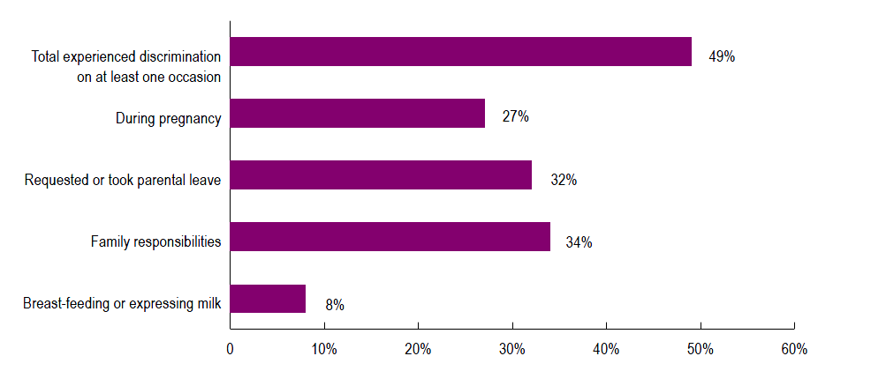

Base: Total respondents: (n=2002); During pregnancy: biological mothers (n= 2001); when requested or took parental leave: mothers who took leave or would have liked to take leave (n=1902); mothers who returned to work as an employee (n=1576)

Type of discrimination
* Please refer to the chart on page 9 for a key to the ‘types of discrimination’ that are included in the categories below.
Discrimination is experienced in many different forms ranging from negative attitudes in the workplace through to dismissal.
Many women experience more than one form of discrimination during pregnancy, parental leave and return to work.
One in five (18%) mothers indicated they were made redundant/restructured/dismissed or that their contract was not renewed, either during their pregnancy, when they requested or took parental leave, or when they returned to work.

Types of discrimination experienced during pregnancy
Of the 27% of mothers that reported experiencing discrimination in the workplace during pregnancy:
- More than a third (37%) reported that they had been threatened with redundancy or dismissal, made redundant/restructured, were dismissed or did not have their contract renewed.
- Half (49%) reported discrimination related to pay, conditions and duties.
- 48% reported discrimination related to their health and safety.
- 46% reported discrimination related to their performance assessment or career advancements opportunities.
- 40% reported negative comments/attitudes from their manager/employer or colleagues.

Figure 2 – Types of discrimination during pregnancy
Of the 27% of mothers who experienced discrimination during pregnancy … | 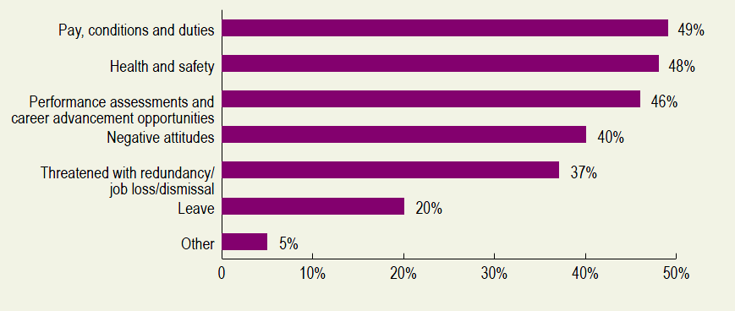
Base: Biological mothers (n=2001); who experienced discrimination in the workplace during pregnancy (n=482)

Types of discrimination experienced when requesting or on parental leave
Of the 32% of mothers that reported experiencing discrimination in the workplace when requesting or on parental leave:
- Over two thirds (69%) reported discrimination related to pay, conditions and duties.
- Almost half (46%) reported discrimination in relation to their performance assessment and career advancement opportunities.
- Nearly a third (30%) reported that they had been threatened with redundancy or dismissal, made redundant/restructured, were dismissed or did not have their contract renewed when they either requested or took leave.

Figure 3 – Types of discrimination when requesting or on parental leave
Of the 32% of mothers who experienced discrimination during pregnancy … | 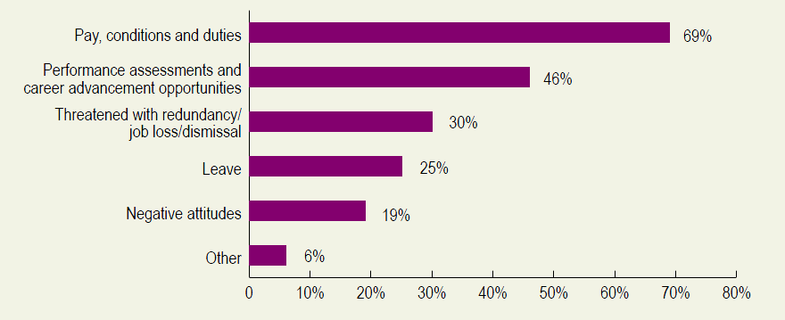
Base: Mothers who took leave or would have liked to take leave (n=1902); experienced discrimination in the workplace when requested or on parental leave (n=615)

Types of discrimination experienced upon return to work
Of the 36% of mothers that reported experiencing discrimination in the workplace when returning to work after parental leave:
- Nearly two thirds (63%) reported receiving negative attitudes or comments from colleagues or managers/employers.
- Half (50%) reported discrimination when they requested flexible work arrangements.
- Two in five (38%) reported discrimination related to pay, conditions and duties.

Figure 4 – Types of discrimination on return to work
Of the 36% of mothers that experienced discrimination on return to work … | 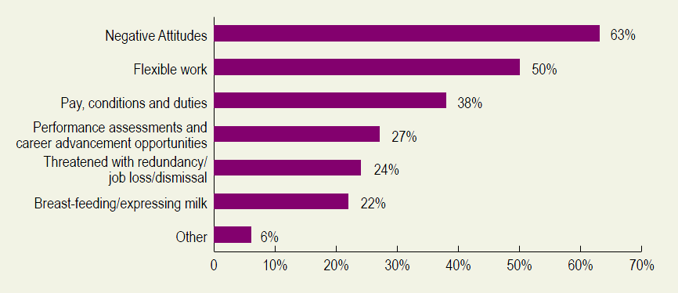
Base: Mothers who returned to work as an employee (n=1576); who experienced discrimination in the workplace on return to work (n=578)

*This chart provides a key to the types of discrimination that fall within each category
Negative attitudes | You received inappropriate or negative comments from your employer/manager about your pregnancy (pregnancy)
 | You received inappropriate or negative comments from your colleagues about your pregnancy (pregnancy)
 | You received inappropriate or negative comments from your employer/manager because you requested or took leave to care for your child (parental leave)
 | You received inappropriate or negative comments from your colleagues because you requested or took leave to care for your child (parental leave)
 | You received inappropriate or negative comments about breastfeeding or expressing milk (return to work)
 | You received inappropriate or negative comments about working part-time or flexible hours (return to work)
 | You received inappropriate or negative comments about needing time off to care for your child due to illness (return to work)
 | You were viewed as a less committed employee (return to work)
 | You were unfairly criticised about your performance at work (return to work)
Pay, conditions and duties | Your hours were changed against your wishes
 | Your roster schedule was changed against your wishes (pregnancy and parental leave)
 | Your duties or role were changed against your wishes
 | You were made casual (pregnancy and parental leave)
 | You had a reduction in your salary or bonus
 | You didn't receive a pay rise or bonus, or received a lesser pay rise or bonus than your peers at work
 | You missed out on a salary increment or bonus (parental leave)
 | Your position was replaced permanently by another employee (parental leave and return to work)
 | Your employer did not adequately backfill your position during your parental leave and this negatively impacted you (parental leave)
Performance assessments and career advancement opportunities | You were unfairly criticised about your performance at work (pregnancy)
 | You failed to gain a promotion you felt you deserved (pregnancy and return to work)
 | You were denied access to training that you would otherwise have received (pregnancy and return to work)
 | You missed out on opportunities for training (parental leave)
 | You missed out on opportunities for promotion (parental leave)
 | You missed out on a performance appraisal (parental leave)
Job loss/dismissal | You were treated so poorly that you felt you had to leave
 | You were threatened with redundancy or dismissal
 | You were made redundant/restructured
 | You were dismissed
 | Your contract was not renewed
Leave | You were unfit for work due to pregnancy-related illness or because your pregnancy ended and your employer denied you special unpaid maternity leave (pregnancy)
 | You were denied leave to attend medical appointments for your pregnancy (pregnancy)
 | Your employer encouraged you to start or finish your parental leave earlier or later than you would have liked (parental leave)
 | You were denied leave that you were entitled to (parental leave)
Health and safety | You were unable to take toilet breaks as you needed (pregnancy)
 | You were not provided with a suitable uniform (pregnancy)
 | Your work/workload was not adequately adjusted to accommodate your pregnancy (pregnancy)
 | Your health and safety were jeopardised by failure to accommodate your pregnancy (pregnancy)
 | You were not provided with a safe job (pregnancy)
 | You were transferred to a safe job but it involved a different number hours of work that you did not agree to (pregnancy)
 | You were transferred to a safe job but did not have the same terms and conditions of employment (pregnancy)
 | You were not provided with appropriate breastfeeding or expressing facilities (return to work)
Flexible work | Your requests for flexible hours or work from home were denied (return to work)
 | Your requests for time off to cope with illness or other problems with your baby were denied (return to work)
 | You were given unsuitable work or workloads (return to work)
 | You were given work at times that did not suit your family responsibilities (return to work)

Impact of discrimination
Discrimination has a significant negative impact on women’s health, finances, career and job opportunities and their family
84% of mothers who experienced discrimination on at least one occasion, reported a negative impact as a result of discrimination.
Of this group:
- More than two thirds (72%) reported that the discrimination impacted on their mental health, including their level of stress and loss of self-esteem and confidence.
- Two in five (42%) reported that the discrimination had a financial impact on them, while a similar proportion (41%) felt it impacted on their career and job opportunities.
Figure 5 – Impact of discrimination experienced
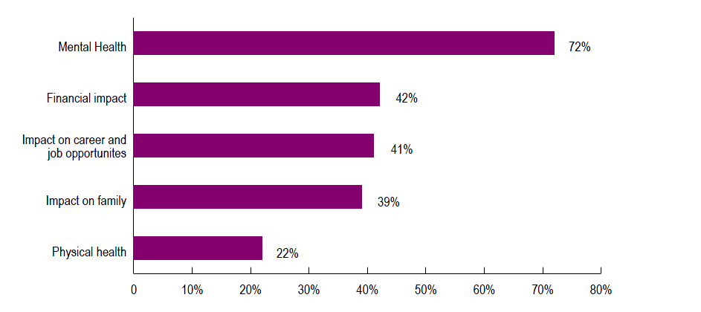
Base: Total experienced discrimination on at least one occasion (n=978)

Discrimination has a negative impact on women’s engagement in the workforce and their attachment to their workplace

- 22% of mothers who reported experiencing discrimination at work during their pregnancy did not return to the workforce as an employee, compared to 14% who reported that they did not experience discrimination.
- 23% of mothers who reported experiencing discrimination at work during their pregnancy did not return to the ‘main employer’ they had before the birth/adoption of their child, compared to 13% of mothers that reported they did not experience discrimination.

Response to discrimination
Nearly a third of women who experience discrimination look for another job or resign.
32% of all mothers who were discriminated against at some point went to look for another job or resigned.
The majority of women who experience discrimination do not make a formal complaint
75% of women reported that they took action in response to discrimination they experienced on at least one occasion.
Of this group only one in ten (10%) contacted or made a complaint to a government agency, and only 8% made a formal complaint within their organisation.

Figure 6- Actions taken in response to discrimination experienced
Of the 75% of mothers that took action in response to discrimination… | 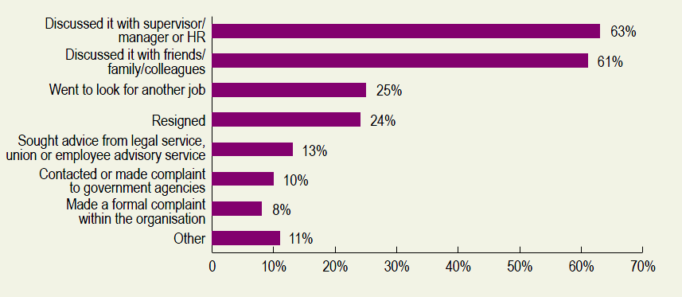
Base: Total experienced discrimination on at least one occasion (n=978); took action in response to discrimination experienced on at least one occasion (n=725)

Fathers and Partners Survey – a case study of fathers and partners that took leave under the ‘Dad and Partner Pay’ scheme
This survey provides a case study of the experiences of discrimination of fathers and partners that took the legislative entitlement to 2 weeks leave at the minimum wage under the ‘Dad and Partner Pay’ scheme.
The survey revealed that the vast majority of fathers and partners interviewed took very short periods of leave. 85% of the fathers and partners surveyed took less than 4 weeks of leave.

Prevalence of discrimination
Despite taking very short periods of parental leave, fathers and partners face discrimination. Over a quarter (27%) of survey respondents reported experiencing discrimination during parental leave or when they returned to work.
Discrimination occurs at both stages:
- One in five (20%) reported experiencing discrimination during parental leave, and
- One in six (17%) reported experiencing discrimination when they returned to work as an employee.

Figure 7 - Prevalence of discrimination in the workplace during parental leave and return to work

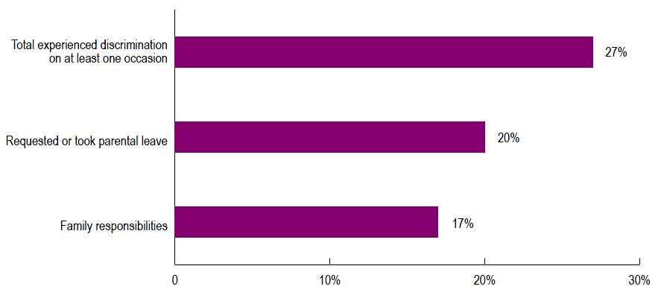

Base: During parental leave: all respondents (n=1001); family responsibilities: returned to work as an employee (n=977)

Type of discrimination
* Please refer to the chart on page 9 for a key to the ‘types of discrimination’ that are included in the categories below.
Fathers and partners experience discrimination in many different forms ranging from negative attitudes in the workplace through to dismissal.
Many fathers and partners experience more than one form of discrimination when requesting or during parental leave and on return to work.
Of the fathers who experienced discrimination on at least one occasion (27%):
- Half (49%) reported receiving negative comments and attitudes from colleagues or manager/employer.
- 46% reported discrimination related to pay, conditions and duties.
- A third (35%) experienced discrimination related to flexible work.

Figure 8 – Types of discrimination experienced
Of the 27% of fathers and partners that experienced discrimination… | 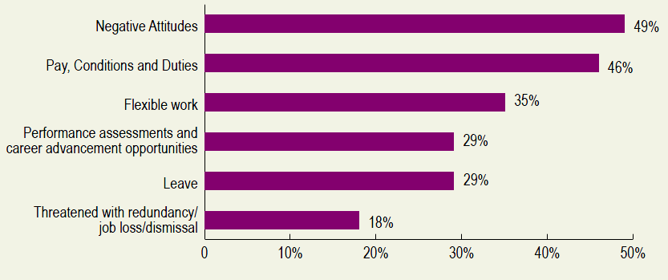

Base: All respondents (n=1001); experienced discrimination on at least one occasion (n=271)

Impact of discrimination
Discrimination has a significant negative impact on fathers and partners’ mental health, family, finances and career and job opportunities.

76% of fathers and partners who experienced discrimination during parental leave or on return to work reported a negative impact as a result of discrimination.

Of this group:

61% reported a negative impact on their mental health including their level of stress and loss of self-esteem and confidence.

Two in five (42%) reported that it had a negative impact on their families.

Over a third (37%) said that this had a negative financial impact on them while a similar proportion (30%) felt it negatively impacted on their career and job opportunities.

Figure 9 – Impact of discrimination experienced
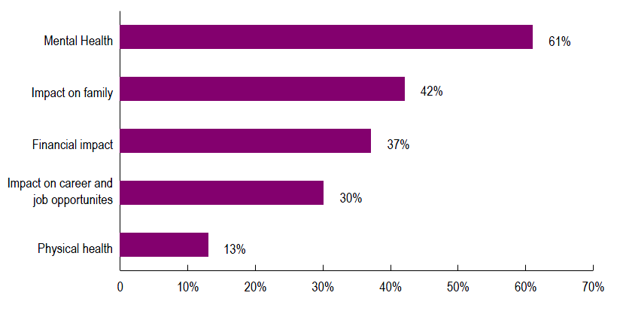
Base: Total experienced discrimination on at least one occasion (n=271)

Response to discrimination
A substantial number of fathers and partners that reported experiencing discrimination went to look for another job or resigned
A quarter (23%) of fathers and partners that reported experiencing discrimination at some point went to look for another job and one in ten (10%) resigned.
62% of fathers and partners that reported experiencing discrimination at some point took action in response to the discrimination.
Of these, only 8% made a formal complaint within their organisation and only 6% contacted or made a complaint to a government agency.
Figure 10 - Actions taken in response to discrimination experienced
Of the 62% of fathers and partners that took action in response to discrimination… | 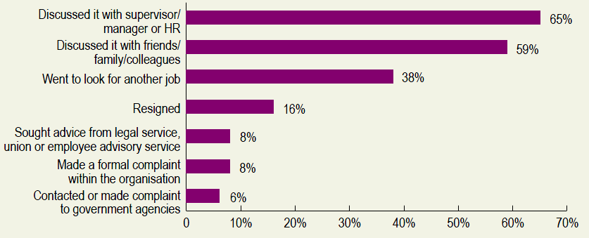
Base: Total experienced discrimination on at least one occasion (n=271); took action in response to discrimination experienced on at least one occasion (n=167)

Make a complaint
The Sex Discrimination Act 1984 (Cth) (the SDA) makes it against the law to treat a person unfairly because of their sex, family responsibilities or because they are pregnant. The SDA can also provide some protections to people wanting to return to work after parental leave. If you would like more information about what might be covered by the SDA or you would like to make a complaint to the Australian Human Rights Commission, you can contact our National Information Service on:
Phone: 1300 656 419 or 02 9284 9888
Email: infoservice@humanrights.gov.au
Fax: 02 9284 9611
TTY: 1800 620 241 (toll free)
NRS: 133 677
If you need an interpreter you can call 131 450 and ask to be connected to the Australian Human Rights Commission.
To make a complaint online click here.
More information is also available at the Complaints Section webpage.

The Commission acknowledges the contribution of the following academics in providing expert comment on the survey questionnaire and methodology: Marian Baird, University of Sydney; Sara Charlesworth, University of South Australia; Lyn Craig, University of New South Wales; Belinda Hewitt, University of Queensland, Paula McDonald, Queensland University of Technology; Lyndall Strazdins, Australian National University; and Gillian Whitehouse, University of Queensland.
L Adams, F McAndrew and M Winterbotham, Pregnancy discrimination at work: a survey of women Equal Opportunity Commission (2005). At http://www.maternityaction.org.uk/wp/2013/11/pregnancy-discrimination-at-work-a-survey-of-women/ (viewed 1 April 2014).
H Russell, D Watson and J Banks Pregnancy at Work: A National Survey, HSE Crisis Pregnancy Programme and Equality Authority (2011). At http://www.equality.ie/en/Research/Research-Publications/Pregnancy-at-Work-A-National-Survey.html (viewed 1 April 2014).
For example, Australian Bureau of Statistics, 4913.0 - Pregnancy and Employment Transitions, Australia, Nov 2011. At http://www.abs.gov.au/ausstats/abs@.nsf/Latestproducts/4913.0Main%20Features3Nov%202011?opendocument&tabname=Summary&prodno=4913.0&issue=Nov%202011&num=&view= (viewed 1 April 2014).
The Reference Group consists of 7 members representing business, community groups, unions and academics. The Reference Group is chaired by Elizabeth Broderick, Sex Discrimination Commissioner. The members include: Elizabeth Broderick, Sex Discrimination Commissioner; Innes Willox, Australian Industry Group; CEO, Australian Chamber of Commerce and Industry; Ged Kearney, Australian Council of Trade Unions; Therese Bryant, Shop Distributive and Allied Employees Association; Marian Baird, University of Sydney; and Anna Davis, Working Women’s Centre, NT.
In the period in which the sample was drawn (May – November 2011), 98.5 of mothers were paid either the PPL or BB as a proportion of all children born in 2011–12 based on the Australian Bureau of Statistics publication 3222.0 Series B estimates. The Department of Families, Housing, Community Services and Indigenous Affairs (FaHCSIA), Annual Report 2011-2012, p 50. At http://www.dss.gov.au/about-fahcsia/publications-articles/corporate-publications/annual-reports/2012 (viewed 3 April 2014).
The sample structure for the PPL and BB survey was calculated using the November 2011 Australian Bureau of Statistics’ ‘Pregnancy and Employment Transitions’. Survey Results which estimated that amongst mothers with a child born on or after 1st January 2011, who were in the workforce as an employee, 79% reported claiming PPL and 21% reported claiming BB. Australian Bureau of Statistics, 4913.0 - Pregnancy and Employment Transitions, Australia, Nov 2011. At http://www.abs.gov.au/ausstats/abs@.nsf/Latestproducts/4913.0Main%20Features3Nov%202011?opendocument&tabname=Summary&prodno=4913.0&issue=Nov%202011&num=&view= (viewed 1 April 2014).
The Australian Bureau of Statistics (ABS) calculated that at the time of the survey 109,078 Australian women who were aged between 18 and 49, and were employed in the previous nine months as an employee, had given birth to a child in the six months prior to the time of the survey. This estimate was provided by ABS to the Commission for the purposes of weighting the survey data and was based on a Labour Force Survey estimate that 3.7million women in this age group were employed as employees and that based on national age-specific fertility rates for women of this age, 109,078 of them would have given a birth to a child in a six month period.
In the 6 month period following the introduction of the ‘Dad and Partner Pay’ scheme (January – June 2013), 26,212 fathers and partners accessed the scheme. The Department of Families, Housing, Community Services and Indigenous Affairs (FaHCSIA), Annual Report 2012-2013, p 40. At http://www.dss.gov.au/about-the-department/publications-articles/corporate-publications/annual-reports/fahcsia-annual-report-2012-2013 (viewed 1 April 2014).
‘Mothers’ refers to women aged 18-49 years and in the workforce as an employee at some time during their pregnancy (or while adopting a child) with a child of approximately 2 years of age.
An overall incidence of the level of workforce discrimination was calculated as the total number of individuals who were treated unfairly or disadvantaged at least once either during their pregnancy, when requesting or on parental leave, or when returning to work following parental leave.
Questions asked to respondents: Q8. At work, were you ever treated unfairly or disadvantaged because you were pregnant with <NAMEOFCHILD>/your child born in <MONTHYEAR>? Q10/a/b. Do you think that during your pregnancy with <NAMEOFCHILD>/your child born in <MONTHYEAR>, you were treated in any of the following ways as a result of your pregnancy? Q20. At work, were you treated unfairly or disadvantaged because you took or requested to take leave to care for <NAMEOFCHILD>/your child born in <MONTHYEAR>? Q22/a/b. Did you personally experience any of the following because you requested or took leave to care for your child? Q47. After the/in the first job you had after the adoption/birth of your child, were you ever treated unfairly or disadvantaged because of your family responsibilities for <NAMEOFCHILD>/your child born in <MONTHYEAR>? Q49. After the/in the first job you had after the birth/adoption of your child, were you ever treated unfairly or disadvantaged because you were breast-feeding or expressing milk? Q50/a/b. After the/in the first job you had after the birth/adoption of your child, have you ever personally experienced any of the following because of your family responsibilities for <NAMEOFCHILD>/your child born in <MONTHYEAR>?
Questions asked to respondents: Q8. At work, were you ever treated unfairly or disadvantaged because you were pregnant with <NAMEOFCHILD>/your child born in <MONTHYEAR>? Q9. What kind of unfair treatment or disadvantage did you face? Q10/a/b. Do you think that during your pregnancy with <NAMEOFCHILD>/your child born in <MONTHYEAR>, you were treated in any of the following ways as a result of your pregnancy?
Questions asked to respondents: Q20. At work, were you treated unfairly or disadvantaged because you took or requested to take leave to care for <NAMEOFCHILD>/your child born in <MONTHYEAR>? Q21. What unfair treatment or disadvantage did you experience because you requested or took leave to care for your child? Q22/a/b. Did you personally experience any of the following because you requested or took leave to care for your child?
Questions asked to respondents: Q47. After the/in the first job you had after the adoption/birth of your child, were you ever treated unfairly or disadvantaged because of your family responsibilities for <NAMEOFCHILD>/your child born in <MONTHYEAR>? Q48. What unfair treatment or disadvantage did you experience because of your family responsibilities for your child? Q49. After the/in the first job you had after the birth/adoption of your child, were you ever treated unfairly or disadvantaged because you were breast-feeding or expressing milk? Q50/a/b. After the/in the first job you had after the birth/adoption of your child, have you ever personally experienced any of the following because of your family responsibilities for <NAMEOFCHILD>/your child born in <MONTHYEAR>?
Question asked to respondents: Q11/Q23/Q51. Thinking about this, what impact, if any did this treatment have on you?
Mothers who have finished their parental leave and experienced discrimination at work during their pregnancy were less likely to return to work as an employee (78%) compared to mothers who were not discriminated against during their pregnancy (86%).
‘Main employer’ refers to the job they had just prior to parental leave. If they had more than one job at the time it refers to the job for which they did the most number of hours per week.
Mothers who have finished their parental leave and experienced discrimination at work during their pregnancy were less likely to return to the main employer they had before the birth/adoption of their child (77%), compared to mothers who didn’t experience discrimination during their pregnancy (87%).
Question asked to respondents: Q12/Q24/Q52. What actions, if any, did you take?
Questions asked to respondents: Q13. At work, were you treated unfairly or disadvantaged because you took or requested to take leave to care for <NAMEOFCHILD>/your child born in <MONTHYEAR>? Q14/15. Did you personally experience any of the following because you requested or took leave to care for your child? Q40. After the/in the first job you had after the adoption/birth of your child, were you ever treated unfairly or disadvantaged because of your family responsibilities for <NAMEOFCHILD>/your child born in <MONTHYEAR>? Q41/42. After the/in the first job you had after the birth/adoption of your child, have you ever personally experienced any of the following because of your family responsibilities for <NAMEOFCHILD>/your child born in <MONTHYEAR>?
Questions asked to respondents: Q13. At work, were you treated unfairly or disadvantaged because you took or requested to take leave to care for <NAMEOFCHILD>/your child born in <MONTHYEAR>? Q14. What unfair treatment or disadvantage did you experience because you requested or took leave to care for your child? Q15/a/b. Did you personally experience any of the following because you requested or took leave to care for your child? Q40. After the/in the first job you had after the adoption/birth of your child, were you ever treated unfairly or disadvantaged because of your family responsibilities for <NAMEOFCHILD>/your child born in <MONTHYEAR>? Q41. What unfair treatment or disadvantage did you experience because of your family responsibilities for your child? Q42/a/b. After the/in the first job you had after the birth/adoption of your child, have you ever personally experienced any of the following because of your family responsibilities for <NAMEOFCHILD>/your child born in <MONTHYEAR>?
Question asked to respondents: Q16/Q43. Thinking about this, what impact, if any did this treatment have on you?
Question asked to respondents: Q17/Q44. What actions, if any, did you take?

