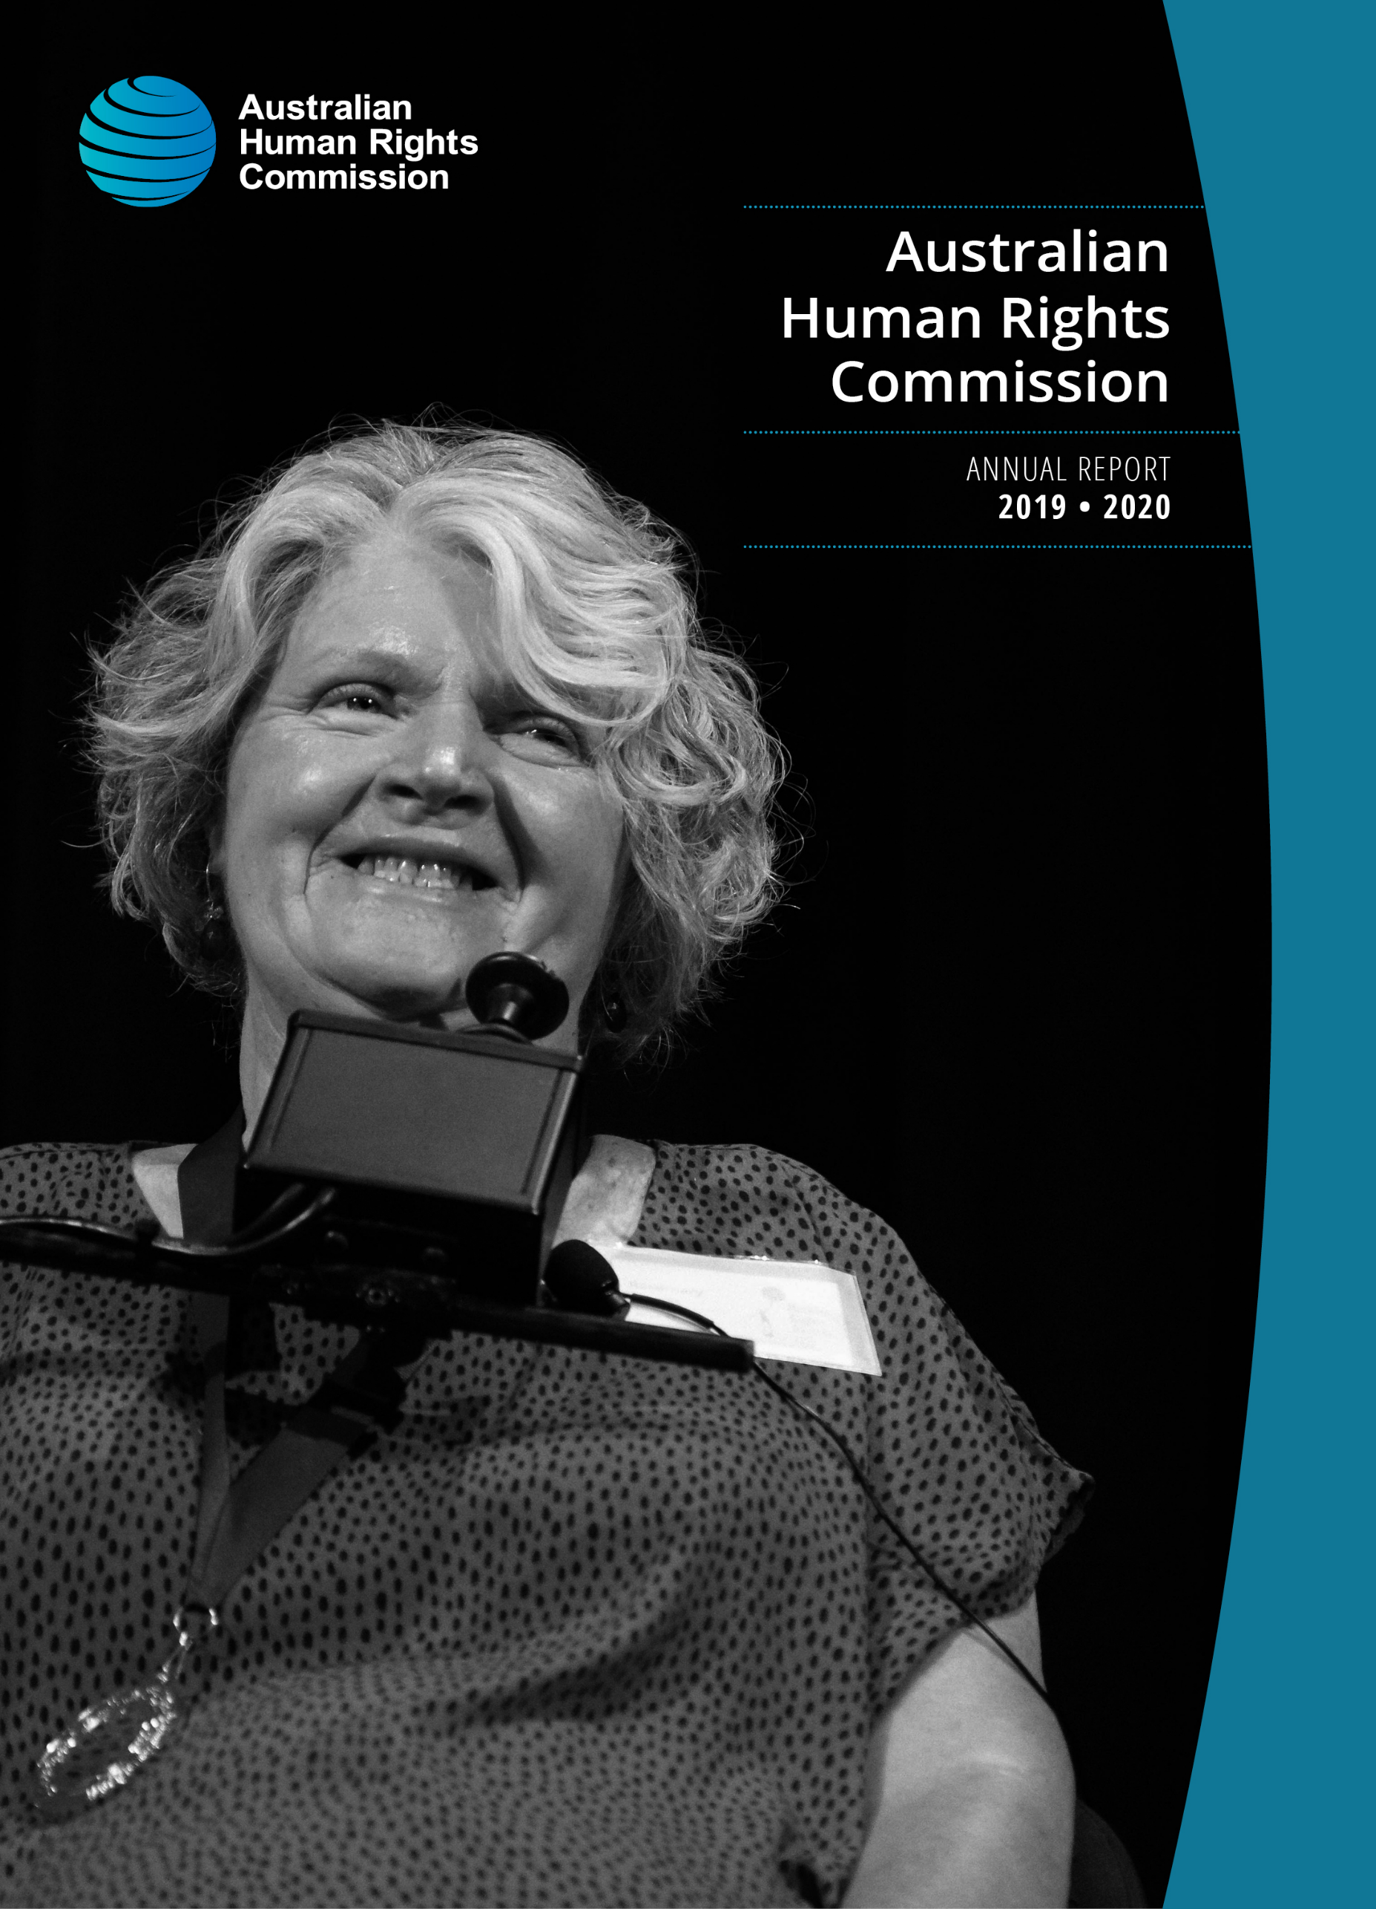
© Australian Human Rights Commission 2020
The Australian Human Rights Commission encourages the dissemination and exchange of information provided in this publication.
All material presented in this publication is licensed under the Creative Commons Attribution 4.0 International Licence, with the exception of:
photographs and images
the Commission’s logo, any branding or trademarks
where otherwise indicated.
To view a copy of this licence, visit http://creativecommons.org/licenses/by/4.0/legalcode.
In essence, you are free to copy, communicate and adapt the publication, as long as you attribute the Australian Human Rights Commission and abide by the other licence terms. Please give attribution to: © Australian Human Rights Commission 2020.
ISSN 1837-6444
Annual Report and Financial and Non-Financial Statement 2019–2020.
This publication can be found in electronic format on the Australian Human Rights Commission’s website at: www.humanrights.gov.au/our-work/commission-general/publications/annual-reports.
For further information about the Australian Human Rights Commission or copyright in this publication, please contact:
Communications Unit, Australian Human Rights Commission, GPO Box 5218, SYDNEY NSW 2001 Telephone: (02) 9284 9600, email: communications@humanrights.gov.au, website: www.humanrights.gov.au.
To order more publications from the Australian Human Rights Commission, download a Publication Order Form at:
www.humanrights.gov.au/about/publications/, call: (02) 9284 9600, fax: (02) 9284 9611 or email: publications@humanrights.gov.au.
Design and layout: Dancingirl Designs
Printing: Bright Print Group
Cover image: Australian Human Rights Commission
Cover photo: By Matt Syres: Winner of the 2019 Human Rights Medal, Ms Rosemary Kayess. Mrs Kayess received the 2019 Human Rights Medal in recognition of her work in international human rights law for people with disability.
Contents
1 About the Commission 7
1.1 Our purpose 7
1.2 Achieving our purpose 8
1.3 Organisational structure 9
1.4 Our functions and legislation 10
1.5 Responsible Minister 13
1.6 Location 13
1.7 Governance 14
1.8 President and Commissioners 15
1.9 Achieving a national reach 16
2 The year in review 18
3 Annual performance statement for non-financial outcomes 23
3.1 Results 24
3.2 Audit Committee 26
4 Commission activity 28
5 Goal 1: Greater prioritisation and embedding of human rights issues at the national level 30
5.1 Outcome 1.1 30
5.2 Outcome 1.2 34
5.3 Outcome 1.3 [PBS criterion] 48
6 Goal 2: More people, communities, and organisations respect and understand human rights 55
6.1 Outcome 2.1 [PBS criterion] 55
6.2 Outcome 2.2 [PBS criterion] 61
7 Goal 3: More people, communities, and organisations take action to respect protect and promote human rights in their own contexts 70
7.1 Outcome 3.1 [PBS criterion] 70
7.2 Outcome 3.2 [PBS criterion] 71
8 Goal 4: Effective access to justice and remedy for people and communities whose rights are breached 87
8.2 Outcome 4.1 [PBS criterion] 87
9 Performance analysis – how we are meeting our goals 91
9.1 Goal 1 92
9.2 Goal 2 95
9.3 Goal 3 97
9.4 Goal 4 100
10 Environment statement 102
11 Financial statements 103
Independent Audit Report 103
Statement by the Accountable Authority and Chief Finance Officer 105
Statement of Comprehensive Income 106
Statement of Financial Position 108
Statement of Changes in Equity 110
Cash Flow Statement 112
Overview 114
1. Financial Performance 121
1.1 Expenses 121
1.2 Own-Source Revenue and gains 124
2. Financial Position 128
2.1 Financial Assets 128
2.2 Non-Financial Assets 130
2.3 Payables 136
2.4 Interest Bearing Liabilities 137
2.5 Other Provisions 137
3. Funding 138
3.1 Corporate Commonwealth Entity Payment 138
4. People and relationships 139
4.1 Employee Provisions 139
4.2 Key Management Personnel Remuneration 140
4.3 Related Party Disclosures 142
5. Managing uncertainties 143
5.1 Contingent Assets and Liabilities 143
5.2 Financial Instruments 144
5.3 Fair Value Measurement 146
6. Other information 148
6.1 Aggregate Assets and Liabilities 148
12 Executive Remuneration 149
13 Appendices 153
Appendix 1: Performance measurement framework table 2019–2020 153
Appendix 2: Key employee statistics 159
Appendix 3: Key activities, program areas and services 2019–2020 160
Appendix 4: Major events, reports, publications and education resources 162
14 List of Requirements 165

17 September 2020
The Hon Christian Porter MP
Attorney-General
Parliament House
CANBERRA ACT 2600
Dear Attorney,
I am pleased to present the Annual Report of the Australian Human Rights Commission for the period ending 30 June 2020. The report has been prepared pursuant to section 45 of the Australian Human Rights Commission Act 1986 (Cth) and in accordance with the requirements of section 46 of the Public Governance, Performance and Accountability Act 2013 (Cth).
As the Accountable Authority of the Australian Human Rights Commission, I am responsible for the preparation and contents of the Annual Report of Operations. I approved the Annual Report 2019–2020 on 17 September 2020. by signing a memorandum.
Yours sincerely,
Emeritus Professor Rosalind Croucher AM
President

- About the Commission

Our purpose
As Australia’s national human rights institution, our purpose is to ensure that Australians have access to effective, independent complaint handling and public inquiry processes on human rights and discrimination matters, and benefit from our human rights education, advocacy, monitoring and compliance activities.
Portfolio Budget Statement

The Australian Human Rights Commission (the Commission) is Australia’s national human rights institution.
We operate under the Australian Human Rights Commission Act 1986 (Cth) as well as federal laws that seek to ensure freedom from discrimination on the basis of age, disability, race, sex, sexual orientation, intersex status and gender identity. The Commission also has specific responsibilities under the Native Title Act 1993 (Cth) and the Fair Work Act 2009 (Cth).
We operate as a Corporate Commonwealth Entity under the Public Governance, Performance and Accountability Act 2013 (Cth). Our operations are determined independently of the government through our President and Commissioners.
Our job is to work towards an Australia in which human rights are respected, protected and promoted, finding practical solutions to issues of concern, advocating for systemic change and raising awareness across the community.
We provide direct services to the Australian community, in particular by assisting people to resolve disputes about discrimination and breaches of human rights. Much of our work is also at the policy level – encouraging government, industry and community groups alike to see fundamental rights and freedoms realised. It involves building the case for change on issues ranging from age discrimination in employment to constitutional recognition of Aboriginal and Torres Strait Islander peoples. It involves providing a human rights analysis to the courts and parliamentary inquiries, conducting research and contributing to partnerships.
Our work also involves exchanging ideas with equivalent bodies around the world, while closer to home we monitor and report on the experiences of those particularly vulnerable to disadvantage.
From addressing complaints of discrimination, to engaging with government on policy issues, the Commission’s task is both to apply those rights that are currently recognised in our laws, and to aspire for greater recognition and protection of those that are not yet.
Our vision is for an Australia where human rights are enjoyed by everyone, everywhere, everyday.

Achieving our purpose
There is no simple way to solve complex human rights issues. From the challenges that face a person with a disability seeking to live independently, to ensuring that Australia’s immigration detention policies meet our human rights obligations and treat people with dignity, the promotion of human rights must address issues for individuals as well as the need for broader, systemic change.
Our Corporate Plan is the roadmap that guides the Commission’s work for the reporting period. The plan contains the Commission’s performance framework, which links the performance criteria outlined in our 2019–2020 Portfolio Budget Statement to the results in this Annual Report. The Commission's performance measurement framework is detailed in Appendix 1.

Organisational structure
The Commission is a national independent statutory body established under the Australian Human Rights Commission Act 1986 (Cth).

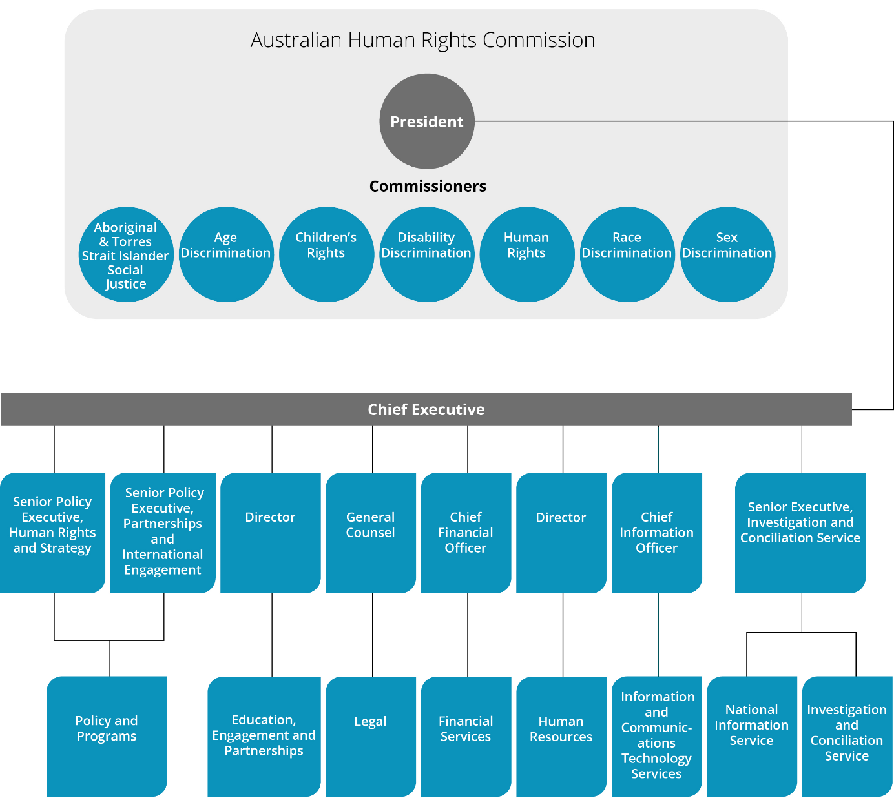

See Appendix 2 for key employee statistics, as at 30 June 2020.

Our functions and legislation
The Commission exercises functions under the following Acts:

Australian Human Rights Commission Act 1986 (Cth)
Establishes the Commission and outlines its powers and functions.
It defines human rights by reference to the following international instruments:
- International Covenant on Civil and Political Rights
- Convention on the Rights of the Child
- Declaration on the Rights of the Child
- Convention on the Rights of Persons with Disabilities
- Declaration on the Rights of Disabled Persons
- Declaration on the Rights of Mentally Retarded Persons
- Declaration on the Elimination of All Forms of Intolerance and of Discrimination Based on Religion or Belief
- Convention Concerning Discrimination in Respect of Employment and Occupation.

Racial Discrimination Act 1975 (Cth)
Gives effect to Australia’s obligations under the International Convention on the Elimination of All Forms of Racial Discrimination.
Its main aims are to:
- promote equality before the law for all persons, regardless of their race, colour or national or ethnic origin
- make discrimination on the basis of race, colour, descent or national or ethnic origin, unlawful
- provide protection against racial hatred.

Sex Discrimination Act 1984 (Cth)
Gives effect to Australia’s obligations under the Convention on the Elimination of All Forms of Discrimination Against Women and to other relevant international instruments including the International Covenant on Civil and Political Rights.
Its main aims are to:
- promote equality between men and women
- eliminate discrimination on the ground of sex, sexual orientation, gender identity, intersex status, marital or relationship status, pregnancy (or potential pregnancy) and breastfeeding in work, education and other areas of public life
- eliminate discrimination on the ground of family responsibilities in work
- eliminate sexual harassment in work, education and other areas of public life.

Disability Discrimination Act 1992 (Cth)
Its main aims are to:
- eliminate discrimination against people with disabilities as far as is possible
- promote community acceptance of the principle that people with disabilities have the same fundamental rights as all members of the community
- ensure as far as practicable that people with disabilities have the same rights to equality before the law as other people in the community.

Age Discrimination Act 2004 (Cth)
Its main aims are to:
- promote equality before the law for all persons regardless of their age
- eliminate discrimination against persons on the ground of age in many areas of public life, such as employment, education and the provision of goods, services or facilities
- change negative stereotypes about people based on their age (young or old).

The Commission
We exercise our functions under this federal legislation by:
- investigating and conciliating complaints of discrimination or breaches of human rights
- developing an extensive and accessible website containing research, publications, resources and education programs for young people, teachers, community groups, business, media and the community at large
- working with the media to raise and promote public awareness about important human rights issues
- working with organisations and leaders in the community, government and business sectors to provide education on relevant human rights issues and to support them in their efforts to better protect and promote human rights
- holding public inquiries and consultations to resolve systemic human rights issues of national importance that we have identified
- working closely with the federal government to provide independent advice regarding the development of laws, programs and policies that will better protect and promote human rights
- publishing reports on Aboriginal and Torres Strait Islander social justice and native title and children’s rights
- making submissions to parliamentary and other inquiries in order to identify human rights issues which may arise in proposed or existing laws and policies
- working in the legal system by appearing as an intervener or as amicus curiae in cases that involve human rights
- working with other national human rights institutions, particularly through the Asia Pacific Forum of National Human Rights Institutions.
The President, the Aboriginal and Torres Strait Islander Social Justice Commissioner, the National Children’s Commissioner and the Sex Discrimination Commissioner have additional responsibilities.

President
The President is the Accountable Authority of the Commission, responsible for its financial and administrative affairs. The President is also responsible for the complaint-handling function of the Commission.

Aboriginal and Torres Strait Islander Social Justice Commissioner
Under the Australian Human Rights Commission Act 1986 (Cth), the Aboriginal and Torres Strait Islander Social Justice Commissioner may report to the Minister on the exercise and enjoyment of human rights of Indigenous peoples and undertakes social justice education and promotional activities.
This Commissioner may report under the Native Title Act 1993 (Cth) on the operation of the Act and its effect on the exercise and enjoyment of human rights of Indigenous peoples. In addition, the Commissioner reports, when requested by the Minister, on any other matter relating to the rights of Indigenous peoples under this Act.

Sex Discrimination Commissioner
The Sex Discrimination Commissioner has functions under the Fair Work Act 2009 (Cth) in relation to federal awards and equal pay.

National Children’s Commissioner
Under the Australian Human Rights Commission Act 1986 (Cth) the National Children’s Commissioner may report to the Minister on the enjoyment and exercise of human rights by children in Australia.

Responsible Minister
The Hon Christian Porter MP, Attorney-General, is the Minister in Parliament responsible for the Commission. The Attorney-General has several powers under the Australian Human Rights Commission Act 1986 (Cth).

Location
The office of the Australian Human Rights Commission is in Sydney. The Australian Human Rights Commission conducts its activities nationally – including by maintaining a National Information Service, and conducting consultations, meetings, and events across Australia.

Governance
The Commission leadership (consisting of the President, Commissioners and Chief Executive) hold formal Commission meetings with senior management four times a year. These meetings facilitate high-level reporting of progress against the annual work plan and President and Commissioners’ term goals, allows management to provide updates from across the Commission’s work, and provides a space for key decisions by the leadership team. Published materials by the Commission are formally approved - as required - through a process in accordance with the Australian Human Rights Commission Act 1986 (Cth). The Commission obtains appropriate ethics approval for all relevant major activities.
Our risk management framework provides a mechanism for proactively identifying and mitigating risks across the organisation, and for monitoring the operating environment. We are supported by our internal auditors who conduct regular audit reviews and other assurance activities for our strategic planning and core business processes.

President and Commissioners
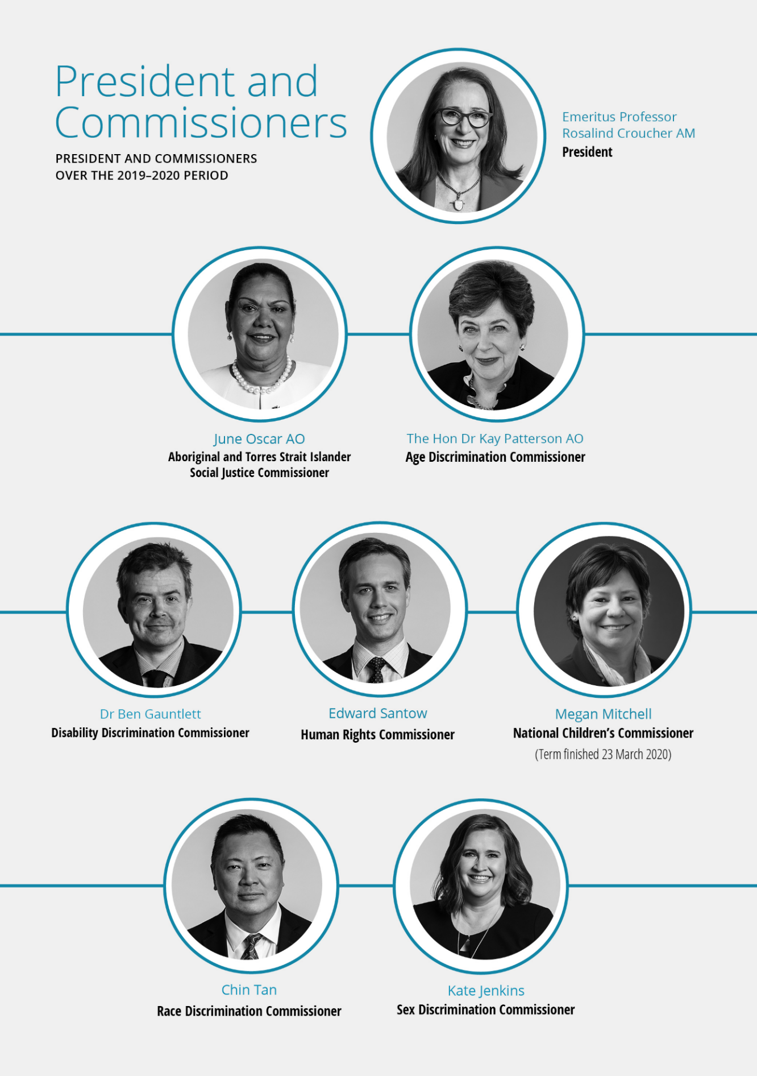

Achieving a national reach
Being a small entity, with limited resourcing and a single base to our organisation, creates challenges to ensuring national coverage of our work and engaging with communities in rural, regional, and remote areas.
In addressing this we have made it a priority for the Commission to build consideration of rural, regional and, where possible, remote activity into our planning processes. These can vary from consultation and engagement events, conducting training and workshops, commissioned research, and Commissioner engagements.
This is our third year of monitoring and reporting on this priority.
In this reporting period, the Commission has had engagements in every state and territory. Due to the COVID-19 pandemic, engagements ‘in person’ were not conducted after February 2020. Nonetheless, the commission continued to work Australia wide by virtual means. Figure 1 depicts ‘in person’ engagements which fell outside of a major capital city, between July 2019 and February 2020.
The onset of the COVID-19 pandemic resulted in significant changes to our outreach strategies with the loss of the ability to travel to conduct face to face consultations and meetings. In March, we moved quickly to ensure the Commission could pivot to using virtual outreach strategies and had the tools to continue to conduct activities through digital engagement.
Our focus on this priority will continue with an emphasis on ensuring that the increased reliance on digital technologies does not impact negatively on the reach and access of vulnerable and marginalised in these areas.

Figure 1: Rural regional and remote engagement July 2019 to February 2020
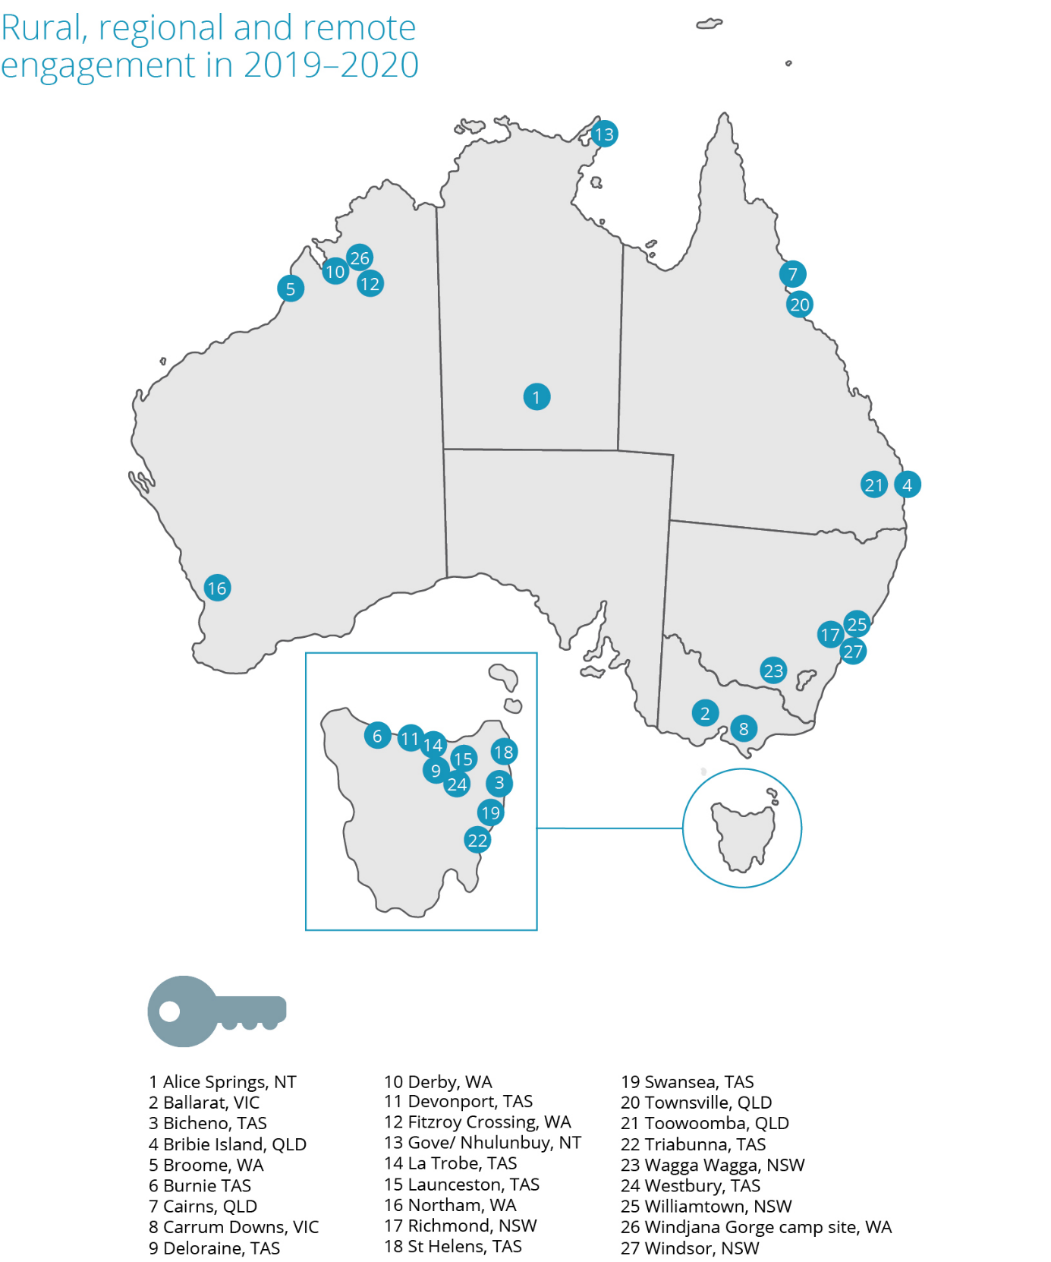

- The year in review
The 2019–2020 financial year has been a challenging period.
It is impossible to reflect on this period without focusing on the tragic circumstances that have unfolded across Australia and globally since November 2019 – namely, the devastating bushfires across Australia and the ongoing global COVID-19 pandemic, with its widespread community lockdowns, loss of life, impacts on the most vulnerable in our communities and severe economic and social impacts that have been felt by all of us.
These events have been deeply unsettling. As in most times of crisis, they have highlighted the worst of human nature and most importantly, the very best.
I, like many, have been humbled and inspired by the extraordinary efforts of our frontline workers in particular. But everyone is playing their part – most of the community have demonstrated their willingness to do their bit to prevent the spread of COVID-19 by social distancing and accepting very difficult restrictions on individual liberties and freedoms in the name of a greater good.
It has been the most extraordinary display of commitment. It has highlighted vividly that we are more than a collection of individuals. That we see ourselves as part of a community, with responsibilities to each other, and where the rights of others matter.
The Australian Human Rights Commission has played its part in the response to the pandemic. Our Commissioners have offered advisory support on the human rights implications of the pandemic, for example, by:
- highlighting the gendered impact of the pandemic and in identifying structural reform to ensure women are appropriately supported and do not bear an unequal burden of the pandemic’s implications
- developing resources for multicultural communities experiencing racism during the pandemic, and assisting government in engaging with these communities to effectively respond to the scourge of racism
- playing a leading role in the development of guidance on the impacts of the pandemic on persons with disability and also Aboriginal and Torres Strait Islander communities
- engaging with government on key issues relating to the restriction of rights and freedoms generally – such as by ensuring appropriate privacy protections with the COVID-Safe contact tracing app, encouraging the use of masks as a public health measure, and monitoring the scope of restrictions on freedom of movement, association and related rights (such as family reunion)
- handling complaints of discrimination that have arisen during the pandemic, predominately relating to racial discrimination and disability discrimination
- closely monitoring the impact of the pandemic on particular groups of people vulnerable to adverse consequences: such as older persons, people in immigration detention, and children.
While we have refocused much of our work in the second half of the year to deal with these essential challenges, we have also continued to promote better protections for human rights across the full year.
The report of the landmark national inquiry into sexual harassment in Australian workplaces, Respect@Work, was released in March 2020. Incidents of sexual harassment continue to receive much attention, across a range of institutional settings, highlighting the need for significant reforms as outlined in the report. It sets out a reform agenda for addressing this serious problem through cultural and legal reform, and in ensuring more systemic focus from government.
Over this past year, the Commission has also continued to conduct industry-specific projects aimed at achieving cultural reform around sexual harassment and abuse, as well as racial discrimination. A key focus of this work is through our longstanding partnership with the Australian Defence Force, which has been extended for another four years.
Prior to completing her term in March 2020, our National Children’s Commissioner, Megan Mitchell, finalised the development of a series of e-resources on child safety to assist organisations of all sizes to build a proactive culture that can prevent child abuse. This work, and the National Child Safety Principles that they support, has been a major achievement for the Commission and will likely have a positive impact for many years to come.
The Commissioner finalised her term with the release of her sixth National Children’s Report setting out a roadmap for protecting the rights of children in Australia. This followed her engagement with the UN Committee on the Rights of the Child – which conducted its 7-yearly review of Australia’s progress under the Convention on the Rights of the Child.
This work on child safety has also assisted the Commission to develop better capacity to deliver online education and training. We have significantly increased the scope of this work over the past year. In the coming year, we will look to build on this additional capacity by focusing on opportunities to create human rights education training for public servants.
Throughout the past year, as President, I also focused on the ‘free and equal’ initiative, our national conversation on human rights. This ambitious project aims to set out a human rights reform agenda for the next decade. Highlights of the project over the past year include the national free and equal conference, and the associated series of roundtables that were convened with the UN High Commissioner for Human Rights in October 2019. Workshops were also convened on accountability frameworks for human rights; federal discrimination law reform; and improving human rights consideration in parliamentary and government decision-making processes.
A series of reports from this project will be released from late 2020, commencing with the Commission’s proposed federal discrimination law reform agenda.
The coming year will see the culmination of two major projects – first, by our Human Rights Commissioner, Ed Santow, on human rights and technology; and second, by our Aboriginal and Torres Strait Islander Social Justice Commissioner, June Oscar AO, the Wiyi Yanu U Thangani report on the voices of Indigenous women and girls.
A discussion paper as well as national consultations, technical workshops and other activities have been conducted for the human rights and technology project over the reporting year. The outcomes of this report will be considerable in addressing issues relating to the use of artificial intelligence in decision-making processes and ensuring that the digital revolution benefits rather than disadvantages persons with disability, among other challenges.
The Wiyi Yanu U Thangani report is the culmination of several years of work engaging directly with Indigenous women and girls – telling their stories and their priorities, in their voices. It will propose significant systemic reforms to the approach of governments to Aboriginal and Torres Strait Islander peoples. This will occur at the same time as other key initiatives such as the Closing the Gap national reform agreement and progress on the Uluru Declaration from the Heart. Common to all three of these reforms is the need for an Indigenous voice to sit at the centre of policy responses to the situation of indigenous peoples.
The Commission continues to play a role in the Closing the Gap process, with the secretariat for the Close the Gap NGO coalition continuing to operate from the Commission – as it has since its inception.
The Commission’s work on disability rights has also been significant in this period. Our new Disability Discrimination Commissioner, Dr Ben Gauntlett, led our engagement with the UN Committee on the Rights of Persons with Disability, and has brought a significant human rights focus to the refreshing of the National Disability Strategy.
Important reviews are currently underway examining achievements under the standards under the Disability Discrimination Act, which the Commissioner is engaged in, and the Commission has also regularly provided its expertise to the Royal Commission into institutional abuse of persons with disability.
Our Race Discrimination Commissioner, Chin Tan, has also led a major consultation process with Muslim Australians, the outcomes of which are due for publication in late 2020; and has been engaged with government in revamping efforts to address racism in all of its forms.
The Age Discrimination Commissioner, the Hon Dr Kay Patterson AO, has also focused considerable attention on the importance of addressing elder abuse in the community, through community awareness activities and in working with governments to implement the Australian Law Reform Commission’s report on elder abuse.
Alongside this work, sits the Commission’s work in handling complaints of discrimination and breaches of human rights. There was a 13% increase in complaints lodged with the Commission in this financial year.
All complaints that come to the Commission are lodged by individuals or organisations – the Commission has no power to initiate complaints itself.
I am very proud of the fact that our Investigation and Conciliation Service continues to receive exceptionally high satisfaction ratings from those participating in the process. It is notable that the highest satisfaction ratings come from respondents to complaints. That the Commission is seen as professional, supportive and impartial in how it acquits its role in addressing complex complaints, often in stressful circumstances, is a testament to the quality of our staff.
As we enter the 2020–21 financial year, the Commission is focused on building on its considerable achievements from the past year:
- turning recommendations from our significant project work into action, including to better protect all Australians from algorithmic bias in automated decision-making processes, better protect people from sexual harassment, elevate the voice of Indigenous women and girls, incorporate the human rights of persons with disability into all government programs and policies
- ensuring that in the continued response to the COVID-19 pandemic, the human rights of all Australians are only limited in circumstances that are fully justified as necessary, the minimal intrusion of rights that is required, and lasting for the shortest necessary period
- ensuring that in the recovery phase from the COVID-19 pandemic, no-one is left behind and that certain groups of people in Australia (such as women and Asian Australians) do not bear a disproportionate or unequal burden of the economic and social consequences
- embedding human rights protections in the ordinary processes of government decision making, to proactively protect the rights of all people in Australia better.
We look forward to Australia emerging from the pandemic with our communities stronger, and with people more connected to each other; with there being a greater appreciation of the importance of respecting each other’s rights and our individual and collective role in achieving this; and with the knowledge that no challenge is too great for our nation to face – knowing that bold, determined action can be taken on any number of human rights challenges, if there is a will to do so.
Emeritus Professor Rosalind Croucher AM
President

- Annual performance statement for non-financial outcomes
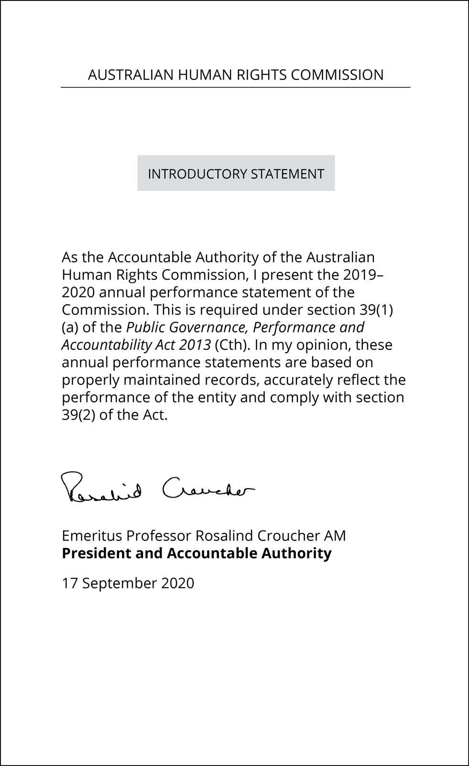

Results

Introduction
The Commission undertakes a wide range of activities in pursuit of our statutory functions. We focus our work on issues that constitute ‘protected attributes’ under federal discrimination law or for which there is a mandated special purpose Commissioner. This includes: race; age; disability; sex discrimination; Aboriginal and Torres Strait Islander social justice; children; sexual orientation, gender identity and intersex status; and issues within the role of the Human Rights Commissioner, including asylum seekers and immigration, national security and technology issues.
We must inquire into and attempt to conciliate complaints of unlawful discrimination, and breaches of human rights, and process applications for exemptions under the age, disability and sex discrimination acts.
We may also produce reports to the federal Parliament in relation to the enjoyment and exercise of human rights by children in Australia, by Aboriginal persons and Torres Strait Islanders, and in relation to complaints of breaches of human rights. We have a range of functions to raise awareness, conduct research and develop educational resources about human rights, and consider the compatibility of legislation with human rights.
The Australian Human Rights Commission Act 1986 (Cth) requires us to exercise our functions in a manner that achieves the ‘greatest possible benefit to the people of Australia’ and ‘with regard for the indivisibility and universality of human rights’. Accordingly, we also conduct human rights education, intervene in human rights matters before the courts, and promote the role of business in addressing human rights.
Our work priorities are set through an annual planning process framed by the four goals in our 2019–2020 Corporate Plan. In addition, the Commission ensures its work helps achieve the outcome articulated in its Portfolio Budget Statement, being:
An Australian society in which human rights are respected, protected and promoted through independent investigation and resolution of complaints, education and research to promote and eliminate discrimination, and monitoring and reporting on human rights.

the sole program of which, Program 1.1, is:
Australians have access to independent human rights complaint handling and public inquiries processes and benefit from human rights education, promotion and monitoring, and compliance activities.

Performance measurement
The performance statement on pages 23–101 of this report identifies how the Commission has met its purpose. These results are reported in relation to our Performance measurement framework, published in the 2019–2020 Corporate Plan. In this framework our purpose and functions are reflected in the organisational goals and outcomes. The outcomes are pitched to a level where we can reasonably expect to contribute to them:
- within the four-year outlook of each corporate plan,
- through the collective contributions of our President and Commissioners across their individual terms, and through our ongoing programs and services, and
- in an operating context that remains stable.
Progress indicators are mapped to each of the outcomes. They are designed to provide reasonable evidence of contribution to the outcome, and include output, process, and outcome measures. They are, in turn, supported by a range of data from monitoring and evaluation strategies implemented across the Commission’s programs and services.
Six of the outcomes correspond to the performance criteria in the Commission’s Portfolio budget statement (PBS), and eleven of the indicators correspond to the performance targets in our PBS. This relationship is indicated in the full framework table, located in Appendix 1, and throughout the following statement. In this way, a clear line of sight is maintained between our PBS, work plan and results.
In reporting against all the progress indicators, we have focused on case studies and exemplar activities to demonstrate our performance.

Audit Committee
Under the PGPA Rule requirement (subsection 17(2)(b)), our Audit and Risk Committee has assessed this performance statement, reviewing the performance information, systems and framework and the completeness and appropriateness of our performance reporting.
Under the PGPA Rule requirement (subsection 17AG(2A)), the following information is provided:
- http://humanrights.gov.au/sites/default/files/ahrc_audit_and_risk_committee_charter.pdf
- Audit Committee Members in 2019–2020:
- Rachel Holt (Chair)
- Donna Hargreaves
- Andrew Solomon
- Rocelle Ago
- Qualifications, knowledge and experience of audit committee members
- Rachel Holt holds a Bachelor of English and Art History and a Masters Of English, a Graduate Diploma of Legal Practice and was admitted to the Supreme Court of NSW in 2010. Ms Holt is also a nationally accredited mediator. Ms Holt has worked as a solicitor (in community legal centres), an Investigator Conciliator and Principal Investigator and is currently Senior Executive of the Commission’s Investigation and Conciliation Service (ICS). Ms Holt manages the budget, staffing and overall strategic direction of the ICS and exercises statutory delegation on behalf of the President.
- Donna Hargreaves holds a Bachelor of Business (Accounting) and is a Certified Practising Accountant. Ms Hargreaves has held a number of senior roles within the government sector including most recently Director, Financial Governance and Compliance (NDIS), various roles within the Department of Finance and Acting Accountant General (Solomon Islands Ministry of Finance and Treasury). In her roles, Ms Hargreaves has provided high level advice and briefing to Federal Ministers on policy and budgetary matters, managed and prepared monthly financial statements and developed and implemented financial assurance and compliance frameworks.
- Rocelle Ago holds a Bachelor of International Studies, Bachelor of Laws (Hons Class I), Graduate Diploma in Legal Practice and a Master of Laws and was admitted to the Supreme Court of NSW and High Court of Australia in 2006. Ms Ago is currently Principal Director, Freedom of Information at the Office of Australian Information Commissioner (OAIC). In her role, Ms Ago manages the Australian Information Commissioner’s regulatory functions under the Freedom of Information Act 1982. Ms Ago has worked in legal regulatory and policy roles across various agencies including the OAIC, Department of Health, Attorney-General’s Department and the Administrative Appeals Tribunal.
- The Audit and Risk Committee held 5 meetings in 2019–2020 on these dates:
- 20 August 2019
- 10 September 2019
- 10 December 2019
- 3 March 2020
- 26 May 2020.
Rachel Holt and Donna Hargreaves attended all Audit and Risk Committee meetings in 2019–2020.
Andrew Solomon resigned from the Audit and Risk Committee on 15 October 2019. He attended Audit and Risk Committee meetings on 20 August 2019 and 10 September 2019.
Rocelle Ago was appointed to the Audit and Risk Committee on 26 November 2019, was an apology for the 10 December 2019 meeting and attended/participated in the Audit and Risk Committee meetings on 3 March 2020 and 26 May 2020. It is noted that the meeting on 26 May 2020 was conducted remotely due to COVID-19.
- No Audit and Risk Committee member was remunerated for their service on the committee during this period.

- Commission activity
The following provides a snapshot of the Commission’s monitored activity for 2019–2020.
Public presence | 9 Major events  118 Web news  339 Media enquiries  244 Interviews  8 Opinion pieces
Key speaking engagements | 248 Combined Commission Executive orations, keynote and other speeches
Digital engagement | 35 YouTube videos  3,890 YouTube subscribers  6,139,151 Website visits  10,245,468 Website pageviews  121,208 Facebook likes (Combined Commission/Commissioner)  125,289 Facebook followers (Combined Commission/Commissioner)  92,173 Twitter followers (Combined Commission/Commissioner)
National Information Service | Answered 12,554 enquiries from people seeking information about discrimination and human rights
Investigation and Conciliation Service | 2,307 complaints about discrimination and breaches of human rights received  1,432 conciliation processes conducted – 70% of these complaints successfully resolved
Reports, research, educational resources, and publications | 1 Statutory Report  1 National Inquiry and Report  15 Other reports, Issue/Discussion papers, Guidelines, corporate publications  3 Training / school teaching packages  2 School teaching packages  6 Information resource suites
Human rights education and training | 21 Face-to-face training workshops with 566 participants  10 Online training workshops with approx.1,204 participants  31 Information sessions reaching over 1,377 attendees
Legal expertise and investigation | 48 Submissions to public inquiries 15 invited appearances at hearings  4 Intervention in Court proceedings (judgment delivered)  7 Australian Human Rights Commission Act reports
Appendix 3 lists the Commission’s 2019–2020 key activities, programs and services in 2019–2020.
Appendix 4 lists the Commission’s major events, reports, education resources and other publications completed in 2019–2020.

- Goal 1: Greater prioritisation and embedding of human rights issues at the national level

Outcome 1.1
The national human rights reform agenda proposed in the national conversation initiative is considered by the Parliament, government and the non-government sector.

Progress indicators 1.11 and 1.12
Implementation of the national conversation initiative is viewed by stakeholders as impartial, inclusive, participatory and consensus led. Parliament, government and non-government stakeholders access and engage with the relevant stages of the national conversation initiative.

Free and Equal: An Australian conversation on human rights
‘I think a conversation on human rights is a very important issue for Australia and commend and support the Commission in taking this issue forward.’
—survey respondent, Free and Equal Conference
The Commission commenced the Free and Equal: an Australian conversation on human rights project (the National Conversation) towards the end of the previous reporting period. It seeks to identify what an effective system of human rights protection for 21st century Australia would look like, and what steps Australia needs to take to get there.
The purpose of the National Conversation is to examine Australia's human rights system as a whole and understand how well Australians’ rights are currently being respected, protected, and fulfilled. This includes exploring: the effectiveness of Australia's system of anti-discrimination laws and its ability to ensure steps are taken to prevent discrimination; positive measures to ensure rights are considered and upheld during policy and law-making; and applying accountability processes to ensure progress continues to be made towards fulfilling human rights.
Over this, and the previous reporting period, the President led an inclusive discussion about these issues and possible solutions. More than a 1,000 stakeholders from across Parliament, government, the business, legal and academic sectors and the community participated in the process, through submissions, consultation events, roundtables, technical workshops, key stakeholder meetings and a national conference attended by the UN High Commissioner on Human Rights, Her Excellency Dr Michelle Bachelet (see the Conference story below). Participant feedback supported the consultation process as engaging, participatory and inclusive, for example:
‘Especially well facilitated and inclusive.’
‘It was great that everyone had the opportunity to raise key human rights issues of concern.’
‘The workshop was very well run. Everyone had the chance to share their views.’
—survey respondents
To start these discussions, the Commission released an Issues Paper describing the human rights landscape and asking general questions about priorities for reform. The Commission then released three technical discussion papers on discrimination law reform; ideas for increasing the positive framing of human rights in Australian legislation; and accountability mechanisms.
As a result, the Commission gained a comprehensive understanding of priorities for reform and reinvigorated a discussion across Australia about how to build an innovative and effective human rights framework for all.
The narrative emerging from the consultations is that Australia’s human rights framework (including anti-discrimination law and human rights scrutiny for legislation and policy) is not seen as positively protecting Australians’ rights to effectively prevent breaches. Our systems are piecemeal and lack comprehensive coverage.
In the coming year, the Commission will continue to engage with Parliamentary, government and non-government stakeholders to finetune ideas, then release a range of detailed proposals to guide reform of Australia’s human rights framework. Many of these proposals will focus on reforming Australia’s federal discrimination laws. This builds on the Commission’s other work, including the National Inquiry on Sexual Harassment in Australian Workplaces and its report, Respect@Work. The proposals will also feed into the Commission’s advocacy as part of Australia’s engagement with the third cycle of the UN Universal Periodic Review to occur in January 2021.
The Commission aims to have a significant impact on the realisation of human rights for all Australians through this initiative. The Commission will continue to work with Parliament, government and the community to embed more effective human rights frameworks into our national processes.
Free and Equal National Conference, October 2019
‘the Commission is a leader in the space, and I think that it’s a trusted institution … you need trusted institutions that are evidence based to lead such projects.’
—interview participant
The Conference held in Sydney featured UN High Commissioner for Human Rights, Her Excellency Dr Michelle Bachelet, as the keynote speaker. The Conference program was shaped around the human rights ‘respect, protect, fulfil’ framework. It featured a series of panel discussions on key issues for human rights nationally including: Indigenous rights, the role of different communities and sectors in protecting rights, balancing competing rights, and young people and the future of human rights. The program also included a fireside chat focusing on Hakeem al-Araibi’s experience as a refugee and being detained in Thailand.
The range of featured voices at the conference aimed to encompass the varied perspectives and experiences of human rights nationally. The Conference provided a platform to voice and hear these diverse and sometimes competing experiences of human rights. Evaluation of the 400 participants showed support for the Commission’s leadership with many respondents stating that taking part had been valuable and beneficial:
- 97% of survey respondents said the Commission’s leadership was important.
‘The Commission is highly respected and informed and needs to keep taking the lead here.’
‘Free and Equal not just 'important' but, I think, critical!’
—survey respondents
- 98% found participating worthwhile.
‘Fantastic experience. Really challenged my mind.’
—survey respondent
‘The program today has such a wonderful breadth of information and topics helping us to reflect on what we can take back and work on within our organisations.’
—interview participant
- 73% increased their understanding of human rights in their own contexts, and 78% found they developed greater awareness of human rights in other contexts.
‘The diversity of areas of rights was extremely helpful. It helped emphasise that human rights are part of the broad everyday context of our lives.’
—survey respondent

Progress indicator 1.13
Commission recommendations to the United Nations Human Rights Council as part of Australia’s 3rd Universal Periodic review are reflected in the Council recommendations to Australia.

Australia’s 3rd Universal Periodic Review
Australia was due to appear before the Human Rights Council as part of the 3rd cycle of the Universal Periodic Review (UPR) in November 2020. However, due to the COVID-19 pandemic, this appearance has been postponed to January 2021.
The Commission, as Australia’s A-status National Human Rights Institution (NHRI), plays a distinct role in the UPR process by providing an independent assessment of Australia’s human rights situation and the steps taken by the Australian Government since the last appearance.
The Commission made its submission to the UN in July 2019. It describes the status of human rights in Australia and makes 48 recommendations about ongoing challenges. The Commission also submitted an ‘implementation matrix,’ reflecting on the 290 recommendations made by 101 countries in Australia’s second-cycle review.
Throughout this process, the Commission is engaging with stakeholders across Parliament, government, and the non-government sector. This includes providing input and feedback to the Australian Government on its report to the UPR, engaging in discussions about potential ‘voluntary commitments’ that could be made through this process, and coordinating with non-government organisations (NGOs) to maximise our collective impact through advocacy.
The Commission will continue to work towards securing tangible outcomes through the UPR process over the coming year.

Outcome 1.2
The leadership and advocacy of Commissioners on thematic areas or identified human rights issues, improves the enjoyment of human rights by affected groups.

Progress indicator 1.21
Research, reporting and advice activities of the Commission:
- Are viewed as evidenced, persuasive and credible by stakeholders
- Increase understanding of the human rights issues and impacts raised
- Strengthen stakeholder capacity to promote and advocate for the human rights issues raised.

Highlighting the human rights impacts during the COVID-19 pandemic
COVID-19 has posed unique challenges for government, which has been required to act quickly in response to the evolving threat to public health.
The Commission has undertaken a number of activities to ensure that the human rights impacts of the COVID-19 pandemic are understood.

Bringing a disability lens to the health policy response to Disability and COVID-19
In recognition of the impact of the pandemic on people with disability, the Australian Government established the Advisory Committee on the Health Emergency Response to Coronavirus for People with Disability to advise the Chief Medical Officer. Commissioner Gauntlett was invited to join the Committee, together with other colleagues in the disability sector with lived experience of disability.
The Advisory Committee published the Management and Operational Plan for COVID-19 for People with Disability. In support of the Plan, the Commission was asked to prepare a set of Guidelines – Guidelines on the rights of people with disability in health and disability care during COVID-19. The Guidelines examine the rights outlined in the Convention on the Rights of Persons with Disabilities that may be at particular risk during a pandemic and provide practical examples for practitioners and people with disability. The Guidelines, including an Easy English version, were published in August 2020.
Racism and COVID-19
A significant issue during the pandemic has been a rise in racism and race hate. Commissioner Tan led the Commission’s response to address this through co-operation with federal and state governments and other organisations to deliver practical information and support projects coupled with strong messages that racism is unacceptable. A major outcome of the approach has been extensive reach into multicultural communities, with tailored information and practical support.
For example, over March and April 2020, Commissioner Tan attended seven roundtables led by the Department of Home Affairs seeking the views and advice of more than 50 multicultural community leaders on the impact of COVID-19 on their community. Key findings included concern about COVID-19 related racist incidents and the priority to improve access to in-language information and promote strong anti-racism messages. The Commission’s response strategy included partnering with the Department of Home Affairs to:
- translate factsheets into 64 languages outlining racial discrimination, race hate and the process for making a complaint to the Commission.
- collaborate on the development of its Help Stop Racism campaign in English and 14 other languages. The campaign launched in June 2020, providing messages of support to diverse Australians affected by COVID-19-related racism and information about what to do in the event of a racist incident, for both those directly affected and for bystanders. In its first month the campaign delivered almost twelve and a half million impressions across seven digital and social media channels, resulting in more than 41,000 clickthroughs to the related website.

An increase in racist cyber abuse related to COVID-19 was another priority issue uncovered by the roundtables. In this instance, the Commission collaborated with the e-Safety Commission to translate a video highlighting support for victims of cyber abuse into 12 languages, along with new multilingual resources to support targets of cyber abuse in diverse communities.
Human rights and the COVIDSafe App
In April 2020, the government introduced the COVIDSafe App, to assist with contact tracing. To address concerns about the possible impact of the app on the right to privacy, the government introduced legislative measures to limit the uses of information gathered from users, first by making the Biosecurity (Human Biosecurity Emergency) (Human Coronavirus with Pandemic Potential) (Emergency Requirements – Public Health Contact Information) Determination 2020, and subsequently by the passing of the Privacy Amendment (Public Health Contact Information) Bill 2020.
Prior to the launch of the app and the Biosecurity Determination, Commissioner Santow met with government and other stakeholders to discuss the privacy implications of the app, and to provide advice about the need to ensure robust privacy protections were included in both the app and the Determination.
In May, the Commission engaged closely with the government to provide detailed input about the proposed protections in the Privacy Amendment Bill – and a number of the Commission’s suggestions for enhanced protections were reflected in the Bill. The Commission made early public comment about the extent of these privacy protections to increase public confidence in, and therefore the use and effectiveness of, the app.
Gender and COVID-19
Commissioner Jenkins convened a group of fellow gender equality leaders and experts, including the Ambassador for Women in STEM (science, technology, engineering and mathematics), the eSafety Commissioner and the heads of ANROWS (Australia's National Research Organisation for Women's Safety) and Our Watch, to identify key issues and actions to promote and protect gender equality during the COVID-19 period and share lessons learned.
Commissioner Jenkins advocated for and participated in a Stakeholder Roundtable on COVID-19 Response and Recovery hosted by the Minister for Women – and for a gender-inclusive economic response to COVID-19 in meetings with a range of government and business stakeholders, including the Prime Minister’s Office and State and Federal Ministers.
Ageism and COVID-19
During COVID-19, all three of Commissioner Patterson’s priority areas have been affected – older women at risk of homelessness, older workers and elder abuse.
In support, Commissioner Patterson has been active in working with stakeholders to develop elder abuse messaging and to monitor call numbers to the national ELDERHELP phone line (1800 353 374) in the expectation of a rise in cases during physical distancing and beyond.
Commissioner Patterson is monitoring mainstream media and social channels for ageist comments and responses towards both older and younger Australians. She is also dealing with issues raised by community groups and connecting them with relevant services.
Looking ahead, Commissioner Patterson is working with the Collaborative Partnership for Mature Age Employment to create strategies to assist older workers as Australia moves into the economic recovery phase of the pandemic.

Children and young people, and COVID-19
Kids Helpline and the Australian Human Rights Commission came together to examine the main COVID-19 concerns that children and young people raised with Kids Helpline counsellors between January and the end of April 2020. Some main themes include: mental health concerns, social isolation, educational impacts and impacts on family life, among others.

This national insight into children and young people’s concerns will be used to guide the types of supports they are offered in the short-term, as well as into the recovery phase. A report analysing the contact data was published in September 2020.
Aboriginal and Torres Strait islanders and COVID-19
Commissioner Oscar was a member of the Western Australian Government’s advisory committee for COVID-19 in the Kimberley Region. She has fed her experiences from this into national discussions to ensure appropriate protections are in place to protect Aboriginal communities from the spread of the virus.

Human Rights and technology
This multi-year project commenced with the publication of an issues paper, launched at an international conference, hosted by the Commission, in Sydney, July 2018. The project aims to facilitate and lead a public conversation on how to protect human rights in an era of unprecedented technological development.
In this last year, a wide-ranging, inclusive consultation was conducted, drawing on a broad stakeholder network of experts, high-level decision makers and other key stakeholders. The consultation involved several parts undertaken across this and the last reporting period:
- The issues paper posing ten high-level questions. To discuss these, around 380 invited participants from academia, government, civil society and the technology, consultancy and finance sectors attended roundtables in Sydney, Canberra, Melbourne, Brisbane, Perth and Newcastle.
- Co-authoring of a white paper, with the World Economic Forum, focusing on leadership and governance related to AI, published in January 2019. The Commission hosted a symposium with 65 senior representatives from government, industry, academia and civil society in March 2019.
- Consultations and submissions on a substantial discussion paper outlining proposals for change and released in December 2019. Proposals focused on governance and regulation for new technologies; the use of artificial intelligence (AI) in decision making (including how automation, predictive analysis and data mining can impact human rights); and how to ensure new and emerging technologies are accessible for people with a disability.
Together, the consultation stages have delivered an inclusive conversation, drawing together stakeholders with often differing vested interests, to consider significant, and pressing, areas of Australian public policy.
These metrics reflect the high level of engagement during this period:
- 289 written submissions from organisations and individuals, across three consultation publications
- 581 invited experts and stakeholders participated in roundtable consultations
- estimated engagement by the Commissioner with 14,000 people at international and domestic speaking events, conferences and expert meetings relevant to the project.

A review of the engagement activity and feedback to date indicates these outcomes:
- A shift in the conversation.

The Commission’s work has led to increased recognition of the social impact of technology as a human rights issue.
’this project…it's given us huge opportunities already to have conversations and to be involved in conversations that we would not have otherwise been involved in. It's not just a discussion paper, it's not just a project. It’s changing the conversation.’

—participant, Discussion Paper Roundtable on Accessible Technology
- A collaborative and inclusive platform.

Attracting engagement from diverse stakeholders, and high calibre domestic and international experts, has in turn contributed to broader awareness of the human rights impact of technological development.
‘ACOLA congratulates the Commission for their inclusive and comprehensive consultation with stakeholders across all sectors and interest groups and welcomes the proposals from the Commission motivated to ensure human rights are protected.’

—Australian Council of Learned Academics, submission to Discussion Paper

‘We welcome the process that has taken place so far to inform the Discussion Paper. We believe that this work has resulted in well-balanced and pragmatic proposals.’
—SAS Institute, submission to Discussion Paper
- Developed capability to define the issues and identify solutions.

The Commission has developed the knowledge base and expertise to analyse complex social issues related to the impact of the design, development and use of new technologies, and put forward regulatory solutions.
‘We congratulate the AHRC on the significant stakeholder and academic research undertaken to develop the proposals put forward in the Paper. The work makes an important contribution to this emerging area of discussion in Australia and internationally.’
—Telstra, submission to Discussion Paper

‘The discussion paper is an important contribution to thinking through profound change. By anchoring the government’s response and responsibilities in the rule of law, it provides a compelling road map to manage change.’
—Australia Institute’s Centre for Responsible Technology, submission to Discussion Paper

- Recognition of Commissioner leadership, expertise and experience.
Commissioner Santow is consistently invited to comment as an expert, by media, at domestic and international public speaking events, and in key expert fora. An example of the latter is the Commissioner’s work with the Attorney-General’s Department and the Australian Information and Privacy Commissioner to ensure that privacy protections were embedded in the COVIDSafe App launched in April 2020.

Wiyi Yani U Thangani (Women’s Voices)
‘It is all about self-determination and participation and respecting our culture and how do we pick our kids up…we make ourselves powerful, as an individual, [make ourselves] strong.’
—Kempsey women

This multiyear initiative led by Commissioner Oscar builds on the legacy of the last national consultation with Aboriginal and Torres Strait Islander women and girls in the 1986 Women’s Business Report. It aims to advance the realisation of human rights for Aboriginal and Torres Strait Islander women and girls, their families and their communities.
The first phase of national consultation and research was completed in the previous reporting period, and involved 105 engagements, in 50 locations enabling the Commissioner and team to meet with 2,294 Aboriginal and Torres Strait Islander women and girls. Over 100 submissions and over 300 survey responses were also received.
This reporting period has been devoted to analysing the data to give voice to Aboriginal women and girls. The final report of the project will be tabled in late 2020.
Women have been clear that they and their families must play a key role in decision-making. Aboriginal and Torres Strait Islander peoples know best what is in their own interests. It is they who have the solutions. What is required is an enabling environment in which Aboriginal and Torres Strait Islander Peoples can flourish. This will require Australian Governments at the Federal, State and local levels to change ways of working so that processes, programs and services are community-led, strengths-based, and trauma-informed.
The Commissioner has been engaged with the National Indigenous Australians Agency to discuss the preliminary findings of the project and to identify ways that these findings can be built in policy approaches by the government. The preliminary findings of the report reinforced the messages that were also provided to the government through the Closing the Gap refresh process, that culminated in a new national agreement in mid-2020.
Stage two of Wiyi Yani U Thangani
Prior to the finalisation of the consultation report, the Government agreed to fund a second stage of the project.
This commenced with additional consultations with senior female cultural elders in Aboriginal communities. These consultations were curtailed by the COVID-19 pandemic, which limited the ability to meet with women in remote locations and face to face. The perspectives of the senior women who were consulted has been incorporated into the consultation report.
The remainder of stage two has been delayed due to the COVID-19 pandemic and will occur in the next financial year and will consider the changes required for the system to be transformed. To do this, Commissioner Oscar and her team will focus on what First Nation children and their families need to enhance their health and wellbeing. This approach will address the root causes of systemic issues such as preventing early life trauma. In doing so, the aim is to dramatically reduce punitive interventions in the early years of life, and to begin to alter a life-course for the better.

Children’s Rights Report 2019 – In Their Own Right
This statutory report tells the story of how well children’s rights are protected and promoted across Australia. It covers all the basic rights that children need in order to do well, like having a home and a family, getting a good education, being able to access quality health care, being safe from harm, and having a voice.
It reflects issues raised by the UN Committee on the Rights of the Child when Australia appeared before it in September 2019, and also includes their concluding observations on Australia’s progress in meeting its obligations to children under the Convention on the Rights of the Child.
In Their Own Right is intended to help hold Australian governments to account for the wellbeing of our children, now and into the future. It makes recommendations to improve child wellbeing in Australia and honour our obligations to Australian children under the Convention on the Rights of the Child. It forms a baseline against which progress can be measured when Australia next appears before the UN Committee in January 2024.
As it was the final report of former Commissioner Mitchell, Australia’s inaugural National Children’s Commissioner, it covers the work she undertook since beginning her term in 2013.

What’s age got to do with it?
In this period Commissioner Patterson commenced a project on age stereotyping across the lifespan, to be completed in the coming year. The rationale behind this initiative is to investigate age-based societal attitudes for both younger and older adult cohorts through a human-rights lens. While there is existing Australian and international research on ageism-based attitudes experienced by older people, there is a gap in research about the experience of ageism (as evidenced by ageist stereotypes and myths) and resulting social and other exclusions for younger adults. The work complements existing research on older people by the Commission and other organisations and will contribute new insights into age stereotyping in Australia and how ageism affects generations across the lifespan.

Progress indicator 1.22
Instances of programs attracting strategic partnerships that advance the priority human rights issues we have advocated for.

Disability Employment Initiative
The Australian Bureau of Statistics reports that the labour force participation rate for people with disability (53.4%), has remained relatively unchanged for the previous 20 years.
Under Commissioner Gauntlett’s term goal to increase access to meaningful employment opportunities for people with disability, the Commission entered a three-year strategic partnership with the Paul Ramsay Foundation in this reporting period.
The program aims to increase capacity among the leaders of Australia’s largest public and private sector employers – and their organisations – to address employment barriers for Australians living with disability.
Key features of the program include establishing and working with an influential ‘champions network’ of employers, and an ‘ambassador’ group comprised of people with lived experience of disability. In the coming year, the capacity building program will be delivered, and resources and a web portal will be developed ahead of a second phase to pilot employment programs in situ.
A comprehensive monitoring and evaluation plan will support the program to make an evidence-based assessment of the program’s progress, improvements, quality, value, and impact in the coming years.

Monash Housing Project
Commissioner Gauntlett’s term goal to increase access to accessible housing for people with disability led to another strategic partnership with the Department of Architecture at Monash University. The project will explore how to use modifications that are simple, flexible and affordable to make housing accessible and adaptable. It will also seek to assist people with disability to identify housing suitable for modification. Key features and milestones will include:
- A positioning research report, which will explore current approaches to the adaptation and modification of existing housing stock to meet a range of access needs. The report will explore relevant economic, regulatory, technological, construction and other frameworks that impact on accessible housing.
- Delivery of three design research units. Students will undertake design research developing modification-based solutions to the housing access and disability needs of people with disability.
- An exhibition of the resulting research developed through the university’s ‘design research’ units.

Close the Gap Campaign Steering Committee
The Close the Gap campaign aims to raise the health and life expectancy of Aboriginal and Torres Strait Islander People to that of the non-Indigenous population within a generation: to close the gap by 2030. It aims to do this through effective advocacy for the implementation of a human rights-based approach to Indigenous health as set out in former Commissioner Calma’s Social Justice Report 2005.
Co-chaired by Commissioner Oscar, the campaign consists of the Close the Gap Campaign Steering Committee – a coalition of 52 of Australia’s peak Aboriginal and Torres Strait Islander health organisations, health professional bodies and human rights organisations. The campaign’s secretariat operates from the Commission.
The Campaign released its Annual Report, ‘We Nurture our Culture for our Future and our Culture Nurtures Us’ on National Close the Gap Day, 20 March 2020. The report, again prepared by the Lowitja Institute, highlights the evidence that when Aboriginal and Torres Strait Islander people have legitimate decision-making power over their own lives the outcomes are far better. This is demonstrated in the report through case studies and evidence with a focus on the cultural determinants of health.

Progress indicator 1.23
Instances of changed Federal and state government policy, practice and legislative change that reflect our advice.

Respect@Work: National Inquiry into Sexual Harassment in Australian Workplaces report
‘I thank you Commissioner Kate Jenkins, for giving many of us a voice during this inquiry, and I hope that those of us who have spoken out can find comfort in knowing that no matter how small or large your contribution…this inquiry will bring those changes forward. By speaking out that others will be encouraged to also.’
—Submission 252, Respect@Work report
In this reporting period Commissioner Jenkins released her Respect@Work report. The report, tabled in Parliament on 5 March 2020, is the culmination of an 18 month-long National Inquiry into Sexual Harassment in Australian Workplaces. The Inquiry drew on a national survey of 10,000 workers, 60 public consultations with 600 participants, and 460 written submissions, as well as comprehensive modelling of the economic costs of workplace sexual harassment by Deloitte Access Economics.
‘The process lifted me temporarily out of a space that was drowning me in many ways. I felt validated and respected by the enquiry process very rare in these competitive ruthless times.’
—Submission 401, Respect@Work report

‘They won, but the fact that I can write this submission means that I’ve not lost.’
—Submission 302, Respect@Work report

The inquiry examined the nature, prevalence, and drivers of sexual harassment in Australian workplaces, and measures to address and prevent it – finding that sexual harassment is pervasive, occurring in every industry and across every level in Australian workplaces.

It found that the current system for responding to sexual harassment places a disproportionate onus on the victim to complain, despite the fact that only 17% of survey respondents who said they were sexually harassed at work made a complaint. The Inquiry also uncovered the high economic cost of sexual harassment. Deloitte Access Economics estimated that workplace sexual harassment cost the Australian economy $3.8 billion in 2018.

Respect@Work revealed an urgent need to shift from Australia’s current reactive, complaints-based approach to one that requires positive action from employers, and which focuses on prevention. The report made 55 recommendations to achieve this shift, grouped under five key areas of focus and improvement.

The Commissioner launched the report alongside the Minister for Women, Senator the Hon Marise Payne, on 6 March 2020. Minister Payne and the Attorney-General, the Hon Christian Porter MP, welcomed the report and said the Australian Government would carefully consider its recommendations. They also underlined the government’s commitment to ensuring Australian workplaces are safe and free from sexual harassment. In the coming year, the Commission will review the impact of Respect@Work, including the government’s forthcoming official response to the report.

Through Respect@Work, the Commission aims to make a significant contribution to eliminating workplace sexual harassment, helping to ensure safer and more productive Australian workplaces, and combatting violence against women. Monitoring indicates that the report was well-received by stakeholders and the wider community, and that the research, survey data, economic modelling, findings and recommendations form a high-quality foundation for governments and businesses to take concrete actions to tackle workplace sexual harassment.

‘Kate Jenkins’ important report, Respect@Work, confirms that the right of workers to be free from sexual harassment is a workplace right and a health and safety right, as well as a human right.’
—ACTU, 2020

‘The release today of the report and recommendations of the Sex Discrimination Commissioner’s National Inquiry into Sexual Harassment in Australian Workplaces, is an important step in implementing necessary changes.’

—National Employer Association Ai Group, 2020

‘The Minerals Council of Australia (MCA) commends the Commissioner on bringing these cases to light. The MCA welcomes the comprehensive recommendations which proposes a new approach for government, employers and the community to better prevent and respond to sexual harassment in the workplace.’
—Minerals Council of Australia, 2020

In the reporting period, Commissioner Jenkins has also hosted or participated in nine webinars, reaching an audience of over 1500 people, to share Respect@Work findings and secure stakeholder buy-in to its recommendations. Each webinar focused on recommendations that were relevant to different stakeholder groups. To date, legal practitioners, employment law experts, unions, large employer groups, small and medium-sized employer groups, frontline practitioners, members of the Diversity Council of Australia, ACON (AIDS Council of NSW) members, and SAGE (Science in Australia Gender Equity) members.

In the coming year, Commissioner Jenkins will continue to host and participate in Respect@Work webinars and discussions with stakeholders to implement the recommendations.

Outcome 1.3 [PBS criterion]
Law and policy makers, at all levels, consider and address the human rights impacts we identify through our submissions, Inquiries, research, reports and United Nations engagement.

Progress indicator 1.31 [PBS target]
High proportion of Committee inquiry reports reflect and cite the Commission’s advice.

Submissions
Our human rights scrutiny and parliamentary committee work is led by the Commission’s President. We contribute to parliamentary processes, seeking to ensure that our expertise on human rights, with a particular focus on Australia’s international human rights obligations, is applied to matters under consideration by the Parliament, by providing a persuasive voice when scrutinising proposed laws and policies.
This year, the Commission made 48 submissions to parliamentary committees, government inquiries, and other legislative review processes – providing specialist, independent policy and legal analysis of the human rights impact of current and proposed laws and on public policy issues. In this reporting period, there were no submissions to United Nations processes.
We evaluate the impact of the Commission’s submission work on law and policy by monitoring appearances before committees and inquiries, citation in any reports, and examining the extent to which any recommendations we make are reflected in any committee reports.
These metrics help demonstrate the extent to which the Commission’s contributions influence public debate on proposed laws and policies and provides valuable input to inquiries into social policy issues. In this period:
- 100% of the available reports cited our submissions.
- Commissioners were invited to appear 15 times at inquiry hearings in this period – a further indicator of the value of the Commission’s contribution,
- Public comment on the value of the Commission’s input to parliamentary committee and other legislative review processes by committee bodies. For example, in an appearance before the Parliamentary Joint Committee on Intelligence and Security, one of the Committee members, the Hon Mark Dreyfus QC MP, noted that:
‘the Human Rights Commission generally has been of great assistance to this committee over decades in making specific suggestions on particular bills.’
—Hansard transcript, 13 August 2019
Case study 1: Submission to the Independent National Security Legislation Monitor’s review of citizenship loss provisions
In June 2019, the Commission made a submission to the Independent National Security Legislation Monitor’s (INSLM) review of the operation, effectiveness and implications of the terrorism-related citizenship loss provisions in the Australian Citizenship Act 2007 (Cth) (the Act). These provisions govern the circumstances in which dual citizens can lose their Australian citizenship for particular terrorism-related conduct or convictions. The law currently operates to automatically remove a person’s citizenship if they engage in certain conduct deemed to repudiate their allegiance to Australia, and also permits the Minister to make a determination to remove someone’s citizenship as a result of certain criminal convictions.
In both its submission to the INSLM, and in the related public hearing, the Commission expressed serious concerns about the following aspects of the regime: the automatic nature of citizenship loss, the impacts on children as young as 10-years old, which may contravene the Convention on the Rights of the Child (CRC), the lack of procedural safeguards including merits review, the ambiguity of certain conduct that could result in citizenship being lost, and the retrospective application of the regime.
A key recommendation of the Commission was that citizenship loss for dual citizens should never occur automatically but should rather require a positive decision to be made by a decision-maker and follow a relevant and serious criminal conviction.
The INSLM Report considered the human rights implications and referenced various aspects of the Commission’s submission and evidence given at the hearing by Commissioner Santow, with particular attention paid to the Commission’s analysis of children’s rights. The INSLM made the following conclusions and recommendations that:
- automatic citizenship loss is inconsistent with obligations under the CRC, in line with the Commission’s submission,
- the automatic citizenship loss provisions ‘do not pass muster’ for several reasons, including many highlighted by the Commission,
- the provisions be urgently repealed with retrospective effect and replaced with a Ministerial decision-making model to remove Australian citizenship based on a person’s conduct.
In response to the INSLM report, the government introduced the Australian Citizenship Amendment (Citizenship Cessation) Bill 2019 (Cth), which implements some (but not all) of the INSLM’s recommendations. The Bill was referred to the Parliamentary Joint Committee on Intelligence and Security (PJCIS) for inquiry. The Commission also made a submission to the PJCIS with respect to the Bill and appeared at a public hearing in October 2019. As of 30 June 2020, the PJCIS had not yet published its report.

Case study 2: Submission to the PJCIS Review of the Identity-Matching Services Bill 2019 and the Australian Passports Amendment (Identity-Matching Services) Bill 2019
Introduced in July 2019, the Identity-Matching Services Bill 2019 (the IMS Bill), authorises the Department of Home Affairs (DOHA) to create and maintain two centralised facilities for sharing facial images and other identity information between government agencies and, in some cases, private organisations. These facilities include an ‘interoperability hub’ (essentially a router that agencies and organisations can request and transmit information through’) and a National Driver Licence Facial Recognition Service (NDLRFS), a federated database of information contained in government identity documents. The Bill also allows for the Minister to make rules defining new identity-matching services (IMS) as well as for defining new kinds of ‘identification information’, and allows for disclosure of identification information via the ‘interoperability hub’.
The Commission’s submission to the PJCIS review, and oral evidence provided at the public hearing, expressed serious concerns with several aspects of the IMS Bill, including:
- that some of the purposes for which IMS may be used for do not justify the potentially significant limitation on privacy and other rights
- the broadness of the provisions and the conferral of a discretionary power on department secretaries determine how key aspects of the Bill will operate
- the Minister’s rule-making power to define new kinds of identification together with the Minister’s power to define new IMS,
- some of the IMS could allow for intrusive surveillance in public places,
- the potential for personal information collected for particular purposes to be used for different purposes (‘function creep’),
- the fallibility of biometric facial recognition technology.
The Commission recommended that either the IMS should not proceed or, alternatively, that it be amended so that core elements of the ‘interoperability hub’ are specified in the IMS Bill, that access to the face identification service (FIS) is only available on the issue of a warrant, and any identification information disclosed in response to a request for an IMS is not retained beyond the time necessary to verify or establish identify and is not used for any other purpose than establishing or verifying identity. The Commission also recommended that the provisions defining each of the IMS should be redrafted so that the functionality is fully defined in the IMS Bill, and that the Minister’s rule-making powers to define new kinds of identification and new IMS services should not be passed.
In its report, the PJCIS referenced a wide range of issues identified in the Commission’s submission, through both direct quotes and in a detailed summary of the Commission’s main concerns. The Commission’s submission was the most frequently cited non-Government submission (31 citations), and John Howell’s evidence was also directly quoted twice, including in the substantive analysis by the Committee on the question of whether the Face Identification Service should only be available on the issue of a warrant.
A number of the findings and recommendations of the PJCIS in its Report are consistent with those made by the Commission in its submission. Most significantly, and in line with the Commission’s principle recommendation, the PJCIS recommended that the IMS Bill be redrafted and that, following its reintroduction to the House, it should be referred to the Committee for further review.

Progress indicator 1.32
Instances of our recommendations to UN mechanisms being reflected in treaty body concluding observations and other reports.

United Nations engagement and scrutiny
As a national human rights institution, the Commission has a role in engaging with UN human rights mechanisms, including the UN Human Rights Council, treaty bodies and special procedures (such as special rapporteurs). This role is independent of the Australian Government and non-government organisations.
In this period, Commissioner Gauntlett and Commissioner Mitchell engaged with two treaty processes. Both engagements meet this indicator, being effective in getting our recommendations reflected in the respective treaty body concluding observations reports.
Convention on the Rights of Persons with Disabilities (CRPD)
The CRPD reaffirms that all persons with all types of disabilities must enjoy all human rights and fundamental freedoms. It clarifies how categories of rights apply to persons with disabilities, identifies areas where reasonable adjustments are to be made for persons with disabilities to effectively exercise their rights, and identifies areas where rights must be reinforced. Having ratified the CRPD in 2008, Australia is required to give ‘periodic reports’ to the UN CRPD Committee. This process provides an opportunity for public discussion and scrutiny of the Government’s performance under the CRPD.
Australia submitted its combined second and third periodic reports at the Committee’s 22nd session, held in September 2019 in Geneva. Commissioner Gauntlett and senior Commission staff provided oral and written submissions, which assisted the Committee with its assessment of Australia’s compliance with the CRPD.
To determine the effectiveness of the Commission’s participation in the review process, we examined the extent that our recommendations were considered in the Committee’s Concluding Observations report.
The assessment indicates that our work did inform the Committee’s concluding observations, specifically:
- most of the Commission’s 58 recommendations were reflected in the report.

- all three identified ‘priority areas’ were included, with two of those recommendations being identified as ‘urgent measures,’ and

- specific reference was made to the Commissions 2018 report: ‘A Future Without Violence’ – the Committee recommended that its findings be implemented.
Convention on the Rights of the Child (CRC)
Every five years, the Australian Government reports to the United Nations Committee on the Rights of the Child on how children are faring in Australia and what it is doing to protect children’s rights.
In February 2019, Commissioner Mitchell addressed the UN Committee and assisted them in looking at the major issues facing children living in Australia. Following this, in this reporting period, the Committee provided the Australian Government with a list of issues to address in writing by August 2019. In this same period, the Australian Government appeared before the Committee in Geneva (September 2019). As part of this process, Commissioner Mitchell met with the Committee to help in its deliberations. Subsequently, the Committee issued its concluding observations on Australia’s progress in meeting its obligations to children under the Convention on the Rights of the Child.
In examining the effectiveness of our participation through the extent to which our recommendations were considered in the Committee’s concluding observations report on Australia’s progress in meeting its obligations to children under the Convention on the Rights of the Child, we found that, of 60 recommendations made to the Committee, 65% of these were reflected in the Committee’s own recommendations.

Progress indicators 1.33 and 1.34 [PBS targets]
Respectively: The majority of our applications to the courts for leave to appear are accepted; Instances of our court submissions reflected in the final judgment of the matter.

Contribution of expertise on human rights to court process
The Commission has the power to intervene, with the leave of the Court, in proceedings that involve issues of race, sex, age and disability discrimination, human rights issues and equal opportunity in employment.
In this period, the Commission made 5 applications for leave to intervene, with all being granted by the Courts. Judgment was handed down in four of the matters in which we intervened. The case study below is an analysis developed from one of the four judgments and provides an illustration of our submissions being reflected in the final judgment.

Case study 3: CLM18 v Minister for Home Affairs [2019] FCAFC 170
This case dealt with the question of what amounts to a fair process for assessing the protection claims of an asylum seeker.
Between 13 August 2012 and 31 December 2013, around 30,000 asylum seekers arrived in Australia by boat. This group was referred to by the Australian Government as the ‘legacy caseload’. They were initially unable to apply for protection visas because of a statutory bar in s 46A of the Migration Act 1958 (Cth). After temporary protection visas were reintroduced, the statutory bar was progressively lifted for members of the legacy caseload between 2015 and 2017. In May 2017, the Australian Government set a deadline of 1 October 2017 for applications to be made. At the time the deadline expired, there were 71 people who had not lodged an application.
The Department of Home Affairs established an internal process to deal with the claims made by the 71 people who missed the deadline. This involved a desk review of documents already held by the Department to see if these people had plausible protection claims and compelling circumstances for missing the deadline. However, the people were not given an opportunity to make further submissions or to comment on adverse information held by the Department.
The Department said it was not required to afford people ‘procedural fairness’ because the process it established was ‘non-statutory’. However, the Full Court of the Federal Court agreed with submissions made by the Appellant and the Commission that the process was statutory and was required to be procedurally fair. The High Court refused the Minister special leave to appeal.
As a result of the judgment, the Department has established a new process for the people who missed the deadline. They will be provided an opportunity to make submissions to the Department, and all people who raise plausible protection claims will have their cases referred to the Minister for consideration of raising the bar under s 46A.

- Goal 2: More people, communities, and organisations respect and understand human rights

Outcome 2.1 [PBS criterion]
Our education activities increase capability among individuals, communities and organisations to promote and protect human rights and address discrimination.

Progress indicator 2.11 [PBS target]
Most participants in our adult training programs report:
- satisfaction with the quality and relevance of the training
- increased understanding, expertise, reframed attitudes.

Upholding the Rights of Older Workers training – NSW Government
‘I didn’t realise until today that ageism was a thing … now I’m going back to my office to see how I can change how I work.’
—training participant
This initiative, to deliver and evaluate ten face-to-face workshops with NSW Government’s Department of Communities and Justice staff began in the previous period and was completed and evaluated in this period. The findings are summarised below. The results are an example of how our face-to-face training programs meet indicator 2.11 and the PBS target through employers’ staff training programs.
96% of respondents reported they benefited from the training
99% said the training was well facilitated
97% said the activities supported learning.
A before-to-after training impact analysis showed that:
All increased their understanding of the topics covered
All increased their ability to foster an age friendly workplace
’The most interesting training session I have attended this year! [names trainer] was a fabulous facilitator with deep knowledge of this topic.’
‘A great combination of facts and practical examples of tangible things you can do at work.’
‘The discussion…especially the economic benefits if the over 50s participate in the workforce blew me away!!’
‘It has made me rethink my assumptions of many situations.’
—survey respondents
As an endorsement of this outcome, the NSW Government commissioned a further training program and other work. However, due to the COVID-19 pandemic, the face-to-face project pivoted to the development and implementation of an online Upholding the rights of older workers training package. Online delivery will ensure training can be delivered within the parameters of existing physical distancing requirements while offering learners greater convenience and flexibility. The reach of online training, to be delivered in 2020–2021, will also be much more substantial. Other ‘age’ resource projects funded by NSW Government are reported under Indicator 2.21.

Commission-Defence Collaboration: Inclusive Leadership Network pilot
The Commission team developed the Inclusive Leadership Network (ILN) pilot project. The ILN aimed to prepare and equip a group of Defence leaders to lead, model, champion and mainstream inclusive leadership practices, and drive cultural reform across Defence. Commissioner Jenkins and Ken Lay, former Chief Commissioner of Victoria Police, delivered the first ILN pilot from September 2018 to June 2019. The pilot evaluation was completed in this reporting period. This snapshot shows how this work meets indicator and PBS target 2.11.

The majority (at least 80%) of respondents reported that they were satisfied with the ILN meetings and activities, and that they found them engaging, relevant and worthwhile.
ILN participants agreed that the training, content, and activities increased their: practical inclusive leadership skills; understanding of diversity and inclusion in a Defence context; and ability to respond to resistance and backlash. See the chart below: Changes in respondents’ capabilities as a result of the ILN experience (Data collection: end of ILN course survey, N=15).
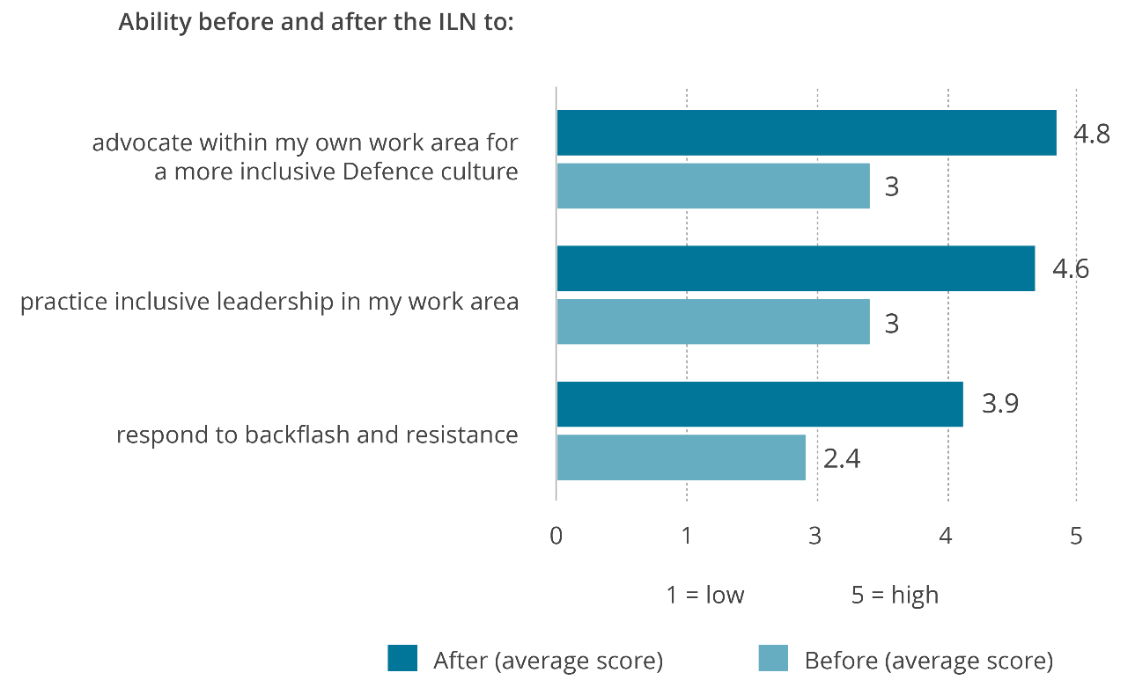

Working with schools
Start to Talk
In this reporting period the Commission initiated this project to develop a suite of resources aimed at the promotion of child safety and participation while playing sport. Public consultations were held with 78 children and young people between the ages of 6 and 12, and current primary and high school teachers. The resources are currently being designed in consultation with a young artist and planned for release in the next financial year as part of a broader public campaign to be developed by Play by the Rules.
Teaching School Children About Digital Health Records
The My Health Record system offers an unprecedented opportunity to engage Australian children in an important conversation about their health rights.
Commissioned by the Australian Digital Health Agency, this project developed a set of resources to guide and support children using the My Health Record system. The resources are primarily targeted at those aged 14–17 years, given children in this age range can control their own health records. Some of the resources are also aimed to educate younger children about their health rights and what to expect when they turn 14.
The lesson plans are aligned with the Australian Curriculum, including the curriculum areas of Health and Physical Education, Digital Technologies, and Civics and Citizenship. They were co-designed by school students and are available to all teachers in Australia.

Partnership with the Shark Island Institute
In partnership with the Shark Island Institute, the Commission consulted on the development of 52 lessons for Years 5 to 12 that explore topics such as racism, privilege, and resilience and are designed to support teachers and students in exploring the key themes of the Australian documentary, The Final Quarter. In addition, the Commission provided expert advice on the development of three educational resources to support the promotion and use of ‘In My Blood It Runs’, a documentary about the lived experiences of ten-year-old Arrernte Aboriginal boy, Dujuan Hoosan.

Progress indicator 2.12
Instances of organisations working with the Commission to develop human rights education/training activities.

Inclusive leadership training materials for the Royal Australian Navy
The Commission-Defence Collaboration delivered content for two inclusive leadership workshops for the Royal Australian Navy (Navy) in 2019–2020: Inclusive Behaviours for Supervisory Leaders, and Inclusive Leadership for Middle Managers.
The workshops support the Navy’s focus on developing a diverse, inclusive, and respectful workplace. Navy is integrating the workshops into their gateway and promotional leadership courses.
Navy facilitators presented the ‘Inclusive Behaviours for Supervisory Leaders workshop’ several times in late 2019 and early 2020. The Commission then refined the workshop content in response to participant and facilitator evaluation.

Evaluation of Inclusive Behaviours for Supervisory Leaders found that:
- over 60% of workshop participants reported that their understanding had increased in three areas: diversity and inclusion (61%); inclusive behaviours (67%); and inclusive language (65%),
- participants provided positive feedback on the workshop content,
- facilitators stated that the materials were well-structured and formatted and relevant to Navy’s context.

The Navy will present the Inclusive Leadership for Middle Managers workshop online or to a changed schedule due to COVID-19 restrictions.

Fostering multigenerational workforces – NSW Government
The NSW Government funded the Commission to undertake a several projects in alignment with its NSW Ageing Strategy 2016–2020.
Initially, the Commission developed and released (in the last reporting period): Multigenerational workforces: a guide to the rights of older workers under the Age Discrimination Act 2004 (Cth). The guide provides employers and other work providers with information about the operation of the Act and practical guidance about promoting the inclusion of older workers in multigenerational workforces.
In this period, the development of a Multigenerational Workforces: factsheet, and a suite of posters, postcards and bookmarks was completed. The webpage hosting the resources has been viewed 2,080 times in 2019–2020 with 791 and 518 downloads of the guide and factsheet, respectively.

Outcome 2.2 [PBS criterion]
Our information resources, services, events, and campaigns reach inform and influence users and audiences.

Progress indicator 2.21 [PBS target]
Targeted audiences are reached, access our information resources and services, and participate in our events and campaigns. Demonstrated by:
- digital engagement analytics exceeding the previous year’s benchmark by 5%
- high rates of users report them engaging and relevant.

Public and digital engagement
For the 2019–2020 period the Commission implemented the ‘Google Search’ function on our website to enable a full text search across the site and publications. These results show the Commission exceeded the Indicator and PBS target of 5% growth in pageviews and website visits – with a 5.5% increase in pageviews and 10% increase in website visits for 2019–2020.
Other digital engagement and data in this reporting period:
- 127,835 users searched the website in 2019–2020,
- subscribers to our interest lists went to over 55,000, and the Commissions monthly e-newsletter reached over 21,000 people,
- a new version of the Commission’s website went live in January 2020. In 2019–2020 the website was visited 6, 139,151 times with 10, 245,468 pageviews,
- an online ‘submissions hub’ was also established was launched in February 2020 and has had over 4, 000 pageviews,
- the Commission compiled its COVID-19 information in one central area on the website. Since the launch there have been 24,000 pageviews.

Events and launches
Our public presence helps us to reach large and diverse audiences and to facilitate informed debate. In this period, we hosted and promoted at least eight major events that have engaged substantial audiences and generated significant awareness and debate through media coverage:
- Human Rights Awards
- Human Rights Day Oration
- Free and equal: An Australian conversation on human rights – Conference, and associated events with HE Dr Michelle Bachelet, United Nations High Commissioner for Human Rights (reported under Indicator 1.11)
- Forum on Child Safe Organisations
- Launch of National Inquiry into Sexual Harassment in Australian workplaces: Respect@Work report
- The Final Quarter documentary screenings
- Launch of The Children’s Rights Report 2019 – In their own right
- Kep Enderby Memorial Lecture, delivered by Thomas Keneally, AO: The moveable feast: Australia and ace hate as experienced in the Lifetime as an observer.

Human Rights Day
The 2019 Human Rights Awards, held on 12 December 2019, was attended by 575 delegates from government, legal, business, and community sectors from around Australia. The Commission received 346 nominations across the nine Awards categories. Based on a post-event survey, 90% of respondents would recommend the Awards to their colleagues or organisations in their network.
Public engagement on the Awards was successful, with over 156, 826 Twitter accounts reached, and over 218, 000 impressions, with an accumulative reach of 8,795 via Instagram. Pageviews on the Awards website were 46% higher than the previous year, with 35,365 pageviews throughout the Awards period. The Awards also received a surplus of 90 media stories, with a minimum audience reach of 40,184.

Elder abuse advocacy and awareness
In this reporting period, Commissioner Patterson continued her term goal and program to improve Australia’s recognition and response to elder abuse, building on the findings of the 2017 Australian Law Reform Commission (ALRC) report, Elder Abuse – A National Legal Response and encouraging implementation of the recommendations.
Commissioner Patterson completed a pilot information campaign in Tasmania which included the launch of an elder abuse awareness bookmark – a resource developed with the agreement of the concept originators, ACT Legal Aid and in partnership with the Attorney-General’s Department.
The Commissioner travelled across the east coast of Tasmania, supported by a partnership with key stakeholder COTA Tasmania, who arranged the itinerary and logistics for community events and distribution of the resources through key stakeholder channels. As a result, the pilot increased awareness of the materials, leading to requests for bookmarks to distribute by stakeholders from key sectors, including banks, allied health providers, pharmacies and community organisations.
In tandem with the pilot, Commissioner Patterson leveraged multi-media media opportunities to increase knowledge of this project and resources across Australia and has reached international stakeholders. This led to a partnership with the US National Centre on Elder Abuse (NCEA), where an adapted bookmark was used in their 2020 World Elder Abuse Awareness Day (WEAAD).
‘We love your bookmark campaign and would like to discuss partnering with you on it for the next WEAAD campaign. We all know elder abuse is a global social justice issue and I believe this could unite our efforts and build awareness.’
— Julie Schoen, NCEA Deputy Director
Evaluation and monitoring of the pilot indicate the bookmark resource and campaign messaging has gained traction, with Tasmanian stakeholders finding the bookmark relevant and practical.
‘This is a great resource, easy to distribute and easily understood.’
‘I hope that the bookmarks can be more widely distributed throughout Australia, they really are a great resource.’
‘We had some feedback that the bookmarks in the Seniors Week brochures were an incentive to some people to attend subsequent information sessions about elder abuse.’
—survey respondents, Tasmanian pilot
COVID-19 caused disruption to the distribution of the elder abuse materials, however, numerous organisations continued to disseminate the resources – nearly half a million bookmarks have been distributed nationally. Partnerships with Australia Post resulted in an undertaking to distribute bookmarks in 3,501 outlets across Australia in conjunction with WEAAD 2021, and with Queensland’s Department of Communities Disability Services and Seniors, to distribute 25,000 bookmarks by, in their Seniors Card mail out.
In this period, Commissioner Patterson also facilitated a collaboration among allied health stakeholders to develop elder abuse training materials for their workforces. She continued to raise the importance of harmonising powers of attorney legislation across jurisdictions and developing a national online register of powers of attorney with the Council of Attorneys-General.
In the coming year, Commissioner Patterson will continue her advocacy and education around elder abuse and the supports available. This includes launching an elder abuse awareness video, to be distributed across a range of channels to increase awareness of elder abuse and the national helpline, 1800 ELDERHelp (1800 353 374).

Racism. It Stops With Me – Let’s talk race resource
As part of this campaign, the Commission developed the Let’s talk race: a guide on how to conduct a conversation about racism resource to assist Australian organisations conduct meaningful and productive conversations about racism. The website page for this resource has been viewed 12,041 times in 2019–2020, with over half of these downloading the guide (6,298).
The Racism. It Stops with Me campaign website received 822,832 pageviews in 2019–2020.

Progress indicator 2.22
Instances of legal information, resources, guidelines, and exemption processes helping employers and organisations to comply with Australian discrimination and human rights law.

Guidelines
The Commission can issue guidelines under discrimination laws to assist the community to understand the law and provide examples of how to best to comply with it. In this section, we follow up on the outcomes of guidelines previously released and report on new guideline development.
Guidelines for the promotion of equal opportunity for women and girls in golf
Last year we reported on the release of these Guidelines, developed by Commissioner Jenkins in partnership with Golf Australia. Monitoring activities in this period indicate the guidelines are reaching clubs, are being used by them, and are making a difference.
Golf Australia has used the guidelines in its work on a national female engagement and gender equality strategy, Vision 2025: The Future of Women and Girls in Golf. As part of this work, Golf Australia:
- supported the Guidelines release in an Australia-wide roadshow that delivered 51 presentations to nearly 1,500 golf club leaders
- published 2020: 2025 Visionaries, which celebrated the significant steps the sport has taken towards gender equality since publication of the guidelines, and its own gender equality strategy.
‘Visionaries’ is a collection of case studies highlighting golf clubs that are doing work to promote equal opportunity. Many of the case studies refer directly to the Commission’s Guidelines and their role in increasing the recognition of equality issues and the need for change, and in supporting that change. For example, Huntingdale Golf Club commented that:
‘Management, a very supportive club committee, and membership and women’s sub-committees have been leading their club forward with Vision 2025 strategies to grow female participation by making changes reflective of the AHRC Guidelines to provide equal opportunity for women and girls.’
—2020: 2025 Visionaries

While Torquay Golf Club realised that:

‘Some of our policies and procedures ran contrary to the requirements of the Sex Discrimination Act. We were not only being unlawful, but also not working to our ‘one club’ philosophy – to provide equal golfing experiences for both men and women.’

—2020: 2025 Visionaries

The webpage hosting these Guidelines was viewed 1,388 times in 2019–2020 with 2,587 downloads.
Guidelines for the inclusion of transgender and gender diverse people in sport
In June last year Commissioner Jenkins published these Guidelines, developed in partnership with Sport Australia and the Coalition of Major Professional and Participation Sports. In this period, several major sports organisations began developing their own inclusion policies, drawing on the Guidelines – including Cricket Australia in publishing its policies (elite and community) in August 2019.
Monitoring in this period shows the webpage hosting the Guidelines has been viewed 5,773 times with 1,424 downloads, and includes positive feedback received directly from individuals affected by the Guidelines. For example, a transgender woman told her story of competing in a regional sporting event. Encouraged by the launch of the Guidelines, she reached out to the organisers, speaking to them about the Guidelines. In response, they placed her in a women’s sporting team that was short a player. She was welcomed by both the organisers and the team. The impact on her was significant:
‘The affirmation, inclusion and feelings of community and belonging I have experienced are so over the top compared to anything I have ever experienced before, I can’t stop crying whenever I think of it…I thought I understood before how important sport was, but I was wrong. I had no idea what it felt like to belong. I only thought I did.’
—Sport Australia, shared correspondence, 20 July 2020

Disability Guidelines
The Commission has the power under the Disability Discrimination Act 1992 (Cth) to issue guidelines ‘for the avoidance of discrimination’ on the ground of disability. In this period Commissioner Gauntlett led the work on the development of two such guidelines, both to be published early in the next reporting period:
The Guidelines: Equivalent Access under the Disability Standards for Accessible Public Transport 2002 (Cth) aim to help operators and providers ensure that public transport services and infrastructure are accessible. The Commission partnered with the Department of Infrastructure, Transport, Regional Development and Communications to develop the guidelines. They provide guidance on the equivalent access provisions of the Disability Standards for Accessible Public Transport 2002 (Cth) (Transport Standards), their interaction with the Disability Discrimination Act 1992 (Cth), and practical help on assessing equivalent access measures.
The Guidelines on the rights of people with disability in health and disability care during COVID-19. In April 2020 the Commission was asked by the Advisory Committee on Health Emergency Response to Coronavirus for People with Disability to develop a set of Guidelines to support the implementation of the ‘Management and Operational Plan for COVID-19 for People with Disability’, developed by the Committee. The purpose of these Guidelines is to provide practical guidance on how to apply a human rights-based approach to decision making, that takes the right of people with disability into account, within the health system in the context of the of current pandemic.

Legal information and resources
Reports to the Minister under the Australian Human Rights Commission Act 1986 (Cth)
When the Commission receives a complaint of a breach of human rights or workplace discrimination, we attempt to resolve the complaint through conciliation. If conciliation is inappropriate or unsuccessful, and we find that there has been a breach of human rights or that the matter amounts to workplace discrimination, then we may prepare a report of the complaint for the Attorney-General.
When the Commission receives several complaints raising the same or similar issues, it may prepare one report focusing on the systemic issue raised by the group of complaints.
In this period, the Commission prepared 7 reports to the Attorney-General. Each of these reports is published on the Commission’s website. Two of these reports focused on systemic issues raised by multiple complainants, namely:
- Use of force in immigration detention – see the case study below.
- The practice of the Australian Government of sending families with young children who arrived in Australia seeking asylum to Nauru. This report was tabled in Parliament in 2019 and was titled Ms BK, Ms CO and Mr DE on behalf of themselves and their families v Commonwealth of Australia (Department of Home Affairs) [2018] AusHRC 128.

Case study 4: Use of force in immigration detention [2019] AusHRC 130
This report is based on an inquiry into 14 separate complaints received by the Commission about use of force. It draws together observations about how force is used in a variety of circumstances and makes recommendations aimed at systemic practical outcomes for people in immigration detention in Australia. The 14 complaints investigated related to the following kinds of use of force:
- the use of handcuffs on detainees while being transferred between detention centres, or when attending court or medical appointments
- the use of a face mask on a person being removed from Australia
- the use of force on detainees within the detention centre environment
- a significant incident where a number of detainees, including families with children, were removed from a detention facility by the operator’s Emergency Response Team.
The Commission found that, in nine cases, the use of force was contrary to the requirements of article 10 of the International Covenant on Civil and Political Rights, which provides that all persons deprived of their liberty shall be treated with humanity and with respect for their inherent dignity.
The report examined how risk assessments are carried out. If risk assessments are inaccurate, if they are not sufficiently tailored to the particular circumstances of the detainee, or if they are not sufficiently tailored to the particular circumstances where the use of force is anticipated, it can result in force being used too readily. The Commission welcomes the outcome that, following the commencement of this inquiry, the department decided to review its security risk assessment tool.
The report also found that there needs to be effective oversight of the use of force. This starts with ensuring there are clear lines of authority for approving the use of force, that specific approval is given for each use of force, and that records of such approvals are kept. Further, the actual use of force must be documented appropriately. The best way to do this is to ensure that any pre-planned use of force (and other uses of force to the extent possible) are filmed in their entirety. Reports on the use of force should be prepared to allow for subsequent review of whether it was appropriate.
The Department did not agree that the conduct complained of in the particular incidents involved a breach of human rights. Nevertheless, it said that since receiving a preliminary version of the Commission’s findings, it had made amendments to its internal policies which were directed to many of the issues identified by the Commission. The Department also said that it would take further action in the future to implement other recommendations in the report.

- Goal 3: More people, communities, and organisations take action to respect protect and promote human rights in their own contexts

Outcome 3.1 [PBS criterion]
Our activities increase the capacity of vulnerable groups, communities and their advocates to understand and advocate for their rights.

Progress indicator 3.11 [PBS target]
Instances of participants/community stakeholders reporting:
- robust processes that facilitate their access and participation
- experiences of meaningful participation that are beneficial and empowering.

Sharing the stories of Australian Muslims
Commissioner Tan’s Sharing the Stories of Australian Muslims project was established with the core objectives to listen to and share the stories and experience of Australian Muslims and to understand their concerns and needs. The research phase was completed in this period using a mixed method design of face-to-face consultations and online survey.
Access and participation were achieved using a community-informed survey distribution strategy that helped the Commission to both engage widely and connect with hard-to-reach communities. The survey was available in English, Dari, Urdu and Arabic, and Muslim community leaders, organisations and networks helped share and promote the survey. The project’s Advisory Group members and Critical Friends provided insight and advice, while non-Muslim organisations also promoted the survey and encouraged Australian Muslims to take part.

The survey was the first national opportunity for Australian Muslims to record the individual, family and community impact of their experiences as Australian Muslims. The importance of this opportunity for meaningful participation and consultation on this issue was clearly valued. As a result, a significant participation sample was achieved: 1,017 Australian Muslims took part in the survey, and responses were received from every state and territory, including from metropolitan and regional locations.

In addition to quantitative survey questions, many respondents were able to include their personal experiences and stories. As the project was established in the wake of the terrorist attacks in Christchurch respondents were also invited to comment on this experience – 87% of those surveyed took the opportunity to share how the Christchurch tragedy had affected them, their friends, or their family. A respondent wrote:
‘I appreciate this survey to hear my community voice. This gives me a feeling that someone cares about us and [is] here to listen to us.’
—research survey data set, item 31

In addition, over 30 consultations with the Australian Muslim community were held between July 2019 and February 2020. Results were communicated back through word cloud resources created for each location. These were shared with participants, allowing them and their communities to quickly see the discussions from their area and to know their stories had been heard. These resources were then used by some participants in their own communications.
The report of the research findings will be published in late 2020. It is anticipated this will inform the work of project stakeholders and be supported by Commission education and advocacy.

Outcome 3.2 [PBS criterion]
Our activities increase the capacity of Governments, organisations, other groups and services to understand and address the human rights impact of their actions, particularly when working with vulnerable groups and communities.

Progress indicator 3.21 [PBS target]
Instances of stakeholders in our activities with organisations reporting that our work has contributed to increased understanding of the impact of their systems and operations on human rights.

Commission-Defence Collaboration to support and improve cultural reform across Defence (2014–2024)
The Commission has worked with the Australian Defence Force for the past 6 years to support and improve cultural reform.
In June 2020, the Commission and Defence signed a new four-year agreement to continue this work. The Collaboration program includes high-level dialogue and policy review and advice combined with short and long-term projects – some at the individual service level and some across Defence, including Defence Australian Public Service. Outcome reports for two of the projects undertaken in this reporting period are located under other indicators.
The Commission brings a human-rights based approach to its cultural reform work with Defence. This means turning human rights from legal instruments into effective policies and practical realities. Defence has worked with this approach to redefine problems, examine root causes, and expand its range of responses to problems. For instance, when Defence addressed structural and systemic inequalities to improve women’s participation in one program, it also increased participation among men and provided a model for broader implementation across other services.

Building capacity for child safety: A suite of Child Safe Organisation e-learning modules
In the last reporting period, we reported on Commissioner Mitchell’s work to develop the National Principles for Child Safe Organisations. Following this, the Australian Government commissioned the development of practical tools and resources to help organisations implement the Principles.
In this period, we completed a suite of 11 e-learning modules, which are available at no cost to any organisation or interested party. The modules are designed to help organisations increase their knowledge and understanding of the Principles and identify the steps they need to take as they work towards implementing them.
Since the e-learning modules were launched in August 2019, 4,194 users have registered – suggesting this work is actively contributing to organisations making changes to policy and practice, to protect and promote children’s human rights in their context.

Immigration detention, refugee, and asylum seeker program
Commissioner Santow leads the Commission’s work on human rights issues facing asylum seekers, refugees and people in immigration detention. This involves inspections of immigration detention facilities, engagement with Parliament and other reform bodies regarding changes to Australia’s migration laws, and the conduct of thematic research projects on refugee and asylum seeker policy.
In addition, the President handles complaints under the AHRC Act relating to the International Covenant on Civil and Political Rights (ICCPR) and Convention on the Rights of the Child (CRC). This regularly includes complaints from people in closed immigration detention or community detention arrangements.
In this period, the Commission released a major report, Lives on hold: Refugees and asylum seekers in the Legacy Caseload, which provides the first comprehensive assessment of the human rights implications of laws and policies affecting this group. The report received widespread media coverage and has been used as a resource by civil society organisations to inform their policy and advocacy work.
In the second half of 2019, the Commission completed inspections of all immigration detention facilities on the Australian mainland, identifying human rights issues specific to individual facilities, as well as systemic issues across Australia’s detention network.
The risks posed by COVID-19 to people in immigration detention has been a significant focus of work in 2020. Commissioner Santow maintains regular contact with the Australian Government in relation to these issues, with high-level fortnightly meetings with officials from Australian Border Force. The Commission has commenced a targeted review of how some risks posed by COVID-19 are being managed in Australia’s immigration detention facilities from a human-rights perspective, with particular reference to expert health advice and relevant guidelines.
The Commission will deliver reports on both activities later in 2020.

Progress indicator 3.22 [PBS target]
Instances of stakeholders in our activities with organisations making changes to organisational policy and practice, to protect and promote human rights in their context.

OPCAT implementation in Australia
In December 2017, the Australian Government ratified the Optional Protocol to the Convention Against Torture, Cruel, Inhuman and Degrading Treatment (OPCAT). OPCAT aims to improve how people’s rights are protected and promoted when they are deprived of their liberty, by providing for a rigorous process of independent inspections of all places of detention in a country’s jurisdiction.
When the Government announced its intention to ratify OPCAT in February 2017, Commission Santow was asked by former Attorney-General, the Hon Senator George Brandis QC, to conduct a consultation into how Australia should implement the treaty.
The project aimed to contribute to the effective implementation of OPCAT in Australia and, in doing so, to increase understanding of how the treaty should be complied with. This work was achieved through:
- an inclusive, collaborative consultation with government, civil society and independent monitors and inspectors of places of detention (completed in the last period), and
- the completion of a Final paper: Implementing OPCAT in Australia, an evidence-based blueprint for action in this reporting period.
The consultation initiated with background research and the release of a consultation paper in mid-2017, which asked high-level questions about how OPCAT should be implemented. This drew together written submissions from a diverse range of stakeholders, including medical professionals, lawyers, social workers, academics, human rights bodies, religious groups and organisations representing people with lived experience of detention. Stakeholder expertise covered a range of sectors, including criminal justice, aged care, disability, Indigenous justice and immigration.
In addition, the Commission held seven roundtables with key stakeholders across Australia, undertaken with the support of the Asia Pacific Forum of National Human Rights Institutions. An ‘Interim Report’ set out the Commission’s preliminary views on fundamental aspects of OPCAT implementation and was communicated to the Attorney-General in September 2017.
A further stage built on the groundwork from above. A second consultation paper, published in June 2018, sought feedback on proposals made in an Interim Report to the Attorney General, and asked additional questions regarding OPCAT implementation. Four expert roundtables were held across Australia.
Significant, and valued stakeholder participation was achieved by the project from across the consultation strategy:
- The Commission received 122 written submissions across the two consultation stages (a total of 148 organisations and individuals contributed to these submissions).

- Evaluation of the initial consultation found that 94% of respondents rated the Commission’s role in informing and consulting with stakeholders and reporting to government as ‘very’ or ‘extremely important’; 86% reported that taking part in the roundtable had been either ‘very’ or ‘extremely’ worthwhile.

In this reporting period, the final paper, Implementing OPCAT in Australia was published, finalising the project.
The final paper draws authoritatively on the evidence base of submissions received across both consultation stages and desktop research, including how OPCAT has been implemented in comparable international jurisdictions. Together with the views of experts and key stakeholders, it provides a blueprint for implementation, with recommendations to ensure OPCAT is implemented in a way that will better safeguard the human rights of people in all places of detention. It also sets out a clear and deliberative timeline for action.
The final paper has been welcomed by civil society, government and academia.
The project has contributed to the Commissioner’s term goal of improving human rights protections for vulnerable groups and in difficult contexts. Commissioner Santow has been recognised as having expertise relevant to the implementation of the treaty. For example, receiving numerous invitations to speak in the media, at conferences, expert meetings and civil society fora. In addition, Commissioner Santow was invited to join the Commonwealth Ombudsman’s Expert Advisory Group on OPCAT implementation – which followed the appointment of the Ombudsman as co-ordinator of Australia’s network of National Preventative Mechanisms.

Freedom of religion in Australia: a focus on serious harms
The Commission’s work on freedom of religion is led by Commissioner Santow. This year, the Commission’s work was focused on considering and responding to the Australian Government’s proposed religious discrimination bills and increasing understanding of serious harms experienced by people on account of their religious beliefs. To progress this work, the Commissioner met with diverse religious leaders and other people of faith to discuss their experiences and concerns, as well as with government, legal and medical stakeholders.
In October 2019, the Commission supported and participated in an academic roundtable organised by the University of Divinity entitled ‘Religious Perspectives on Human Rights’. Commissioner Santow contributed a paper and an introduction to a publication resulting from the roundtable.
Just outside this reporting period, on 1 July 2020, the Commission partnered with the Victorian Equal Opportunity and Human Rights Commission to launch a joint position paper, Freedom of religion in Australia: A focus on serious harms. This was based on feedback from two roundtables with religious communities held in Sydney and Melbourne, as well as additional research. The paper contains a number of recommendations to the federal and Victorian Governments to reduce the incidence of serious harms on the basis of religion, defined as ‘experiences of violence, abuse, intimidation, severe discrimination and some forms of vilification’. Stakeholders reported that this will be a useful resource in their ongoing work.
The Commission has sought to work collaboratively with religious communities and organisations on human rights issues. An example of this was a meeting in April 2020 with Christian, Muslim and Jewish leaders to discuss their concerns during the COVID-19 lockdown and, in particular, the issue of government support for temporary visa holders in Australia.

Progress indicator 3.23
Instances of business stakeholders reporting that our work has contributed to increased understanding and awareness of their role to prevent modern slavery in their supply chains and operations, and how to address it.

Strategy for Business and Human Rights
The Commission’s program of work in this area is led by President Croucher and seeks to leverage the growing momentum internationally and domestically around the 2011 United Nations Guiding Principles on Business and Human Rights (UNGPs) and other business and human rights (BHR) standards. The work program includes the projects below, which have contributed to this indicator using awareness raising and capacity building strategies.

Annual Business and Human Rights Dialogue – 2014 to 2019
In this reporting period, the sixth annual Australian Dialogue on Business and Human Rights was convened by the Global Compact Network Australia (GCNA) and the Commission on 17 October 2019 in Melbourne. Over 100 people attended.
The 2019 theme was ‘Doing Business with Respect for Human Rights in the Asia-Pacific Region’. This focus reflected the pivotal role of the Asia-Pacific region as a key trading partner for Australian companies, and the fact that many companies are considering their relationships with suppliers from the region as they prepare to report under the Modern Slavery Act 2018 (Cth). The event included a range of speakers drawn from the region, including from India, the Philippines, Papua New Guinea and New Zealand, who provided first-hand experience of working on business and human rights issues in the region.
‘The speakers with lived experience added real richness and depth to the conversation.’
—survey respondent, 2019
Panel discussions covered a range of topics including: protecting human rights defenders and civic space in the region; creating effective company grievance mechanisms; understanding climate inaction as a human rights risk; the connections between human rights violations and corruption; and empowering women and girls in the region. At the 2019 Dialogue, modern slavery issues were raised in panel discussions throughout the day, including in relation to grievance mechanisms.
‘Great mix of business, civil society, gov in both audience and panelists. All panelists were engaging with different subject matters.’
—survey respondent, 2019
The Dialogue is Australia’s largest and most recognised forum for discussion of business and human rights issues. It brings together the wide range of stakeholders that are known as essential to effectively operationalising the UNGPs and especially, in in helping businesses understand the expectations of their corporate responsibility to respect under Pillar II of the UNGPs.
Over the last six years, the Dialogue has evolved a reputation for relevance and value and, critically, as a forum that regularly brings together all the key stakeholders. The UNGPs rest on a polycentric framework where states, business, civil society and workers are all expected to have a role in creating state and non-state-based solutions to addressing corporate human rights abuses.
The Dialogue has allowed the Commission to facilitate collaborative and robust discussion among these stakeholders and to ensure marginalised or vulnerable groups (such as survivors of modern slavery) are included. Over the six period the Dialogue has:
- played an important role in nurturing the growth of a vibrant business and human rights community and progressing the BHR agenda in Australia
- increased awareness and understanding of the business community of business and human rights issues and frameworks
- helped drive regulatory progress, in particular, through the introduction of the Modern Slavery Act 2018 (Cth).
From 2015, the Dialogue has been evaluated annually, and each year the findings demonstrate the event is beneficial to the participants. Figure 2 summarises the achievements and outcomes drawn from these data.

Figure 2: Outcomes snapshot: Annual Business and Human Rights Dialogue, 2014 to 2019

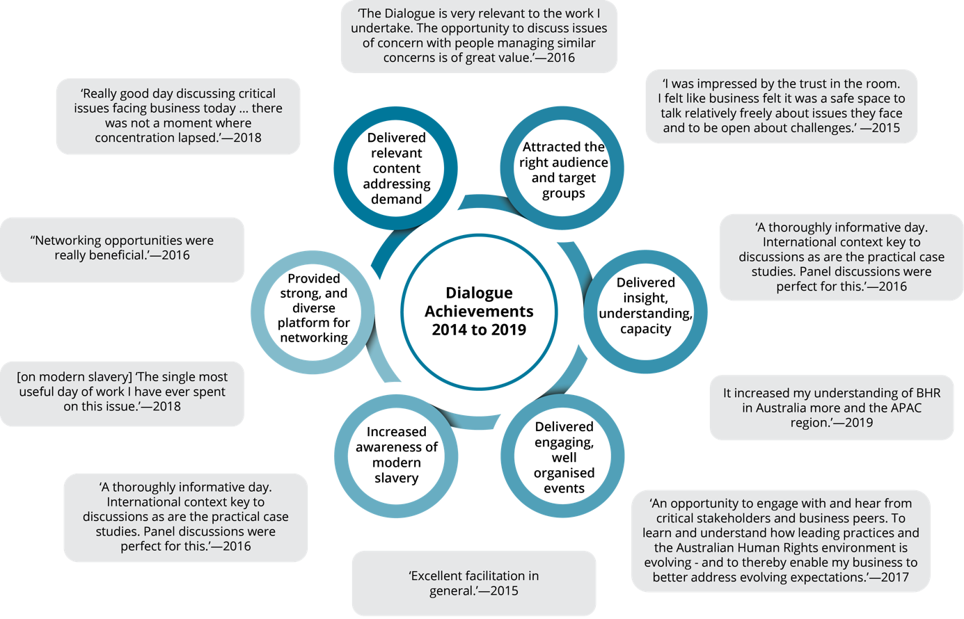

KPMG partnership on modern slavery
The Modern Slavery Act 2018 (Cth) requires certain large entities and the Government to report annually on their efforts to address risks of modern slavery in their global operations and supply chains. The first reporting under this Act begins in the 2020–2021 financial year.
The Commission is working to support Australian businesses to effectively respond to the Modern Slavery Act 2018 (Cth) through a partnership with KPMG, which seeks to promote measures that improve modern slavery risk management and situate efforts to identify and address the risks within a broader human rights framework.
Throughout October and November 2019, the Commission, the Australian Institute of Company Directors (AICD) and KPMG co-hosted a series of Directors Briefings: Modern Slavery Reporting – Is your board ready?
These events were for AICD members (usually company directors) in Canberra, Brisbane, Sydney, Melbourne and Adelaide. Commission Chief Executive, Padma Raman participated in each panel with a representative from KPMG and a local company director who is a member of the AICD or similar.
Company directors were the target audience because, under the Act, board directors must sign off on their company’s annual modern slavery statement. The panel events sought to assist board directors to better understand their responsibilities under the Act, and to respond effectively to modern slavery risks, using a ‘risks to people’ lens.
The event series reached 412 members of the AICD, in 5 cities. In December 2019, following the panel events, the Commission and KPMG presented an interactive webinar for AICD members.
A survey evaluation of the series indicates the events were beneficial, with many respondents rating the topic relevance and speaker quality as high – and providing positive feedback:
‘It was great to hear from VERY relevant speakers…. the speakers were perfect for the topic’,
‘Key issues well-articulated - not just outlined requirements, but helped provide an overall understanding of why, how and benefits/impact of adoption’,
‘A quality event with high calibre speakers. Good exploration of the topic. Fast moving. Worthwhile’.
—survey respondents
In addition, the Commission is working with KPMG to prepare a suite of sector-based guidance on responding to the Modern Slavery Act 2018 (Cth), by managing modern slavery risks using a rights-based approach. The guidance packs will be released in the next reporting period.
Leading by example
As a small, Commonwealth Corporate Entity, the Commission is not required to report under the Modern Slavery Act 2018 (Cth). However, in this period, the Commission has been taking steps to identify and address key risk areas for modern slavery in our own supply chains, including by introducing:
- a new Responsible Sourcing Policy,
- Factsheet for suppliers: The Modern Slavery Act 2018 and your business (for commission suppliers), and
- developing modern slavery training for Commission staff.
The Commission’s work in this space not only reflects our organisational values, but also aligns with the Commonwealth Government’s efforts to respond to modern slavery risks in government procurement. This work is also part of the Commission’s commitment to implementing the UNGPs, which ask States to promote business respect for human rights through their relationships with suppliers of goods and services.

Progress indicator 3.24
Instances of partners’:
- increased knowledge and application of human rights frameworks, principles, and practices to advance human rights reform
- practice/policy reform relating to human rights principles, which are reviewed or developed as a result of technical cooperation activities.

International Programs
With support from the Department of Foreign Affairs and Trade (DFAT), the Commission continued its human rights capacity-building programs, using its blended learning model approach. This combination of online modules and interactive sessions allows the Commission’s capacity-building work to continue, despite the COVID-19-related travel restrictions and inability to meet face-to-face.
Vietnam Human Rights Fund 2017–2021
Under the Vietnam Human Rights Fund, the Commission has two initiatives – the Human Rights Education Partnership and the Advancing Responsible Business Conduct Partnership. Supported by DFAT, both Partnerships aim to contribute to the promotion and protection of human rights in Vietnam, over the 2017–2021 period.
Human rights education partnership:
Under this partnership with the Ho Chi Minh National Academy of Politics, the Commission developed, and ongoing, will host three online training modules focused on human rights, human rights frameworks, and human rights education on its learning management system (LMS). In 2019–2020, approximately 428 people had enrolled in one of the three online modules.
In conjunction with the online modules, the Commission also facilitated a face-to-face ‘Train the Trainer’ program in Human Rights Education. The primary objective of the workshops was to develop the confidence and skills of a group of university-level human rights lecturers to deliver forthcoming workshops on human rights education for teachers and education officials. There were 15 law lecturers from five academic institutions who participated and four observers from the Ministry of Education and Training.
The immediate outcome of the training is that participants should have an enhanced understanding of the purpose and principles of human rights education, and effective adult learning methodologies. To assess these changes in knowledge, skills, and attitudes, participants were asked to complete a feedback survey, including rating their knowledge, skills, and attitudes both before and after the workshop, in relation to a series of statements:
Overall, responses indicated that 33–46% increased:
- their knowledge and understanding of human rights education and adult learning principles, and
- their confidence to apply those principles in upcoming human rights education workshops.
Qualitative feedback also demonstrated training benefits experienced by the respondents:
‘The interactive method was interesting which enhanced learning.’
‘The online course (training) was very useful.’
‘I have learned quite a bit about important pedagogical skills from lecturers as well as classmates.’
—survey respondents

Advancing Responsible Business Conduct Partnership:
This Partnership with the Vietnamese Chamber of Commerce and Industry (VCCI) aims to advance responsible business conduct in Vietnam through increasing the human rights knowledge and capabilities of businesses and future business leaders. Under this partnership, the Commission has facilitated the attendance of VCCI partners at international and interregional forums on business and human rights, raising their awareness and understanding of the need for human rights protection in Vietnam.
The Commission has also been involved in drafting a Responsible Business Conduct sector guide, focusing on human rights concerns in the Footwear and Apparel sector in Vietnam. The Guide will be the first of a number, each providing guidance on how businesses in Vietnam can implement human rights into their operations. The information contained in the guides will also be used as a framework for subsequent business and stakeholder workshops and training for higher education professionals teaching business studies.
The outcomes of this Partnership build the capacity of the VCCI and business in Vietnam to understand and incorporate human rights frameworks, principles and practices into their business operations, with the aim of reducing human rights harms. Uptake and application of the Guide (and successive guides) in Vietnam will be demonstrated more clearly in Year 2 of this partnership.
Human Rights, Technology and Cyber Security in Vietnam
Developed in response to a request from Vietnamese Government representatives, the Human Rights, Technology and Cyber Security program aims to increase the understanding and commitment of Government of Vietnam officials regarding human rights online and the importance of an open, free and secure internet. With the support of DFAT, in partnering with Vietnamese Government departments, the Commission also seeks to strengthen existing and establish new networks between Australia and Vietnam.
The Commission is in the process of developing online training modules that focus on key topics including human rights online, online security for women and children, privacy online, hate speech online and human rights and artificial intelligence. These online modules will form part of a blended learning approach that will promote a more robust and informed approach to human rights online in Vietnam.
Lao PDR-Australia Human Rights Technical Cooperation Program (HRTCP)
The Lao PDR-Australia HRTCP is designed to strengthen the promotion and protection of human rights in the Lao PDR, by sharing Australia’s experiences, supporting the Lao Government to enhance its engagement with the United Nations human rights mechanisms and building capacity around the Convention on the Rights of People with Disability (CRPD), the International Covenant on Economic, Social and Cultural Rights (ICESCR) and the Universal Periodic Review (UPR).
In this period, the HRTCP delivered five activities, including civil society consultations for the UPR process, a training workshop for Lao Government officials on the CRPD, a study visit to Australia, and attendance at key UN engagements for key Lao Government personnel. The 6th Australia-Lao PDR Human Rights Dialogue also occurred, with participation facilitated in part by the HRTCP and the Commission in attendance.
This is the third year of the HRTCP, and the positive relationship between the Commission and the key implementing partner, the Department of Treaties and Law, continues to grow and strengthen. All activities have been implemented to a high standard, with feedback and evaluation surveys consistently reporting positive outcomes and progress towards the HRTCP objectives. One indication of the success of the HRTCP is its recent expansion to also providing support to the Lao Government on its COVID-19 response to ensure human rights are considered and respected in the response and recovery efforts.
Supporting Human Rights in Association of Southeast Asian Nations (ASEAN)
Supported by DFAT, this program aims to foster partnerships, collaboration and cooperation on human rights between the Commission and ASEAN Inter-Governmental Commission on Human Rights (AICHR) and ASEAN-based NHRIs. In this reporting period, the Commission was a trusted partner in the 3rd annual Human Rights Dialogue between Australia and AICHR, as well as the AICHR Interregional Dialogue on Business and Human Rights and the 2019 Bangkok Business Week.
The Commission worked to strengthen knowledge, capacity and cooperation on human rights in the region through facilitating the attendance of six ASEAN-based NHRI representatives at the AICHR Interregional Dialogue, the 2019 Bangkok Business Week and NHRI-specific interregional meetings.
Commission presentations at a number of AICHR events not only raised human rights knowledge and capacity, it also promoted Australia’s role as a proponent of human rights in the ASEAN region.
Repeated requests for the Commission’s involvement in and contribution to AICHR and ASEAN NHRI-related programs indicates recognition of the Commission’s relevance and effectiveness in building knowledge, co-operation and capacity of human rights in ASEAN. Participants in Commission-facilitated NHRI-specific meetings have noted that these are invaluable opportunities to learn, share and collaborate on interregional human rights issues.

- Goal 4: Effective access to justice and remedy for people and communities whose rights are breached

Outcome 4.1 [PBS criterion]
We deliver a fair and effective investigation and conciliation service.

National Information and Investigation and Conciliation Services
In 2019–2020, the Commission assisted over 12,554 people and organisations by providing information about the law and the complaint process, assisting with problem solving and providing referrals to other services.
The Commission provided approximately 26 information/education sessions to stakeholders, professionals, advocates and community groups across Australia.
In 2019–2020, the Commission accepted 2,307 complaints of alleged discrimination and breaches of human rights and finalised 2,237 complaints. The Commission conducted approximately 1,432 conciliations processes, of which 1,004 complaints (70%) were successfully resolved.

Progress indicator 4.11 [PBS target]
85% of complaints are finalised in under 12 months, 40% of complaints are resolved by conciliation, 85% of parties to complaints are satisfied with the service they receive.
In the 2019–2020 period, the Commission met and exceeded all criteria in the above indicator:
- 98.5% of complaints were finalised within 12 months
- 46% of complaints were resolved by conciliation
- 93% of surveyed participants reported that they were satisfied with the service they received and with 77% rating the service ‘very good’ or ‘excellent’, and additionally
- 99% of surveyed participants to complaints that were conciliated, reported that they were satisfied and 83% rated the service as ‘very good’ or ‘excellent’.

Figure 3: Breakdown of satisfaction and service rating data by conciliation complainants and respondents
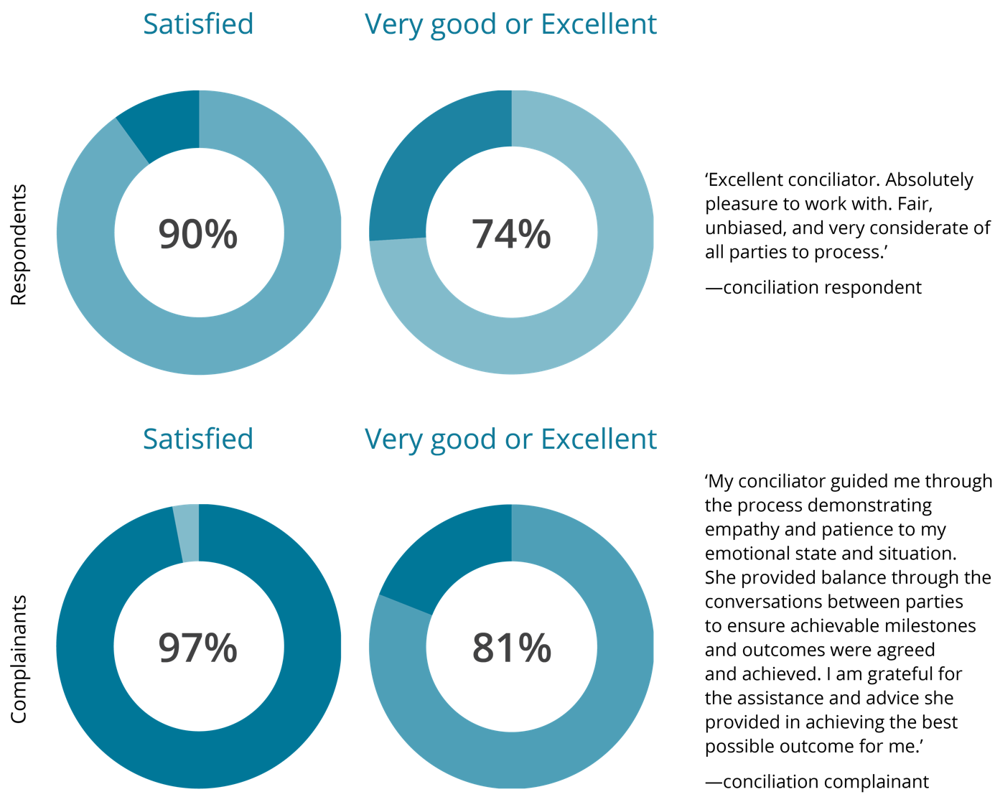

Progress indicator 4.12 [PBS target]
Instances where the terms on which investigation and conciliation disputes are resolved include systemic outcomes that accord with the objectives of the law.
Information on the outcomes of conciliated complaints under federal anti-discrimination law indicates that 39% of outcomes included terms which will have benefits for people beyond the individual complainant. For example, agreements to introduce anti-discrimination policies and provide anti-discrimination training in workplaces and agreements to undertake modifications to buildings and services to address potential discriminatory factors.

Progress indicator 4.13 [PBS target]
Instances where participation in the investigation and conciliation process results in increased understanding of rights and responsibilities in the law.
Commission survey data highlights the educative effect of the Commission’s complaint process. For example, in relation to conciliated complaints, 77.5% of surveyed participants indicated that involvement in the complaint process had assisted them to better understand their rights and responsibilities under federal human rights and anti-discrimination law.
These case studies are an example of these outcomes:
Case study 5: Complaint of sexual harassment under the Sex Discrimination Act 1984 (Cth)
The complainant worked as an assistant with the respondent company. She alleged her manager sexually harassed her, including by making sexual advances by text message, commenting on her breasts, inviting her to a hotel and offering to go to her place and give her a massage. She claimed when she complaints to the manager’s supervisor, she was told there was insufficient evidence for any action to be taken and recommended she delete the telephone messages. On being advised of the complaint, the company agreed to participate in conciliation.
The complaint was resolved. The parties agreed to end the employment relationship. The company agreed to pay the complainant $40,000 as general damages and provide her with a reference. The complainant’s former manager apologised to her for the distress she experienced from the events giving rise to the complaint. The company undertook to provide commission training for all staff on sexual harassment, workplace discrimination, the company’s complaint process and the obligations of staff and managers.

Case study 6: Complaint of disability discrimination under the Disability Discrimination Act 1992 (Cth)
The complainant has a brain injury and alleged the respondent entertainment venue company did not allow the online purchase of companion tickets and that seating maps did not show the location of doors or steps.
The company advised that, in response to the issues raised in the complaint, it undertook a review and upgrade of its online ticket purchasing platform and seating maps. The company said the new ticket purchasing platform allowed for easier and more streamlined purchase and verification of companion tickets.
The complainant considered that the actions taken by the company resolved her complaint.

- Performance analysis – how we are meeting our goals
The commission operates in a complex and fluid cultural, social, economic and political context. The nature of human rights issues is that they are many and diverse and the ultimate results (what difference, what benefit) of our activities are difficult to measure and attribute, generally being long-term and incrementally achieved, and undertaken collaboratively with multiple stakeholders.
In this context the Commissions monitoring and evaluation framework maps progress indicators to performance expectations that are feasible in the 4 -year outlook of the Corporate Plan (all being well in our operating context).
This statement has provided a range of monitored and evaluated activities, project examples and case studies to illustrate our performance.
The table below provides an assessment of the extent to which we have met the performance expectations and the challenges, context and lessons from this years’ experience.
Refer to Appendix 1 for the full performance measurement framework table.

Goal 1
Outcomes 1.1, 1.2, 1.3 (PBS criterion)
Performance expectation | To what extent did we meet it?
For outcome 1.1  Recommendations and actions in the ‘national conversation’ report to the Attorney-General and federal Parliament are positively received and progressed or adopted  Recommendations to Australia from the 3rd United Nations (UN) Universal Periodic Review Council (UPR) are accepted by federal Government and progressed | The national conversation initiative and UPR project operate in a multi-year context. In this reporting period, the foundations for meeting the performance expectations were laid by:  - conducting the high-profile conference that raised awareness of the need for a ‘conversation’ and the issues, and generated momentum among existing stakeholders and drew new stakeholders to the initiative,  - the research and participatory consultation phase which delivered stakeholder views – strengthening the credibility and persuasiveness of the findings,  - delivering clear stakeholder-led narrative to anchor the recommendations and reports as they are finalised in the next period.  - identifying key elements of a human rights reform agenda with the finalisation of the Commission UPR submission – building on the key themes from consultations from the national conversation project.
For outcome 1.2  Our research, reporting and advice influences decision makers and other stakeholders to take action to address the identified human rights issues | During COVID-19 the Commission’s President and commissioners have provided guidance on the human rights implications of the pandemic and response measures, and have been sought out by key decision makers (such as the National COVID Commission) for input.  Over the past year, the Commission has also advanced several research and reporting initiatives that are multi-year in their operation.* These projects have achieved progress results that will strengthen their influence including:  - empowering and inclusive consultation processes that participants feel have elevated their voices and views.  - diverse stakeholders brought together with often differing vested interests and still generated ownership.  - collaborative, strategic partnerships that have increased reach and accessed technical expertise benefiting the overall findings and outcomes of the projects.  A high degree of satisfaction was expressed by stakeholders across different projects, indicating a high level of trust in and support for the Commission’s expertise and leadership role.  *Respect@Work, Children’s Rights 2019 report, Human Rights and Technology, Wiyi Yani Thangani (Women’s voices), Sharing the Stories of Australian Muslims, and OPCAT implementation in Australia).
For outcome 1.3  Parliamentary committee inquiry reports adopt the human rights issues raised in our submissions and recommendations.  UN treaty body concluding observations and other recommendations are adopted by Government and implemented  Arguments presented in our submissions to courts influence outcomes for parties and non-parties in a way that is consistent with human rights | Trust in our human rights expertise, the rigour and evidence base of our analysis, and of our reputation for robust, independent engagement are critical to the success of the Commission against this outcome area.  In this reporting period, parliamentary submissions were referenced by parliamentary committees with a number of our issues reflected in the final inquiry report. In our United Nations engagement, the Commission’s advice and recommendations were reflected in the periodic reporting dialogue sessions between the relevant UN treaty committee and the Australian government, as well as being reflected in the concluding observations of the Committee on the Rights of the Child and the Committee on the Rights of Persons with Disability. The challenge remains for the concluding observations of UN treaty committees to be systematically addressed in Australia.  The Commission has strict criteria for when it seeks leave of the Court to intervene in legal proceedings. We only seek leave when it is appropriate to do so – accordingly, the number of interventions conducted is not a measure of the success of this work. A more reliable indicator is first the acceptance by the courts of our request to intervene, and second the extent to which our advice is used.  In this period, all our requests to intervene were accepted. The case studies presented in this statement show the contributions we made in these court proceedings.
Many of the projects and activities referred to under goal 1 seek to provide national leadership by identifying important issues that are not sufficiently on the national policy agenda and create momentum for those issues to be addressed.
The Commission has been successful in raising awareness and building greater understanding of issues (such as the importance of focusing on human rights protections for new technologies, or on hearing the distinct voice of children, or Aboriginal and Torres Strait Islander girls and women to understand the main issues that affect them). Having achieved greater awareness and recognition of these issues, there are two main challenges to be faced.
First, finalising reporting of often expansive consultations on complex issues. Major projects in the past two years have extended beyond original timelines, reflecting the need to do justice to the inputs achieved within constrained funding. Second, is the challenge of achieving systemic change to address concerns that have been identified. This is a longer term objective which requires the Commission to advocate for issues that may not be priorities to government at the time that they are raised; and to identify opportunities that may arise to shift existing approaches through law, policy and practice. This implementation challenge is bigger than the Commission – often requiring action from actors across multiple domains – political, business, and the community.
In the past year, the COVID-19 Pandemic has created further challenges to achieving this goal. The Commission has had to modify its approach to different projects, such as adapting to online consultation techniques and conducting awareness activities through virtual processes. The Commission has changed to the use of online technologies well, but this has nevertheless created challenges in accessing more vulnerable and marginalised communities, and in outreach beyond the cities, and in building awareness of key findings at a time when the priority focus has to be on addressing the public health crisis facing the country and world.

Goal 2
Outcomes 2.1, 2.2 (both PBS criterion)
Performance expectation | To what extent did we meet it?
For outcome 2.1  Participants in education activities benefit through achieving the stated human rights learning and capability objectives | Human rights education is a mandated function of the Commission achieved directly through specific training and resource development programs, and indirectly as critical pre-condition in the success outcomes of other programs.  - In this statement we provide evidence of meeting this expectation through the development of targeted adult learning training packages expertly delivered. Participant level evidence shows this work has exceeded individual targets, with most participants very satisfied after finding them relevant, engagingly delivered, and worthwhile – and in turn reporting raised knowledge, understanding, ability and skill results.  - This performance expectation is met and enhanced when individual training results are supported and sustained as part of a greater organisational educational and change agenda. Examples in this statement include initiatives where the Commission is working with partners to develop multi-faceted organisational approaches to achieving common human rights goals.*  - In this reporting period the Commission progressed its training strategy to include an online function. This enabled a quick pivot to continue to meet the needs of project partners. Online delivery will ensure training can be delivered within the parameters of existing physical distancing requirements while offering learners greater convenience and flexibility.  - The challenge of meeting this expectation in the school context is managed by ensuring our school teaching packages are mapped to the national curriculum and developed with input of teachers.**  *Upholding the rights of older workers training (face to face & online) and multigenerational workforce resources with NSW Government, Commission-Defence collaboration program and the Inclusive leadership training materials for the Royal Australian Navy project. **Start to Talk, Teaching School Children About Digital Health Records.
For outcome 2.2  Target audiences benefit from our information resources, services, campaigns, and events | Foundational to meeting this expectation is that targeted audiences are reached, access our information resources and services, and participate in our events and campaigns.  The effectiveness of website and multimedia engagement in supporting reach and access is evidenced through the digital engagement data provided – which exceeded the 5% growth target for pageviews and website visits. This statement also lists a wide range of high-profile public events and educational and information resources that have been delivered. Access and reach are demonstrated through the stakeholder participation rates, digital access and download data provided across the reported work.  This statement provides clear examples of this expectation through target audiences that have benefited from our legal and guideline resources and have found a key awareness campaign (and its resources) relevant and valuable.*  *Reports to the Minister under the Australian Human Rights Commission Act 1986 (Cth), Guidelines for the promotion of equal opportunity for women and girls in golf, Guidelines for the inclusion of transgender and gender diverse people in sport, Elder abuse advocacy and awareness initiative.
The requirement to deliver all training through online techniques is likely to be a focus for some time due to the COVID-19 pandemic. The benefit of this is that it enables greater systematisation of our training resources, potential for larger reach beyond physical attendance requirements, and longevity through being able to utilise materials in multiple formats and contexts.
The challenge is maintaining online systems and educational resources that are engaging and useful, and that are targeted to need.
Our education and outreach work is growing, through a mix of fee for service opportunities and external partnerships. A challenge we will continue to face is balancing our proactive, resource development capacity so that we are relevant and a leading provider of content, and ensuring we have capacity to meet demand on emerging issues of concern to the community in a timely and effective manner.
We will continue to re-invest funding obtained through fee for service arrangements to grow our educational capacity and skills capacity, as well as maintaining rigorous evaluation processes to improve and grow our existing training work.
The Commission conducts a number of public events each year. This is not feasible in the same way for the foreseeable future, due to the COVID-19 Pandemic, and the Commission will need to adapt to other engagement practices to communicate with the community. We are focused on progressively building digital-based communication capacities, such as through in-house skills in developing infographics, short videos and other social media content; and in building into our work digital engagement strategies to improve our reach. We are also focused on identifying ways to adapt our materials for multiple audiences to achieve broader reach and awareness of human rights issues.

Goal 3
Outcomes 3.1, 3.2 (both PBS criterion)
Performance expectation | To what extent did we meet it?
For outcome 3.1  Participants and stakeholders, in our consultations, research and education and informing activities experience participation, empowerment and benefit | Ensuring authentic and inclusive participation in our programs and initiatives is an important Commission value. Achieving it also strengthens the credibility and influence of the reports and other products that projects culminate with. This statement provides:  - Examples* of initiatives that have achieved inclusive participation strategies that attracted a diverse range of stakeholders to activities and in turn receiving feedback on the authenticity of the Commission’s leadership and independence in that activity.  - Examples* of initiatives that demonstrate the performance expectation through the empowerment and benefit of more vulnerable participants in consultations, research and education and informing activities. Several of these initiatives describe activities that build on the empowerment through participation providing real time participant feedback, such as consultation results presented as word cloud resources that can be shared among the community or community versions of the reports. In the coming period, several will develop education and advocacy resources for communities to use by and for themselves.  *Free and Equal: an Australian conversation on human rights, Human Rights and Technology, OPCAT implementation in Australia, Business and Human Rights Dialogue, Respect@Work, Sharing the stories of Australian Muslims, Wiyi Yani U Thangani (women and girls).
For outcome 3.2  Our activities with stakeholder organisations lead to systemic and sustained action, including changes to organisational policy and practice, to protect and promote human rights in their context  Our activities with Australian business increase their capability to identify, prevent and address modern slavery in their operations and supply chains.  Our regional technical cooperation activities increase stakeholder capacity to advance national reform in partner states. | In this period, most initiatives working directly with partner organisations have met or progressed this expectation.  - Examples in the statement demonstrate foundational results across these expectations through activities that have first increased participating organisations understanding of the impact of their systems and operations on human rights and then gone on to collaboratively deliver activities that turning human rights from legal instruments into effective policies and practical realities.  - The benefit from initiatives undertaken with several partners is also illustrated by the renewal of multiyear funding arrangements by partners.  - The activities of our business and human rights strategy evidence how we have met this expectation through the collective results of multiyear activities in which business participants report an increased understanding of their role in preventing modern slavery and greater capacity to take practical action address it.*  *Commission-Defence Collaboration to support and improve cultural reform across Defence (2014–2024), Guidelines for the promotion of equal opportunity for women and girls in golf, Annual Business and Human Rights Dialogue – 2014 to 2019, KPMG partnership on modern slavery.  Regional technical cooperation programs  - These programs work in a long-term multiyear context where this expectation is progressed within the challenges of international work. This statement demonstrates progressive results towards this expectation that include the strengthening of relationships between the Commission and the key implementing State partners, positive learning outcomes from the annual programs of human rights educational and knowledge exchange events and the commencement of technical information resources.  With the onset of the COVID-19 these programs pivoted to blended learning models. This combination of online modules and interactive sessions allows the capacity-building work to continue, despite the travel restrictions. The value of these initiatives to both the regional countries and the Australian Government is further illustrated by the extensions to the scope of programs in both countries.*  *Vietnam Human Rights Fund 2017–2021, Human Rights, Technology and Cyber Security in Vietnam, Lao PDR-Australia Human Rights Technical Cooperation Program.
Critical to achieving this goal is the development of effective partnerships at the community level and with sectors of society, such as sporting organisations and the business community. The Commission is currently revamping its national anti-racism strategy which has the potential to foster many partnerships across different sectors, and provide a basis for greater collaboration across sectors.
The Commission has formed effective partnerships with sporting organisations through its work on child safety, as well as sports specific guidance to assist compliance with discrimination laws and in assisting cultural reform initiatives. The challenges to undertaking this work relate to our small staffing footprint to progress partnerships and the need for individual activities to be fully funded (requiring us to be agile and flexible in staffing projects at short notice).
Effective community partnerships also enable the Commission to access members of the community who may be distrusting of government or otherwise difficult to access.
The Commission has a high degree of trust at the community level which can assist this work. It means that we are able to engage in dialogue that would not always be achievable for mainline government departments. For example, the Commission’s Wiyi Yani U Thangani project is a joint initiative with the National Indigenous Australians Agency, which has assisted this government department to understand issues faced by indigenous women and girls. Our capacity building potential is often recognised by government but is under-utilised to investigate complex human rights challenges that exist in Australia. The challenge we face is to build awareness of our processes and to promote of this function.

Goal 4
Outcome 4.1 (PBS target)
Performance expectation | To what extent did we meet it?
For outcome 4.1  Our investigation and conciliation of complaints and dispute resolution meet performance indicators on timeliness, efficiency and service user satisfaction. | In the 2019-2020 period, the Commission met and exceeded all targets.
For outcome 4.1  Our investigation and conciliation of complaints and dispute resolution processes have systemic and educational outcomes. | Nearly half or 39% of conciliated outcomes included terms beneficial for people beyond the individual complainant.  Educational outcomes for parties were indicated in 77.5% of conciliated complaints.
The Commission’s National Information Service (NIS) and Investigation and Conciliation Service (ICS) both contribute significantly to the Commission’s key functions as Australia’s National Human Rights Institution, by providing education about human rights and responsibilities and by providing an accessible, fair and impartial complaint-handling process.
The 2020 calendar year has included exceptional challenges for individuals and businesses across Australia as some have faced the devastating health and economic implications of COVID-19. All Australians have had their lives impacted in unprecedented ways and issues of concern that have been raised with the NIS and ICS include loss of employment, racial abuse, travel restrictions, altered education experiences, and impaired access to essential services.
Despite the above challenges, over 1,000 complaints were resolved through an ICS conciliation process in 2019–2020. This represents successful dispute resolution for well over 2,000 individuals and organisations. Importantly, in some instances the outcomes have included the maintaining of employment relationships, facilitating access to education for children with disabilities and ensuring ongoing, appropriate access to services for some of the most vulnerable and disadvantaged Australians.
In times of uncertainty and unprecedented change, successful dispute resolution can assist complainants and respondents to maintain employment and education relationships and facilitate enhanced and appropriate service provision in ways that encourage community building and understanding.
Given the COVID-19 led changes to the way in which people are working and interacting in the community, the ICS has embraced the use of new technologies. These technologies have enabled ICS staff to facilitate conciliation conferences with participants from across Australia and run inclusive and accessible community information sessions via online resources.

- Environment statement
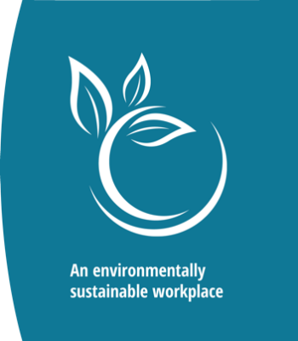
Human rights principles are fundamentally embedded within the principles of ecologically sustainable development. The Commission uses energy saving methods in its operations and it endeavours to make the best use of resources while reducing its environmental impact through appropriate recycling schemes.
In 2019–2020 we continued to mitigate the effects of our impact on the environment by:
- maintaining our commitment to an Electronic Document Record Management System (EDRMS), facilitating digital recordkeeping. Our implementation of this system has been recognised as being a frontrunner for clever use of technology within Government
- using Microsoft Skype for Business and Microsoft Teams facilities to reduce air and road travel
- building on the establishment of our paperless record management system for the Investigation and Conciliation Service
- continuing to facilitate the management of paperless corporate operations through the continued use of and implementation of any enhancements available for our enterprise resource management system
- participating in Earth Hour (to the extent possible during COVID-19)
- powering down all non-essential electronic equipment (including multi-use devices and non-essential air conditioning units) during the Christmas to New Year, and other sustained shutdown periods, including during the COVID-19 pandemic
encourage utilisation of facilities and other workspace initiatives made available under our building lease, which support the Commission’s commitment to environmental sustainability and provide opportunities for staff to ride and walk to work participating in our building’s sustainable waste management system which promotes recycling.
- Financial statements
Independent Audit Report
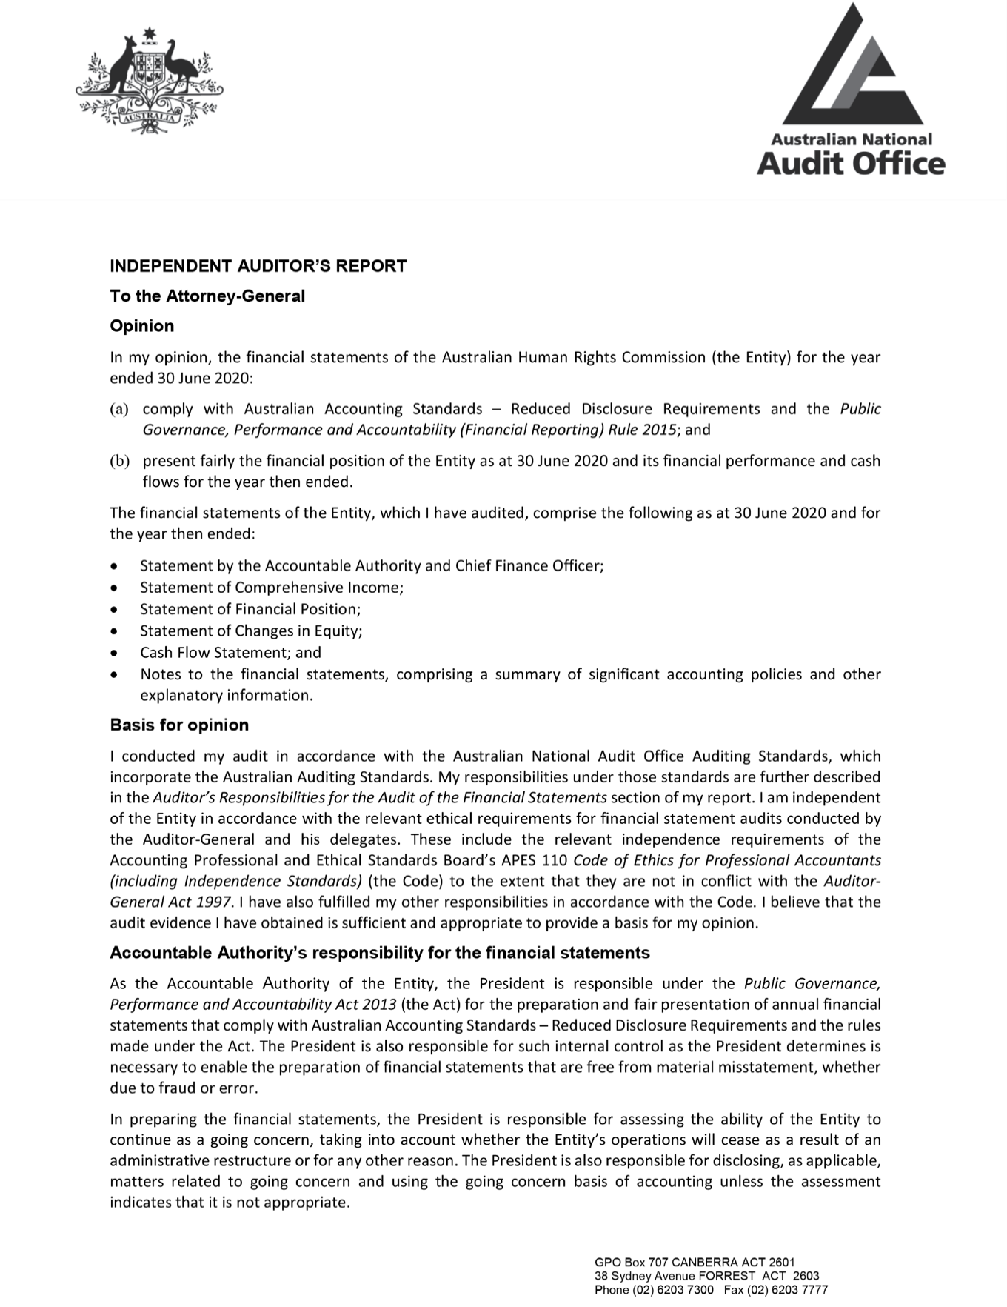

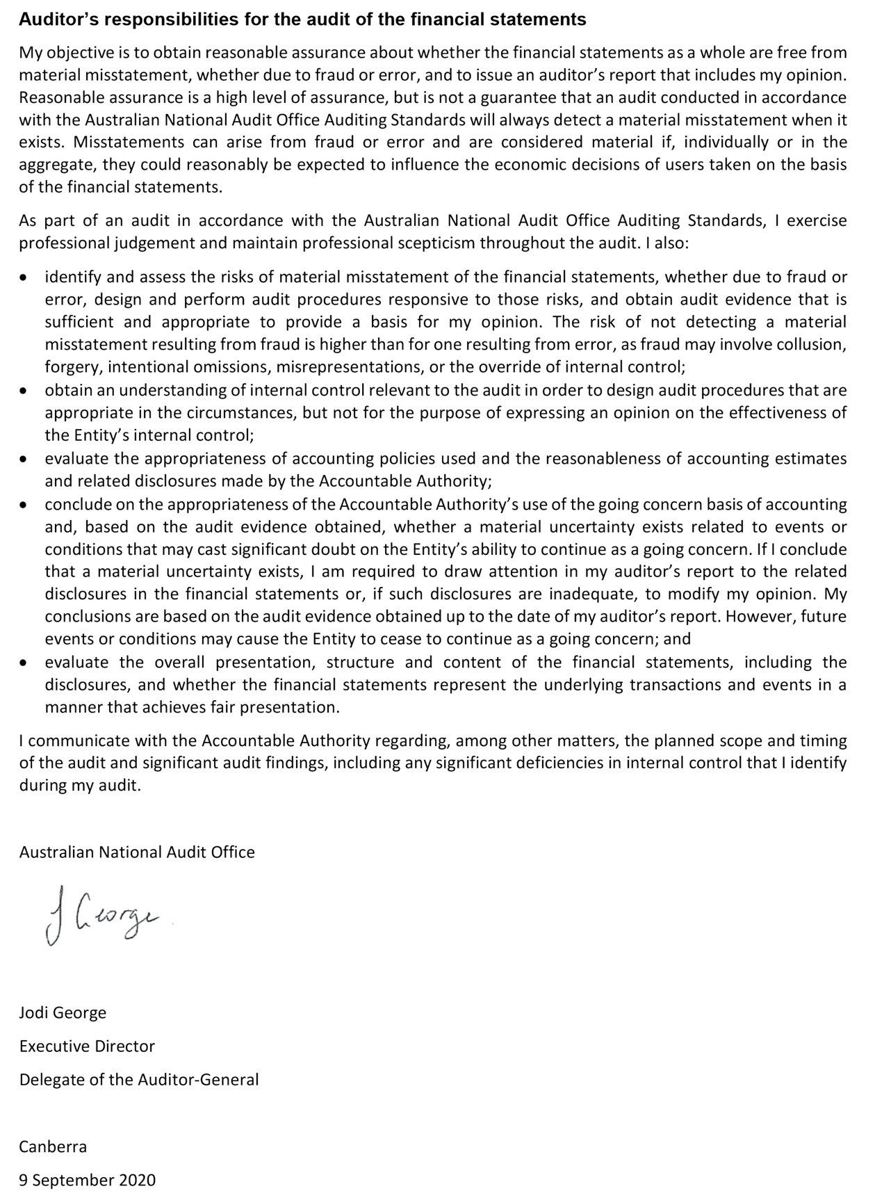

Statement by the Accountable Authority and Chief Finance Officer

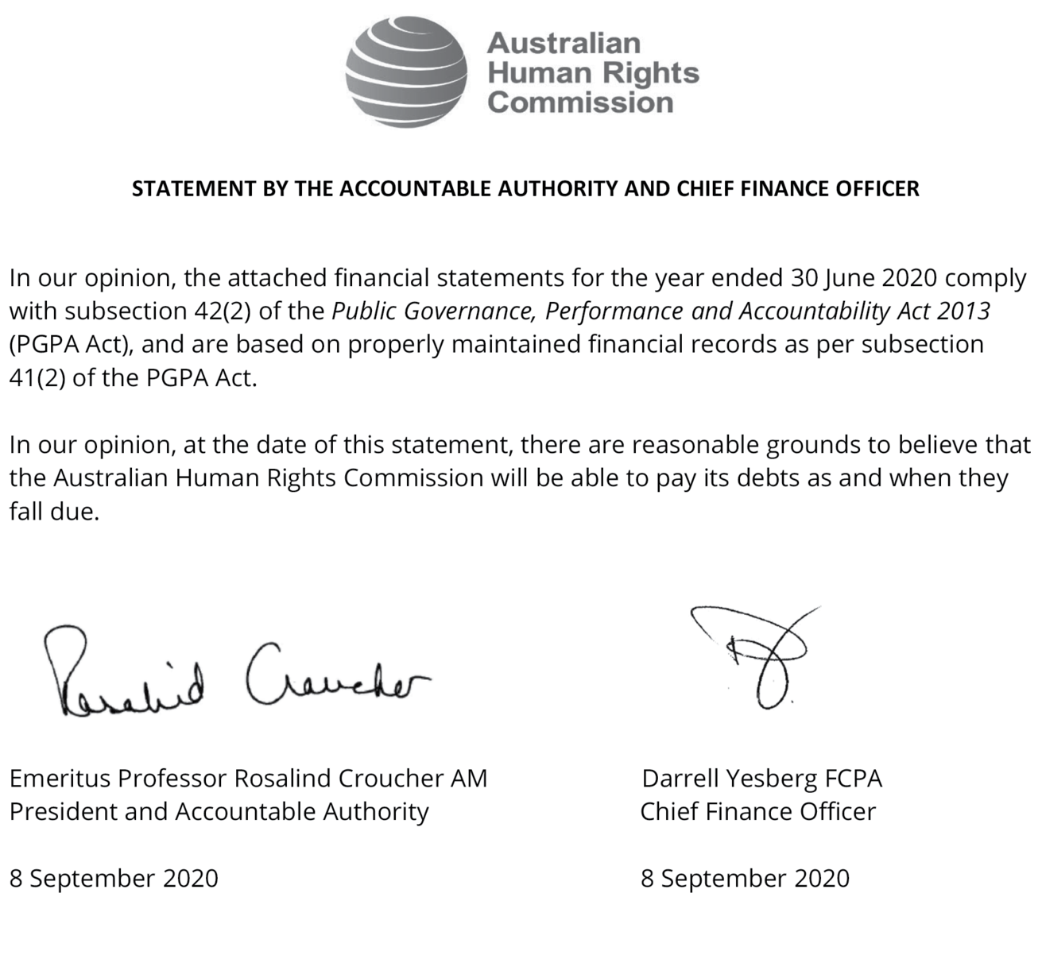

Statement of Comprehensive Income
for the period ended 30 June 2020
 | Notes | 2020  $’000 | 2019  $’000 |  | Original Budget  $’000
NET COST OF SERVICES
Expenses
Employee benefits | 1.1A | 19,522 | 19,198 |  | 17,548
Suppliers | 1.1B | 5,213 | 7,885 |  | 5,016
Depreciation and Amortisation | 2.2A | 4,177 | 910 |  | 863
Finance costs | 1.1C | 47 | - |  | -
Write-down and impairment of other assets | 1.1D | - | 2 |  | -
Total expenses |  | 28,959 | 27,994 |  | 23,427
Own-source income
Own-source revenue
Rendering of Services | 1.2A | 5,408 | 8,683 |  | 4,650
Interest | 1.2B | 40 | 198 |  | 250
Other Revenue | 1.2C,D | 1,198 | 1,186 |  | 985
Total own-source revenue |  | 6,646 | 10,067 |  | 5,885
Gains
Other Gains | 1.2E | 1 | 33 |  | 46
Total gains |  | 1 | 33 |  | 46
Total own-source income |  | 6,648 | 10,100 |  | 5,931
Net cost of services |  | (22,312) | (17,894) |  | (17,496)
Revenue from Government | 1.2F | 16,538 | 16,709 |  | 16,538
Deficit attributable to the Australian Government |  | (5,774) | (1,185) |  | (958)
OTHER COMPREHENSIVE INCOME
Items not subject to subsequent reclassification to net cost of services
Changes in asset revaluation surplus |  | 171 | - |  | -
Total other comprehensive income |  | 171 | - |  | -
The above statement should be read in conjunction with the accompanying notes.
Budget Variances Commentary - Statement of Comprehensive Income
Major variances reflect the impacts from implementation of new accounting standards AASB 15 Revenue from Contracts with Customers and AASB 16 Leases during the reporting period. Recognition of revenue from rendering of services applies the single AASB 15 model to contracts with customers and two approaches to recognising revenue: at a point in time or over time. Commentary for the operating deficit is included on the Statement of Changes in Equity. Depreciation and amortisation show the removal of lease classification as either operating or finance leases – for the lessee – effectively treating all leases as finance leases. Further commentary is included on the Statement of Financial Position.

Statement of Financial Position
as at 30 June 2020
 |  | 2020  $’000 | 2019  $’000 |  | Original Budget  $’000
ASSETS
Financial assets
Cash | 2.1A | 2,575 | 6,942 |  | 3,779
Trade and Other Receivables | 2.1B | 3,317 | 1,541 |  | 822
Total financial assets |  | 5,892 | 8,482 |  | 4,601
Non-financial assets¹
Property Lease | 2.2A | 2,975 | - |  | -
Infrastructure, Plant and Equipment | 2.2A | 1,006 | 1,508 |  | 1,398
Intangibles | 2.2A | 812 | 931 |  | 655
Other Non-Financial Assets | 2.2B | 346 | 174 |  | 245
Total non-financial assets |  | 5,140 | 2,613 |  | 2,298
Total assets |  | 11,032 | 11,095 |  | 6,899
LIABILITIES
Payables
Suppliers | 2.3A | 963 | 1,410 |  | 1,444
Other Payables | 2.3B | 5,475 | 4,965 |  | 2,244
Total payables |  | 6,438 | 6,375 |  | 3,688
Interest bearing liabilities
Leases | 2.4A | 3,051 | - |  | -
Total interest bearing liabilities |  | 3,051 | - |  | -
Provisions
Employee provisions | 4.1A | 4,069 | 3,677 |  | 3,288
Other provisions | 2.5A | - | - |  | 48
Total provisions |  | 4,069 | 3,677 |  | 3,336
Total liabilities |  | 13,558 | 10,053 |  | 7,024
Net assets |  | (2,525) | 1,042 |  | (125)
EQUITY
Contributed equity |  | 2,511 | 2,511 |  | 2,511
Reserves |  | 637 | 465 |  | 466
Accumulated results |  | (5,672) | (1,934) |  | (3,102)
Total equity |  | (2,525) | 1,042 |  | (125)
The above statement should be read in conjunction with the accompanying notes.
1. Right-of-use assets are included in the property lease line item.

Budget Variances Commentary - Statement of Financial Position
Major variances reflect the impacts from implementation of new accounting standards, AASB 15 Revenue from Contracts with Customers and AASB 16 Leases during the reporting period. Recognition of revenue received in advance (note2.3B) applies the single AASB 15 model to contracts with customers and two approaches to recognising revenue: at a point in time or over time. Commentary for accumulated results is included on the Statement of Changes in Equity. Property Lease, Leases and Lease Incentives show the removal of lease classifications as either operating or finance leases – for the lessee – effectively treating all leases as finance leases. Cash and Trade and Other Receivables variance is the timing difference for a significant $2.0m receivable payable under partnership agreement with a Commonwealth government entity.

Statement of Changes in Equity
for the period ended 30 June 2020
 | Notes | 2020  $’000 | 2019  $’000 |  | Original Budget  $’000
CONTRIBUTED EQUITY
Opening balance
Balance carried forward from previous period |  | 2,511 | 2,511 |  | 2,511
Closing balance as at 30 June |  | 2,511 | 2,511 |  | 2,511
RETAINED EARNINGS
Opening balance
Balance carried forward from previous period |  | (1,935) | (750) |  | (2,144)
Adjustment for errors |  | (5) | - |  | -
Adjustment on initial application of AASB 16 |  | 2,041 | - |  | -
Adjusted opening balance |  | 101 | (750) |  | (2,144)
Comprehensive income
Surplus/(Deficit) for the period |  | (5,774) | (1,185) |  | (958)
Closing balance as at 30 June |  | (5,673) | (1,935) |  | (3,102)
ASSET REVALUATION RESERVE
Opening balance
Balance carried forward from previous period |  | 466 | 466 |  | 466
Comprehensive income
Other comprehensive income |  | 171 | - |  | -
Closing balance as at 30 June |  | 637 | 466 |  | 466
TOTAL EQUITY
Opening balance
Balance carried forward from previous period |  | 1,042 | 2,227 |  | 833
Adjustment for errors |  | (5) | - |  | -
Adjustment for changes in accounting policies |  | 2,041 | - |  | -
Adjusted opening balance |  | 3,078 | 2,227 |  | 833
Comprehensive income
Surplus/(Deficit) for the period |  | (5,774) | (1,185) |  | (958)
Other comprehensive income |  | 171 | - |  | -
Total comprehensive income |  | (5,603) | (1,185) |  | (958)
Transactions with owners
Contributions by owners |  | - | - |  | -
Total transactions with owners |  | - | - |  | -
Closing balance as at 30 June |  | (2,525) | 1,042 |  | (125)
The above statement should be read in conjunction with the accompanying notes.

Accounting Policy
Equity Injections
Amounts appropriated which are designated as ‘equity injections’ for a year (less any formal reductions) and Departmental Capital Budgets (DCBs) are recognised directly in contributed equity in that year.
Budget Variances Commentary - Statement of Changes in Equity
Major variances reflect the impacts from implementation of new accounting standards AASB 15 Revenue from Contracts with Customers and AASB 16 Leases during the reporting period. A full review and assessment of revenue from contracts with customers as at 30 June 2020 determined total revenue recognition in accordance with AASB 15 to be $5.408m (2019: $8.683m) representing an increase of $4.817m to the original estimated operating result of $0.958m first reported in the 2018-19 original budget in 2018-19. Other significant contributions to the operating result include a higher salary and wages accrual ($0.265m) and increased Depreciation on the Right of Use Property Lease Asset ($0.248m) created from the implementation of AASB 16.

Cash Flow Statement
for the period ended 30 June 2020
 | Notes | 2020  $’000 | 2019  $’000 |  | Original Budget  $’000
OPERATING ACTIVITIES
Cash received
Receipts from Government |  | 16,538 | 16,709 |  | 16,538
Sale of goods and rendering of services |  | 7,431 | 8,637 |  | 5,271
Interest |  | 40 | 198 |  | 250
GST received |  | 387 | 183 |  | 150
Total cash received |  | 24,396 | 25,727 |  | 22,209
Cash used
Employees |  | (19,609) | (18,799) |  | (17,548)
Suppliers |  | (5,611) | (8,637) |  | (5,538)
Interest payments on lease liabilities |  | (46) | - |  | -
Total cash used |  | (25,266) | (27,436) |  | (23,086)
Net cash from/(used by) operating activities |  | (870) | (1,709) |  | (877)
INVESTING ACTIVITIES
Cash used
Purchase of property, plant and equipment |  | (139) | (99) |  | (326)
Purchase of intangibles |  | (458) | (685) |  | -
Total cash used |  | (597) | (784) |  | (326)
Net cash from/(used by) investing activities |  | (597) | (784) |  | (326)
FINANCING ACTIVITIES
Cash used
Principal payments of lease liabilities |  | (2,900) | - |  | -
Total cash used |  | (2,900) | - |  | -
Net cash from/(used by) financing activities |  | (2,900) | - |  | -
Net increase/(decrease) in cash held |  | (4,367) | (2,493) |  | (1,203)
Cash and cash equivalents at the beginning of the reporting period |  | 6,942 | 9,435 |  | 4,982
Cash and cash equivalents at the end of the reporting period | 2.1A | 2,575 | 6,942 |  | 3,779
The above statement should be read in conjunction with the accompanying notes.

Budget Variances Commentary - Cash Flow Statement
Major variances are:
Interest received reflects cash management decisions and reduced investment in short-term deposits during the reporting period.
Employee entitlements arise from the continuation of non-ongoing contracts following the extension of partnership arrangements with other organisations for the delivery of services that were not known at the time of original budget preparation.
Interest payments on lease liabilities and principal payments of lease liabilities reflect the transitional arrangements for implementation of AASB 16 Leases.
Purchases of property, plant and equipment, and intangibles reflects management decisions to reallocate capital expenditure for continued enhancement of business support systems and capacity during the reporting period.

Overview
Objectives of the Entity
The Australian Human Rights Commission (the Commission) is an Australian Government controlled entity. It is a not-for-profit entity. The Commission's objective is to ensure that Australians have access to independent human rights complaint handling and public inquiry processes and benefit from human rights education, promotion, monitoring and compliance activities.
The Commission is structured to meet the following outcome:
An Australian society in which human rights are respected, protected and promoted through independent investigation and resolution of complaints, education and research to promote and eliminate discrimination, and monitoring, and reporting on human rights.
The continued existence of the Commission in its present form and with its present programmes is dependent on Government policy and on continuing funding by Parliament for the Commission’s administration and programmes.
The Basis of Preparation
The financial statements are general purpose financial statements and are required by section 42 of the Public Governance, Performance and Accountability Act 2013.
The financial statements have been prepared in accordance with:
- Public Governance, Performance and Accountability (Financial Reporting) Rule 2015 (FRR); and
- Australian Accounting Standards and Interpretations – Reduced Disclosure Requirements issued by the Australian Accounting Standards Board (AASB) that apply for the reporting period.
The financial statements have been prepared on an accrual basis and in accordance with the historical cost convention, except for certain assets and liabilities at fair value. Except where stated, no allowance is made for the effect of changing prices on the results or the financial position. The financial statements are presented in Australian dollars.
New Accounting Standards
Adoption of New Australian Accounting Standard Requirements
No accounting standard has been adopted earlier than the application date as stated in the standard.
No new, revised, amending standards and interpretations that were issued prior to the signing of the statement by the accountable authority and chief financial officer, were applicable to the current reporting period and had a material effect on the Commission's financial statements:

Standard/ Interpretation | Nature of change in accounting policy, transitional provisions, and adjustment to financial statements
AASB 15 Revenue from Contracts with Customers / AASB 2016-8 Amendments to Australian Accounting  Standards – Australian Implementation Guidance for Not-for-Profit Entities and AASB 1058 Income of Not-For-Profit Entities | AASB 15, AASB 2016-8 and AASB 1058 became effective 1 July 2019.  AASB 15 establishes a comprehensive framework for determining whether, how much and when revenue is recognised. It replaces existing revenue recognition guidance, including AASB 118 Revenue, AASB 111 Construction Contracts and Interpretation 13 Customer Loyalty Programmes. The core principle of AASB 15 is that an entity recognises revenue to depict the transfer of promised goods or services to customers in an amount that reflects the consideration to which the entity expects to be entitled in exchange for those goods or services.  AASB 1058 is relevant in circumstances where AASB 15 does not apply. AASB 1058 replaces most of the not-for-profit (NFP) provisions of AASB 1004 Contributions and applies to transactions where the consideration to acquire an asset is significantly less than fair value principally to enable the entity to further its objectives, and where volunteer services are received.  The details of the changes in accounting policies, transitional provisions and adjustments are disclosed below and in the relevant notes to the financial statements.
AASB 16 Leases | AASB 16 became effective on 1 July 2019.  This new standard has replaced AASB 117 Leases, Interpretation 4 Determining whether an Arrangement contains a Lease, Interpretation 115 Operating Leases—Incentives and Interpretation 127 Evaluating the Substance of Transactions Involving the Legal Form of a Lease.  AASB 16 provides a single lessee accounting model, requiring the recognition of assets and liabilities for all leases, together with options to exclude leases where the lease term is 12 months or less, or where the underlying asset is of low value. AASB 16 substantially carries forward the lessor accounting in AASB 117, with the distinction between operating leases and finance leases being retained. The details of the changes in accounting policies, transitional provisions and adjustments are disclosed below and in the relevant notes to the financial statements.  The property lease has created a right of use asset and lease liability for the Commission. The Commission only has one lease that meets the criteria of AASB 16 for the recognition as right of use assets and associated liabilities. This has impacted the value of assets and liabilities and increased the depreciation expense.

Future Australian Accounting Standard Requirements
The following new, revised, amending standards and interpretation were issued by the Australian Accounting Standards Board prior to the signing of the statement by the accountable authority and chief financial officer, which are expected to have a material impact on the Commission's financial statements for future reporting period(s):
Standard/ Interpretation | Application date for the Commission | Nature of impending change/s in accounting policy and likely impact on initial application
AASB 2018-7 Amendments to Australian Accounting Standards – Definition of Material | 1 July 2020 | The amendments to the definition of ‘material’ clarify that materiality will depend on the nature or magnitude of information or both. An entity will need to assess whether the information, either individually or in combination with other information, is material in the context of the financial statements. AASB 2018-7 aligns the definition of ‘material’ across AASB 101 Presentation of Financial Statements and AAS 108 Accounting Policies, Changes in Accounting Estimates and Errors and clarify certain aspects of the definition.
AASB 2019-2 Amendments to Australian Accounting Standards – Implementation of AASB 1059 | 1 July 2020 | AASB 2019-2 amends AASB 16 and AASB 1059 primarily to provide a practical expedient to grantors of service concession arrangements so that AASB 16 needs not be applied to assets that would be recognised as service concession assets under AASB 1059. AASB 2019-2 clarifies measurement requirements of the liability of grantors that use the modified retrospective approach upon initial adoption of AASB 1059.
AASB 1059 Service Concession Arrangements: Grantors | 1 July 2020 | AASB 1059 takes effect from 1 January 2020. It addresses the accounting for a service concession arrangement by a grantor that is a public sector entity. The standard requires a grantor to:  - Recognise a service concession asset constructed, developed or acquired from a third party by the operator, including an upgrade to an existing asset of the grantor when the grantor controls the asset.  - Reclassify an existing asset as a service concession asset when it meets the criteria for recognition as a service concession asset.  - Initially measure a service concession asset at current replacement cost in accordance with the cost approach to fair value in AASB 13 and subsequent to the initial recognition or reclassification of the asset, the service concession asset is accounted for in accordance with AASB 116 or AASB 138.  - Recognise a corresponding liability measured initially at the fair value of the service concession asset, adjusted for any other consideration between the grantor and the operator, using either the financial liability model or the grant of a right to the operator model or both.  The new standard will have no impact on the Commission.
AASB 1060 General Purpose Financial Statements – Simplified Disclosures for For-Profit and Not-for-Profit Tier 2 Entities | 1 July 2020 | AASB 1060 is the new simplified disclosure standard developed by the AASB based on IFRS for Small and Medium-sized Entities. It requires Tier 2 entities to follow the recognition and measurement requirements under Australian Accounting Standards but to apply the simplified disclosure requirements in AASB 1060. This standard will only apply to disclosures.  Finance has yet to analyse the possible impact of this standard on entity financial statements.

Application of AASB 15 Revenue from Contracts with Customers / AASB 1058 Income of Not-For-Profit Entities
The Commission adopted AASB 15 and AASB 1058 using the modified retrospective approach, under which the cumulative effect of initial application is recognised in retained earnings at 1 July 2019. Accordingly, the comparative information presented for 2019 is not restated, that is, it is presented as previously reported under the various applicable AASBs and related interpretations.
Under the new income recognition model the Commission shall first determine whether an enforceable agreement exists and whether the promises to transfer goods or services to the customer are ‘sufficiently specific’. If an enforceable agreement exists and the promises are ‘sufficiently specific’ (to a transaction or part of a transaction), the Commission applies the general AASB 15 principles to determine the appropriate revenue recognition. If these criteria are not met, the Commission shall consider whether AASB 1058 applies.
In relation to AASB 15, the Commission elected to apply the new standard to all new and uncompleted contracts from the date of initial application. The Commission is required to aggregate the effect of all of the contract modifications that occur before the date of initial application.
In terms of AASB 1058, the Commission is required to recognise volunteer services at fair value if those services would have been purchased if not provided voluntarily, and the fair value of those services can be measured reliably.
Set out below are the amounts by which each financial statement line item is affected as at and for the year ended 30 June 2020 as a result of the adoption of AASB 15 and AASB 1058. The first column shows amounts prepared under AASB 15 and AASB 1058 and the second column shows what the amounts would have been had AASB 15 and AASB 1058 not been adopted:
Refer to page 123 for AASB 15/AASB 1058 transition disclosure.
Application of AASB 16 Leases
The Commission adopted AASB 16 using the modified retrospective approach, under which the cumulative effect of initial application is recognised in retained earnings at 1 July 2019. Accordingly, the comparative information presented for 20x1 is not restated, that is, it is presented as previously reported under AASB 117 and related interpretations.
The Commission elected to apply the practical expedient to not reassess whether a contract is, or contains a lease at the date of initial application. Contracts entered into before the transition date that were not identified as leases under AASB 117 were not reassessed. The definition of a lease under AASB 16 was applied only to contracts entered into or changed on or after 1 July 2019.

AASB 16 provides for certain optional practical expedients, including those related to the initial adoption of the standard. The Commission applied the following practical expedients when applying AASB 16 to leases previously classified as operating leases under AASB 117:
- Apply a single discount rate to a portfolio of leases with reasonably similar characteristics;
- Exclude initial direct costs from the measurement of right-of-use assets at the date of initial application for leases where the right-of-use asset was determined as if AASB 16 had been applied since the commencement date;
- Reliance on previous assessments on whether leases are onerous as opposed to preparing an impairment review under AASB 136 Impairment of assets as at the date of initial application; and
- Applied the exemption not to recognise right-of-use assets and liabilities for leases with less than 12 months of lease term remaining as of the date of initial application.
As a lessee, the Commission previously classified leases as operating or finance leases based on its assessment of whether the lease transferred substantially all of the risks and rewards of ownership. Under AASB 16, the Commission recognises right-of-use assets and lease liabilities for most leases. However, the Commission has elected not to recognise right-of-use assets and lease liabilities for some leases of low value assets based on the value of the underlying asset when new or for short-term leases with a lease term of 12 months or less.
On adoption of AASB 16, the Commission recognised right-of-use assets and lease liabilities in relation to leases of office space which had previously been classified as operating leases.
The lease liabilities were measured at the present value of the remaining lease payments, discounted using the Commission's incremental borrowing rate as at 1 July 2019. The Commission's incremental borrowing rate is the rate at which a similar borrowing could be obtained from an independent creditor under comparable terms and conditions. The weighted-average rate applied was 1.08%
The right-of-use assets were measured as follows:
- Office space: measured at an amount equal to the lease liability, adjusted by the amount of any prepaid or accrued lease payments.
- All other leases: the carrying value that would have resulted from AASB 16 being applied from the commencement date of the leases, subject to the practical expedients noted above.
Impact on transition
On transition to AASB 16, the Commission recognised additional right-of-use assets and additional lease liabilities, recognising the difference in retained earnings. The impact on transition is summarised below:
1 July 2019
$'000
Right-of-use assets - property lease | 5,951
Lease liabilities | 5,951
Retained earnings | 2.041

The following table reconciles the minimum lease commitments disclosed in the entity's 30 June 2019 annual financial statements to the amount of lease liabilities recognised on 1 July 2019:
1 July 2019
$’000
Minimum operating lease commitment  at 30 June 2019 | 8,568
Less: short-term leases not recognised under AASB 16 | -
Less: low value leases not recognised under AASB 16 | (73)
Plus: effect of extension options reasonably certain to be exercised | -
Undiscounted lease payments | 8,495
Less: effect of discounting using the incremental borrowing rate as at the date of initial application | -
Less: Other expenses included as part of operating lease commitments | (2,544)
Lease liabilities recognised at 1 July 2019 | 5,951

Taxation
The entity is exempt from all forms of taxation except Fringe Benefits Tax (FBT) and the Goods and Services Tax (GST).
Events After the Reporting Period
The Commission is not aware of any significant events that have occurred since balance date that warrant disclosure in these financial statements.

Transitional disclosure | AASB 15 / AASB 1058  $’000 | Previous AAS  $’000 | Increase / (decrease)  $’000
EXPENSES
Employee benefits and Suppliers | 5,408 | 5,408 | -
Total Expenses | 5,408 | 5,408 | -
REVENUE
Rendering of Services | 5,408 | 7,328 | (1,920)
Total Revenue | 5,408 | 7,328 | (1,920)
Net cost of services | - | (1,920) | 1,920
ASSETS
Total Assets | - | - | -
LIABILITIES
Revenue received in advance | 5,191 | 3,271 | 1,920
Total Liabilities | 5,191 | 3,271 | 1,920
Retained earnings | (5,191) | (5,191) | -

The changes identified are the impact from implementation of new accounting standard AASB 15 Revenue from Contracts with Customers during the reporting period. Recognition of revenue applies the single AASB 15 model to contracts with customers and two approaches to recognising revenue: at a point in time or over time. Under previous accounting standards most of the Commission's revenue was recognised at a point in time, application of the new accounting standard results in most revenue being recognised over time.

- Financial Performance
This section analyses the financial performance of Australian Human Rights Commission for the year ended 2020.
1.1 Expenses
 | 2020  $’000 | 2019  $’000
1.1A: Employee benefits
Wages and salaries | 15,001 | 15,029
Superannuation
Defined contribution plans | 1,759 | 1,627
Defined benefit plans | 645 | 702
Leave and other entitlements | 1,765 | 1,667
Separation and redundancies | 134 | 5
Other employee expenses | 218 | 168
Total employee benefits | 19,522 | 19,198

Accounting Policy
Accounting policies for employee related expenses is contained in the People and Relationships section.

 | 2020  $’000 | 2019  $’000
1.1B: Suppliers
Goods and services supplied or rendered
General property operating expenses | 1,129 | 1,001
Insurance | 44 | 52
Office consumables | 87 | 55
Official travel | 768 | 1,079
Postage and freight | 12 | 15
Printing and publications | 148 | 102
Professional services and fees | 1,769 | 1,967
Reference materials, subscriptions and licenses | 576 | 736
Staff training | 101 | 105
Telecommunications | 127 | 97
Other | 315 | 415
Total goods and services supplied or rendered | 5,077 | 5,624
Goods supplied | 235 | 157
Services rendered | 4,842 | 5,466
Total goods and services supplied or rendered | 5,077 | 5,623
Other suppliers
Operating lease rentals in connection with
Minimum lease payments | - | 2,236
Low value leases | 111 | -
Workers compensation expenses | 25 | 25
Total other suppliers | 136 | 2,261
Total suppliers | 5,213 | 7,885

Accounting Policy
Short-term leases and leases of low-value assets
The Commission has elected not to recognise right-of-use assets and lease liabilities for short-term leases of assets that have a lease term of 12 months or less and leases of low-value assets (less than $10,000). The Commission recognises the lease payments associated with these leases as an expense on a straight-line basis over the lease term.

 | 2020  $’000 | 2019  $’000
1.1C: Finance costs
Interest on property lease | 47 | -
Total finance costs | 47 | -
1.1D: Write-down and impairment of other assets
Impairments of assets | - | 2
Total write-down and impairment of other assets | - | 2

1.2 Own-Source Revenue and gains
 | 2020  $’000 | 2019  $’000
Own-Source Revenue
1.2A: Rendering of Services
Rendering of services | 5,408 | 8,683
Total sales of goods and rendering of services | 5,408 | 8,683
Disaggregation of revenue from contracts with customers
Major product / service line:
Service delivery | 5,408 | 8,683
 | 5,408 | 8,683
Type of customer:
Australian Government entities (related parties) | 4,784 | 7,914
State and Territory Governments | 100 | 66
Non-government entities | 524 | 703
 | 5,408 | 8,683
Timing of transfer of goods and services:
Over time | 4,673 | 7,905
Point in time | 735 | 778
 | 5,408 | 8,683

Accounting Policy
Revenue from the rendering of services is recognised when performance of specific service obligations, that are required and enforceable under a contract or agreement made between the Commission and the customer, sufficiently allow the Commission to determine when they have been satisfied.
The principal activities from which the Commission generates its revenue include, service fees and direct cost recoveries from the supply of domestic and international human rights technical assistance programs, development of education resources and delivery of training services, provision of shared corporate services and accommodation, and interest earned on short-term bank deposits.
The Commission predominantly provides services to its customers under agreed terms and conditions contained in contracts or agreements made between the two parties. The nature, timing of satisfaction of performance obligations, and any significant payment terms are specified in the agreed terms and conditions, milestones and payment schedules.
The transaction price is the total amount of consideration to which the Commission expects to be entitled in exchange for transferring promised services to a customer. The consideration promised in a contract with a customer may include fixed amounts, variable amounts, or both. No consideration from contracts is excluded in the transaction price. In the event that a change is required to any of the terms and conditions contained in a contract or agreement, including transaction price, a Contract Variation is agreed between the parties. The Commission has a right to consideration from a customer in an amount that corresponds directly with the value to the customer of the Commission's performance completed to date under the original contract or subsequent variations to the contract.
Where performance obligations are satisfied over time, revenue is recognised monthly in arrears following a review costs incurred for the delivery of service obligations for the project(s) and activities related to the customer contract. Costs incurred are primarily recurring in nature, and the customer simultaneously receives and effectively gains control of the services as the Commission performs its obligations.
Revenue for performance obligations satisfied at a point in time is recognised in accordance with specified milestones for the performance of obligations in the contract, for example "acceptance of a final report by the customer". Customer contracts with performance obligations satisfied at a point in time are short-term and include agreed dates for completion of milestones and transferral of any deliverable(s), this also indicates when a customer obtains control of outputs from the promised services. Milestone completion is confirmed with relevant contract manager prior to revenue recognition.
Receivables for goods and services, which have 30 day terms, are recognised at the nominal amounts due less any impairment allowance account. Collectability of debts is reviewed at end of the reporting period. Allowances are made when collectability of the debt is no longer probable.

 | 2020  $’000 | 2019  $’000
1.2B: Interest
Deposits | 40 | 198
Total interest | 40 | 198

Accounting Policy
Interest revenue is recognised using the effective interest method.

 | 2020  $’000 | 2019  $’000
1.2C: Other Revenue
Operating lease
Sub lease rental income | 1,152 | 1,083
Total rental income | 1,152 | 1,083
1.2D: Other Revenue
Resources received free of charge
Remuneration of auditors | 46 | 46
Conference support | - | 50
Other | - | 7
Total other revenue | 46 | 103

Accounting Policy
Resources Received Free of Charge
Resources received free of charge are recognised as revenue when, and only when, a fair value can be reliably determined and the services would have been purchased if they had not been donated. Use of those resources is recognised as an expense. Resources received free of charge are recorded as either revenue or gains depending on their nature.

 | 2020  $’000 | 2019  $’000
GAINS
1.2E: Other Gains
Gain on reduction of prior year provisionsì | - | 32
Other - Sale of assets | 1 | 1
Total other gains | 1 | 33

Accounting Policy
Other Gains
Gains on the reduction of prior year provisions are recognised at their nominal value as gains, when, and only when, the original provision for services has been determined to no longer be required.
Sale of Assets
Gains from disposal of assets are recognised when control of the asset has passed to the buyer.

 | 2020  $’000 | 2019  $’000
1.2F: Revenue from Government
Attorney-General's Department:
Corporate Commonwealth entity payment item | 16,538 | 16,709
Total revenue from Government | 16,538 | 16,709

Accounting Policy
Revenue from Government
Funding received from the Attorney-General's Department (received by the Commission as a corporate Commonwealth entity) is recognised as Revenue from Government unless the funding is in the nature of an equity injection or a loan.

- Financial Position
This section analyses the Australian Human Rights Commission assets used to conduct its operations and the operating liabilities incurred as a result. Employee related information is disclosed in the People and Relationships section.
2.1 Financial Assets
 |  | 2020  $’000 | 2019  $’000
2.1A: Cash
Cash on hand and at bank |  | 2,575 | 6,942
Total cash and cash equivalents |  | 2,575 | 6,942

Accounting Policy
Cash is recognised at its nominal amount. Cash and cash equivalents include:
- cash on hand;
- demand deposits in bank accounts with an original maturity of 3 months or less that are readily convertible to known amounts of cash and subject to insignificant risk of changes in value. At the reporting date the Commission did not hold any term deposits with a maturity greater than three months.

 |  | 2020  $’000 | 2019  $’000
2.1B: Trade and Other Receivables
Goods and services receivables
Goods and services |  | 3,317 | 1,537
Total goods and services receivables |  | 3,317 | 1,537
Other receivables
Interest |  | - | 4
GST Receivable from the Australian Taxation Office |  | - | -
Total other receivables |  | - | 4
Total trade and other receivables (gross) |  | 3,317 | 1,541
Less impairment loss allowance |  | - | -
Total trade and other receivables (net) |  | 3,317 | 1,541
Trade and other receivables (net) expected to be recovered
No more than 12 months |  | 3,317 | 1,541
Total trade and other receivables (net) |  | 3,317 | 1,541

Accounting Policy
Receivables
Receivables are measured at amortised cost using the effective interest method less impairment.

2.2 Non-Financial Assets
2.2A: Reconciliation of the Opening and Closing Balances of Property Lease, Infrastructure, Plant and Equipment and Intangibles
 | Property Lease  $’000 | Lease Improvements  $’000 | Lease Improvements - Work in Progress  $’000 | Computer, Plant and Equipment  $’000 | Intangibles  $’000 | Intangibles - Work in Progress  $’000 | Total  $’000
Reconciliation of the Opening and Closing Balances of Property Lease, Infrastructure, Plant and Equipment and Intangibles for 2020
As at 1 July 2019
Gross book value | - | 2,213 | 5 | 66 | 1,949 | 192 | 4,420
Accumulated depreciation, amortisation and impairment | - | (722) | - | (49) | (1,210) | - | (1,981)
Total as at 1 July 2019 | - | 1,491 | 5 | 17 | 739 | 192 | 2,439
Recognition of right of use asset on initial application of AASB 16 | 5,951 | - | - | - | - | - | 5,951
Adjusted total as at 1 July 2019 | 5,951 | 1,491 | 5 | 17 | 739 | 192 | 8,390
Additions
Purchase | - | - | - | 139 | 458 | - | 597
Work in progress transfer |  |  |  |  |  | (192)
Revaluations and impairments recognised in other comprehensive income | - | 132 | - | 39 | - | - | 171
Depreciation and amortisation | - | (771) | - | (46) | (385) | - | (1,202)
Depreciation on right-of-use assets | (2,975) | - | - | - | - | - | (2,975)
Total as at 30 June 2020 | 2,975 | 852 | 5 | 149 | 812 | - | 13,371
Total as at 30 June 2020 represented by
Gross book value | 5,951 | 852 | 5 | 149 | 2,407 | - | 9,364
Accumulated depreciation, amortisation and impairment | (2,975) | - | - | - | (1,595) | - | (4,571)
Total as at 30 June 2020 | 2,975 | 852 | 5 | 149 | 812 | - | 4,794
Carrying amount of right-of-use assets | 2,975 | - | - | - | - | - | 2,975
No indicators of impairment were found for infrastructure, plant and equipment and intangibles.
No infrastructure, plant and equipment and intangibles are expected to be sold or disposed of within the next 12 months.

Revaluations of non-financial assets
All revaluations were conducted in accordance with the revaluation policy stated at Note 2.2. On 30 June 2020, an independent valuer conducted the revaluations.
 | Property Lease  $’000 | Lease Improvements  $’000 | Computer, Plant and Equipment  $’000 | Intangibles  $’000 | Intangibles - Work in Progress  $’000 | Total  $’000
Reconciliation of the opening and closing balances of Infrastructure, Plant and Equipment and Intangibles for 2019
As at 1 July 2018
Gross book value | - | 2,114 | 68 | 1,426 | 24 | 3,632
Accumulated depreciation, amortisation and impairment | - | - | - | (1,071) | - | (1,071)
Total as at 1 July 2018 | - | 2,114 | 68 | 355 | 24 | 2,561
Additions
Purchase | - | 99 | - | 523 | 168 | 790
Depreciation and amortisation | - | (722) | (49) | (139) | - | (910)
Disposals |  | - | (2) | - | -
Total as at 30 June 2019 | - | 1,491 | 17 | 739 | 192 | 2,441
Total as at 30 June 2019 represented by
Gross book value | - | 2,213 | 66 | 1,949 | 192 | 4,420
Accumulated depreciation, amortisation and impairment | - | (722) | (49) | (1,210) | - | (1,981)
Total as at 30 June 2019 | - | 1,491 | 17 | 739 | 192 | 2,439

Accounting Policy
Assets are recorded at cost on acquisition except as stated below. The cost of acquisition includes the fair value of assets transferred in exchange and liabilities undertaken. Financial assets are initially measured at their fair value plus transaction costs where appropriate.
Assets acquired at no cost, or for nominal consideration, are initially recognised as assets and income at their fair value at the date of acquisition, unless acquired as a consequence of restructuring of administrative arrangements. In the latter case, assets are initially recognised as contributions by owners at the amounts at which they were recognised in the transferor’s accounts immediately prior to the restructuring.
Asset Recognition Threshold
Purchases of property, plant and equipment are recognised initially at cost in the statement of financial position, except for purchases costing less than $5,000 which are expensed in the year of acquisition (other than where they form part of a group of similar items which are significant in total).
The initial cost of an asset includes an estimate of the cost of dismantling and removing the item and restoring the site on which it is located. This is particularly relevant to ‘make good’ provisions in property leases taken up by the entity where there exists an obligation to restore the property to its original condition. These costs are included in the value of the Commission's leasehold improvements with a corresponding provision for the ‘make good’ recognised.
Lease Right of Use (ROU) Assets
Leased ROU assets are capitalised at the commencement date of the lease and comprise of the initial lease liability amount, initial direct costs incurred when entering into the lease less any lease incentives received. These assets are accounted for by Commonwealth lessees as separate asset classes to corresponding assets owned outright but included in the same column as where the corresponding underlying assets would be presented if they were owned.
On initial adoption of AASB 16 the Australian Human Rights Commission has adjusted the ROU assets at the date of initial application by the amount of any provision for onerous leases recognised immediately before the date of initial application. Following initial application, an impairment review is undertaken for any right of use lease asset that shows indicators of impairment and an impairment loss is recognised against any right of use lease asset that is impaired. Lease ROU assets continue to be measured at cost after initial recognition in Commonwealth agency, GGS and Whole of Government financial statements.
Revaluations
Following initial recognition at cost, property, plant and equipment (excluding ROU assets) are carried at fair value (or an amount not materially different from fair value) less subsequent accumulated depreciation and accumulated impairment losses. Valuations are conducted with sufficient frequency to ensure that the carrying amounts of assets did not differ materially from the assets’ fair values as at the reporting date. The regularity of independent valuations depended upon the volatility of movements in market values for the relevant assets.
Revaluation adjustments are made on a class basis. Any revaluation increment is credited to equity under the heading of asset revaluation reserve except to the extent that it reversed a previous revaluation decrement of the same asset class that was previously recognised in the surplus/deficit. Revaluation decrements for a class of assets are recognised directly in the surplus/deficit except to the extent that they reversed a previous revaluation increment for that class.
Any accumulated depreciation as at the revaluation date is eliminated against the gross carrying amount of the asset and the asset restated to the revalued amount.

Depreciation
Depreciable property, plant and equipment assets are written-off to their estimated residual values over their estimated useful lives to the entity using, in all cases, the straight-line method of depreciation.
Depreciation rates (useful lives), residual values and methods are reviewed at each reporting date and necessary adjustments are recognised in the current, or current and future reporting periods, as appropriate.
Depreciation rates applying to each class of depreciable asset are based on the following useful lives:
 | 2020 | 2019
Leasehold improvements | Lease term | Lease term
Computer, plant and equipment | 4 to 10 years | 4 to 10 years

The depreciation rates for ROU assets are based on the commencement date to the earlier of the end of the useful life of the ROU asset or the end of the lease term.
Impairment
All assets were assessed for impairment at 30 June 2019. Where indications of impairment exist, the asset’s recoverable amount is estimated and an impairment adjustment made if the asset’s recoverable amount is less than its carrying amount.
The recoverable amount of an asset is the higher of its fair value less costs of disposal and its value in use. Value in use is the present value of the future cash flows expected to be derived from the asset. Where the future economic benefit of an asset is not primarily dependent on the asset’s ability to generate future cash flows, and the asset would be replaced if the entity were deprived of the asset, its value in use is taken to be its depreciated replacement cost.
Derecognition
An item of property, plant and equipment is derecognised upon disposal or when no further future economic benefits are expected from its use or disposal.
Intangibles
The entity's intangibles comprise internally developed software for internal use. These assets are carried at cost less accumulated amortisation and accumulated impairment losses.
Software is amortised on a straight-line basis over its anticipated useful life. The useful lives of the Commission's software are 2 to 5 years (2019: 2 to 5 years years).
All software assets were assessed for indications of impairment as at 30 June 2020.
Accounting Judgements and Estimates
The fair value of infrastructure, plant and equipment has been taken to be the market value of similar assets as determined by an independent valuer.

 |  | 2020  $’000 | 2019  $’000
2.2B: Other Non-Financial Assets
Prepayments |  | 346 | 174
Total other non-financial assets |  | 346 | 174
Other non-financial assets expected to be recovered
No more than 12 months |  | 341 | 174
More than 12 months |  | 5 | -
Total other non-financial assets |  | 346 | 174
No indicators of impairment were found for other non-financial assets.

2.3 Payables
 | 2020  $’000 | 2019  $’000
2.3A: Suppliers
Trade creditors and accruals | 963 | 592
Rent Payable | - | 818
Total suppliers | 963 | 1,410
Suppliers expected to be settled
No more than 12 months | 963 | 828
More than 12 months | - | 582
Total suppliers | 963 | 1,410
2.3B: Other Payables
Salaries and wages | 155 | 122
Superannuation | 111 | 23
Other employee expenses | - | 3
Revenue received in advance | 5,191 | 3,586
GST payable to the Australian Taxation Office | 18 | 8
Lease Incentives | - | 1,223
Total other payables | 5,475 | 4,965
Other payables to be settled
No more than 12 months | 5,475 | 2,527
More than 12 months | - | 2,438
Total other payables | 5,475 | 4,965

2.4 Interest Bearing Liabilities
 | 2020  $’000 | 2019  $’000
2.4A: Leases
Property Lease Liabilities | 3,051 | -
Total leases | 3,051 | -
Total cash outflow for leases for the year ended 30 June 2020 was $2.913m

Accounting Policy
Refer Overview section for accounting policy on leases.
2.5 Other Provisions
2.5A: Other provisions
The Commission had no other provisions for the period ended 30 June 2020.

3. Funding
This section identifies the Australian Human Rights Commission funding structure.
3.1 Corporate Commonwealth Entity Payment
3.1A: Annual Corporate Commonwealth Entity Payment ('Recoverable GST exclusive')
Annual Corporate Commonwealth Entity Payment for 2020
The Commission's funding is received through a grant from the Attorney-General's Department.
Refer to Note 1.2F.

4. People and relationships
This section describes a range of employment and post employment benefits provided to our people and our relationships with other key people.
4.1 Employee Provisions
 | 2020  $’000 | 2019  $’000
4.1A: Employee provisions
Leave | 4,069 | 3,589
Separations and redundancies | - | 88
Total employee provisions | 4,069 | 3,677
Employee provisions expected to be settled
No more than 12 months | 3,151 | 2,885
More than 12 months | 918 | 792
Total employee provisions | 4,069 | 3,677

Accounting policy
Liabilities for short-term employee benefits and termination benefits expected within twelve months of the end of reporting period are measured at their nominal amounts.
Leave
The liability for employee benefits includes provision for annual leave and long service leave.
The leave liabilities are calculated on the basis of employees’ remuneration at the estimated salary rates that will be applied at the time the leave is taken, including the Commission's employer superannuation contribution rates to the extent that the leave is likely to be taken during service rather than paid out on termination.
The liability for long service leave has been determined by reference to the work of an actuary performed for the Department of Finance (DoF) and summarised in the Standard Parameters for use in 2019–20 Financial Statements published on the DoF website. The estimate of the present value of the liability takes into account attrition rates and pay increases through promotion and inflation.
Separation and Redundancy
Provision is made for separation and redundancy benefit payments. The Commission recognises a provision for termination when it has developed a detailed formal plan for the terminations and has informed those employees affected that it will carry out the terminations.

Superannuation
The Commission's staff are members of the Commonwealth Superannuation Scheme (CSS), the Public Sector Superannuation Scheme (PSS), or the PSS accumulation plan (PSSap), or other superannuation funds held outside the Australian Government.
The CSS and PSS are defined benefit schemes for the Australian Government. The PSSap is a defined contribution scheme.
The liability for defined benefits is recognised in the financial statements of the Australian Government and is settled by the Australian Government in due course. This liability is reported in the Department of Finance’s administered schedules and notes.
The Commission makes employer contributions to the employees' defined benefit superannuation scheme at rates determined by an actuary to be sufficient to meet the current cost to the Government. The Commission accounts for the contributions as if they were contributions to defined contribution plans.
The liability for superannuation recognised as at 30 June represents outstanding contributions for the final fortnight of the financial year.
Accounting Judgements and Estimates
The long service leave has been estimated in accordance with the FRR taking into account expected salary growth, attrition and future discounting using the government bond rate.
4.2 Key Management Personnel Remuneration
Key management personnel are those persons having authority and responsibility for planning, directing and controlling the activities of the Commission. The Commission has determined the key management personnel to be the President, Commissioners and Chief Executive.
 | 2020  $’000 | 2019  $’000
Short-term employee benefits | 3,242 | 4,014
Post-employment benefits | 257 | 399
Other long-term employee benefits | 79 | 87
Termination benefits | - | 38
Total key management personnel remuneration expenses¹ | 3,578 | 4,538

The total number of key management personnel that are included in the above table are 9 (2019: 16). In the current financial year there have been changes to the Commission's Key Management Personnel. In 2019 the positions of Race and Disability Discrimination Commissioner each had two occupants.
1. The above key management personnel remuneration excludes the remuneration and other benefits of the Portfolio Minister. The Portfolio Minister’s remuneration and other benefits are set by the Remuneration Tribunal and are not paid by the Commission.
2. Other long-term employee benefits results from the movement in accrued leave balances for the period.

4.3 Related Party Disclosures
Related party relationships:
The Commission is an Australian Government controlled entity. Related parties to this entity are Key Management Personnel including the Portfolio Minister and Executive, and other Australian Government entities.
Transactions with related parties:
Given the breadth of Government activities, related parties may transact with the government sector in the same capacity as ordinary citizens. Such transactions include the payment or refund of taxes, receipt of a Medicare rebate or higher education loans. These transactions have not been separately disclosed in this note.
Significant transactions with related parties can include:
- the payments of grants or loans;
- purchases of goods and services;
- asset purchases, sales transfers or leases;
- debts forgiven; and
- guarantees.
Giving consideration to relationships with related entities, and transactions entered into during the reporting period by the entity, it has been determined that there are no related party transactions to be separately disclosed.

5. Managing uncertainties
This section analyses how the Australian Human Rights Commission manages financial risks within its operating environment.
5.1 Contingent Assets and Liabilities
Quantifiable Contingencies
At the time signing these financial statements, the Commission had no quantifiable contingent liabilities.
Unquantifiable Contingencies
At the time of signing these financial statements the Commission:
- was a respondent to two judicial review applications in the Federal Court. While the Federal Court may award costs in such applications, any costs order is unlikely to be significant. In one proceeding, we consider a cost order to be unlikely as the application is in our view without merit and the proceeding is being defended by another Commonwealth agency. The Commission has filed a submitting appearance in that proceeding. In the second proceeding the Commission is in the process of assessing the merits of the claim but, assuming the claim is contested, any exposure to costs is unlikely to be significant including because the applicant is unrepresented.
- was a respondent to proceedings in the High Court in which the applicant is seeking a writ of certiorari to quash a decision of the Commission to terminate his complaint. While the High Court may award costs in such an application it is unlikely as the application is in our view without merit. The Attorney-General has been joined to the proceedings as a contradictor and the Commission has filed a submitting appearance.
In addition, an application for leave to appeal a decision of the Federal Court summarily dismissing judicial review proceedings against the Commission’s has been filed. The Attorney-General has been joined to the proceeding to act as a contradictor, and the Commission has filed a submitting appearance. Any costs order is unlikely as the appeal proceedings are in our view without merit.
A further three Federal Court appeals have been filed in relation to interlocutory orders made in the three related first instance proceedings. The first instance proceedings have been dismissed by the Court as an abuse of process, and the applicant requires leave of the Court in each case in order to appeal. The Commission is a respondent in two of the appeals. The Commission has made written submissions as to why leave should not be granted. A costs order is unlikely as the appeal proceedings are in our view without merit.
Accounting Policy
Contingent liabilities and contingent assets are not recognised in the statement of financial position but are reported in the notes. They may arise from uncertainty as to the existence of a liability or asset or represent an asset or liability in respect of which the amount cannot be reliably measured. Contingent assets are disclosed when settlement is probable but not virtually certain and contingent liabilities are disclosed when settlement is greater than remote.

5.2 Financial Instruments
 |  |  |  | 2020  $’000 | 2019  $’000
5.2A: Categories of financial instruments
Financial assets at amortised cost
Cash on hand and at bank |  |  |  | 2,575 | 6,942
Trade and other receivables |  |  |  | 3,317 | 1,541
Total financial assets at amortised cost |  |  |  | 5,892 | 8,483
Total financial assets |  |  |  | 5,892 | 8,483
Financial Liabilities
Financial liabilities measured at amortised cost
Trade creditors and accruals |  |  |  | 963 | 592
Total financial liabilities measured at amortised cost |  |  |  | 963 | 592
Total financial liabilities |  |  |  | 963 | 592

Accounting Policy
Financial assets
With the implementation of AASB 9 Financial Instruments for the first time in 2019, the entity classifies its financial assets in the following categories:
- financial assets at fair value through profit or loss;
- financial assets at fair value through other comprehensive income; and
- financial assets measured at amortised cost.
The classification depends on both the entity's business model for managing the financial assets and contractual cash flow characteristics at the time of initial recognition. Financial assets are recognised when the entity becomes a party to the contract and, as a consequence, has a legal right to receive or a legal obligation to pay cash and derecognised when the contractual rights to the cash flows from the financial asset expire or are transferred upon trade date.
Comparatives have not been restated on initial application.
Financial Assets at Amortised Cost
Financial assets included in this category need to meet two criteria:
1. the financial asset is held in order to collect the contractual cash flows; and
2. the cash flows are solely payments of principal and interest (SPPI) on the principal outstanding amount.
Amortised cost is determined using the effective interest method.
Effective Interest Method
Income is recognised on an effective interest rate basis for financial assets that are recognised at amortised cost.

Financial Assets at Fair Value Through Other Comprehensive Income (FVOCI)
Financial assets measured at fair value through other comprehensive income are held with the objective of both collecting contractual cash flows and selling the financial assets and the cash flows meet the SPPI test.
Any gains or losses as a result of fair value measurement or the recognition of an impairment loss allowance is recognised in other comprehensive income.
Financial Assets at Fair Value Through Profit or Loss (FVTPL)
Financial assets are classified as financial assets at fair value through profit or loss where the financial assets either doesn't meet the criteria of financial assets held at amortised cost or at FVOCI (i.e. mandatorily held at FVTPL) or may be designated.
Financial assets at FVTPL are stated at fair value, with any resultant gain or loss recognised in profit or loss. The net gain or loss recognised in profit or loss incorporates any interest earned on the financial asset.
Impairment of Financial Assets
Financial assets are assessed for impairment at the end of each reporting period based on Expected Credit Losses, using the general approach which measures the loss allowance based on an amount equal to lifetime expected credit losses where risk has significantly increased, or an amount equal to 12-month expected credit losses if risk has not increased.
The simplified approach for trade, contract and lease receivables is used. This approach always measures the loss allowance as the amount equal to the lifetime expected credit losses.
A write-off constitutes a derecognition event where the write-off directly reduces the gross carrying amount of the financial asset.
Financial liabilities
Financial liabilities are classified as either financial liabilities ‘at fair value through profit or loss’ or other financial liabilities. Financial liabilities are recognised and derecognised upon ‘trade date’.
Financial Liabilities at Fair Value Through Profit or Loss
Financial liabilities at fair value through profit or loss are initially measured at fair value. Subsequent fair value adjustments are recognised in profit or loss. The net gain or loss recognised in profit or loss incorporates any interest paid on the financial liability.

Financial Liabilities at Amortised Cost
Financial liabilities, including borrowings, are initially measured at fair value, net of transaction costs. These liabilities are subsequently measured at amortised cost using the effective interest method, with interest expense recognised on an effective interest basis.
Supplier and other payables are recognised at amortised cost. Liabilities are recognised to the extent that the goods or services have been received (and irrespective of having been invoiced).
 | 2020  $’000 | 2019  $’000
5.2B: Net gains or losses on financial assets
Interest revenue | 40 | 198
Net gains on financial assets at amortised cost | 40 | 198
Net gains on financial assets | 40 | 198
5.3 Fair Value Measurement
The following tables provide an analysis of assets and liabilities that are measured at fair value. The remaining assets and liabilities disclosed in the statement of financial position do not apply the fair value hierarchy.
The different levels of the fair value hierarchy are defined below.
Level 1: Quoted prices (unadjusted) in active markets for identical assets or liabilities that the entity can access at measurement date.
Level 2: Inputs other than quoted prices included within Level 1 that are observable for the asset or liability, either directly or indirectly.
Level 3: Unobservable inputs for the asset or liability.
Accounting Policy
The Commission considers the fair value hierarchy levels at the end of the reporting period. There were no transfers in or out of any levels during the reporting period.

 | Fair value measurements at the end of the reporting period |  |  | Valuation Technique(s) and Inputs Used
 | 2020  $’000 | 2019  $’000 | Category (Level 1, 2 or 3)
5.1A: Fair value measurement  Non-financial assets¹  Infrastructure, plant and equipment | 1,006 | 1,508 | 2 | Market approach. Market replacement cost less estimate of written down value of asset used.
1. There were no non-financial assets where the highest and best use differed from its current use during the reporting period.
2. The remaining assets and liabilities reported by the Commission are not measured at fair value in the Statement of Financial Position.

6. Other information
6.1 Aggregate Assets and Liabilities
 | 2020  $’000 | 2019  $’000
6.1A: Aggregate assets and liabilities
Assets expected to be recovered in:
No more than 12 months | 3,658 | 1,715
More than 12 months | 5 | -
Total assets | 3,663 | 1,715
Liabilities expected to be settled in:
No more than 12 months | 11,676 | 4,754
More than 12 months | 918 | 3,887
Total liabilities | 12,594 | 8,641

- Executive Remuneration
This section contains information about the remuneration of the Australian Human Rights Commission (the Commission) Key Management Personnel, Senior Executive Service (SES) and other highly paid staff.
Remuneration Policies and Practices
Remuneration for the President and Commissioners is set by the Remuneration Tribunal. The Remuneration Tribunal also determines increases to remuneration and allowances.
The Commission’s remuneration for SES and other highly paid staff is determined by the President under s 24(1) of the Public Service Act 1999. When determining SES and other highly paid staff remuneration, the President has regard to the Australian Public Service Remuneration report and comparable agencies.
SES determinations set out salary on commencement and provide for increments of salary, in line with percentage increases awarded to the Commissioners by the Remuneration Tribunal.
Key Management Personnel
The Commission has determined that our key management personnel (KMP) are the President, Commissioners and Chief Executive. The Commission reviewed our Related Party Policy in 2020, resulting in a reassessment of Key Management Personnel. The term of the National Children’s Commissioner ended on 24 March 2020 and remains vacant as at 30 June 2020.
The KMP and their term are:
Name | Position title | Term As KMP
Rosalind Croucher | President | Full Year
Ben Gauntlett | Disability Discrimination Commissioner | Full Year
Kate Jenkins | Sex Discrimination Commissioner | Full Year
Megan Mitchell | National Children’s Commissioner | Part Year - Term Ended 24 March 2020
June Oscar | Aboriginal and Torres Strait Islander Social Justice Commissioner | Full Year
Kay Patterson | Age Discrimination Commissioner | Full Year
Edward Santow | Human Rights Commissioner | Full Year
Chin Tan | Race Discrimination Commissioner | Full Year
Padma Raman | Chief Executive | Full Year
Details for KMP remuneration for the period ended 30 June 2020 are in note 4.2 of the financial statements. Disaggregated information is shown in the table below and is prepared in accordance with the Public Governance, Performance and Accountability Rule 2014 (PGPA Rule) and Commonwealth Entities Executive Remuneration Reporting Guide for Annual Reports, Resource Management Guide No. 138 (July 2020).
Individual KMP Remuneration
 |  | Short‑term benefits |  |  | Post‑employment benefits | Other long‑term benefits |  | Termination benefits | Total remuneration
Name | Position title | Base salary | Bonuses | Other benefits and allowances | Superannuation contributions | Long service leave | Other long‑term benefits
Rosalind Croucher | President | 466,831 |  |  | 21,003 | 11,333 |  |  | 499,166
June Oscar | Aboriginal and Torres Strait Islander Social Justice Commissioner | 315,610 |  | 40,000 | 21,003 | 8,736 |  |  | 385,349
Kay Patterson | Age Discrimination Commissioner | 340,764 |  |  | 21,003 | 8,847 |  |  | 370,614
Ben Gauntlett | Disability Discrimination Commissioner | 352,727 |  | 15,399 | 34,046 | 8,074 |  |  | 410,246
Edward Santow | Human Rights Commissioner | 348,834 |  |  | 21,003 | 8,847 |  |  | 378,684
Megan Mitchell | National Children’s Commissioner (Term ended 24 March) | 244,280 |  |  | 34,905 | 6,858 |  |  | 286,042
Chin Tan | Race Discrimination Commissioner | 342,685 |  | 39,000 | 34,046 | 8,163 |  |  | 423,894
Kate Jenkins | Sex Discrimination Commissioner | 350,815 |  | 39,890 | 21,003 | 8,892 |  |  | 420,600
Padma Raman | Chief Executive | 345,468 |  |  | 48,647 | 9,318 |  |  | 403,433
 |  | $3,108,014 | $- | $134,289 | $256,658 | $79,068 | $- | $- | $3,578,029

Senior Executive Service Remuneration
The Commission has three Senior Executive Service Officers: the Chief Executive, who is included in the KMP disclosures; Senior Executive – Investigation and Conciliation Service; and Senior Policy Executive – Human Rights and Scrutiny. The table below provides average annual reportable remuneration for SES officers.
 |  | Short‑term benefits |  |  | Post‑employment benefits | Other long‑term benefits |  | Termination benefits | Total remuneration
Total Remuneration Bands | Number of Senior Executives | Average Base salary | Average Bonuses | Average Other benefits and allowances | Average Superannuation contributions | Average Long service leave | Average Other long‑term benefits | Average Termination Benefits | Average Total Remuneration
$225,000-$250,000 | 1 | 193,887 | - | - | 28,168 | 9,901 | - | - | 231,956
$250,001-$275,000 | 1 | 214,705 | - | - | 38,911 | 7,414 | - | - | 261,030
Total number of SES staff | 2

Other Highly Paid Staff Remuneration
The Commission has three staff who meet the definition for other highly paid staff. The table below contains average annual remuneration for other highly paid staff.
 |  | Short‑term benefits |  |  | Post‑employment benefits | Other long‑term benefits |  | Termination benefits | Total remuneration
Total Remuneration Bands | Number of Highly Paid Staff | Average Base salary | Average Bonuses | Average Other benefits and allowances | Average Superannuation contributions | Average Long service leave | Average Other long‑term benefits | Average Termination Benefits | Average Total Remuneration
$225,000-$250,000 | 2 | 190,675 | - | - | 33,218 | 5,329 | - | - | 229,222
$250,001-$275,000 | 1 | 213,138 | - | - | 38,294 | 5,317 | - | - | 256,930
Total number of other highly paid staff | 3

- Appendices

Appendix 1: Performance measurement framework table 2019–2020
Table notes:
- This framework was introduced in 2019–20 and this is the Commission’s first report against it. It will be continually reviewed to ensure the performance indicators meet the requirements for performance measures for Commonwealth entities under s16EA of the PGPA Rule.
- For brevity some PBS criterion and targets are abridged, and several have been divided across the table’s cells to better meet the technical functions of the framework.
Goal | Outcomes (and PBS criteria) | Performance expectation | Progress indicator (and PBS target)  (feasible qualitative and/or quantitative measures of the expected performance) | 2019–20 | 2020–21 | 2021–22 | 2022–23
1 Greater prioritisation and embedding of human rights issues at the national level | 1.1 The national human rights reform agenda proposed in the national conversation initiative is considered by the Parliament, government and the non-government sector. | Recommendations and actions in the national conversation report to the Attorney-General and federal Parliament are positively received and progressed/ or adopted. | 1.11 Implementation of the national conversation initiative is viewed by stakeholders as impartial, inclusive, participatory and consensus led. | √ | √ | - | -
 |  |  | 1.12 Parliament, government and non-government sector stakeholders access and engage with the relevant stages of the national conversation initiative. | √ | √ | - | -
 |  | Recommendations to Australia from the 3rd United Nations (UN) Universal Periodic Review Council are accepted by federal Government and progressed. | 1.13 Commission recommendations to the UN Human Rights Council as part of Australia’s 3rd Universal Periodic review are reflected in the Council recommendations to Australia. | √ | √ | - | -
 | 1.2 The leadership and advocacy of Commissioners on thematic areas or identified human rights issues, improves the enjoyment of human rights by affected groups. | Our research, reporting and advice influences decision makers and other stakeholders to take action to address the identified human rights issues. | 1.21 Research, reporting and advice activities of the Commission:  - Are viewed as evidenced, persuasive and credible by stakeholders  - Increase understanding of the human rights issues and impacts raised  - Strengthen stakeholder capacity to promote and advocate for the human rights issues raised. | √ | √ | √ | √
 |  |  | 1.22 Instances of programs attracting strategic partnerships that advance the priority human rights issues we have advocated for. | √ | √ | √ | √
 |  |  | 1.23 Instances of changed Federal and state government policy, practice and legislative change that reflect our advice. | √ | √ | √ | √
 | 1.3 Law and policy makers, at all levels, consider and address the human rights impacts we identify through our submissions, Inquiries, research, reports and United Nations engagement. [PBS criterion] | Parliamentary committee inquiry reports adopt the human rights issues raised in our submissions and recommendations. | 1.31High proportion of Committee inquiry reports reflect and cite the Commission’s advice. [PBS target] | √ | √ | √ | √
 |  | UN treaty body concluding observations and other recommendations are adopted by Government and implemented. | 1.32 Instances of our recommendations to UN mechanisms being reflected in treaty body concluding observations and other reports. | √ | √ | √ | √
 |  | Arguments presented in our submissions to courts influence outcomes for parties and non-parties in a way that is consistent with human rights. | 1.33 Majority of our applications to the courts for leave to appear are accepted. [PBS target] | √ | √ | √ | √
 |  |  | 1.34 Instances of our court submissions reflected in the final judgment of the matter. [PBS target] | √ | √ | √ | √
2 More people, communities, and organisations respect and understand human rights | 2.1 Our education activities increase capability among individuals, communities and organisations to promote and protect human rights and address discrimination. [PBS criterion]  2.2 Our information resources, services, events and campaigns reach, inform and influence users and audiences. [PBS criterion] | Participants in education activities benefit through achieving the stated human rights learning and capability objectives. | 2.11 Most participants in our adult training programs report:  - satisfaction with the quality and relevance of the training,  - increased understanding, expertise, reframed attitudes. [PBS target] | √ | √ | √ | √
 |  |  | 2.12 Instances of organisations working with the Commission to develop human rights education/training activities. | √ | √ | √ | √
 |  | Target audiences benefit from our information resources, services, campaigns and events. | 2.21 Targeted audiences are reached, access our information resources and services, and participate in our events and campaigns. Demonstrated by:  - digital engagement analytics exceeding the previous year’s benchmark by 5%,  - high rates of users report them engaging and relevant. [PBS target] | √ | √ | √ | √
 |  |  | 2.22 Instances of legal information, resources, guidelines and exemption processes helping employers and organisations to comply with Australian discrimination and human rights law. | √ | √ | √ | √
3 More people, communities, and organisations take action to respect protect and promote human rights in their own contexts | 3.1 Our activities increase the capacity of vulnerable groups, communities and their advocates to understand and advocate for their rights. [PBS criterion] | Participants and stakeholders, in our consultations, research and education and informing activities experience participation, empowerment and benefit. | 3.11 Instances of participants/community stakeholders reporting:  - robust processes that facilitate their access and participation  - experiences of meaningful participation that are beneficial and empowering. [PBS target] | √ | √ | √ | √
 | 3.2 Our activities increase the capacity of Governments, organisations, other groups and services to understand and address the human rights impact of their actions, particularly when working with vulnerable groups and communities. [PBS criterion] | Our activities with stakeholder organisations lead to systemic and sustained action, including changes to organisational policy and practice, to protect and promote human rights in their context. | 3.21 Instances of stakeholders in our activities with organisations reporting that our work has contributed to increased understanding of the impact of their systems and operations on human rights. [PBS target] | √ | √ | √ | √
 |  |  | 3.22 Instances of stakeholders in our activities with organisations making changes to organisational policy and practice, to protect and promote human rights in their context. [PBS target] | √ | √ | √ | √
 |  | Our activities with Australian business increase their capability to identify, prevent and address modern slavery in their operations and supply chains. | 3.23 Instances of business stakeholders reporting that our work has contributed to increased understanding and awareness of their role to prevent modern slavery in their supply chains and operations, and how to address it. | √ | √ | √ | -
 |  | Our regional technical cooperation activities increase stakeholder capacity to advance national reform in partner states. | 3.24 Instances of partners’:  - increased knowledge and application of human rights frameworks, principles, and practices to advance human rights reform  - practice/policy reform relating to human rights principles, which are reviewed or developed as a result of technical cooperation activities. | √ | √ | - | -
4 Effective access to justice and remedy for people and communities whose rights are breached | 4.1 We deliver a fair and effective investigation and conciliation of complaints service. [PBS criterion] | Our investigation and conciliation of complaints and dispute resolution meet performance indicators on timeliness, efficiency and service user satisfaction. | 4.11 85% of complaints are finalised in under 12 months.  40% of complaints are resolved by conciliation.  85% of parties to complaints are satisfied with the service they receive. [PBS target] | √ | √ | √ | √
 |  | Our investigation and conciliation of complaints and dispute resolution processes have systemic and educational outcomes. | 4.12 Instances where the terms on which investigation and conciliation disputes are resolved include systemic outcomes that accord with the objectives of the law. [PBS target] | √ | √ | √ | √
 |  |  | 4.13 Instances where participation in the investigation and conciliation process results in increased understanding of rights and responsibilities in the law. [PBS target] | √ | √ | √ | √

Appendix 2: Key employee statistics
The Commission’s single office is located in Sydney, to which all staff are attached. During the Covid-19 period however, 8 staff were working remotely across different states and territories. The table below provides key employee statistics on on an ongoing and non-ongoing basis.
 | Ongoing Full-Time | Ongoing Part-Time | Non-Ongoing Full-Time | Ongoing Part Time
As at 30 June 2020
Male | 21 | 2 | 11 | 2
Female | 50 | 22 | 29 | 8
Total |  |  |  |  | 145
As at 30 June 2019
Male | 23 | 1 | 10 | 2
Female | 49 | 21 | 29 | 8
Total |  |  |  |  | 143

Appendix 3: Key activities, program areas and services 2019–2020
President: Rosalind Croucher
Free and equal: an Australian conversation on human rights
Engagement with United Nations Mechanisms
International and Human Rights Technical Cooperation Programs
Business and Human Rights Strategy
Human Rights Education and Training
Human Rights Scrutiny
Investigation and Conciliation Service and National Information Service
Aboriginal and Torres Strait Islander Social Justice Commissioner: June Oscar
Wiyi Yani U Thangani, Aboriginal and Torres Strait Islander Women and Girls
Close the Gap Campaign
Native Title
Aboriginal and Torres Strait islanders and COVID-19
Age Discrimination Commissioner: Kay Patterson
Older Australians and Employment program
Older Women at Risk of Homelessness
Elder Abuse Awareness program
Supporting and promoting positive ageing. Inc. Ageism and COVID-19
Disability Discrimination Commissioner: Ben Gauntlett
Accessible Housing
Disability and Employment
Disability Royal Commission engagement
Engagement with the United Nations Committee on the Rights of Persons with Disability
Disability and COVID-19

Human Rights Commissioner: Edward Santow
Human Rights and Technology
Immigration Detention and Asylum Seekers Program
Protecting the Human Rights of People Born with Variations in Sex Characteristics in the Context of Medical Interventions
Optional Protocol to the Convention Against Torture in Australia
Freedom of Religion
Human Rights and COVID-19
National Children’s Commissioner: Megan Mitchell
Children’s Rights Report 2019
Engagement with United Nations Committee on the Rights of the Child
Child Safe Organisations
Children and young people, and COVID-19
Race Discrimination Commissioner: Chin Tan
Sharing the stories of Australian Muslims
National Anti-Racism Strategy and Racism. It Stops with Me
Racism and COVID-19
Sex Discrimination Commissioner: Kate Jenkins
Violence against women projects: National Inquiry into Sexual Harassment in Australian Workplaces
Commission-Defence Collaboration for Cultural Reform in the Australian Defence Force
Inclusion and sport
Women’s economic security projects
Gender and COVID-19
Organisational
Legal Services (Inc. legal interventions)
Communications (public, media, and digital engagement, major events and launches)

Appendix 4: Major events, reports, publications and education resources
Reports, publications and education resources:
Aboriginal and Torres Strait Islander Social Justice
- Close the Gap Campaign Annual Report: ‘We Nurture our Culture for our Future (2020)
Age
- Elder abuse awareness bookmarks and posters
Australian Human Rights Commission Act Reports
- No. 127 HM and Master YM v Commonwealth (Department of Home Affairs) (2019)
- No. 128 BK, CO and DE on behalf of themselves and their families v Commonwealth (Department of Home Affairs) (2019)
- No. 129 IB and IC v Commonwealth (Department of Home Affairs) (2019)
- No. 130 Use of force in immigration detention (2019)
- No. 131 BP, BQ and BR v Commonwealth (Department of Home Affairs) (2019)
- No. 132 TA and TB v Commonwealth (Department of Home Affairs) (2019)
- No. 133 Mr Anees v Commonwealth (Department of Home Affairs) (2019)
Business and Human Rights
- Factsheet for [Commission] suppliers: The Modern Slavery Act 2018 and your business (2020)
Children
- National Principles for Child Safe Organisations: 11 e-learning Child Safe Organisation Modules (2019)
- Children’s Rights in Australia: a scorecard (2019)
- Children’s Rights Report 2019 – In Their Own Right (2020)
- Child-friendly version of the Children’s Rights Report 2019 (2020)

Corporate
- Corporate Plan 2020–2024 (2020)
- Annual Report 2018–19 (2019)
Education and training
- Supporting factsheet, posters, postcards and bookmarks to the Multigenerational workforces: a guide to the rights of older workers under the Age Discrimination Act 2004 (Cth) (2019)
- Let’s talk race: a guide on how to conduct a conversation about racism (2019)
- Upholding the rights of older workers online training package (2020)
- School teaching package – teaching children about Digital Health Records (2020)
Rights and freedoms
- Free and Equal: an Australian national conversation: Discussion paper: Priorities for federal discrimination law reform
- Free and Equal: an Australian national conversation: Discussion paper: A model for positive human rights reform
- Free and Equal: an Australian national conversation: Discussion paper: Ensuring effective national accountability for human rights
Human Rights
- Implementing OPCAT in Australia (2020)
- Human Rights and Technology Discussion Paper (2019)
- Freedom of Religion in Australia: A Focus on Serious Harms (co-authored by Victorian Equal Opportunity and Human Rights Committee) (2020 [note: published just outside this reporting period on 1 July])
Immigration Detention and Asylum Seekers
- Lives on hold: Refugees and asylum seekers in the ‘Legacy Caseload’ (19 July 2019)

Race
- Factsheet translations, in 64 languages of: Making a complaint, and Complaints under the Racial Discrimination Act
- Sharing the Stories of Australian Muslims Project word cloud resources
Sex and gender
- Respect@Work: Sexual Harassment National Inquiry report (March 2020)
- Respect@Work: Community Guide to the Sexual Harassment National Inquiry report (March 2020)
Major events and launches:
- Human Rights Awards (December 2019)
- Human Rights Day Oration (December 2019)
- Conference: Free and equal: An Australian conversation on human rights Following the conference there was a program of consultations and meeting held over several days with the participation of the UN High Commissioner. (October 2019)
- Forum on Child Safe Organisations (August 2019)
- National Inquiry into Sexual Harassment in Australian workplaces – Respect@Work report launch (March 2020)
- The Final Quarter Screenings (July 2019)
- The Children’s Rights Report 2019 – In their own right: Report launch (February 2020)
- Kep Enderby Memorial Lecture, The Moveable Feast – Australia and race hate as experienced in the lifetime as an observer – Thomas Keneally AO (November 2019).

- List of Requirements
Below is the table set out in Schedule 2A of the PGPA Rule. Section 17BE(u) requires this table be included in entities’ annual reports.
PGPA Rule Reference | Part of Report (page) | Description | Requirement
17BE | Contents of annual report
17BE(a) | 10–14 | Details of the legislation establishing the body | Mandatory
17BE(b)(i) | 10–14 | A summary of the objects and functions of the entity as set out in legislation | Mandatory
17BE(b)(ii) | 7 | The purposes of the entity as included in the entity’s corporate plan for the reporting period | Mandatory
17BE(c) | 13 | The names of the persons holding the position of responsible Minister or responsible Ministers during the reporting period, and the titles of those responsible Ministers | Mandatory
17BE(d) | NA | Directions given to the entity by the Minister under an Act or instrument during the reporting period | If applicable, mandatory
17BE(e) | NA | Any government policy order that applied in relation to the entity during the reporting period under section 22 of the Act | If applicable, mandatory
17BE(f) | NA | Particulars of non-compliance with:  (a) a direction given to the entity by the Minister under an Act or instrument during the reporting period; or  (b) a government policy order that applied in relation to the entity during the reporting period under section 22 of the Act | If applicable, mandatory
17BE(g) | 23–101 | Annual performance statements in accordance with paragraph 39(1)(b) of the Act and section 16F of the rule | Mandatory
17BE(h), 17BE(i) | NA | A statement of significant issues reported to the Minister under paragraph 19(1)(e) of the Act that relates to non-compliance with finance law and action taken to remedy non-compliance | If applicable, mandatory
17BE(j) | 6 | Information on the accountable authority, or each member of the accountable authority, of the entity during the reporting period | Mandatory
17BE(k) | 9 | Outline of the organisational structure of the entity (including any subsidiaries of the entity) | Mandatory
17BE(ka) | 159 | Statistics on the entity’s employees on an ongoing and non-ongoing basis, including the following:  (a) statistics on full-time employees;  (b) statistics on part-time employees;  (c) statistics on gender;  (d) statistics on staff location | Mandatory
17BE(l) | 13 | Outline of the location (whether or not in Australia) of major activities or facilities of the entity | Mandatory
17BE(m) | 14 | Information relating to the main corporate governance practices used by the entity during the reporting period | Mandatory
17BE(n), 17BE(o) | NA | For transactions with a related Commonwealth entity or related company where the value of the transaction, or if there is more than one transaction, the aggregate of those transactions, is more than $10,000 (inclusive of GST):  (a) the decision-making process undertaken by the accountable authority to approve the entity paying for a good or service from, or providing a grant to, the related Commonwealth entity or related company; and  (b) the value of the transaction, or if there is more than one transaction, the number of transactions and the aggregate of value of the transactions | If applicable, mandatory
17BE(p) | NA | Any significant activities and changes that affected the operation or structure of the entity during the reporting period | If applicable, mandatory
17BE(q) | NA | Particulars of judicial decisions or decisions of administrative tribunals that may have a significant effect on the operations of the entity | If applicable, mandatory
17BE(r) | NA | Particulars of any reports on the entity given by:  (a) the Auditor-General (other than a report under section 43 of the Act); or  (b) a Parliamentary Committee; or  (c) the Commonwealth Ombudsman; or  (d) the Office of the Australian Information Commissioner | If applicable, mandatory
17BE(s) | NA | An explanation of information not obtained from a subsidiary of the entity and the effect of not having the information on the annual report | If applicable, mandatory
17BE(t) | NA | Details of any indemnity that applied during the reporting period to the accountable authority, any member of the accountable authority or officer of the entity against a liability (including premiums paid, or agreed to be paid, for insurance against the authority, member or officer’s liability for legal costs) | If applicable, mandatory
17BE(taa) | 26–27 | The following information about the audit committee for the entity:  (a) a direct electronic address of the charter determining the functions of the audit committee;  (b) the name of each member of the audit committee;  (c) the qualifications, knowledge, skills or experience of each member of the audit committee;  (d) information about each member’s attendance at meetings of the audit committee;  (e) the remuneration of each member of the audit committee | Mandatory
17BE(ta) | 149–151 | Information about executive remuneration | Mandatory
17BF | Disclosure requirements for government business enterprises
17BF(1)(a)(i) | NA | An assessment of significant changes in the entity’s overall financial structure and financial conditions | If applicable, mandatory
17BF(1)(a)(ii) | NA | An assessment of any events or risks that could cause financial information that is reported not to be indicative of future operations or financial conditions | If applicable, mandatory
17BF(1)(b) | NA | Information on dividends paid or recommended | If applicable, mandatory
17BF(1)(c) | NA | Details of any community service obligations the government business enterprise has including:  (a) an outline of actions taken to fulfil those obligations; and  (b) an assessment of the cost of fulfilling those obligations | If applicable, mandatory
17BF(2) | NA | A statement regarding the exclusion of information on the grounds that the information is commercially sensitive and would be likely to result in unreasonable commercial prejudice to the government business enterprise | If applicable, mandatory

2019–20 Corporate Plan https://humanrights.gov.au/our-work/commission-general/publications/corporate-plan-2019-2020
Consultation breakdown: 22 Consultations, Roundtables and Technical workshops with 450 participants, 8 small group meetings with 31 key stakeholders, over 165 written submissions and one national conference with over 400 participants.
Source: Email communication, Department of Home Affairs, Media and Communication Branch, 22 July 2020.
Australian Bureau of Statistics, 2015, Disability, Ageing and Carers, Australia: First Results, cat. no. 4430.0.10.001. Available at http://www.abs.gov.au/ausstats/abs@.nsf/mf/4430.0.10.001. NB 2015 is the last time that these statistics were published.
The need to introduce a legal framework that recognises the equal legal capacity of people with disability and enables and facilitates the creation and implementation of various supports for the exercise of legal capacity; the need to accelerate action to ensure people with disability are not unlawfully or arbitrarily deprived of their liberty on the basis of disability, including in the criminal justice system; and the need to prohibit the practice of sterilisation of children with disability, and adults with disability without their free, prior and informed consent.
65% calculated from of 59 recommendations, as recommendation 30 on Foetal Alcohol Syndrome had already been fulfilled by the Australian government.
Play by the Rules is an initiative that provides online education and information on discrimination, harassment, and child protection in sport, and is governed by a national Management Committee, which includes representatives from sport and recreation and human rights agencies.
Seven open consultation sessions, five women’s consultation sessions, three student consultations, over a dozen targeted consultation sessions were held in Canberra, Melbourne, Adelaide, Sydney, Brisbane and Townsville. In February 2020, six consultations were held in Perth and Darwin. Consultations in Tasmania did not take place because of COVID-19 travel restrictions.
AICHR Interregional Dialogue, the Regional Consultation of Commonalities of Environmental Impact Assessments (EIA) in ASEAN Member States and Advancing a harmonised and Rights-based Approach to EIA in ASEAN, and the AICHR Regional Dialogue on the Mainstreaming of the Rights of Persons with Disabilities in the ASEAN Community (Gender Perspectives on Disability Rights).

