Cover: Keeping kids safe and well - your voices. National Children's Commission

Image of star drawing with handwriting inside and outside of the star.

© Australian Human Rights Commission 2021.

The Australian Human Rights Commission encourages the dissemination and exchange of information presented in this publication.



All material presented in this publication is licensed under the [Creative Commons Attribution 4.0 International Licence](http://creativecommons.org/licenses/by/4.0/legalcode), with the exception of:

* photographs and images;
* the Commission’s logo, any branding or trademarks;
* content or material provided by third parties; and
* where otherwise indicated.

To view a copy of this licence, visit <http://creativecommons.org/licenses/by/4.0/legalcode>.

In essence, you are free to copy, communicate and adapt the publication, as long as you attribute the Australian Human Rights Commission and abide by the other licence terms.

**Please give attribution to:** © Australian Human Rights Commission 2021.

**Keeping kids safe and well – your voices • 2021**

ISBN 978-1-925917-64-2

Acknowledgements

Keeping kids safe and well – your voices was drafted by Susan Nicolson, Susan Newell, Sorrell Palmer, Olivia Aitken, Eugenia Muñoz Prieto, Mia Bridle, Amy Graham, Niamh Kealy and Natasha Rose.

The National Children’s Commissioner thanks the following staff of the Australian Human Rights Commission: Darren Dick and Leon Wild.

**Electronic format**

This publication can be found in electronic format on the Australian Human Rights Commission’s website at https://www.humanrights.gov.au/our-work/publications.

Contact details

For further information about the Australian Human Rights Commission or copyright in this publication, please contact:

Australian Human Rights Commission  
GPO Box 5218  
SYDNEY NSW 2001  
Telephone: (02) 9284 9600  
Email: [communications@humanrights.gov.au](mailto:communications@humanrights.gov.au)

Design and layout Dancingirl Designs

Internal illustrations MightyIsland on iStock

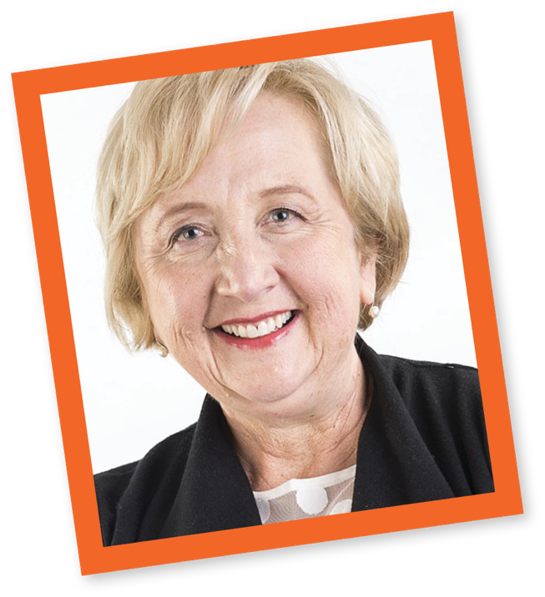 Speech Bubble:

Quote from Anne Hollonds, National Children's Commissioner: 

"Most of the kids I spoke to said that it was very imortant that the government listens to what they have have to say."

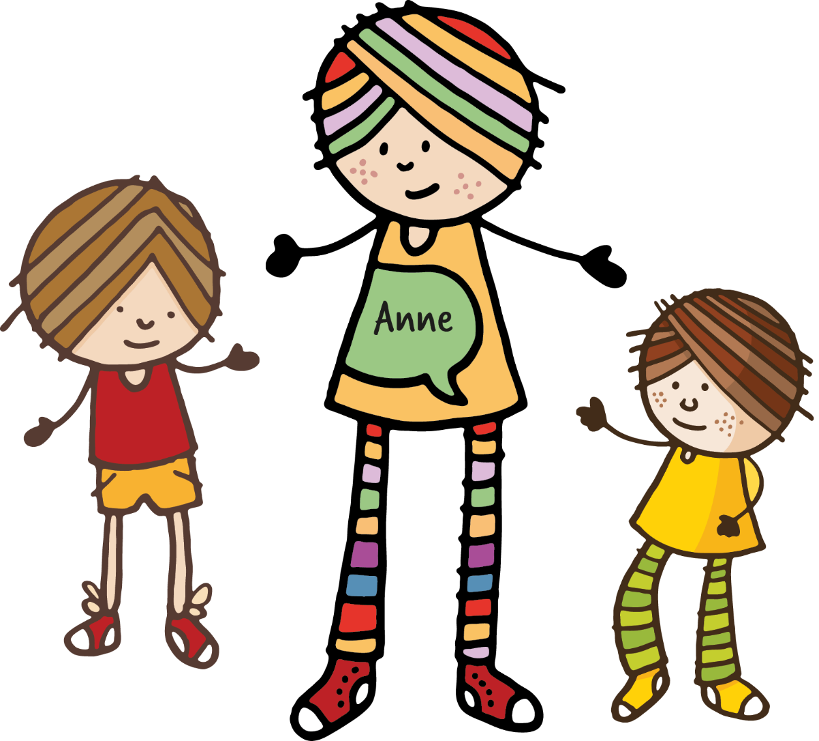



I’m Anne Hollonds, the National Children’s Commissioner.

My job is to protect the rights of all children and young people in Australia and to make sure they get the help they need to be safe and well.

I want all the kids in Australia to have the things they need to grow up safe and well. This means somewhere safe to live, someone who cares for them and looks after them, being connected to their culture, having enough to eat, health care, school, a safe neighbourhood, and time and space to play.

Not all kids and their families have the things they need to grow up well and healthy.

In 2021, the Australian Government asked me to talk to kids and families across Australia to find out what would help to keep them safe and well, especially kids and families having a tough time.

Between May and July 2021, I talked with 400 kids and parents across Australia. I talked with many of you in person and some of you online using video because COVID lockdowns meant we could not meet face-to-face.

426 of you answered some questions in a short survey.

You told me about what you need to be safe and well, and what makes it hard to get help when you need it. I’ve put lots of what you said into a report that I have given to the Australian Government.

The Australian Government wants to use the information you gave me to come up with an action plan to keep all kids safe and well. This plan will be part of Safe and Supported: The National Framework for Protecting Australia’s Children 2021‑2031.

# What you told me

Many of you told me that you feel safe with your parent or carer, your friends, your teachers and other people in your communities.

You told me that more needs to be done to make sure kids are safe.

The top three things you and parents said would help keep you safe were:

|  |  |  |
| --- | --- | --- |
| Illustration: Two parents, both holding a red house in the air in between them. There is a small child on the ground between the two parents, raising her hands up towards the red house in the centre. Caption underneath reads: "help with housing".  help with housing | Illustration: Icon of older boy with his arms stretched on both sides with the palms up. There are seven red arrows around his head all pointing inwards. Caption underneath reads "mental health services"  mental health services | Illustration: Blue bowl of porridge with steam rising up, and the handle of a spoon visible coming out of the porridge. There is a yellow stripe and a red heart on the front of the bowl. The caption below reads: "help with basic needs".  help with basic needs |

Many of you, and parents, said that it can be tricky to find the help you need and that sometimes the right help isn’t there for you. You said it feels a bit like a maze.

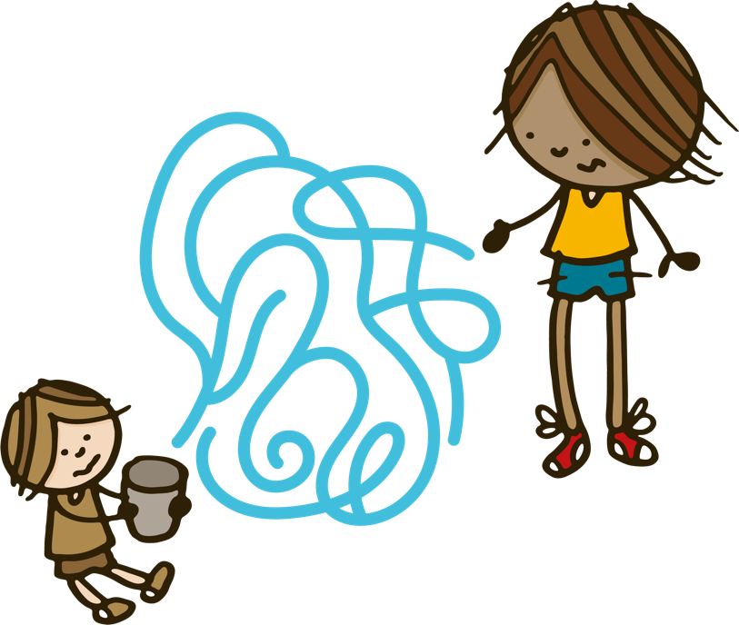

You told me that you want help to be:

|  |  |  |
| --- | --- | --- |
| Icon representing a frustrated mother on the phone. She is staring into an old fashioned style phone receiver with an unhappy expression on her face. The caption below reads: "available".  available | Icon illustration of small girl placing a coin on the top of a high stack of coins. The caption below reads: "affordable".  affordable | Icon illustration representing a mother holding a big map indicator (red pin) on top of a paper map. The caption below reads: "accessible".  accessible |
| Icon illustration of a mother affectionately touching the top of the head of her daugher with her hand. The caption below reads: "respectful".  respectful | **Icon illustration showing a circle of happy children of various races and cultures. Caption below reads: "culturally safe and inclusive".**  culturally safe and inclusive | Icon illustration of small girl in red dress, holding a loud-speaker up to her mouth. Caption below reads: "open to listening to the voices of children and their families".  open to listening to the voices of children and their families |

I heard that the people and services that help to keep you safe and well are the ones who take the time to listen to you and to understand you. They do not discriminate against you, and they respect you. Being able to talk to the same trusted people at these services is very important to you.

It can be hard to find the help you need. I heard that you and parents want to be able to get different kinds of help for family members from one place, including what to do when there is violence at home and for mental health concerns.

Many of you told me that you want to have more of a say in decisions about your life.

# Aboriginal and Torres Strait Islander kids and their families

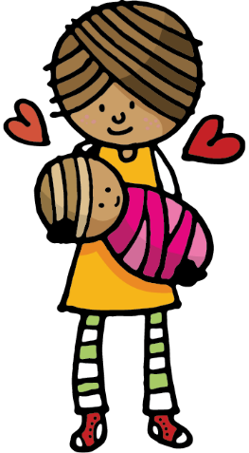

Many of you and parents told me that Aboriginal and Torres Strait Islander families continue to experience trauma because of actions by governments, anddiscrimination by services and authorities.

Some parents are worried that asking for help might mean that child protection authorities will take their children away. They told me it was often hard to trust people in government who should be there to help them keep their kids safe and well.

You told me that sometimes schools are not welcoming of you and your families and you want this to change, so that you can feel comfortable going to school.

I heard that the services you can trust are run by the local Aboriginal and Torres Strait Islander community members.

# Kids and parents with disabilities

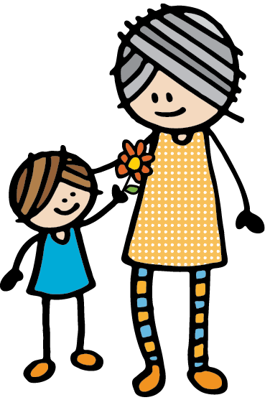

You told me that kids and parents with disabilities are the experts on what kinds of support they need.

Many of you told me that you face challenges finding and getting the right help for you.

Sometimes services don’t treat you with respect, or you have to tell your story to someone new every time. You find services are often not flexible with the help they can give you.

I heard that the people and services that you trust are the ones who take the time to listen and to understand you.

Sadly, some of you and some parents said that school does not always feel safe for you.

Children's handwritten quote: 

"More support for families
• extra $
• help them get on their feet" 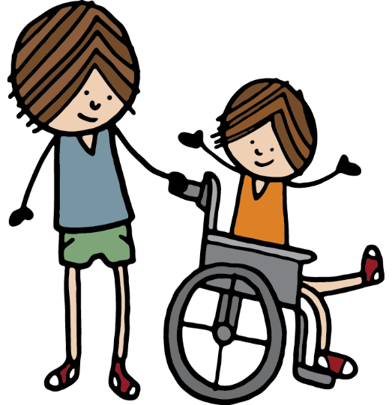

# Basic living conditions

Some of you and many parents told me that families need enough money to look after their kids and that payments from the government are not enough. This makes life very stressful every day.

You and parents said that the government needs to make sure that the payments cover the things you really need, like housing and food.

I heard that finding safe and secure homes was a big problem for families.

I met many young people, who are also parents of young children, who are couch-surfing or living in refuges, because they can’t afford rent and it takes many years of waiting to get social housing.

I was also told that public transport is often not available to get to the places that you need to go, like school and doctors’ appointments.

Some of you told me that you don’t have computers or internet at home to be able to do your schoolwork.

Speech Bubble:

It’s really difficult to get into Housing Commission – I might have stayed with my old partner just to have a place to live. Lots of my friends stay with abusive partners just to have somewhere to live. –Young parent, NSW

# Family support

Lots of you told me that you feel safe with your families: with your mum, dad, grandparents, aunties, uncles, other family members, and carers and guardians.

Children's handwritten quote:

"mum she makes me happy all the time"

But many of you also told me that families need more help to keep kids safe and well at home and that it isn’t always easy to get that help.

Some parents said that they don’t feel like they can get help until they are in crisis. Other parents said that they were worried that if they asked for help, their children would be taken away.

Speech Bubble:

Everyone’s doing their best.
How can we work together to provide the best care for kids. –Parent, QLD

# Out-of-home care

Kids told me that they need more support to be safe and well in out-of-home care.

You told me that you didn’t feel like your carers understand what you are going through. You said that you don’t get enough help from your caseworkers, especially with your mental health.

Speech bubble with bee illustration on top:

Every kid should be looked after well – it should not be a matter of luck whether they get someone that cares for them. Most people who go through the care system have had nothing but negatives. –Young person, TAS

Some kids are looked after by family members, such as their grandparents. Grandparent carers told me that they need more help, including to make sure their grandchildren who have disabilities have the help they need.

Kids who are leaving out-of-home care told me that they need ongoing support, for example with housing and money, and training and employment, to make sure they are okay.

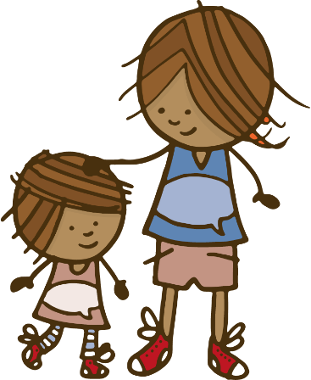

# Violence and safety

Many of you and parents told me you were all worried about violence at home and in your communities.

Speech Bubble:

Sometimes the community itself is toxic, for example, if a lady is abused at home or experiencing some form of violence, community will tell her not to leave and bear with it and be strong. The community can come between families. –Young person, SA

Speech Bubble:

When you grow up with violence you don’t know any better. –Young person, NT

Speech Bubble:

Parents can be really stubborn. They don’t understand how to break the cycle or they don’t want to. Growing up in that situation, I became a lot more numb to the situation because that was what my ‘safe’ was. –Young person, NSW 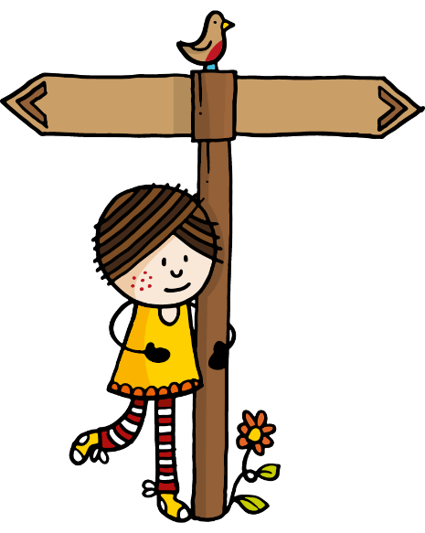

You said that there were lots of reasons why it can be difficult to get help when there is violence in your home, including:

|  |  |  |
| --- | --- | --- |
| Icon illustration of a policewoman looking a bit perplexed. Caption below reads: "not feeling like the police will understand".  **not feeling like the police will understand** | Icon illustration of a mother and daughter. The mother is patting the daughter affectionately on the head. Caption below reads: "worried about children being taken away".  **worried about children being taken away** | Icon illustration of a red house, with a pink heart in the centre. Caption below reads: "not having another place to live".  **not having another place to live** |

Some kids and parents who have violence in their homes told me that the people who were supposed to help them, like police and child protection authorities, needed more training about how to help them.

Many of you have had to move far away from your family and friends so that you can be safe from violence.

Many of you told me that being safe from violence at home was a big problem for you.

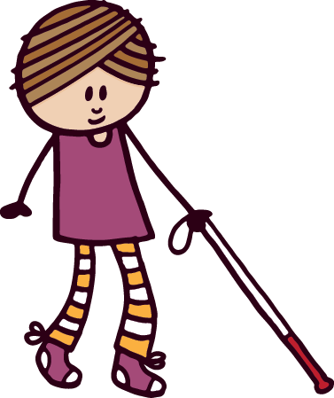 Children's handwritten quote:

"Hard for people who don't know how to speak up".

# Health and mental health

I heard that it’s often hard to get the right kind of health care and mental health support when you need it.

You and parents said there are many barriers:

|  |  |  |
| --- | --- | --- |
| Icon illustration of a bee with a calendar. Caption below reads: "long wait times to get help".  **long wait times  to get help** | Icon illustration of small boy pointing to a world globe. Caption below reads: "no services nearby".  **no services nearby** | Icon illustration of a tall stack of coins. Caption below reads: "too expensive".  **too expensive** |
| Icon illustration of small boy holding a clipboard. Caption below reads: "too many rules to get in".  **too many rules  to get in** | **Icon illustration of a woman behind a desk holding a document in her hands. Caption below reads: "staff who didn't understand them".**  **staff who didn’t understand them** |  |

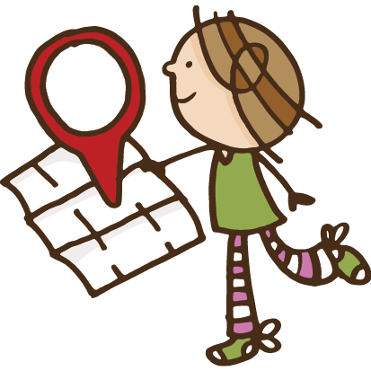

# Schools and education

Some of you told me that you feel safe and looked after at school and said that your teacher was someone you could turn to for help with all kinds of problems.

But others said to me that school can be tough, with bullying and violence, and not being treated fairly. You said you don’t feel safe at school.

Some of you also told me that you didn’t feel your school was welcoming to Aboriginal and Torres Strait Islander children and their families.

You and parents told me that teachers need more support and training and that schools should be more welcoming of kids and their families.

Young people, including those of you in youth detention, told me that you need training so that you can get a job, but you also said that training is hard to get.

Parents talked about needing early childhood education and care so that they can get training and jobs, and also for the learning and development of their children.

Speech Bubble:

I don’t like school because I get teased every time I go there. The teachers don’t really help. I have tried asking for help from a teacher. They sorted it out a little bit but then it started back up again. So, I just started fighting with the kids. –Young person, VIC

Speech Bubble:

We need somewhere for the people who want to hang out with their friends and not go back home. —Young person, NT

# Youth community activities

You told me that you like to have safe and local places that you can go to in your neighbourhood.

For example, you like drop-in youth centres where you can get help with lots of different things, like homework, mental health support, and free food. You also said that you like the kind and caring staff working at these places who help you with your worries, and you like hanging out with your friends there.

Lots of you told me that everyone should have somewhere to go after school where they can get any help they might need.

You also talked about the importance of sports clubs, homework centres and libraries in the local area.



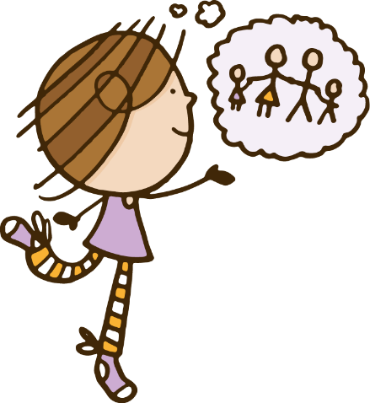

# What happens next

I have given my report to the Australian Government and asked them to use it in planning better services for the future. I will be looking at how your views are used and will let you know what happens.

# What you need to know

If you feel unsafe or worried about anything, it is important to speak up and ask for help. You can talk to someone you trust – like a family member, friend, teacher or school counsellor.

You can talk to **Kids Helpline**:

* on the phone on **1800 55 1800**
* online at[www.kidshelpline.com.au](http://www.kidshelpline.com.au/)

You can also talk to **headspace**:

* face-to-face at a headspace centre
* online atwww.eheadspace.org.au
* on the phone on **1800 650 890**



If you think you are in immediate danger,

you can call the **police** by dialling **000**.

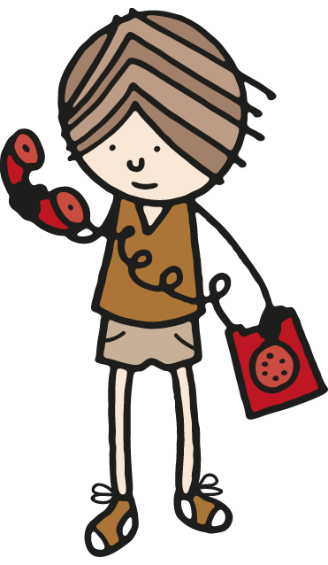

# Fun activity using words in the important information you shared with me

Can you find some of the important words that you used when sharing your ideas with me?

|  |  |  |  |  |  |  |  |  |  |  |  |  |  |  |
| --- | --- | --- | --- | --- | --- | --- | --- | --- | --- | --- | --- | --- | --- | --- |
| **C** | **U** | **N** | **P** | **G** | **F** | **S** | **C** | **H** | **O** | **O** | **L** | **S** | **O** | **E** |
| **M** | **B** | **C** | **M** | **A** | **T** | **F** | **A** | **I** | **R** | **D** | **B** | **P** | **S** | **I** |
| **T** | **E** | **N** | **I** | **A** | **R** | **H** | **C** | **E** | **F** | **K** | **A** | **I** | **U** | **E** |
| **V** | **R** | **N** | **V** | **W** | **Z** | **E** | **L** | **O** | **A** | **I** | **S** | **V** | **S** | **O** |
| **M** | **A** | **A** | **T** | **I** | **M** | **N** | **N** | **K** | **M** | **N** | **I** | **R** | **U** | **G** |
| **O** | **H** | **T** | **N** | **A** | **O** | **R** | **C** | **T** | **I** | **D** | **C** | **I** | **P** | **I** |
| **K** | **O** | **E** | **R** | **S** | **L** | **B** | **A** | **W** | **L** | **Q** | **N** | **G** | **P** | **D** |
| **A** | **U** | **A** | **M** | **Y** | **P** | **H** | **U** | **F** | **Y** | **Z** | **E** | **H** | **O** | **C** |
| **U** | **S** | **C** | **Y** | **G** | **R** | **O** | **E** | **L** | **N** | **P** | **E** | **T** | **R** | **H** |
| **I** | **I** | **H** | **L** | **Q** | **E** | **I** | **R** | **A** | **L** | **A** | **D** | **S** | **T** | **E** |
| **V** | **N** | **E** | **J** | **F** | **S** | **J** | **O** | **T** | **L** | **Y** | **S** | **Y** | **F** | **C** |
| **J** | **G** | **R** | **F** | **Z** | **P** | **A** | **H** | **I** | **T** | **T** | **I** | **A** | **I** | **H** |
| **U** | **V** | **I** | **O** | **L** | **E** | **N** | **C** | **E** | **K** | **H** | **H** | **N** | **C** | **Q** |
| **K** | **X** | **B** | **O** | **Y** | **C** | **X** | **H** | **E** | **L** | **P** | **C** | **T** | **G** | **W** |
| **M** | **V** | **L** | **D** | **R** | **T** | **Y** | **F** | **J** | **O** | **B** | **S** | **N** | **R** | **V** |

HELP, SUPPORT, RIGHTS, MENTAL HEALTH, PARENT, FAMILY, HOUSING, TRANSPORT, SCHOOL, BASIC NEEDS, JOBS, BULLYING, TEACHER, FOOD, RESPECT, VIOLENCE, KIND, FAIR