Children’s Rights in Australia: a scorecard

Contents
Introduction 3
Australia’s children 6
A nationwide children’s rights framework 6
Children’s voices 7
Civil rights 9
Safety 11
Family life 13
Health 14
Living standards 17
Education, leisure and cultural activities 19
Youth justice 21
Aboriginal and Torres Strait Islander children 23
Asylum seeker and refugee children 26
Moving forward 28
A blueprint for reform — Key actions 29
Appendix 41

Introduction
This scorecard tells the story of how well children’s rights are protected and promoted across Australia. It tells us where we are doing ok, where we should be doing much better, and where we do not yet know enough to make an assessment of our performance. It is intended to help hold Australian Governments to account for the wellbeing of our children, now and into the future.
This year, 2019, marks the 30th anniversary of the Convention of the Rights of the Child (CRC), the most complete statement of children’s rights ever produced. The CRC sets out all the basic rights that children need to do well: like having a home and a family, getting a good education, being able to access quality health care, being safe from harm, and having a voice. It covers all aspects of a child’s life, and makes clear that every child has rights, irrespective of their circumstances, and that as a society we must work together to make sure all children can enjoy them.
Australia ratified this treaty in 1990, meaning that Australia has agreed to take action to make sure all children in Australia can enjoy their rights.
In September 2019, Australia appeared before the United Nations Committee on the Rights of the Child (the Committee) to answer questions about how it is working to advance the rights of children in Australia. The Committee provided Australia with a range of recommendations, called Concluding Observations, to improve its performance in relation to children’s rights. The Concluding Observations (2019) called for urgent measures to be taken in order to protect children:
• from violence
• in alternative care
• in relation to mental health
• from environmental damage and climate change
• who are refugees, seeking asylum and in situations of migration, and
• in the administration of justice.
A summary of the observations made by the Committee on the Rights of the Child is included in the appendix.

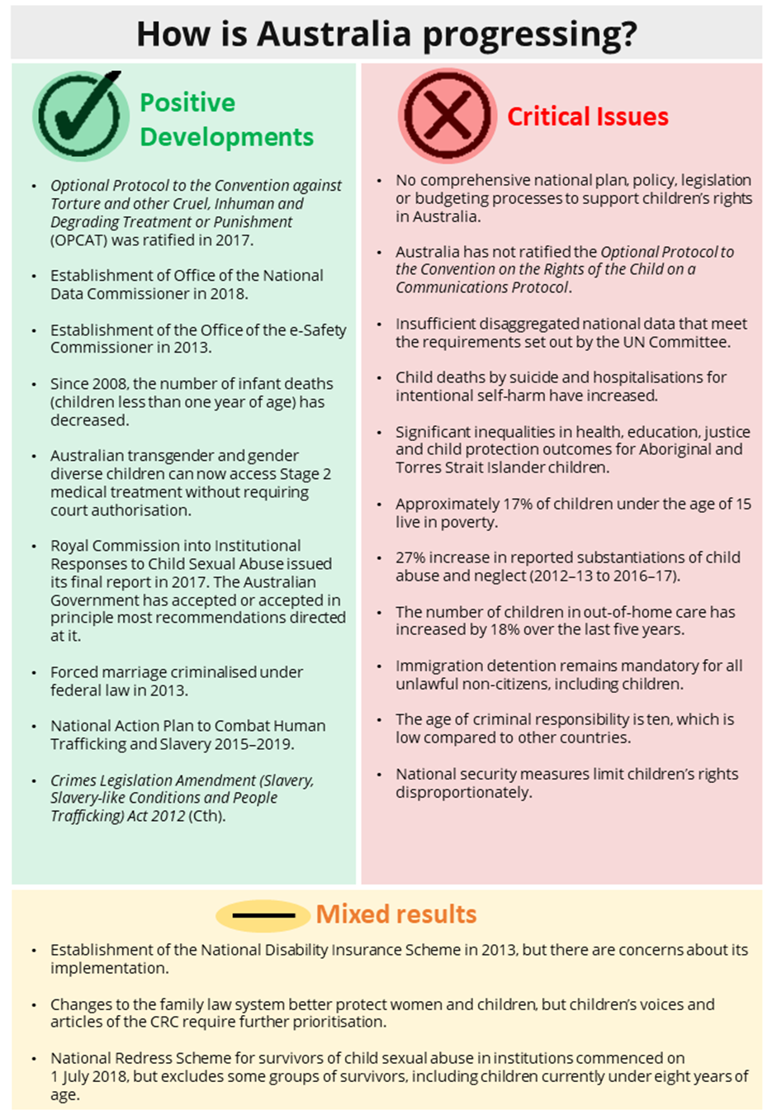
We have made progress on some issues, with national frameworks agreed to by all Australian Governments that focus on children’s needs. However, generally progress on children’s rights occurs on discrete issues and policy areas and fails to take into account the broader inter-connections between issues that reflect the reality of children’s lived experience.
Further, while most Australian children live in safe and healthy environments and do well, there are some groups of children whose rights are not adequately protected, which impacts negatively on their wellbeing and ability to thrive. This includes Aboriginal and Torres Strait Islander children, children with disability, those from culturally and linguistically diverse backgrounds, and lesbian, gay, bisexual, trans and intersex (LGBTI) children.
The lack of action to address children’s rights in a holistic way means that critical issues fall through the gaps and have received little policy attention in the seven years since Australia’s last appearance before the Committee on the Rights of the Child in 2012.
Without comprehensive legal protection, education and other measures to promote an understanding of human rights and monitor compliance with human rights, our government is not fully meeting its obligations to make sure that the human rights of all Australian children are respected, protected and fulfilled.

Australia’s children
There are approximately 5.5 million children living in Australia.
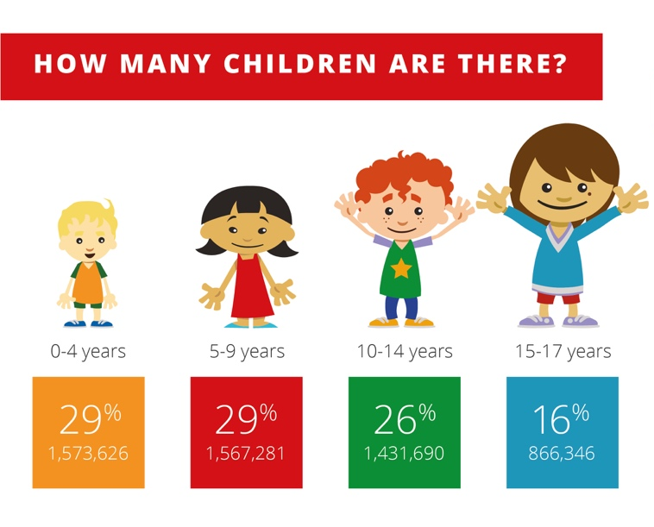
Of all children in Australia:
- over 6% are Aboriginal and Torres Strait Islander children (2016)
- approximately 9% were born overseas (2016)
- 76.5% of children aged under 15 live with couple parents, 13.5% in single parent families, 4.2% in multiple-family households (2017)
- 70.7% live in major cities, 27% in regional areas and 2.3% in remote areas (2016)
- 47,915 children are living in out-of-home care (2017)
- around 26,000 children are homeless (2016).

A nationwide children’s rights framework
The CRC asks that countries put in place comprehensive laws, policies, systems and plans to realise the promises made to children in the CRC.
By and large, in Australia, there are few laws and policies at the national level that protect human rights, and specifically children’s rights. There is no national platform from which to advance children’s rights across the domains of the CRC, apart from the activities of the National Children’s Commissioner. For example:
- The legal protections of children’s rights in Australia are not comprehensive and do not provide an effective remedy for violations.
- There is no national level coordination of the many policy initiatives that exist across all governments relating to children.
- Australia does not have budgeting processes that specifically track the allocation of resources to all children.
- Across Australia, state and territory Children’s Commissioners/Guardians and Ombudsmen have independent monitoring powers within their own jurisdictions. These powers vary and can include oversight of child protection, out-of-home care, juvenile justice systems, and complaint handling. The National Children’s Commissioner does not have a mandate to monitor or deal with complaints about individual children.
- There are significant and serious gaps in the data that is collected and is publicly available on children.

Children’s voices
Children are strong people and they deserve to be heard
(child, 10)
Article 12 of the CRC requires governments to ensure that children and young people have the opportunity to participate in decisions that affect them.
This is one of the guiding principles of the CRC because having a genuine voice and being heard is the gateway to claiming all other rights. This right is both safeguarding and empowering for children.
The participation of children is not a routine part of the development of laws or policy in Australia. However, there has been a noticeable trend over recent years towards creating mechanisms for the participation of children in a variety of contexts.
In 2018, the National Children’s Commissioner heard from 22,700 children through an online national Children’s Rights Poll and consulted in person with approximately 450 children. Through talking to children about human rights, and their rights in particular, it is clear that rights knowledge strengthens children’s agency and capabilities, and also engenders respect for the rights of others.
Children’s Rights Poll
Growing up in Australia is good because I can have my say and I get to participate in sport and things I like
(child, 10)
All children should be able to have a say in things that matter
(child, 11)
Adults sometimes think kids don’t know things and ignore their ideas
(child, 10)

Civil rights
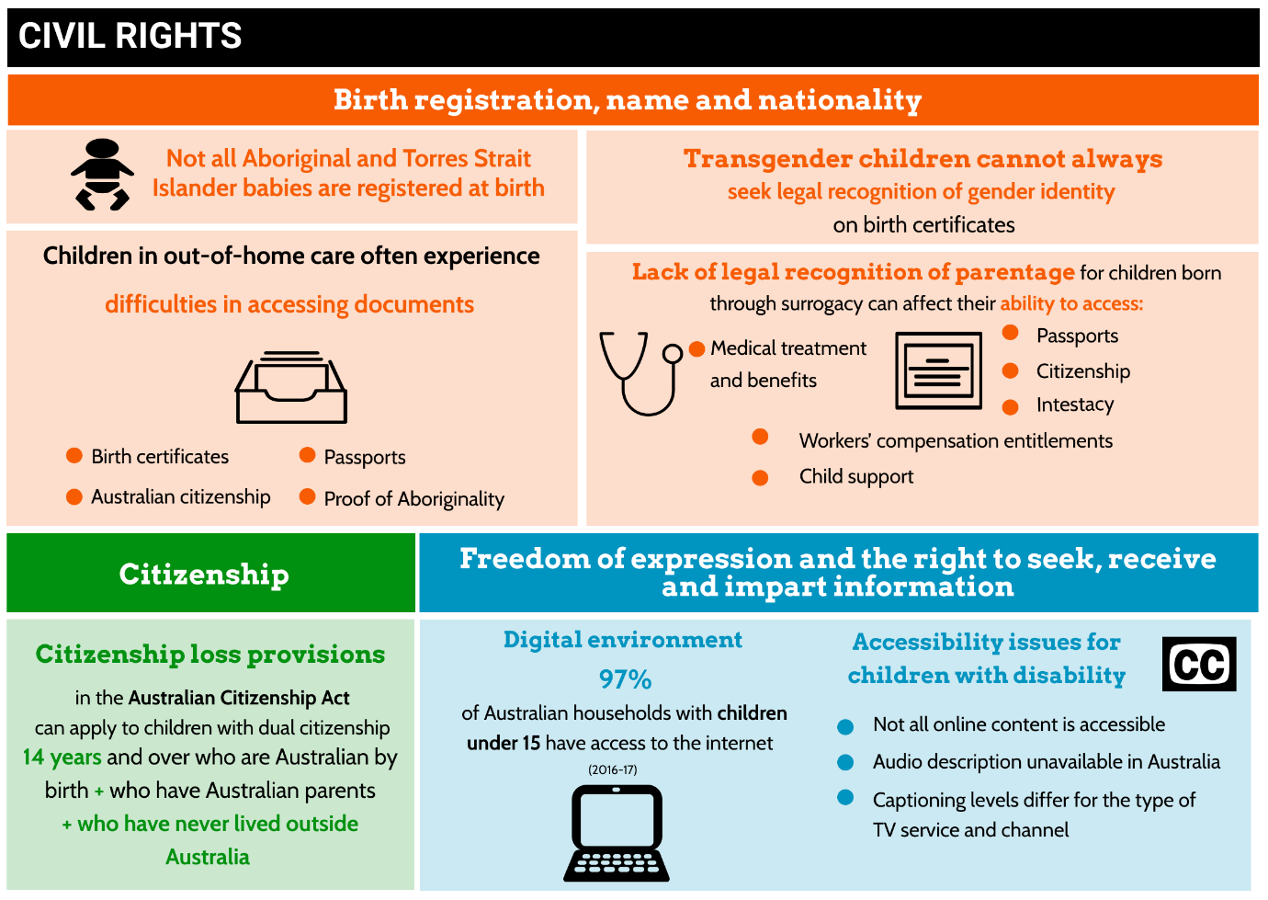
Under the CRC children have rights to identity, such as the right to have their birth registered, the right to a name, the right to know who their parents are and the right to a nationality. The CRC also protects a child’s right to live a life free from discrimination and their right to access accurate information in writing, print or other media.
Some concerns for children’s civil rights in Australia are:
- Not all babies in Australia are registered at birth, especially those born to Aboriginal and Torres Strait Islander parents. Birth certificates play an important role in ensuring that a child has access to education and other resources.
- It is not always possible for transgender children in Australia to seek legal recognition of their gender identity. The inability to change the sex marker on birth certificates can make the experience of attending school, for example, difficult for transgender children.
- Children in out-of-home care can experience difficulties in accessing identity documents, such as birth certificates, proof of Aboriginality, proof of Australian citizenship, and passports.
- Lack of recognition of legal parentage for children born overseas through surrogacy can affect the ability of children to access a variety of other rights relating to citizenship, medical treatment and benefits, inheritance, passports, child support and workers’ compensation entitlements.
- Australian children and young people experience discrimination on the basis of their gender, sexual orientation, race, national or ethnic origin, and disability.
- A range of new legislative measures in response to the threat of international terrorism have the potential to impact negatively on children, including changes to the Australian Citizenship Act 2007 (Cth) which allow the Australian Government to revoke the citizenship of dual nationals aged 14 years and over if they engage in terrorism-related conduct.

Safety
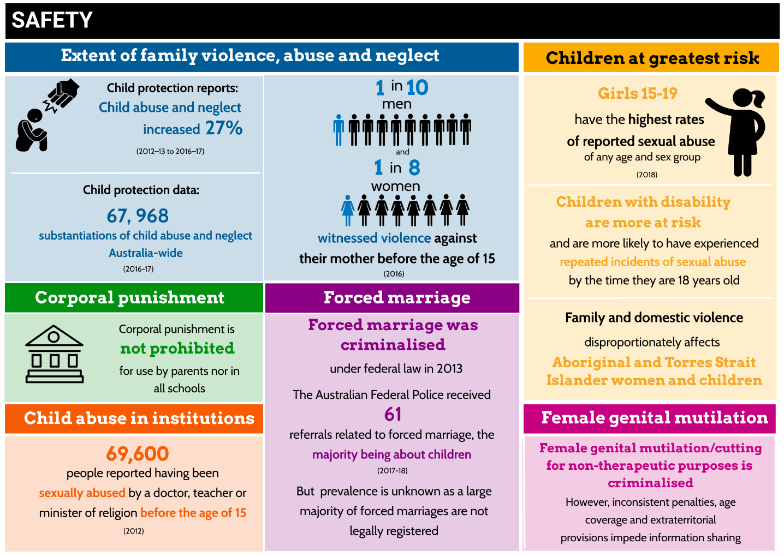
Children have the right to be safe and protected from violence and abuse in all aspects of their lives—in their homes, at school, in their online activities and in the broader community. Children say that the right to safety is the number one priority for them.
While most children in Australia tell us they feel safe, many children experience unacceptable levels of violence, abuse and neglect. For example:
- Most violence against children is committed by someone that the child knows, the family being the most common setting. Tragically, every year a small number of children die at the hands of a family member.
- Children are frequently witnesses and bystanders of violence in the family, commonly violence directed at their mother. The family law system could better ensure child safety by adopting a more child-centred approach.
- Attitudes that support violence still persist among young Australians.
- Some groups of children are at greater risk of family violence, abuse and neglect. The need for better national, disaggregated data on children’s experiences of family and domestic violence should be a key priority for action.
- Corporal punishment has not been explicitly prohibited in all settings, including homes and all child-related institutions.
- Some children have been maltreated in the care of institutions such as schools, recreational organisations, residential care, youth detention and immigration detention. While the harmful effects of institutional maltreatment have been brought into stark relief in Australia by the Royal Commission into Institutional Responses to Child Sexual Abuse (2012–2017), there is still much to do to make sure that child-related institutions are safe for children.
- Bullying at school, including cyberbullying, remains a major health concern.
- There have been exponential increases in reports of online child exploitation.
- A small number of children in Australia are victims of child trafficking, slavery or slavery-like practices, including forced child marriage.
- International surrogacy remains unregulated, highlighting risks of child trafficking.
- Some people in Australia have been the victims in childhood of female genital mutilation or cutting (FGM/C), with serious lifelong health impacts.

Family life
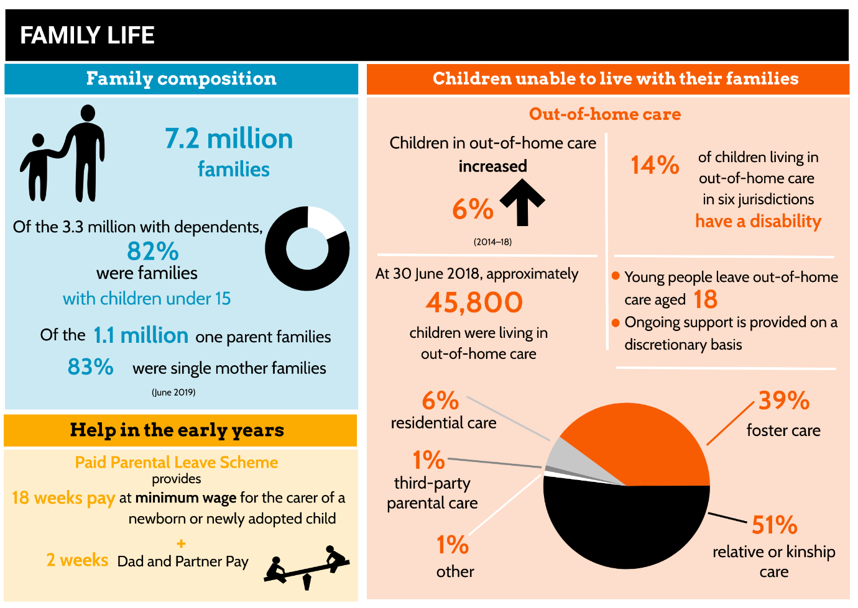
The CRC emphasises the importance of family to children, stipulating that there should be no arbitrary or unlawful interference with family, and this should be protected by law.
Australia needs to support families to care for children, including:
- improvements in universal support services in the early years, such as paid maternity leave
- making sure that removing a child from their home and from the care of their parent(s) is considered an intervention of last resort across all Australian statutory child protection jurisdictions, with governments committed to making all efforts to keep children at home with their families
- supporting young people leaving out-of-home care
- taking into account Australia’s history of forced removals and forced adoptions of Aboriginal and Torres Strait Islander children when considering the transfer of legal guardianship as an option for any Aboriginal and Torres Strait Islander child.

Health
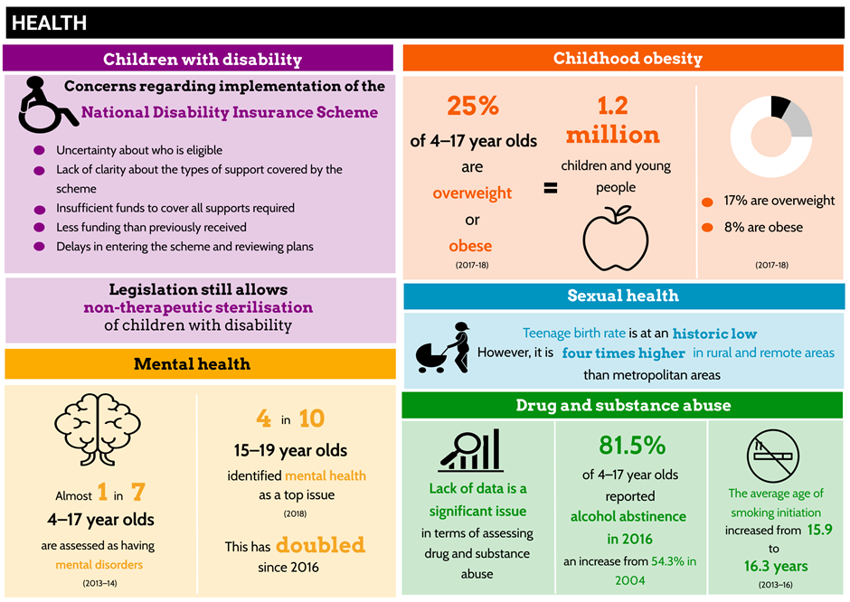
Children have a right to the highest attainable standard of health and to facilities for the treatment of illness and rehabilitation.
Generally, most Australian children have good health outcomes and access to health care. Australia is ranked in the top third of Organisation for Economic Co-operation and Development (OECD) countries for life expectancy at birth, low youth smoking rates and low rates of young people drinking alcohol at risky levels. Infant mortality rates decreased between 2006 and 2016, and injury deaths of children decreased between 2004 and 2016.
However, some children are at greater risk of poorer health outcomes due to factors including geography, health literacy, culture, social and economic circumstances, and individual characteristics. There are also areas where Australia could do better to improve children’s health. For example:
- It is difficult to gain a clear picture of the prevalence of disability among children because of inconsistent definitions of disability across different contexts and jurisdictions and the current incapacity to report reliably on specific sub-population groups.
- While the National Disability Insurance Scheme (NDIS) is designed to make it easier for individuals to access support services, a range of issues have been raised about the implementation of the scheme in respect of children. Also, many people with disability, including children, do not meet the NDIS eligibility criteria.
- A hearing service stream for children newly diagnosed with hearing loss, established in 2018, only applies to children who attend Hearing Australia for the first time post-2018. A significant proportion of children are not covered.
- Legislation in Australia still permits the non-therapeutic sterilisation of children with disability.
Surveys of children, young people and their families show that mental health problems are a significant concern to them. While services such as Kids Helpline and Headspace provide valuable mental health support, there is a shortage of mental health services. In 2017, suicide was the leading cause of death of Australian children aged 5–17, with an increased number of deaths of children due to suicide from 2016. Between 2007 and 2017 there were 35,997 hospitalisations of children aged 3–17 years for intentional self-harm. While we have some understanding about suicide and intentional self-harm, there is still much that we do not know.
The lack of accurate information about the incidence and prevalence of Fetal Alcohol Spectrum Disorder is a serious impediment to developing effective health and policy responses.
In 2017–18, one in four (25%) children aged 2–17 were overweight or obese—equating to approximately 1.2 million children and adolescents.
The percentage children on the Australian Immunisation Register fully immunised at one year of age is slightly less than most OECD countries.
Although 90% of Australian mothers initiate breastfeeding, only 15% of infants are exclusively breastfed for the six-month period recommended by the World Health Organisation (WHO).
There is domestic and international concern about involuntary surgery on infants born with variations in sex characteristics. Decision-making about medical interventions for intersex children should be guided by children’s right to have their best interests taken as a primary consideration, their right to the highest attainable standard of health and their right to have due weight given to their views.
Australian transgender and gender diverse children can now access stage two hormonal treatment without seeking court authorisation, due to a landmark court ruling in Re Kelvin. However, the removal of the requirement of court authorisation does not extend to children in the out-of-home care or youth justice systems.
Since 2008, the number of infant deaths (children less than one year of age) has decreased. Since 2001, the death rate for Aboriginal and Torres Strait Islander infants also decreased, but it is still almost twice the rate of all infants. There is still no regular national report on all causes of death for Australian children under the age of 18 years.
Although the teenage birth rate is at a historic low, teenagers in rural and remote areas experience young parenthood at four times the rate of their metropolitan counterparts. Surveys of young people show that contraceptive knowledge is low.
The misuse of drugs and alcohol is a major cause of preventable disease and illness in Australians. Government-funding remains primarily focused on law enforcement and treatment. Lack of data for children under the age of 18 years is a significant issue in terms of assessing drug and substance abuse.
The practice of male circumcision is sometimes conducted for non-therapeutic purposes and infants are unable to give consent, giving rise to human rights concerns. Better data that distinguishes between therapeutic and non-therapeutic male circumcisions would enhance our understanding of male circumcision in Australia.

Living standards
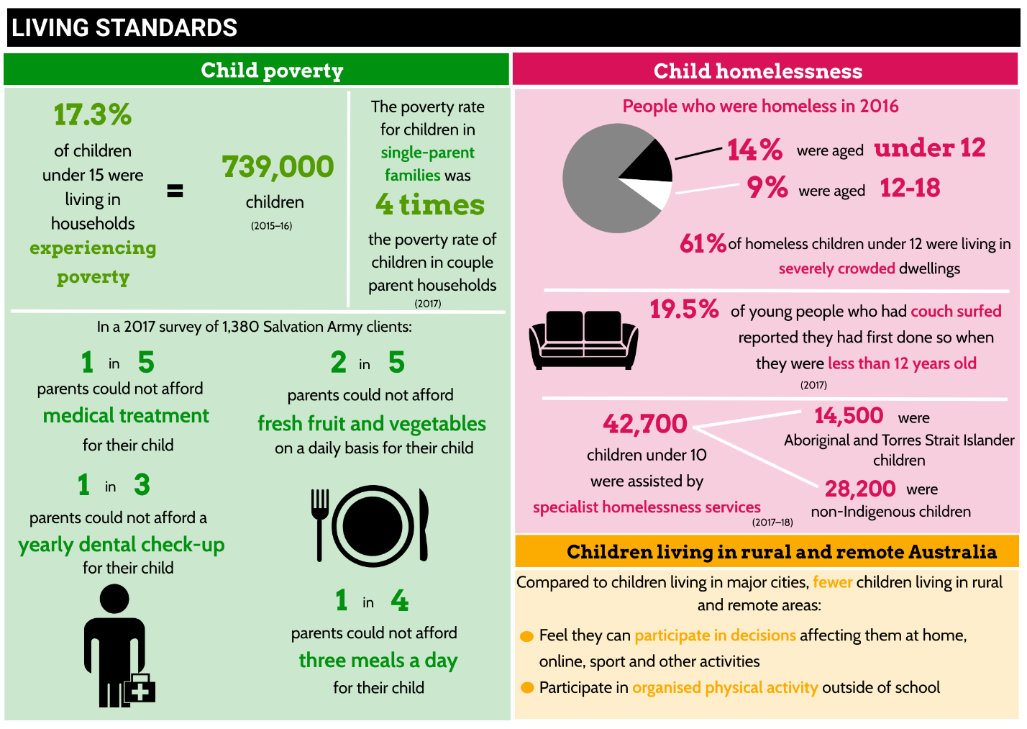
Under the CRC, every child has the right to a standard of living that is necessary for the child’s physical, mental, spiritual, moral and social development. Governments are required to provide material assistance and support programs, such as welfare and housing when necessary.
In 2015–16, 17.3% of children under the age of 15 years (739,000—more than one in six) in Australia were living in households experiencing poverty. Australia currently lacks an agreed national definition of poverty and a poverty reduction plan.
Homelessness continues to be an issue that affects children in Australia. Its causes are varied and complex and include domestic violence, a shortage of affordable housing, unemployment, mental illness, family breakdown, and drug and alcohol abuse.
Children living in rural and remote areas experience disadvantage across a range of domains. For example:
- Children who live in remote areas are more likely to die due to intentional self-harm than by other external causes, compared to children who live in metropolitan areas.
- Children from very remote areas were four times as likely as those from major cities to be the subject of a substantiation of abuse or neglect after an investigation of an at-risk notification.
- Teenagers in rural and remote areas experience young parenthood at four times the rate of their metropolitan counterparts.
- Four-year-old children living in very remote areas of Australia are more than twice as likely as those from major cities to be developmentally vulnerable (45.5% and 20.8% respectively) against Australian Early Childhood Development Index domains.
- School attendance across years one to ten decreases as remoteness increases.
- Children in regional and remote areas of Australia typically have access to a more limited range of organised sports and physical activities when compared with children living in metropolitan areas.
- Children in rural and remote areas also experience negative impacts from natural disasters not experienced by children living in major cities.

Education, leisure and cultural activities
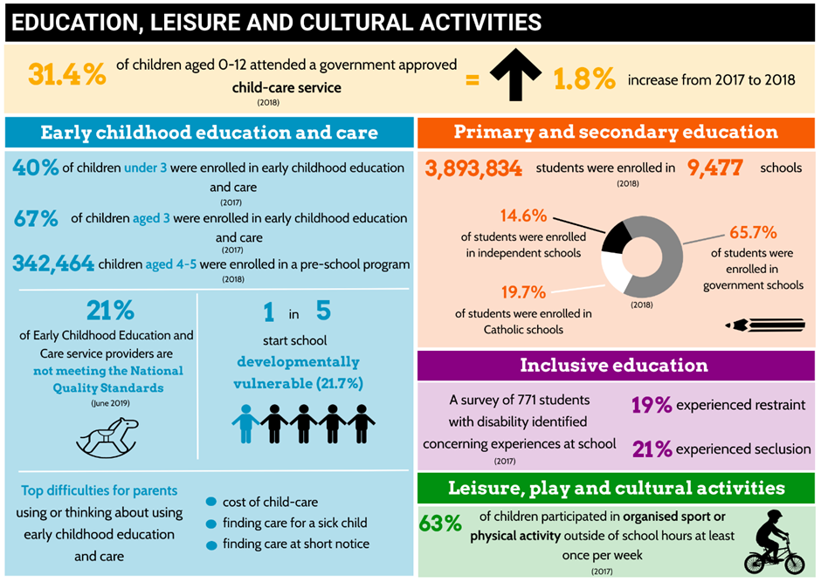
Every child in Australia has the right to an education, to engage in appropriate play and recreational activities and to participate fully in cultural life.
Australia falls below the OECD averages for enrolment in early childhood education and care (ECEC). Also, only 15% of three-year-olds in Australia participate in a pre-primary education program compared with the OECD average of 68.6%.
The most recent data of the Australian Early Development Census in 2018 shows that more than one in five (21.7%) Australian children start school developmentally vulnerable. This is largely unchanged from the 2015 data.
A new Child Care Subsidy to support the attendance of children at early education and care services was introduced in July 2018. There are serious concerns that many vulnerable and disadvantaged children are no longer accessing quality early childhood education and care services because of the changes, particularly for single parents and parents whose employment is insecure or unpredictable.
Across 10 years from 2008, the national minimum standard in Year 9 reading performance is largely the same and there is an improvement in numeracy. However, there has been a consistent decline in performance for Year 9 in the writing domain from 87.2% (2008) to 82.6% (2013) to 79.7% in 2018.
If all students are to become successful learners, confident and creative individuals, and active and informed citizens able to live fulfilling, productive and responsible lives, inclusive education is a necessary requirement. Current issues in the Australian education system include:
- There is no clear definition of what ‘inclusive education’ means in the Australian context.
- Educational outcomes for Aboriginal and Torres Strait Islander children are poor when compared with their non-Indigenous peers.
- Children who are part of, or assumed to be part of, lesbian, gay, bisexual, transgender and gender diverse or intersex populations can face particular difficulties at school, and in the community more generally.
- Parents of children with disability have reported experiencing some form of difficulty when enrolling their child in a mainstream school. A 2017 survey of 771 students with disability, conducted by Children and Young People with Disability Australia, identified that 19% of all respondents had experienced restraint at school, and 21% of respondents had experienced seclusion.
- The Multicultural Youth Australia Census found that discrimination most commonly takes place in education institutions and on the street.
- Data on suspensions and expulsions in government schools are inconsistent and unavailable in some states and territories.
- According to the 2018 Report Card on Physical Activity for Children and Young People, Australia performs poorly for overall physical activity levels of children and young people, but better than average for participation in organised sport.

Youth justice
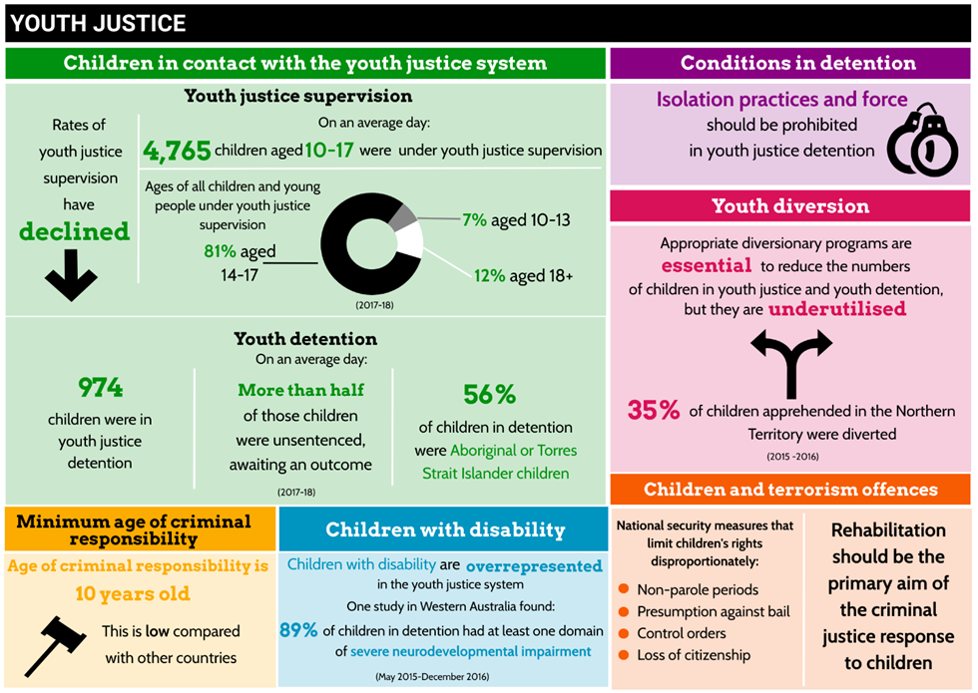
Children who come into contact with the criminal justice system have the same rights as other children—including the right to be kept safe, be heard, and be treated in a way that promotes their dignity and worth. They also have special rights specific to their experiences. Reintegration and rehabilitation should be a key aim of how children are treated in youth justice. Wherever possible, measures should not resort to judicial proceedings. Detention should only be used as a measure of last resort, and for the shortest appropriate period of time. The law must also set a minimum age below which a child should not be considered to have the capacity to commit an offence.
In Australia, although the numbers of children in the youth justice system are small, and have been declining over the past five years, there are still a significant number of children coming into contact with the youth justice system. Also, while the overall numbers of all children have declined, the level of overrepresentation of Aboriginal and Torres Strait Islander children has risen over the same period.
Children with disability are also overrepresented in the youth justice system, particularly children with intellectual disabilities or psychosocial disabilities. In some jurisdictions, declarations of unfitness to stand trial may lead to the indefinite detention of unconvicted people with disability, including children with disability.
A small proportion of children under youth justice supervision end up in youth detention. Younger children, including those as young as ten years, are sometimes detained in youth justice facilities.
While most states and territories do not place children in adult detention facilities, each jurisdiction has legislation that allows children to be detained in adult facilities in certain circumstances. Article 37(c) of the CRC requires authorities to separate children from adults in detention. The Australian Government still has a reservation to this article.
Despite legislation in most states and territories that prohibits the use of isolation and limits the use of force to certain circumstances, allegations of mistreatment of children in youth detention have arisen in several jurisdictions over recent years.
The availability of appropriate diversionary programs is essential to reducing the numbers of children in youth detention. While diversion from the criminal justice system is a key principle of all youth justice systems in Australia, it appears to be underutilised for a variety of reasons.
Onerous bail laws play a role in the disproportionately high, and increasing, numbers of children on remand in youth detention.
Although most states and territories do not have mandatory minimum sentences for juveniles, in the Northern Territory and Western Australia these still exist.
The minimum age of criminal responsibility in Australia is ten years, which is low compared with many other countries. The Committee on the Rights of the Child has recently recommended all countries increase the minimum age of criminal responsibility to at least 14 years.
Although protecting the Australian community from terrorism is an important priority for the Australian Government, national security measures should not undermine the rights of children convicted of terrorism offences to special consideration as children under the law. A number of national security measures limit children’s rights disproportionately.

Aboriginal and Torres Strait Islander children
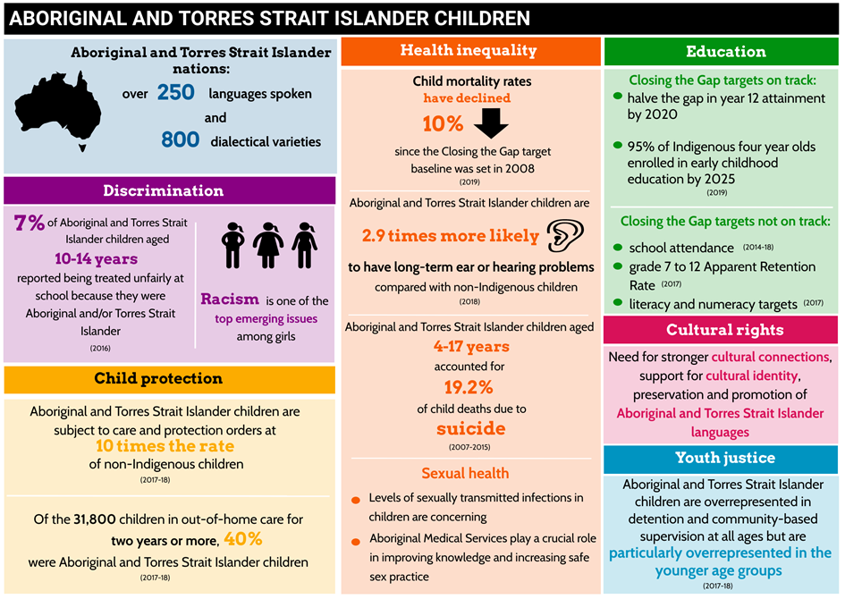
Aboriginal and Torres Strait Islander children continue to face significant disadvantage across a range of domains relevant to their rights and wellbeing, including in health and education, discrimination, exposure to family violence, and overrepresentation in child protection and youth justice systems. This overall disadvantage has roots in past government policies and practices, and the continued legacy of intergenerational trauma and disadvantage that these policies created.
Current issues in the area of health include:
- There are major gaps in data on important health issues affecting Aboriginal and Torres Strait Islander children.
- Since the Closing the Gap target baseline was set in 2008, Aboriginal and Torres Strait Islander child mortality rates have declined by 10%. However, the gap between Aboriginal and Torres Strait Islander children and non-Indigenous children has not narrowed, because the non-Indigenous rate has declined at a faster rate.
- Ear disease is a significant health issue facing Aboriginal and Torres Strait Islander children.
- In 2012–13, 30% of Aboriginal and Torres Strait Islander children aged 2–14 were overweight or obese, compared with 25% of their non-Indigenous counterparts.
- The likelihood of probable serious mental illness has been found to be consistently higher among Aboriginal and Torres Strait Islander children compared to their non-Indigenous peers.
- Aboriginal and Torres Strait Islander children aged 4–17 accounted for 19.2% of all child deaths due to suicide between 2007–15.
- The levels of sexually transmitted infections (STIs) in children, especially those from Aboriginal and Torres Strait Islander communities, are concerning.
Numerous studies confirm the negative impact of Aboriginal and Torres Strait Islander peoples’ experiences of racial discrimination, including institutional racism. Settings that were identified as places of concern include employment, education, shops, public spaces and sport, health and justice.
Data on hospitalised injury among Aboriginal and Torres Strait Islander people between 2011–12 and 2015–16 show the most commonly reported perpetrator of assaults on Aboriginal and Torres Strait Islander peoples was a family member.
Aboriginal and Torres Strait Islander children continue to be significantly overrepresented in Australia’s child protection systems. Aboriginal and Torres Strait Islander children are subject to care and protection orders at ten times the rate of non-Indigenous children. The number of Aboriginal and Torres Strait Islander children who were subject to care and protection orders has steadily risen from 15,500 in 2014 to 20,500 in 2018.
School attendance, literacy and numeracy outcomes did not meet the Closing the Gap targets for Aboriginal and Torres Strait Islander children set by the Australian Government for 2018. However, targets to halve the gap in Year 12 attainment or equivalent by 2020 and to have 95% of Indigenous four-year-olds enrolled in early childhood education by 2025 are on track.
One in ten Aboriginal and Torres Strait Islander people reported speaking an Australian Indigenous language at home in the 2016 Census. While the National Curriculum for schools includes a framework for Aboriginal and Torres Strait Islander languages, there is no national approach and the programs implemented in schools vary greatly across jurisdictions.
Current issues in the area of youth justice include:
- While around 5% of children aged 10–17 in Australia are from an Aboriginal or Torres Strait Islander background, half (49%) of the children under youth justice supervision on an average day in 2017–18 were Aboriginal and Torres Strait Islanders.
- Aboriginal and Torres Strait Islander children are overrepresented in both detention and community-based supervision at all ages but are particularly overrepresented in the younger age groups.
- Children placed in out-of-home care are 16 times more likely than children in the general population to be under youth justice supervision in the same year. This risk increases when the child is Aboriginal or Torres Strait Islander.

Asylum seeker and refugee children
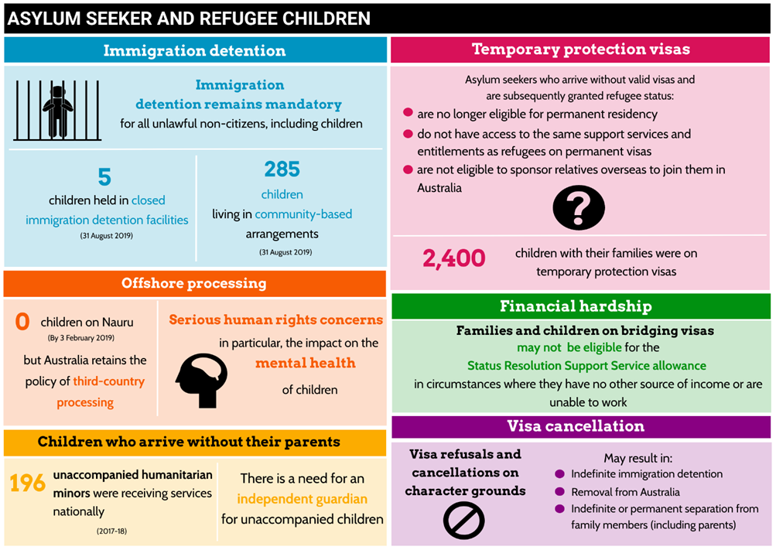
Asylum seeker and refugee children have the right to be provided with appropriate protection and humanitarian assistance so they can enjoy the rights set out in the CRC. This includes their right to be protected from torture or cruel, inhuman or degrading treatment or punishment and be protected from all forms of physical or mental violence, injury or abuse and the right to non-refoulement. Unaccompanied children are entitled to special protection and assistance.

While Australia’s resettlement program is good by world standards, its policies and laws towards refugees who come to Australia seeking protection are harsh. For example:
- The number of children in immigration detention has decreased markedly since 2012, and community-based alternatives to detention are most commonly used for children. However, immigration detention remains mandatory for all unlawful non-citizens, including children, under migration law.
- Numerous inquiries have demonstrated that closed immigration detention is an unsafe environment for children. The 2014 National Inquiry into Children in Immigration Detention found that prolonged detention had a profoundly negative impact on the mental and emotional health and development of children.
- In early 2019, the Australian Government announced that all children sent for offshore processing had been removed from Nauru, most of these on a temporary basis to receive medical treatment in Australia. However, the policy of offshore processing remains in place. Although international law does not specifically prohibit offshore processing of asylum seekers, it is difficult to see how Australia’s human rights obligations can be reconciled with the effects of this policy.
- Children and their families who have arrived by boat, allowed to remain in Australia and found to be refugees are granted temporary protection visas only. Granting temporary protection to children is more likely to compound mental health problems rather than facilitate their rehabilitation and integration into Australian society.
- The Minister for Home Affairs is the legal guardian of unaccompanied children seeking asylum in Australia. However, given the Minister’s multiple roles, the Australian Human Rights Commission considers it is difficult for the Minister (or their delegate) to ensure that the best interests of the child are a primary consideration when making decisions concerning unaccompanied children.
- Mental health experts have reported that children in the ‘legacy caseload’ experience severe mental health symptoms as a result of stress and trauma. Many children in the ‘legacy caseload’ face uncertainty and prolonged or indefinite family separation.
- Families and children on Bridging Visas may not be eligible for the Status Resolution Support Service allowance in circumstances where they have no other source of income or are unable to work.
- Visa refusals and cancellations on character grounds may result in children facing indefinite immigration detention, removal from Australia and/or indefinite or permanent separation from family members (including parents).
- Asylum seeker and refugee children who have been involved in armed conflict overseas should be identified on arrival and assisted in their recovery.

Moving forward
All Australian Governments need to recommit to the protection of human rights of children. This first and foremost requires upfront and transparent consideration of how to best protect the rights of children in Australia, which includes:
- reference to the rights contained in the CRC
- dialogue and engagement with children
- education for children, the community, key professions and decision makers about children’s rights
- appropriate data and measurement for tracking progress
- rigorous, public measurement frameworks that governments are accountable for and are committed to implementing.
The key elements of a national framework committing to the wellbeing of children include:
- an enabling legislative and policy framework that puts children’s rights at the centre of law and policy makers’ minds when they are designing services for children
- informed decision-making processes, with greater knowledge of children’s rights, and scrutiny processes that genuinely examine the potential impact of different measures on children
- participatory processes that engage children in the things that they have knowledge about—such as their own lives
- partnership models that build consensus on key goals, provide an evidence base on what works and create common shared purpose across government and non-government settings
- national accountability frameworks for children’s rights—with clear targets and accountability for outcomes.
Protecting children’s rights requires a commitment to provide all children in Australia with the very best chance to thrive and succeed, and the creation of an environment that also enables the next generation of children to thrive.

A blueprint for reform — Key actions

What is needed to ensure children’s rights in Australia are fully protected?
- The Australian Government should fully incorporate into Australian law its human rights obligations to children, by bringing its domestic laws and practice into conformity with the principles and provisions of the CRC, including by ensuring that effective remedies are available.

- The Australian Government should introduce child rights and wellbeing impact assessments on legislative changes that affect children’s rights.

- The Australian Government should review the parliamentary human rights scrutiny of bills process to ensure it is properly resourced and ensures avenues for public input.

- The Australian Government should ensure training about human rights, and children’s rights specifically, for all public servants and parliamentarians.

- The Australian Government should commit to establishing a formal Ministerial Council that has primary carriage for advancing the National Plan for Child Wellbeing as well as appointing a senior Minister with responsibility for children’s issues.

- The Australian Government should ratify the Optional Protocol to the CRC on a Communications Protocol (the third Optional Protocol).

- Australian Governments, in conjunction with the Office of the National Data Commissioner, the Australian Bureau of Statistics and the Australian Institute of Health and Welfare, should develop a national children’s data framework to ensure appropriate data collection that supports monitoring and policy making on children’s rights issues. This should:
  - address the key data gaps relating to children’s rights and wellbeing
  - be consistent with the requirements set out by the Committee on the Rights of the Child in its Guidelines on the inclusion of statistical information and data in periodic reports
  - enable disaggregation by developmental phases and age groupings, and priority population groups such as Aboriginal and Torres Strait Islander children
  - ensure national coverage of data collection, addressing gaps in current collection methods.

- The Australian Government should publicly report data on the implementation of the Sustainable Development Goals and indicators, including goals and indicators relating to children’s rights.

- The Australian Government should support regular programs of education of children and adults about children’s rights and the CRC, through schools, the Australian Public Service, and other settings.

Children’s voices
- The Australian Government should resource the National Children’s Commissioner to conduct consultations with children on decisions that affect them at the national level on an ongoing basis.

- The Australian Government should review and amend all relevant Commonwealth laws to require that children are provided with an opportunity to express their views in all matters that affect their rights or interests.

Civil rights
- The Australian Government should adopt measures to promote birth registration of Aboriginal and Torres Strait Islander children, including education and awareness raising about the importance of birth registration.

- The Australian Government should insert a clearer definition of ‘parent’ into the Family Law Act 1975 (Cth) for the purpose of clarifying the parent/child relationship for children born from surrogacy arrangements.

- The Australian Government should repeal section 38(c) of the Sex Discrimination Act 1984 (Cth) which allows religious institutions to refuse education services to children on the basis of their sexuality, marital status and pregnancy.

- The Australian Government should amend the Australian Citizenship Act 2007 (Cth) to stipulate that loss of citizenship by conduct should not be possible in the case of children and to increase the age for loss of citizenship as a result of a criminal conviction to at least 14 years.

- The Australian Government should increase education activities targeted to children to promote an understanding of privacy and prevent image-based abuse and exposure to pornography.

- The Australian Government should ensure digital accessibility for children with disabilities, particularly in relation to online content, audio description and captioning to foster participation in wider society and education.

Safety
- The Australian Government should increase prevention measures and responses to family violence that address the distinct impacts on children.

- Australian Governments should provide child-specific therapeutic intervention, counselling and early intervention programs for child victims of family and domestic violence, delivered across a range of services.

- Australian Governments should remove legal defences for the use of corporal punishment across all education, care and private settings, and implement educational programs for parents, carers and educators.

- The Australian Government should amend the Family Law Act 1975 (Cth) to require that children are provided with an opportunity to express their views in all matters that affect their rights or interests. A child should not be compelled to express a view but should be provided with the opportunity to do so in a manner appropriate to their age and maturity.

- Australian Governments should ensure all children receive respectful relationships education targeted to different group needs.

- The Australian Government should implement a nationally consistent, standardised model for checking the suitability of people in child-related work across all jurisdictions.

- The Australian Government should support the National Children’s Commissioner and others to promote implementation of the National Principles in organisations working with and for children.

- The Australian Government should develop a federal victims compensation scheme for victims of trafficking, slavery and slavery-like conditions, including children.

- Australian Governments should achieve consistency between surrogacy laws and include criteria directed at the suitability of intended parents. If international surrogacy arrangements are to be permitted, such checks should also form part of the regulation of those arrangements. The Australian Government should:
  - continue to engage with the Hague Conference on Private International Law in relation to the potential for an international convention dealing with the regulation of parentage and surrogacy
  - engage with countries where Australians enter into surrogacy arrangements, for the purpose of determining whether bilateral agreement can be reached on the regulation of parentage and surrogacy
  - undertake a systematic review of the structure and enforcement of regulatory regimes in countries where Australians enter into surrogacy arrangements.

- The Australian Government should consider including child marriage in definitions of family and domestic violence for the purposes of data collection, monitoring and access to service delivery, including prevention programs.

- The Australian Government should consider reviewing the Marriage Act 1961 (Cth) to eliminate any exception to the minimum age of marriage of 18.

- Australian Governments should harmonise laws that criminalise female genital mutilation, and conduct awareness education for health professionals and communities.

Family life
- Australian Governments should urgently prioritise:
  - prevention and early intervention programs to reduce the number of children entering child protection systems
  - removing barriers to sustained reunification of children with their families by strengthening services and supports leading up to and post-reunification.

- Australian Governments should ensure that data gaps relating to outcomes for children in or having left child protection services are addressed in the national children’s data framework.

- The Australian Government should widely publicise the availability of the Transition to Independent Living Allowance for children in out-of-home care, making it available for all care leavers leaving home up to the age of 25, and directly accessible from Centrelink.

- Australian Governments should improve exit planning, supports and monitoring of outcomes for young people leaving out-of-home care, including consideration of increasing the age of leaving out-of-home care.

Health
- The Australian Government should develop a dedicated strategy to communicate and engage with children and young people about the National Disability Insurance Scheme, including to receive their feedback.

- The Australian Government should introduce legal protections to prevent sterilisation of children with disability without consent.

- The Australian Government should expand and fund the delivery of child targeted mental health and other necessary support services.

- The Australian Government should establish a national research agenda on children and young people engaging in intentional self-harm and suicidal behaviour to improve our ability to prevent and respond to these behaviours. The agenda should prioritise:

  - understanding the multiplicity of risk factors for intentional self-harm and suicidal behaviour to effectively target and support children and young people
  - understanding the impact and interrelated nature of protective factors
  - direct participation of children and young people in research
  - understanding the incidence of and mechanisms leading to intentional self-harm without suicidal intent
  - evaluating effectiveness of services after a suicide death
  - investigating ways to restrict access to the means used for intentional self-poisoning
  - finding effective ways to encourage children and young people to access appropriate help or support for early signs and symptoms of difficulties.

- The Australian Government should support implementation of the National Fetal Alcohol Spectrum Disorder Strategic Action Plan 2018–2028 and address the recommendations made by the Senate Inquiry into Effective Approaches to Prevention, Diagnosis and Support for Fetal Alcohol Spectrum Disorder.

- The Australian and New Zealand Child Death Review and Prevention Group should be supported to continue its work in relation to the development of a national child death database, in conjunction with the Australian Institute of Health and Welfare.

- Australian Governments should ensure health systems and services meet the specific sexual and reproductive health needs of adolescents, including access to prescribed medical forms of contraception, safe abortion services and sexual health information.

Living standards
- The Australian Government should develop a national poverty reduction plan that explicitly focuses on children.

- Australian Governments should work to increase social housing stock and affordable housing with a specific focus on the needs of homeless children and young people. This should form part of the overall strategy for advancing children’s rights.

- Australian Governments should include children under 12 years of age in the Reconnect Program.

- The Australian Government should address inequality experienced by children living in regional and remote Australia through targeted measures.

Education, leisure and cultural activities
- Australian Governments should commit to the National Quality Framework and support the Australian Children’s Education and Care Quality Authority beyond 2020.

- Australian Governments should commit to enhancing universal access to quality early childhood education and care services.

- Australian Governments should monitor the progress of children who are developmentally vulnerable, especially in relation to whether changes to subsidies negatively impact on their experiences.

- The Australian Government in its Nationally Consistent Collection of Data on School Students with Disability should include children that do not qualify for support or do not have access to mainstream schools.

- The Australian Government should commission an investigation into the use of restrictive practices in Australian schools and strategies to promote inclusive education for children with disability.

- Australian Governments should ensure that data gaps relating to suspensions and expulsions are addressed in the national children’s data framework.

Youth justice
- The Australian Government should withdraw its reservation to article 37(c) of the CRC.

- Australian Governments should explicitly prohibit the use of isolation practices and force as punishment in youth justice facilities. These practices should only be permitted when necessary to prevent an imminent and serious threat of injury to the child or others, and only when all other means of control have been exhausted.

- Australian Governments should review existing systems of monitoring and inspection of youth justice facilities for compliance with OPCAT and amend their legislative frameworks accordingly.

- The Australian Government should establish a children’s sub-group of the National Preventive Mechanism in Australia to ensure those with expertise and experience of working with children can provide specialist advice, information and recommendations.

- Australian Governments should better implement the principle of detention as a last resort by identifying and removing barriers for young offenders accessing diversionary programs, in particular for Aboriginal and Torres Strait Islander children.

- Australian Governments should expand the availability and range of diversionary programs for young offenders, including community-controlled and culturally-safe programs.

- Australian Governments should review bail laws for their impact on the number of children on remand in detention and ensure non-custodial options.

- Australian Governments should abolish mandatory minimum sentencing laws that apply to children.

- Australian Governments should raise the minimum age of criminal responsibility to at least 14 years.

- Australian Governments should ensure that laws that allow for children to be detained following a finding of unfitness to stand trial, or a verdict of not guilty by reason of mental impairment:
  - impose effective limits on the total period of detention
  - require regular reviews of the need for detention
  - require a plan to be put in place, including actions to be taken for the child’s rehabilitation to facilitate their transition into progressively less restrictive environments, and eventually out of detention.

- The Australian Government should:
  - ensure that whenever a control order is imposed in relation to a person under 18 years of age, any obligations, prohibitions and restrictions imposed constitute the least interference with the child’s liberty, privacy or freedom of movement that is necessary in all the circumstances
  - amend national security laws so that the best interests of the child is:
    - a primary consideration at all stages in proceedings relating to the potential issue of an interim or confirmed control order
    - not made subject to any higher order ‘paramount consideration’.
  - amend the Crimes Act 1914 (Cth) so that minimum non-parole periods do not apply to children
  - amend the Crimes Act 1914 (Cth) so that presumptions against bail for persons accused of certain Commonwealth offences do not apply to children.

Aboriginal and Torres Strait Islander children
- Australian Governments should commit to targets to overcome the health disadvantage experienced by Aboriginal and Torres Strait Islander children (including child mortality, ear disease, obesity, mental health and sexual health) and adopt special measures to address the disparities in the enjoyment of rights, with the effective engagement of their communities, as part of the Closing the Gap Refresh process.

- The Australian Government should commit to a national statistical profile of ear disease and associated hearing loss for Aboriginal and Torres Strait Islander children based on diagnostic assessment.

- The Australian Government should support Aboriginal controlled organisations and, where appropriate, their partners, to develop and implement a comprehensive sexual health education strategy for children and young people.

- The Australian Government should include education and prevention programs directed at younger children under the Fourth National Sexually Transmissible Infections Strategy 2018–2022.

- Australian Governments should resource Aboriginal and Torres Strait Islander organisations to prevent and respond to family violence and its impacts on children.

- Australian Governments should prioritise prevention and early intervention programs to reduce the number of Aboriginal and Torres Strait Islander children entering child protection systems, and remove barriers to sustained reunification of children with their families, by strengthening services and supports leading up to and post-reunification.

- Australian Governments should ensure Aboriginal and Torres Strait Islander voices are present at all levels of policy and practice decision making in relation to child protection interventions.

- Australian Governments should invest in Aboriginal and Torres Strait Islander specific programs in early childhood education and care, school attendance and retention, and literacy and numeracy.

- Australian Governments should invest in the teaching and maintenance of Indigenous languages in schools.

- Australian Governments should:
  - identify and remove barriers for young offenders accessing diversionary programs, in particular for Aboriginal and Torres Strait Islander children
  - establish a national, holistic and whole of government strategy to address Aboriginal and Torres Strait Islander imprisonment rates
  - commit to introducing national justice targets for Aboriginal and Torres Strait Islander adults and children as part of the Closing the Gap Refresh.

Asylum seeker and refugee children
- The Australian Government should amend the Migration Act 1958 (Cth) to prohibit placing children in closed immigration detention and use alternative community-based measures.

- The Australian Government should include in its immigration detention statistics all children residing in closed immigration detention facilities and alternative places of detention.

- The Australian Government should review current care, protection and support arrangements for children seeking asylum.

- The Australian Government should resettle all children and their families previously held on Nauru and removed to Australia for medical reasons, as a matter of urgency.

- The Australian Government should ensure that no child is sent to offshore detention for processing. Children should be able to reside in community-based accommodation and have their human rights respected while their claims for protection are being processed.

- The Australian Government should introduce legislation to amend the Immigration (Guardianship of Children) Act 1946 (Cth) to create an independent guardian role so that the Minister for the Department of Home Affairs is no longer the legal guardian of unaccompanied children seeking asylum.

- The Australian Government should implement the recommendations included in the Australian Human Rights Commission’s Lives on hold: Refugees and asylum seekers in the ‘Legacy Caseload’ Report 2019, including by:
  - granting permanent protection to all temporary protection visa holders who are determined to be in ongoing need of protection
  - expediting the processing of the legacy caseload visa applications, including renewal of Bridging Visas
  - establishing a dedicated support service for families and children in the legacy caseload
  - ensuring those facing financial hardship remain eligible for income support under the Status Resolution Support Services program (including those whose applications are deemed ‘finally determined’)
  - increasing income support payments under the Status Resolution Support Services
  - implementing measures to facilitate family reunion for children and families.

- The Australian Government should provide appropriate and specific physical and psychological rehabilitation for all children arriving in, or returning to, Australia, who may have been involved in armed conflict.

Moving forward
- The Australian Government should provide an interim public response on its implementation of the 2019 Concluding Observations made by the Committee on the Rights of the Child within twelve months, including actions it and state and territory governments will take in response to the Concluding Observations. This response should be developed in consultation with children.

- The Australian Government should develop a National Plan for Child Wellbeing using the CRC as its foundation. The development of the next phase of the National Framework for Protecting Australia’s Children may provide a basis for this.

- The Australian Government should appoint a Cabinet level Minister with overall responsibility for driving children’s issues at the federal level.

Appendix
A summary of the recommendations made by the Committee on the Rights of the Child, in its Concluding Observations on Australia 2019
The Committee on the Rights of the Child calls on Australia to:
General measures of implementation:
- consider withdrawing its reservation to article 37(c) of the CRC
- enact a comprehensive national child rights legislation fully incorporating the CRC and providing clear guidelines for its consistent and direct application throughout its states and territories
- adequately resource the Parliamentary Joint Committee on Human Rights to examine the impact of all legislation on children’s rights
- guarantee that such legislation is fully compatible with the CRC
- adopt a national comprehensive policy and strategy on children that encompasses all areas of the CRC, with sufficient resources for implementation
- provide an Assistant Minister for Children and Families with a clear mandate, sufficient authority and resources to coordinate all activities related to implementation of the CRC at cross-sectoral, federal, state, territory and local levels
- allocate adequate resources for the implementation of all policies, plans, programs and legislative measures for children and establish a tracking system to monitor the efficient use of these resources
- conduct regular assessments of the distributional impact of government investment in sectors supporting the realisation of children’s rights with a view to addressing the disparities in indicators related to children’s rights, with particular attention to Aboriginal and Torres Strait Islander children
- establish appropriate mechanisms and inclusive processes for civil society, the public and children to participate in all stages of the budget process
- ensure that data collected on children’s rights covers all areas of the CRC, in particular relating to violence, alternative care, natural disasters and children in conflict with the law, and is disaggregated by age, sex, disability, geographic location, ethnic origin, national origin, and socioeconomic background, and identifies those in situations of vulnerability, such as Aboriginal and Torres Strait Islander children, children with disabilities, and asylum-seeking, refugee and migrant children
- ensure that the data and indicators are shared among the ministries concerned and used for the formulation, monitoring and evaluation of policies, programs and projects for implementing the CRC
- ensure that the Office of the National Data Commissioner has the resources necessary for its effective functioning
- ensure that the National Children’s Commissioner has adequate and sufficient resources to implement and monitor the CRC
- establish by law mandatory consultation between the National Children’s Commissioner and children on issues that affect them
- ensure effective coordination between the National Children’s Commissioner and the Aboriginal and Torres Strait Islander Social Justice Commissioner on relevant policies and measures
- strengthen awareness-raising programs on the CRC, including through greater media and social media engagement, in a child-friendly manner, promoting the active involvement of children in public outreach activities including measures targeting parents, social workers, teachers and law enforcement officials
- include mandatory modules on human rights and the CRC in the school curriculum and in training programs for all professionals working with or for children, including all law enforcement officials, teachers, health personnel, social workers and personnel of childcare institutions, as well as state and local government officials
- strengthen support to Aboriginal and Torres Strait Islander organisations and prioritise them as service providers, and strengthen support to organisations working with asylum-seeking and refugee and migrant children and those working on climate change and environmental issues
- adopt a child-rights based approach in respect of its trade agreements and development aid policy and programs, including children in program design, delivery and evaluation
- ensure the legal accountability of Australian companies and their subsidiaries for violations of children’s rights and establish mechanisms for the investigation and redress of such abuses
- require companies to undertake assessments, consultations, and to make full public disclosure of the environmental, health-related and children’s rights impacts of their business activities
- strengthen its support to the Australian Human Rights Commission for the implementation of the UN Guiding Principles on Business and Human Rights
- undertake awareness-raising campaigns with the tourism industry and the public at large on the harmful effects of sexual exploitation of children in the context of travel and tourism
- support the Sustainable Development Goals targets to:
    - by 2030, reduce by one third premature mortality from non-communicable diseases through prevention and treatment and promote mental health and well-being
    - by 2030, ensure that all girls and boys complete free, equitable and quality primary and secondary education leading to relevant and effective learning outcomes
    - eliminate all harmful practices, such as child, early and forced marriage and female genital mutilation
    - ensure equal opportunity and reduce inequalities of outcome, including by eliminating discriminatory laws, policies and practices and promoting appropriate legislation, policies and action in this regard
    - end abuse, exploitation, trafficking and all forms of violence against and torture of children
    - by 2030, provide legal identity for all, including birth registration.
Definition of the child:
- review the Marriage Act 1961 (Cth) to eliminate any exception to the minimum age of marriage of 18 for girls and boys.
Non-discrimination:
- address disparities in access to services by Aboriginal and Torres Strait Islander children, children with disabilities, children in alternative care, asylum-seeking, refugee and migrant children, regularly evaluate the enjoyment by those children of their rights and prevent and combat discrimination
- strengthen its awareness-raising and other preventative activities against discrimination, including through school curricula, and take affirmative action for the benefit of children affected.
Best interests of the child:
- ensure that procedures and criteria guiding persons in authority for determining the best interests of the child are coherent and consistently applied, and make publicly available all judicial and administrative judgments and decisions regarding children, specifying the criteria used to assess the best interests of the child.
Right to life, survival and development:
- effectively implement the National Injury Prevention Strategy 2018–2021, targeting the underlying causes of child deaths, and support the work of the Australian and New Zealand Child Death Review and Prevention Group.
Respect for the views of the child:
- amend the Family Law Act 1975 (Cth) to provide all children, in accordance with their age and maturity, the opportunity to have their views heard in all matters concerning them, including in ‘non-court based family services’
- amend the Migration Act 1958 (Cth) to ensure respect for the views of the child at all stages of the migration process
- provide training to the Independent Children’s Lawyers to ensure they have direct contact with the children they represent in Family Courts
- enhance children’s meaningful and empowered participation within the family, community and schools, with particular attention to girls, children with disabilities, Aboriginal and Torres Strait Islander children
- support the development of toolkits for public consultation with children on issues that affect them, including climate change.
Civil rights and freedoms:
- ensure that all children, particularly Aboriginal and Torres Strait Islander children, children living in remote areas, and children in child protection services, are registered at birth and receive free birth certificates
- revoke the December 2015 amendments to the Citizenship Act which allow for children under 18 years to lose their Australian citizenship if they ‘engage in or are convicted of certain foreign fighting or terrorism related conduct’
- ensure that children born through international surrogacy arrangements have access to a clear process with uniform rules throughout the country to obtain Australian nationality
- ensure that children born through assisted reproduction technologies, in particular through surrogacy, are able to access information about their origin, and that all involved are provided with appropriate counselling and support
- ensure full respect for the rights of Aboriginal and Torres Strait Islander children, including those placed for adoption, to their identity, name, culture, language and family relationships
- promote the right to freedom of expression
- review its legislation to respect children’s rights to freedom of association and peaceful assembly
- expand access to information, including via the internet, in relevant language(s), to children in rural or remote areas
- ensure that children, their parents and other caregivers are taught appropriate online behaviour, including preventive strategies, against online abuse and/or exploitation
- promote access to online information for children with disabilities through making available audio description and captioning.
Violence against children:
- explicitly prohibit corporal punishment in law in all settings, including in homes, public and private schools, detention centres and alternative care settings, and repeal the legal defence of ‘reasonable chastisement’
- develop awareness-raising and education campaigns to promote positive and alternative forms of discipline, and the adverse consequences of corporal punishment
- review the action plans of the National Framework for the Protection of Australia’s Children and the National Plan to Reduce Violence against Women and their Children to prioritise implementation of key prevention measures and responses to violence against children of all ages, including sexual violence, in particular against girls
- ensure that a National Centre for the Prevention of Child Sexual Abuse establishes a comprehensive standard with regard to intervention in cases of child sexual abuse, including child-friendly, multi-agency measures and appropriate therapeutic services to avoid secondary or re-traumatisation of child victims
- review the National Redress Scheme to include non-citizens or non-permanent residents, persons sentenced for a crime to five years or longer, and children under 8 in 2018, and disregard the Catholic church ‘deeds of release’ for the victims and survivors of abuse by religious personnel who wish to pursue an independent and secular redress process
- support child-specific therapeutic intervention and counselling to child victims of violence, in addition to the support provided to families
- substantially increase family violence prevention and responses related to Aboriginal and Torres Strait Islander children, including through the Indigenous Family Safety Programme
- review the National Framework and the National Plan to adequately address the prevention of violence against children with disabilities, and prohibit by law the sterilisation of girls with disabilities without their prior, fully informed and free consent
- encourage community-based programs to address violence in all its forms against children in remote areas and in communities with a culturally and linguistically diverse background, and for LGBTI children
- strengthen its measures to raise awareness on the harmful effects of child marriage on the physical, mental health and well-being of girls
- enact legislation explicitly prohibiting coerced sterilisation or unnecessary medical or surgical treatment, guaranteeing bodily integrity and autonomy to intersex children as well as adequate support and counselling to families of intersex children.
Family environment and alternative care:
- provide the necessary human, technical and financial resources to family support services for children and their families, particularly Aboriginal and Torres Strait Islanders, with the support needed to prevent violence, abuse and neglect
- extend paid maternity leave to six months to support appropriate care of newborn children
- invest in prevention measures for children and their families to avoid child removal and, when this is a necessary measure, to limit it to the shortest time possible, and ensure participation of children, their families and communities in decision-making, to guarantee an individualised and community-sensitive approach
- harmonize, make transparent and publicise the criteria for removal and placement of a child in alternative care
- ensure adequate resourcing of child protection services and alternative care and proper training of those working with and for children in alternative care
- strongly invest in measures developed and implemented for Aboriginal and Torres Strait Islander children and communities to prevent their placement in out-of-home care, provide the adequate support while in alternative care and facilitate their reintegration into their families and communities
- provide adequate training to child protection carers on the rights and needs of children with disabilities to prevent their maltreatment and abuse
- ensure that children in alternative care have access to the mental health and therapeutic services necessary for their healing and rehabilitation.
Disability, basic health and welfare:
- provide greater clarity about eligibility criteria and the types of support covered by the National Disability Insurance Scheme (NDIS) and ensure the NDIS has the necessary human, technical and financial resources for its optimal and timely implementation
- conduct awareness-raising campaigns aimed at government officials, the public and families to combat the stigmatisation of and prejudice against children with disabilities and promote a positive image of such children
- promptly address the disparities in health status of Aboriginal and Torres Strait Island children, children with disabilities, children living in remote or rural areas, and children in alternative care
- address the increasing rate of child obesity
- invest in addressing the underlying causes of children’s suicide and poor mental health, improve mental health literacy for children to promote children’s awareness and access to support services, and ensure that the Fifth National Mental Health and Suicide Prevention Plan has a clear child focused strategy that involves children’s perspectives in the response services provided
- prioritise mental health service delivery to children in vulnerable situations, in particular Aboriginal and Torres Strait Islander children, children with disabilities, children in alternative care, homeless children, children living in rural and remote areas, asylum-seeker, refugee and migrant children, children from culturally and linguistically diverse backgrounds and LGBTI children
- strengthen measures to ensure that the prescription of psycho-stimulant drugs to children with ADHD is used as a measure of last resort and only after an individualised assessment of the best interests of that child, and that children and their parents are properly informed about the possible side effects of this medical treatment and about non-medical alternatives
- increase the availability of online mental health services and web-based counselling, while making in-person mental health services child-friendly and accessible to children, including those under 14 years, throughout Australia
- strengthen its measures to prevent teenage pregnancies among Aboriginal and Torres Strait Islanders girls, including by providing culturally sensitive and confidential medical advice and services
- provide children with education on sexual and reproductive health as part of the mandatory school curriculum, with special attention on preventing early pregnancy and sexually transmitted infections
- ensure that children’s views are taken into account in developing policies and programmes addressing climate change, the environment and disaster risk management, and increase children’s awareness and preparedness for climate change and natural disasters
- promptly take measures to reduce its emissions of greenhouse gases, establishing targets and deadlines to phase out the domestic use of coal and its export, and accelerate the transition to renewable energy
- address the high rates of homelessness among children, particularly focusing on children leaving alternative care, and include children under 12 years in the Reconnect program.
Education, leisure and cultural activities:
- address the shortcomings of the Closing the Gap measures for Aboriginal and Torres Strait Islander children, to reach the targets on school attendance, retention rates, literacy and numeracy standards, paying particular attention to remote areas, and invest in teachers’ cultural competency of these communities’ history
- strengthen investments in improving early childhood education, and primary and secondary levels, paying particular attention to children living in remote areas, Aboriginal and Torres Strait Islander children, children with disabilities, children in marginalised and disadvantaged situations, children in alternative care and children from refugee and migrant backgrounds
- ensure that all children with disabilities have access to inclusive education, are provided with the support needed, and address cases of restraint and seclusion
- strengthen the school-based Respectful Relationships initiative to promote gender equality and respect
- intensify its efforts to prevent and address bullying in schools, including online bullying, through the eSafety Commissioner and provide support to child victims, in particular LGBTI children.
Asylum-seeking, refugee and migrant children:
- amend the Immigration (Guardianship of Children) Act 1946 (Cth) to create an independent guardian for children
- amend the Migration Act 1958 (Cth) to prohibit the detention of asylum seekers, refugee and migrant children
- amend the Migration and Maritime Powers Act to ensure respect for non-refoulement obligations
- enact legislation prohibiting the detention of children and their families in regional processing countries
- ensure the best interests of the child are a primary consideration in all decisions and agreements in relation to the reallocation of asylum-seeking, refugee or migrant children within Australia or to other countries
- ensure children who were detained in regional processing countries have access to adequate child protection, education and health services, including mental health
- implement durable solutions including financial and other support for all refugee and migrant children to ensure their early rehabilitation, reintegration and sustainable resettlement
- introduce adequate mechanisms for monitoring the wellbeing of children involved in asylum, refugee and migration processes.
Indigenous children:
- ensure that Aboriginal and Torres Strait Islander children and their communities are meaningfully involved in the planning, implementation and evaluation of policies concerning them
- ensure that the Joint Council on Closing the Gap established in March 2019 has a clear mandate and the necessary resources to function effectively.
Administration of child justice:
- raise the minimum age of criminal responsibility to an internationally accepted level and make it conform with the upper age of 14 at which doli incapax applies
- immediately implement the 2018 recommendations of the Australian Law Reform Commission to reduce the high rate of indigenous incarceration
- explicitly prohibit the use of isolation and force, including physical restraints, as a means of coercion/discipline of children under supervision
- promptly investigate all cases of abuse and maltreatment of children in detention and adequately sanction the perpetrators
- actively promote non-judicial measures, such as diversion, mediation and counselling, for children accused of criminal offences and, wherever possible, the use of non-custodial sentences, such as probation or community service
- where detention is unavoidable, ensure that the children are detained in separate facilities and for pre-trial detention, that detention is regularly and judicially reviewed
- review laws so as to repeal mandatory minimum sentences to children in the Northern Territory and Western Australia
- ensure that children with disabilities are not detained indefinitely without conviction and their detention is regularly and judicially reviewed
- provide children in conflict with the law with information about their rights and how to report abuses.
Child victims and witnesses of crime:
- apply a child-friendly and multisectoral approach to avoid retraumatisation of child victims, and ensure that cases are promptly recorded, investigated and prosecuted, and that perpetrators are duly sanctioned
- put in place child-sensitive mechanisms for reporting of cases and ensure that complaint mechanisms are available and child-friendly
- ensure that the national mechanism for the prevention of torture has access to places where children are placed
- ensure the development of programmes and policies for the full recovery and social reintegration of child victims
- guarantee child victims’ access to adequate procedures to seek compensation for damages
- ensure that all child victims and witnesses of crime have access to adequate support, independently of assisting police investigations, prosecutions or trials.
Optional Protocol on the sale of children, child prostitution and child pornography:
- define and criminalise child sexual exploitation for all children in accordance with articles 1, 2 and 3 of the Protocol, and harmonise legislation across its states and territories
- ensure that crimes under the Protocol are investigated, and perpetrators prosecuted and sanctioned, in addition to trafficking cases
- ensure that all children subject to any form of sexual exploitation, sale or trafficking, are treated as victims and not subject to criminal sanctions
- amend its legislation to exercise extraterritorial jurisdiction over sexual exploitation of all children under 18 years, including sexual exploitation in travel and tourism where child victims are between 16 and 18 years of age
- further strengthen its measures to combat and prevent sexual exploitation of children online, including by criminalising online grooming
- strengthen training programmes on the identification and referral of child victims of sale, sexual exploitation and trafficking.
Optional Protocol on children in armed conflict:
- develop mechanisms for the early identification of asylum-seeking, refugee and migrant children who may have been recruited or used in hostilities abroad; conduct training for personnel responsible for the identification and referral of those children to protection services; and provide child victims with appropriate assistance for their full physical and psychological recovery and social reintegration
- make the National Firearms Agreement binding on all states and territories, allowing firearms licenses to only be issued to people over 18 years
- strengthen measures prohibiting the sale of arms to countries known to be, or potentially recruiting or using children in armed conflict and/or hostilities.
Ratification of other human rights instruments:
- ratify the Optional Protocol to the Convention on the Rights of the Child on a communications procedure
- consider ratifying Convention for the Protection of All Persons from Enforced Disappearance and the International Convention on the Protection of the Rights of All Migrant Workers and Members of Their Families.

Australian Human Rights Commission, Children’s Rights Report 2015 (2015) 99 <www.humanrights.gov.au/our-work/childrens-rights/projects/childrens-rights-reports>.
Australian Human Rights Commission, Children’s Rights Report 2015 (2015) Chapter 4 <www.humanrights.gov.au/our-work/childrens-rights/projects/childrens-rights-reports>.
Australian Institute of Health and Welfare, Child protection Australia: 2017–18 (Report, 2019) 3 <www.aihw.gov.au/reports/child-protection/child-protection-australia-2017-18/contents/table-of-contents>.
ARACY, Report Card 2018 The Wellbeing of Young Australians (Report, 2018) 7.
Australian Institute of Health and Welfare, Children’s Headline Indicators Overview (2018) <www.aihw.gov.au/reports/children-youth/childrens-headline-indicators/contents/overview>.
Department of Health (Cth), National Action Plan for the Health of Children and Young People 2020–2030 (2019) 8.
Australian Institute of Health and Welfare, People with Disability in Australia, Key Data Gaps (3 September 2019) <https://pp.aihw.gov.au/reports/disability/people-with-disability-in-australia/key-data-gaps>.
Joint Standing Committee on the National Disability Insurance Scheme, Progress Report (March 2019) 62.
Social Policy Research Centre, Review of Implementation of the National Disability Strategy 2010-2020 (Final Report, August 2018) 2.
Joint Standing Committee on the National Disability Insurance Scheme, Progress Report (March 2019) 52.
Joint Standing Committee on the National Disability Insurance Scheme, Progress Report (March 2019) 52.
Australian Institute of Health and Welfare, Overweight and Obesity: An Interactive Insight: A Web Report, Prevalence (19 July 2019) <https://www.aihw.gov.au/reports/overweight-obesity/overweight-and-obesity-an-interactive-insight/contents/prevalence>. See Chapter 12 for information on overweight and obesity in Aboriginal and Torres Strait Islander children.
Organisation for Economic Co-operation and Development, OECD Family Database, CO1.4 Childhood Vaccination (2019) <www.oecd.org/els/family/database.htm>.
Department of Health (Cth), Breastfeeding (2 August 2019) <www1.health.gov.au/internet/main/publishing.nsf/Content/health-pubhlth-strateg-brfeed-index.htm>.
Intersex Human Rights Australia, Shadow Report Submission to the Committee on the Rights of Persons with Disabilities on the Situation of Intersex People in Australia (8 June 2017); Intersex Human Rights Australia (Organisation Intersex International Australia), Submission No 23 to Senate Standing Committee on Community Affairs, Involuntary or Coerced Sterilisation of People with Disabilities In Australia (5 February 2013); Juan E Méndez, Report of the Special Rapporteur on torture and other cruel, inhuman or degrading treatment or punishment, UN Doc A/HRC/22/53 (1 February 2013).
Re Kelvin (2017) FamCAFC 258.
Re Kelvin (2017) FamCAFC 258.
Australian Institute of Health and Welfare, Australia’s Health 2018 (Report, 2018) 22.
Jennifer Marino, Lucy Lewis, Deborah Bateson, Martha Hickey and Rachel Skinner, ‘Teenage Mothers’ (2016) 45(10) Australian Family Physician 712; Australian Bureau of Statistics, 3301.0 Births, Australia, 2017 (December 2018).
Australian Drug Foundation, Preventing Alcohol and Drug Problems in Your Community: A Practical Guide to Planning Programs and Campaigns (June 2014).
For example, ‘young people’ are defined in the following data collections as: 0–24 years (Australian Burden of Disease data), 12–17 years (Australian Secondary Students’ Alcohol and Drug survey), 10–29 years (Alcohol and Other Drug Treatment Services National Minimum Dataset). Australian Institute of Health and Welfare, Alcohol, Tobacco and Other Drugs in Australia, Younger people (23 September 2018) <www.aihw.gov.au/reports/alcohol/alcohol-tobacco-other-drugs-australia/contents/priority-populations/young-people>.
The Royal Australasian College of Physicians, Circumcision of Infant Males (September 2010) 5.
Australian Council of Social Services, Fast Facts Child Poverty in Australia <https://antipovertyweek.org.au/wp-content/uploads/2019/10/Child-Poverty-Revised-APW-2019.pdf>.
Australia Council of Social Service and the University of New South Wales, Poverty in Australia 2018 (Report, 2018) <www.acoss.org.au/wp-content/uploads/2018/10/ACOSS_Poverty-in-Australia-Report_Web-Final.pdf >.
Australian Bureau of Statistics, 2049.0 Census of population and housing: Estimating homelessness 2016 (2018) <www.abs.gov.au/ausstats/abs@.nsf/mf/2049.0>.
Australian Human Rights Commission, Children’s Rights Report 2014 (2014) 108 <www.humanrights.gov.au/our-work/childrens-rights/publications/childrens-rights-report-2014>.
Australian Institute of Health and Welfare, Child protection Australia 2016–2017 (Report, 2018) vii <www.aihw.gov.au/reports/child-protection/child-protection-australia-2016-17/contents/children-receiving-child-protection-services>.
Jennifer Marino, Lucy Lewis, Deborah Bateson, Martha Hickey and Rachel Skinner, ‘Teenage Mothers’ (2016) 45(10) Australian Family Physician 712; Australian Bureau of Statistics, ‘Births, Australia 2015’ ABS Catalogue No 3301.0 (7 February 2017) <www.abs.gov.au/ausstats/abs@.nsf/mf/3301.0>.
Australian Government Department of Education and Training, Australian Early Development Census National Report 2018 (2019) 16 <www.aedc.gov.au/resources/detail/2015-aedc-national-report>.
Productivity Commission, Report on Government Services (2018), Chapter 4, 4.8 <https://www.pc.gov.au/research/ongoing/report-on-government-services/2018/child-care-education-and-training/school-education>.
Australian Human Rights Commission, Children’s Rights Report 2013 (2013) 94 <www.humanrights.gov.au/our-work/childrens-rights/publications/childrens-rights-report-2013>.
OECD, Education at a Glance (2019) 5 < www.oecd.org/education/education-at-a-glance/EAG2019_CN_AUS.pdf>.
Susan Pascoe and Deborah Brennan, Lifting Our Game: Report of the Review to Achieve Educational Excellence in Australian Schools through Early Childhood Interventions, Victorian Government (2017) 75.
Australian Government Department of Education and Training, Australian Early Development Census National Report 2018 (2019) 42 <www.aedc.gov.au/resources/detail/2015-aedc-national-report>.
Royal Australasian College of Physicians, Submission 60 to Australian Human Rights Commission, Report under article 44, paragraph 1(b), on the Convention on the Rights (30 May 2018) 5; Good Shepherd Australia New Zealand, Submission 116 to Australian Human Rights Commission, Report under article 44, paragraph 1(b), on the Convention on the Rights (30 May 2018) 17; Australian Council of Social Services, Submission 75 to Australian Human Rights Commission, Report under article 44, paragraph 1(b), on the Convention on the Rights (30 May 2018) 5; Family Care, Submission 94 to the Australian Human Rights Commission, Report under article 44, paragraph 1(b), on the Convention on the Rights (30 May 2018) 2; Early Childhood Australia, Submission 115 to Australian Human Rights Commission, Report under article 44, paragraph 1(b), on the Convention on the Rights (30 May 2018) 9.
Early Childcare Australia, Submission 115 to Australian Human Rights Commission, Report under article 44, paragraph 1(b), on the Convention on the Rights (30 May 2018) 9.
Australian Curriculum, Assessment and Reporting Authority, National Assessment Program Results (Report, 2018) < https://reports.acara.edu.au/Home/Results#results>.
Eleanor Jenkin, Claire Spivakovsky, Sarah Joseph and Marius Smith, Improving Education Outcomes for Children with Disability in Victoria (The Monash University Castan Centre for Human Rights, 2018).
Children and Young People with Disability Australia, CYDA Education Survey 2017 (2017) <www.cyda.org.au/education-survey-results-2017>.
Johanna Wyn, Rimi Khan and Babak Dadvand, The Multicultural Youth Australia Census 2017/18, University of Melbourne (2018) 18 <www.education.unimelb.edu.au/__data/assets/pdf_file/0011/2972036/MY-Aust-Report-17-18.pdf>.
Active Healthy Kids Global Alliance <www.activehealthykids.org/australia/>.
Active Healthy Kids Global Alliance <www.activehealthykids.org/australia/>.
Australian Human Rights Commission, Information concerning Australia’s compliance with Convention on the Rights of Persons with Disabilities (25 July 2019) <www.humanrights.gov.au/about/news/disability-discrimination-commissioner-reports-un>.
Australian Law Reform Commission, Incarceration Rates of Aboriginal and Torres Strait Islander Peoples (Discussion Paper 84, 2017) 11.60 <www.alrc.gov.au/publications/indefinite-detention-when-unfit-stand-trial#_ftn86>.
Australian Human Rights Commission, Children’s Rights Report 2016 (2016) 184.
Royal Commission and Board of Inquiry into the Protection and Detention of Children in the Northern Territory (Final Report, 2017) vol 4, 29; Western Australian Office of the Inspector of Custodial Services, Behaviour management practices at Banksia Hill Detention Centre (June 2017) <www.oics.wa.gov.au/reports/behaviour-management-practices-at-banksia-hill-detention-centre/>; Victorian Commission for Children and Young People, The same four walls: inquiry into the use of isolation, separation and lockdowns in the Victorian youth justice system (2017) <https://ccyp.vic.gov.au/upholding-childrens-rights/systemic-inquiries/the-same-four-walls>/; Inspector of Custodial Services, Use of force, separation, segregation and confinement in NSW juvenile justice centres (2018), <www.custodialinspector.justice.nsw.gov.au/Documents/use-of-force-seperation-segregation-confinement-nsw-juvenile-justice-centre.pdf>; Kathryn McMillan and Megan Davis, Independent Review of Youth Detention (2017), <www.youthdetentionreview.qld.gov.au/index.html>.
Sentencing Act (NT) s 78DH; Criminal Code 1913 (WA) ss 297, 318, 401(4).
Australian Human Rights Commission, Children’s Rights Report 2016 (2016) 189 <www.humanrights.gov.au/our-work/childrens-rights/projects/childrens-rights-reports>.
United Nations Committee on the Rights of the Child, General comment No 24 (2019) on children’s rights in the child justice system, UN Doc CRC/C/GC/24 (18 September 2019) para 22.
Australian Institute of Health and Welfare, Child Protection Australia: 2017–18 (Report, 2019) 30 <www.aihw.gov.au/reports/child-protection/child-protection-australia-2017-18/contents/table-of-contents>.
Australian Institute of Health and Welfare, Aboriginal and Torres Strait Islander adolescent and youth health and wellbeing 2018 (Report, 2018) xii.
Department of Prime Minister and Cabinet, Closing the Gap Report: Prime Minister’s Report 2019 (Report, 2019) 10 <https://ctgreport.niaa.gov.au/>.
Department of Prime Minister and Cabinet, Closing the Gap Report: Prime Minister’s Report 2019 (2019) 10 <https://ctgreport.niaa.gov.au/>.
Australian Institute of Health and Welfare, A Picture of Overweight and Obesity in Australia 2017 (Report, 2017) 14 <https://www.aihw.gov.au/getmedia/172fba28-785e-4a08-ab37-2da3bbae40b8/aihw-phe-216.pdf.aspx?inline=true>.
Mission Australia, Youth Survey Report 2017 (2017) 4 <www.missionaustralia.com.au/publications/research/young-people>.
National Coronial Information System. Report prepared for the National Children’s Commissioner on Intentional Self-Harm Fatalities of Persons under 18 in Australia 2007–2015. Report prepared on 07/02/2018.
See Yin Paradies, ‘A systematic review of empirical research and self-reported racism and health’ (2006) 35 International Journal of Epidemiology 888; Yin Paradies and Joan Cunningham, ‘Experiences of racisms among urban Indigenous Australians: Findings from the DRUID study.’ (2009) 32 Ethnic and Racial Studies 548; Yin Paradies and Joan Cunningham, ‘The DRUID study: Exploring mediating pathways between racism and depressive symptoms among Indigenous Australians’ (2012) 47 Social Psychiatry and Psychiatric Epidemiology 165.
Australian Human Rights Commission, Freedom from Discrimination: Report on the 40th anniversary of the Racial Discrimination Act (2015) 65–9 <www.humanrights.gov.au/our-work/race-discrimination/publications/freedom-discrimination-report-40th-anniversary-racial>. See, eg, Yin Paradies, ‘A systematic review of empirical research and self-reported racism and health.’ (2006) 35 International Journal of Epidemiology 888; Yin Paradies and Joan Cunningham, ‘Experiences of racisms among urban Indigenous Australians: Findings from the DRUID study.’ (2009) 32 Ethnic and Racial Studies 548; Yin Paradies and Joan Cunningham, ‘The DRUID study: Exploring mediating pathways between racism and depressive symptoms among Indigenous Australians’ (2012) 47 Social Psychiatry and Psychiatric Epidemiology 165; Australian Government, National Aboriginal and Torres Strait Islander Health Plan 2013–2023 (2013) <www.health.gov.au/internet/main/publishing.nsf/Content/natsih-plan> and <www.health.gov.au/internet/publications/publishing.nsf/Content/oatsih-healthplan-toc~priorities~health-enablers>; Victorian Equal Opportunity & Human Rights Commission, Systemic racism as a factor in the over-representation of Aboriginal people in the Victorian criminal justice system (2005) <https://humanrightscommission.vic.gov.au/our-resources-and-publications/reports/item/1391-systemic-racism-as-a-factor-in-the-over-representation-of-aboriginal-people-in-the-victorian-criminal-justice-system-sep-2005>.
Australian Institute of Health and Welfare, Hospitalised injury among Aboriginal and Torres Strait Islander people 2011–12 to 2015–16 (Report, 2019) 78.
Royal Commission into Institutional responses to Child Sexual Abuse, Final Report: Contemporary out of home care (Final Report, vol 12, 2017) 57.
Australian Institute of Health and Welfare, Child Protection Australia: 2017–18 (Report, 2019) 44 <www.aihw.gov.au/reports/child-protection/child-protection-australia-2017-18/contents/table-of-contents>.
Australian Institute of Health and Welfare, Child Protection Australia: 2017–18 (Report, 2019) 46 <www.aihw.gov.au/reports/child-protection/child-protection-australia-2017-18/contents/table-of-contents>.
Department of Prime Minister and Cabinet, Closing the Gap Report: Prime Minister’s Report 2019 (2019) 10 <https://ctgreport.niaa.gov.au/>.
Department of Prime Minister and Cabinet, Closing the Gap Report: Prime Minister’s Report 2019 (2019) 10 <https://ctgreport.niaa.gov.au/>.
Australian Bureau of Statistics, 2071.0 Census of population and housing: Reflecting Australia stories from the census 2016 (12 July 2018) <www.abs.gov.au/AUSSTATS/abs@.nsf/Lookup/2071.0Main+Features1132016?OpenDocument>.
Australian Institute of Health and Welfare, Youth Justice in Australia 2017–18 (Report, 2019) 9 <www.aihw.gov.au/reports-data/health-welfare-services/youth-justice/overview>.
Australian Law Reform Commission, Pathways to Justice: Inquiry into the Incarceration Rate of Aboriginal and Torres Strait Islander Peoples (ALRC Report 133, 2018) 487 <www.alrc.gov.au/publications/indigenous-incarceration-report133>.
Australian Law Reform Commission, Pathways to Justice: Inquiry into the Incarceration Rate of Aboriginal and Torres Strait Islander Peoples (ALRC Report 133, 2018) 487 <www.alrc.gov.au/publications/indigenous-incarceration-report133>.
Migration Act 1958 (Cth) ss 189, 196.
Australian Human Rights Commission, The Forgotten Children: National Inquiry into Children in Immigration Detention (2014) 47 <www.humanrights.gov.au/our-work/asylum-seekers-and-refugees/publications/forgotten-children-national-inquiry-children>.
Scott Morrison, ‘Asylum seeker children off Nauru’ (Media Release, 3 February 2019) <www.pm.gov.au/media/asylum-seeker-children-nauru>.
Australian Human Rights Commission, Lives on hold: Refugee and asylum seekers in the ‘Legacy Caseload’ (2019) 70–72 <www.humanrights.gov.au/our-work/asylum-seekers-and-refugees/publications/lives-hold-refugees-and-asylum-seekers-legacy>.
Immigration (Guardianship of Children) Act 1946 (Cth).
Human Rights and Equal Opportunity Commission, A last resort? National Inquiry into Children in Immigration Detention (2004) 174 <www.humanrights.gov.au/last-resort-report-national-inquiry-children-immigration-detention-2004>.
United Nations Committee on the Rights of the Child, Concluding Observations on the Combined Fifth and Sixth Periodic Reports of Australia, 82nd Sess, UN Doc CRC/C/AUS/CO/5-6 (30 September 2019).

