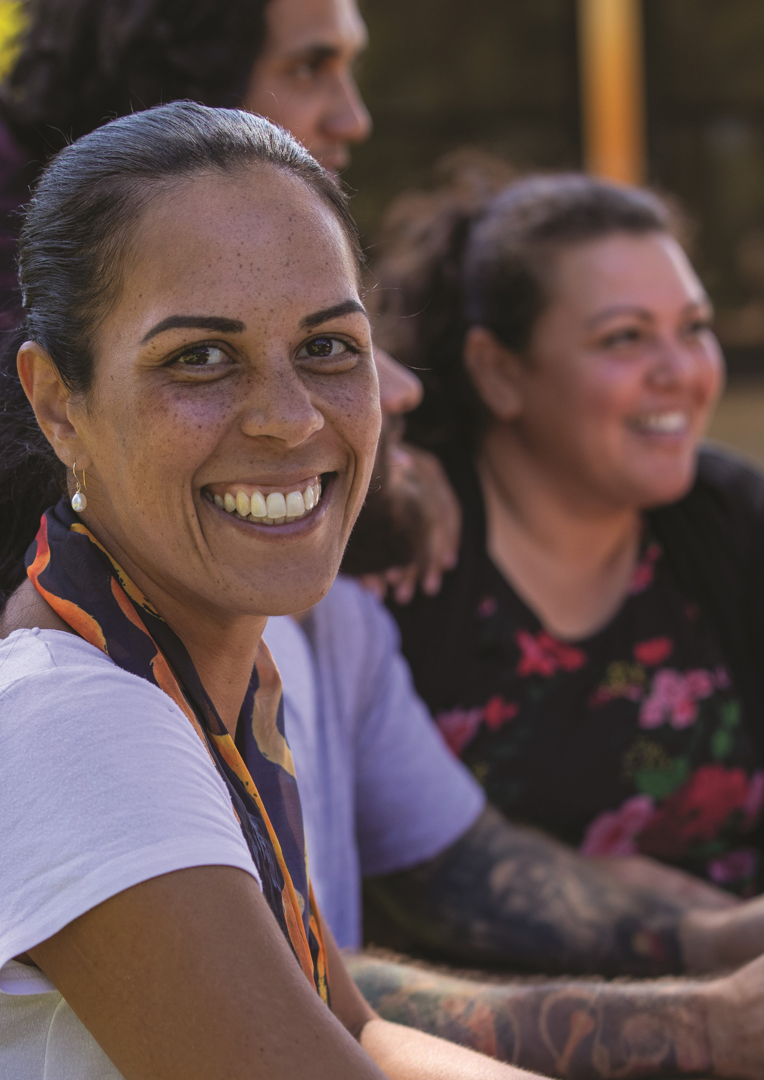
CORPORATE
PLAN
2021–2022
COVERING THE PERIOD
2021–22
TO 2024–
25
The Australian Human Rights Commission encourages the dissemination and
exchange of information provided in this publication.
All material presented in this publication is provided under a Creative Commons
Attribution 3.0 Australia, with the exception of:
•
the Australian Human Rights Commission logo,
•
photographs and images, and
•
any content or material provided by third parties.
The details of the relevant licence conditions are available on the
Creative
Commons
website, as is the full legal code for the
CC BY 3.0 AU licence
.
Attribution
Material obtained from this publication is to be attributed to the Australian
Human Rights Commission with the following copyright notice:
Corporate Plan 2021−2022

ISSN 2206-8368 (Online)
Third party copyright
Wherever a third party holds copyright in material presented in this publication,
the copyright remains with that party. Their permission may be required to use the
material.
The Commission has made all reasonable efforts to:
•
clearly label material where the copyright is owned by a third party. Please
note this does not include photos, images and video which are all regarded
as third-party material and ensure that the copyright owner has consented
to this material being presented on this website.
Graphic design:
Australian Human Rights Commission
Cover photography:
iStock photo
Internal photography:
AHRC

internal photography
Preface

4

Our purpose

5
Our goals

7

Who we are

8
Our leadership team

9
Key activities, how we work

10
Our performance framework

13
President and Commissioner terms

13
Commission goals, outcomes and
telling our ‘performance story’

14
Measuring our performance

14
Operating context

16
Risk oversight and management

17
Our organisational structure

18
Index of corporate plan
requirements

19
CONTENTS

PREFACE
As the accountable authority of the Australian Human Rights Commission, I am pleased to present our 2021–22 Corporate Plan.
It covers the four-year period to 2024–25, as required under section 35(1)(b) of the Public Governance, Performance and Accountability Act 2013 (Cth).
It identifies the strategic and operating framework in which we operate, and the actions we will take to achieve our purpose. This year has a particular focus on the COVID-19 pandemic, both in terms of its immediate ongoing impact and in the recovery phase to follow.
This Corporate Plan ensures a line of sight exists between our Portfolio Budget Statement and the purpose and strategic goals of our organisation, as set out below.
The Corporate Plan articulates how our actions contribute to achieving our vision for an Australian society where human rights are enjoyed by everyone, everywhere, everyday.

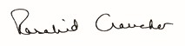
Emeritus Professor Rosalind Croucher AM
President
OUR STAFF AND TEAMS
Individual workplans and performance agreements.
OPERATIONAL WORKPLAN
Strategic internal resource integrating operating context,
program and services workplans, milestones, timelines and
workflow, with an annual focus and multiyear horizon.
CORPORATE PLAN
Public view of our goals, key activities, expected outcomes,
operating context, and multiyear outlook.
PORTFOLIO BUDGET STATEMENT
Links our core funding to key activities and
performance reporting.
PURPOSE GOALS
Legislative mandate.

OUR PURPOSE
As Australia’s national human rights institution, our purpose is to ensure that Australians have access to effective, independent complaint handling and public inquiry processes on human rights and discrimination matters, and benefit from our human rights education, advocacy, monitoring and compliance activities.
Portfolio Budget Statement
Our role is to work towards an Australia in which human rights are respected, protected and promoted, finding practical solutions to issues of concern, advocating for systemic change, and raising awareness of human rights and fundamental freedoms across the community.
Our statutory functions require us to undertake activities that:
- Promote understanding, acceptance and public discussion of human rights in Australia (including through our specialist Commissioners).
- Promote compliance with human rights and federal discrimination law (including through the preparation of guidelines, developing and monitoring disability standards, and considering applications for exemptions under relevant discrimination laws).
- Undertake research, educational and other programs for promoting human rights, including by reporting to Parliament on the status of enjoyment of human rights by children and Aboriginal and Torres Strait Islander peoples.
- Conduct inquiries into acts or practices that may be contrary to human rights, report on laws that Parliament should make, or actions that the Commonwealth should take, to meet Australia’s international human rights obligations.
- Examine laws and proposed laws for consistency with human rights.
- Inquire into, and attempt to conciliate, complaints of unlawful discrimination, or breaches of human rights or discrimination in employment.
We undertake this work in a complex strategic and operating environment, as set out in the diagram below.
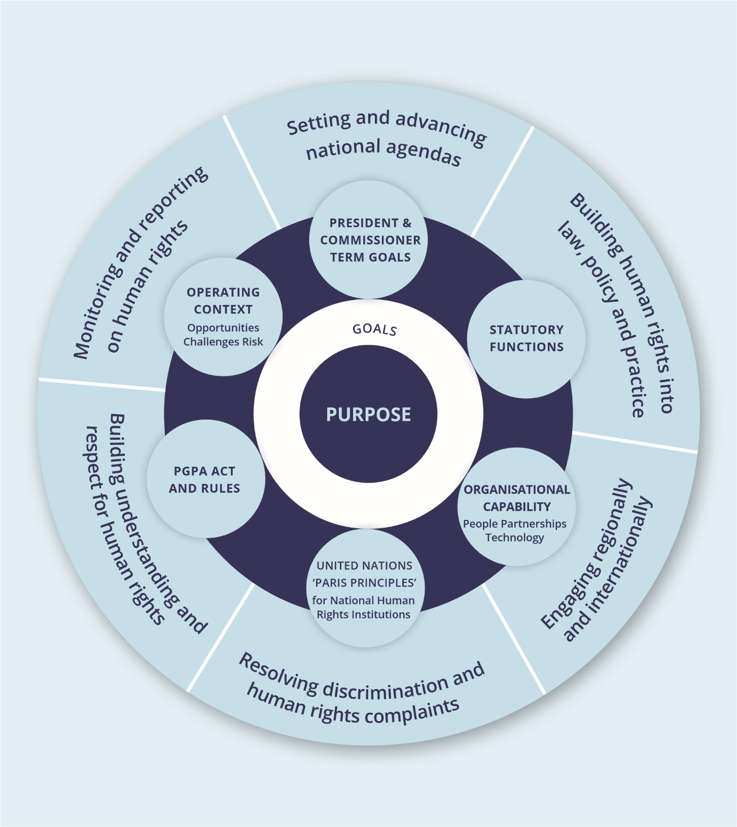

OUR GOALS
Our vision and purpose are reflected in our goals.
Greater prioritisation and embedding of human
rights issues at the national level.
More people, communities, and organisations
take action to respect, protect and promote
human rights in their own contexts.
More people, communities, and organisations
understand and respect human rights.
Improved access to justice and remedies
for people and communities whose rights

WHO WE ARE
We operate the Australian Human Rights Commission Act 1986 (Cth) as well as federal laws that seek to ensure freedom from discrimination on the basis of age, disability, race, sex, sexual orientation, intersex status and gender identity. The Commission also has specific responsibilities under the Native Title Act 1993 (Cth) and the Fair Work Act 2009 (Cth). Our operations are determined independently of the government through our President and Chief Executive, with the support of our Commissioners.
We are accredited as an ‘A status’ national human rights institution (NHRI). This accreditation is regularly reviewed through United Nations sanctioned processes by the Global Alliance of NHRIs. To achieve ‘A status’, NHRIs must be established and operate in compliance with the United Nations Principles Relating to the Status of National Institutions for the Promotion and Protection of Human Rights—commonly known as the ‘Paris Principles’.1 The Principles require us to operate in a robust, independent manner in order to provide accountability for human rights in Australia.

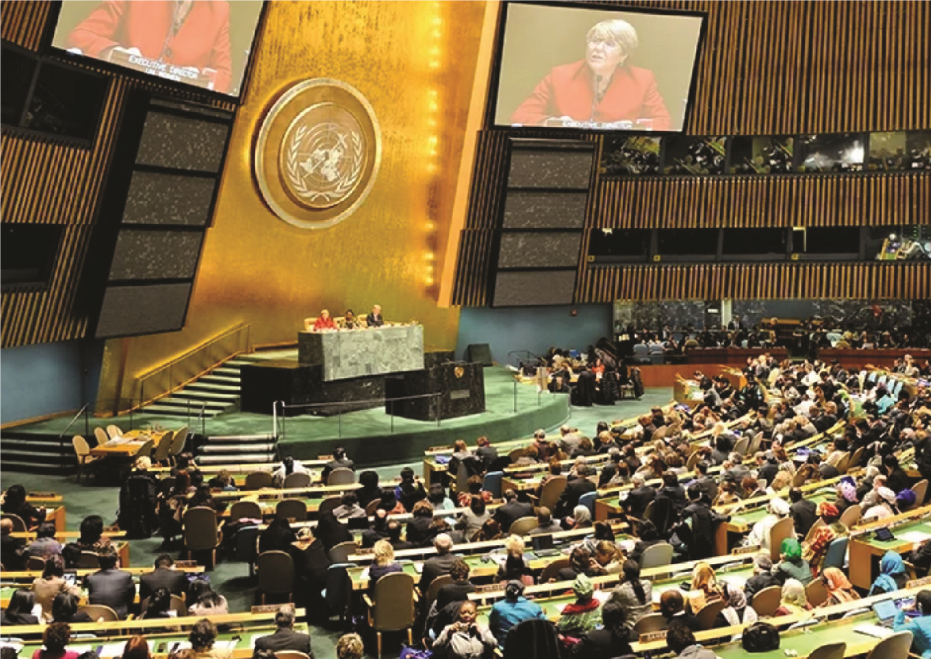

OUR LEADERSHIP TEAM

Our work is led by a President, seven Commissioners and Chief Executive.

KEY ACTIVITIES, HOW WE WORK
There is no simple way to solve complex human rights issues. Accordingly, we adopt a range of differing approaches to fulfilling our statutory functions and achieving our purpose.
We conduct some activities on an ongoing or regular basis— such as complaint handling under federal discrimination law, statutory reports on the human rights status of children and Indigenous peoples, and educational outreach. Other key activities are undertaken for a defined period, such as major inquiries, engagement in United Nation human rights scrutiny processes and partnership programs with other government entities, the business and community sectors.
The COVID-19 pandemic continues to have a significant impact on our work—we have seen a significant increase in discrimination and human rights complaints.
Our President and Commissioners are responsible for our key activities. Each of these statutorily appointed office holders has their own strategic goals and work programs, anchored in their specific functions and specialist portfolios to guide their work over the course of their appointment (usually five years).
For the President and Commissioner term goals, key activities and workplans, visit our Corporate Plan website page at https://humanrights.gov.au/our-work/commissiongeneral/publications/corporate-plan-2021-2022

SETTING AND ADVANCING NATIONAL HUMAN RIGHTS AGENDAS
We have a track record of drawing national attention to pressing human rights issues, raising community awareness, and encouraging positive action by governments, service providers and others.
In 2021, the Commission is undertaking a review of Commonwealth Parliament as a workplace, while also contributing to actions to implement the recommendations of the Commission’s Respect@Work national inquiry into sexual harassment in the workplace. The Disability Discrimination Commissioner will launch the innovative Includability project in partnership with leading businesses to address longstanding issues about employment of people with a disability. The Race Discrimination Commissioner will complete national consultations, including with governments, on developing a national anti-racism framework to provide a more cohesive and effective response to this issue.
THE COMMISSION’S PROJECT, FREE AND EQUAL:
A national conversation on human rights will culminate with the release of a series of position papers and reports in 2021. This project sets out a national reform agenda across all areas of human rights. The recommendations of the project will guide the Commission’s advocacy on law reform over the next four years, as well as shaping the strategic objectives of the Commission over this period. The first position paper to be released will set out a national reform agenda for federal discrimination law.

BUILDING HUMAN RIGHTS INTO AUSTRALIAN LAW, POLICY, AND PRACTICE
Human rights protection needs to be a central part of laws, policies and practices in order to build a fairer and more inclusive Australia.
The advocacy of our Commissioners, as well as the partnerships we engage in, help us to positively influence laws and practices and drive other practical changes.
The National Children’s Commissioner is leading national consultations with children to directly input their voices into national frameworks to protect children from abuse and neglect, and in situations of violence. The Aboriginal and Torres Strait Islander Social Justice Commissioner is following up her landmark Wiyi Yani U Thangani: Women’s Voices report with a series of community workshops to promote implementation of the report’s key findings.
Our work in promoting more effective responses to elder abuse in the community, for innovation in learning activities in housing modifications for disability access with design and architecture students, and our engagement with Parliament on the human rights impact of proposed laws ensures human rights issues are considered.
In partnership with the New Zealand Human Rights Commission, we will also be leading a human rights audit ahead of the FIFA Women’s World Cup to ensure all aspects of the competition respect and protect human rights.

BUILDING UNDERSTANDING AND RESPECT FOR HUMAN RIGHTS
We focus on increasing understanding and respect for human rights in our community. This includes building recognition that everyone has a responsibility to respect the rights of others. We empower people to engage in meaningful activity on human rights and to make the connection between what human rights are and how they apply to everyday life in Australia.
We will release a report (July 2021) setting out the experiences of Muslim Australians in everyday life, as well as conducting research and consultation to better understand the mental health impacts of the COVID-19 Pandemic on children and young people.
In the coming year, we will continue our cultural reform partnership with the Australian Defence Force, as well as commence a new partnership with the Australian Federal Police.

MONITORING AND REPORTING ON THE HUMAN RIGHTS SITUATIONS OF VULNERABLE GROUPS
Some people in Australia are especially vulnerable to discrimination, exclusion, and unfair treatment. We have a responsibility to monitor the situation facing these groups, identify issues of concern and propose solutions that will improve their lives.
Our regular Children’s Rights Reports, as well as reports of conditions in immigration detention centres, put the spotlight on the situation of vulnerable people in Australia. In 2021–22, we will also release a report on involuntary medical procedures experienced by people born with variations in sex characteristics, and focus on the implications of long-term immigration detention. The Aboriginal and Torres Strait Islander Social Justice Commissioner will also release a Native Title Report on the experiences of Indigenous women in that system.

ENGAGING REGIONALLY AND INTERNATIONALLY WITH HUMAN RIGHTS AGENCIES AND SYSTEMS
As a national human rights institution, we engage in UN mechanisms such as the Human Rights Council and human rights treaty bodies to provide a credible, independent voice on the status of human rights in Australia.
These processes have been greatly affected by the COVID-19 Pandemic. Australia is due to appear before the Committee Against Torture for its next regular review in the coming twelve months. The Commission is also due to undergo its five-yearly accreditation review as a national human rights institution in 2022.
We undertake technical cooperation programs funded by DFAT in Vietnam and the Lao People’s Democratic Republic, as well as other activities with the ASEAN Inter-Governmental Commission on Human Rights and regional partners in the Asia-Pacific region.

RESOLVING DISCRIMINATION AND HUMAN RIGHTS COMPLAINTS
One of our core functions is to help people resolve complaints of discrimination and other breaches of human rights through our complaint-handling service.
People can complain to us about discriminatory treatment or breaches of their human rights in employment or more generally. Our conciliation service often resolves complaints without the need to proceed to court and achieves systemic improvements in the workplace.
The COVID-19 Pandemic has seen an extraordinary increase in the number of complaints to the Commission about a wide variety of issues including racial discrimination, disability discrimination, and international travel caps.
Our National Information Service offers advice to businesses and members of the community about the operation of discrimination laws.
We use information about trends in complaints to develop targeted education programs and suggest policy reforms to address the underlying factors that lead to discrimination.

OUR PERFORMANCE FRAMEWORK

PRESIDENT AND COMMISSIONER TERMS
Our planning and performance framework differs from many other agencies as a President and seven Commissioners lead our work in different priority areas as independent statutory officeholders. The President and Commissioners are appointed as individual vacancies arise and for terms that end at different times (usually after 5 years). Each office holder develops term goals and work programs for their portfolios. The figure below shows the status of the terms of our President and Commissioners,2 and how it links to the four-year reporting outlook of this Corporate Plan. The different stages that Commissioners are at in their terms is factored into our planning and performance framework, and through our annual planning and reporting processes.
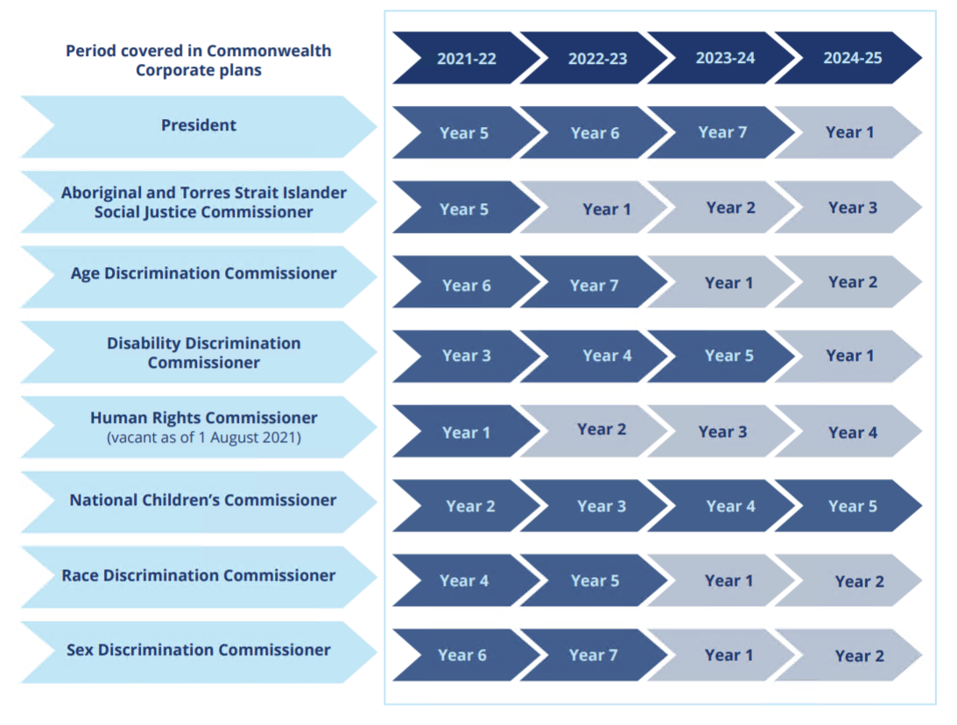

COMMISSION GOALS, OUTCOMES AND TELLING OUR ‘PERFORMANCE STORY’
Having our purpose and functions reflected in organisational goals and outcomes helps us to tell an entity level ‘performance story’ through the contributions of successive Presidents and Commissioners and our ongoing, statutorily required programs and services.
On the next page, is our organisational goals and outcomes map. It shows the ‘line of sight’ between President and Commissioner portfolio goals and programs and the pursuit of organisational level goals and outcomes.
The outcomes are the changes we anticipate from our work. They are pitched to a level where we can reasonably expect to contribute to them:
- within the four-year outlook of this Corporate Plan
- through the collective annual-to-term results of President and Commissioner activities and other ongoing programs and services, and
- in our given operating environment.

MEASURING OUR PERFORMANCE
Measuring our impact (what difference, what benefit), in the context and nature of our work, is complex. The ultimate results of our activities are often long-term and incrementally achieved.
Our role is generally collaborative, and challenging to attribute.
Our performance measurement framework shows how we measure our results in this context. It maps performance expectations and progress indicators to each organisational outcome. The progress indicators are designed to provide ‘reasonable’ evidence of contribution to the given outcome, and are, in turn, supported by data from monitoring and evaluation strategies implemented across the Commission’s programs and services.
For the Commission’s performance measurement framework, visit our Corporate Plan website page at https://humanrights.gov.au/our-work/commissiongeneral/publications/corporate-plan-2021-2022
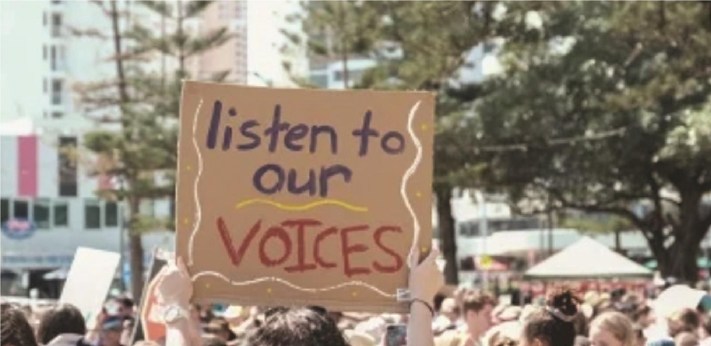

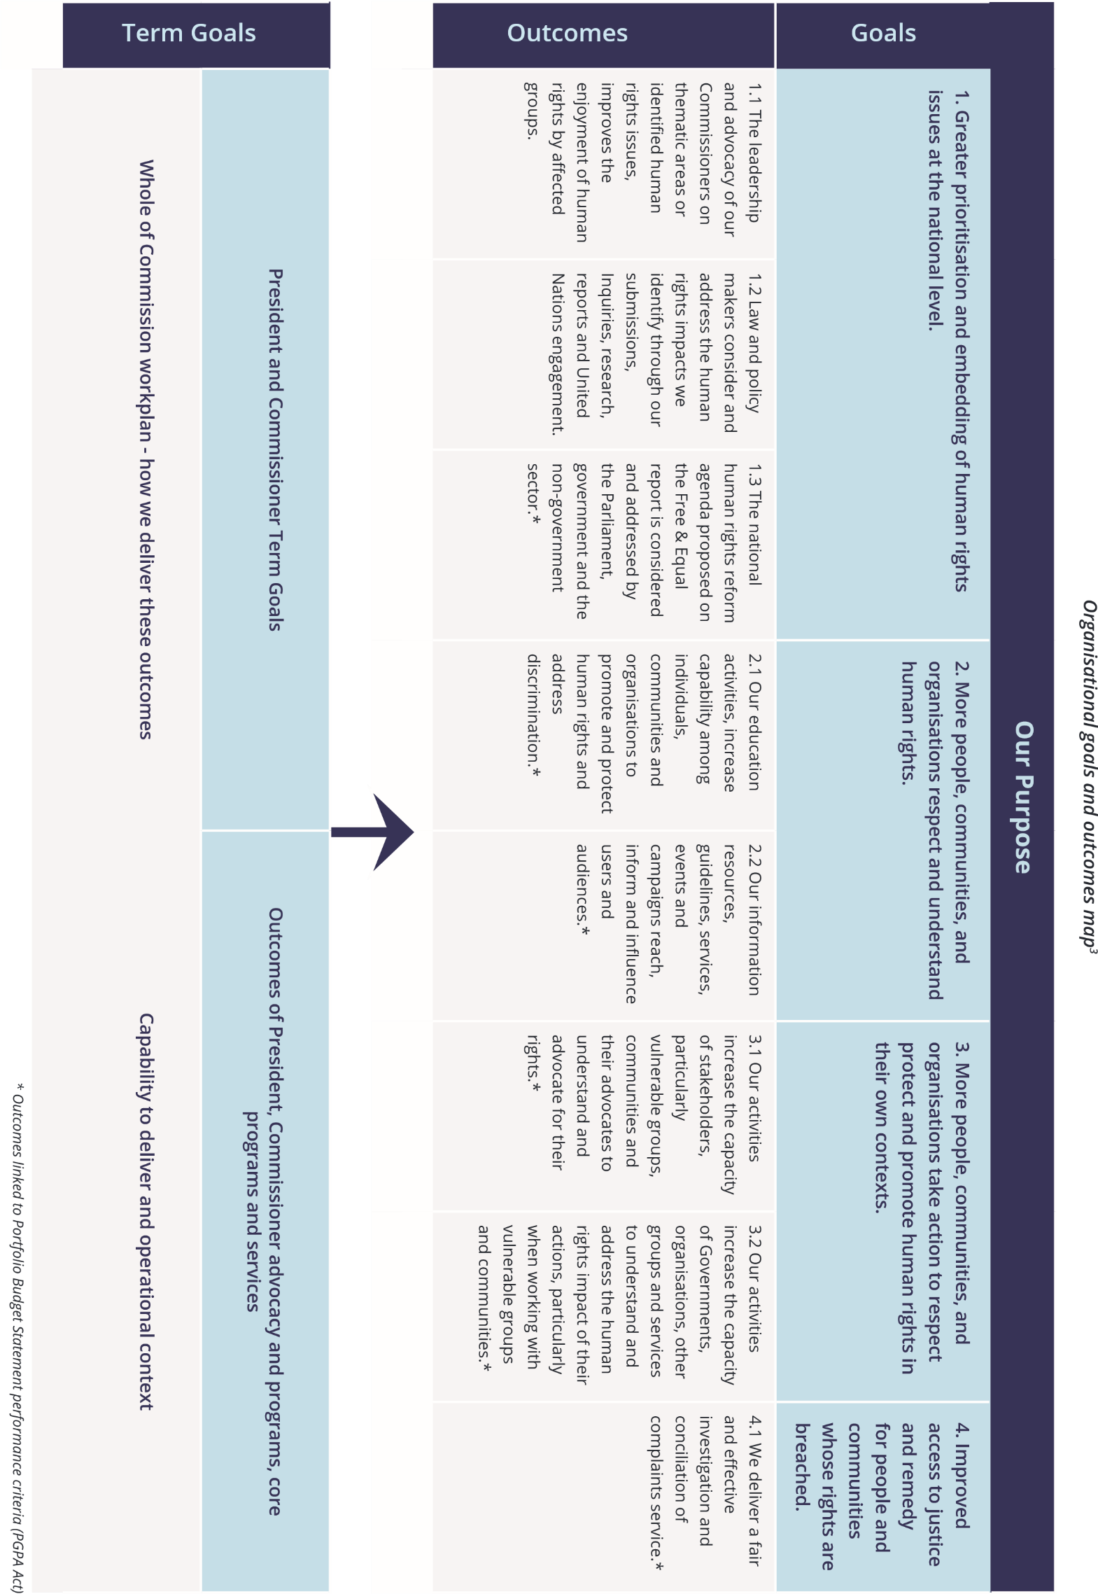

OPERATING ENVIRONMENT

We work in a complex social and political context with multiple factors that can affect how and how well we achieve our purpose. In deciding how to exercise our functions, we examine our forward operating environment each year. In doing so we assess the factors (constraints, dependencies, risks, challenges, strengths and opportunities) that may have an impact on our work in the coming year, and in our four-year outlook.
The figure below shows the key factors identified in the assessment for the 2021–22 (to 2025) environment.
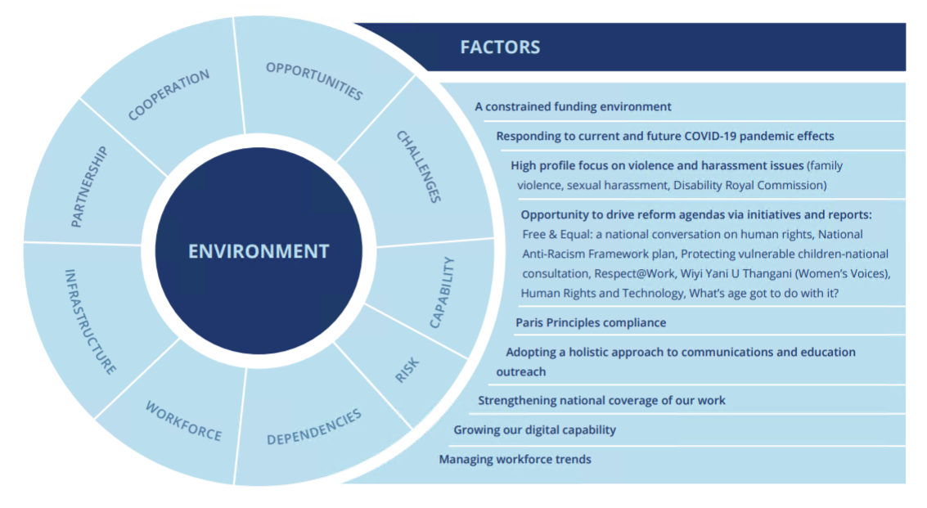
For the full analysis of this operating environment, including our workforce, digital infrastructure and investment, cooperation and partnerships capabilities, and the key factors, the varying degrees of control we have over them, and our management strategy, visit our Corporate Plan website page at https://humanrights.gov.au/our-work/commissiongeneral/publications/corporate-plan-2021-2022

RISK OVERSIGHT AND MANAGEMENT

We adopt a positive risk management culture that promotes an open and proactive approach to managing risk.
Our existing risk management framework provides a mechanism for proactively identifying and mitigating risks across the organisation, and for monitoring the operating environment. The risk management framework is tailored to meet the needs of the Commission, and covers three main areas:
- Key strategic risks: including a constrained funding environment, damage to the Commission’s independence and reputation, not managing relationships with key government stakeholders and other external parties and not responding quickly and effectively to a changing political landscape.
- Core business risks: including policy activities that are not aligned to the Commission’s strategic objectives, failing to provide an accessible and effective complaint handling service that complies with all relevant laws and community engagement activities that fail to achieve the objective of increased public awareness of human rights.
- Corporate support risks: including failure to recruit and retain appropriately skilled and diverse staff, the misuse of assets or resources, business continuity processes not in place, IT interruption, outage or information compromise and an unsafe work environment.

For more on the mitigation strategies and controls in place to manage these key risks, visit our Corporate Plan website page at https://humanrights.gov.au/our-work/commissiongeneral/publications/corporate-plan-2021-2022

OUR ORGANISATIONAL STRUCTURE

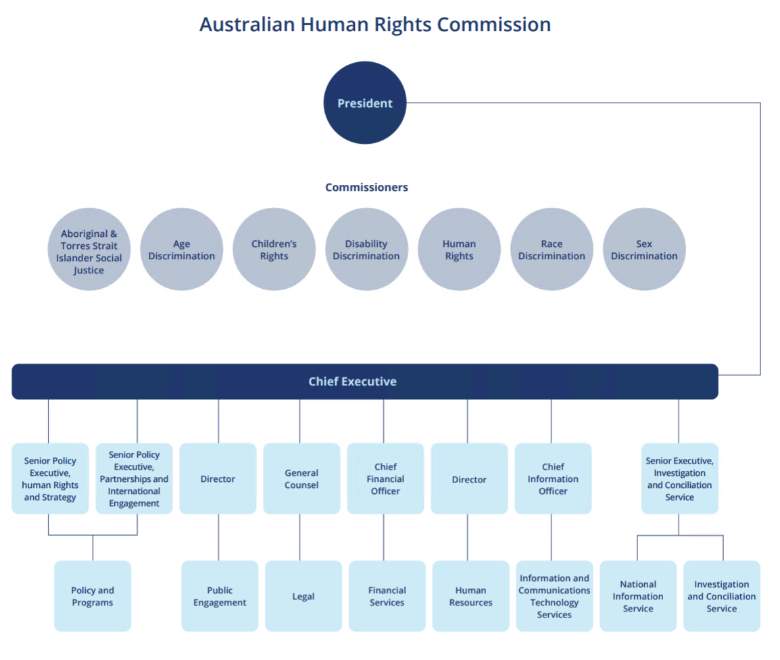

Index of corporate plan requirements
The table details the requirements met by the Australian Human Rights Commission corporate plan and the page reference(s) for each requirement.

Requirement | Page(s)
Introduction  - Statement of preparation  - Reporting period for which the plan is prepared  - Reporting periods covered by the plan | 4  4  4
Purpose | 5
Key activities | 10-12
Operating context  - Environment  - Risk oversight and management | 16  17
Performance | 13-14

Materials providing additional information on our key activities, operating context and performance measurement are on our Corporate Plan webpage at https://humanrights.gov.au/our-work/commissiongeneral/publications/corporate-plan-2021-2022

ENDNOTES
- Further information: http://nhri.ohchr.org/EN/AboutUs/Pages ParisPrinciples.aspx.
- The current President is appointed for a seven-year term. The National Children’s Commissioner’s second year of term begins in November.
- Asterisk denotes linkage to PBS Performance Criteria.
FURTHER
INFORMATION
Australian Human Rights Commission
Level 3, 175 Pitt Street SYDNEY NSW 2000
GPO Box 5218 SYDNEY NSW 2001
Telephone: (02) 9284 9600
Complaints Infoline: 1300 656 419
General enquiries and publications: 1300 369 711
TTY: 1800 620 241
Fax: (02) 9284 9611
Website: http://www.humanrights.gov.au.
For detailed and up to date information about the
Australian Human Rights Commission visit our website at:
www.humanrights.gov.au. To order more publications
from the Australian Human Rights Commission, download
a Publication Order Form at: www.humanrights.gov.au
our-work/publications, call: (02) 9284 9600, fax: (02) 9284
9611
or email: publications@humanrights.gov.au.
Australian Human Rights Commission
www.humanrights.gov.au

