Mr BX v Commonwealth of Australia
(Department of Home Affairs)
[2024] AusHRC 163
April 2024

Mr BX v Commonwealth of Australia
(Department of Home Affairs)
[2024] AusHRC 163
Report into the use of force
Australian Human Rights Commission 2024

The Hon Mark Dreyfus KC MP
Attorney-General
Parliament House
Canberra ACT 2600

Dear Attorney
I have completed my report pursuant to s 11(1)(f) of the Australian Human Rights Commission Act 1986 (Cth) (AHRC Act) into the human rights complaint of Mr BX, alleging a breach of his human rights by the Department of Home Affairs (Department).
Mr BX complains that, as a result of a use of force by staff of Serco Australia Pty Ltd (Serco) while Mr BX was detained at Villawood Immigration Detention Centre (VIDC) he was rendered unconscious on two separate occasions, incurring injuries, including nasal bone fractures and a perforated ear drum in relation to one of the use of force incidents. Consequently, Mr BX complains that the force used against him contravened article 10(1) of the International Covenant on Civil and Political Rights (ICCPR).
As a result of this inquiry, I have found that the use of force on 22 November 2020, was excessive, and the prolonged use of restraints on Mr BX in his subsequent transit to hospital was unreasonable and disproportionate in the circumstances. I find that these actions were inconsistent with, or contrary to Mr BX’s right under article 10(1) of the ICCPR to be treated with humanity and respect for his inherent dignity when deprived of liberty.
On 25 January 2024, I provided the Department with a notice issued under s 29(2) of the AHRC Act setting out my findings and recommendations in this matter. The Department provided its response to my findings and recommendations on 12 March 2024. That response can be found in Part 10 of this report.
I enclose a copy of my report.
Yours sincerely,
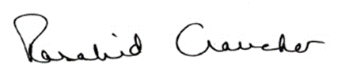
Emeritus Professor Rosalind Croucher AM FAAL
President
Australian Human Rights Commission
April 2024

Contents
1 Introduction 5
2 Summary of findings and recommendations 5
3 Background 6
3.1 Immigration detention 6
3.2 Events of 22 July 2020 7
3.3 Events of 22 November 2020 8
4 Legal framework for human rights inquiry 10
4.1 Functions of the Commission 10
4.2 Scope of ‘act’ and ‘practice’ 10
4.3 Right of detainees 10
5 Legal framework for use of force in immigration detention 12
6 Act or practice of the Commonwealth 14
7 Consideration of records of incidents 14
7.1 Use of force on 22 July 2020 14
7.2 Use of force on 22 November 2020 18
7.3 Use of restraints on 22 November 2020 24
8 Findings 25
8.1 Use of force on 22 July 2020 25
8.2 Use of force on 22 November 2020 26
8.3 Use of restraints on 22 November 2020 30
9 Recommendations 32
10 The Department’s response to my findings and recommendations 32

Introduction
- The Australian Human Rights Commission (Commission) has conducted an inquiry into a complaint by Mr BX against the Commonwealth Department of Home Affairs (the Department) alleging a breach of his human rights. The inquiry was undertaken pursuant to s 11(1)(f) of the Australian Human Rights Commission Act 1986 (Cth) (AHRC Act).
- Mr BX complains that force was used against him on two separate occasions by staff of Serco Australia Pty Ltd (Serco) while detained at Villawood Immigration Detention Centre (VIDC).
- Mr BX’s complaint raises possible breaches of articles 7 and 10 of the International Covenant on Civil and Political Rights (ICCPR).
- Mr BX complains that on 22 July 2020, he was taken to the ground by Emergency Response Team (ERT) officers using excessive force, after he asked ERT officers to stop holding another detainee to the ground. Mr BX complains that his head hit the ground and he fell unconscious. He was also handcuffed and later taken to hospital with a gash to his head and pain in his right wrist.
- Mr BX also complains that on 22 November 2020, approximately eight ERT officers came to his room. He alleges a series of events that followed. He alleges that one of the officers punched him on the chin. He was handcuffed, kneed to the head, and punched again. He became unconscious and was carried out of the room, put to the ground and punched and kicked. He fell unconscious a second time. An ambulance came to take him to the hospital, but the officers refused to take off his handcuffs.
- At the hospital, a CT scan was taken and showed fractures to his nasal bone. A subsequent GP review also noted a perforated eardrum in his left ear and multiple bruises around his eyes, face and scalp.
- This report is issued pursuant to s 29(2) of the AHRC Act setting out the findings of the Commission in relation to Mr BX’s complaint.
- Mr BX has requested that his name not be published in connection with this inquiry. I consider that the preservation of his anonymity is necessary to protect his privacy and human rights. Accordingly, I have given a direction under s 14(2) of the AHRC Act prohibiting disclosure of his identity, and refer to him as ‘Mr BX’ in this document.

Summary of findings and recommendations
- As a result of this inquiry, I find the following:
        - excessive force was used on Mr BX by ERT officers in relation to the second incident on 22 November 2020
        - the manner in which one of the ERT officers forcibly grabbed both sides of his head to bring him to the ground was disproportionate to the need to protect him, the safety of staff and to maintain good order at the centre
        - the serious injuries sustained to Mr BX’s nose and ear, occurred as a result of the force used to bring him to the ground and during his subsequent stabilisation
        - the level of force was not used as a last resort and escalated the physicality of the situation including the involvement of other detainees – further communication, negotiation and conflict de-escalation strategies could and should have been attempted
        - the use of handcuffs for almost 6 hours following the use of force incident was unreasonable and disproportionate to the risk Mr BX presented, and contributed to his pain and discomfort.
- These actions are contrary to Mr BX’s rights under article 10 of the ICCPR, to be treated with humanity and with respect for his inherent dignity when deprived of liberty.
- I make the following recommendations:
Recommendation 1
The Commonwealth pay to Mr BX an appropriate amount of compensation to reflect the loss and damage he suffered as a result of the breach of his human rights identified by this inquiry, being the pain and suffering he experienced as a result of the use of force against him.
Recommendation 2
The Department and Serco ensure that officers who may be required to use force in their roles be appropriately and periodically trained on how to select and properly deploy use of force techniques, so as to avoid harm to the person against whom force is used.
Recommendation 3
The Department and Serco ensure that officers who may be required to use force in their roles be appropriately and periodically trained on communication, negotiation and conflict de-escalation strategies as alternatives to the use of force.

Background

Immigration detention
- On 2 July 2008, Mr BX entered Australia as a holder of a Global Special Humanitarian visa. At the time, he was approximately 13 years old. On 18 February 2014, he acquired Australian citizenship by conferral.
- On 14 October 2015, he was convicted of four counts of ‘robbery in company’ and was sentenced to a term of imprisonment of 8 years and 2 months with the offences being committed on various dates between 7 January 2014 and July 2015. On 21 June 2018, his Australian citizenship was revoked by the Minister for Immigration, using his discretionary power and on the same day, he was granted an Ex-Citizen visa. Mr BX sought review of the decision to revoke his Australian citizenship.
- On 6 March 2019, Mr BX’s Ex-Citizen visa was mandatorily cancelled on the basis of his substantial criminal record and full-time imprisonment. He applied for revocation of the cancellation decision, however the application was lodged outside of time and found to be invalid.
- On 8 July 2019, the AAT affirmed the Minister for Immigration’s decision to revoke Mr BX’s Australian citizenship. Mr BX sought judicial review of his Ex-Citizen visa cancellation but his appeal was dismissed by the Full Court of the Federal Court on 15 August 2023. Mr BX has an ongoing protection visa application before the Department and has made representations for ministerial intervention.
- On 8 April 2020, Mr BX was released from criminal custody and transferred to VIDC. On 3 January 2023, he was released briefly from VIDC following the decision in Pearson v Minister for Home Affairs, but was re-detained there on 19 April 2023 following legislative amendments that re-validated his visa cancellation.
- On 10 August 2023, Mr BX was transferred from VIDC to Yongah Hill Immigration Detention Centre. Mr BX advises through his solicitor that this occurred without notice and no explanation was given for his transfer. On 18 December 2023, Mr BX was transferred back to VIDC from Yongah Hill.

Events of 22 July 2020
- The circumstances leading up to the first use of force incident do not appear to be contested between the Department and Mr BX, rather the matter of the level of force used and whether this was excessive.
- On 22 July 2020, Mr BX was with another detainee in the outdoor Hume A compound at VIDC. At this time, Mr BX had been detained in immigration detention at VIDC for over 3 months.
- Mr BX states in his complaint to the Commission, that he was sitting next to the kitchen in Hume A with another detainee when ERT officers used force to bring the other detainee to the ground. He states that this other detainee was yelling and couldn’t breathe so he walked up to the officers involved and asked them to stop.
- He further states that ERT officers then used force to bring him to the ground, with two officers on his shoulders and one officer on his legs. He says that his head hit the ground and he fell unconscious.
- Mr BX claims he woke up in the International Health Medical Services (IHMS) clinic at VIDC and had a ‘gash’ to his head. He noticed that his handcuffs were tight and hurting his shoulders. The next night, he felt dizzy and his hands, neck and legs were hurting. He was taken by ambulance to hospital and diagnosed with pain to his right wrist. He was discharged the next day on 23 July 2020.
- In its response to Mr BX’s complaint, the Department states that on 22 July 2020, ERT officers were called in response to an incident involving another detainee in the Hume A compound. It says that the other detainee had requested to borrow a broom at the officer’s station but when informed that there was none, punched a window and pushed over a computer monitor. Mr BX alleges that a Serco officer had been sleeping in the officer’s station.
- The Department alleges that the other detainee who was with Mr BX, became abusive, aggressive and non-compliant by sitting and kicking the ERT officers and was therefore ground stabilised to ensure the safety, security and good order of the Centre.
- Upon doing so, the Department alleges that Mr BX also became abusive and aggressive by yelling at the ERT officers who were attempting to move the other detainee out of the area for safety reasons.
- The Department states that Mr BX was verbally directed on several occasions to calm down and stay back, however he attempted to physically push through two ERT officers.
- ERT officers escorted Mr BX out of the compound, however after a short distance, he became non-compliant by resisting the officers. The ERT officers ground stabilised Mr BX to prevent him from harming himself or the officers and handcuffs were applied.
- While being escorted to the property department, the Department states that Mr BX became limp but remained conscious. ERT officers called IHMS to attend, and Mr BX was escorted to the IHMS clinic for assessment.
- On 24 July 2020, Mr BX made a complaint regarding this first use of force incident to the Department’s Global Feedback Unit. They referred the complaint to the Australian Border Force (ABF) at VIDC.
- On 25 August 2020, Serco provided a response to Mr BX, advising that the complaint was found to be unsubstantiated. It found that at no time had ERT officers used inappropriate force on him.

Events of 22 November 2020
- The version of events for the second use of force incident on 22 November 2020, differs significantly between Mr BX and the Department. The Department states in its response to the complaint, that on 22 November 2020, a suspicious package was observed being thrown over the fence from Hume B to Hume A compound and was picked up by Mr BX.
- As a result, ERT officers conducted a targeted room search of Mr BX’s room. Upon entering his room, Mr BX was found to be with other detainees and observed to be smoking. He was instructed not to do so.
- The Department states that Mr BX then became aggressive and non-compliant by attempting to close the door to his room, which was being held open by an ERT officer. It states, ‘in an effort to maintain safety, security and good order, the ERT applied reasonable, justified and proportionate force to ground stabilise Mr BX’.
- The Department also alleges that during the use of force incident, Mr BX picked up a handheld wand (used to detect metal) and assaulted an ERT officer by striking him multiple times on his leg.
- In his complaint to the Commission, Mr BX states that at the time of the incident, he was in his room when approximately eight ERT officers came in. He alleges that one officer punched him on the chin and he fell to the floor. The officers closed the door to the room and he was handcuffed on the floor. He states that two or three ERT officers were on top of him and he was kneed to the head. He also alleges that another officer ran in and punched him. He fell unconscious. He says that he was carried out of the room towards the property department, put to the ground and punched and kicked. He fell unconscious again and was taken to hospital by ambulance.
- A CT scan taken at the hospital showed fractures to his nose. A follow up review with an IHMS GP, also noted a perforation of Mr BX’s left eardrum.
- On 26 November 2020, Mr BX made a complaint concerning the second use of force incident to the Department’s Global Feedback Unit which was referred to the ABF.
- On 8 December 2020, the ABF responded to Mr BX, advising that the matter had been referred to the Australian Federal Police (AFP).
- Mr BX’s complaint to the Commission regarding both use of force incidents was lodged on 8 December 2020.
- It is important to note that Mr BX also alleges that some of the ERT officers involved in the second use force incident were the same officers involved in the first use of force incident. He alleges that these officers warned him not to make a complaint and that he felt threatened and intimidated.
- In response to my preliminary view, the Department stated:
In respect to [Mr BX’s] claims of misconduct by FDSP [Facilities and Detention Service Provider] officers, the Department advises the Commission that the powers exercised by Australian Border Force (ABF) and FDSP officers working in immigration detention are underpinned by clear risk-based policy guidance, training and decision making by senior officers to maintain the objective of safe, secure and sustainable IDCs for all detainees, staff and visitors.
…
All personnel working in IDCs must abide by a code of conduct. Allegations of staff misconduct are investigated and any cases that may involve criminal, corrupt and/or serious misconduct are referred to Police, or to the National Anti-Corruption Commission. In any case where a referral is made to law enforcement, the Department refers the Commission to the relevant law enforcement agency for any information sought pertaining to that investigation.
- Mr BX’s legal representative has said that Mr BX has yet to receive any outcome (whether from the Department or from the AFP), from the referral of the use of force incident on 22 November 2020, to the AFP.

Legal framework for human rights inquiry

Functions of the Commission
- Section 11(1) of the AHRC Act provides that the Commission has the function to inquire into any act or practice that may be inconsistent with or contrary to any human right.
- Section 20(1)(b) of the AHRC Act requires the Commission to perform its function when a complaint is made in writing alleging that an act or practice is inconsistent with or contrary to any human right.
- Section 8(6) of the AHRC Act provides that the functions of the Commission under s 11(1)(f) are to be performed by the President.
- The rights and freedoms enumerated in the ICCPR are ‘human rights’ within the meaning of the AHRC Act.

Scope of ‘act’ and ‘practice’
- The terms ‘act’ and ‘practice’ are defined in s 3(1) of the AHRC Act to include an act done or a practice engaged in by or on behalf of the Commonwealth or an authority of the Commonwealth, or under an enactment.
- Section 3(3) of the AHRC Act provides that the reference to, or to the doing of, an ‘act’ includes a reference to a refusal or failure to do an act.
- The functions of the Commission identified in s 11(1)(f) of the AHRC Act are only engaged where the act complained of is not one required by law to be taken, that is, where the relevant act or practice is within the discretion of the Commonwealth, its officers or agents.

Right of detainees
- Persons subject to immigration detention enjoy all of the human rights protected by the ICCPR, including special protections as persons deprived of their liberty by the state.
- Article 7 of the ICCPR provides:
No one shall be subjected to torture or to cruel, inhuman or degrading treatment or punishment. In particular, no one shall be subjected without his free consent to medical or scientific experimentation.
- Article 10(1) of the ICCPR provides:
All persons deprived of their liberty shall be treated with humanity and with respect for the inherent dignity of the human person.
- States have a responsibility to ensure that the rights guaranteed in articles 7 and 10 of the ICCPR are accorded to detainees in privately run detention facilities.
- Article 10(1) imposes a positive obligation on States to ensure that detainees are treated with humanity and respect for their inherent dignity. This is in recognition of the fact that detained persons are particularly vulnerable because they are wholly reliant on a relevant authority to provide for their basic needs. In this case, the relevant authority is the Commonwealth of Australia through the Department and the service providers who act on its behalf.
- Professor Manfred Nowak has commented on the threshold for establishing a breach of article 10(1), when compared to the related prohibition against ‘cruel, inhuman or degrading treatment’ in article 7 of the ICCPR, as follows:
In contrast to article 7, article 10 relates only to the treatment of persons who have been deprived of their liberty. Whereas article 7 primarily is directed at specific, usually violent attacks on personal integrity, article 10 relates more to the general state of a detention facility or some other closed institution and to the specific conditions of detention. As a result, article 10 primarily imposes on States parties a positive obligation to ensure human dignity. Regardless of economic difficulties, the State must establish a minimum standard for humane conditions of detention (requirement of humane treatment). In other words, it must provide detainees and prisoners with a minimum of services to satisfy their basic needs and human rights (food, clothing, medical care, sanitary facilities, education, work, recreation, communication, light, opportunity to move about, privacy, etc.).
…
Finally it is again stressed that the requirement of humane treatment pursuant to article 10 goes beyond the mere prohibition of inhuman treatment under article 7 with regard to the extent of the necessary ‘respect for the inherent dignity of the human person’.
- These conclusions are also evident in the jurisprudence of the United Nations Human Rights Committee, which discusses the positive obligation on relevant authorities to treat detainees with humanity and respect for their dignity.
- The content of article 10(1) has been developed through a number of United Nations instruments that articulate minimum international standards in relation to people deprived of their liberty, including:
        - the Standard Minimum Rules for the Treatment of Prisoners (Nelson Mandela Rules), and
        - the Body of Principles for the Protection of all Persons under Any Form of Detention (Body of Principles).
- In 2015, the Mandela Rules were adopted by the United Nations. They provide a restatement of a number of United Nations instruments that set out the standards and norms for the treatment of prisoners. At least some of these principles have been determined to be minimum standards regarding the conditions of detention that must be observed regardless of a State Party’s level of development.
- Several of the Mandela Rules are relevant to the use of force on detainees by detaining officers. Rule 82(1) of the Mandela Rules provides:
Prison staff shall not, in their relations with the prisoners, use force except in self-defence or in cases of attempted escape, or active or passive physical resistance to an order based on law or regulations. Prison staff who have recourse to force must use no more than is strictly necessary and must report the incident immediately to the prison director.
- This rule provides limits on the circumstances in which force may be used and limits the use of force in those circumstances to what is necessary.
- Rule 121 requires that civil prisoners ‘shall not be subjected to any greater restriction or severity than is necessary to ensure safe custody and good order’.
- From the above, the following conclusions may be drawn:
        - article 10(1) of the ICCPR imposes a positive obligation on State parties to take action to ensure that detained persons are treated with humanity and dignity
        - the threshold for establishing a breach of article 10(1) of the ICCPR is lower than the threshold for establishing ‘cruel, inhuman or degrading treatment’ within the meaning of article 7 of the ICCPR, which is a negative obligation to refrain from such treatment
        - article 10(1) of the ICCPR may be breached if a detainee’s rights, protected by one of the other articles of the ICCPR, are breached – unless that breach is necessitated by the deprivation of liberty
        - minimum standards of humane treatment must be observed in detention conditions, including immigration detention.

Legal framework for use of force in immigration detention
- The Serco contract with the Department to run immigration detention facilities, and the Department’s Detention Services Manual (DSM) are the primary documents that set out the obligations of Serco and departmental staff with respect to use of force.
- The Serco contract provides that Serco must ensure that force is not used unless as a measure of last resort, and then only with the reasonable level of force necessary. It further states that all reasonable precautionary measures must be taken to ensure the safety of detainees. It requires personnel who use force to be properly trained and accredited.
- When Serco has used force or instruments of restraint such as handcuffs on a detainee, it must prepare an incident report for the Department and refer the detainees to the Detention Health Services Provider for a medical examination immediately after the use of force or restraints.
- As described in the Department’s DSM, both the Department and its service providers owe a duty of care to all persons held in immigration detention. This means that they are legally obliged to exercise reasonable care to prevent detainees from suffering reasonably foreseeable harm. The Department’s duty of care is non-delegable.
- When the Department contracts out the provision of services to people in held detention to third parties, it has a responsibility to ensure the contracted service providers are qualified and can meet the standards outlined in the contract.
- While these third parties must also discharge their own duty of care obligations to a detainee in held detention, this duty is additional to, and is not a substitute for, the Department’s duty of care.
- In addition to the Department’s duty of care, the Department recognises that international human rights standards can inform the standard of care a detainee is to receive while detained in an immigration detention facility.
- The Department’s DSM gives policy and procedural guidance to the ABF and Serco officers on the use of force in immigration detention facilities. The following principles, taken from the manual, are consistent with the Commonwealth’s human rights obligations in relation to the use of force on detainees in their care:
        - there is a presumption against the use of force, including restraints, during movements within an IDF, transfers between IDFs, and during transport and escort activities outside of IDFs
        - conflict resolution through negotiation and de-escalation, where practicable, must be considered before the UoF and/or restraint is used
        - UoF and/or restraint should only be used as a last resort
        - the amount of force used and the application of restraints must be reasonable.
[emphasis in original]
- In relation to the use of restraints, the Department’s DSM provides that instruments of restraint must:
        - never be applied as a punishment or for discipline
        - never be applied as a substitute for medical treatment
        - never be used for convenience or as an alternative to reasonable staffing
        - be removed once the threat has diminished and the officer believes that the detainee is no longer a threat to themselves, others or property.
- Serco’s contract with the Department provides that Serco must ‘ensure that restraints are not used in a manner which is likely to cause injury, serious discomfort or potential danger to a Detainee’.

Act or practice of the Commonwealth
- The relevant acts or practices of the Commonwealth for the purpose of this inquiry are:
        - the decision to use force against Mr BX on 22 July 2020
        - the decision to use force against Mr BX on 22 November 2020
        - the decision to use restraints against Mr BX on 22 November 2020.
- The Department has provided bodycam footage from ERT officers involved in both use of force incidents. I have noted where there is no footage capturing the alleged use of force. This is particularly so in relation to some aspects of the second use of force incident.
- The documents provided by the Department, which include incident detail reports, service provider reports, use of force records and medical records, also record key events on 22 July 2020 and 22 November 2020.

Consideration of records of incidents

Use of force on 22 July 2020
- On 22 July 2020 at approximately 4.13 pm, Department incident reports state that ERT officers were called to Hume A compound in response to another detainee (not Mr BX) displaying abusive and aggressive behaviour. That detainee had presented at the officer’s station wanting to borrow a broom but was informed by the Detainee Services Officer that there was none. The Department alleges that the detainee became aggressive and punched the window in front of the officer’s station and pushed over a computer monitor. I note that there is no footage of this incident and recordings provided to the Commission commence shortly after ERT officers are called to assist.
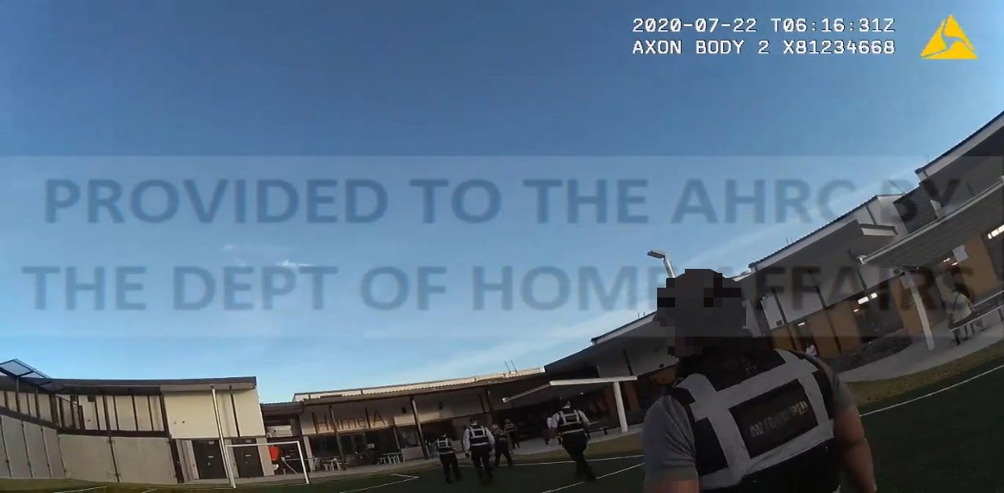
- At approximately 4.16 pm, footage records two ERT officers entering Hume A compound. They are followed shortly after by approximately seven other ERT officers (Figure 1). Mr BX can be seen standing next to the other detainee who is seated in front of the officer’s station (Figure 2).

Figure 1: Some of the ERT officers approaching the officer’s
station
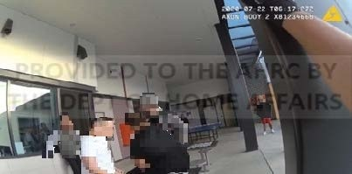

Figure 2: Mr BX (in the white t-shirt), with the other
detainee in front of the officer’s station

- As the first two ERT officers approach Mr BX and the other detainee, a Serco officer is seen coming out of the officer’s station. He explains to the ERT officers that the other detainee was ‘upset because of the broom’. One of the ERT officers enters the station and returns saying, ‘apparently, he went to the thing and threw everything out’, as he points to the station window and then at the other detainee.
- The ERT officer then asks the other detainee what happened. He replies, ‘it’s got nothing to do with you, just go and get your manager’. Mr BX points to the Serco officer and alleges that he was sleeping on the chair and would not wake up. The Serco officer shakes his head in disagreement.
- Another ERT officer directs Mr BX to move away from the other detainee and tells him, ‘you don’t need to be here’. Mr BX complies and sits on a nearby table.
- At approximately 4.18 pm, ERT officers can be seen speaking with the other detainee who is asking to see the manager. ERT officers direct the other detainee to walk with them, but he replies, ‘I’m not going nowhere, fuck you’ and appears to sit to the ground. Other footage at this point shows the other detainee on the ground, being restrained by approximately five ERT officers.
- Mr BX appears to go to the other detainee’s aid and tells the ERT officers, ‘just let him go bro, he’s gonna go by himself … you don’t need to do this, be professional’. Mr BX is directed by ERT officers not to get involved and to walk with them out of the compound.
- At approximately 4.20 pm, Mr BX is held by two ERT officers either side of him and led through a secure gate out of the compound. There is some calm but firm interaction by one of the ERT officers who directs Mr BX to walk with them and to, ‘listen to me … walk cuz walk’. He tells the ERT officers, ‘I’m not gonna fucking walk alright, you can’t make me walk, fuck off’.
- As he is led out of the gate, he resists the ERT officers’ attempts to pull him forward and is taken to the ground with one of the ERT officers placing his hand on the back of Mr BX’s head and forcing it to the ground (Figures 3 and 4). An ERT officer says, ‘why didn’t you listen cuz’, to which Mr BX replies, ‘fuck you, fuck you up’. He is then handcuffed with his hands behind his back. This takes some time as they tighten the handcuffs. Mr BX is brought up to his knees and approximately three ERT officers proceed to carry him.

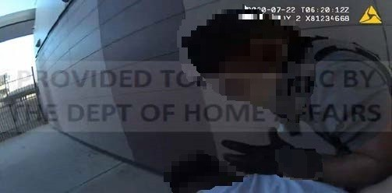

Figure 3: ERT officer moving to place his hand on Mr BX’s
Head

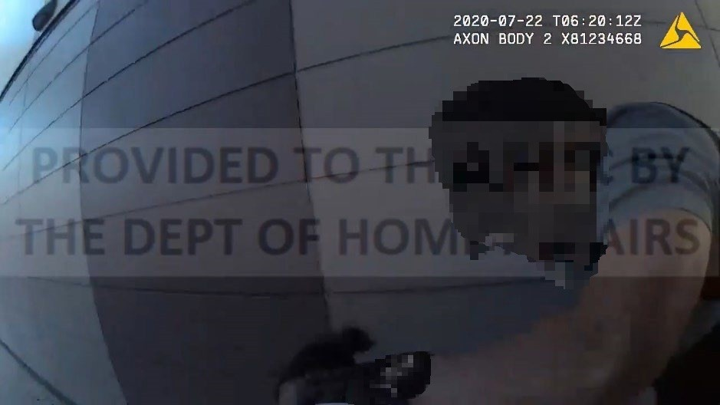

Figure 4: ERT officer forcing Mr BX’s head to the ground
- At approximately 4.24 pm, an ERT officer directs them to stop walking and Mr BX is briefly placed to the ground. An ERT officer is heard trying to speak to him, but he is unresponsive. The ERT officer says to call a nurse. Mr BX is directed to sit up and not to drop his weight. The officers proceed to escort him to the IHMS clinic. Mr BX can be seen standing and walking as he enters the clinic at approximately 4.25 pm.
- As he enters the clinic, Mr BX appears to go to the ground. An ERT officer tells him to breathe. The ERT officer explains to medical staff that the ‘abrasion to his head happened when he went down to the floor … resisting’. He explains that while they were walking him to the property department, he thinks Mr BX became ‘catatonic’ and in a ‘slump’.
- Mr BX is assisted up and seated on a bed. He asks for his cuffs to be taken off. There is no response from ERT officers. Medical staff attend to him. A gash is seen on his forehead and a staff member comments that it is ‘very swollen’.
- An IHMS clinical record dated 22 July 2020, notes that Mr BX has a ‘3-4mm haematoma’ in the left part of his forehead which is ‘slightly tender to touch’.
- A Department incident detail report dated 28 July 2020, states that after being assessed by IHMS, Mr BX was escorted to the property department to be interviewed. At approximately 4.35 pm, his handcuffs were removed. In total, Mr BX was handcuffed for approximately 15 minutes.
- Serco’s post incident review dated 22 July 2020, states that at approximately 7.00 pm, Mr BX was returned to Hume A compound after his behaviour was considered safe for staff and detainees.
- The Department’s response to Mr BX’s complaint provides a summary of his medical injuries and treatment relating to the use of force incident:
Following the incident, [Mr BX] was brought to the IHMS Clinic on 22 July 2020 by Serco staff. [Mr BX] was ambulant and handcuffed. [Mr BX] had a noted injury (haematoma) to the left side of his forehead and superficial abrasion, injuries were likely sustained during stabilisation. [Mr BX] denied any symptoms of headache, dizziness nausea or vomiting. [Mr BX’s] wound was cleaned by an IHMS nurse. [Mr BX] was examined by an IHMS General Practitioner (GP) who reported that [Mr BX] had a bruised left forehead. The IHMS GP recommended [Mr BX] for a compression bandage, an ice pack and simple analgesia. [Mr BX] was recommended for review as required by the IHMS GP.
- Later that day, at approximately 11.00 pm, IHMS were contacted by Serco staff in relation to Mr BX reporting further symptoms. Mr BX was taken by ambulance to the Liverpool Hospital and discharged the next day. The Department’s response summarises this event:
On the same day, at approximately 23:00 the IHMS Health Advice Service (HAS) were contacted by Serco staff. It was reported that [Mr BX] had symptoms of dizziness, double vision, abdominal pain, nausea and vomiting and flu and fever symptoms. An ambulance was called and [Mr BX] transferred to Liverpool Hospital for assessment. A Computed Tomography (CT) scan of [Mr BX’s] brain and cervical spine was attended which did not show any evidence of a fracture or bleed. A chest x-ray and x-ray of right wrist was also attended which did not show any new fractures (an old fracture of the right wrist was identified). [Mr BX] was diagnosed with pain to his wrist by hospital staff and discharged from hospital on 23 July 2020.
- IHMS clinical records state that on 24 July 2020, Mr BX attended a GP consultation. It was noted that his left forehead haematoma was ‘diminishing and healing’. His right wrist was examined and noted to have its ‘range of motion intact’ and ‘no elbow tenderness’. The GP recommended simple analgesia and review as required.
- On 28 July 2020, Mr BX attended a GP consultation on referral by the IHMS psychologist, due to pain in his ankle, wrist and scalp. A physical examination by the GP was reported as unremarkable. Mr BX was reassured regarding the settling of his pain and soft tissue injuries and advised to take Panadol.

Use of force on 22 November 2020
- The Department’s incident detail report dated 23 November 2020, states that at approximately 3.38 pm, on 22 November 2020, a suspicious item was observed by a Detainee Services Officer being thrown over the fence from Hume B compound to Hume A compound and was picked up by Mr BX. No footage has been provided by the Department, capturing this event.
- A file note provided by the Department from the law firm, ‘Human Rights for All’, describes Mr BX’s version of events. He claims that he had asked a Serco officer to pass him a packet of tobacco from his friend in Hume B to Hume A, where he was located. The officer refused to do so and his friend threw the tobacco pack over the fence. Mr BX picked it up off the grass, went to his room and rolled a cigarette.
- The Department’s incident detail reports state that in response to this event, ERT officers attended at Mr BX’s room at approximately 4.00 pm to conduct a targeted room search.
- Bodycam footage shows approximately nine ERT officers approaching Mr BX’s room (Figure 5). An ERT officer is seen at the front of Mr BX’s door, which is closed. The door opens and Mr BX can be seen with two other detainees in the room (Figure 6). He is smoking.
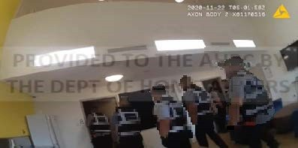

Figure 5: Some of the ERT officers captured approaching
Mr BX’s room
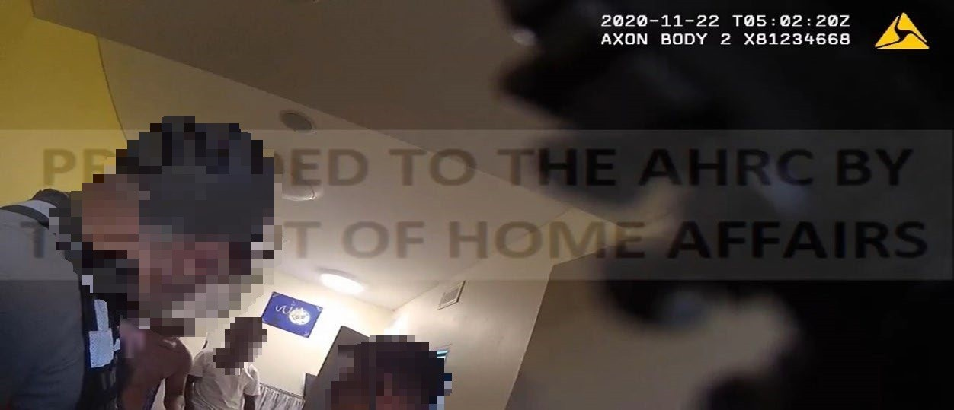

Figure 6: Mr BX is with the other detainees in his room
- Footage records the detainees being directed to leave the room and Mr BX responding, ‘yep, just one sec please’, as he prepares to go. He appears calm and compliant. That ERT officer tells him, ‘you’re not supposed to be smoking anyway, put your smoke out’.
- A second ERT officer enters the room and appears to direct all the detainees out of the room as he holds the door open. The ERT officer is wearing sunglasses. One detainee leaves the room and is given a wand and pat search while another is standing at the door, with Mr BX behind him. As Mr BX goes to leave, he appears to raise his right closed fist, up in front of the ERT officer’s face who is holding the door open (Figure 7). The ERT officer immediately grabs Mr BX’s head forcibly on both sides and thrusts him to the ground (Figure 8).
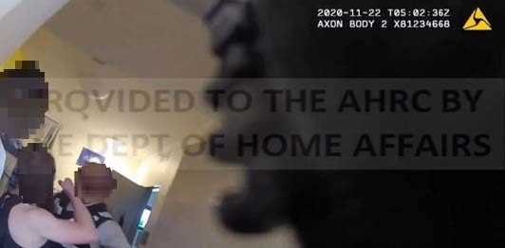

Figure 7: Mr BX raises his right fist up to the ERT officer
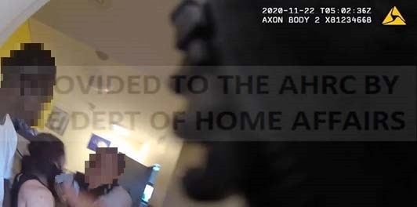

Figure 8: The ERT officer grabs both sides of Mr BX’s head
- The ERT officer concerned, states in his Serco Officer’s report dated 22 November 2020:
When I entered the room I saw [Mr BX] smoking a cigarette. I then instructed him to put the smoke away but he became abusive aggressive towards me. He stated ‘What’s your fucking problem’ I then gave him a verbal warning ‘You are not allow to smoke in the room’. [Mr BX] continued to show signs of agitation and abusive aggressive towards me. [Mr BX] took a step forward towards me at the same time he attempted to close the door in a very aggressive manner. I then initiated a spontaneous use of force by controlling his head to the ground stabilize position as per ERT approved training technic. [ERT officer] took control of his left arm and [ERT officer] took control of his legs. [Mr BX] resisted and refused instructions to stop resisting.
[Mr BX] managed to get hold of the wand that was on the floor and strikes [ERT officer] a few times. Through the struggle on the ground due to his non compliant and the small space in the room I ended up controlling both arms where [Mr BX] attempted to strike me on my left side. [ERT officer] gained control of his left arm again and removed the wand away from him.
[ERT officer] assisted us and took control of his legs and mechanical [restraints] was then placed on [Mr BX]. He was then placed on recovery position while waiting for further instructions as other ERT officers tried to clear the room so we can transfer him to Property holding room.
- I note that footage shows this ERT officer speaking to Mr BX when he first enters the room, however there is a delay in the sound commencing and his conversation is not clearly recorded.
- I also note that the footage does not appear to show Mr BX attempting to close the door, or that he did so in a ‘very aggressive manner’. It is the ERT officer that is the one holding the door open the whole time as Mr BX goes to leave.
- After the use of force incident occurs and Mr BX is brought to the ground, the detainee who is at the door appears to go to his aid and asks the ERT officer, ‘what are you doing?’. ERT officers attempt to restrain that detainee.
- Footage from another angle appears to show approximately seven of the ERT officers quickly entering the room. One of those officers is tasked with holding the door open. Another detainee is seen to walk by the door, peer in and enter. The ERT officer who is now holding the door, goes to restrain this detainee. There are now three detainees being restrained in the room, including Mr BX.
- At this point, the footage turns shaky as all three detainees are ground stabilised. The door of the room is now seen closed. It is difficult to determine exactly what actions are being taken, given the number of officers exercising force and their positioning in a way that blocks visibility of their specific actions and of Mr BX. Both the detainees and ERT officers can be heard yelling in the background. The ERT officers can be heard yelling out, ‘stop resisting’.
- A Serco Officer’s report dated 22 November 2020, records:
At approximately 1602 hrs I heard commotion coming from the room to which I entered and witnessed a struggle for control by [ERT officer] on [Mr BX] … I assisted [ERT officer] by ground stabilising [Mr BX] and I attempted to secure his left arm and apply Mechanical Restraints (MR’s). I witnessed [ERT officer] was situated on top of [Mr BX] attempting to gain control and secure the right arm.
At that time I saw [detainee] enter the room in an aggressive manner to which I saw [ERT officer] assist [Team Leader] to ground stabilise [detainee] and bumped into me as I lost control of [Mr BX’s] arm. I then witnessed [Mr BX] who was situated on the ground take control of the wand which dropped out of my left pocket and used it as a weapon to strike [ERT officer]. I witnessed [Mr BX] strike my left side of my lower leg on multiple occasions. Due to the threat that was presented I initiated an open hand strike towards the chest area of [Mr BX] and attempted to secure and gain control of the right wrist. Through the struggle, [ERT officer] and I were able to secure both arms and gain control in which the wand was retrieved.
At approximately 1605hrs, I applied MR’s to both wrists with the assistance of [T/L] and [ERT officer] … to [Mr BX] who appeared to be unconscious but breathing was in recovery position to allow for breathing.
- The footage, although blurry, shows Mr BX appearing to hold a wand in his hand and waving it at the ERT officer who is restraining him (Figure 9). The ERT officer is heard saying, ‘you hit me, you just hit me’. Mr BX appears to yell out, ‘you fucking punch me, you fucking dog’. Shortly afterwards, the ERT officer appears to be over Mr BX’s body, holding him down with his back to the camera. Another ERT officer moves in and directs Mr BX to ‘give me your fucking arm’. Handcuffs are applied as his arms are held behind his back. An ERT officer asks Mr BX if he is breathing, but no response is heard.
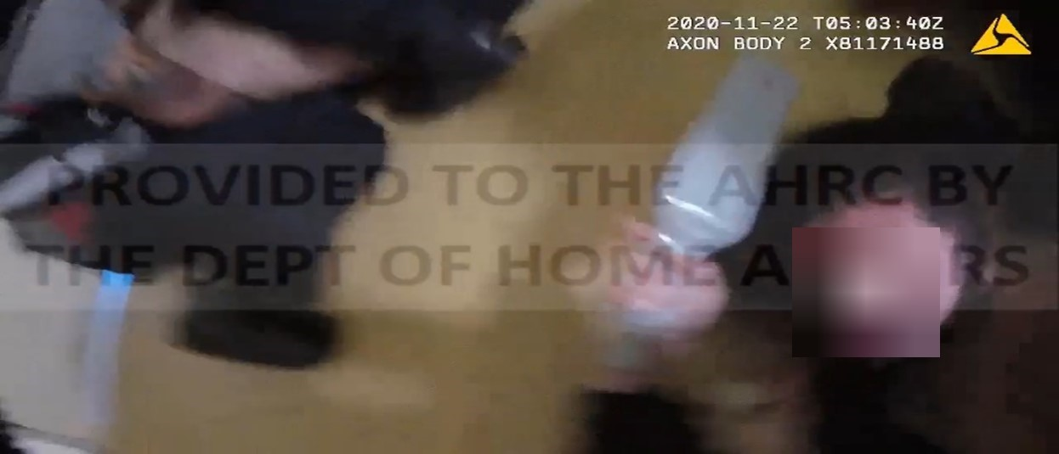

Figure 9: Mr BX appears to be holding a wand
- After a few minutes, the detainees appear to have been stabilised and clearer footage shows that one detainee is positioned near the front door and another to the rear of the room. Mr BX is lying on the ground at the right of the door. His eyes are closed and he appears motionless. An ERT officer looks towards him while another ERT officer comments, ‘he’s breathing, he’s fantastic’.
- ERT officers prepare to remove the detainees from the room and to clear a pathway for them. Footage switches to other detainees in the compound, who are seen gathered outside the screen door of the common area. They are directed to move away.
- The first detainee is led out, followed by the second. Mr BX is the last detainee to be removed at approximately 4.12 pm.
- The ERT officers lift Mr BX up but he appears limp and his head hangs forward. There is some blood around his nose. He is directed to stand up. As ERT officers lead him outside, he appears to fall to the ground. Another detainee who is observing, calls out to the ERT officers, ‘look at him brother, he’s fucking dying … let him walk … this is fucking bullshit’. An ERT officer replies, ‘we’re trying to hold him up ok’.
- He is picked up again and escorted out of the compound gate. He is heard yelling out, ‘let me go’. While walking, the ERT officers stop briefly and Mr BX can be seen face down on the ground again. An ERT officer asks him, ‘are you going to stop resisting?’, Mr BX replies repeatedly, ‘I can’t breathe’ and is yelling out in distress. The ERT officers lift him up again and continue to carry him forward.
- Seconds later, the ERT officers place him to the ground. One of the officers says, ‘he doesn’t want to walk’, and medical assistance is requested. An ERT officer says, ‘[Mr BX], you brought this on yourself alright, you assaulted officers mate’. No response is heard from Mr BX. Officers lift him up again, he is walked a little further and placed on a grassed area to wait for medical assistance.
- Soon after, nurses arrive at the scene and ask what happened. An ERT officer explains, ‘we had to break him off from his room cos we did a targeted room search on them’. Another officer says, ‘we got to do a search and they started assaulting us’.
- The nurse asks Mr BX if he can get up and to squeeze his hand. Mr BX cannot be seen in the footage due to the positioning of the camera. The nurse comments that his heart rate is ‘very fast’.
- A nurse asks if his handcuffs can be released but this request is refused by the ERT officer who replies, ‘there’s a reason why we’ve got cuffs there, he’s just assaulted an officer … you’re gonna have to get permission from our FOM to release the cuffs, we’re not gonna release the cuffs, well I’m not anyway … he could kick off in a second’. Mr BX is seen lying on the ground, motionless.
- The Department’s response to the Commission, further describes IHMS’s response:
On 22 November 2020, IHMS staff responded to a code blue (ME) call at approximately 16:30. [Mr BX] was noted to be breathing heavily, had an elevated heart rate and blood pressure and verbally non-responsive. An ambulance was called for transfer of [Mr BX] to Bankstown Hospital. [Mr BX] had a CT scan of his head and facial bones which showed bilateral nasal bone fractures. The hospital staff arranged for ear nose and throat (ENT) specialist follow-up, recommended [Mr BX] for a GP consultation, and analgesia and review as required for any ongoing issues. On 22 November 2020 [Mr BX] was discharged.
- After he is checked by nurses, footage shows Mr BX being lifted up by five officers and carried off to the property department. During this time, they take a short break, place him down and confirm that he is breathing. He is then placed into one of the rooms in the property department.
- Department incident detail reports state that Mr BX was taken to hospital at approximately 5.00 pm. The hospital discharge summary shows that he was discharged at 8.27 pm.
- IHMS clinical records indicate that Mr BX was reviewed on 25 November 2020 by the IHMS GP, who noted that he had ‘multiple bruising, blood, swelling around eyes, face, scalp’ and a perforated tympanic membrane in the left ear. Mr BX also reported a loss of hearing to his left ear, extreme pain and that he was unable to sleep due to the pain. He was prescribed a course of oral antibiotic medication for infection prevention and analgesia medication.
- On 30 November 2020, he attended an outpatient ENT consultation at Bankstown Hospital.
- On 17 December 2020, he was reviewed by the IHMS GP and reported that difficulties breathing through his nose had worsened since his nasal fracture.
- On 14 January 2021, he attended a consultation with an IHMS mental health nurse and reported being ‘stressed out’ and not sleeping and ‘always worried’. He also reported that he was unable to breathe with his broken nose and was waiting on surgery to fix this.
- The Department’s response to Mr BX’s complaint, states that on 11 March 2021, the ENT report was received which stated that antibiotics and surgery were not required and the treatment plan was to provide assurance.
- The Department also states that on 16 March 2021, Mr BX was referred to an ENT surgeon for review due to ongoing nasal pain and trouble breathing. Mr BX advises, through his legal representative, that he continues to experience difficulty breathing and sleeping and is still awaiting results from a medical assessment.

Use of restraints on 22 November 2020
- The Department’s response to Mr BX’s complaint states that Mr BX was restrained using mechanical restraints ‘to ensure his own safety and the safety of the Serco officers attempting to escort him out of the room for the room search’. They state that he was also handcuffed during his transport to Bankstown Hospital, citing this as ‘standard procedure for [Mr BX’s] escort risk rating’. The handcuffs remained on him throughout his hospital stay.
- The Department’s incident detail reports and hospital records, set out the following approximate timeline for the use of handcuffs on Mr BX:
4.05 pm handcuffs are applied to Mr BX
4.25 pm IHMS call the ambulance
4.50 pm ambulance arrives at VIDC
5.00 pm Mr BX is taken to hospital
8.27 pm Mr BX is discharged from hospital
9.50 pm Mr BX returns to VIDC and handcuffs are removed
- From this timeline, it appears that the handcuffs remained on Mr BX for a total of almost 6 hours, and including while he underwent a CT scan of his head and facial bones.
- In his complaint to the Commission, Mr BX also states that there were approximately four officers around him in the hospital and that he did not get an opportunity to talk to a doctor without the officers present.
- I note that the Commission has previously undertaken an inquiry into the use of force in immigration detention and I refer to the comments made as part of that inquiry regarding the use of security risk assessments and the use of handcuffs during medical escort, without repeating them here.1F

Findings

Use of force on 22 July 2020
- I find the use of force on 22 July 2020 to ground stabilise Mr BX after exiting the compound, was reasonable, necessary and proportionate to the need to protect Mr BX, the safety of the staff and to maintain good order in the detention centre.
- I consider ERT officers reasonably believed that he was at risk of escalating the physicality of the other detainee’s situation and that this may have had an unintended flow-on effect to the other detainees in the compound. I accept that it was reasonable to remove Mr BX from the compound to maintain good order.
- While I am concerned about the application of downward force to Mr BX’s head by the ERT officer concerned, footage shows that by this point, Mr BX was heavily resisting ERT officers’ attempts to walk him through the compound gate and to comply with their directions. I consider that ERT officers reasonably believed he was at risk of harm to himself and to others and I consider that force was used as a last resort.
- I note however, that Mr BX’s resisting and lack of compliance was in direct response to the manner in which ERT officers were treating the other detainee. ERT officers appear to have made little attempt to de-escalate the situation with that detainee when they arrived at the scene. They spoke briefly with the other Serco officers involved and then directed the other detainee to walk with them shortly afterwards.
- By the time the other detainee was ground stabilised, there was little opportunity to de-escalate the conflict with Mr BX. His behaviour had already escalated and footage shows a growing level of physical aggression towards the ERT officers.
- I consider that the number of ERT officers that attended at the scene may have been excessive and may have escalated the physicality of the situation. Footage shows approximately seven ERT officers entering the compound and circling around Mr BX and the other detainee. I accept that they were called in response to a detainee being abusive and aggressive in an outdoor area amongst other detainees. However, I consider that the presence of multiple officers in protective gear, responding to the actions of a single detainee, may have undermined efforts to de-escalate the situation.
- I find that the injuries of the haematoma and abrasion to Mr BX’s forehead were caused by the use of force. I note that the Department acknowledges in its response to the complaint, that the ‘injuries were likely sustained during stabilisation’. Further, the pain to Mr BX’s right wrist may have been caused by ERT officer’s attempts to escort him to the property department and the application and use of restraints after he was ground stabilised. I note that Mr BX presented to the hospital on the same day as the use of force incident and was diagnosed with pain to his wrist. At the very least, the pre-existing injury to his right wrist was likely to have been exacerbated.
- In response to my preliminary view, the Department stated:
The Department notes the Commission’s view that [Mr BX] may have suffered a wrist injury or exacerbated a pre-existing wrist injury, to the extent that it maintains that the use of force was reasonable and appropriate in the circumstances. Where increasingly non-complaint [sic] behaviour is exhibited during the application of force, there is an increased risk of injury to both the detainee and officers.
- I am not satisfied that Mr BX became unconscious when his head hit the ground after being ground stabilised. Footage records him swearing at the ERT officers while on the ground and as they carry him to the property department. At approximately 4.24 pm, ERT officers stop walking and place Mr BX on the ground. He appears unresponsive. It is possible that he lost consciousness briefly at this point until approximately 4.25 pm, when footage shows him standing and walking as he enters the IHMS clinic.

Use of force on 22 November 2020
- I find that the second use of force incident involved treatment contrary to article 10(1) of the ICCPR and was not reasonable, necessary or proportionate to the need to protect Mr BX, the safety of the staff and to maintain good order in the detention centre.
- I find that the ‘spontaneous’ control and restraint technique used on Mr BX by the ERT officer grabbing both sides of this head and bringing him to the ground with significant force, was not necessary and appropriate in the circumstances. This technique was highly forceful, hostile and intimidating, and led to Mr BX being held face down on the floor by up to three ERT officers. It also triggered the involvement of two other detainees in the incident. I find it concerning that this technique was cited to be, ‘as per ERT approved training technic’.
- In response to my preliminary view, the Department stated that at the time of the decision to use force, Mr BX was ‘positioned face-toward a responding officer’:
Where this is the case, FDSP officers are appropriately trained to employ a technique whereby an officer’s hands are placed on the sides and or back of the detainee’s head, leading the detainee forward and downwards in a controlled manner while additional officers step in to support arm and leg control so that ground stabilisation can occur. This technique requires rapid action in order to establish ground stabilisation prior to the detainee striking, or otherwise inflicting harm to an officer. During the application of this technique, FDSP officers attempted to control [Mr BX] with the least amount of force possible, however, [Mr BX] accelerated his trajectory of non-compliance.
- I am not persuaded that this technique was necessary or that the level of force used to execute it was proportionate to Mr BX’s perceived risk. I find that it was the use of force itself that ‘accelerated his trajectory of non-compliance’.
- I further find that force was not used as a last resort. The ERT officer’s use of force occurred in immediate response to Mr BX raising his right fist up, in front of the officer’s face. I accept that the ERT officer may have reacted in response to perceiving an immediate threat of physical violence by Mr BX. However, the footage does not show Mr BX being aggressive when he is initially directed to leave the room. He verbally agrees to do so and appears visibly calm as he moves around his belongings. Footage shows him raising his fist up to the ERT officer, but the manner in which he does so, appears to be more of a gesture as he goes to leave, rather than an actual attempt to make contact. The ERT officer responds immediately by using force. He does not attempt to communicate with Mr BX at all or deploy any negotiation or de-escalation techniques.
- In response to my preliminary view, the Department describes that, upon commencing the targeted room search, Mr BX began ‘displaying intimidating, aggressive and abusive behaviour towards FDSP officers’, including attempting to close the door on officers. As previously indicated however, the footage does not support this version of events. Mr BX is both seen and heard to comply with the ERT officer’s direction to leave the room. Footage also shows Mr BX situated near the back of the room when the door opens, and it is the ERT officer who is the one holding the door open as the detainees go to leave.
- In relation to the very serious allegations made by Mr BX that he was kneed to the head during his subsequent ground stabilisation and punched by another officer who ran into the room, I am not able to be satisfied that these actions occurred. The footage does not capture the specific actions of the ERT officers involved in restraining Mr BX. Neither does it capture the alleged actions of Mr BX striking ERT officers.
- I am concerned regarding the actions of the ERT officer who initiated an open hand strike towards Mr BX’s chest area, in response to the threat presented by him. It is unclear why a strike of this manner to his chest was necessary to gain control of his right wrist, even where he was holding the wand in his right hand. At that point, there appear to have been two ERT officers on top of Mr BX, restraining him.
- In response to my preliminary view, the Department stated:
During the FDSP officers’ attempt to implement ground stabilisation, Mr BX picked up a fallen search wand and progressed to utilise the search wand as a weapon to strike an officer repeatedly and attempted to strike another, while concurrently kicking his legs and flailing his arms. As soon as officers were able to gain control of [Mr BX], mechanical restraints were applied in a reasonable and proportionate response to [Mr BX’s] erratic and unpredictable behaviour. The actions of [Mr BX], including the intimidation and aggression he displayed towards officers at the beginning of the incident, were such that multiple FDSP officers reported to be in fear and danger of being assaulted by [Mr BX].
- It still remains unclear however, why an ‘open hand strike’ to Mr BX’s chest area was necessary and reasonable to extract the wand from his right hand, particularly where two ERT officers were on top of Mr BX.
- I also find it concerning that the door to the room was closed shortly after the third detainee walked in and remained closed for approximately 4 minutes while all three detainees were being restrained. As this was an accommodation room, it did not have any CCTV coverage. I accept this was an unplanned use of force in a fast-moving situation, however closing the door was more likely to result in the absence of clear footage with multiple officers and detainees being held together in a tight space with no clear external lines of sight.
- Although the number of ERT officers initially deployed to the scene (approximately nine in total), appears excessive based on the room search of one detainee, I consider this number then became reasonable, in light of the subsequent ground stabilisation of all three detainees.
- I find that Mr BX’s complaint that once he was carried out of the room towards property, he was placed to the ground and punched and kicked, is not supported by the footage.
- In response to my preliminary view, the Department submitted that Serco officers did not use excessive force on Mr BX during the incident on 22 November 2020, and that the force was used as a last resort. The Department highlighted Mr BX’s ‘extensive history of serious violence’ and provided his Security Risk Assessment which shows a ‘high’ risk for aggression/violence and criminal profile. I note that this was an unplanned use of force event and consider the assessment is of less significance in these circumstances.
- I find that the injuries Mr BX sustained were a result of the use of force. I note that the Department acknowledges that, ‘it is likely that injuries occurred during ground stabilisation while the detainee continued to physically resist the officer’s attempt to stabilise him. Serco cannot confirm the exact point of injuries occurring during the control and restraint of the detainee.’
- In response to my preliminary view, the Department reaffirmed its view that Mr BX obtained his facial injuries whilst being ground stabilised, but reiterated its view that the use of force was reasonable and appropriate in light of Mr BX’s escalating and threatening behaviour.
- Mr BX’s injuries are serious and consist of bilateral nasal bone fractures, a left ear tympanic membrane perforation and multiple bruises around his eyes, face and scalp. I note that there are no photos of his injuries, despite their seriousness. He has also reported difficulties with breathing and pain, and was referred for counselling due to feeling anxious and stressed about the incident.
- The seriousness of his injuries suggests at the very least, that a significant level of force was used to restrain him. I note that Mr BX is not of large build. Documents provided to the Department on his behalf and subsequently provided to the Commission indicate that he is 170cm and 65kg. The perforation of his ear drum may have been caused by the ERT officer grabbing the sides of his head, however the fractures to his nose and bruising around his eyes and face, cannot as easily be explained and raises serious questions.
- I consider that Mr BX may have lost consciousness at some point shortly after being ground stabilised. Footage shows his head on the floor with his eyes closed and his body still. After being carried out of the room, his head is seen hanging forward. Shortly after, Mr BX is placed to the ground in a recovery position, medical assistance is requested and a Serco officer’s report states that he appears ‘unconscious’ but breathing. It is unclear at what point Mr BX regained consciousness, but I note that later footage of ambulance officers arriving at VIDC, suggests some responsiveness on his part.
- In response to my preliminary view, the Department stated that:
FDSP officers escorting [Mr BX] to the property room immediately following the incident reported that [Mr BX] continued to display resistance and non-compliance during the escort, including attempting to trip an officer, dropping his (body) weight and dragging his feet. FDSP officers temporarily ceased the escort, placing [Mr BX] down on a grassed area of a compound, in order to rest due to his challenging presentation and to ensure his wellbeing
…
During this time, the FDSP called for the assistance of the Detention Health Service Provider (DHSP) to assess [Mr BX]. The DHSP responded and reported that [Mr BX] was breathing heavily with an elevated heart rate and normal eye response to light, however, [Mr BX] was non-verbal in responding to the DHSP which triggered a recommendation that an ambulance attend to further assess [Mr BX’s] wellbeing.
- The Department also sought to highlight the similarities between the use of force incidents on 22 July 2020 and 22 November 2020, describing Mr BX’s aggressive and threatening behaviour and non-compliance before ‘allegedly becoming limp, and lacking indications of verbal responsiveness’, during escort to the property room.

- The Department submitted that in both incidents, Serco staff used reasonable and proportionate force to manage Mr BX’s adverse behaviour when verbal de-escalation tactics were no longer appropriate and responded swiftly by seeking the assistance of IHMS.
- I note the Department’s response, however Mr BX’s complaint concerns two separate use of force incidents, each with very different circumstances. While I have found that the first incident did not amount to a breach of article 10 of the ICCPR, the second incident was more serious. In the second incident, force was not used as a last resort, the use of force techniques used were not necessary in the circumstances, and more force was used than was necessary in the circumstances resulting in serious injuries to Mr BX.

Use of restraints on 22 November 2020
- I find that although the initial use of handcuffs was reasonable in the circumstances, the use of mechanical restraints on Mr BX for almost 6 hours while being treated in hospital for very serious injuries, was not reasonable, necessary or proportionate to the need to protect Mr BX and the safety of others.
- I find that the use of handcuffs in these circumstances, was contrary to his rights under article 10(1) of the ICCPR to be treated with humanity and with respect for his inherent dignity.
- The use of restraints should only be used for the shortest amount of time possible and be removed once the threat has diminished. I note that even before Mr BX was taken to the hospital, a nurse had asked for his handcuffs to be released but this was refused by an ERT officer. At that point, Mr BX was lying motionless on the ground and appeared non-responsive. He then had to be physically lifted up and carried by five officers to the property department.
- Given his physical state and the time that passed until the ambulance arrived (approximately 25 minutes), I consider he was no longer likely to be a threat to others or to himself and ERT officers should have considered removing the handcuffs at that point. After he arrived at hospital, it is even less clear why it was necessary for the handcuffs to remain on Mr BX for a further 5 hours until his return to VIDC.
- In response to my preliminary view, the Department reiterated Mr BX’s extensive history of adverse behaviour and violent criminal history reflected in his Security Risk Assessment.
The use of mechanical restraints for the duration of [Mr BX’s] escort remained appropriate on this basis and under the circumstances of his actualised physical violence towards FDSP officers immediately prior to the escort. Additionally, the Department notes that at no point while in the ED did any medical professional assess [Mr BX] as experiencing exacerbated pain due to the mechanical restraints. [Mr BX] was offered medical review upon return to the IDC and following the removal of the mechanical restraints, however, [Mr BX] declined. On this basis, the Department disagrees with the Commission’s preliminary view that the use of mechanical restraints on [Mr BX] was contrary to his rights under article 10(1) of the ICCPR.
- The Department also referred to its DSM in relation to use of force and that Facilities and Detention Service Provider (FDSP) officers acted in accordance with the policy in using mechanical restraints for the duration of Mr BX’s escort to the hospital. The DSM provides that ‘physical restraints during transport and escort applies for those for whom the risk assessment indicates that they potentially pose a high risk or above’, including for detainees having an ‘adverse behavioural or violent criminal history’.
- I note, however, that the DSM also provides that if a detainee is restrained, an officer must:
        - conduct checks at regular intervals
        - be aware at all times of the safety of the detainee including while travelling in a restrained manner in a motor vehicle
        - take special account of the detainee’s comfort and dignity, particularly when there is a need to apply restraints to the detainee for a lengthy period.
- In response to my preliminary view, Mr BX’s legal representative stated:
In our submission, it is relevant to the assessment of whether the prolonged use of restraints was unreasonable and disproportionate that the Department was aware that [Mr BX] is a survivor of torture and trauma and that use of restraints on [Mr BX] may exacerbate his trauma symptoms.
…
It is concerning that there is no evidence that an assessment was made about the appropriateness of the ongoing use of force at any point during the almost six hours [Mr BX] was restrained.
While the ERT officers did not have the benefit of a risk assessment in a situation where the use of force was unplanned, in circumstances where the Department was aware of [Mr BX’s] trauma history and the impact that restraint can have on survivors, it was incumbent on the Department to ensure that the use of restraints was regularly reviewed for duration of the incident and ended at the first opportunity.
We submit that failure to do so precludes any argument that might be made that the use of restraints was reasonable and proportionate.
- Mr BX’s legal representative also provided documents which show that Mr BX disclosed a history of torture and trauma in his induction mental health screening at VIDC, and that this was reported by IHMS to the Department on 9 April 2020. Mr BX’s solicitor also provided IHMS risk assessments for planned use of force events in relation to Mr BX. These appear to be requested for proposed transfer or escort activities and are dated after the use of restraints on Mr BX on 22 November 2020. The risk assessments do however, stipulate that Mr BX is a known survivor of torture and/or trauma and the use of restraints may exacerbate trauma symptoms and strongly recommends that it not be employed.

- The Department has provided no evidence to show that officers conducted checks at regular intervals or that they took special account of the Mr BX’s comfort and dignity during the lengthy time he was in restraints. These are obligations that rest with the Department and its contracted provider. As previously stated, both the Department and its service providers owe a duty of care to all persons held in immigration detention and are legally obliged to exercise reasonable care to prevent detainees from suffering reasonably foreseeable harm. The Department’s duty of care is non-delegable.

Recommendations
- As a result of this inquiry, I find that the decision of the Department to use force on Mr BX on 22 November 2020, was inconsistent with or contrary to his rights under article 10 of the ICCPR to be treated with humanity and with respect for his inherent dignity.
- Where, after conducting an inquiry, the Commission finds that an act or practice engaged in by a respondent is inconsistent with, or contrary to, any human right, the Commission is required to serve notice on the respondent setting out its findings and reasons for those findings.
- The Commission may include in the notice any recommendation for preventing a repetition of the act or a continuation of the practice. The Commission may also recommend the payment of compensation to, or in respect of, a person who has suffered loss or damage and the taking of other action to remedy or reduce the loss or damage suffered by a person.
- I make the following recommendations:
Recommendation 1
The Commonwealth pay to Mr BX an appropriate amount of compensation to reflect the loss and damage he suffered as a result of the breach of his human rights identified by this inquiry, being the pain and suffering he experienced as a result of the use of force against him.
Recommendation 2
The Department and Serco ensure that officers who may be required to use force in their roles be appropriately and periodically trained on how to select and properly deploy use of force techniques, so as to avoid harm to the person against whom force is used.
Recommendation 3
The Department and Serco ensure that officers who may be required to use force in their roles be appropriately and periodically trained on communication, negotiation and conflict de-escalation strategies as alternatives to the use of force.

The Department’s response to my findings and recommendations
- On 25 January 2024, I provided the Department with a notice of my findings and recommendations.
- On 12 March 2024, the Department provided the following response to my findings and recommendations:
The Department of Home Affairs (the Department) respects the role of the Australian Human Rights Commission and acknowledges the findings and recommendations identified in this report.
Recommendation 1 – Disagree
The Commonwealth pay to Mr BX an appropriate amount of compensation to reflect the loss and damage he suffered as a result of the breach of his human rights identified by this inquiry, being the pain and suffering he experienced as a result of the use of force against him.
The Commonwealth can only pay compensation to settle a monetary claim against the Department if there is a meaningful prospect of legal liability within the meaning of the Legal Services Directions 2017 and it would be within legal principle and practice to resolve this matter on those terms. Based on the current evidence, the Department's position is that it is not appropriate to pay compensation in this instance.
Recommendation 2 – Accepts and is already addressing
The Department and Serco ensure that officers who may be required to use force in their roles be appropriately and periodically trained on how to select and properly deploy use of force techniques, so as to avoid harm to the person against whom force is used.
The Department accepts and is already addressing recommendations two and three.
The Department contracts the provision of garrison, facilities management, security, transport and escort and detainee welfare and engagement services to the Facilities and Detainee Service Provider (FDSP).
FDSP officers hold and maintain a security accreditation provided by a registered training organisation and are trained in maintaining the safety and security of detainees, staff and visitors and the immigration detention facility.
All FDSP officers in detainee facing roles undertake a mandatory Initial Training Course (ITC) on commencement of their employment with the FDSP. The ITC covers all aspects of use of force utilising theory sessions and practical application of use of force techniques. Following the ITC, officers complete annual Ongoing Security Training. This training ensures that FDSP officers understand that use of force and/or restraint should be proportionate to the situation, objectively justifiable and only used as a measure of last resort. The current training package encompasses communication, negotiation and conflict de-escalation strategies which are assessed annually.
All officers working in the Immigration Detention Network must abide by a code of conduct. Allegations of staff misconduct are investigated and any cases that may involve criminal, corrupt and/or serious misconduct are referred to the Police or to the Department's Integrity and Professional Standards.
Recommendation 3 – Accepts and is already addressing
The Department and Serco ensure that officers who may be required to use force in their roles be appropriately and periodically trained on communication, negotiation and conflict de-escalation strategies as alternatives to the use of force.
Refer to response at Recommendation 2.

- I report accordingly to the Attorney-General.

Emeritus Professor Rosalind Croucher AM FAAL
President
Australian Human Rights Commission
April 2024

Endnotes

International Covenant on Civil and Political Rights, opened for signature 16 December 1966, 999 UNTS 171 (entered into force 23 March 1976) articles 7 and 10.
Pearson v Minister for Home Affairs [2022] FCAFC 203.
Migration Amendment (Aggregate Sentences) Act 2023 (Cth).
See the definition of ‘human rights’ in s 3(1) of the Australian Human Rights Commission Act 1986 (Cth).
See Secretary of the Department of Defence v Human Rights and Equal Opportunity Commission, Burgess & Ors (1997) 78 FCR 208.
UN Human Rights Committee, General Comment No 21: Article 10 (Humane treatment of persons deprived of their liberty), 44th sess, UN Doc HRI/GEN/1/Rev.9 (10 April 1992) 1 [3].
UN Human Rights Committee, General Comment No 21: Article 10 (Humane treatment of persons deprived of their liberty), 44th sess, UN Doc HRI/GEN/1/Rev.9 (10 April 1992) 1 [3].
Manfred Nowak, UN Covenant on Civil and Political Rights CCPR Commentary (N.P. Engel, 2nd ed, 2005) 250.
UN Human Rights Committee, Views: Communication No. 529/1993, 60th sess, UN Doc CCPR/C/60/D/639/1995 (19 August 1997) (‘Walker and Richards v Jamaica’); UN Human Rights Committee, Views: Communication No 845/1998, 74th sess, UN Doc CCPR/C/74/D/845/1998 (‘Kennedy v Trinidad and Tobago’); UN Human Rights Committee, Views: Communication No 684/1996, 57th sess, UN Doc CCPR/C/74/D/684/1996 (‘R.S. v Trinidad and Tobago’).
UN Human Rights Committee, General Comment No 21: Article 10 (Humane treatment of persons deprived of their liberty), 44th sess, UN Doc HRI/GEN/1/Rev.9 (10 April 1992) 1 [5].
United Nations Office on Drugs and Crime, The United Nations Standard Minimum Rules for the Treatment of Prisoners, GA Res 70/175, UN Doc A/RES/70/175 (8 January 2016, adopted 17 December 2015) (‘The Nelson Mandela Rules’).
The Body of Principles were adopted by the UN General Assembly in Body of Principles for the Protection of all Persons Under Any Form of Detention or Imprisonment, GA Res 43/173, UN GAOR, 6th Comm, 43rd sess, 76th plen mtg, Agenda Item 138, UN Doc A/43/49 (9 December 1988) Annex.
United Nations Office on Drugs and Crime, The United Nations Standard Minimum Rules for the Treatment of Prisoners, GA Res 70/175, UN Doc A/RES/70/175 (8 January 2016, adopted 17 December 2015) (‘The Nelson Mandela Rules’).
Immigration Detention Facilities and Detainee Services Contract between the Commonwealth and Serco, 10 December 2014, Sch 2 (Statement of Work), Section 4 (Security Services) clause 3.8.
Immigration Detention Facilities and Detainee Services Contract between the Commonwealth and Serco, 10 December 2014, Sch 2 (Statement of Work), Section 4 (Security Services) clause 3.10.
Department of Home Affairs, Detention Services Manual – Chapter 1 – Legislative and principles overview – Duty of care to detainees (July 2016) [4].
Department of Home Affairs, Detention Services Manual – Chapter 1 – Legislative and principles overview – Duty of care to detainees (July 2016) [5].
Department of Home Affairs, Detention Services Manual – Chapter 1 – Legislative and principles overview – Duty of care to detainees (July 2016) [5].
Department of Home Affairs, Detention Services Manual – Chapter 1 – Legislative and principles overview – Duty of care to detainees (July 2016) [7].
Department of Home Affairs, Detention Services Manual – Chapter 10.18 - Safety and security management – Use of force (10 October 2018) [4].
Department of Home Affairs, Detention Services Manual – Chapter 10.18 - Safety and security management – Use of force (10 October 2018) [7].
Department of Home Affairs, Detention Services Manual – Chapter 10.18 - Safety and security management – Use of force (10 October 2018) [7].
Immigration Detention Facilities and Detainee Services Contract between the Commonwealth and Serco, 10 December 2014, Sch 2 (Statement of Work), Section 4 (Security Services) clause 3.9(a)(i).
Australian Human Rights Commission, Use of force in immigration detention [2019] AusHRC 130 (Report, 2019) part 6 and 8.
Department of Home Affairs, Detention Services Manual – Chapter 10.18 - Safety and security management – Use of force (10 October 2018) [8].
Department of Home Affairs, Detention Services Manual – Chapter 10.18 - Safety and security management – Use of force (10 October 2018) [8].
Department of Home Affairs, Detention Services Manual – Chapter 1 – Legislative and principles overview – Duty of care to detainees (July 2016) [4].
Department of Home Affairs, Detention Services Manual – Chapter 1 – Legislative and principles overview – Duty of care to detainees (July 2016) [5].
Australian Human Rights Commission Act 1986 (Cth) s 29(2)(a).
Australian Human Rights Commission Act 1986 (Cth) s 29(2)(b).
Australian Human Rights Commission Act 1986 (Cth) s 29(2)(c).

