Encouraging respect for cultural diversity
Early childhood is an ideal time for children to learn about and form friendships with people from different cultural, ethnic and racial backgrounds.

In Australia, we live in a highly diverse, multicultural society, with a population that identifies with over 270 different ancestries. Australia is also home to the world’s oldest continuous cultures, the Aboriginal and Torres Strait Islander cultures.

Here are 3 simple ways you can encourage respect for cultural diversity in your setting…

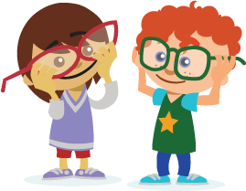 | Explore similarities and differences  Emphasise how we are all special and unique in our own way but share many things in common.

Challenge stereotypes  Identifying and challenging harmful stereotypes is an important way of preventing prejudice. | 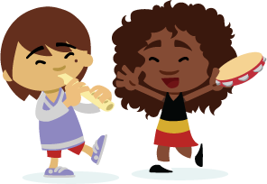

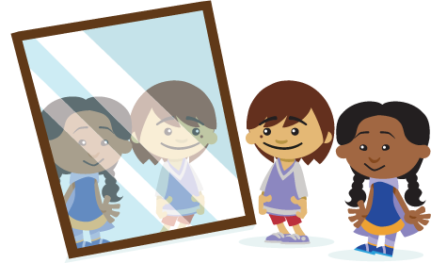 | Discover more about different cultures and different families  Discover new things about different cultures, families and communities through art, music, stories, museums, libraries and festivals. Find out more about different families’ customs, values and beliefs.

Find out more ways to build belonging in your centre at the Australian Human Rights Commission’s ‘Building Belonging’ website.

