Sydney New Year’s Eve Unit 2014 - 2017 Inclusion (Disability) Action Plan
April 2014
City of Sydney
Town Hall House
456 Kent Street
Sydney NSW 2000

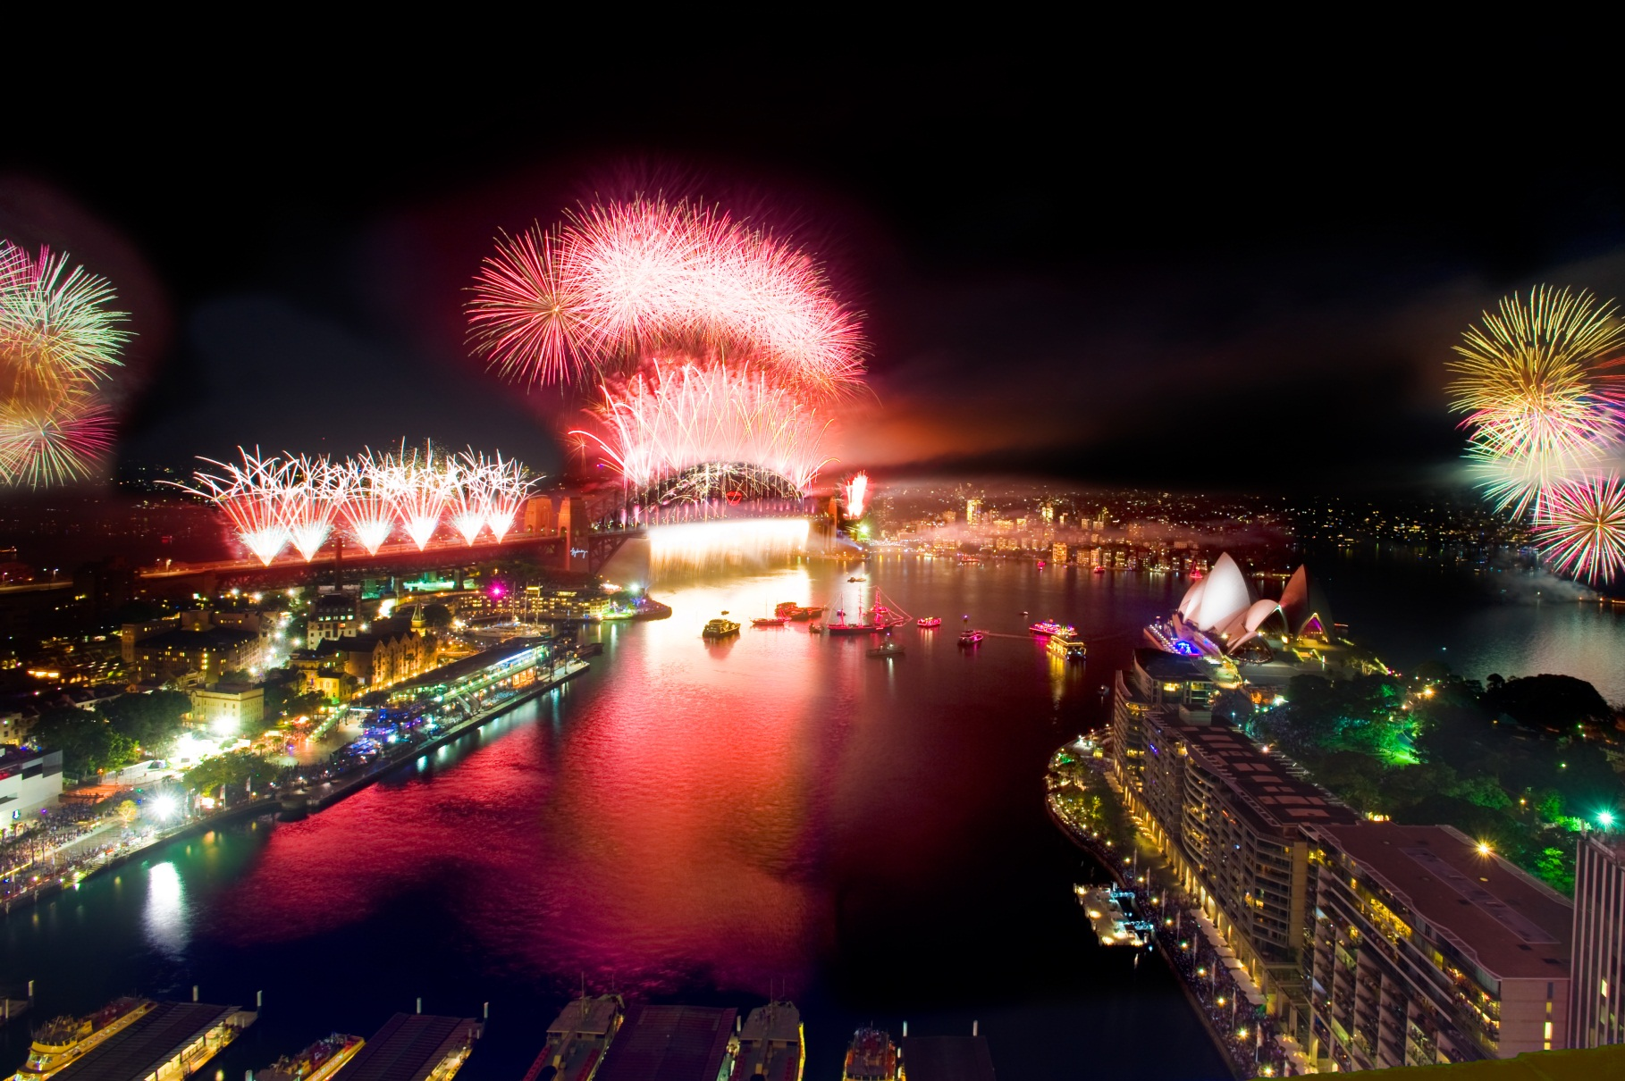

Contents
Executive Summary 2
Introduction 2
Sydney New Year’s Eve Unit 2
Customers 4
City of Sydney 4
Accessible Tourism 5
Stakeholders 6
Relevant Legislation and Policy 6
City of Sydney Statement of Commitment 6
Definition of Disability 7
Consultation Process 7
Monitoring and Evaluation 7
Review 7
Sydney New Year’s Eve Business Objectives 7
Challenges 7
Mission Statement 9
Objectives 9
Aims 9
Action Plan: 10
Objective 1: Increase participation of people with disability who experience Sydney New Year’s Eve 10
Objective 2: Lead the industry in best practice of event accessibility 12

Executive Summary
The City of Sydney’s New Year’s Eve Unit is committed to making the Sydney New Year’s Eve experience safe, inclusive, accessible and enjoyable for all and increasing the participation of people with disability. The first Inclusion (Disability) Action Plan was implemented in 2011 to align with the City of Sydney’s Sustainable 2030 Vision.
The uniqueness of the Sydney New Year’s Eve event, the physical landscape of the city, and the number of agencies involved in the execution of the event provide significant challenges.
This plan determines the strategic direction of the accessibility program for the unit over the next three years. The framework in this plan will allow the unit to consult better with the disability sector and stakeholders to ensure improvement and consistency of accessibility services across the event.

Introduction

Sydney New Year’s Eve Unit
Sydney New Year’s Eve (SNYE) is the world’s ultimate fireworks event, reaching 1.6 million people by Sydney Harbour, 2.7 million across Australia and more than a billion worldwide. Research by Events NSW found that Sydney New Year’s Eve contributes $156 million to the local economy. The event draws larger crowds than Paris (100,000), London (700,000), Berlin (1 million) and New York City (1 million). It is the reason why Sydney is the New Year’s Eve Capital of the World.
The event is produced by the City of Sydney. Fifteen months of hard work go into planning, designing and preparing Sydney New Year’s Eve each year by the City’s team of six dedicated full-time staff led by the Producer. Over 1,000 accredited personnel work on the night of the event to ensure everything runs smoothly, with 300 volunteers also pledging their time and support to help with Sydney New Year’s Eve.
The City of Sydney’s New Year’s Eve fireworks displays are the world’s largest and most technologically advanced for New Year’s Eve. Each year the top-secret Sydney Harbour Bridge (Lighting) Effect is a highly anticipated part of the night and is revealed in part during the 9PM Family Fireworks display and in full during the Midnight Fireworks display. The fireworks displays are carefully designed by the City of Sydney’s pyrotechnics contractor, Foti International Fireworks, and require a pyrotechnical crew of 45.
Some of the main components of the Sydney New Year’s Eve event produced by the City of Sydney are:

Pre-Show Entertainment
A series of pre-show entertainment components entertain the crowd gathered around Sydney Harbour in advance of the Fireworks displays. Entertainment includes Harbour-focussed aerial flyers, the Sydney Port’s Fire Tug, and a traditional Aboriginal and Torres Strait Islander Smoking Ceremony to cleanse the Harbour of bad spirits.

Acknowledgement of Country
The Acknowledgement of Country segment is a ceremony of respect for the Aboriginal and Torres Strait Islanders peoples as custodians of the land, acknowledging their culture and traditions. It is performed prior to the commencement of the Sydney New Year’s Eve celebratory programme both on Sydney Harbour and at the Lord Mayor’s Party.

9pm Family Fireworks
Designed and choreographed specifically for children with a pop soundtrack to match, these fireworks delight and dazzle audiences as the night sky fills with colour. The 9PM Family Fireworks display is a prelude to the spectacular display that follows at midnight.

Harbour of Light Parade®
The Harbour of Light Parade® features up to 60 illuminated boats, making a majestic passage within and around the Sydney Harbour Exclusion Zone after the 9PM Family Fireworks, building up excitement before the countdown to midnight. The boats carry over 8,000 people and join more than 3,000 other vessels celebrating NYE on Sydney Harbour.

Midnight Fireworks
At the stroke of midnight, we celebrate the start of a New Year! Sydney does this in style by lighting up the night sky with a spectacular fireworks display, launched from barges on the Harbour, and the Sydney Harbour Bridge.

Lord Mayor’s Party
From 8pm until 2am, 1,200 invited guests of the Lord Mayor and the City of Sydney enjoy live music and entertainment at a premiere function on the Northern Broadwalk of the Sydney Opera House. In addition to providing guests with the greatest view of the Sydney Harbour celebrations, the site functions as the host location for the national television broadcast of the event.

Lord Mayor’s Picnic
Held at the Royal Botanic Gardens from 5pm until after the 9pm Family Fireworks, this invitation only event is for 1,000 children with specific needs and their carers. Tickets are distributed via registered charities, with the City providing activities, entertainment, catering and a first-class view of the 9pm Family Fireworks.

Dawes Point Viewing Area
An invitation only event for 2,200 guests of the City of Sydney, including families of sponsors and event partners held at Dawes Point Reserve in The Rocks. The function runs from 8pm until 1am, providing a casual environmental, entertainment, and a prime foreshore location to enjoy the Fireworks displays.

General Public Serviced Sites
In conjunction with agencies and landowners, the City of Sydney will provide access to viewing locations and associated amenities for the general public to view and access the 2013 Sydney New Year’s Eve celebrations.
Within the Local Government Area, the City of Sydney will provide six serviced sites offering views of elements of Sydney Harbour celebrations, food and beverage vendors and general amenities:
- Bicentennial Park – Glebe
- Embarkation Park – Kings Cross
- Observatory Hill – Millers Point
- Pirrama Park – Pyrmont
- Giba Park – Pyrmont
- Beare Park – Elizabeth Bay

Citywide Operations
Macquarie Street is a key precinct for Sydney New Year’s Eve. It provides the means of accessing ticketed events including the Lord Mayor’s Party and Picnic and events at Sydney Opera House, Royal Botanic Garden and RTA Cahill Expressway, produced by landowners. The area will provide a main entry point for the general public accessing prime foreshore viewing locations, businesses and residents in East Circular Quay as well as standby for the City’s Official Party vehicles.
To assist with crowd safety and access management, the City of Sydney operates a managed access point at Macquarie Street, north of Bridge Street and a soft ticket checkpoint at Conservatorium Road.
The City of Sydney provides spectator information services via information booths and way finding signage throughout the city. Across the Sydney CBD area, in addition to the six serviced sites, the City of Sydney will coordinate the provision of general food and beverage vendors in a variety of high-traffic general public areas including Circular Quay, George Street and Hyde Park.

Customers

Sydney New Year’s Eve Event
SNYE attracts 1.6 million attendees on the night who watch the fireworks from vantage points around Sydney Harbour these include residents, event goers, families with children, youth, domestic and international visitors.
A national television audience of over two million and a global television audience of more than one billion from 160 countries worldwide watch the broadcast of the Fireworks Displays.

City of Sydney
The City of Sydney is a vibrant Local Government Area, made up of diverse community groups spread across 2,672 hectares (27 km2). As one of Australia’s leading global cities, the City is unique and demands consideration of how we treat residents, workers and visitors. Over 395,000 people work in the City and 10.5 million people visit Metropolitan Sydney annually.
Currently, there are more than 180,000 people living within the City’s boundaries, with the population predicted to increase by 1.5 per cent per annum to reach 243,000 people by 2030. In 2011, more than 4,000 residents of the City of Sydney reported needing help with day‑to‑day activities including self-care, body movement and communication due to disabilities.1 However, this number is not a true reflection of the extent of the City’s responsibilities; we know there are many more residents who identify with disability, and many people with a disability who visit and work in the City of Sydney.
In Australia, we know that approximately 20 per cent of the Australian population, equivalent to more than 3 million people have one or more disabilities. There are “1.3 million people in NSW with disability, of which 420,000 have a severe or profound disability that affects their ability to communicate, get around and care for themselves”.2 Given that approximately one in five people have some form of disability in Australia, inclusion and access is vital for City of Sydney as a global, inclusive and accessible city.
1. Australian Bureau of Statistics, Census of Population and Housing 2011, compiled and presented by profile.id, available from: http://profile.id.com.au/sydney/assistance
2. National Disability Strategy NSW Implementation Plan (2013) p.4, available from: http://www.adhc.nsw.gov.au/__data/assets/file/0003/262542/3002_ ADHC_NDS_NIP_A4_reprint_web.pdf

Accessible Tourism
Tourism New South Wales has identified that there are 730,000 people with a physical disability in New South Wales. Research indicates that 77 per cent of these people travelled within Australia in the previous year and 11per cent travelled overseas. The average group size for domestic trips was 4.1 people, generally with only one person in having a disability in the group.
The National Visitor Survey estimated that:
- Some 88 per cent of people with disability take a holiday each year that accounted for some 8.2 million overnight trips.
- The average travel group size for people with a disability is 2.8 people for a domestic overnight trip and 3.4 for a day trip.
- There is a myth that the accessible tourism market does not spend because of economic circumstance and are a significant proportion of each travel market segment.
- They travel on a level comparable with the general population for domestic overnight and day trips.
- The total tourism expenditure attributable to the group is $8bn per year or 11% of overall tourism expenditure.
National Visitor Survey 2003 as analysed by Darcy and Dwyer (2008)

Economic contribution
In Australia in 2003-04, it is estimated those tourists with a disability:
- Spent between $8,034.68 million and $11,980.272 million;
- Contributed between $ 3,075.5243 million and $4,580.219 million to Tourism Gross Value Added (12.27 - 15.60 per cent of total tourism GVA);
- Contributed between $ 3,885.168 million and $5,787.435 million to Tourism Gross Domestic Product (11.02 - 16.41 per cent of total); and sustained between 51,820 and 77,495 direct jobs in the tourism industry (11.6 - 17.3 per cent of direct tourism employment).

Stakeholders
The delivery of SNYE relies on continual dialogue and engagement of a complex network of stakeholders. - event partners, local, state and Commonwealth Government Agencies, City Business Units, service providers, landowners and venues.
Regular meetings are held with these key stakeholders:
- Broadcast (Television/Radio)
- Charity Partner
- Key stakeholders: Sydney Harbour Foreshore Authority, Roads & Maritime Services, Royal Botanic Gardens, Sydney Opera House and NSW Maritime.
- NYE Maritime Operations
- Premier’s Department meetings: whole-of-government planning, primarily in the areas of operations, safety and spectator services
- Sydney Harbour Bridge

Relevant Legislation and Policy
The SNYE Unit Inclusion (Disability) Action Plan complies with the following legislation and policies:
- Australian Federal Disability Discrimination Act 1992
- NSW Disability Service Act 1993
- The Convention of the Rights of Persons with Disabilities
- National Disability Strategy 2010-2020
- National Disability Strategy NSW Implementation Plan 2012-2014
- Sustainable Sydney 2030 Community Strategic Plan
- City of Sydney Inclusion (Disability) Action Plan 2014-2017

City of Sydney Statement of Commitment
The City of Sydney is committed to being an inclusive and accessible city for people with a disability, now and in the future. The City seeks to meet and exceed its legislative obligations under the Disability Discrimination Act 1992 and become a leader in relation to these issues. The City of Sydney seeks to achieve this by providing equitable opportunities for participation for people who live, work and visit the City of Sydney. This will be achieved through:
- Ongoing dialogue and genuine consultation with people with a disability, both as a community in its own right and as members of the public with broad issues and interests;
- Improved inclusion and access to the City’s services and facilities; and
- Increased awareness and understanding of access and inclusion issues in the City’s internal workforce as well as in the wider community. The Inclusion (Disability) Action Plan will set the framework and priorities to implement best practice in relation to access and inclusion for people with a disability. Diverse participation and contributions made by the whole community will strengthen the City’s vision of a vibrant global and connected Sydney.

Definition of Disability
The definition of disability contained within the Disability Discrimination Act 1992 (DDA) is particularly broad and includes physical, intellectual, psychiatric, sensory, and neurological or learning disabilities; physical disfigurement; or the presence of disease causing organisms. It also covers disabilities that people have now, have had in the past, might have in the future, or are believed to have; the need to use a palliative or therapeutic device; the need to be accompanied by a guide dog, hearing assistance dog or other trained animal; or the need for an interpreter, reader, assistant and/or carer.
The City acknowledges the right of a person with a disability to elect not to disclose or discuss their disability with the City according to the Privacy Act and commits nevertheless to assist in any way possible.

Consultation Process
The SNYE Unit Inclusion Action Plan was developed in 2011 by the Sydney New Year’s Eve core team in consultation with stakeholders.
The City of Sydney appointed an Access Inclusion Advisory Panel in 2012. Consultation with the panel and others from the disability sector will continue annually. Targeted consultation for specific projects will be undertaken with relevant stakeholders.

Monitoring and Evaluation
The city will measure and review key outcomes annually.

Review
The plan is due for review in 2017 following recommendations from the previous year’s event. This process will include consultation with:
- Sydney New Year’s Eve core team
- City of Sydney Access Inclusion Advisory Panel
- Department of Premier and Cabinet Manager, Event Access & Inclusion
- Other interested organisations and individuals.

Sydney New Year’s Eve Business Objectives
- Showcase Sydney as a global city, highlighting cultural diversity and tourism
- Deliver an innovative event, creating and experience that is safe, inclusive, accessible and enjoyable

Challenges
- The Sydney New Year’s Eve Unit relies on other units in the City of Sydney, external agencies and organisations to deliver the event
- The event program and communication are currently substantially based on visual elements
- The event attracts a large number of spectators from a wide demographic to the city centre and various vantage points
- Sydney city terrain is steep. Paths of travel and entry to some vantage points and event sites are permanently not accessible by people with a disability
- Operational difficulties in the providing services due to crowd size, street closures and event timings
- Long wait times for spectators at vantage points and travelling to and from the event
- Lack of current accessibility mapping data and resources for accessibility event planning
- Temporary infrastructure and irregular operations obstruct ability to successfully plan and accommodate accessibility needs.

Mission Statement
Produce an experience of Sydney New Year’s Eve that is safe, inclusive, accessible and enjoyable for all.

Objectives
- Increase participation of people with disability who experience Sydney New Year’s Eve
- Lead the industry in best practice of event accessibility

Aims
- Ensure barriers faced by people with disability are no greater than the average attendee
- Build our accessibility and disability knowledge base
- Develop accessibility initiatives
- Comply with relevant legislation and policies
- Use a Universal Access approach

Action Plan:

Objective 1: Increase participation of people with disability who experience Sydney New Year’s Eve
Strategy | Performance Measure
Annual consultation with disability sector  - Develop a plan for targeted consultation to review current services and identify areas for enhancement year on year.  - Review the Accessibility Services Matrix to ensure that services are provided across a broad range of abilities | - Annual Consultation Plan completed by November each year  - Evidence of new and ongoing partnerships with disability sector representatives and organisations annually  - Annual Accessibility Services Matrix review by November of each year
Information provision:  - Profile information to general public via the official SNYE website to promote accessibility services and assist in planning for the event  - Provide dedicated event information webpage for guests of SNYE private ticketed events.  - Provide information in alternative formats on needs basis.  - Provide a designated accessibility contact and enquiry service to manage individual access options and solutions.  - Provide event on- ground services including signage and spectator services. | - Number of visits to Accessibility webpage 1 November – 31 January  - Number of visits to SNYE private tickets event webpages 1 December – 1 January  - Number or customised access plans developed  - Number spectator service volunteers provided at event  - Quantity and coverage of wayfinding signage  - Timely response to alternative formal requests
Develop a Marketing & Communications plan which includes strategies to selectively target the disability sector and raise awareness of accessibility services. | - Reach through distribution channels  - Referrals to website from disability sector sources
Enhance accessibility services city wide for the event. | - Evidence of City of Sydney services enhanced each year  - Evidence of other agencies services enhanced each year

Objective 2: Lead the industry in best practice of event accessibility
Strategy | Performance Measure
Implementation of an established SNYE Access & Inclusion Plan | - Plan reviewed every three years  - Plan registered with Human Rights Commission
Collaborate with disability sector partners and organisations to identify opportunities for future research and initiatives. | - Evidence of initiatives or participation in research projects
Showcase SNYE accessibility initiatives to promote awareness and best practice. | - Evidence of case studies developed and shared
Develop a global network for collaboration strategy. | - Evidence of strategy established
Collaborate with relevant event stakeholders to coordinate consistency across accessibility services. | - Evidence of positive outcomes from collaborative initiatives with other agencies
Collaborate with relevant stakeholders that develop accessible tourism | - Evidence of collaborative initiatives with tourism organisations
Promote and increase awareness of the rights and needs of people with disability | - Evidence of briefings that include SNYE Disability Awareness  - 100% of SNYE staff receives disability awareness development. .
Consider inclusion of artists with a disability in creative content | - Evidence that research has been conducted and placement of artists where appropriate
Consider opportunities for promotion of disability awareness across the event programming. | - Evidence of elements in creative program which integration disability awareness
Advocate for accessibility services on major events. | - Evidence of advocacy

