

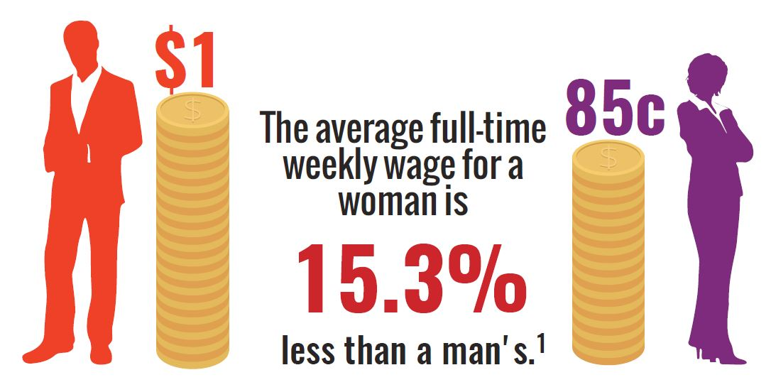

**Face the facts:**

GENDER EQUALITY • **2018**

The Australian Human Rights Commission encourages the dissemination and exchange of information provided in this publication. All material presented in this publication is provided under Creative Commons Attribution 3.0 Australia, with the exception of:

* the Australian Human Rights Commission Logo
* photographs and images
* any content or material provided by third parties.

The details of the relevant licence conditions are available on the Creative Commons website, as is the full legal code for the CC BY 3.0 AU licence.

**Attribution**

Material obtained from this publication is to be attributed to the Australian Human Rights Commission with the following copyright notice:

© Australian Human Rights Commission 2018.

**Face the Facts:** Gender equality • **2018 ISBN** 978-1-921449-88-8

**Design and layout** Dancingirl Designs

**Infographic Design** Firefly Interactive

**Content** James Iliffe, Black and White Media Australia

**Electronic format**

This publication can be found in electronic format on the website of the Australian Human Rights Commission:

[**http://www.humanrights.gov.au/publications**](http://www.humanrights.gov.au/publications/sex-discrimination)

**Contact details**

For further information about the Australian Human Rights Commission, please visit

[**www.humanrights.gov.au**](http://www.humanrights.gov.au/)or email [**communications@humanrights.gov.au**.](mailto:communications@humanrights.gov.au) You can also write to:

Communications Team

Australian Human Rights Commission GPO Box 5218

Sydney NSW 2001

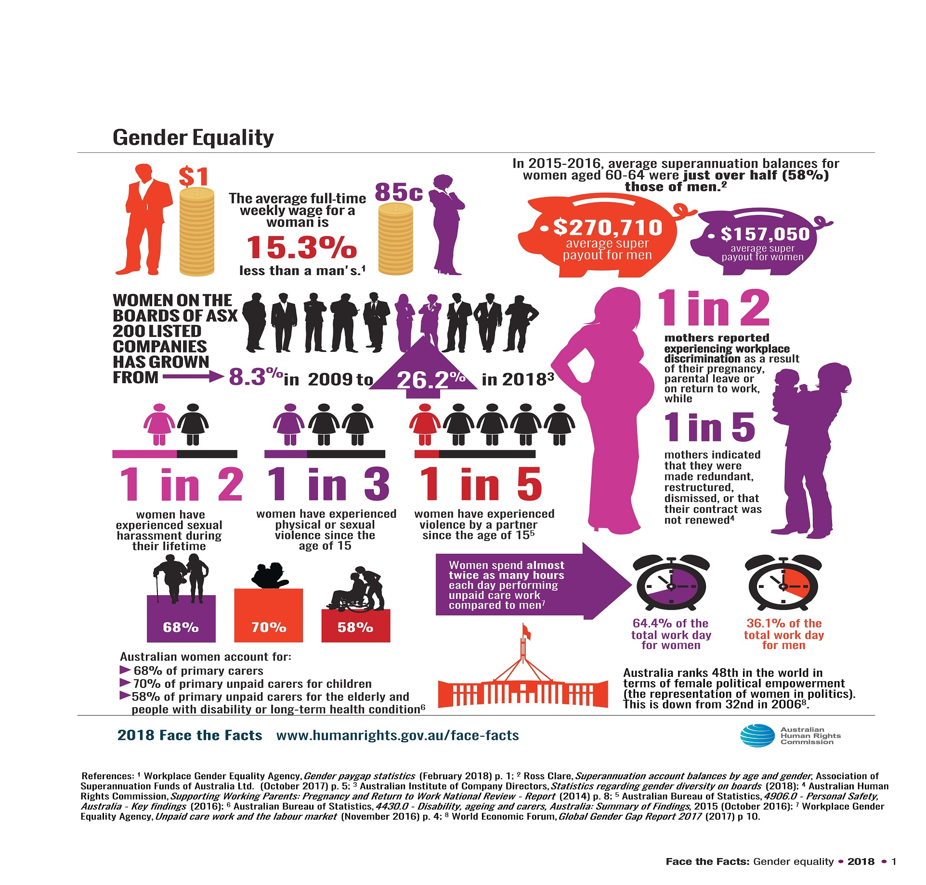

Gender equality

In recent decades, women in Australia have made significant strides towards equality with men. At universities, in workplaces, in boardrooms and in government, a growing number of women have taken on leadership roles, forging pathways for other women and girls to follow.

In 1984, the [Sex Discrimination Act](https://www.humanrights.gov.au/publications/know-your-rights-sex-discrimination-and-sexual-harassment) came into force, making sex discrimination and sexual harassment across various parts of public life against the law.

The Act, which gives effect to Australia’s [international human](http://www.humanrights.gov.au/sex_discrimination/international/cedaw.html) [rights obligations](http://www.humanrights.gov.au/sex_discrimination/international/cedaw.html), has played an important role in changing community attitudes and helping advance gender equality in this country.

Despite this progress, women and girls continue to experience inequality and discrimination in many important parts of their lives, which can limit the choices and opportunities available to them.

About

* Women and girls make up just over half (50.7 per cent) of the Australian population.1
* While women comprise roughly 47 per cent of all employees in Australia,2 they take home $251.20 less than men each week (full-time adult ordinary earnings).3 The national gender “pay gap” is 15.3 per cent and it has remained stuck between 15 per cent and 19 per cent for the past two decades.4
* Australian women account for 68% of primary carers for older people and people with disability.5
* 95% of primary parental leave (outside of the public-sector) is taken by women and women spend almost three times as much time taking care of children each day, compared to men. 6
* In 2017, Australia was ranked 35th on a global index measuring gender equality, slipping from a high point of 15th in 2006. While Australia scores very highly in the area of educational attainment, there is still a lot of progress to be made in the areas of economic participation and opportunity and political empowerment. 7

## Barriers to gender equality

* [The Australian workforce is highly segregated by](http://www.humanrights.gov.au/publications/gender-equality-blueprint-2010#fn32) [gender and female-dominated industries – such as](http://www.humanrights.gov.au/publications/gender-equality-blueprint-2010#fn32) [aged care, child care and health and community](http://www.humanrights.gov.au/publications/gender-equality-blueprint-2010#fn32) [services – have been historically undervalued.8](http://www.humanrights.gov.au/publications/gender-equality-blueprint-2010#fn32) [Australian women are over-represented as part-time](http://www.humanrights.gov.au/publications/gender-equality-blueprint-2010#fn32) [workers in low-paid industries](http://www.humanrights.gov.au/publications/gender-equality-blueprint-2010#fn32) and in insecure work and continue to be underrepresented in leadership roles in the private and public sectors.9
* More than half of women aged 18 or older have experienced sexual harassment in their lifetime.10
* On average, women spend 64 per cent of their working week performing unpaid care work.11 They spend almost twice as many hours performing such work each week compared to men.12
* In 2015-2016 the average Australian woman was reaching retirement with an average of $113,660 less superannuation than the average male.13 As a result, women are more likely to experience poverty in their retirement years and be far more reliant on the Age Pension.14
* More than one in three Australian women has experienced physical or sexual violence in her lifetime and one in two experiences sexual harassment.15 It is estimated that violence against women and their children cost the Australian economy $22 billion in 2015-16.16

## Positive developments

* + The number of women on the Boards of ASX-listed companies grew from 8.3 per cent in 2009 to

26.2 per cent in 201717 due in part to a diversity policy implemented by the ASX Corporate Governance Council in 2010. [Increasing the number of women in](http://www.humanrights.gov.au/publications/women-male-dominated-industries-toolkit-strategies-2013/chapter-1-summary-strategies#fn7) [corporate leadership positions is likely to](http://www.humanrights.gov.au/publications/women-male-dominated-industries-toolkit-strategies-2013/chapter-1-summary-strategies#fn7)  significantly increase financial returns.18

* + Australian men and women overwhelmingly believe (90 per cent) that men should be as involved in parenting as women.19 However, while a significant number of fathers, and in particular young fathers, would like to be able to access better workplace flexibility arrangements, men are much more likely than women to have such requests denied.20
  + As of 2016, over one million Australian workers are able to take leave and enjoy other protections because of domestic violence clauses in their workplace agreement or award conditions.21

## Did you know?

* + Australian women have to work an **extra 56 days a year** to earn the same pay as men for doing the **same work**.22

## Find out more

* Australian Bureau of Statistics, [*Caring in the*](http://www.abs.gov.au/ausstats/abs@.nsf/Latestproducts/4436.0Main%20Features22012?opendocument&tabname=Summary&prodno=4436.0&issue=2012&num=&view=)[*Community, 2012*](http://www.abs.gov.au/ausstats/abs%40.nsf/Latestproducts/4436.0Main%20Features12009?opendocument&amp;tabname=Summary&amp;prodno=4436.0&amp;issue=2009&amp;num&amp;view)(updated June 2014)
* Australian Bureau of Statistics, [*Gender Indicators, Australia*](http://www.abs.gov.au/ausstats/abs@.nsf/mf/4125.0) (latest update 2017)
* Australian Human Rights Commission, [*Working*](https://www.humanrights.gov.au/working-without-fear-results-sexual-harassment-national-telephone-survey-2012)[*without fear: Results of the Sexual Harassment*](https://www.humanrights.gov.au/working-without-fear-results-sexual-harassment-national-telephone-survey-2012)[*National Telephone Survey*](https://www.humanrights.gov.au/working-without-fear-results-sexual-harassment-national-telephone-survey-2012)(2012)
* Australian Human Rights Commission, [*Unleashing Gender Equality*](https://www.humanrights.gov.au/our-work/sex-discrimination/publications/unleashing-power-gender-equality-2017) (2017)
* Australian Human Rights Commission, [*Supporting Working Parents: Pregnancy and Return to Work National Review – Report*](https://www.humanrights.gov.au/our-work/sex-discrimination/publications/supporting-working-parents-pregnancy-and-return-work) (2014)
* Our Watch,[*Change the Story: A shared framework for the primary prevention of violence*](https://www.ourwatch.org.au/What-We-Do/National-Primary-Prevention-Framework)(2015)
* Australia’s National Research Organisation for Women’s Safety, [*Publications*](https://anrows.org.au/publications-0).
* Workplace Gender Equality Agency, [*Gender pay gap*](https://www.wgea.gov.au/sites/default/files/gender-pay-gap-statistics.pdf)[*statistics*](https://www.wgea.gov.au/sites/default/files/2014-03-04-Gender_Pay_Gap_factsheet_website.pdf)(August 2017)
* Workplace Gender Equality Agency*,* [*Gender workplace statistics at a glance*](https://www.wgea.gov.au/sites/default/files/Stats%20at%20a%20Glance%20FEB2017.pdf)(February 2017)
* World Economic Forum, [*Global Gender Gap Report*](https://www.weforum.org/reports/the-global-gender-gap-report-2017)[*2017*](http://www.weforum.org/reports/global-gender-gap-report-2013)(2017)

## Our role

The Commission helps people resolve complaints of unfair treatment under the [Sex Discrimination Act](https://www.humanrights.gov.au/publications/know-your-rights-sex-discrimination-and-sexual-harassment), including discrimination on the basis of sex, marital (or relationship) status and pregnancy. The Act also protects workers with family responsibilities and makes sexual harassment against the law.

The [Sex Discrimination Commissioner](https://www.humanrights.gov.au/about/commissioners/sex-discrimination-commissioner) works in partnership with a broad range of groups to promote gender equality and counter discrimination, sexual harassment, violence against women and other barriers to equality. She also undertakes major research projects and provides policy advice to government and others to bring about positive change.

Find out more about [our work](https://www.humanrights.gov.au/our-work/sex-discrimination) in this area.

Endnotes

1. Australian Bureau of Statistics*,* [*2071.0 - Census of Population and Housing: Reflecting Australia – Stories from the Census, 2016, Snapshot of Australia*](http://www.abs.gov.au/ausstats/abs@.nsf/Lookup/by%20Subject/2071.0~2016~Main%20Features~Snapshot%20of%20Australia,%202016~2) (June, 2017).
2. Australian Bureau of Statistics, [*6202.0 - Labour Force, Australia, Table 01:*](http://www.abs.gov.au/AUSSTATS/abs@.nsf/DetailsPage/6202.0Dec%202017?OpenDocument)[*Labour force status by sex*](http://www.abs.gov.au/AUSSTATS/abs@.nsf/DetailsPage/6202.0Dec%202017?OpenDocument)(December 2017).
3. Workplace Gender Equality Agency, [*Gender pay gap statistics*](https://www.wgea.gov.au/sites/default/files/gender-pay-gap-statistics.pdf)

(February 2018) p 1.

1. Workplace Gender Equality Agency, [*Gender pay gap statistics*](https://www.wgea.gov.au/sites/default/files/gender-pay-gap-statistics.pdf)

(February 2018) p 3.

1. Australian Bureau of Statistics[, *4430.0 - Disability, ageing and carers, Australia: Summary of Findings, 2015*](http://www.abs.gov.au/AUSSTATS/abs@.nsf/Latestproducts/4430.0Main%20Features402015?opendocument&tabname=Summary&prodno=4430.0&issue=2015&num=&view=)(October 2016).
2. Australian Bureau of Statistics,[*4125.0 - Gender Indicators, Australia, Table 10.1: Total number of hours and minutes per day spent on work (employment related and unpaid)*](http://www.abs.gov.au/AUSSTATS/abs@.nsf/Lookup/4125.0Main+Features2Sep%202017?OpenDocument) (September 2017).
3. World Economic Forum, [*Global Gender Gap Report 2017*](https://www.weforum.org/reports/the-global-gender-gap-report-2017)(2017) p 10.
4. Australian Human Rights Commission, [*Women in male-dominated*](https://www.humanrights.gov.au/women-male-dominated-industries-toolkit-strategies)[*industries: A toolkit of strategies*](https://www.humanrights.gov.au/women-male-dominated-industries-toolkit-strategies)(2013), p 3.
5. For example: approximately 45 per cent of women in the workforce are employed part-time compared with around 16 per cent of men. See: Australian Bureau of Statistics*,* [*4125.0 – Gender Indicators, Summary – Economic Security*](http://www.abs.gov.au/ausstats/abs@.nsf/Lookup/by%20Subject/4125.0~Sep%202017~Main%20Features~Economic%20Security~4)(September 2017); women make up only 5 percent of CEOs and only 20 per cent of executive management in ASX 200 companies (see: Chief Executive Women, [*Senior Executive Census 2017*](https://cew.org.au/media-and-research/cew-research/)) and, despite making up almost 60 per cent of all Commonwealth public servants, they comprise only 43 per cent of the Senior Executive Service (see: [*Australian Public Service Statistical Bulletin, Tables 8 and 12*](https://data.gov.au/dataset/australian-public-service-statistical-bulletin-snapshot-at-december-31-2016) (31 December 2016).
6. Australian Bureau of Statistics, [4906.0 – Personal Safety, Australia, 2016, Experience of Sexual Harassment](http://www.abs.gov.au/ausstats/abs@.nsf/Lookup/by%20Subject/4906.0~2016~Main%20Features~Experience%20of%20Sexual%20Harassment~29) (2017).
7. Workplace Gender Equality Agency, [*Unpaid care work and the labour market*](https://www.wgea.gov.au/.../australian-unpaid-care-work-and-the-labour-market.pdf) (November 2016) p 4.
8. Workplace Gender Equality Agency, [*Unpaid care work and the labour market*](https://www.wgea.gov.au/.../australian-unpaid-care-work-and-the-labour-market.pdf) (November 2016) p 4.
9. Association of Superannuation Funds of Australia Ltd., [*Superannuation account balances by age and gender*](https://www.superannuation.asn.au/ArticleDocuments/359/1710_Superannuation_account_balances_by_age_and_gender.pdf.aspx?Embed=Y) (October 2017) p 5.
10. R Tanton, Y Vidyattama, J McNamara, Q Ngu Vu & A Harding, [*Old Single*](http://onlinelibrary.wiley.com/doi/10.1111/j.1759-3441.2009.00022.x/abstract)[*and Poor: Using Microsimulation and Microdata to Analyse Poverty and*](http://onlinelibrary.wiley.com/doi/10.1111/j.1759-3441.2009.00022.x/abstract)[*the Impact of Policy Change Among Older Australians*](http://onlinelibrary.wiley.com/doi/10.1111/j.1759-3441.2009.00022.x/abstract)(2008) p 15.
11. Australian Bureau of Statistics[, *4906.0 – Personal Safety, Australia – Key findings*](http://www.abs.gov.au/ausstats/abs@.nsf/Lookup/by%20Subject/4906.0~2016~Main%20Features~Key%20Findings~1)(2016).
12. KPMG*,* [*The Cost of Violence against Women and their Children in Australia*](https://www.dss.gov.au/women/publications-articles/reducing-violence/the-cost-of-violence-against-women-and-their-children-in-australia-may-2016) (May 2016) p 4.
13. Australian Institute of Company Directors, [*Appointments to ASX 200*](http://aicd.companydirectors.com.au/advocacy/board-diversity/statistics)[*Boards*](http://www.companydirectors.com.au/Director-Resource-Centre/Governance-and-Director-Issues/Board-Diversity/Statistics)(updated online resource).
14. Deloitte Access Economics, [Toward Gender Parity: Women On Boards Initiative](https://www2.deloitte.com/content/dam/Deloitte/au/Documents/Economics/deloitte-au-toward-gender-parity-women-on-boards-initiative-041016.pdf) (Research Report) (October 2016).
15. A Evans and E Gray, ‘What makes an Australian family?’ in S Wilson,

G Meagher, R Gibson, D Denemark & M Western (eds), *Australian Social Attitudes: The first report* (2005), pp 12–29, p 27.

1. Workplace Gender Equality Agency*,* [*Engaging men in flexible workplace arrangements*](https://www.wgea.gov.au/sites/default/files/20130829_PP_engaging_men_flex_work_2.pdf) (August 2013) p 2.
2. L McFerran, [*Domestic violence is a workplace issue; Australian developments 2009-2016*](https://www.wgea.gov.au/completed-australian-research/domestic-violence-workplace-issue-australian-developments-2009-2016http:/www.abc.net.au/unleashed/4516492.html) (June 2016).
3. Equal Pay Day marks the additional number of days that the average woman must work in a year to receive the same amount of pay as the average man. Equal Pay Day is calculated using the following formula: 365 days x gender gap estimate ÷ 100. Workplace Gender Equality Agency[, *Gender pay gap statistics*](http://www.wgea.gov.au/sites/default/files/2014-03-04-Gender_Pay_Gap_factsheet_website.pdf)(March 2014) p 4; Workplace Gender Equality Agency, [*Gender pay gap statistics*](https://www.wgea.gov.au/sites/default/files/gender-pay-gap-statistics.pdf)(February 2017) p 3.