Improving life for people with disabilities

Australian Human Rights Commission GPO Box 5218

Sydney NSW 2001

**RE: FaHCSIA's Application for an exemption under the Disability Discrimination Act 1992 (Cth) to use the BSWAT.**

Advocacy for Inclusion opposes FaHCSIA's application for an exemption under the DDA to permit Australian Disability Enterprises (ADEs) to continue to assess and pay wages using the BSWAT.

The Federal Court was clear in its ruling that the competency component of the BSWAT is discriminatory because it assesses competencies irrelevant to the worker's actual job. This discrimination has occurred since the introduction of BSWAT 10 years ago and it is unacceptable to allow this discrimination to continue for a further 3 years. The High Court has subsequently confirmed this view.

In addition, the United Nations Committee on the Rights of Persons with Disabilities has now made an unambiguous recommendation that Australia immediately cease to use the BSWAT1.

FaHCSIA has requested a 3 year exemption to undertake further consultation, sector development, assessments, capacity building among people with disabilities and families, and to establish a new wage assessment tool. These tasks are clearly targeted at achieving a long-term solution. Knowingly subjecting people with disabilities to continuing discrimination while a long-term solution is developed is unacceptable and unfair. FaHCSIA must commit to an interim solution while it transitions the entire system to become more human rights compliant.

FaHCSIA has already undertaken initial consultations resulting in wide agreement that the Supported Wage

System (SWS) should be introduced as the alternative to BSWAT. Some believed that the minimum wage component should be modified prior to introduction. The SWS already exists and is recognised as valid and non-discriminatory2. Advocacy for Inclusion recommends that FaHCSIA introduce this system immediately, with the necessary modifications, as an **interim** solution while the 3 year transition towards a long-term solution is developed.

FaHCSIA states that if a 3 year transition period, using the BSWAT, is not allowed ADEs may be unable to comply with legislated quality assurance requirements and through this lose certification and funding.

1 Committee on the Rights of Persons with Disabilities. (4 October 2013). *Concluding observations on the initial report of Australia, adopted by the Committee at its tenth session (2-13 September 2013)* (Para. 50). http://tbinternet.ohchrorgi_layouts/treatybodyexternal/Download.aspx?symbolno=CRPD%2fCc/o2fAUS%2fC0%2f1&Lang=en

2 NCI D. (10 May 2013). *Commonwealth discriminates against people with intellectual disability, High Court rules.* <http://www.ncid.org.au/index.php/employment-first/108-commonwealth-discriminates-against-people-with-intellectual-disability-high-court-rules>

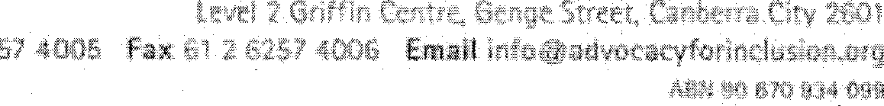

FAHCSIA should accept responsibility for managing this by focussing immediate attention on facilitating transition for those ADEs that use the BSWAT to move to SWS.

The BSWAT issue sits in a much broader issue of a discriminatory employment system, which segregates people with disabilities in workplaces separate from the open labour market, and which fails to provide meaningful work for fair pay. The Court rulings provide a much needed point for dramatic, whole of system change aimed at supporting people with disabilities in open employment for fair pay. Delaying the change to BSWAT only enables this discriminatory system to become further embedded, and condones deliberate discrimination.

Advocacy for Inclusion opposes this exemption, in accordance with the CRPD Concluding Observations, and insists on an immediate move to the Supported Wages System as part of a 3 year transition towards a more inclusive employment system for people with disabilities.

Yours sincerely

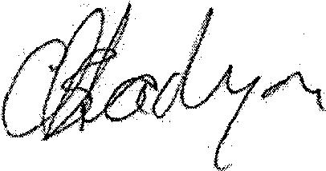

Christina Ryan General Manager 8 October 2013