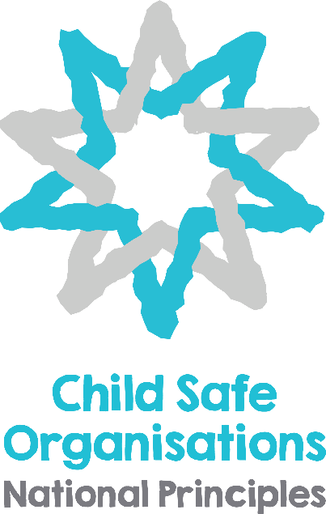

National Statement of Principles for Child Safe Organisations
(Consultation Draft)

The National Statement of Principles for Child Safe Organisations is released for sector wide consultation from 2017 – 2018.
To learn more about the National Statement of Principles for Child Safe Organisations or to provide feedback please visit www.humanrights.gov.au/child-safe or contact childsafe@humanrights.gov.au.

PREAMBLE

Australia ratified the United Nations Convention on the Rights of the Child (CRC) in 1990. Under the Convention, children and young people, like adults, possess human rights. They also have the right to special protection because of their vulnerability to exploitation and abuse. Under the Convention, a child is defined as every human being below eighteen years of age.

A wide range of organisations work with children and young people throughout Australia. These may be small and community based, such as a sports club or playgroup where families and community members contribute voluntarily, through to more highly organised structures like schools, hospitals and churches. These may also be businesses or organisations employing staff and/or volunteers providing services to and working with children and young people, and which may work across state boundaries.

In 2013 the Australian Government authorised a Royal Commission into Institutional Responses to Child Sexual Abuse in response to community concern about widespread reports of cases where Australian institutions failed to protect children from sexual abuse. The work of this Commission has emphasised that members of the public, children and young people, parents, carers, families and communities should be confident that organisations working with children provide safe environments where children’s rights, needs and interests are met.
On (date of COAG endorsement) 2018 Council of Australian Governments (COAG) endorsed a National Statement of Principles for Child Safe Organisations (the National Principles). Drawn from the work of the Royal Commission, Australia’s Children’s Commissioners and Guardians and the 2005 National Framework for Creating Safe Environments for Children, the National Principles are underpinned by a child-rights approach to build capacity to deliver child safety and wellbeing in organisations, families and communities.

The National Statement of Principles will drive implementation of a child safe culture across all sectors providing services to children and young people to ensure the safety and wellbeing of children and young people across Australia. The principles are high level to allow flexibility in implementation and in recognition of the variety of organisational types, sizes and capacities. The indicators are examples of signposts that an organisation meets the principles. The indicators are provided as a guide only and will vary for different organisations.

The adoption and application of these principles throughout all relevant sectors nationwide is a significant milestone in promoting child safety and wellbeing.

The National Statement of Principles sets out 10 principles which collectively show that a child safe organisation is one that creates a culture, adopts strategies and takes action to promote child wellbeing and prevent harm to children and young people. A child safe organisation consciously and systematically:
- Creates an environment where children’s safety and wellbeing is the centre of thought, values and actions.
- Places emphasis on genuine engagement with and valuing of children
- Creates conditions that reduce the likelihood of harm to children and young people
- Creates conditions that increase the likelihood of identifying any harm
- Responds to any concerns, disclosures, allegations or suspicions of harm.
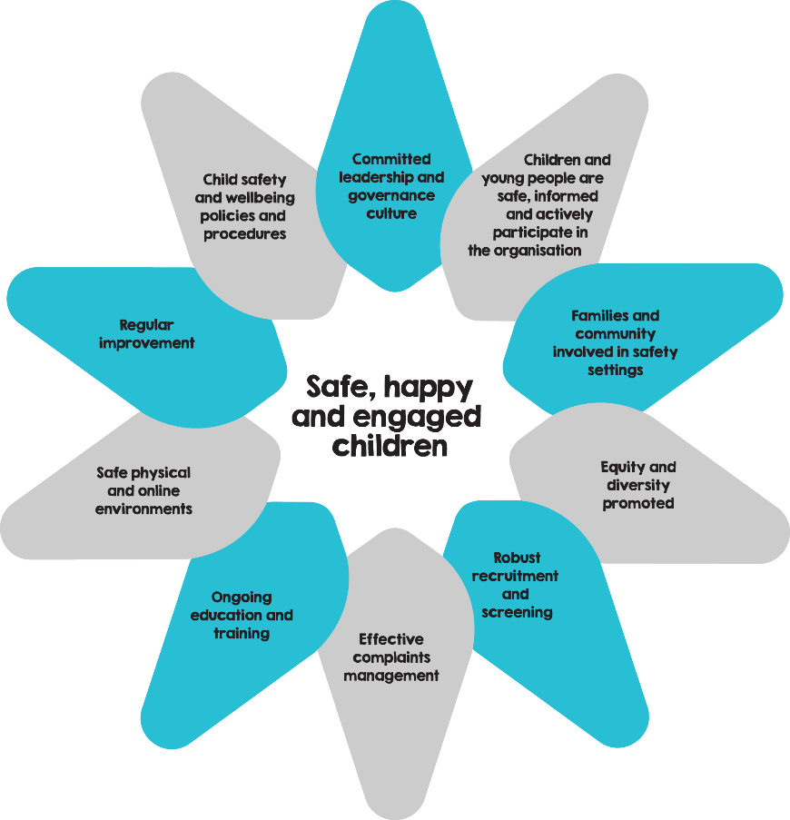

Wheel of Child Safety
The graphic on this page depicts a 10 point star known as the Wheel of Child Safety. The points of the star match the 10 Principles. Starting at the top centre point and working in a clockwise direction, the Principles read:

- Committed leadership and governance culture
- Children and young people are safe, informed and actively participate in the organisation
- Families and community involved in safety settings
- Equity and diversity promoted
- Robust recruitment and screening
- Effective complaints management
- Ongoing education and training
- Safe physical and online environments
- Regular improvement
- Child safety and wellbeing policies and procedures

In the centre of the star it says “Safe, happy and engaged children”.

National Statement of Principles for Child Safe Organisations

- A commitment to child safety and wellbeing is embedded in organisational leadership, governance and culture.

- Children and young people are informed about their rights, participate in decisions affecting them and are taken seriously.

- Families and communities are informed and involved in promoting child safety and wellbeing.

- Equity is promoted and diversity is respected in policy and practice.

- People working with children and young people are suitable and supported to reflect child safety and wellbeing values in practice.

- Processes for complaints and concerns are responsive, understood, accessible and used by children, young people, families, staff and volunteers.

- Staff and volunteers are equipped with the knowledge, skills and awareness to keep children and young people safe through ongoing education and training.

- Physical and online environments promote safety and wellbeing while minimising the opportunity for children and young people to be harmed.

- Organisations regularly review and improve implementation of their child safety and wellbeing policies and procedures.

- Policies and procedures document how the organisation is safe for children and young people.

INDICATIVE ONLY - SIGNATURE PAGE FOR COAG ENDORSEMENT

The Parties have confirmed their commitment to the National Statement of Principles for Child Safe Organisations as follows:

Signed for and on behalf of
the Commonwealth of Australia by

XXXXXX

Prime Minister of Australia

Signed for and on behalf of  the State of New South Wales by  XXXXXX  Premier of New South Wales | Signed for and on behalf of  the State of Western Australia by  XXXXXX  Premier of Western Australia
Signed for and on behalf of  the State of Queensland by  XXXXXX  Premier of Queensland | Signed for and on behalf of  the State of Tasmania by  XXXXXX  Premier of Tasmania
Signed for and on behalf of  the State of South Australia by  XXXXXX  Premier of South Australia | Signed for and on behalf of  the Australian Capital Territory by  XXXXXX  Chief Minister of ACT
Signed for and on behalf of  the State of Victoria by  XXXXXX  Premier of Victoria | Signed for and on behalf of  the Northern Territory by  XXXXXX  Chief Minister of NT

Principle 1: A commitment to child safety and wellbeing is embedded in organisational leadership, governance and culture.

Article 3: All adults should do what is best for children. When adults make decisions, they should think about how their decisions will affect children.

This principle provides guidance on the role of organisational leadership and governance in promoting inclusive and welcoming environments for children and young people and the ways in which a child safe culture is developed and maintained.

Governance arrangements are transparent and include a shared commitment to child safety and wellbeing through all levels of the organisation, a child safety and wellbeing policy, practice guidance, a Code of Conduct and a risk management framework. The organisation is public about its commitment to child safety and wellbeing. Governance arrangements will vary depending on the type, nature and size of an organisation. Organisational leadership provides an authorising environment for the sharing of information about risks to children and young people.
Key action areas:
  - A child safe culture is championed and modelled at all levels of the organisation from the top down and the bottom up.
  - The organisation makes a public commitment to child safety.
1.3 An accessible and clear child safety and wellbeing policy is widely available.
1.4 A Code of Conduct provides guidelines for staff and volunteers on expected behavioural standards and responsibilities.
1.5 Governance arrangements facilitate implementation of the child safety and wellbeing policy at all levels.
1.6 Risk management strategies focus on preventing, identifying and mitigating risks to children and young people.
1.7 Leaders promote sharing good practice and learnings about child safety and wellbeing.

Indicators that this principle is upheld:
- Organisations can demonstrate they have publicly available and current documents such as a child safety and wellbeing policy, practice guidance, information sharing protocols, staff and volunteer codes of conduct and risk management strategies.
- The organisational leadership models and regularly reinforces attitudes and behaviours that value children and young people and a commitment to child safety and wellbeing. This commitment is clear in duty statements, performance agreements and staff and volunteer review processes.
- Staff, volunteers, children and young people have a sound knowledge of children’s rights, including their rights to feel safe and be heard, and the accountabilities that accompany these rights.

Principle 2: Children and young people are informed about their rights, participate in decisions affecting them and are taken seriously.

Article 12: Children have the right to give their opinion, and for adults to listen and take it seriously.

This principle explores how children and young people are informed about their rights and responsibilities in an age appropriate way. In this way, they can contribute to and actively participate in building an organisational culture that is safe for them. They will know about the organisation’s commitment to child safety and wellbeing and access relevant information and programs. This will include recognising safe environments and understanding protective behaviours. Staff and volunteers will value and respect children and young people, be comfortable and skilled in engaging with them, and understand their developmental needs.

This principle encourages an organisational culture where children and young people are supported to understand what safety and wellbeing means. They feel comfortable participating in decisions and communicating their views and concerns. Ultimately, however, the responsibility for child wellbeing in an organisation rests with the organisation and its workers.
Key action areas:
2.1 Children and young people are informed about all their rights, including to safety, information, and participation.
2.2 Child friendly strategies enable children and young people to communicate their views, participate in decisions and raise concerns.
2.3 The importance of peer friendships is recognised and encouraged, to help children and young people feel safe and supported.
2.4 Relevant information and programs enable children and young people to recognise safe environments, understand protective behaviours and know how to seek help.

Indicators that this principle is upheld:
- Organisations have programs and resources to educate children and young people on their rights including their right to safety and right to be listened to.
- Organisations are proactive in regularly seeking children’s and young people’s views and encouraging participation in decision-making. The staff provide age appropriate platforms for children and young people to communicate and participate.
- Children and young people can identify trusted adults and friends.
- The organisation environment is friendly and welcoming for children and young people.
- Children and young people participate in decision-making in the organisation, including in relation to safety issues and risk identification.
- Opportunities for participation are documented and regularly reviewed.
- Staff and volunteers have a good understanding of children and young people’s developmental needs.
- Children and young people are informed of their roles and responsibilities in helping ensure the safety and wellbeing of their peers.

Principle 3: Families and communities are informed, and involved in promoting child safety and wellbeing.

Article 5: Families have the responsibility to help children learn to exercise their rights, and to ensure that their rights are protected.

This principle outlines the range of ways an organisation can involve families and the community in its approach to child safety and wellbeing, relevant policies and practices and the provision of accessible information. This will help inform parents and carers about safeguarding children and young people and encourage their feedback and input. They will be empowered to speak up and drive conversations regarding child safety and wellbeing and how and when they can raise issues and concerns.
Key action areas:
3.1 The organisation engages and openly communicates with families and the community about its child safe approach and relevant information is accessible.
3.2 Parents and caregivers are informed about the organisation’s policies including the child safety and wellbeing policy, Code of Conduct, its services and their children and young people’s participation.
3.3 Families and communities have a say in the development and review of the organisation’s policies and practices.

Indicators that this principle is upheld:
- Child safe organisations are responsive to the needs of the families and communities they engage with and support approaches which build cultural safety.
- Organisations create opportunities for families and communities to be involved in how the organisation operates.
- Organisations have clear and accessible information for families and communities about the organisation’s operations and policies, including codes of conduct and complaints and investigation processes.
- Organisations seek feedback from families and communities on issues of child safety and wellbeing and incorporate this into their policies and practices.

Principle 4: Equity is promoted and diversity is respected in policy and practice.

Article 2: All children have rights, no matter who they are, where they live, what their parents do, what language they speak, what their religion is, whether they are a boy or girl, what their culture is, whether they have a disability, whether they are rich or poor.

This principle examines how recognition of children and young people’s diverse circumstances enables an organisation to work in a more child centred way and empowers children and young people to participate more effectively. This builds an organisational culture which embraces all children regardless of their abilities, gender, or social, economic, or cultural background.
Key action areas:
4.1 The organisation, including staff and volunteers, understands children and young people’s diverse circumstances, and provides support and responds to those who are vulnerable.
4.2 Staff and volunteers are enabled to recognise and respond to the needs of children and young people from diverse backgrounds and circumstances.
4.3 Children and young people have access to information, support and complaints processes in ways that are culturally safe, accessible and easy to understand.

Indicators that this principle is upheld:
- Staff and volunteers are trained to recognise and respond effectively to children and young people with diverse needs.
- Organisations have specific policies in place that promote equity and respect diversity for the safety and wellbeing of all children and young people.
- Organisations produce child-friendly material in accessible language and formats that promotes inclusion and informs all children and young people of the support available to them.
- Board members, employees and volunteers champion attitudes and behaviours that respect the human rights of all children and young people, are inclusive, well informed and responsive to diverse needs.

Principle 5: People working with children and young people are suitable and supported to reflect child safety and wellbeing values in practice.
Article 3.3: Children should feel confident about the standards established in an organisation, particularly in areas in safety, health, number and suitability of staff, as well as supervision.

This principle describes recruitment and staff development policies, including appropriate screening, that are a foundation of child safe organisations. This principle also includes induction training, understanding child safety responsibilities, and appropriate supervision of staff and volunteers. Reporting obligations, training in record keeping and information sharing provide staff and volunteers with the relevant practice tools to better safeguard children and young people.
Key action areas:
5.1 Recruitment, including advertising, referee checks and staff and volunteer pre-employment screening, emphasises child safety and wellbeing.
5.2 Relevant staff and volunteers have current working with children checks or equivalent background checks.
5.3 All staff and volunteers receive an appropriate induction and are aware of their responsibilities to children and young people.
5.4 Staff and volunteers understand the child safety policy and procedures of the organisation and meet their record keeping and information sharing responsibilities.
5.5 Ongoing supervision and people management is focused on child safety and wellbeing.

Indicators that this principle is upheld:
- Organisations emphasise their commitment to child safety and wellbeing when advertising, recruiting and screening for staff and volunteers.
- Duty statements, selection criteria and referee checks demonstrate children and young people are valued and respected and a commitment to child safety and wellbeing.
- Employers, staff and volunteers in an organisation have completed background check requirements.
- Staff can meet their child safety responsibilities, including reporting, record keeping a information sharing obligations.
- Ongoing staff support, supervision and performance management processes involve child safety elements.
- The organisation has a range of tools and processes to monitor and mitigate risk.

Principle 6: Processes for complaints and concerns are responsive, understood, accessible and used by children, young people, families, staff and volunteers.

Article 42: Children have the right to know their rights! Adults should know about these rights and help children learn about them, too.

This principle provides guidance on how human resource management policies and practices and effective complaints management processes should be responsive to and understood by children and young people, families, staff and volunteers. Complaint management processes will be linked to the Code of Conduct and provide details about where breaches of the Code have occurred. Training will help staff and volunteers to recognise and respond to neglect, grooming and other forms of harm, provide appropriate support to children and young people in these instances and meet legal requirements. This includes training to assist in responding to different types of complaints, privacy considerations, listening skills, disclosures of harm and reporting obligations.
Key action areas:
6.1 The organisation has a child focussed complaint handling policy which clearly outlines the roles and responsibilities of leadership, staff and volunteers, approaches to dealing with different types of complaints, breaches of relevant policies or the Code of Conduct and obligations to act and report.
6.2 Effective complaint handling processes are understood by children and young people, staff, families and volunteers.
6.3 Complaints are taken seriously, and responded to promptly and thoroughly.
6.4 Reporting, privacy and employment law obligations are met.

Indicators that this principle is upheld:
- Staff and volunteers in an organisation are well-informed about their roles and responsibilities, reporting and privacy obligations and processes for responding to disclosures. They feel empowered and supported to draw attention to breaches of the Code of Conduct within the organisation and to challenge these behaviours.
- The organisation’s complaints handling policy prioritises the safety and wellbeing of children and young people and recognises the role of families and communities in understanding and using the policy.
- Staff and volunteers have a good knowledge of the different ways children and young people express concerns or distress and disclose harm.
- Information about all complaints and concerns, including breaches of relevant policies or the Code of Conduct, is recorded and analysed, including in relation to processes and timeframes. Systemic issues are identified and mitigated through this process.
- Children and young people know who to talk to if they are feeling unsafe and know what will happen.
- Timely feedback is provided to children and young people, families, staff and volunteers who raise concerns or complaints. This includes reporting back on incidents, concerns and complaints.
Principle 7: Staff and volunteers are equipped with the knowledge, skills and awareness to keep children and young people safe through information, ongoing education and training.

Article 19: Children have the right to be protected from being hurt and mistreated, in body or mind.

This principle emphasises the importance of information, ongoing education and training for staff and volunteers. Staff and volunteers build on their knowledge and skills and evidence-based practice tools through professional seminars and memberships, supervised peer discussions, team training days and access to research and publications. This ensures staff and volunteers develop awareness and insights into their attitudes towards children and young people, and have a contemporary understanding of child development, safety and wellbeing. They will be able to identify indicators of child harm, respond effectively to children and young people and their families and support their colleagues. Staff and volunteers are able to respond in culturally appropriate ways to children and young people who disclose or show signs that they are experiencing harm outside the organisation.
Key action areas:
7.1 Staff and volunteers are trained and supported to effectively implement the organisation’s child safety and wellbeing policy.
7.2 Staff and volunteers receive training and information to recognise indicators of child harm including harm caused by other children and young people.
7.3 Staff and volunteers receive training and information to respond effectively to issues of child safety and wellbeing and support colleagues who disclose harm.
7.4 Staff and volunteers receive training and information on how to build culturally safe environments for children and young people.
Indicators that this principle is upheld:
- Organisations provide regular opportunities to educate and train staff on child safety and wellbeing policies and procedures and evidence-based practice.
- Organisations provide a supportive and safe environment for staff and volunteers who disclose harm or risk to children and young people.
- Staff and volunteers recognise the range of indicators of child harm.
- Staff and volunteers respond effectively when issues of child safety and wellbeing or cultural safety arise.

Principle 8: Physical and online environments promote safety and wellbeing while minimising the opportunity for children and young people to be harmed.
Article 17: Children have the right to get information that is important to their wellbeing, from radio, newspaper, books, computer and other sources. Adults should make sure that the information children get is not harmful, and help them find and understand the information they need.

This principle highlights that reducing the risk of harm in physical and online environments is an important preventative mechanism. Risk management strategies clarify potential risks where adult to child or child to child interactions occur, or where the physical environment is unsafe.
Technological platforms within organisations provide valuable tools in education, communication and help seeking. Risks associated with these platforms are minimised through all necessary means, including: education of children and young people, parents, staff and volunteers about expectations of online behaviour; the application of safety filters; and communication protocols.
Key action areas:
8.1 Staff and volunteers identify and mitigate risks in the online and physical environments without compromising a child’s right to privacy, access to information, social connections and learning opportunities.
8.2 The online environment is used in accordance with the organisation’s Code of Conduct and child safety and wellbeing policy and practices.

Indicators that this principle is upheld:
- The organisation’s policies promote the use of safe online applications for children and young people to learn, communicate and seek help.
- The organisation’s risk management strategy addresses physical and online risks, including risks arising from child to child and adult to child interactions and the state and nature of physical spaces.
- Staff and volunteers are proactive in identifying and mitigating physical and online risks.
- Staff and volunteers access and use online environments in line with the organisation’s Code of Conduct and relevant communication protocols.
- Children and young people and their families are informed about the use of the organisation’s technology and safety tools.

Principle 9: Organisations regularly review and improve implementation of their child safety and wellbeing policies and procedures.

Article 29: Children’s education should help them use and develop their talents and abilities. It should also help them learn to live peacefully, protect the environment and respect other people.

This principle emphasises that child safe organisations seek to continuously improve their delivery of services and their operations. They also conduct reviews to ensure that organisational policies and procedures are being implemented by staff and volunteers. The participation and involvement of staff, volunteers, children and young people, families and community mentors in these reviews will strengthen the organisation’s child safeguarding capacities. This includes the importance of reporting on the finding of reviews, and sharing good practice and learnings on a regular basis. Regular reviews ensure that organisations address new challenges or concerns that arise.
Key action areas:
9.1 The organisation regularly reviews, evaluates and improves child safe practices.
9.2 Complaints, concerns and safety incidents are analysed to identify causes and systemic failures so as to inform continuous improvement.
9.3 The organisation reports on the findings of relevant reviews to staff and volunteers, community and families and children and young people.

Indicators that this principle is upheld:
- The organisation seeks the participation of children and young people, parents and community in its regular reviews of child safety and wellbeing policies and procedures.
- Child safety and wellbeing indicators are included in documentation used for reviews.
- Review outcomes are considered and implemented to improve child safe practices.
- Regular analysis of complaints demonstrates improvement in child safe practices.

Principle 10: Policies and procedures document how the organisation is safe for children and young people.

Article 4: Organisations have a responsibility to ensure children’s rights are protected. They can help families to protect children’s rights and create an environment where children can grow and reach their potential.

This principle outlines the importance of organisations having a clearly documented child safety and wellbeing policy. This will ensure all stakeholders, including organisational staff and volunteers, children and young people and their families and carers, are aware of how the organisation is planning to meet its obligations to create an environment that is safe for children. Partner agencies or organisations funded to provide services to children and young people should demonstrate adherence to child safety and wellbeing policies and practices.
Documenting policies and procedures ensures consistent application of child safe practices across the organisation. It also enables organisations to examine, through review processes, adherence to child safety and wellbeing principles and practices.
Key action areas:
10.1 Policies and procedures address all child safety and wellbeing organisation elements and are documented.
10.2 Policies and procedures are in accessible language and formats and are easy to understand.
10.3 The development of policies and procedures is informed by stakeholder consultation.
10.4 Leaders champion and model compliance with policies and procedures.
10.5 Staff and volunteers understand and implement policies and procedures.

Indicators that this principle is upheld:
- An organisation’s child safety and wellbeing policy and procedures are documented and easily accessible.
- Audits of the organisation’s policies and procedures provide evidence of how the organisation is child safe through its governance, leadership and culture.
- Practice within the organisation is consistent across the board and compliant with child safe policies and procedures.
- Interviews or surveys of children and young people, families and community members demonstrate confidence and awareness of the organisation’s policies and procedures in promoting a child safe culture.
- Surveys of executive, staff and volunteers demonstrate high levels of understanding of policies, procedural and practice requirements of the organisation.

Notes
Notes

The Australian Human Rights Commission has been engaged by the Commonwealth Department of Social Services to lead the work on the development of a National Statement of Principles for Child Safe Organisations. The goal is to build cultures in all organisational settings to advance the safety and wellbeing of children and young people.

Community Services Ministers from all jurisdictions agreed to this work as part of the National Framework for Protecting Australia’s Children Third Action Plan (2015-2018).

This draft National Statement of Principles is for sector consultation to finalise the Principles and develop related resources.

For more information on Child Safe Organisations please go to: https://www.humanrights.gov.au/child-safe
Contact: childsafe@humanrights.gov.au
or follow the National Children’s Commissioner, Megan Mitchell.

MeganM4Kids@twitter.com

www.facebook.com/MeganM4Kids

www.instagram.com/Scout4kids

Australian Human Rights Commission

Level 3, 175 Pitt Street
SYDNEY NSW 2000
GPO Box 5218
SYDNEY NSW 2001

Telephone: (02) 9284 9600
Complaints Infoline: 1300 656 419
General enquiries and publications: 1300 369 711
TTY: 1800 620 241
Fax: (02) 9284 9611

Website: www.humanrights.gov.au

