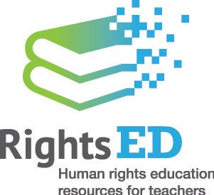
Tackling racism in Australia

Introduction
This unit of work encourages students to think about diversity, particularly in relation to people, groups and their cultures, to affirm and celebrate difference and to use their understanding of diversity to act with respect, empathy and trust.
The unit also explores the impact of discrimination and harassment on individuals, their family and friends and the wider community. Students learn to identify racial discrimination, racial harassment and racial vilification as unlawful acts, which undermine safe, respectful environments for all.
Building on learning activities in the unit, students develop strategies and actions for celebrating diversity and taking action against racism.

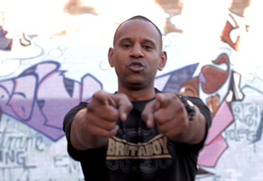
Screenshot from the What You Say Matters video, Australian Human Rights Commission

Table of Contents

Introduction 1
Links to the Australian Curriculum 4
Focus 7
Teaching and learning activities 7
Teacher support 8
Achievement and learning outcomes 10
Resources 10
Sequence 1—Exploring and affirming diversity 11
Sequence 2 — Let’s talk about Racism 25
Sequence 3 — The impact on individuals and communities 31
Sequence 4 — Being a voice for change 41
Resources for ‘Tackling racism in Australia’ 54
Worksheets 57

About this resource:

The Australian Human Rights Commission encourages the dissemination and exchange of information provided in this publication.
All material presented in this publication is provided under Creative Commons Attribution 3.0 Australia, with the exception of:
- the Australian Human Rights Commission Logo
- photographs and images
- any content or material provided by third parties.
The details of the relevant licence conditions are available on the Creative Commons website, as is the full legal code for the CC BY 3.0 AU licence

Attribution
Material obtained from this publication is to be attributed to the Australian Human Rights Commission with the following copyright notice:
© Australian Human Rights Commission 2014.

Electronic format
This publication can be found in electronic format on the website of the Australian Human Rights Commission: www.humanrights.gov.au/publications/index.html.
Contact details
For further information about the Australian Human Rights Commission, please visit www.humanrights.gov.au or email communications@humanrights.gov.au.

You can also write to:
Human Rights Education Team
Australian Human Rights Commission
GPO Box 5218
Sydney NSW 2001

Links to the Australian Curriculum
Years 9 and 10: Personal, Social and Community Health

Content
The content in this unit relates to the Australian Curriculum: Health and Physical Education for Years 9 and 10, covering the strand of Personal, Social and Community Health.

General Capabilities
The general capabilities emphasised in this unit of work are Intercultural understanding, Ethical understanding, Literacy, Personal and social capability, Critical and creative thinking and Information and communication technology (ICT) capability.

Cross-curriculum priority
The cross-curriculum priority emphasised in this unit is Aboriginal and Torres Strait Islander histories and cultures

Curriculum content descriptions
Content description | Elaborations
Communicating and interacting for health and wellbeing
ACPPS093 - Investigate how empathy and ethical decision making contribute to respectful relationships | - investigating the characteristics of positive, respectful relationships and the rights and responsibilities of individuals in relationships (RS, MH, S)  - investigating how the balance of power influences the nature of relationships and proposing actions that can be taken when a relationship is not respectful (RS, S, MH)  - appropriate bystander behaviour when confronted with racist attitudes or behaviours(RS, S)
Contributing to healthy and active communities
ACPPS096 - Plan, implement and critique strategies to enhance the health, safety and wellbeing of their communities | - developing and implementing proposals to enhance the wellbeing of staff and students in the school (MH, FN, S, RS, AD, HBPA)  - investigating community-action initiatives that have had a positive influence on the health and wellbeing of their communities (MH, S, FN, RS, AD, HBPA)
ACPPS097 - Plan and evaluate new and creative interventions that promote their own and others’ connection to community and natural and built environments | - designing and critiquing a strategy to involve family, friends and members of the community in cultural celebrations to promote a sense of connection with and belonging to the community (RS, MH)
ACPPS098 - Critique behaviours and contextual factors that influence the health and wellbeing of their communities | - analysing the implications of attitudes and behaviours such as prejudice, marginalisation, homophobia, discrimination, violence and harassment on individuals and communities, and proposing counter-measures to prevent these behaviours (RS, S, MH)
Key (Health and Physical Education focus areas)
AD — alcohol and other drugs
CA — challenge and adventure activities
FN — food and nutrition
HBPA — health benefits of physical activity
MH — mental health and wellbeing
RS — relationships and sexuality
S — safety

Focus
Racism has no place in Australian schools. It goes against important principles of our education system, such as giving all students equal opportunities to learn and flourish, regardless of their background. In order to put a stop to racist attitudes, beliefs and behaviours, it is important that we involve students in becoming part of the solution. This unit is designed to inform students about the realities of racism and its impact on Australian society.
This unit focuses on identifying types and sources of discrimination and harassment, analysing their impact on individuals, families, friends and the wider community, and examining how the law responds. The second overlapping focus is on affirming the importance of diversity, the value of different beliefs and perspectives, and advocating against discrimination and harassment.

Teaching and learning activities
These sequences can be taught as a unit or as individual lessons:
- Exploring and affirming diversity
- Let’s talk about Racism
- The impact on individuals and communities
- Being a voice for change

Sequence 1 begins by having students consider the different cultures represented within our society and how this diversity shapes our country.
In Sequence 2, students delve into the issue of racism by exploring the concepts of discrimination, harassment and vilification and examining how issues of racism are addressed within the law.
Sequence 3 is designed to challenge students to exercise empathy and analyse the impacts of racial discrimination and harassment on individuals and on wider society.
Sequence 4 encourages students to think about what they can do to address racism as an individual and a member of the community.

Teacher support
Please be aware that a number of the activities in this unit raise issues that may be sensitive or controversial and should be addressed with care.
When confronted with sensitive or controversial issues, young people are likely to express a wide range of responses based on their different experiences, learning styles and emotional intelligence levels. It is important to handle these issues without reinforcing stereotypes, increasing confusion or raising tension between students.
Some strategies for introducing controversial topics and managing responses can be found in the guide Dos and don’ts when teaching about cultural differences, from Civics and Citizenship Education.
Other strategies and techniques include:
- Splitting the class into smaller groups. This will ensure that greater confidentiality exists and enables less confident students to express their opinions in a less-pressured environment.
- Frame discussions around controversial issues in ways that are as open-ended and inclusive as possible and challenge students to consider issues from a variety of perspectives and sources.
- Encourage all students to develop and maintain a sense of pride in their language, their lived culture, their experiences, their families, and their communities.
As further reading, the report The Impact of Racism upon the Health and Wellbeing of Young Australians includes examples of how racism is experienced by young people and can provide some background in supporting teacher understanding.
Resources:
Dos and don’ts when teaching about cultural differences, Civics and Citizenship Education.
The Impact of Racism upon the Health and Wellbeing of Young Australians, the Foundation for Young Australians

Getting Help
In cases where students require counselling or support refer them to assistance from the school counsellor or from one of the following organisations:
Kids Helpline
Kids Helpline is a counselling service for Australian children and young people aged between 5 and 25 years.
Website: http://www.kidshelp.com.au/
Phone: 1800 551 800
Headspace
The National Youth Mental Health Foundation provides information and advice for young people going through difficulties through their Headspace centres, online and through telephone support services
Website: https://www.eheadspace.org.au/
Phone: 1800 650 890
Lifeline
Lifeline provides 24 hour crisis support and suicide prevention services.
Website: https://www.lifeline.org.au/Home
Phone: 13 11 14

Achievement and learning outcomes
As a result of this unit of study students will:
- examine the positive aspects of cultural diversity
- discuss the value of differences and diverse perspectives
- explore the different types and sources of racial discrimination, racial vilification and racial harassment
- develop an understanding of the Racial Discrimination Act 1975
- explore the extent of discrimination within society
- investigate the impact of discrimination and harassment on individuals, their family and friends and the wider community
- design strategies and actions for celebrating diversity and taking action against racism within their community.
This will be evident when students are able to:
- express their own personal values and recognise negative community attitudes relating to diversity
- analyse the impact of discrimination and harassment on individuals within their community
- assess the value of difference within their school and wider community.

Resources
Resources used in this unit are listed at the end of each teaching and learning activity. Alternatively, find the full list of resources at the back of this document.

Sequence 1—Exploring and affirming diversity
This introductory sequence is designed to engage and challenge students through a combination of student directed learning, inquiry based learning and personal narrative. Many of the activities are discussion-based and aim to lead students to a deeper understanding of the cultural diversity in Australia.
Particular aspects of the sequence, such as the class survey, require students to respond to personal questions about their background and heritage.
Teacher’s note: Please be mindful that it may not be easy for all students to share openly about their heritage or family background. Exercise professional judgment when using these activities. For further information, consider the guide Dos and don’ts when teaching about cultural differences, from Civics and Citizenship Education, which outlines some useful strategies for conducting constructive conversations about race and racism. You may also wish to consult the research paper ‘Creating a Culturally Inclusive Classroom’ from Griffith University and the web page Creating a Supportive Environment, from NSW DEC.

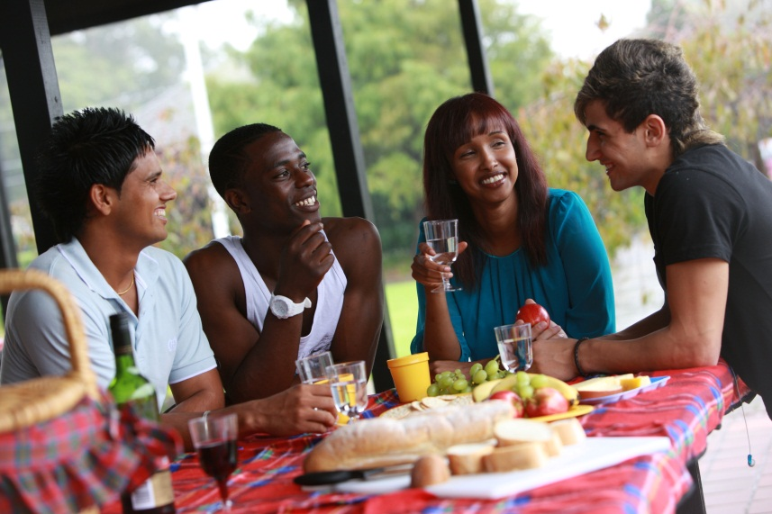
Photo by Australian Human Rights Commission
Resources:
Dos and don’ts when teaching about cultural differences, Civics and Citizenship Education
‘Creating a Culturally Inclusive Classroom’, Griffith University
Creating a Supportive Environment, NSW Department of Education and Communities

Discussion – Exploring cultural diversity
With the teacher’s note above in mind, discuss the differences between students, and the resulting diversity within the class. Talk about different aspects of students’ lives and living situations and use prompts to involve students, with questions about language and culture, such as:
- Does anyone speak another language or have friends who speak another language?
- Has anyone been to another country?
- Does anyone have grandparents who were born in another country?

Reflect on diversity within the class by posing the following questions:
- Were students surprised about the differences within the class?
- Do students think the responses to these questions would be the same in different places, such as in another town or city?

Class poll activity
As an introduction to the topic of cultural diversity, consider conducting a class poll. Ask students the following questions about diversity and after each question, tally responses on the board.
- What percentage of Australians do you think were born overseas?
- What percentage of Australians do you think are born in Australia?
- What percentage of Australians are Aboriginal or Torres Strait Islander people?
- What percentage of Australians do you think would speak another language?
- How many languages do you think are spoken in Australia?

Teacher’s note: When conducting this exercise it is important to be mindful of the size and dynamics of the class to ensure a safe and supportive environment for all students. This could be achieved, for instance, by asking students to write their answers anonymously on a slip of paper to be tallied and displayed on the board. You could also make use of online survey sites like Survey Monkey or Poll Everywhere which allow students to confidentially respond to questions via text or computer.
Resources
Survey Monkey website
Poll Everywhere website

Online Research Activity
Next, instruct students to find out the answers to the questions posed in the class poll activity by researching cultural diversity in Australia.
Begin by dividing the class into groups. Assign each group one of the following topics and allocate them the corresponding worksheet:
- Diversity of birthplace (Birthplace Work Sheet)
- Diversity of language (Language Work Sheet)
- Diversity of religion and spiritual beliefs (Religion and spiritual beliefs Work Sheet)
You may wish to direct students to the following sources as a starting point for their research:
- QuickStats, Australian Bureau of Statistics: this search engine offered by the ABS is a fast, simple way for users to search for statistical information about any given geographical area in Australia, from the 2011 Census
- Cultural Diversity in Australia, Australian Bureau of Statistics: this article from the ABS series ‘Reflecting a Nation: Stories from the 2011 Census, 2012–2013’ provides a summary of information about cultural diversity in Australia
- Choose Your Own Statistics, ABC Splash: this website is an interactive learning resource that provides statistical information on a range of important issues in Australian society, including topics on religion, country of birth and refugees and asylum seekers
- ConCensus, ABC Splash: this website provides interactive graphs that use statistical data from the 2011 census. It provides information about ethnic background and languages spoken at home.
After students have completed their group’s worksheet, ask students to create a PowerPoint presentation explaining the key features and significance of their findings to present to the class.
In their presentation, students should evaluate some of the implications of the information they were able to find. For instance, you may ask students to consider the following questions:
- What does this information tell us about the society that we live in?
- What impacts does diversity have on our society?
Teacher’s note: In conducting this exercise, special care should be taken when referring to Aboriginal and Torres Strait Islander peoples. No judgments should be made in the classroom about whether a person is an Aboriginal or Torres Strait Islander person or not. It is particularly important not to make assumptions about identities based on physical appearance. The individual person’s identification should be respected.
For an authoritative source on Aboriginal and Torres Strait Islander languages, teachers should refer to the AIATSIS report on the Second National Indigenous Languages Survey (NILS). This report documents that 120 languages are still spoken and 13 are considered strong. Aboriginal and Torres Strait Islander communities, along with governments, are undertaking significant activities to maintain and revitalise languages.
Finally, teachers wishing to discuss Aboriginal or Torres Strait Islander spirituality are advised to consult with local Aboriginal or Torres Strait Islander communities to seek advice about terminology and how to discuss local spirituality. Note that most Torres Strait Islander people are Christian
Resources:
Birthplace Work Sheet
Language Work Sheet
Religion and spiritual beliefs Work Sheet
QuickStats, Australian Bureau of Statistics
Cultural Diversity in Australia, Australian Bureau of Statistics
Choose Your Own Statistics, ABC Splash
ConCensus, ABC Splash

Responses to diversity
Having gained an overview of the cultural diversity in the Australian population, this section asks students to think about what this means for our community.
Teacher’s note: This activity encourages students to think about the positives and negatives of diversity within Australian society which represent ‘the good’ and ‘the bad’ and ‘the ugly’. The ‘ugly’ refers to those truly terrible examples of racial discrimination, harassment and vilification, which will be explored further below. See Know your rights: Racial discrimination and vilification for further information. Ensure discussion is well monitored and discussions are respectful of all class members.
Resources:
Know your rights: Racial discrimination and vilification, Australian Human Rights Commission

Activity — The Good, the Bad and the Ugly
Provide each student with blank paper and ask them to divide the paper into three columns labelled ‘The Good’, ‘The Bad’ and ‘The Ugly’.
The Good
In the column titled ‘The Good’, ask students to write down examples of positive things arising from having a society made up of people from different races and cultures, with diverse religions and spiritual beliefs.
Prompt students to consider the following:
- different languages, art forms and cuisines
- community events celebrating different cultures, such as festivals
- welcoming refugees escaping from danger and persecution in other parts of the world

Ask students to share some of their examples with the class and pose the following questions:
- What are some of the benefits of being part of a diverse society?
- Did you identify or learn about any new benefits that you hadn’t thought of before?

The Bad
Under ‘The Bad’ heading, ask students to list negative aspects that can arise from having a culturally diverse society made up of people from different races and cultures, with diverse religions and spiritual beliefs.
Ensure that students understand that this exercise is not about identifying negative aspects of a particular cultural or ethnic group, but instead looking at the social issues that can arise with cultural diversity.
Some examples that you could provide to prompt students include:
- Negative stereotypes, for example assuming all people of foreign heritage cannot speak English.
- Racist behaviour, such as the racial abuse of AFL football player and Australian of the Year, Adam Goodes at a football game in 2013
- Segregation and exclusion of people belonging to particular cultural or ethnic backgrounds

Pose the following questions:
- Do all Australians view diversity in the same way?
- What might be some of the motivations and reasons behind negative attitudes towards diversity?
- Can you think of any examples of negative beliefs and attitudes towards diversity that are evident in your local community?

The Ugly
Finally, ask students to write down examples of incidents and attitudes that could fall into the category of ‘The Ugly’. Explain that these should include more extreme examples of racist attitudes and beliefs and displays of discriminatory behaviour.
Some examples include:
- the Cronulla Riots in 2006 (note that you can find a detailed overview of this event in the Australian Human Rights Commission’s Year 10 History unit of work, Sequence 4)
- Racist attacks on public transport, such as:
  - the racist attack on a public bus on the Gold Coast in Queensland in February 2014.
  - the woman who racially abused fellow passengers on a NSW train in July 2014
  - the attack on young Jewish students on a Sydney bus in August 2014
  - the incident of a teenager racially abusing a guard on a Brisbane train in October 2014

Pose the following questions:
- What kinds of things did you list?
- Why do you think these incidents occurred?
- Do you think these things occur in your local community?
- How often do you think these types of incidents occur?
- What are some of the consequences of these incidents?

Teacher’s note: If suitable for the class, you may wish to introduce historical accounts of racism which have occurred in Australian society over the last hundred years. The Australian Human Rights Commission has a Year 10 History resource which provides examples of relevant historical events such as:
- The white Australia policy
- Experiences of early immigrants from Vietnam and other Asian countries, often called ‘boat people’
- The Cronulla Riots
- Detention of asylum seekers

Each of the above dot points provides a useful basis for discussion with students around examples of ‘Bad’ and ‘Ugly’ behaviour. These historical events also offer insights into how government policy can reflect intolerance and work against cultural diversity. The emphasis here is on assisting students to develop an understanding of the broader context for racism within Australia.
To conclude this activity, explain to students that although there are many examples of the celebration and recognition of the cultural diversity we enjoy in Australia, the reality is that racism does occur.
According to the findings of the Challenging Racism research:
- More than one in 20 Australians say they have been physically attacked because of their race.
- One in seven Australians say they experienced discrimination because of their colour or background in 2011, a figure that has been increasing steadily in recent years.
- Around one in five Australians say they have experienced race-hate talk, such as verbal abuse, racial slurs or name-calling.
- Around one in ten Australians say they have experienced race-based exclusion in the workplace or social events.

Resources:
Year 10 History Resource, Australian Human Rights Commission
Challenging Racism, University of Western Sydney

Body poll on cultural diversity issues in Australia
Invite all students to participate in ‘body voting’ by leaving their chair and standing in the middle of the room. Label each corner of the room with the following labels: STRONGLY AGREE, STRONGLY DISAGREE, AGREE and DISAGREE.
Read out the following statements in relation to cultural diversity and race issues in Australia and ask students to respond by ‘voting with their feet’ and moving to the place in the room that matches their feelings about the statement. Explain that if students neither agree nor disagree with a statement they can remain in the centre of the room.
Suggested statements
- In Australia all shop signs should only be in English.
- Australia is a racist country.
- Australia has lots of space and we should share it with people in need.
- People should only be allowed to come to Australia if they speak English.
- The only people who are truly Australian are the Aboriginal and Torres Strait Islander peoples.
- Detention centres should be banned.
- Australia should accept more refugees.
- There is nothing an individual can do about racism.
- People who migrate to Australia should leave their old culture behind.
- Migrants from the same country shouldn’t be allowed to live together in the same location or town.
- Having a diverse population makes Australia an interesting place to live.

You may need to read each statement out a couple of times whilst the students think and decide. Don’t change the statement or explain it. If students don’t understand, they should remain in the centre of the classroom.
After reading out each statement, move around the room and invite students to explain why they have chosen to stand where they have. Try to ask different students within the class and give all students the opportunity to share their views.
Be mindful that many statements could lead to students displaying ill-informed or potentially racist beliefs. After students have shared their opinion you might like to ask them how they have formed that opinion and what information it is based on.
Where appropriate, question particular opinions (especially those which reflect prejudicial or stereotypical assumptions) and encourage discussion between students with differing viewpoints. The purpose of this is not to dispute the students’ opinions, but to facilitate discussion.
After the discussion of each statement you may wish to allow time for students to move to a different area if they have changed their initial stance.
Teacher’s note: Either during or after this values-based positioning activity, it may be necessary to address any examples of racism or discrimination that arose. The following is a suggested statement:
‘Certain comments put forward in our discussion did reflect racism toward certain groups of people, and sometimes the comments people made were not always based on the facts. In society sometimes people’s views on diversity are based on assumptions or personal beliefs about cultural groups. Racism is not okay and so it is important that we reflect on our personal beliefs and the beliefs of others, as well as find out the facts so we can recognise racism when it occurs.’
This activity may require further investigation into the definition of asylum seekers and refugees as well as an explanation of the detention centres and offshore processing centres used by the Australian Government. The Australian Human Rights Commission offers a student-friendly Asylum seekers and refugees guide, discussing both the Universal Declaration of Human Rights and the Australian legal framework.
Teacher’s note: This activity has been adapted from the ‘Discuss It’ Lesson on the Harmony Day website.
Resources:
Asylum seekers and refugees guide, Australian Human Rights Commission
‘Discuss It’ Lesson, Harmony Day website

Affirming diversity (Summative assessment task)

Part 1: Brainstorming activity
Begin this section of the sequence by discussing the ways in which diversity and difference are celebrated within school and the wider community.
As a class, brainstorm a list of community activities or celebrations that students are aware of and spend time exploring the aims and goals of each activity.
For examples, read about how Fairfield City Council celebrates diversity or consider the annual National Multiculturalism Festival held in Canberra.

Part 2: Harmony Day discussion
Harmony Day is held annually on March 21 and is a day dedicated to celebrating cultural diversity in Australia.
As the Harmony Day website states:
‘It is a day of cultural respect for everyone who calls Australia home — from the traditional owners of this land to those who have come from many countries around the world.’
Harmony Day is timed to coincide with the United Nations International Day for the Elimination of Racial Discrimination.
As a class, explore the Harmony Day website and the online materials about this day. Show students the video 2014 Harmony Day Message, in which Senator Concetta Fierravanti-Wells, the Parliamentary Secretary to the Minister for Social Services, explains the importance of Harmony Day and its personal significance for her.
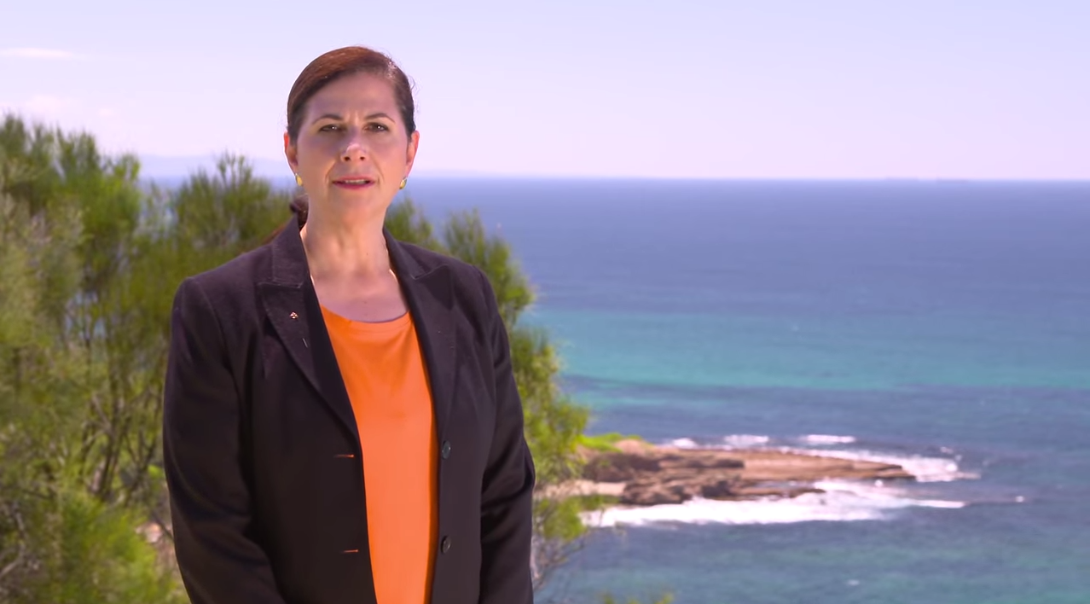
Screenshot from 2014 Harmony Day Message, Department of Social Services
As a class, discuss the purpose of Harmony Day and how it encourages Australians to celebrate the diversity within our country.
Pose the question:
How does Harmony Day assist in promoting a sense of connection with and belonging to community?

Part 3: Plan an event
In the concluding part of this activity, ask students to plan an event that could be held as part of one of the cultural diversity celebrations identified in Part 1 or could be held as a Harmony Day event.
In planning their event students should:
- Come up with creative ideas about how their event could promote a sense of connection with and belonging to the community
- Consider ways to involve their family, friends and extended community networks in the event
- Develop strategies for promoting their event, for example using social media, or advertising through community networks.

Some useful resources for planning an event are provided on the Harmony Day website, these include:
- Event ideas
- Promotional materials
- Community publicity guide
Resources:
2014 Harmony Day Message, Department of Social Services
Harmony Day website
Fairfield City Council website
National Multiculturalism Festival website

Resources used in Sequence 1
Find a summary of all the resources used in this sequence in the ‘Resources’ section at the end of this document.

Sequence 2 — Let’s talk about Racism
This sequence focuses on developing students’ understanding of racism by providing definitions of the key concepts (‘discrimination’, ‘harassment’ and ‘vilification’) and identifying some of the legal implications of racial discrimination and harassment.

Class discussion - What is Racism?
Teacher’s note: Before beginning this discussion activity, you may wish to refer to the following explanation of racism from National Anti-Racism Strategy (p.3) by the Australian Human Rights Commission:
‘Racism can take many forms, such as jokes or comments that cause offence or hurt, sometimes unintentionally; name-calling or verbal abuse; harassment or intimidation, or commentary in the media or online that inflames hostility towards certain groups.
At its most serious, racism can result in acts of physical abuse and violence. Racism can directly or indirectly exclude people from accessing services or participating in employment, education, sport and social activities.
It can also occur at a systemic or institutional level through policies, conditions or practices that disadvantage certain groups. It often manifests through unconscious bias or prejudice.
On a structural level, racism serves to perpetuate inequalities in access to power, resources and opportunities across racial and ethnic groups. The belief that a particular race or ethnicity is inferior or superior to others is sometimes used to justify such inequalities.’
Alternatively, the Racism. It Stops With Me website offers a useful, student-friendly introduction to the topic of racism on its page What is racism?
Begin this sequence with a class discussion on racism. Ask students to provide their own explanations of racism and to think about the following questions:
- What are some examples of racism that can be seen or heard? (i.e. overt forms of racism such as verbal or physical abuse)
- What are some examples of racism that might be “invisible” or harder to perceive (i.e. covert forms of racism such as discrimination on a systemic level)
Discussions about racism usually coincide with questions about why people are racist.
Explain to students that it’s not always easy to know why a person would choose to engage in discriminatory or harassment behaviours, however many forms of discrimination and harassment are based on negative community or personal values and beliefs which may be passed on through the generations.
Provide students with the Why are people racist? resource sheet, adapted from the Racism. It Stops With Me website, which answers commonly asked questions about the motivations for racism.
Resources:
Why are people racist? resource sheet
Why are people racist?, Racism. It Stops With Me
What is racism?, Racism. It Stops With Me

What does the law say?
This section of the sequence looks at how Australian law, in the form of the Racial Discrimination Act 1975, works to prevent racism.
The following is a brief background on the origins of the Racial Discrimination Act. You may also wish to provide students with the Racial Discrimination Act Resource Sheet
During the 1960s, increasing international pressure to address officially sanctioned forms of racial discrimination and segregation in countries such as the United States and South Africa, culminated in the creation of United Nations International Convention on the Elimination of All Forms of Racial Discrimination (CERD).
CERD was one of the first human rights treaties to be adopted by the United Nations (UN) and today is widely supported, with more than 156 countries (four-fifths of the membership of the UN) having ratified the Convention.
Australia signed the Convention on 13 October 1966 and made its commitment to CERD official in 1975 through the creation of the Racial Discrimination Act.
Prior to this point, Australia had a series of racially discriminatory policies and legislation called the White Australia Policy, which limited who was allowed to enter the country. CERD was one of the global influences that helped to dismantle the White Australia Policy.
More recently, Australia has also recognised the specific rights of children and young people to be free from discrimination by signing and ratifying the United Nation’s Convention of the Rights of the Child in 1990.
What does the Racial Discrimination Act do?
The Racial Discrimination Act aims to ensure that Australians of all backgrounds are treated equally and have the same opportunities.
This Act makes it against the law to treat someone unfairly, or to discriminate against them, on the grounds of race, colour, descent, national or ethnic origin and immigration status. It also makes racial hatred against the law.
The Act protects you against discrimination in many areas of public life, including:
- employment – getting a job, terms and conditions of a job, training, promotion, being dismissed
- education – enrolling or studying in a course at a private or public school, college or university
- accommodation – renting or buying a house or unit
- getting or using services – such as banking and insurance services, services provided by government departments, transport or telecommunication services, professional services like those provided by lawyers, doctors or tradespeople, services provided by restaurants, shops or entertainment venues
- accessing public places – such as parks, government offices, restaurants, hotels or shopping centres.

Resources:
Racial Discrimination Act Resource Sheet
International Convention on the Elimination of All Forms of Racial Discrimination (CERD), the United Nations Office of the High Commissioner for Human Rights
Know your rights: Racial discrimination and vilification, Australian Human Rights Commission
What does the law say?, Racism. It Stops With Me

Defining discrimination, harassment and vilification
Having gained an overview of how the Racial Discrimination Act provides legal protection against racism, students should now explore the types of racism that the Racial Discrimination Act protects against.
Provide students with the following explanations of ‘racial discrimination’, ‘harassment’ and ‘vilification’.

Racial discrimination
Racial discrimination is when a person is treated less favourably than another person in a similar situation because of their race, colour, descent, national or ethnic origin or immigrant status. Racial discrimination can be both direct and indirect. For example, it would be ‘direct discrimination’ if a real estate agent refuses to rent a house to a person because they are of a particular racial background or skin colour.
‘Indirect discrimination’ is when there is a rule or policy that is the same for everyone but has an unfair effect on people of a particular race, colour, descent, national or ethnic origin or immigrant status.
For example, it may be indirect racial discrimination if a company says that employees must not wear hats or other headwear at work, as this is likely to have an unfair effect on people from some racial/ethnic backgrounds.

Harassment
Under federal and state legislation, unlawful harassment occurs when someone is made to feel intimidated, insulted or humiliated because of their race, colour, national or ethnic origin; sex; disability; sexual preference; or some other characteristic specified under anti-discrimination or human rights legislation.
Harassment can include behaviour such as:
- telling insulting jokes about particular racial groups
- displaying offensive posters or screen savers
- making derogatory comments or taunts about someone’s race or religion

Racial vilification
Racial hatred (sometimes referred to as vilification) is doing something in public which is likely to offend, insult, humiliate or intimidate an individual or group of people of a particular race, colour or national or ethnic origin. Examples of racial hatred may include:
- racially offensive material on the internet, including eforums, blogs, social networking sites and video sharing sites
- racially offensive comments or images in a newspaper, magazine or other publication such as a leaflet or flyer
- racially offensive speeches at a public rally
- racially abusive comments in a public place, such as a shop, workplace, park, on public transport or at school
- racially abusive comments at sporting events by players, spectators, coaches or officials.

Brainstorming Activity
After giving students the opportunity to look over these definitions, conduct a brainstorming activity as a class to map out the main points of commonality and the main points of difference between these three key concepts.

Creating proposals for preventing racism (Summative assessment task)
Divide students into groups and ask them to brainstorm what forms of racial discrimination and harassment might occur in a school setting.
Next ask students to consider what rules and practices are already in place in the school setting to prevent these things from occurring.
Finally, ask students to develop a proposal that suggests ways to enhance the existing rules or practices that prevent racism or create a proposal that offers new strategies for preventing racism in the school setting.
In their proposal students should outline how their suggested initiative will enhance the wellbeing of staff and students in the school.

Resources used in Sequence 2
Find a summary of all the resources used in this sequence in the ‘Resources’ section at the end of this document.

Sequence 3 — The impact on individuals and communities
This sequence is focused on assessing the implications of attitudes and behaviours such as discrimination and harassment on individuals, their family and friends and the wider community, and proposing counter-measures to prevent these behaviours.
Teacher’s note: Please be mindful that some activities in this unit may prompt students to discuss personal accounts of racism. In cases where students require counselling or support refer them to assistance from the school counsellor or from one of the organisations listed in the Teacher Support section.

Assessing the impacts — five stories of racism in Australia
Often discrimination and harassment are seen as societal issues that may affect people in Australia, but not anyone we know. We may have heard racist comments or watched programs that present people from other cultures in a stereotypical or negative way, but it is not often we consider the effect on the individuals involved.
As an introduction to the impacts of discrimination and harassment, have students read the article ‘Five experiences with racism’ from the Sydney Morning Herald, which looks at the experiences of five well-known Australians.
After reading the article ask students to briefly describe the effects on the individuals on the Five experiences with racism worksheet.
Discuss the completed worksheet and ask students for their observations from the stories.
- How do these stories reflect the experiences of Australians from different cultural backgrounds?
- How are their stories different or similar?
- What do you think are some other impacts of racism that are not covered in these stories?
- What are some other stories you have heard about people’s experiences of racism and how has this impacted the people involved?

Resources:
Five experiences with racism worksheet
Five experiences with racism’, the Sydney Morning Herald

‘No excuse’ brainstorming activity
Begin this activity by watching as a class the following video from Yarra City Council, called No Excuse.
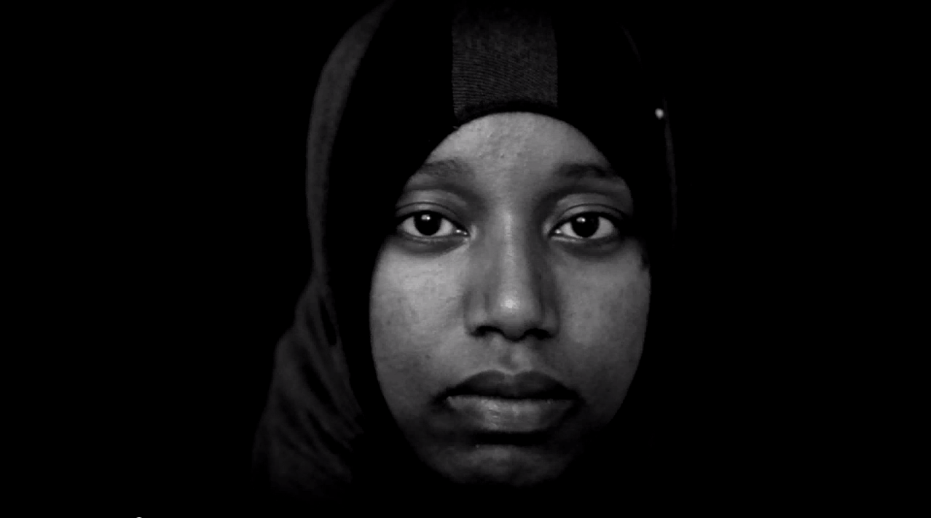
Screenshot from the video NoExcuse, Yarra City Council
Ask students to select one person from the video and brainstorm how the situation might affect their lives and those around them.
You could ask students to do this by drawing an outline of a person and then instruct students to write examples of the ways an individual might personally be affected by racism inside this outline. Then ask students to include examples of the ways that the broader community might be affected by racism around the outside of the person.
Use the following questions as a stimulus:
- What might be some effects on the persons’ self-esteem?
- What might be some effects on their relationships with other people?
- What might be some effects on the way this person feels about people in the community such as the police, bus drivers or adults?

Resources:
NoExcuse, Yarra City Council

The impacts of racism on Aboriginal and Torres Strait Islander peoples
“Just being born Indigenous makes you feel second class.” – Greg, 35
Source for quote above: Racism. It Stops with Me — find further comments on racism and harassment on this page.
This section of the sequence focuses on how Aboriginal and Torres Strait Islander peoples are affected by racism.
Begin the section by explaining that Aboriginal and Torres Strait Islander peoples today are still dealing with the effects of past laws, government policies and social attitudes and behaviours which treated them as inferior to other Australians.
This history of entrenched discrimination at a systemic and social level has meant that Aboriginal and Torres Strait Islander peoples have experienced considerable disadvantage and inequality. This has led to problems in areas such as health, housing, education and employment which were not experienced to the same degree by other Australians.
In many cases this disadvantage has been passed from one generation to the next, meaning that many Aboriginal and Torres Strait Islander peoples today miss out on the opportunities that other Australians take for granted.

‘How do Aboriginal and Torres Strait Islander peoples experience racism?’ – Online research task
Ask students to get an overview of this issue by reading Section 3 of the Close the Gap Campaign Submission on Part IIA of the RDA: ‘Racism as a key determinant of health’.
Next, instruct students to conduct online research into how Aboriginal and Torres Strait Islander peoples experience racism. Students should create a one page summary of their research. When conducting their research ask students to consider what shape and form racism against Aboriginal and Torres Strait Islander peoples takes.

Some starting points for student research include:
- The Health and Welfare of Australia's Aboriginal and Torres Strait Islander Peoples: Social and Emotional Wellbeing, Australian Bureau of Statistics
- Who experiences racism?, Racism. It Stops With Me
- What are the impacts of racism on aboriginal health, NACCHO
Once students have conducted their research, conduct a class discussion on their findings.
You may wish to share with students the following infographic which was created by the Close the Gap Steering Committee, showing statistics on the forms of racism experienced by Aboriginal and Torres Strait Islander peoples.
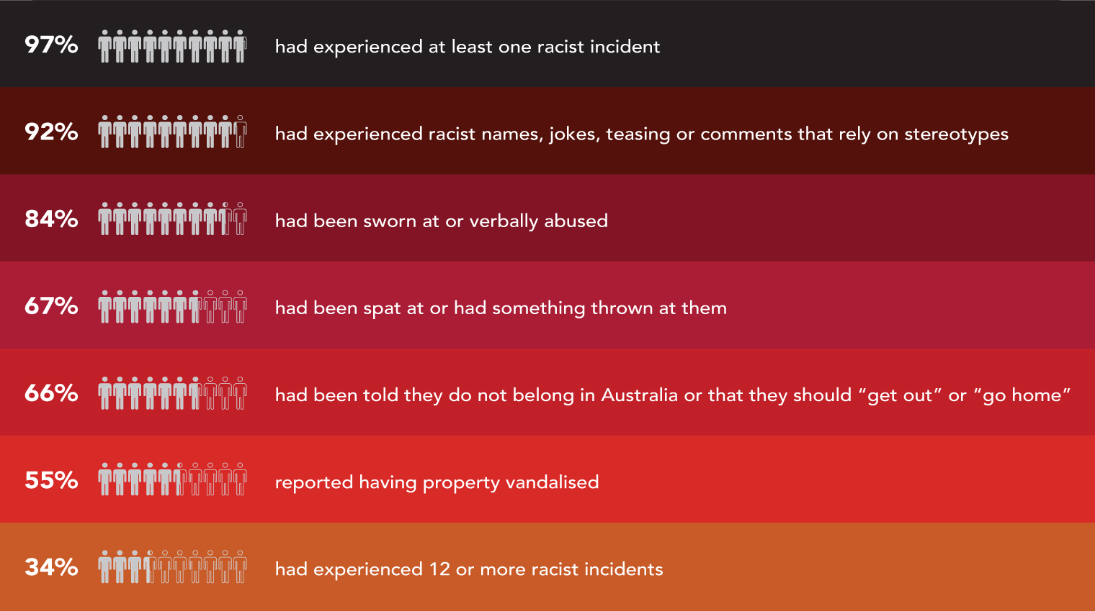
Infographic from the Close the Gap Steering Committee, showing prevalence data on racism experienced by Aboriginal people in Victoria.

Resources:
Campaign Submission on Part IIA of the RDA: ‘Racism as a key determinant of health’, Close the Gap Steering Committee
Infographic from the Close the Gap Steering Committee,
The Health and Welfare of Australia's Aboriginal and Torres Strait Islander Peoples: Social and Emotional Wellbeing, Australian Bureau of Statistics
Who experiences racism?, Racism. It Stops With Me
What are the impacts of racism on aboriginal health, NACCHO

‘What impact does racism have on Aboriginal and Torres Strait Islander peoples?’
Ask students to read the Impacts of racism on Aboriginal and Torres Strait Islander peoples Resource Sheet for an overview of the evidence.
After students have read the resource sheet, pose the following questions:
- What are some examples of the physical impacts that racial discrimination and harassment have on Aboriginal and Torres Strait Islander peoples?
- What are some examples of the psychological impacts?
- What do you think the short term consequences of these impacts might be?
- What do you think the long term impacts might be?
- What effects does racism against Aboriginal and Torres Strait Islander peoples have on their relationships with other people?
- What might be some effects on the way Aboriginal and Torres Strait Islander peoples use community services, for example health services such as hospitals and medical centres?
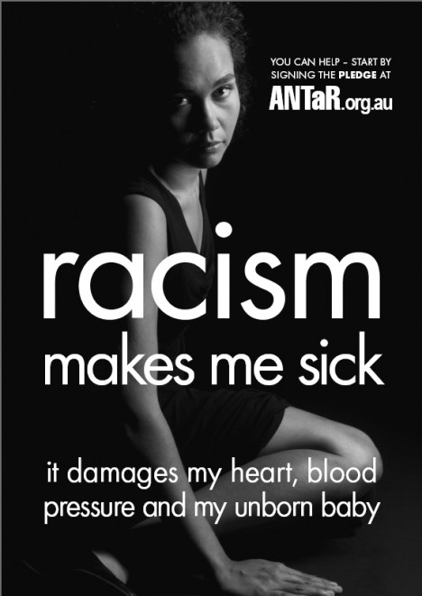
‘Racism makes me sick’ Poster, by ANTaR, highlighting the impacts of racism on Aboriginal and Torres Strait Islander peoples

Next, ask students to analyse the impacts of racism using the following two case studies.
Adam Goodes
As a class, view After Adam pointed the finger, a video produced by The Age, which explores the incident of a young girl shouting a racial slur at AFL player Adam Goodes during a game at the Melbourne Cricket Ground in May 2013.
You may also wish to show the class the following videos to provide context:
- Adam Goodes' response to the racism incident, a video from the Sydney Swans in which Adam Goodes explains his reaction to the racial abuse
- Racial taunt mars Swans' win, a Channel 7 news report which contains footage of the incident.
Ask students to explain why the insult shouted at Adam Goodes was an example of racial abuse and why it had such a significant impact on Adam.
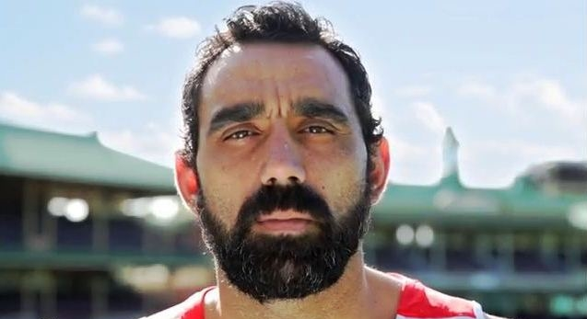
Adam Goodes, AFL Player and Australian of the Year (2014)
The Invisible Discriminator
As a class watch the video The Invisible Discriminator. This video advertisement is part of a public awareness campaign by beyondblue called ‘Stop. Think. Respect.’ which highlights the impact of racism on the social and emotional wellbeing of Aboriginal and Torres Strait Islander peoples.
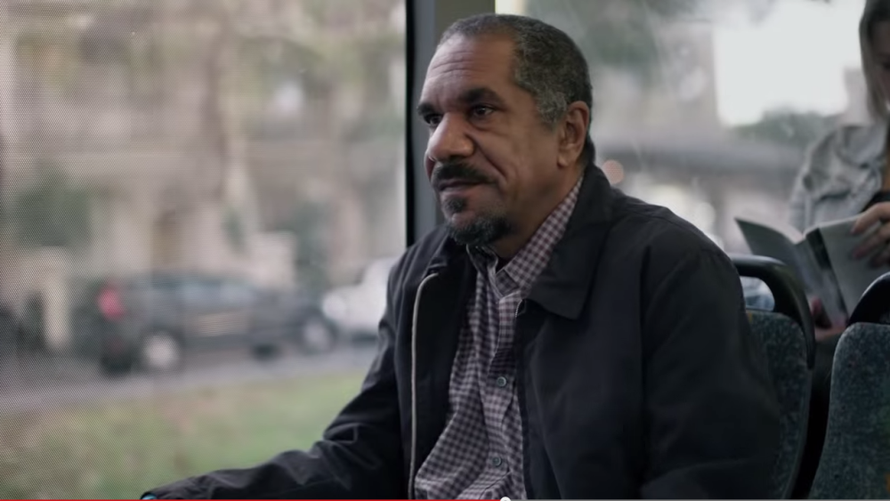
Screenshot from The Invisible Discriminator, beyondblue
You may also wish to direct students to the Racial discrimination and mental health page on the beyondblue website which features a video of the actors in the advertisement talking about their experiences of racism and explaining how racism affects their mental health.
After viewing this material, divide students into groups and ask them to come up with strategies for providing support to people who have experienced racism. These strategies should focus on promoting positive, respectful relationships and could be targeted at the school environment or the broader community.
In preparing their response, ask students to think about how power imbalances within the community can influence the nature of relationships.

Summary Activity
After considering these two case studies, ask students to prepare a short one-page essay explaining the different ways in which racial discrimination and harassment impact on the health and wellbeing of Aboriginal and Torres Strait Islander peoples.

Resources:
After Adam pointed the finger, The Age, Faifax Media
Adam Goodes' response to the racism incident, SwansTV
Racial taunt mars Swans' win, 7NEWS
The Invisible Discriminator, beyondblue Racial discrimination and mental health, beyondblue

‘Play by the Rules’ (Summative assessment task)
The summative task for this sequence asks students to demonstrate an understanding of how racial discrimination and harassment impact on individuals and communities by developing an effective counter-measure to prevent these behaviours.
Provide students with the following brief:
You are the manager of a local sporting club. Lately there have been several incidents of racism among players, officials and even parents. You are concerned about these issues and decide to do something about it.
Using the Play by the Rules — Racism in Sport Toolkit, design a plan to address the issues within the club. Your plan should include the following sections:
- An overview explaining — ‘What is racism?’
- Clear guidelines for officials on dealing with racism and harassment during games
- A suggested speech for coaches to provide to their players, highlighting the issues and discouraging further incidents
- A commitment to be signed by all players pledging to stop racism in sport
- A club complaints handling process specific to the sport and the age group
- A list of further resources you can direct interested people to.

Your plan should not exceed four pages in length and must be clear and succinct.
Resources:
Racism in Sport Toolkit, Play by the Rules

Resources used in Sequence 3
Find a summary of all the resources used in this sequence in the ‘Resources’ section at the end of this document.

Sequence 4 — Being a voice for change
This final sequence builds on the learning activities in the unit by exploring ways in which students can take action against racism and support those who may have experienced racism.
Students identify opportunities for bystander action and ways to promote community health and wellbeing.

Tackling racism in Australia
Begin the section by asking students to read the article, How best to tackle racism, Australian style by Race Discrimination Commissioner Tim Soutphommasane. The article explores attitudes towards racism in Australia and outlines ways to address it.
For a more in-depth exploration of racism in Australia, you may also wish to share the audio or transcript from Ugly Mongrel: Racism and aggressive nationalism, an episode from Tim Soutphommasane’s radio series ‘Mongrel Nation’ on Radio National.
This episode discusses a number of recent events that have caused people to question whether Australia is a racist nation, and also features interesting interviews with guests such as Penny Wong and Jeremy Fernandez who share some of their personal experiences of racism.
Resources:
How best to tackle racism, Australian style, Sydney Morning Herald
Ugly Mongrel: Racism and aggressive nationalism, Radio National

Race Discrimination Commissioner Tim Soutphommasane, Australian Human Rights Commission

What You Say Matters – Group Activities
As a class watch the ‘What You Say Matters’ video. The ‘What You Say Matters’ website and video are materials designed for young people as part of the Racism. It Stops With Me campaign.
The Racism. It Stops With Me campaign by the Australian Human Rights Commission is an awareness campaign that aims to encourage people to be part of a national movement to prevent racism.
After watching the video, pose the following questions:
- Who is this video aimed at?
- What are some of the main messages of the video?
- What techniques does the video use to get its message across?
- Is the video effective in promoting its message?
Above: Screenshot from the What You Say Matters video, Australian Human Rights Commission
Ask students to explore other examples of campaigns against racism. Examples of websites that feature anti-racism campaigns include:
- Racism. It Stops With Me
- Racism. No Way!
- Play by the Rules
- Take a Stand Together
- Show Racism the Red Card
- All Together Now
After students have explored some of the sites listed above, ask students to pick one example and provide answers to the following questions:
- What does the campaign challenge people to do?
- How do they aspire to create change in our society?
- What could you do to be a part of it?

Resources:
Racism. It Stops With Me website
Racism. No Way website
Play by the Rules website
Take a Stand Together website
Show Racism the Red Card website
All Together Now website

Being a bystander
This section explores what it means to be a bystander and what options are available to people who witness racism to take action.
As a class watch the Tips for Bystanders video from Racism. It Stops With Me and ask students to read the Tips for Bystanders Resource Sheet.
Have students go to the website section ‘What can you do?’ on the Racism. It Stops With Me website to explore the list of suggestions for people who are experiencing racism, see racism, or just want to do something about it.
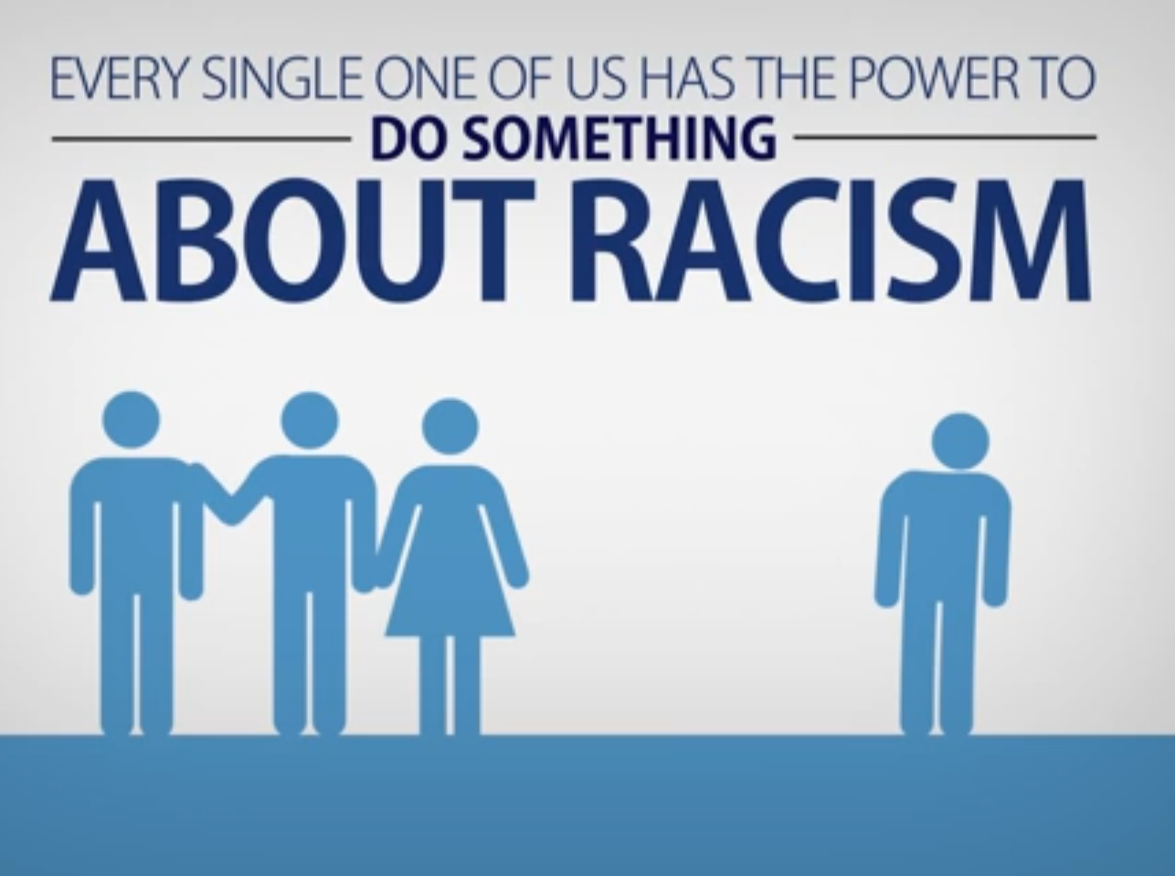
Screenshot from Bystander action on preventing race-based discrimination, VicHealth,
Class Discussion
Explain to students that what one person believes to be discrimination or harassment could be considered to be acceptable by another person and this is often why people don’t stand up and challenge it.
However, discrimination and harassment are against the law; therefore all people have the right to challenge it if they witness it.
Pose the following questions to the class:
- What might prevent you from doing something when you witness someone saying or doing something racist?
- How would you take action if the person expressing a racist attitude is a friend or family member?
- What could you say or do as a bystander in this situation (noting that the Tips for Bystanders point out that it’s not a good idea to be confrontational)
- Do you have any different sense of your ability to change a situation after learning more about bystander action?
Resources
Tips for Bystanders video from Racism. It Stops With Me
Bystander action on preventing race-based discrimination, VicHealth ‘What can you do?’, Racism. It Stops With Me

Rant Against Racism – exploring bystander action
Next, share the following real-life stories with the class. They are examples of racist incidents and how bystanders responded, from a competition run by the Australian Human Rights Commission called ‘Rant Against Racism’.

JODIE, 42
‘I lead the creation of cultural manners for our workplace. My team members had received all kinds of inappropriate, ignorant and hurtful comments and questions as Aboriginal guides working at a tourism attraction. We documented all the commonly asked stupid questions and our insightful and humorous answers to them into a handout so now our visitors pick up their manners on the way into our park to improve the psychological safety of our workplace for our team.’
KAWSAR, 17
I think prior to my story it is important to note that I am a young Muslim who wears the headscarf. I was at the public bus station and overhead ladies saying the “Taliban are taking over” and “"Muslims only come to Australia because they get bored of killing people in our country”. When I looked at the two of them, they spat at me “This is a free country! If you don't like what we are saying walk down to the other side of the f*****g bus station.” I told them, here I am minding my own business while they are voicing their stereotypical opinion loudly, and no, I will not walk down to the end of the bus station because of them when my bus is coming any second. They started raging and were waiting for a reply. I am really good with comebacks but decided to use something else on them - I told them to have a nice day with a smile on my face as I entered the bus. Sitting down with my friends I just carried on smiling and showed them the better person we can be despite all of the discrimination we cop all of the time. Sure I could have shot back hurtful words at them but I think it is more important to not be a bully back but assertively advocate against racial discrimination. I mean it is 2014 - come on guys, no hate.
STEVEN, 44
‘I was watching AFL at a pub in FNQ [Far North Queensland], Liam Jurrah was playing, man at the next table turned to me said out loud a pretty horrible thing about ‘lucky the lights are on ... ’ (you can work out rest) I said ‘NO. NO. That is just wrong’ and turned away from him with my hand out palm first like a stop sign. I was expecting abuse. He grumbled something, and after a few minutes of being blanked by me got up and left. A couple next to me said ‘good onya’. I was quite nervous, because he was a big bloke. But it felt right to do it. Silence is acquiescence.’
SANKET, 27
I was working part time for [a telephone company] 2 years back when I came across this customer on a call who wanted to speak to the CEO or the highest authority of the company as he had a billing dispute for huge amount. However, while I was trying to help him he started shouting at me that he wouldn't want to speak to, or deal with, an Indian and wanted to speak to the CEO of the company. I was quite upset by the way he said it as I was trying to help him and nothing more. He again asked me to transfer the call to the CEO or someone who could speak English and I thought this was the perfect chance to rant against his racist attitude, so I said “the CEO is Indian. Are you still keen to speak to the CEO?” He was quiet for a moment and then apologised and said that he did not want to be rude. I think he learnt his lesson that way.

Resources:
‘Rant Against Racism’, Racism. It Stops With Me

Group activity
After reading through the ‘Rant Against Racism’ stories, ask students in groups to come up with examples of racist incidents that they may have witnessed or heard about.
Instruct each group to select either one of the ‘Rant Against Racism’ stories or one of their own examples.
Using this example, ask groups to brainstorm answers to the following questions and record their thoughts on butchers’ paper:
- What were some of the causes of the racism described in your chosen story?
- What were the consequences of the racism? (who did it effect and how?)
- What action was taken to stop the racism?
- What other things that could have been done during or after the event?
- How could the person demonstrating racist behaviours or attitudes be made aware that their actions were inappropriate?
When students have finished brainstorming, have spokespeople for each group share their story and suggestions on how to take action against racism with the class.

Extension activity – Creating a cartoon
Have students choose one of the ‘Rant Against Racism’ stories, or a racist incident that they may have witnessed or heard about. Ask students to use their chosen scenario as the basis for creating a cartoon that raises awareness of how people can take action against racism. Instruct students that the cartoon should include a clear message about how to promote positive, respectful relationships.
Students could use one of the following methods to create their cartoon:
- Create a cartoon using Toondoo or Bitstrip, online resources for creating comic strips
- Create a short video using Dvolver moviemaker
- Create a cartoon filmstrip in their books.

Resources:
Toondoo website
Bitstrip website
Dvolver moviemaker website
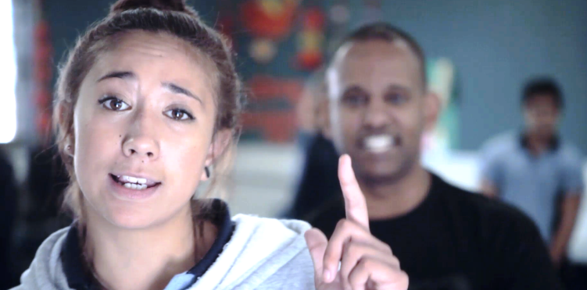
Screenshot from the What You Say Matters video, Australian Human Rights Commission

Group Activity – creating an anti-racism performance or presentation
In this activity students are required to use their knowledge about bystander action to create a performance or presentation that promotes respectful relationships and action against racism.
You may choose to assign students either one or both of the options outlined below. In both options, students should consider the following:
- Who is this target audience your performance/presentation?
- What is your main message?
- What techniques will you use to get your message across?
Performance Option
Ask students to work in groups to create a short skit or rap with an anti-racism message. The skit or rap should include a demonstration of how people can stand up to others who are being racist.
When complete, ask the groups to perform their skit or rap for the class.
You may wish to show students ‘It Stops With Me’, an anti-racism rap video created by young people as part of the ‘Raw Elements’ hip hop program facilitated by Maribyrnong City Council.
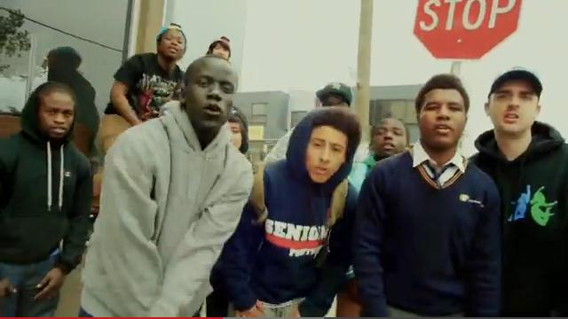
Screenshot from the video ‘It Stops With Me’, Raw Elements
Presentation Option
Ask students to design a presentation in an electronic form, for example using Prezi, Glogster, Animoto or iMovie, which encourages people to take action against racism and support those who have experienced it. The presentation should include strategies and suggestions for creating positive, respectful relationships with others.
Have students show their presentation to the class when they have completed it.

Resources:
‘It Stops With Me’, Raw Elements
Prezi website
Glogster website
Animoto website

Take action (Summative assessment task)
The final activity for this unit requires students to reflect on what they have learned and to consider how they can translate this knowledge into action.
You may wish to ask students to complete either one or both parts of this activity.

Part 1 -Individual reflection activity
By the completion of this unit of work students will have considered the nature and impact of racial discrimination and harassment and the importance of the diversity in our community and country. As a concluding task, ask students to complete an individual reflection on the lessons learned during the unit.
Guiding questions:
- What new things have you learned about multiculturalism and diversity in Australia?
- Outline the ways in which this unit has challenged your own ideas and thoughts about discrimination, harassment and racism.
- Describe the impact of racism on a) individuals b) their friends and family and c) the wider community.
- Make a list of five ways in which you can continue to address racism in Australia.

Students can develop on this last point by creating a personal pledge against racism. The Racism. It Stops With Me website provides a pledge template in both Word and PDF form.
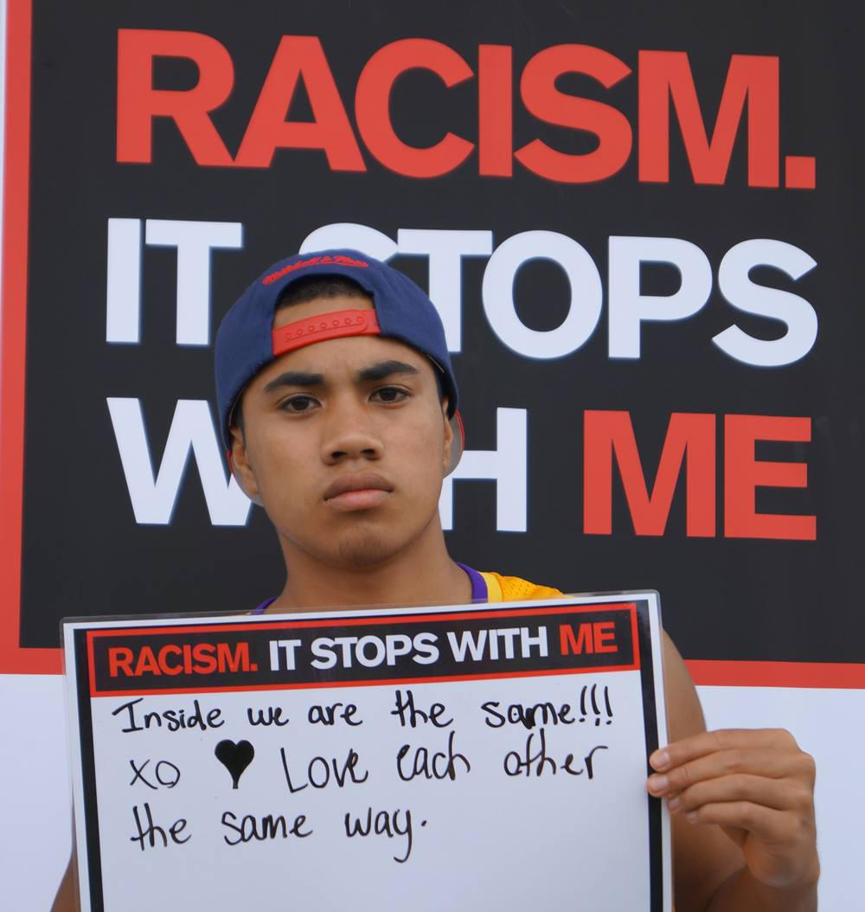
Example of a pledge against racism, image from the Multicultural Development Association

Part 2 – taking action in the community
Divide students into groups and ask them to brainstorm ideas about how they can address racism within the wider community.
Ask students to then develop their ideas into a plan for an event or activity that aims to address racism by promoting connection and belonging within the community.
You may wish to provide students with the example of ‘Vindaloo Against Violence’, an event instigated by one person who wanted to show support for the Indian community after a series of attacks on Indian students in 2010. You can read more about this in the following news stories:
Aussies urged to vindaloo against violence, ABC News
Fight against violence fills many stomachs, The Age
Other examples of actions students can take include holding a Harmony Day event or other multicultural celebration, or submitting a proposal to the local council about ways to promote cultural diversity in the community.

Resources
Pledge against racism Racism. It Stops With Me
Aussies urged to vindaloo against violence, ABC News
Fight against violence fills many stomachs, The Age

Resources used in Sequence 4
Find a summary of all the resources used in this sequence in the ‘Resources’ section at the end of this document.

Resources for ‘Tackling racism in Australia’
The following resources have been used in the development of this unit for Health and Physical Education, Years 9 and 10.

Sequence 1—Exploring and affirming diversity
- Dos and don’ts when teaching about cultural differences, Civics and Citizenship Education
- ‘Creating a Culturally Inclusive Classroom’, Griffith University
- Creating a Supportive Environment, NSW Department of Education and Communities
- Survey Monkey survey website
- Poll Everywhere survey website
- Birthplace Work Sheet
- Language Work Sheet
- Religion and spiritual beliefs Work Sheet
- QuickStats, Australian Bureau of Statistics
- Cultural Diversity in Australia, Australian Bureau of Statistics
- Choose Your Own Statics, ABC Splash
- ConCensus, ABC Splash
- Know your rights: Racial discrimination and vilification, Australian Human Rights Commission
- Challenging Racism, University of Western Sydney
- Asylum seekers and refugees guide, Australian Human Rights Commission
- ‘Discuss It’ Lesson, Harmony Day website
- 2014 Harmony Day Message, Department of Social Services
- Harmony Day website
- Fairfield City Council website
- National Multiculturalism Festival website
- The Second National Indigenous Languages Survey (NILS) , AIATSIS

Sequence 2 — Let’s talk about racism
- ‘Why are people racist’ resource sheet
- ‘Why are people racist’, Racism. It Stops With Me
- ‘What is racism?’, Racism. It Stops With Me
- Racial Discrimination Act Resource Sheet
- International Convention on the Elimination of All Forms of Racial Discrimination (CERD), the United Nations Office of the High Commissioner for Human Rights
- Know your rights: Racial discrimination and vilification, Australian Human Rights Commission
- What does the law say?, Racism. It Stops With Me

Sequence 3—The impact on one
- Five experiences with racism worksheet
- Five experiences with racism’, the Sydney Morning Herald
- NoExcuse, Yarra City Council
- Campaign Submission on Part IIA of the RDA: ‘Racism as a key determinant of health’, Close the Gap Steering Committee
- Infographic from the Close the Gap Steering Committee,
- The Health and Welfare of Australia's Aboriginal and Torres Strait Islander Peoples: Social and Emotional Wellbeing, Australian Bureau of Statistics
- Who experiences racism?, Racism. It Stops With Me
- What are the impacts of racism on aboriginal health, NACCHO
- After Adam pointed the finger, The Age, Faifax Media
- ‘Adam Goodes' response to the racism incident’, SwansTV
- ‘Racial taunt mars Swans' win’, 7NEWS
- After Adam pointed the finger, The Age, Faifax Media
- ‘Adam Goodes' response to the racism incident’, SwansTV
- ‘Racial taunt mars Swans' win’, 7NEWS
- ‘The Invisible Discriminator’, BeyondBlue
- Racial discrimination and mental health, BeyondBlue
- Racism in Sport Toolkit, Play by the Rules

Sequence 4—Being a voice for change
- How best to tackle racism, Australian style, Sydney Morning Herald
- Ugly Mongrel: Racism and aggressive nationalism, Radio National
- Racism. It Stops With Me website
- Racism. No Way website
- Play by the Rules website
- Take a Stand Together website
- Show Racism the Red Card website
- All Together Now website
- Tips for Bystanders video from Racism. It Stops With Me
- Bystander action on preventing race-based discrimination, VicHealth
- What can you do?, Racism. It Stops With Me
- Rant Against Racism, Racism. It Stops With Me
- Toondoo website
- Bitstrip website
- Dvolver moviemaker website
- It Stops With Me, Raw Elements
- Prezi website
- Glogster website
- Animoto website
- Pledge against racism Racism. It Stops With Me
- Aussies urged to vindaloo against violence, ABC News
- Fight against violence fills many stomachs, The Age

Worksheets

Sequence 1 Worksheet Sheet: Research Activity

Diversity of birthplace
In the 2011 Census, how many Australians were born outside the country?
______________________________________________________
What are the top 10 countries that overseas born Australians come from?

______________________________________________________
What percentage of people have ancestors who were born overseas?
______________________________________________________
How many people identified as Aboriginal or Torres Strait Islander in the last census?
______________________________________________________
How are ‘Aboriginal’ and ‘Torres Strait Islander’ defined in the census? (Refer the Australian Bureau of Statistics definition)
______________________________________________________
Which state has the highest number of Aboriginal and Torres Strait Islander people?
______________________________________________________
How does your classroom compare to the composition of the national population? (For example, what percentage of the class was born overseas or has a parent born overseas?)
______________________________________________________
______________________________________________________
______________________________________________________

Sequence 1 Worksheet Sheet: Research Activity

Diversity of language
How many languages are spoken in Australia?
______________________________________________________
What percentage of Australians speak another language?
______________________________________________________
What are the most common languages in addition to English? (Include the top 5–10)
______________________________________________________
______________________________________________________
How do the most common languages spoken vary across the states and territories?
______________________________________________________
______________________________________________________
How many Aboriginal and Torres Strait Islander languages are spoken?
______________________________________________________
______________________________________________________
How many people speak Aboriginal and Torres Strait Islander languages?
______________________________________________________
______________________________________________________

Sequence 1 Worksheet Sheet: Research Activity

Diversity of Religion
How many religions are represented in Australia?
______________________________________________________
Which are the most common? (Include the top 5)

What percentage of the population follows each of these religions?
______________________________________________________

What are the largest Christian denominations? (Include the top 3)
______________________________________________________
What proportion of the Australian population stated that they had no religion?
______________________________________________________
______________________________________________________
Which is the fastest growing religion?
______________________________________________________

Sequence 2 Resource Sheet: Why are people racist?

‘Why do people think that something as permanent as race, something we have no choice in, can make us better than another person?’—Sarah, 16
Source for quote above: Racism. It Stops with Me
It’s a question that people ask all the time. If we’re all part of the human race, why are people racist? After all, there are no biological differences between people. No race is superior or inferior to another. We’re all the same.

There are many reasons why people can have racist attitudes.
We take on the views of people around us
A lot of our attitudes are shaped when we’re young. When our family members or friends express racist opinions, it’s common that we will take on those views ourselves. The problem is that, unless we do something about it, they can stay with us for a lifetime.
We only hang around with people “like us”
It’s normal to want to spend time with people that have the same interests, background, culture and language. It creates a sense of belonging that is really important. The downside is that it can also set up differences between other groups and, over time, this might lead to us to thinking that our group is better than others.
We’re quick to judge
We often put labels on people. He dresses like this so he must be into this music. She goes to that school so she must be rich. We can also stereotype people from different racial backgrounds as “lazy”, “brainy”, “aggro”… you get the idea. The way to beat the stereotypes? Don’t judge a whole group. Get to know people from different racial backgrounds and find out how much you have in common.
We blame others for our problems
When we feel angry or frustrated, we often look for someone else to blame for our problems. As a community, we can do the same thing. People who look or talk differently to us are an easy target. You can hear it happening today in comments like, “those people take our jobs” or “they get government handouts all the time”. Nearly all the time, these statements are wrong.

Sequence 2 Resource Sheet:
The Racial Discrimination Act
The Racial Discrimination Act (RDA) was the first anti-discrimination and human rights legislation passed by the Commonwealth Parliament. It addressed a major gap in Australian law. Prior to the RDA’s passage, there were few effective remedies against discrimination based on race.
And the impact of the RDA has been significant. In the time that has elapsed since 1975, all states and territories have enacted anti-discrimination legislation. The Commonwealth parliament has also enacted legislation concerning sex discrimination, disability discrimination and age discrimination. It was through a number of High Court cases involving the RDA that it has been established that domestic laws could be considered constitutionally valid under the external affairs power.
The background behind the RDA reflects as well this connection between domestic and international. The RDA embodies Australia’s commitment as a signatory to the International Convention on the Elimination of All Forms of Racial Discrimination (CERD). Adopted by the international community in 1966, CERD reflected the heightened global concern about racial discrimination and its consequences. The Holocaust, the advent of apartheid in South Africa, the emergence of the civil rights movement in the United States – these all gave irresistible impetus to the recognition of racial equality. Speaking in favour of CERD’s adoption in 1965, the then President of the UN General Assembly Amintore Fanfani would say that, “the fight against racial discrimination ... is one of the most urgent and crucial problems that have arisen in the matter of protecting fundamental human rights”.
There was also a local urgency to the RDA, though it would take almost a decade between Australia’s signature to CERD and domestic legislation. The 1970s saw the formal demise of the White Australia policy, and the transition to a multicultural Australian society. Mass immigration meant it was no longer tenable to expect that newcomers could be assimilated into an Australian way of life, at least one defined by ethnic and racial homogeneity.
The RDA was the legislative expression of Australia’s new commitment to a multicultural nation. The idea here was that society would be one “in which all components can enjoy freedom to make their own distinctive contribution to the family of the nation”. That all citizens, regardless of their background, would always be proud to declare, perhaps with different accents, “I am an Australian”.

This information is an excerpt from a speech given by Race Discrimination Commissioner, Dr Tim Soutphommasane.
The full speech, called ‘Legislative innovation and the Racial Discrimination Act’ can be found at: https://www.humanrights.gov.au/news/speeches/legislative-innovation-and-racial-discrimination-act

Sequence 3 Worksheet: Five experiences with Racism
After reading the Sydney Morning Herald article ‘Five experiences with racism’, make notes to briefly describe the effects on the individuals concerned in the table below.
Kamahl
Physical | Emotional | Mental | Social
Other:

Archie Roach
Physical | Emotional | Mental | Social
Other:

Mo’onia Gerrard
Physical | Emotional | Mental | Social
Other:

Benjamin Law
Physical | Emotional | Mental | Social
Other:

Claudia Chan Shaw
Physical | Emotional | Mental | Social
Other:

Sequence 3 Resource Sheet: Impacts of racism on Aboriginal and Torres Strait Islander peoples
There is strong evidence of links between racial discrimination and ill-health. Research has shown that:
- Discrimination restricts access to resources required for good health, such as employment, housing and education, and increases exposure to risks to health such as contact with the criminal justice system
- Those affected internalise negative evaluations and stereotypes of their own group, leading to poor self-worth, self-esteem and psychological wellbeing
- Stress, negative thoughts and emotions produced may have negative psychological and physiological effects
- It can result in individuals disengaging from healthy activities, such as exercise, taking medications and maintaining good sleep patterns, as well as attempting to cope by engaging in behaviours that impact negatively on their health such as smoking, excess alcohol consumption and drug use
- It can lead to injury through racially motivated assault, resulting in negative physical and mental health outcomes.
Research has found that Aboriginal and Torres Strait Islander people who had experienced racial discrimination were more likely than those who had not experienced discrimination to report high/very high levels of psychological distress (44% compared with 26%) and to be in fair/poor health (28% compared with 20%).
They were also more likely to engage in binge drinking (42% compared with 35%) and to have recently used illicit substances (28% compared with 17%).
Racism also undermines trust – a key element of social cohesion.
Research has shown that:
- 72% of Indigenous Australians and 70% of the general population believe Indigenous and non-Indigenous Australians are prejudiced against each other
- Only 15% of Indigenous and 13% of the general population believe Indigenous and non-Indigenous Australians can trust each other.
- Research has found that Aboriginal people who have experienced racism are less likely to trust the police, their local school, their doctor and/or hospital and other people in general.

Research shows that Aboriginal and Torres Strait Islander peoples confront racism and discrimination on an almost daily basis – from the general public, at work, when accessing and using services, and in contact with the law and justice systems.
Australian Bureau of Statistics data from 2008 shows that 27% of Aboriginal and Torres Strait Islander people aged 15 years and over reported having experienced discrimination in the last 12 months. The most common situations or places where discrimination was experienced included in public places (11%), by police/security personnel/courts of law (11%), and at work or when applying for work (8%).

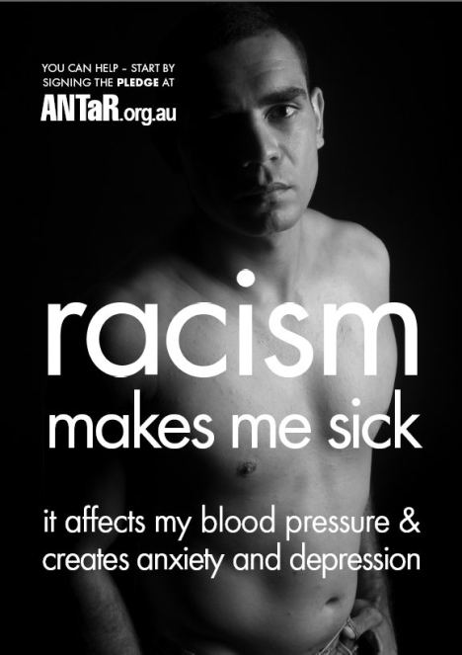
‘Racism makes me sick’ Poster (2008), by ANTaR, highlighting the impacts of racism on Aboriginal and Torres Strait Islander peoples

Sequence 3 Worksheet:
Tips for Bystanders

If you see racist behaviour in public, you could….
Say something if it feels safe to do so. It doesn’t have to be aggressive, in fact it’s often more effective if it’s not.
It could be as simple as saying “Why don’t you just leave him/her alone?”

If it doesn’t feel safe to say something, you could….
Tell someone responsible such as the driver if it’s happening on a bus or tram or a security guard if it’s happening at a club or venue.
Call the police on 000 if you think that you or somebody else may be in danger.
Think about how you can support the target of the abuse – for example, you could go and sit or stand next to them and check if they’re ok.

If you see racist material online, you could….
Report it. Most social networking sites have policies for dealing with offensive content and enable users to report this material. More information is usually available on these sites under “guidelines”, “standards” or “terms of use”.
Say something. Check out the Anti-Hate spray campaign to see messages you can post in response to “haters” online.
http://www.antihate.vic.gov.au/

If you see racism directed towards a classmate, colleague or team-mate, you could….
Say something. Check out the Speak UP! Handbook for ideas of things to say to counter prejudice in any situation.
Let them know they can complain. The Australian Human Rights Commission can investigate and resolve complaints of race discrimination in areas including employment, education, sport, accommodation and the provision of goods and services. The complaints process is free and confidential. For more information go to the Complaints page at: http://www.humanrights.gov.au/complaints-information
Suggest they talk to someone. Most schools, workplaces and sports clubs will have a policy for dealing with bullying and harassment, including racism. You might like to suggest to the person experiencing the racist behaviour that they seek advice from the contact person named in the policy such as the student welfare officer at school, human resources in the workplace or manager or club official in a sports club.

Paradies et al (2009), cited in VicHealth (2009), Building on our strengths: A framework to reduce race-based discrimination and support diversity in Victoria, Full report, p 35-36. At: http://www.vichealth.vic.gov.au/Programs-and-Projects/Freedom-from-discrimination/Building-on-our-strengths.aspx.
VicHealth (2008) ‘Ethnic and race-based discrimination as a determinant of mental health and wellbeing’, accessed 7 March 2012 from: http://www.vichealth.vic.gov.au/en/Publications/Freedom-from-discrimination/Ethnic-and-race-based-discrimination-as-a-determinant-of-mental-health-and-wellbeing.aspx cited in Reconciliation Australia submission to the National Anti-Racism Strategy (2012) at http://itstopswithme.humanrights.gov.au/it-stops-with-me/consultations.
A Markus, Mapping Social Cohesion 2012: the Scanlon Foundation Survey (2012). At: http://monash.edu/mapping-population/social-cohesion-report.html.
Reconciliation Australia (2012), Reconciliation Barometer 2012. At: http://www.reconciliation.org.au/home/resources/australian-reconciliation-barometer.
Australian Bureau of Statistics (2010) The Health and Welfare of Aboriginal and Torres Strait Islander Peoples, Oct 2010 (ABS catalogue number 4704.0) Canberra: Australian Bureau of Statistics cited in Reconciliation Australia submission to the National Anti-Racism Strategy (2012) at http://itstopswithme.humanrights.gov.au/it-stops-with-me/consultations.
Australian Institute of Health and Welfare, The health and welfare of Australia’s Aboriginal and Torres Strait Islander people: An overview 2011, note 42. At: http://www.aihw.gov.au/publication-detail/?id=10737418989.

