Australian Government Publishing Service
Canberra 1990

Human Rights and Equal
Opportunity Commission
Annual Report
1989-90
Commonwealth of Australia ISSN 1031-5098
Printed in Australia by Alken Press Pty. Ltd. - Smithfield, N.S.W.

Human Rights Australia

President

30 November 1990
The Hon Michael Duffy MP
Attorney-General Parliament House CANBERRA ACT 2600
Dear Attorney
I have pleasure in presenting the Annual Report of the Human Rights and Equal Opportunity Commission for 1989-90, pursuant to s.45 of the Human Rights and Equal Opportunity Commission Act 1986. The report has been prepared in accordance with the requirements of sub sections 25(6) and (7) of the Public Service Act 1922. A schedule detailing the location in the report of material relating to those requirements appears at Appendix 4.
Yours sincerely
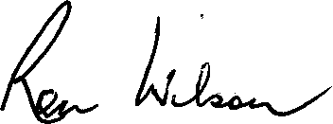
Ronald Wilson President

Human Rights and Equal Opportunity Commission Level 24 American Express Building
388 George Street Sydney NSW 2000
GPO Box 5218 Sydney NSW 2001
Telephone: 2297600 Facsimile: 2297611
Telex: A4 778000 DX 869 Sydney

Contents
Annual Report 1989-90
Page
The Commission 1
Objectives 1
Social Justice 1
Overview 1989-90 2
History and Evolution 11
Structure and Functions 15
Charter 15
Structure 16
Functions 16
Powers 18
Responsible Minister 19
Presidents of the Commission 20
Presidents' Engagements 1989-90 22
Human Rights 23
Human Rights Commissioner 23
Public Inquiries 24
Discrimination in Employment 27
Research 29
Legislative Review 31
Complaint Investigation/Resolution and Enquiries 36
International Instruments 41
Promotional Activities 43
Human Rights Commissioner's other Major
Speaking Engagements 1989-90 46
Race Discrimination 53
Human Rights and Equal Opportunity Commission
Race Discrimination Commissioner 53
Public Inquiries 55
Aboriginal Issues 59
Research 61
Legislative Review 61
Complaint Investigation/Resolution and Enquiries 62
Referred Matters 65
Promotional Activities 67
Race Discrimination Commissioner's Major
Public Engagements 1989-90 70
Sex Discrimination 73
Sex Discrimination Commissioner 73
Research 76
Legislative Review 77
Submissions 78
Intervention 80
Exemptions 81
Complaint Investigation/Resolution and Enquiries 82
Referred Matters 88
Promotional Activities 89
Sex Discrimination Commissioner's Speaking
Engagements 1989-90 93
Privacy 97
Annual Report 1989-90
Privacy Commissioner 97
Advice 98
Compliance 99
Complaint Investigation/Resolution and Enquiries . . . 99
Promotional Activities 102
Privacy Commissioner's Speaking
Engagements 1989-90 103
Coordination and Consultation 107
Non-government Organisations 107
Joint Projects 107
Promotional Activities 108
External Consultants 112
Cooperative Arrangements with the States 113
Corporate Services 115
Legislation 115
Objective 115
Management Issues 115
Regional Offices 129
Industrial Democracy 133
Occupational Health and Safety 136
Equal Employment Opportunity 137
Access and Equity 141
Library 143
Freedom of Information 144

Appendix 1: Appendix 2: Appendix 3: Appendix 4:
Commission Publications 147
Consultants Engaged 1989-90 151
Financial Statement 1989-90 155
Summary of Reporting Requirements . . 175

Human Rights and Equal Opportunity Commission

The Commission
Annual Report 1989-90 1

Objectives
The objectives of the Human Rights and Equal Opportunity Commission are:
- To increase the understanding, acceptance and observance of human rights and equal opportunity in Australia.
- To promote a fairer society by protecting basic human rights and ensuring that Australia complies with its human rights obligations under international law.
Social Justice
Departments and agencies are required in their annual reports to address the social justice aspects of their programs. All Commission activities serve to enhance the Government's objective of creating a fairer Australia, particularly by ensuring that:
- access to government programs is fair and equal;
- all Australians have the opportunity to participate in personal development, community life and decision making; and
- everyone enjoys the same protection of their basic human rights.
In fact, these rights are given effect to in the international instruments scheduled to the Human Rights and Equal Opportunity Commission Act 1986 (HREOC Act). Everything the Commission does serves a social justice purpose. Each of our activities is specifically targeted at one or more of the most disadvantaged and vulnerable groups in our society, with the aim of ensuring that they are given the opportunity to participate equally in all aspects of Australian life, free from discriminatory treatment.
2 Human Rights and Equal Opportunity Commission
Overview
1989-90
The past year has seen the streamlining of many of the administrative aspects of the Commission, allowing the most cost-effective use of time and resources by Commissioners and staff. The Privacy Commissioner completed his first full financial year and has made substantial progress in raising community awareness about the legislation he administers. The extra demands made on Commission resources by the Privacy Commissioner's activities have resulted in expansion of some facilities.
The Commission welcomed its new President midway through the financial year, and a new Attorney-General after the Federal elections in March.
The Commission has grouped its activities under the four portfolio headings of Human Rights, Privacy, Sex Discrimination and Race Discrimination - each relating to a separate Act. For the financial year 1989-90, budgeting and planning was organised on a portfolio basis, with an additional Corporate Services strand for general activities, non-portfolio specific business, and business which it is too costly or time consuming to segregate. The material in this year's Annual Report has also been presented in this manner.
A number of Commission activities cannot be categorised into one or other of the portfolios. These include general promotional activities to raise awareness of human rights. An example is the Human Rights Congress, which in September 1989 attracted some 360 participants from all parts of Australia and New Zealand (notwithstanding major difficulties caused by the domestic pilots' dispute). Each of the forty sessions was well attended.
Human Rights Week (December 4-10) is another major promotional activity. It is a national event to celebrate the anniversary of the Universal Declaration of Human Rights. A major feature of the Week is the presentation of the Human Rights Awards - this year by Mrs Hazel Hawke. (A complete
list of award winners is included in the chapter on Consultation and Coordination.)
Annual Report 1989-90 3
The Commission's research work is closely connected with its community education and promotion activities. It also forms the basis for submissions to government and to parliamentary inquiries regarding legislation and/or policy. Research and legal staff work closely with enquiries and conciliation staff in discharging the Commission's complaint handling function. In a two-way process, directions for research are strongly influenced by issues arising in complaint handling and by the Commission's contact and cooperation with non-government organisations.
Researchers also provide data for the many speeches which Commissioners and other officers deliver. Speaking engagements (which are listed at the end of each chapter on the portfolio areas) provide opportunities not only to explain the human rights embodied in the legislation which the Commission administers, but also to promote understanding of the practical implications of these rights.
Complaints
This year has been a particularly challenging one for the Commission's conciliation staff. There was a substantial increase in complaints received under the HREOC Act, due to the declaration in January 1990 of additional grounds of discrimination under the International Labour Organisation Convention Concerning Discrimination in Respect of Employment and Occupation (ILO 111). This development, along with an existing backlog, and consistent numbers of new complaints under the other Acts administered by the Commission, resulted in conciliators carrying high case loads throughout the year.
Heightened community awareness about privacy rights and the general impact of the Privacy Act resulted in a steady intake of privacy matters in the Commission's central office.
During 1989-90 the Commission received some 13,000 approaches for assistance. This figure includes 10,498 telephone enquiries and 391 personal interviews. Although direct comparisons with the previous year are not possible (because detailed statistics were not previously kept for telephone enquiries) there has been a significant increase in such enquiries and additional staff have been engaged to cope with the demand.
4 Human Rights and Equal Opportunity Commission
The Commission and its agencies handled 2,039 matters received in writing from people seeking to lodge complaints under the legislation the Commission administers. Of these, 1,064 were found to fall under one of the Acts administered by the Commission, an increase of 18.4 percent over the previous year (see Table 1). The remaining 975 matters were assessed as outside jurisdiction.
Table 1
New Complaints within Jurisdiction Received July 1, 1989 to June 30, 1990

 | Central  Office | QLD | NT | TAS | NSW | VIC | SA | WA | Total
SDA | 37 | 80 | 12 | 16 | 189 | 56 | 181 | 22 | 593
RDA | 18 | 67 | 13 | 1 | 120 | 16 | 47 | 15 | 297
HREOC Act | 86 | 18 | 8 | 3 |  |  | - |  | 115
Privacy Act | 59 |  |  |  |  |  |  |  | 59
Total | 200 | 165 | 33 | 20 | 309 | 72 | 228 | 37 | 1064

This year there was a slight increase in the number of complaints lodged under the Sex Discrimination Act. Figure 1 shows that complaints lodged under the Sex Discrimination Act accounted for 55.7 percent of all new complaints. There was a significant increase in Privacy complaints, with the total number more than double last year's figure. Complaints lodged under the Human Rights and Equal Opportunity Commission Act increased by 113 percent over last year's figures, while complaints under the Racial Discrimination Act increased by 22 percent.
Figure 1
Annual Report 1989-90 5
New Complaints Received July 1, 1989 to June 30, 1990
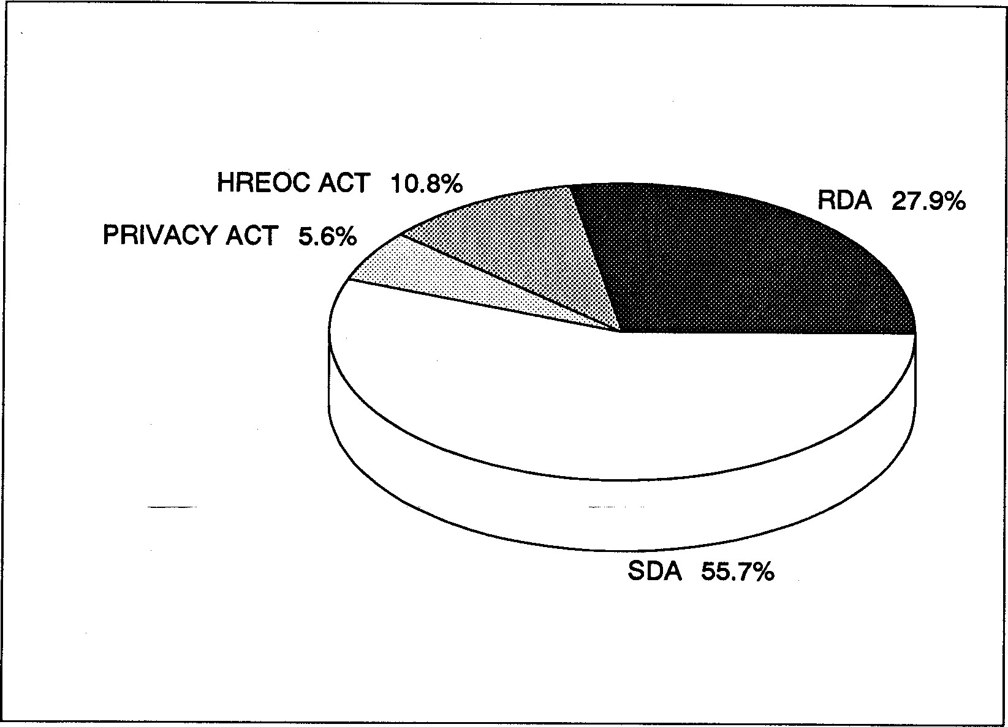
Table 2 indicates that 932 cases were finalised during the year, a marked increase of 47.7 percent on last year's total of 628 - despite staffing shortages experienced throughout the year in a number of the Commission's offices.
Table 2
Cases Closed July 1, 1989 to June 30, 1990

 | Central  Office | QLD | NT | TAS | NSW | VIC | SA | WA | Total
SDA | 26 | 87 | 16 | 9 | 172 | 69 | 145 | 23 | 547
RDA | 18 | 61 | 14 |  | 92 | 21 | 67 | 12 | 285
HREOC Act | 59 | 2 | 5 | 2 |  |  |  |  | 68
Privacy Act | 32 |  |  |  |  | - |  |  | 32
Total | 135 | 150 | 35 | 11 | 264 | 90 | 212 | 35 | 932

The conciliation process has continued to prove very effective in resolving complaints which, at times, have involved complex and highly sensitive issues. Conciliators in the Commission's central and regional office, and in the cooperating State agencies investigated and successfully conciliated many hundreds of complaints which were brought under each of the Federal Acts administered by the Commission. Only a very small number of cases (4.1 percent) required referral to a formal hearing. Table 3 indicates the outcomes in relation to complaints closed.
6 Human Rights and Equal Opportunity Commission
Table 3
Outcomes of Complaints Closed July 1, 1989 to June 30, 1990

 | Central  Office | QLD | NT | TAS | NSW | VIC | SA | WA | Total
Conciliated | 48 | 85 | 25 | 4 | 119 | 22 | 111 | 11 | 425
Withdrawn/ Lost contact | 43 | 23 | 7 | 4 | 69 | 28 | 42 | 14 | 230
Declined | 5 | 22 | 0 | 2 | 19 | 29 | 21 | 3 | 101
Outside | 15 |  | 3 |  |  |  | 9 | 4 | 31
Jurisdiction
Referred elsewhere | 6 |  |  |  |  |  | 18 |  | 24
Referred for investigation by |  |  |  | 1 |  |  | 10 | 1 | 12
Commissioner
Referred for | 8 | 11 |  |  | 5 | 11 | 1 | 2 | 38
Hearing
Report to | 10 |  |  |  |  |  |  |  | 10
Minister
Other |  | 9 |  |  | 52 |  |  |  | 61
Total | 135 | 150 | 35 | 11 | 264 | 90 | 212 | 35 | 932
Outlines of some of the more significant matters are given below (in the chapters on the Racial Discrimination Act and Sex Discrimination Act).
Of the cases closed, 70.3 percent were considered to be successfully resolved with a mutually agreed settlement or the complaint being withdrawn. The Commission and its agencies declined 10.5 percent of the cases received on the basis that they could not be substantiated. (Figure 2)
Annual Report 1989-90
7
Figure 2
Outcomes of Complaints Closed July 1, 1989 to June 30, 1990
Declined 10.8% Withdrawn/lost contact 24.7%
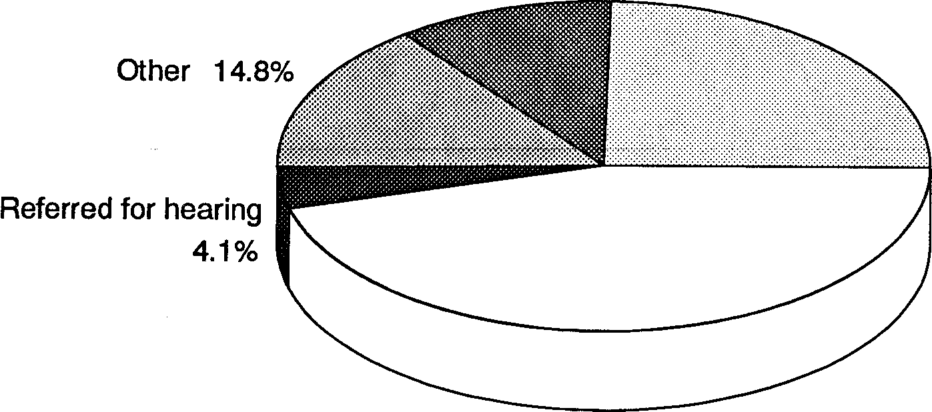
Conciliated 45.6%

Table 4 shows the time taken in central office to finalise written complaints. The average processing time was ten months which is a significant improvement on earlier years, but is still considered to be longer than desirable. The Commission will
Less than 6 6- 12 months 12- 18 months Over 18 months months | Table 4

38.6% 29.6% 17.7% 14.4% | Time taken to  finalise written  complaints  1989-90
Average time: 10 months | Time taken to  finalise written  complaints  1989-90

continue to explore ways to reduce processing times even further.
In the period 1 July 1989 to 30 June 1990, 975 complaints found to be 'Not under the Act' (NUA) were received by the Commission's central office and its three regional offices in Queensland, the Northern Territory and Tasmania. Table 5 shows a breakdown of the 474 NUA complaints received in central office and demonstrates the range of issues placed before the Commission.

Miscellaneous 64
Table 5
Privacy Act related 53
Categories of NUA Enquiries Received Central Office
July 1,1989 to June 30, 1990
Referred to agent 47
Race related 39
HREOC related 40
Sex related 38
Immigration 35
Employment 30
Family law/legal and justice system 25
Goods, services, places, facilities 23
State/local government 17
Prisons 14
Disability 14
Overseas matters 13
Age 13
Police 4
AIDS 2
Overseas qualifications 2
Housing/accommodation 1

8 Human Rights and Equal Opportunity Commission
Total | 474

Staffing increases were necessitated by the impact of the Privacy legislation, and the introduction of additional grounds of discrimination under ILO Convention 111 (incorporated in the Human Rights and Equal Opportunity Commission Act).

The Commission now has jurisdiction to inquire into, and attempt to resolve, complaints of discrimination in employment and occupation on the following additional grounds: age, medical record, criminal record, physical disability, mental, intellectual and psychiatric disability, nationality, marital status, sexual preference or trade union activity. All employers - private sector; Federal, State and local government - are covered by this legislation. Of the new grounds, complaints relating to age discrimination in employment are proving particularly challenging and difficult to conciliate. In some instances, the Commission has met with considerable resistance as respondent organisations grapple with the problem of formulating flexible employment policies in place of long-standing retirement practices. Further details appear in the chapter on Human Rights.
Annual Report 1989-90 9
As in previous years, complaints under Federal legislation were handled in one of three ways: by the Commission's central office in Sydney; by its regional offices in Brisbane, Hobart and Darwin; or by State agencies in New South Wales, Victoria, South Australia and Western Australia. The Commission has been working with the State agencies to ensure a uniform method of recording information about complaints. However, some of the statistical discrepancies reflect the continuing lag in securing a uniform approach by the States to data collection.
The Commission has continued to achieve substantial financial outcomes for complainants, particularly in the sex and race discrimination areas. In Queensland, for example, a complaint of sexual harassment was resolved when the respondent paid $17,500 in compensation to the complainant.
The first substantial settlement under the Privacy Act was made during the year to a complainant whose right to privacy had been infringed.
Regular analysis of the type of complaints received assists the Commission in planning its community education programs. For example, the emerging profile of the typical complainant in the majority of sexual harassment cases, as a young woman working in a small business, prompted the Commission to
develop the SHOUT (Sexual Harassment is OUT) Campaign. Taking the SHOUT Campaign to its target audience will be one of the major public activities of the Sex Discrimination Commissioner over the coming months.
10 Human Rights and Equal Opportunity Commission
ACT Complaints
The Commission continued to provide an effective service to complainants in the ACT through the investigation and conciliation of a number of matters. Of the 200 formal complaints handled by central office, 38 (or 19 percent) originated in the ACT, with the Human Rights and Equal Opportunity Commission Act accounting for the highest proportion of complaints received.
Of the 474 NUA complaints received by the Commission's central office, 34 related to ACT matters. Of the 23 interstate visits made by conciliators from central office, 16 were in relation to ACT complaints.
The workload originating in the ACT has reinforced the Commission's desire to establish an office in Canberra, and a New Policy Proposal was put forward for this purpose in the 1990-91 Budget context. The Commission held discussions during the year with the ACT Government about the feasibility of a joint ACT/Federal human rights office in Canberra. These matters remain unresolved at the time of writing.
Media and Promotions
The role of the Media Unit is to maintain an effective liaison with media outlets throughout Australia, with the objective of increasing public awareness of the work of the Commission and the human rights issues involved. In the past twelve months there has been an enormous amount of coverage of human rights issues by the Australian media. This coverage has played an important role in raising the level of public understanding about the Commission's functions and the issues being addressed by each of the Commissioners. The Education and Promotion Section is involved with the Media Unit in the planning and execution of the public awareness campaigns which are described in more detail later in this report. It is also
involved in the development of educational and promotional strategies, the design and production of promotional material, and the design and implementation of training material.
Annual Report 1989-90 11
The demand for resource material is one measure of the Commission's success in reaching the Australian community. The past year has seen an 87% increase over the previous year in the demand for Commission publications. A list of
Commission publications appears at Appendix 1.
History and Evolution
The horrific violations of human rights during the Second World War led to a concerted effort in the aftermath of the War to establish some effective means of recognising and enforcing human rights, in both the international and national arenas. Many concerned individuals and some governments had previously been aware of the need to protect human rights, but the post-war period and the forum of the United Nations Organisation provided the opportunity to take specific steps in the provision of safeguards.
The first historic step was the adoption by the United Nations General Assembly on 10 December 1948 of the Universal Declaration of Human Rights. The Universal Declaration was not originaly seen as creating international law on human rignts binding on nation states; rather, it was a general declaration defining the human rights which ought to be respected. It was a goal for nations to achieve.
The second stage was the development in international law of major Covenants on human rights which are binding on nations which ratify them. The two Covenants associated with the Universal Declaration are the International Covenant on Economic, Social and Cultural Rights and the International Covenant on Civil and Political Rights (ICCPR). Both were adopted by the UN General Assembly in 1966 and became operative in 1976.
The third stage involves the establishment of national measures
and machinery for the implementation of the international
instruments. The Australian Parliament passed the Racial Discrimination Act in 1975, incorporating in it the International Convention on the Elimination of All Forms of Racial Discrimination. This Convention had been adopted by the UN General Assembly in 1965, and came into force in 1969, although it was not ratified by Australia until 1975.
12 Human Rights and Equal Opportunity Commission
The Federal Government introduced the Human Rights Commission Act in 1981, having ratified the ICCPR in the previous year.
The Human Rights Commission, established under that Act, was empowered to handle complaints and conduct educational, promotional and research programs in relation to the Racial Discrimination Act, the ICCPR, and the United Nations Declarations dealing with the Rights of Children, the Mentally Retarded, and the Disabled. The Commission was established basically as a part-time body, with one full-time member and six to ten part-time members (including the Chairman). The Commissioner for Community Relations, who performed certain functions on behalf of the Commission under the Racial Discrimination Act, was not a member of the Commission.
With the passing of the Sex Discrimination Act in 1984, the Human Rights Commission was given significant additional responsibilities. Like the Commissioner for Community Relations, the Sex Discrimination Commissioner was not a member of the Commission. Thus the anomalous situation had arisen where the two full-time Commissioners (for Community Relations and Sex Discrimination), who performed the bulk of the Human Rights Commission's complaint-handling work, were not themselves members of the Commission and had no direct input into the setting of priorities within the Commission.
The Hawke Labor Government decided that the Human Rights Commission should be restructured in order to overcome this anomaly and for several other reasons. There was a perceived need to integrate the work of the Commission with the National and State Committees on Discrimination in Employment and Occupation, which administered the International Labour Organisation Convention Concerning Discrimination in Respect
of Employment and Occupation (ILO 111). There was also a growing awareness of the inadequacy of a structure based on part-time membership, especially in light of the Commission's additional responsibilities which contributed to an expanding complaints caseload, as well as educational and research projects. Finally, the development of cooperative arrangements with four of the States meant that the Commission had agents there in the form of relevant State equal opportunity bodies.
Annual Report 1989-90 13
These factors, together with the need for cost savings, led the Government to the view that the Human Rights Commission should be replaced with a smaller body of full-time Commissioners. It felt that this would be the structure best adapted to handle complaints under the instruments in respect of which the Commission had responsibility, thus ensuring that Australia honoured its international human rights obligations.
In 1986, the Government introduced the Human Rights and Equal Opportunity Commission Bill. (A 'sunset' clause in the 1981 Human Rights Commission Act effected its dissolution after five years.) It also decided to move the Commission from Canberra to Sydney.
The new Commission comprised a part-time President, three full-time Commissioners, and a considerably reduced staff. One position - the Sex Discrimination Commissioner - was already in place under the Sex Discrimination Act; the new statutory position of Race Discrimination Commissioner was created to replace the Commissioner for Community Relations under the Racial Discrimination Act. The Human Rights Commissioner was given executive responsibility for the management of the Commission.
The new Human Rights and Equal Opportunity Commission continued the cooperative arrangements made by its predecessor with State governments in New South Wales, Victoria, South Australia and Western Australia. This involved delegating certain of the Commission's powers to State bodies which were already administering their own anti-discrimination legislation, thus minimising duplication in the provision of services.
On 1 January 1989, the new position of Privacy Commissioner was created to complement the protection of human rights provided by the Human Rights and Equal Opportunity Commission. The Privacy Commissioner was appointed under the Privacy Act 1988. The Act's major concerns are the protection of personal privacy by ensuring that information collected by Federal Government departments or agencies is adequately safeguarded, and ensuring proper use of Tax File Numbers.
14
Human Rights and Equal Opportunity Commission
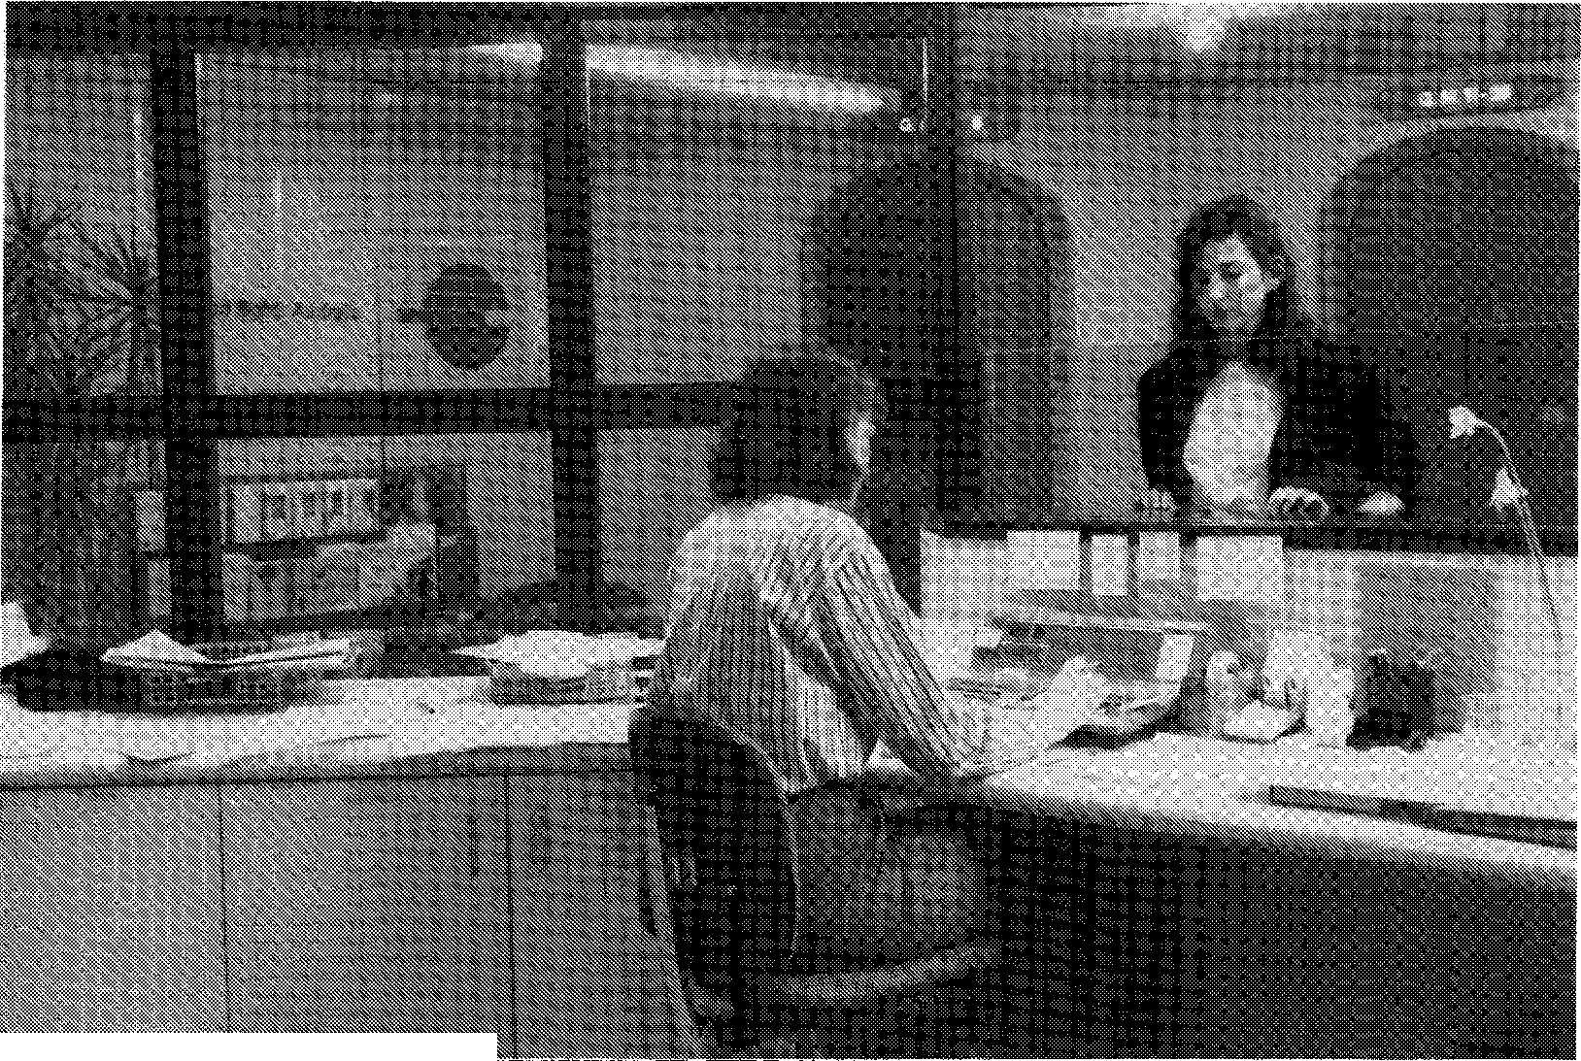
The reception area at the Commission's Sydney Office.
Structure and Functions
Annual Report 1989-90 15
Charter
The Commission is a permanent independent statutory authority with responsibility for the following Acts of Parliament:
- Human Rights and Equal Opportunity Commission Act 1986
- Racial Discrimination Act 1975
- Sex Discrimination Act 1984
The Commission also assists the Privacy Commissioner in administering the:
- Privacy Act 1988
These Acts give force to the following international instruments to which Australia has committed itself:
Human Rights and Equal Opportunity Commission Act
- International Covenant on Civil and Political Rights
- Declaration of the Rights of the Child
- Declaration on the Rights of Mentally Retarded Persons
- Declaration on the Rights of Disabled Persons
- International Labour Organisation Convention Concerning Discrimination in Respect of Employment and Occupation
Racial Discrimination Act
- International Convention on the Elimination of All Forms of RacialDiscrimination
Sex Discrimination Act
- International Convention on the Elimination of All Forms of Discrimination Against Women
Privacy Act
- International Covenant on Civil and Political Rights (Article 17)
• Organisation for Economic Cooperation and Development Guidelines on the Protection of Privacy and Transborder Flows of Personal Data
16 Human Rights and Equal Opportunity Commission
Structure
The Commission's organisational structure appears on the following chart.
Functions
Sections 11 and 31 of the Human Rights and Equal Opportunity Commission Act detail the functions of the Commission. Schedule 1 of the Privacy Act 1988 amends the Human Rights and Equal Opportunity Commission Act to make the Privacy Commissioner a member of the Human Rights and Equal Opportunity Commission. The Privacy Commissioner is assisted in carrying out his statutory obligations by the staff of the Commission.
In broad terms, the Commission reviews existing and proposed legislation for any inconsistency with human rights or for any discriminatory provision which impairs equality of opportunity or treatment in employment or occupation. It examines any new international instruments relevant to human rights in order to advise the Federal Government on their consistency with other international treaties and existing Australian law. The Commission may also propose laws or suggest actions that the Government should take on matters relating to human rights and discrimination.
The Commission also inquires into acts or practices that may infringe human rights or that may be discriminatory and, in the event that infringements are identified, recommends action to remove them. It sponsors public discussion and also undertakes and coordinates research and educational programs to promote human rights.
For the purposes of the Commission's jurisdiction, 'human
rights' are defined as those rights set out in the Covenant and
06⁻696L Pode,y lenuuv
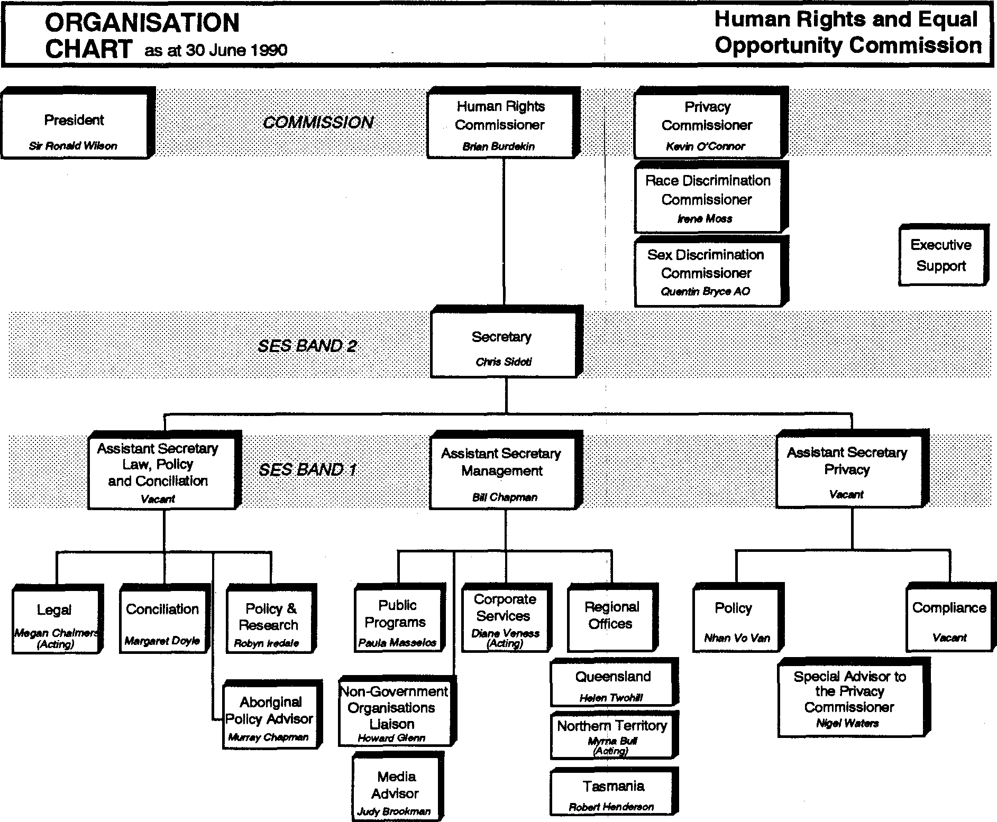
Sex Discrimination
Commissioner
Quentin Bryce AO
Executive
Support
Human Rights and Equal Opportunity Commission
ORGANISATION
CHART as at 30 June 1990
Race Discrimination
Commissioner
Irene Moss
Human Rights
Commissioner
Brian Surtlekin
Privacy
Commissioner
Kevin O'Connor
.SESBAND Z.
Assistant Secretary
Law, Policy
and Conciliation
Vacant
Assistant Secretary
Management
SS Chapman

I
Assistant Secretary : Privacy
v
Conciliation
Margaret Doyle
Policy & Research
Robyn hods!.
Public Programs
Paula Masselos
Corporate Services
Diane VO1POSS
(Aaing)
Policy
Nhan Vs Van
Compliance
Regional
Offices
Queensland | Special Advisor to
Helen Ryden | the Privacy
Helen Ryden | Commissioner
Northern Territory I | Commissioner
Northern Territory I | Nigel Waters
^{A}rolfª .ar "

Tasmania I
Robert Henderson
Aboriginal
Policy Advisor
Murray Chnoman
COMMISSION
SES BAND.1
Non-Government
Organisations
Uaison
Howard Glenn
Media Advisor
Judy Brockman
President
Si Ronald %Noon
Declarations scheduled to the Human Rights and Equal Opportunity Commission Act.
18 Human Rights and Equal Opportunity Commission
Powers
The Commission is given certain powers by the enabling legislation so that it may discharge its responsibilities effectively. These include power to:
- conduct an inquiry as the result of a complaint, or on its own initiative, or when the Minister so requests, and to conciliate in the matter;
- decline an inquiry as the result of a complaint;
- require individuals to furnish information, produce documents or appear before it to give evidence (including on oath or affirmation);
- in certain circumstances, prohibit the disclosure of the identity of a person providing information.
The Commission can report to the Government on any matter arising in the course of its functions. With the approval of the Minister, it can establish advisory committees. It can delegate its powers and work with and consult appropriate individuals, government bodies and non-government organisations. The Commission is also empowered to:
- formulate guidelines for the avoidance by government of practices that infringe human rights;
- intervene, with leave of the court, in legal proceedings which involve human rights matters;
- inquire, report, conciliate and educate in relation to the International Labour Organisation Convention
Concerning Discrimination in Respect of Employment and Occupation.
Under the Racial Discrimination Act and the Sex Discrimination Act, the Commission has further powers to inquire into any alleged unlawful act of racial discrimination or discrimination on the basis of sex, marital status or pregnancy following a written complaint or when it appears to the Commission that an unlawful act has been committed. The
relevant Commissioner attempts to settle the matter by conciliation.
Annual Report 1989-90
19
The Privacy Act lays down strict privacy standards that Federal Government departments and agencies must observe in collecting, storing and using personal information. The Privacy Commissioner can inspect the records of agencies and direct them to change their information handling practices to ensure that they follow certain Information Privacy Principles. He can investigate complaints and award compensation if damage results from a breach of these Principles or of the Tax File Number Guidelines. He can also issue Public Interest Determinations where the acts or practices of agencies breach the Information Privacy Principles but the public interest in the agencies so doing outweighs the public interest in adhering to the Principles.
Responsible Minister
The Minister responsible in the Federal Parliament for the
Commission is the Attorney-General, the Honourable Michael
Duffy MP. He has the following powers under the HREOC Act:
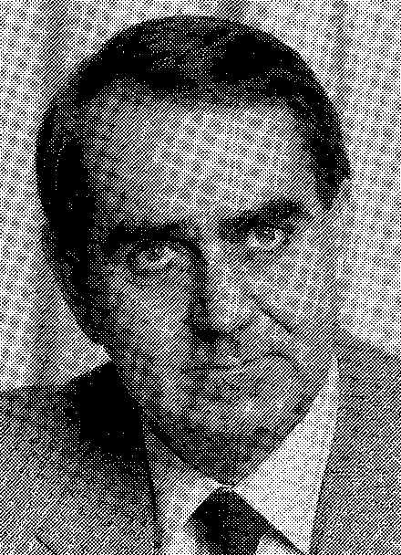
- to make, vary or revoke an arrangement with the States for the performance of functions relating to human rights or to discrimination in employment or occupation;
- to declare, after consultation with the States, an international instrument to be one relating to human rights and freedoms for the purposes of the Act;
- to establish an advisory committee (or advisory committees) to advise the Commission in relation to the The Hon Michael Duffy MP, performance of the Commission's functions and, when Attorney-General
requested by the Minister, to report to him on Australia's compliance with ILO Convention 111 and to advise the Minister in regard to national policies relating to equality of opportunity and treatment in employment and occupation.
The Attorney-General also has the power to request the Commission to report to him on certain matters and to establish one or more committees to advise the Commission in relation to the performance of its functions. In addition he has the power to
issue to the Commission a certificate that the disclosure of certain information or the contents of certain documents would not be in the public interest.
20 Human Rights and Equal Opportunity Commission
Under the Sex Discrimination Act and the Racial Discrimination Act, the Attorney-General may:
- appoint people to participate in inquiries and determine the terms and conditions of such appointments, including their termination;
- refer any matter to the Commission for inquiry as a complaint;
- authorise Commonwealth assistance, under certain circumstances, to people who are parties to proceedings before the Commission.
The Minister also has a role under the Privacy Act, including receiving the Privacy Commissioner's reports to him about interferences with privacy or about proposed Federal legislation that may interfere with privacy. Under this Act, he can also consider applications for financial assistance and can issue certificates which prevent the disclosure of certain matters in the public interest.
Presidents of the Commission
The first President appointed to the Commission in December 1986 was the Hon. Justice Marcus Einfeld who was concurrently serving as a Justice of the Federal Court of Australia.
Prior to his appointment, Justice Einfeld had had a long involvement with civil and human rights, and had been a part-time member of the former Human Rights Commission.
During his term as President of the Human Rights and Equal Opportunity Commission, Justice Einfeld was particularly moved by the plight of Aboriginal Australians and the deprivations that they suffered as a result of both deliberate and careless neglect of the majority white society and governments.
He chaired the Toomelah Inquiry which resulted in conditions being ameliorated for the Aboriginal residents of Toomelah, Goondiwindi and Boggabilla on the New South Wales-Queensland border.l.
In January 1990, after a little over three years as President, Justice Einfeld resigned his position on account of his already heavy workload as a Federal Court judge.
On 7 February 1990, the then Deputy Prime Minister and Attorney-General, the Hon. Lionel Bowen, MP, announced the appointment of Sir Ronald Wilson, AC, KBE, CMG, as the new President of the Commission for a term of five years. Sir Ronald had retired one year previously as Senior Puisne Justice of the High Court of Australia.

In parallel with his long legal career in the service of his home State of Western Australia(b_efore his move ta the High Court), Sir Ronald also served his church, being at times the Moderator of the Presbyterian Church in Western Australia and Moderator of the WA Synod of the Uniting Church. He has been National Commission President,
Sir Ronald Wilson
President of the Uniting Church in Australia since 1988. In another important public role, Sir Ronald has served as the Chancellor of Murdoch University since 1980.
Like his predecessor, Sir Ronald has a particular concern for the violation of the human rights of Aboriginal Australians, believing that Australia will be judged internationally by its response to Aboriginal needs and aspirations. Another of his concerns is poverty, with particular emphasis on human rights.
At the time of Sir Ronald's appointment, the Attorney-General said:
He will bring a depth of judgment and compassion to this job that will serve as a demonstration, both at home and abroa4 to ongoing commitment in this country to the protection of human rights that we all need to survive as civilised human beings.
Toomelah Report, HREOC 1988
Annual Report 1989-90 21
Presidents'
Engagements
1989-90
Both the former President and the current President undertook extensive speaking and other engagements on behalf of the Commission during the year. Like his predecessor, Sir Ronald Wilson sits on a number of the Commission hearings and he chairs Commission meetings. Sir Ronald has also given numerous media interviews and has supported the full-time Commissioners' in their promotional and educative activities.

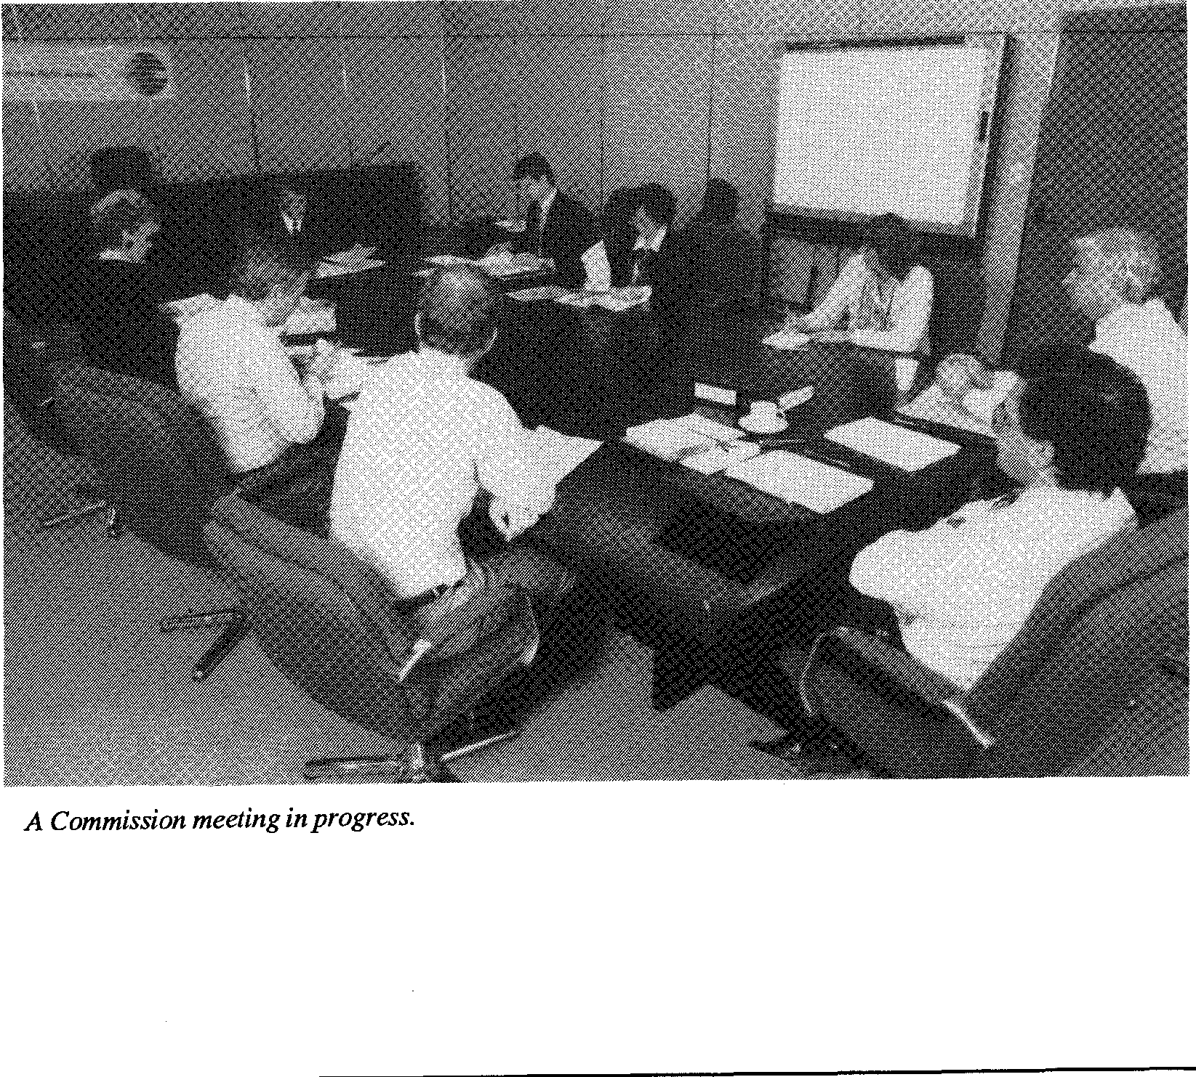
A Commission meeting in progress.
Human Rights
Annual Report 1989-90
23
Human Rights
Commissioner
The Human Rights Commissioner, Mr Brian Burdekin, is responsible for handling issues arising under the Human Rights and Equal Opportunity Commission Act. Appointed in December 1986 for a seven-year term, Mr Burdekin is also the executive head of the Commission, responsible for its day to day administration. Prior to his appointment he had been a lawyer and diplomat, representing Australia in Washington and Geneva and in a number of international negotiations.
Statement from the Human Rights Commissioner
The first Human Rights Commission was set up in 1981 by the Fraser Government. Its successor, the Human Rights and Equal Opportunity Commission, was established by the Hawke Government in 1986.  After three and a half years I believe it is fair to say that our Commission is still something of an 'experimental model'. However, it is interesting to note that the United Nations and a number of other countries have expressed the view that the powers which we exercise and the structure of the Commission represent one of the most effective models in any country. | 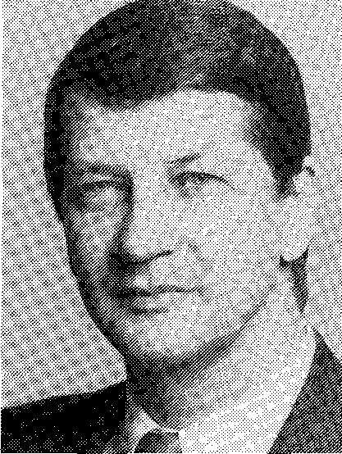

Human Rights Commissioner,
There is no doubt that the existing structure can be improved Mr Brian Burdekin
upon. What is essential, however, is a better understanding in the general community and at the political level of the need for human rights machinery, given the limitations of our court .system to provide affordable and effective remedies for many of our most disadvantaged Australians.
In the past year, the Commission has worked hard to advance
human rights - through complaint handling, through
submissions to Federal and State parliamentary and other inquiries, and through itself conducting public inquiries.
24 Human Rights and Equal Opportunity Commission
A general but important achievement of the Commission has been to raise awareness of the relevance of human rights principles - in government, in a wide range of non-government organisations and in the general community.
Some achievements in my own area of responsibility have been made - but much remains to be done. I hope the Commission can continue to inform public opinion and alert the community to continued abuses of the rights of the most vulnerable in our society.
The inquiry into the human rights of people with mental illness will be a major part of my work in the coming year.
We will continue to focus our efforts on achieving tangible results.
Public Inquiries
Mental Illness Inquiry
In September 1989, Commissioner Burdekin announced his intention to conduct a National Inquiry Concerning the Human Rights of People with Mental Illness. He will be assisted in the Inquiry by the Hon. Dame Margaret Guilfoyle DBE, Deputy Chair of the Mental Health Research Institute of Victoria, and Mr David Hall, Convenor of the National Coalition of Mental Health and Psychiatric Disability Groups, and Executive Director of the Richmond Fellowship of Victoria. Professor Beverley Raphael, Head of the Department of Psychiatry at Queensland University, will act as Special Advisor to the Inquiry.
The terms of reference for the Inquiry were announced in June 1990, following extensive research and consultation with many individuals and organisations concerned with mental illness. This research strongly suggested that many thousands of
Australians with a mental illness were subject to serious violations of their human rights: through inadequate or inappropriate treatment; through lack of resources for rehabilitation; through entrenched discrimination or simply through being ignored.
Annual Report 1989-90 25
The terms of reference for the Inquiry are:
- To inquire into the human rights and fundamental freedoms afforded persons who are or have been, or are alleged to be, affected by mental illness, having due regard to the rights of their families and members of the general community.
- In particular, to inquire into the effectiveness of existing legislative provisions, legal mechanisms and other measures in protecting and promoting the human rights of such persons.
- To examine the respective roles and responsibilities of Commonwealth, State and Territory Governments in these areas.
- Without limiting the generality of the preceding terms, to consider:
- any discrimination on the basis of mental illness in Commonwealth laws or programs;
- any discrimination in employment, occupation, accommodation or access to goods and services on the basis of mental illness; and
- human rights in relation to institutional and non-institutional care and treatment of persons with mental illness.
The Inquiry will be conducted by the Commission pursuant to its charter under Federal law.
Homeless Children's Inquiry
26 Human Rights and Equal Opportunity Commission
The National Inquiry into Homeless Children, undertaken by Commissioner Burdekin with Ms Jan Carter and Father Wally Dethlefs, was reported upon in detail in the Commission's 1988-89 Annual Report. When presenting the report of the Inquiry in February 1989, the Human Rights Commissioner undertook to reconvene the Inquiry at an appropriate time to assess progress on implementing the report's findings and recommendations. In line with that undertaking, the Inquiry was reconvened in Canberra in December 1989 and in Melbourne in June 1990.
At the Canberra Hearing, evidence was received from the Hon. Peter Staples, then Minister for Housing and Aged Care, representing the Federal Government, and representatives from most State and Territory Governments. Further brief sittings are planned in NSW, Queensland and Western Australia during the coming year.
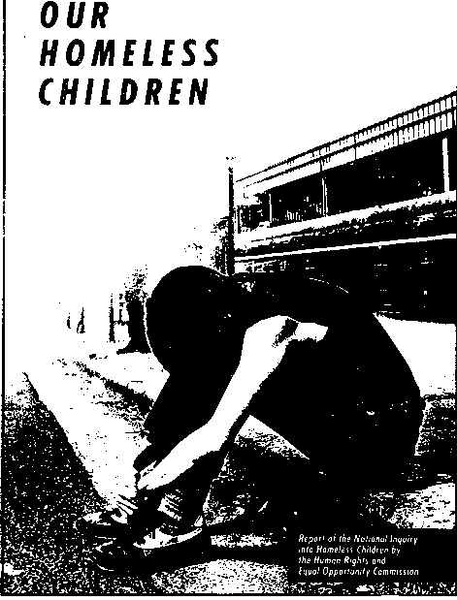

The Commission was encouraged by the significant initiatives announced by the Federal Government in the 1989-90 Budget and outlined in the publication, Towards Social Justice for Young Australians. This commits the Government to an expenditure of $100 million over four years for services and accommodation for homeless and disadvantaged young people. The Social Justice package commits the Government to provide secure accommodation for an additional 6000 homeless youth, improve coordination between services, establish adolescent mediation services and innovative health care measures, and take action in several other areas where the Inquiry made specific recommendations.
However, responses by State and Territory governments were generally not as timely or as comprehensive as had been hoped. In several important areas the Federal funding package required the States to match funds on offer. Some States were reticent about such a commitment. The central problems highlighted in the Inquiry's Report of poor coordination and inadequate
t Human Rights and Equal Opportunity Commission, Our Homeless Children, AGPS, Canberra, 1989.
consultation by governments with workers in the field continued to inhibit efforts to reform existing approaches and practices. Nevertheless, there have been significant signs of progress in several States. The Inquiry has been particularly encouraged by the response of the private sector, with a number of Trusts and Foundations committing substantial funds to services for homeless youth.
The Commission will continue to monitor developments and press for speedy and effective reforms to address abuses of the human rights of this severely disadvantaged section of our community.
Before the establishment of the Human Rights and Equal Opportunity Commission in December 1986, responsibility for Australia's compliance with the International Labour Organisation Convention Concerning Discrimination in Respect of Employment and Occupation (ILO 111) lay with the Attorney-General's Department. The Convention requires a tripartite approach to problem solving - involving unions and employers, as well as government. Upon ratification of the Convention in 1973, the Federal Government established Committees on Discrimination in Employment and Occupation to eliminate discrimination and promote equality of opportunity. Each State and the Northern Territory had a local Committee with representatives from the Australian Council of Trade Unions, Confederation of Australian Industry, and Federal and State Governments. Each Committee was serviced by an Executive Officer who handled conciliation of complaints other than those based on race or sex.
.
Discrimination in Employment
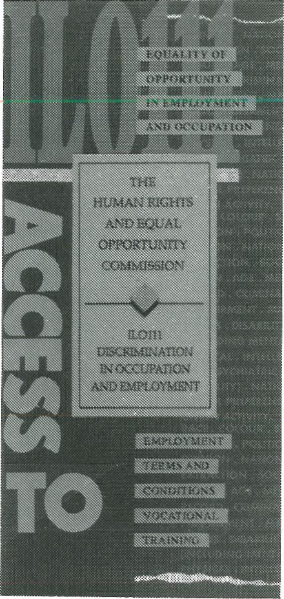

There was also a National Committee on Discrimination in Employment and Occupation which set policy and dealt with complaints on an Australia-wide basis. It also received complaints which could not be solved at the State or Territory level.
Annual Report 1989-90
27
There have always been seven bases of discrimination
prohibited by this Convention: race, colour, sex, religion,

political opinion, national extraction and social origin. There were a further nine grounds not specified in the Convention but recognised by the Committees on Discrimination: age, marital status, criminal record, medical record, disability, sexual preference, trade union activities, nationality and personal attributes. (The Convention allows for other grounds to be declared, following consultation with the tripartite partners.)
28 Human Rights and Equal Opportunity Commission
With the establishment of the Human Rights and Equal Opportunity Commission, responsibility for ILO 111 was removed from the Attorney-General's Department and vested in the Commission. The grounds for complaint, however, were restricted to the original seven grounds in the Convention.
The Act empowers the Commission to inquire into any act or practice that may constitute discrimination and, where it is considered appropriate, to effect a conciliated settlement of the matters that gave rise to the inquiry.
Discrimination is defined in Section 3 to mean:
(a) any distinction, exclusion or preference made on the basis of race, colour, sex, religion, political opinion, national extraction or social origin that has the effect of nullifying or impairing equality of opportunity or treatment in employment or occupation; and
(b) any other distinction, exclusion or preference that
- has the effect of nullifying or impairing equality of opportunity or treatment in employment or occupation; and
- has been declared by the regulations to constitute discrimination for the purpose of this Act,
but does not include any distinction, exclusion or preference:
(c) in respect of the particular job based on the inherent requirements of the job; or
(d) in connection with employment as a member of the staff of an institution that is conducted in accordance with the doctrines, tenets, beliefs or teachings of a particular
religion or creed, being a distinction, exclusion or preference made in good faith in order to avoid injury to the religious susceptibilities of adherents of that religion or that creed.
Annual Report 1989-90 29
New regulations which came into force on 1 January 1990 provide twelve additional grounds of discrimination in relation to employment and occupation for the purposes of the Act. The Commission's jurisdiction extends to acts and practices of Federal, State and local government and private sector employers.
Accordingly, the Commission now has jurisdiction to inquire into and attempt to resolve complaints of discrimination in employment and occupation on the basis of any one of the following nineteen grounds:
- race • criminal record
- colour • medical record
- sex • physical disability
- marital status • intellectual disability
- religion • mental disability
- political opinion • psychiatric disability
- nationality • impairment
- national extraction • sexual preference
- social origin • trade union activity
- age
Research
Disability
The Research section of the Commission has undertaken major projects during 1989-90 in the Human Rights area, particularly with regard to disabilities issues (including psychiatric disability).
In November 1989, the Human Rights Commissioner
announced an eighteen month Program of Action on Disability
to better secure the rights of people with disabilities. (This
program follows up earlier work by the Commission and
30 Human Rights and Equal Opportunity Commission
includes a number of new initiatives.)
In 1988, the Commission had engaged the National Council on Intellectual Disability, in association with the Australian Council for Rehabilitation of the Disabled, and Disabled Peoples International, to prepare a discussion paper citing existing instances and sources of discrimination and suggested responses to ensure that people with a disability enjoy the full range of human rights.
The discussion paper was released for consultation and comment in November 1989 at the launch of the Program of Action on Disability. Responses were invited from interested individuals and organisations. By 30 June 1990, 150 responses had been received. The Commission is currently analysing this material and anticipates reporting to the Federal Government in 1991. It is intended that this report will identify areas where increased legislative and other protection is required, as well as the need for further work by the Commission and other organisations.
Psychiatric disability was not included in the discussion paper and the resulting process of consultation for two reasons. First, the necessary infrastructures and information systems do not exist to the same extent as those in the areas of intellectual and physical disabilities. The organisations which do exist are comparatively underdeveloped and underfunded. Second, the Human Rights Commissioner considered that physical and intellectual disability on the one hand, and mental illness and psychiatric disability on the other, present several human rights issues which need to be dealt with separately.
The Human Rights Commissioner also made representations to the Attorney-General concerning the discriminatory impact of various taxation and revenue provisions on people with disabilities. In general, the Commission is undertaking an ongoing examination of legislative, programmatic or other steps required to ensure that persons affected by any form of disability enjoy the full range of human rights.
Background research was required to determine whether, and if so how, the Human Rights and Equal Opportunity Commission should contribute to the Royal Commission being conducted in NSW into aspects of mental health care. The first phase of inquiry by the Royal Commission (known as the Chelmsford Royal Commission) dealt with specific allegations in relation to the Chelmsford Private Hospital and the Commission did not consider it appropriate to make submissions in this phase. However, the Human Rights Commissioner is considering submissions in the second phase which deals more broadly with mental health care.
Annual Report 1989-90 31
Rights of the Child
Another major research task during 1989-90 concerned the rights of children. The Commission has been monitoring developments concerning juvenile justice in a number of jurisdictions, with respect to recommendations made by the National Inquiry into Homeless Children and also in the course of promoting the Convention on the Rights of the Child. Research has been undertaken to prepare for a major study of human rights in the child welfare area, in cooperation with the Australian Council of Social Service. This study commenced in June 1990 and will be completed during 1990-91.

Legislative Review
The Commission examined legislation in a number of jurisdictions which affected the rights of people with disabilities, including consultation with the Federal Government on issues regarding Australia's ratification of International Labour Organisation Conventions 158 (dealing with equal opportunity for disabled persons) and 159 (dealing with rehabilitation).
The Commission submitted advice to the Federal Government recommending ratification by Australia of the first Optional Protocol to the International Covenant on Civil and Political Rights. This would permit individual complaints to the United Nations Human Rights Committee regarding breaches of Australia's existing obligations under the International
Covenant on Civil and Political Rights. The Federal Government has been committed in principle to this step since 1984 and the Commission submitted that further delay was not justified.
32 Human Rights and Equal Opportunity Commission
It also provided advice to the Government on a number of other matters relating to United Nations human rights instruments . This included contribution to the preparation of Australia's report under Articles 13-15 of the International Covenant on Economic, Social and Cultural Rights, dealing with rights to education and rights concerning culture. These comments emphasised the need for the report to provide adequate details of discrimination affecting enjoyment of those rights and measures taken in response.
Age Discrimination
A particular focus of legislative review in the human rights area in 1989-90 was discrimination on the basis of age. The Commission had been working with relevant non-government organisations since 1988 to examine and promote improved legislative protection against discrimination based on age. In July 1989, a joint seminar was held with the Australian Council on the Ageing and the Youth Affairs Council of Australia, with over one hundred representatives of government, youth and ageing organisations in attendance. The seminar was addressed by the Governor-General, the Human Rights Commissioner and representatives of several States which have made proposals for legislative reform. Workshops discussed priorities for future action.
One of the steps discussed in these consultations was the addition of age to the grounds of discrimination covered by the Commission's jurisdiction under ILO 111. This was formally recommended to the Attorney-General by the Human Rights Commissioner, and on 1 January 1990, regulations adding age discrimination in employment and occupation to the Commission's jurisdiction took effect. (Full details of the additional grounds under ILO 111 are set out above.)
The House of Representatives Standing Committee on
Community Affairs, in the course of its inquiry on the
community involvement of retired persons, requested and was provided with advice on measures against age discrimination. The Commission also provided formal legal advice to the Attorney-General on the need for further legislation against age discrimination.
Annual Report 1989-90 33
Submissions
People With Disabilities
The Commission made a submission to the Senate Standing Committee on Community Affairs Inquiry into Employment of People with Disabilities - focusing, in particular, on the adequacy of provisions made within the Australian Public Service to ensure equal opportunity for people with disabilities.
The Commission was also invited to make a submission to the same Standing Clmmittee's Inquiry into accommodation for people with disabilities. Representatives of the Commission appeared before the Committee on 31 January 1990.
Migration
A submission was made to the House of Representatives Standing Committee on Community Affairs Inquiry into Conditional Migrant Entry. This emphasised the need for respect for relevant human rights, and in particular the rights of people with disabilities, in the design and administration of the proposed Conditional Migrant Entry Program.
The Commission also provided advice to the Government on human rights issues raised by the Migration Regulations promulgated in 1989. In addition, a paper was prepared for submission to the Joint Select Committee on Migration Regulations Inquiry into Regulations under the Migration Act 1958. This paper raised a number of concerns regarding the review of decisions on applications for entry; consideration of application for permanent entry on humanitarian grounds by persons within Australia; the effect of the new Regulations on the rights of families; the adequacy of dissemination of
information on the new Regulations; and the continuing need for more accountable procedures in dealing with applications by people with disabilities.
34 Human Rights and Equal Opportunity Commission
The Joint Select Committee's inquiry lapsed with the dissolution of Parliament prior to the March 1990 election. However, it has been announced that the Migration Regulations are to be substantially revised. The Commission will monitor the development and implementation of the revised Regulations closely and make further submissions as appropriate.
Australian Sports Drug Agency Bill 1990
The Commission was asked by the Department of the Arts, Sport, the Environment, Tourism and Territories to comment on the draft Australian Sports Drug Agency Bill. Comments were made concerning provisions to ensure that fully informed consent to testing would be obtained from competitors, particularly concerning children and the role of parents, and competitors with disabilities.
Customs (Detention and Search) Bill 1990
The Privacy Commissioner was asked by the Attorney-General's Department to comment on the draft Customs (Detention and Search) Bill. He commented on privacy aspects of the Bill and referred it to the Human Rights Commissioner for other comments. The Human Rights Commissioner provided comments on various human rights restrictions contained in the provisions dealing with internal searches, particularly the proposed procedures in relation to searches of children.
Interventions
A number of matters before the courts were brought to the Commission's attention in the course of the year. The Commission rendered assistance in certain cases involving human rights and discrimination issues, usually by way of written representations or submissions.
However the Commission resolved formally to seek leave to intervene (pursuant to Section 11 (1)(o) of the Human Rights and Equal Opportunity Commission Act) in one matter only. In this case, the Commission presented oral submissions and assisted the court in the role of amicus curiae, or 'friend of the Court'. The case was one before the Full Bench of the Family Court of Australia. The parents of a young girl with an intellectual disability had applied to the Court for appropriate orders relating to the authorisation of surgery for the sterilisation of the child.
Annual Report 1989-90 35
The Chief Judge of the Family Court wrote to the Commission to advise it of the hearing. He suggested that the Commission may wish to consider intervening in light of the Commission's previous roles in the matters of In re a Teenager and In re Jane. Both cases involved applications before the Family Court for authorisation of surgery to sterilise young women with intellectual disabilities.
The parties consented to the Commission's application and the Court granted the Commission leave to intervene. The Full Court considered the case and the written and oral submissions from the parties on 26 and 27 June. (It is anticipated that a decision on the questions of law may be handed down in August 1990.)
Complaint
Investigation/ Resolution and Enquiries
Table 6 indicates that 115 new complaints were lodged under the Human Rights and Equal Opportunity Commission Act (HREOC Act) during the year. This represents a 113 percent increase on last year's figure of 54 complaints. Of these, 74 were received following the introduction in January 1990 of additional grounds for discrimination under ILO 111.
Table 7 shows the type of complaint lodged under ILO III since January 1990 and demonstrates the range of matters which have been received under the additional grounds. Of these complaints, 22 were lodged in relation to alleged age discrimination. Respondents to complaints under the additional grounds included 44 Federal and 9 State departments. Fourteen complaints involved private sector organisations as respondents.
Compared with last year's figures, the proportion of complaints lodged under each of the other relevant international instruments remained broadly similar, with the exception of the International Covenant on Civil and Political Rights where there was a decrease. The bulk of the remaining complaints came under the Declaration on the Rights of Disabled Persons (32 in total compared with 22 in 1988-89) (see Table 6).
As in past years, the highest proportion of complaints (82.6 percent) involved employment issues (Figure 3). In these complaints, disability issues figured prominently (as they did in 1988-89). The Human Rights Commissioner wrote late in the year to the Minister for Immigration, Local Government and Ethnic Affairs on ten disability complaints against his Department. Despite extensive negotiations, it had not been possible to conciliate these complaints and the Commissioner decided to write directly to the Minister concerned before exercising the powers available under the Act.
Table 6
Complaints Lodged under the HREOC Act
July 1, 1989 to June 30, 1990
Annual Report 1989-90 37

 | Central  Office | QLD NT |  | TAS | Total
Relevant International Instrument  International Convenant on Civil and Political Rights International Labour Organisation Convention 111 Declaration of the Rights of the Child  Declaration on the Rights of Disabled Persons | 7  48  1  30 | 17  1 | 1  6  1 | 3 | 8  74  1  32
Total | 86 | 18 | 8 | 3 | 115
Area of Complaint
Employment | 69 | 17 | 7 | 2 | 95
Immigration | 6 | 17 |  |  | 6
Access to goods and services | 6 |  | 1 |  | 7
Education | 3 |  |  | 1 | 4
Civil rights in general | 2 |  |  |  | 2
Other |  | 1
Total | 86 | 18 | 8 | 3 | 115
Category of Complainant
Males | 41 | 10 | 6 | 2 | 59
Females | 31 | 7 | 2 | 1 | 41
Group/Organisation | 8 |  |  |  | 8
Not provided | 6 | 1 |  |  | 7
Total | 86 | 18 | 8 | 3 | 115
Category of Respondent
Commonwealth authority | 44 | 4 | 1 | 1 | 50
Other | 28 | 14 | 7 | 2 | 51
Not recorded | 14 |  |  |  | 14
Total | 86 | 18 | 8 | 3 | 115

Table 7 | Grounds

Complaints lodged under ILO Convention 111 January 1,1990 to June 30, 1990
Central Office Only
Age 22
Medical record 10
Criminal record 4
Impairment 5
Marital status
Mental disability
Psychiatric disability Intellectual disability Physical disability Nationality
Sexual preference
Trade union activity 5
Religion 2
Total 48

Many of the complaints investigated and conciliated under the HREOC Act resulted in matters being resolved at a policy level. Consequently, the positive outcomes achieved in relation to policy changes affected large numbers of people and not just the individual complainant.
38 Human Rights and Equal Opportunity Commission
Case Studies
The following case studies are included to illustrate the variety of complaints dealt with by conciliators under the HREOC Act.
Case Study 1
This involved a complaint of sexual harassment from a woman who had been employed by a State government authority. She alleged that her employment had been terminated because she did not respond to the unwelcome advances of her supervisor.
As the harassment occurred in a State where no anti-discrimination legislation was in place, the only possible recourse was through Federal legislation. However, the Commission was unable to pursue the complaint under the Sex

Figure 3
Annual Report 1989-90 39
Area of Complaint of those lodged under HREOC Act
Employment 82.6%

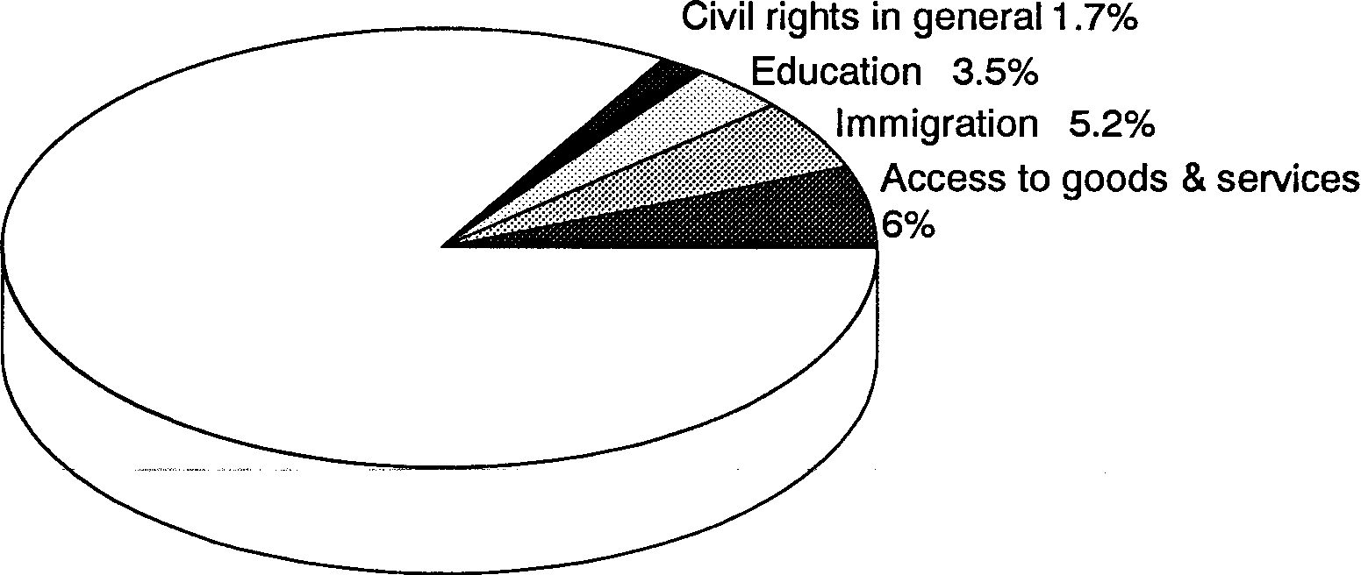
Civil rights in general 1.7%
Education 3.5%
Immigration 5.2%
Access to goods & services 6%
Discrimination Act due to Section 13 which exempts State instrumentalities from the provisions of the Act.
The Commission overcame these jurisdictional difficulties by investigating the complaint under the Human Rights and Equal Opportunity Commission Act and ILO Convention 111. (The Convention covers discrimination on the grounds of sex, which includes sexual harassment.)
After a challenge from the former State government concerning the Commission's jurisdiction was resolved, the complaint was successfully conciliated. The terms of settlement included financial compensation, an interview for a suitable position should one become available, and a work reference.
Case Study 2
40 Human Rights and Equal Opportunity Commission
This involved a complaint from a Vietnamese man who was resident in Australia with a number of his siblings and their families. The family had made a number of applications to have their elderly father, two sisters and a brother join them in Australia. The applications had been unsuccessful because the brother had Down's Syndrome resulting in an intellectual disability.
The remaining family members in Vietnam decided to escape by boat, arriving in a refugee camp in the Philippines in September 1986. Another application for migrant entry was lodged under the Refugee and Special Humanitarian Program. The brother was refused on medical grounds and the other family members were also refused because it was considered that he was dependent on their care.
The Commission intervened on behalf of the family and the Minister reviewed the decision in light of the complexity and compassionate circumstances of the case. The family arrived in Australia in May 1990 for permanent resettlement.
Case Study 3
A young woman who suffered from slight cerebral palsy alleged that she had been denied a position as a telephonist with a Federal authority due to her disability.
The woman had successfully passed an aptitude test and was considered suitable at interview but had failed to meet the required medical standards. According to the examining medical officer, she was unable to undertake the duties of the position because she only had full use of one arm. The medical officer was also concerned that the computer screen she would be required to use could put her vision at risk. The complainant refuted these suggestions and argued that her disability would not affect her capacity to undertake the duties of a telephonist.
Following negotiations, the respondent agreed to allow the complainant to be reassessed by both a medical officer and an independent optometrist. The woman successfully passed both examinations and as a result was offered employment by the authority concerned.
Annual Report 1989-90 41
International Instruments
Convention on the
Rights of the Child
The Convention on the Rights of the Child was adopted by the United Nations General Assembly on 20 November 1989 and opened for signature and ratification on 26 January 1990. As noted in previous annual reports, the Commission made major contributions to the active role played by the Australian Government in drafting this Convention and securing its adoption. The Human Rights Commissioner participated in the final sessions of the negotiations (where the bulk of the text was settled) as a special advisor to the Australian delegation. The Commission has urged the Australian Government to sign and ratify the Convention without delay.
Draft Principles on Mental Illness
Another major project involved the Commission's contribution to the Working Group of the UN Commission on Human Rights charged with preparing 'Principles and Guarantees for the Protection of Mentally Ill Persons and for the Improvement of Mental Health Care'. These principles do not imply that existing human rights standards do not apply in relation to mental health care. Rather, they are intended to give more detailed guidance on how those standards apply. They are therefore comparable to the UN Standard Minimum Rules for the Treatment of Prisoners or the Standard Minimum Rules for the Administration of Juvenile Justice.
The scope of the Principles includes not only 'negative rights' -
questions of arbitrary deprivation of human rights and freedoms
on the basis of mental condition, and protection of detainees -
but also 'positive rights', including the right to have appropriate treatment available, and measures for the improvement of mental health care.
42 Human Rights and Equal Opportunity Commission
The Working Group responsible for consideration and development of the draft Principles met in January 1990. Prior to the meeting, comments on the draft were requested from individual countries; the Commission contributed substantially to the comments made by Australia (with widespread approval of these comments from national organisations to which the draft Principles and comments were circulated).
The Human Rights Commissioner was invited to form part of the Australian delegation to the Working Group, together with officers from the Attorney-General's Department, Department of Community Services and Health, and the Department of Foreign Affairs and Trade. The session completed a first
reading of fourteen major Articles. The contribution of the Australian delegation was recognised as important and successful. The Commission intends to make further substantial contributions to the development of these Principles.
Proposed
International
Convention on
the Inter-Country
Adoption of Children
In June 1990 a special commission of the Hague Conference on Private International Law was held to consider a proposed convention on the inter-country adoption of children. The Human Rights Commissioner provided advice to the Australian Delegation on issues arising from such a convention, on the basis of the Declaration of the Rights of the Child and the Convention on the Rights of the Child. Although the Commission was unable to be represented at the meeting it considered the event a significant one and was concerned to ensure that the proposed convention was consistent in all respects with existing international human rights standards.
At the meeting of the United Nations Economic and Social Council in May 1990, Sweden proposed 'an initiative to promote the equalisation of opportunities for people with disabilities'. The Commission supported the Swedish proposal and strongly recommended that the Australian Government co-sponsor it. The Commission was concerned to ensure that the initiative was consistent with existing international human rights standards, was developed with the active support of Australia, and would produce tangible improvements for Australians with disabilities.
Swedish Initiative on Disability
Annual Report 1989-90 43
4:
Promotional Activities
The Human Rights Commissioner undertook an extensive round of speaking engagements and media interviews to inform the general public about the specific rights and legislative protections which fall within his area of responsibility. The more significant activities are set out below.
The Commission's public information campaign on the Convention on the Rights of the Child, designed to promote informed debate and support early Australian signature and ratification, was formally launched by Mrs Hazel Hawke in July 1989. Prior to this campaign, the Commission had undertaken a range of activities specifically intended to inform interested organisations.
A number of organisations have expressed opposition to the Convention, most of which has been based on misunderstanding and/or misinformation. In particular, it has been suggested that the Convention threatens or diminishes the rights of families. The Commission has undertaken a number of public activities in response, to ensure that the public is not misled and is able to consider the Convention on the basis of accurate information.
A wide range of community organisations have formally
declared support for the Convention and for signature and
ratification by Australia. Support has also been expressed by the
Australian Catholic Bishops, the President of the Uniting Church, and by the Social Responsibilities Commission of the Anglican Diocese of Melbourne.

Publications
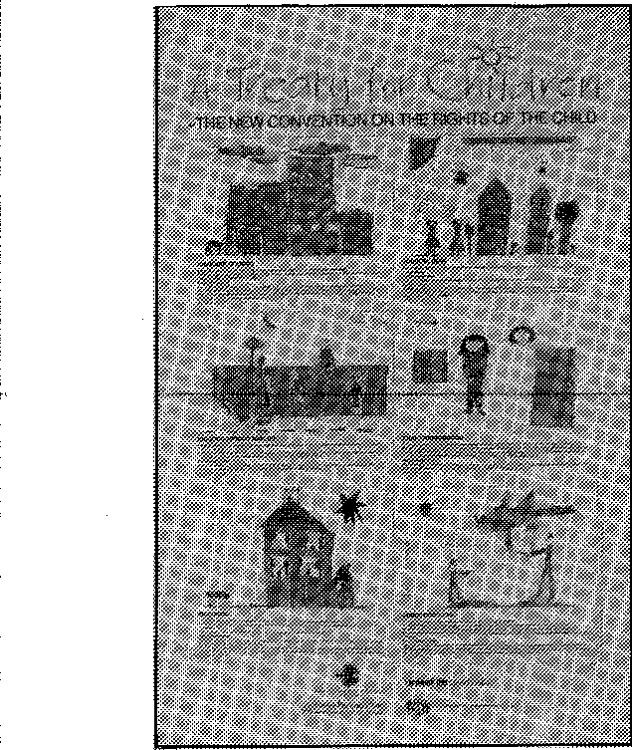
Access to information is essential to ensure that people are aware of their rights and the remedies available to redress discrimination. The Commission has developed, or is in the process of developing, information and distribution strategies in each portfolio area.
A major publication program accompanied the Commission's information campaign about the Convention on the Rights of the Child. Apart from freely distributing copies of the Convention on request, and participating in the publication of a special edition of the Australian Early Childhood Journal, the Commission produced a series of fact sheets on the Convention, a questions and answers brochure, and an information kit jointly with UNICEF. In addition, the Commission produced a set of posters in conjunction with Foster Parents' Plan, UNICEF Australia and the Australian Early Childhood Association. The posters were designed by Ms Betty Greenhatch from illustrations by Victorian school children depicting various articles of the law.

The Disability Rights discussion paper referred to above was published under the title: Areas of Need for Increased Protection of the Rights of People with Disabilities. Copies were distributed to disability organisations throughout Australia. It was also made available in braille and on audio tape.
44 Human Rights and Equal Opportunity Commission
Papers from the Schizophrenia Symposium held in February 1990 were edited and published (Occasional Papers from the Human Rights Commissioner No.1). A booklet explaining the background to the Inquiry into the human rights of people suffering from mental illness is also available.
Work has commenced on a revised series of pamphlets about
the Commission and human rights in general, and about
discrimination in employment and occupation. Also under way

is a revised brochure on Conciliation and Complaints which aims to explain clearly how to lodge a complaint and the process of conciliation.
Annual Report 1989-90 45
A summary of the powers and functions of the Commission is now available, as is a new publications' order form which lists all Commission publications and their cost, if any. A complete list of Commission publications is at Appendix 1 of this Report. Enquiries or orders should be directed to the Publications Unit (Telephone (02) 229 7600).
Seminars and Conferences
The major seminars and conferences in the Human Rights area were the Commission's Human Rights Congress, the National UNICEF Conference (particularly in relation to the Rights of the Child), the joint seminar on age discrimination mentioned earlier and the ACROD Convention where the Commissioner launched the Program of Action on Disability.
Shortly after the new grounds for discrimination under ILO 111 were announced, the Commission, in association with the Australian Council of Trade Unions, the Confederation of Australian Industry and the Council for Equal Opportunity in Employment, held a series of information seminars to inform employers, EEO practitioners and the legal profession about the new grounds.
In the international arena, the Human Rights Commissioner was invited (and funded) by the United Nations to contribute to two major events. He participated in and presented a paper at a conference on the protection of human rights and the prevention of discrimination in relation to HIV and AIDS. The conference, held in July 1989, was organised jointly by the United Nations Centre for Human Rights and the World Health Organisation in Geneva.
He also participated in and addressed an Asian-Pacific
Workshop on Human Rights conducted by the United Nations
in Manila during May 1990. His topic, 'National Institutions for
the Promotion and Protection of Human Rights and Fundamental Freedoms: The Implementation Function', was designed to inform other countries in the region of the advantages of an independent national commission to monitor observance of human rights.

Northern Suburbs Liberal Club, Sydney: Homeless Children
Human Rights Commissioner's other Major
Speaking
Engagements
1989-90
5 July 1989
15 July
27 July 29 July 31 July 4 August
National Association for the Prevention of Child Abuse and Neglect Conference, Sydney: Homeless Children
Royal Children's Hospital, Melbourne: Homeless Children (by proxy)
Women's College, Queensland: Homeless Children (by proxy)
Public Forum for Missing Persons' Week: Homeless Children (by proxy)
Future Directions Conference, Sydney: Convention on the Rights of the Child (by proxy)
Lower Eyre Peninsula Women's and Children's Emergency Hostel, Port Lincoln: Homeless Children
18 August

21 August Child and Family Welfare Conference, Mt
46 Human Rights and Equal Opportunity Commission
Victoria: Homeless Children (by proxy)

22 August Launched Convention on the Rights of the
Annual Report 1989-90 47
Child, Melbourne
4 September Children's Rights Conference, Brisbane:
Convention on the Rights of the Child
9 September Opened Gamrad Units for Homeless Young
People, SWISH Housing Cooperative, Sydney
16 September St Ives Uniting Church, Sydney: Homeless
Children
20 September Association of Civilian Widows, Brisbane:
Homeless Children (by proxy)
23 September Human Rights Congress, Melbourne:
Legislative Protection of the Rights of People with Disabilities
24 September Human Rights Congress, Melbourne:
Children's Rights: The Impact of the New Convention on the Rights of the Child
24 September National Marriage Education Conference,
Melbourne: Homeless Children
25 September Human Rights Congress, Melbourne:
Government responses on homeless children
4 October Drug Arm Annual Public Meeting,
Brisbane: Homeless Children
6 October Lions Club International, Newcastle:
Homeless Children
11 October Speech of Thanks to Dame Roma Mitchell
(1989 Mitchell Oration), Adelaide
12 October Annual General Meeting of Uniting
48 Human Rights and Equal Opportunity Commission
5 December
Australian Early Childhood Association Annual Council Meeting, Canberra: Convention on the Rights of the Child
Church's Harrison Youth Services, Melbourne: Homeless Children
14 October National UNICEF Conference, Melbourne:
Convention on the Rights of the Child
16 October Opened Mental Health Week, Sydney
21 October Hunter Valley Early Childhood Inservice
Council, Newcastle NSW: Homeless Children
31 October Rotary Club, Sydney: Homeless Children
4 November Opening of Salvation Army's Crossroads
Centre for Homeless Young People, Ascot Vale, Melbourne
8 November | Australian Early Childhood Association, SA branch: Convention on the Rights of the Child (by proxy)

9 November Kenneth Jenkins Oration, ACROD National
Conference, Canberra
15 November Beenleigh and District Interagency,
Brisbane: Homeless Children
16 November Seminar, Brisbane: Convention on the
Rights of the Child
26 November Launched Project Triple Care for Homeless
Youth, Sydney City Mission, Knights Hill, NSW
28 November Manly and Warringah Shire Councils,
Sydney: Homeless Children
2 December Opened Community Welfare Centre, Perth
12 December Launched Aftercare video, Sydney (by
Annual Report 1989-90 49
proxy)
12 December Sociolegal Conference, La Trobe
University, Melbourne: The Role of Human Rights
17 February Annual General Meeting of NSW Council
for 1990 Intellectual Disability, Sydney
28 February Launched Salvation Army's Oasis Program
for Homeless Children, Sydney
1 March Royal Children's Hospital, Melbourne:
Follow-up to Homeless Children's Report
9 March Launched Hunter Region Youth
Accommodation Resource Folder,
Newcastle
22 March | National Volunteer Centre Conference, Melbourne: Human Rights and Social Change

30 March Council on Intellectual Disability Annual
Conference, Melbourne

6 April  18 April | Launched Burdekin and Beyond Project for Homeless and Disadvantaged Children (funded by the Potter Foundation), Melbourne  Australian Child Protection Conference, Macquarie University: Homeless and Abused Children

27 April Disability Housing Coalition Forum,
50 Human Rights and Equal Opportunity Commission
Brisbane
30 April Australian Association of Adolescent Health
Conference, Canberra: Health needs of homeless young people
3 May United Nations Association of Australia,
Canberra: Convention on the Rights of the Child
5 May Delivered the 1990 Uniting Church
Matthew Lecture, Melbourne
7 May Country Women's Association, NSW State
Conference, Coonabarabran: Convention on the Rights of the Child and Homeless Children
7 May Launched Salvation Army's ACT Red
Shield Appeal, Canberra
8 May Annual Conference of the Family Services
Association, Collaroy (By proxy)
27 May Northern Territory ACROD Conference,
Darwin: Disability and Human Rights
4 June Opened St John's Shelter for the Homeless,
Adelaide
6 June Launched Report of Youth Accommodation
Coalition, Perth
13 June Institute for International Affairs, Cairns:
The Convention on the Rights of the Child
15 June North Queensland Community Groups
Concerned with Disability, Townsville
Annual Report 1989-90 51
15 June  19 June  20 June | Independent Advocacy Conference,  Townsville: The Rights of the Disabled  Torch Bearers for Legacy, Maitland  Handicapped Association of the Redlands District, Brisbane

Race Discrimination
Annual Report 1989-90 53
Race Discrimination Commissioner
Ms Irene Moss graduated in Arts and Law from Sydney University and later took a Masters degree in Law from Harvard University in the USA.  Prior to her appointment as Race Discrimination Commissioner, she worked with the then newly established New South Wales Anti-Discrimination Board (ADB) (1977-86). Whilst with the ADB she was involved in a number of landmark discrimination cases relating to race and sex discrimination, physical and intellectual disability and other human rights issues. | 
Ms Moss was appointed Race Discrimination Commissioner in 1986 for a seven-year term. The Commission has overall responsibility for administering the Racial Discrimination Act and the Commissioner exercises certain statutory powers of inquiry, conciliation, and settlement of racial dsicrimination complaints.  She is presently chairing the Commission's National Inquiry into Racist Violence. | Race Discrimination Commissioner, Ms Irene Moss

Statement from the
Race Discrimination
Commissioner
The Commission is concerned that its work in the area of race discrimination is focuse4 with practical outcomes for the people who need it most. Within its limited budget, the Commission aims at developing practical programs that help to achieve long-term change, rather than producing reports that gather dust.
There are several dimensions to the Commission's work in the
race area: firstly, complaint handling; secondly, informing and
raising the awareness of the general public about race issues; thirdly, achieving practical and measurable results in improving the situation of Aboriginal people and people of non-English speaking background
At the time of the release of the Toomelah Report , the Commission anticipated that it would have flow on effects for other Aboriginal communities. We hoped that when the appalling living conditions of the people of Toomelah were exposed governments and the community in general would review policies and practices to improve conditions for Aboriginal people across-the-board Aboriginal communities throughout Australia are still fighting the same battles against inefficiency and lack of coordination that were fought in Toomelah. This is a continuing problem that the Commission is addressing through specific projects like the Water Project and the Baiyulgil Report which are addressed in more detail later in this chapter.
Major achievements in my area this year have been:
- completion of the National Inquiry into Racist Violence - the report of the Inquiry is currently being finalised and I hope it will be available for public release early next year;
- the release and subsequent government responses to the Baryulgil Report - the Commission welcomes recent undertakings by the New South Wales and Federal Governments and I anticipate reviewing the situation at Baiyulgil during 1991; and
- the completion of the Cooktown Inquiry and the progress of stage two of the Water Project.
The Commission has also been closely involved in the development of the Federal Government's Community Relations Strategy as part of the National Agenda for a Multicultural Australia and the next year will see several major initiatives for the Strategy. The positive and ongoing involvement of government and non-government organisations
t Toomelah Report, Human Rights and Equal Opportunity Commission, 1989

54 Human Rights and Equal Opportunity Commission

in the Race Relations in the Workplace Program has ensured its success.
Annual Report 1989-90 55
In the race area in particular, the Commission is aware that there is still a great deal of change to be achieved Creating an understanding society which is aware of the special needs of Aboriginal people and people of non-English speaking background remains a priority for 1991. The Commission will continue to develop projects which not only educate people about their rights but help them to exercise them. In the 1990s the Commission will continue its work in addressing the key human rights and social justice issues that continue to be of concern to Aboriginal people. I anticipate that in 1991 there will be more investigations and reports like that undertaken at Baryulgil - with the aim of pin-pointing particular problems and having them effectively addressed The launch and subsequent follow-up of the report of the National Inquiry into Racist Violence will be a major focus in the year ahead as will the Community Relations Strategy.
Public Inquiries
National Inquiry into Racist Violence
The major focus of public attention in the race discrimination area in the past year has been the National Inquiry into Racist Violence. The Inquiry was announced in November 1988, its broad scope being to inquire into acts of violence or intimidation directed at people because of their race or because of their advocacy of non-racist policies.
Racist violence is the most blatant manifestation of racism in the community. Over the past ten years there has been extensive research and inquiry into the phenomenon of racist violence in the United States, Canada and Great Britain, which, amongst other things, indicates that racist violence is a reactive phenomenon especially in times of economic and social uncertainty. Many of the overseas studies were initiated as a result of specific race relations problems such as full scale riots and murders, and the activities of extremist groups such as the Ku Klux Klan and the National Front.
Although Australia has never had to deal with major race riots and overt acts of racially-based violence on the scale of those experienced in the United States and Great Britain, there have been increasing signs of problems in this country. The impetus for the National Inquiry into Racist Violence came in late 1988 following an apparent increase in overtly racist activity in the form of harassment and intimidation of anti-racist campaigners and members of various ethnic and Aboriginal communities by what appeared to be extremist groups.
56 Human Rights and Equal Opportunity Commission
At that time, the Race Discrimination Commissioner received a number of representations from various affected groups. It seemed that much racially-based physical harassment and intimidation was going unreported and that there was no systematic gathering of statistics by police forces throughout the country.
The National Inquiry into Racist Violence is the first of its kind in Australia. The Inquiry's terms of reference are to inquire into:
- Acts of violence or intimidation based on racism directed at persons, organisations or property.
- Acts of violence or intimidation directed at persons or organisations on the basis of their advocacy of support for or implementation of non-racist policies, including violence or intimidation intended to deter such advocacy, support or implementation.
- Current or prospective measures of government or government instrumentalities to deal with the above matters.
The Race Discrimination Commissioner was assisted in the Inquiry by Melbourne barrister, Mr Ron Castan QC, who acted as co-Commissioner. The Inquiry Commissioners were careful not to duplicate the work being undertaken by the Royal Commission into Aboriginal Deaths in Custody and the National Committee on Violence. Consultations were held with both bodies in order to avoid this.
Public hearings commenced on 24 August 1989 in Redfern
(Sydney) and continued over the next several months across
Australia, at Cabramatta (NSW), Townsville, Perth, Adelaide and Melbourne. Over 150 witnesses testified at the hearings. A similar number of written submissions were received, as well as many hundreds of incident reports and other forms of evidence.
Annual Report 1989-90 57
It became clear very early in the Inquiry that many people who had been victims of apparent racist violence were reluctant to report their experiences to social workers, police or other authorities. In order to overcome this problem, an extensive outreach program was undertaken to obtain information from those who felt unable to speak publicly or to write to the Commission. Reports were compiled from questionnaires or small group sessions organised with assistance from the Migrant Resource Centres and the Office of Multicultural Affairs. Facilitators from the same ethnic background as the complainants helped in the outreach program and many sessions were conducted in languages other than English.
The Inquiry also commissioned a number of consultancy reports into specific topics such as: Aboriginal-police relations, overseas experience, role of the media, the history of racist violence in Australia, and extremist groups.
The report of the Inquiry will be presented to the Federal Attorney-General for tabling in Parliament in 1990-91.
Redfern Police
Raids
The National Inquiry into Racist Violence was concerned with
many issues affecting Aboriginal people - particularly Aboriginal-police relations. In May, a report prepared for the Inquiry on Aboriginal-police relations in the Sydney suburb of Redfern was released following widespread community concern about the so-called 'Redfern Raid' in February 1990.
The report, which was prepared by an independent consultant, Mr Chris Cunneen, found that:
It is open to the National Inquiry into Racist Violence to find that the 'Redfern Raid' constituted an act of racist violence within its terms of reference ...
Although the Redfern report was specific to one area, the issues raised are relevant to Aboriginal-police relations in general. The Inquiry will be addressing these issues and making recommendations in its final report.
58 Human Rights and Equal Opportunity Commission
Cooktown Inquiry
Based on information received in the course of investigating certain complaints and advice from Counsel, the Commission resolved towards the end of last financial year to hold an Inquiry into the provision of medical services to the Aboriginal communities of Cooktown and nearby settlements, including Wujal Wujal and Hopevale, in far north Queensland. The Commission authorised the Race Discrimination Commissioner to conduct the Inquiry, and accordingly, in July 1989, she notified the relevant persons and groups, including the Queensland Government. The Inquiry, originally scheduled for early October 1989, was delayed firstly as a result of the domestic pilots' industrial action and further postponed as a result of litigation instituted by the former Queensland Government to prevent the Inquiry.
The Inquiry has since been reconstituted and will be conducted by the Commission President, Sir Ronald Wilson, during July 1990. The terms of reference of the inquiry are:
1. To inquire into and report upon the provision of medical and related services to residents of Cooktown, Wujal Wujal and Hopevale.
2. To inquire into and report upon:
- the provision of medical and related services to the Aboriginal residents of Cooktown, Wujual Wujal and Hopevale; and
- the adequacy and appropriateness of the provision of the said services, in light of the particular needs of Aboriginal communities.
3. To recommend to appropriate persons and authorities measures, if any, which should be taken in relation to:
(i) the provision of the services, in order to guarantee the full and equal enjoyment of those human rights
recognised in the International Convention on the Elimination of All Forms of Racial Discrimination; and
Annual Report 1989-90 59
(ii) promoting an understanding of and compliance with the Racial Discrimination Act 1975.

Aboriginal Issues
Baryulgil
Since June 1989, the Commission has received representations from several organisations and individuals concerning the effects of asbestos mining operations on the Aboriginal community at Baryulgil in northern New South Wales.
The representations referred frequently to the findings and recommendations of the House of Representatives Standing Committee on Aboriginal Affairs, which released a report on Baryulgil in 1984. In January the Race Discrimination Commissioner commenced research into the issue and in February the Commissioner visited Baryulgil and Malabugilmah on a 'fact finding' visit.
The Commissioner has prepared a report which will be released in mid-July, 1990.
The Commissioner found that the failure of government authorities to take effective action to decontaminate the former asbestos mining town of Baryulgil constitutes a gross disregard for the human rights of the residents. During her visit the Commissioner found that no effective action had been taken to either monitor or reduce the significant health risk to the community from asbestos tailings present in road surfaces and land fill in and around Baryulgil. This was despite the Standing Committee's recommendation in 1984 that the NSW Government should institute a 'vigorous' program to decontaminate Baryulgil Square.
Following the release of her report, the Commissioner will monitor State and Federal government initiatives in the area, and proposes to review the situation in one year's time.
60 Human Rights and Equal Opportunity Commission
Water Supply Project | As a result of the Commission's report on Toomelah a number of representations were received regarding water supply in Aboriginal communities. These representations claimed that there were very serious deficiencies in the supply of reliable, adequate, quality water to many communities.

The Commission's research into this area commenced last year with the announcement that the tender to undertake a broad overview of the water situation and an intensive study of the situation in ten individual communities had been awarded to the Centre for Appropriate Technology (Alice Springs) in conjunction with the Centre for Remote Development at Murdoch University in Western Australia.
Dr Bruce Walker from the Centre for Appropriate Technology commenced work on the project in late 1989, after reaching agreement with ten Aboriginal communities (located in most States and Territories) for their participation in the project. The communities represented a range of different situations, from townships and reserves to stock route camps and outstations.
Dr Walker received funding of $50,000 from the Commission, and an additional $20,000 with the assistance of the then Minister for Aboriginal Affairs, the Hon. Gerry Hand, which enabled the inclusion of Torres Strait Islander communities in the study, as well as further consultation with Aboriginal representatives.
The project is expected to be completed in the new financial year, and the report presented to the Commission. It is anticipated that the report will eventually be publicly released. A second report dealing with the Torres Strait Islander community will also be published.
t Toomelah Report, op cit.
Research
Annual Report 1989-90 61
The Federal Government's National Agenda for a Multicultural Australia addresses a number of issues relevant to the Commission's responsibilities. The Commission has engaged in consultation with relevant government agencies and community organisations concerning these issues. These include the proposal for a Multiculturalism Act, and the reference given to the Australian Law Reform Commission addressing a number of aspects of law in a multicultural society. The National Agenda also proposed action to implement strategies for improving community relations between all members of the Australian community. The Race Discrimination Commissioner is a member of the Working Party for this Community Relations Strategy.
Following a number of complaints, the Commission has conducted_lesearch to determine what, if any, issues of racial discrimination are raised by conditions attached to recognition of overseas medical qualifications. The results of this research are presently under consideration by the Commission.
/
Legislative Review
The Commission undertook a review of certain provisions of the Racial Discrimination Act in the light of its experience in the administration of the Act. The Act had been amended in 1986 to provide greater consistency with the provisions of the Sex Discrimination Act. Those amendments, however, did not address several issues of significance.
The Commission recommended to the Federal Attorney-General that the Racial Discrimination Act be amended, consistent with the existing provisions of the Sex Discrimination Act, to:
- remove the requirement that race be the dominant reason for doing an act;
- include indirect discrimination on the basis of race;
3. provide for vicarious liability of employers and principals for acts of racial discrimination by their employees and agents.
62 Human Rights and Equal Opportunity Commission
Complaint
Investigation/ Resolution and Enquiries
Table 8 indicates that 297 new complaints were lodged this year under the Racial Discrimination Act. This represents a 22.2 percent increase on last year's figure of 243 new complaints. The most noticeable increase occurred in relation to complaints concerning the provision of goods and services (an increase of 37 complaints), while complaints concerning access to places and facilities decreased by 45. Race discrimination complaints accounted for 27.9 percent of all written complaints received by the Commission in 1989-90 (see Figure 1).
Once again, employment was the dominant area in which complaints were lodged. These types of complaints were often quite difficult to investigate and conciliate as the alleged discrimination was frequently covert and therefore difficult to substantiate. The application of the 'dominant reason' provision of the Act (Section 18) tended to exacerbate this difficulty. The Commission has made recommendations to the Attorney-General regarding amendments to the Racial Discrimination Act in relation to dominant reason, indirect discrimination and vicarious liability.
The second and third most common areas in which new complaints were lodged under the Racial Discrimination Act were in the provision of goods and services and in the area of land, housing and accommodation (Table 8). The denial of the provision of goods and services on racial grounds continued to occur frequently in Queensland. The Commission is examining new strategies to address this issue.
An analysis of the ethnicity of complainants in Table 8 shows
that the number of complaints by Aboriginal people appears to
be consistent with the figures for last year. The number of
Table 8
Annual Report 1989-90 63
Complaints Lodged under the Racial Discrimination Act
July 1, 1989 to June 30, 1990

 | Central  Office | QLD | NT | TAS NSW |  | VIC | SA | WA | Total
Area of Complaint
Access to places and facilities |  | 7 |  |  | 1 |  | 1 |  | 9
Land/housing/ accommodation ' | 1 | 2 | 2 |  | 9 |  | 3 |  | 17
Provision of goods and services | 4 | 33 | 4 |  | 13 | 4 | 21 | 5 | 84
Employment | 13 | 21 | 5 | 1 | 42 | 12 | 21 | 10 | 125
Advertising/media |  |  |  |  | 1 |  |  |  | 1
Incitement to unlawful acts |  |  |  | - | 2 |  |  |  | 2
Education |  | 1 | 2 |  | 6 |  | 1 |  | 10
Other |  | 3 |  |  | 46 |  | - |  | 49
Total | 18 | 67 | 13 | 1 | 120 | 16 | 47 | 15 | 297
Complainant's Ethnicity
Aboriginal |  | 30 | 10 |  | 2 |  | 22 | 4 | 68
Non-English speaking background | 6 | 15 | 2 |  | 34 | 9 | 19 | 1 | 86
English speaking background |  | 4 | 1 | 1 | 84 | 7 | 6 | 8 | 111
Association
Not recorded | 12 | 18 |  |  |  |  |  | 2 | 32
Total | 18 | 67 | 13 | 1 | 120 | 16 | 47 | 15 | 297
Category of Complainant
Female | 3 | 23 | 4 |  | 29 | 6 | 19 | 6 | 90
Male | 13 | 44 | 8 | 1 | 59 | 10 | 27 | 9 | 171
Group/ Organisation |  |  | 1 |  | 32 |  | 1 |  | 34
Not recorded | 2 |  |  |  |  |  |  |  | 2
Total | 18 | 67 | 13 | 1 | 120 | 16 | 47 | 15 | 297

complaints from people of non-English speaking background decreased by 23 compared with last year's figures. As in previous years, men were far more likely than women to lodge race complaints. Of the 297 complaints received during the reporting period, 171 were lodged by men and 90 by women.
64 Human Rights and Equal Opportunity Commission
The National Inquiry into Racist Violence appears to have had a very positive educative impact in focusing community attention on discrimination issues and promoting awareness of the complaint provisions available under the Racial Discrimination Act. The Commission is currently investigating a number of complaints which were lodged as a result of contact by individuals or communities with the Inquiry.
Case Studies
The following case studies illustrate some of the different types of complaints received under the Racial Discrimination Act.
Case Study 1
A Cambodian man who had been resident in Australia for thirteen years lodged a complaint of racial discrimination in employment. The complainant alleged that the work he was doing was inconsistent with his qualifications and that he was being denied opportunities for promotion and career development. He believed that this was the result of false rumours that were being spread by staff concerning his previous activities in Cambodia.
Although the employer denied that the complainant had been the victim of racial discrimination, a satisfactory conciliation agreement was reached. The terms of the settlement included the appointment of a 'mentor' who would assist the complainant with career planning, training and skill development.
Case Study 2
A woman who had worked as a temporary receptionist lodged a
complaint alleging that she had been discriminated against on
the grounds of her ethnic origin. The complainant claimed that she had applied for the position after it had been advertised as a permanent appointment and was unsuccessful due to an alleged deficiency in her comprehension of English.
Annual Report 1989-90 65
The respondent maintained that, whilst the complainant was a diligent and intelligent employee, she nevertheless lacked the ability to carry out the job to the level required. The complainant strongly refuted this assessment.
The terms of settlement following conciliation included a statement of apology, a certificate of employment, the provision of a reference, and placement on a mailing list advising of vacancies for which she was eligible to apply.
Case Study 3
A young man of Aboriginal descent who had been employed by a large organisation for a number of years complained that he was being singled out and treated differently to other workers because of his race. He claimed that he was being denied equal rights to display material within his personal work station and that personal possessions were being removed or destroyed.
The complaint was conciliated when both parties agreed to and confirmed that the organisation would not tolerate discrimination in the workplace as defined within the Racial Discrimination Act and that the principles of equal opportunity in employment and education would be adhered to. The organisation also agreed to train the young man in other areas of work within the organisation.
Referred Matters
Of the small percentage of matters (4.1 percent) which failed to be conciliated and were referred by the relevant Commissioner for a formal hearing, 6 were race complaints. The more significant race matters which were referred for a hearing are outlined in the following summary.
Ardeshirian v. Robe River Iron Associates: The complainant
alleged that he had been dismissed from his employment
contrary to Section 15(1)(c) of the Act, and that he had been subjected to many incidents of racist abuse and harassment, thereby depriving him of the same conditions available to other workers, contrary to sections 9 and 15 of the Act. Following an Inquiry, the Commission held that the reasons put forward by the respondent did not displace the complainant's national and ethnic origin as the dominant reason for dismissal and awarded him $10,000 compensation.
66 Human Rights and Equal Opportunity Commission
Williams v. Tidily: Ms Williams lodged a complaint pursuant to Sections 9 and 15 of the Act. She alleged that she had been the subject of racial discrimination by the respondent as a consequence of a series of management actions and decisions, for which Ms Tiddy was responsible, in contravention of Sections 9 and 15 of the Act.
Following the Inquiry, the Commission dismissed the complaint on the grounds that the acts of the respondent were not based upon and did not constitute racial discrimination.
White and White v. Gollan: Mr and Mrs White both lodged complaints of racial discrimination under Section 13 of the Act. They alleged that they were refused service in the public bar of the Tattersall's Hotel in Toowoomba, Queensland. The respondent was the licensee of that hotel.
Following a hearing into the matter, the Commission found that the complainants were refused service by staff of the hotel and that, by his presence in the bar at the material time, the respondent had acquiesced in that refusal of service. The Commission determined that, as a result of the refusal of service, the complainants experienced acute embarrassment, humiliation and indignation.
The Commission declared that the respondent should pay $2,000 by way of compensation to Mrs White for two refusals of service and $1,000 to Mr White for one refusal of service; in addition it was declared that the respondent should publish an apology to the complainants in a local district newspaper.
Following the high media profile of both the Toomelah and Racist Violence Inquiries, a concerted effort has been made during 1989-90 to direct community education resources to those problems highlighted during the Inquiries. The Race Discrimination Commissioner has been careful to avoid areas which were being addressed by other agencies, in order to maximise the use of her available resources.
Promotional
Activities
Annual Report 1989-90 67
Community Education
National Agenda for a Multicultural Australia
The National Agenda for a Multicultural Australia includes an initiative for a community relations strategy, intended to foster and promote awareness of the importance of harmonious community relations. The strategy is intended to discourage prejudice against, and encourage respect for, people of different race, ethnicity, religion, culture or language, and to identify suitable relevant government programs and other strategies.
The management of the campaign has been jointly entrusted to the Human Rights and Equal Opportunity Commission; the Aboriginal and Torres Strait Islander Commission; the Department of Immigration, Local Government and Ethnic Affairs; and the Office of Multicultural Affairs. Funding of $5.7 million has been allocated by the Federal Government over a three-year period. A number of expert consultancy reports were commissioned and reviewed by a Working Party of representatives of the four organisations, with Commissioner Moss representing the Commission. The Working Party, after a two-day conference, proposed a Draft Strategy which is currently being circulated to relevant government departments and community organisations for comment. The strategy is designed to improve relations between all sections of the Australian community and to encourage respect for ethnic diversity.
Race Relations in the Workplace
68 Human Rights and Equal Opportunity Commission
The Race Relations in the Workplace Project, reported on in last year's annual report, has continued through 1989-90. This program has run pilots with two manufacturers in Sydney and Brisbane and aims to raise awareness about racial discrimination in the workplace, develop strategies to promote a harmonious workplace, and measure efficiencies and effectiveness of these two strategies.
Recently conducted evaluation at the two sites indicates very positive outcomes including a demonstrable increase in productivity, profitability and efficiency. Certificates of Commendation were presented to the participating organisations by the Race Discrimination Commissioner to mark the companies' contribution to the promotion of a harmonious and culturally diverse workplace.

Race Discrimination Commissioner, Irene Moss, presenting a certificate of commendation to CSR Bradford Insulations General Manager, Peter Wigham, in recognition of the company's participation in the Race Relations in the Workplace Program.
As a consequence of this program, the Commission is roducing a training kit which is designed to offer strategies to upper and middle management when dealing with a diverse workforce, as well as providing training modules for trainers. To ensure the relevance of these materials, meetings have been held with representatives from relevant government agencies, employer organisations, unions and selected private corporations.
Annual Report 1989-90
69
Human Rights in Education
Whilst working to improve race relations in the workplace, the Commission also endeavours to ensure that future employers and employees will have better understanding of, and respect for, cultural diversity. To this end, the Commission participated in different school-level projects in both NSW and Tasmania, which were reported on in last year's annual report.
The NSW project involved the compilation of a resource manual containing material on non-sexist education, Aboriginal education and multicultural education by teachers and curriculum specialists. During the past year, the resource kits have been distributed and the NSW Department of Education has designated interested teachers as the implementation contact officers in each region. The contact officers have been organising seminars to introduce the materials, train teachers in each region and provide assistance as required.
Publications

The race discrimination pamphlet A Guide to the Act has been revised and copies of the new-look pamphlet are being distributed to ethnic, Aboriginal and other relevant organisations throughout Australia. A message inside the cover of this publication in seventeen languages advises that the Commission can arrange interpreters if required.  A poster about race discrimination has also been designed and copies will be available for distribution in the new financial year. Another poster, specially designed to provide sensitive and appropriate information about the Racial Discrimination | 

Act for the Aboriginal community, is in preparation. Consultation with key Aboriginal groups is planned to ensure the poster's appropriateness.
Information about the Aboriginal communities' water supply project (see above) was published as a pamphlet during the year. Previous publications - the Racial Discrimination Act, the Toomelah Report and Summary - are available from the Commission on request.

Race
Discrimination Commissioner's Major Public
Engagements
1989-90
24 August
25 August
21 September
29 September
12 October
19 October
24 October
24 November
29 November
National Inquiry into Racist Violence (NIRV) 1989 Public Hearing, Redfern, New South Wales
NIRV Public Hearing, Cabramatta, New South Wales
NIRV Public Hearing, Richmond, Victoria
Society's Perceptions of Asian Women, Melbourne
National Conference on Violence, Canberra NIRV Public Hearing, Townsville
Racism: NIRV and Race Relations in the Workplace, Sydney
The Challenge for Conflict Resolutions, Sydney University, Sydney
NIRV Public Hearing, Perth

70 Human Rights and Equal Opportunity Commission

30 November NIRV Public Hearing, North Perth
Annual Report 1989-90 71
15 December NIRV Public Hearing, Aboriginal Centre,
Adelaide
15 December NIRV Public Hearing, Commonwealth
Government Centre
21 February The Immigrant Women's Resource Centre,
Sydney, 1990 New Lanc4 New Law
3 March The Queensland Bar and Law Association
Symposium, Gold Coast, Queensland
3 May The Law, the Police and Minority Groups,
NSW Law Week Seminar (by proxy)
15 May University of NSW Human Rights Club,
Sydney
13 June Ethnic Youth Issues Network Project
Launch, Melbourne

Sex Discrimination
Annual Report 1989-90 73

Sex Discrimination Commissioner
Ms Quentin Bryce AO took up her five-year appointment as Sex Discrimination Commissioner in February 1988, having previously been the Commission's Regional Director for Queensland. Prior to that, she had established the Queensland Women's Information Service, part of the Office of the Status of Women in the Department of Prime Minister and Cabinet, and served as its foundation director from 1984-87, as well as being the women's representative on the National Committee on Discrimination in Employment and Occupation.  As Sex Discrimination Commissioner, Ms Bryce advises the Commission concerning its responsibilities and functions under the Sex Discrimination Act, and carries out many of those functions on the Commission's behalf. She has certain statutory powers of inquiry, conciliation and settlement of sex discrimination complaints under the Act. | 
Sex Discrimination
Commissioner,
Ms Quentin Bryce AO

Statement from the
Sex Discrimination
Commissioner
The year 1989-90 marked two significant events, the tenth anniversary of the adoption by the United Nations of the Convention on the Elimination of All Forms of Discrimination Against Women and the fifth anniversary of the proclamation of the Sex Discrimination Act. These events sparked an analysis of progress made and challenges ahead in the struggle for equality of opportunity and equal status for women at international, domestic and grassroots levels.
The Human Rights Congress included a stream on sex
discrimination in employment, which is the source of 85 percent
of sex discrimination complaints to the Commission. The Chair
of the British Equal Opportunity Commission Joanna Foster described the biggest task of the 1990s as:
to persuade every man and woman that equal opportunities affect them in all aspects of their working community and family roles.
Speakers considered aspects of managing maternity at work from various perspectives and the need for flexible structures and examined ways to develop a constructive partnership between work life and family life. The announcement in May by the Federal Government of ratification of ILO Convention 156 concerning Workers with Family Responsibilities was good news indeed. In February, I appeared before the Industrial Relations Commission on behalf of our Commission to intervene in support of the ACTU test case on paternity leave.
The Commission welcomed the announcement that the Australian Defence Forces will no longer apply the Sex Discrimination Act exemption to combat related duties. The review of the exemption relating to discrimination in insurance was completed and is in publication. The review process involved extensive consultation with industry and women's groups.
Exemptions under the Act must be regularly scrutinised and questions asked of the need for their continued existence, eg should the Social Security Act be exempt in toto? Should industrial awards be exempt?
The Commission takes the view that s.44 exemptions should be strictly interpreted and granted only in exceptional circumstances. We look forward to the long awaited draft Code of Practice being developed by Worksafe Australia to redress the exclusion of women from employment in the lead industry and to protect the health and safety of all workers in that industry.
The Commission prepared a submission to the House of Representatives Standing Committee on Legal and Constitutional Affairs Inquiry into Equal Opportunity and
74 Human Rights and Equal Opportunity Commission
Equal Status for Australian Women. The submission brought to the attention of the Inquiry the achievements of the Sex Discrimination Act and proffered suggestions for reform to improve the administration of the Act.
Annual Report 1989-90 75
Promotion of the Act continues to have a high priority in my work schedule. This is a part of my job that I enjoy and appreciate very much as it involves consultations and meetings with individuals and groups working in different ways for equality of opportunity and equal status for Australian women.
For some time I have been concerned about the increasing numbers of complaints from young women about sexual harassment in the workplace. Not all of the complaints I have heard have been the subject of a formal complaint to the Commission.
Following consultations with relevant interest groups, I decided to commission some independent research into the issue. The research results confirmed my feeling that while the Sex Discrimination Act enjoys a fairly high profile in the community and a large proportion of young women are aware of the provisions of the Act, there is a general lack of awareness of the provisions regarding sexual harassment and a reluctance to use the Act as a remedy in cases of sexual harassment.
As a result of this research, I decided that a concerted education campaign was required not only to inform young women of their rights under the Sex Discrimination Act but also to empower them to resolve problems of sexual harassment on their own initiative, and also to make the harassers aware that their behaviour was unacceptable and unlawful.
Further details regarding this campaign, which will provide a major focus for my activities in 1990-91, and other work I have been doing, appear below.
76 Human Rights and Equal Opportunity Commission
Research
Paid Maternity | Leave

A great deal of the research effort within the area administered by the Sex Discrimination Commissioner was directed towards the submissions and legislative review outlined below. However, in addition, research has commenced on paid maternity leave. When ratifying the Convention on the Elimination of All Forms of Discrimination Against Women, Australia placed a reservation on Article 11(2) (b) relating to maternity leave with pay, to the effect that Australia was not yet in a position to take the measures required to introduce paid maternity leave through Australia. The Sex Discrimination Commissioner is investigating the possibility of removing this reservation.
Lead Industry
The Commission has been examining issues relating to women working in the lead industry. To date, women have been excluded from employment in many areas of the lead processing industry on the basis of occupational health and safety. Prior to the introduction of the Sex Discrimination Act, this exclusion was provided for in State legislation, but the Act invalidated these provisions after a two-year exemption period to allow for review. The exemption was extended for New South Wales, Queensland and Tasmania by Federal regulations, but the last of these is due to expire on 31 July 1991. No general exemption now exists in relation to the lead industry in Victoria, South Australia, Western Australia or Tasmania.
It is possible for individuals or companies to apply for exemptions under Section 44 of the Sex Discrimination Act so they are not acting unlawfully by excluding women from employment in lead processing. One company operating in South Australia, Broken Hill Associated Smelters Pty Ltd, has been granted such an exemption until 16 September 1990. A
number of other applications for exemption were made but have been withdrawn or put on hold pending finalisation of the National Occupational Health and Safety Commission guidelines on control and safe use of lead at work.
Annual Report 1989-90 77
The Commission has the responsibility to promote equal opportunity and prevent sex discrimination in employment. It also recognises the fundamental importance of the protection of health and safety. The Commission considers that these goals are best achieved by the promotion of practices and standards which ensure a safe working environment for all workers, male and female, and that there should be no blanket exclusion of women from particular occupations or industries. The Sex Discrimination Commissioner is consulting with the National Occupational Health and Safety Commission, employer and employee organisations, and the State Commissioners for Equal Opportunity to promote this approach and examine means for its implementation. She attended and spoke at a national
conference on this question in March 1990.
Legislative Review
Superannuation
At the request of the then Attorney-General, the former Human Rights Commission conducted a review of the exemption relating to superannuation in the Sex Discrimination Act (Section 41(1)). A report resulting from this reviewt was presented to the Attorney-General in 1986. The major recommendations of the report were that:
- section 41(1) of the Sex Discrimination Act be repealed; and
- a transitional period of three years be granted to allow superannuation schemes to prepare variations to their trust deeds and effect necessary changes in practice.
Legislation to amend the Act in accordance with the
recommendations of this report was put before the Parliament
t Superannuation and the Sex Discrimination Act, 1984, Part 1 - Superannuation, AGPS, Canberra, 1986
in 1989 but lapsed with the dissolution of Parliament in March 1990. It is expected that the Amendment Bill will be reintroduced in the Budget session of the present Parliament.
78 Human Rights and Equal Opportunity Commission
Should the amendments take effect, the Commission will be required to publish guidelines for their implementation. The Commission has conducted preparatory work for this purpose. Further consultations with interested parties will occur before the guidelines are issued.
Insurance
The Commission also completed a review of the exemption relating to insurance in the Sex Discrimination Act (Section 41(4)) in 1989. A report resulting from that review will be presented to the Attorney-General early in the new financial year.
ILO 156
The Sex Discrimination Commissioner continued to make representations in favour of Australia's ratification of the Workers with Family Responsibilities Convention (ILO Convention 156), in keeping with the commitment made by the Prime Minister in 1983. Following the announcement in March 1990 that Australia would proceed to ratify this Convention, the Commission has begun consultation with the Federal Government on the role of the Commission in its implementation.
Submissions
A major research effort was undertaken by the Commission in 1989-90 in preparing a submission to the House of Representatives Standing Committee on Legal and Constitutional Affairs Inquiry into Equal Opportunity and Equal Status for Australian Women, which was announced in August 1989 as a review of progress made in relation to equal opportunity for women in Australia since the passage of the Sex Discrimination Act five years earlier. The Commission presented its submission in January 1990 and the Sex Discrimination Commissioner was subsequently asked to give further evidence before the Committee. However, with the
dissolution of Parliament for the March 1990 Federal Election, her appearance before the Committee has been delayed.
Annual Report 1989-90 79
The submission emphasised the importance for women of the Sex Discrimination Act, and the substantial community support it now received. The submission noted that the Act had functioned well since its introduction, but suggested three areas which either required attention or should continue to receive priority:
- Promotion of the Act and educational programs
The effectiveness of the Act is largely determined by awareness of its provisions. Promotion and educational work will continue to be given a high priority in the work of the Commission.
- Complaint Handling
The submission emphasised that conciliation had proved very effective, and should continue as the major form of dispute resolution under the Sex Discrimination Act. The submission stressed the importance of the provision for lodgement of representative complaints by trade unions and discussed means of ensuring more effective use of this provision. The Sex Discrimination Commissioner has been conducting research and consultations for this purpose, and to promote more effective involvement of trade unions in the operation of the Sex Discrimination Act generally.
- Amendments to the Sex Discrimination Act
The submission recommended a number of legislative amendments:
- The definition of discrimination on the grounds of pregnancy should be amended to include discrimination based on a woman's intention to become pregnant in future.
- Discrimination in employment, based on family responsibilities, should be expressly prohibited.
- The process of enforcement of determinations made by the Commission should be reviewed. The present process involves excessive costs, delay and stress to parties.
80 Human Rights and Equal Opportunity Commission
- The exemptions contained in Division 4, Part II of the Act should be reviewed. Five years since the introduction of the Act should be considered an appropriate time to determine whether these exemptions remain necessary.
- Section 13 of the Act should be repealed. This section denies employees of State instrumentalities the protection of the Sex Discrimination Act. This is cause for particular concern in those jurisdictions which still lack their own anti-discrimination legislation. Repeal of this section would give the Sex Discrimination Act the same application in this respect as the Racial Discrimination Act.
Intervention
Parental Leave
In July 1989, the Sex Discrimination Commissioner, on behalf of the Commission, sought and obtained leave to intervene in the ACTU claim before the Federal Industrial Relations Commission. This claim is a test case for extending parental leave to fathers, and expanding the availability of parental leave for both parents.
In its submission before the Industrial Relations Commission, the Commission referred to Section 3 of the Sex Discrimination Act and Articles 5 and 16 of the International Convention on the Elimination of All Forms of Discrimination Against Women in support of the claim.
The Commission argued that the introduction of parental leave for fathers is the next step in a two-step process of ensuring equality between the sexes.
The first step required the acknowledgment of de facto inequality of opportunities for women as a result of their traditional role as primarily responsible for the care of young children and their consequent loss of career opportunities. In order to remedy this, it was and is necessary to provide maternity leave to women.
Annual Report 1989-90 81
The second step requires the acceptance and recognition of the fact that men should share equally in family responsibilities. The introduction of measures that will enable men to assume this role without sacrificing their careers will serve to help remove the coercive nature of existing stereotypes and reduce the expectation that it will be the mother who continues to have the major responsibility for childcare even beyond the child's first year.
Many of the submissions made by the Commission were adopted by the Industrial Relations Commission in its decision handed down in July 1990.
Exemptions
Australian Federal
Police
The Commission received a number of enquiries relating to possible exemption from the operation of certain provisions of the Sex Discrimination Act. One formal application from the Australian Federal Police (AFP) was considered by the Commission. The application related to the AFP's employment practices regarding the selection of personnel to work as part of Australia's contribution to the United Nations peace keeping force in Cyprus.
The Commission considered that the AFP should bring its selection practices into line with the Sex Discrimination Act and the Convention on the Elimination of All Forms of Discrimination Against Women as quickly as possible. However, the Commission resolved to grant the exemption for six months.
The Commission's concerns were put by the Australian Federal Police to the Commander of the United Nations Forces in Cyprus. The Commander indicated that the policy of his predecessor would not be continued and that there would be no limitations on the number of women able to be included in the Australian contingent or on the type of duties such women were able to perform.
82 Human Rights and Equal Opportunity Commission
The Commission is continuing to pursue with the Australian Federal Police the actual implementation of a non-discriminatory policy in relation to the Australian contingent.
The Commission has also drawn the matter to the attention of the United Nations Committee on the Elimination of All Forms of Discrimination Against Women (CEDAW), and the Commission proposes to monitor the situation and any relevant developments.
Complaint
Investigation/ Resolution and Enquiries
Table 9 indicates that 593 new complaints were lodged under the Sex Discrimination Act during 1989-90. This represents a slight (3 percent) increase on the 575 complaints received last year. Complaints under the SDA accounted for 55.7 percent of all written complaints received by the Commission in 1989-90 (see Figure 1).
The largest proportion of complaints under the Act (35.2 percent) were lodged under the ground of sex (see Table 9). The next largest area involved complaints of sexual harassment in employment, which constituted 23.8 percent of the total figure.
Complaints on the ground of pregnancy represented 13.9 percent of all complaints lodged under the Act during 1989-90, compared with only 9 percent in 1988-89. Table 9 outlines the areas in which complaints under this Act were lodged. 84.9
Table 9
Complaints Lodged under the Sex Discrimination Act
July 1, 1989 to June 30, 1990
Annual Report 1989-90 83

 | Central  Office | QLD | NT | TAS NSW |  | 'VIC | SA | WA | Total
Category of Complaint Sex  Sexual harassment  Sex and sexual harassment Marital status  Pregnancy  Other | 8  10  1 5 13 | 34  25  7  14 | 3  5  3  1 | 4  6  2  4 | 72 35 11 13 33 25 | 17  16  12  4  7 | 59  40  59  8  10  5 | 15  3  3  1 | 212 140 83 45 83 30
Total | 37 | 80 | 12 | 16 | 189 | 56 | 181 | 22 | 593
Area of Complaint
Employment | 35 | 67 | 10 | 15 | 154 | 49 | 159 | 15 | 504
Accommodation |  |  |  |  |  | - | 4 |  | 4
Goods/Services/ Facilities | 1 | 7 | 2 |  | 15 | 7 | 10 | 7 | 49
Clubs |  | 2 |  | 1 | 10 |  | 1 |  | 14
Commonwealth law programs |  |  |  |  |  | -
Education |  | 2 | - |  |  |  | 2 |  | 4
Application forms |  | - |  |  |  |  | 1 |  | 1
Land |  |  | - |  |  | -
Advertising |  | 1 |  |  | 1 | - | 4 | - | 6
Other | 1 | 1 |  |  | 9 |  |  | - | 11
Total | 37 | 80 | 12 | 16 | 189 | 56 | 181 | 22 | 593
Category of Complainant
Male | 2 | 2 | 1 | 1 | 24 | 5 | 7 | 7 | 49
Female | 33 | 76 | 11 | 15 | 164 | 50 | 174 | 15 | 538
Husband and Wife | 2 |  |  |  |  |  |  |  | 2
Group/ Organisation |  | 2 |  |  | 1 | 1 |  |  | 4
Total | 37 | 80 | 12 | 16 | 189 | 56 | 181 | 22 | 593
Category of Respondent
Commonwealth | 13 | 3 |  | 2 | 20 | 10 | 7 | 15 | 70
Other | 24 | 77 | 12 | 14 | 169 | 46 | 174 | 7 | 521
Total | 37 | 80 | 12 | 16 | 189 | 56 | 181 | 22 | 593

percent of all complaints were in the area of employment. This reflects the trend in previous years whereby increasingly this is the area where most sex discrimination complaints are made. The provision of goods, services and facilities represented 8.2 percent of complaints, a slight increase in comparison to last year's figures.
84 Human Rights and Equal Opportunity Commission
Women continue to outnumber men in utilising this legislation, with the figures indicating that some 91 percent of all complaints were lodged by women. This is to be expected as the Act is based on the United Nations Convention on the Elimination of All Forms of Discrimination Against Women. However, it should be emphasised that a major objective of the Act is to promote equality between men and women. Men are not precluded from using the Act and there are a number of instances where they have done so successfully.
Case Studies
The following case studies illustrate typical examples of complaints lodged under the Sex Discrimination Act and their outcomes.
Case Study 1
A woman employed as a secretary alleged that she had been sexually harassed by her supervisor, including an uninvited visit to her home and an occasion of sexual intercourse against her will. The woman was frequently threatened with the loss of her job if she refused the supervisor's advances or told anyone of his behaviour. After returning from vacation, and after refusing the continued advances by her supervisor, the woman was denied work.
Following her complaint to the employing company's board of administration, the supervisor resigned his position and the woman was provided with employment. However, the woman claimed that on her return to work she suffered victimisation by the replacement supervisor, eventually resulting in her dismissal.
Whilst the respondent (the employing company) denied that the woman had been dismissed in an act of victimisation, the complainant was paid $17,500 in damages by way of compensation.
Annual Report 1989-90 85
Case Study 2
A woman working in a Federal Government department lodged a complaint alleging that she had been discriminated against on the grounds of sex.
As a condition of her employment, the complainant was required to undertake some interstate travel which meant that she was often away from home for several days at a time. As the complainant had sole care for her young daughter, she had to employ professional carers for her child whilst she was away, at considerable personal expense. The complainant argued that she should be entitled to claim these costs from the department as they were legitimate expenses occurred in the course of her employment. The respondent did not accept that the reimbursement of these costs was the responsibility of the department.
The complaint was further complicated by additional allegations of sexual harassment and victimisation of the complainant in the workplace.
Although there were a number of jurisdictional difficulties, the complaint was successfully conciliated. The terms of settlement included fairly substantial financial compensation, an undertaking that sexual harassment education programs would be implemented by the department, and a formal apology. In return, the complainant (who had subsequently found alternative employment) agreed to resign from the Australian Public Service.
Case Study 3
A woman employed as a checkout supervisor alleged that she
had been sexually harassed by her manager and had suffered
verbal and physical harassment following her refusal to accede to his advances. The woman made a complaint to the personnel department of the employing company but alleged that she was not provided with suitable support and that her complaint was allegedly not sufficiently investigated. The harassment continued and because the woman had lost faith in the employing company's ability to deal with the situation, she lodged a complaint with the Commission.
86 Human Rights and Equal Opportunity Commission
Despite efforts to relocate the woman in her employment, her distress was sufficient to cause severe health problems and the woman was unable to continue working. By way of compensation, the respondent paid $10,000 to the complainant and made certain confidential undertakings to the Commission concerning changes to the company's policies and procedures in handling such matters. The respondent undertook to employ an EEO officer in the region and to provide counselling for the staff involved in this particular matter.
Case Study 4
A complaint was lodged against a Federal government employee alleging sexual harassment. The young female complainant alleged that the respondent had deliberately grabbed her breast whilst she was completing a typing test to determine her suitability for temporary employment.
The matter was subject to an internal investigation by the department, but the complainant was not satisfied with the findings and outcome of the investigation.
Following negotiations with the respondent and the department, the complaint was successfully resolved. As part of the conciliation agreement, the department committed itself to running training programs for all staff on sexual harassment. It was also decided that the department would make structural changes to the typing test area to ensure visibility of staff and clients at all times. An apology was issued to the complainant for any embarrassment or humiliation she experienced over the incident.
Case Study 5
Annual Report 1989-90 87
A female clerk who was employed on a casual basis with an ACT government statutory authority lodged a complaint concerning the retirement policy of the authority, which specified that, while men could retire at 65, women had to retire at 60. The complainant had been removed from the work roster as soon as she had turned 60 and was therefore without employment.
During the investigation of the complaint, the employer decided to extend the compulsory retirement age to 65 for all staff. At the conciliation conference it was agreed that the complainant should be reinstated on the work roster pending a satisfactory medical examination.
Case Study 6
A woman employed by a sporting association complained that she was dismissed by the association's manager because she refused his sexual advances. The respondent denied that he had sexually harassed her and claimed that her dismissal was based on poor work performance.
The matter was resolved at a conciliation conference when the respondent apologised to the complainant and agreed to provide her with a statement of employment. A settlement was also made for pain and suffering.
Case Study 7
A female trainee sales consultant alleged that she was sexually harassed by her male employer whilst on a business trip. Her employer had made unwelcome advances and had attempted to kiss her. The complainant was retrenched three weeks after this incident.
At a conciliation conference, the respondent agreed to provide
the complainant with a written apology and also agreed to pay
her $1,400 for loss of wages. Both parties agreed that no further action would be taken on the matter.
88 Human Rights and Equal Opportunity Commission
Case Study 8
An Aboriginal woman lodged a complaint alleging that she had been denied permanent appointment to a position she had been acting in, on the grounds of her sex. It was further alleged that, as a result of her not attaining that position permanently, her standing in the Aboriginal community was affected and she had suffered real embarrassment as a result.
The employer, a major educational institution, acknowledged that the woman suffered inconvenience and embarrassment, and recognised that she could have perceived the employer's actions as discriminatory, although it was firmly denied that this was so. The sum of $6,000 was paid in compensation, as well as a statement of apology which included references to the woman's abilities and contributions to the institution in which she had been employed.
Referred Matters
During 1989-90 thirteen complaints which were not able to be conciliated were referred by the Sex Discrimination Commissioner for a formal hearing. An example of one of the more significant sex discrimination matters which were referred for a hearing is outlined in the following summary.
Hough v. The Caboolture Shire Council: Ms Hough lodged a complaint under Sections 14 and 28 of the Sex Discrimination Act. She alleged that whilst working for the Caboolture Shire Council as a labourer under a community employment program she was sexually harassed by the Council's foreman and that her dismissal was a result of rejecting the foreman's advances.
The respondents alleged that the Commission did not have the
jurisdiction to entertain the complaint as the Council was an
instrumentality of the State within the meaning of Section 13 of the Act.
Annual Report 1989-90
89
The complainant alleged that the Commission did have jurisdiction in accordance with Sections 14, 26 and 28 of the Act. Section 26 concerns the administration of Commonwealth laws and programs.
On 20 December 1989, the Commission held that it had jurisdiction to entertain the complaint and the respondents' application for summary dismissal was refused.
,
Promotional Activities
Community Education
Young Women - Sexual Harassment
Following workshops held with young women in early 1989, strategies have been developed during the past year to raise young women's awareness about sexual harassment and their rights under the Sex Discrimination Act. This followed research showing that young women are particularly vulnerable to sexual harassment in the workplace for a variety of reasons, including their age, inexperience and limited knowledge of their rights. The majority of complaints dealt with by the Commission alleging sexual harassment are typically from young women employed by small businesses. As such, they are vulnerable targets for this form of discriminatory behaviour.
Further research conducted with young women between the ages of fifteen and twenty-five indicated that, while there is a high level of concern about sexual harassment and an equally high level of awareness of the Sex Discrimination Act, there is a fairly low level of understanding of the remedies provided in the Act and a concomitant lack of preparedness to use the Act amongst that age group. The Commission wants to encourage young women to speak out if they are subjected to sexual
harassment and to have the knowledge and the confidence to deal with harassment if it occurs.

In view of this, a major public awareness campaign specifically targeted at young women was developed during the year by the Commission's Media and Promotions units in conjunction with an advertising agency (Pembertons) to be launched early in the new financial year. The campaign, known as the SHOUT campaign (Sexual Harassment is OUT), will commence in July 1990 with a well-publicised toll free telephone information service. Trained staff will provide immediate information and advice to callers. The project will involve a significant media campaign and a quantity of back-up literature in the form of an information kit.
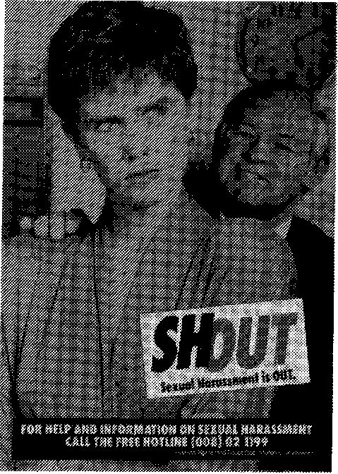
An evaluation of the project will be undertaken towards the end of 1990, although some results (including a possible rise in the number—of-sexual harassment complaints lodged by young women) may not be apparent in the short term. It is anticipated that, as young women become better informed of their rights, there could be a noticeable increase in complaints. However, the main thrust of the campaign is to inform young women how to deal with sexual harassment and of their rights under Federal law to work in an environment free from discriminatory treatment.
Women of Non-English Speaking Background
Another group of women of particular concern to the Commission is those of non-English speaking background (NESB). This group has always been under-represented in terms of lodging complaints. The Commission believes that this does not reflect a lack of discrimination against this group, but rather a general lack of awareness by NESB women of the means of reporting and rectifying discrimination.

Pilot projects in three languages were run in Sydney and Melbourne during 1988-89 to test the effectiveness of the use of ethnic radio in reaching NESB women and informing them about the Commission in general and providing some specific

90
Human Rights and Equal Opportunity Commission

instances of discrimination against which measures could be taken. An evaluation of the pilot projects in November 1989 found that radio, in conjunction with printed and visual material in the relevant community languages, was an effective medium for raising general knowledge about anti-discrimination laws amongst the target group. Of special interest and lasting benefit was the cooperation of the Grant-in-Aid workers and the Group Facilitators networks of the Office of Multicultural Affairs; many specific queries about human rights issues were answered by these staff.
Annual Report 1989-90 91
The pilot projects also stimulated the interest of the South Australian Equal Opportunity Commission, which is presently developing an information campaign targeting NESB women in South Australia. The South Australian campaign will include the written material and radio community service announcements developed by the Human Rights and Equal Opportunity— Commission. The Sex Discrimination Commissioner will contribute towards this project.
Publications
Occasional Papers:
- The United Nations in Public Profile: Evatt Memorial Lecture 1988 delivered by Quentin Bryce AO.
- Address given by the Sex Discrimination Commissioner on the Fifth Anniversary of the Sex Discrimination Act 1984.
- Papers on Sex Discrimination in Employment from the 1989 Human Rights Congress.
The following brochures, providing information on the Sex Discrimination Act and the mechanisms for making complaints, are available on request.
- A Guide to the Law
- Sex Discrimination in the Workplace
- Sexual Harassment in the Workplace
• The Rights and Responsibilities of Pregnant Workers
92
Human Rights and Equal Opportunity Commission
Guidelines for employers about Rights and Responsibilities of Pregnant Workers were developed in response to a high number of complaints that were received at the Commission regarding discrimination on the grounds of pregnancy. The feedback from employers has been positive.
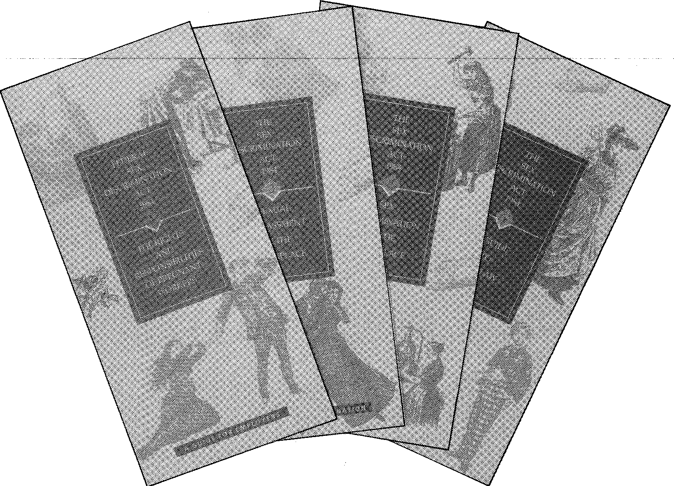
20-21 July 1989 ACOA Women's Seminar, University of Technology, Sydney
Sex
Discrimination Commissioner's
Speaking
Engagements
1989-90
22 July Keynote Speaker 1989 ALGWA Seminar -
The Special Needs of Women in Our Community - A Local Government Perspective, Brisbane
28 July Women at Work Seminar - Maternity and
Parental Leave, WIS Brisbane
29 July Women's College Forum Nobody's
Children - Who Cares? - Keynote Address, St Lucia
1 August 5th Anniversary SDA Address, UNAA,
Melbourne
3 August Elizabeth Le Froy Memorial Lecture,
University of Western Australia
5 August | Australian Council for Educational  Research Ltd National Conference on Educational Programs for Children and Adolescents with Emotional or Behavioural Problems, Marysville, Victoria

17 August Women Lawyers' Association (NSW)
Annual Report 1989-90 93
National Law Conference, Sydney.
21 August Soroptimist International Meeting -
Homeless Youth - Street Kids, Sydney
31 August Convention of Building Societies Annual 1
94 Human Rights and Equal Opportunity Commission
September Conference, Hamilton Island
8 September Women's Electoral Lobby (Far North
Queensland) Meeting, Cairns
11 September Zonta Annual Luncheon Address, Cairns
12 September Cairns Business Women's Club Annual
Luncheon Address
12 September Family Planning Association, Cairns
19 September Association of Civilian Widows National
Conference, Park Royal Hotel, Brisbane
22-25 September Human Rights Congress, Melbourne
5 October Mary Mount College, Gold Coast
6 October Gold Coast Women's Association, Surfers
Paradise
13 October National Conference on Violence, Canberra
21 October Amnesty International's Celebrity Lock-Up,
Brisbane
23 October Guest Speaker - Achieving Women's
Luncheon, Coolum
31 October Women in the 90's, Speech to Year 12
students, Star of the Sea College, Southport
1 November Sexual Harassment, Yeronga College of
TAFE, Qld
24 November GROW Community Mental Health
Movement Seminar, The Community and the Mentally In, Brisbane
January 1990 International Women's Rights Action
Annual Report 1989-90 95
Watch (IWRAW) Conference to mark the 10th Anniversary of CEDAW, New York, USA
1 March | Nation Women's Consultative Council Meeting Address Current Work at HREOC, Melbourne

2 March National Women's Consultative Council
ILO 156 Conference, Melbourne
6 March Keynote Speaker International Women's
Day, Sydney
8 March International Women's Day Dinner,
Geelong
12 March Conference on Women's Employment in the
Lead Industry, Adelaide
25-26 March Girls With Disabilities Seminar, Hobart,
22 April Jessie Street Oration, Sydney
24 April Speech - Gold Coast Women's Centre,
Southport
28 April Mackay Women's Health and Information
Centre Annual Dinner, Mackay
2 May | International Business Communications Conference Women and Your Workforce - Opportunities in Diversity, Sydney

9 May Women in Insurance Luncheon, Sydney

6 June | The Australian Federation of Business and Professional Women, Queensland Day Breakfast, Brisbane

96
Human Rights and Equal Opportunity Commission
9 June | National Federation of Blind Citizens of Australia Ltd Convention - Keynote Speech, Ashfield

18 June Young Women's Project Preview to
Community Organisations, Brisbane
20 June Macquarie University and Affirmative
Action Agency Conference, Women, Management and Industrial Relations, Graduate School of Management, Macquarie University, Sydney

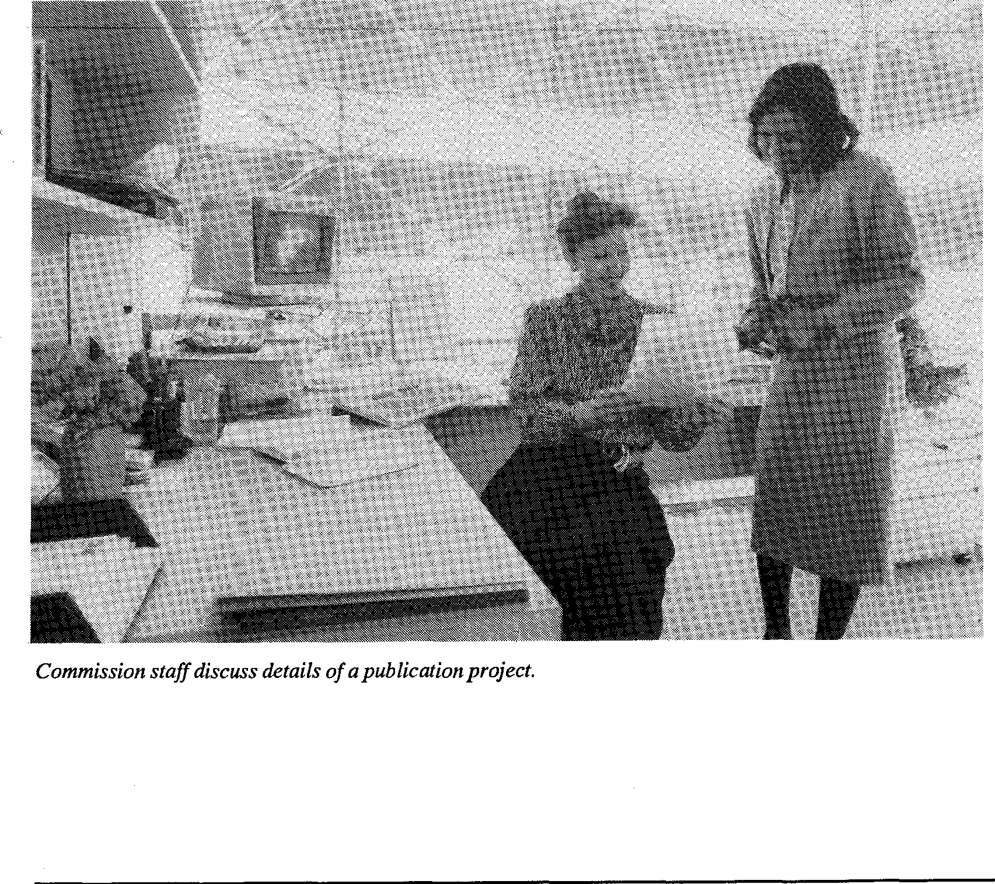
Commission staff discuss details of a publication project.
Privacy
Annual Report 1969-90 97

Privacy Commissioner
Mr Kevin O'Connor was appointed as the first Federal Privacy Commissioner on 1 January 1989 for a five-year term. He had previously been Deputy-Secretary in the Victorian Attorney-General's Department and Secretary to the Standing Committee of Attorneys-General. His background is in law and government, with extensive association with law reform and human rights issues. He undertook research for the Australian Law Reform Commission's major report on Privacyt, and served as Australian delegate in Geneva to the United Nations' working party on the draft Convention on the Rights of the Child. | 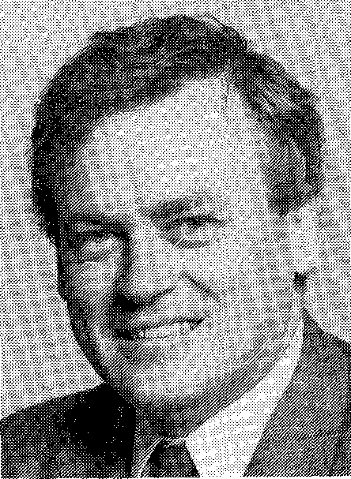

The Privacy Commissioner is a member of the Human Rights and Equal Opportunity Commission and is assisted by the staff of the Commission in carrying out his functions. He is required by the legislation to produce a separate annual report on the operation of the Privacy Act. A brief account of the activities within his portfolio appears below. | Privacy Commissioner, Mr Kevin O'Connor

Statement from the
Privacy
Commissioner
The year 1989-90 has seen further consolidation of the work
started in January 1989 to establish the function. By February
1990 all staff positions had been filled
Key achievements during 1989-90 were:
- Conduct of Privacy Act training for some 900 SES officers and agency privacy contact officers;
- Approval of interim guidelines for the protection of privacy in the conduct of medical research in consultation with the National Health and Medical
t The Law Reform Commission, 1983, Privacy, AGPS, Canberra.
Research Council and an ensuing period of consultation;
98 Human Rights and Equal Opportunity Commission
- Advice to the Attorney-General on the exclusions that should be allowed to the spent convictions scheme under part VII C of the Crimes Act;
- Issuing of revised Tax File Number Guidelines in accordance with Section 17 of the Act;
- Advice on the implementation of phase 2 of the Tax File
Number scheme which will commence on 1July 1990;
- Publication of the first Personal Information Digest;
- Commencement of a national advertising campaign.
The coming year will be a busy one. Major objectives will be the development of guidelines for Commonwealth agencies on data matching, covert surveillance, and the use of HIV/AIDS information; publication of a Privacy Handbook and further training of Commonwealth officers on the impact of the Act; and promotion of the spent convictions scheme.
Advice
In addition to his other responsibilities the Privacy Commissioner is required to provide advice (with or without a request) to a Minister or an agency on any matter relevant to the operation of the Privacy Act.
Many agencies have availed themselves of the opportunity to consult with the Privacy Commissioner on Bills being introduced into Parliament and on day-to-day matters relevant to the way the agency handles personal information. The Commissioner has also been active in the development of guidelines relating to covert surveillance and data matching.

Compliance
Under the Privacy Act the Privacy Commissioner has extensive powers to audit Commonwealth agencies and their personal information holdings and in the case of tax file numbers to audit all TFN recipients throughout Australia. Audit manuals have been developed during 1990 for both these unique areas of auditing and a program of audits is being devised.
Complaint
Investigation/
Resolution and
Enquiries
During 1989-90, 59 formal complaints were received in relation to the Privacy Act. Table 10 shows that 54 complaints (91.5 percent) concerned alleged breaches of the Information Privacy Principles, and 5 (8.5 percent) related to alleged breaches of the Tax File Number Guidelines. A further 53 written complaints were received which, after investigation, were found to be outside the Privacy Commissioner's jurisdiction.
To date, all complaints finalised have proceeded to successful conclusion or have been withdrawn during the investigation as being unsubstantiated. The Privacy Commissioner has not exercised his powers of determination in order to resolve any complaint. Conciliators in central office resolved 32 complaints during the year, a number of which involved significant policy changes in relation to the handling of personal information by Commonwealth agencies.
An increase is expected in Privacy complaints in 1990-91 as a result of the new Part VII C of the Crimes Act 1914 which limits the collection and use of spent conviction information, and as a result of increased promotional activities by the Privacy Commissioner.
Annual Report 1989-90 99
Table 10
100 Human Rights and Equal Opportunity Commission
Complaints Lodged under the Privacy Act July 1,1989 to June 30,1990
Ground of Complaint
Alleged breaches of Information Privacy Principles (IPPs)
Collection of information: [PP 1-3 27
Storage of information and access to it: IPP 4-7 6
Accuracy and use of information: IPP 8-9 4
Limits on use and disclosure: IPP 10-11 17
Alleged breaches of Tax File Number Guidelines 5

Total | 59

Respondent Category
Commonwealth Agencies 56
Other 3

Total | 59

Privacy Hotline
A toll-free hotline continued to operate following its establishment at the beginning of 1989. The hotline has been advertised widely and is used as the point of contact in each promotional activity held throughout the year. The hotline has been most useful in advising complainants of their rights under the Act. Between 1 July 1989 and 30 June 1990 the hotline had received in excess of 2000 calls.
The hotline number is (008) 023986.
Case Studies
Annual Report 1989-90 101
The following case studies illustrate the different types of
complaints lodged under the Privacy Act and their outcomes.
Case Study 1
A complainant alleged that a Commonwealth agency disclosed his silent telephone number and his private address in the telephone directory. The complainant had wanted a silent line because his partner's ex-husband had a history of aggressive behaviour necessitating a restraining order being taken out to prevent harassment.
The respondent apologised for the error, paid financial compensation and agreed to tighten provisions relating to the security of silent numbers.
Case Study 2
A couple approached the Commission on behalf of their daughter alleging that her privacy had been breached by a Federal government agency.
The parents alleged that an occupational psychologist's assessment report was used to determine their daughter's suitability for a traineeship with a Federal department. The daughter was allegedly refused employment due to inaccurate information contained in the report. The parents objected to the release of this information to potential employers without their daughter's consent and were concerned that it could affect her future employment prospects.
The matter was successfully resolved with the respondent agreeing to destroy the assessment report and increase staff awareness on the need for client consent concerning the release of personal information. The respondent also undertook to assist the daughter in finding suitable employment.
Promotional Activities
Education and Training
A great deal of effort has been directed during the year to informing the community about Privacy legislation. A special training pack (containing a video) was produced. The pack also contains training materials for the private and community sectors focusing on rights and responsibilities. Two additional videos are being produced to supplement the training, focusing specifically on the obligations of record keepers and the rights of the individual respectively.
The training pack was designed primarily for use by staff members within Federal agencies whose task it will be to ensure compliance with Privacy guidelines. It has been supplemented by a series of seminars directed at those staff, and to date some 900 SES officers and agency staff have attended Privacy seminars. More are being planned for private sector and community groups in the new financial year.

The training pack is available to government, private and community sectors. At the time of writing 200 copies had been sold. A distribution list is being maintained to allow regular update.
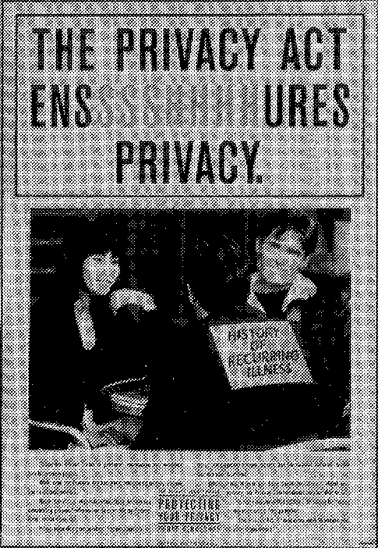
The broader community - with special attention to women, the business sector, NESB population, and young people - was targeted with a national public awareness campaign commencing in June 1990 and running through until September 1990. The campaign included a number of specifically targeted newspaper and magazine advertisements, featuring the Privacy Hotline telephone number to facilitate immediate and expert advice to callers. In the first two-week period, over one thousand calls were received, seeking information about individuals' rights under the Privacy Act.

102 Human Rights and Equal Opportunity Commission

Publications
Publications available free on request include the revised Tax File Number Guidelines and the Privacy Commissioner's Advice to the Attorney-General on the Federal Spent Convictions Scheme, as well as the pamphlet, Guide to the Federal Privacy Act and accompanying posters. The Training Pack (with videos) referred to above is available from the Commission at a cost of $50.00 per copy.

Privacy
Commissioner's
Speaking
Engagements
1989-90

14 July Queensland Branch, Australian Computer
Society, 1989 Brisbane: Privacy Act - Issues Raised by the Computerisation of Information
16-21 July  12 August | Second International Conference on Health  Law and Ethics, London: Refusal of Medical  Treatment:Victoria's Legislative Experience  Australian Society of Labor Lawyers, Sydney: AIDS and Privacy - Australia's Response

2 September Victorian Council for Civil Liberties,
Annual Report 1989-90 103
Melbourne: The Emerging Awareness of the Right to Privacy

6-8 Data Protection and Credit Information
104 Human Rights and Equal Opportunity Commission
September Conference, Copenhagen: Credit Reporting Developments in Australia
26 September Cross Selling Personal Financial Services
Conference, Sydney: Handling the Critical Issue of Privacy in Database Marketing
9 October International Telecommunications Law and
Policy, Sydney: The New Privacy Legislation - Does It Go Far Enough?
13 November Annual Conference of Queensland Regional
Directors, Townsville: The Privacy Act - Some Implications for Administration
1 December Future Directions in Banking and Finance
Conference, Melbourne: The Likely Impact of Privacy Laws on the Banking and Finance Industry
13 December International Records Management
Conference, Perth: Information Privacy - Australian and International Trendy
7 March 1990 ACT Branch of Record Management
Association Seminar, Canberra: Storage Media and the Privacy Act
24 April Managing Legal Complexities of the
General Insurance Industry Seminar, Sydney: The Impact of the New Privacy Laws, on the Insurance Industry

26 April  9 May | Communications and Media Law Association, Sydney: Privacy Problems of the 90s  Australian Telecomunication Users Groups Conference (ATUG '90), Melbourne: Privacy and Telecommunications

13 May
Northern Territory Regional Heads Forum, Alice Springs: Privacy Implications for Benefit Administrators
Annual Report 1989-90 105
5 June  12 June | South Australian Records Management Association, Adelaide: Storage Media and the Privacy Act  Australian Society of Accountants, Canberra: Privacy Act: Recent Developments Affecting Government Auditors and Accountants

26 June Longman Professional Conference, Sydney:
Privacy and Government Records

Coordination and Consultation
Annual Report 1989-90 107

Non-government Organisations
The Human Rights and Equal Opportunity Commission maintains strong links with a variety of non-government organisations (NG0s) whose concern lies with human rights or discrimination issues. To facilitate communication and to minimise duplication of effort, the Commission organises an annual meeting with national NGOs to discuss its overall work program and consult on major issues. This year's meeting was attended by representatives of some forty organisations whose interests coincide with those of the Commission in one or other of its jurisdictions. In addition, Commissioners and staff met with and took part in joint activities with a number of NGOs during the year, including State-based organisations.
In order to keep NGOs and the general public informed of its activities, the Commission produces a regular Human Rights Update which is distributed free of charge.
Joint Projects
The Commission cooperated with the Australian Council on Ageing and the Youth Affairs Council of Australia to conduct a seminar which examined options for improved legislative protection against discrimination based on age. It is also working with the Australian Council of Social Services to examine existing child welfare laws, policies and practices throughout Australia in order to identify deficiencies and inconsistencies. The Commission has also worked closely with UNICEF, the Australian Early Childhood Association, Foster Parents' Plan and others in relation to the Convention on the Rights of the Child.
Promotional
108 Human Rights and Equal Opportunity Commission
Activities
Human Rights
Congress 1989
Challenges for the 1990s was the theme of the third Human Rights Congress, held from 23 to 25 September at the University of Melbourne. The Congress was opened by the Governor-General, with the Minister for Justice, Senator the Hon. Michael Tate, giving the keynote address. Ms Joanna Foster, Chair of the British Equal Opportunity Commission, and Justice Elizabeth Evatt AO, Chair of the UN Committee on the Elimination of Discrimination Against Women, were major speakers. The closing address was delivered by Ms Margaret Mulgan, Chief Commissioner of the New Zealand Human Rights Commission, with assistance from other members of her delegation.
Topics covered in speeches, workshops and plenary sessions included legislative protection of the rights of people with disabilities, sex discrimination in employment, the state of community relations in Australia, age discrimination, managing maternity, race relations in the workplace, privacy, child and youth homelessness, the Convention on the Rights of the Child, education about human rights, AIDS and women's health.
Human Rights Medal
and Awards
The Human Rights Medal, awarded annually by the Commission, is given in recognition of the efforts of an Australian citizen or resident who, through personal endeavours, has made a substantial contribution to the promotion and advancement of the rights of all people - regardless of their sex, race, colour, origin, age or disability - to live in a fair and just society in which they may reach their maximum potential.
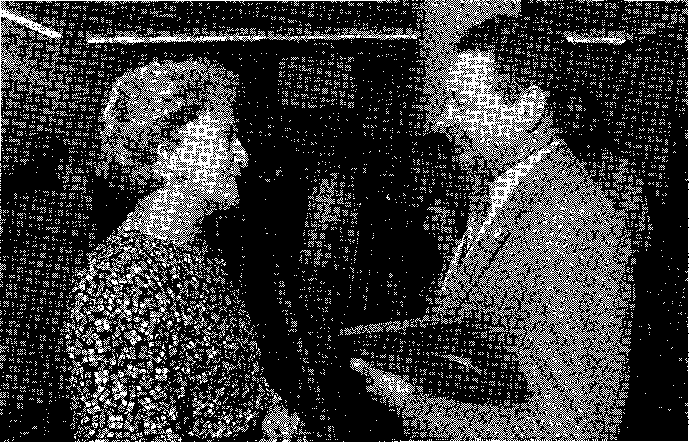
1989 Human Rights Medal Winner, Reverend Robert Ridley, chats with Mrs Hazel Hawke after the presentation ceremony.
Annual Report 1989-90 109
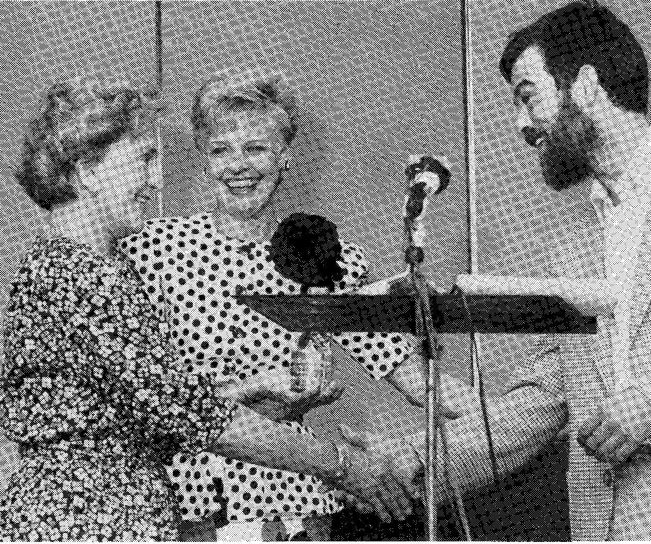
Mrs Hawke presenting the 1989 Human Rights Award for Literature to her son Steve Hawke for his work Noonkcanbah, as Sex Discrimination Commissioner, Quentin Bryce, looks on.
The 1989 Medal and Awards were presented to the winners on Human Rights Day, 10 December, by Mrs Hazel Hawke at a very well attended and well publicised ceremony at the Commission's Sydney Office.
110 Human Rights and Equal Opportunity Commission
The Human Rights Medallist 1989 was the Reverend Robert Ridley from Victoria, Director of Orana Family Services and a minister of the Uniting Church. He was considered to have made an outstanding effort in identifying and promoting action to overcome discrimination and the infringement of human rights by a panel of four judges: Sir Laurence Street, Mrs Katherine Greiner, Brisbane Lord Mayor Mrs Sallyanne Atkinson and the Reverend Dorothy McMahon (the 1988 Medallist).
Human Rights Awards are also made in the areas of film, literature and other writing, and media, for those works which are considered by the judging panels to best promote the understanding and public discussion of human rights in Australia.
Rim
The film prize - judged by Mr Phillip Adams, Ms Margaret Pomeranz and Mr Evan Whitton - was selected from a disappointingly small number of entries. The worthy winner nevertheless was Blowpipes and Bulldozers, produced by Jenni Kendall and Paul Tait.
Literature and Other Writing
The panellists, Dr Thomas Shapcott AO, Ms Wendy McCarthy and Mr Don Anderson, read twenty-three nominated books. They chose three equal winners and nominated another four as Highly Commended. The winners were Wanamurraganya by Sally Morgan, Noonkanbah by Steve Hawke and Michael Gallagher, and I Came Back to Show You I Could Fly by Robyn Klein.
Highly commended were:
Annual Report 1989-90 111
No Man's Land by Barbara James
The Lost Children edited by Coral Edwards and Peter Read Black Words, White Page by Adam Shoemaker
Miracle of the Waters by Zeny Giles
Media
This is a broad category offering awards for print material, television drama, and radio and television documentary/current affairs. The same panel, consisting of Dr David Millikin, Mr Stepan Kerkyasharian, Mr Les Hollings and Mr Kevin Kitchener, judged all sections. Their choices were as follows.
Television drama: GP, ABC/Roadshow Coote and Carroll
Television Documentary: Nobody's Children, David Goldie, ABC
Radio Documentary: 'There's No Place Like Baryugil', Background Briefing, Sharon Davis, ABC
Print Newspapers: 'Corporate Woman', Sue Neales, Australian Financial Review
Print Magazines: Yarranma, WA Alcohol and Drug Authority and the Nindila Committee
Highly commended was:
Denise Barrass for her series of articles in the Maitland Mercury entitled 'Youth in Crisis'
Exhibitions/Displays
112 Human Rights and Equal Opportunity Commission
As part of its strategy to increase public awareness about its powers and functions, the Commission is increasingly participating in exhibitions and other promotional activities. Materials have been developed for 'stand alone' displays in exhibitions and during conferences, seminars, special interest weeks and so on. This year, the Commission participated in the 1990 New South Wales Law Week with a successful seminar about the Privacy Act and the new grounds of complaint under ILO Convention 111. The 'stand alone' display at the Justice and Police Museum in Sydney helped promote better understanding about the Commission and its legislation to school students and others. The annual Sydney Women's Festival, scheduled for September in 1990, will provide a further opportunity for the Commission to inform the general public of its activities, particularly in the sex discrimination area. The Commission will continue to involve itself in such activities and will explore opportunities in other States once an appropriate movable display is available.
Consultants
The Commission maintains a Register of Consultants to which it refers when specific expertise is needed on a short-term or project basis. The register was established initially by advertising in all the major press for expressions of interest from researchers and other specialist consultants who wished to be included in the register. The register is continually being updated and individuals or firms who wish to register as consultants can request registration forms from the Commission's central office or by telephoning (02) 229 7600.
Appendix 2 contains a list of consultants engaged by the Commission during 1989-90.

Cooperative Arrangements with the States
In the Commission's history, set out briefly in the first chapter of this Report, reference is made to the Commission continuing the cooperative arrangements that its predecessor had formed with the State Governments in New South Wales, Victoria, South Australia and Western Australia.
The cooperative arrangements involve the handling of certain complaints on behalf of the Human Rights and Equal Opportunity Commission by State anti-discrimination and equal opportunity bodies which are set up under State legislation. The arrangement is made possible by delegation of Commission powers in respect of Federal legislation to the State agencies in order to minimise duplication in the provision of services. It enables the Commission to utilise the expertise available in the State bodies to handle complaints arising under Federal legislation.
Although the Commission has from time to time been concerned about the efficacy of the arrangements, particularly with regard to uniformity in the quality of service delivery, it has continued with them arrangements, but has sought to obtain greater accountability from the State agencies involved for the quality of service provided and for the expenditure of Commonwealth funds. The arrangements in 1990-91 will require data on performance evaluation.
Commonwealth funds allocated for cooperative arrangements in 1989-90 totalled $1.5m, which included a carryover from 1988-89. Funds were distributed as follows:
- NSW Anti-Discrimination Board: $460,000
- Victorian Commission for Equal Opportunity: $593,505 (including carryover from 1988-89)
- South Australian Commission for Equal Opportunity: $238,457
• Western Australian Commission for Equal Opportunity: $214,085
114 Human Rights and Equal Opportunity Commission
Residents of New South Wales, Victoria, South Australia and Western Australia wishing to lodge complaints under the Federal Sex Discrimination Act or Racial Discrimination Act may do so at the offices of the State agencies listed below:
NSW Anti-Discrimination Board Level 4, Australia Council Building
181 Lawson Street, REDFERN 2016 Telephone: (02) 318 5400
South Australian Commissioner for Equal Opportunity Ground Floor, Wakefield House,
30 Wakefield Street, ADELAIDE 5000
Telephone: (08) 226 5660
Victorian Commissioner for Equal Opportunity 4th Floor, 356 Collins Street, MELBOURNE 3000 Telephone: (03) 602 3222
Western Australian Commissioner for Equal Opportunity First Floor, City Mutual Building,
5 Mill Street, PERTH 6000
Telephone: (09) 222 8999
Further details on the work of the State bodies are contained in their annual reports.
Corporate Services
Annual Report 1989-90 115

Legislation
The major legislation and regulations applicable to the Corporate Services Program include:
- Public Service Act 1922
- Personnel Management Manuals and Streamlining Guidelines
- Audit Act and Finance Regulations
- Freedom of Information Act

Objective
The objective of the Corporate Services Section is the timely and efficient provision of corporate services to areas within the Commission. These services include:
- Financial Management
- Human Resource Management
- Accommodation and Services
- Purchasing and Travel
- Library
- Records Management
- Computer Support M:MVS.".` 117.,SWEr/
Management
Issues
Corporate
Management
The Commission's corporate goals and direction are set by the members of the Commission meeting as a corporate body. The Commission's program structure is organised so that each Commissioner is responsible for the management of a specific program of activities and budget in his or her area of
responsibility. Individual Commissioners report regularly to the Commission on their plans, strategies and program outcomes.
116 Human Rights and Equal Opportunity Commission
Integrated services such as complaint handling, legal services, library services, media and promotions services, and management services are grouped together under a single corporate services program, of which the Human Rights Commissioner, as executive head of the organisation, is the manager. Commissioners are assisted by the Senior Executives in managing their programs.
The Commission's corporate plan is being reviewed to bring it into line with structural changes in the Commission and the increased emphasis being given to program evaluation. Commission staff will be involved in the review process.
Human Resources Management
The Public Service Act 1922 governs the Commission's staffing arrangements. The Commission's average staffing level for 1989-90 was 78.9. The projected ASL was 74.7. However, this was exceeded because a number of temporary staff were employed pending recruitment of permanent staff. Because of the relative inexperience of temporary staff, it was necessary to engage larger numbers than would normally have been the case if more experienced permanent staff had been available. Despite this, expenditure on salaries was below estimate. There are a number of reasons for this, including the fact that the temporary staff were generally at lower salary levels.
By the end of the financial year, most permanent recruitment had been finalised, although some replacement has been necessary due to staff turnover. The staff turnover rate for the year (including temporary staff) was approximately 20 percent, which is not regarded as excessive by service-wide standards, but the effect on a small agency like the Commission is generally more severe than on larger agencies and departments. It is hoped that the Commission will enter a period of stability in terms of staffing during 1990-91.
The Commission's staffing profile appears at Table 11.
Annual Report 1989-90 117
Post Separation Employment
There were no cases of post-separation employment during
1989-90. | Table 11  Staffing Profile within Classification Levels  as at 30 June 1990
Classification | Males | Females | Total
Commissioners | 2 | 2 | 4
SES Band 2 | 1 |  | 1
SES Band 1 | 1 |  | 1
Principal Legal Officer | - | 1 | 1
Senior Legal Officer |  | 1 | 1
ASOC 8 | 1 | 4 | 5
ASOC 7 | 4 | 5 | 9
ASOC 6 | 6 | 11 | 17
Legal Officer |  | 1 | 1
Librarian Class 2 |  | 1 | 1
ASOC 5 | 1 | 6 | 7
ASOC 4 | 1 | 6 | 7
ASOC 3 | 3 | 11 | 14
ASOC 2 |  | 6 | 6
ASOC 1 | 2 | 0.4 | 2.4
Total | 22 | 55.4 | 77.4

Human Resource
Development
The Commission recognises that a planned investment in Human Resource Development is in the interests of its future strategic direction and that training and development play an important role in maximising the potential of its staff resource. A total of 253 staff days were devoted to training and
development in 1989-90, which represents an average of approximately 3.4 days per staff member.
118 Human Rights and Equal Opportunity Commission
Staff of the Commission have access to a variety of formal and informal training and development opportunities. The more significant of these are discussed below:
Formal Training Courses
Courses such as presentation skills, supervision, time management, negotiation skills etc. were attended by staff. These courses were conducted by various organisations including the Attorney-General's Department, the Public Service Commission and the NSW Small Agency Network. In addition, the Commission runs in-house training courses on such topics as telephone techniques, legal research and negotiation skills, as well as conferences for conciliators at which experts in various fields present sessions.
Computer Training
The majority of computer training provided to staff is conducted in-house by the Computer Support Officer. The courses offered cover topics such as Introduction to Personal Computers (PCs), Operating PCs, Document Management and Word Processing.
Staff have also attended external, specialist computer skills courses when required. A number of additional training requirements have been identified in this area and the issue will remain under constant review.
Law, Policy and Conciliation
Several legal and para-legal organisations provide continuing legal education, often through courses which give academic accreditation for the participants. To further the aims of multiskilling, staff from the Policy/Research and Conciliation sections also attend these courses.
Service-wide Training
Annual Report 1989-90 119
These courses are generally sponsored by other Commonwealth agencies and provide training in such areas as administrative law, industrial democracy, financial and staff resource management skills.
Seminars and Conferences
Staff also attend work-related seminars and conferences which provide them with professional and technical development opportunities.
Studies Assistance
In 1990, three staff members were participating in the Studies Assistance scheme.
Overseas Staff Exchanges
The Commission supports the concept of overseas staff exchanges which give its own staff the opportunity to learn at first hand the human rights experiences of other countries and to study different methodologies being used to promote human rights. Equally, the Commission welcomes working visitors from abroad and is pleased to share its own techniques.
In 1989-90, one staff member participated in the United Nations Human Rights Internship Program for five weeks. This program is coordinated by the UN Human Rights Centre in Geneva, Switzerland.
A student from Columbia University in the United States is currently undertaking a placement with the Commission - the third student from Columbia to do so.
The Commission's Aboriginal Policy Advisor visited New
Zealand for four weeks in February 1990 as part of an exchange
arrangement with the New Zealand Office of the Race
Relations Conciliator. A member of the New Zealand Office spent four weeks with the Commission in September 1989.
120 Human Rights and Equal Opportunity Commission
Further opportunities for overseas staffing exchanges are being pursued, including a possible exchange with the Canadian Human Rights Commission.
Public Service Commission Program Placements
The Commission is currently providing a 20-week placement to an officer participating in the Senior Women in Management Program (SWIM). She is undertaking her placement in the Privacy branch where she has the opportunity of increasing her skills in the policy development area.
Work Experience Placements
The Commission offered work experience placements to a number of Year 10 high school students. They spend a week in the Commission learning aspects of the operations of various parts of the Commission.
Financial
Management and Performance
Evaluation
Financial Reporting
Financial management and reporting has been improved in the past year with the introduction of enhanced, computer-based financial accounting systems. Program managers receive detailed monthly financial reports to improve the quality of decision-making and financial management.
More work is required to improve the management information on the use of human resources, and this will be a priority for 1990-91.
Financial Statement
Annual Report 1989-90 121
The Commission's Financial Statement for 1989-90 appears at Appendix 3.
Program Structure
Financial management during 1989-90 was handled differently to past years, due to changes in the program structure and system of budgeting. Thus the estimates for 1989-90, calculated without precedents, varied slightly from the final outcomes. These are dealt with more fully in the Explanatory Notes which form part of the Budget Papers series.
The Commission's running costs form a consolidated budget from which allocations are made to the various program elements by the Commission meeting as a whole, thus allowing for maximum flexibility in the management of programs and program funds.
The program structure adopted in 1989-90 had the following program elements:
- Human Rights
- Race Discrimination
- Sex Discrimination
- Privacy
- Corporate Services
- Cooperative Arrangements With the States
The following charts show the breakdown of expenditure by program element (Figure 4) and by classification (Figure 5), as well as a comparison of expenditure by classification between 1988-89 and 1989-90 (Figure 6). The increase in expenditure in 1989-90 came about as a result of the inclusion of the Privacy Commissioner as a member of the Commission.
Figure 4
Expenditure by Program Element 1989-90

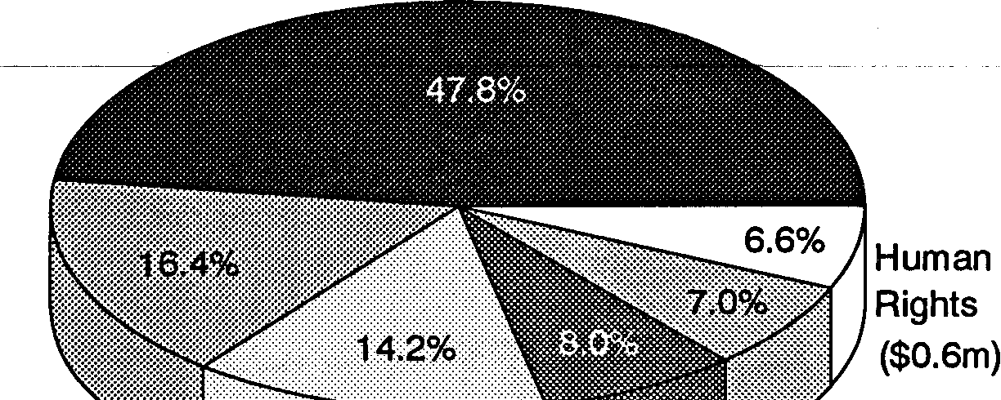
Corporate Services ($4.38m)

Cooperative
Arrangements Race Discrimination
($1.5m)
Privacy ($1.3m) | Sex ($0.64m)  Discrimination  ($0.73m)

122 Human Rights and Equal Opportunity Commission

Although much of the expenditure in the corporate services program relates to activities in the other program areas, it is not possible in many cases to disaggregate the exact costs to those programs. Hence expenditure in the corporate services program seems disproportionately large compared with the other programs.
Annual Report 1989-90
123
Figure 5
Expenditure by Classification 1989-90
Administrative and Program Expenses

($3.3m)
Payments to the States ($1.5m)

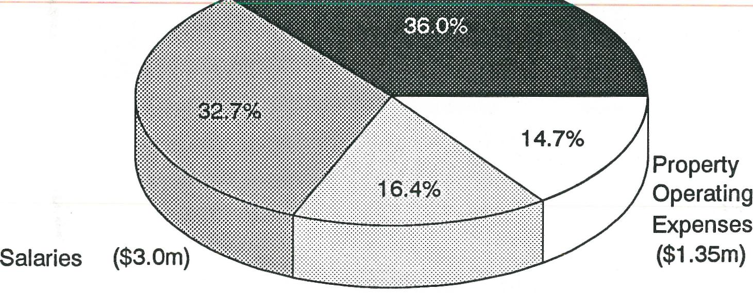
16.4%
Property Operating Expenses ($1.35m)
Salaries ($3.0m)
Figure 6
124 Human Rights and Equal Opportunity Commission
Expenditure by Classification Comparison 1988-89 with 1989-90
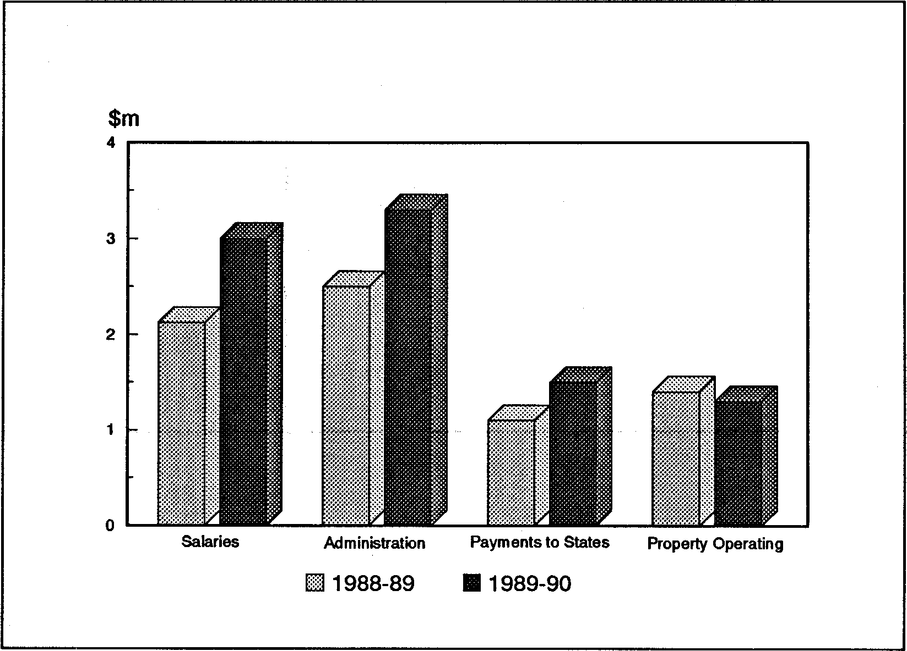
Figures 7 and 8 indicate estimated expenditure by both program element and classification for 1990-91. The projected increases over 1989-90 are the result of additional responsibilities given to the Commission in relation to the Spent Convictions Scheme (see chapter on Privacy), ILO Convention 111 (see chapter on Human Rights), and the Community Relations Strategy (see chapter on Race Discrimination).
Figure 7
Annual Report 1989-90 125
Estimate of Expenditure by Program Element 1990-91
Corporate Services ($5.5m)

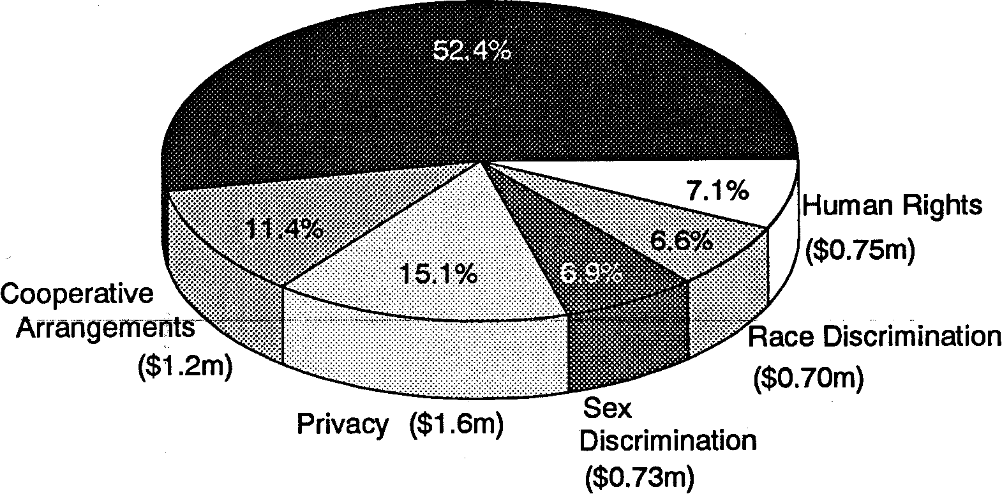
Human Rights ($0.75m)
Race Discrimination ($0.70m)
Privacy ($1.6m)
Performance Evaluation
The Explanatory Notes also contain comprehensive information on the Commission's performance evaluation. The Commission has developed an Evaluation Plan for the three years 1990-91 to 1992-93. The key result areas to be evaluated are:
- Public Inquiries and Research
- Public Awareness and Training Programs
- Complaint Investigation/Resolution and Enquiries
- Cooperative Arrangements with State Government Agencies
Figure 8
126 Human Rights and Equal Opportunity Commission
Estimate of Expenditure by Classification1990-91
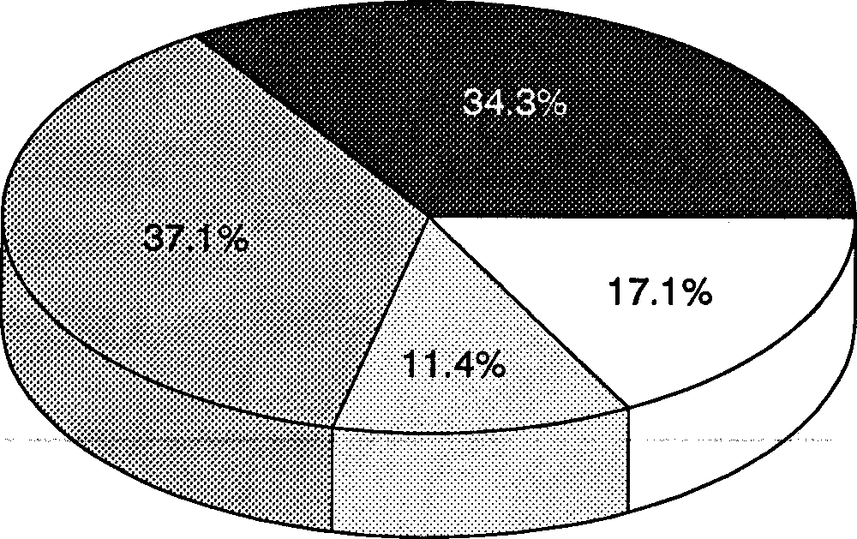
- Consultation and Cooperative Ventures with Relevant Non- Government Organisations

Administrative and Program Expenses
($3.6m)
Payments to the States ($1.2m)
Property Operating Expenses ($1.8m)
Salaries ($3.9m)
- Privacy Audit and Inspection
Advice, Guidance, Liaison and Training
- Corporate Services
Evaluation techniques will include needs analyses, public attitude and awareness research, client surveys, statistical analysis and cost/benefit analysis.
Purchasing Reform Update
The Commission is participating in the implementation of
purchasing reforms being co-ordinated within the portfolio by
the Attorney-General's Department. At the end of the financial
year the Department was developing new procurement procedures. These procedures are expected to be trialled by the Commission from November 1990.
Annual Report 1989-90 127
Management Information Systems
The Commission continues to rely heavily on improvements in
its use of information technology to maintain high levels of
efficiency and productivity.
The Commission's computer system has grown rapidly and been under considerable strain during the past year from the demands of new staff engaged to assist the Privacy Commissioner. The Commission has adopted an Information Technology Strategic Plan which involves even greater use of technology than at present and further automation of information _and communication systems within the Commission.
At present, there is shared access to statistical data, complaints and enquiry records (to authorised staff only), library catalogue information, and communication with remote databases such as SCALE, Info-One and Lexis.
Increased utilisation of specialised facilities such as financial accounting, records management and desktop publishing has resulted in the progressive upgrading of staff skills and existing computer resources. (This report was prepared on the Commission's desktop publishing facility.)
Recently, three computer workstations equipped with CD-ROM drives have been installed to take advantage of newly available compact disk-based publications and text searching/retrieval services. Portable computers are increasingly being used by staff to provide an efficient and convenient means of compiling, storing and transmitting information while absent from Head Office.
A series of in-house induction seminars and applications
training courses have proved to be an effective means of
improving staff computing skills as well as helping staff to keep pace with the development of office information technology.
128 Human Rights and Equal Opportunity Commission
The Commission's computer systems are managed by an Information Technology Advisory Committee which includes staff representatives. The committee advises the Commission on the best use of available technology, suggests improvements in the use of the Commission's current technology, ensures that both management and staff are kept informed of any proposed changes and that staff are consulted in relation to changes that will affect them.
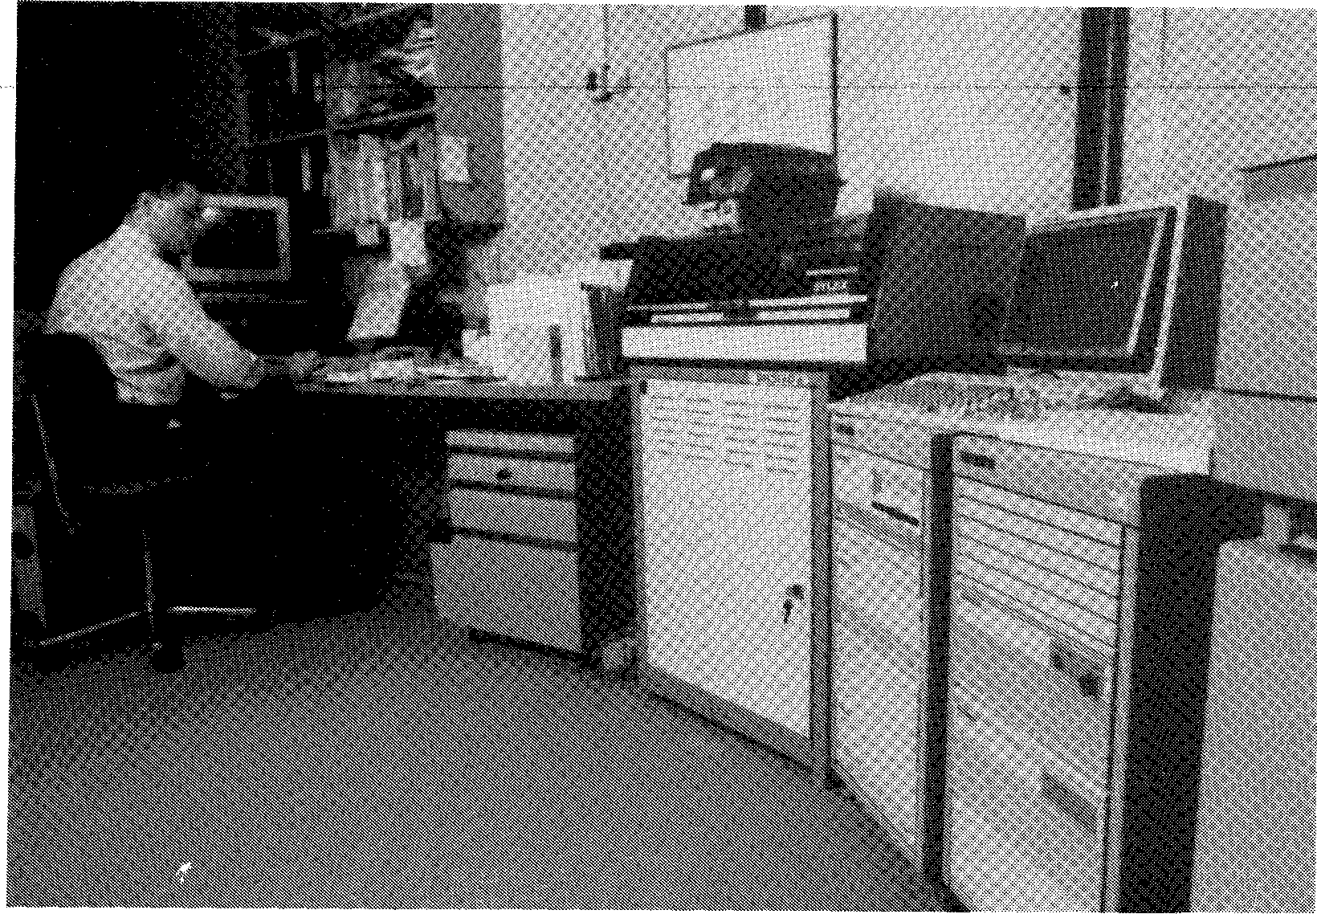
The Commission's HP3000 computer facility.
Regional Offices
Annual Report 1989-90 129
By and large the activities described in this report involve the Commission's regional offices as well as its central office, Staff of the regional ofices are involved in the planning and decision making process and they are closely affected by major policy developments such as the declaration of additional grounds of complaint under ILO 111. The following provides some additional insight into the activities of the regional offices.
Queensland
The conciliation case load for the Queensland office increased quite dramatically throughout the year. As many of the complaints are in remote areas of Queensland this required staff to travel extensively. There are significant and continuing problems in relation to racial discrimination, particularly in the far north Queensland area. These issues will continue to be addressed by the Commission.
Community education is a very important means of informing the public about the role and work of the Commission and the legislation it administers and staff from the Queensland office continue to play an active role in a variety of settings, including schools, TAFE colleges, community organisations etc.
With the election of a new Government in Queensland late in 1989 it is understood that State anti-discrimination legislation will be introduced before the end of 1990 or early in 1991. This will have a major impact on the operations of the Commission in Queensland. Discussions have commenced with the Queensland Government on the possibility of co-operative arrangements for the administration of State and Federal legislation following the passage of State legislation.
A new Regional Director was appointed to the Queensland office late in the year and staffing in the office is now stabilised following a period of fairly rapid turnover.
Northern Territory
130 Human Rights and Equal Opportunity Commission
Within the Darwin region, staff accepted invitations to participate in community education programs with secondary and tertiary students, as well as public speaking engagements from a large range of community organisations.
With the introduction in January 1990 of additional grounds for complaint in the Human Rights and Equal Opportunity Commission Act jurisdiction (ILO Convention 111), enquiries received at the Darwin office more than doubled, compared with the first six months of the financial year. An increase in enquiries from Northern Territory public servants was also noted, many seeking clarification of the new grounds and their local application.
An Aboriginal woman was engaged for a three-month period at the end of 1989 to conduct interviews with Aboriginal people and organisations in relation to the National Inquiry into Racist Violence. The results of these interviews, conducted in Darwin, Katherine and Alice Springs, were contained in a report to the Inquiry. Similar interviews with people of different ethnic backgrounds were conducted by the Office of Multicultural Affairs and a report forwarded to the Inquiry through the Director of that Office.
The Human Rights Commissioner and the Privacy Commissioner visited the Northern Territory during the year, and both visits attracted considerable media attention.
A highlight of the year was Human Rights Week 1989. The emphasis in the Northern Territory was on community involvement and to this end letters were sent to all religious groups asking them to include Human Rights Week in worship. Information packages on the Commission and the various United Nations Conventions and Declarations were distributed to all public and school libraries. Other activities included a children's party hosted by four major community organisations, a phone-in on discrimination by the NT AIDS Council, and a public forum arranged by Defence for Children International.
The Regional Office, together with 8-Top FM, sponsored a Human Rights Rock Concert which featured the Aboriginal band, Blekbala Mujik. All proceeds from the concert were contributed to the Menzies School of Health Research for its Aboriginal Middle Ear Infection Program.
Annual Report 1989-90 131
Local media coverage during the year focused on the Human Rights Concert, the introduction of the new Regulations under ILO 111, the National Inquiry into Racist Violence, and the study into the supply of water to Aboriginal communities.
The increased media attention, including that directed towards the two Commissioners during their visits, heightened the profile of the Commission throughout the Northern Territory and no doubt was a contributing factor in the increase in enquiries received by the Regional Office during the year.
All staff members in the Darwin office participated in training courses during 1989-90 in personal development, skills enhancement and management principles.
Courses included business writing skills, evaluation and performance measurement, change and management programs, computer operation and specific training for inquiry officers. Most training programs were made available on a cost-shared basis through the Commonwealth Staff Development Network. The Regional Office cooperated with the NT Department of Labour and Administrative Services in the latter's Management Skills for Women Program, by providing a woman manager role model to demonstrate management skills.
Travel was a major component of the Regional Office's workload and centres visited during the year included Alice Springs, the Gove Peninsula, Katherine and the Tennant Creek/Barkly region. Visits to these centres involved complaint conciliation, meetings with Aboriginal communities and organisations, and training sessions with public contact officers in both government and non-government organisations.
Tasmania
132 Human Rights and Equal Opportunity Commission
March 1990 saw the appointment of a new Regional Director to coordinate the Commission's operations in Tasmania. The position had been vacant for some time. Three officers from Central Office acted for short periods as temporary Regional Director during the period of vacancy. Apart from making long-term planning difficult, the lack of a permanent Director also affected other staff positions in the Regional Office. The next financial year will see a period of stability.
Despite staffing difficulties, a great deal was accomplished in the area of community education. Many copies of the Sex Discrimination Commissioner's pamphlet, The Rights and Responsibilities of Pregnant Workers, were distributed, as were information kits on the Convention on the Rights of the Child. The latter were particularly in demand after an ABC television program on the subject in April 1990.
Requests for speakers on the role of the Commission and its jurisdiction were received throughout the year, and the appointment of the new Regional Director provided an opportunity to contact the union movement, the private sector and non-government organisations to alert them to his availability as a speaker.
Media attention was drawn to the Commission's work during Human Rights Week, which was marked by a visit from the Commission's Secretary who took the opportunity to visit government departments as well as presenting the Human Rights Week Address.
The Sex Discrimination Commissioner visited in March 1990 to attend a seminar on Young Women and Disabilities.
The year concluded with the Privacy Commissioner's first official visit to Tasmania. The Commissioner and his staff conducted seminars explaining the privacy legislation; attended an Information Night in Launceston organised by the Hobart office for interested members of the public; and had a series of meetings with government and non-government organisations.
Annual Report 1989-90 133
Industrial Democracy
The Commission's philosophy on Industrial Democracy is that staff are more fully able to contribute to the efficient and effective operation of the Commission and enjoy a better quality of working life if they are more fully involved in the decision-making process as it affects them. The Commission is therefore committed to the involvement of its staff in that process through the industrial democracy procedures outlined below.
The Human Rights Commissioner is the Senior Executive responsible for Industrial Democracy matters within the Commission. The position of Director, Corporate Services has as part of its functions the responsibility of implementing industrial democracy principles and practices in the workplace. This responsibility is shared in a general sense by all staff of the Commission through the Consultative Council processes.
Significant
Achievements
1989-90
As foreshadowed in last year's Annual Report, the first Joint Union/Management Consultative Council was established during this year. It comprises equal numbers of union and management members, and Regional Office management and staff are represented. The Council plans to meet quarterly.
A facilities package for Union members has been agreed. A major priority of the Consultative Council has been the drafting of the Industrial Democracy Plan. This has been developed after extensive consultation with staff associations and will only be formally adopted after full agreement is reached between management and unions. It is expected that the Plan will be formally approved at the Consultative Council Meeting in July 1990 and adopted by the Commission shortly thereafter.
Although the Industrial Democracy Plan is yet to be formally
adopted, the Consultative Council has already reached
agreement on the formation of the following five
134 Human Rights and Equal Opportunity Commission
sub-committees and working parties:
- Industrial Democracy Working Party
- Office Structures Implementation Working Party
- Equal Employment Opportunity Sub-Committee
- Occupational Health and Safety and Accommodation Sub-Committee
- Staff Development and Training Sub-Committee These sub-committees plan to meet at regular intervals.
Consultative
Mechanisms
Apart from the Consultative Council, which is the peak Management/Union consultative forum, there are a number of other consultative mechanisms in the Commission:
- Commission meetings, to which staff have input by way of discussion papers and whose Minutes, except for items of a confidential or sensitive nature, are made available to staff.
- Senior Staff meetings, where overall priorities and work programs are discussed, objectives and goals determined, and activities planned.
- Branch/Section/Regional Office meetings, where senior officers involve their staff in the process of developing individual programs, tailored to the relevant work area.
- Project/Work Group meetings, where planning, implementing and monitoring of specific projects takes place.
- Full staff meetings, where significant matters affecting
all staff, whether union members or not, are discussed.
- Union meetings, where matters of industrial concern are discussed.
- Weekly Staff Circular, which informs staff of personnel
changes or movements and other matters of interest.
- Monthly Reports by Senior Staff, on progress within their areas as well as staffing/resource issues.
In the past, only Commissioners and senior staff have been involved in the corporate planning process. However, in the current review of the Commission's Corporate Plan, an effort will be made to give all staff the opportunity to provide input to the plan through the Consultative Council process.
Corporate Planning
Processes
Annual Report 1989-90 135
Special Issues
Facing the
Commission
The Commission is characterised by its relatively small size (less than 80 ASL); its geographic spread, with offices in Sydney, Brisbane, Hobart and Darwin; and a diversity of activities as can be seen from this Report. These considerations require maximum flexibility in the Commission's operations to ensure that it is effectively able to meet the constantly changing environment in which it functions. Qualities of flexibility and multiskilling in its staff are of vital importance in meeting these challenges.
Major Priorities
1989-90
The Commission's main industrial democracy priorities last year were the establishment of a Consultative Council and the revision of its Industrial Democracy Plan. As outlined above, both these objectives were met.
Priorities 1990-91
The major priorities for the next year will be the effective operation of the Consultative Council and its sub-committees, the development of a monitoring and evaluation mechanism, and a review of the Corporate Plan.
The Consultative Council will have input to the following industrial democracy priorities for next year:
- Job redesign
- Streamlining of the planning process
- More participative work practices
136 Human Rights and Equal Opportunity Commission
- Improved use of technology
- Improved working environment
- Improved human resource development opportunities.
Monitoring, Review and Evaluation
The Consultative Council is charged with responsibility for monitoring, review and evaluation of the progress and effectiveness of Industrial Democracy in the Commission. Indicators will include productivity, industrial relations record and staff morale.
Occupational Health and
Safety
The Commission continued to place a high priority on occupational health and safety issues during 1989-90. Some of these issues are discussed below.
Accommodation
All the fit-outs in Commission offices were designed in accordance with Commonwealth occupational health and safety standards. Office design, ambient atmosphere and the use of ergonomic furniture have all been utilised to assist in the creation of a safe and healthy workplace.
However, the increase in staff numbers, particularly as a result of the activities of the Privacy Commissioner, has resulted in a critical shortage of office accommodation. A proposal for the funding of additional space to comfortably accommodate all staff within the present building occupied by the Commission's central office was being considered in the Works Technical New Policy Proposals context at the end of the financial year.
Smoke-free work environment
Annual Report 1989-90 137
This policy applies throughout Commission offices to both staff and visitors.
Fire wardens
Selected staff in the central office of the Commission were trained as fire wardens and fire drill practice was undertaken by all staff. Regional office staff also participated in mandatory fire drills.
Equal Employment Opportunity
The Equal Employment Opportunity (EEO) Program of the Commission has been approved by the Public Service Commission.
The objective of the Commission's program is to enhance equal opportunity to the point where it may simply be incorporated within the Corporate Plan and not (except for statutory requirements) be regarded as a discrete issue to be given an identity separate from other management questions.
EEO Resources and Consultative Mechanism
The Secretary is the Senior Executive responsible for EEO within the Commission. The Personnel Manager has responsibility for EEO coordination and grievance handling within the Commission. In Regional Offices, day-to-day responsibility for EEO falls to the Regional Directors.
The consultative mechanism for EEO is part of the Industrial Democracy process. There is an EEO and ID sub-committee of the Consultative Council which meets regularly.
Within its resources, the Commission assists other Federal and
State agencies, professional bodies and private companies with
training on race, sex and disability discrimination; on cultural discrimination in the workplace; on EEO for managers; and with training for lawyers in conflict resolution.
138 Human Rights and Equal Opportunity Commission
Statistical Data
Table 12 and Figure 9 show that the Commission has a higher proportion of EEO target group members than service-wide averages prevailing at December 1989. Last year's Annual Report noted that the Commission's major EEO objective for 1989-90 would be to increase the representation of persons of non-English speaking background (NESB) and persons with a disability in its staffing profile. This objective was achieved.
The percentages rose from 14 percent to 18 percent for NESB staff, and 2 percent to 6 percent for persons with a disability.
Table 12
Representation of EEO Groups within Classification Levels as at June 1990
ASO classification Total N² Staff with Women 1VESB1 1VESB2 ATSI FWD
and equivalent
of staff E data

ASOC 1-4 | 30 | 20 | 24 | 5 | 4 | 1 | 2
 |  | (67%) | (80%) | (17%) | (13%) | (3%) | (6%)
ASOC 5-6 | 26 | 20 | 19 | - | 3 | 1 | 2
 |  | (80%) | (73%) |  | (12%) | (4%) | (8%)
ASOC 7-8 | 16 | 13 | 11 | 1 | 1 | 2 | 1
 |  | (81%) | (69%) | (6%) | (6%) | (12%) | (6%)
SES BANDS 1 & 2 | 2 | 2
 |  | (100%)
SES BAND 3 and above | 4 | 1 | 2 |  | 1
 |  | (25%) | (50%)
Total | 78 | 56 | 56 | 6 | 9 | 4 | 5
 |  | (72%) | (72%) | (8%) | (12%) | (5%) | (6%)
Average service-wide % as at December 1989 * |  |  | 43% | 5% | 7% | 1% | 0.5%

* Source: Australian Public Service Statistical Bulletin A
Table 13
Annual Report 1989-90 139
Representation of EEO Groups within Occupational Groups
as at June 1990

Occupational Group | Total Ng SW! with Women NESB1 of staff EEO data |  |  |  | NESB2 | ATSI | PWD
SES and Commissioners | 6 | 3 | 2 |  | 1
 |  | (50%) | (33%) |  | (17%)
ASO and related | 68 | 49 | 50 | 6 | 8 | 4 | 5
 |  | (72%) | (74%) | (9%) | (12%) | (5%) | (7%)
Professional | 4 | 4 | 4
 |  | (100%) | (100%)
Total | 78 | 56 | 56 | 6 | 9 | 4 | 5
 |  | (72%) | (72%) | (8%) | (12%) | (5%) | (6%)

Key: *
NESB1 - Persons born overseas
NESB2 - Australian born with parents born overseas
ATSI - Aboriginal or Torres Strait Islander
PWD - Persons with a disability
* Applies to both Tables
Note: Percentages for women based on total staff; percentages for other groups based on staff for whom EEO data was available
Figure 9
140 Human Rights and Equal Opportunity Commission
Comparison of HREOC EEO Statistics with Service-wide Averages
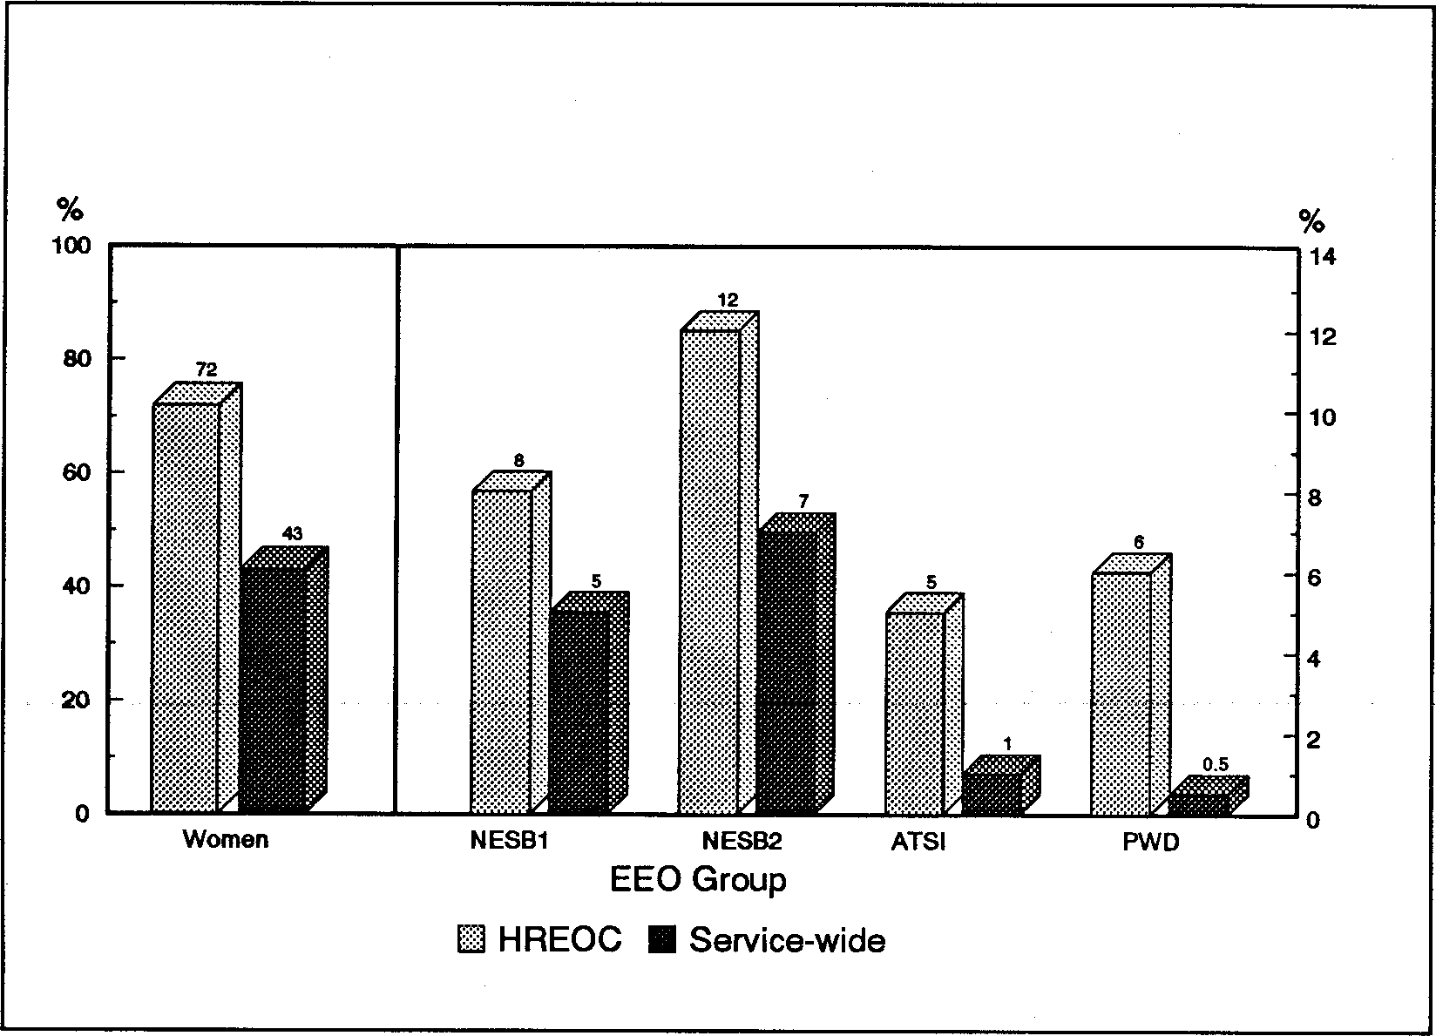
These data have been compiled from manually maintained statistics. The Commission plans to acquire an automated Human Resource Development System which will facilitate the retrieval of statistical information.
Major Priorities
1989-90
The Commission foreshadowed the adoption of a new EEO program as its highest EEO priority in last year's Annual Report. This has been achieved during the year with the implementation of a program approved by the Public Service Commission. Another priority was the designation of one ASL specifically for a person with a disability. This has also been achieved in 1989-90 and the current occupant of the position works on a permanent part-time basis. It is expected that a second position will be so designated in 1990-91.
The Commission's priority for EEO in the next year will be to use the newly established EEO and ID sub-committees of the Consultative Council effectively. The major issue to be addressed by the sub-committees will be further development of an integrated office structure as a tool for the advancement of EEO.
Major Priorities
1990-91
Annual Report 1989-90 141
Access and Equity
To ensure access to its services and equity in the provision of those services for people of non-English speaking background (NESB), the Commission has identified the following aims:
- to inform NESB people about the Commission's role and functions, particularly with regard to their rights covered by the Acts administered by the Commission;
- to ensure that, when dealing with the Commission, the language needs of this target group are met efficiently and appropriately;
- to ensure that the special issues affecting NESB people are addressed both specifically, through special projects, and generally, in all of the research, project, policy and other work undertaken by the Commission.
The activities undertaken to achieve these aims, either specifically or indirectly, during the past year have been described in the preceding portfolio reports. They are briefly summarised here:
- Immigrant Women's Information Pilot Program
- Young Women's Sexual Harassment Campaign
- Race Relations in the Workplace Project
- National Inquiry into Racist Violence
- Privacy Publicity Campaign
- Planning for the second-stage Privacy Information Sessions
- Schools Program
- Development of a Translations Policy
- Revision of the Race Discrimination brochure, including a 'Help Page' translated into seventeen community languages
142 Human Rights and Equal Opportunity Commission
- Planning for the translation of other Commission material into community languages
- Development of the Publication Distribution Strategy, including ethnic community organisations and individuals and NESB women's groups
- Monitoring of the Commission's contact database and statistics on service users
- Cross-cultural sensitisation in staff training programs
- Preparation of a submission relating to the refusal of entry to migrant applicants because of failure to meet health standards
- Conciliation of complaints from NESB people
- Distribution of publications and media releases to multilingual and ethnic community newspapers, radio and SBS television
- The Race Discrimination Commissioner's involvement in the working party developing a community relations strategy as part of the Government's National Agenda for a Multicultural Australia
While the above emphasises the Commission's efforts to improve access and equity for NESB people, the Commission is also conscious of the needs of other disadvantaged groups and of the needs of people living in rural areas. Many of the activities outlined above also included strategies which catered for the needs of such groups. The Commission is also a contributor to the Department of Primary Industries and Energy's Countrylink rural information access program.
Library

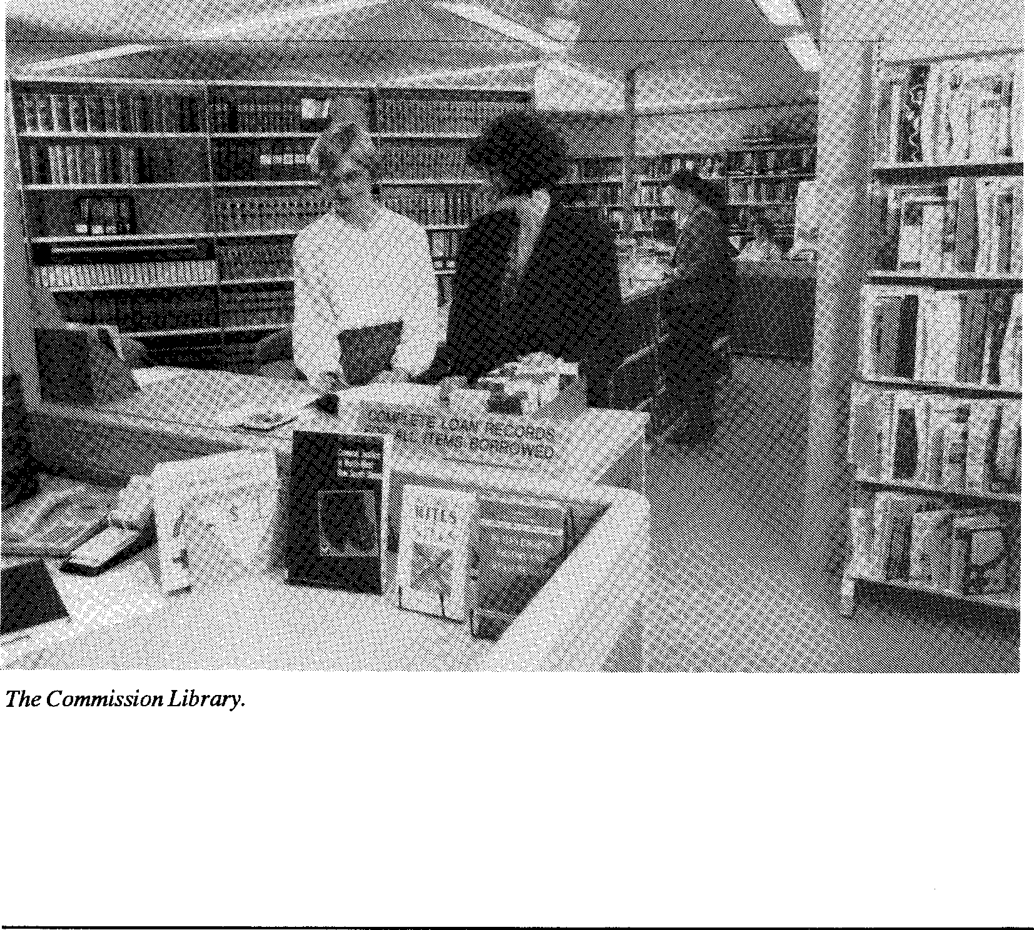
The Commission Library.
Annual Report 1989-90
143
The major library project for the past year has been the computerisation of the catalogue. So far, 3,500 items have been put onto the catalogue. Although the process of retrospective conversion is very slow, users have been delighted with the system and how 'user friendly' it is.
As well as regular reader education sessions for the staff on the use of the library, specific training in the area of legal research has been conducted and proved to be very successful.
The library is open to the public from 10.00 am to 5.00 pm by appointment for reference use only; a coin-operated photocopier is provided.
Freedom of
Information
144 Human Rights and Equal Opportunity Commission
The Freedom of Information Act extends the right of access of the Australian community to information in the possession of the Federal Government.
It requires Federal agencies to publish information about their operations and powers affecting members of the public as well as their manuals and other documents used in making decisions or recommendations affecting the public. It also requires agencies to provide access to documents in their possession unless the document is within an exception or exemption specified in the legislation.
Access to all documents in the possession of government is not possible as confidentiality must be maintained where necessary for the protection of essential public interests and the private and business affairs of persons in respect of whom information is collected. Complaints to the Commission are subject to the confidentiality provisions of the Acts it administers.
Categories of
Documents
The Commission maintains the following categories of documents:
- Administration
Matters including personnel and recruitment, accounts, general administration files, documents and registers, registry and library records and indices.
- Conciliation
Matters including the investigation, clarification and resolution of complaints
- Legal
Matters including legal documents, opinions, advice and representations
- Research
Matters including research papers in relation to complaints, existing or proposed legislative practices, public education, enquiries and other relevant issues.
- Operational
Annual Report 1989-90 145
Including files on formal Inquiries
- Reference Materials
Including press clippings, survey and research materials, documents relating to conferences, seminars and those contained in the Library.
- Policy
Including minutes of meetings of the Commission, administrative and operational guidelines.
The printed material which is available to the public has been listed in the Publications section of each portfolio report and in summary form at Appendix 1.

Freedom of
Information
Procedures
Initial enquiries concerning access to Commission documents should be directed to the FOI Officer by either telephoning (02) 229 7600 or by writing to:
The Secretary
Human Rights and Equal Opportunity Commission
GPO Box 5218
SYDNEY NSW 2001
Facilities for examining documents and obtaining copies are available at the Commission's offices as follows:
Level 24, American Express Building
388 George Street, SYDNEY 2000
Telephone: (02) 229 7600
Ground floor,
146 Human Rights and Equal Opportunity Commission
187 Melbourne Street, SOUTH BRISBANE 4101 Telephone: (07) 844 6099
First floor, Randazzo Building
80 Mitchell Street, DARWIN 0800 Telephone: (089) 81 9111
Suite 4, Ground floor, The City Mill 11-13 Morrison Street, HOBART 7000 Telephone: (002) 23 8511
Appendix 1
Annual Report 1989-90 147
Commission Publications
Human Rights Pamphlets
A Guide to Our Homeless Children
A Treaty for Children - Questions and Answers, Information Sheets
Human Rights of Australians with Disabilities - A Challenge for Government?
Convention on the Rights of the Child What are Human Rights?
Universal Declaration of Human Rights
Kit
Convention on the Rights of the Child Reports
Our Homeless Children - Report of the National Inquiry into Homeless Children
Our Homeless Children: Their Experiences - Report by Dr Ian O'Connor to the National Inquiry into Homeless Children
Occasional Paper
No 1 - Papers on Schizophrenia and Human Rights

 |  |  |  |  |  |  | Discussion Paper
 |  |  |  |  |  |  | The Rights of People with Disabilities - Areas of Need for Increased Protection
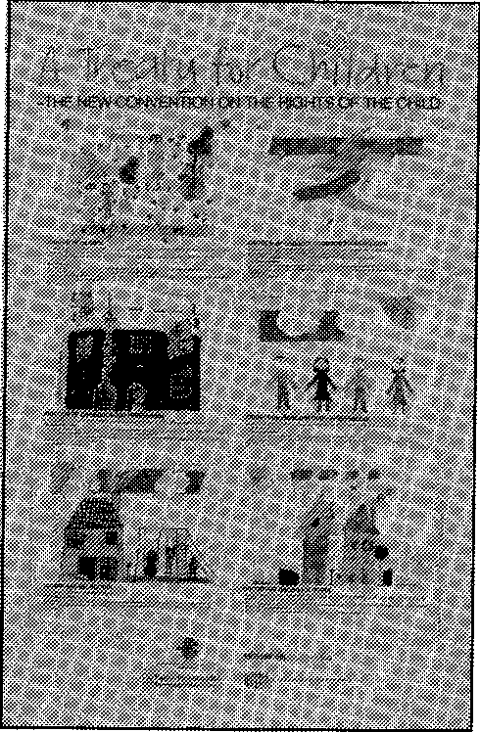 |  |  |  |  |  |  | Posters
 |  |  |  |  |  |  | Declaration of the Rights of the Child
Declaration on the Rights of the Disabled Persons
Declaration on the Elimination of All Forms of Intolerance and of Discrimination Based on Religion/Belief
A Treaty for Children - Convention on the Rights of the Child (set of 4)
What are Human Rights?
Universal Declaration of Human Rights

Race Pamphlets
Racial Discrimination Act 1975 Water Rights: A Study
Reports
Toomelah Report - Report on the Problems and Needs of Aborigines Living on the NSW - Queensland Border
Summary of Toomelah Report Toomelah Review

148 Human Rights and Equal Opportunity Commission

Sex Pamphlets
Sex Discrimination Act No 1 - A Guide to the Law

The Rights and Responsibilities of Pregnant Workers
A Guide for Employers
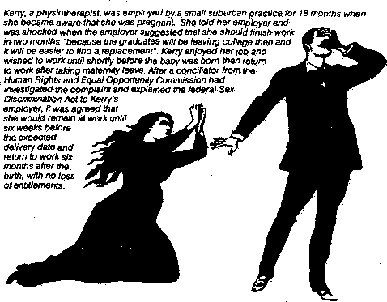
Sex Discrimination Act No 2- Sex Discrimination in the Workplace
Sex Discrimination Act No 3 - Sexual Harassment in the Workplace
Sex Discrimination Act No 4-Rights and Responsibilities of Pregnant Workers
Booklet
The Rights and Responsibilities of Pregnant Workers - A Guide for Employers
Occasional Paper
No 1 - 1988 Evatt Memorial Lecture, the UN in Public Profile
No 2 -Address on 5th Anniversary of the SDA 1984
No 3 - Sex Discrimination in Employment from the 1989 Human Rights Congress
Privacy Pamphlets
Privacy No 1 - Guide to the Federal Privacy Act Booklets
TFN Guidelines - Draft Consultation
Federal Spent Conviction Scheme: Exclusions - Background Paper
- Summary of Submissions

Annual Report 1989-90
149

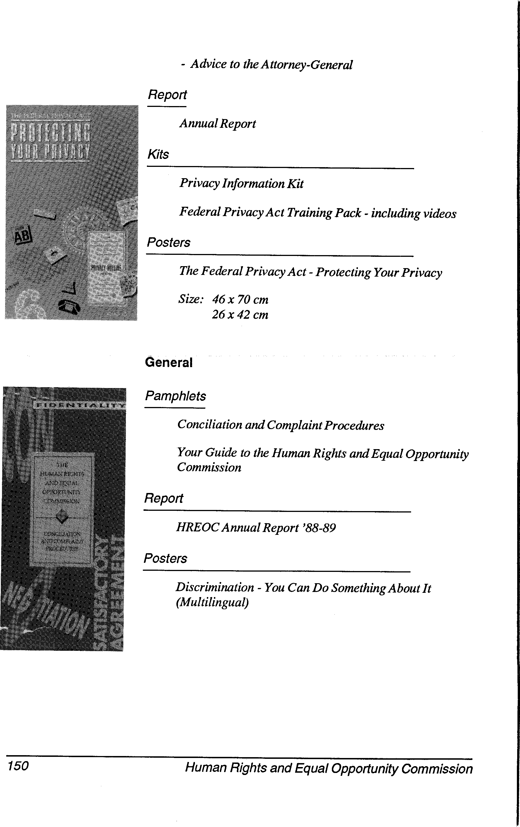
150 Human Rights and Equal Opportunity Commission
- Advice to the Attorney-General Report
Annual Report
Kits
Privacy Information Kit
Federal Privacy Act Training Pack - including videos Posters
The Federal Privacy Act - Protecting Your Privacy
Size: 46 x 70 cm 26 x 42 cm
Conciliation and Complaint Procedures
Your Guide to the Human Rights and Equal Opportunity Commission
Pamphlets
Report
HREOC Annual Report '88-89
Posters
Discrimination - You Can Do Something About It (Multilingual)
General
Appendix 2
Consultants Engaged
1989-90

Investigate community relations 13,500.00
Aboriginal Law Centre
between Police and Aborigines
within NSW and Old.
Conduct client survey research 50,000.00
AGB Research
for Privacy Act.
Prepare report on racist violence 5,500.00
Albrook Cattalini
Research Pty Ltd
towards Aborigines in certain
localities in Western Australia.

Alston, Prof P
Briggs, J and Assocs
Brookman, J
Centre for Appropriate Technology
Centre for Multicultural Studies
Technical review of the draft principles on Mental Illness.
Devise and implement training program re Privacy Act.
10,000.00 7,700.00 66,971.00 33,427.00
Media adviser to the Commission.
Investigate the water and drainage facilities of ten Aboriginal communities throughout Australia.
Provide comparative analysis of 18,300.00
international strategies for combatting racist violence. Prepare discussion paper on racism and racist violence.

Annual Report 1989-90
151

Fieldhouse, A Provide legal advice to the 38,276.33
Engel, C
Prepare and present part of a submission to Senate Standing Committee on Community Affairs Inquiry into the employment of people with disabilities and accommodation for people with disabilities.
894.00
152 Human Rights and Equal Opportunity Commission
Commission.
Fouras, D Research assistance for Homeless 16,720.00
Children Inquiry.
Gallagher, M Prepare report on racist violence 3,000.00
towards Aborigines in certain
localities in Western Australia.
Hitech Editing Advice on Privacy and the 23,580.00
Freedom of Information Act.
Training SES in relation to
Privacy Act. Research and
development of data matching
guidelines.
Hollingsworth, M Prepare report on racist violence 4,000.00
towards Aborigines in certain
localities in Queensland.
Jakubowiez, Dr A Investigate role of the media in 9,000.00
reporting racism and racist
violence.
Jocarm Pty Ltd Advise on private sector strategy 30,000.00
in relation to homeless children,
and Commission involvement
with private sector generally.
Jodico Pty Ltd Prepare paper on pregnancy 1,439.00
discrimination and income.

Katz, L | Legal advice on interpretation of 600.00  Information Privacy Principles.

KPMG Peat Develop Privacy Audit 73,25250
3,000.00
Marwick methodology.
Lintas Conduct advertising campaign for 179,278.00
Privacy.
Markus, Dr A Provide a history of racist 3,000.00
violence in Australia.
McKellar, F Prepare report on racist violence 4,000.00
towards Aborigines in certain
localities in New South Wales.
Mojo Corporate Formulate training modules and 2,000.00
plan second phase of the Race
Relations in the Workplace
project.
Oxus Public Policy Prepare EEO plan; develop 25,800.00
Consultants superannuation guidelines;
advise on Insurance exemption
under Sex Discrimination Act and
assist in preparation of report of
National Inquiry into Racist
Violence.

Palamara, A
Assist with implementation of 4,543.26
Immigrant Women Project in
Victoria.
Papsis, P
Conduct evaluation of Race Relations in the Workplace pilot project.

Pearson, B Provide legal advice to the 6,809.20
Annual Report 1989-90 153
Commission.
Pemberton Conduct advertising campaign on 173,015.44
Advertising sexual harassment in the
workplace
Saunders, S Prepare report on racist violence 6,000.00
towards Aborigines in certain
localities in South Australia.

Simmons, W
Research and policy advice, 46,412.38
Homeless Children Inquiry.
Stubbs, K | Co-ordinate Race Relations in the 9,500.00  Workplace project in Sydney.  Prepare training modules.

Sue Wood and Management of 2nd Human 27,228.11
Associates Rights Congress.
Tahmindjis, P Provide legal advice to the 12,200.00
Commission.
The Research Assist with preparation of Annual 8,400.00
Team Report; Race Relations in the
Workplace project.

Tillett, Dr G
Research the extent of 3,000.00
inter-ethnic violence in Australia.
Victorian Law Reform Commission
Investigate and report on the climate of racist opinion in Australia.
10,000.00

Vonaldy Pty Ltd Presentation at Human Rights 285.00
154 Human Rights and Equal Opportunity Commission
Congress.
Waters, N Advise Privacy Commissioner on 69,900.80
implementation of Privacy Act.
Wylkale Pty Ltd Computer systems consultants. 58,772.50
Xamax Training of SES in relation to 26,075.00
Consultancy Pty Privacy Act.
Ltd Research/development of data
matching guidelines.

Appendix 3
Annual Report 1989-90 155
Financial
Statement
1989-90
156 Human Rights and Equal Opportunity Commission
 | AUSTRALIAN NATIONAL AUDIT OFFICE  7th Floor Shell House  140 Phillip Street  Sydney New South Wales 2001

our rei;
N90/582
The Human Rights Commisioner
Human Rights and Equal Opportunity Commission GPO Box 5218
SYDNEY NSW 2001
Dear Sir
HUMAN RIGHTS AND EQUAL OPPORTUNITY COMMISSION AUDIT REPORT ON FINANCIAL STATEMENTS
FOR YEAR ENDED 30 JUNE 1990
The audit of that part of the financail statements prepared in accordance with paragraph 50 (2)(a) of the Audit Act 1901 has now been completed.
Attached is my report on the audit together with the original of the financial statements comprising the Aggregate Statement of Transactions by fund, the Detailed Statement of Transactions by fund, the Program Summary, the Program Statement, the Statement of Supplementary Financial Information, the Notes to the FInancial Statements and the Glossary of Terms.
Yours faithfully

ANDY MILTON
Senior Director Audit Operations
20 August 1990 Encl.
GPO Box 24 Sydney New South Wales 2001 Telephone (02) 2297500 Facsimile (02) 2338285
HUMAN RIGHTS AND EQUAL OPPORTUNITY COMMISSION
FINANCIAL STATEMENTS
1989-90
Annual Report 1989-90 157
CONTENTS | PAGE
Certification of the Financial Statements | 2
Aggregate Statement of Transactions by Fund | 3
Detailed Statement of Transactions by Fund | 4-6
Program Summary | 7
Program Statement | 8-10
Statement of Supplementary Financial Information | 11
Notes to the Financial Statements | 12-14
Glossary of Terms | 15-18

STATEMENT BY THE HUMAN RIGHTS COMMISSIONER
AND
PRINCIPAL ACCOUNTING OFFICER
CERTIFICATION
We certify that the financial statements for the year ended 30 June 1990 are in agreement with the Commission's accounts and records and, in our opinion, the statements have been prepared in accordance with the Financial Statements Guidelines for Departmental Secretaries issued in June 1989.

Signed
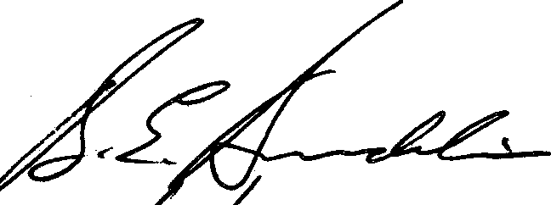
Dated _{A}nto
Brian Burdekin
Federal Human Rights Commissioner
Signed Dated
William Chapman
Assistant Secretary Management

158 Human Rights and Equal Opportunity Commission

HUMAN RIGHTS AND EQUAL OPPORTUNITY COMMISSION
Annual Report 1989-90 159
AGGREGATE STATEMENT OF TRANSACTIONS BY FUND
FOR THE YEAR ENDED 30 JUNE 1990
This Statement shows aggregate cash transactions, for which the Commission is responsible, for each of the three funds comprising the Commonwealth Public Account (CPA).
1988-89 1989-90 1989-90
ACTUAL BUDGET ACTUAL
$ $ $

 | CONSOLIDATED REVENUE FUND (CRF)  Nil RECEIPTS  Expenditure from Special Nil Appropriations | 27,058
 |  | Nil Nil

 | Expenditure from Annual
5,614,215 | Appropriations | 9,330,000 | 9,198,912
5,614,215 | EXPENDITURE | 9,330,000 | 9,198,912
 | LOAN FUND
Nil | Receipts | Nil | Nil
Nil | Expenditure | Nil | Nil
 | TRUST FUND
Nil | Receipts | Nil | Nil
Nil | Expenditure | Nil | Nil

HUMAN RIGHTS AND EQUAL OPPORTUNITY COMMISSION
160 Human Rights and Equal Opportunity Commission
DETAILED STATEMENT OF TRANSACTIONS BY FUND
FOR THE YEAR ENDED 30 JUNE 1990
CONSOLIDATED REVENUE FUND (CRF) RECEIPTS TO CRF
The CRF is the main working fund of the Commonwealth and consists of all current moneys received by the Commonwealth (excluding loan raisings and moneys received by the Trust Fund). The Authority is responsible for the following receipt items.
1988-89 SUB- 1989-90 1989-90
ACTUAL PROGRAM* BUDGET ACTUAL
$ $ $

Nil RECEIPTS |  | 2.1 Nil 27,058

Nil TOTAL RECEIPTS CRF Nil 27,058
EXPENDITURE FROM CRF
The Constitution requires that an appropriation of moneys by Parliament is required before any expenditure can be made from the CRF. Appropriations follow two forms:
special (or standing) appropriations; and annual appropriations
The Commission is responsible for the following expenditure items.
Refer to Program Statement (This information has not been subject to audit).
EXPENDITURE FROM CRF (CONT)
Annual Report 1989-90 161

1988-89 EXPENDITURE | SUB- PROGRAM* |  | 1989-90 1989-90  APPROPRIATION ACTUAL
 | ANNUAL APPROPRIATIONS
 | (Appropriation Act No 1 | 2.1 | 7,678,000)
4,530,645 | (Appropriation Act No 3 | 2.1 | 63,000) | 7,692,863
1,083,570 | Appropriation Act No 2 | 2.1 | 1,567,000 | 1,506,049
 | Appropriation Act No 4 |  | 22,000
 | TOTAL EXPENDITURE FROM
5,614,215 | ANNUAL APPROPRIATIONS |  | 9,330,000 | 9,198,912
5,614,215 | TOTAL EXPENDITURE FROM CRF |  |  | 9,198,912

Refer to Program Statement (This information has not been subject to audit).
DETAILS OF EXPENDITURE FROM ANNUAL APPROPRIATIONS

1988-89 SUB- 1989-90 1989-90
EXPENDITURE PROGRAM* APPROPRIATION EXPENDITURE
$ $ $
APPROPRIATION ACTS NOS 1 AND 3

Division 177.1 Running Costs
7,741,000
3,003,000 2,990,858
4,738,000 4,702,005
7,741,000 7,692,863
Salaries and Payment
2,125,301
2,405,344
4,530,645
in the Nature of
Salary 2.1
Administrative Expenses 2.1

162 Human Rights and Equal Opportunity Commission
APPROPRIATION ACTS NOS 2 AND 4  Division 818.1  Acquisitions, Buildings, Works, Plant and  Equipment  34,950 03 Plant and Equipment 2.1  Division 819  Payment to or  for the States and the Northern Territory | Nil Nil

1,048,620  1,083,570 | 03 Payment under  co-operative arrangements  with the States 2.1 | 1,589,000 1,506,049  1,589,000 1,506,049

Refer to Program Statement (This information has not been subject to audit).

HUMAN RIGHTS AND EQUAL OPPORTUNITY COMMISSION
Annual Report 1989-90 163
PROGRAM SUMMARY
FOR THE YEAR ENDED 30 JUNE 1990
This statement shows the outlays for each program administered by the Office and reconciles the Office's total outlays to total expenditure from appropriations. "Expenditure" refers to the actual amount of resources consumed by a program whereas "outlays" refers to the "net" amount of resources consumed, after offsetting associated receipts and other items.
The Statement also reconciles the total receipts classified as revenue (ie receipts not offset within outlays or classified as financing transactions) for each program, with "Receipts to CRF".
This Statement (and related notes) has not been subject to audit.

1988-89 Actual  $'000 |  | 1989-90 Budget $'000 | 1989-90 Actual  $'000
 | EXPENDITURE
 | Outlays
743 | - Human Rights | 855 | 600
759 | - Race Discrimination | 939 | 646
913 | - Sex Discrimination | 1,042 | 731
669 | - Privacy | 1,456 | 1,337
1,409 | - Corporate Services | 3,449 | 4,379
1,049 | - Co-operative Arrangements | 1,589 | 1,506
5,542 | TOTAL OUTLAYS | 9,330 | 9,199
 | Plus receipts offset within outlays
37 | - Human Rights | Nil | Nil
35 | - Race Discrimination | Nil | Nil
72 |  | Nil | Nil
 | TOTAL EXPENDITURE FROM
5,614 | APPROPRIATIONS | 9,330 | 9,198

HUMAN RIGHTS AND EQUAL OPPORTUNITY COMMISSION
164 Human Rights and Equal Opportunity Commission
PROGRAM STATEMENT
FOR THE YEAR ENDED 30 JUNE 1990
This Statement shows details of expenditure from annual appropriations for each program administered by the Office. Partial allocations of appropriation items to sub-programs are indicated by ('p') following the item.
This Statement has not been subject to audit.

1988-89 Actual $'000 | Notes | 1989-90 Budget $'000 | 1989-90 Actual  $'000
 | - HUMAN RIGHTS
 | Running Costs (177.1) (p)
373 | Salaries and Related Exp | 475 | 281
407 | Administrative Expenses | 380 | 319
 | Capital Costs (818.1) (p)
Nil | Plant & Equipment and Minor Works | Nil | Nil
780 | Expenditure from Appropriations | 855 | 600
37 | Less Receipts Offset Within Outlays |  | -
743 | Outlays | 855 | 600
 | - RACE DISCRIMINATION
 | Running Costs (177.1) (p)
333 | Salaries and Related Exp | 559 | 395
461 | Administrative Expenses | 380 | 251
 | Capital Costs (810.1) (p)
Nil | Plant & Equipment and Minor Works | Nil | Nil
794 | Expenditure from Appropriations | 939 | 646
35 | Less Receipts Offset Within Outlays
759 | Outlays | 939 | 646

==_
PROGRAM STATEMENT (CONT)
Annual Report 1989-90 165
1988-89 1989-90 1989-90
Actual Notes Budget Actual
$'000 $'000 $¹000
- SEX DISCRIMINATION
Running Costs (177.1) (p)
525 Salaries and Related Exp 662 410
388 Administrative Expenses 380 321
Capital Costs (818.1) (p)
Nil Plant & Equipment and Minor Works Nil Nil
913 Expenditure from Appropriations 1,042 731
===
913 Outlays 1,042 731
- PRIVACY*
Running costs (177.1) (p)
243 Salaries and Related Exp 651 544
426 Administrative Expenses 805 793
Capital Costs (818.1) (p)
Plant & Equipment and Minor Works Nil Nil
669 Expenditure from Appropriations 1,456 1,337

669 Outlays | 1,456 1,337

The Privacy Act was established on 1 January 1989.
166 Human Rights and Equal Opportunity Commission
1988-89 Actual  $'000 |  | 1989-90 Budget $'000 | 1989-90 Actual  $'000
 | - CORPORATE SERVICES
 | Running Costs (177.1) (p)
551 | Salaries and Related Expenses | 893 | 1,371
823 | Administrative Expenses | 2,556 | 3,004
 | Capital Costs (818.1) (p)
35 | Plant and Equipment and Minor Works | Nil | Nil
1,409 | Expenditure from Appropriations | 3,449 | 4,378
1,409 | Outlays | 3,449 | 4,378
 | - CO-OPERATIVE ARRANGEMENTS
1,049 | Payments to the States (819.0) | 1,589 | 1,506
1,049 | Expenditure from Appropriations | 1,589 | 1,506
1,049 | Outlays | 1,589 | 1,506

HUMAN RIGHTS AND EQUAL OPPORTUNITY COMMISSION
Annual Report 1989-90 167
STATEMENT OF SUPPLEMENTARY FINANCIAL INFORMATION
AS AT 30 JUNE 1990
This Statement has not been subject to audit.

1988-89  $'000 | Notes | 1989-90  $'000

 | NON-CURRENT ASSETS
72 | Computer & Office Equipment |  | 233
290 | Plant & Equipment | 2 | 290
301 | Furniture and Fittings |  | 411
 | CURRENT LIABILITIES
52 | Creditors | 3 | 91

HUMAN RIGHTS AND EQUAL OPPORTUNITY COMMISSION
NOTES TO THE FINANCIAL STATEMENTS
FOR THE YEAR ENDED 30 JUNE 1990
NOTE 1
STATEMENT OF SIGNIFICANT ACCOUNTING POLICIES
- The financial statements have been prepared in accordance with the 'Financial Statements Guidelines for Departmental Secretaries' issued by the Minister for Finance.
- (i) The financial statements have been prepared on a cash basis with the exception of the Statement of Supplementary Financial Information which includes certain accrual-type information.
(ii) The financial statements have been prepared in accordance with the historical cost convention and do not take account of changing money values or, except where stated, current values of non-current assets.
- Amounts shown in the Aggregate Statement of Transactions By Fund and the Detailed Statement of Transactions by Fund have been rounded to the nearest $1; other amounts have been rounded to the nearest $1000.
- Non-current assets are valued at cost of acquisition. Minor assets having a unit cost less than $2000 have not been accounted for in the Statement of Supplementary Information.
- Inventories held as consumable stores are brought to account in the Statement of Supplementary Financial Information if the individual item value exceeds $1000.
- Salaries, wages and related benefits payable to officers and employees of the Department have not been accounted for in the balance of creditors in the Statement of Supplementary Financial Information.

168 Human Rights and Equal Opportunity Commission

NOTE 2
Annual Report 1989-90 169
FORWARD OBLIGATIONS
The Commission has entered into the following forward obligations as at 30 June which are payable as follows:
Not later than
Item one year Total
Plant and Equipment Nil Nil
NOTE 3
CREDITORS
Trade Creditors
Of the total amount $90,962 as at 30 June 1990 the following amounts were overdue for -
1988/89 1989/90
$¹000 $'000
52 Less than 30 days 91
Nil 30-60 days Nil
Nil More than 60 days Nil
NOTE 4
ACT OF GRACE PAYMENTS
No payments were made during the financial year 1989/90 pursuant to authorisation given under section 34A of the Audit Act 1901.
NOTE 5
WAIVER OF RIGHTS TO PAYMENT OF MONEYS
No payments were waived during the financial year 1989/90 under subsection 70C(2) of the Audit Act 1901.
NOTE 6
AMOUNTS WRITTEN OFF
No amounts were written off during the financial year 1989/90 under subsection 70C(1) of the Audit Act 1901.
NOTE 7
170 Human Rights and Equal Opportunity Commission
LOSSES AND DEFICIENCIES, ETC, IN PUBLIC MONEYS AND OTHER PROPERTY
There were no losses or deficiencies recorded during the financial year 1989/90 under Part XII of the Audit Act 1901.
NOTE 8
RESOURCES RECEIVED FREE OF CHARGE
During the 1989/90 financial year, a number of Commonwealth Departments and agencies provided services to the Office without charge. Expenditures for the services were met from those Departments' appropriations. The major services received include the following:
Attorney-General's Department:
The arrangement and processing of payment of salaries and related expenses to the Commission staff including the final processing of claims for general administrative expenses.
Australian National Audit Office (ANA0):
. Auditing services as required by the Audit Act 1901 were provided
to this office by the ANAO without charge. The ANAO has estimated the cost of these services to be $37,500.
Department of Finance:
The provision of training services not able to be provided within the Office.
The provision of accounting and budgetary services in the form of the computerised finance ledger and payroll services.
NOTE 9
NON-CURRENT ASSETS
During the period 1 July 1989 to 30 June 1990 the Human Rights and Equal Opportunity Commission expended $75,477 on capital improvements.
APPENDIX: GLOSSARY OF TERMS
Annual Report 1989-90 171
Act of Grace Payments: Section 34A of the Audit Act 1901 provides that, in special circumstances, the Commonwealth may pay an amount to a person notwithstanding that the Commonwealth is not under any legal liability to do so.
Administrative Expenses: Includes not just expenditure on office based activities but all operational expenditure (excluding salaries). The item includes both direct costs and overhead expenditure: it includes, inter alia, minor capital expenditure which is considered part of ordinary annual services; it does not include, inter alia, major capital expenditure, grants, loans or subsidies.
Annual Appropriations: Acts which appropriate moneys for expenditure in relation to the Government's activities during the financial year. Such appropriations lapse on 30 June.
Appropriation: Authorisation by Parliament to expend public moneys from the Consolidated Revenue Fund or Loan Fund for a particular purpose, or the amounts so authorised. All expenditure (ie outflows of moneys)
from the Commonwealth Public Account must be appropriated ie authorised by the Parliament. The authority for expenditure from individual trust accounts is provided under the Audit Act 1901 or an Act establishing the trust account and specifying its purposes. See also 'Annual
Appropriations' and 'Special Appropriations'.
Appropriation Act (No 1): An act to appropriate moneys from the Consolidated Revenue Fund for the ordinary annual services of Government.
Appropriation Act (No 2): An Act to appropriate moneys from the Consolidated Revenue Fund for other than ordinary annual services. Under existing arrangements between the two Houses of Parliament this
Act includes appropriations in respect of new policies (apart from those funded under Special Appropriations), capital works and services, plant and equipment and payments to the States and the Northern Territory.
Appropriation Act (Nos 3 and 4): Where an mount provided in an Appropriation Act (No 1 or 2) is insufficient to meet approved obligations falling due in a financial year, additional appropriation may be provided in a further Appropriation Act (No 3 or No 4). Appropriations may also be provided in these Acts for new expenditure proposals.
Audit Act 1901: The principal legislation governing the collection, payment and reporting of public moneys, the audit of the Public Accounts and the protection and recovery of public property. Finance Regulations and Directions are made pursuant to the Act.
Commonwealth Public Account (CPA): The main bank account of the Commonwealth, maintained at the Reserve Bank in which are held the moneys of the Consolidated Revenue Fund, Loan Fund and Trust Fund (other than the National Debt Sinking Fund).

Consolidated Revenue Fund (CRF); Loan Fund: Trust Fund: The three Funds comprise the Commonwealth Public Account (CPA):
CRF - The principal working fund of the Commonwealth mainly financed
by taxation, fees and other current receipts. The Constitution requires an appropriation of moneys by the Parliament before any expenditure can be made from the CRF. These follow two forms:
- annual appropriations consisting of Supply Acts (nos 1 and 2), the Supply (Parliamentary Departments) Act, the Appropriation Acts (Nos 1-4) and the Appropriation (Parliamentary Departments) Acts (Nos 1 and 2) (the Supply Acts relate to the first five months of the financial year and are subsumed by the corresponding Appropriation Acts); and
- Special or standing appropriations.
Loan Fund - Authority for its establishment comes from the Audit Act. All moneys raised by loan on the public credit of the Commonwealth are credited to the Loan Fund. Expenditures from the Loan Fund require an appropriation by Parliament and are limited to the purpose(s) for which moneys were originally raised as specified.
Trust Fund - Essentially comprises trustee funds (termed 'Heads of Trust') established under s.60 of the Audit Act (ie moneys held in trust for the benefit of persons or bodies other than the Commonwealth); trust accounts established under s.62A of the Audit Act (ie working accounts covering certain government agencies and certain other accounts in the nature of 'suspense accounts'); and trust accounts established under other Acts to meet future expenditure.
Payments into the Trust Fund may be by way of appropriation from the CRF or Loan Fund or direct credit of private moneys. Expenditure from the Trust Fund is appropriated for (and limited to) the specific purposes of each trust account, or head of trust, by the Audit Act or the Act establishing the trust account or head of trust. Unlike the used portion of annual appropriations, trust account balances - as with 'special' or 'standing' appropriations - do not lapse at the end of the financial year.
Legal advice is to the effect that investments, and the liquidation of those investments, involve 'expenditure' and 'receipts' for the purposes of subsection 50(2) of the Audit Act and that the balances of the Trust Fund should be reduced by the amount of investments outstanding at 30 June. In the interests of informative reporting, the financial statements have been designed so as to include explicit investment information. In particular, information concerning expenditure and receipts has been split as between investment and non-investment activities so as to provide 'notional' balances taking into account the value of the investments, and a 'cash' balance after account is taken of investment transactions.
Expenditure: The total or gross amount of money spent by the Government on any or all of its activities (ie the total outflow of moneys from the Commonwealth Public Account) (cf 'Outlays'). All expenditure must be appropriated ie authorised by the Parliament, (see also 'Appropriations'). Every expenditure item is classified to one of the
172 Human Rights and Equal Opportunity Commission
economic concepts of outlays, revenue (ie offset within revenue) or financial transactions.
Annual Report 1989-90 173
Financing Transactions: Relate to the raising and repayment of loan principal or transactions involving financial assets or liabilities (eg changes in investments or holding of cash). They represent the difference between outlays and revenue and hence involve the investment of Budget surpluses of the financing of Budget deficits. As such they are referred to as 'below the line' transactions. See also 'Appropriations classified as financing transactions'.
Forward Obligations: Obligations existing at 30 June which create or are intended to create a legal liability on the Commonwealth to provide funds in future years and which have not been exempted from the forward obligation system. In special circumstances, arrangements which do not create a legal liability, but which require forward obligations cover for effective program management, may also be included in the forward obligations system, eg memoranda of understanding with other Governments and foreign aid arrangements. The following items are exempted from the forward obligations systems:
all items classified in Appropriation Acts as Running Costs (ie salaries, administrative and operating expenses);
those items for which payment is authorised by special legislation where the amount and timing of payments are specified or clearly
dictated by eligibility criteria (ie most, but not all, Special Appropriations); and
those items which have been exempted by the Minister for Finance as a result of specific case-by-case requests from departments.
Loan Fund: See 'Consolidated Revenue Fund'
Outlays: An economic concept which shows the net extent to which resources are directed through the Budget to other sectors of the economy after offsetting recoveries and repayments against relevant expenditure items ie outlays consist of expenditure net of associated receipt items. Outlays are 'above the line' transactions. The difference between outlays and revenue determines the Budget balance (ie surplus or deficit). See also 'Appropriations'; 'Appropriations classified as revenue'; 'Appropriations classified as financing transactions'; and 'Receipts offset within outlays'.
Receipts: The total or gross amount of moneys received by the Commonwealth (ie the Commonwealth Public Account). Every receipt item is classified to one of the economic concepts of revenue, outlays (ie offset within outlays) or financing transactions.
Receipts not offset within outlays: Receipts classified as 'revenue'. See also 'Revenue'.
Receipts offset within outlays: Refers to receipts which are netted against certain expenditure items because they are considered to be closely or functionally related to those items.
Revenue: Items classified as revenue are receipts which have not been offset within outlays or classified as financial transactions. The term 'revenue' is an economic concept which comprises the net amounts received from taxation interest, regulatory functions, investment holdings and government business undertakings. It excludes amounts received from the sale of government services or assets (these are offset within outlays) and amounts received from loan raised (these are classified as financing transactions). Some expenditure is offset within revenue eg refunds of PAYE instalments and the operating expenditure of budget sector business undertakings. See also 'Receipts'.
174 Human Rights and Equal Opportunity Commission
Special (Standing) Appropriation: Moneys appropriated by a specific Act of Parliament for a specific purpose ie unemployment benefits, grants to States for schools). They may or may not be for a specific amount of money or particular period of time. Special Appropriations do not require annual spending authorisation by the parliament as they do not lapse at the end of each financial year. A distinction is sometimes made between Standing and Special Appropriations. Standing Appropriations refer to an open-ended appropriation of the Consolidated Revenue Fund by the enabling Act of a legislatively-based program: the amount appropriated will depend on the demand for payments by claimants satisfying program eligibility criteria specified in the legislation. Special Appropriations can be regarded as somewhere between Standing and Annual Appropriations: while a specified amount is provided, it is included in a separate Bill authorising the particular program and can be specified for any number of years.
Trust Fund: See 'Consolidated Revenue Fund'.
Appendix 4
Annual Report 1989-90 175
Summary of
Reporting
Requirements
Page
Access and Equity. 141
Commission Goals 1, 23, 53, 73, 97
Consultants 112 and Appendix 2
EEO Reporting 137
Financial Statements 120 and Appendix 3
Freedom of Information 114
Functions and Objectives 1, 16
Industrial Democracy 133
Legislation 15, 115
Occupational Health and Safety 136
Post Separation Employment 117
Program Activities 1, 14, 23-146
Publications Appendix 1
Purchasing Reform 126
Responsible Minister 19
Staffing Information 17, 116
Structure 16, 17

