**REQUEST TO JOIN EXEMPTION APPLICATION LODGED BY THE DEPARTMENT OF   
FAMILIES, HOUSING, COMMUNITY SERVICES AND INDIGENOUS AFFAIRS (FaHCSIA)   
UNDER S56 OF *THE DISABILITY DISCRIMINATION ACT* (1992) (CTH)**

I/We seek to join/support the exemption application submitted by FaHCS1A as follows:

* 1/We seek an exemption for all existing ADEs from sections 15 and 24 of the DDA, and the Commonwealth (and officers of the Commonwealth) from section 29 for a period of three years.
* This exemption would apply to use of the BSWAT to:

1. assess wages for employees; and
2. pay wages to ADE employees based on assessments conducted under the BSWAT.

* The proposed exemption would apply while alternative wage setting arrangements are being considered, devised and/or established and implemented by FaHCSIA.

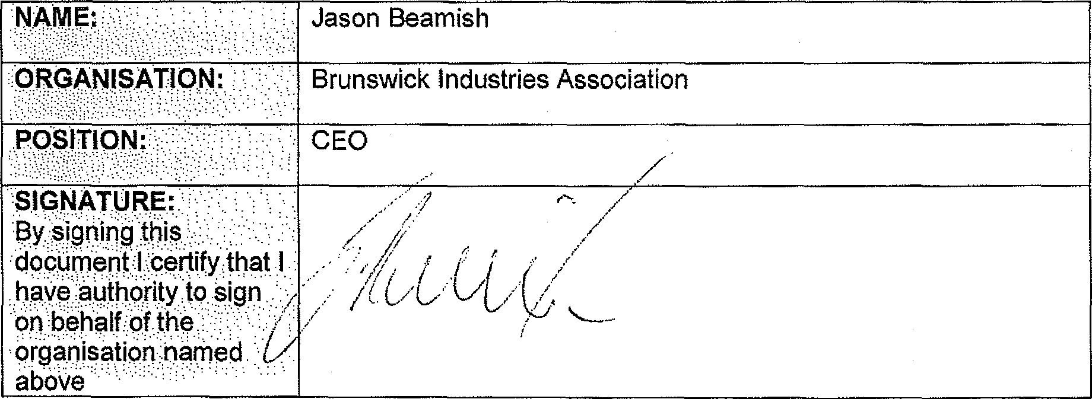

Jason Beamish

**.ORGANISATION:**

Brunswick Industries Association

CEO

**SIGNATURE:** By signing this

.clocOment,:l..;Certify.thot 1

have authority to 0199

Or.) behalf of the

organisation name

above

* ***( I If I I***

***/ C/ L,***

**COMMENTS**

We fully support the application for exemption to continue to use BSWAT whilst a new assessment tool is developed