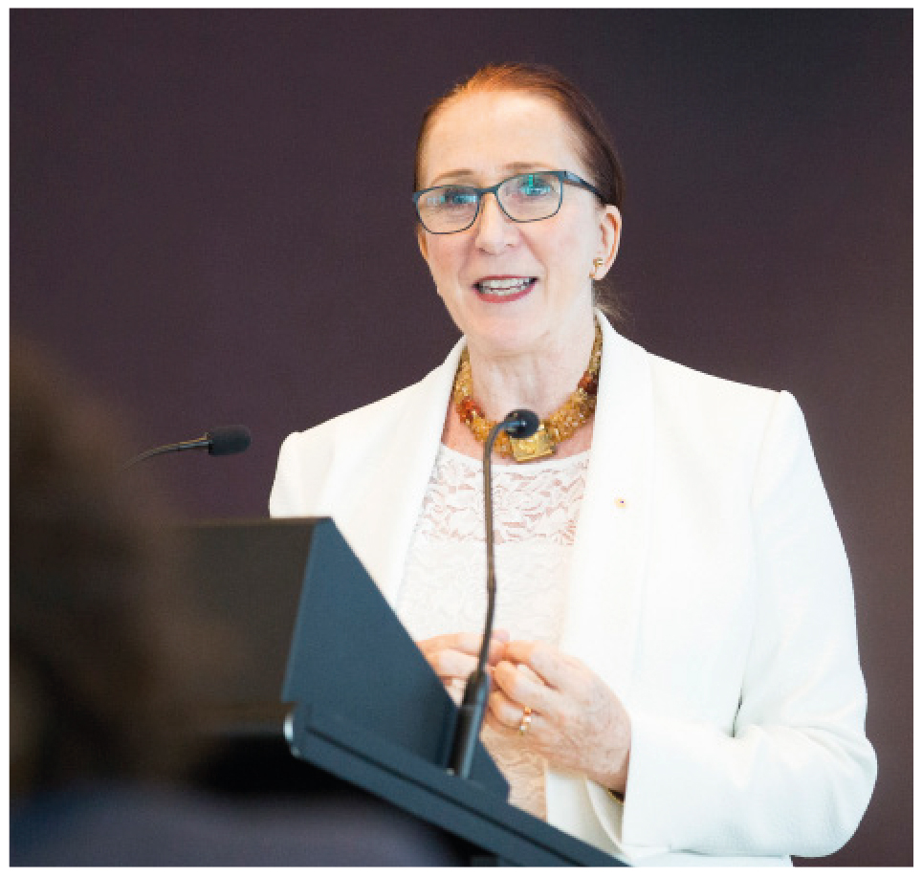 | Emeritus Professor  Rosalind Croucher AM  President  SECOND YEAR OF TERM | ‘Good relationships and open doors are absolutely crucial for us to be able to play the role of trusted adviser to its fullest—to be the devil’s advocate and at times to be the ‘devil’s blowtorch’, you need to have a respected seat at the table.’

TERM GOALS
Effectively lead and manage the internal and external governance of the Commission | Advance the Commission’s relationship with key stakeholders including Commonwealth Government and Parliament | Progress the role and leadership of the Commission as an independent statutory agency and as Australia’s National Human Rights Institution | Foster and lead a positive and collegiate Commission and organisational culture | Promote a community of understanding human rights and build an Australian culture of rights-mindedness

PROGRAMS AND SERVICES
In addition to the governance, statutory functions and leadership of the President, Professor Croucher leads the following programs and services.

Investigation and Conciliation Service | - National Information service  - Investigation and Conciliation Service
Human rights education and training | - School education and adult training programs  - Development of fee for service training/education and advisory function
Human rights technical co‑operation | - Human Rights Technical Cooperation programs: China, Laos  - Vietnam Education Program
International engagement | - United Nations (UN) Program: Universal Periodic Review; UN Treaty Engagement; Human Rights Council activities  - Global Alliance of National Human Rights Institutions  - Office High Commissioner Human Rights and Special Rapporteur visits  - Asia Pacific Forum
Business and human rights program | - National Guidelines: Trans and Intersex inclusion in sport  - National Annual Dialogue on Business and Human Rights  - Human Rights Impact Assessments Toolkit  - Inter-regional and regional dialogue on business and human rights
Human rights scrutiny | - Parliamentary Joint Committee on Human Rights, legislative scrutiny, support, advice and training  - Submissions coordination and development

