Disability Access and Inclusion Plan 2014 to 2018

Department for Communities and Social Inclusion

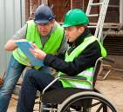
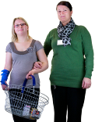
It is important that everyone in South Australia feels:
- involved

- connected
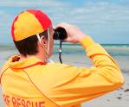
- safe
- supported.
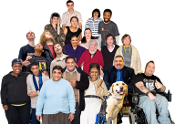
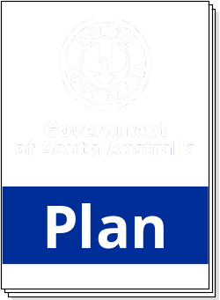There are a lot of people in South Australia with disability – about one in five people.


It is important that people with disability are included in community life.

The government has written plans to help make sure everyone is included.
They are called the Disability Access and Inclusion Plans.

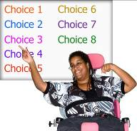
The government will follow the plans to give people
with disability:
- more choices

- more control
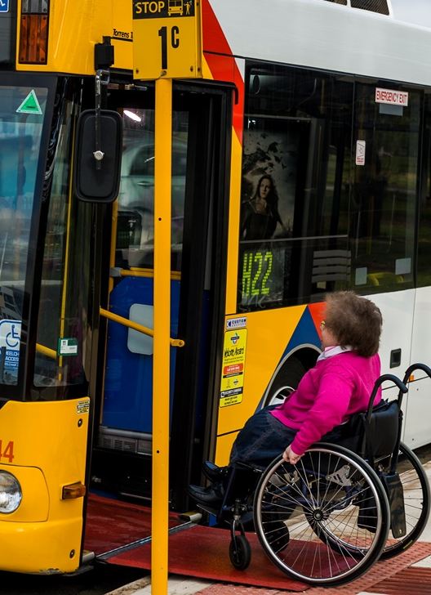
- more independence.

Our plan has six goals. We call them outcomes.
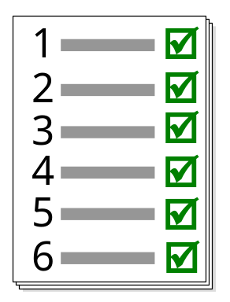
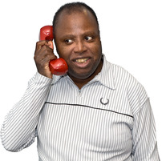
You can talk to our staff about these outcomes.
Our phone number is 8415 4250.

Outcome 1 - Inclusive and accessible communities
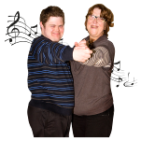



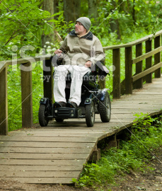
The government wants to help people with disability live in places that are easy for them to move around and enjoy.
The government wants to make it easier for people with disability to:
- join in social events
- look for jobs or volunteer
- get into sport and exercise
- join in and create art, music, dance and other cultural activities.

Outcome 2 - Economic security and employment

The government wants people with disability, their families and carers to have:
- enough money to live
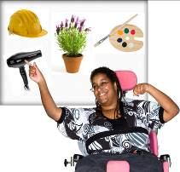
- more choices about their work
- more say about how they live.

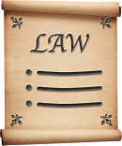
Outcome 3 - Rights protection, justice and legislation
The government will protect the rights of people with disability.

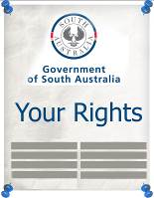
The government will let everyone know about their rights.


Outcome 4 - Personal and community support
The government wants people with disability, their families and carers to get more support to:
- live independently

- join in community activities

Outcome 5 - Learning and skills
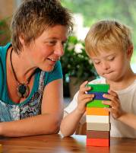
The government wants people with disability to have more support to learn and take part:
- in school


- in training

- in university

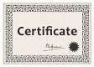
Some people want to learn certain skills. These skills may help them live independently or get a job.
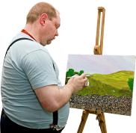

Some people might like to go to day activities.
Learning new things is not just for young people.
Adults can learn new things too.

Outcome 6 - Health and wellbeing
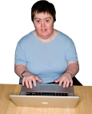

The government wants people with disability to have more support to stay healthy.

Contact us
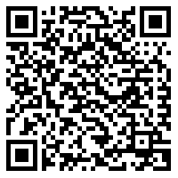
For more information, you can look at www.dcsi.sa.gov.au/daip
Scan the grid with
a QR reader.




You can phone us on 8415 4250

You can email us at dcsi.disabilitysa@dcsi.sa.gov.au
You can send us a letter to:
Disability Inclusion
NDIS Reform, Disability SA
PO Box 70
Rundle Mall
Adelaide SA 5000

