

**DISABILITY EMPLOYMENT**

**ACTION PLAN 2015–2018**

*Towards a Disability inclusive organisation*



*“Treating everyone equally does not mean treating everyone the same”*



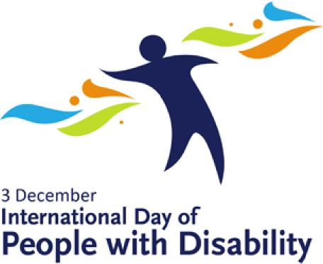



Accessibility

The ACT Government is committed to making its information, services, events and venues as accessible as possible.

If you have difficulty reading a standard printed document and would like to receive this publication in an alternative format such as large print, please phone 13 22 81 or email [HealthACT@act.gov.au](mailto:HealthACT@act.gov.au)

If English is not your first language and you require the Translating and Interpreting Service (TIS), please call 13 14 50.

If you are Deaf, or have a speech or hearing impairment and need the teletypewriter service, please phone 13 36 77 and ask for 13 22 81.

For speak and listen users, please phone 1300 555 727 and ask for 13 22 81. For more information on these services visit <http://www.relayservice.com.au>

© Australian Capital Territory, Canberra, January 2015

This work is copyright. Apart from any use as permitted under the Copyright Act 1968, no part may be reproduced by any process without written permission from the Territory Records Office, Community and Infrastructure Services, Territory and Municipal Services, ACT Government, GPO Box 158, Canberra City ACT 2601.

Enquiries about this publication should be directed to ACT Health Communications and Marketing Unit, GPO Box 825 Canberra City ACT 2601 or [email: HealthACT@act.gov.au](mailto:HealthACT@act.gov.au)

[www.health.act.gov.au](http://www.health.act.gov.au) | [www.act.gov.au](http://www.act.gov.au) Enquiries: Canberra 13ACT1 or 132281

1 Director General’s Foreword

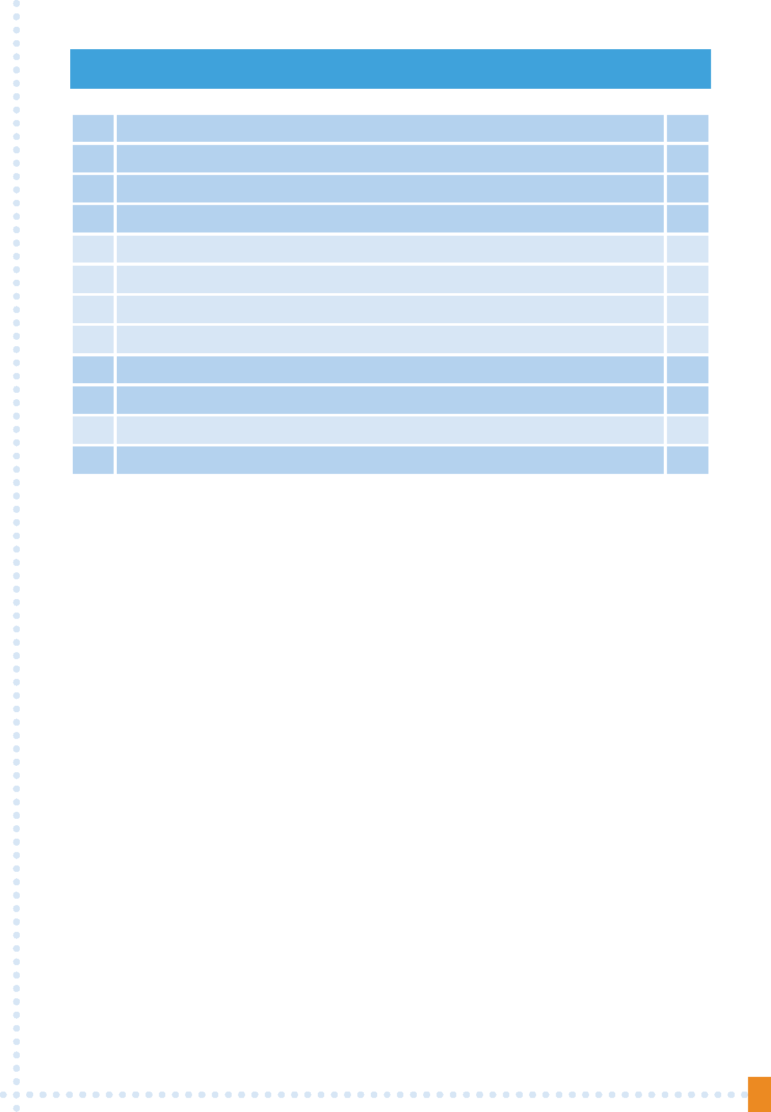

4

2

3

4

4.1

4.2

4.3

4.4

**Contents**

Staff Statements

Objective

Disability

Definition of a disability

People with a disability

Types of disability

Employment and people with disability

6.1

5

6

7

The Employment Strategy

Our vision for People with a disability

Our Disability Employment Action Plan

Objectives and Targets for ACT Health over the life of Disability Action Plan 2015–2018

14

15

16

5

12

12

12

13

13

14

**1**

**1 DIRECTOR GENERAL’S FOREWORD**

The ACT Health Disability Employment Action Plan 2015–18 outlines our responsibility to share human rights and to respect and protect the rights of others with our patients, clients, consumers and staff.

In 2008, Australia ratified the United Nations Convention for the Rights of People with Disability. As a nation we made a commitment to ensure that people with disability can equally participate in all aspects of life. At ACT Health this means a commitment to support and engage with our employees with disability and to those with a carer role.

The ACT Public Service Employment Strategy for People with Disability 2011–2015 vision is to double the 30 June 2010 headcount of persons with a disability in the ACTPS by 2015. Another part of that vision is for The ACTPS to be:

***A disability confident service, in which people with disability are able to access secure and sustainable employment opportunities and are respected for their skills and capabilities.***

ACT Health’s vision is to support the ACTPS vision. We will be a disability proficient service that is committed to providing an accessible and inclusive environment for people with disability.

ACT Health is committed to ensuring that consumers can actively participate in health care and can access ACT Health facilities and services. ACT Health is also striving to establish a disability confident workplace, and is committed to building its capability to support and engage with persons with disability in the workforce.

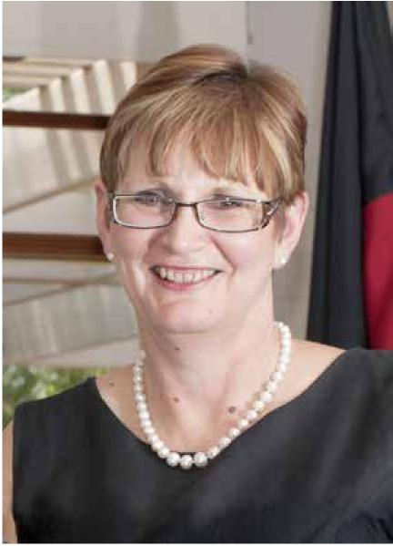

Dr Peggy Brown

MB, BS (Hons) FRANZCP Director-General, ACT Health January 2015

**2**

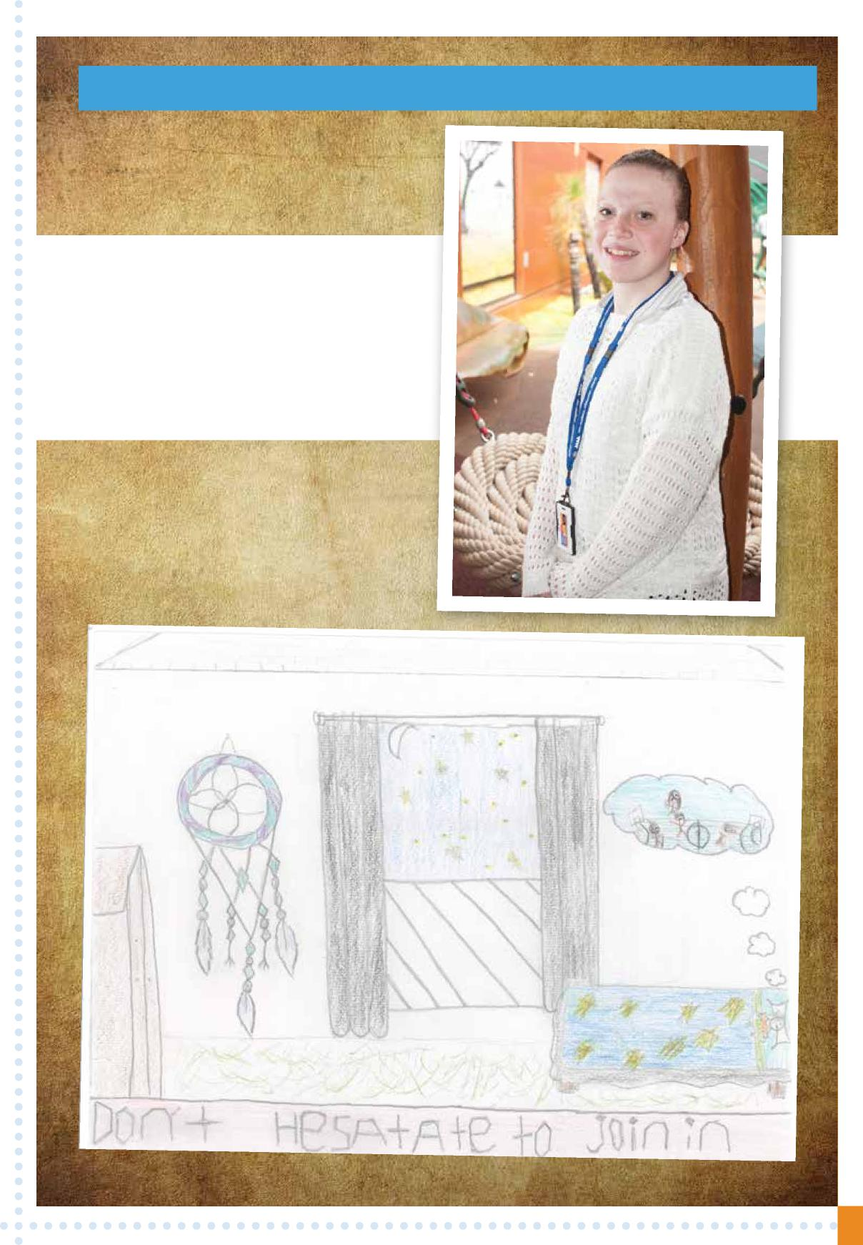

**2 STAFF STATEMENTS**

My Name is Ashlee Griffin, I am working with ACT Health   
as an Australian School Based Apprentice (ASBA).   
I am currently in College and work 1 day per week   
with ACT Health in People Strategy and Services.   
I am working towards my Year 12 certificate and a   
Certificate in Business Administration.   
I created my artwork picture below to show what inclusion   
means to me, the picture is about being left out, it shows a   
child that is dreaming of being involved and included   
with others. People with disability can join in.

**3**

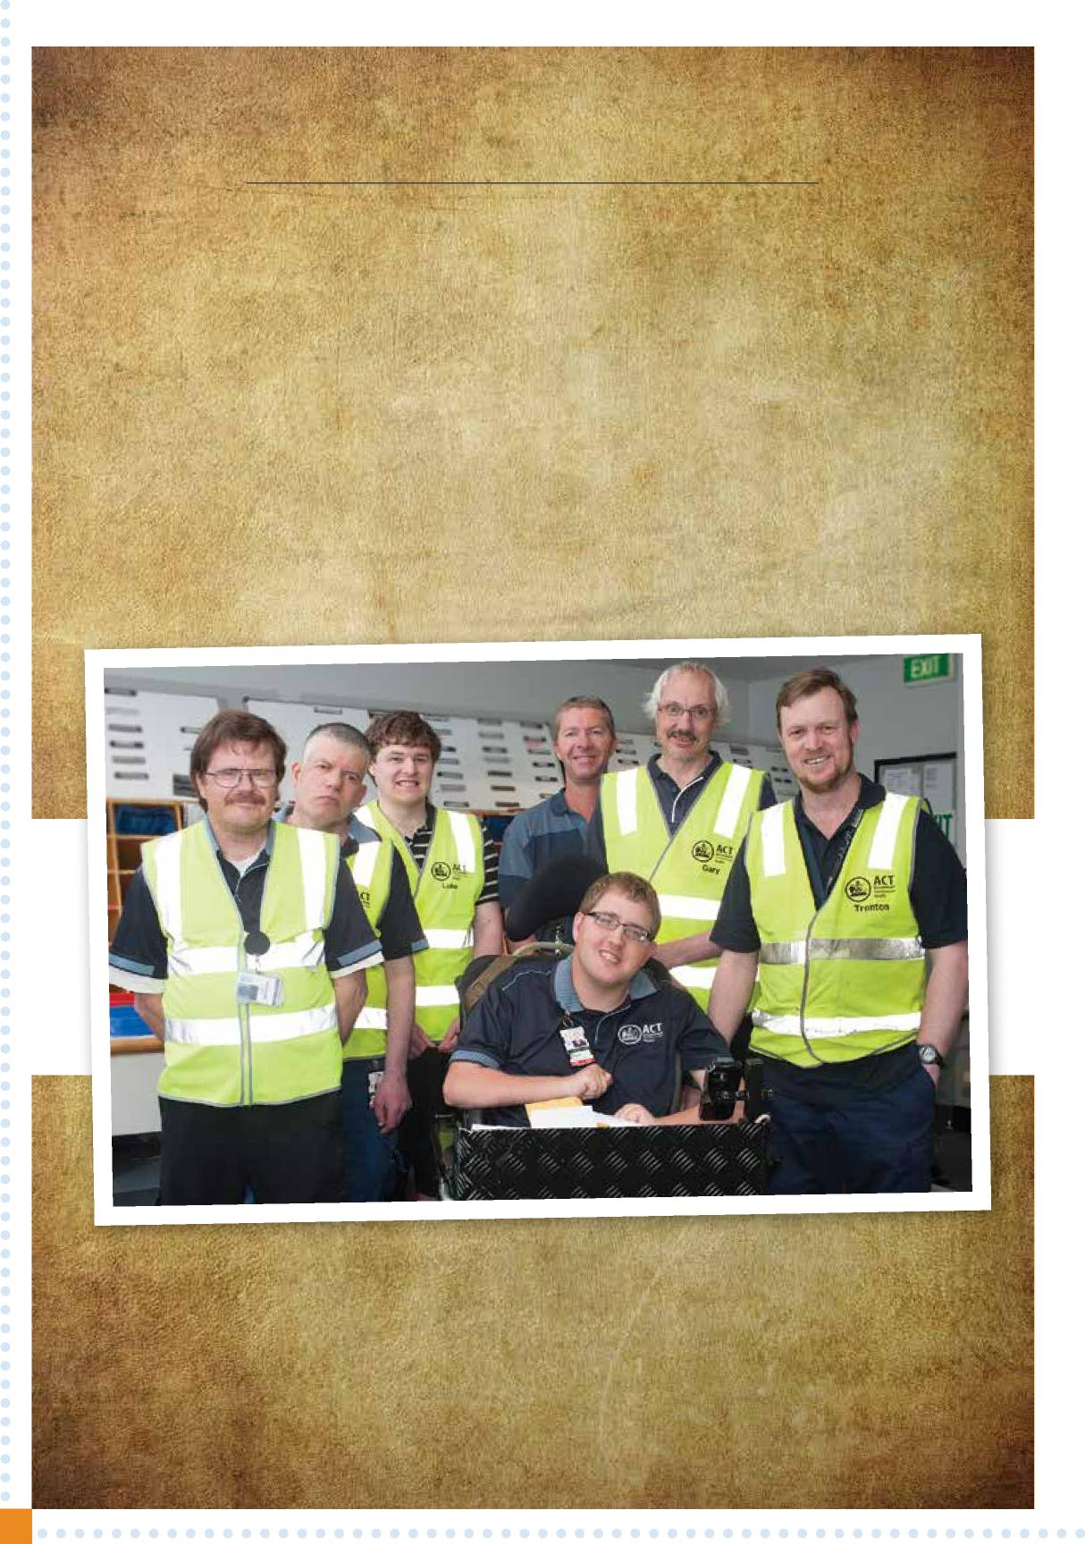

**Mailroom Overview**

The Mailroom provides the receipt and delivery of internal and external mail to the Canberra hospital campus. The Mailroom team comprises a mix of non disability staff and staff with varying disabilities. Recently, the team participated in a competency based assessment which moved their classification from ASO1 to the Broad-banded ASO1/2. Successful completion of the competencies allows the Mailroom staff to be recognised at the ASO2 level and enhances further career opportunities. The journey of the mailroom team through the Broad-banding process, irrespective of disabilities has been invaluable. The team enhance the morale of all individuals that they come into contact with across the campus with a positive attitude and realisation that there is no challenge too great.

**Group Photo:**

**Left to Right: Ian Sneddon, Joe Fallace, Luke Arsego, Ben Pattrick (front), Garth Jensen (Supervisor), Gary Taggart, Trenton Lee.**

**4**

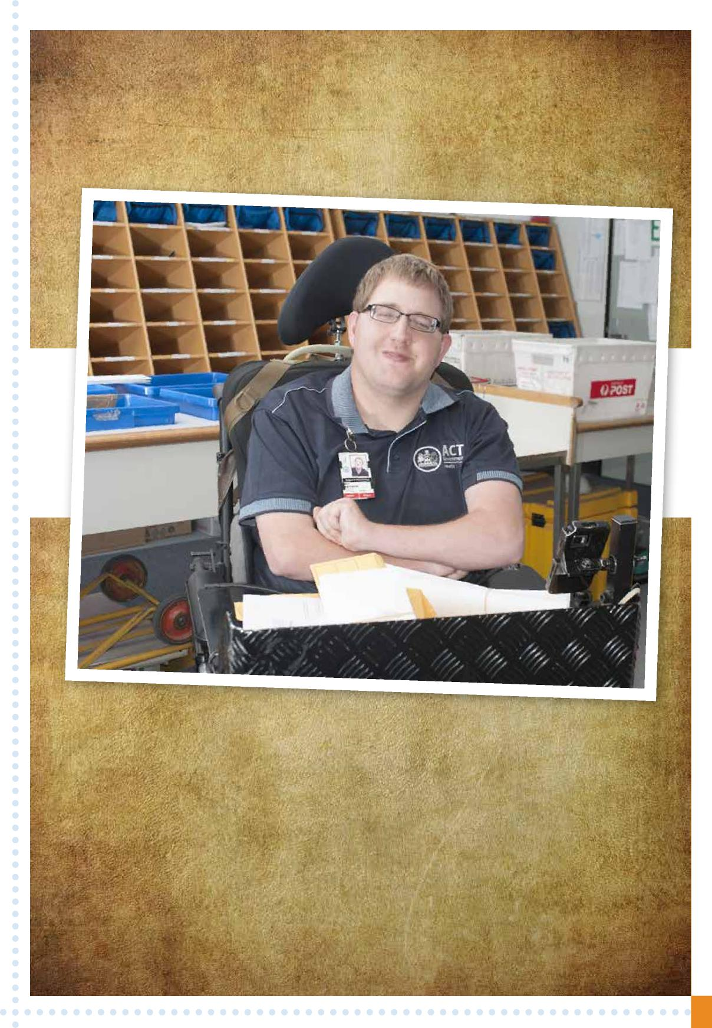

Ben Pattrick:   
Ben says that he likes working for Health and the Mailroom because he has good   
friends that he works with and it’s fun and keeps them busy doing an important job.   
Ben likes working with everyone in the Mailroom, and advises that they   
are the best people and they all do their job well.

**5**

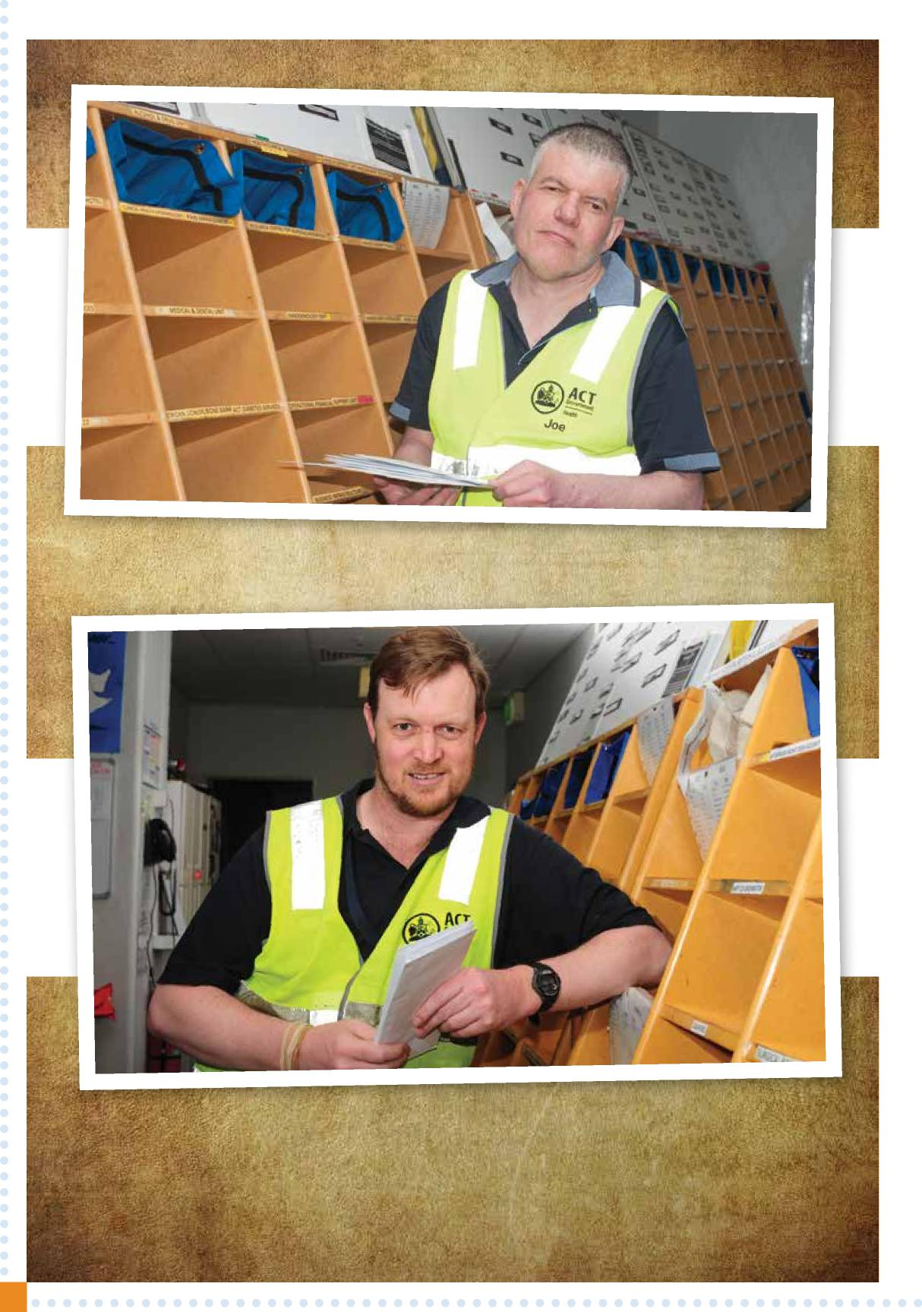

Joe Fallace:

I like working in the Mailroom because we are a good team and we care about each other.

Trenton Lee:   
I like the people I work with.   
I like the fact we can have a joke with each other.   
I like the relationships I have built up over the years.   
I like the mates I have gained at the hospital, both male and female.   
I like that everyone is tolerant of people’s abilities and disabilities.   
I like the fact that I can talk to anyone at anytime.   
I enjoy working with Ben Pattrick.

**6**

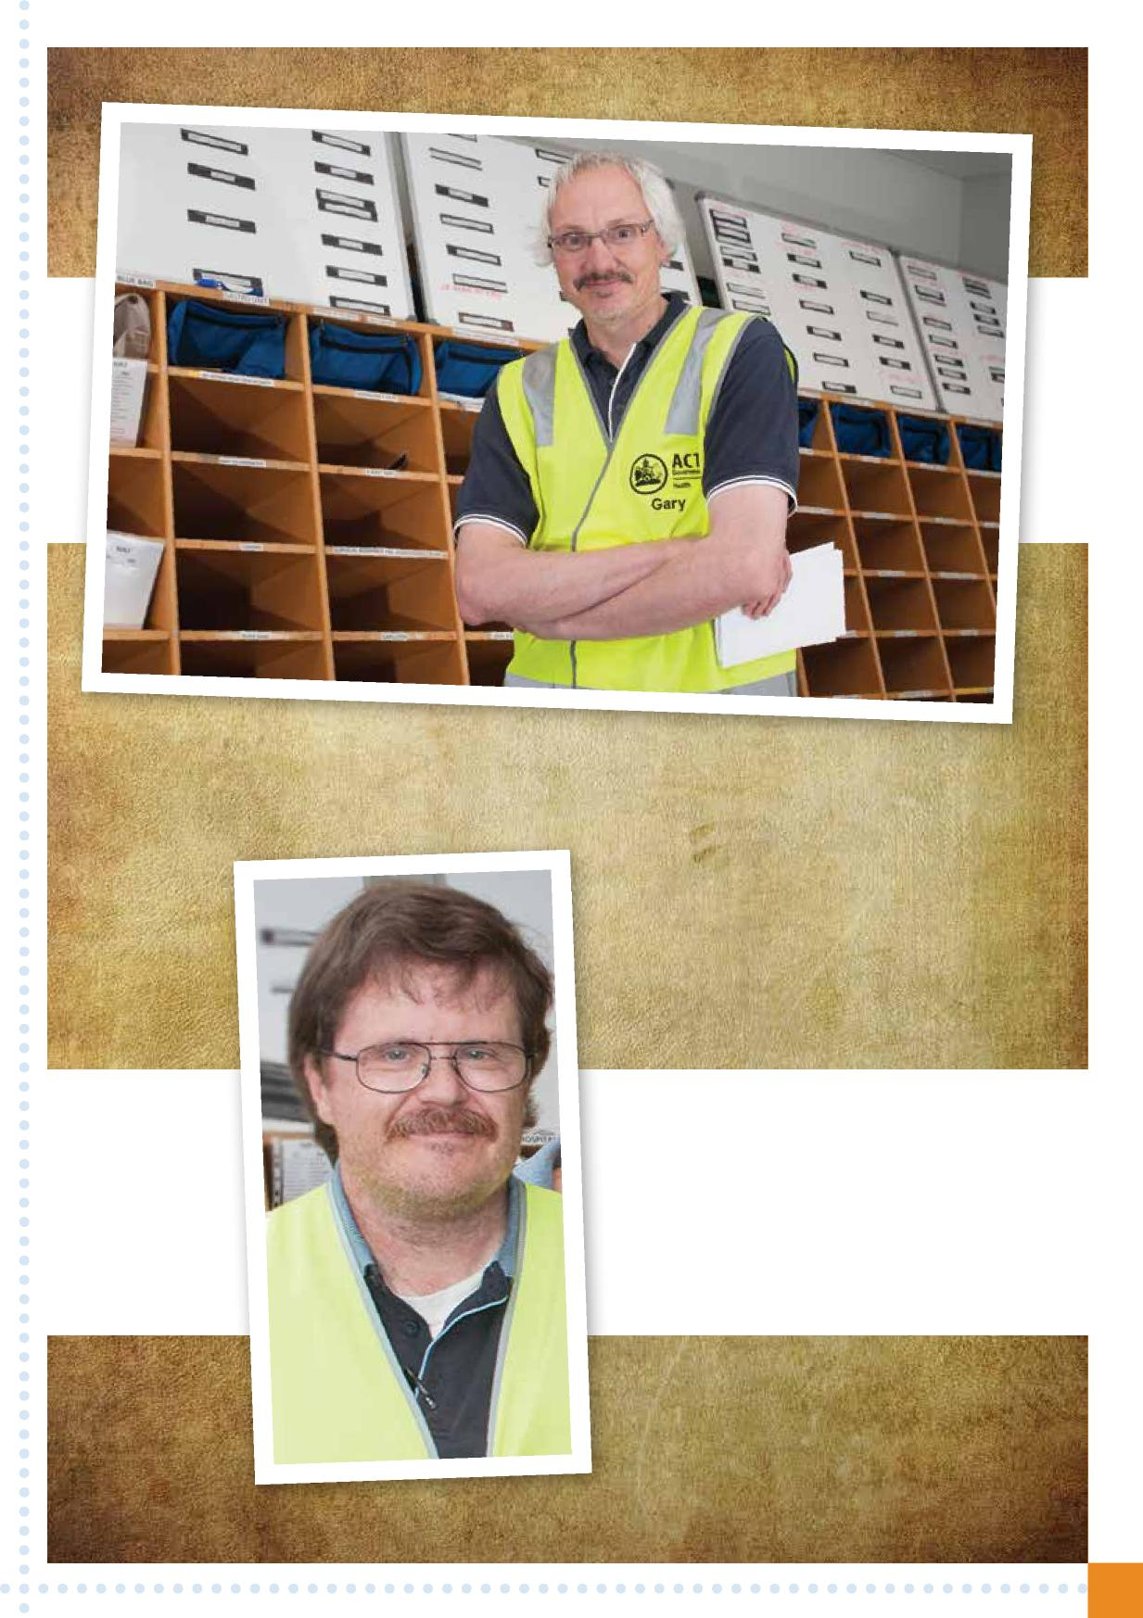

Gary Taggart:

Gary advises that he likes working in the Mailroom and for ACT Health because they are a great bunch of people and they help make the Hospital run smoothly.

Ian Sneddon:   
Ian Sneddon says that what he likes best   
about working in the Mailroom is that they   
can have a joke but do the best job they can.

**7**

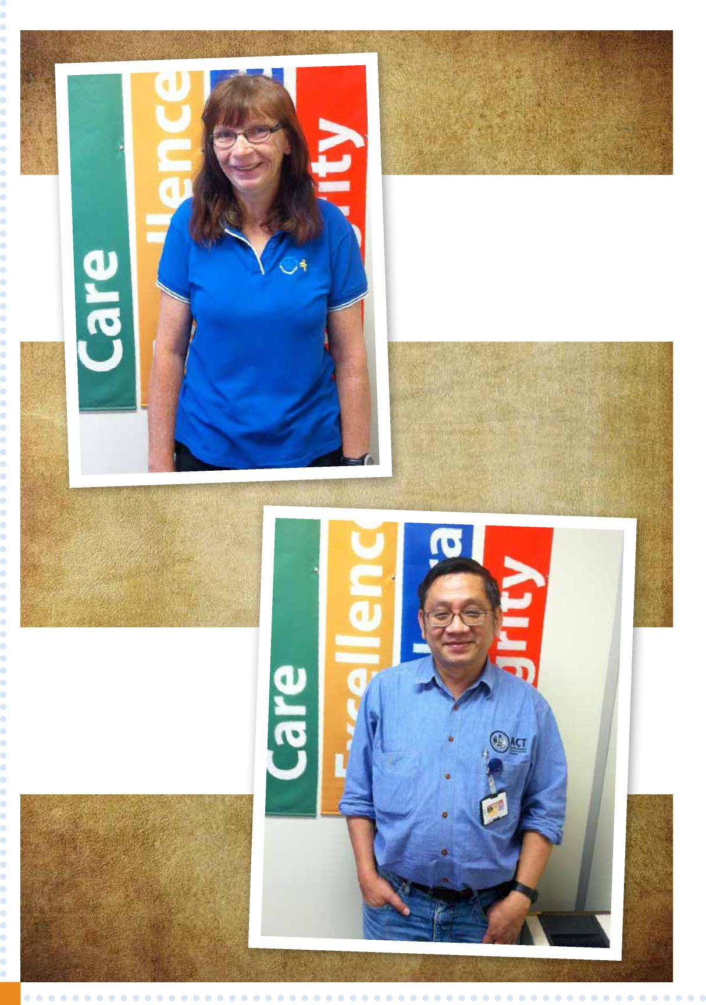

Renia Ferguson:   
Renia Ferguson says that working in   
ACT Health is not about the money, but   
about the passion and the reward to work   
with people with disabilities and encourage   
them to feel a personal achievement within   
themselves in the ACT Health work force.

Tan Hua:   
Tan says the Canberra Hospital’s   
Mailroom has been active to accept   
and support disabled staff.   
As a team member, I am proud   
to work with them.

**8**

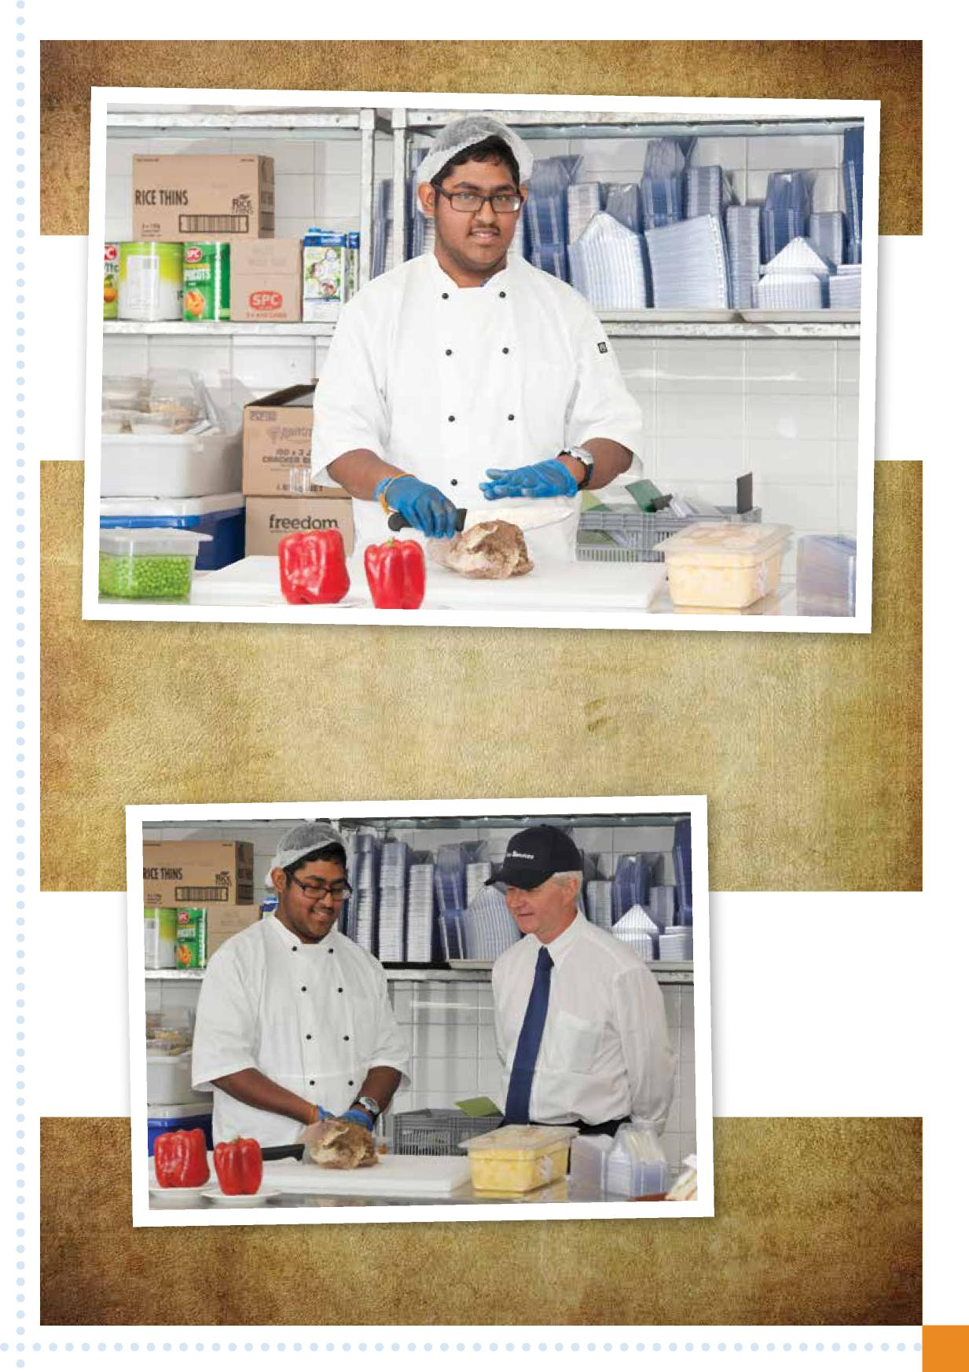

Vishma Chelliah:   
I am very happy to be working in Food Services and I think without   
ACT Health working and helping with my Employment provider,   
I may never have found a job. But now I have, everything is great.

Vishma Chelliah and Tom Walsh.

**9**

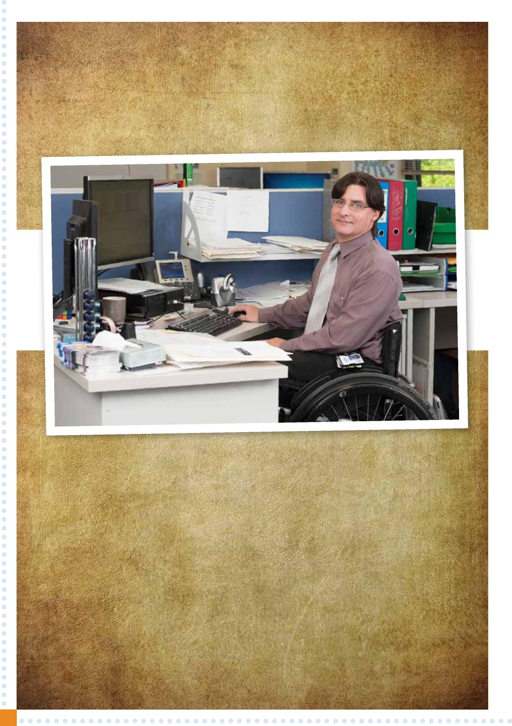

Jamie Coleman:

I am a T11 complete paraplegic. In the four years that I have worked in my department (Fleet Management), I can confidently say that due to the support of welcoming colleagues, work helps me to quickly lose thought that I have a disability as I am treated and viewed as an integral part of the team. That said, I am comforted with surety that any and all adjustments that have and will need to be made are met with enthusiasm. My experience is that working with a disability is achievable, highly rewarding and a very important part of my life.

**10**





**3 OBJECTIVE**

Through this plan, ACT Health is committed to the following objective as the long-term, overarching aspiration that all governments should strive for in the provision of disability services. All aspects of the National Disability Agreement contribute to, or measure progress towards:

***“People with disability and their carers have an enhanced quality of life and participate as valued members of the community”***

**4 DISABILITY**

**4.1 Definition of a disability**

The *Disability Discrimination Act 1992* (Cth) defines disability as:

* total or partial loss of the person’s bodily or mental functions
* total or partial loss of a part of the body
* the presence in the body of organisms causing disease or illness
* the malfunction, malformation or disfigurement of a part of the person’s body
* a disorder or malfunction that results in the person learning differently from a person without the disorder or malfunction
* a disorder, illness or disease that affects a person’s thought processes, perception of reality, emotions or judgment, or that results in disturbed behaviour;

and includes a disability that:

* presently exists
* previously existed but no longer exists
* may exist in the future
* is imputed to a person (meaning it is thought or implied that the person has disability but does not).

There are many different kinds of disability and they can result from accidents, illness or genetic disorders. A disability may affect mobility, ability to learn things, or ability to communicate easily and some people may have more than one. A disability may be visible or hidden, may be permanent or temporary and may have minimal or substantial impact on a person’s abilities.

Although some people are born with disability, many people acquire a disability. For example, people may have acquired a disability as a result of an accident. Some people may develop a disability as they age or through a disease process. There is a strong relationship between age and disability, as people grow older, there is a greater tendency to develop conditions which cause disability.

**4.2 People with a disability**

Disability is part of human diversity. One in five people in Australia, almost four million people, have a disability and this proportion is increasing with the ageing population. People with disability purchase consumer goods, have jobs, go on holidays, access information and do all of the things that people without a disability do. The only difference is that often people with disability come up against significant barriers while trying to do the things that many of us take for granted.

**11**

**4.3 Types of disability**

Advice from the Australian Network on Disability advises that the majority of people (83.9%) with disability have a physical disability, 11.3% have mental and behavioural disability and 4.8% have an intellectual or developmental disability.

The breadth of impairments and medical conditions covered by the DDA are set out below:

* Physical – affects a person’s mobility or dexterity
* Intellectual – affects a person’s abilities to learn
* Mental Illness – affects a person’s thinking processes
* Sensory – affects a person’s ability to hear or see
* Neurological – affects the person’s brain and central nervous system
* Learning disability
* Physical disfigurement
* Immunological – the presence of organisms causing disease in the body.

To be deemed a disability the impairment or condition must impact daily activities, communication and/or mobility, and has lasted or is likely to last 6 months or more.

People with disability are part of every section of our community: men, women, and children; employers

and employees; students and teachers; indigenous and non-indigenous; clients and citizens. No two people with the same disability experience their disability in the same way.

The only thing that distinguishes a person with a disability is they may require some form of adaptation/ adjustment to enable them to do certain things in the same way as people in the mainstream of society.

**4.4 Employment and people with disability**

According to the National Disability Strategy (2011):

Work is essential to an individual’s economic security and is important to achieving social inclusion.

Employment contributes to physical and mental health, personal wellbeing and a sense of identity. Income from employment increases financial independence and raises living standards.

Unfortunately, a lot more people with disability are unemployed than those without disability. However, of the people with disability who are employed, there is representation across many occupations.

Professionals, managers and administrators are the largest occupational grouping and this represents 37% of people with disability in employment. Clerical sales and service workers are the second largest grouping representing approximately 30% and the remaining occupational categories include tradespersons, production and transport workers as well as labourers and related workers representing approximately 33% of people with disability in employment.

**12**



**5 OUR VISION FOR PEOPLE WITH DISABILITY**

ACT Health’s vision is that we will be a disability proficient service that is committed to providing accessible and inclusive environment for people with disability.

ACT Health is committed to ensuring that consumers can actively participate in health care and can access ACT Health facilities and services. ACT Health is also striving to establish a disability confident workplace, and is committed to building its capability to support and engage with persons with disability in the workforce.

**6 OUR DISABILITY EMPLOYMENT ACTION PLAN**

The ACT Health Disability Employment Action Plan (DEAP) *2015–2018* supports the: ACT Health Workforce Plan *2013–2018*

National Disability strategy *2010–2020.*

***Council of Australian Governments (COAG) National Disability Agreement – The National Disability Agreement provides the national framework and key areas of reform for the provision of government support to services for people with disabilities.***

It builds on the ACT Public Service Respect, Equity and Diversity (ACTPS RED) Framework and actions within the ACTPS Employment Strategy for people with disability.

Commitment to achieving ACT Health’s potential to be a leading disability confident organisation is described in the following key policy documents:

* Council of Australian Governments (COAG) National Disability Agreement
* National Disability Strategy *2010–2020 –* An initiative of the Council of Australian Governments
* ACT Public Service Employment Strategy for People with Disability – Building on inclusive ACT Public Service
* ACT Health Workforce Plan *2013–2018.*

An important aim of the ACT Government is to make a positive difference in the lives of people with disability and their families. Providing genuine employment is a crucial part of enabling people with disability to have as independent lives as possible. This Employment Strategy aims to build our confidence to employ people with disability in a great variety of roles across the service.

Under the RED Framework there is recognition that more needs to be done in the ACTPS to attract, retain and support people with disability in our workforce.

**13**

**6.1 The Employment Strategy**

* Outlines the vision for the ACTPS that is the same for ACT Health.
* Discusses why we need to develop an Employment Strategy for people with disability.
* Identifies the challenges facing the ACTPS in improving the employment outcomes for people with disability.
* Determines high level indicators of performance including a numerical target for increase in staffing numbers.
* Outlines the objectives for employing people with disability.
* Determines actions to be undertaken to meet the identified challenges and deliver results.
* Outlines how performances will be monitored and evaluated through an annual progress report (under the RED Framework) to the Chief Minister.
* Outlines the legislative provisions supporting the employment of people with disability.

***ACT Public Service Employment Strategy for People with Disability – Building an inclusive ACT Public Service.***

**14**

**7 Objectives and targets for ACT Health over the life of the Disability Action Plan 2015–2018**

|  |  |
| --- | --- |
| **Responsibility** | **Timeline** |
| Employment Inclusion Manager, All of  ACT Health | Over period of Action Plan |
| Employment  Inclusion Manager | Ongoing |

**Measureable Target**

* Increased numbers of people with disability are engaged by ACT Health
* Managers and Supervisors are supported and gain expertise to support and mentor other Supervisors and Managers

**Action**

Increase in the % of staff who are employed with ACT Health

being someone with a Disability

Provide support, mentoring and assistance to Supervisors and Managers that employ or are looking to employ staff with disability

Accessibility Assessment of ACT Health facilities

Staff to be provided access to training, seminars and presentations regarding effective communication with clients and employees with disability

Employment

Inclusion Manager

Employment Inclusion Manager and Individual Managers/Supervisors

Over period of Action Plan starting with buildings over 10 years of age

Within 6 months for new staff, and then as needed

* Accessibility Assessment reports are presented to DEAP Committee and Director-General as appropriate
* All staff attend available training as required
* Annual guest speaker at function or presentation in support of International Day of People with a Disability

Develop a reasonable adjustment policy based on definition in discrimination law

Employment Inclusion Manager and People Strategy & Services

Within 12 months.

* Checklist developed and endorsed
* Checklist posted on website



All staff advised that attitudes and behaviour regarding people with disability can be included in staff performance management processes

Employment Inclusion Manager and Individual Managers/Supervisors

Within 12 months.

* Performance Agreements able to make reference to unacceptable behaviours and attitudes towards people with disability



A copy of or access to the ACT Health DEAP provided to every new staff member

Employment Inclusion Manager and Individual Managers/Supervisors

As required

* All new staff are provided with a copy of or access to the guide during their first month of employment



Develop a guide for disability awareness and communication kit for inclusion in the staff induction

Employment Inclusion Manager and People Strategy & Services

Within 24 months

* All new staff receive a copy of or provided access to the guide during their first week

**15**

**Abbreviations**

|  |  |  |
| --- | --- | --- |
| **ACT** |  | Australian Capital Territory |

|  |  |  |
| --- | --- | --- |
| **ACTPS** |  | Australian Capital Territory Public Service |
|  |  |  |
| **ACTH** |  | ACT Health |

|  |  |  |
| --- | --- | --- |
| **ASBA** |  | Australian School Based Apprentice |
|  |  |  |
| **COAG** |  | Council of Australian Governments |

|  |  |  |
| --- | --- | --- |
| **DEAP** |  | Disability Employment Action Plan |
|  |  |  |
| **NDIS** |  | National Disability Insurance Scheme |

|  |  |  |
| --- | --- | --- |
| **RED** |  | Respecting Equity and Diversity |

**Acknowledgements**

ACT Health would like to thank the following organisations and people for their help, support, advice and assistance:

* ACT Human Rights Office
* Australian Network on Disability
* The Chef Minister Office
* National Disability Employment Service Providers
* All of the ACT Health Staff that have provided input, assistance and help.

**16**

**I**



**DISABILITY EMPLOYMENT**

**ACTION PLAN 2015–2018**

*Towards a Disability inclusive organisation*

