Australian Human Rights Commission
GPO Box 5218
Sydney
NSW 2001

By email to disability@humanrights.gov.au

JUNE 2018

Dear Madam/Sir

I am writing to submit an Action Plan under section 64 of the Disability Discrimination Act 1992.
Background
The Blessing is an independent church aligned with the Full Gospel Churches of Australia. Prior to our move to Waitara, we leased two different ground level premises in Ryde. Our immediately previous premises’ leasehold was terminated by the landlords who offered us a settlement. After an extensive search we located our current premises at 11 Pattison Ave Waitara. Prior to signing the lease, an in-person approach was made to Hornsby Shire Council to check the suitablity of the site so that we would be able to operate our church.

Following Council providing in principal approval, we signed the lease and commenced works to upgrade the building to suit our needs. It was only later that we learned that we would need a development application, or DA, for change of use before we could move in (prior to our leasing the building the upper or first floor was used as a factory. The lower or ground floor was a rabbit warren of offices). We knew we had to submit a DA but did not know Council required all this completed & approved before we moved in.

Our current lease is a “5 + 5 + 5” lease. That is a lease for 5 years with the option to renew at the end of each 5 year period. We chose these premises as the buidling was vacant, the rent was affordable and it is located where a church can operate.

Within the building footprint there were two other tenants at the time of our signing the lease. One tenant moved out in early 2018, so we now share the building with just one other tenant.

At no time during our search or lease negotiations were we aware that we would need to make the upper level accessible, otherwise we would have continued searching for a ground level building.

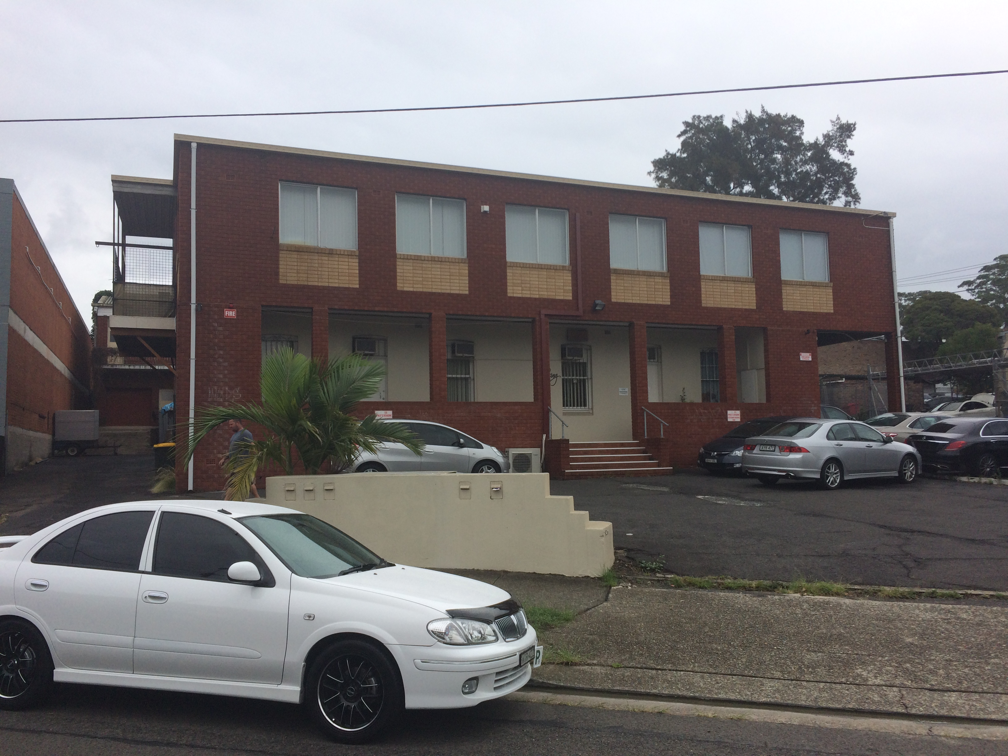

Figure 1 Photo of the building

Description of the building
The building is a two storey building with off street parking for 16 cars.

The ground level currently contains
- Stepped entrance facing street
- Entry hall
- Kitchen
- 3 offices
- Meeting room
- Retreat room
- Vacant areas (recently acquired since one of the other tenants moved out)
  - Store room
  - Laundry
  - Toilet

The first floor contains
- Multi-purpose overflow room
- Auditorium (where our church services are conducted)
- Library space
- Children’s’ room with its own toilet
- Internal toilets
  - Male
  - Female
- External toilet

Outside there is on-site parking. On the eastern side of the building there is an existing flight of external stairs that connects to a landing that runs the length of that side of the building. These stairs need to be replaced.
Planning and zoning
The premises is in an area that is zoned B6 Enterprise Corridor by Hornsby Shire Council. Under the Hornsby Shire Council Local Environmental Plan 2013, this area has the following development objectives:

﻿Zone B6 Enterprise Corridor
1 Objectives of zone
• To promote businesses along main roads and to encourage a mix of compatible uses.
• To provide a range of employment uses (including business, office, retail and light industrial uses).
• To maintain the economic strength of centres by limiting retailing activity.
• To provide for residential uses, but only as part of a mixed use development.

The area is dominated by motor vehicle dealerships, as illustrated by the Google map below. We have been informed that some of the dealerships have been lobbying the Council to have the area re-zoned. The re-zoning would permit the development of multi-level shop-top housing, similar to that found on the other side of the train line. At the time of the re-zoning we are led to believe that our premises may be sold. Being unsure about the longevity of our lease is a major concern.

The main reason that we have had to be located in an industrial area is the many complaints that were received from residents when we applied to lease other buildings in more residential areas.

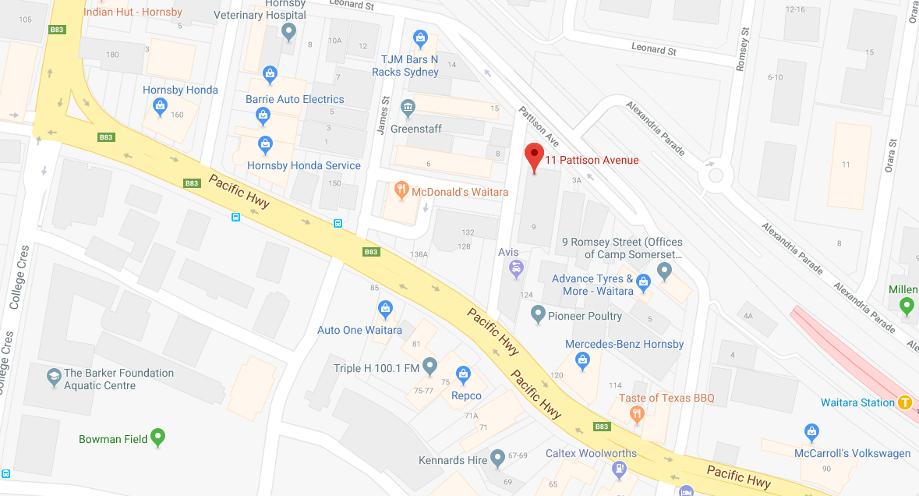
Figure 2 – location map

Purpose of building
Our area of the building is used solely for the operating of our church and its associated activities.

Our church holds one Sunday morning service. We also hold a Thursday morning bible study on-site. Our church’s administration operates from offices located on the ground floor. Outside our office hours and worship times, the building is unoccupied.

Description of Organisation
We are an independent church, with approximately 60 members. Each Sunday we now have around 40 people who attend our service. Prior to our relocation we regularly had 80 members attending on a Sunday. Due to fire safety restrictions set by Council, we can only have a maximum of 50 people in the building at any one time, to which we strictly adhere.

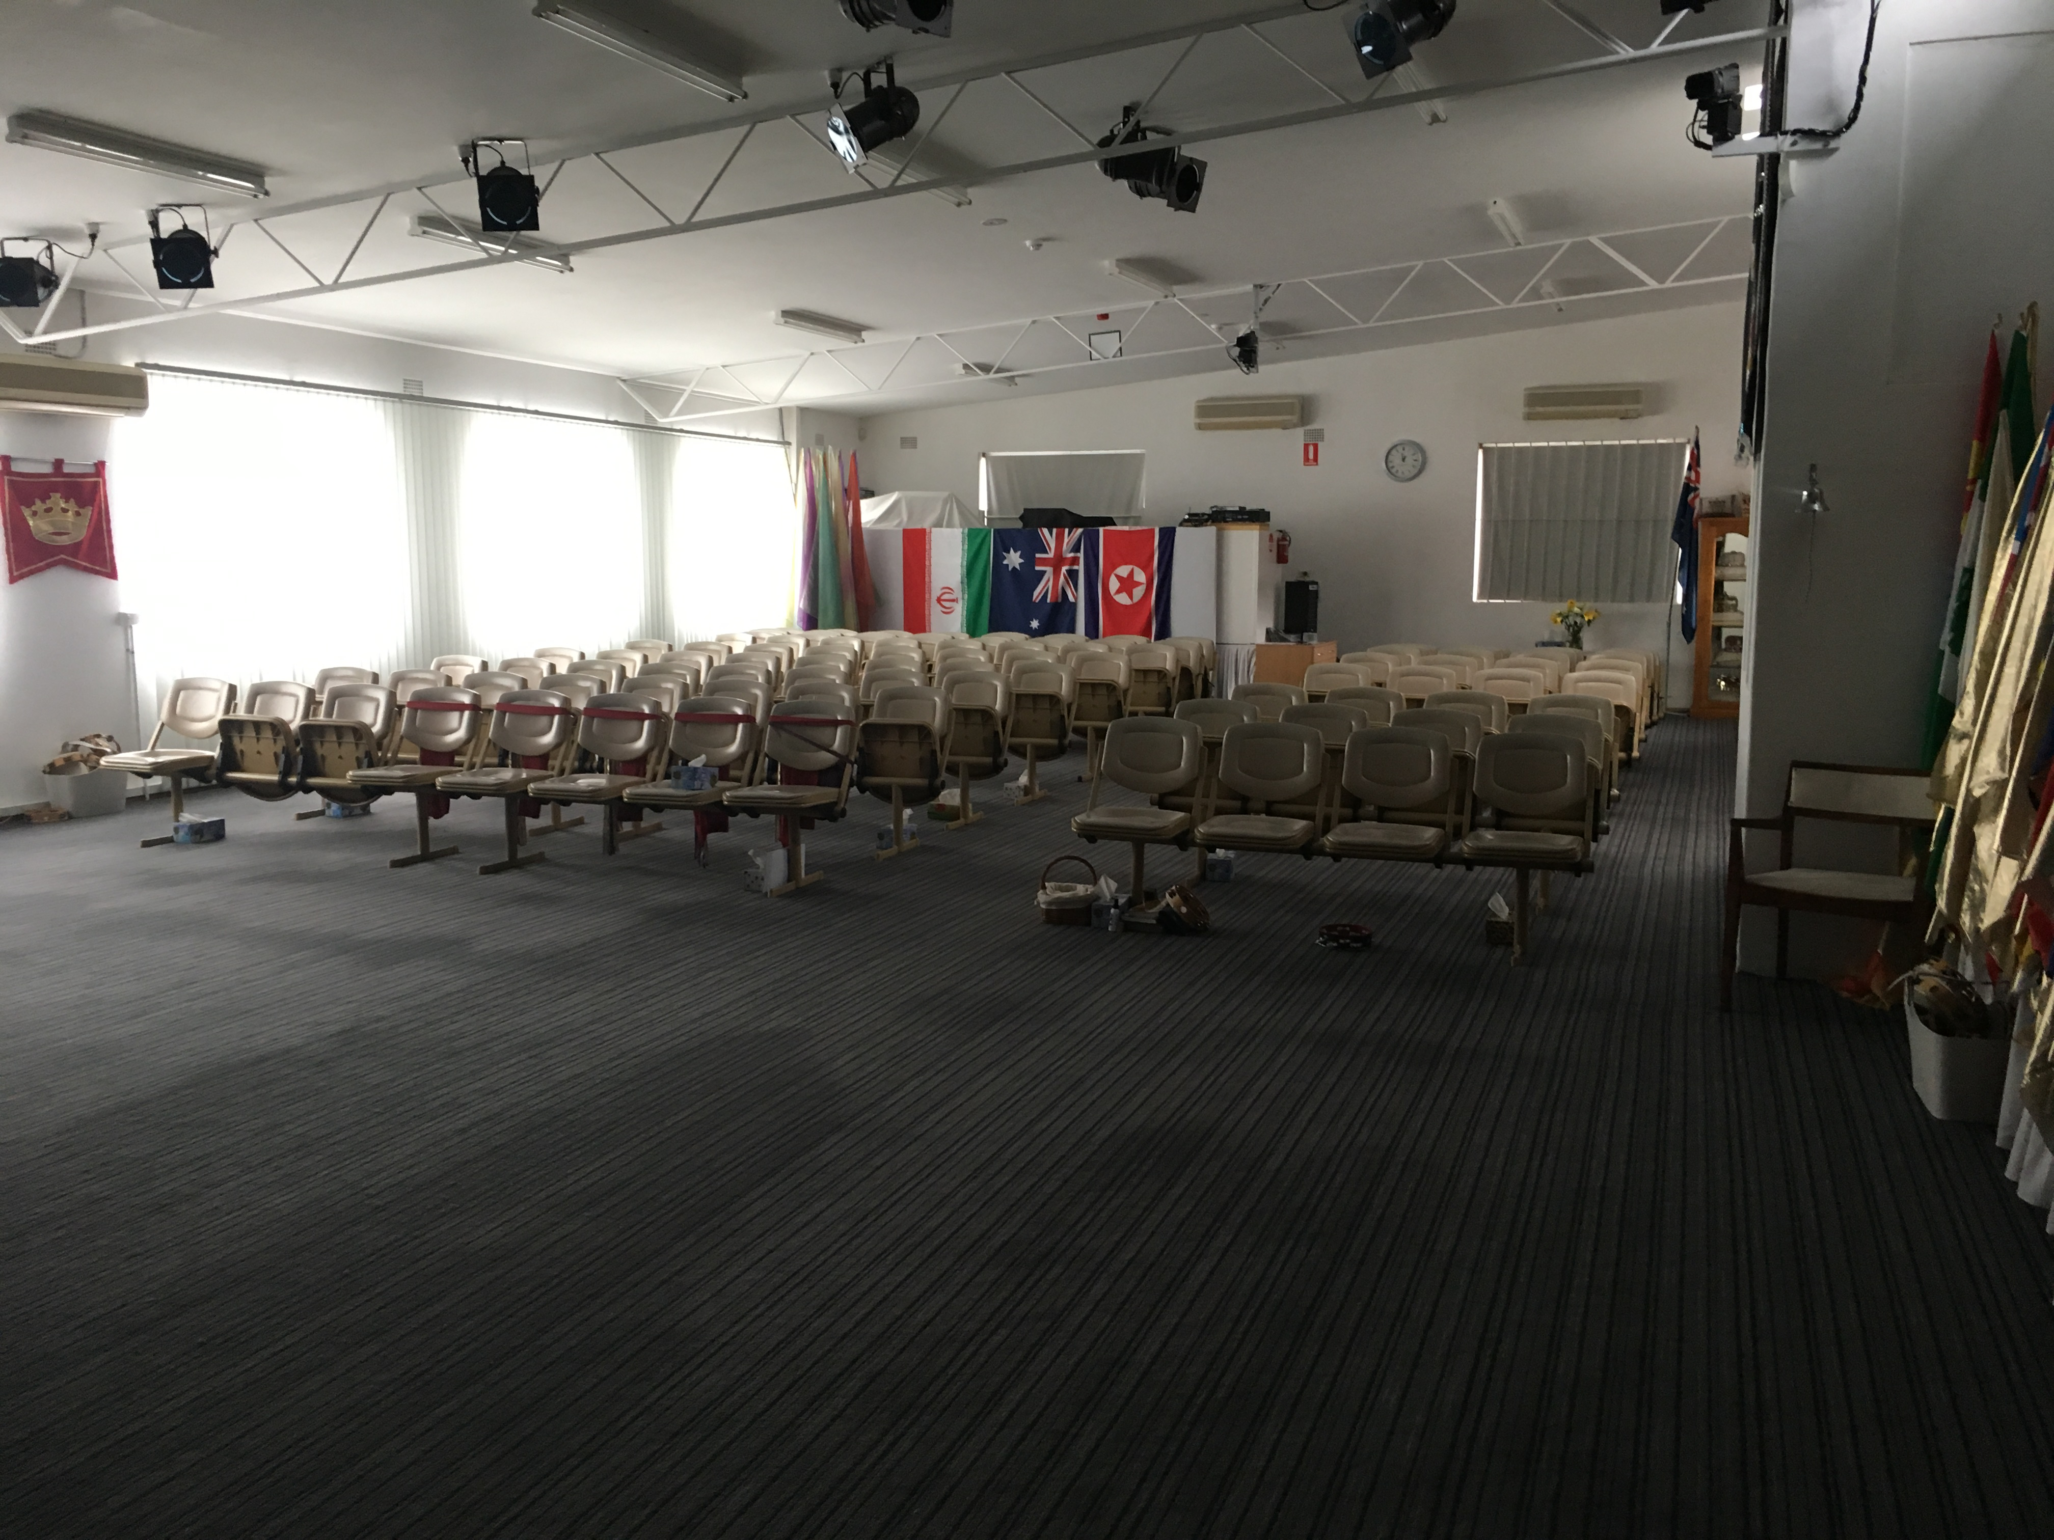
Figure 3 - Auditorium

The change in use required a significant upgrade of features and amenities including a substantial amount of work on fire safety upgrades. We were required to upgrade the fire safety of the entire building to ensure that our portion of the building met Australian codes and standards. This scope of works was funded by our previous leasehold pay-out.

Following our lodging of the change of use DA we were informed by Council that we need to ensure that both levels of the building are accessible, particularly for a person with mobility related disabilities. Additional work is also required to upgrade the external stairs to permit us to have an increased occupancy of our portion of the building. With the replacement stairs we have been informed that our capacity will increase to 80 people in the building at any one time. This is because Council requires a place of worship to have 1 on-site parking bay space per 5 people and we only have 16 on-site car parking spaces.

While substantial design, budgeting and financial viability work was undertaken prior to our renting of the property, the range of issues that have to be addressed in order to maintain our church operations and continue being financially viable have now proved to be extensive. With the reduced occupancy of the building and a reduction of our congregation due to our relocation, our ability to raise funds has been reduced.

Within the Disability (Access to premises – buildings) Standards 2010 (Premises Standards) we note that it is not unlawful for a person to fail to comply with a requirement of the Premises Standards where compliance would impose an unjustifiable hardship. We wish to lodge this Action Plan to demonstrate that whilst immediate compliance is not possible, we will meet compliance requirements once the necessary funds have been raised. It is hoped that lodging of our Action Plan with the Australian Human Rights Commission and any evidence of our implementation of the same, may be considered a relevant factor in the event of a DDA complaint.

Proposed approach
We are proposing a 2-stage approach to progressively address the access requirements of people with mobility disability to both ground and first floor facilities.

We believe the financial viability of the church relies on having the DA for change of use and conditional Occupation Certificate approved as soon as possible. Growing our congregation and a period of dedicated fundraising will also enable us to raise the money needed to undertake the works required to make the building accessible.

In order to do this, we are seeking a temporary or conditional Occupation Certificate from Hornsby Shire Council as the certifying body, to operate for a period up to 7 years (remainder of our initial 5-year lease period and the whole of the next 5-year lease period) on condition that the actions identified in our Disability Action Plan are implemented. We believe that we will need this length of time to raise approximately $80,000 needed to install the lift and do any other work associated with the lift installation.

If at the end of the period of temporary or conditional occupation the actions have not been completed, Council will withdraw our occupancy approval.

Proposed Stage 1
Stage 1
- Finalisation of plans for stage 1 works by architect
- Review by an Accredited Access Consultant that all proposed works and fittings will provide access as required by the Premises Standards, Building Code of Australia and referenced Australian Standards
- Lodge plans for approval with Hornsby Shire Council
- Works toinclude
  - Relocation of the principal pedestrian entrance to the eastern side of the building
  - Principal pedestrian entrance to be made accessible
  - Construction of a AS1428.1-2009 complying accessible unisex toilet on the ground floor
  - Demolition of existing external stairs and landing on eastern side of building
  - Construction of external stairs and landing to comply with both access and fire safety standards
  - Landing to be constructed so that lift installation can be undertaken when funds have been raised
  - Dependent on guidance from architect, works may include the ground works required for future lift installation
- Undertake works as proposed above

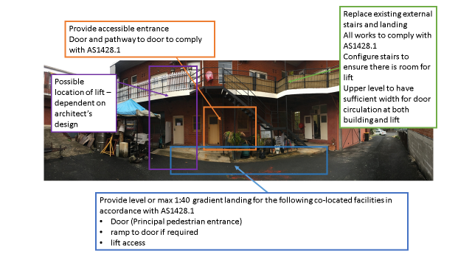
Figure 4 – stage 1 scope of works illustrated

This scope of works will ensure that the ground floor is accessible for people with disabilities. The first stage scope of works will also include preparations for the lift installation which we believe is evidence of our intention to make the upper level of the building accessible. We note that all of the construction works listed above are in extremely close proximity and will need carefully planning and design by our architect.

Proposed Stage 2
Stage 2 will involve the securing of approval from Hornsby Shire Council for

- Lift installation
- Replace existing doors with “cat and kitten” door to ensure that the active leaf provides the required clear door opening width which is currently 850mm

While initial discussions with Hornsby Shire Council have been positive, the formal process of gaining approval to install the lift, raise funds, complete the necessary works and establish the proposed new first floor entrance is likely to take many months.

We would be grateful if you could inform us when the Action Plan has been registered.

Yours sincerely

Judith Gates Diane O’Connor
Senior Pastor / Director Associate Pastor / Director

11 Pattison Avenue
Waitara

Attached
Appendix 1 – Action Plan
Appendix 2 – Rezoning proposal information
The Blessing commenced as a Christian Church, originally known as SHOW, in 2001 and has been operating ever since. Over the years we have had hundreds of people visit, many stayed, others enjoyed a season with us. In our initial years we held our services and conferences in halls and meeting rooms and for the past fifteen years we have been leasing permanent buildings around Sydney, establishing great facilities and an environment in which our congregation has been able to prosper and flourish whilst working towards seeing our Vision and Mission accomplished in many lives. We have never been a large congregation in terms of numbers but we have a heartfelt desire to achieve great things in our community and nation whilst being very aware of the nations of our world. We also desire to see our congregation grow in our current building and so are committed to fulfilling the requirements and plans for better accessibility for all those who visit or choose to call us their spiritual home. The Blessing is an independent pentecostal church aligned with the Full Gospel Churches of Australia and registered with ACNC.
Our VISION- To contribute to the growth, enlargement and prosperity of the church as the greatest entity on earth. To make disciples and true worshippers.
Our MISSION- To announce the Good News of Jesus the Anointed One who God anointed with the Holy Spirit and with power and went around doing good and instantly, divinely healing everyone because God was with Him.

Like many small organisations, The Blessing faces the challenge of limited financial, human, and physical resources. This creates specific obstacles in developing strategies that can reduce the variety of disadvantages that people with disabilities experience. The main challenge is the inability to dramatically alter physical accessibility at our rental premises.

Proposed Stage 1
Stage 1
- Finalisation of plans for stage 1 works by architect
- Review by an Accredited Access Consultant that all proposed works and fittings will provide access as required by the Premises Standards, Building Code of Australia and referenced Australian Standards
- Lodge plans for approval with Hornsby Shire Council
- Works to include
  - Relocation of the principal pedestrian entrance to the eastern side of the building
  - Principal pedestrian entrance to be made accessible
  - Construction of a AS1428.1-2009 complying accessible unisex toilet on the ground floor
  - Demolition of existing external stairs and landing on eastern side of building
  - Construction of external stairs and landing to comply with both access and fire safety standards
  - Landing to be constructed so that lift installation can be undertaken when funds have been raised
  - Dependent on guidance from architect, works may include the ground works required for future lift installation.

- Undertake works as proposed above
This scope of works will ensure that the ground floor is accessible for people with disabilities. The first stage scope of works will also include preparations for the lift installation which we believe is evidence of our intention to make the upper level of the building accessible. We note that all of the construction works listed above are in extremely close proximity and will need careful planning and design by our architect.

Proposed Stage 2
Stage 2 will involve the securing of approval from Hornsby Shire Council for

- Lift installation
- Replace existing doors with “cat and kitten” door to ensure that the active leaf provides the required clear door opening width which is currently 850mm

Goal: To ensure equitable access to and within the building.

Action | Timeframe | Responsibility | Reporting
1. Obtain approval for a Conditional Occupation Permit for a period of 7 years subject to meeting the actions set out in this plan from Hornsby Shire Council. | Within 2 months of the registration of this Action Plan | Diane O’Connor | A brief report informing of the granting of the Temporary Occupation Permit and any attached conditions to be provided to the Commission within 2 months of the registration of this Action Plan.  Contingency:- Time taken by Hornsby Shire Council to process application
2. Develop and implement policies and procedures within The Blessing | As a part of Church’s annual Vision Sunday (held each year at the beginning of the calendar year)  - Establish a disability action plan monitoring and review committee.  - Ensure that review and planning is in place in the Church’s calendar for each year of the plan  - Develop a communication strategy that regularly alerts the congregation of the content and availability of the action plan. |  | A report on progress will be provided to the Commission six months from the registration of this Action Plan
3. Complete the Stage 1 works of the proposed plan to provide  an accessible unisex toilet and access to the ground floor facilities. | Within 24 months of the registration of this Action Plan:  - Finalise design and construction details  - Comprehensive review of design and construction details for access compliance by an accredited Access Consultant  - Gain approvals  - Landlord  - Council | Diane O’Connor | A report on progress will be provided to the Commission six months from the registration of this Action Plan, and annually thereafter.
- Commence fundraising | - Establish a fundraising committee responsible to the disability action plan monitoring and review committee  - Develop a fundraising plan for the next 60 months  - Set fundraising targets for each year  - Seek financial advice re investing money during fundraising period and invest funds accordingly | Board of Directors  (Authorised contact - Diane O’Connor) | Report to Congregation during Vision Sunday (held at beginning of each calendar year)  AHRC annually on progress of fundraising (following Vision Sunday, held at beginning of each calendar year)  Report to congregation and AHRC annually on progress of fundraising
- Active fundraising | t take Undertake fundraising  ake f a activities for the next 60 aaaa months in line with fund- aa raising plan (as above) | Board of Directors  (Authorised contact - Diane O’Connor)
6. Commence the Stage 2 works – installation of lift and door rectification works. | Within 60 months of the completion of Stage 1 works. In total 84 months.  7 years . | Diane O’Connor | A report on commencement of the access arrangements to be provided to the Commission within 60 months of the completion of the Stage 1 works  Report to AHRC to be provided on completion of works

Implementation, monitoring and review of the Disability action plan

The Disability action plan demonstrates improved access for people with disabilities through the implementation, monitoring and review of the plan.
- Establish a disability action plan monitoring and review committee.
- Ensure that review and planning is in place in the Church’s calendar.
- Develop a communication strategy that alerts the congregation of the availability of the action plan.
- Lodge the Disability action plan with the Australian Human Rights Commission (AHRC).
- Progress of the plan’s implementation is reported on an annual basis.

The DAP will be monitored and reviewed by the Church’s Board of Directors annually as part of strategic planning activities and reported on in our Annual Vision Sunday, held at the beginning of each calendar year

Appendix 2
Source http://www.colliers.com.au/news/2016/planning-proposals-set-to-reshape-the-waitara-enterprise-corridor/ accessed 14 March 2018 2:05pm

Planning proposals set to reshape the Waitara Enterprise Corridor
Property owners are looking to increase building heights and density to meet unprecedented market demand for high quality apartments.
The continued demand for residential apartments, supported by increases in the value of properties with development upside, has seen property owners within the Waitara Enterprise Corridor seeking to increase the number of apartments developed on their land.

The Waitara Enterprise Corridor runs between Pacific Highway and the North Shore train line, starting at the intersection of the two and continuing east to the junction with Carden Avenue Waitara, the site of Phil McCarroll Toyota. Consisting of predominantly industrial, retail and a multitude of car dealerships, the precinct benefits from close proximity to both Hornsby transport interchange and Waitara railway station as well as Hornsby Westfield Shopping Centre.

Zoned B6 Enterprise Corridor under Hornsby Shire Council, a zoning designed to promote a range of employment uses while allowing for residential if part of a mixed use development. Current planning controls restrict development in the Waitara Enterprise Corridor to a maximum of two storeys which many property owners and developers view as overly restrictive considering that the adjoining precinct allows for developments up to 11 storeys.

With the development value of permissible floor space at over $2,000/sqm, many owners within the precinct have taken a proactive approach to increasing the potential development yield of their land by preparing and lodging planning proposals to substantially increase their permissible height and density. An example is the planning proposal that has been lodged for the Hornsby Mazda Site at 64-72 Pacific Highway, which seeks to increase permissible height to allow for an 18 storey development while increasing density to allow for over 28,700sqm of floor space.

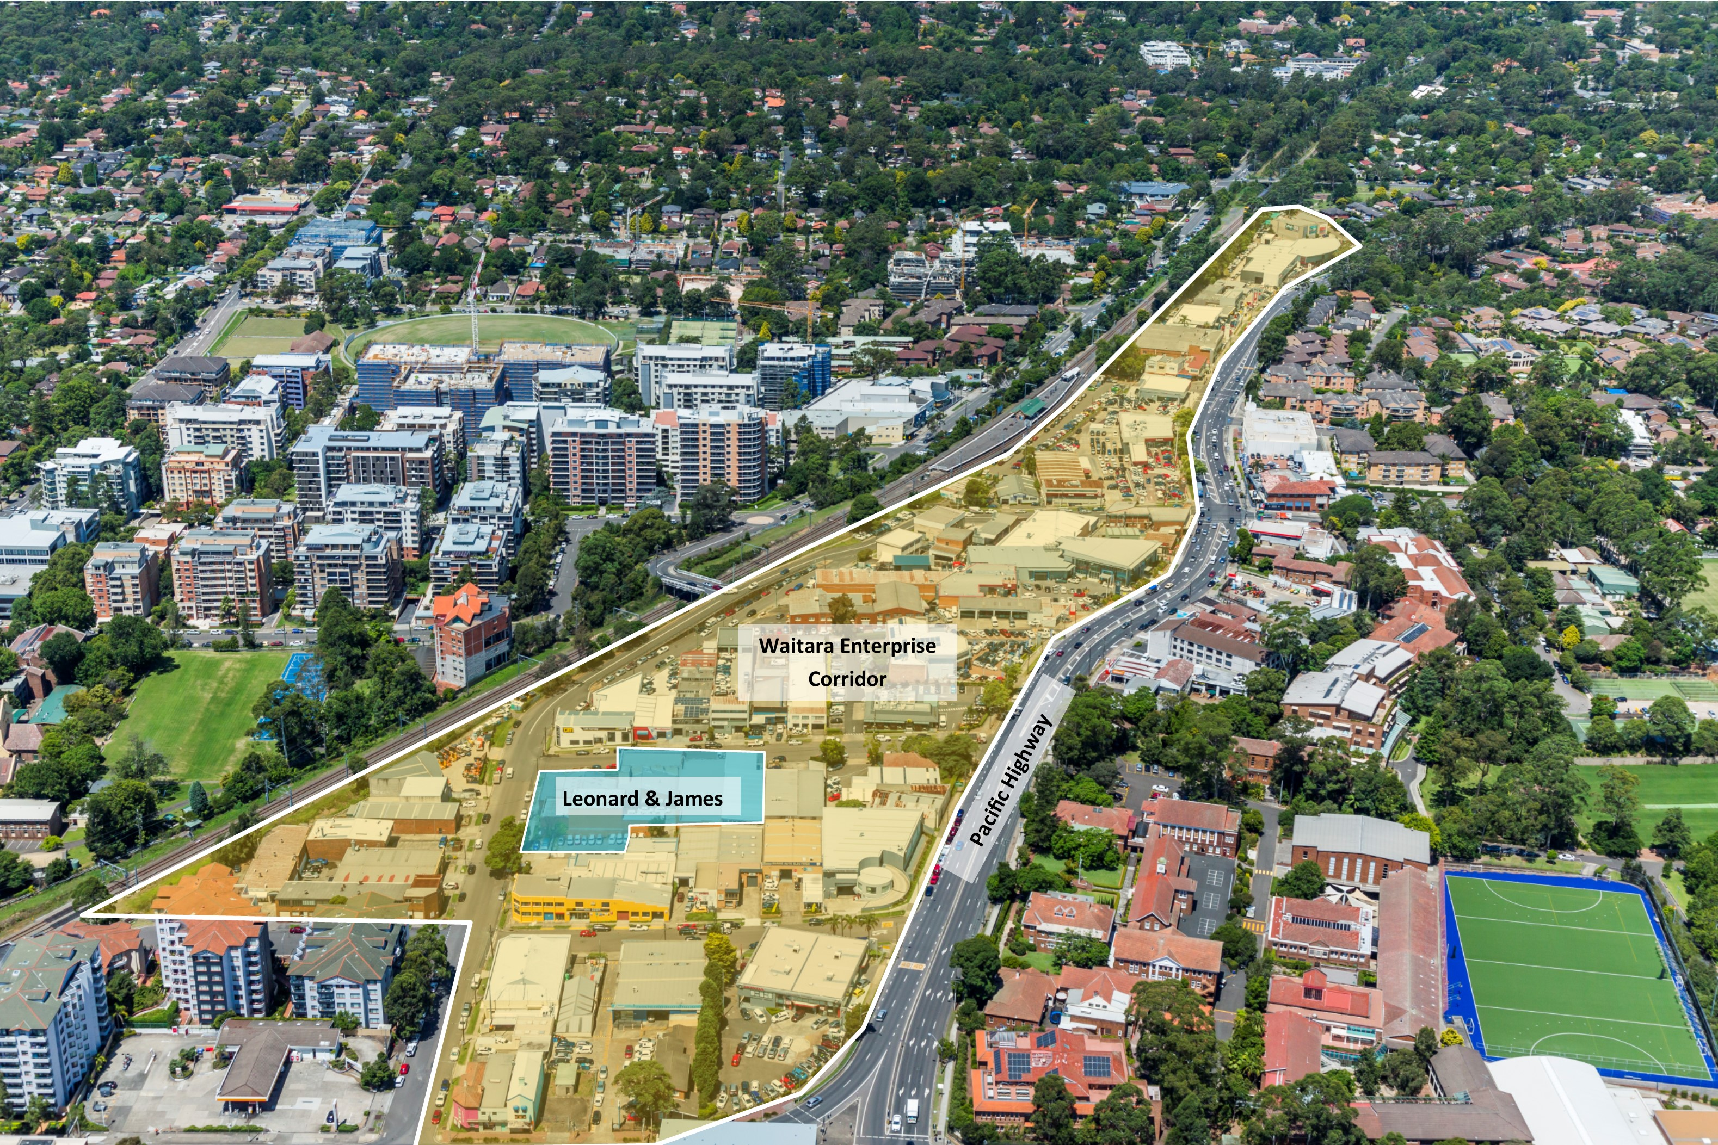

Another site which is likely to see an application for increased height and density is 8-12 Leonard Street & 5-9 James Street, a substantial 3,110sqm site which has recently been placed on the market by private owners looking to secure a sale to a development group. Initial planning advice has indicated that the site could suit a development of up to 11 storeys with circa 150 apartments plus ground floor employment uses subject to approval of a planning proposal. The selling agent, Corey Beauchamp of Colliers International, is confident that the site will attract strong interest from both local, interstate and offshore development groups who will look to capitalise on the site’s key benefits.

“The Leonard & James site benefits from a corner position, North East frontages and close proximity to a range of transport options. Given the position of the site in context to adjoining properties and surrounding development, there is real scope to increase the residential component of a proposed development whilst retaining the vital employment uses of the land”.

Mr Beauchamp believes that increasing the scale of the residential component will make the site more likely to be bought and developed. “With unprecedented demand for residential apartments in major centres such as Hornsby, values of apartments have risen and there is a genuine demand for more stock to be added to the market”.

This increase in demand has been demonstrated by the success of Park Rise Apartments in Waitara, a 295 apartment development by Winten Property Group where 75% of units were sold in only 6 hours by the Colliers International Residential team.

With strong demand expected through 2016, the trend of property owners looking to capitalise on current market conditions is expected to continue.

