

8 Manton Street Darwin GPO Box 3180 Darwin NT 0801 phone: 8982 1 1 1 1 freecall; 1800 812 953 fax:8982 1112 email; info@dds,[org.au](http://org.au) website; [www.dcls.org](http://www.dcls.org).aU ABM 42 840 626 724

**LEGAL SERVICE**

Legal Section

Australian Human Rights Commission

By [email:](mailto:legal@humanrights.gov.au) legal@humanrights.gov.au 30 October 2013

Dear Sir/Madam,

**RE: APPLICATION FOR TEMPORARY EXEMPTION UNDER SECTION 66 OF THE DISABILITY DISCRIMINATION ACT 1992— SUBMISSION BY THE DARWIN COMMUNITY LEGAL SERVICE**

1. We refer to the application by the (former) Department of Families, Housing, Community Services and Indigenous Affairs (FaHCSIA) for an exemption from the operation of sections 15 and 24 of the *Disability Discrimination Act* to enable the continued use of the Business Services Wage Assessment Tool (BSWAT).
2. We **oppose** the application. In the event that the Commission is minded to grant the application we submit that it should do so for a period of 6 months only.
3. The application for an exemption is being sought to enable FaHCSIA to

address the implications of the Federal Court (sic) judgment *Nojin & Prior v Commonwealth [2012] FCAFC 192* (Nojin).

1. In the interests of accuracy it should be noted that the judgment is a judgment of the Full Court of the Federal Court of Australia and that an application by the Commonwealth for leave to appeal the Full Court's decision to the High Court was refused. The High Court held ([2013] HCATrans 101):

The unchallenged expert evidence was that the BSWAT produced a differential effect for intellectually disabled persons and reduced their score. We see no reason to doubt the conclusions of the Full Court.

free legal advice and information human rights and public interest law residential aged care rights disability rights welfare rights tenants' rights **Darwin Community Legal Service inc.**

*Patron:Her Honour the Honourable Sally Thomas AM, Administrator of the Northern Territory*

1. The Commonwealth's statement that the

... use of BSWAT was found to constitute unlawful discrimination in the *particular circumstances* relating to Mr Nojin and Mr Prior "(original emphasis")

is disingenuous.

1. The Full Court made no finding that the Applicants should be distinguished from other intellectually disabled employees. The Full Court found by a majority that BSWAT discriminated against intellectually disabled employees of which the Applicants were but two.
2. For instance, at paragraph 109, his Honour Buchanan J in referring to the expert evidence states

Their evidence gives considerable support for the proposition that the supposed measure of competencies involved in BSWAT is theoretical, artificial and irrelevant to the practical circumstances of intellectually disabled workers *like* Mr Nojin and Mr Prior. (emphasis added)

1. His Honour goes on to say at paragraph 71

The concern I have is a more fundamental one than that.

The assessment required by BSWAT explored matters With which, on the expert evidence to be referred to later, intellectually disabled people would struggle.

1. And at paragrah 147 states

It is not a sufficient answer to say that intellectually disabled people can do the test like everybody else, and may do their best. Intellectually disabled people are placed, at the outset, at a disadvantage which prevents effective compliance. They are not able to comply in substance, regardless of the outward form.

1. We submit that a temporary exemption should not be granted to the Commonwealth for the following reasons:
   1. To grant a temporary exemption would undermine the High Court decision that BSWAT discriminates against intellectually disabled employees. There is no appeal from a decision of the High Court. The Commonwealth should respect the Court's decision as final and discontinue use of BSWAT. There are many other productivity based wage assessment tools which do not offend the *Disability Discrimination Act* which could be utilized. To the extent that there needs to be a period

2

of transition to another wage assessment tool we submit that a period of 6 months is ample time.

10.2 An exemption would endorse discrimination against employees with an intellectual disability. The Full Court found that BSWAT was fundamentally flawed. At one point Mr Nojin was earning as little as $1.85 per hour despite being a productive employee. The Association of Employees with a Disability Legal Centre (AED Legal Centre) states in its submission (at page 3), in response to the Commonwealth's application for an exemption, that application of BSWAT has resulted in employees being paid as little as 33 cents per hour.

10.3 There are other wage assessments tools which could be used. The Full Court noted that there were 22 other tools in use some of which were alternatives to BSWAT.

11. For the foregoing reasons we submit that the Commission should refuse the

Commonwealth's application or in the alternative allow the exemption for as short a period as possible.

Yours sincerely

**Darwin Community Legal Service Inc**

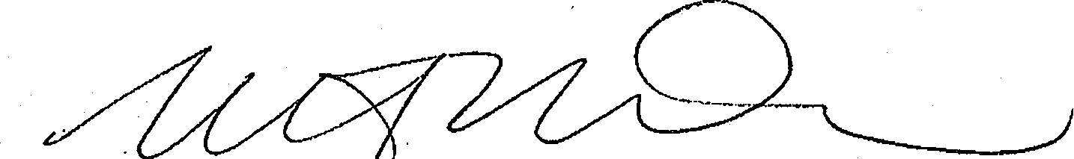

Mary Hawkins

Solicitor

**Disability Discrimination Advocate**

1:08 89821111

E: [mary_hawkins@c1c.net.au](mailto:mary_hawkins@c1c.net.au)

3