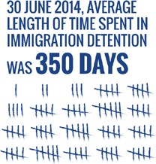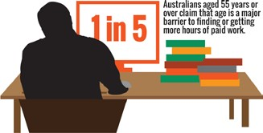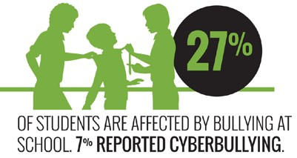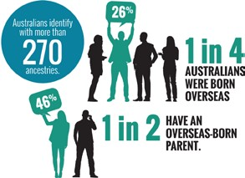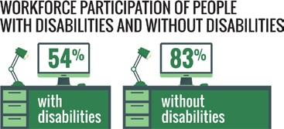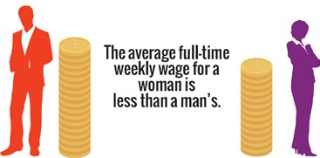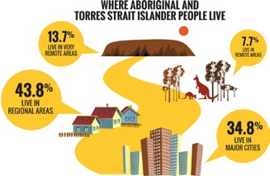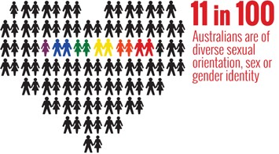

**Face the facts:**

#### 2014

**Face the Facts**

### Contents

Aboriginal and Torres Strait Islander Peoples 2

Asylum seekers and refugees 6

Children’s rights 10

Cultural diversity 14

Disability rights 18

Gender equality 22

Lesbian, gay, bisexual, trans and intersex people 26

Older Australians 30

The Australian Human Rights Commission encourages the dissemination and exchange of information provided in this publication. All material presented in this publication is provided under Creative Commons Attribution 3.0 Australia, with the exception of:

* the Australian Human Rights Commission Logo
* photographs and images
* any content or material provided by third parties.

The details of the relevant licence conditions are available on the Creative Commons website, as is the full legal code for the CC BY 3.0 AU licence.

**Attribution**

Material obtained from this publication is to be attributed to the Australian Human Rights Commission with the following copyright notice:

© Australian Human Rights Commission 2014.

**Face the Facts** • **2014 ISBN** 978-1-921449-67-3

**Design and layout** Dancingirl Designs

**Infographic Design** Firefly Interactive

**Content** James Iliffe, Black and White Media Australia

**Electronic format**

This publication can be found in electronic format on the website of the Australian Human Rights Commission:

[**http://www.humanrights.gov.au/publications**](http://www.humanrights.gov.au/publications/sex-discrimination)

**Contact details**

For further information about the Australian Human Rights Commission, please visit

[**www.humanrights.gov.au**](http://www.humanrights.gov.au/)or email [**communications@humanrights.gov.au**.](mailto:communications@humanrights.gov.au) You can also write to:

Communications Team

Australian Human Rights Commission GPO Box 5218

Sydney NSW 2001

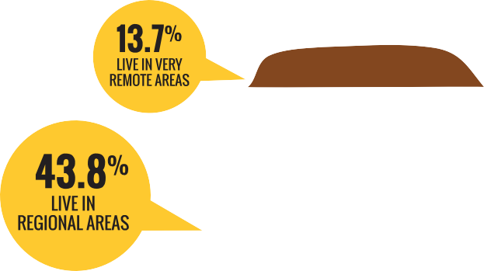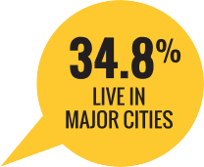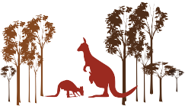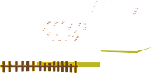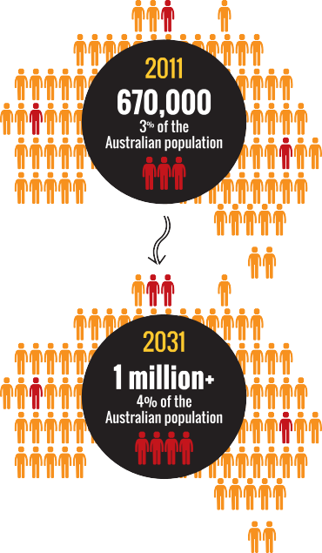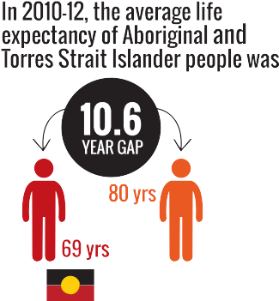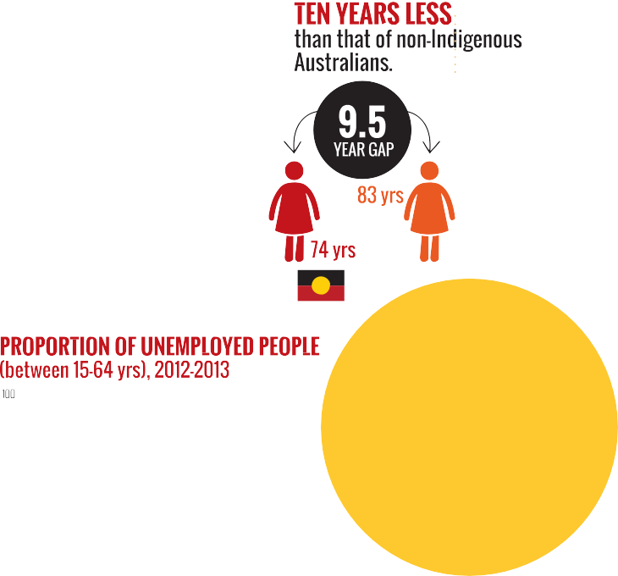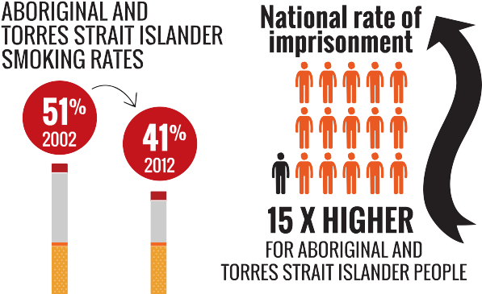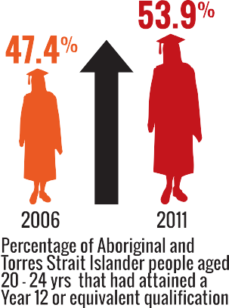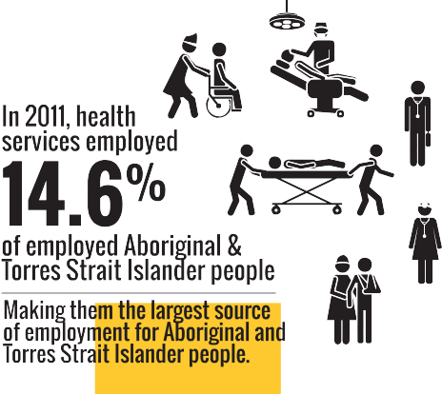

 



**[www.humanrights.gov.au/face-facts](http://www.humanrights.gov.au/face-facts)**



# Aboriginal and Torres Strait Islander Peoples

Aboriginal and Torres Strait Islander Peoples have a unique place in Australia as the original inhabitants of the land.

Across the country, many individuals and communities maintain strong connections to their culture, language and traditional lands, while also contributing to the environmental management, economic development and cultural identity of our nation.

Aboriginal and Torres Strait Islander Peoples hold distinctive rights as Australia’s First Peoples, set out in international law.

And in 2009, Australia gave its formal support to the [United](https://www.humanrights.gov.au/un-declaration-rights-indigenous-peoples) [Nations Declaration on the Rights of Indigenous Peoples](https://www.humanrights.gov.au/un-declaration-rights-indigenous-peoples),

a ground-breaking document that seeks to reset relationships between indigenous peoples and governments around the globe.

However, despite some improvements in recent years, Aboriginal and Torres Strait Islander people continue to be one of the most vulnerable groups in Australia.

### About

* In 2011, almost 670 000 Aboriginal and Torres Strait Islander people were living in Australia;1 around three per cent of the Australian population. By 2031, it is estimated that this number will exceed one million, with Aboriginal and Torres Strait Islander people comprising

3.9 per cent of the population.2

* One third (34.8 per cent) of Aboriginal and Torres Strait Islander people live in major cities;3 43.8 per cent live in regional areas; 7.7 per cent live in remote areas; and 13.7 per cent live in very remote areas.4
* In 2011, more than one in three Aboriginal and Torres Strait Islander people were under 15 years (36 per cent), compared with one-fifth of non-Indigenous Australians. Almost four per cent of Aboriginal and Torres Strait Islander people were aged 65 years and over, compared with 14 per cent of non-Indigenous Australians.5
* In 2011, 11 per cent of Aboriginal and Torres Strait Islander people spoke an Indigenous language at

home.6

### Key issues for Aboriginal and Torres Strait Islander Peoples

* In 2010-12, the average life expectancy of Aboriginal and Torres Strait Islander people was approximately ten years (10.6 years for men and 9.5 years for women) less than that of non-Indigenous Australians.7 Leading causes of death included heart disease, diabetes, respiratory disease and cancer.8
* Just over half (52.2 per cent) of Aboriginal and Torres Strait Islander people aged between 15 and 64 years were not employed in 2012-2013, compared with

24.4 per cent of non-Indigenous Australians.9

* One in five Aboriginal and Torres Strait Islander women experienced physical violence in the previous 12 months, compared to seven per cent of non- Indigenous women. Over the same period, Aboriginal and Torres Strait Islander women (12 per cent) were three times more likely to experience sexual violence than non-Indigenous women (four per cent).10
  + In 2008, half of all Aboriginal and Torres Strait Islander people aged 15 years and over had some form of disability.11 In non-remote areas, Aboriginal and Torres Strait Islander people were one-and-a-half times more likely than non-Indigenous adults to have a disability or a long-term health condition.12
  + Around one in twelve Aboriginal and Torres Strait Islander adults are part of the Stolen Generations. In 2008, eight per cent (26,900) of Aboriginal and Torres Strait Islander people aged 15 years and over stated that they had been removed from their natural family. Thirty five per cent assessed their health as fair or poor and 39 per cent experienced high or very high levels of psychological distress.13
  + The national imprisonment rate for Aboriginal and Torres Strait Islander adults is 15 times higher than that for non-Indigenous adults.14 In the December quarter of 2013, Aboriginal and Torres Strait Islander people comprised 27 per cent of Australia’s full-time adult prison population.15
  + There were approximately 250 Australian Indigenous languages spoken at the time of colonisation. However, a 2005 survey found that only 145 Indigenous languages are still spoken to some degree and less than 20 are considered to be “strong” and able to be spoken by all generations.16

### Positive developments

* + Between 2005-07 and 2010-12, life expectancy for Aboriginal and Torres Strait Islander men increased by

1.6 years and by 0.6 years for women. Over the same period, the life expectancy gap between Aboriginal and Torres Strait Islander people and the rest of the Australian population reduced by 0.8 years for men and 0.1 years for women.17

* + In 2011, 53.9 per cent of Aboriginal and Torres Strait Islander people aged between 20 and 24 years had attained a Year 12 or equivalent qualification, up from

47.4 per cent in 2006.18 Higher levels of educational attainment are associated with better health outcomes.19

* + Between 2002 and 2012, Aboriginal and Torres Strait Islander smoking rates dropped from 51 per cent to 41 per cent.20
  + The 2011 Census results show that health services currently employ 14.6 per cent of employed Aboriginal and Torres Strait Islander people. Health services are the single biggest “industry” source of employment for Aboriginal and Torres Strait Islander people, expanding by almost 4,000 places since 2006.21

### Did you know?

The Aboriginal rock art in Western Australia’s Dampier Archipelago is at least twice as old as the Pyramids of Egypt.22

### Find out more

* Australian Human Rights Commission, [Social Justice Reports](https://www.humanrights.gov.au/publications/social-justice-reports-index)
* Australian Human Rights Commission, [Native Title Reports](http://www.humanrights.gov.au/social_justice/nt_report/index.html)
* Australian Human Rights Commission; [*Bringing*](https://www.humanrights.gov.au/publications/bringing-them-home-report-1997)[*Them Home: Report of the National Inquiry into*](https://www.humanrights.gov.au/publications/bringing-them-home-report-1997)

[*the Separation of Aboriginal and Torres Strait Islander*](https://www.humanrights.gov.au/publications/bringing-them-home-report-1997)[*Children from Their Families*](https://www.humanrights.gov.au/publications/bringing-them-home-report-1997)(1997)

* [Close the Gap: Campaign for Indigenous Health](https://www.humanrights.gov.au/close-gap-indigenous-health-campaign) [Equality](https://www.humanrights.gov.au/close-gap-indigenous-health-campaign) (2006 – current)
* Australian Human Rights Commission, [*Close the Gap:*](https://www.humanrights.gov.au/publications/close-gap-progress-and-priorities-report-2014)[*Progress and Priorities Report 2014*](https://www.humanrights.gov.au/publications/close-gap-progress-and-priorities-report-2014)(2014)
* Productivity Commission, [Overcoming Indigenous](http://www.pc.gov.au/gsp/overcoming-indigenous-disadvantage) [Disadvantage: Key Indicator Reports](http://www.pc.gov.au/gsp/overcoming-indigenous-disadvantage)
* United Nations, [Declaration on the Rights of](https://www.humanrights.gov.au/publications/un-declaration-rights-indigenous-peoples-1) [Indigenous Peoples](https://www.humanrights.gov.au/publications/un-declaration-rights-indigenous-peoples-1)

### Our role

The [Aboriginal and Torres Strait Islander Social Justice](https://www.humanrights.gov.au/about/commissioners/aboriginal-and-torres-strait-islander-social-justice-commissioner) [Commissioner](https://www.humanrights.gov.au/about/commissioners/aboriginal-and-torres-strait-islander-social-justice-commissioner) keeps the human rights issues facing Australia’s First Peoples before the Australian Parliament by preparing an annual [Social Justice Report](http://www.humanrights.gov.au/social_justice/sj_report/index.html) and [Native Title](http://www.humanrights.gov.au/social_justice/nt_report/index.html) [Report](http://www.humanrights.gov.au/social_justice/nt_report/index.html). He also promotes community understanding of and respect for the rights of Aboriginal and Torres Strait Islander Peoples.

The Commission’s role includes reviewing the impact of laws, policies and programs on Aboriginal and Torres Strait Islander people, as well as providing policy advice and research on a range of pressing human rights issues.

The Commission also hosts the [Close the Gap: Campaign](https://www.humanrights.gov.au/close-gap-indigenous-health-campaign) [for Indigenous Health Equality](https://www.humanrights.gov.au/close-gap-indigenous-health-campaign).

Find out more about [our work](https://www.humanrights.gov.au/our-work/aboriginal-and-torres-strait-islander-social-justice) in this area.

##### Endnotes

1. Australian Bureau of Statistics, [*3238.0.55.001-Estimates of Aboriginal*](http://www.abs.gov.au/ausstats/abs%40.nsf/mf/3238.0.55.001)[*and Torres Strait Islander Australians*](http://www.abs.gov.au/ausstats/abs%40.nsf/mf/3238.0.55.001)*, June 2011* (August 2013).
2. Australian National University, [*CAEPR Indigenous Population Project,*](http://caepr.anu.edu.au/sites/default/files/cck_indigenous_outcomes/2013/11/2011CensusPaper_14_Population_Projections.pdf)[*2011 Census Papers – Paper 14, Population Projections*](http://caepr.anu.edu.au/sites/default/files/cck_indigenous_outcomes/2013/11/2011CensusPaper_14_Population_Projections.pdf)(2011).
3. Australian Bureau of Statistics, note 1.
4. Australian Bureau of Statistics, note 1.
5. Australian Bureau of Statistics, [*2075.0-Census of Population and*](http://www.abs.gov.au/ausstats/abs%40.nsf/Lookup/2075.0main%2Bfeatures32011)[*Housing: Counts of Aboriginal and Torres Strait Islander Australians, 2011*](http://www.abs.gov.au/ausstats/abs%40.nsf/Lookup/2075.0main%2Bfeatures32011)(June 2012).
6. Australian Bureau of Statistics, [*2076.0-Census of Population and*](http://www.abs.gov.au/ausstats/abs%40.nsf/Latestproducts/2076.0Main%20Features902011?opendocument&amp;tabname=Summary&amp;prodno=2076.0&amp;issue=2011&amp;num&amp;view)[*Housing: Characteristics of Aboriginal and Torres Strait Islander*](http://www.abs.gov.au/ausstats/abs%40.nsf/Latestproducts/2076.0Main%20Features902011?opendocument&amp;tabname=Summary&amp;prodno=2076.0&amp;issue=2011&amp;num&amp;view)[*Australians, 2011*](http://www.abs.gov.au/ausstats/abs%40.nsf/Latestproducts/2076.0Main%20Features902011?opendocument&amp;tabname=Summary&amp;prodno=2076.0&amp;issue=2011&amp;num&amp;view)(November 2012).
7. Australian Bureau of Statistics, [*3302.0.55.003-Life Tables for Aboriginal*](http://www.ausstats.abs.gov.au/ausstats/subscriber.nsf/0/BD51C922BFB7C6C1CA257C230011C97F/%24File/3302055003_2010-2012.pdf)[*and Torres Strait Islander Australians*](http://www.ausstats.abs.gov.au/ausstats/subscriber.nsf/0/BD51C922BFB7C6C1CA257C230011C97F/%24File/3302055003_2010-2012.pdf)(November 2013).
8. Australian Bureau of Statistics, [*3303.0-Causes of Death, Australia, 2011*](http://www.abs.gov.au/ausstats/abs%40.nsf/Lookup/489D9A69EDA30684CA257B2E000D7703?opendocument)

(March 2013).

1. Department of Prime Minister and Cabinet, Australian Government,

[*Closing the Gap, Prime Minister’s Report 2014*](http://www.dpmc.gov.au/publications/docs/closing_the_gap_2014.pdf)(2014).

1. Victorian Health Promotion Foundation (VicHealth), [*Preventing violence*](http://www.vichealth.vic.gov.au/Publications/Freedom-from-violence/Violence-against-women-in-Australia-research-summary.aspx)[*against women in Australia: Research summary*](http://www.vichealth.vic.gov.au/Publications/Freedom-from-violence/Violence-against-women-in-Australia-research-summary.aspx)(2011).
2. Australian Bureau of Statistics, [*4704.0-The Health and Welfare of*](http://www.abs.gov.au/AUSSTATS/abs%40.nsf/lookup/4704.0Chapter500Oct%2B2010)[*Australia’s Aboriginal and Torres Strait Islander Peoples, October 2010*](http://www.abs.gov.au/AUSSTATS/abs%40.nsf/lookup/4704.0Chapter500Oct%2B2010)(February 2011).
3. Australian Bureau of Statistics, above.
4. Australian Bureau of Statistics, note 11.
5. Australian Bureau of Statistics, [*4512.0-Corrective Services, Australia,*](http://www.abs.gov.au/ausstats/abs%40.nsf/mf/4512.0)[*December quarter 2013*](http://www.abs.gov.au/ausstats/abs%40.nsf/mf/4512.0)(March 2014).
6. Australian Bureau of Statistics, above.
7. Australian Bureau of Statistics, [*1301.0-Year Book Australia, 2009–10*](http://www.abs.gov.au/AUSSTATS/abs%40.nsf/Lookup/1301.0Feature%2BArticle42009%E2%80%9310)

(June 2010).

1. Australian Bureau of Statistics, note 7.
2. Department of Prime Minister and Cabinet, Australian Government, note 9.
3. Australian Bureau of Statistics, note 11.
4. Australian Bureau of Statistics, [*4727.0.55.001-Australian Aboriginal and*](http://www.abs.gov.au/ausstats/abs%40.nsf/Latestproducts/39E15DC7E770A144CA257C2F00145A66?opendocument)[*Torres Strait Islander Health Survey: First Results, Australia, 2012-13*](http://www.abs.gov.au/ausstats/abs%40.nsf/Latestproducts/39E15DC7E770A144CA257C2F00145A66?opendocument)(November 2013).
5. Australian Bureau of Statistics, [‘New 2011 Census data reveals more](http://www.abs.gov.au/websitedbs/censushome.nsf/home/CO-64?opendocument&amp;navpos=620&amp;industry%20(Accessed%2014%20January%202014)) [about Aboriginal and Torres Strait Islander peoples’](http://www.abs.gov.au/websitedbs/censushome.nsf/home/CO-64?opendocument&amp;navpos=620&amp;industry%20(Accessed%2014%20January%202014)) (Media release) 30 October 2012.
6. Australian Heritage Council, [*National Heritage Assessment: The Dampier*](http://www.environment.gov.au/node/19176)[*Archipelago (including the Burrup Peninsula)*](http://www.environment.gov.au/node/19176)(2006).

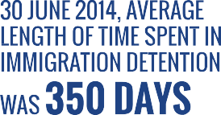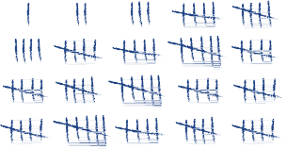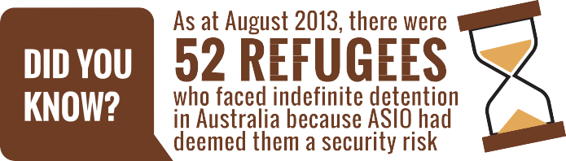

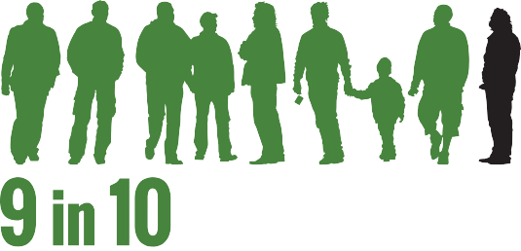

 

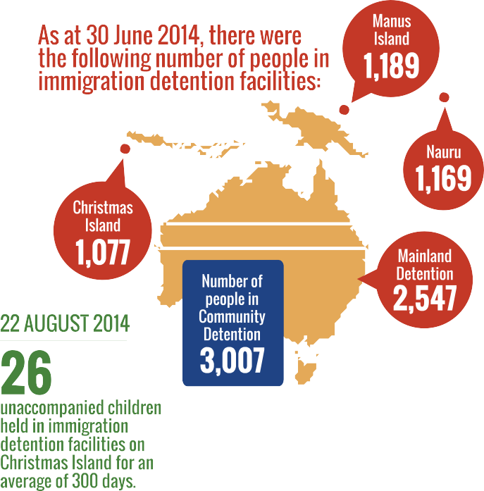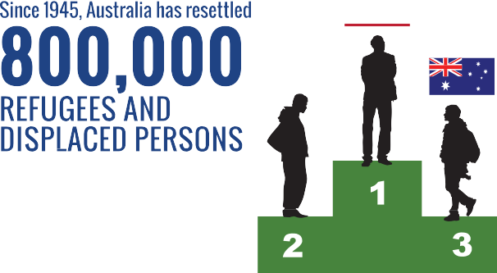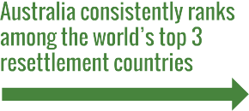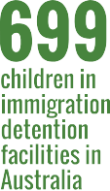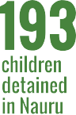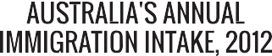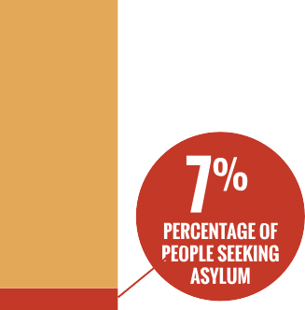



 



[**www.humanrights.gov.au/face-facts**](http://www.humanrights.gov.au/face-facts)



# Asylum seekers and refugees

Seeking asylum in Australia is not illegal. In fact, it is a basic human right. All people are entitled to protection of their human rights, including the right to seek asylum, regardless of how or where they arrive in Australia.

Countries that have ratified the [Convention Relating to the](http://www.unhcr.org/3b66c2aa10.html) [Status of Refugees 1951](http://www.unhcr.org/3b66c2aa10.html), such as Australia, are required to assess asylum seekers’ claims for protection from persecution. The Refugee Convention defines who is a refugee and sets out the basic rights that countries should guarantee to refugees.

Australia’s policy of mandatory immigration detention was introduced in 1992. Under the [Migration Act 1958](http://www.austlii.edu.au/au/legis/cth/consol_act/ma1958118/), any non-citizen who is in Australia without a valid visa must be detained.

In August 2012, the Australian Government introduced “third country” processing. Under this system, asylum seekers who arrive by boat without a valid visa are transferred to and detained in Nauru or Papua New Guinea (PNG). Those asylum seekers who are transferred will have their claims for protection assessed under Nauruan or PNG law, not Australian law.

### About

* + As at 31 January 2014, there were 5,867 people in immigration detention facilities and 3,391 people in community detention in Australia.1 Forty-three per cent (3,967) were detained in facilities on the mainland,

37 per cent were in community detention (3,391) and 20 per cent were held on Christmas Island (1,900).2

* + As at 31 January 2014, there were 1,012 asylum seekers who had been transferred by the Australian Government and detained in Nauru. There were a further 1,353 asylum seekers detained on Manus Island in PNG.
* As at 31 January 2014 there were 1,006 children in immigration detention facilities in Australia and 132 children detained in Nauru.3 As at 19 August

2013, there were 358 unaccompanied minors held in immigration detention facilities, ranging in age from seven to 17 years.4 The average age of children in closed detention facilities in September 2013 was

10 years.5

* The number of people seeking asylum in 2012 (15,963)6 made up less than seven per cent of Australia’s annual immigration intake and four per cent of our overall population growth.7 The top five source countries for asylum seekers who arrived in Australia by boat in 2012 were Afghanistan, Sri Lanka, Iran, Pakistan and Iraq.8
* Around 90 per cent of asylum seekers who arrive in Australia by boat are ultimately found to be refugees and are granted protection visas.9

### Key issues for asylum seekers and refugees

* Australia has one of the most restrictive immigration detention systems in the world. It is mandatory, indefinite and provides no opportunity for people to challenge the need for their detention in court.10 As at 31 January 2014, the average length of time a person spent in immigration detention was seven months and nine days. However, 119 people had been held in immigration detention for over two years.11
* Prolonged detention can have a devastating and long- lasting impact on the mental health of asylum seekers, especially children. Further, the cost of treating

mental illnesses caused or made worse by prolonged detention is conservatively estimated at an average of

$25,000 per person.12

* + In 2012–13, there were 846 reported incidents of self-harm across Australia’s immigration detention system.13
  + Asylum seekers arriving in Australia by boat on or after 13 August 2012 who have been granted bridging visas are not allowed to work.14 This restriction on working and earning an income can have serious effects on a person’s well-being and contribute to problems with physical health, mental health, social isolation and family breakdown.15
  + Implementing Australia’s policy of mandatory immigration detention cost Australian taxpayers $1.235 billion in 2011–2012.16

### Supporting asylum seekers and refugees

* + Australia has resettled around 800,000 refugees since 1945 and consistently ranks among the world’s top three resettlement countries.17
  + A total of 13,750 people will be accepted through Australia’s [Humanitarian Program](http://www.immi.gov.au/media/fact-sheets/60refugee.htm) in 2013-2014.18
  + Alternatives to closed immigration detention, such as community arrangements, save Australian taxpayers money and involve fewer risks to the health, safety and well-being of asylum seekers and refugees. This helps lower rates of self-harm and leads to fewer claims for compensation.19

### Did you know?

As of August 2013, there were **52 refugees who faced indefinite detention in Australia** because ASIO had deemed them a security risk. The United Nations Human Rights Committee found that the indefinite detention of a group of refugees with adverse security assessments was inflicting serious psychological harm upon them, amounting to cruel, inhuman or degrading treatment.

### Find out more

* Australian Human Rights Commission, [*Asylum*](http://www.humanrights.gov.au/publications/asylum-seekers-refugees-and-human-rights-snapshot-report)[*seekers, refugees and human rights: Snapshot Report*](http://www.humanrights.gov.au/publications/asylum-seekers-refugees-and-human-rights-snapshot-report)(2013)
* Australian Human Rights Commission, [*A last resort?*](http://www.humanrights.gov.au/last-resort-report-national-inquiry-children-immigration-detention-2004)[*Report of the National Inquiry into Children in*](http://www.humanrights.gov.au/last-resort-report-national-inquiry-children-immigration-detention-2004)[*Immigration Detention*](http://www.humanrights.gov.au/last-resort-report-national-inquiry-children-immigration-detention-2004)(2004)
* [Convention Relating to the Status of Refugees 1951](http://www.unhcr.org/3b66c2aa10.html) and [Protocol Relating to the Status of Refugees 1967](http://www.unhcr.org/protect/PROTECTION/3b66c2aa10.pdf)
* A. Houston, P. Aristotle and M. L.’Estrange, [*Report of*](http://expertpanelonasylumseekers.dpmc.gov.au/)[*the Expert Panel on Asylum Seekers*](http://expertpanelonasylumseekers.dpmc.gov.au/)(2012)
* UN Refugee Agency (UNHCR), Monitoring visit to [Manus Island](http://unhcr.org.au/unhcr/images/2013-11-26%20Report%20of%20UNHCR%20Visit%20to%20Manus%20Island%20PNG%2023-25%20October%202013.pdf) (2013) and [Nauru](http://unhcr.org.au/unhcr/images/UNHCR%20Monitoring%20Report%20Nauru.pdf) (2013)

### Our role

The Commission has undertaken extensive work in the area of Australian law, policy and practice relating to asylum seekers, refugees and immigration detention. This has included conducting national inquiries; examining proposed

legislation; monitoring and reporting on immigration detention; and investigating complaints from individuals subject to Australia’s immigration laws and policies.

We have also developed minimum [human rights standards for](https://www.humanrights.gov.au/publications/human-rights-standards-immigration-detention) [immigration detention](https://www.humanrights.gov.au/publications/human-rights-standards-immigration-detention) and [advocated for stronger federal laws](https://www.humanrights.gov.au/publications/addressing-sexual-orientation-and-sex-andor-gender-identity-discrimination-consultati-0) to ensure that the conditions in immigration detention meet international standards.

The [National Children’s Commissioner](https://www.humanrights.gov.au/about/commissioners/ms-megan-mitchell-national-childrens-commissioner) works collaboratively within the Commission to protect the rights of child asylum seekers and unaccompanied minors.

Find out more about [our work](https://www.humanrights.gov.au/commissions-role) in this area.

**Face the Facts** • **2014** • 7

In February 2014, the Commission announced that it would undertake a follow-up [National Inquiry into](https://www.humanrights.gov.au/our-work/asylum-seekers-and-refugees/national-inquiry-children-immigration-detention-2014) [Children in Immigration Detention](https://www.humanrights.gov.au/our-work/asylum-seekers-and-refugees/national-inquiry-children-immigration-detention-2014). The inquiry will investigate what has changed in the ten years since

the Commission released [*A last resort? Report of the*](https://www.humanrights.gov.au/publications/last-resort-national-inquiry-children-immigration-detention)[*National Inquiry into Children in Immigration Detention*](https://www.humanrights.gov.au/publications/last-resort-national-inquiry-children-immigration-detention)in 2004.

##### Endnotes

1. Department of Immigration and Border Protection, Australian Government, [*Immigration Detention and Community Statistics Summary:*](http://www.immi.gov.au/managing-australias-borders/detention/_pdf/immigration-detention-statistics-jan2014.pdf)[*31 January 2014*](http://www.immi.gov.au/managing-australias-borders/detention/_pdf/immigration-detention-statistics-jan2014.pdf)(2014) p 3.
2. Department of Immigration and Border Protection, Australian Government, above, p 3.
3. Department of Immigration and Border Protection, Australian Government note 1, pp 3-4.
4. Australian Human Rights Commission, [*Asylum seekers, refugees*](http://www.humanrights.gov.au/publications/asylum-seekers-refugees-and-human-rights-snapshot-report)[*and human rights: Snapshot Report, October 2013*](http://www.humanrights.gov.au/publications/asylum-seekers-refugees-and-human-rights-snapshot-report), footnote 54, 55.

Department of Immigration and Citizenship, Response to the Australian Human Rights Commission’s 13 August 2013 request for information concerning detention and asylum seekers, provided by email to the Commission on 16 September 2013, p 3.

1. Australian Human Rights Commission, above, footnote 43.
2. Australian Human Rights Commission, note 4, footnote 18, 19; Department of Immigration and Citizenship, [*Asylum statistics – Australia,*](http://www.immi.gov.au/media/publications/statistics/asylum/)[*Quarterly tables – March Quarter 2013*](http://www.immi.gov.au/media/publications/statistics/asylum/)(2013), p 1; United Nations High Commissioner for Refugees (UNHCR), [*UNHCR Global Trends 2012,*](http://unhcr.org/globaltrendsjune2013/)[*Displacement: The New 21st Century Challenge*](http://unhcr.org/globaltrendsjune2013/)(2013), p 3.
3. Australian Human Rights Commission, note 4, footnote 20, 21; Australian Bureau of Statistics, [*3101.0–Australian Demographic Statistics, Dec 2012*](http://www.abs.gov.au/AUSSTATS/abs%40.nsf/allprimarymainfeatures/7B8C452A1CDFAB9FCA257BF100136758?opendocument)(June 2013).
4. Australian Human Rights Commission, note 4, p 8.
5. See, for example, the statistics provided by the Department of Immigration and Border Protection for the last five financial years in [*Asylum Trends – Australia: 2012-13 Annual Publication*](http://www.immi.gov.au/media/publications/statistics/)(2013), p 30.
6. Australian Human Rights Commission, note 4, Executive Summary.
7. Department of Immigration and Border Protection, Australian Government, note 1, p 10.
8. Australian Human Rights Commission, note 4, footnote 94; T Ward, [*Long-*](http://www.yarrainstitute.org.au/Portals/0/docs/Ward.long-term%20costs)[*term health costs of extended mandatory detention of asylum seekers*](http://www.yarrainstitute.org.au/Portals/0/docs/Ward.long-term%20costs)(2011).
9. Australian Human Rights Commission, note 4, Executive Summary.
10. Australian Human Rights Commission, [*Tell Me About: Bridging Visas*](http://www.humanrights.gov.au/publications/tell-me-about-bridging-visas-asylum-seekers)[*for Asylum Seekers*](http://www.humanrights.gov.au/publications/tell-me-about-bridging-visas-asylum-seekers)(April 2013).
11. Australian Human Rights Commission, above, footnote 5.
12. Australian Human Rights Commission, note 4, footnote 39; Australian National Audit Office, [*Individual Management Services Provided to*](http://www.anao.gov.au/Publications/Audit-Reports/2012-2013/Individual-Management-Services-Provided-to-People-in-Immigration-Detention)[*People in Immigration Detention, Report No 21*](http://www.anao.gov.au/Publications/Audit-Reports/2012-2013/Individual-Management-Services-Provided-to-People-in-Immigration-Detention)(2013), p 12.
13. Australian Human Rights Commission, note 4, Executive Summary.
14. See [*Mid-Year Economic and Fiscal Outlook, Appendix A: Policy decisions*](http://www.budget.gov.au/2013-14/content/myefo/html/12_appendix_a_expense-12.htm)[*taken since the 2013-14 Budget –Expense Measures – Immigration and*](http://www.budget.gov.au/2013-14/content/myefo/html/12_appendix_a_expense-12.htm)[*Border Protection*](http://www.budget.gov.au/2013-14/content/myefo/html/12_appendix_a_expense-12.htm).
15. Australian Human Rights Commission, note 4, footnote 103; International Detention Coalition and La Trobe Refugee Research Centre, *There*

*are alternatives: A handbook for preventing unnecessary immigration detention* (2011), section 5.

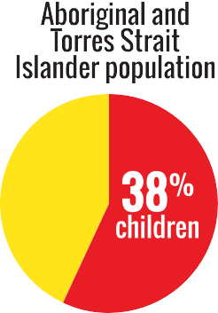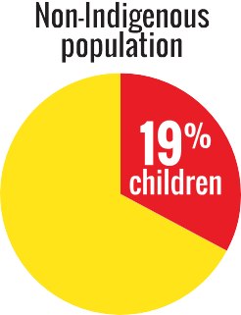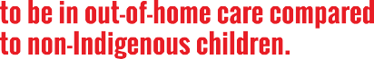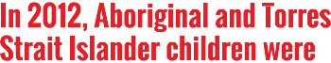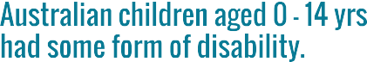

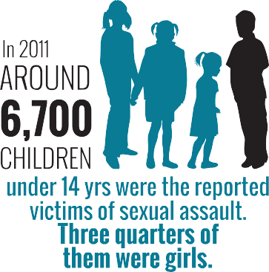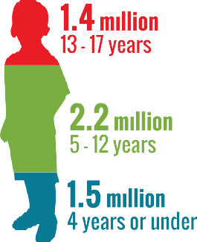

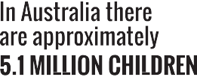



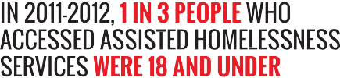

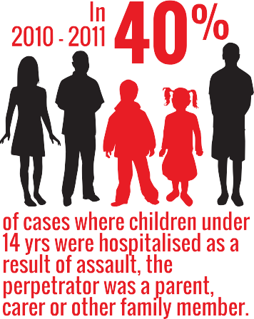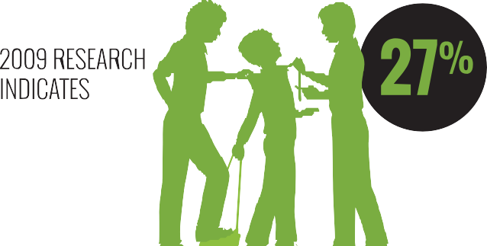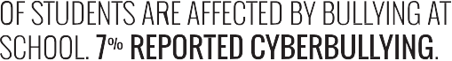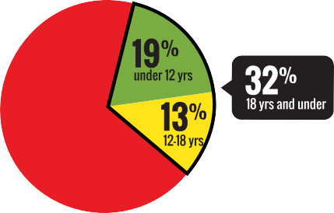

[**www.humanrights.gov.au/face-facts**](http://www.humanrights.gov.au/face-facts)

# Children’s rights

Most children in Australia grow up in a safe, healthy and positive environment.

Broadly speaking, children in Australia have access to high- quality schools and health services. Most live in safe and nurturing homes, where they can pursue their interests, be involved in their communities and plan for their futures.

However, twenty years after Australia signed the Convention on the Rights of the Child, there are still vulnerable groups of children and young people who are at risk of being left behind or falling through the cracks.

Children experiencing homelessness or mental health issues, children with disabilities, children living in out-of-home care, children in immigration detention and Aboriginal and Torres Strait Islander children require particular assistance to make sure their rights are protected.

### About

* + There are approximately 5.1 million children in Australia. Roughly 1.5 million are aged four years or under; 2.2 million are aged between five and 12 years; and 1.4 million are aged between 13 and 17 years.1 The proportion of children among Australia’s total population has been steadily declining in recent decades due to sustained low fertility and increased life expectancy.2
  + In 2006, there were an estimated 294,000 Aboriginal and Torres Strait Islander children in Australia (4.2 per cent of all Australian children).3 Children make up more than half (57 per cent) of the total Aboriginal and Torres Strait Islander population.4
  + In 2009, around seven per cent (290,000) of Australia’s children aged 0 to 14 years had some form of disability. Of these children, more than half had severe or profound limitation of core activities.5
  + On 30 June 2012, there were 39,621 children living

in out-of-home care in Australia,6 an increase of 27 per cent from 2008.7 Aboriginal and Torres Strait Islander children were nearly ten times more likely to be in out- of-home care compared to non-Indigenous children.8

* + As of 31 January 2014, there were 1,006 children in closed immigration detention facilities in Australia.9

### Key issues for children and their rights

* Across Australia during 2011-2012, 37,781 children aged 0 to17 years were the subject of one or more substantiations of abuse or neglect – an 18 per cent increase from 2007-2008.10
* Children often experience violence within the family. In 2010-2011, 39 per cent of hospitalised cases involving assault against children aged 0 to14 years

involved a perpetrator who was a parent, carer or other family member.11 Around 42 per cent of Aboriginal and Torres Strait Islander children reported witnessing violence against their mother or stepmother, compared with 23 per cent of all children.12

* Around 6700 children aged 0 to 14 years – or 157 in every 100,000 children – were the reported victims of sexual assault. Three quarters of these reported victims were girls.13
* In 2011-2012, around 107,200 people aged 0 to 24 years were assisted by specialist homelessness services; around 19 per cent were under 12 years and around 13 per cent were aged 12 to 18 years.14
* On an average day in 2011-2012, there were 6940 children and young people aged 10 years or older under youth justice supervision;15 the vast majority were male (83 per cent) and aged between 14 to 17 years (79 per cent).16. About 40 per cent of this group were Aboriginal or Torres Strait Islander.17
* Mental health problems and disorders comprise the highest burden (almost 50 per cent) of disease

among Australian children.18 From 2007 to 2011, there were 53 deaths by suicide of children aged under

15 years. Aboriginal and Torres Strait Islander children accounted for 17 (32 per cent) of these deaths.19

* Australian research in 2009 indicates that over a quarter (27 per cent) of students are affected by bullying at school; around seven per cent reported cyberbullying.20 Similarly, around a quarter of children and young people surveyed in 2011 said bullying was an issue. It was of most concern to children aged

11 to 14 years (28.3 per cent).21

### Positive developments

* The vast majority (93 per cent) of Australian children rate their health as “good”, “very good” or “excellent”.22
* Most children in Australia are achieving national minimum standards for reading, writing and numeracy; are fully engaged in study or work; and have strong support networks.23
* Most children say they are able to get support from outside their household in times of crisis.24
* There has been a significant decrease in death rates among children in recent years, mostly due to a fall in injury-related deaths.25

### Did you know?

Over 60 per cent of children and young people who took part in a survey by the Australian Human Rights Commission said they did not know or were unaware that they had special rights.26

### Find out more

* Australian Human Rights Commission, [*Children’s*](https://www.humanrights.gov.au/childrens-rights-report-2013)[*Rights Report*](https://www.humanrights.gov.au/childrens-rights-report-2013)(2013)
* Australian Human Rights Commission, [Back Me Up](https://www.humanrights.gov.au/back-me-2012) [Cyber-bullying project](https://www.humanrights.gov.au/back-me-2012) (2012)
* Australian Institute of Health and Welfare, [*Young*](http://www.aihw.gov.au/WorkArea/DownloadAsset.aspx?id=10737419385)[*Australians: their health and wellbeing*](http://www.aihw.gov.au/WorkArea/DownloadAsset.aspx?id=10737419385)(2011)
* Australian Institute of Health and Welfare, [*A picture of*](https://www.aihw.gov.au/publication-detail/?id=10737423343)[*Australia’s children 2012*](https://www.aihw.gov.au/publication-detail/?id=10737423343)(2012)
* Australian Institute of Health and Welfare, [*Youth justice*](http://www.aihw.gov.au/publication-detail/?id=60129543149)[*in Australia 2011-12: An overview*](http://www.aihw.gov.au/publication-detail/?id=60129543149)(2013)
* United Nations, [Convention on the Rights of the Child](https://www.humanrights.gov.au/convention-rights-child)

### Our role

In 2013, a [National Children’s Commissioner](https://www.humanrights.gov.au/about/commissioners/ms-megan-mitchell-national-childrens-commissioner) was appointed to the Australian Human Rights Commission.

A key role of the Commissioner is to monitor and report annually on the status of children’s rights in Australia and to make recommendations to ensure that children can enjoy their rights.

The Commissioner also promotes community awareness and discussion of children’s rights; undertakes research and educational programs; and can examine and make

recommendations on new and existing Commonwealth laws to ensure that the rights of children are respected.

To do this work, the Commissioner consults with children and children’s advocates.

Find out more about [our work](https://www.humanrights.gov.au/our-work/childrens-rights) in this area.

##### Endnotes

1. Australian Human Rights Commission, [*Children’s Rights Report 2013*](https://www.humanrights.gov.au/publications/childrens-rights-report-2013)

(2013), p 19 (footnote 8).

1. Australian Bureau of Statistics, [*3101.0-Australian Demographic Statistics,*](http://www.abs.gov.au/AUSSTATS/abs%40.nsf/allprimarymainfeatures/EB76EA379A44E842CA2576F0001C70C9?opendocument)[*June 2009*](http://www.abs.gov.au/AUSSTATS/abs%40.nsf/allprimarymainfeatures/EB76EA379A44E842CA2576F0001C70C9?opendocument)(December 2009).
2. Australian Bureau of Statistics, [*4725.0-Aboriginal and Torres Strait*](http://www.abs.gov.au/ausstats/abs%40.nsf/Lookup/4725.0Chapter110Apr%202011)[*Islander Wellbeing: A focus on children and youth, April 2011*](http://www.abs.gov.au/ausstats/abs%40.nsf/Lookup/4725.0Chapter110Apr%202011)(May 2012).
3. Australian Bureau of Statistics, above.
4. Australian Bureau of Statistics, [*4102.0-Australian Social Trends,*](http://www.abs.gov.au/AUSSTATS/abs%40.nsf/Lookup/4102.0Main%2BFeatures30Jun%2B2012)[*June 2012*](http://www.abs.gov.au/AUSSTATS/abs%40.nsf/Lookup/4102.0Main%2BFeatures30Jun%2B2012)(2012).
5. Australian Human Rights Commission, note 1, footnote 21.
6. Australian Human Rights Commission, note 1, footnote 22.
7. Australian Human Rights Commission, note 1, footnote 23.
8. Department of Immigration and Border Protection, [*Immigration Detention*](http://www.immi.gov.au/managing-australias-borders/detention/_pdf/immigration-detention-statistics-jan2014.pdf)[*and Community Statistics Summary: 31 January 2014*](http://www.immi.gov.au/managing-australias-borders/detention/_pdf/immigration-detention-statistics-jan2014.pdf)(2014) p 3.
9. Australian Human Rights Commission, note 1, footnote 19.
10. Australian Institute of Health and Welfare, [*A picture of Australia’s children*](https://www.aihw.gov.au/publication-detail/?id=10737423343)[*2012*](https://www.aihw.gov.au/publication-detail/?id=10737423343)(2012), p 90.
11. Secretariat of National Aboriginal and Islander Child Care study cited in K Richards, [‘Children’s Exposure to Domestic Violence in Australia’](http://aic.gov.au/publications/current%20series/tandi/401-420/tandi419.html), Australian Institute of Criminology Trends and Issues in Crime and Criminal Justice, 419 (2011).
12. Australian Human Rights Commission, note 1, footnote 32.
13. Australian Institute of Health and Welfare, [*Australia’s welfare 2013*](http://www.aihw.gov.au/publication-detail/?id=60129543825)(2013) p 178.
14. Australian Institute of Health and Welfare, [*Youth justice in Australia*](http://www.aihw.gov.au/publication-detail/?id=60129543149)[*2011-12: an overview*](http://www.aihw.gov.au/publication-detail/?id=60129543149)(2013), p 3, 18.
15. Australian Institute of Health and Welfare, above, p 1.
16. Australian Institute of Health and Welfare, note 14, p 181.
17. Australian Institute of Health and Welfare, [*Young Australians: their health*](http://www.aihw.gov.au/WorkArea/DownloadAsset.aspx?id=10737419385)[*and wellbeing 2011*](http://www.aihw.gov.au/WorkArea/DownloadAsset.aspx?id=10737419385)(2011); Australian Institute of Health and Welfare, [*The burden of disease and injury in Australia*](http://www.aihw.gov.au/publication-detail/?id=6442467990)(2003).
18. Australian Bureau of Statistics, [*3303.0-Causes of Death, Australia, 2011*](http://www.abs.gov.au/ausstats/abs%40.nsf/Lookup/3303.0Appendix12011)

(March 2013).

1. Child Health Promotion Research Centre, Edith Cowan University,

[*Australian Covert Bullying Prevalence Study*](http://www.chprc.ecu.edu.au/projects/past-projects/chprc/covert-bullying-project-its-nature-and-prevalence-in-australian-schools)(2009), p 284.

1. Mission Australia, [*Insights into the concerns of young Australians: Making*](https://www.missionaustralia.com.au/research-page/young-people-page?view=docman)[*sense of the 2011 Youth Survey*](https://www.missionaustralia.com.au/research-page/young-people-page?view=docman)(2012), p 5.
2. Australian Institute of Health and Welfare, [*Young Australians: their health*](http://www.aihw.gov.au/WorkArea/DownloadAsset.aspx?id=10737419385)[*and wellbeing 2011*](http://www.aihw.gov.au/WorkArea/DownloadAsset.aspx?id=10737419385)(2011).
3. Australian Institute of Health and Welfare, above.
4. Australian Institute of Health and Welfare, note 22.
5. Australian Institute of Health and Welfare, note 22.
6. Australian Human Rights Commission note 1, p 21.

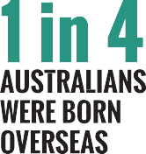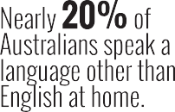

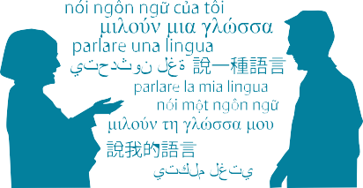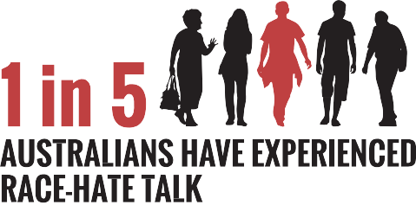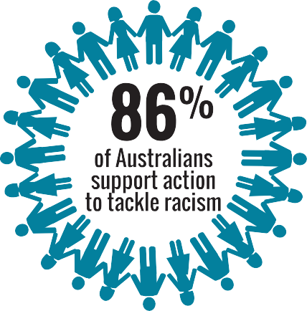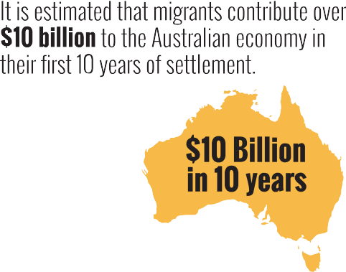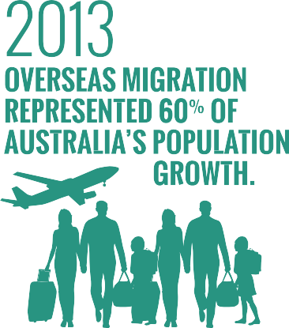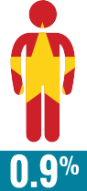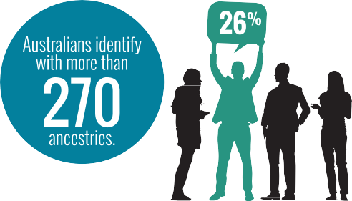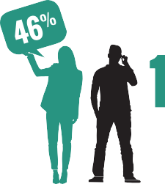

[**www.humanrights.gov.au/face-facts**](http://www.humanrights.gov.au/face-facts)

# Cultural diversity

Australia is a vibrant, multicultural country. We are home to the world’s oldest continuous cultures, as well as Australians who identify with more than 270 ancestries. Since 1945, almost seven million people have migrated to Australia.

This rich, cultural diversity is one of our greatest strengths. It is central to our national identity.

In 1975, the [Racial Discrimination Act](https://www.humanrights.gov.au/publications/know-your-rights-racial-discrimination-and-vilification) came into force, making discrimination in different parts of public life against the law.

The Act, which was Australia’s first federal anti-discrimination law, continues to send a strong message about our common commitment to racial equality and the importance of a fair go for all.

In 1995, the Act was extended to make public acts of racial hatred against the law.

Despite this legal protection, too many people in Australia continue to experience prejudice and unfair treatment because of how they look or where they come from.

### About

* + One in four of Australia’s 22 million people were born overseas; 46 per cent were born overseas or have a parent who was born overseas; and nearly 20 per cent of Australians speak a language other than English at home.1
  + In 2012-2013, overseas migration represented 60 per cent of Australia’s population growth in the year.2
  + People born in the United Kingdom continue to be the largest group of overseas-born residents (5.3 per cent), followed by New Zealand (2.6 per cent), China (1.8 per cent), India (1.6 per cent) and Vietnam (0.9

per cent).3 In 2012-13, 123,438 people from more than 190 countries were approved to become Australian citizens.4

* + Migrants make an enormous contribution to Australia’s economy and provide an estimated fiscal benefit

of over 10 billion dollars in their first ten years of settlement.5 In 2010-11, international education contributed $16.3 billion to the Australian economy.6

* + Barriers to racial equality
* One in ten Australians (1.5 million of the nation’s adult population) believe that some races are inferior or superior to others.7
* Around 20 per cent of Australians have experienced race-hate talk;8 11 per cent have experienced race- based social exclusion;9 six per cent reported physical attacks based on their race and/or traditional dress; and 19 per cent reported discrimination because of their skin colour, ethnic origin or religion.10
* Of the 500 complaints lodged under the Racial Discrimination Act in 2012-2013*,* 192 related to incidents of racial hatred. This was a 59 per cent increase over the previous year, with a large proportion of the complaints (41 per cent) involving material on the Internet.11
* People born in countries where English is not the main spoken language are three times as likely to experience discrimination in the workplace,12 twice as likely to experience discrimination in education13 and

around four times as likely to experience discrimination in policing and housing.14

* Around one in three (35 per cent) recent migrants said they faced hurdles to finding their first job due to a lack of Australian work experience or references (64 per cent), language difficulties (33 per cent), a lack of local contacts or networks (23 percent) or difficulties having their skills or qualifications recognised (15 per cent).15

### Positive developments

* + Most new migrants say they feel a strong sense of belonging to Australia and that this feeling deepens over time.16
  + Most Australians (86 per cent) support action to tackle racism in Australia.17
  + Since being launched in 2012, over 200 organisations

– from the business, sports, education, local government and community sectors – have signed on as supporters of the national anti-racism campaign, *Racism. It Stops with Me*.

### Did you know?

* + The vast majority of Australians (84 per cent) believe that multiculturalism has been good for Australia.18

### Find out more

* + Australian Human Rights Commission; [National](http://itstopswithme.humanrights.gov.au/it-stops-with-me/strategy) [Anti-Racism Strategy 2012-2015](http://itstopswithme.humanrights.gov.au/it-stops-with-me/strategy) (2012)
  + Australian Human Rights Commission; [Racism.](http://itstopswithme.humanrights.gov.au/) [It Stops with Me](http://itstopswithme.humanrights.gov.au/) (2012- )
  + Department of Immigration and Border Protection; [*The People of Australia – Australia’s Multicultural*](http://www.immi.gov.au/living-in-australia/a-multicultural-australia/multicultural-policy/)[*Policy*](http://www.immi.gov.au/living-in-australia/a-multicultural-australia/multicultural-policy/)(2011)
  + Australian Bureau of Statistics, [*Reflecting a Nation:*](http://www.abs.gov.au/ausstats/abs%40.nsf/Lookup/2071.0main%2Bfeatures902012-2013)[*Stories from the 2011 Census*](http://www.abs.gov.au/ausstats/abs%40.nsf/Lookup/2071.0main%2Bfeatures902012-2013)(2012-2013)
  + University of Western Sydney, [*Challenging Racism:*](http://www.uws.edu.au/ssap/school_of_social_sciences_and_psychology/research/challenging_racism)[*The Anti-Racism Research Project*](http://www.uws.edu.au/ssap/school_of_social_sciences_and_psychology/research/challenging_racism)(2008)

### Our role

The Commission helps people resolve complaints of discrimination under the [Racial Discrimination Act](http://www.humanrights.gov.au/our-work/legal/legislation). The Act protects people across Australia from unfair treatment on the basis of their race, colour, descent, or national or ethnic origin. It also makes racial vilification against the law.

The [Race Discrimination Commissioner](https://www.humanrights.gov.au/race-discrimination-commissioner-dr-tim-soutphommasane) undertakes a wide range of activities to address racism and racial discrimination, which includes implementing the [National Anti-Racism](http://itstopswithme.humanrights.gov.au/it-stops-with-me/strategy) [Strategy](http://itstopswithme.humanrights.gov.au/it-stops-with-me/strategy) and coordinating the national anti-racism campaign*,* [Racism. It Stops with Me](http://itstopswithme.humanrights.gov.au/).

The Commissioner also undertakes research projects and provides policy advice on issues affecting different groups in the community.

Find out more about [our work](https://www.humanrights.gov.au/our-work/race-discrimination) in this area.

##### Endnotes

1. Australian Bureau of Statistics, *4102.0-Australian Social Trends*

(April 2013).

1. Australian Bureau of Statistics, [*3101.0-Australian Demographic Statistics,*](http://www.abs.gov.au/ausstats/abs%40.nsf/mf/3101.0)[*September 2013*](http://www.abs.gov.au/ausstats/abs%40.nsf/mf/3101.0)(March 2014).
2. Australian Bureau of Statistics, [*3412.0-Migration, Australia, 2011-12 and*](http://www.abs.gov.au/ausstats/abs%40.nsf/Lookup/3412.0Chapter12011-12%20and%202012-13)[*2012-13*](http://www.abs.gov.au/ausstats/abs%40.nsf/Lookup/3412.0Chapter12011-12%20and%202012-13)(December 2013).
3. Department of Immigration and Border Protection: [*Facts and Statistics*](http://www.citizenship.gov.au/learn/facts-and-stats/)

(2013)

1. Department of Immigration and Citizenship, [*Immigration update*](http://www.immi.gov.au/media/publications/statistics/immigration-update/update-2010-11.pdf)[*2010–2011*](http://www.immi.gov.au/media/publications/statistics/immigration-update/update-2010-11.pdf)(2011), p 109.
2. Australian Education International, [*Export Income to Australia from*](https://www.aei.gov.au/research/Research-Snapshots/Documents/Export%20Income%202010-11.pdf)[*Education Services in 2010–11*](https://www.aei.gov.au/research/Research-Snapshots/Documents/Export%20Income%202010-11.pdf)(November 2011).
3. University of Western Sydney, [*Challenging Racism: The Anti-Racism*](http://www.uws.edu.au/ssap/ssap/research/challenging_racism/findings_by_region)[*Research Project*](http://www.uws.edu.au/ssap/ssap/research/challenging_racism/findings_by_region)(2008).
4. University of Western Sydney, above.
5. University of Western Sydney, note 7.
6. Scanlon Foundation, [*Mapping Social Cohesion: The Scanlon Foundation*](http://www.scanlonfoundation.org.au/docs/2013_SocC_report_final.pdf)[*Survey 2013*](http://www.scanlonfoundation.org.au/docs/2013_SocC_report_final.pdf)(2013), p 2.
7. Australian Human Rights Commission, [*Annual Report 2012-2013*](https://www.humanrights.gov.au/publications/annual-report-2012-2013)(2013).
8. Victorian Health Promotion Foundation (VicHealth), [*More than tolerance:*](http://www.vichealth.vic.gov.au/discrimattitudes/)[*Embracing diversity for health: Discrimination affecting migrant and*](http://www.vichealth.vic.gov.au/discrimattitudes/)[*refugee communities in Victoria, its health consequences, community*](http://www.vichealth.vic.gov.au/discrimattitudes/)[*attitudes and solutions*](http://www.vichealth.vic.gov.au/discrimattitudes/)(2007).
9. VicHealth, above.
10. VicHealth, note 12.
11. Australian Bureau of Statistics, [*6250.0-Characteristics of Recent*](http://www.abs.gov.au/ausstats/abs%40.nsf/Products/6250.0%7ENov%2B2010%7EMain%2BFeatures%7EEmployment?OpenDocument)[*Migrants, Australia, November 2010*](http://www.abs.gov.au/ausstats/abs%40.nsf/Products/6250.0%7ENov%2B2010%7EMain%2BFeatures%7EEmployment?OpenDocument)(May 2011).
12. The [*Ipsos McKay Report: SBS Immigration Nation*](http://media.sbs.com.au/home/upload_media/site_20_rand_2115667245_sbs_immigration_nation_final_report_16_dec.pdf)(2011) found that

60 per cent of first-generation migrants felt a strong sense of belonging to Australia, which rose to 80 per cent by the second generation, in line with the national average.

1. University of Western Sydney, note 7.
2. Scanlon Foundation, note 10.

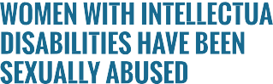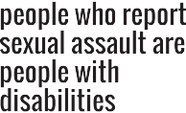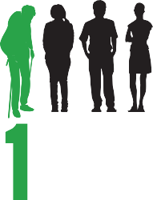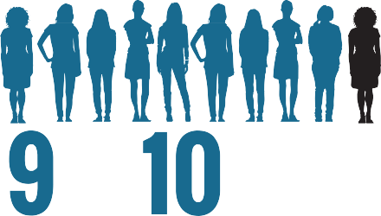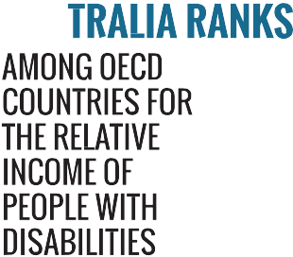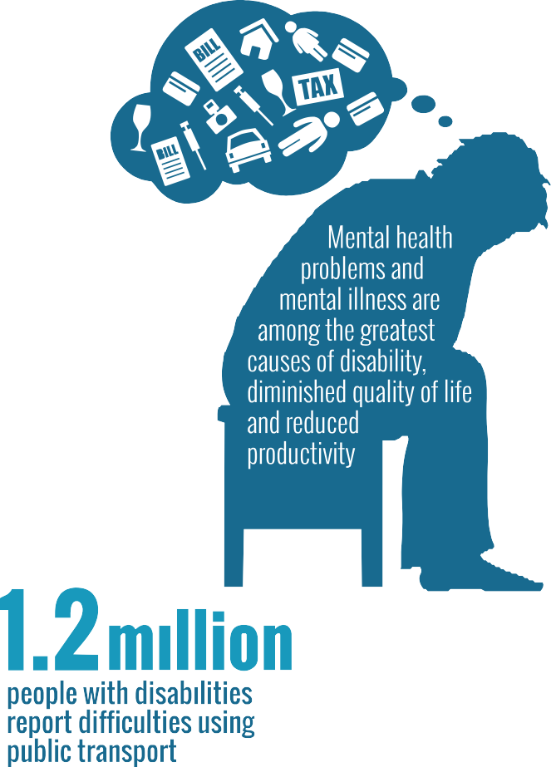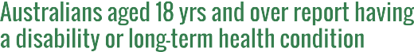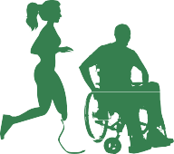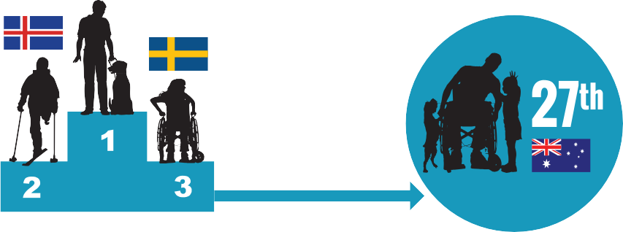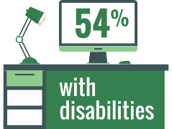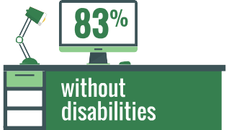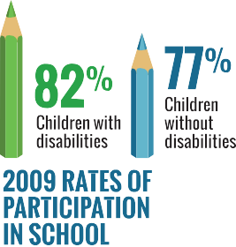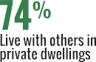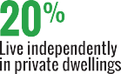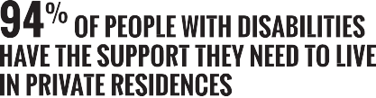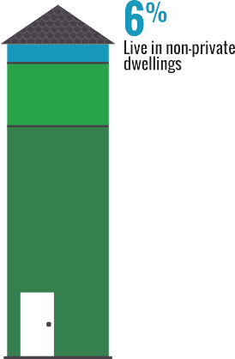

 



[**www.humanrights.gov.au/face-facts**](http://www.humanrights.gov.au/face-facts)



# Disability rights

Many people will have a disability at some stage in their lives. For some, the disability will be temporary. Others may be affected for a lifetime.

Whatever the type or impact of a disability, everyone has the right to be an active member of their community and to have a say in the decisions that affect their lives.

The United Nations [Convention on the Rights of Persons with](https://www.humanrights.gov.au/our-work/disability-rights/international/disability-rights-international-convention-human-rights-and) [Disabilities](https://www.humanrights.gov.au/our-work/disability-rights/international/disability-rights-international-convention-human-rights-and), which Australia ratified in 2008, sets out the role of governments to make this a reality.

However, negative attitudes, physical barriers and difficulties accessing necessary supports still limit the opportunities of people with disabilities to find work, study, socialise and be included in community life.

In Australia, the [Disability Discrimination Act](http://www.humanrights.gov.au/about/legislation/index.html#dda) protects people across Australia from unfair treatment in many areas of public life. It also promotes equal rights, equal opportunity and equal access for people with disabilities.

### About

* + Around 6.8 million Australians (40 per cent) aged 18 years and over report having a disability or long-

term health condition.1 Most (87 per cent) are restricted in carrying out at least one everyday activity, such as self-care, mobility or communication.2

* + The likelihood of having a disability increases as people age. For example, seven per cent of children aged under 15 years, 15 per cent of people aged

15 to 64 years and over half (53 per cent) of people aged 65 years and over report having some form of disability.3

* + In 2009, 290,000 children aged 0 to 14 years reported having a disability. Over half (57 per cent) had a profound or severe disability and almost one in five (18 per cent) had a moderate or mild disability.4

### Key issues for people with disabilities

* People with disabilities are more likely to experience poverty, live in poor quality or insecure housing and have low levels of education. They are often socially isolated, with fewer opportunities to take part in community life.5
* Mental health problems and mental illness are among the greatest causes of disability, diminished quality of life and reduced productivity.6
* Australia ranks lowest among OECD countries for the relative income of people with disabilities.7 Overall employment rates for people with disabilities remain low, with workforce participation at around 54 per cent compared to 83 per cent for people without a disability.8
* In NSW, young people with mental health disorders and/or cognitive impairment are at least six times more likely to be in prison compared with young people without a disability.9
* Despite progress towards making all public transport in Australia fully accessible by 2022, 1.2 million people with disabilities report difficulties using public transport.10
* More than a quarter of people who report sexual assault have a disability.11 Ninety per cent of women with intellectual disabilities have been sexually abused.12

### Positive developments

* + In 2009, children with disabilities had significantly higher rates of participation in school compared to children without disability (82 per cent and 77 per cent respectively). This reflects a growing number of children with disabilities staying in school for longer.13
  + Most people with disabilities (94 per cent) have the support they need to live in private residences; 74 per cent live with others and 20 per cent live alone. People with disabilities are also more likely to own their own home outright (24 per cent) compared with people who do not have disabilities (16 per cent).14
  + In July 2013, the [National Disability Insurance](http://www.ndis.gov.au/) [Scheme](http://www.ndis.gov.au/) was rolled out in Tasmania, South Australia, Victoria (Barwon area) and NSW (Hunter area). From July 2014, it will commence across the ACT and in the Northern Territory (Barkly region) and Western Australia (Perth Hills area). The full national scheme will commence progressively from July 2016.

### Did you know?

The life expectancy of Australians born with Down Syndrome has more than tripled in the four decades to 2002, increasing from 18 years to 60 years. A contributing factor to this positive outcome is the shift in public attitudes regarding Down Syndrome.15

### Find out more

* Australian Human Rights Commission, [*Twenty Years,*](http://www.humanrights.gov.au/twenty-years-twenty-stories)[*Twenty Stories; Celebrating 20 years of the Disability*](http://www.humanrights.gov.au/twenty-years-twenty-stories)[*Discrimination Act*](http://www.humanrights.gov.au/twenty-years-twenty-stories)(2013)
* Council of Australian Governments (COAG), [*Disability*](https://www.coagreformcouncil.gov.au/reports/disability/disability-2011-12-comparing-performance-across-australia)[*2011-12: Comparing performance across Australia*](https://www.coagreformcouncil.gov.au/reports/disability/disability-2011-12-comparing-performance-across-australia)(2013)
* Department of Social Services, [*National Disability*](http://www.dss.gov.au/our-responsibilities/disability-and-carers/program-services/government-international/national-disability-strategy#1)[*Strategy 2010-2020*](http://www.dss.gov.au/our-responsibilities/disability-and-carers/program-services/government-international/national-disability-strategy#1)(2011)
* National People with Disabilities and Carer Council, [*Shut Out: The Experience of People with Disabilities*](http://www.dss.gov.au/our-responsibilities/disability-and-carers/program-services/government-international/national-disability-strategy-shut-out-report)[*and their Families in Australia*](http://www.dss.gov.au/our-responsibilities/disability-and-carers/program-services/government-international/national-disability-strategy-shut-out-report)(2012)

### Our role

The Commission helps people resolve complaints of unfair treatment under the [Disability Discrimination Act](http://www.humanrights.gov.au/about/legislation/index.html#dda). We also assess applications for temporary [exemptions](http://www.humanrights.gov.au/disability_rights/exemptions/exemptions.html) under the Act and provide advice on laws, policies and programs that affect people with disabilities.

The [Disability Discrimination Commissioner](http://www.humanrights.gov.au/about/president_commissioners/innes.html) works in partnership with others to help all Australians understand their rights and meet their legal responsibilities by conducting

[public inquiries](http://www.humanrights.gov.au/disability_rights/inquiries/inquiries.html), negotiating disability [standards and guidelines](http://www.humanrights.gov.au/disability_rights/standards/standards.html) and assisting organisations to develop [Disability Action Plans](http://www.humanrights.gov.au/disability_rights/action_plans/index.html).

Find out more about [our work](https://www.humanrights.gov.au/our-work/disability-rights) in this area.

##### Endnotes

1. Australian Bureau of Statistics, [*4159.0-General Social Survey: Summary*](http://www.abs.gov.au/ausstats/abs%40.nsf/Products/7CF609FE3B72F353CA25791A0082C3EB?opendocument)[*Results, Australia, 2010*](http://www.abs.gov.au/ausstats/abs%40.nsf/Products/7CF609FE3B72F353CA25791A0082C3EB?opendocument)(September 2011).
2. Australian Bureau of Statistics, [*4429.0-Profiles of Disability, Australia,*](http://www.abs.gov.au/ausstats/abs%40.nsf/Lookup/by%20Subject/4429.0%7E2009%7EMain%20Features%7EHome%20Page%7E1)[*2009*](http://www.abs.gov.au/ausstats/abs%40.nsf/Lookup/by%20Subject/4429.0%7E2009%7EMain%20Features%7EHome%20Page%7E1)(June 2012).
3. Victorian Health Promotion Foundation (VicHealth), [*Disability and health*](http://www.vichealth.vic.gov.au/Publications/Health-Inequalities/Disability-and-health-inequalities-in-Australia.aspx)[*inequalities in Australia*](http://www.vichealth.vic.gov.au/Publications/Health-Inequalities/Disability-and-health-inequalities-in-Australia.aspx)(2012). This prevalence data is based on a VicHealth analyses of the [*Survey of Disability, Ageing and Carers 2009*](http://www.abs.gov.au/AUSSTATS/abs%40.nsf/DetailsPage/4430.02009)and the current ABS disability classification system.
4. Australian Bureau of Statistics, [*4102.0-Australian Social Trends, June*](http://www.abs.gov.au/AUSSTATS/abs%40.nsf/Lookup/4102.0Main%2BFeatures30Jun%2B2012)[*2012*](http://www.abs.gov.au/AUSSTATS/abs%40.nsf/Lookup/4102.0Main%2BFeatures30Jun%2B2012)(June 2012).
5. World Health Organization and World Bank Group, [*World report on*](http://www.who.int/disabilities/world_report/2011/en/)[*disability*](http://www.who.int/disabilities/world_report/2011/en/)(2011), p 263.
6. Australian Bureau of Statistics, *4446.0-Disability, Australia, 2009*

(May 2011).

1. Organisation for Economic Co-operation and Development, [*Sickness,*](http://www.oecd.org/employment/emp/42699911.pdf)[*disability and work: Keeping on track in the economic downturn –*](http://www.oecd.org/employment/emp/42699911.pdf)[*Background paper*](http://www.oecd.org/employment/emp/42699911.pdf)(2009), p 34.
2. Australian Human Rights Commission, [*Submission to the United Nations*](https://www.humanrights.gov.au/submissions/information-concerning-australia-and-convention-rights-persons-disabilities)[*Committee on the Rights of Persons with Disabilities: Information*](https://www.humanrights.gov.au/submissions/information-concerning-australia-and-convention-rights-persons-disabilities)[*concerning Australia and the Convention on the Rights of Persons with*](https://www.humanrights.gov.au/submissions/information-concerning-australia-and-convention-rights-persons-disabilities)[*Disabilities*](https://www.humanrights.gov.au/submissions/information-concerning-australia-and-convention-rights-persons-disabilities)(11 March 2013); Australian Bureau of Statistics, note 6.
3. University of New South Wales and PwC, [*People with mental health*](https://www.humanrights.gov.au/publications/justice-reinvestment-people-disability-could-save-millions)[*disorders and cognitive impairment in the criminal justice system: Cost-*](https://www.humanrights.gov.au/publications/justice-reinvestment-people-disability-could-save-millions)[*benefit analysis of early support and diversion*](https://www.humanrights.gov.au/publications/justice-reinvestment-people-disability-could-save-millions)(2013).
4. Australian Bureau of Statistics, note 6, [Transport](http://www.abs.gov.au/ausstats/abs%40.nsf/Latestproducts/4446.0Main%20Features122009?opendocument&amp;tabname=Summary&amp;prodno=4446.0&amp;issue=2009&amp;num&amp;view) (2011).
5. Statewide Steering Committee to Reduce Sexual Assault, Office of Women’s Policy, Department for Victorian Communities, [*Study of*](http://mams.rmit.edu.au/igzd08ddxtpwz.pdf)[*Reported Rapes in Victoria 2000–2003: Summary Research Report*](http://mams.rmit.edu.au/igzd08ddxtpwz.pdf)(2006), p 16.
6. C Frohmader, Women with Disabilities Australia, [*There is no justice –*](http://find.lib.uts.edu.au/search.do%3Bjsessionid%3D418D49B976CF8AE8B80A2BDC1C293C58?R=OPAC_b1880778)[*there’s just us: The status of women with disabilities in Australia*](http://find.lib.uts.edu.au/search.do%3Bjsessionid%3D418D49B976CF8AE8B80A2BDC1C293C58?R=OPAC_b1880778)(2002); as cited in VicHealth, [*Disability and health inequalities in Australia*](http://www.vichealth.vic.gov.au/Publications/Health-Inequalities/Disability-and-health-inequalities-in-Australia.aspx)(2012).
7. Australian Bureau of Statistics, note 2.
8. Australian Bureau of Statistics, note 6.
9. A Bittles and E Glasson 2004, [*‘*Clinical, social, and ethical implications of](http://onlinelibrary.wiley.com/doi/10.1111/j.1469-8749.2004.tb00483.x/abstract) [changing life expectancy in Down syndrome’](http://onlinelibrary.wiley.com/doi/10.1111/j.1469-8749.2004.tb00483.x/abstract), *Developmental Medicine & Child Neurology*, vol 46, no 4 (2004) p 282.



**www.humanrights.gov.au/face-facts**

# Gender equality

In recent decades, women in Australia have made significant strides towards equality with men. At universities, in workplaces, in boardrooms and in government, a growing number of women have taken on leadership roles, forging pathways for other women and girls to follow.

In 1984, the [Sex Discrimination Act](https://www.humanrights.gov.au/publications/know-your-rights-sex-discrimination-and-sexual-harassment) came into force, making discrimination in different parts of public life against the law.

The Act, which gives effect to Australia’s [international human](http://www.humanrights.gov.au/sex_discrimination/international/cedaw.html) [rights obligations](http://www.humanrights.gov.au/sex_discrimination/international/cedaw.html), has played an important role in changing community attitudes and helping advance gender equality in this country.

Despite this progress, women and girls continue to experience inequality and discrimination in many important parts of their lives, which can limit the choices and opportunities available to them.

### About

* Women and girls make up just over half (50.2 per cent) of the Australian population.1
* While women comprise roughly 46 per cent of all employees in Australia,2 they take home $262.50 less than men each week (full-time adult ordinary time earnings).3 The national gender “pay gap” is 17.1 per cent and it has remained stuck between 15 per cent and 18 per cent for the past two decades.4
* Australian women account for 92 per cent of primary carers for children with disabilities, 70 per cent of primary carers for parents and 52 per cent of primary carers for partners.5
* In 2013, Australia was ranked 24th on a global index measuring gender equality, slipping from a high point of 15th in 2006.6

### Barriers to gender equality

* [The Australian workforce is highly segregated by](http://www.humanrights.gov.au/publications/gender-equality-blueprint-2010#fn32) [gender and female-dominated industries – such as](http://www.humanrights.gov.au/publications/gender-equality-blueprint-2010#fn32) [aged care, child care and health and community](http://www.humanrights.gov.au/publications/gender-equality-blueprint-2010#fn32) [services – have been historically undervalued.7](http://www.humanrights.gov.au/publications/gender-equality-blueprint-2010#fn32) [Australian women are over-represented as part-time](http://www.humanrights.gov.au/publications/gender-equality-blueprint-2010#fn32) [workers in low-paid industries](http://www.humanrights.gov.au/publications/gender-equality-blueprint-2010#fn32)8 and in insecure work and continue to be underrepresented in leadership roles in the private and public sectors.9
* A quarter of women were sexually harassed in the workplace over the past five years.10 The harasser

was most likely to be a co-worker (52 per cent) and the most common forms of sexual harassment included sexually suggestive comments/jokes (55 per cent), intrusive questions about private life or appearance (50 per cent) and inappropriate staring or leering (31 per cent).11

* Women do two-thirds of the unpaid caring and domestic work in Australian households.12 They spend almost three times as many hours each week looking after children compared to men.13
* In 2009-2010, Australian women reached retirement age with an average of 36 per cent – or $87,532 – less superannuation than men.14 As a result, women are more likely to experience poverty in their retirement years and be far more reliant on the Age Pension.15
* One in three Australian women experiences physical violence in her lifetime16 and nearly one in five experiences sexual assault.17 It is estimated that violence against women and children will cost the Australian economy $15.6 billion per year by 2021- 2022 unless decisive action is taken to prevent it.18
* More than smoking or obesity, domestic and family violence is the leading preventable cause of death, disability and illness in women aged 15 to 44 years.19

### Positive developments

* + The number of women on the Boards of ASX-listed companies has grown from 8.3 per cent in 2010 to

15.4 per cent in 2013,20 due in part to a diversity policy implemented by the ASX Corporate Governance Council in 2010. [Increasing the number of women in](http://www.humanrights.gov.au/publications/women-male-dominated-industries-toolkit-strategies-2013/chapter-1-summary-strategies#fn7) [corporate leadership positions has the potential the](http://www.humanrights.gov.au/publications/women-male-dominated-industries-toolkit-strategies-2013/chapter-1-summary-strategies#fn7) [boost the level of economic activity in Australia by up](http://www.humanrights.gov.au/publications/women-male-dominated-industries-toolkit-strategies-2013/chapter-1-summary-strategies#fn7) [to 20 per cent.](http://www.humanrights.gov.au/publications/women-male-dominated-industries-toolkit-strategies-2013/chapter-1-summary-strategies#fn7)21

* + Australian men and women overwhelmingly believe (90 per cent) that men should be as involved in parenting as women.22 [Men are also more likely than women to](http://www.humanrights.gov.au/publications/gender-equality-blueprint-2010#fn22) [want greater employment flexibility to care for their](http://www.humanrights.gov.au/publications/gender-equality-blueprint-2010#fn22) [children (46 per cent compared with 40 per cent).](http://www.humanrights.gov.au/publications/gender-equality-blueprint-2010#fn22)23
  + From 2013, over one million Australian workers are able to take leave and enjoy other protections because of domestic violence clauses in their workplace agreement or award conditions.24

### Did you know?

* + The average Australian woman has to work an **extra 66 days a year to earn the same pay** as the average man.25

### Find out more

* Australian Bureau of Statistics, [*Caring in the*](http://www.abs.gov.au/ausstats/abs%40.nsf/Latestproducts/4436.0Main%20Features12009?opendocument&amp;tabname=Summary&amp;prodno=4436.0&amp;issue=2009&amp;num&amp;view)[*Community, 2009*](http://www.abs.gov.au/ausstats/abs%40.nsf/Latestproducts/4436.0Main%20Features12009?opendocument&amp;tabname=Summary&amp;prodno=4436.0&amp;issue=2009&amp;num&amp;view)(updated October 2011)
* Australian Human Rights Commission, [*Working*](https://www.humanrights.gov.au/working-without-fear-results-sexual-harassment-national-telephone-survey-2012)[*without fear: Results of the Sexual Harassment*](https://www.humanrights.gov.au/working-without-fear-results-sexual-harassment-national-telephone-survey-2012)[*National Telephone Survey*](https://www.humanrights.gov.au/working-without-fear-results-sexual-harassment-national-telephone-survey-2012)(2012)
* Australian Human Rights Commission, [*Gender*](https://www.humanrights.gov.au/publications/gender-equality-blueprint-2010)[*Equality Blueprint 2010*](https://www.humanrights.gov.au/publications/gender-equality-blueprint-2010)(2010)
* Australian Human Rights Commission, [*Australian*](https://www.humanrights.gov.au/publications/australian-study-tour-report-visit-un-special-rapporteur-violence-against-women)[*study tour report: Visit of the UN Special Rapporteur*](https://www.humanrights.gov.au/publications/australian-study-tour-report-visit-un-special-rapporteur-violence-against-women)[*on violence against women*](https://www.humanrights.gov.au/publications/australian-study-tour-report-visit-un-special-rapporteur-violence-against-women)(2012)
* Workplace Gender Equality Agency, [*Gender pay gap*](https://www.wgea.gov.au/sites/default/files/2014-03-04-Gender_Pay_Gap_factsheet_website.pdf)[*statistics*](https://www.wgea.gov.au/sites/default/files/2014-03-04-Gender_Pay_Gap_factsheet_website.pdf)(March 2014)
* Workplace Gender Equality Agency; *Gender workplace statistics at a glance* (October 2013)
* World Economic Forum, [*Global Gender Gap Report*](http://www.weforum.org/reports/global-gender-gap-report-2013)[*2013*](http://www.weforum.org/reports/global-gender-gap-report-2013)(2013)

### Our role

The Commission helps people resolve complaints of unfair treatment under the [Sex Discrimination Act](https://www.humanrights.gov.au/publications/know-your-rights-sex-discrimination-and-sexual-harassment), including discrimination on the basis of sex, marital (or relationship) status and pregnancy. The Act also protects workers with family responsibilities and makes sexual harassment against the law.

The [Sex Discrimination Commissioner](https://www.humanrights.gov.au/about/commissioners/sex-discrimination-commissioner) works in partnership with a broad range of groups to promote gender equality and counter discrimination, sexual harassment, violence against women and other barriers to equality. She also undertakes major research projects and provides policy advice to government and others to bring about positive change.

Find out more about [our work](https://www.humanrights.gov.au/our-work/sex-discrimination) in this area.

##### Endnotes

1. Australian Bureau of Statistics, [*3201.0-Population by Age and Sex,*](http://www.abs.gov.au/AUSSTATS/abs%40.nsf/Lookup/3201.0Main%2BFeatures1Jun%202009?Open)[*Australian States and Territories, June 2009*](http://www.abs.gov.au/AUSSTATS/abs%40.nsf/Lookup/3201.0Main%2BFeatures1Jun%202009?Open), (December 2009).
2. Workplace Gender Equality Agency, [*Gender workplace statistics at a*](http://www.wgea.gov.au/sites/default/files/2013-04%20-%20Stats%20at%20a%20glance_0.pdf)[*glance*](http://www.wgea.gov.au/sites/default/files/2013-04%20-%20Stats%20at%20a%20glance_0.pdf)(April 2013).
3. Workplace Gender Equality Agency, [*Gender pay gap statistics*](https://www.wgea.gov.au/sites/default/files/2014-03-04-Gender_Pay_Gap_factsheet_website.pdf)

(March 2014) p 2.

1. Workplace Gender Equality Agency, above.
2. Australian Bureau of Statistics, [*4153.0-How Australians Use Their Time,*](http://www.abs.gov.au/ausstats/abs%40.nsf/mf/4153.0)[*2006*](http://www.abs.gov.au/ausstats/abs%40.nsf/mf/4153.0)(February 2008).
3. World Economic Forum, [*Global Gender Gap Report 2013*](http://www.weforum.org/reports/global-gender-gap-report-2013)(2013).
4. Australian Human Rights Commission, [*Women in male-dominated*](https://www.humanrights.gov.au/women-male-dominated-industries-toolkit-strategies)[*industries: A toolkit of strategies*](https://www.humanrights.gov.au/women-male-dominated-industries-toolkit-strategies)(2013), p 3.
5. For example approximately 45 per cent of women in the workforce are employed part-time compared with around 16 per cent of men. See: Australian Bureau of Statistics, [*6202.0-Labour Force, Australia, Table 03:*](http://www.ausstats.abs.gov.au/ausstats/meisubs.nsf/0/2DE8EA310F563A2BCA257648001518D9/%24File/6202003.xls#A163137K)[*Labour force status by sex*](http://www.ausstats.abs.gov.au/ausstats/meisubs.nsf/0/2DE8EA310F563A2BCA257648001518D9/%24File/6202003.xls#A163137K)(September 2009).
6. For example, women hold only four CEO positions and make up only

10.7 per cent of executive management positions in ASX 200 companies (see: [www.eowa.gov.au/Australian_Women_In_Leadership_Census.](http://www.eowa.gov.au/Australian_Women_In_Leadership_Census.asp) [asp](http://www.eowa.gov.au/Australian_Women_In_Leadership_Census.asp)) and, despite making up more than half of all Commonwealth public servants, they comprise only 37% of the Senior Executive Service (see: [www.apsc.gov.au/stateoftheservice/index.html](http://www.apsc.gov.au/stateoftheservice/index.html)).

1. Australian Human Rights Commission, [*Working without fear: Results of*](https://www.humanrights.gov.au/working-without-fear-results-sexual-harassment-national-telephone-survey-2012)[*the Sexual Harassment National Telephone Survey*](https://www.humanrights.gov.au/working-without-fear-results-sexual-harassment-national-telephone-survey-2012)(2012).
2. Australian Human Rights Commission, above.
3. Australian Bureau of Statistics, note 5.
4. Australian Bureau of Statistics, note 5.
5. Council of Australia Governments (COAG) Reform Council, [*Tracking*](https://www.coagreformcouncil.gov.au/reports/gender-equity/tracking-equity-comparing-outcomes-women-and-girls-across-australia)[*equity: Comparing outcomes from women and girls across Australia*](https://www.coagreformcouncil.gov.au/reports/gender-equity/tracking-equity-comparing-outcomes-women-and-girls-across-australia)(2012).
6. R Tanton, Y Vidyattama, J McNamara, Q Ngu Vu & A Harding, [*Old Single*](http://onlinelibrary.wiley.com/doi/10.1111/j.1759-3441.2009.00022.x/abstract)[*and Poor: Using Microsimulation and Microdata to Analyse Poverty and*](http://onlinelibrary.wiley.com/doi/10.1111/j.1759-3441.2009.00022.x/abstract)[*the Impact of Policy Change Among Older Australians*](http://onlinelibrary.wiley.com/doi/10.1111/j.1759-3441.2009.00022.x/abstract)(2008) p 15.
7. Australian Bureau of Statistics, [*4906.0 – Personal Safety, Australia, 2005*](http://www.abs.gov.au/AUSSTATS/abs%40.nsf/Lookup/4906.0Main%2BFeatures12005%20(Reissue)?OpenDocument)[*(Reissue)*](http://www.abs.gov.au/AUSSTATS/abs%40.nsf/Lookup/4906.0Main%2BFeatures12005%20(Reissue)?OpenDocument)(August 2006).
8. Australian Bureau of Statistics, above.
9. The National Council to Reduce Violence against Women and their Children, [*The cost of violence against women and their children*](http://www.dss.gov.au/sites/default/files/documents/05_2012/vawc_economic_report.pdf)(March 2009), p 4.
10. Victorian Health Promotion Foundation (VicHealth), [*The health costs of*](http://www.vichealth.vic.gov.au/Publications/Freedom-from-violence/The-Health-Costs-of-Violence.aspx)[*violence: Measuring the burden of disease caused by intimate partner*](http://www.vichealth.vic.gov.au/Publications/Freedom-from-violence/The-Health-Costs-of-Violence.aspx)[*violence*](http://www.vichealth.vic.gov.au/Publications/Freedom-from-violence/The-Health-Costs-of-Violence.aspx)(2004), p 8.
11. Australian Institute of Company Directors, [*Appointments to ASX 200*](http://www.companydirectors.com.au/Director-Resource-Centre/Governance-and-Director-Issues/Board-Diversity/Statistics)[*Boards*](http://www.companydirectors.com.au/Director-Resource-Centre/Governance-and-Director-Issues/Board-Diversity/Statistics)(updated online resource).
12. Goldman Sachs JB Were Investment Research, [*Australia’s Hidden*](http://www.womenonboards.org.au/pubs/reports/091130gsjbw.pdf)[*Resource: The Economic Case for Increasing Female Participation*](http://www.womenonboards.org.au/pubs/reports/091130gsjbw.pdf)(2009).
13. A Evans and E Gray, ‘What makes an Australian family?’ in S Wilson,

G Meagher, R Gibson, D Denemark & M Western (eds), *Australian Social Attitudes: The first report* (2005), pp 12–29, p 27.

1. Newspoll Market Research, [*Out of School Hours Care Study*](http://www.nfaw.org.au/assets/Socialpolicy/080807-Out-of-School-Hours-Care-Study-2.pdf)(2008).
2. L McFerran, Safe at Home, Safe At Work Project, Australian Domestic and Family Violence Clearing House, UNSW, [‘When domestic violence](http://www.abc.net.au/unleashed/4516492.html) [becomes a workplace problem’](http://www.abc.net.au/unleashed/4516492.html), ABC The Drum Opinion 13 February 2013.
3. Workplace Gender Equality Agency, [*Gender pay gap statistics*](https://www.wgea.gov.au/sites/default/files/2014-03-04-Gender_Pay_Gap_factsheet_website.pdf) *2014* note 3, p 4.

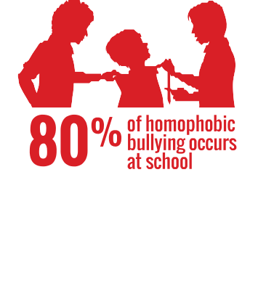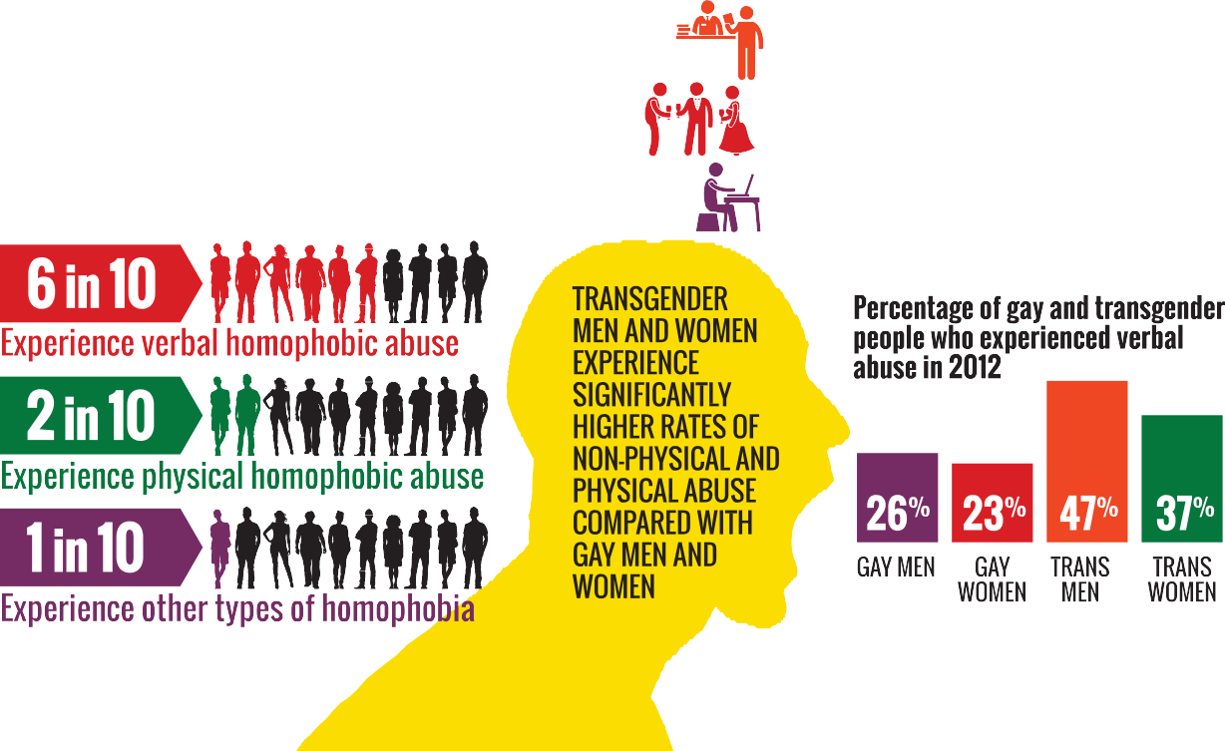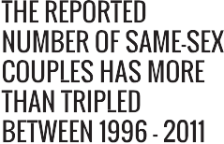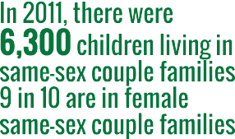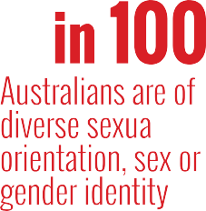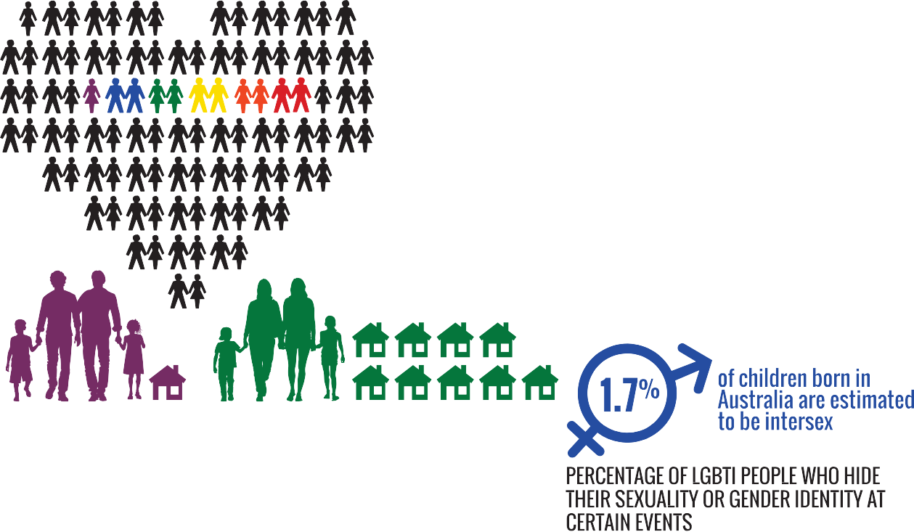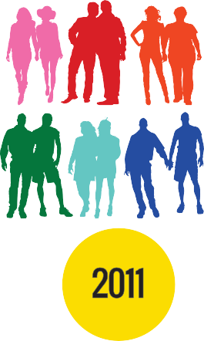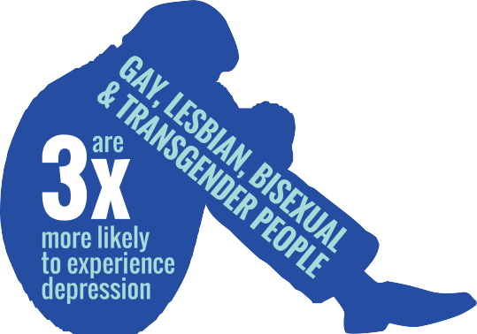

[**www.humanrights.gov.au/face-facts**](http://www.humanrights.gov.au/face-facts)

# Lesbian, gay, bisexual, trans and intersex people

Equality and freedom from discrimination are fundamental human rights that belong to all people, regardless of sexual orientation, gender identity or because they are intersex.

On 1 August 2013, the [Sex Discrimination Act 1984](http://www.comlaw.gov.au/Details/C2013C00012) was amended to make discrimination on the basis of a person’s sexual orientation, gender identity and intersex status against the law.

Despite this important step forward, lesbian, gay, bisexual,

### Key issues for LGBTI people

* + A large number of LGBTI people hide their sexuality or gender identity when accessing services (34 per cent), at social and community events (42 per cent) and

trans and intersex (LGBTI) people in Australia still experience

at work (39 per cent).6

Young people aged 16 to 24

discrimination, harassment and hostility in many parts of everyday life; in public, at work and study, accessing health and other services and securing proper recognition of their sex in official documents.

### About

* + - Australians of diverse sexual orientation, sex or gender identity may account for up to 11 per cent of the Australian population.1
    - [Same-sex couples make up about one per cent of](http://www.humanrights.gov.au/publications/gender-equality-blueprint-2010#fn2) [all couples in Australia. In 2011, there were around](http://www.humanrights.gov.au/publications/gender-equality-blueprint-2010#fn2)

[33,700 same-sex couples in Australia, including 17,600](http://www.humanrights.gov.au/publications/gender-equality-blueprint-2010#fn2) [male same-sex couples and 16,100 female same-sex](http://www.humanrights.gov.au/publications/gender-equality-blueprint-2010#fn2) [couples.2](http://www.humanrights.gov.au/publications/gender-equality-blueprint-2010#fn2) The number of same-sex couples more than tripled between 1996 and 2011.3

* + - In 2011, there were 6,300 children living in same-sex couple families, up from 3,400 in 2001. Most of these children (89 per cent) are in female same-sex couple families.4
    - There are no firm figures for Australia’s intersex population. Estimates range from one in 2,000 births to four per cent of the population.5

years are most likely to hide their sexuality or gender

identity.7

* LGBTI young people report experiencing verbal homophobic abuse (61 per cent), physical homophobic abuse (18 per cent) and other types of homophobia (nine per cent), including cyberbullying, graffiti, social exclusion and humiliation.8
* Eighty per cent of homophobic bullying involving LGBTI young people occurs at school and has a profound impact on their well-being and education.9
* Transgender males and females experience significantly higher rates of non-physical and physical abuse compared with lesbians and gay men.10
* Gay, lesbian, bisexual and transgender people are three times more likely to experience depression compared to the broader population.11
* Around 60 per cent of same-sex attracted and gender- questioning young people said they experienced verbal abuse because of their sexuality, while 18 per cent reported experiencing physical abuse. Young men (70 per cent) and gender-questioning young people (66 per cent) were more likely than young women (53 per cent) to experience verbal abuse.12

### Positive developments

* + LGBTI young people at schools where protective policies are in place are more likely to feel safe compared with those in schools without similar policies (75 per cent compared with 45 per cent). They are almost half less likely to be physically abused at school, less likely to suffer other forms of homophobic abuse, less likely to self-harm and less likely to attempt suicide.13
  + People in same-sex couples tend to be more highly educated,14 more likely to work in highly skilled occupations (53 per cent compared with 43 per cent)15 and more likely to have higher incomes.16
  + On measures of general health and family cohesion, children aged 5 to 17 years with same-sex attracted parents had significantly better scores when compared to Australian children from all other backgrounds and family contexts. For all other health measures, there were no statistically significant differences.17

### Did you know?

* **Almost half** of all gay, lesbian, bisexual and transgender people **hide their sexual orientation or gender identity** in public for fear of violence or discrimination.18

### Find out more

* Australian Human Rights Commission, [*Addressing*](https://www.humanrights.gov.au/publications/addressing-sexual-orientation-and-sex-andor-gender-identity-discrimination-consultation)[*sexual orientation and sex and/or gender identity*](https://www.humanrights.gov.au/publications/addressing-sexual-orientation-and-sex-andor-gender-identity-discrimination-consultation)[*discrimination: Consultation Report*](https://www.humanrights.gov.au/publications/addressing-sexual-orientation-and-sex-andor-gender-identity-discrimination-consultation)(2011)
* Australian Human Rights Commission, [*Sex Files: the*](https://www.humanrights.gov.au/sex-files-sex-gender-diversity-project-2008)[*legal recognition of sex in documents and government*](https://www.humanrights.gov.au/sex-files-sex-gender-diversity-project-2008)[*records*](https://www.humanrights.gov.au/sex-files-sex-gender-diversity-project-2008)(2009)
* Australian Human Rights Commission, [*Same-Sex:*](https://www.humanrights.gov.au/same-sex-same-entitlements)[*Same Entitlements*, Report of the National Inquiry](https://www.humanrights.gov.au/same-sex-same-entitlements) [into discrimination against people in same-sex](https://www.humanrights.gov.au/same-sex-same-entitlements) [relationships in the area of financial and work related](https://www.humanrights.gov.au/same-sex-same-entitlements) [entitlements](https://www.humanrights.gov.au/same-sex-same-entitlements) (2007)
* Australian Research Centre in Sex, Health and Society, La Trobe University, [*Private Lives 2: The*](http://www.glhv.org.au/files/PrivateLives2Report.pdf)[*second national survey of the health and wellbeing of*](http://www.glhv.org.au/files/PrivateLives2Report.pdf)[*GLBT Australians*](http://www.glhv.org.au/files/PrivateLives2Report.pdf)(2012)
* Beyond Blue, *In my shoes: Experiences of discrimination, depression and anxiety among gay, lesbian, bisexual, trans and intersex people* (2012)

### Our role

The Commission can investigate complaints of discrimination on the basis of sexual orientation, gender identity and intersex status under the [Sex Discrimination Act](https://www.humanrights.gov.au/complaints-under-sex-discrimination-act-gender-identity), which was amended in August 2013.

The amended Act also protects same-sex couples from discrimination under the definition of “marital or relationship status”.

We have conducted a number of major projects in recent years to identify and build community awareness around the human rights issues faced by LGBTI people.

Find out more about [our work](https://www.humanrights.gov.au/our-work/sexual-orientation-sex-gender-identity) in this area.

##### Endnotes

1. Department of Health, Australian Government, [*National Lesbian, Gay,*](http://www.health.gov.au/internet/main/publishing.nsf/Content/ageing-lgbti-national-aged-care-strategy-html)[*Bisexual, Transgender and Intersex (LGBTI) Ageing and Aged Care*](http://www.health.gov.au/internet/main/publishing.nsf/Content/ageing-lgbti-national-aged-care-strategy-html)[*Strategy*](http://www.health.gov.au/internet/main/publishing.nsf/Content/ageing-lgbti-national-aged-care-strategy-html)(2012).
2. Australian Bureau of Statistics, [*4102.0 – Australian Social Trends, July*](http://www.abs.gov.au/AUSSTATS/abs%40.nsf/Lookup/4102.0Main%2BFeatures10July%2B2013)[*2013, Same-Sex Couples*](http://www.abs.gov.au/AUSSTATS/abs%40.nsf/Lookup/4102.0Main%2BFeatures10July%2B2013)(July 2013).
3. Australian Bureau of Statistics, above.
4. Australian Bureau of Statistics, note 2.
5. See the website of the Organisation Intersex International Australia (OII). OII recommends a mid-range figure of 1.7 per cent of all births.
6. Australian Research Centre in Sex, Health and Society, La Trobe University, [*Private Lives 2: The second national survey of the health and*](http://www.glhv.org.au/files/PrivateLives2Report.pdf)[*wellbeing of GLBT Australians*](http://www.glhv.org.au/files/PrivateLives2Report.pdf)(2012).
7. Australian Research Centre in Sex, Health and Society, La Trobe University, above.
8. Australian Research Centre in Sex, Health and Society, La Trobe University, [Writing Themselves in 3: The third national study on](http://www.glhv.org.au/files/wti3_web_sml.pdf) [the sexual health and wellbeing of same sex attracted and gender](http://www.glhv.org.au/files/wti3_web_sml.pdf) [questioning young people](http://www.glhv.org.au/files/wti3_web_sml.pdf) (2010).
9. Australian Research Centre in Sex, Health and Society, La Trobe University, above.
10. For example, while 26 per cent of males and 23 per cent of females reported verbal abuse in the past 12 months, the percentages jump to 47 per cent and 37 per cent for trans males and trans females

respectively. See Australian Research Centre in Sex, Health and Society, La Trobe University, note 6.

1. Beyond Blue, *In my shoes: Experiences of discrimination, depression and anxiety among gay, lesbian, bisexual, trans and intersex people* (2012).
2. Australian Research Centre in Sex, Health and Society, La Trobe University, note 8.
3. T Jones and Western Australian Equal Opportunity Commission, [A report](http://www.eoc.wa.gov.au/Libraries/GBTI_project/2012-GBLTI_-_Tiffany_Jones_report.sflb.ashx) [about discrimination and bullying on the grounds of sexual orientation](http://www.eoc.wa.gov.au/Libraries/GBTI_project/2012-GBLTI_-_Tiffany_Jones_report.sflb.ashx) [and gender identity in Western Australian education](http://www.eoc.wa.gov.au/Libraries/GBTI_project/2012-GBLTI_-_Tiffany_Jones_report.sflb.ashx) (2012).
4. Australian Bureau of Statistics, note 2.
5. Australian Bureau of Statistics, note 2.
6. Australian Bureau of Statistics, note 2.
7. University of Melbourne, [*Australian Study of Child Health In Same-Sex*](http://www.achess.org.au/)[*Families (ACHESS): Interim report*](http://www.achess.org.au/)(2013).
8. Australian Research Centre in Sex, Health and Society, La Trobe University, note 6.

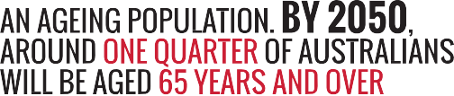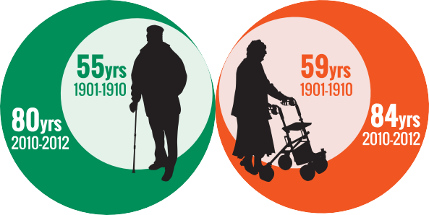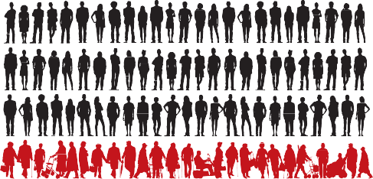

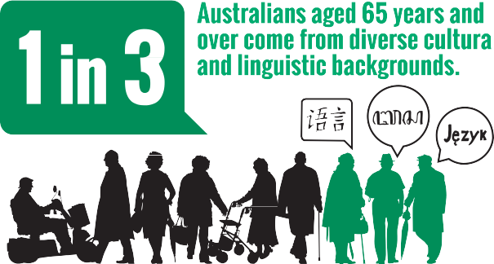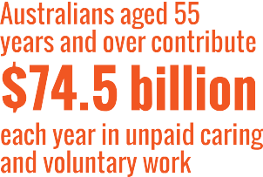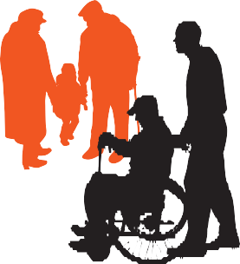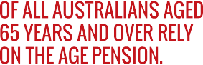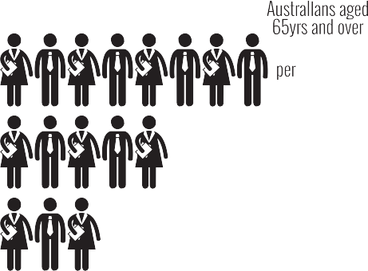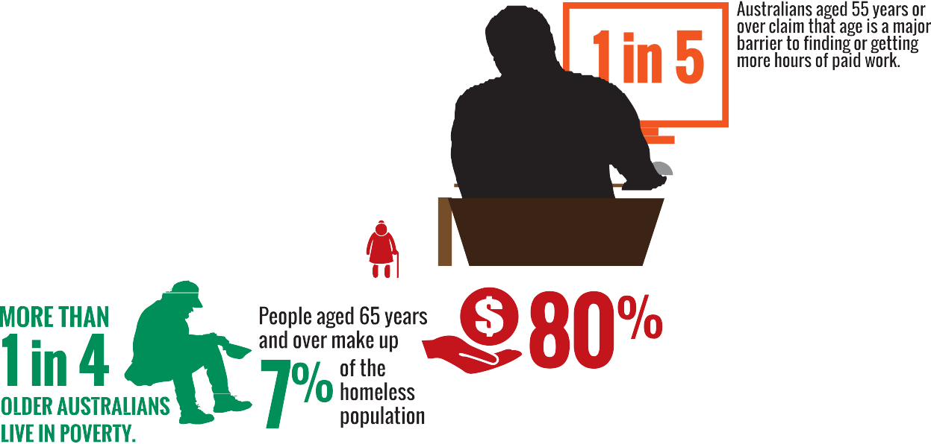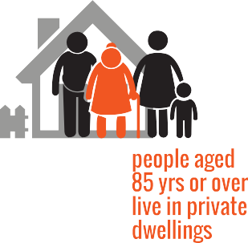





[**www.humanrights.gov.au/face-facts**](http://www.humanrights.gov.au/face-facts)



# Older Australians

Every day, across the country, older Australians make an enormous contribution to our society.

For example, Australians aged 65 years and over contribute almost $39 billion each year in unpaid caring and voluntary work. If the unpaid contribution of those aged 55 to 64 years is included, that figure rises to $74.5 billion per year.1

Older Australians should be recognised for their role in building strong and healthy communities.

However, many say that negative attitudes about older people can translate into unfair treatment and social exclusion.

Being labelled as “too old” or “past their use-by date” means that some miss out on work, training, study and other opportunities.

In 2004, the [Age Discrimination Act](https://www.humanrights.gov.au/our-work/legal/legislation#Age) came into force. The Act makes it unlawful to treat people unfairly on the basis of their age in different areas of public life. It also highlights the need to tackle the negative stereotypes that can lead to age discrimination.

### About

* + By 2050, around one quarter of all Australians will be aged 65 years and over, with the proportion of younger Australians declining.2 In fact, the number of people aged 65 years and over will overtake the number of children aged 0 to 14 years by around 2025.3
  + There are twice as many women as men aged 85 years and over, reflecting their longer life expectancy.4 It is estimated that the number of Australians aged

85 and over will increase from 400,000 in 2010 to

1.8 million by 2050.5

* + One in three Australians aged 65 years and over come from diverse cultural and linguistic backgrounds. Around 840,000 Australians aged 65 years and over were born overseas.6

### Key issues for older Australians

* Around one in three Australians (35 per cent) aged between 55 and 64 years say they have experienced discrimination because of their age.7 The most common types of discrimination include being turned down for a job, being ignored or treated rudely and having disparaging jokes made about their age.8
* One in five Australians aged 55 years or over claim that age is a major barrier to finding a job or getting more hours of paid work. They say that employers consider them “too old”.9
* Approximately 80 per cent of all Australians aged 65 years and over rely on the Age Pension.10 There are currently five people of working age to support each person aged 65 years and over. However, by 2041 there will only be just half the number (2.5 people) of working age to support each retiree.11
* More than one in four older Australians live in poverty.12 People aged 65 years and over make up seven per cent of the homeless population.13
* Older Aboriginal and Torres Strait Islander people are almost three times more likely than non-Indigenous older people to need help with self-care, mobility or communication.14
* In 2009-2010 women reached retirement age with an average of 36 per cent – or $87,532 – less superannuation than men.15

### Positive developments

* + Australians enjoy one of the highest life expectancies in the world. Men today live nearly 80 years and women live 84 years, both up 25 years from a century ago.16 The physical health of older Australians is also improving and most people (82 per cent) are positive about their quality of life.17
  + The majority of older Australians live independently at home. Only one in four people aged 85 years or over live in care accommodation.18
  + Rates of volunteering among the “baby boomer” generation – recently retired, healthy and wanting to contribute to their communities – are continuing to rise compared to previous generations.19
  + Increasing paid employment of Australians over

55 years by five per cent would add $48 billion to the bottom line of our national economy, every year.20

### Did you know?

Over the past two decades, the number of centenarians (people aged 100 years and over) increased by 271%, compared with a 31 per cent in the general population over the same period.21

Australia has produced 23 verified super centenarians (aged 110 [years](http://www.reference.com/browse/wiki/Year) or older). The oldest Australian was Christina Cock, who died in 2002 aged 114 years.

### Find out more

* Australian Government, [*Australia to 2050: Future*](http://archive.treasury.gov.au/igr/igr2010/report/pdf/IGR_2010.pdf)[*challenges*](http://archive.treasury.gov.au/igr/igr2010/report/pdf/IGR_2010.pdf)(2010)
* Australian Human Rights Commission, [*Fact or fiction?*](https://www.humanrights.gov.au/fact-or-fiction-stereotypes-older-australians)[*Stereotypes of older Australians*](https://www.humanrights.gov.au/fact-or-fiction-stereotypes-older-australians)(2013)
* Australian Institute of Health and Welfare, [*Australia’s*](http://www.aihw.gov.au/publication-detail/?id=10737422172)[*heath 2012*](http://www.aihw.gov.au/publication-detail/?id=10737422172)(2012)
* Deloitte Access Economics, [*Increasing participation*](https://www.humanrights.gov.au/increasing-participation-among-older-workers-grey-army-advances2012)[*among older workers: The grey army advances*](https://www.humanrights.gov.au/increasing-participation-among-older-workers-grey-army-advances2012)(2012)

### Our role

The Commission helps people resolve complaints of unfair treatment under the [Age Discrimination Act](https://www.humanrights.gov.au/our-work/legal/legislation#Age).

Our work, led by the [Age Discrimination Commissioner](https://www.humanrights.gov.au/about/commissioners/age-discrimination-commissioner-hon-susan-ryan-ao), also includes research, policy advice and education initiatives that tackle the community attitudes that can lead to age discrimination.

For example, the Australian Government funded a [major](https://www.humanrights.gov.au/fact-or-fiction-stereotypes-older-australians) [research project](https://www.humanrights.gov.au/fact-or-fiction-stereotypes-older-australians) in 2013 to promote greater awareness of the damaging effects of negative stereotypes around ageing.

Find out more about [our work](https://www.humanrights.gov.au/our-work/age-discrimination) in this area.

##### Endnotes

1. Australian Institute of Family Studies, [*Measuring the value of unpaid*](http://www.aifs.gov.au/institute/pubs/respaper/rp34.html)[*household, caring and voluntary work of older Australians*](http://www.aifs.gov.au/institute/pubs/respaper/rp34.html)(2003).
2. Australian Human Rights Commission, [*Age Positive: Promoting Positive*](https://www.humanrights.gov.au/sites/default/files/fact_sheet_age_stereotying.pdf)[*and Diverse Portrayals of Older Australians: Research Project Fact Sheet*](https://www.humanrights.gov.au/sites/default/files/fact_sheet_age_stereotying.pdf)(2012).
3. Australian Bureau of Statistics, [*3101.0-Australian Demographic Statistics,*](http://www.abs.gov.au/ausstats/abs%40.nsf/0/AE3CAF747F4751CDCA2579CF000F9ABC?OpenDocument)[*June 2011*](http://www.abs.gov.au/ausstats/abs%40.nsf/0/AE3CAF747F4751CDCA2579CF000F9ABC?OpenDocument)(December 2011).
4. Australian Bureau of Statistics, [*3201.0-Population by Age and Sex,*](http://www.abs.gov.au/Ausstats/abs%40.nsf/mf/3201.0)[*Australian States and Territories, June 2010*](http://www.abs.gov.au/Ausstats/abs%40.nsf/mf/3201.0)(December 2010).
5. Australian Human Rights Commission, [*A human rights approach for*](https://www.humanrights.gov.au/human-rights-approach-ageing-and-health-respect-and-choice-home-based-and-residential-care-older)[*ageing and health – Respect and choice: home-based and residential*](https://www.humanrights.gov.au/human-rights-approach-ageing-and-health-respect-and-choice-home-based-and-residential-care-older)[*care for older people*](https://www.humanrights.gov.au/human-rights-approach-ageing-and-health-respect-and-choice-home-based-and-residential-care-older)(2012), footnote 3; The Treasury, Australian Government, [*Australia to 2050: Future Challenges*](http://archive.treasury.gov.au/igr/igr2010/default.asp)(2010), p 56.
6. Australian Bureau of Statistics, [*2006 Census Tables*](http://www.abs.gov.au/websitedbs/censushome.nsf/home/historicaldata2006?opendocument&amp;navpos=280)*: Country of birth by age and sex, by usual residence* (Cat. No. 2068.0).
7. Australian Human Rights Commission, note 2, footnote 2; Australian Bureau of Statistics, [*3222.0-Population Projections, Australia, 2006 to*](http://www.abs.gov.au/AUSSTATS/abs%40.nsf/DetailsPage/3222.02006%20to%202101?OpenDocument)[*2101*](http://www.abs.gov.au/AUSSTATS/abs%40.nsf/DetailsPage/3222.02006%20to%202101?OpenDocument)(September 2008).
8. Australian Human Rights Commission, above.
9. Australian Bureau of Statistics, [*4102.0-Australian Social Trends, Sep*](http://www.abs.gov.au/AUSSTATS/abs%40.nsf/Lookup/4102.0Main%2BFeatures30Sep%2B2010)[*2010: Older People and the Labour Market*](http://www.abs.gov.au/AUSSTATS/abs%40.nsf/Lookup/4102.0Main%2BFeatures30Sep%2B2010)(September 2010).
10. Aged and Community Services Australia, [*An Ageing Australia: Fact Sheet*](http://www.agedcare.org.au/publications/resources/fact-sheets/acsa-fact-sheet-1-2008--an-ageing-australia.pdf/view)[*1*](http://www.agedcare.org.au/publications/resources/fact-sheets/acsa-fact-sheet-1-2008--an-ageing-australia.pdf/view)(July 2011), p 2.
11. The Treasury, Australian Government, note 5.
12. Australian Human Rights Commission, [*Age discrimination: Exposing the*](https://www.humanrights.gov.au/publications/age-discrimination-exposing-hidden-barrier-mature-age-workers-2010)[*hidden barrier for mature age workers*](https://www.humanrights.gov.au/publications/age-discrimination-exposing-hidden-barrier-mature-age-workers-2010)(2010).
13. Department of Social Services, Australian Government, [*The Road Home:*](http://www.dss.gov.au/our-responsibilities/housing-support/programs-services/homelessness/the-road-home-the-australian-government-white-paper-on-homelessness-0)[*The Australian Government White Paper on Homelessness*](http://www.dss.gov.au/our-responsibilities/housing-support/programs-services/homelessness/the-road-home-the-australian-government-white-paper-on-homelessness-0)(2008).
14. Australian Institute of Health and Welfare, [*Older Aboriginal and Torres*](http://www.aihw.gov.au/indigenous-observatory-older-people/)[*Strait Islander people*](http://www.aihw.gov.au/indigenous-observatory-older-people/)(May 2011).
15. Council of Australia Governments (COAG) Reform Council, [*Tracking*](https://www.coagreformcouncil.gov.au/reports/gender-equity/tracking-equity-comparing-outcomes-women-and-girls-across-australia)[*equity: Comparing outcomes from women and girls across Australia*](https://www.coagreformcouncil.gov.au/reports/gender-equity/tracking-equity-comparing-outcomes-women-and-girls-across-australia)(2012).
16. Australian Institute of Health and Welfare, [*Aged care packages in the*](http://www.aihw.gov.au/publication-detail/?id=10737422820)[*community 2010-11: a statistical overview*](http://www.aihw.gov.au/publication-detail/?id=10737422820)(2012), p 122.
17. Australian Institute of Health and Welfare, [*Australia’s health 2012*](http://www.aihw.gov.au/publication-detail/?id=10737422820)(2012).
18. Australian Institute of Health and Welfare, [*Australia’s welfare 2011*](http://www.aihw.gov.au/publication-detail/?id=10737420537)(2011) p 168.
19. The Australia Institute, [*The benefits of an ageing population*](http://www.tai.org.au/documents/dp_fulltext/DP63.pdf)(2002).
20. Deloitte Access Economics for the Australian Human Rights Commission, [*Increasing participation among older workers: The grey army advances*](https://www.humanrights.gov.au/increasing-participation-among-older-workers-grey-army-advances2012)(2012), p i.
21. Australian Bureau of Statistics, [*3101.0-Australian Demographic Statistics,*](http://www.abs.gov.au/ausstats/abs%40.nsf/0/1CD2B1952AFC5E7ACA257298000F2E76?OpenDocument)[*June 2013*](http://www.abs.gov.au/ausstats/abs%40.nsf/0/1CD2B1952AFC5E7ACA257298000F2E76?OpenDocument)(December 2013).