Face the Facts:
Lesbian, gay, bisexual, trans and intersex people

December 2014

ABN 47 996 232 602
Level 3, 175 Pitt Street, Sydney NSW 2000
GPO Box 5218, Sydney NSW 2001
General enquiries 1300 369 711
Complaints info line 1300 656 419
TTY 1800 620 241
ABN 47 996 232 602
Level 3, 175 Pitt Street, Sydney NSW 2000
GPO Box 5218, Sydney NSW 2001
General enquiries 1300 369 711
Complaints info line 1300 656 419
TTY 1800 620 241

The Australian Human Rights Commission encourages the dissemination and exchange of information provided in this publication.
All material presented in this publication is provided under Creative Commons Attribution 3.0 Australia, with the exception of:
- the Australian Human Rights Commission Logo
- photographs and images
- any content or material provided by third parties.
The details of the relevant licence conditions are available on the Creative Commons website, as is the full legal code for the CC BY 3.0 AU licence.
Attribution
Material obtained from this publication is to be attributed to the Australian Human Rights Commission with the following copyright notice:
© Australian Human Rights Commission 2014.
Face the Facts: Children’s rights • 2014
ISBN 978-1-921449-67-3
Infographic Design Firefly Interactive
Content James Iliffe, Black and White Media Australia
Electronic format
This publication can be found in electronic format on the website of the Australian Human Rights Commission:
http://www.humanrights.gov.au/publications
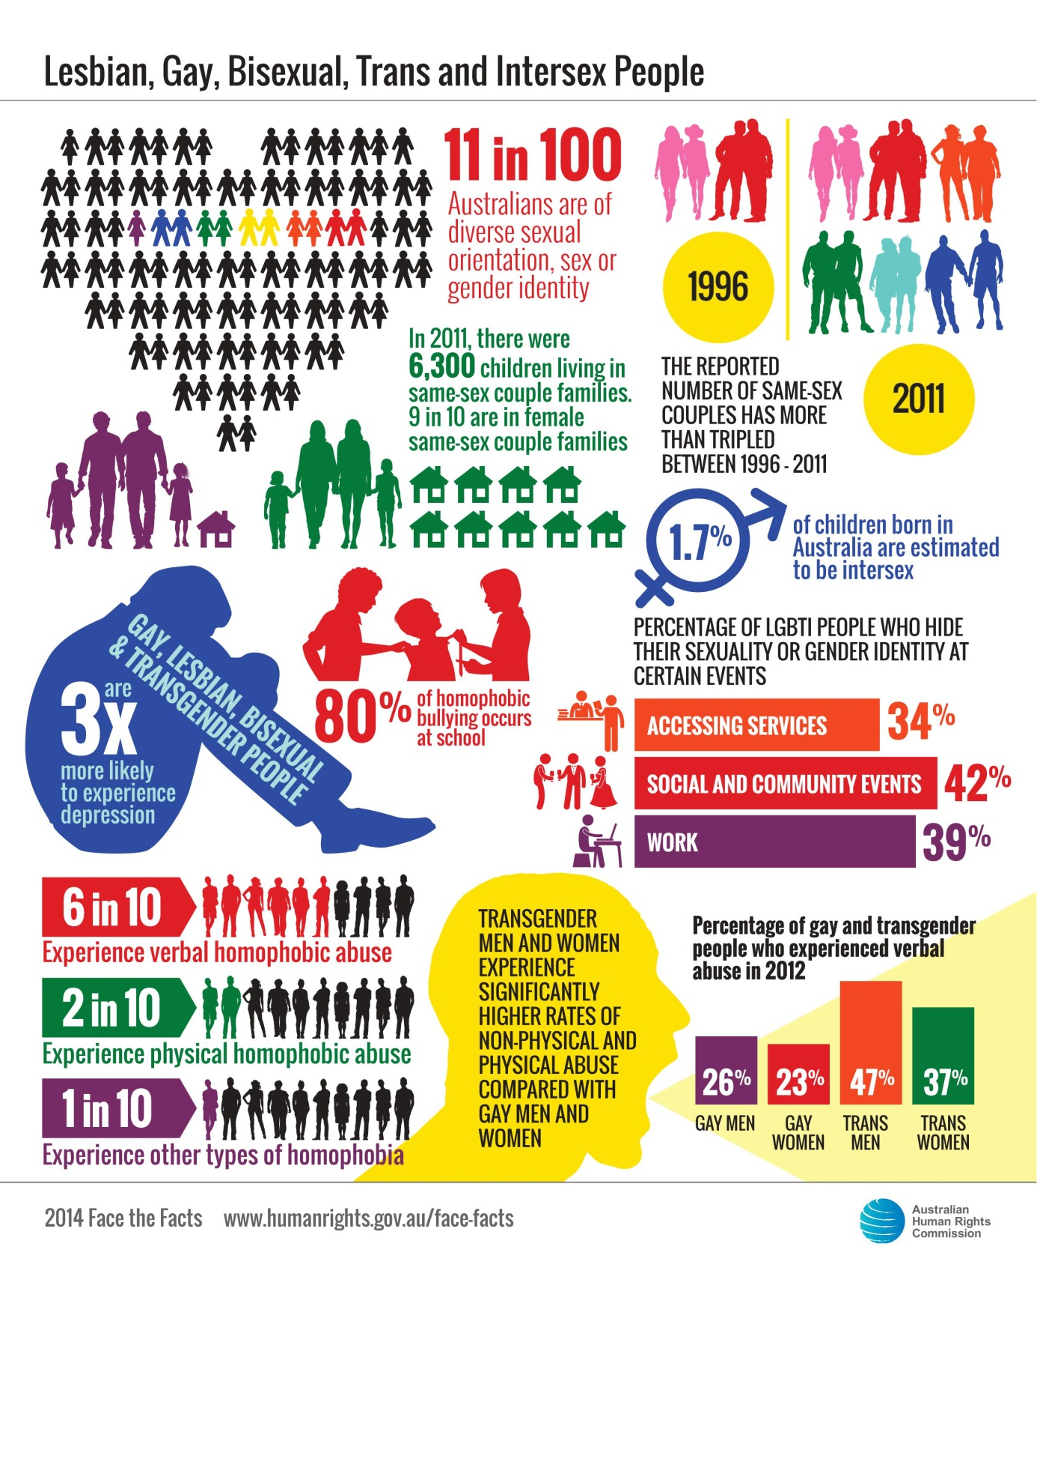

Lesbian, gay, bisexual, trans and intersex people
Equality and freedom from discrimination are fundamental human rights that belong to all people, regardless of sexual orientation, gender identity or because they are intersex.
On 1 August 2013, the Sex Discrimination Act 1984 was amended to make discrimination on the basis of a person’s sexual orientation, gender identity and intersex status against the law.
Despite this important step forward, lesbian, gay, bisexual, trans and intersex (LGBTI) people in Australia still experience discrimination, harassment and hostility in many parts of everyday life; in public, at work and study, accessing health and other services and securing proper recognition of their sex in official documents.

About LGBTI people
- Australians of diverse sexual orientation, sex or gender identity may account for up to 11 per cent of the Australian population.
- Same-sex couples make up about 1 per cent of all couples in Australia. In 2011, the reported number of same-sex couples in Australia was around 33,700, which included 17,600 male same-sex couples and 16,100 female same-sex couples. The reported number of same-sex couples has more than tripled between 1996 and 2011.
- In 2011, there were around 6,300 children living in same-sex couple families, up from 3,400 in 2001. Most of these children (89 per cent) are in female same-sex couple families.
- Intersex people are people born with physical, hormonal or genetic features that are neither wholly female nor wholly male, or a combination of female and male, or neither female nor male. As with the general population, people with intersex variations have a broad range of gender identities and sexual orientations.
- There are no firm figures for Australia’s intersex population. Estimates range from one in 2,000 births to four per cent of the population however the Organisation Intersex International Australia (OII Australia) recommends a mid-range figure of 1.7 per cent of all births.

Key issues for LGBTI people
- A large number of LGBTI people hide their sexuality or gender identity when accessing services (34 per cent), at social and community events (42 per cent) and at work (39 per cent). Young people aged 16 to 24 years are most likely to hide their sexuality or gender identity.
- LGBTI young people report experiencing verbal homophobic abuse (61 per cent), physical homophobic abuse (18 per cent) and other types of homophobia (9 per cent), including cyberbullying, graffiti, social exclusion and humiliation.
- 80 per cent of homophobic bullying involving LGBTI young people occurs at school and has a profound impact on their well-being and education.
- Transgender males and females experience significantly higher rates of non-physical and physical abuse compared with lesbians and gay men.
- Gay, lesbian, bisexual and transgender people are three times more likely to experience depression compared to the broader population.
- Around 61 per cent of same-sex attracted and gender-questioning young people said they experienced verbal abuse because of their sexuality, while 18 per cent reported experiencing physical abuse. Young men (70 per cent) and gender-questioning young people (66 per cent) were more likely than young women (53 per cent) to experience verbal abuse.

Positive developments
- LGBTI young people at schools where protective policies are in place are more likely to feel safe compared with those in schools without similar policies (75 per cent compared with 45 per cent). They are almost 50 per cent less likely to be physically abused at school, less likely to suffer other forms of homophobic abuse, less likely to self-harm and less likely to attempt suicide.
- People in same-sex couples tend to be more highly educated, more likely to work in highly skilled occupations (53 per cent compared with 43 per cent) and more likely to have higher incomes.
- On measures of general health and family cohesion, children aged 5 to 17 years with same-sex attracted parents had significantly better scores when compared to Australian children from all other backgrounds and family contexts. For all other health measures, there were no statistically significant differences.

Did you know?
- Almost half of all gay, lesbian, bisexual and transgender people hide their sexual orientation or gender identity in public for fear of violence or discrimination.

Our role
The Commission can investigate complaints of discrimination on the basis of sexual orientation, gender identity and intersex status under the Sex Discrimination Act, which was amended in August 2013.
The amended Act also protects same-sex couples from discrimination under the definition of “marital or relationship status”.
We have conducted a number of major projects in recent years to identify and build community awareness around the human rights issues faced by LGBTI people.
Find out more about our work in this area.

Find out more
- Australian Human Rights Commission, Addressing sexual orientation and sex and/or gender identity discrimination: Consultation Report (2011)
- Australian Human Rights Commission, Sex Files: the legal recognition of sex in documents and government records (2009)
- Australian Human Rights Commission, Same-Sex: Same Entitlements, Report of the National Inquiry into discrimination against people in same-sex relationships in the area of financial and work related entitlements (2007)
- Australian Research Centre in Sex, Health and Society, La Trobe University, Private Lives 2: The second national survey of the health and wellbeing of GLBT Australians (2012)
- Beyond Blue, In my shoes: Experiences of discrimination, depression and anxiety among gay, lesbian, bisexual, trans and intersex people (2012).

Department of Health, Australian Government, National Lesbian, Gay, Bisexual, Transgender and Intersex (LGBTI) Ageing and Aged Care Strategy (2012), p 4.
Australian Bureau of Statistics, 4102.0 - Australian Social Trends, July 2013, Same-Sex Couples (July 2013).
Australian Bureau of Statistics, above.
Australian Bureau of Statistics, note 2.
See the information page What is Intersex? Defining Intersex on the OII Australia website for a more detailed explanation of intersex.
OII Australia, On the number of intersex people information page
Australian Research Centre in Sex, Health and Society, La Trobe University, Private Lives 2: The second national survey of the health and wellbeing of GLBT Australians (2012) pp 45-46.
Australian Research Centre in Sex, Health and Society, La Trobe University, above, p 46.
Australian Research Centre in Sex, Health and Society, La Trobe University, Writing Themselves in 3: The third national study on the sexual health and wellbeing of same sex attracted and gender questioning young people (2010), p 39.
Australian Research Centre in Sex, Health and Society, La Trobe University, above, p 39.
For example, while 26 per cent of males and 23 per cent of females reported experiencing verbal abuse within a 12 months period, the percentages jump to 47 per cent and 37 per cent for trans males and trans females respectively. See Australian Research Centre in Sex, Health and Society, La Trobe University, note 7, p 47.
Beyond Blue, In my shoes: Experiences of discrimination, depression and anxiety among gay, lesbian, bisexual, trans and intersex people (2012), pp 1-2.
Australian Research Centre in Sex, Health and Society, La Trobe University, note 9, p 40.
T Jones and Western Australian Equal Opportunity Commission, A report about discrimination and bullying on the grounds of sexual orientation and gender identity in Western Australian education (2012), p 11.
Australian Bureau of Statistics, note 2.
Australian Bureau of Statistics, note 2.
Australian Bureau of Statistics, note 2.
University of Melbourne, Australian Study of Child Health In Same-Sex Families (ACHESS): Interim report (2013), p 1.
Australian Research Centre in Sex, Health and Society, La Trobe University, note 7, p 46.

