**REQUEST TO JOIN EXEMPTION APPLICATION LODGED BY THE DEPARTMENT OF   
FAMILIES, HOUSING, COMMUNITY SERVICES AND INDIGENOUS AFFAIRS (FaHCSIA)   
UNDER S55 OF *THE DISABILITY DISCRIMINATION ACT* (1992) (CTH)**

We seek to join the exemption application submitted by FaHCSIA as follows:

* We seek an exemption for all existing ADEs from sections 15 and 24 of the DDA, and the Commonwealth (and officers of the Commonwealth) from section 29 for a period of three years.
* This exemption would apply to use of the BSWAT to:

1. assess wages for employees; and
2. pay wages to ADE employees based on assessments conducted under the

* BSWAT.
* The proposed exemption would apply while alternative wage setting arrangements are being considered, devised and/or established and implemented by FaHCSIA.

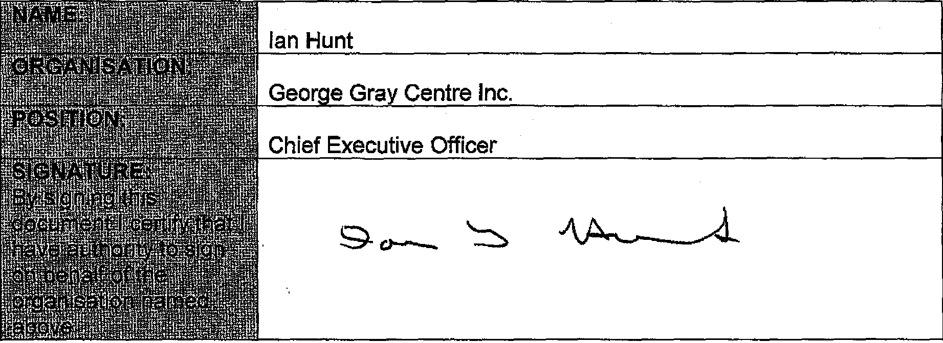

**COMMENTS**

We are strongly behind this application to ensure continuity of employment for persons with a disability is maintained and to allow our organisation time to plan for the introduction of an alternative wage assessment.