**JAS-ANZ**



08th November 2013

Ms Lara Emery

Paralegal, Legal Section

Australian Human Rights Commission

GPO Box 5218,

Sydney NSW 2001

By email: [lecalRhumanrichts.dov.au](http://lecalRhumanrichts.dov.au).

Dear Lara

Many thanks for your consideration of our request for submission of comment regarding the Department of Social Services application for temporary exemption under section 55 of the Disability Discrimination Act 1992 in connection with the use of the Business Services Wage Assessment Tool.

Within the limits of our role in the DEES scheme JAS-ANZ appreciates the opportunity to acknowledge support for the application.

Please find attached our submission which is concerned

principally with our understanding of the implications of Nojin v Commonwealth of Australia [2012] 208 FCR 1 for the conduct of accreditation and certification under the DEES

1.Aleilington 6143

Phone: +64 10)4 473 4426

JOINT ACCREDITATION SYSTEM OF AUSTRALIA AND NEW ZEALAND HELPING MARKETS WORK BETTER

Australia

FECCA House 4 Phipps Close

Deakin, ACT 2600

PO Box 5634 Hughes, ACT 2605

Phone: ,61 1012 6232 2000

Yours sincerely

[www.jas-anz.org](http://www.jas-anz.org)

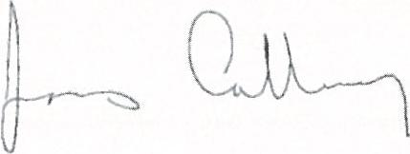

James Galloway

Chief Executive Officer

Joint Accreditation System of Australia and New Zealand



**PAC**

MS, r

\