126th ANNIVERSARY OF THE BATTLE OF
THE EUREKA STOCKADE
Papers presented at the
6th Annual Lalor Address on Community Relations
held at
The Playhouse,
Canberra Theatre Centre,
Canberra
on
3 December 1980
Commissioner for Community Relations
Canberra

ISSN 0314-3694
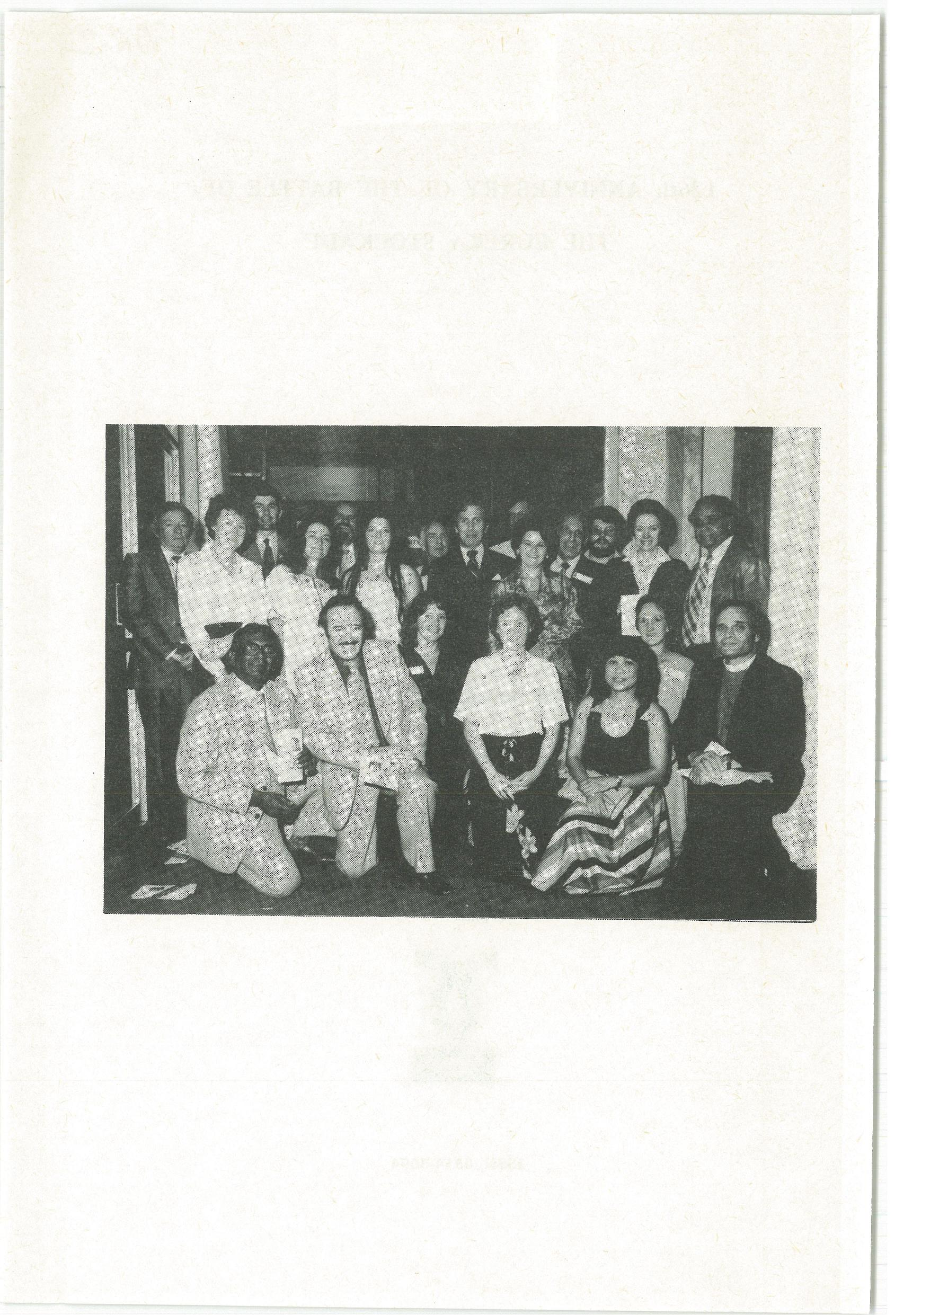
PROGRAM

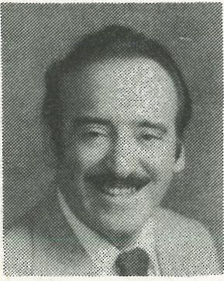 | Official Welcome  The Hon. A.J. Grassby  Australian Commissioner for  Community Relations |  | Pane  1

The Australian Community and
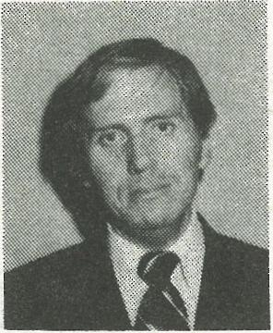
Anti-Heroes
The Hon. Mr Justice M.D. Kirby Chairman of the Australian Law Reform Commission
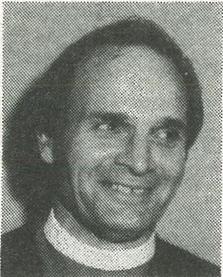
4
Stereotypes
The Rt. Rev. M.B. Challen
Assistant Bishop
Anglican Diocese of Perth
17
An Insight into the Relationship
between Aboriginal and Other
Australians
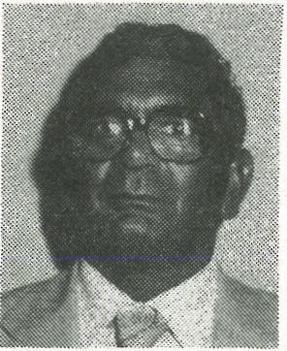
Mr J. Hagan
National Chairman
National Aboriginal Conference
23

Belconnen High School Choir, Conducted by Miss Annette Pirani
Advance Australia Fair
Brother James' Air (23rd Psalm) The Rhythm of Life
P.I., My Beautiful Home
Pearly Shells
Harmonie Choir, Conducted by Mr W. Hunt, MBE
Kein Schbner Land Wiegenlied — Schubert Annchen von Tarau Heidenroslein
Frohlicher Wanderer
Bwcgomen Dance Team, St Michael's School, Palm Island
Mr Eddie Robertson — Deputy Chairman of the Palm Island
Community Council
Mr Laurie Doughan — Teacher
Dancers — Mr Carlo Allen  Mr Algon Congoo Thomas Clumpoint Noel Coolwell Gary Prior  Roy Prior  Noel Prior  lan Palmer  Fletcher Daisy Walter Barney | Bradley Foster Kelly Roberts Bindi Roberts Raymond Barry Patrick Barry Ashley Blanket Lance Wotton Thomas Johnson

OFFICIAL WELCOME BY THE HONOURABLE A.J. GRASSBY
COMMISSIONER FOR COMMUNITY RELATIONS Your Excellencies, Ladies and Gentlemen,
Welcome to the sixth in the series of Annual Lalor Addresses on Community Relations.
The objective on this annual occasion, which marks the anniversary of the Battle of the Eureka Stockade, is to help build unity and amity among all sections of the Australian people.
Australia today is made up of people from 140 different ethnic backgrounds, speaking 90 different languages at home, and practising 80 different religions.
The Lalor Address was inaugurated to provide a forum for understanding and recognition of the right of all Australians to treasure their background and their heritage. The Battle of the Eureka Stockade 126 years ago was the first time that Australians of all backgrounds came together in a common cause. There were Irishmen, Italians, Germans, Englishmen, Americans, Canadians, Welshmen and others, all united in fighting for their rights and liberties.
It was a moving moment in Ballarat last December 3 when the grandson of Peter Lalor, who is a member of the Victoria Police Force, proudly wearing his uniform in the presence of the Premier of the State, raised the Southern Cross again on Bakery Hill. Peter Lalor the third said this, 'If I had been alive at the time of Eureka I would have followed and fought with my grandfather for the rights of the people.'
As Mark Twain said, 'Eureka was the finest moment in modern Australian history.'
The Lalor Address this year is presented against the background of rising tensions in many parts of Australia. In the past ten days my Office has been involved in incidents of violence and bloodshed in several parts of the country. In one case a riot involving 70 or 80 people in the main street of a country town; in another, an Aboriginal community worker cruelly beaten because of actions he had taken on behalf of his people; in another, a white publican slashed so badly that he needed 14 stitches to his face.
These and other incidents are the product of a confrontation with equality. For the first time in nearly 200 years the Aboriginal people of Australia are feeling a new strength, a new purpose, and have taken us at our word and said, 'We will now seek the equality that you have talked about so much but until now have never granted.'
So the confrontation for many people in many parts of Australia is a confrontation with Aboriginal equality for the first time. In the past, as long as they kept their heads down and kept out of sight, community relations were regarded as satisfactory.
Today very properly, with the guarantees of the Racial Discrimination Act and other enactments, the people have found a new pride and a new spirit of independence. It is this new spirit of equality that has caused the tensions now present in so many parts of the country. The solution lies in a spirit of conciliation, and in the recognition of the wrongs of the past and the problems of the present.
2
I should warn that as we go into 1981 the tensions will rise and the confrontation with equality will occur more often. We must be prepared for it and to work to resolve the new and inevitable rash of problems that arise with the new situation.
I believe that recognition of the events of Eureka and its high motivation brings a message for us today, not a message of war but a message that all Australians should come together again in a common cause to build a truly just and equal multicultural society.
The Eureka flag is a symbol of that unity and I would renew my call this year that it be gazetted as an official flag of the Australian people. It should not be captured by this group or that group or regarded as the property of any one organisation, political, social or industrial. It is a flag⁻of the Australian people and of the Australian nation and I would hope that it will be given its due recognition and protection by a national proclamation this time next year.
This year's opening address will be given by His Honour Mr Justice Michael Donald Kirby, Chairman of the Australian Law Reform Commission since 1975 and Deputy President of the Australian Conciliation and Arbitration Commission. Mr Justice Kirby has addressed himself as a reformer to many of the problems which beset our society in the sphere of law. He brings scholarship and leadership to his address this evening.
The second address will be given by the Right Reverend Bishop Michael Boyd Challen. Bishop ChaIlen was appointed Assistant Bishop of Perth on June 24, 1978, following some years as Archdeacon and Executive Director of the Anglican Health and Welfare Services of Perth Diocese. Since 1975 he has been the Chairman of one of the most successful and hard-working Consultative Committees on Community Relations that exist anywhere in Australia.
The Perth Committee over the years has dealt with many complaints of racial discrimination and has conciliated upon many of them successfully. If it were not for the work of men and women of goodwill from many backgrounds serving in these Committees in 30 locations throughout Australia, the implementation of the Racial Discrimination Act in an adequate way would hardly be possible.
The third address will be given by Mr Jim Hagan, National Chairman of the National Aboriginal Conference, a position which he took up in February, 1980 after being a member of the Executive of the N.A.C. since December, 1977.
It is with regret that I announce that Canon Bogo Pilot, of the Anglican Diocese of North Queensland in Townsville, who was also to have been with us tonight, has been stricken with illness and is not able to participate. Canon Bogo Pilot has been engaged in Community Relations work with my office during the last five years and has been a source of inspiration in many difficult and tense situations. I pay tribute to him in his absence tonight.
This then is the program for the most ambitious celebration that we have yet held. I believe that the inspiration of the Palm Island dancers, the Belconnen High School Choir, and the Harmonie Choir will together demonstrate the richness of our society today and the hope that we share of making it the best polyethnic society in the world.
3
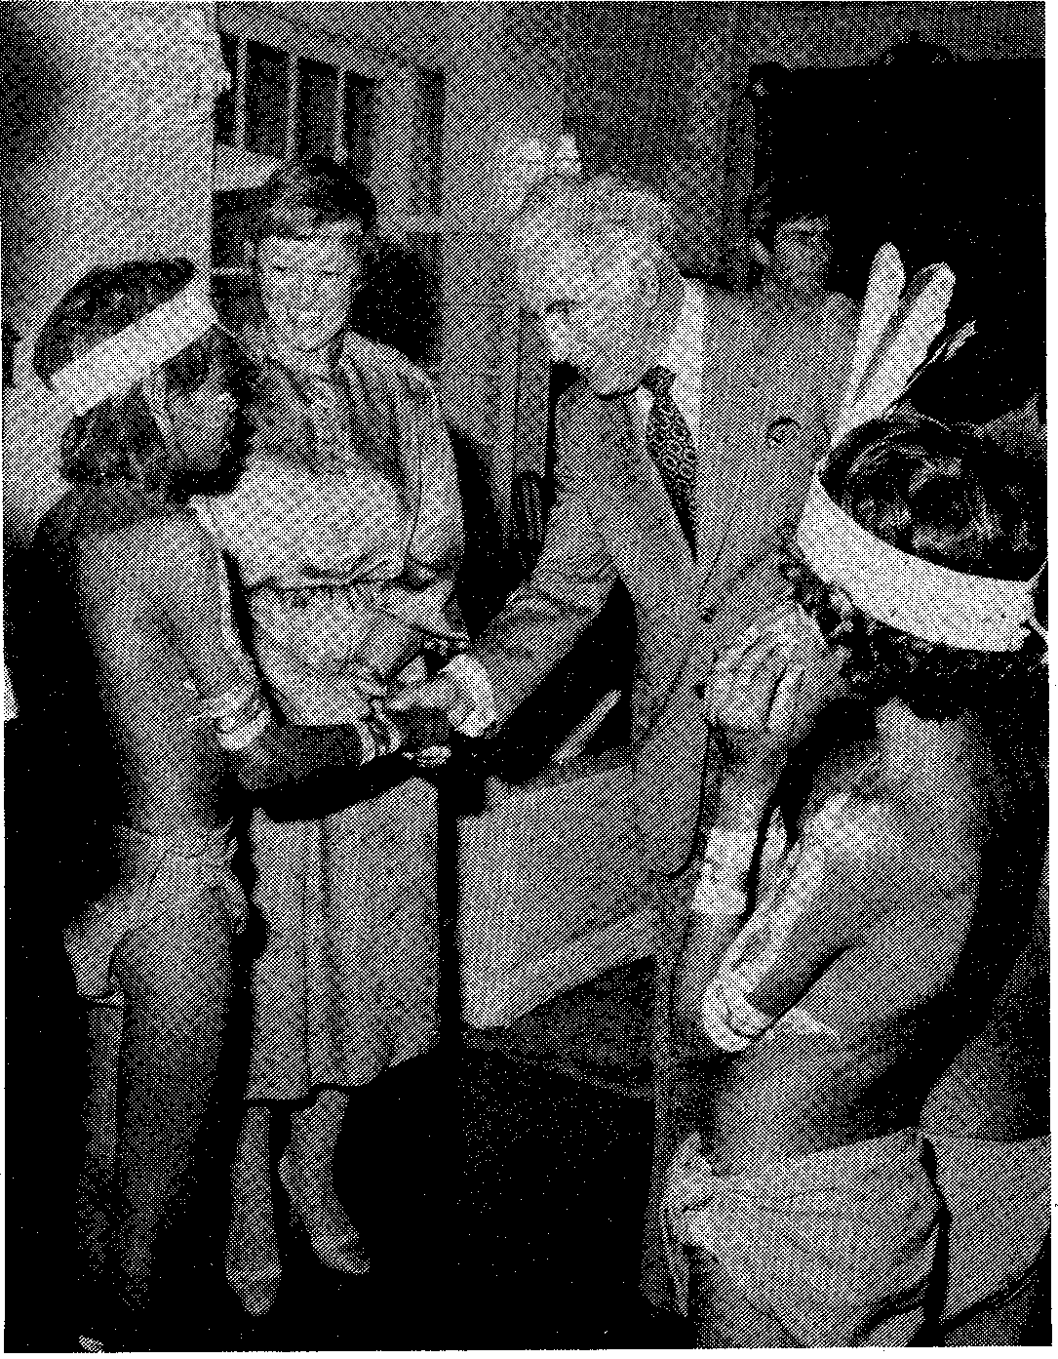
THE AUSTRALIAN COMMUNITY AND ANTI-HEROES
4
by
The Honourable Mr Justice M.D. Kirby
Chairman of the Australian Law Reform Commission
A Tradition of Anti-heroes
Foreign observers and newcomers to Australia must find some of our objects of national pride and celebration curious, to say the least.
We commemorate the modern history of Australia, in the knowledge that it began very largely by accident and as a direct outgrowth of Britain's loss of the penal colonies in America, following the American Revolution. Our colonial history started with nothing more elevated than the establishment of a prison colony. The rough early settlers showed little tolerance and less respect for the indigenous people of the continent, who had lived for thousands of years in harmony with its special environment.
The Eureka Stockade in 1854 is celebrated today, 3 December. Yet this is a tale of a group of gold diggers who defied the legitimate authority of government. They broke the law. They refused to pay taxes. They hoisted a rebel flag over a stockade. They resisted, with arms, a body of the Queen's troops sent by the lawful government. They were defeated in the assault. In fact it was all over in a matter of minutes. Three soldiers and more than 30 diggers were killed. The leaders of the rising were tried for treason, though even in this there was an element of fiasco as each accused was acquitted.
In the very month of the Stockade, there was born the archetypal Australian anti-hero, Ned Kelly. The century of his execution has just been celebrated. It has inspired a great outpouring of writing.¹ The most extravagant prose has been used in praise of a group of bushrangers who (in the eye of the law at least) were desperadoes: guilty of the murder of three policemen and other innocent civilians. Yet Ned Kelly is celebrated today and the judge who tried him is burnt in effigy in Melbourne streets.² I have even read the suggestion that Ned be made a saint: though the proponent was prepared to settle for what was apparently thought the next best thing: a posthumous knighthood.
Critics of the Kelly legend say that Kelly had to be invented because there are so few genuine Australian heroes. Royal Commissions of Inquiry might denounce Kelly as 'cruel, wanton and inhuman'. But on the other hand, Professor Manning Clark sees the admiration of Kelly as an Australian quest for 'the life of the free, the fearless and the bold'. Historian Clive Turnbull says that, in Kelly, there are to be found 'those qualities which are deemed the most desirable in the Australian conception of manhood — courage, resolution, independence, loyalty, chivalry, sympathy with the poor and ill-used'.³
Many commentators have said that, but for the chance of time, the Kelly Gang would have been at Gallipoli, showing the courage in that field of war which is still the chief object of our military pride. Yet Gallipoli must seem to
outsiders a strange battle for a country to commemorate. Ten years ago I stood at Anzac Cove not far from Gelibolu in Turkey. I looked down to where the Australian and New Zealand soldiers stormed the impossible cliffs and fought bravely, but unsuccessfully, against the valiant Turkish defenders. One can see from that battlefield where Xerxes crossed the Hellespont, leading his troops across the Dardenelles from Persia to the conquest of Greece. We celebrate Anzac because it was the first great battle, after our country was united in Federation, in which the spirit of its soldiers was tested.
5
But 60 years before, at Eureka, on this day — led by Peter Lalor — an earlier test had demonstrated, within Australia, important and enduring features of the Australian people.
Stung by Kellymania, a recent correspondent to The Age⁴ declared that he was thoroughly bored with the 'wild and woolly' Ned Kelly legend. He lamented the lack of real interest in Peter Lalor, the hero of Eureka who 'fought only when violence was thrust upon him' and who knew quite well that he could die by the gun or the gallows but was prepared to do so. Australians, it was suggested, would have far preferred Lalor if he had only died in battle or at the end of a judicially-ordained noose. 'They often seem to prefer a dead "hero" to a live thinker', said the writer.
Of other Australian leaders, Mr Whitlam has been equally pessimistic:
Our chief men and our chief efforts have been singularly associated with failure and frustration. . .. There is a deep poignance in the fate of a remarkably long list of our chief figures from the very beginning: Phillip embittered and exhausted; Bligh disgraced; Macquarie despised here and discredited at home; Macarthur mad; Wentworth rejecting the meaning of his own achievements; Parkes bankrupt; Deakin outliving his superb faculties in a long twilight of senility; Fisher forgotten; Bruce living in self-chosen exile; Scullin heartbroken; Lyons dying in the midst of relentless intrigue against him; Curtin driven to desperation. . . and Theodore suddenly struck powerless at the very time when his power and ability were at their peak and most needed.⁵
That passage was written in 1971. The past decade may have even reinforced Mr Whitlam's sentiments. Significantly, the Whitlam industry' is now said to be on the way to overtaking even the Ned Kelly industry. At least 12 books have been written on the former Prime Minister since his fall in 1975. Our fascination with these subjects extends even into our own time.⁶
So here we have it. A country begun as a prison, over long contemptuous of people here thousands of years before, celebrating on this day a pathetically unsuccessful and short-lived revolt, idolising a 'desperado', annually commemorating a failed military enterprise and dealing out a generally poor hand to many of its leaders: all to the tune of 'Waltzing Matilda': a stirring song which itself condemns lawful authority. Do we have here a contra-suggestible nation of anti-heroes? Is it all as simple as this?
The Facts of Eureka
6
Some would doubtless think it strange, even 126 years after the event, for a judge to take part in a celebration of the Eureka Stockade and the leadership of Peter Lalor. Certainly the Governor of Victoria at the time, Sir Charles Hotham, would have found it quite insupportable. When he wrote to London, to report the unhappy events of the Stockade, he put forward most eloquently the view that legitimate government must always uphold and enforce even unpopular laws. This is what Hotham wrote:
So long as a law, however obnoxious and unpopular it may be, remains in force, obedience must be rendered, or government is at an end. Concessions made to demonstrations of physical force bring their speedy retribution; the laws which regulate the goldfields are as I found them and until they are legitimately repealed or modified, it is my duty to maintain them.⁷
The dispute which broke out in the goldfields has been blamed by some upon the dishonesty of the colonial judiciary and by others on the indifference of the unelected colonial administration.
So far as the judiciary is concerned, it is said that a magistrate named Dewes wrongly, and to the outrage of the gold diggers, acquitted the owner of the Eureka Hotel of the charge of murdering a popular miner named Robie. The community denounced the magistrate Dewes. It accused him of having a financial interest in the Eureka Hotel which led him dishonestly to protect his friend the publican. The discontent of the community at the injustice of the magistrate's action led, on 19 October 1854, to a large assembly burning the Eureka Hotel to the ground. Later, Mr Dewes was removed from office and his conduct criticised as
tending to subvert public confidence in the integrity and impartiality of the Bench.⁸
The hotel proprietor was also charged and convicted of the manslaughter of Scobie, the digger. In a sense, the law responded to the community's demand that its procedures should be impartial and just and that guilty men should be brought to trial and punished.
The unrest which arose out of the Scobie murder on 6 October lasted to the Stockade itself. The flames of the Eureka Hotel were easily rekindled at the Stockade. The gold diggers were inflamed by an attempt of the Governor to enforce a licence fee resented as unjust, unequal and unfairly imposed.
The injustice of the fee was that it fell equally on miners, whether or not they discovered gold. The inequality of the fee was that it fell heavily on miners whilst the landed squatters paid little or no tax. It was unfairly imposed because English liberties had been founded on the constitutional principle that there should be no taxation without Parliamentary representation. Within living memory, the American Revolution had been fought, at least in part, for this principle. Yet at the time of Eureka the principle was not observed in Victoria. Sir Robert Menzies, paying tribute to the motivation of the gold diggers resisting the Governor's force of arms said:
The Eureka Revolution was an earnest attempt at democratic government⁹ ... so far as the Eureka revolt indicated any general movement at all, it was a fierce desire to achieve true Parliamentary government and true popular control of public finance.¹⁰
7
From the Labor side of politics, it has been said that the Eureka Stockade marked the beginnings of trade unionism in Australia.¹¹ Dr H.V. Evatt pointed to the fact that though English and Irish diggers took the lead, participants in the Stockade came from many countries 'united in defence of the Southern Cross'. ¹² He declared that the Stockade:
was of crucial importance in the making of Australian democracy.¹³
When Labor and Liberal politicians agree that this was an event important for Australia's national identity, democratic aspirations and resistance to unfair authority, we can safely assume that Eureka is a national and in no way a class, sectional or partisan event.
Eureka, Lalor and law reform
Why have I been chosen to make this address in 1980? As you have heard, I am the Chairman of the Australian Law Reform Commission. That Commission is a permanent body established by the Australian Federal Parliament for the orderly review, modernisation and simplification of the federal laws of our country. Nowadays, the pent-up frustration with unjust laws and unfair administration of those laws need not lead to a stockade, gunfire and death. Soon after the Eureka Stockade, and doubtless hastened by concern that it should ever have come to this, Victoria adopted a system of elected Parliaments which was the first step here on the road to the modern representative democracy. One of the advantages of having lawmakers who are periodically accountable to ordinary people through the ballot box is that laws are more likely to be made which are sensitive to the community's modern sense of fairness. Thus it was not long after an elected Parliament assembled in Melbourne that a different system of taxation was introduced, reforming the unjust licence fee on the gold diggers which had led to the Stockade.
Rules which courts enforce in our country are made, for the most part, by Parliament or by the judges themselves. Sometimes they get out of step with society's sense of right and wrong. Some of our criminal laws may fall into this class. Certainly some of the earlier attitudes to women, to Aborigines, to the poor and to others may be seen today as discrimination. Attitudes to personal morality and to the role of the family appear to be changing. Sometimes the social base of the law itself changes. Law reform exists to help lawmakers cope with these difficult problems, so that they will not be swept under the carpet and met with delay and indifference as happened when the gold diggers objected to the licence fee.
Henry Lawson, commenting on those who died at Eureka, referred specifically to the fact that one of the causes for which they died was reform of bad, outdated laws:
But not in vain those diggers died. Their comrades may rejoice; For o'er the tyranny is heard the people's voice;
8
It says: 'Reform your rotten law, the diggers' wrongs make right;
Or else with them, our brothers now, we'll gather in the fight '14
The law and better community relations
One of the forces leading to the need for law reform today is the influx into the Australian community of so many people from a unique variety of linguistic and legal cultures. Absorption by osmosis of the common law of England, unreasonable for Old Australians, is specially unfair in the case of newcomers. For a newcomer arriving from a non-English-speaking culture there is distinct risk of a legal culture shock. The provision of interpreting and translation services in courts, important though it is, is inadequate to overcome the problems of a new legal culture. Especially as more migrants come from the Middle East and Asia, the needs of adjustment are much more sophisticated. Literal translation of what is happening is merely the first step in communication. A range of measures is required to ensure that migrants understand at least the rudiments of the Australian legal system and that those involved, whether judges, police, lawyers, court clerks, social workers and others, are made sensitive by their training to the cultural characteristics and differences of a very large and growing minority of the population of this country.
There is a great deal of evidence that the experiences and expectations of migrants concerning police and legal procedures make it difficult for them to understand the way we typically do things in Australia. For example. Australian courts have adopted the adversary system of trial. In most countries of the non-English-speaking world, a different system of court trial exists under which the judge or magistrate is in charge of a judicial inquiry. Under this system, the defendant can rely on the judge to protect and even advance his interests. Under our system the judicial officer is, to a very large extent, a neutral umpire. We use juries in serious cases. In most of the countries from which we now draw our immigrants, jury trial does not exist. The Law Reform Commission's latest task on the reform of the laws of evidence in Federal Courts requires us to examine these and other issues relevant to the ethnic communities.
Quite apart from institutional differences it must be frankly acknowledged that the difficulties are not all on the one side. Cultural stereotypes about various migrant groups undoubtedly exist in the minds of many Australians, including educated Australians. The behaviour of even those who work in the legal system can be distorted by such stereotypes.
It cannot be said too often that, even with the inadequate data we have on the incidence of crime in Australia, it appears quite clear that migrants do not breach the criminal law more frequently than non-migrants. Compared to people born in Australia, surveys that have been undertaken point to the fact that people born overseas tend to be much more law-abiding. Proportionately, they are under-represented in our prisons. This fact is of particular interest since migrants, as a whole, come from a slightly lower socio-economic status group than the average Australian-born. Crime indices tend to be higher in lower socioeconomic groups, other things being equal. Yet news reporting frequently lays
emphasis upon the ethnic background of an offender. Specific attention is called to his or her ethnic origin, distorting the reality which more balanced examination of the data will disclose.
9
Migrants and the Police
Migrant contacts with the police can pose difficulties for both. In the postwar years, police in Australia had to cope with many and rapid changes in Australian society. They were confronted, often for the first time, with members of the public whose lifestyles and values were at variance with the traditional Anglo-Celtic concepts or who were unfamiliar with the procedures accepted as routine in this country. A breakdown in understanding between police and the migrant population was not unusual or specially remarkable. For instance, a particular difficulty in police/migrant relations is the unfamiliarity of many migrants with some Australian police procedures. By way of example, fingerprinting in Italy is used only for the most serious crimes. In Australia, it is a more routine practice. For an Italian, the experience of fingerprinting can be quite traumatic. Likewise bail is most unusual in European legal systems. Many migrants have mistaken the payment of bail for payment of a fine and have been surprised by subsequent arrest for non-appearance at court.
Suggestions to overcome some of these difficulties have included the specific recruitment into police forces of more migrants, providing police with an opportunity to learn other languages, in-service training of police officers and production of information in various languages to help migrants understand their rights. The Australian Law Reform Commission suggested important safeguards in the criminal investigation process, designed to equalise the position of non-English-speaking persons being interrogated by Federal Police. The Federal Government adopted these recommendations in the Criminal Investigation Bill 1977.¹⁵ However, the Bill lapsed and has not yet been re-introduced.
Migrants and the Courts
A study undertaken at the Central Court of Petty Sessions in Sydney has indicated that all migrant groups except the Greeks were legally represented in court substantially less frequently than Australian-born accused in the same interval.¹⁶ A clear association has been shown to exist between having legal representation and the outcome of criminal proceedings. A person who is represented has been found to have six and a half times better chance of securing an outright decision in his favour than an unrepresented accused. A person who is not represented appears to have a three times greater likelihood of being sent to prison than one who is represented. The New South Wales Anti-Discrimination Board has drawn attention to the importance of representation in proceedings under the Mental Health Act. Under that Act, a hearing before a magistrate determines whether or not a person involuntarily committed to a psychiatric centre will be held for treatment and if so for how long. If further treatment is considered, the magistrate decides if the patient is to be released or detained. In the case of non-English-speaking patients it is often difficult for doctors to
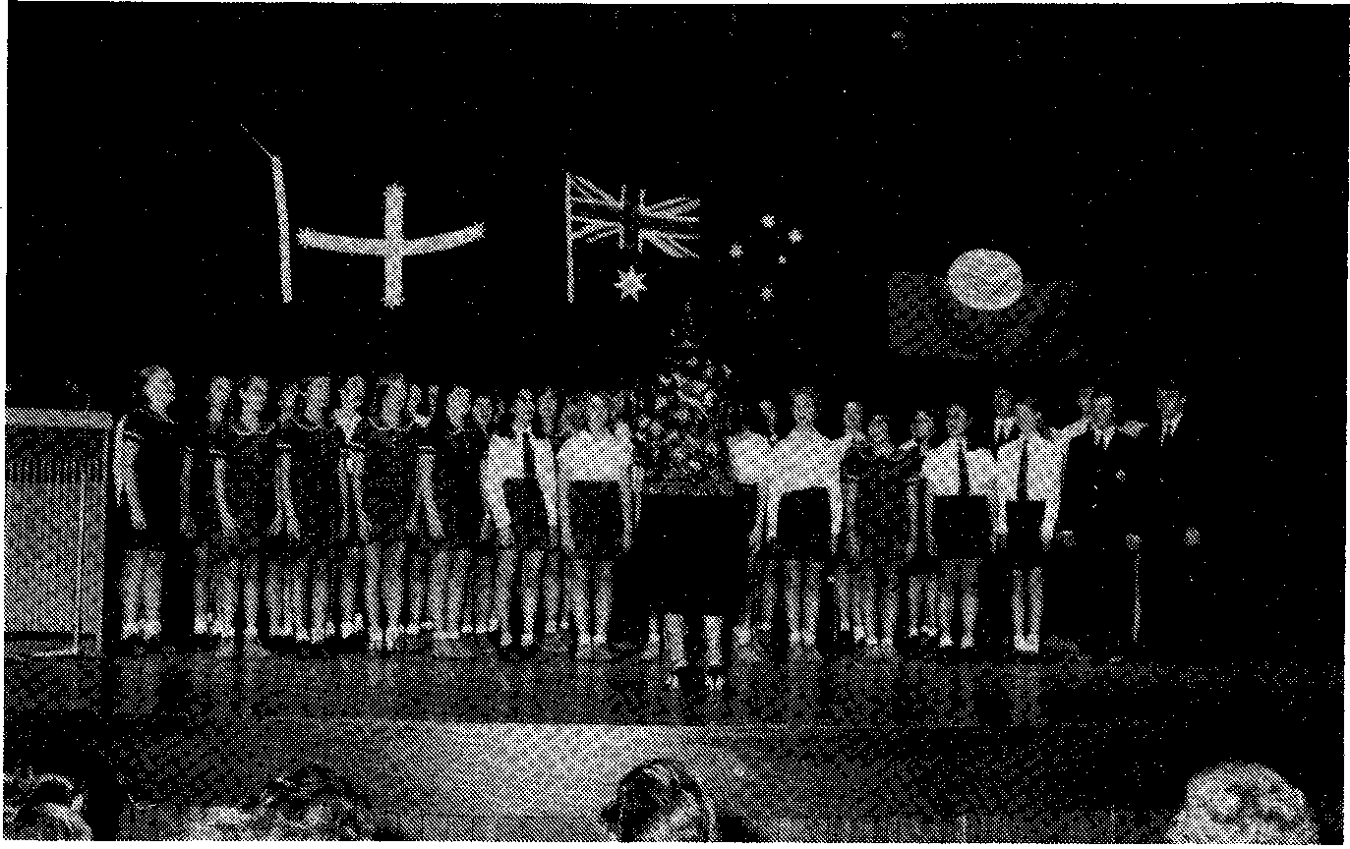
10
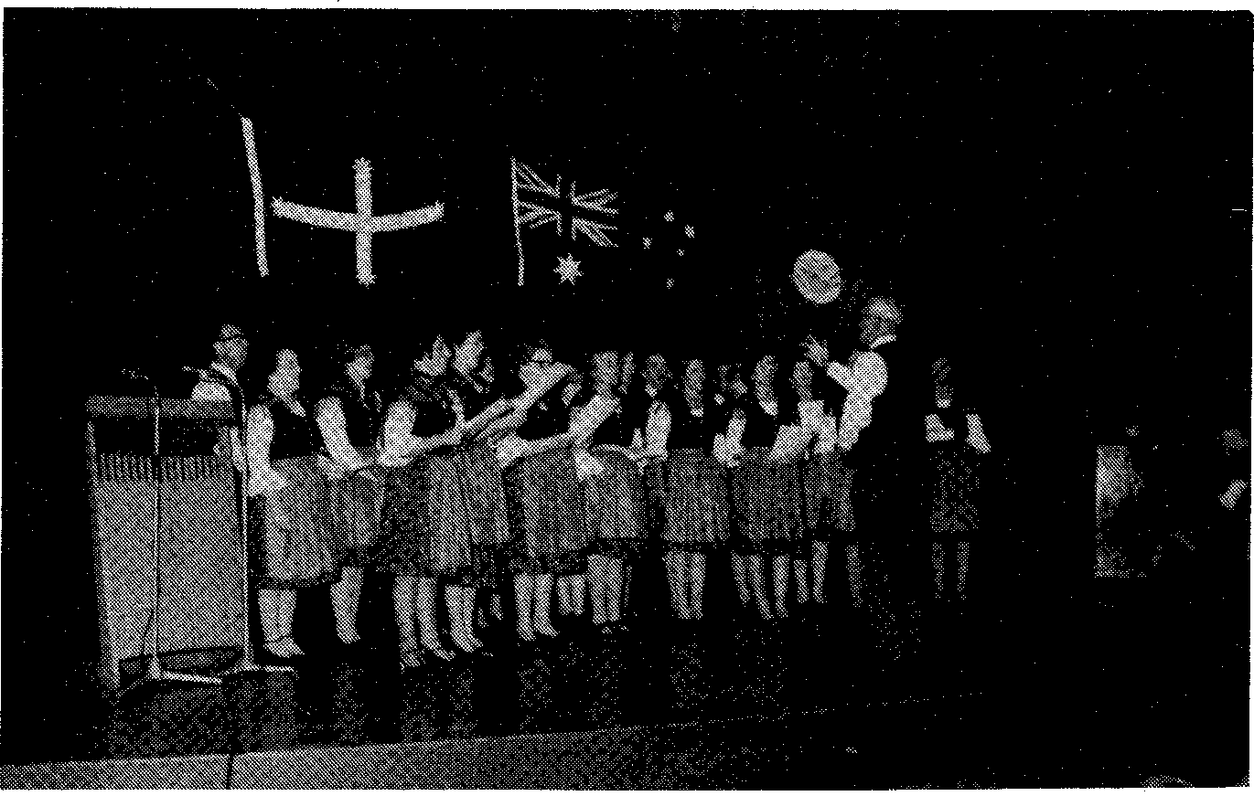
secure a history and make a diagnosis, because of the problems of communication. Yet in practical terms, a person's liberty can depend upon his ability to communicate in such circumstances.
11
The operation of the system
Sometimes entirely without intending it, our legal system can operate unfairly upon persons from a different cultural background. In the criminal trial especially, the impression which the accused may make on a magistrate, judge or members of the jury may be critical. Yet people from different cultural backgorunds and with different accepted modes of behaviour may act in a way that seems quite alien for the simple reason that it is alien. Witnesses may appear excited. The fair administration of justice requires that migrants' cultural and linguistic backgrounds should be taken into account in assessing their conduct and their later evidence in court. But without regular contact with migrants and familiarity with their ways how is this fairness to be achieved?
In criminal cases, legal punishment, especially of confinement, can have an aggravated effect if the sentence is imposed on a person not able to communicate adequately in English. To be removed from an environment which is culturally familiar and from those with whom one can communicate, and be imprisoned in an Australian gaol can add a special, exquisite punishment which the non-migrant prisoner may not suffer. Furthermore, the migrant removed from his or her family may leave close relatives alone, isolated, resulting in profound punitive effects that fall unequally upon innocent parties: wives, children and the old. This is not, of course, to say that migrants must be exempt from punishment for wrongdoing. It is simply to call to attention the way in which the criminal justice system, particularly, operates unevenly in its punishments in a country with a large migrant population.
Quite apart from procedural matters, there are areas of the substantive criminal law which may need to be changed to reflect our new society. One instance relates to the defence of provocation to a charge of murder. Should the standard of provocation be an objective or a subjective one? This issue was dealt with in a working paper by the Victorian Law Reform Commissioner Provocation as a Defence to Murder. The Commissioner said:
In this State, where there is a considerable cultural mix and where it has been asserted, for example, that Melbourne has the largest Greek population of any city outside Athens, it would seem an insoluble problem to pin-point the qualities of characteristics of the ordinary man when considering such a man's (or woman's) ability or propensity to lose his (or her) self-control.
What may provoke an Italian or Frenchman or Vietnamese beyond endurance may not be the same as what will provoke an Englishman. The time is fast approaching, if it has not already arrived, when it is quite unsafe in Australia to judge the 'ordinary man' by the characteristics of the 'ordinary Englishman'. Such an approach is perfectly valid in a society of Englishmen. It was acceptable in a community of transported, antipodean Englishmen. It may be doubted, however, whether it is still the fair standard for an Australian society whose
cultural composition has so radically changed.
12
In fact, the process of adjustment to new national circumstances has already begun in the law. In Glavonjic v. Fosteri ⁷ Mr Justice Gobbo had to deal with the case of a motor accident victim, with a very limited command of English, who refused to undergo brain surgery treatment. The question arose as to whether his refusal was reasonable. He said he had little faith in the likely success of the operation. In judging what was reasonable the court applied the test: what would a reasonable man in the position of the plaintiff (Glavonjic) have done? Applying that test, it held that the plaintiff's refusal was reasonable. Mr Justice Gobbo — himself one of the first Australian judges from a non-AngloCeltic background — said:
That is not to say that one simply applies a subjective test and considers whether the plaintiff thought it was reasonable for him to refuse surgery. It is, however, appropriate to adopt the test that asks whether the reasonable man in the circumstances as they existed to the plaintiff and subject to the various factors such as the difficulty of understanding and the plaintiff's medical history and condition that affected the plaintiff, would have refused treatment. In my opinion, applying the broader test, I am of the view that the defendants have not discharged the onus which is upon them. . . •1 ⁸
Migrant women
Other migrant groups, perfectly law-abiding, suffer special problems. Many migrants, in coming to this country, lose the support of an extended family. Women may be subject not only to the inequalities and discrimination suffered by women in many societies, including Australia. Their status as women in their own societies may conflict significantly with the status and toles expected of them in this country. A recent newspaper report revealed that many New South Wales Government-funded women's refuges in Sydney are catering increasingly for women migrants. Half of the Marrickville Women's Refuge clientele, for example, is said to comprise migrant women.
The family and employment disadvantages of women often force them into a cocoon of their own language and culture, causing crises when they are exposed to threatening situations. In cases of domestic violence, police in Anglo-Celtic culture (unlike others) may generally be reluctant to intrude. Yet where they do intervene it is not a criticism of the police to say that they may be more likely to accept what is said by a man able to communicate in English than by a woman who has little or no ability to speak the language. The frustration and injustice caused by this predicament is not difficult to imagine. The distress experienced by women in illegal migrant situations, where there is a family breakdown, violence or abuse is even more acute. These women are a silent group who through fear and sometimes through ignorance are unable to go to recognised authorities for protection and guidance. They are susceptible to blackmail, including from amongst their own number. It is for that reason that amnesties may be specially desirable to remove the causes of such injustice.
Migrant women may be particularly disadvantaged in understanding the Family Law Act of this country. It embodies principles which are often quite at variance with the law and customs of their countries of origin. For example, in custody matters, migrant women may often assume that their husband or his family would be more likely to be granted custody of the children, as is frequently the case in other cultures. Ignorance about our legal system, compounded by an inability to communicate and an ignorance of where to start, is all too often the tale of the migrant in Australia with legal problems. The fear which many people have about the law and its institutions is magnified by assumptions brought from other countries and an inability, by communication, to remove misapprehensions.
13
The legal profession
In addition to all these problems, misunderstandings frequently arise between lawyers and migrants. A number of studies have indicated that migrants are more likely than native-born Australians to think that lawyers are dishonest, that they are mainly interested in making money and that they tend to take the side of authority rather than their client. In many cases, there is a serious communication breakdown between a migrant and his legal advisor. One confusing aspect of the legal profession in most parts of Australia is the divided profession: solicitors and banisters. This division is simply not known in most countries from which non-English-speaking migrants are drawn. In the case of migrants, the trust and understanding that may be built up over a long period of time with a solicitor must suddenly, and in their view unaccountably, be transferred to a barrister whom they see briefly before the case, in circumstances generally of great stress and confusion.
Many studies have shown that lawyers in Australia continue to be drawn predominantly from families with high educational and income backgrounds. A study of the legal profession in Victoria revealed what a small proportion of migrants make their way into the legal profession. The Bench in Australia, whether the magistracy or the judiciary is still overwhelmingly Anglo-Celtic. The legal profession is overwhelmingly Anglo-Celtic. The law has been called the last Anglo-Celtic bastion of our country. One is faced with the situation that an important profession in society, integral to the orderly running of society, does not yet reflect the composition and diversity of our society. I can see no ready solution to this problem. But it must be kept steadily in mind for it is unhealthy for a profession so important to the just ordering of Australia to be so little affected by the radical cultural changes that are felt everywhere else. At the very least, it behoves lawyers and courts to be alert to the changes in the general Australian population and the need to review our laws and procedures to take account of those changes.
Conclusion
A large number of those who led the Eureka revolt, and not a few who died, were not English. Of course, a number were Scottish and many were Irish. But there was also a sizeable number of non-Britishers. In the actual Eureka
command, 'foreigners' certainly predominated. Though the Irish took a leading part, there were two Germans, including Frederick Vern, who it was that first moved that the diggers burn their licences.¹⁹ They were joined by an American and a Canadian.² ⁰
Since those early days, the role in Australian life of people from countries other than the British Isles has increased apace. The Commissioner for Community Relations has helped by his enthusiastic endeavours to bring home to us all the remarkable changes in the make-up of our country. No country other than Israel has such a high proportion of ethnic minorities. Our legal system should be sensitive to these changes. Its substantive rules, its procedures and its personnel should come to reflect, by orderly processes of reform and renewal, the changes which have taken place.
Whilst clinging to the virtues of the legal system we have inherited, we should show Peter Lalor's resolution to reform the law to meet the requirements of our new, diverse, more interesting and multi-cultural community.
FOOTNOTES
1 See e.g. N. Brown, Ned Kelly: Australian Son; C.F. Cave, Ned Kelly: Man and Myth; K. Dunstan, Saint Ned; J. Molony, Jam Ned Kelly; J. McQuilton, The Kelly Outbreak 1878 — 1880. These recent additions to the Kelly Library are reviewed in The Bulletin, 11 November 1980, 97.
2 For the alternative point of`view, see P. Ryan, Redmund Barry: A Colonial Life 1813— 1880 and Sir Zelman Cowen, `Redmund Barry Oration — Extract', Australian Law News, November 1980, 6; See also Sir Zelman Cowen, Address to the Annual Dinner of the Chamber of Commerce and Industry, South Australia, 21 November 1980, mimeograph, 13.
3 Cited in K. Dunstan, Ned!, a condensed version of 'Saint Ned' in Readers' Digest, June 1980, 191,238.
- 0. Gray, `Lalor Makes a Better Hero', Letter to The Age, 27 October 1980, 12.
- E.G. VVhitlam in Young's biography of Theodore, cited in W.F. Broderick, 'Gough Whitlam: His Blessed Dawn and the Tragic Flaw of Omnipotence', The Age, 13 November 1980, 11.
- Broderick, ibid.
- Sir Charles Hotham, Letter to Sir George Gray, No. 162, 20 December 1954 in G. Blainey, Eureka Documents, Melbourne, The Public Record Office, 6, 8.
- ibid, No. 148, 5.
- R.G. Menzies, Melbourne Sun, 17 July 1946, cited in Historical Studies of Australia and New Zealand, Special Eureka Supplement, University of Melbourne, December 1954, 79.
- R.G. Menzies, Melbourne Sun, 9 July 1946, cited loc cit.
14
11 W. Forgan Smith, Report of Speech to Annual Convention of Australian Workers' Union, Sydney Morning Herald, 2 February 1938, cited ibid, 78.
15
12 H.V. Evatt, Golden Jubilee souvenir of the A.L.P., 1890-1940, Sydney, 1940, cited ibid, 78.
13 Evatt loc cit.
14 Henry Lawson, cited in L. Fox, Eureka and Its Flag, 1973, 14.
15 See the Law Reform Commission, Criminal Investigation, 1975. The relevant provisions of the Criminal Investigation Bill 1977 (CwIth) are clauses 18 (notification of rights in a language in which the accused is fluent); 22 (communication with relatives or friends); 27 (presence of a competent interpreter).
16 Bureau of Crime Statistics and Research (N.S.W.), Pilot Study of Central Court of Petty Sessions, Sydney, 1973, cited in Jakubowicz and Buckley, Migrants and the Law, 1975, 25.
17 119791 V.R. 536.
18 ibid, 538.
19 Fox, 5.
20 See Special Eureka Supplement op cit, 45.
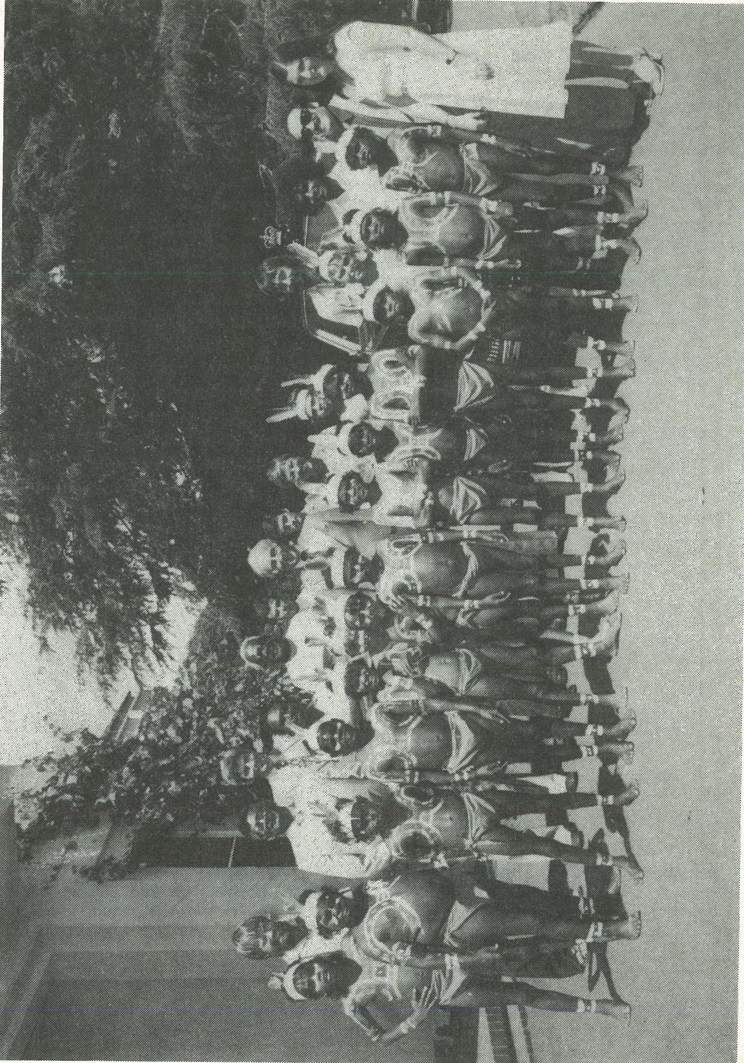
16
STEREOTYPES
17
by
The Rt. Rev. M.B. Challen
Assistant Bishop, Anglican Diocese of Perth
Honourable Commissioner, Your Excellencies, Distinguished Guests and other fellow-Australians,
It was indeed a pleasant surprise to receive a telephone call from your Office, Mr Commissioner, inviting me to be a speaker at this 6th Annual Lalor Address. It came as a surprise, for we in Western Australia are not accustomed to receiving communications from Canberra. It is a pleasant surprise for your manner has always been so warm, positive and enthusiastic.
But on second thoughts this invitation is not a pleasant surprise, for the Eastern States have become more aware of Western Australia in recent months, not because of further discoveries of nickel lodes or increasing iron exports or more gold beneath the streets of Boulder. No. Western Australia has made headlines in the Eastern newspapers and received much editorial comment as the inevitable clash between contrasting cultures and social systems was precipitated by our State Government's determination to proceed with oil drilling at Noonkanbah.
Mr Commissioner, you have given me the freedom and responsibility to speak about the experiences of the Perth Consultative Committee on Community Relations and the thoughts that have arisen from that involvement.
Our Committee was established in October, 1977, and a committee of twelve was elected from two general meetings involving over thirty people. The Committee includes people of various ethnicities including Aboriginal, Indian, Burmese, Malaysian, as well as Anglo-Saxons. All of them are intensely involved with people and some are drawn from the helping professions such as law, education, community organisation and social work.
The Committee initially had great dreams of developing its work in three different areas:
- Education of the community especially through schools, service clubs and religious organisations.
- Monitoring the reporting by all three media, that is to say radio, television and newspapers.
- Investigating complaints involving racial discrimination whether by individuals or institutions.
The Committee believes all three tasks are essential responsibilities but finds them far beyond the resources of this body of able volunteers. Fortunately both Mt Lawley College of Advanced Education and the West Australian Institute of
Technology have on-going programs of multicultural studies, but their influence of course is limited to those who choose such courses. The main Churches as such and the Western Australian Council of Churches are developing a positive and carefully planned education program for their members. The urgency for this has arisen following the Noonkanbah agony. On two occasions our Committee has monitored the reporting by the media of particular issues and brought its results to the attention of their managements which have seen fit to act on our recommendations.
18
However, to do this on an on-going basis was too big a task for our Committee. So we have directed our time and energy to investigating alleged incidents of discrimination. At no point has the Committee ever sought such complaints. It surprises me that people have been able to discover our existence since we have no office, no secretary, no telephone entry or any of the usual points of referral.
A detailed analysis of our work is available in the Commissioner's Fourth Annual Report of 1979. In summary most incidents have been lodged by Aborigines and Vietnamese. They relate to access to housing, employment, including recognition of job qualifications, hotels and entertainment generally.
The Committee has experienced three main difficulties.
Logistics. The most disadvantaged section of the West Australian population is undoubtedly Aborigines located on the fringes of distant country towns or even more remote areas. Our Committee has always seen its work primarily in terms of the metropolitan area, but the main task to be done is in fact in centres hundreds and even thousands of kilometres away. During this year two officers from Canberra visited the Kimberleys and in particular Turkey Creek. By this direct personal visit your Office, Sir, did valuable work not only in settling a dispute and establishing compensation for the first time in Western Australia, but also in helping a local community to see the positive value of racial conciliation, especially outside the court room. It is not physically or financially possible for volunteers in Perth to provide such necessary personal conciliation service to complainants 2,000 kilometres away or more. This State needs an official, paid, full-time Commissioner for Community Relations, together with adequate support staff, right now.
Status. I assume that each of the Consultative Committees on Community Relations throughout Australia has had the same difficulty. That is the Committee's lack of status in the eyes of the community, defendants or, in our case, the State Government. The Federal Government passed its Racial Discrimination Act in 1975. That Act provides for Consultative Committees and yet six years later there is no machinery or regulations authorised by the Attorney-General to create, legitimise and empower these Committees so that they have the status of Consultative Committees in the meaning of the Act. While there are certain advantages under the present situation — namely of working through volunteers and persuasion on the grounds of morality and good sense rather than through law, legal threat and bureaucracy — nevertheless the failure to release regulations, I believe, reveals the big double-think that is going on within our Federal Government and within our own society, which purports to be open and egalitarian.
State Rights and Federalism. For us in Western Australia this seems to be
19
the crux of the problem. It does not matter which party forms either the Federal or State Government, there is an on-going struggle between Federal and State Governments over each other's responsibilities and accompanying powers. To my mind, the responsibility to guarantee the rights of the individual is being lost in the battle over Federal and State rights. It is a simple fact of life that the social condition of our nation has changed dramatically since our Constitution was adopted in 1901. There are sociological forces acting within and without Australia which require us to act consistently and concertedly as a nation. One such force is the demand by ordinary people for human rights. If the Federal Government was sincere in being a signatory to the United Nations International Convention on the Elimination of All Forms of Racial Discrimination in 1966, then either the Federal Government ought to be given the power to act on the legal implications of this Convention, or the State Governments should pass their own enabling legislation consistent with that Convention to give it effect within their own State.
As a result of these experiences I wish to share with you a social comment, a little philosophy, and then make two practical suggestions.
The fact of racism. Hundreds of people in Perth must have been alarmed and grieved when our newspapers splashed the story that one house-owner advertised his house for sale but not to Asians. I do not believe it was a genuine sale, but rather a piece of racist manipulation. Perth people frequently see despicable slogans on bus shelters and walls to freeways (Visions go home' or the like).
I expect to see more of such slogans as our nation, together with the whole world family, undergoes radical changes in the area of economics, politics, military alliances as well as social organisation, and as people become insecure under these circumstances. Such circumstances cause people to find some reason or explanation, even if an irrational one. They will look for some scapegoat, the classic one being 'them' — and of course foreigners with dark skins and the forgotten original Australians become convenient examples of 'them'. The illogicality and hysteria of much of the material released by the League of Rights (for example) feeds upon the irrationality and anxiety of the community as we are required to move into some new perspective. At this time of increasing scapegoating, the Office of Community Relations is all the more necessary.
Legislation for human rights. The United Nations Convention against racial discrimination was initialled by Australia in 1966. The Racial Discrimination Act was passed in 1975. Now a second move has been made to have a bill on Human Rights passed within our Federal legislature. I believe the effectiveness of this legislation will be dependent upon the readiness of our Federal and State Governments to empower the necessary machinery. And without being cynical, one suspects a compromise will result in a weak Act. However, the existence of an Act concerning Human Rights can have some value.
Australia, like most nations of today, has no one clear value system or ideology. In this as well as other respects we are thoroughly pluralistic. So there does seem to be a need to have on record our nation's commitment to Human Rights, that we are prepared to be our brother's keeper notwithstanding the
rampant individualism and pragmatism of contemporary society. When our Federal Government incorporates the International Covenant on Civil and Political Rights in an Act it will be declaring through a secular instrument in secular terms some fundamental moral values.
20
But having passed the legislation, do not think we have done our task. Or to misquote a psalmist, 'Do not put your trust in law or in any delight of man', for with law there is an inherent problem — what does the law define and therefore what does it include and exclude?
Most of us I would think have insurance policies not only on ourselves but on our possessions. Most of us, I believe, some time or other would have tried to make a claim on the basis of that policy only to discover that it does not cover our particular circumstances. We are either beaten by the fine print or the lack of fine print! What has happened, of course, is that a perfectly acceptable contractual system is used against the intent of the spirit of the policy. This is a basic trait in human nature as the enlightened Christian and Jew know only too well.
Ultimately you cannot legislate for morality, especially the virtue of comprehensive and generous love, and so your Office, Sir, must pursue its efforts in education and social change and conciliation in addition to the pursuit of legal structures and processes.
Stereotypes. This inherent deficiency in law leads me to my first practical
suggestion. Where do our prejudices come from? Obviously you and I have been conditioned by the assumptions, values, attitudes, habits, interests and associations of our parents, their friends, and our peers. In addition we have been shaped by the traditions of our society, whether they have been inculcated within us informally by social mores or formally through such institutions as education and religion. The influences of all these people and structures are subtle and yet strong and are largely unconscious. It is not too much to say that our very psyche has been structured by our social history and setting.
For me racial discrimination is not so much the result of active conscious prejudice but an inability to venture forth from one's own acceptable preconceptions to embrace people of other personalities or ethnicities. We all need to be freed from our social conditioning, from our ethnocentrism — a ghastly but helpful word, for it has the value of being morally neutral.
If then we are to deal with these deep forces, it is necessary for us to have our preconceptions of Australia, Australians, and Australian culture extended. No doubt education — in the sense of imparting information — is of some value, as is social inter-change. But I believe the image makers of Australia could exercise a far more effective and profound influence. For it is the advertising agencies, the TV scriptwriters and producers of soap operas, the fashion promoters, playwrights and actors, and even TV 'anchor staff' who are forever affirming or changing our stereotypes of human beings.
To illustrate. Many of us were thrilled by the A.B.C. TV series of the gold diggings entitled 'Rush'. Others, just as faithfully, viewed eipsode after episode of 'The Restless Years' in spite of its cliches. Likewise 'The Sullivans'. I believe these programs are so popular because they safely reflect and affirm our origins, our formative past, and our present suburban ways. Paul Hogan becomes a
so-called 'star' because after vigorous and clever promotion he resolves the ambiguity many Australians have about their own identity, 'Anyhow . . . ' — a meaningless but characteristically Australian utterance.
21
But of course Australian society does not consist only of Ockers! There are lithe athletes and brawny footballers. There are beer-drinking TV addicts as there are blue-rinse charity workers. There are the caftan-draped pioneers of permaculture as there are the tailored-denim pâté consumers. But there are also the alert and environmentally adaptable tribal Aborigines with their smartly dressed urban cousins in their city offices. There are the grateful and industrious Vietnamese as there are the gracious Indians. And what a revolution the effusive Italians, delighting in family and food, have let loose. Stand up the real Mister Australia! We all would have to — yet we have such preconceived and urgent stereotypes that we make people in our own image. What a shock to that image and ourselves would occur if tonight's A.B.C. News had been read by an Aborigine!
I would seriously suggest to the Office of Community Relations that it seeks the goodwill and services of our image makers so that the 'Aussie image' may be updated to reflect the multicultural nature of our society.
My second practical suggestion is directed to a special section of the community which has so much influence on either uniting or dividing our community, namely religious organisations, whether Christian or non-Christian. Just 200 years ago the dominant religion of this country was displaced, or perhaps should I say almost destroyed, by a wave of white migrants. Aggressive Christian evangelism was backed by the power of the white invader. Recent migrants likewise have brought their faiths with them — so that Taoism, Hinduism, Islam and Buddhism are now in evidence together with Judaism and Christianity.
The Christian Church, from my perspective at least, must be prepared to allow other religious bodies to have what it seeks for itself — namely the right to have, to practise, and to share with others its religion.
This right needs to reflect not so much a begrudging concession but a genuine attitude of acceptance of people as people, notwithstanding their different beliefs. This basic principle may be readily acknowledged in one's mind, but is not so easily accepted in one's heart and throughout one's social relationships. For the Church, which has been so accustomed to a dominant position in society for centuries, at least in the western world, the establishment of a relationship of mutual acceptance and equal status will be a strange and demanding exercise.
The social divisiveness of ideology is well and tragically illustrated in various parts of the world at present — Northern Ireland and the Middle East, just to quote two instances. An explosive mixture arises when ideology, political power, economic dominance, and ethnicity become co-terminous.
I urge the Christian Churches to ensure that minority groups in our society are not kept powerless or disadvantaged because they happen to practise a different religion. At all times we need to affirm a primacy of persons over all things including religious teachings.
Conclusion
22
I have concentrated on the issue of attitudinal racism as distinct from institutional, not that I would wish to deny the existence or the potency of the latter. In considering personal attitudes I have intended to highlight the unconscious foundation to much of our prejudices, and have suggested how powerful institutions in our society may be harnessed to creatively change our stereotypes.
May I describe a personal experience which brought some of my unconscious prejudices to the fore and then destroyed them.
In 1968 I joined a training program for urban mission in that exciting, pluralistic and dangerous city of Chicago. Participants were required to spend the first week on the snow-covered streets with temperatures well below freezing point, without any practical or social support and only $6.00 in their pockets. I had only walked about half a mile from the Training Centre when I sensed I was being followed. I turned right, he turned right. I crossed to the other sidewalk, and he crossed. I turned left, and he turned left. And then I noticed him; I noticed his swarthy skin and slanty eyes. It was just my luck, and my wife and two girls back in Australia. What a fool I have been to come to Chicago! I walked on and he still followed me. I could not stand it any longer. I crossed to the corner. He paused on the other side and then I decided to take the initiative. I turned back to meet him in the middle of the junction. Then we met, but he was the first to speak. To my amazement the Puerto Rican said, 'You're bumming it too!' With that he grasped my hand and gave me a heartwarming shake.
In the end our stereotypes and our images have to be challenged by reality. What more powerful method is there than that of personal encounter?
THE RELATIONSHIP BETWEEN
ABORIGINAL AND OTHER AUSTRALIANS
23
by
Mr Jim Hagan
National Chairman, National Aboriginal Conference
Honourable Commissioner, Distinguished Guests, Ladies and Gentlemen,
I have been invited here tonight, as National Chairman of the National Aboriginal Conference, to contribute to this Lalor Community Relations Address an insight into the nature of the relationship currently existing between Aboriginal and other Australians.
It is a relationship of special complexity because it is based on race, rather than on nationality or religion. Actually, this very occasion provides us with a commentary on the difference between being black and white in Australia.
As you are aware the Lalor Community Relations Address commemorates a struggle for rights, of which it was said by last year's eminent speaker, Sir John Nimmo: 'Incensed by the oppression to which they were subjected and by the sense that justice was not being fairly administered they introduced their own flag as a symbol of freedom and took an oath beneath it that they would fight to defend their rights and liberties'.
Sir John was referring to the gallant band of Ballarat miners who struggled to free themselves of the burden of bureaucratic injustice. .
While their struggle is aptly commemorated today as the spirit of Eureka and is regarded as symbolic of the right of every man to Australian justice and fair play, a like motivated struggle that has endured for almost two centuries has failed to inspire such noble sentiment. Yet the expectations of the Aborigines that have waged it are no different or no less than were those of the men of the Eureka Stockade.
They too are incensed by the oppression to which they have been, and still are, subjected. They too suffer a sense that justice has not been fairly administered. They too want to free themselves of the burden of bureaucratic indifference.
Ladies and gentlemen, to understand the relationship between black and white Australians it is necessary to realise that it has grown from a philosophy of racial inequality and has continually been influenced by the inherent characteristics of that philosophy — prejudice and discrimination.
Because of this it is to be expected that Aboriginal and European Australians view their relationship from different positions in the social structure and accordingly there exists a wide division of values and goals.
By virtue of the assumed superiority of the dominant group, it has been inevitable that white Australia's view of what is considered best for Aboriginals—what might be considered suitable expectations for Aboriginal people — would dominate Aboriginal existence and progress, despite the fact that the recipients
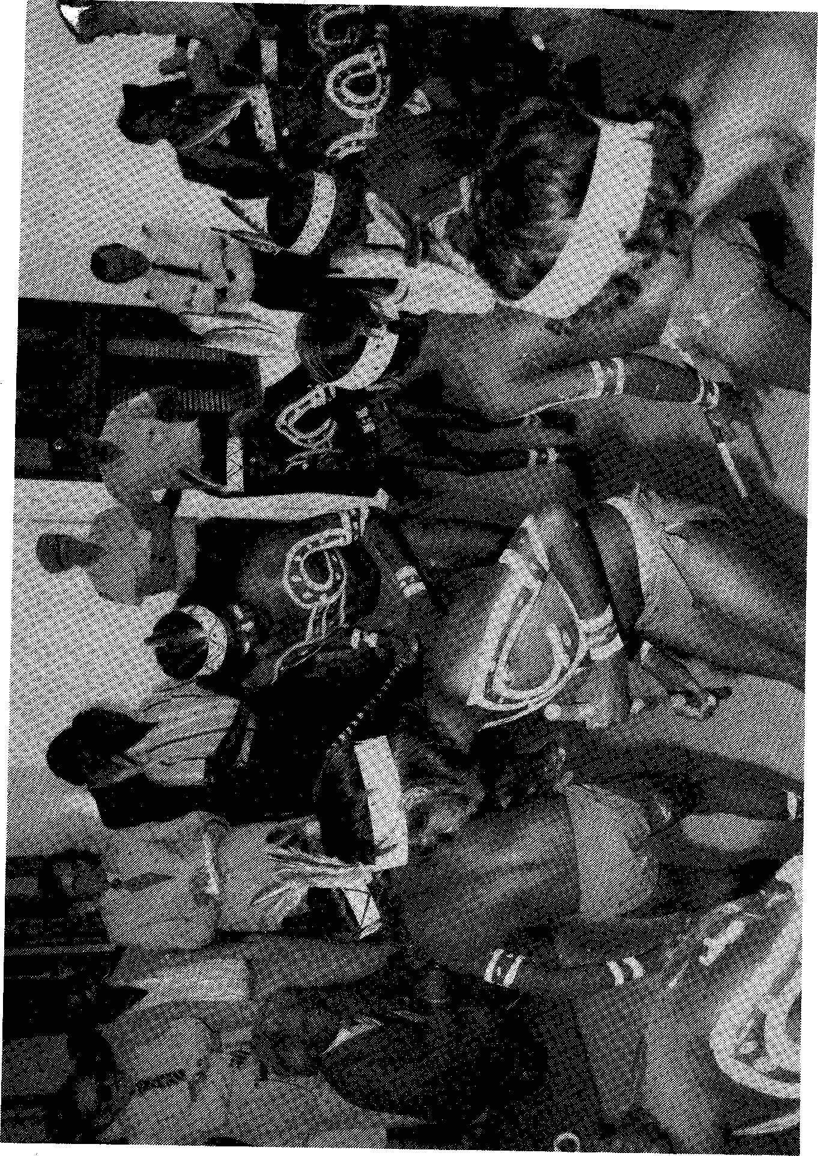
24
have considered the emphasis irrelevant to their real needs.
25
As the subordinate group in this relationship, Aborigines have been expected to show such desirable traits as patience, obedience, loyalty and faithfulness, leaving ambition, pride and independence to be considered the natural pursuits of their so-called superiors. An Aboriginal striving for these higher values was to be considered as 'above himself' and a threat to the established order.
In this manner have the Aboriginal people been denied the minimum essentials for survival and progress in a democratic society: recognition of their values, freedom equal to that of others, the right to be judged on personal worth, equality before the law, evality of educational opportunity and occupational choice, and full admission to the privileges and obligations of citizenship.
This denial, this subtle discrimination, has been devastating in its effects on the Aboriginal self-image, corrosive to his dignity, oblivious of his needs as a human being, and prejudicial to his rights to satisfy them.
This is the foundation on which the existing relationship between Aboriginal and white Australians has been built. This is the platform from which, if there is to be a correction of the imbalance between black and white in this country, such reform must be launched.
Ladies and gentlemen, Aboriginal people have endured two centuries of colonial rule and have remarkably little to show for it other than the scars of conflict. Despite pious pronouncements by Governments that they know what is best, that substantial sums have been spent on improvement and extension of Aboriginal services, there can be no argument against the facts. Aboriginals are the most economically depressed minority group in this country, the most unemployed, the most imprisoned, the most neglected in health and education services, the most powerless and still, the most discriminated against.
They have endured policies of annihilation, protection, assimilation and integration and as a direct result have suffered in turn destruction, indignity, denial and frustration.
Even integration — based on a philosophy of peoples being different but equal within one society — has not worked because, though different Aboriginal people may be, they have never been regarded as equal. So the Australian system of fair play and justice for all has fallen short of its ideal and the spirit of Eureka has been betrayed.
Australia has failed to recognise its responsibilities to Aboriginals, it has failed to capitalise on their rich heritage and timeless wisdom, it has failed to create a community of common purpose, it has failed to convince an increasingly sceptical world that it is guided by such honourable intent.
Thus the Aboriginal is faced with a choice of either pursuing a separatist policy of development, or else seeking to change community priorities so that he may expect to enjoy a part in decision-making for the common good of all Australians.
No one is as Australian as an Aboriginal and no one has more concern for the future of Australia than those who have respected this land for 40,000 years. Thus he is obliged to choose the latter course of dual development, despite the difficulties compounded by the realities of a larger community suspicious of change, uncommitted to the espoused values of a claimed Christian commitment,
and uncommitted to the Human Rights Covenants signed by Governments in pursuit of international respectability. -
26
It is a task even further compounded by the disillusionment that followed the historic Referendum of 1967, in which white Australia voted overwhelmingly for Federal control of Aboriginal affairs, and then teased the Aboriginal with the hope that this community was more for him than against him. Having cast their vote, the majority of Australians mistook that gesture as the reality of reform and retreated to their former indifference. In questioning the benefits that were to flow from this Referendum Aboriginals were to find themselves accused of 'never being satisfied'. 'We voted for you,' said white Australia, 'what more do you expect?'
Their vote for restoration of a degree of decency in Aboriginal life had apparently at no time been perceived as a mandate for equality.
It has become increasingly obvious, post-Referendum, that Australia is locked hopelessly into a struggle of irresolution and contradiction on the question of Aboriginal rights, and that Governments are committed to following the paths of least resistance when deciding policy on Aboriginal affairs.
It is time then for implementation of the final policy — one which Aboriginal people have advocated, one which enlightened pockets of this society have realised is the only alternative — the policy of self-determination for the Aboriginal race.
This concept, as envisaged by Aboriginal people, is not partisan in philosophy or based on a cult of elitism. It merely represents the opportunity for Aboriginals to realise their own potential, to rid themselves of the indignity of dependence, and to prove their worth as members of the larger community.
Self-determination in fact implies independence, choice and freedom within that community and is essential for the fulfilment of psychological needs arising from man's social nature. These needs are to be wanted and needed by family and community, to develop and express oneself through creative contribution, to be recognised as an individual, to give meaning to existence, to have the right and the opportunity to influence and be involved in society.
In our history of co-existence in this land, Aborigines have been denied this fulfilment. Yet they know that self-determination as a goal cannot be satisfied independently of the whole community. The desire for it and the expectancy of benefits from it must be a joint ambition if it is to become reality.
The first steps towards self-determination have already been taken, however unwittingly, and the evidence of this is the fact that I stand before you tonight as an elected representative of my people with the responsibility of advising the Government on their behalf. The reality of it, though, is that this advice can be accepted or rejected depending on its acceptability to the electorate.
This indicates that true self-determination is still far away, and with it the idyllic state of community relations to which we aspire. In the meantime then, our best weapon is education and the increasingly skilful use of it as an agent to discount the influence of the myth of racial inequality that has governed our relations in the past.
Education must be more readily available to Aborigines and must be more relevant to their search for fulfilment and social compatibility. It must involve
the teaching of Aboriginal culture in schools as a measure to promote better understanding between our races. It must be selectively geared towards creation of a community in which all Australians are equal in opportunity and in fact.
27
Education must pursue the fulfilment of these ideals regardless of the concept that everything must be justifiable in economic terms, because if it does not we will be forced to pay a higher price. . . the price of failing to exploit the most natural avenue of communication we have.
Ladies and gentlemen, time has not permitted me to present more than an outline of what Aboriginal people see as the reasons for, effects of and possible solutions to the problems of community relations between black and white in Australia.
I trust I have at least given you further food for thought. Remember that whatever our differences we are all here and the majority of us, black and white, were born here. This is our home and we have nowhere else to go. We were all born into a world we never made and none of us had any choice in our race, our sex, the time and place of our birth, or the parents who bore us and raised us. None of us is responsible for anything his ancestors did or for any events that occurred before he was born. We all share in the responsibility of doing the best we can in the world as we found it.
Display trust in the integrity of the Aboriginal, respond favourably to his desire for equal and peaceful co-existence in this land, strive for the common good, and Australia may yet set the example to the rest of the world that she fondly imagines she does today.


