Vision
Message from the CEO of Melbourne and Olympic Parks
Brian Morris

It is with great pride that I present the Melbourne and Olympic Parks’ Diversity and Inclusion Plan 2014-2017.

Melbourne and Olympic Parks (M&OP) is an organisation that prides itself as being a world class business that delivers world class events. In doing so, we are continuously looking to improve the guest experience for our visitors of all ages and abilities.

The Diversity and Inclusion Plan is about bringing to life one of M&OP’s strategic goals to ensure the customer experience is at the heart of everything we do. That’s why, within this plan you will find strategies and actions that will ensure accessible and inclusive systems that allow for a seamless experience at any one of our world class venues.

Our plan aligns with the National Disability Strategy 2010-2020, and fulfils legislative obligations under the Victorian Disability Act 2006, the Victorian Equal Opportunity Act 1995 and the Commonwealth Disability Discrimination Act 1995.

Thank you to those who have been involved in the planning and development process and we now look forward to implementing the improvements across the Melbourne and Olympic Parks precinct.

Brian Morris
Chief Executive Officer

The Impact of Disability on M&OP

In Australia disability is often defined from a medical perspective, that is, a disability can be any physical, sensory, intellectual, cognitive or psychiatric limitation that affects a person’s ability to undertake everyday activities. The M&OP, through the Diversity and Inclusion Strategy views disability from another perspective - a disability is a consequence of environmental, social and attitudinal barriers that prevent people with different degrees of ability from maximum participation in society.

A disability can occur at any time in life. People can be born with a disability or acquire a disability suddenly through an accident. Some forms of disability are episodic, others are temporary. Some disabilities may be obvious while others are hidden.

This Strategy recognises that disability is a continuum of ability which encompasses a broad range of needs and solutions and takes a customer centric approach in the development of its goals.

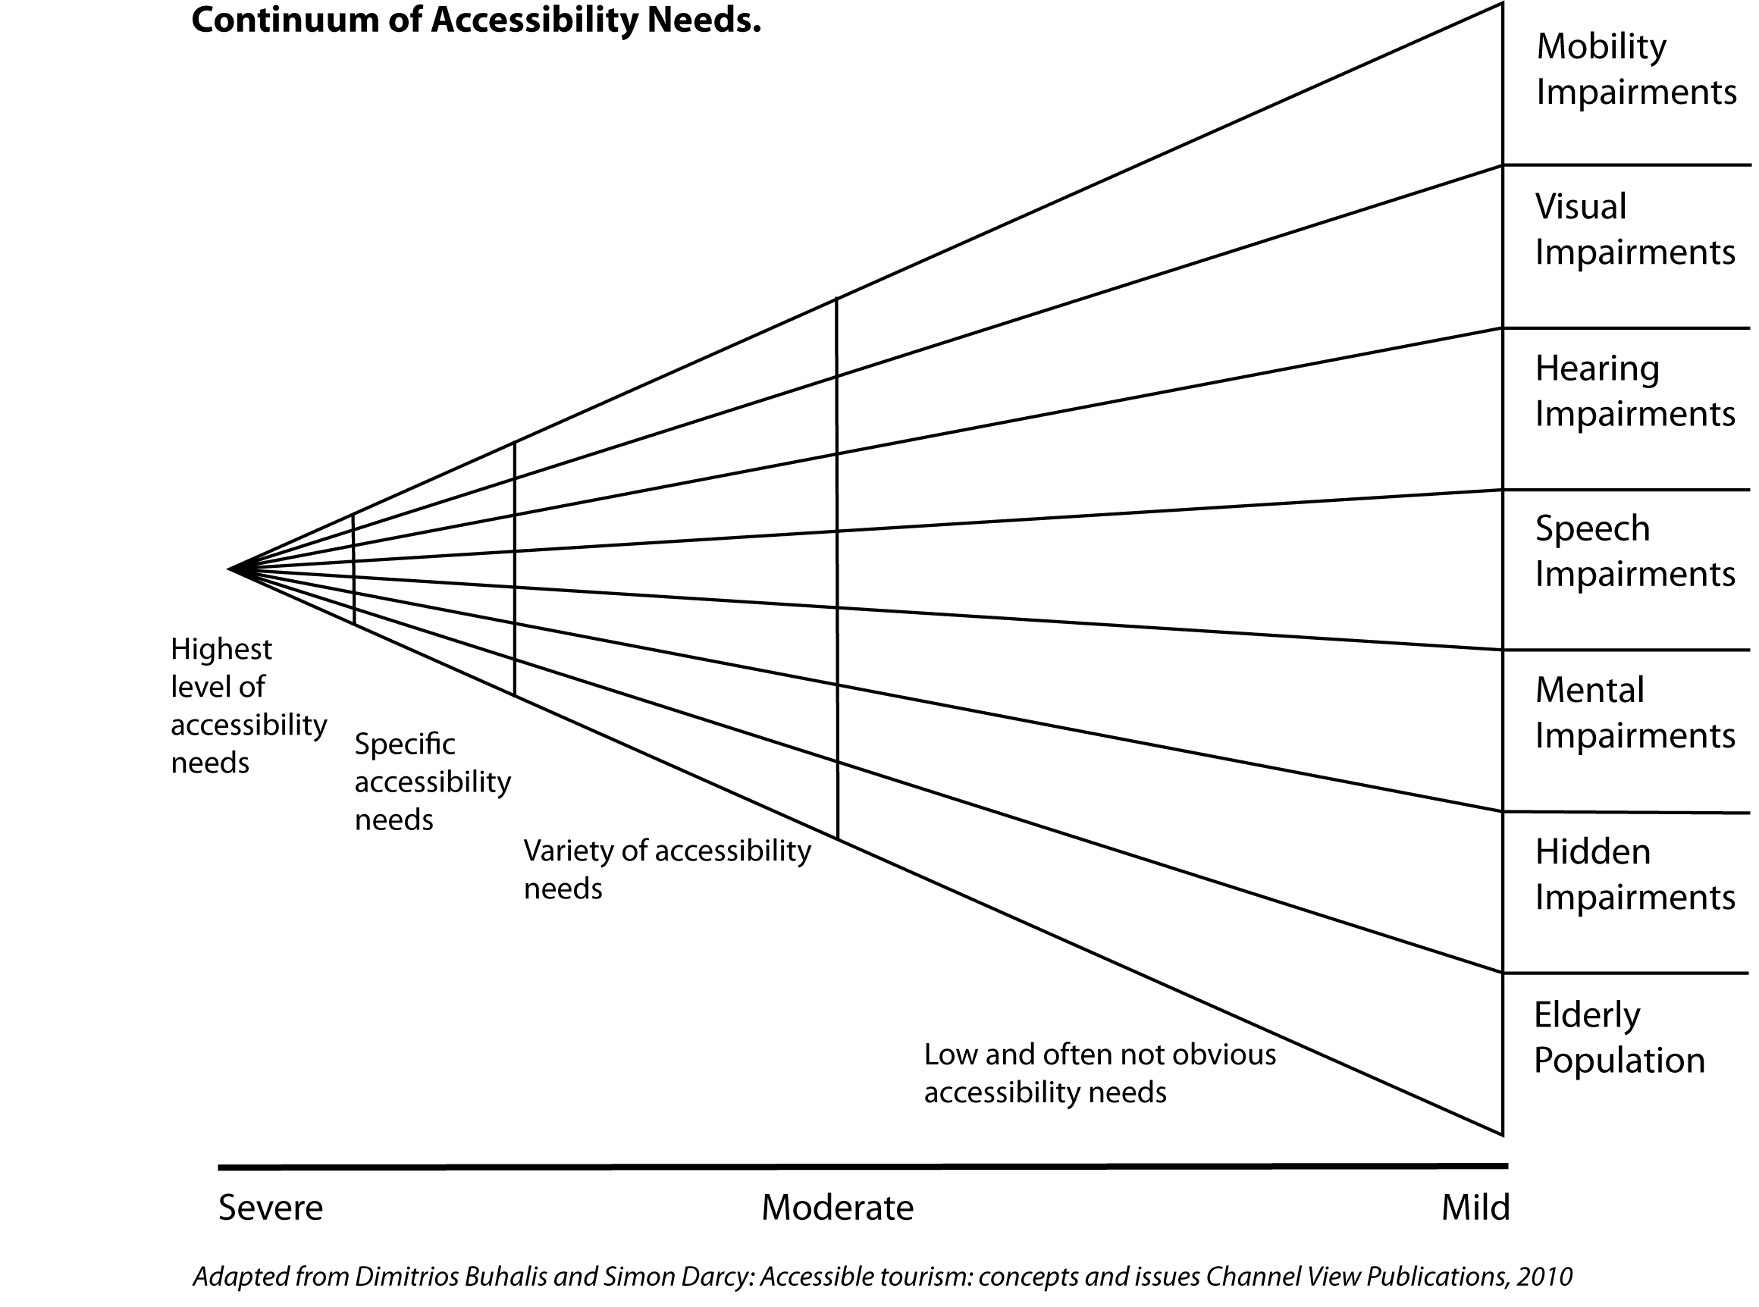

Australian research conducted by Dr Simon Darcy concluded that people with a disability engage in leisure activities on a level compatible with the general population. They tend to travel, on average, with 3.4 friends or family members.

This plan recognises that in addition to physical access there needs to be a clear strategy to provide an inclusive experience for guests of all abilities.

Key Strategies
The Diversity and Inclusion Plan is based on six key customer focused objectives:
- People of all abilities can easily navigate around M&OP
- People of all abilities have easy access to all information about M&OP
- People of all abilities will have easy access to M&OP via public and private transport
- People of all abilities can enjoy events and functions with their family and friends
- People of all abilities have access to the full range of seating options
- M&OP will leverage its accessible conference facilities to active promote its expertise in conferences for all abilities
- People of all abilities will be treated as equal and valuable guests in all dealings with M&OP
Strategic and Policy Guidelines
The Victorian Disability Act 2006 requires public sector bodies to prepare Disability Action Plans for the purposes of:
- reducing barriers to persons with a disability accessing goods, services and facilities;
- reducing barriers to persons with a disability obtaining and maintaining employment;
- promoting inclusion and participation in the community of persons with a disability; and
- achieving tangible changes in attitudes and practices which discriminate against persons with a disability.

The Victorian Equal Opportunity Act 1995 makes discrimination based on disability against the law.

The Commonwealth Disability Discrimination Act 1992 establishes a responsibility for the M&OP to:
- eliminate, as far as possible, discrimination against persons on the ground of disability in the areas of work, accommodation, education, access to premises, clubs and sport, and through the provision of goods, facilities, services and land;
- ensure, as far as practicable, that persons with disabilities have the same rights to equality before the law as the rest of the community; and
- promote recognition and acceptance within the community of the principle that persons with disabilities have the same fundamental rights as the rest of the community.

Australia is also a signatory to the United Nations Convention on the Rights of Persons with Disabilities, which is a legally binding standard that recognises people with a disability as equal and active citizens.
Article 30 - Participation in cultural life, recreation, leisure and sport states:
- Parties recognise the right of persons with disabilities to take part on an equal basis with others in cultural life, and shall take all appropriate measures to ensure that persons with disabilities:
- Enjoy access to places for cultural performances or services, such as theatres, museums, cinemas, libraries and tourism services, and, as far as possible, enjoy access to monuments and sites of national cultural importance.

- With a view to enabling persons with disabilities to participate on an equal basis with others in recreational, leisure and sporting activities, States Parties shall take appropriate measures:
- To ensure that persons with disabilities have access to sporting, recreational and tourism venues;
- To ensure that persons with disabilities have access to services from those involved in the organization of recreational, tourism, leisure and sporting activities
Guiding Principles
The Australian Government’s National Disability Strategy 2010-2020 sets out a 10 year national policy framework for improving life for Australians with disability, their families and carers. It represents a commitment by all levels of government, industry and the community to a unified, national approach to policy and program development. This new approach will assist in addressing the challenges faced by people with disability, both now and into the future.
The Strategy is a 10 year national policy framework that sets out six priority areas for action to improve the lives of people with disability, their families and carers. These are:
- Inclusive and accessible communities—the physical environment including public transport; parks, buildings and housing; digital information and communications technologies; civic life including social, sporting, recreational and cultural life.
- Rights protection, justice and legislation—statutory protections such as anti-discrimination measures, complaints mechanisms, advocacy, the electoral and justice systems.
- Economic security—jobs, business opportunities, financial independence, adequate income support for those not able to work, and housing.
- Personal and community support—inclusion and participation in the community, person-centred care and support provided by specialist disability services and mainstream services; informal care and support.
- Learning and skills—early childhood education and care, schools, further education, vocational education; transitions from education to employment; life-long learning.
- Health and wellbeing—health services, health promotion and the interaction between health and disability systems; wellbeing and enjoyment of life.
In order to work towards the goals of the National Disability Strategy the consultation and development of the Access, Inclusion and Equity Strategy was underpinned by `the seven principles of universal design`.
These are:
- Equitable use
- Flexibility of use
- Simple and intuitive use
- Perceptible information
- Tolerance for error
- Low physical effort
- Size and space for approach and use.

Plan Summary

Objective 1 - Wayfinding and Navigation
Our Vision
People of all abilities can easily navigate around M&OP
What we will do
- Create and enhanced precinct map that clearly shows the step-free routes through the precinct to all facilities, including the three main venues, the show courts, Margaret Court Area, Arena Cafe, accessible transport and car parking.
- Add a precinct map to existing signage throughout the complex
- Update the overhead signage throughout the site with the international disability symbol to indicate step free routes and distances.
- Include accessible toilet facilities in the overhead signage on the Eastern Plaza
- Confirm and indicate accessible public transport options
- Add a wall plaque indicating accessible routes opposite the disabled parking bays in Olympic Boulevard.
- Develop an overall wayfinding strategy that takes into account the needs of patrons with a disability that allows easy access throughout the precinct
- Install on ground markers indicating direction and distance via step free routes
- Add to the style guide signage that has an eye level of 1.2 metres from the ground
- Consider creating braille and audio information and direction boards in addition to the written signage

Objective 2 - Web Information
Our Vision
People of all abilities have easy access to all information about M&OP
What we will do
- Incorporate “customer first” language in all accessibility information
- Integrate accessibility information into each information page throughout the website
- Enhance the information of accessible public transport with specific information on accessible trams, bus and train options
- Include information of the facilities available to people of all abilities including key measurements of toilet facilities
- Create a revised precinct map that clearly shows.
- Step-free routes
- Location of all disabled toilets
- Location of venue entrances with accessible turnstiles
- Location of accessible parking
- Location of accessible public transport, including accessible trams, train station entrances and low floor bus stops
- Location of set down points and loading zones
- Indication of which outside courts have accessible seating areas
- Indicate seating areas for people of all abilities
- Show the step-free route from the entry to the stadium to the seating
- Development of an interactive online precinct map that allows a visitor with a disability to find accessible transport, route through the precinct, venue entrances and seating.
- Develop interactive maps for each stadium that includes the seating areas and views from the designated all abilities areas
- Phase out the use of PDF documents on the web

Objective 3 - Transport
Our Vision
People of all abilities will have easy access to M&OP via public and private transport
What we will do
- Negotiate with Public Transport Victoria for regular low floor trams to be provided to M&OP
- Ensure accessible trams are available for all M&OP events
- Include accessible transport options in all event programs
- Negotiate with the Victorian Taxi Directorate to ensure accessible taxis are available for all major events.

Objective 4 - Booking and seating
Our Vision
People of all abilities can enjoy events and functions with their family and friends
People of all abilities have access to the full range of seating options
What we will do
- Provide enhanced booking information on how to block book seats for groups including people of all abilities
- Provide information on how to book accessible floor seating for events and functions
- Redesign booking procedures and booking software to block the row of seats in front of the all abilities seating and make them available to family and friends of a wheelchair patrons to keep families or groups together to enjoy an event as one.
- Upgrade the web information on Superbox and corporate box accessibility and include access as part of the booking options available at all three stadiums
- Consider the purchase portable slings and train staff in their use as an interim evacuation solution in case of emergency and non-availability of the lifts.
- Review existing seating structures with a view to designing family and group Inclusive Seating booths to be incorporated into future stadium design.
- Include Universal Design and accessibility in the refurbishment of corporate boxes and toilet facilities on the Superbox levels
- Where possible in stadium redesign, include ramps to upper levels to facilitate emergency evacuation and greater access to all levels of the stadiums.

Objective 5 - Events and conferencing
Our Vision
M&OP will leverage its accessible conference facilities to active promote its expertise in conferences for all abilities
What we will do
- Create a revised events management guide that incorporates guidance on the facilities, information and staff support that should be provided to people of all abilities by events organisers
- Consider a new conference facility strategy to market M&OP conference facilities to the global disability conference market
- Consider creating braille and audio information and direction boards in addition to written signage.

Objective 6 - Events and conferencing
Our Vision
People of all abilities will be treated as equal and valuable patrons in all dealings with M&OP
What we will do
- Develop a customer first staff briefing guide for communication with people of all abilities
- Incorporate customer needs of patrons of all abilities into all staff training programs and contractor briefings
- Develop a recruitment and monitoring program to ensure people of all abilities are considered for all employment positions

