**REQUEST TO JOIN EXEMPTION APPLICATION LODGED BY THE DEPARTMENT OF   
FAMILIES, HOUSING, COMMUNITY SERVICES AND INDIGENOUS AFFAIRS (FaHCSIA)   
UNDER S55 OF *THE DISABILITY DISCRIMINATION ACT* (1992) (CTH)**

INVe seek to join/support the exemption application submitted by FaHCSIA as follows:

* I/We seek an exemption for all existing ADEs from sections 15 and 24 of the DDA, and the Commonwealth (and officers of the Commonwealth) from section 29 for a period of three years.
* This exemption would apply to use of the BSWAT to:

1. assess wages for employees; and
2. pay wages to ADE employees based on assessments conducted under the BSWAT.

* The proposed exemption would apply while alternative wage setting arrangements are being considered, devised and/or established and implemented by FaHCSIA.

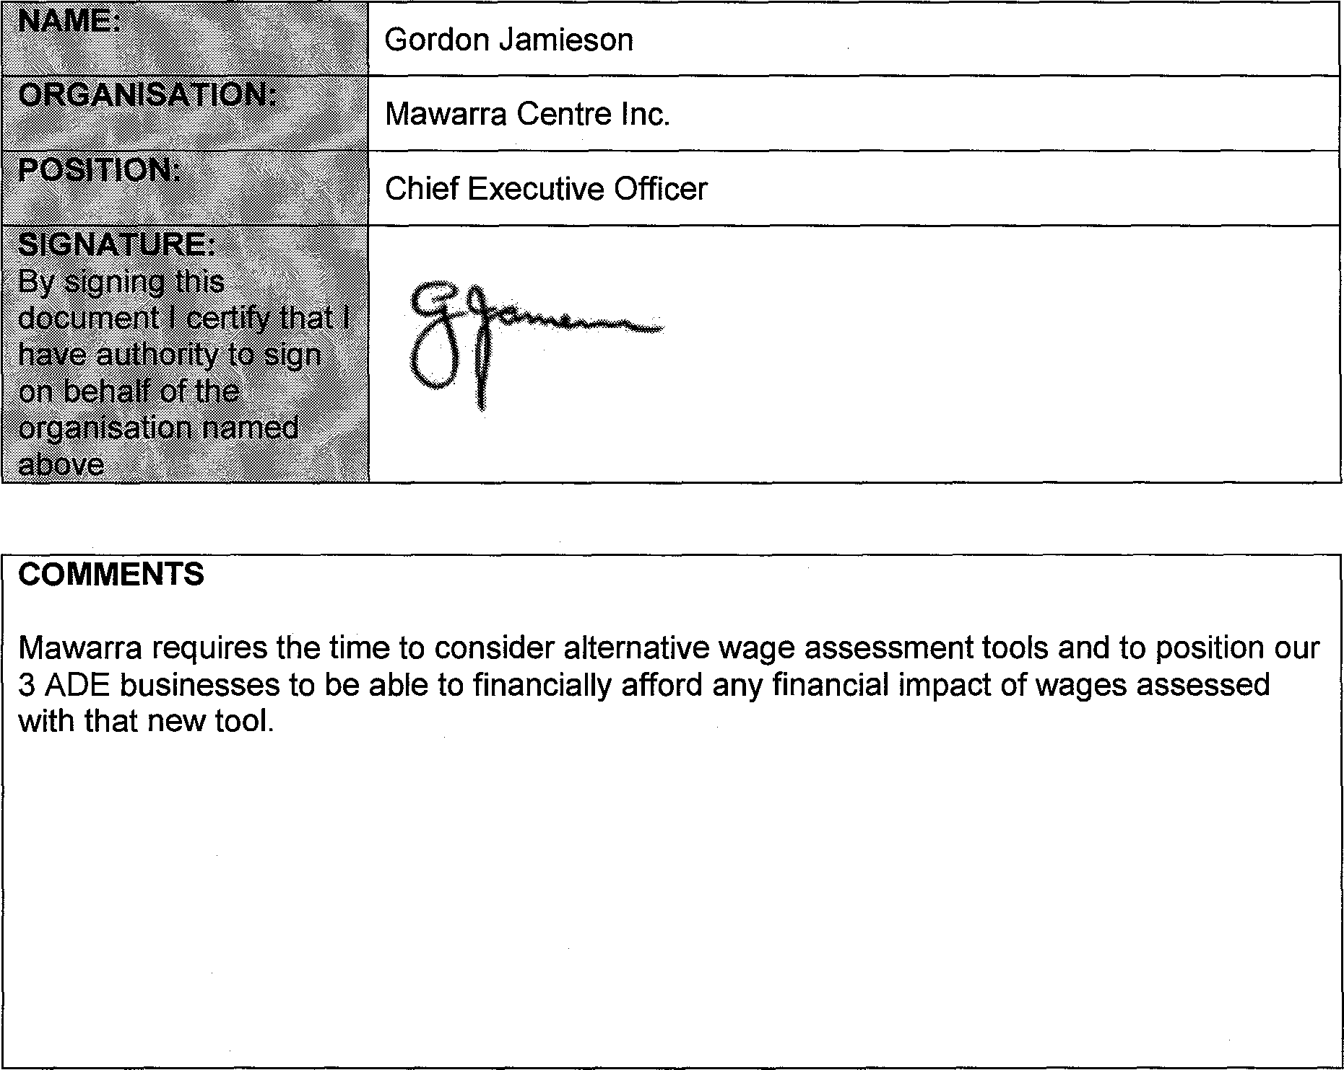

NAME:

Gordon Jamieson

Chief Executive Officer

POSITION:

ORGANISATION:

Mawarra Centre Inc.

SIGNATURE: By signing this document I certify that I have authority to sign on behalf of the organisation named above

**COMMENTS**

Mawarra requires the time to consider alternative wage assessment tools and to position our 3 ADE businesses to be able to financially afford any financial impact of wages assessed with that new tool.